Supplementary Material

Supplemental Figure 1: Effect of preconception nutrition supplements (iron and folic acid, multiple micronutrients, and a lipid based nutrient supplement) on small for gestational age
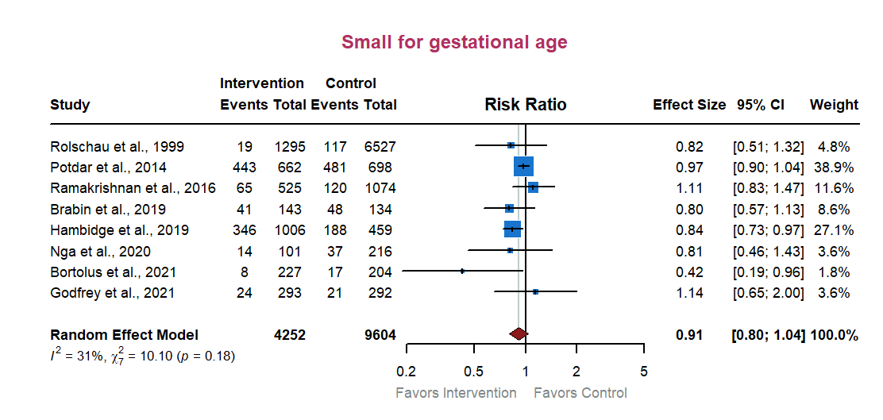

Forest plot depicting the overall pooled effect of preconception nutrition supplements (iron and folic acid or folic acid alone, multiple micronutrients, and lipid-based nutrient supplement) on small for gestational age (birth weight < 10th percentile for gestation age). The blue squares represent individual study’s risk ratio and horizontal black lines indicate corresponding 95% CIs. The maroon diamond represents a pooled risk ratio for small for gestational age and corresponding 95% CI.

Supplemental Figure 2: Effect of preconception nutrition supplements (iron and folic acid, multiple micronutrients, and a lipid based nutrient supplement) on preterm birth
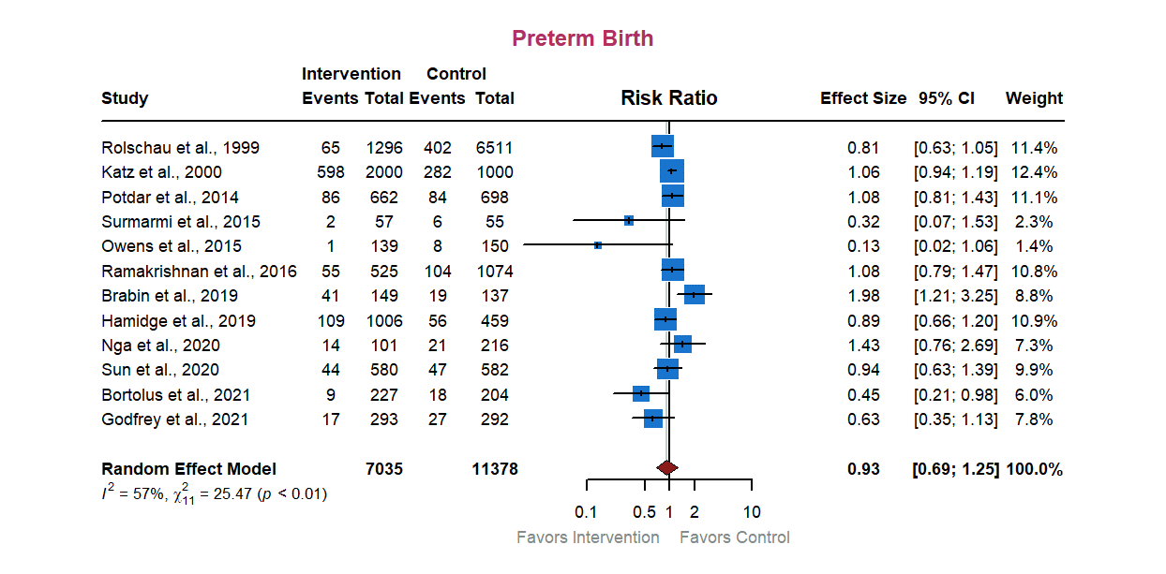

Forest plot depicting the overall pooled effect of preconception nutrition supplements (iron and folic acid or folic acid alone, multiple micronutrients, multivitamins, vitamin A or beta carotene, and lipid-based nutrient supplement) on preterm birth (birth before 37 weeks of gestation). The blue squares represent individual study’s risk ratio and horizontal black lines indicate corresponding 95% CIs. The maroon diamond represents a pooled risk ratio for preterm birth and corresponding 95% CI.

Supplemental Figure 3: Funnel plot and Egger’s regression test results for meta-analysis of RCTs included in the review (maternal hemoglobin and birth weight)
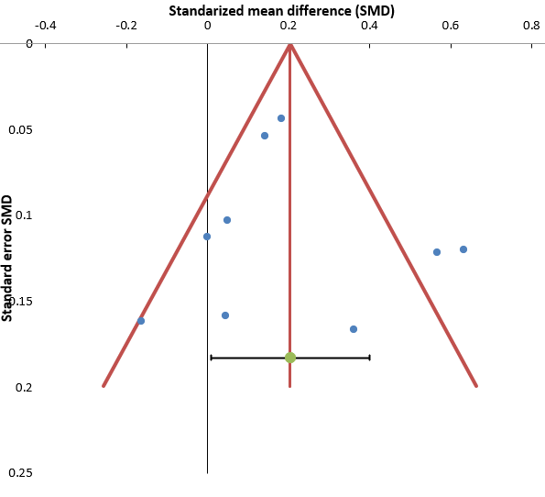
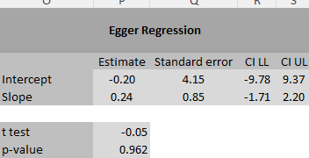
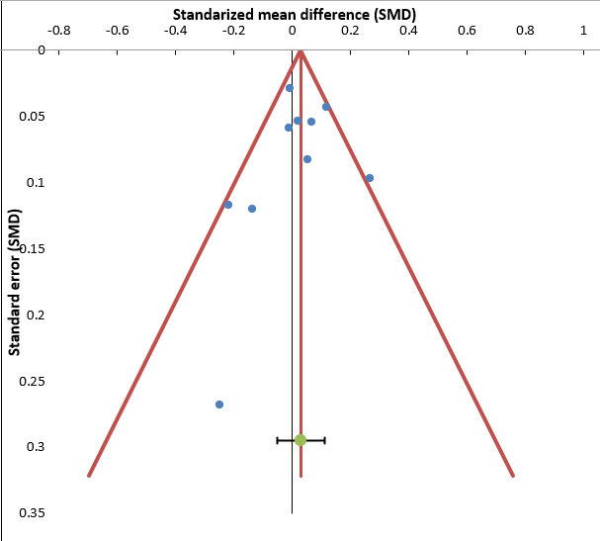
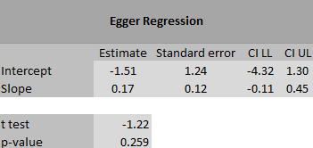
Maternal Hemoglobin (g/dL)
Birth weight (gm)

Supplemental Figure 4: Funnel plot and Egger regression test results for meta-analysis of RCTs included in the review (Small for gestational age and preterm birth)
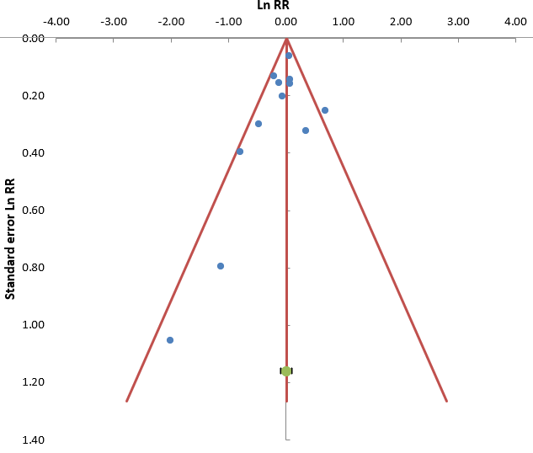
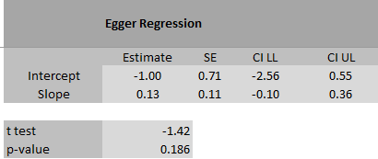
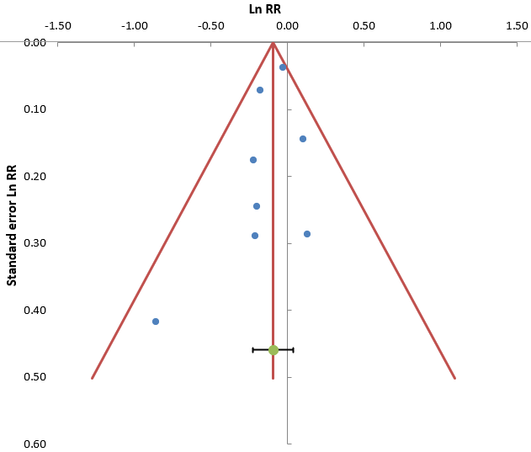
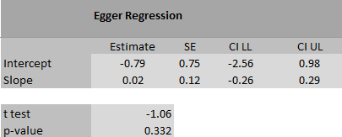
Preterm birth

Small for gestational age

Supplemental Table 1: Search terms used to search electronic databases for systematic review and meta-analysis of RCTs investigating the role of preconception nutrient supplements on maternal anemia and three markers of intrauterine growth
Full Search Strategy for PubMed (Free text and MeSH terms)
Focus |  | Search terms
Preconception window |  | "preconception"[All Fields] OR "pre-pregnancy"[All Fields] OR "before conception"[All Fields] OR "pre-conception"[All Fields] OR "periconception"[All Fields] OR "Periconception Period"[MeSH Terms]
Nutrition Intervention |  | "iron and folic acid"[All Fields] OR "micronutrient*"[All Fields] OR "multiple micronutrient*"[All Fields] OR "iron supplement*"[All Fields] OR "macronutrient*"[All Fields] OR "protein energy supplement*"[All Fields] OR "fatty acid*"[All Fields] OR "omega fatty-acid*"[All Fields] OR "lipid-based nutrient supplement*"[All Fields] OR "Micronutrients"[MeSH Terms] OR "Nutritional Supplements"[MeSH Terms]
Outcome |  | "maternal hemoglobin"[All Fields] OR "maternal anemia"[All Fields] OR "birth weight"[All Fields] OR "low birth weight"[All Fields] OR "preterm birth"[All Fields] OR "small for gestational age"[All Fields] OR "newborn size"[All Fields] OR "birth length"[All Fields] OR "head circumference at birth"[All Fields] OR "Anemia"[MeSH Terms] OR "Birth Weight"[MeSH Terms] OR "Preterm Birth"[MeSH Terms] OR "Gestational Age"[MeSH Terms]
RCT Filter |  | "randomized controlled trial"[Publication Type] OR "RCT"[All Fields] OR "randomized"[All Fields] OR "clinical trial"[Publication Type]
Language Filter |  | "English"[Language]
Combined Final Search Strategy |  | ("preconception"[All Fields] OR "pre-pregnancy"[All Fields] OR "before conception"[All Fields] OR "pre-conception"[All Fields] OR "periconception"[All Fields] OR "Periconception Period"[MeSH Terms]) AND ("iron and folic acid"[All Fields] OR "micronutrient*"[All Fields] OR "multiple micronutrient*"[All Fields] OR "iron supplement*"[All Fields] OR "macronutrient*"[All Fields] OR "protein energy supplement*"[All Fields] OR "fatty acid*"[All Fields] OR "omega fatty-acid*"[All Fields] OR "lipid-based nutrient supplement*"[All Fields] OR "Micronutrients"[MeSH Terms] OR "Nutritional Supplements"[MeSH Terms]) AND ("maternal hemoglobin"[All Fields] OR "maternal anemia"[All Fields] OR "birth weight"[All Fields] OR "low birth weight"[All Fields] OR "preterm birth"[All Fields] OR "small for gestational age"[All Fields] OR "newborn size"[All Fields] OR "birth length"[All Fields] OR "head circumference at birth"[All Fields] OR "Anemia"[MeSH Terms] OR "Birth Weight"[MeSH Terms] OR "Preterm Birth"[MeSH Terms] OR "Gestational Age"[MeSH Terms]) AND ("randomized controlled trial"[Publication Type] OR "RCT"[All Fields] OR "randomized"[All Fields] OR "clinical trial"[Publication Type]) AND "English"[Language]
EMBASE Search Strategy (with EMTREE and Keyword Strategy)
Preconception window | ('preconception' OR 'periconception*' OR 'pre-pregnancy' OR ‘before conception' OR 'pre-conception' OR 'prior to pregnancy')/ti,ab,kw
Nutrition Intervention | ('iron and folic acid' OR 'micronutrient*' OR 'multiple micronutrient*' OR 'iron supplement*' OR 'macronutrient*' OR 'protein energy supplement*' OR 'fatty acid*' OR 'omega fatty-acid*' OR 'balanced protein energy supplement*' OR 'lipid-based nutrient supplement*')/ti,ab,kw
Outcome | ('maternal hemoglobin' OR 'maternal anemia' OR 'intrauterine growth' OR 'birth size' OR 'newborn size' OR 'newborn anthropometry' OR 'birth weight' OR 'low birth weight' OR 'birth length' OR 'head circumference at birth' OR 'preterm birth' OR 'small for gestational age' OR 'gestational age')/ti,ab,kw
Combined final search strategy | ('preconception' OR 'periconception*' OR 'pre-pregnancy' OR 'before conception' OR 'pre-conception' OR 'prior to pregnancy')/ti,ab,kw AND ('iron and folic acid' OR 'micronutrient*' OR 'multiple micronutrient*' OR 'iron supplement*' OR 'macronutrient*' OR 'protein energy supplement*' OR 'lipid-based nutrient supplement*')/ti,ab,kw AND ('maternal hemoglobin' OR 'maternal anemia' OR 'intrauterine growth' OR 'birth weight' OR 'low birth weight' OR 'preterm birth' OR 'small for gestational age')/ti,ab,kw
EMTREE Strategy | ('anaemia'/de OR 'iron deficiency anemia'/de OR 'iron status'/de) AND ('nutrition'/exp OR 'micronutrient'/exp OR 'multivitamin'/exp)
Filters/Limitations Applied | "Map to preferred term in EMTREE" (use /de for MeSH terms); "Explode using narrower EMTREE terms" (/exp); "Document Type" (Article, Review); "Language" (English)
Full Search Strategy for Web of Science (with ALL field)
Preconception window | ALL=("preconception" OR "periconception*" OR "pre-pregnancy" OR "before conception" OR "pre-conception" OR "prior to pregnancy")
Nutrition Intervention | ALL=("iron and folic acid" OR "micronutrient*" OR "multiple micronutrient*" OR "iron supplement*" OR "macronutrient*" OR "protein energy supplement*" OR "fatty acid*" OR "omega fatty-acid*" OR "balanced protein energy supplement*" OR "lipid-based nutrient supplement*")
Outcome | ALL=("maternal hemoglobin" OR "maternal anemia" OR "intrauterine growth" OR "birth size" OR "newborn size" OR "newborn anthropometry" OR "birth weight" OR "low birth weight" OR "birth length" OR "head circumference at birth" OR "preterm birth" OR "small for gestational age" OR "gestational age")
Combined Final Search Strategy | ALL=("preconception" OR "periconception*" OR "pre-pregnancy" OR "before conception" OR "pre-conception" OR "prior to pregnancy") AND ALL=("iron and folic acid" OR "micronutrient*" OR "multiple micronutrient*" OR "iron supplement*" OR "macronutrient*" OR "protein energy supplement*" OR "lipid-based nutrient supplement*") AND ALL=("maternal hemoglobin" OR "maternal anemia" OR "intrauterine growth" OR "birth weight" OR "low birth weight" OR "preterm birth" OR "small for gestational age")
Filters/Limitations Applied | Refined by: DOCUMENT TYPES (Articles), LANGUAGES (English)
Full Search Strategy for CINAHL
Preconception window | ("preconception" OR "periconception*" OR "pre-pregnancy" OR "before conception" OR "pre-conception" OR "prior to pregnancy")
Nutrition Intervention | ("iron and folic acid" OR "micronutrient*" OR "multiple micronutrient*" OR "iron supplement*" OR "macronutrient*" OR "protein energy supplement*" OR "fatty acid*" OR "omega fatty-acid*" OR "balanced protein energy supplement*" OR "lipid-based nutrient supplement*")
Outcome | ("maternal hemoglobin" OR "maternal anemia" OR "intrauterine growth" OR "birth size" OR "newborn size" OR "newborn anthropometry" OR "birth weight" OR "low birth weight" OR "birth length" OR "head circumference at birth" OR "preterm birth" OR "small for gestational age" OR "gestational age")
Combined Final Search Strategy | ("preconception" OR "periconception*" OR "pre-pregnancy" OR "before conception" OR "pre-conception" OR "prior to pregnancy") AND ("iron and folic acid" OR "micronutrient*" OR "multiple micronutrient*" OR "iron supplement*" OR "macronutrient*" OR "protein energy supplement*" OR "lipid-based nutrient supplement*") AND ("maternal hemoglobin" OR "maternal anemia" OR "intrauterine growth" OR "birth weight" OR "low birth weight" OR "preterm birth" OR "small for gestational age")
Filters/Limitations Applied | Refined by: Document Type (Articles, Reviews), Language (English), Human studies
Full Search Strategy for ClinicalTrials.gov
Preconception window | "preconception" OR "periconception*" OR "pre-pregnancy" OR "before conception" OR "pre-conception" OR "prior to pregnancy"
Nutrition Intervention | "iron and folic acid" OR "micronutrient*" OR "multiple micronutrient*" OR "iron supplement*" OR "macronutrient*" OR "protein energy supplement*" OR "fatty acid*" OR "omega fatty-acid*" OR "balanced protein energy supplement*" OR "lipid-based nutrient supplement*"
Outcome | "maternal hemoglobin" OR "maternal anemia" OR "intrauterine growth" OR "birth size" OR "newborn size" OR "newborn anthropometry" OR "birth weight" OR "low birth weight" OR "birth length" OR "head circumference at birth" OR "preterm birth" OR "small for gestational age" OR "gestational age"
Combined Final Search Strategy | "preconception" OR "periconception*" OR "pre-pregnancy" OR "before conception" OR "pre-conception" OR "prior to pregnancy" AND "iron and folic acid" OR "micronutrient*" OR "multiple micronutrient*" OR "iron supplement*" OR "macronutrient*" OR "protein energy supplement*" OR "lipid-based nutrient supplement*" AND "maternal hemoglobin" OR "maternal anemia" OR "intrauterine growth" OR "birth weight" OR "low birth weight" OR "preterm birth" OR "small for gestational age" OR "anemia"
Filters/Limitations Applied | Refined by: Study Type (Randomized Controlled Trials), Condition ("birth weight" OR “birth length” OR “birth head circumference” OR "preterm birth" OR "small for gestational age" OR "anemia"), Age (Adults, Pregnancy), Status (Completed, Recruiting, Active)
Full Search Strategy for Cochrane Central (with Free Text Terms and MeSH/Controlled Vocabulary Terms)
Focus | Search Terms (Free Text) |  | MeSH/Controlled Vocabulary Terms
Preconception window | "preconception" OR "pre-pregnancy" OR "before conception" OR "pre-conception" OR "periconception" |  | "Conception" [MeSH] OR "Pregnancy" [MeSH]
Nutrition Intervention | "iron and folic acid" OR "micronutrient*" OR "multiple micronutrient*" OR "iron supplement*" OR "macronutrient*" OR "protein energy supplement*" OR "fatty acid*" OR "omega fatty-acid*" OR "lipid-based nutrient supplement*" |  | "Micronutrients" [MeSH] OR "Nutritional Supplements" [MeSH] OR "Fatty Acids" [MeSH] OR "Nutritional Interventions" [MeSH]
Outcome | "maternal hemoglobin" OR "maternal anemia" OR "birth weight" OR "low birth weight" OR "preterm birth" OR "small for gestational age" OR "newborn size" OR "birth length" OR "head circumference at birth" |  | "Anemia" [MeSH] OR "Birth Weight" [MeSH] OR "Preterm Birth" [MeSH] OR "Small for Gestational Age" [MeSH] OR "Gestational Age" [MeSH] OR "Infant, Newborn" [MeSH]
Combined Final Search Strategy | "preconception" OR "pre-pregnancy" OR "before conception" OR "pre-conception" OR "periconception" AND "iron and folic acid" OR "micronutrient*" OR "multiple micronutrient*" OR "iron supplement*" OR "macronutrient*" OR "protein energy supplement*" OR "lipid-based nutrient supplement*" AND "maternal hemoglobin" OR "maternal anemia" OR "birth weight" OR "low birth weight" OR "preterm birth" OR "small for gestational age" |  | ("Conception" OR "Pregnancy") AND ("Micronutrients" OR "Nutritional Supplements" OR "Fatty Acids" OR "Nutritional Interventions") AND ("Anemia" OR "Birth Weight" OR "Preterm Birth" OR "Small for Gestational Age" OR "Gestational Age")
Filters/Limitations Applied | Refined by: Review Type (Cochrane Reviews, Intervention Reviews), Condition ("birth weight" OR "preterm birth" OR "small for gestational age"), Status (Completed, Recruiting, Active)
Full Search Strategy for Google Scholar (Free Text Terms)
Preconception window | "preconception" OR "pre-pregnancy" OR "before conception" OR "pre-conception" OR "periconception"
Nutrition Intervention | "iron and folic acid" OR "micronutrient*" OR "multiple micronutrient*" OR "iron supplement*" OR "macronutrient*" OR "protein energy supplement*" OR "fatty acid*" OR "omega fatty-acid*" OR "lipid-based nutrient supplement*"
Outcome | "maternal hemoglobin" OR "maternal anemia" OR "birth weight" OR "low birth weight" OR "preterm birth" OR "small for gestational age" OR "newborn size" OR "birth length" OR "head circumference at birth"
RCT Filter | "randomized controlled trial" OR "RCT" OR "randomized" OR "clinical trial"
Combined Final Search Strategy | "preconception" OR "pre-pregnancy" OR "before conception" OR "pre-conception" OR "periconception" AND "iron and folic acid" OR "micronutrient*" OR "multiple micronutrient*" OR "iron supplement*" OR "macronutrient*" OR "protein energy supplement*" OR "lipid-based nutrient supplement*" AND "maternal hemoglobin" OR "maternal anemia" OR "birth weight" OR "low birth weight" OR "preterm birth" OR "small for gestational age" AND "randomized controlled trial" OR "RCT" OR "randomized" OR "clinical trial"

Supplemental Table 2. Findings of meta-regression analysis for hemoglobin and birth weight
 |  |  | β | LL | UL | P-value | τ² | I² (%) | R² (%)
 |  | RCTs examining maternal hemoglobin (g/dL) n=9
Publication year |  |  | -0.01 | -0.06 | 0.02 | 0.32 | 0.09 | 83.3 | 3.1
Multiple micronutrients vs. IFA |  |  | -0.09 | -0.68 | 0.50 | 0.72 | 0.11 | 85.90 | 0
Intervention (Weekly vs. Daily) |  |  | 0.05 | -0.57 | 0.67 | 0.86 | 0.11 | 84.15 | 0
Control Arm (Alternative vs. Standard of care or placebo |  |  | -0.39 | -0.86 | 0.07 | 0.09 | 0.06 | 74.17 | 37.0
Risk of bias (high/some concerns vs. low) |  |  | 0.23 | -0.39 | 0.83 | 0.40 | 0.09 | 84.7 | 0
Mean age of participants |  |  | 0.03 | -0.01 | 0.07 | 0.17 | 0.07 | 81.2 | 21.0
Mean BMI of participants |  |  | -0.05 | -0.28 | 0.17 | 0.58 | 0.10 | 85.6 | 0
RCTs examining birth weight (gm) n=10
Publication year |  |  | 0.57 | -3.96 | 5.11 | 0.78 | 1310.08 | 59.49 | 0
LMICs vs. HICs |  |  | -41.61 | -128.98 | 45.75 | 0.30 | 1517.85 | 64.07 | 0
Multiple micronutrients vs. IFA |  |  | -12.75 | -141.87 | 116.36 | 0.82 | 886.44 | 57.89 | 0
Intervention (Weekly vs. Daily) |  |  | -41.64 | -139.63 | 56.35 | 0.35 | 986.76 | 57.90 | 0
Control Arm (Alternative vs. Standard of care or placebo |  |  | 14.50 | -70.98 | 99.79 | 0.70 | 1349.81 | 63.33 | 0
Risk of bias (high/some concerns vs. low) |  |  | -45.52 | -126.0 | 34.94 | 0.23 | 494.94 | 40.69 | 22.19
Mean age of women |  |  | 6.99 | -1.76 | 15.74 | 0.10 | 1159.30 | 62.50 | 0
Mean BMI of women |  |  | 11.70 | -20.62 | 44.01 | 0.43 | 1205.19 | 63.32 | 0
I² represents the proportion of remaining between-study heterogeneity after including a study level predictor; R² represents the proportion of heterogeneity that can be explained by study-level predictor; τ² represents estimated variance of the true effects beyond sampling variability; BMI: Body mass index; IFA: Iron and folic acid; HICs: High income countries; LMICs: Low-middle income countries; LL: Lower limit of 95% CI, UL: Upper limit of 95% CI; We could not regress hemoglobin on study setting (LMICs vs. HICs) because all studies on hemoglobin were reported from LMICs.

Supplemental Table 3: Risk of bias assessments for each domain for studies included in the review
Study | Domains to assess risk of bias
Study | Randomization process | Deviations from intended interventions |  | Missing outcome data | Measurement of the outcome | Selection of the reported result | Overall risk of bias
MRC Vitamin Study Research Group., 1991 | + | + |  | +  + | —  + | + | +
Czeizel et al., 1994 | + | + |  | + |  | + | —
Rolschau et al., 1999 | — | + |  |  | +  + | + | —
ICMR, 2000 | + | + |  | + |  | ? | ?
Katz et al., 2000 | + | + |  | + | ? | ? | ?
Gilgen et al., 2001 | ? | + |  | + | + | + | ?
Moriarty-Craige et al., 2004 | ? | + |  | + | + | + | ?
Khambalia et al., 2009 | + | + |  | + | + | + | +
Cooper et al., 2012 | ? | — |  | +  — | + | + | —
Potdar et al., 2014 | + | + |  |  | + | +  + | +
Gunaratna et al., 2015 | +  + | + |  | +  — | + |  | +
Sumarmi et al., 2015 |  | — |  |  | + | + | —
Ramakrishnan et al., 2016 | + | + |  | + | + | + | +
Brabin et al., 2019 | + | + |  | + | + | + | +
Hambidge et al.,2019 | + |  | + | + | + | + | +
Sun et al., 2020 | + |  | + | + | + | — | —
Nga et al., 2020 | ? |  | + | + | + | + | ?
Widasari et al., 2020 | + |  | + | — | + | + | —
Godfrey et al., 2021 | + |  | + | + | + | + | +
Bortolus et al.,2021 | + |  | + | + | + | + | +
+  ? | Low risk
 | Some concerns
— | High risk

Supplemental Table 4: Quality of evidence of RCTs assessing the effect of preconception nutrition supplements on maternal hemoglobin, birth weight, length, head circumference, small for gestational age, and pre-term birth: GRADE assessment tool findings
Outcome | GRADE tool Criteria |  |  |  |  |  | Final rating
Outcome | Risk of bias | Inconsistency | Imprecision | Indirectness | Publication bias
Maternal hemoglobin (g/dL) | Not serious¹ | Serious² | Not serious | Not serious | Not detected | Moderate
Birth weight (gm) | Very verious³ | Serious⁴ | Not serious | Very serious⁵ | Not detected | Very low
Birth length (cm) | Serious⁶ | Serious⁷ | Not serious | Serious⁸ | Not detected | Very low
Birth head circumference (cm) | Serious⁹ | Very serious¹⁰ | Serious¹¹ | Serious¹² | Not detected | Very low
Small for gestational age | Not serious¹³ | Not serious¹⁴ | Not serious | Serious¹⁵ | Not detected | Moderate
Preterm birth | Serious¹⁶ | Serious¹⁷ | Not serious | Very serious¹⁸ | Not detected | Very low
¹ Total 9 studies: 6 with low risk of bias, 1 high risk of bias, and 2 with some concerns
² The statistical heterogeneity was high (I²=79%)
³ Total 15 studies: 7 with low risk of bias, 6 with high risk of bias, and 2 with some concerns
⁴ Wide variation across the RCTS resulted in statistical moderate heterogeneity (I²=55%)
⁵ Indirectness of evidence was mainly due to variation in the type of nutrient supplements and comparator group: 1 RCT tested lipid-based nutrient supplement (LNS), 1 tested iron folic acid (IFA), 1 tested high dose folic acid, and one tested multivitamins; 8 RCTs tested multiple micronutrient (MMN) (3 from food and 5 from capsule/tablet/powder sachets) with varying frequency (4 daily, 1 every other day, one 5/week, one twice daily, and one 1/week).
⁶ Total 5 studies: 2 with low risk of bias, 2 with high risk of bias, and 1 with some concerns
⁷ Wide variation across the RCTs with moderate heterogeneity (I²=68%)
⁸ Indirectness of evidence was mainly due to variation in the type of nutrient supplements and control group: 1 RCT tested LNS and 4 RCTs tested MMN (1 from food and 3 from capsule/tablet/powder sachets). Type of control groups differed (2 RCTs provided no supplement at all, 1 provided placebo, 1 provided IFA, and one provided low energy MMN).
⁹ Total 4 studies: 2 with low risk of bias, 1 with high risk of bias, and 1 with some concerns
¹⁰ Wide variation across the RCTS with high heterogeneity (I²=84%)
¹¹ The sample size was adequate and criterion for optimal information size was met, but 95% CIs include the substantial harm
¹² Indirectness of evidence was mainly due to variation in the type of nutrient supplements and control group: 1 RCT tested LNS and 3 RCTs tested MMN (1 from food and 2 from capsule/tablet/powder sachets). Type of control groups differed (2 RCTs provided no supplement at all, 1 provided placebo, and one provided low energy MMN).
¹³ Total 8 studies: 6 with low risk of bias, 1 with high risk of bias, and 1 with some concerns
¹⁴ low statistical heterogeneity (I²=31%) implies not substantial variation across RCTs
¹⁵ Indirectness of evidence was mainly due to variation in the type of nutrient supplements and control group: 1 RCT tested LNS, 2 tested folic acid, 1 tested IFA, and 4 RCTs tested MMN (2 from food and 2 from capsule/tablet/powder sachets).
¹⁶ Total 12 studies: 7 with low risk of bias, 3 with high risk of bias, and 2 with some concerns
¹⁷ Wide variation across the RCTs resulted in statistical moderate heterogeneity (I²=57%)
¹⁸ Indirectness of evidence was mainly due to variation in the type of nutrient supplements and control group: 1 RCT tested LNS, 2 tested folic acid, 1 tested IFA, 1 tested vitamin A supplement, and 7 RCTs tested MMN (3 from food and 4 from capsule/tablet/powder sachets) with varying frequency (4 daily, 1 every other day, one 5/week, and one twice daily). Type of control groups differed (2 RCTs provided no supplement at all, 1 provided beta-carotene, 2 provided placebo, 1 provided IFA, 4 provided folic acid, one provided low energy snack, and one provided MMN).

