Additional file 3. Risk of bias figures.
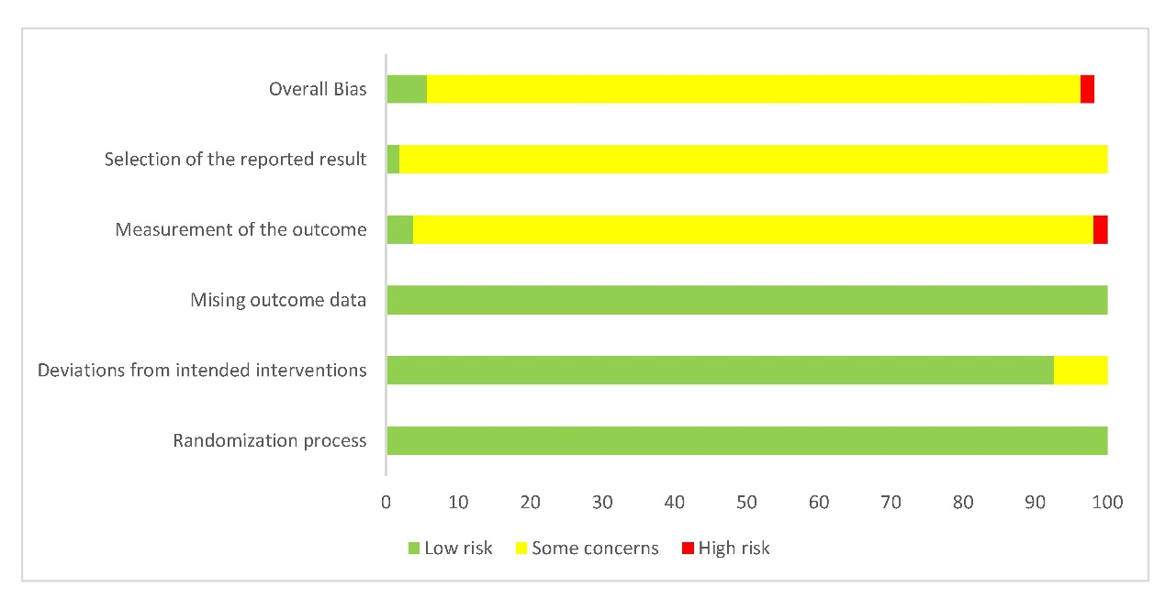
Additional file 3. Risk of bias figure A
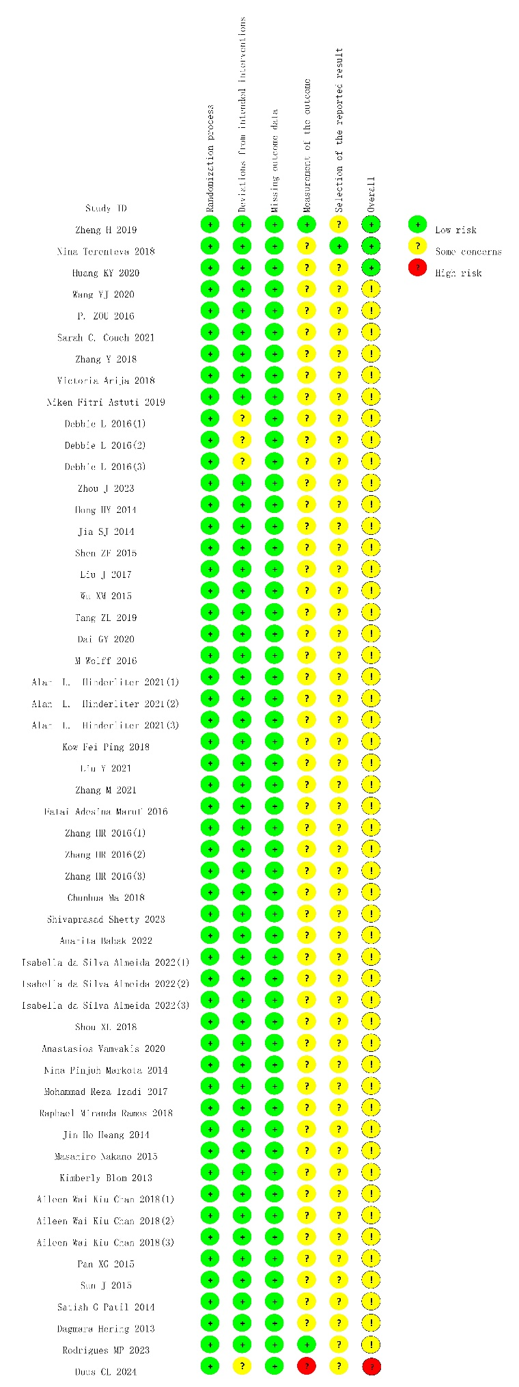
Additional file 3. Risk of bias figure B

