Supplementary Materials
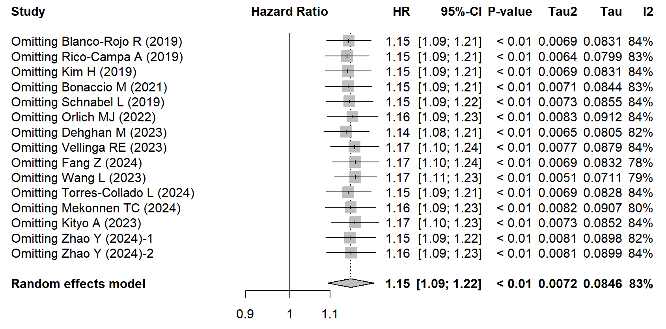
Supplementary Figure 1. Sensitivity analysis for the association between UPF intake and the risk of all-cause mortality, comparing the highest and lowest categories.

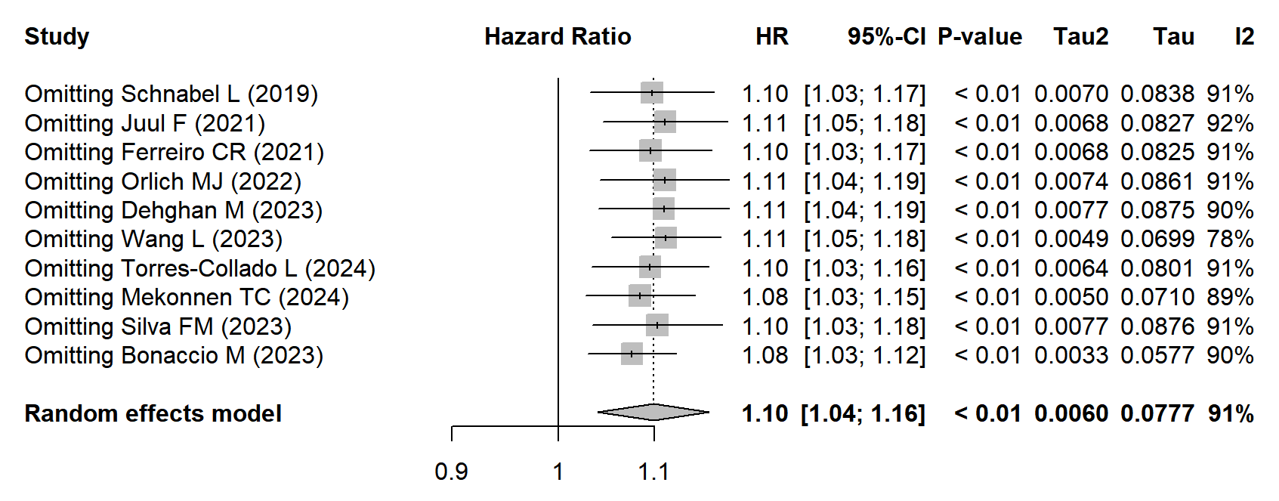
Supplementary Figure 2. Sensitivity analysis for the association between UPF intake and the risk of all-cause mortality, per 10% increment in UPF intake.

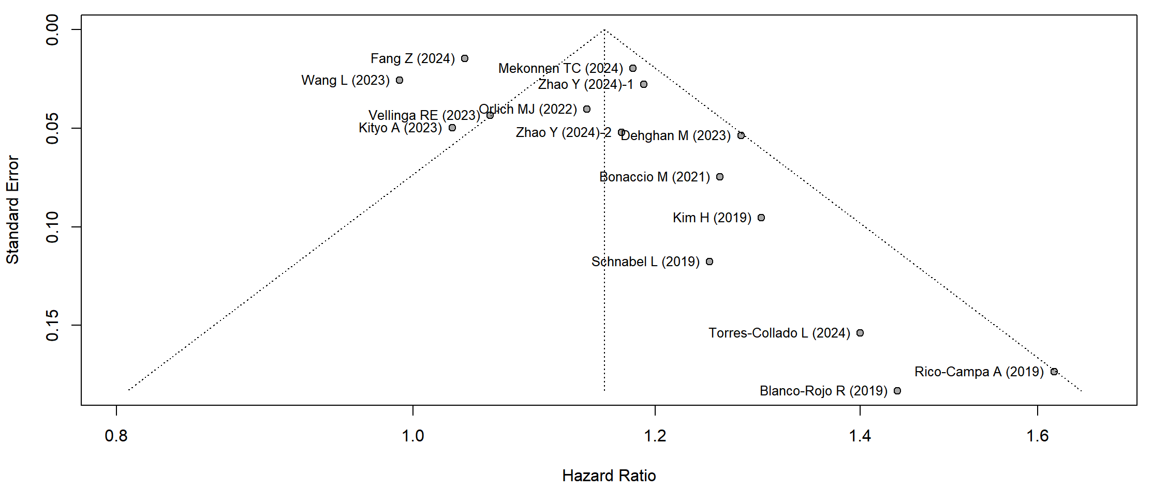
Supplementary Figure 3. Funnel plot for studies included in the association between UPF intake and the risk of all-cause mortality, comparing the highest and lowest categories.
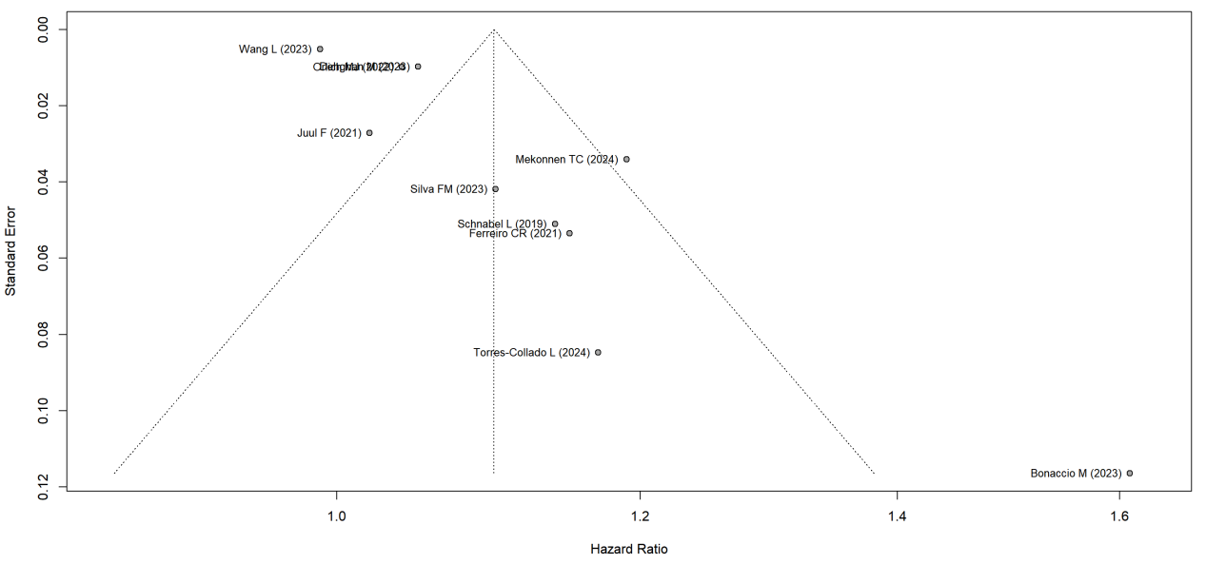

Supplementary Figure 4. Funnel plot for studies included in the association between UPF intake and the risk of all-cause mortality, per 10% increment in UPF intake.
Supplementary Table 1. Number of citations by each database searched
Databases | Citations
Databases
Medline | 358
Embase | 122
Cochrane Library | 23
Hand search from previous meta-analysis | 9
Total databases | 512

Supplementary Table 1.1 Search Strategy for PubMed
ID | Search
#1 | ((((((((((Food, Processed[MeSH Terms]) OR (Ultra-Processed Foods)) OR (Ultra-Processed Food)) OR (Ultra Processed Foods)) OR (Ultra Processed Food)) OR (Food, Ultra-Processed)) OR (Food, Ultra Processed)) OR (Foods, Ultra-Processed)) OR (Foods, Ultra Processed)) OR (UPF)) OR (UPFs)
#2 | "death"[Title/Abstract] OR "Mortality"[Title/Abstract] OR "all cause mortality"[Title/Abstract] OR "Mortality"[MeSH Terms]
#3 | #1 AND #2
#4 | Filters: from 2022 - 2024
Results | 358

Supplementary Table 1.2 Search Strategy for EMBASE
ID | Search
#1 | 'ultra-processed foods':ab,ti
#2 | 'ultra-processed food':ab,ti
#3 | 'ultra processed foods':ab,ti
#4 | 'ultra processed food':ab,ti
#5 | 'food, ultra-processed':ab,ti
#6 | 'food, ultra processed':ab,ti
#7 | 'foods, ultra processed':ab,ti
#8 | 'foods, ultra-processed':ab,ti
#9 | 'upf':ab,ti
#10 | 'upfs':ab,ti
#11 | #1 OR #2 OR #3 OR #4 OR #5 OR #6 OR #7 OR #8 OR #9 OR #10
#12 | 'death ':ab,ti
#13 | 'mortality ':ab,ti
#14 | 'all-cause mortality ':ab,ti
#15 | #12 OR #13 OR #14
#16 | #11 AND #15
#17 | #11 AND #15 AND [humans]/lim AND [2022-2024]/py
Results | 122

Supplementary Table 1.3 Search Strategy for Cochrane
ID | Search
#1 | Ultra-Processed Foods
#2 | Ultra-Processed Food
#3 | Ultra Processed Foods
#4 | Ultra Processed Food
#5 | Food, Ultra-Processed
#6 | Food, Ultra Processed
#7 | Foods, Ultra-Processed
#8 | Foods, Ultra Processed
#9 | UPF
#10 | UPFs
#11 | #1 OR #2 OR #3 OR #4 OR #5 OR #6 OR #7 OR #8 OR #9 OR #10 in Cochrane Reviews
#12 | death
#13 | mortality
#14 | all-cause mortality
#15 | #12 OR #13 OR #14
#16 | #11 AND #15
Results | 23

Supplementary Table 2. Quality assessment of included studies according to the Newcastle-Ottawa Scale for cohort study
ID | Author (year) | Selection |  |  |  | Comparability | Outcome |  |  | score
ID | Author (year) | Representativeness of the exposed cohort | Selection of non-exposed cohort | Ascertainment of exposure | Outcome of interest was not present at start of study | Comparability of cohort on the basis of design or analysis controlled for confounders | Assessment of outcome | Follow-up long enough for outcomes to occur | Adequacy of follow-up | 0-9
1 | Blanco-Rojo R (2019) | 1 | 1 | 1 | 1 | 2 | 1 | 1 | 1 | 9
2 | Rico-Campa A (2019) | 0 | 1 | 1 | 1 | 2 | 1 | 1 | 1 | 8
3 | Kim H (2019) | 1 | 1 | 1 | 1 | 2 | 1 | 1 | 1 | 9
4 | Bonaccio M (2021) | 1 | 1 | 1 | 1 | 2 | 1 | 1 | 1 | 9
5 | Schnabel L (2019) | 0 | 1 | 1 | 1 | 2 | 1 | 1 | 1 | 8
6 | Juul F (2021) | 1 | 1 | 1 | 1 | 2 | 1 | 1 | 1 | 9
7 | Ferreiro CR (2021) | 1 | 1 | 1 | 1 | 2 | 1 | 1 | 1 | 9
8 | Orlich MJ (2022) | 0 | 1 | 1 | 1 | 2 | 1 | 1 | 1 | 8
9 | Dehghan M (2023) | 1 | 1 | 1 | 1 | 2 | 1 | 1 | 1 | 9
10 | Vellinga RE (2023) | 1 | 1 | 1 | 1 | 2 | 1 | 1 | 1 | 9
11 | Bonaccio M (2023) | 0 | 1 | 1 | 1 | 2 | 1 | 1 | 1 | 8
12 | Zhao Y (2024) | 1 | 1 | 1 | 1 | 2 | 1 | 1 | 1 | 9
13 | Fang Z (2024) | 0 | 1 | 1 | 1 | 2 | 1 | 1 | 1 | 8
14 | Wang L (2023) | 0 | 1 | 1 | 1 | 2 | 1 | 1 | 1 | 8
15 | Torres-Collado L (2024) | 1 | 1 | 1 | 1 | 2 | 1 | 1 | 1 | 9
16 | Mekonnen TC (2024) | 1 | 1 | 1 | 1 | 2 | 1 | 1 | 1 | 9
17 | Silva FM (2023) | 1 | 1 | 1 | 1 | 2 | 1 | 1 | 1 | 9
18 | Kityo A (2023) | 1 | 1 | 1 | 1 | 2 | 1 | 1 | 1 | 9

