Supplemental Material
Efficacy and Safety of Corticosteroids for Stroke and Traumatic Brain Injury: A Systematic Review and Meta-Analysis
Yanan Wang, PhD^{1#}, Linrui Huang, MB^{1#}, Jingjing Li, MB^{1#}, Jiangang Duan, PhD², Xiaohua Pan, PhD³, Bijoy K. Menon, PhD^{4,5}, Craig S. Anderson, MD, PhD^{6,7}, Ming Liu, PhD^{1,8}, Simiao Wu, MD, PhD^{1,8,9}*
- Department of Neurology, West China Hospital, Sichuan University, Chengdu, China
- Department of Emergency, Xuanwu Hospital, Capital Medical University, Beijing, China
- Department of Neurology, Baotou Eighth Hospital, Inner Mongolia, China
- Department of Clinical Neurosciences, University of Calgary, Calgary, AB, Canada
- Department of Radiology, University of Calgary, Calgary, AB, Canada
- The George Institute for Global Health, Faculty of Medicine, University of New South Wales, Sydney, NSW, Australia
- Institute of Science and Technology for Brain-inspired Intelligence, Fudan University, Shanghai, China
- Centre of Cerebrovascular diseases, West China Hospital, Sichuan University, Chengdu, China
- Institute for Brain Science and Diseases, West China Hospital, Sichuan University, Chengdu, China
# These authors contributed equally to this work.
* Corresponding author: Simiao Wu, Department of Neurology, West China Hospital, Sichuan University, No. 37 Guo Xue Xiang, Chengdu, 610041, Sichuan, China (e-mail: simiao.wu@hotmail.com).
Contents
Table S1. Full search strategy 3
Table S2. Summary of corticosteroids treatment 5
Table S3. Ongoing clinical trials and observational studies 13
Table S4. Risk of bias assessment for cohort studies 16
Table S5. Subgroup analysis the effect of treatment dose and duration on death 17
Table S6. Sensitivity analyses 18
Figure S1. Risk of bias of included randomised controlled trials. (A) details of each included trials; (B) summary of risk of bias of included trials 22
Figure S2. Funnel plot of death after traumatic brain injury (A), functional outcome after traumatic brain injury (B), Any type of infections (C), gastrointestinal bleeding (D), or hyperglycaemia/diabetes mellitus (E). 23
Supplementary References 24

Table S1. Full search strategy
1 | steroid.mp.
2 | steroid/
3 | 1 or 2
4 | corticosteroid.mp.
5 | corticosteroid/
6 | 4 or 5
7 | glucocorticoid.mp.
8 | glucocorticoid/
9 | 7 or 8
10 | methylprednisolone.mp.
11 | methylprednisolone/
12 | 10 or 11
13 | Dexamethasone.mp.
14 | dexamethasone/
15 | 13 or 14
16 | Betamethasone.mp.
17 | betamethasone/
18 | 16 or 17
19 | cortisone.mp.
20 | cortisone/
21 | 19 or 20
22 | Hydrocortisone.mp.
23 | Hydrocortisone/
24 | 22 or 23
25 | Prednisone.mp.
26 | Prednisone/
27 | 25 or 26
28 | Prednisolone.mp.
29 | prednisolone/
30 | 28 or 29
31 | Deflazacort.mp.
32 | Deflazacort/
33 | 31 or 32
34 | Fludrocortisone.mp.
35 | Fludrocortisone/
36 | 34 or 35
37 | Triamcinolone.mp.
38 | Triamcinolone/
39 | 37 or 38
40 | 3 or 6 or 9 or 12 or 15 or 18 or 21 or 24 or 27 or 30 or 33 or 36 or 39
41 | Cerebrovascular Disorders.mp.
42 | cerebrovascular disease/co, dt, et, th
43 | 41 or 42
44 | Stroke.mp.
45 | cerebrovascular accident/dt, et, th
46 | 44 or 45
47 | IS.mp.
48 | ischaemic stroke.mp.
49 | IS/dt, et, th
50 | 47 or 48 or 49
51 | intracranial hemorrhage.mp.
52 | intracranial haemorrhage.mp.
53 | brain hemorrhage/dt, et, th
54 | 51 or 52 or 53
55 | intracerebral hemorrahge.mp.
56 | intracerebral haemorrhage.mp.
57 | brain hemorrhage/dt, et, th
58 | 55 or 56 or 57
59 | subarachnoid hemorrhage.mp.
60 | subarachnoid haemorrhage.mp.
61 | subarachnoid hemorrhage/dt, et, th
62 | 59 or 60 or 61
63 | Cerebral Hemorrhage.mp.
64 | Cerebral Haemorrhage.mp.
65 | brain hemorrhage/dt, et, th
66 | 63 or 64 or 65
67 | traumatic brain injury.mp.
68 | Craniocerebral Trauma.mp.
69 | Brain Injuries.mp.
70 | traumatic brain injury/dt, et, th
71 | head injury/dt, et, th
72 | brain injury/dt, et, th
73 | 67 or 68 or 69 or 70 or 71 or 72
74 | 43 or 46 or 50 or 54 or 58 or 62 or 66 or 73
75 | 40 and 74
76 | limit 75 to full text
77 | limit 76 to human

Table S2. Summary of corticosteroids treatment
Study  participants | Corticosteroids | Treatment | Initial dose (mg) | Total dose (mg) | Total dose (Standardised, mg) * | Duration (days) | Reference
IS
 | DXM
 |  | Starting at 100 mg; 16 mg every 6 hours for 2 days; total dose: 228 mg | 100 | 228 | 228 | 2 | Ogun 2001(1)
 |  | 24 mg p.o./i.v. every 6 hours with progressively diminishing the doses until the 12th day; total dose: 480mg | 24 | 480 | 480 | 12 | Norris 1986(2)
 |  | 4.2 mg i.m. every 6 hours for 10 days; 4.2 mg i.m. every 8 hours for 1 day; 4.2 mg i.m. every 12 hours for 2 days; 4.2 mg i.m. once for 1 day; total dose: 201.6 mg | 4.2 | 201.6 | 202 | 14 | Mulley 1978(3)
 |  | 24 mg i.v. every 24 hours for 10 days; total dose: 240 mg | 24 | 240 | 240 | 10 | Santambrogio 1978(4)
 |  | Starting at 8 mg i.v. bolus; 4 mg i.v. every 6 hours decreased over a period of 12 day; total dose: 140 mg | 8 | 140 | 140 | 12 | Norris 1976(5)
 |  | Starting at 12 mg i.v.; 4 mg i.m. every 6 hours for 3 days; 4 mg i.m. every 8 hours for 3 days; 4 mg i.m. every 12 hours for 2 days; 4 mg i.m. every 24 hours for 2 days; total dose: 120 mg | 12 | 120 | 120 | 10 | Bauer 1973(6)
 |  | Starting at 16 mg daily and decreasing progressively until the 15th day; total dose: 152 mg | 16 | 152 | 152 | 15 | Reuck 1988(7)
 | MP
 |  | 2 mg/kg/day i.v. | 140 | 420 | 79 | 3 | Yang 2024(8)
 |  | Starting at 2 g, and decreasing to 0.125 g; total dose: 3.875 g | 2000 | 3875 | 727 | 5 | Reuck 1988(7)
 | Beta
 |  | Staring 10 mg; 10 mg/day in divided doses for 2 days; 8 mg/day in divided doses for 3 days; 6 mg/day in divided doses for 3 days; 4 mg/day for 3 days; 2 mg/day for 10 days; total dose: 94 mg | 10 | 94 | 118 | 21 | Gupta 1978(9)
 |  | Starting at 12 mg i.m.; 4 mg i.m. every 8 hours for 1 day; 4 mg i.m. every 8 hours for 9 days; 4 mg i.m. every 2 hours for 2 days; 2 mg i.m. every 2 hours for 2 days; total dose: 345 mg | 12 | 345 | 431 | 14 | McQueen 1978(10)
ICH
 | DXM
 |  | Starting at 10 mg; 5 mg every 6 hours for 6 days; 5 mg every 12 hours for 2 days; 5 mg every 24 hours for 2 days; total dose: 160 mg | 10 | 160 | 160 | 10 | Sm 2008(11)
 |  | Starting at 100 mg; 16 mg every 6 hours for 2 days; Total dose: 228 mg | 100 | 228 | 228 | 2 | Ogun 2001(1)
 |  | 4 mg i.v. every 6 hours for 12 days; 4 mg i.v. every 12 hours for 2 days; 2 mg i.v. every 12 hours for 2 days; total: 216 mg | 4 | 216 | 216 | 16 | Desai 1998(12)
 |  | Starting at 10 mg i.v.; 5 mg i.v.every 6 hours for 6 days; 5 mg i.v. every 12 hours for 2 days; 5 mg i.v. for one day; total dose: 120 mg | 12 | 120 | 120 | 10 | Poungvarin 1987(13)
 |  | Starting at 12 mg i.v.; 4 mg i.m. every 6 hours for 3 days; 4 mg i.m. every 8 hours for 3 days; 4 mg i.m. every 12 hours for 2 days; 4 mg i.m. every 24 hours for 2 days; total: 120 mg | 12 | 120 | 120 | 10 | Tellez 1973(14)
 |  | 6 mg i.m. every 4 hours for 10 days; total dose: 360 mg | 6 | 360 | 360 | 10 | Hooshmand 1972(15)
 |  | Starting at 16 to 32 mg every day in 4 divided doses. Every 2 days afterward, dexamethasone was decreased to half and was discontinued within 10 to 12 days from the start. total dose: 113.8 ± 83.3 mg |  | 113.8 ± 83.3 | 113.8 ± 83.3 | 9.0 ± 5.7 | Zaganas 2011(16)
SAH
 | DXM
 |  | Short course: 4 mg every 6 hours for 1 day followed by a daily total dose reduction by 25% and then by 50% on last day; total dose: 36 mg.  Long course: 4 mg every 6 hours for 5–7 days followed by reduction by 50% every other day; total dose: 31-31.75 mg | 4 | - 36  - 31-31.75 | - 36  - 31-31.75 | - 3  - 5-7 | Miller 2021(17)
 |  | Starting at 4 mg every 6 hours, then tapering down by 1 mg per dose every 24 hours until discontinuation; total dose: 91 mg | 4 | 228 | 228 | 7 | Mohney 2018(18)
 |  | 4 mg every 6 h for 5–7 days, depending on the clinical course, and reduction of dexamethasone dosage by 50% every second day to avoid hypocortisolism; total dose: 31-31.75 mg | 4 | 31-31.75 | 31-31.75 | 5-7 | Czorlich 2017(19)
 | HC
 |  | 300 mg i.v. every 6 hours for 10 days; 300 mg i.v. every 12 hours for 2 days; 300 mg i.v. every 24 hours for 2 days; Total dose: 13800 mg | 300 | 13800 | 518 | 14 | Katayama 2007(20)
 |  | 300 mg every 6 hours for 10 days and the dose was gradually reduced ending on day 14. total dose: at least 12000 mg | 300 | 12000 | 450 | 14 | Moro 2003(21)
 |  | 3000 mg i.v. every 12 hours for 3 days; total dose: 18000 mg | 3000 | 18000 | 675 | 3 | Hashi 1988(22)
 | MP
 |  | 16 mg/kg | 1120 | 3360 | 630 | 3 | Gomis 2010(23)
 |  | 30mg/kg iv. every 6 hours for 3 days; 15mg/kg iv. every 6 hours for 1 day; 7.5mg/kg iv. every 6 hours for 1 day; 3mg/kg iv. every 6 hours for 1 day; 1.5mg/kg iv. every 12 hours for 1 day | 2100 | 32550 | 6103 | 7 | Chyatte 1987(24)
 | Fludrocortisone
 |  | 0.3 mg/day p.o/i.g.; divided into three doses/day; from day 1 or 2 to day 8 | 0.1 | 2.4 | 1 | 8 | Mori 1999(25)
 |  | 400/ug/day in two doses, i.v./p.o. for a maximum duration of 12 days | 0.2 | 2.4 | 1 | 12 | Hasan 1989(26)
TBI
 | DXM
 |  | Starting 200 mg i.v.; then 300 mg i.v. over next 3 hours, then 200 mg i.v. 3 hours later, then 200 mg i.v. every 6 hours for 2 days; total dose: 2300 mg | 200 | 2300 | 2300 | 3 | Gaab 1994(27)
 |  | 1 mg/kg per day | 70 | 210 | 210 | 3 | Kloti 1987(28)
 |  | 0.36 mg/kg/day i.v. | 25.2 | 226.8 | 227 | 9 | Zagara 1987(29)
 |  | - 6 mg/kg i.v. single bolus;  - Starting at 6 mg/kg, i.v.; then 0.1 mg/kg i.v every 6 hours for 5 days;  - 6 mg/kg i.v. every 6 hours for 1 day; then 1 mg/kg i.v. every 6 hours for 4 days | 420 | - 420  - 560  - 1792 | - 420  - 560  - 1792 | - 1  - 5  - 5 | Braun 1986(30)
 |  | Starting at 50 mg i.v.; 100 mg i.v. every 24 hours for 3 days; 50 mg i.v. every 24 hours for 1 day; 25 mg i.v. every 24 hours for 1 day; total dose: 375 mg | 50 | 375 | 375 | 5 | Dearden 1986(31)
 |  | Starting at 100 mg i.v.; 100 mg i.v. every 24 hours for 4 days; 16 mg i.v./i.m. every 24 hours for 3 days; 12 mg i.v./i.m. every 24 hours for 1 day; 8 mg i.v./i.m. every 24 hours for 1 day; 4 mg i.v./i.m. every 24 hours for 1 day; total: 572 mg | 100 | 572 | 572 | 10 | Braakman 1983(32)
 |  | Starting at 250 mg i.v., followed by 125 mg i.v. every 6 hours | 250 | 625-1500 | 625-1500 | 3-10 | Saul 1981(33)
 |  | - High dose: starting at 24 mg i.v. every day, for a maximum of 7 days, tapering off for the last 5 days;  - Low dose: starting at 16 mg i.v. every day, for a maximum of 7 days, tapering off for the last 5 days. | - 24  - 16 | - 168  - 112 | - 168  - 112 | 7 | Pitts 1980(34)
 |  | - High dose: starting at 60 mg i.v.; 24 mg i.m. every 6 hours for 6 days; total dose: 636 mg;  - Low dose: starting at 10 mg i.v.; 4 mg i.m. every 6 hours for 6 days; total dose: 106 mg; | - 60  - 10 | - 636  - 106 | - 636  - 106 | 6 | Cooper 1979(35)
 |  | - High dose: starting at 100 mg; then 100 mg after 6 hours, then 4 mg every 6 hours for 8 days, then tapered off by daily reduction of 4 mg;  - Low dose: starting at 12 mg, then 4mg every 6 hours for 8 days, then tapered off by daily reduction of 4 mg. | - 100  - 12 | - 340  - 152 | - 340  - 152 | 10 | Faupel 1977(36)
 |  | Starting at 10 mg i.v.; 4 mg i.m. every 6 hours for 10 days; total dose: 170 mg | 10 | 160 | 160 | 10 | Alexander 1972(37)
 | MP
 |  | 200 mg i.v. every 24 hours for 5 days; 100 mg i.v. every 24 hours for 1 day; 50 mg i.v. every 24 hours for 1 day; total dose: 1150 mg | 200 | 1150 | 216 | 7 | Roquilly 2011(38)
 |  | Staring at 2000 mg i.v.; 400 mg i.v. every one hour for 2 days; total dose: 21200 mg | 2000 | 21200 | 3975 | 2 | Edwards 2005(39)
 |  | - High dose: 30 mg/kg i.v. twice in 6 hours; 250 mg i.v. every 6 hours for 2 days; 25 mg i.v/i.m. every 6 hours for 3 days; 10 mg i.v/i.m. every 6 hours for 1 day; 5 mg i.v/i.m. every 6 hours for 1 day; 10 mg i.v/i.m. every 24 hours for 3 days; total dose: 6580 mg  - Low dose: 1 mg/kg i.v.twice in 6 hours; 25mg i.v. every 6 hours for 6 days; 10 mg i.v. every 6 hours for 1 day; 5 mg i.v. every 6 hours for 1 day; 10 mg i.v/i.m. every 24 hours for 3 days; total dose: 795 mg | - 2100  - 70 | - 6580  - 795 | - 1234  - 149 | 10 | Stubbs 1989(40)
 |  | - High dose: 30 mg/kg i.v. every 6 hours, 2 doses; 250 mg i.v. every 6 hours for 2 days; tapering doses over the ensuring 8 days  - Low dose: 1.5 mg/kg i.v. every 6 hours, 2 doses; 25 mg i.v. every 6 hours for 2 days; tapering doses over the ensuring 8 days | - 2100  - 105 | - 6200  - 410 | - 1163  - 77 | 10.5 | Giannotta 1984(41)
 |  | 125 mg i.v. every 6 hours for 4 days; total dose: 2000 mg | 125 | 2000 | 375 | 4 | Ransohoff 1972(42)
 | HC
 |  | 200 mg/d i.v. for 5 days, followed by 100 mg i.v. on day 6 and 50 mg i.v. on day 7; total dose: 1150 mg | 200 | 1150 | 43 | 7 days | Roquilly 2011(38)
 |  | 200 mg i.v. every 24 hours for 7 days; 100 mg i.v. every 24 hours for 2 days; 50 mg i.v. every 24 hours for 1 day; total dose: 1650 mg (Fludrocortisone: enteral administration of 50 μg per day for 10 days) | 200 | 1650 | 62 | 10 | Asehnoune 2014(43)
 | Beta
 |  | Starting at 100 mg i.v.; 80 mg i.v. every 24 hours for 7 days; then tapering off over further 7 days; | 100 | 600 | 750 | NA | Hernesniemi 1979(44)
 | Triamcinolone
 |  | Starting at 200 mg i.v.; 40 mg i.v. every 8 hours for 4 days; 20 mg i.v. every 8 hours for 4 days; total dose: 920 mg. | 200 | 920 | 173 | 8 | Grumme 1995(45)
Beta, Betamethasone; DXM, Dexamethasone; HC, hydrocortisone; IS, ischaemic stroke; ICH, Intracerebral haemorrhage; MP, Methylprednisolone; SAH, Subarachnoid haemorrhage; TBI, Traumatic brain injury.
i.v.: intravenously; i.m.: intramuscularly; p.o.: orally; i.g. intragastrically
*Total standardized dose was expressed in dexamethasone equivalents and based on an adult with 70kg body weight (0.75 mg dexamethasone=4 mg Methylprednisolone=20 Hydrocortisone=0.6 mg Betamethasone=2 mg Fludrocortisone=4 mg Triamcinolone)

Table S3. Ongoing clinical trials and observational studies
Registration Number | Title | Type of participant | Intervention | Control | Date of registration | Study type | Site
ChiCTR2300075076 | The effect of combined low-dose methylprednisolone on neurological function and hemodynamics in patients with acute cerebral infarction combined with rheumatoid arthritis | Ischaemic stroke with rheumatoid arthritis | Methylprednisolone | Standard care | 2023/8/24 | Randomised controlled trial | China
ChiCTR2200057668 | The Effect of Glucocorticoid on T lymphocytes after Acute Ischemic Cerebral infarction | Ischaemic stroke | Glucocorticoid | Control | 2022/3/15 | Observational | China
NCT04202549 | Improving Neuroprotective Strategy for IS With Sufficient Recanalization After Thrombectomy by Intra-arterial Cocktail Therapy (INSIST-CT) | Ischaemic stroke | A combination of argatroban, edaravone, and glucocorticoid | NA | 2019/12/15 | Observational | China
CTRI/2023/04/051314 | Effect of dexamethasone in patients with brain haemorrhage | Intracerebral haemorrhage | Dexamethasone | Standard care | 2023/4/5 | Randomised controlled trial | India
ChiCTR1800016521 | A multicentre and randomized controlled trial for dexamethasone combined with atorvastatin in the treatment of spontaneous intracerebral parenchymal hematoma | Intracerebral haemorrhage | 1. Dexamethasone  2. Atorvastatin  3. Atorvastatin + Dexamethasone | Standard care | 2018/6/6 | Randomised controlled trial | China
ChiCTR-TRC-10001162 | Methylprednisolone for primary supratentorial intracerebral haemorrhage: a randomized double-blind, placebo-controlled trial in postoperative patients. | Intracerebral haemorrhage | Methylprednisolone | Placebo | 2010/12/26 | Randomised controlled trial | China
ChiCTR2200064624 | The impact of low dose dexamethasone treatment upon clinical outcomes in patients undergoing surgically treated intracerebral haemorrhage intracerebral haemorrhage | Intracerebral haemorrhage | Dexamethasone | Non dexamethasone | 2022/10/13 | Observational | China
NCT05132920 | Fight INflammation to Improve Outcome After Aneurysmal Subarachnoid HEmorRhage | Subarachnoid haemorrhage | Dexamethasone | Placebo | 2021/11/2 | Randomised controlled trial | Germany
JPRN-jRCTs051230153 | A Expoloratory Study to evaluate the Efficacy and Safety of Hydrocortisone for the Prevention of Symptomatic Vasospasm after Subarachnoid Hemorrhage. | Subarachnoid hemorrhage | Hydrocortisone | NA | 2023/12/25 | Observational | Japan
NCT04303065 | Dexamethasone for the Treatment of Vasogenic Pericontusional Edema. DEXCON-TBI | Traumatic brain injury | Dexamethasone | Placebo | 2020/3/5 | Randomized controlled trial | Spain

Table S4. Risk of bias assessment for cohort studies
Author | Year | Representativeness of the patients with corticosteroids | Selection of patients without corticosteroids | Ascertainment of corticosteroids | Demonstration that outcome of interest was not present at start of study | Comparability of cohorts based on the design or analysis | Study controls for any additional factor | Assessment of outcome | Was follow-up long enough for outcomes to occur | Adequacy of follow-up of cohorts | Total Score
Chyatte D | 1987 | Yes | Yes | Yes | Yes | Yes | Yes | Yes | Unclear | Yes | 8
De Reuck J | 1988 | Yes | Yes | Yes | Yes | No | Yes | Yes | Yes | Yes | 8
Zaganas I | 2011 | Yes | No | Yes | Yes | Yes | Yes | Yes | Yes | Yes | 8
Miller MM | 2021 | Yes | Yes | Yes | Yes | Yes | Yes | Yes | Yes | Yes | 9
Czorlich P | 2017 | Yes | Yes | Yes | Yes | Yes | Yes | Yes | Yes | Yes | 9
Mohney N | 2018 | Yes | Yes | Yes | Yes | Yes | Yes | Yes | Yes | Yes | 9
Maximum score of 9; a higher score indicates better methodological quality.

Table S5. Subgroup analysis the effect of treatment dose and duration on death
 |  |  | No. of Studies | Sample size | OR (95% CI) | Between-group heterogeneity
 |  |  | No. of Studies | Sample size | OR (95% CI) | Chi² | P values
Death at 3 months after IS
 | Dose* |  |  |  |  | 0.17 | 0.68
 |  | ≤200 mg | 1 | 1673 | 0.76 (0.61, 0.94)
 |  | >200 mg | 1 | 118 | 0.89 (0.42, 1.89)
 | Duration
 |  | ≤7 days | 1 | 1673 | 0.76 (0.61, 0.94) | 0.17 | 0.68
 |  | >7 days | 1 | 118 | 0.89 (0.42, 1.89)
Death at 6 months after TBI
 | Dose*
 |  | ≤200 mg | 3 | 653 | 1.31 (0.89, 1.92) | 0.19 | 0.66
 |  | >200 mg | 6 | 10122 | 1.20 (1.09, 1.31)
 | Duration |  |  |  |  | 0.16 | 0.69
 |  | ≤7 days | 6 | 10236 | 1.21 (1.10, 1.32)
 |  | >7 days | 3 | 539 | 1.11 (0.74, 1.67)
IS: Ischaemic stroke; TBI: traumatic brain injury. *Total standardised dose was expressed in dexamethasone equivalents and based on an adult with 70kg body weight.

Table S6. Sensitivity analyses
Study population | Outcomes | Studies | Sample size | RR/MD (95% CI) | P values | df | I²
IS
 | Death ª
 | At 3 months | 2 | 1791 | 0.85 (0.74, 0.98) | 0.03 | 1 | 2%
 | At 1 month | 7 | 416 | 0.91 (0.62, 1.33) | 0.63 | 6 | 23%
 | At 1 year | 1 | 118 | 0.87 (0.70, 1.08) | 0.21 | 0 | 0%
 | Poor functional outcome ª
 | At 3 months | 1 | 1673 | 0.90 (0.80, 1.00) | 0.06 | 0 | 0%
 | At 1 year | 1 | 31 | 0.84 (0.23, 3.12) | 0.8 | 0 | 0%
 | Neurological complications ª
 | Any radiologic intracranial haemorrhage | 1 | 1653 | 1.03 (0.91, 1.16) | 0.66 | 0 | 0%
 | Symptomatic intracranial haemorrhage | 1 | 1653 | 0.74 (0.55, 0.99) | 0.04 | 0 | 0%
 | Neurological deficit improvement ª | 1 | 89 | 0.90 (0.55, 1.47) | 0.68 | 0 | 0%
 | Gastrointestinal bleeding ª | 3 | 1787 | 0.73 (0.24, 2.27) | 0.59 | 2 | 35%
 | Pneumonia ª | 1 | 1680 | 0.84 (0.76, 0.92) | 0.0003 | 0 | 0%
 | Hyperglycaemia/Diabetes mellitus ª | 1 | 1680 | 1.67 (1.02, 2.75) | 0.04 | 0 | 0%
ICH
 | Death ª
 | At 1 month | 3 | 345 | 1.27 (0.82, 1.99) | 0.28 | 2 | 78%
 | At 6 months | 1 | 20 | 0.60 (0.19, 1.86) | 0.88 | 0 | 0%
 | Poor functional outcome ª | 3 | 146
 | At discharge | 1 | 26 | 0.97 (0.70, 1.35) | 0.87 | 0 | 0%
 | At 1 month | 2 | 120 | 1.03 (0.85, 1.25) | 0.78 | 1 | 0%
 | Requirement for decompressive craniectomy ª | 1 | 93 | 1.02 (0.07, 15.85) | 0.99 | 0 | 0%
 | Gastrointestinal bleeding ª | 4 | 384 | 1.59 (0.72, 3.51) | 0.25 | 3 | 0%
 | Infections ª
 | Any type of infections | 3 | 146 | 1.06 (0.35, 3.28) | 0.91 | 2 | 54%
 | Pneumonia | 1 | 93 | 1.43 (0.49, 4.18) | 0.51 | 0 | 0%
 | Sepsis | 1 | 93 | 7.15 (0.38, 134.66) | 0.19 | 0 | 0%
 | Urinary tract infection | 1 | 93 | 2.04 (0.19, 21.77) | 0.55 | 0 | 0%
 | Fever | 1 | 225 | 1.63 (1.06, 2.51) | 0.03 | 0 | 0%
 | Perianal abscess | 1 | 93 | 3.06 (0.13, 73.33) | 0.49 | 0 | 0%
 | Electrolytes disturbance
 | Hypokalaemia ª | 1 | 225 | 0.69 (0.30, 1.59) | 0.38 | 0 | 0%
 | Hyponatremia ª | 1 | 225 | 1.88 (0.78, 4.48) | 0.16 | 0 | 0%
 | Daily potassium excretion, mEq/day ^{b} | 1 | 28 | 54.10 (43.68, 64.52) | <0.00001 | 0 | 0%
 | Serum potassium, mEq/L ^{b} | 1 | 28 | -0.40 (-0.47, -0.33) | <0.00001 | 0 | 0%
 | Total protein, mg/dL ^{b} | 1 | 28 | -0.40 (-0.47, -0.33) | <0.00001 | 0 | 0%
 | Hyperglycaemia/Diabetes mellitus ª | 3 | 344 | 1.44 (0.55, 3.78) | 0.46 | 2 | 14%
 | Rising of blood pressure ª | 1 | 225 | 1.27 (0.68, 2.36) | 0.46 | 0 | 0%
SAH
 | Death ª | 1 | 140
 | At 1 month | 1 | 140 | 1.49 (0.85, 2.61) | 0.16 | 0 | 0%
 | Poor functional outcome ª
 | At 1 month | 2 | 211 | 1.01 (0.82, 1.25) | 0.93 | 1 | 0%
 | At 6 months | 2 | 58 | 0.28 (0.05, 1.59) | 0.15 | 1 | 0%
 | At 1 year | 1 | 95 | 0.56 (0.27, 1.16) | 0.12 | 0 | 0%
 | Cerebral vasospasm ª | 5 | 410
 | Hypodensities on computed tomography | 1 | 95 | 1.10 (0.57, 2.11) | 0.79 | 0 | 0%
 | Delayed cerebral ischemia | 1 | 91 | 0.70 (0.35, 1.41) | 0.32 | 0 | 0%
 | Symptomatic cerebral vasospasm | 4 | 224 | 0.79 (0.46, 1.34) | 0.37 | 3 | 0%
 | Gastrointestinal bleeding ª | 4 | 288 | 1.32 (0.49, 3.55) | 0.58 | 1 | 0%
 | Electrolytes disturbance ª
 | Decreased plasma volume (>10%) at day 6 | 1 | 62 | 0.78 (0.36, 1.66) | 0.51 | 0 | 0%
 | Decreased plasma volume (>10%) at day 12 | 1 | 46 | 0.45 (0.14, 1.47) | 0.19 | 0 | 0%
 | Negative cumulative fluid balance at first 6 days of treatment | 1 | 78 | 1.75 (0.45, 6.84) | 0.42 | 0 | 0%
 | Negative cumulative fluid balance in entire 12-day period of treatment | 1 | 62 | 0.28 (0.03, 2.40) | 0.25 | 0 | 0%
 | Negative cumulative sodium balance at first 6 days or treatment | 1 | 77 | 0.61 (0.38, 0.98) | 0.04 | 0 | 0%
 | Negative cumulative sodium balance in entire 12-day period of treatment | 1 | 61 | 0.41 (0.22, 0.77) | 0.005 | 0 | 0%
 | Hypokalaemia | 2 | 58 | 2.45 (1.20, 4.98) | 0.01 | 1 | 0%
 | Hyponatremia | 2 | 58 | 0.14 (0.03, 0.74) | 0.02 | 1 | 74%
 | Increased urine volume (more than 10 L/d) | 1 | 28 | 0.08 (0.00, 1.25) | 0.07 | 0 | 0%
 | Hyperglycaemia/Diabetes mellitus ª | 3 | 217 | 1.68 (1.03, 2.74) | 0.04 | 1 | 0%
 | Blood glucose (mmol/L) ^{b} | 1 | 28 | 1.88 (1.56, 2.20) | <0.00001 | 0 | 0%
TBI
 | Death
 | At 6 months ª | 8 | 10779 | 1.14 (1.07, 1.22) | <0.0001 | 7 | 0%
 | In hospital ª | 4 | 561 | 0.60 (0.35, 1.06) | 0.08 | 3 | 49%
 | At 1 month ª | 2 | 10125 | 1.17 (1.08, 1.26) | <0.0001 | 1 | 0%
 | At 1 year ª | 1 | 375 | 0.85 (0.59, 1.23) | 0.39 | 0 | 0%
 | At end of follow up period ª | 4 | 375 | 0.95 (0.72, 1.24) | 0.69 | 3 | 0%
 | Not specified timepoint ª | 2 | 379 | 0.81 (0.55, 1.19) | 0.29 | 1 | 0%
 | Poor functional outcome after TBI ª | 12 | 11707
 | At discharge | 2 | 491 | 0.89 (0.74, 1.08) | 0.24 | 1 | 0%
 | At 6 months | 8 | 10408 | 1.04 (0.99, 1.10) | 0.14 | 7 | 2%
 | At 1 year | 1 | 375 | 0.87 (0.65, 1.15) | 0.32 | 0 | 0%
 | At end of follow up period | 2 | 433 | 0.96 (0.78, 1.19) | 0.73 | 1 | 0%
 | Requirement for decompressive craniectomy ª | 1 | 328 | 0.99 (0.55, 1.77) | 0.97 | 0 | 0%
 | Elevated Intracranial pressure ª | 1 | 51 | 0.67 (0.42, 1.07) | 0.09 | 0 | 0%
 | Gastrointestinal bleeding ª | 9 | 1582 | 0.96 (0.45, 2.04) | 0.91 | 8 | 0
 | Infections ª
 | Any type of infections | 4 | 907 | 0.98 (0.75, 1.27) | 0.85 | 3 | 36%
 | Pneumonia | 4 | 622 | 0.97 (0.58, 1.64) | 0.92 | 3 | 68%
 | Sepsis | 1 | 328 | 0.90 (0.39, 2.06) | 0.8 | 0 | 0%
 | Urinary tract infection | 1 | 328 | 0.85 (0.48, 1.52) | 0.59 | 0 | 0%
 | Meningitis/Ventriculitis | 1 | 328 | 1.48 (0.25, 8.75) | 0.66 | 0 | 0%
 | Surgical site infection | 1 | 328 | 0.74 (0.17, 3.26) | 0.69 | 0 | 0%
 | Hyperglycaemia/Diabetes mellitus ª | 2 | 472 | 0.96 (0.78, 1.20) | 0.73 | 1 | 38%
 | Blood glucose (mmol/L) ^{b} | 1 | 104 | 1.49 (1.38, 1.60) | <0.00001 | 0 | 0%
IS, ischaemic stroke; ICH, Intracerebral haemorrhage; SAH, Subarachnoid haemorrhage; TBI, Traumatic brain injury.

Figure S1. Risk of bias of included randomised controlled trials. (A) details of each included trials; (B) summary of risk of bias of included trials
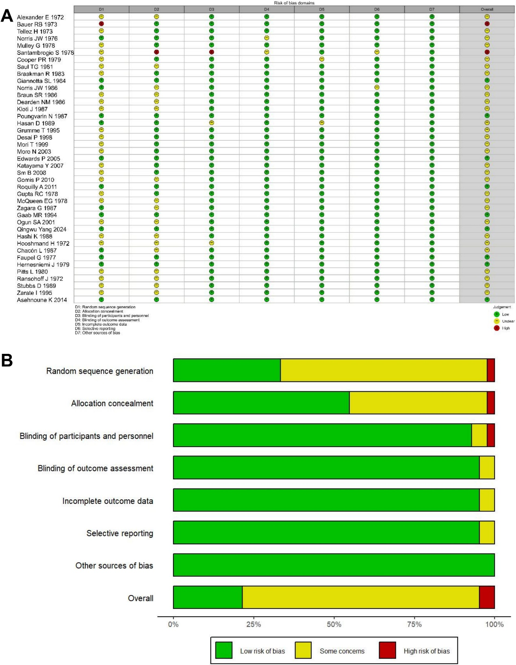

Figure S2. Funnel plot of death after traumatic brain injury (A), functional outcome after traumatic brain injury (B), Any type of infections (C), gastrointestinal bleeding (D), or hyperglycaemia/diabetes mellitus (E).
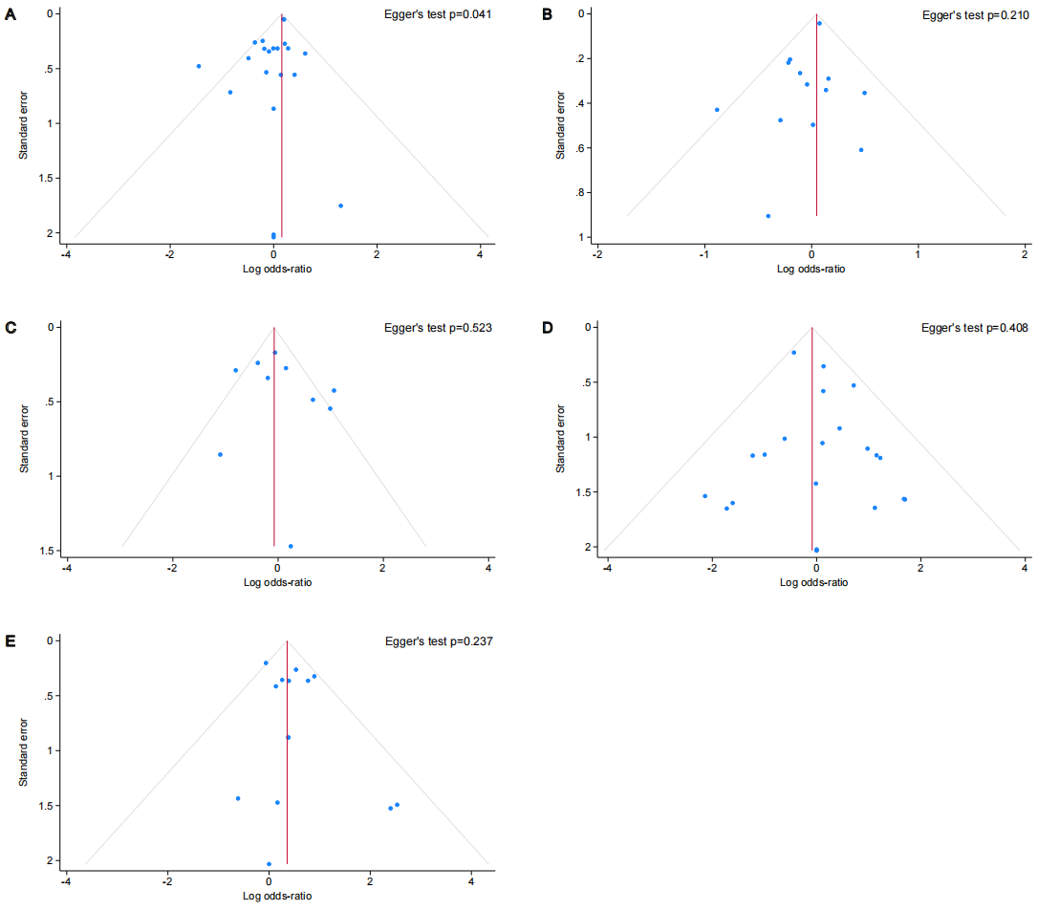

Supplementary References
1. Ogun SA, Odusote KA. Effectiveness of high dose dexamethasone in the treatment of acute stroke. West Afr J Med. 2001;20(1):1-6.
2. Norris JW, Hachinski VC. High dose steroid treatment in cerebral infarction. Br Med J (Clin Res Ed). 1986;292(6512):21-3.
3. Mulley G, Wilcox RG, Mitchell JR. Dexamethasone in acute stroke. Br Med J. 1978;2(6143):994-6.
4. Santambrogio S, Martinotti R, Sardella F, Porro F, Randazzo A. Is there a real treatment for stroke? Clinical and statistical comparison of different treatments in 300 patients. Stroke. 1978;9(2):130-2.
5. Norris JW. Steroid therapy in acute cerebral infarction. Arch Neurol. 1976;33(1):69-71.
6. Bauer RB, Tellez H. Dexamethasone as treatment in cerebrovascular disease. 2. A controlled study in acute cerebral infarction. Stroke. 1973;4(4):547-55.
7. De Reuck J, Vandekerckhove T, Bosma G, De Meulemeester K, Van Landegem W, De Waele J, et al. Steroid treatment in acute ischaemic stroke. A comparative retrospective study of 556 cases. Eur Neurol. 1988;28(2):70-2.
8. Marvel Trial Authors for the MARVEL Investigators, Yang Q, Guo C, Yue C, Song J, Yang J, et al. Methylprednisolone as Adjunct to Endovascular Thrombectomy for Large-Vessel Occlusion Stroke: The MARVEL Randomized Clinical Trial. JAMA. 2024;331(10):840-9.
9. Gupta RC, Bhatnagar HN, Gambhir MS, Shah DR. Betamethasone therapy in acute cerebrovascular accidents. J Assoc Physicians India. 1978;26(7):589-94.
10. McQueen EG. Betamethasone in stroke. N Z Med J. 1978;87(605):103-4.
11. Sm B, Ale M, Med P, Effects G, Sharafadinzadeh N. Effects of dexamethasone in primary intracerebral hemorrhage in the South West of Iran. Pak J Med Sci. 2008;24(4):502-5.
12. Desai P, Prasad K. Dexamethasone is not necessarily unsafe in primary supratentorial intracerebral haemorrhage. J Neurol Neurosurg Psychiatry. 1998;65(5):799-800.
13. Poungvarin N, Bhoopat W, Viriyavejakul A, Rodprasert P, Buranasiri P, Sukondhabhant S, et al. Effects of dexamethasone in primary supratentorial intracerebral hemorrhage. N Engl J Med. 1987;316(20):1229-33.
14. Tellez H, Bauer RB. Dexamethasone as treatment in cerebrovascular disease. 1. A controlled study in intracerebral hemorrhage. Stroke. 1973;4(4):541-6.
15. Hooshmand H, Quinn JC, Houff SA. Cerebrospinal fluid pressure changes with chemotherapy for intracerebral hemorrhage. Neurology. 1972;22(1):56-61.
16. Zaganas I, Halpin AP, Oleinik A, Alegakis A, Kotzamani D, Zafiris S, et al. A comparison of acute hemorrhagic stroke outcomes in 2 populations: the Crete-Boston study. Stroke. 2011;42(12):3640-2.
17. Miller MM, Dakay K, Henninger N, Mayasi Y, Mahta A, Yakhkind A, et al. Association of Dexamethasone with Shunt Requirement, Early Disability, and Medical Complications in Aneurysmal Subarachnoid Hemorrhage. Neurocrit Care. 2021;34(3):760-8.
18. Mohney N, Williamson CA, Rothman E, Ball R, Sheehan KM, Pandey AS, et al. A Propensity Score Analysis of the Impact of Dexamethasone Use on Delayed Cerebral Ischemia and Poor Functional Outcomes After Subarachnoid Hemorrhage. World Neurosurg. 2018;109:e655-e61.
19. Czorlich P, Sauvigny T, Ricklefs F, Abboud T, Nierhaus A, Vettorazzi E, et al. Impact of dexamethasone in patients with aneurysmal subarachnoid haemorrhage. Eur J Neurol. 2017;24(4):645-51.
20. Katayama Y, Haraoka J, Hirabayashi H, Kawamata T, Kawamoto K, Kitahara T, et al. A randomized controlled trial of hydrocortisone against hyponatremia in patients with aneurysmal subarachnoid hemorrhage. Stroke. 2007;38(8):2373-5.
21. Moro N, Katayama Y, Kojima J, Mori T, Kawamata T. Prophylactic management of excessive natriuresis with hydrocortisone for efficient hypervolemic therapy after subarachnoid hemorrhage. Stroke. 2003;34(12):2807-11.
22. Hashi K, Takakura K, Sano K, Ohta T, Saito I, Okada K. [Intravenous hydrocortisone in large doses in the treatment of delayed ischemic neurological deficits following subarachnoid hemorrhage--results of a multi-center controlled double-blind clinical study]. No To Shinkei. 1988;40(4):373-82.
23. Gomis P, Graftieaux JP, Sercombe R, Hettler D, Scherpereel B, Rousseaux P. Randomized, double-blind, placebo-controlled, pilot trial of high-dose methylprednisolone in aneurysmal subarachnoid hemorrhage. J Neurosurg. 2010;112(3):681-8.
24. Chyatte D, Fode NC, Nichols DA, Sundt TM, Jr. Preliminary report: effects of high dose methylprednisolone on delayed cerebral ischemia in patients at high risk for vasospasm after aneurysmal subarachnoid hemorrhage. Neurosurgery. 1987;21(2):157-60.
25. Mori T, Katayama Y, Kawamata T, Hirayama T. Improved efficiency of hypervolemic therapy with inhibition of natriuresis by fludrocortisone in patients with aneurysmal subarachnoid hemorrhage. J Neurosurg. 1999;91(6):947-52.
26. Hong RA, Bailey C, Kindle K, Moreno-Cabral CE. Cardiac transplantation in Hawai'i: a summary of the first 21 years. Hawaii Med J. 2008;67(11):289-91.
27. Gaab MR, Trost HA, Alcantara A, Karimi-Nejad A, Moskopp D, Schultheiss R, et al. "Ultrahigh" dexamethasone in acute brain injury. Results from a prospective randomized double-blind multicenter trial (GUDHIS). German Ultrahigh Dexamethasone Head Injury Study Group. Zentralbl Neurochir. 1994;55(3):135-43.
28. Kloti J, Fanconi S, Zachmann M, Zaugg H. Dexamethasone therapy and cortisol excretion in severe pediatric head injury. Childs Nerv Syst. 1987;3(2):103-5.
29. Zagara G, Scaravilli P, Bellucci MC, Seveso M. Effect of dexamethasone on nitrogen metabolism in brain-injured patients. J Neurosurg Sci. 1987;31(4):207-12.
30. Braun SR, Levin AB, Clark KL. Role of corticosteroids in the development of pneumonia in mechanically ventilated head-trauma victims. Crit Care Med. 1986;14(3):198-201.
31. Dearden NM, Gibson JS, McDowall DG, Gibson RM, Cameron MM. Effect of high-dose dexamethasone on outcome from severe head injury. J Neurosurg. 1986;64(1):81-8.
32. Braakman R, Schouten HJ, Blaauw-van Dishoeck M, Minderhoud JM. Megadose steroids in severe head injury. Results of a prospective double-blind clinical trial. J Neurosurg. 1983;58(3):326-30.
33. Saul TG, Ducker TB, Salcman M, Carro E. Steroids in severe head injury: A prospective randomized clinical trial. J Neurosurg. 1981;54(5):596-600.
34. Pitts L, Kaktis J. Effect of megadose steroids on ICP in traumatic coma. In: Kenneth Shulman AM, J. Douglas Miller, Donald P. Becker, Gerald M. Hochwald, Mario Brock, editors. Intracranial pressure IV. Williamsburg/Virginia, USA: Springer; 1980. p. 638-42.
35. Cooper PR, Moody S, Clark WK, Kirkpatrick J, Maravilla K, Gould AL, et al. Dexamethasone and severe head injury. A prospective double-blind study. J Neurosurg. 1979;51(3):307-16.
36. Faupel G, Reulen HJ, Müller D, Schürmann K. Clinical Double-Blind-Study on the Effects of Dexamethasone on Severe Closed Head Injuries. In: Wüllenweber R, Brock M, Hamer J, Klinger M, Spoerri O, editors. Lumbar Disc Adult Hydrocephalus. Berlin, Heidelberg: Springer Berlin Heidelberg; 1977. p. 200-3.
37. Alexander E, Jr. Medical management of closed head injuries. Clin Neurosurg. 1972;19:240-50.
38. Roquilly A, Mahe PJ, Seguin P, Guitton C, Floch H, Tellier AC, et al. Hydrocortisone therapy for patients with multiple trauma: the randomized controlled HYPOLYTE study. JAMA. 2011;305(12):1201-9.
39. Edwards P, Arango M, Balica L, Cottingham R, El-Sayed H, Farrell B, et al. Final results of MRC CRASH, a randomised placebo-controlled trial of intravenous corticosteroid in adults with head injury-outcomes at 6 months. Lancet. 2005;365(9475):1957-9.
40. Stubbs D, Stiger T, Harris W. Multinational controlled trial of high-dose methylprednisolone in moderately severe head injury. In: Capildeo R, editors. Steroids in diseases of the central nervous system. Chichester: John Wiley & Sons; 1989. p. 163-8.
41. Giannotta SL, Weiss MH, Apuzzo ML, Martin E. High dose glucocorticoids in the management of severe head injury. Neurosurgery. 1984;15(4):497-501.
42. Ransohoff J. The effects of steroids on brain edema in man. In: H. J. Reulen, Schürmann K, editors. Steroids and brain edema. Mainz, W. Germany: Springer; 1972. p. 211-7.
43. Asehnoune K, Seguin P, Allary J, Feuillet F, Lasocki S, Cook F, et al. Hydrocortisone and fludrocortisone for prevention of hospital-acquired pneumonia in patients with severe traumatic brain injury (Corti-TC): a double-blind, multicentre phase 3, randomised placebo-controlled trial. Lancet Respir Med. 2014;2(9):706-16.
44. Hernesniemi J, Troupp H. A clinical retrospective and a double-blind study of betamethasone in severe closed brain injuries [proceedings]. Acta Neurochir Suppl (Wien). 1979;28(2):499.
45. Dunner DL, Aaronson ST, Sackeim HA, Janicak PG, Carpenter LL, Boyadjis T, et al. A multisite, naturalistic, observational study of transcranial magnetic stimulation for patients with pharmacoresistant major depressive disorder: durability of benefit over a 1-year follow-up period. J Clin Psychiatry. 2014;75(12):1394-401.

