Supplemental table 1. Example of search strategies for Medline
1 | ("Surgery" or "Operation" or "Surgical" or "Operative Procedures" or "Surgical Procedures").mp.
2 | exp "Surgical Procedures, Operative"/
3 | ("Esketamine" or "Kataved" or "S-Ketamine" or "(S)-2-(o-chlorophenyl)-2-(methylamino)cyclohexanone" or "L-Ketamine" or "(-)-Ketamine" or "Spravato").mp.
4 | ("cognitive adj4 (dysfunction or decline or impairment or deficit*)" or "dementia" or "POCD" or "POD" or "postoperative cognitive dysfunction" or "mini-mental state examination " or "neuropsychological" or "MMSE " or "Cognition" or "delirium" or "postoperative delirium" or "neurocognit*" or "cerebral function" or "Confusion Assessment Method" or "confusion assessment method for the intensive care unit" or "Montreal Cognitive Assessment").mp.
5 | exp "Postoperative Cognitive Complications"/ or exp "Delirium"/
6 | (1 or 2) and 3 and (4 or 5)
7 | 6 and (((randomized controlled trial or controlled clinical trial).pt. or randomi*ed.ab. or placebo.ab. or drug therapy.fs. or randomly.ab. or trial.ab. or groups.ab.) not (exp animals/ not humans.sh.))

Supplemental table 2. Type of surgery and criteria for diagnosis of perioperative neurocognitive disorders
Studies | Procedures | Criteria for POND
Chen 2022 [26] | Thoracoscopic surgery | Z-score ≤−1.96†
Han 2023 [13] | Gastrointestinal Surgery | Z-score ≤−1.96†
Jing 2024 [24] | Laparoscopic abdominal surgery | CAM
Li 2022 [25] | TKR | CAM
Li 2023 [41] | THR | -
Liu 2022 [30] | Laparoscopic total hysterectomy | MMSE decrease by 2 points
Liu 2023 (1) [29] | Laparoscopic gynecological surgeries | CAM-ICU
Liu 2023 (2) [39] | LC | -
Lu 2021 [31] | Bone tumor resection | -
Luo 2024 [12] | Thoracic surgery | CAM
Ma 2023 [14] | Gastrointestinal surgery | CAM-ICU
Mao 2023 [32] | Laparoscopic hysterectomy | MMSE decrease by 3 points
Shi 2024 [33] | Thoracoscopic surgery | -
Sun 2023 [34] | Orthopedic surgery | MoCA < 26 points
Tang 2023 [35] | THR | -
Tu 2021 [27] | Orthopedic surgery | -
Wang 2023 [42] | Thoracoscopic surgery | MMSE decrease by 1 SD
Wu 2021 [36] | Gynecological surgery | MMSE decrease by 2 points
Xiong 2024 [15] | Cardiac valve surgery | CAM/CAM-ICU
Yu 2023 [43] | Rectal surgery | MMSE decrease by 3 points
Zhang 2023 [40] | THR | -
Zhao 2023 [37] | Breast surgery | -
Zhao 2024 [28] | LC | -
Zhu 2023 [38] | TKR | MOCA decrease by 2 SD
CAM: Confusion Assessment Method; ISPOCD: International Study of Post-Operative Cognitive Dysfunction; CAM-ICU: Confusion Assessment Method for the Intensive Care Unit. MoCA: Montreal Cognitive Assessment; MMSE: Mini-Mental State Examination; SD: standard deviation; THR: Total Hip Replacement; TKR: Total Knee Replacement; LC: Laparoscopic cholecystectomy; POND: perioperative neurocognitive disorders; †The Z-score in this study is calculated as the difference between the patient's postoperative and preoperative MMSE scores, adjusted by the mean and standard deviation of changes in a normal control group, with a Z value of less than or equal to -1.96 indicating postoperative neurocognitive disorder.

Supplemental table 3. Esketamine formula and total dosage estimated
Outcome | Bolus  dosage (mg/kg) | Continuous dosage (mg/kg/h) | Surgical time (minutes) | Total dosage estimated (mg/kg)
Chen 2022 [26] | 0.3 | 0.2 | 145 | 0.78
Han 2023 [13] | 0.15 | - | 165 | 0.15
Jing 2024 [24] | 0.25 | 0.1 | 183 | 0.56
Li 2022 [25] | 0.2 | - | 105 | 0.2
Li 2023 [41] | Not used | 0.2 | 91 | 0.3
Liu 2022 [30] | 0.5 | - | 98 | 0.5
Liu 2023 (1) [29] | 0.125 | - | 100 | 0.125
Liu 2023 (2) [39] | 0.5 | - | 94 | 0.5
Lu 2021 [31] | 0.5 | - | 156 | 0.5
Luo 2024 [12] | 0.2/0.5 | - | 145/162 | 0.2/0.5
Ma 2023 [14] | 0.25 | 0.125 | 269 | 0.8
Mao 2023 [32] | 0.5 | - | 86 | 0.5
Shi 2024 [33] | 0.1 | - | 143 | 0.1
Sun 2023 [34] | 0.25 | 0.125 | - | 0.375§
Tang 2023 [35] | 0.25/0.5 | - | - | 0.25/0.5
Tu 2021 [27] | 0.5 | - | - | 0.5
Wang 2023 [42] | 0.25 | - | 115 | 0.25
Wu 2021 [36] | 0.25 | - | - | 0.25
Xiong 2024 [15] | 0.25 | - | 246 | 0.25
Yu 2023 [43] | 0.25/0.5 | - | 215/218 | 0.25/0.5
Zhang 2023 [40] | 0.1 | 0.1 | 85 | 0.24
Zhao 2023 [37] | 0.1 | 0.1 | 100 | 0.27
Zhao 2024 [28] | 0.5 | 0.12/0.24 | 52/51 | 0.6/0.7
Zhu 2023 [38] | 0.5 | 0.4 | 90 | 1.1
§calculated based on the assumption of surgical time of 60min

Supplemental Figure
Supplemental Figure 1. Subgroup analysis on risk of perioperative neurocognitive disorders based on age ( >65 years vs. ≤65 years).
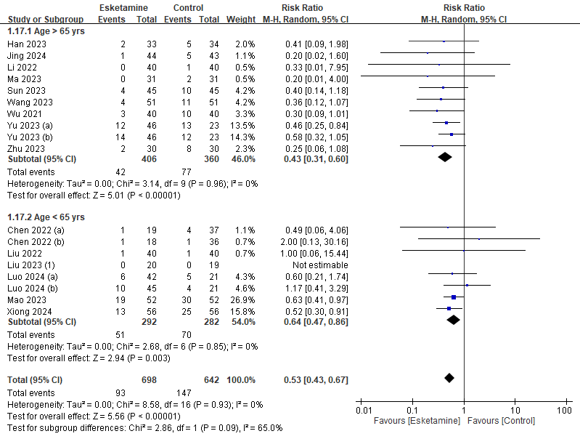

Supplemental Figure 2. Subgroup analysis on risk of perioperative neurocognitive disorders based on quality of studies (low risk of bias vs. some concerns to high risk of bias).
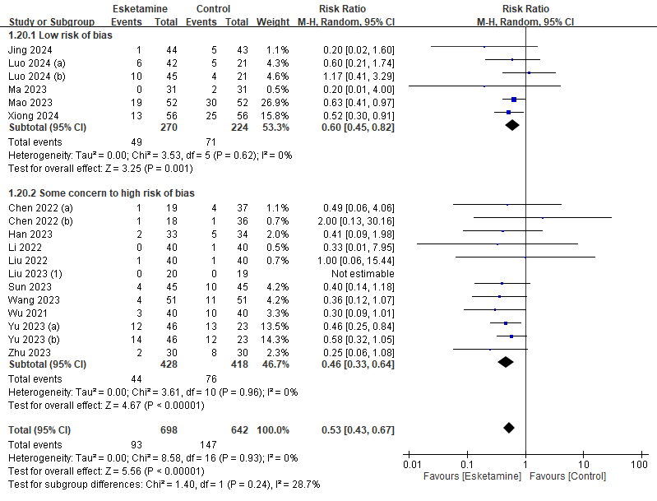

Supplemental Figure 3. Subgroup analysis on risk of perioperative neurocognitive disorders based on type of esketamine administration (bolus only vs. bolus plus infusion).
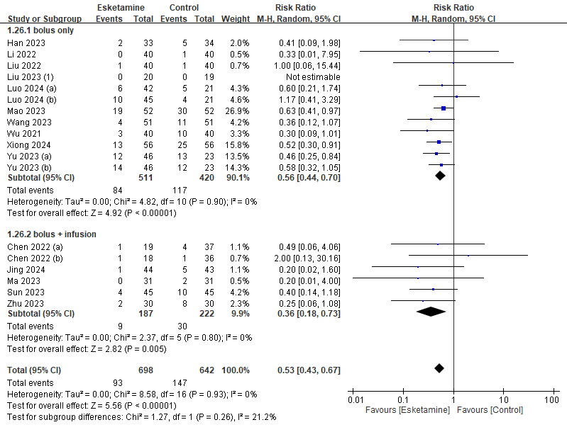

Supplemental Figure 4. Subgroup analysis of cognitive function on postoperative day one based on age ( >65 years vs. ≤65 years).
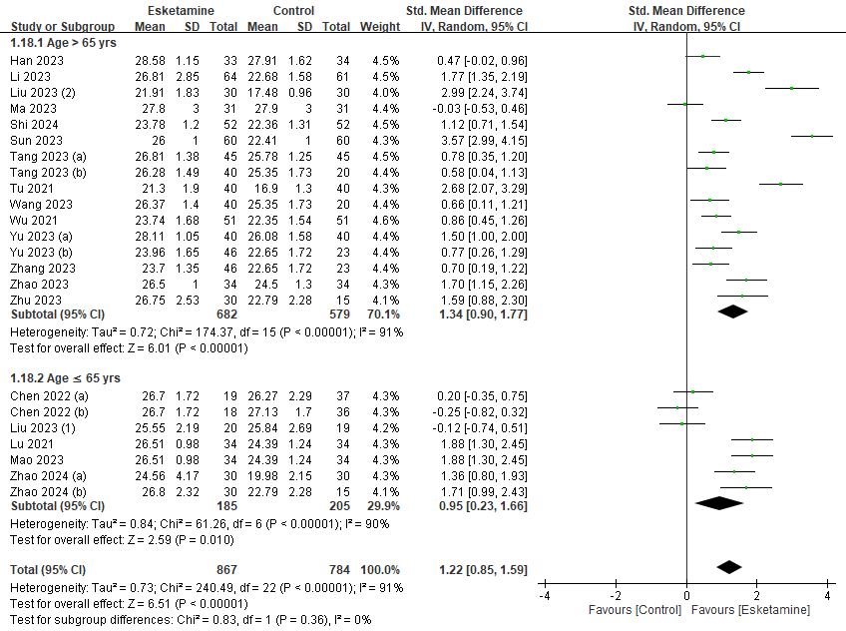

Supplemental Figure 5. Subgroup analysis of cognitive function on postoperative day one based on quality of studies (low risk of bias vs. some concerns to high risk of bias)
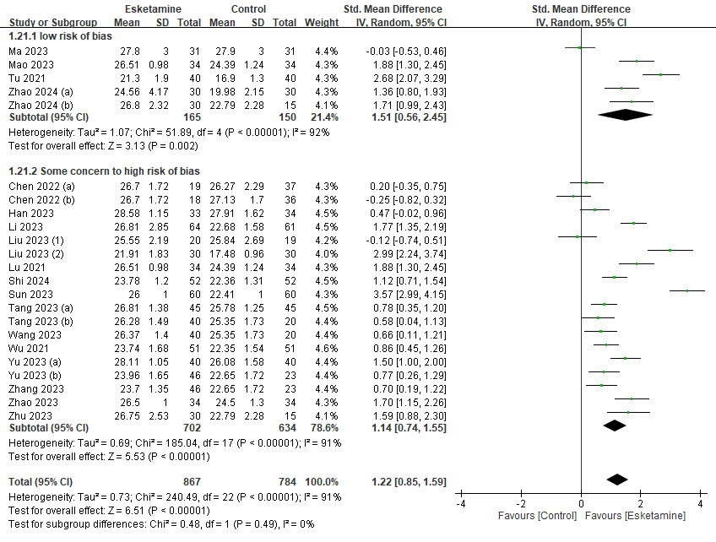

Supplemental Figure 6. Subgroup analysis of cognitive function on postoperative day one based on type of esketamine administration (bolus only vs. bolus plus infusion).
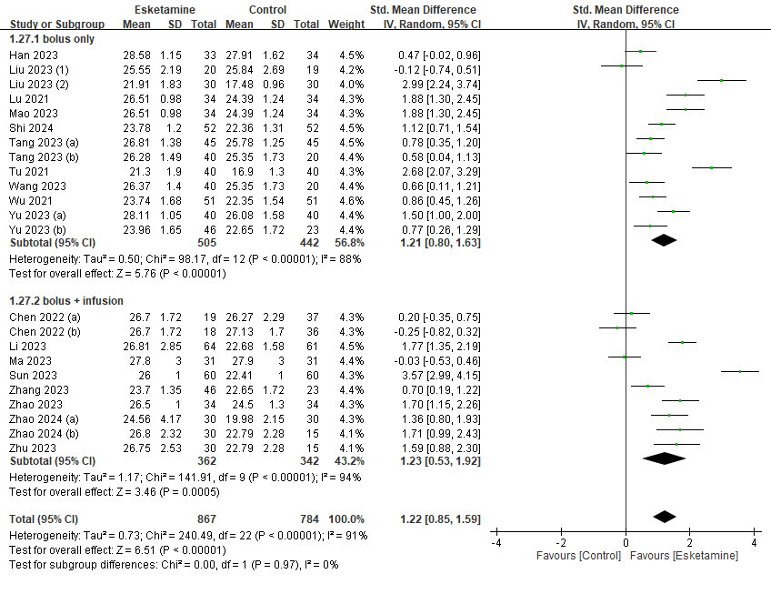

Supplemental Figure 7. Subgroup analysis of cognitive function on postoperative day three based on age ( >65 years vs. ≤65 years).
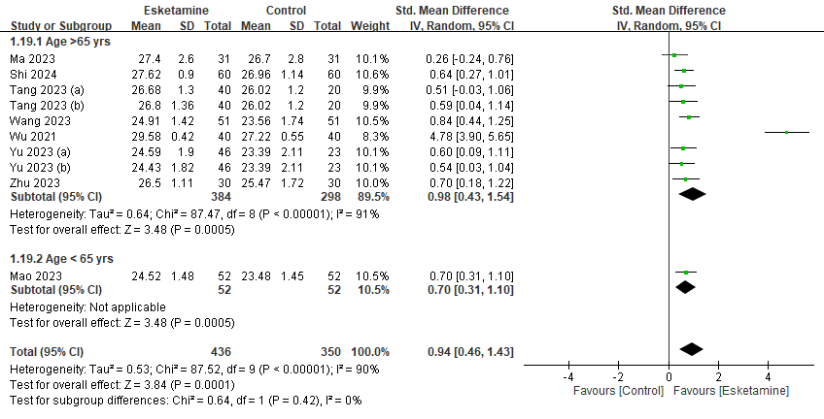

Supplemental Figure 8. Subgroup analysis of cognitive function on postoperative day three based on quality of studies (low risk of bias vs. some concerns to high risk of bias)

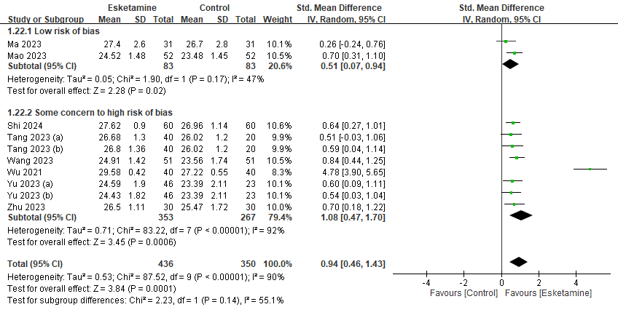

Supplemental Figure 9. Subgroup analysis of cognitive function on postoperative day three based on type of esketamine administration (bolus only vs. bolus plus infusion).

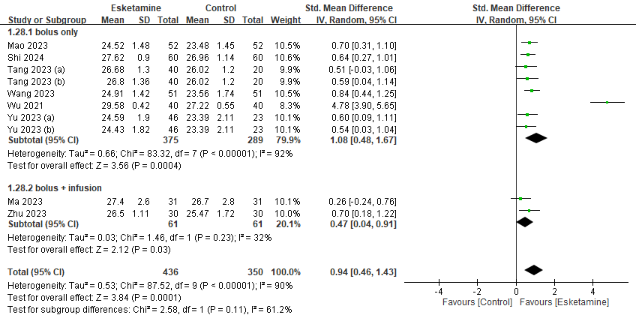

Supplemental Figure 10. Forest plot showing the impact of esketamine use on extubation time
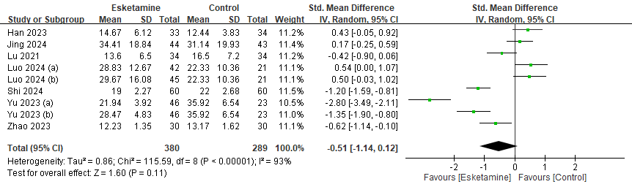

Supplemental Figure 11. Forest plot showing the impact of esketamine use on agitation risk
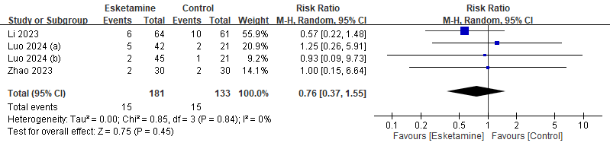

Supplemental Figure 12. Forest plot showing the impact of esketamine use on hallucination risk
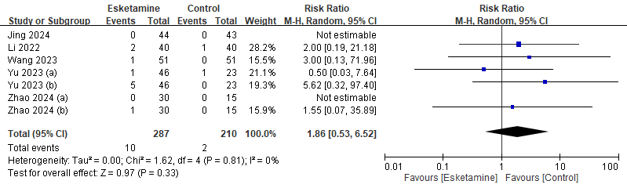

Supplemental Figure 13. Forest plot showing the impact of esketamine use on nightmare risk
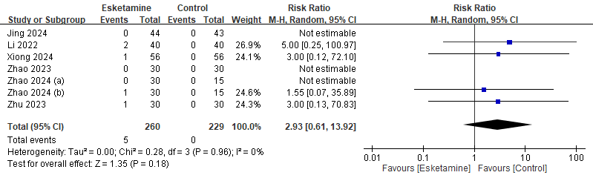

Supplemental Figure 14. Funnel plot show a low risk of publication bias on the risk of perioperative neurocognitive disorders (POND).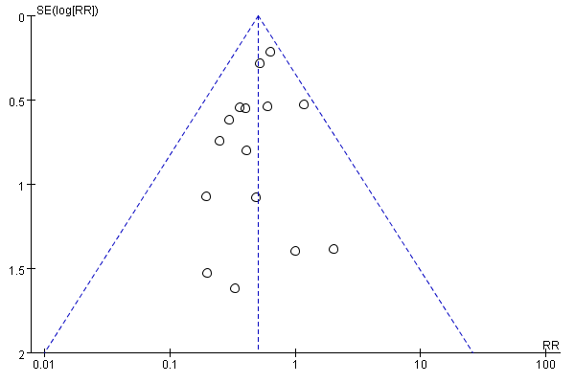

Supplemental Figure 15. Funnel plot showing a low risk of publication bias on the cognitive function on POD1.
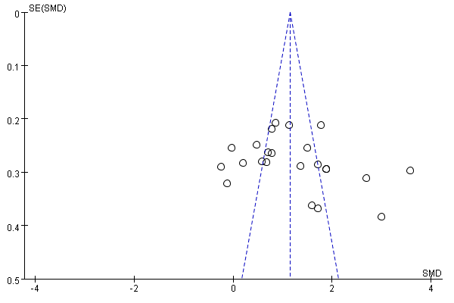

Supplemental Figure 16. Funnel plot showing a low risk of publication bias on the risk of PONV.

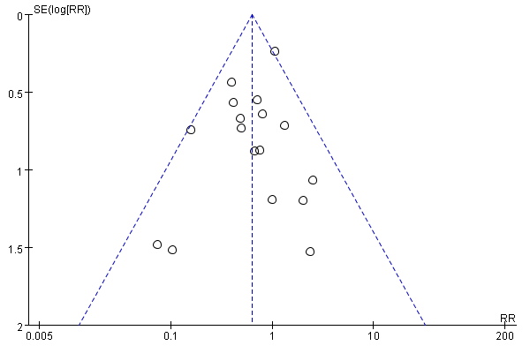

Supplemental Figure 17. Funnel plot suggesting potential risk of publication bias in studies on cognitive function on postoperative day 3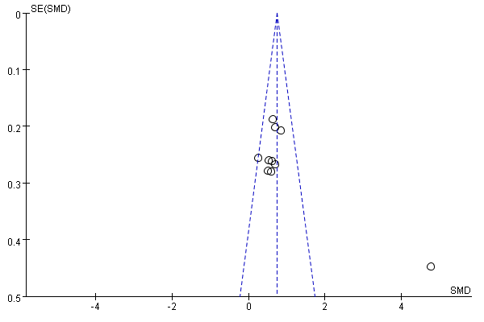

Supplemental Figure 18. Funnel plot suggesting potential risk of publication bias in studies on pain score

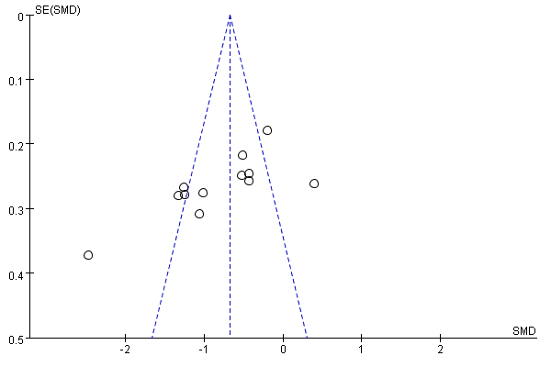

Supplemental Figure 19. Funnel plot suggesting potential risk of publication bias in studies on interleukin 6 (IL-6) levels

