Additional File 5. RISK OF BIAS ASSESSMENT BY TRAFFIC LIGHT PLOT AND SUMMARY PLOT
ROB
For RCTs ROB 2 tool was used
For Non RCTs ROBINS-I was Used

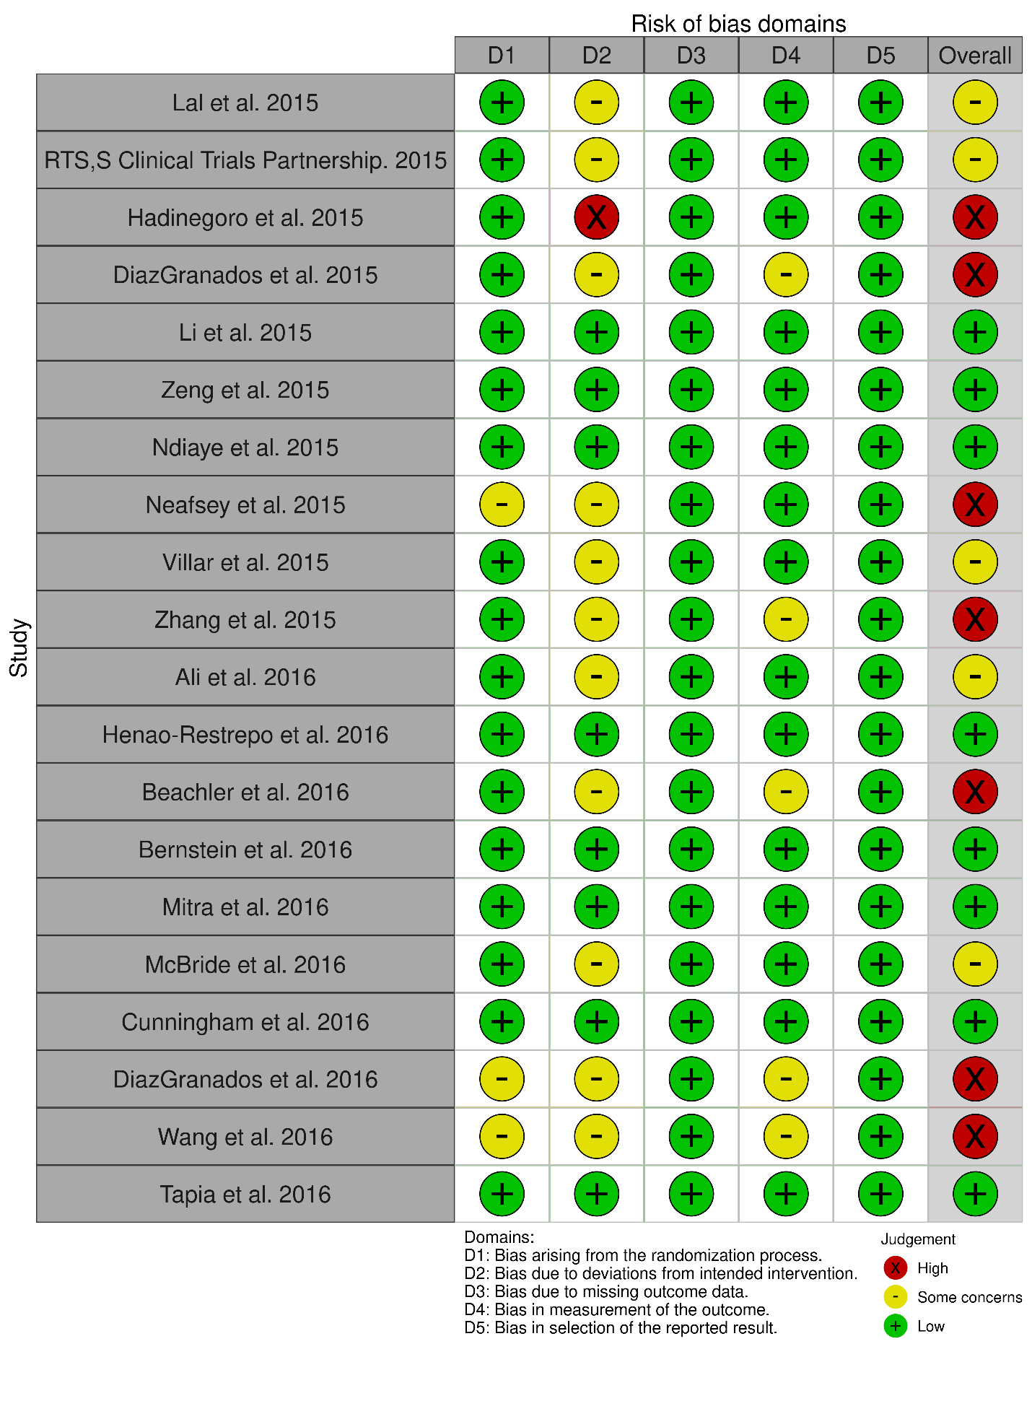
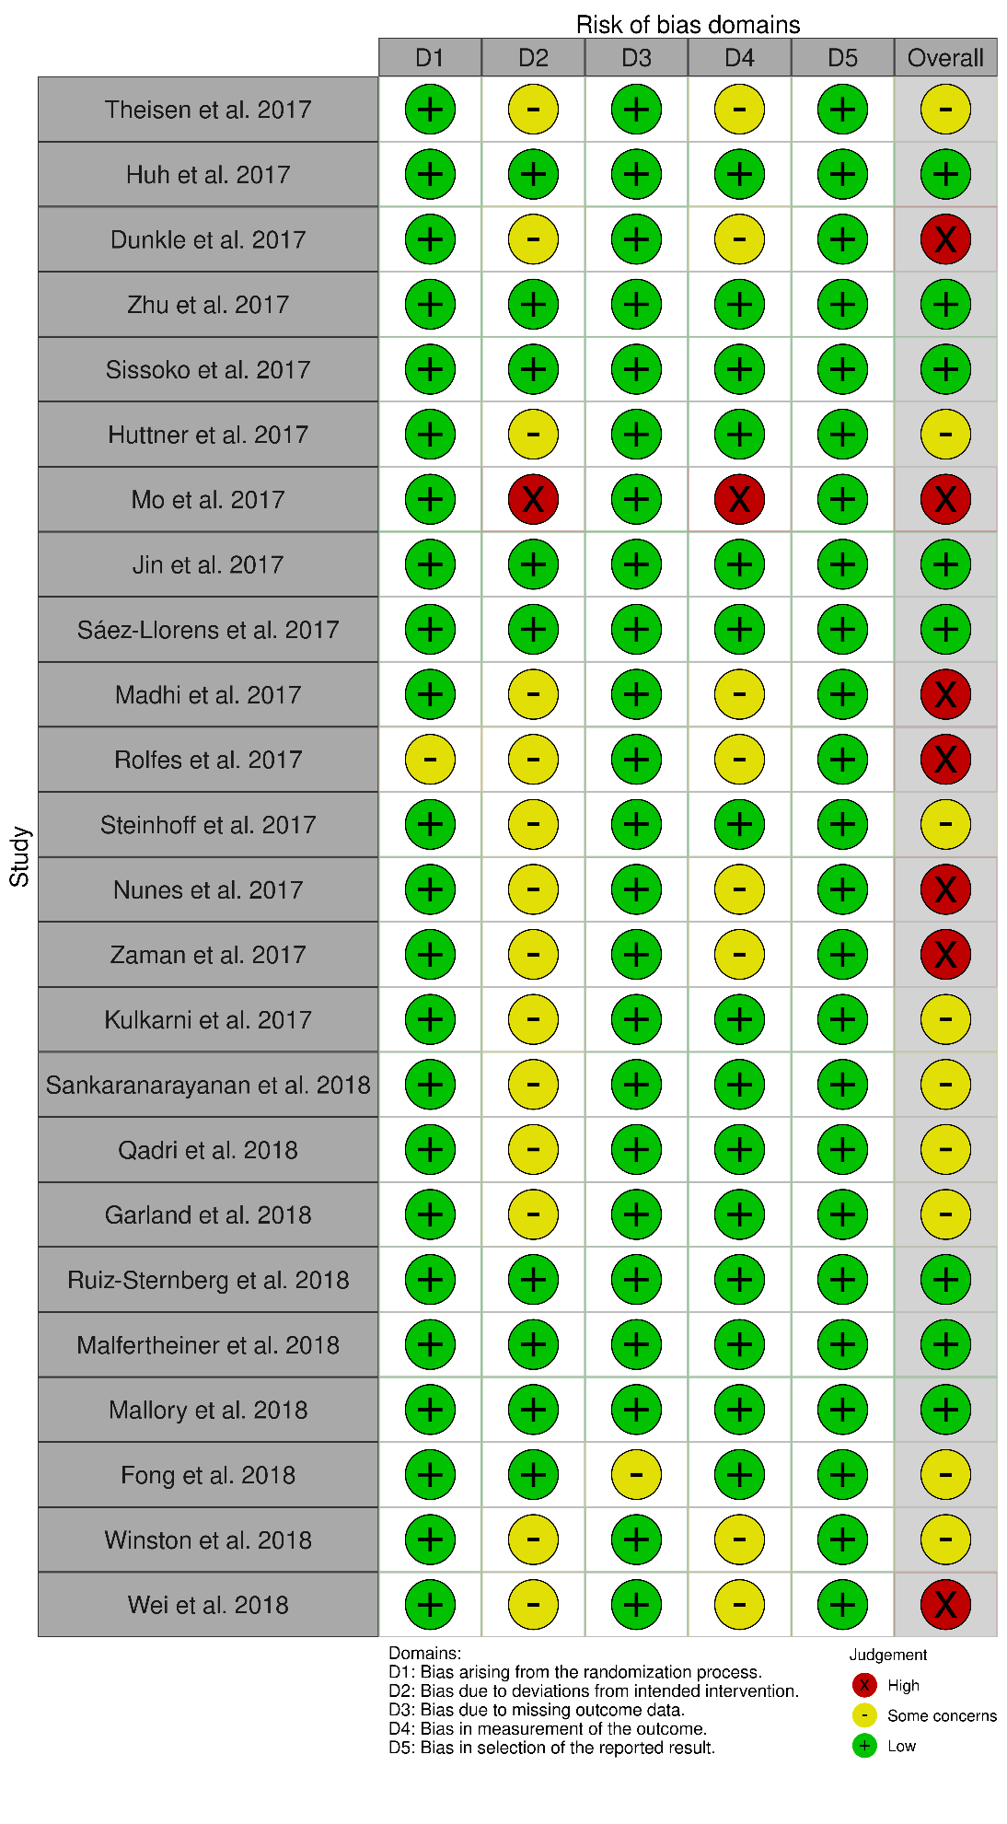
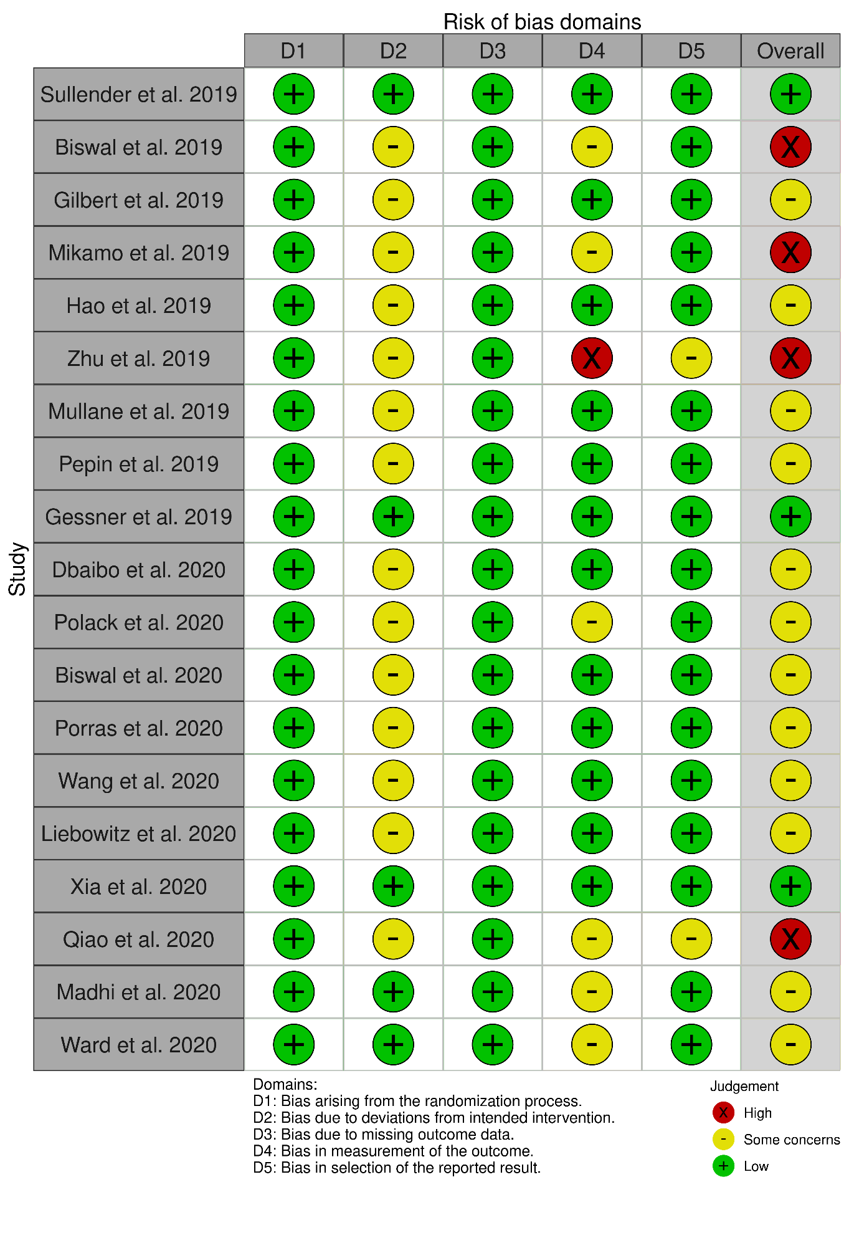
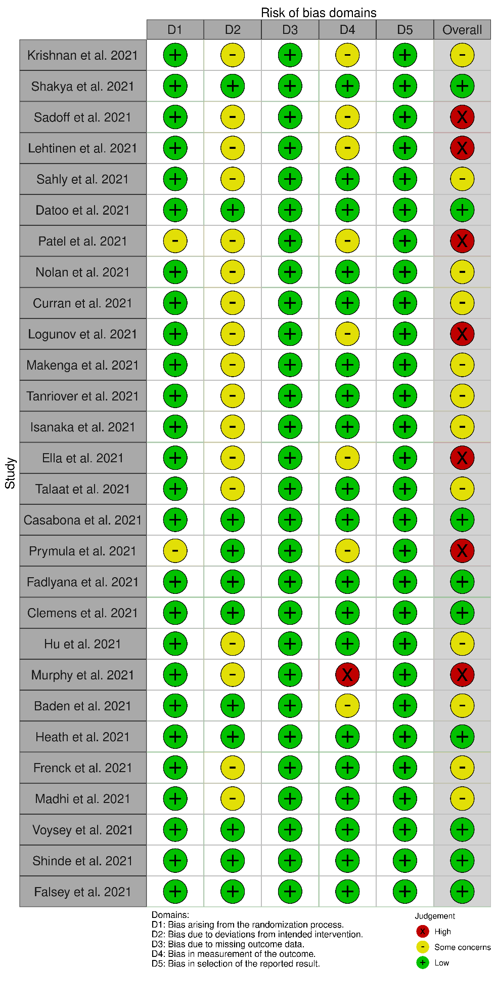
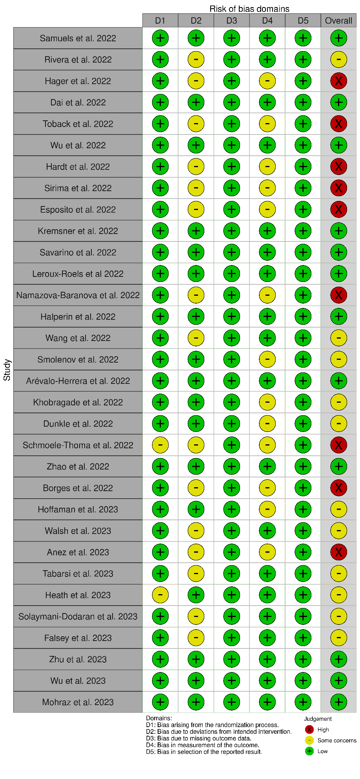

Figure a: Traffic Light plot for the RCTs assessed for Risk of Bias

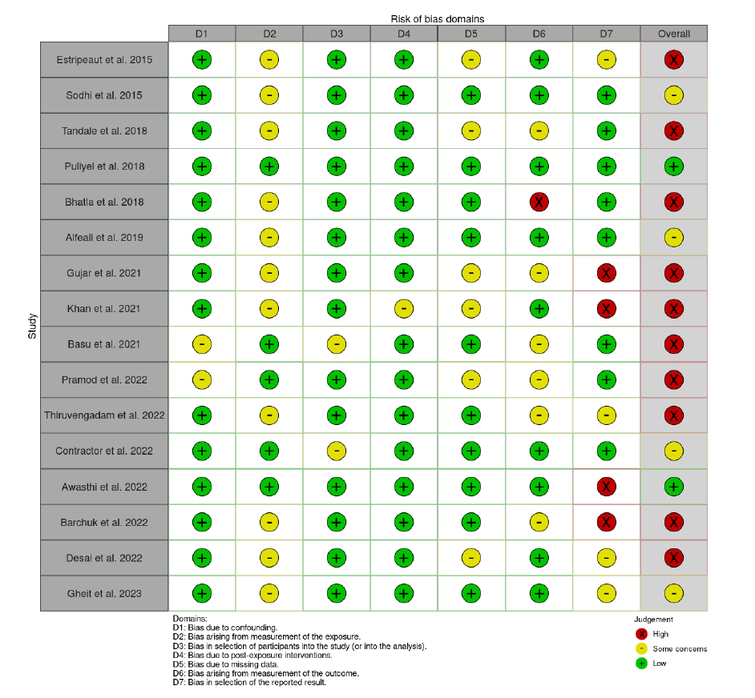

Figure b: Traffic Light plot of Non-RCTs assessed for Risk of Bias

