Online supplementary files
Supplemental text 1: PubMed/Medline search
"cardiovascular disease"[Title/Abstract]) OR ("coronary heart disease"[Title/Abstract])) OR ("coronary arterial disease"[Title/Abstract])) OR ("peripheral arterial diseases"[Title/Abstract])) OR ("myocardial infarction"[Title/Abstract])) AND ("lifestyle interventions"[Title/Abstract])) OR ("technology-based patient education"[Title/Abstract])) OR ("technology-based patient education"[Title/Abstract])) OR ("peer group-based intervention"[Title/Abstract])) OR ("family-based interventions"[Title/Abstract])) OR (:nurse-led patient centered intervention"[Title/Abstract])) AND ("routine care"[Title/Abstract])) AND ("standard care"[Title/Abstract])) OR ("routine care"[Title/Abstract]) (Cholesterol [Mesh]) OR (Lipoproteins, LDL [Mesh]) AND (adherence[Title/Abstract])) AND (smoking[Title/Abstract])) AND ("blood pressure"[Title/Abstract])) AND ("randomized controlled trials"[Title/Abstract])

Supplemental text 2: Cochrane Library search
#1 "Coronary heart diseases" 144
#2 "Myocardial infarction" 38101
#3 "Congestive heart failure" 7138
#4 "Cardiovascular diseases" 20563
#5 "Myocardial ischaemia" 7561
#6 #1 OR #2 OR #3 OR #4 OR #5 66107
#7 "Mobile health" 2618
#8 Telehealth 4514
#9 "Text messaging" 3681
#10 Internet 18778
#11 Web site 3788
#12 Phone call 4451
#13 #7 OR #8 OR #9 OR #10 OR #11 OR #12 34346
#14 Coach* 8791
#15 Consultation 18655
#16 Medic* 750233
#17 #14 OR #15 OR #16 762246
#18 "Blood pressure" 119598
#19 "Systolic blood pressure" 31818
#20 "Diastolic blood pressure" 24994
#21 #18 OR #19 OR #20 119598
#22 "Total Cholesterol" 16261
#23 "Low Density lipoprotein" 16725
#24 "High Density lipoprotein" 13059
#25 #22 OR #23 OR #24 26023
#26 smok* 48646
#27 chat 1818
#28 Khat 48
#29 alcohol* 44067
#30 #26 OR #27 OR #28 OR #29 87252
#31 "quality of life" 169401
#32 depression 109302
#33 anxiety 82260
#34 #31 OR #32 OR #33 286724
#35 #6 AND #13 AND #17 AND #21 AND #25 #30 AND #34 48
Supplemental Text 3: data analysis
Numerical data was reported as mean and standard deviation (SD) and categorical data as number and percentage (%). Where 95% confidence intervals (CIs) and not SD were reported, these were converted to SD using the equation SD= √N x (upper limit 95% CI-lower limit 95% CI)/3.92. Where only the standard error (SE) was reported, this was converted to SD by using the formula: SD = SE x √N.(1)
Some studies reporting lipid profile in millimol/liter was converted to mg/dl by multiplying with 38.67 as a conversion factor which is derived from the molecular weight of cholesterol, 386.7 g/mole(2). Furthermore, studies reporting median (IQR) were converted to mean (SD) using the formula, Mean=2*median + Range/4, SD=R/4. We extracted data from the last observation possible and if data were not reported in the follow up period, we didn’t include from baseline reported data.
A random effect models with the restricted maximum likelihood (REML) method was used as there was substantial heterogeneity between the included studies as depicted by Forest plot, 2 test, I2 test, and Galbraith plot. The subgroup analysis were conducted by types of intervention, and cardiovascular diseases.
The results were reported as standardized mean difference (SMD)(3) or Odds ratio (RR) and 95% CI for dichotomous outcomes.(1) SMDs were interpreted as Cohen’s d values(4), with d=0.2 regarded as a 'small' effect size, d=0.5 as a 'medium' effect size and d=0.8 as a 'large' effect size. All statistical tests were two-sided and a p-value <0.05 was considered significant. Heterogeneity was assessed using I² statistic values (interpreted as 0 to 49%: low, 50 to 74%: moderate and 75 to 100%: high).(5) Leave-one-out (LOO) sensitivity analyses assessed the contribution of each study by excluding individual studies one at a time and recalculating the remaining pooled estimates. Additional sensitivity analyses were performed excluding studies with high risk of bias.(6)
Publication bias was examined by a funnel plot and the objective diagnostic test was conducted with Egger's correlation, Begg's regression tests, and Trim and fill method. All the analysis was conducted with Review manager, STATA 17, and Trial sequential analysis software.
Trial Sequential Analysis was conducted to control for the risks of type I and II errors on the outcomes and it was used to calculate the number of participants needed to detect or reject primary hypotheses and the cumulative Z-curve’s breach of relevant trial sequential monitoring boundaries.
The overall quality of evidence was determined using the GRADE system (Grading of Recommendations, Assessment, Development, and Evaluation)(7, 8). The system incorporates study quality (risk of bias), inconsistency (comparison of effect estimates across studies), indirectness (applicability of the population, intervention, comparator and outcomes to the clinical decision), imprecision (certainty of confidence interval) and high probability of publication bias. The overall quality of evidence were categorized as high, moderate, low, and very low by combining the aforementioned five parameters.

Supplemental Text 4: Trial Sequential Analysis results
The trial sequential analysis for the outcome ‘Total cholesterol’ revealed that the cumulative Z-curve crossed both the conventional and TSA monitoring boundaries for benefit, but it didn’t reach the required information size threshold, revealing inconclusive evidence (supplemental results, Fig 6.1). The trial sequential analysis for the outcome ‘HDL’ revealed that the cumulative Z-curve crossed both the conventional and TSA monitoring boundaries for benefit, but it didn’t reach the required information size threshold, revealing inconclusive evidence. The estimated required information size of 384 patients was calculated using α = 0.05 (two-sided) and β = 0.20 (power 80%), an anticipated estimated mean difference reduction of −1.42, and a heterogeneity correction of 97% in control group. The TSA-adjusted confidence interval was -0.3 to -0.07(supplemental results, Fig 6.2). However, Trial sequential analysis showed that the cumulative Z-curve didn’t cross TSA monitoring boundaries for harm or benefit revealing insufficient evidence to accept or reject the intervention effect for the outcome ’LDL-C’ (supplemental results, Fig 6.3).
The trial sequential analysis was conducted for the modifiable risk factors including systolic blood pressure, diastolic blood pressure, waist circumference, and physical activity, but none of them showed strong quality of evidence to accept or reject the intervention effect. Besides, the quality of evidence was low to moderate due to downgrading for imprecision and inconsistency in most of the outcomes (supplemental results, Fig 6.4-6.7). The Trial sequential analysis for the outcomes physical quality of life (PQOL) and mental quality of life (MQOL) showed that the cumulative Z-curve crosses both alpha-spent boundaries for harm but didn’t reach the required information size threshold, revealing insufficient evidence. However, the quality of evidence was moderate for PQOL, and low for MQOL due to downgrading for imprecision, and inconsistency (supplemental results, Figures 6.8 and 6.9). The Trial sequential analysis showed that the cumulative Z-curve cross both alpha-spending boundaries, but does not reach the required information size threshold, revealing a low power for current evidence to reject or accept the effect of lifestyle and risk factor modification interventions on medication adherence. However, the quality of evidence was moderate due to downgrading for imprecision (supplemental results, Fig 6.10)

Supplemental Table 1: Excluded studies and reasons for exclusion (n=27).
Overall Cohort |  |  |  |  |  |  |  | INTERVENTION GROUP |  | CONTROL GROUP
Study | Reason for exclusion | Country | Design | N | Attrition | follow-up | Population description | N | Description of intervention | Description of control | N
Allen et al | Primary prevention Of CVD | USA |  | 525 | 58 | 1 year | Patients with CVD, and type2 DM | 227 | The intervention group received comprehensive intensive intervention as | Usual care | 240
Appel et al | Primary prevention Of CVD | Korea |  | 810 | - | 6 months | Generally health adult with stage 1 hypertension not on antihypertensive medication | 537 | Established and established plus diet Behavioural intervention involving intensive behavioral change on weight reduction, physical activity, alcohol consumption | A single 30-minute advice and printed material about weight reduction, sodium intake, exercise and diet. | 273
Blumenthal et al | Primary prevention Of CVD | USA | Cluster randomized trial | 140 | 4 | 6 months | Patients with resistant hypertension, body mass index ≥25 kg/m2, lack of regular moderate or vigorous physical activity, and age 35 to 80 years. | 90 | The intervention received a 4-month program of lifestyle modification, where participants received instruction from a nutritionist on diet with caloric and sodium restriction (≤2300 mg/d) and underwent weekly 45-minute group counselling sessions delivered by a clinical psychologist | Patients received a 1-hour educational session on BP management delivered  by a health educator along with a workbook in which they received an individualized diet and exercise program | 50
Broekhuizen et al | Primary prevention Of CVD | Netherlands | Randomized controlled trial | 340 | 24 | 12 months | Participants with diagnosis of familial hypercholesterolemia, aged from 18 to 70 years and with a LDL-C  Level>75th percentile | 181 | The intervention consisted of a personalized health counselling intervention; a combination of computer-generated tailored web-based advice and face-to-face counselling complemented with telephone booster to manage CVS modifiable risk factors, and data were collected at patients home. | The control group received the usual care | 159
Dornelas et al | Myocardial infarction, follow up data were not available | USA | Randomized trial | 100 | NR | 1Year | Cigarette smokers with CHD | 54 | Intervention included bedside cessation counselling delivered by psychologist | The control group received the usual care | 46
Duduma et al | Primary prevention Of CVD | USA | Multicenter randomized control trial | 756 | 40 | 18 months | Individuals with pre- and Stage 1 hypertension who were not treated with antihypertensive medications | 498 | The intervention group received a combination of individual and group counselling sessions focused on behaviour change. They attended 26 group sessions and 7 individual sessions. | The control group received information regarding dietary sodium reduction, weight loss, increased exercise, and eating a healthful diet at the study’s onset and at six-month follow-up | 258
Eriksson et al | Primary prevention Of CVD | Sweden | Open Randomized controlled trial | 151 | 18 | 36 months | All individuals aged 18–65 years with a clinically documented diagnosis of  hypertension, dyslipidemia, type 2 diabetes, obesity or any  combinations | 71 | The intervention received supervised exercise training and diet counselling, followed by regular group meetings.  The first three months of the intervention included three sessions per week of supervised progressive exercise training and diet  counselling on a total of five occasions | Participants in the standard care control group were given verbal and written information about healthy behaviour, including exercise and diet. | 74
Feeney et al | Different outcomes of interest | Australia | Randomized controlled trial | 196 | NR | 12 months | Current cigarette smoker who suffered with acute myocardial infarction | 96 | Nurse-led intervention with manual and telephone call on follow up | The usual care programme included verbal and printed advice about tobacco cessation, and patients watched an educational video during their coronary care unit stay and were reviewed by the ADAU nurse. The Outpatient ADAU supportive counselling and follow up was offered at 3-, 6-, 12-month intervals, and all patients were advised by the attending cardiologist to stop smoking. | 102
Farkouh et al | data for primary outcomes not reported | USA | Randomized controlled trial | 5034 | NR | 1 yer | Patients with and without DM having coronary heart disease | NA | NA | NA | NA
Golshahi et al | Primary prevention Of CVD | China | Randomized controlled clinical trial, | 180 | - | 8 months | Antihypertensive patient who were more than 18-year-old; moderate hypertensive or stage I hypertension, and Iranian by nationality | 135 | The patients and their family were educated by cardiology resident about self-care behaviours through in-person, pamphlets or eight short message services (SMS) | Usual care | 45
Gonzalez-Sanchez et al | Primary prevention Of CVD | Spain | Multicenter randomized control trial | 833 | 118 | 3 months | The participants were 18 and 70 years old attending a consultation with their family doctor in each participating centre. | 415 | The intervention group provided with smartphone with and advising on how to use it for 3 months. The application generated detailed information on the eating deviations. Physical activity was evaluated, using an accelerometer included in the smartphone application, and which counted the steps taken over a period of 24 h. | The control group received counseling on physical activity | 418
Goyer et al | Primary prevention Of CVD | Canada | Parallel, randomized, controlled trial | 185 | 32 | 2 years | Patients aged 35 to 70 years, had at least 2 Cardiovascular risk factors such as systolic blood pressure (SBP) C 140 mmHg; diastolic blood pressure (DBP) C 90 mmHg; elevated low-density lipoprotein cholesterol (LDL-C) (>2.5 mmol/l if Framingham cardiovascular risk over 10 years was >20%, C3.5 mmol/l etc. | 123 | The intervention group received integrated exercise, nutritional and physician counselling over the course of follow up | Usual care | 62
Gaudel et al | Data not reported for primary outcomes | Nepal | Parallel, randomized, controlled trial | 196 | 28 | 3 months | All patients aged over 18 years, who had a diagnosis of CAD confirmed by medical records | 98 | Nurse-led face-to face and telephone interview | Usual care with unstructured counselling | 98
HellCnius et al | Primary prevention Of CVD | Sweden | Parallel, randomized, controlled trial | 157 | - | 6 months | Healthy men aged 35-60 years with slightly to moderately raised cardiovascular risk factors | 118 | Intervention were given individual information about diet and/or exercise by the physician. | Usual care | 39
Ijzelenberg et al | Data not reported for primary outcomes | Netherlands | Parallel, randomized, controlled trial | 146 | 27 | 24 months | patients aged 18–75 years had to be diagnosed  with CVD by a physician and had to have at least one of  the following cardiovascular risk factors: hypertension  (high blood pressure and/or use of antihypertensive  medication), dislipidaemia, hypercholesterolaemia, or  diabetes mellitus, and lifestyle-related risk  factor | 59 | group-based physical training, education and counselling | Usual care by GP | 60
Jakobsson et al | Medication intervention | Sweden | open, population-based, randomized  controlled | 440 | 58 | 12 months | Patients with acute coronary syndrome, stroke, or transient ischemic attack | 225 | Nurse-based telephone follow-up of LDL-C and BP at 1 month  (and 12 months post-discharge, and medications titrated as per response | The patients in the control group received secondary preventive  care according to local standard management | 215
Jeemon et al | Data not reported for primary outcomes | India | open-label, cluster randomised controlled trial | 1671 | 42 | 2 years | The first-degree relatives and spouses, older than age 18 years) of individuals with coronary heart disease who had been diagnosed before age 55 years | 825 | Family-based intervention by non-physician HW | one-time counselling and annual screening for risk factors | 846
Jepma et al | Data not reported for primary outcomes | Netherlands | randomised controlled trial | 823 | 112 | 6 months | patients aged 18 years or older were eligible <8 weeks after hospitalisation  for acute coronary syndrome (ACS), and/or coronary revascularisation | 360 | Registered nurse-led weight loss program | usual care, including visits to the cardiologist, cardiac rehabilitation | 351
Kambic et al incomplete | incomplete outcome data | USA | Cluster Randomized controlled trial | 79 | 20 | 6 months | Patients with acute coronary syndrome and/or percutaneous  coronary intervention (.1.5 month post-event or procedure | 40 | In the high-load resistant group, workload was increased from an initial three sets at intensity 70% of 1-RM (6–11 repetitions/set) to 80% of 1-RM (6–8 repetitions/ set) in the first 7 weeks of the Cardiac rehabilitation | In the low-load group, workload was increased from the initial 35% of 1-RM (12–22 repetitions/set) to 40% of 1-RM (12–16 repetitions/set). | 19
Kandula et al | Primary prevention Of CVD | Iran | Open randomized controlled trial | 61 | - | 6 months | The study included individuals who self-identified as  Asian Indian or Pakistani, were between 30 and 59 years, and had at least one ASCVD risk factor. | 31 | The intervention group attended a 16-week lifestyle intervention that included group classes, experiential activities, behavior change counseling, and telephone support, and outcomes were measured at baseline and at 3- and 6-month follow-ups. | Participants in the control arm received translated print education materials about atherosclerotic cardiovascular disease (ASCVD), and healthy behaviors | 32
Khetan et al | Primary prevention Of CVD | India | Cluster randomized controlled trial | 1242 | 248 | 2 years | Adults of 35 to 70 years old in a single town in India who were screened at home for hypertension, diabetes, and smoking. | 736 | The intervention group had behavioral change communication through regular home visits from community health workers. | Usual community care | 506
Klimis et al | Primary prevention Of CVD | Australia | single-blind randomized clinical trial | 246 | 37 | 6 months | Adults ( ≥18 years) with moderate-high absolute CVD risk (10-year ACVDR (Australian absolute cardiovascular disease risk) ≥10%), had an active mobile phone, and could read English | 122 | Intervention participants received 4 texts per week over 6 months, and standard care, with content covering: diet, physical activity, smoking, general cardiovascular health, and medication adherence. | semipersonalized (smoking status, vegetarian or not-vegetarian, physical ability, taking medications or not) and delivered randomly using automated software | 124
Kooy et al | Primary prevention Of CVD | Australia | multicenter ,randomized controlled trial | 399 | 29 | 360 days | All patients who were older than 65 years and had started statins at least one year prior to inclusion | 265 | Medication instruction was provide in the form of written instruction, and phone call, 10 minutes counselling, and email instruction | patients receive written and spoken information about the therapy and medication, and intermittent follow up | 134
Little et al | Primary prevention Of CVD | UK | Factorial randomized controlled trial | 151 | - | NR | Patients who had one or more risk factors for coronary heart diseases such as hypertension or hyperlipidaemia, a body mass index >25, or diabetes mellitus | - | prescription by GPs for brisk exercise not requiring a leisure facility 30 minutes per day, 5 days per week; counselling by practice nurses, based on psychological theory to modify intentions and perceived control of behaviour, and using behavioural implementation techniques (for example, contracting, ‘rehearsal’); use of the Hhealth Education Authority booklet ‘Getting active, feeling fit’ | NA | -
Michelson et al | Different outcomes of interest | Germany | Randomized trials | 101 | - | 3 years | Patients with documented CAD  after coronary angiography,  percutaneous coronary intervention (PCI) or stationary treatment  for CAD. | 48 | Web-based intervention | written information about stress management and diet | 53
Minneboo et al | Data for primary outcomes not extractable | Netherlands | Randomized trials | 824 | 113 | Adult patients were eligible  <8 weeks after hospitalization for acute coronary syndrome, and/or coronary revascularization | A nurse coordinated community-based lifestyle programs | 360 | A nurse coordinated community-based lifestyle programs | usual care visit to the cardiologist and cardiac rehabilitation | 351
Mohammedi et al | Different outcomes of interest | Iran | Randomized controlled trial | 62 | 1 | 2 months | Patients with coronary heart disease, defined as a recorded diagnosis of stable or unstable angina, or myocardial infarction, including 70 percent stenosis in at least one coronary artery on angiography, passage of 6 months from any acute cardiovascular event, age 35 to 60, education beyond elementary school, and ability to complete the informed consent process | 31 | Participants randomized to the intervention received an eight-session intervention (utilizing 17 positive psychological exercises) provided via two-hour weekly in-person group sessions. The sessions were run on two successive days each week along with cardiac health education. At the final session, a checklist was provided for participants to continue these activities over the subsequent 2 months | The control group received cardiac health education condition that utilized eight 2-hour in-person group sessions that provided extended education about cardiovascular illness and modification of risk factors | 30
Oldenburg et al | Data for primary outcomes not reported | Australia | Randomized controlled trial | 86 | - | 8 weeks | Patients younger than 70 years ,scheduled for CABGE, can perform light exercise, and can speak English | 43 | Group-based intervention | standard medical and nursing care | 43
Pa´ rraga-Martı´nez et al | Primary prevention Of CVD | Spain | Multicenter randomized controlled trial | 178 | 54 | 24 months | Participants aged ≥ 18 years and diagnosed with hypercholesterolemia (TC> 250 mg/dL) who were receiving standard treatment (drug-based or not) and attending the participating canters | 155 | The participants received the combined intervention in the form of written material, self-completed registration cards, and messages to mobile telephones | Usual care | 149
Sherwood et al | Primary prevention Of CVD | USA | Randomized controlled trial | 202 | - | 4 months | Participants were age ≥40 years, not currently exercising, and no current psychiatric treatment. | 153 | The intervention group received supervised aerobic exercise, home-based aerobic exercise, or sertraline. | Usual care | 49
Southard et al | Required data for primary outcomes not reported | USA | Randomized controlled trial | 104 | NR | 12 months | Patients who had diagnosed coronary heart disease, congestive heart failure,  or both. | 53 | Web-based intervention | Usual care | 51
Tekkesin et al | Primary prevention Of CVD | Turkey | Randomized controlled trial | 540 | - | 12 months | Participants who were between  20 and 79 years and at high risk for CVD | 240 | The intervention group received a set of smart devices such as a mobile a wristband a blood pressure monitor, and a list of dietary recommendation | The usual care group  received medications and lifestyle recommendations according to the guidelines | 240
Watson et al | Primary prevention Of CVD | Ireland | Randomized controlled trial | 65 | 6 | 12 months | Participants older than 18 years, BMI 27 to 40 kg/m², inactive or moderately inactive assessed by GPPAQ, and 1 or more CVD risk factors: high blood pressure ≥140/90 mmHg, total cholesterol ≥5.0 mmol/L, or type 2 diabetes mellitus. | 32 | A combined monitoring of weight and physical activity with automated, tailored feedback and support by physiologists by telephone and email. | Usual care | 33
Westland et al | Primary prevention Of CVD | Netherlands | Unblended cluster-randomized controlled | 195 |  | 6 months | Adult patients supported by a primary care nurse working in a general practice, aged 40–75 years, at risk of CVD, perform less than 30 minutes of moderate to vigorous physical activity on 5 or more days a week7 and mastered the Dutch language | 93 | A standardized nurse-led consultations to enhance patients’ level of physical activity consultations being offered at weeks 1, 3, 7 and 12 in patients’ own general practice, with a duration of 20–30 minutes. | Patients in the control group received care as usual according to the Dutch guidelines for CVD risk management. | 102
Wood et al | Required data for primary outcomes not reported | UK | Randomized controlled trial | 3088 | - | 2 years | Hospital patients who were 80 years of age and had coronary heart disease—ie, acute  coronary syndromes or exertional angina, and Patients in  general practice were at least 50 years of age and less than  80 years of age with no history of cardiovascular disease | 1061 | Nurse-coordinated multidisciplinary family-based intervention | Usual care | 306
Yadav et al | incomplete outcome data | India | Randomized controlled trial | 104 | 6 | 12 weeks | Patients after myocardial infarction | 50 | The intervention group was provided routine care along with a nurse-led lifestyle modification follow-up program(health education, educational booklet, & telephone follow- up | Routine care | 48
Zheng et al | Primary prevention Of CVD | China | Randomized controlled trial | 62 | 4 | 12 weeks | Participants who were > 18 years old with cardio-metabolic syndrome(waist circumference ≥ 90 cm for males and ≥ 80 cm for females, fasting serum-triglyceride levels of ≥ 1.7 mmol/L, blood pressure ≥ 130/85) | 31 | A psychologist and an internal medicine physician led the intervention which offered 2 days per week for a group of minimum five patients. It consists of eight modules, each lasts 90– 120 min. | standard lifestyle consultation only | 31
Zheng et al | Primary prevention Of CVD | China |  | 173 | 22 | 3 months | Participants who were > 18 years old with cardio-metabolic syndrome(waist circumference ≥ 90 cm for males and ≥ 80 cm for females, fasting serum-triglyceride levels of ≥ 1.7 mmol/L, blood pressure ≥ 130/85) | 86 | During discharge, one face-to-face education session (30–40 min), supplemented with a 10-chapter educational booklet, was provided by the nurse. Then, the nurse called the participants every two weeks to monitor and support the implementation of these behaviour. | The control group received routine medical treatments and investigations, nursing care and discharge education, but no more intervention was provided after discharge | 87
Legend: Data are presented as n (%), mean (standard deviation SD), or median [interquartile range] unless otherwise specified.

Supplemental table 2: detailed description of inclusion and exclusion criteria of the included studies
Studies | Inclusion criteria | Exclusion criteria | Attrition rate
Abed et al(9) | Patients with symptomatic paroxysmal or persistent atrial fibrillation, body mass index (BMI) greater than 27kg/m2, waist circumference greater than 100 cm(men) or greater than 90 cm(women); and age 21 to 75 years. | Patients with recent participation (within 3 months) in weight loss program; unstable international normalized ratio (INR); diabetes necessitating insulin; significant cardiac valvular disease, and inability to provide informed consent | 150:81
Bae et al(10) | Patients who were aged ≥18 years, diagnosed with CHD and underwent percutaneous coronary intervention (PCI) for the first time | Patients who had no mobile phone or difficulty reading SMS text messages | 879:NR
Chow et al(11) | Patients who were older than 18 years, had documented CHD, and were able to provide informed consent | Patients who did not have an active mobile phone or insufficient English language proficiency to read text messages | 710:652
Dorje et al(12) | All consecutive patients aged 18 years or older with documented coronary heart disease (including myocardial infarction and unstable or stable angina) who were treated with percutaneous coronary interventions during their admission, sufficient Chinese language proficiency, having working smart phone | Patients with Contraindications to exercise rehabilitation, an inability to operate a smartphone for the purpose of the trial (eg, vision, hearing, and cognitive or dexterity impairment), no internet access at their place of residence, or preexisting comorbid disease with a life expectancy of less than 1 year | 312:265
Engelen et al(13) | Patients aged 18 years or older, patients with a cardiovascular disease (myocardial infarction, cerebrovascular disease, peripheral artery disease, or combination); a CVD event within 2 months to 1 year before start of the study; able to read and understand Dutch; and have access to a computer, internet, and an email account. | Patients with psychiatric disorder | 208:74
Fernandez et al(14) | Patients 18 years or older; admitted to hospital with a diagnosis of an acute coronary syndrome, provided written consent and had one or more of the modifiable risk factors including smoking (more than 1 cigarette per day or a breath carbon monoxide (CO) level of 6 or 8 ppm), overweight and obesity as determined by body mass index (BMI) > 25 kg/m and increased waist measurement (≤94 cm males and ≤80 cm for females); high saturated fat intake (more than 21 points) as measured by the 17-item Short Fat questionnaire; low physical activity (less than 30 min of moderate intensity physical activity per day for most days of the week (150 min per week minimum); Documented history of high total cholesterol >4 mmol/L), documented blood pressure | Patients with major comorbidities, such as stroke and cancer that would complicate their convalescence; their physician did not want them to participate in the trial; unavailable for long-term follow-up; and unable to understand English and personally give informed consent. | 51:44
Gallagher et al(15) | All patients who were adults (≥18 years), had a documented diagnosis of CHD [myocardial infarction (MI), angina, coronary artery bypass graft (CABG), percutaneous coronary intervention (PCI) or 50% or greater stenosis in at least one major epicardial vessel on coronary angiography], were able to provide informed consent, owned a smartphone and were able and willing to use apps. | Patients had insufficient English proficiency or a neurocognitive disorder or visual deficit that would limit their capacity to use the app. | 390:275
Goessensa et al(16) | Patients were eligible when two or more of the following modifiable vascular risk factors were detected: smoking, hypertension, dyslipidemia, diabetes mellitus, obesity, or hyperhomocysteinaemia. | Patients with a life expectancy shorter than 2 years, those with terminal malignant disease and those dependent in daily activities (Rankin grade >3) | 239:165
Lehmanna et al(17) | Patients with documented CAD after undergoing coronary angiography, percutaneous coronary intervention, or stationary treatment for CAD | Patients with acute coronary syndrome or coronary bypass operation within the previous 3months, diabetes mellitus type1, a body-mass index (BMI)>33kg/m2, arrhythmias, heart failure or life-threatening comorbidity. | 105:96
Li et al(18) | Patients who were male or female aged ≥18 years, diagnosed with CHD (defined as documented prior myocardial infarction, coronary artery bypass graft surgery, percutaneous coronary intervention, or ≥50% stenosis in at least one major epicardial vessel on coronary angiography), were willing to undergo a self-management intervention and comply with the follow-up plan, had basic reading skills in Chinese, voluntarily participated in the study, and signed the informed consent form. | Patients who already enrolled in another interventional clinical trial, refused to sign the informed consent or withdrew from the study for any specific reasons, had cognitive disorder and were unable to communicate normally, and had limited basic mobile technology skills to operate a mobile app after training. | NR
Liu et al(19) | Patients with age > 18 years old; medical diagnosis of coronary heart disease, able to communicate in Mandarin Chinese; does not participate in regular exercise (performed planned, structured physical activity at moderate intensity for >_30 min and >_3 days/week for >_3 months). | Patients who had cardiac surgery planned during the study period; have been classified as New York Heart Functional Classification IV; have been diagnosed with mental illness or have been receiving active treatment for mental illness; have suffered from severe cognitive impairment; have difficulty in walking, inability to walk or other incapacitating disabilities that may limit the practice of Tai Chi. | 98:76
Michelson et al(20) | Patients aged 18-74 years, having had an MI within the last 2 weeks, owning a smartphone or having access to the internet via a computer or tablet, and being able to handle the software. | Patients having an expected survival of <1 year, dementia, severe psychiatric illness or drug abuse, severe physical disability limiting the patients’ ability to participate in a center-based exercise-based cardiac rehabilitation, inability to speak or understand the Swedish language, and a 3-vessel or left main disease requiring coronary artery bypass grafting | 150:106
Ornish et al(21) | All patients with moderate to severe coronary heart disease | patient refusal, patients with recent Coronary angiography | 48:35
Park et al(22) | Patients diagnosed with a first episode of AMI (ST-elevation MI, non-ST-elevation MI), admitted to the cardiac units for 3 days or longer for percutaneous coronary intervention, eligible for an inpatient cardiac rehabilitation program referred by their primary physician, and agreed to participate in the study up to 6 months of follow- up. | NR | 64:62
Saffi et al(23) | Patients with age > 18 years old; diagnosis by catheterization, treatment of acute coronary syndrome | Patients with cognitive deficit or neurological sequelae, participating in other intervention studies, those who had a new cardiac event or who died before randomization | 80:64
Zheng et al(24) | Patients who were 18 years of age or older, had a documented history of CHD (AMI and PCI) but without diabetes mellitus, had access to a mobile phone to read and send text messages, and were willing to participate. | Patients who had communication or cognitive disorders or were unable to provide informed consent | 822:806

Supplementary Table 3: Detailed descriptions of study definitions and primary and secondary outcomes as described in each included trial
Studies | Description of Intervention | Description of control | Primary and secondary outcomes | Methods of outcome measurement
Abed et al(9) | For the intervention weight loss was induced over 8 weeks using a modified very-low-calorie diet and calorie-controlled foods with high levels of animal and plant proteins and low glycemic index. A written exercise plan prescribed low-intensity exercise (walking or cycling), initially for 20minutes 3 times weekly and then increasing to 45 minutes 3 times weekly. | Control group received written and verbal nutrition and exercise advice was provided at enrollment. Fish oil (3 g/d) was prescribed except for participants taking dual antiplatelet agents or oral anticoagulants, but completion of a diet and activity diary was not requested. | Primary: Atrial Fibrillation at 3 months from baseline to 15 months.  Secondary: The total atrial fibrillation episodes and cumulative duration at baseline and 12 months | Atrial Fibrillation: it was measured by atrial fibrillation Severity Scale scores every 3 months from baseline to 15 months  Atrial fibrillation episodes and cumulative duration: estimated at baseline and 12 months by 7-day Holter, echocardiographic left atrial area, and interventricular septal thickness
Bae et al(10) | Access to a supporting website and SMS text messages regarding lifestyle modification were provided for 6 months to the intervention group, which is based on the Tobacco, Exercise, and Diet Messages (TEXTME) trial and the Australian Heart Foundation Healthy Living Guidelines. The cardiologists, nurses, clinical nutritionists, and preventive medicine experts reviewed the text messages. They received 4 messages per week for 24 weeks in addition to standard care. | Standard care | Primary: LDL-C level, SBP, and BMI at 6 months  Secondary: Healthy lifestyle at the 6-month follow-up: smoking cessation, PA, fruit and vegetable intake up to ≥2 times/day, and medication adherence | Lipid levels (LDL-C) was measured from the fasting blood samples  Blood pressure was measured using electronic devices. Three resting measurements in sitting position with digital recordings were taken, each at least 5 minutes apart. The body weight and height were determined using an automatic standardized scale and electronic height, and BMI was calculated by dividing the weight in kilograms by the square of the height in meters.
Chow et al(11) | The text message–based prevention program involved delivery of regular semipersonalized text messages where, participants received 4 messages per week, the content of the message was on smoking, diet, physical activity, and general cardiovascular health | Usual care | Primary: plasma LDL-C at 6 month  Secondary: Systolic blood pressure, BMI, total cholesterol level, waist circumference,  heart rate, physical activity, smoking status, and adherence | NR
Dorje et al(12) | A simplified and culturally sensitive WeChat-based education programme consisting of 32 cartoon-format modules and 32 cartoon pictures to address CHD knowledge and awareness. The platform integrated to social media communication, online education, physical activity tracking, blood-pressure and heart-rate monitoring, wireless data transfer, and multimedia to support the delivery of a comprehensive home cardiac rehabilitation and secondary prevention programme. | standard care, as provided by their community doctors and cardiologists | primary outcome: change in functional capacity from baseline to 2 months and 6 months  Secondary: knowledge and awareness of CHD; resting heart rate; systolic blood pressure; full lipid profile; adherence to cardio protective medications; smoking status; obesity, psychosocial wellbeing; and quality of life | Primary: The physical activity tolerance was measured with 6MWT  Secondary: Blood pressure was measured by auscultation using a mercury sphygmomanometer after 10 min of seated rest; Knowledge and awareness of CHD was evaluated by a questionnaire; Plasma lipid profile (mmol/L) were assayed after an overnight fast in the hospital’s pathology laboratory; Adherence to cardio protective medications was self-reported; Psychosocial wellbeing was assessed by the Generalized Anxiety Disorder 7-item scale; Quality of life was measured with the 12-item Short-Form Health Survey
Engelen et al(13) | The intervention was provided with a module which contains 6 topics including coping with CVD, setting boundaries in daily life, lifestyle in general with specific attention to tobacco and harmful alcohol use, healthy nutrition, being physically active in a healthy way, and interaction with health care professionals. Each module comprised 3 or 4 sessions, which were personalized and supported by written information, tailored feedback, quotes from and videos of patients with CVD, pictures, and exercises | Usual care | Primary: General Patient-Reported Outcome Measurements which includes: Patient’s illness attributions, general health status, Activation Measure  Secondary: Module-Specific Patient-Reported Outcome Measurements: patient attitudes toward their prescribed medicine, physical activity, and adherence | Primary: Patient’s illness attributions were assessed by the “causes of my illness” section on the IPQ; the patient’s general health status was measured with the Rand-36, consisting of 36 items measuring 8 dimensions; participants’ self-management ability with Patient Activation Measure (PAM-13) Secondary: Medicines Questionnaire to measure patient attitudes toward their prescribed medicine; Patient physical activity was measured with the International Physical Activity Questionnaire (IPAQ) short version); the Dutch Healthy Diet Index is a 34-item questionnaire to estimate adherence to the 2006 Dutch guidelines for a healthy diet; tobacco dependence was measured with the Fagerström Test for Nicotine Dependence;
Fernandez et al(14) | The health-related lifestyle self-management (HeLM) intervention integrated a multifaceted Intervention involving the use of bibliotherapy, a structured evidence-based approach to cardiovascular risk reduction, a communication strategy with general practitioners, three supportive telephone calls to participants and provision of behavioural prompts and a health diary record | The control group received standard care, which included providing information relating to heart disease by health professionals in the clinical area | NR | Self-reports were used to identify incidence of MACE. The blood pressure measurement was taken manually with sphygmomanometer and stethoscope. Smoking status was assessed using self-reports and carbon monoxide (CO) monitoring. Dietary saturated fat intake was determined by using a 17-item validated Short Fat questionnaire. Anthropometric measurements including height, weight, and waist circumference were measured to assess obesity.
Gallagher et al(15) | The Intervention participants in addition to usual care had the app uploaded to their smartphone and were requested to regularly engage with the app for 6 months. The app is open access and intervention participants were encouraged to discuss the app with family but to avoid discussing the app within any patients or staff. All participants received reminders by text message and/or phone call of the 6-month follow-up appointment at 3 and 5 months | The control group received the usual care, which included follow- up visits with the cardiac team at 6 weeks, their general practitioner at 1 week and for eligible participants, referral to their local inpatient CR program | Primary: primary outcome was total physical activity (MET mins/week) at 6 months  Secondary: LDL-C, total cholesterol, triglycerides, BMI, waist circumference, BP, heart rate, smoking status, psychological status, attendance at CR, emergency department presentations, and hospital admissions | The total physical activity (MET mins/week) at 6 months was measured with GPAQ  Secondary: NR
Goessensa et al(16) | The intervention group were invited by a nurse practitioner to attend the risk-factor management clinic. At the first visit, patients were told about their vascular risk factors and individualized, realistic goals were set in co-operation with the patients. At subsequent visits the nurse practitioner provided support, encouragement and reassurance in changing or maintaining the desired lifestyle and in their adherence to the prescribed medication. | usual care provided by the GP and the treating vascular specialist | Primary: achievement of treatment goals for blood pressure, lipid, glucose and homocysteine levels, body mass index, and smoking.  Secondary: NR | NR
Lehmanna et al(17) | The intervention group received lifestyle program that focused on Mediterranean diet, stress reduction with mind-body techniques, where the participants were asked to practice relaxation techniques at least 30 minutes daily. Then, blood lipids, heart rate, blood pressure, angina symptoms and quality-of-life were assessed on entry and at 3-year follow-up | written advice only | NR | Severity and frequency of angina attacks were assessed with 6-point Likert scales; Psychological factors were assessed by Beck Depression Inventory (BDI), State and Trait Anxiety Inventory (STAI), and Cohen Perceived Stress Scale (PSS). Laboratory and hemodynamic measurements were done after an overnight fast on medication. Seated arm blood pressure and heart rate were recorded after a 5 min resting phase with an automatic sphygmomanometer. Blood samples were drawn from participants after overnight fasting and intake of regular medications. Total cholesterol, HDL-C, LDL-C and triglycerides were assessed using standard methods
Li et al(18) | The intervention group received regular follow-up combined with digital therapeutics (DTX), which is a self-management mobile app already installed on an Android 5. Structured data from the hospital informatics system were integrated automatically, and medication, lifestyle intervention plan, follow-up protocol, and patient education materials were also provided according to the diagnosis. Participants could use DTx for self-management at home. Patients were followed up for 1 year and. | The control group used traditional electronic health records | Primary outcomes: percentage of all guideline-recommended medications at 12 months.  Secondary outcomes: percentage adherence to standard secondary prevention medications at 6 months, the control rate of lipid profile, and blood pressure at 6 months and 1 year | Patient record on complete utilization of all recommended medication for secondary prevention of CVD.
Liu et al(19) | Participants in the intervention group attended 6-week group- plus 6-week home-based program. Participants in the intervention group first attended 6-week supervised, group-based, classes at 60 min/session, 2 sessions/week for the first 2 weeks, 3 sessions/week for Weeks 3 and 4; and 4 sessions/week for Weeks 5 and 6. During the intervention session, participants had a 10 min warm-up exercise and a 5 min cooldown exercise, which included stretching and flexibility exercises. After attending the group-based Tai Chi program, the participants were provided with a video CD and handouts for them to practice home-based intervention 4/week, 60 min/ session, for another 6 weeks. Data were collected at baseline, 6-week, 12-week, and 24-week. | usual daily activities and attended non-exercise community activities | Primary outcomes: Physical function; other physical functions included lower body strength, lower-body flexibility, agility and dynamic balance  Secondary outcomes: cardiovascular diseases and include the measurements of body mass index (BMI), body fat percentage (%BF), systolic and diastolic blood pressure (SBP and DBP), total cholesterol (TC), triglyceride (TG), high- and low-density lipoprotein cholesterol (HDL-C and LDL-C), and fasting plasma glucose (FPG); Exercise self-efficacy; and major adverse cardiac events | Physical function was measured with four fitness Tests including 2-Minute Step Test (2MST), Chair Stand Test (CST), Chair Sit-and-Reach Test (CSRT), and 8-Foot Up-and-Go Test (8FGT); The Chinese version (9-item) Self-Efficacy for Exercise (SEE) was used to determine exercise self-efficacy
Michelson et al(20) | The physiotherapist visits at 2 to 4 weeks and 4 to 6 months, a submaximal exercise test on a bicycle ergometer was performed, and during the test, heart rate, systolic BP (SBP), perceived exertion, dyspnea, and chest pain were registered. The follow-up visits with a nurse or physician at approximately 2 weeks, 6 to 10 weeks, and 12 to 14 months focused on risk factors and lifestyle | Five outpatient follow-up visits | Primary outcomes: change in suboptimal exercise capacity  Secondary outcomes: changes in dietary habits, physical activity, SBP and diastolic BP (DBP), total cholesterol, LDL-cholesterol, high-density lipoprotein–cholesterol, triglycerides, fasting plasma glucose, hemoglobin A_{1C} and BMI. The secondary outcomes also included smoking status and uptake and adherence to the web-based application. | NR
Ornish et al(21) | The intervention group received intensive lifestyle changes (10% fat whole foods vegetarian diet, aerobic exercise, stress management training, smoking cessation, group psychosocial support) for 5 years. Adherence to intensive lifestyle changes, changes in coronary artery percent diameter stenosis, and cardiac events were measured over the follow period | The patients in the control group were asked to follow the advice of their personal physicians regarding lifestyle changes | NR | NR
Park et al(22) | The intervention group received a nurse-led theory-based education program in individuals with a first episode of acute myocardial infarction on cardiovascular risks, health behaviors, and quality of life over 6 months. The performance of health behaviors was measured using the cardiac health behavior scale, and Quality of life (QOL) was measured using version 2.0 of the Short Form Health Survey (SF-36v2) | Routine inpatient cardiac rehabilitation program by a nurse | Primary outcome: reduction in the estimated 2-year cardiovascular risk, as calculated by the Framingham risk scores measured at 6–8 weeks and at 6 months. Secondary outcomes: improvements in health behaviors and quality of life. | Performance of health behaviors was measured using the cardiac health behavior scale, which consists of health responsibility (five items), diet habits (eight items), exercise (four items), stress management (five items), and smoking habits (three items). Each item of the 25-item scale was self-reported in a 4-point response format to determine the frequency of that behavior; Quality of life (QOL) was measured using version 2.0 of the Short Form Health Survey (SF-36v2)
Saffi et al(23) | The intervention group received nurse-led guidance by means of five face-to-face sessions and telephone contact over the course of one year, starting three months after hospital discharge. Exercise and dietary goals were set for each patient and monitored at each session. Framingham Risk Scores was calculated, and the Morisky scale, a four-item adherence measure designed to evaluate medication adherence | Standard medical care | Primary outcome: reduction of estimated 10-year cardiovascular risk, as calculated by the Framingham Risk Score, at the end of the lifestyle intervention. Secondary outcomes: improvement in laboratory (lipid profile, blood glucose, glycated hemoglobin) and anthropometric parameters (weight, BMI, WC, WHR), BP, capillary blood glucose measurements, and adherence to pharmacological treatment. | Framingham Risk Scores was estimated from modifiable (age, gender) and modifiable (blood pressure, lipid profile, smoking status) RFs were calculated for participants in both groups during the first and last encounters, using the variables age, gender, High-density lipoprotein cholesterol (HDL-C) level, total cholesterol level, systolic blood pressure, and smoking status; Lipid profile, triglycerides, blood glucose, and glycated hemoglobin were measured at enrollment (month 3) and at the end of one year in both groups; Weight, body mass index (BMI), waist circumference (WC), waist-to-hip ratio (WHR), capillary blood glucose, and blood pressure (BP) were measured during all visits; medication adherence was evaluated by a four-item Morisky scale
Zheng et al(24) | The intervention group received usual care and 6 text messages/week for 6 months delivered by an automated computerized system. The messages provided educational and motivational information related to disease-specific knowledge, risk factor control, physical activity, and medication adherence. | usual care and 2 thank you text messages per month | Primary outcomes: change in systolic blood pressure from baseline to 6 months, smoking status  Secondary outcomes: change in body mass index, LDL-C (low-density lipoprotein cholesterol), and physical activity with IPAQ | Health status was measured using the short versions of Seattle Angina Questionnaire and EuroQol 5-dimensional  Questionnaire; Blood Pressure was measured using an electronic device and calculated as the mean of 2 resting, seated measurements taken at least 5 minutes apart; Physical activity was measured in metabolic equivalents of task/(minute X week), using the short version of the International Physical Activity Questionnaire; Blood samples for LDL-C were analyzed following standard operating procedures.

Supplementary Table 4: Effect of intervention versus control on selected outcomes at the last follow-up
Studies | Number Randomized:  Number Completed | Intervention group(n=) | Control group(n=) | Post intervention LDL-C(mg/dl) |  | Post intervention TC (mg/dl) |  | Post intervention SBP(mmHg) |  | Post intervention DBP(mmHg) |  | Post intervention cessation of smoking N (%) |  | Post intervention medication adherence N (%)
 |  |  |  | intervention | Control | intervention | Control | intervention | Control | intervention | Control | intervention | Control | intervention | Control
Abed et al(9) | 150:81 | 75:42 | 75:39 | 98 | 103 | 169 | 176 | 133 | 136 | 80 | 83 | NR | NR | NR | NR
Bae et al(10) | 879:NR | 440:NR | 439:NR | 73.9 | 77.4 | NR | NR | 126.6 | 128.4 | NR | NR | NR | NR | 376(98.2) | 324(92.1)
Chow et al(11) | 710:652 | 352:319 | 358:333 | NR | NR | 150 | 159 | 128 | 136 | 81 | 84 | 88(26) | 152(42.9) | NR | NR
Dorje et al(12) | 312:265 | 156:134 | 156:131 | 69.5 | 71.2 | 135.1 | 146.7 | 122.5 | 132 | NR | NR | 132(89) | 138(94) | 57(37) | 35(22)
Engelen et al(13) | 208:74 | 103:78 | 105:96 | 81.1 | 84.9 | 154.4 | 162.1 | 134 | 135 | 77 | 79 | NR | NR | NR | NR
Fernandez et al(14) | 51:44 | 29:24 | 22:20 | 158.3 | 170 | NR | NR | 120.3 | 126.4 | 71.2 | 72.1 | NR | NR | NR | NR
Gallagher et al(15) | 390:275 | 194:137 | 196:138 | 69.5 | 69.5 | 135.1 | 142.8 | 107.2 | 108.9 | 73.6 | 73.9 | 4(2) | 7(3.5) | NR | NR
Goessensa et al(16) | 239:165 | 119:90 | 117:75 | 92.6 | 104.2 | NR | NR | 138 | 144 | 78 | 82 | 41(45.6) | 32(42.7) | NR | NR
Lehmanna et al(17) | 105:96 | 51:47 | 54:49 | 105.1 | 123.3 | 168 | 188.8 | 133.3 | 145.3 | 80 | 83.6 | NR | NR | NR | NR
Li et al(18) | NR | NR | NR | NR | NR | NR | NR | NR | NR | NR | NR | NR | NR | NR | NR
Liu et al(19) | 98:76 | 49:39 | 49:37 | NR | NR | NR | NR | NR | NR | NR | NR | NR | NR | NR | NR
Michelson et al(20) | 150:106 | 101:66 | 49:40 | 81 | 77.2 | 135.1 | 135.1 | 126.9 | 126.5 | 76.1 | 75.7 | NR | NR | NR | NR
Ornish et al(21) | 48:35 | 20:NR | 15:NR | 86.5 | 164 | 162.9 | 244 | 126.4 | 128.8 | 77 | 75 | NR | NR | NR | NR
Park et al(22) | 64:62 | 32:31 | 32:31 | 90.1 | 95.3 | 136.4 | 139 | NR | NR | NR | NR | NR | NR | NR | NR
Saffi et al(23) | 80:64 | 43:38 | 37:36 | 99 | 96 | 175 | 173 | 124 | 129 | 77 | 80 | NR | NR | NR | NR
Zheng et al(24) | 822:806 | 411:402 | 411:404 | 93.6 | 99.1 | NR | NR | 127.6 | 129.4 | NR | NR | NR | NR | NR | NR

Supplementary Table 5: Data on the secondary outcomes of interest reported in the included randomized controlled trials.
Study | Any adverse events |  | MI |  | Hospital re-admission |  | PIC |  | CABG |  | Death
Study | Intervention | Control | Intervention | Control | Intervention | Control | Intervention | Control | Intervention | Control | Intervention | Control
Abed et al(9) | NR | NR | NR | NR | NR | NR | NR | NR | NR | NR | NR | NR
Bae et al(10) | NR | NR | NR | NR | NR | NR | NR | NR | NR | NR | NR | NR
Chow et al(11) | NR | NR | NR | NR | NR | NR | NR | NR | NR | NR | NR | NR
Dorje et al(12) | NR | NR | NR | NR | NR | NR | NR | NR | NR | NR | NR | NR
Engelen et al(13) | NR | NR | NR | NR | NR | NR | NR | NR | NR | NR | NR | NR
Fernandez et al(14) | NR | NR | NR | NR | NR | NR | NR | NR | NR | NR | NR | NR
Gallagher et al(15) | NR | NR | NR | NR | NR | NR | NR | NR | NR | NR | NR | NR
Goessensa et al(16) | NR | NR | NR | NR | NR | NR | NR | NR | NR | NR | NR | NR
Lehmanna et al(17) | NR | NR | 0 | 1 | NR | NR | 4 | 4 | 3 | 1 | NR | NR
Li et al(18) | NR | NR | NR | NR | NR | NR | NR | NR | NR | NR | NR | NR
Liu et al(19) | NR | NR | NR | NR | NR | NR | NR | NR | NR | NR | NR | NR
Michelson et al(20) | NR | NR | NR | NR | NR | NR | NR | NR | NR | NR | NR | NR
Ornish et al(21) | 25 | 45 | 2 | 4 | 23 | 44 | 25 | 45 | 25 | 45 | 2 | 1
Park et al(22) | NR | NR | NR | NR | NR | NR | NR | NR | NR | NR | NR | NR
Saffi et al(23) | NR | NR | NR | NR | NR | NR | NR | NR | NR | NR | NR | NR
Zheng et al(24) | NR | NR | NR | NR | NR | NR | NR | NR | NR | NR | NR | NR
Legend: Data is presented as raw numbers or mean (standard deviation). PCI: Percutaneous coronary intervention; CABG: coronary artery bypass graft; MI: myocardial infarction; Ornish et al reported that there were more cardiac events in the control group (45 events for 20 patients, or 2.25 events per patient) than the experimental group (25 events for 28 patients, or 0.89 events per patient) in 5 years follow up, and control group patients were more likely to have undergone coronary angioplasty and bypass surgery and/or to have been hospitalized for cardiac-related problems than were experimental group patients.

Supplementary Table 6: Risk of bias assessment for each included study using the Cochrane Collaboration updated Risk of Bias 2 (RoB-2) tool
RoB-2 Too
Risk of bias assessment area or question | Abed et al(9) | Bae et al(10) | Chow et al(11) | Dorje et al(12) | Engelen et al(14) | Fernandez et al(17) | Gallagher et al(18) | Goessensa et al(20) | Lehmanna et al(24) | Li et al(25) | Liu et al(26) | Michelson et al(28) | Ornish et al(32) | Park et al(33) | Saffi et al(34) | Zheng et al(37)
1.1 Was allocation sequence random? | Y | PY | Y | Y | PY | Y |  |  |  |  |  |  |  |  |  | Y
 |  |  |  |  |  |  | Y | Y | Y | Y | Y | PY | Y | Y | Y | Y
1.2 Was allocation sequence concealed until participants were assigned to intervention/ control? | Y | PY | Y | Y | PY | Y | NI | NI | NI | Y | Y | PY | NI | PY | PY | Y
1.3 Did baseline differences between groups suggest a problem with randomization? | N | N | N | N | N | N | N | N | N | N | N | Y | N | N | N | N
1. Risk of bias judgement | Low | Low | Low | Low | Low | Low | Some | Some | Some | Low | Low | Some | Some | Low | Low | Low
2.1 Were participants aware of their assigned intervention during the trial? | NI | PN | Y | Y | Y | PN | N | PN | NI | PN | N | N | NI | N | PN | Y
2.2 Were carers and people delivering the interventions aware of participants' assigned intervention during the trial? | NI | N | NI | N | N | PN | N | PN | NI | PN | N | N | PN | PN | PY
 |  |  |  |  |  |  |  |  |  |  |  |  |  |  |  | N
2.3. If Y/PY/NI to 2.1 or 2.2: | NI | PN | NI | N | N | PN | N | PN | PN | PN | N | N | NI | N | PN | N
Were there deviations from the intended intervention that arose because of the trial context?
2.4 If Y/PY/NI to 2.3: Were these deviations likely to have affected the outcome? | PN | - | PN | - | - | - | - | - | - | - | - | - | PN | - | - | -
2.5. If Y/PY to 2.4: Were these deviations from intended intervention balanced between groups? | - | - | - | - | - | - | - | - | - | - | - | - | - | - | - | -
2.6 Was an appropriate analysis used to estimate the effect of assignment to intervention? | Y | Y | Y | Y | PN | Y | Y | Y | Y | Y | Y | Y | PY | Y | PY | Y
2.7 If N/PN/NI to 2.6: Was there potential for a substantial impact (on the result) of the failure to analyse participants in the group to which they were randomized? | - | - | - | - | N | - | - | - | - | - | - | - | - | - | - | -
2. Risk of bias judgement | Some | Low | Some | Low | Low | Low | Low | Some | Some | Low | Low | High | Some | Low | Low | Low
3.1 Were data for this outcome available for all, or nearly all, participants randomized? | Y | PY | Y | PY | PN | PY | Y | PY | PY | PY | PY | PY | PY | Y | PY | PY
3.2 If N/PN/NI to 3.1: Is there evidence that the result was not biased by missing outcome data? | - | - | - | - | N | - | - | Y | - | - | - | - | - | - | - | -
3.3 If N/PN to 3.2: Could missingness in the outcome depend on its true value? | - | - | - | - | NI | - | - | - | PY | - | - | - | - | - | -
3.4 If Y/PY/NI to 3.3: Is it likely that missingness in the outcome depended on its true value? | - | - | - | - | NI | - | - | - | PY | - | - | - | - | - | -
3. Risk of bias judgement | Low | Low | Low | Low | High | Low | Low | Low | Low | Low | Low | Low | Low | Low | Low | Low
4.1 Was the method of measuring the outcome inappropriate? | N | N | N | N | N | N | N | N | N | N | N | N | PN | N | N | N
4.2 Could measurement or ascertainment of the outcome have differed between intervention groups? | N | N | PN | N | N | PN | N | N | N | N | N | N | N | N | N | N
4.3 If N/PN/NI to 4.1 and 4.2: Were outcome assessors aware of the intervention received by study participants? | NI | N | N | PN | N | N | N | NI | NI | N | Y | PN | N | PN | NI | PN
4.4 If Y/PY/NI to 4.3: Could assessment of the outcome have been influenced by knowledge of intervention received? | PN | PN | N | - | N | - | - | N/PN | PN | N/- | PN | N | - | PN | N | -
4.5 If Y/PY/NI to 4.4: Is it likely that assessment of the outcome was influenced by knowledge of intervention received? | - | - | - | - | - | - | - | - | - | - | - | - | - | - | - | -
4. Risk of bias judgement | Low | Low | Low | Low | Low | Low | Low | Low | Low | Low | Low | Low | Low | Low | Low | Low
5.1 Were the data that produced this result analysed in accordance with a pre-specified analysis plan that was finalised before unblended outcome data were available for analysis? | Y | Y | PY/NI | PY | PY | N | Y | N | Y | NI | Y | PY | PY | PY | PY | Y
5.2 Is the numerical result being assessed likely to have been selected, on the basis of the results from multiple eligible outcome measurements (e.g. scales, definitions, time points) within the outcome domain? | Y | PY | Y | PY | N | PN | PN | N | N | N | N | N | N | N | N | N
5.3 Is the numerical result being assessed likely to have been selected, on the basis of the results from multiple eligible analyses of the data? | N | N | N | NI | N | PN | PN | N | N | N | N | N | N | N | N | N
5. Risk of bias judgement | Some | Low | Some/Low risk | Some | Some | Low | Low | Some | Low | Low | Low | Some | Some | Low | Some | Low
Overall risk of bias judgement | Low risk | Low Risk | Low Risk | Some concerns | Some concern | Low risk | Low Risk | Some concerns | Some concerns | Low risk | Low Risk | High Risk | High Risk | Low Risk | Some concerns | Low Risk
Legend: The possible outcomes were ‘yes’ (Y), ‘probably yes’ (PY), ‘no information’ (NI), ‘probably no’ (PN), or ‘no’ (N). Where a final consensus could not be made on a particular prompt, the individual ratings of the two authors are reported as author 1/author 2 where the ratings were not mutually exclusive. Overall consensus was made where the two scores were mutually exclusive.

Supplementary Table 7: Summary of key aspects of the integrated lifestyle and medical management interventions in each randomized controlled trial.
Study | Focus areas for types of interventions utilized
Study | PATIENT EDUCATION |  | MONITORING OF RISK FACTORS |  | COACHING REGARDING RISK FACTOR MODIFICATION |  |  | CONSULTATION |  | PHARMACOLOGICAL MANGEMENT
Study | Individual education for achieving risk factor modification | Group education for achieving risk factor modification | Home based monitoring of risk factors/ activity | System for remote risk factor monitoring by treating team | Behavioural interventions focused on risk factors | Lifestyle interventions specifically focused on diet and exercise modification | Interventions to improve medication use | Review by physician or health care professional | Reminders about medical appointments | Pharmacotherapy based interventions (medication dose and class changes) | Medication reminders
Abed et al(9) | Y (phone) | Y (in-person) | Y(Written plan) |  | Y (phone reminder) | Y(in-person) | Y(in-person) | Y(in-person) |  | Y(in person)
Bae et al(10) | Y (phone) |  |  | Y(SMS) | Y (regular SMS messaging ) | Y (SMS) |  | Y (Phone)
Chow et al(11) |  | Y (in-person at initial phase) | Y (bank of messages) |  | Y (SMS)
Dorje et al(12) | Y (phone) |  | Y(WeChat messaging) |  | Y (WeChat messaging) | Y (WeChat messaging) | Y (WeChat messaging) | Y (WeChat-based)
Engelen et al(13) | Y (online module) |  | Y (online module) | Y (online module) | Y (online module) | Y (online module)
Fernandez et al(14) |  | Y (booklet description initially) | Y (phone) | Y (booklet assisted by GP) | Y (automated voice message and online reminders) | Y (online reminders for exercise and weight loss)
Gallagher et al(15) | Y (mobile app) |  | Y (mobile app) |  | Y (mobile) | Y (automated SMS health messages) | Y (automated SMS)
Goessensa et al(16) |  | Y(in-person) |  | Y(in-person by visiting physician and nurse) | Y (in-person) |  | Y(treating physician) | Y(in-person)
Lehmanna et al(17) | Yes(in-person) | Y(in-person) |  | Y(in-person) | Y(in-person) |  |  | Y (trained professionals)
Li et al(18) | Y (mobile app self-care)education) |  | Y (internet) |  | Y (internet) |  | Y (Wi-Fi at home) | Y (in-person while visiting) | Y (in-person) | Y (in-person)
Liu et al(19) |  | Y (in-person) | Y (video and handout) |  |  | Y (telephone calls) |  | Y (phone calls)
Michelson et al(20) | Y(mobile app) |  | Y (automated feedback) | Y(reviewed by nurses) | Y (phone-based feedback) | Y (mobile feedback) | Y (phone) | Y(reviewed by nurses)
Ornish et al(21) |  | Yes( in-person) |  |  |  | Y (in-person healthy diet pattern and PA advice)
Park et al(22) | Y(in-person with face-to-face interview) |  |  | Y(in-person at clinic visit) | Y (in-person with nurse educator) |  |  | Y (in-person with nurse educator)
Saffi et al(23) |  |  |  | Y (in-person with nurse educator) |  |  |  | Y (in-person with nurse educator)
Zheng et al(24) | Y(Text messages) |  | Y(text message feedback) | Y(group of specialists ) |  | Y(group of specialists ) |  | Y(text message feedback)
Legend: Data are presented as Y= yes (this was included in the study). SMS = text messaging

Supplementary Results: Additional analyses, plots, and figures

1. Funnel plots for primary outcomes
1.1.1. Effects of overall intervention systolic blood pressure
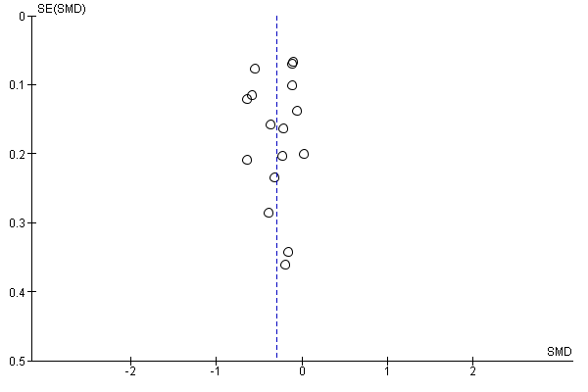

1.1.2. Effects of integrated lifestyle intervention alone on SBP
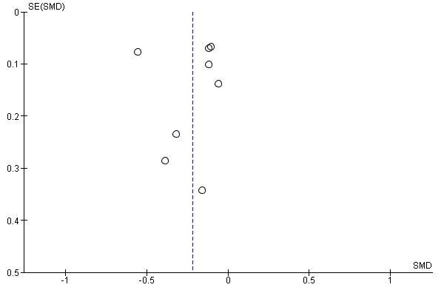

1.1.3. Effects of combined interventions on SBP
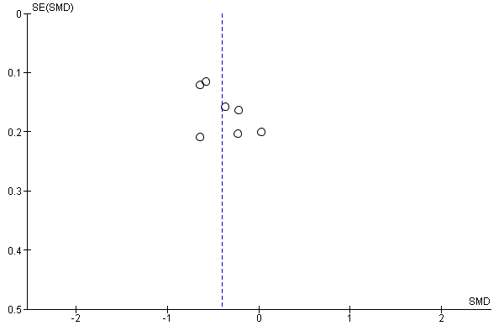

1.2.1. Effects of overall intervention diastolic blood pressure
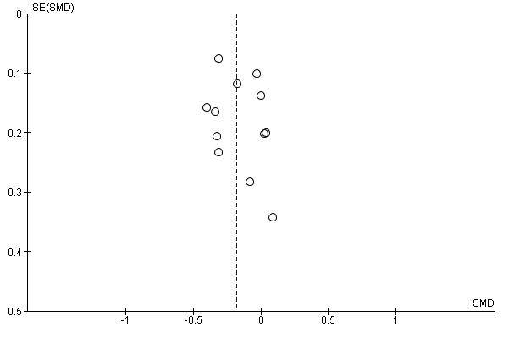

1.2.2. Effects of integrated lifestyle intervention alone on DBP
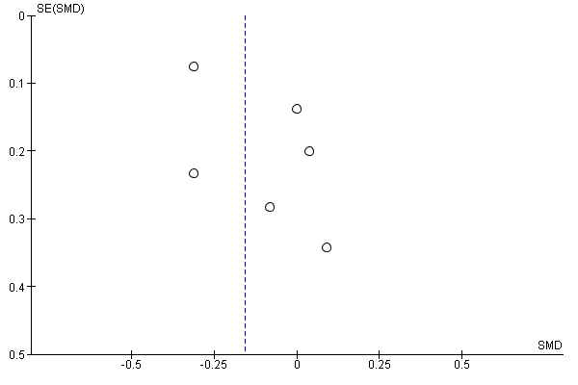

1.2.3. Effects of combined interventions on DBP
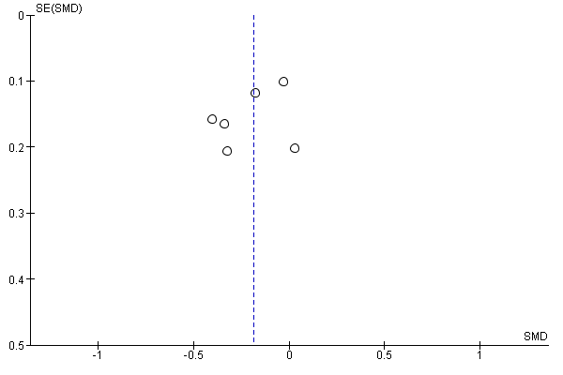

1.3.1. Effects of overall intervention on LDL
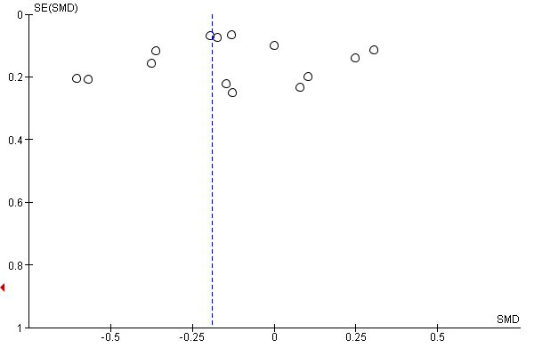

1. 3.2. Effects of integrated lifestyle intervention alone on LDL
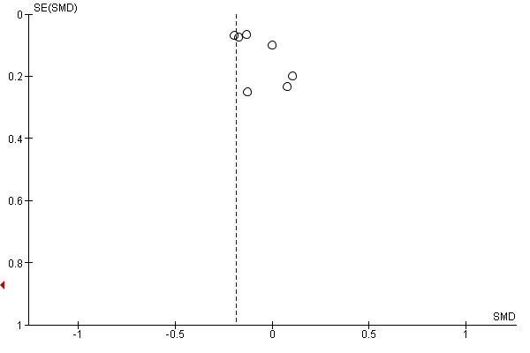

1.3.3. Effects of combined interventions on LDL
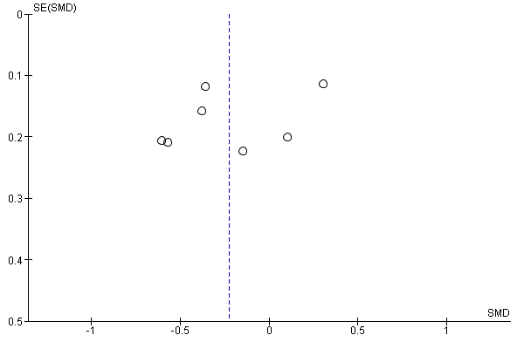

1.4. 1. Effects of overall intervention on Total cholesterol (TC)
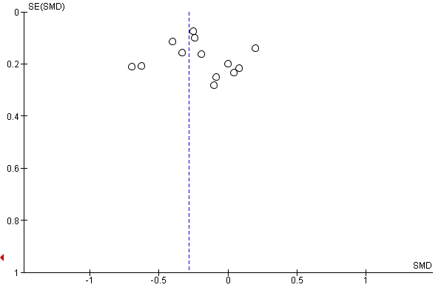

1.4.2. Effects of integrated lifestyle intervention alone on total cholesterol
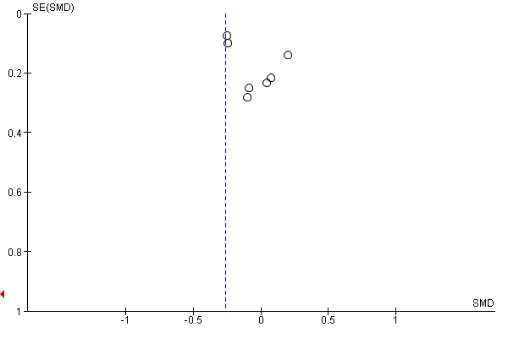

1.4.3. Effects of combined interventions on TC
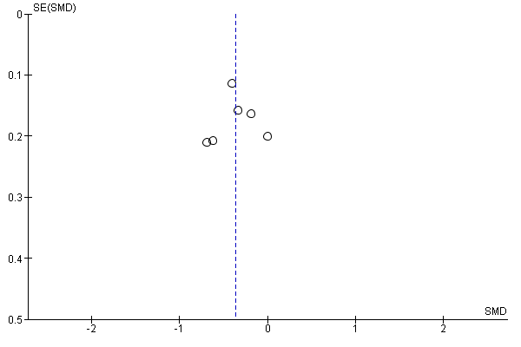

2. Leave one out (LOO) sensitivity analyses for primary outcomes
2.1. 1. Effects of overall intervention on systolic blood pressure
Study excluded | Effect size estimate SMD[95% CI] | Heterogeneity | Test for overall effect (Z)
None | -0.30 [-0.43, -0.17) | Heterogeneity: Tau² = 0.04; Chi² = 51.700, df = 14 (P < 0.00001); I² = 73% | Test for overall effect: Z =4.56(P<0.00001)
Abed et al(11) | -0.31 [-0.44, -0.17) | Heterogeneity: Tau² = 0.04; Chi² = 51.7, df = 13 (P <0.0001); I² = 75% | Test for overall effect: Z = 4.39 (P<0.0001)
Bae et al(11) | -0.32 [-0.46, -0.18) | Heterogeneity: Tau² = 0.04; Chi² = 43.54, df = 13 (P<0.0001); I² = 70% | Test for overall effect: Z = 4.60 (P<0.0001)
Chow et al(11) | -0.27 [-0.39, -0.15) | Heterogeneity: Tau² = 0.03; Chi² =36.35, df = 13 (P =0.0005); I² = 64% | Test for overall effect: Z = 4.32 (P<0.0001)
Dorje et al(11) | -0.32 [-0.45, -0.18) | Heterogeneity: Tau² = 0.04; Chi² = 49.26, df = 13 (P <0.00001); I² = 74% | Test for overall effect: Z = 4.64 (P<0.0001)
Engelen et al(11) | -0.27 [-0.40, -0.14) | Heterogeneity: Tau² = 0.04; Chi² = 44.48, df = 13(P<0.0001); I² = 71% | Test for overall effect: Z = 4.14 (P<0.0001)
Fernandez et al(14) | -0.30[-0.43, -0.16] | Heterogeneity: Tau² = 0.04; Chi² = 51.68, df = 13(P<0.00001); I² = 75% | Test for overall effect: Z =4.38 (P<0.00001)
Gallagher et al(15) | -0.32[-0.45, -0.18] | Heterogeneity: Tau² = 0.04; Chi² = 49.18, df = 13(P<0.00001); I² = 74% | Test for overall effect: Z =4.5 (P<0.00001)
Goessensa et al | -0.30[-0.43, -0.16] | Heterogeneity: Tau² = 0.04; Chi² = 51.51, df = 13 (P < 0.00001); I² = 75% | Test for overall effect: Z = 4.24(P<0.0001)
Lehmanna et al(17) | -0.28 [-0.41, -0.13] | Heterogeneity: Tau² = 0.04; Chi² = 48.68, df = 13 (P < 0.00001); I² = 73% | Test for overall effect: Z = 4.21(P<0.0001)
Li et al(17) | -0.27 [-0.40, -0.14] | Heterogeneity: Tau² = 0.03; Chi² = 41.95 df = 13(P < 0.00001); I² = 69% | Test for overall effect: Z = 4.19(P<0.0001)
Liu et al(19) | -0.30 [-0.44, -0.17] | Heterogeneity: Tau² = 0.04; Chi² = 51.76, df = 13(P < 0.00001); I² = 75% | Test for overall effect: Z = 4.42(P<0.00001)
Michelson et al | -0.32[-0.45, -0.19] | Heterogeneity: Tau² = 0.04; Chi² = 49.48, df = 13(P < 0.00001); I² = 75% | Test for overall effect: Z = 4.72(P<0.00001)
Ornish et al(21) | -0.30[-0.44, -0.17] | Heterogeneity: Tau² = 0.04; Chi² = 51.71, df = 13 (P < 0.00001); I² = 75% | Test for overall effect: Z = 4.51 (P<0.0001)
Saffi et al(23) | -0.30[-0.43, -0.16] | Heterogeneity: Tau² = 0.04; Chi² = 51.79, df = 13(P < 0.00001); I² = 75% | Test for overall effect: Z = 4.37 (P<0.0001)
Zheng et al(24) | -0.32 [-0.46, -0.18] | Heterogeneity: Tau² = 0.04; Chi² = 45.46, df = 13 (P<0.0001); I² = 71% | Test for overall effect: Z = 4.5(P<0.00001)
Legend: 95% CI = 95% confidence interval. SMD= standardized mean difference.
2.1. 2. Effects of integrated lifestyle intervention alone on systolic blood pressure
Study excluded | Effect size estimate SMD  [95% CI] | Heterogeneity | Test for overall effect (Z)
None | -0.22 [-0.38, -0.06) | Heterogeneity: Tau² = 0.03; Chi² = 26.86, df = 7 (P =0.004); I² = 74% | Test for overall effect: Z =2.66(P=0.008)
Bae et al(11) | -0.24 [-0.43, -0.05) | Heterogeneity: Tau² = 0.04; Chi² = 23.10, df = 6 (P = 0.0008); I² = 74% | Test for overall effect: Z = 2.47(P=0.01)
Chow et al(11) | -0.12 [-0.20, -0.05) | Heterogeneity: Tau² = 0.00; Chi² = 1.85, df = 6(P = 0.93); I² = 0% | Test for overall effect: Z = 2.98(P=0.003)
Engelen et al(14) | -0.24[-0.42, -0.06] | Heterogeneity: Tau² = 0.04; Chi² = 25.53, df = 6 (P=0.003); I² = 77% | Test for overall effect: Z =2.67 (P=0.008)
Fernandez et al(14) | -0.21[-0.38, -0.04] | Heterogeneity: Tau² = 0.03; Chi² = 26.50, df = 6 (P=0.0002); I² = 77% | Test for overall effect: Z =2.41 (P=0.02)
Gallagher et al(15) | -0.24[-0.42, -0.05] | Heterogeneity: Tau² = 0.04 Chi² = 25.86, df = 6 (P=0.0002); I² = 77% | Test for overall effect: Z = 2.48 (P=0.01)
Ornish et al(21) | -0.22[-0.39, -0.05] | Heterogeneity: Tau² = 0.03; Chi² = 26.84, df = 6 (P=0.0002); I² = 77% | Test for overall effect: Z = 2.57(P=0.01)
Saffi et al(23) | -0.21[-0.38, -0.04] | Heterogeneity: Tau² = 0.03; Chi² = 26.66, df = 6 (P=0.0001); I² = 77% | Test for overall effect: Z =2.39 (P=0.02)
Zheng et al(24) | -0.24 [-0.43, -0.04] | Heterogeneity: Tau² = 0.04; Chi² = 24.30, df = 6 (P=0.0005); I² = 75% | Test for overall effect: Z = 2.39(P=0.02)
Legend: 95% CI = 95% confidence interval. SMD= standardised mean difference.

2.1.3. Effects of combined intervention on systolic blood pressure
Omitted studies | Effect size estimate SMD  [95% CI] | Heterogeneity | Test for overall effect (Z)
None | -0.40[-0.58, -0.22] | Heterogeneity: Tau² = 0.03; Chi² = 13.78, df = 6(P=0.03); I² = 56% | Test for overall effect: Z = 4.39(P<0.0001)
Abed et al(16) | -0.30[-0.39, -0.21] | Heterogeneity: Tau² = 0.03; Chi² = 11.67, df = 5 (P=0.04); I² = 57% | Test for overall effect: Z = 4.34(P<0.0001)
Dorje et al(16) | -0.36[-0.57, -0.15] | Heterogeneity: Tau² = 0.04; Chi² = 11.93, df = 5 (P=0.04); I² = 58% | Test for overall effect: Z = 3.35(P=0.0008)
Goessensa et al(16) | -0.41[-0.62, -0.19] | Heterogeneity: Tau² = 0.04; Chi² = 13.48, df = 5 (P=0.02); I² = 63% | Test for overall effect: Z = 3.75(P=0.0002)
Lehmanna et al(17) | -0.37 [-0.57, 0.17] | Heterogeneity: Tau² = 0.04; Chi² = 12.78, df = 5 (P=0.03); I² = 61% | Test for overall effect: Z = 3.69(P=0.0.0002)
Li et al(16) | -0.35[-0.55, -0.16] | Heterogeneity: Tau² = 0.03; Chi² = 10.19, df = 5 (P=0.07); I² = 51% | Test for overall effect: Z = 3.56(P=0.0004)
Liu et al(19) | -0.43 [-0.62, -0.23] | Heterogeneity: Tau² = 0.03.; Chi² = 12.53 df = 5 (P=0.03); I² = 60% | Test for overall effect: Z = 4.25 (P<0.0001)
Michalsen et al | -0.47 [-0.62, -0.32] | Heterogeneity: Tau² = 0.01.; Chi² = 7.77 df = 5 (P=0.17); I² = 36% | Test for overall effect: Z = 5.98 (P<0.00001)
Legend: 95% CI = 95% confidence interval. SMD= standardized mean difference.
2.2.1. Effects of overall on diastolic blood pressure
Study excluded | Effect size estimate SMD  [95% CI] | Heterogeneity | Test for overall effect (Z)
None | -0.18 [-0.28, -0.08) | Heterogeneity: Tau² = 0.01; Chi² = 13.56, df = 11 (P=0.26); I² = 19% | Test for overall effect: Z = 3.66(P=0.0003)
Abed et al(11) | -0.17[-0.27, -0.06) | Heterogeneity: Tau² = 0.01; Chi² = 12.56, df = 10(P =0.24); I² = 21% | Test for overall effect: Z = 3.19(P=0.001)
Chow et al(11) | -0.14[-0.23, -0.04) | Heterogeneity: Tau² = 0.00; Chi² =9.80, df = 10(P =0.46); I² = 0% | Test for overall effect: Z = 2.78(P=0.0.005)
Engelen et al(11) | -0.20-0.30, 0.10) | Heterogeneity: Tau² = 0.00; Chi² = 11.51, df = 10(P =0.32); I² = 13% | Test for overall effect: Z = 4.09(P<0.0001)
Fernandez et al(14) | -0.18 [-028, -0.08) | Heterogeneity: Tau² = 0.01; Chi² = 13.42, df = 10(P =0.20); I² = 25% | Test for overall effect: Z = 3.47(P=0.0005)
Gallagher et al(15) | -0.22 [-0.31, -0.12) | Heterogeneity: Tau² = 0.00; Chi² = 10.60, df = 10(P =0.39); I² = 6% | Test for overall effect: Z = 4.49(P<0.00001)
Goessensa et al | -0.16[-0.26, -0.07] | Heterogeneity: Tau² = 0.00; Chi² = 11.66, df = 10(P =0.31); I² = 14% | Test for overall effect: Z = 3.33(P=0.0009)
Lehmanna et al(17) | -0.17[-0.27, -0.07] | Heterogeneity: Tau² = 0.01; Chi² = 13.11, df = 10(P=0.22); I² = 24% | Test for overall effect: Z = 3.26(P=0.001)
Li et al(11) | -0.18[-0.29, 0.07) | Heterogeneity: Tau² = 0.01; Chi² = 13.55, df = 10(P =0.19); I² = 26% | Test for overall effect: Z = 3.13(P=0.002)
Liu et al(19) | -0.19[-0.29, -0.09] | Heterogeneity: Tau² = 0.01; Chi² = 12.36 df = 10, (P=0.26); I² = 19% | Test for overall effect: Z = 381 (P=0.0001)
Michalsen et al(11) | -0.19[-0.29, -0.09) | Heterogeneity: Tau² = 0.00; Chi² = 12.21, df = 10(P =0.0.27); I² = 18% | Test for overall effect: Z = 3.86(P=0.001)
Ornish et al(21) | -0.18[-0.28, -0.09] | Heterogeneity: Tau² = 0.01; Chi² = 10, df = 10(P=0.23); I² =22% | Test for overall effect: Z = 3.65(P=0.0003)
Saffi et al(23) | -0.17 [-0.27, -0.07) | Heterogeneity: Tau² = 0.01; Chi² =13.28, df = 10(P=0.21); I² = 25% | Test for overall effect: Z = 3.29(P=0.00010)
Legend: 95% CI = 95% confidence interval. SMD= standardized mean difference. The overall effect estimate is not significant when the study by Zheng et al is omitted, but the studies were homogenous (I²=0%)

2.2.2. Effects of integrated lifestyle intervention alone on diastolic blood pressure
Study excluded | Effect size estimate SMD  [95% CI] | Heterogeneity | Test for overall effect (Z)
None | -0.16[-0.32, 0.00) | Heterogeneity: Tau² = 0.01; Chi² = 6.83, df = 5 (P=0.23); I² = 27% | Test for overall effect: Z = 1.92 (P=0.05)
Chow et al(11) | -0.04[-0.23, 0.14) | Heterogeneity: Tau² = 0.00; Chi² = 1.78, df = 4 (P=0.78); I² = 0% | Test for overall effect: Z = 0.47 (P=0.68)
Engelen et al | -0.24[-0.38, -0.10) | Heterogeneity: Tau² = 0.00; Chi² = 4.17, df = 4 (P=0.38); I² = 4% | Test for overall effect: Z = 3.38 (P=0.0007)
Fernandez et al(14) | -0.15[-0.34, 0.03) | Heterogeneity: Tau² = 0.02; Chi² = 6.63, df = 4(P=0.016); I² = 40% | Test for overall effect: Z = 1.6 (P=0.11)
Michalsen et al | -0.19[-0.36, -0.03) | Heterogeneity: Tau² = 0.01; Chi² = 5.21, df = 4 (P=0.27); I² = 23% | Test for overall effect: Z = 2.23 (P=0.02)
Ornish et al(21) | -0.17[-0.34, 0.00] | Heterogeneity: Tau² = 0.01; Chi² = 6.06, df = 4(P=0.0.19); I² =34% | Test for overall effect: Z = 1.92(P=0.06)
Saffi et al(23) | -0.12[-0.31, 0.07) | Heterogeneity: Tau² = 0.02; Chi² =6.60 df = 4(P=0.16); I² = 39% | Test for overall effect: Z = 1.26(P=0.21)
Legend: 95% CI = 95% confidence interval. SMD= standardized mean difference

2.2.3. Effects of combined intervention on diastolic blood pressure
Omitted studies | Effect size estimate SMD  [95% CI] | Heterogeneity | Test for overall effect (Z)
None | -0.19[-0.32, -0.05] | Heterogeneity: Tau² = 0.01; Chi² = 6.60, df = 5(P=0.25); I² = 24% | Test for overall effect: Z = 2.69(P=0.007)
Abed et al | -0.16[-0.31, -0.01] | Heterogeneity: Tau² = 0.01; Chi² = 5.45, df = 4(P=0.24); I² = 27% | Test for overall effect: Z = 2.14(P=0.03)
Gallagher et al | -0.25[-0.38, -0.11] | Heterogeneity: Tau² = 0.00; Chi² = 3.59, df = 4(P=0.46); I² = 0% | Test for overall effect: Z = 3.45(P=0.0006)
Goessensa et al(16) | -0.14[-0.27, -01] | Heterogeneity: Tau² = 0.00; Chi² = 4.24, df = 4(P=0.37); I² =6% | Test for overall effect: Z = 2.16(P=0.03)
Lehmanna et al(17) | -0.17[-0.33, -0.02] | Heterogeneity: Tau² = 0.01; Chi² = 6.02, df = 4(P=0.20); I² =34% | Test for overall effect: Z = 2.23(P=0.02)
Li et al | -0.20[-0.38, -0.02] | Heterogeneity: Tau² = 0.02; Chi² = 6.60, df = 4(P=0.16); I² =39% | Test for overall effect: Z = 2.17(P=0.02)
Liu et al(19) | -0.21 [-0.36, -0.07] | Heterogeneity: Tau² = 0.01.; Chi² = 5.51 df = 4 (P=0.24) ; I² = 27% | Test for overall effect: Z = 2.86 (P=0.004)
Legend: 95% CI = 95% confidence interval. SMD= standardized mean difference.
2.3.1. Effects of overall intervention on low-density lipoprotein cholesterol (LDL-C)
Omitted studies | Effect size estimate SMD  [95% CI] | Heterogeneity | Test for overall effect (Z)
None | -0.19 (-0.36, -0.02) | Heterogeneity: Tau² = 0.09, Chi² = 93.21, df = 14(P<0.00001); I² =85% | Test for overall effect: Z = 2.14(P =0.03)
Abed et al | -0.19[-0.37, -0.01] | Heterogeneity: Tau² = 0.09; Chi² = 93.21, df = 13 (P < 0.00001); I² = 86% | Test for overall effect: Z = 2.09(P=0.04)
Bae et al | -0.21[-0.41, -0.01] | Heterogeneity: Tau² = 0.11; Chi² = 93.21, df = 13 (P < 0.0001); I² = 87% | Test for overall effect: Z = 2.03 (P=0.04)
Chow et al | -0.20[-0.40, -0.00] | Heterogeneity: Tau² = 0.11; Chi² = 92.84, df = 13 (P < 0.00001); I² = 86% | Test for overall effect: Z = 2.01 (P=0.04)
Dorje et al | -0.22[-0.40, -0.04] | Heterogeneity: Tau² = 0.08; Chi² = 85.38, df = 13 (P < 0.0001); I² = 85% | Test for overall effect: Z = 2.45 (P=0.01)
Engelen et al | -0.23[-0.40, -0.05] | Heterogeneity: Tau² = 0.08; Chi² = 77.40, df = 13 (P < 0.00001); I² = 83% | Test for overall effect: Z = 2.57 (P=0.01)
Gallagher et al(15) | -0.21[-0.40, -0.02] | Heterogeneity: Tau² = 0.10; Chi² = , df = 13 (P < 0.00001); I² = 86% | Test for overall effect: Z = 2.20 (P=0.03)
Goessensa et al(16) | -0.18 [-0.36, 0.01] | Heterogeneity: Tau² = 0.09; Chi² = 90.74, df = 13 (P < 0.00001); I² = 86% | Test for overall effect: Z = 1.90 (P=0.06)
Lehmanna et al(17) | -0.16 [-0.34, 0.01] | Heterogeneity: Tau² = 0.08.; Chi² = 88.72, df = 13 (P < 0.00001); I² =85% | Test for overall effect: Z = 1.81 (P=0.07)
Li et al | -0.18(-0.36, 0.01] | Heterogeneity: Tau² = 0.09; Chi² = 86.22, df = 13 (P < 0.0001); I² = 87% | Test for overall effect: Z = 1.89 (P=0.06)
Liu et al(19) | -0.16 [-0.34, 0.02] | Heterogeneity: Tau² = 0.08.; Chi² = 87.87 df = 13 (P < 0.00001); I² = 85% | Test for overall effect: Z = 1.79(P=0.07)
Michelson et al(25) | -0.21[-0.39,-0.03] | Heterogeneity: Tau² = 0.09; Chi² = 91.80 df = 13 (P < 0.00001); I² = 86% | Test for overall effect: Z = 2.28 (P =0.02)
Ornish et al(21) | -0.13 [-0.25, -0.00] | Heterogeneity: Tau² = 0.03; Chi² = 42.78, df = 13 (P<0.0001); I² = 70% | Test for overall effect: Z =2.02 (P =0.04)
Park et al(22) | -0.19[-0.37, -0.01] | Heterogeneity: Tau² = 0.09; Chi² = 93.21, df = 13 (P < 0.00001); I² = 86% | Test for overall effect: Z = 2.11 (P=0.03)
Saffi et al(23) | -0.21 [-0.39, -0.03] | Heterogeneity: Tau² = 0.09; Chi² = 93.38, df = 13 (P < 0.00001); I² = 86% | Test for overall effect: Z = 2.24(P=0.02)
Zheng et al | -0.20[-0.40, -0.00) | Heterogeneity: Tau² = 0.11; Chi² = 92.22, df = 13 (P < 0.00001); I² = 86% | Test for overall effect: Z = 1.98(P=0.05)
Legend: 95% CI = 95% confidence interval. SMD= standardized mean difference.

2.2.3 Effects of integrated lifestyle intervention alone on low-density lipoprotein cholesterol (LDL-C)
Omitted studies | Effect size estimate SMD  [95% CI] | Heterogeneity | Test for overall effect (Z)
None | -0.18 (-0.42, 0.05) | Heterogeneity: Tau² = 0.08, Chi² = 55.32, df = 7 (P<0.00001); I² =87% | Test for overall effect: Z = 1.53 (P =0.13)
Bae et al | -0.24 (-0.55, 0.07) | Heterogeneity: Tau² = 0.13, Chi² = 55.32, df = 6 (P<0.00001); I² =87% | Test for overall effect: Z = 150 (P =0.13)
Chow et al | -0.22(-0.52, 0.08) | Heterogeneity: Tau² = 0.12, Chi² = 55.05, df = 6 (P<0.00001); I² =87% | Test for overall effect: Z = 1.45(P =0.15)
Gallagher et al(15) | -0.23[-0.51, 0.04] | Heterogeneity: Tau² = 0.10; Chi² = 53.15, df = 6 (P < 0.00001); I² = 89% | Test for overall effect: Z = 1.66 (P=0.10)
Michelsen et al | -0.23(-0.48, 0.03) | Heterogeneity: Tau² = 0.09, Chi² = 53.80, df = 6 (P<0.00001); I² =89% | Test for overall effect: Z = 1.74 (P =0.08)
Ornish et al(21) | -0.13 [-020, -0.06] | Heterogeneity: Tau² = 0.00; Chi² = 4.99, df = 6(P<0.00001); I² = 0% | Test for overall effect: Z =3.54(P =0.0004)
Park et al(22) | -0.20[-0.45, 0.06] | Heterogeneity: Tau² = 0.09; Chi² = 53.32, df = 6 (P < 0.00001); I² = 89% | Test for overall effect: Z = 1.50 (P=0.13)
Saffi et al(23) | -0.22[-0.47, 0.03] | Heterogeneity: Tau² = 0.09; Chi² = 54.43, df = 6 (P < 0.00001); I² = 89% | Test for overall effect: Z = 1.69(P=0.09)
Zheng et al | -0.22[-0.53, 0.08) | Heterogeneity: Tau² = 0.12; Chi² = 54.47, df = 6(P < 0.00001); I² = 89% | Test for overall effect: Z = 1.42(P=0.15)
Legend: 95% CI = 95% confidence interval, SMD= standardized mean difference, df= degree of freedom
2.3.3. Effects of combined intervention on LDL
Omitted studies | Effect size estimate SMD  [95% CI] | Heterogeneity | Test for overall effect (Z)
None | -0.22[-0.50, 0.06] | Heterogeneity: Tau² = 0.11; Chi² = 31.55, df = 6 (P<0.00001); I² = 81% | Test for overall effect: Z = 1.56 (P=0.12)
Abed et al | -0.24[-0.56, 0.08] | Heterogeneity: Tau² = 0.13; Chi² = 31.54, df = 5 (P<0.00001); I² = 84% | Test for overall effect: Z = 1.46 (P=0.14)
Dorje et al | -0.33[-0.52, -0.14] | Heterogeneity: Tau² = 0.02; Chi² = 8.56, df = 5 (P=0.13); I² = 42% | Test for overall effect: Z = 3.46 (P=0.0005)
Goessensa et al(16) | -0.20[-0.52, 0.12] | Heterogeneity: Tau² = 0.13; Chi² = 29.38, df = 5 (P<0.00001); I² = 83% | Test for overall effect: Z = 1.21(P=0.23)
Lehmanna et al(17) | -0.17 [-0.47, 0.13] | Heterogeneity: Tau² = 0.11; Chi² = 27.36, df = 5 (P<0.001); I² = 82% | Test for overall effect: Z = 1.12(P=0.26)
Li et al | -0.20[-0.53, 0.13] | Heterogeneity: Tau² = 0.14; Chi² = 27.73, df = 5 (P<0.00001); I² = 82% | Test for overall effect: Z = 1.18(P=0.24)
Liu et al(19) | -0.17 [-0.46, 0.13] | Heterogeneity: Tau² = 0.11.; Chi² = 26.52 df = 5 (P<0.0001); I² = 81% | Test for overall effect: Z = 1.10 (P=0.27)
Michelsen et al | -0.28[-0.59, 0.04] | Heterogeneity: Tau² = 0.12.; Chi² = 29.64 df = 5 (P<0.0001); I² = 83% | Test for overall effect: Z = 1.73(P=0.08)
Legend: 95% CI = 95% confidence interval. SMD= standardised mean difference.

2.4.1. Effects of overall intervention on Total cholesterol (TC)
Omitted studies | Effect size estimate SMD  [95% CI] | Heterogeneity | Test for overall effect (Z)
None | -0.28[-0.49, -0.07] | Heterogeneity: Tau² = 0.12; Chi² = 76.39, df = 13 (P<0.00001); I² = 83% | Test for overall effect: Z = 2.62(P=0.009)
Abed et al | -0.30[-0.52, -0.07] | Heterogeneity: Tau² = 0.13; Chi² = 76.31, df = 12 (P<0.00001); I² = 84% | Test for overall effect: Z = 2.53(P=0.01)
Chow et al(11) | -0.30[-0.56, -0.05] | Heterogeneity: Tau² = 0.17; Chi² = 76.35, df = 12 (P<0.00001); I² = 84% | Test for overall effect: Z = 2.37(P=0.02)
Dorje et al | -0.32[-0.54, -0.11] | Heterogeneity: Tau² = 0.11; Chi² = 65.75, df = 12 (P<0.00001); I² = 82% | Test for overall effect: Z = 2.93(P=0.003)
Engelen et al | -0.28[-0.51, -0.05] | Heterogeneity: Tau² = 0.14; Chi² = 74.04 df = 12 (P<0.00001); I² = 84% | Test for overall effect: Z = 2.34(P=0.02)
Fernandez et al(14) | -0.30 [-0.52, -0.07] | Heterogeneity: Tau² = 0.12; Chi² = 76.16, df = 120 (P<0.0001); I² = 84% | Test for overall effect: Z = 2.62(P=0.009)
Gallagher et al(15) | -0.30 [-0.54, -0.06] | Heterogeneity: Tau² = 0.15; Chi² = 76.39, df = 12 (P<0.00001); I² = 84% | Test for overall effect: Z = 2.43(P=0.02)
Goessensa et al(16) | -0.28(-0.51,-0.05) | Heterogeneity: Tau² = 0.13; Chi² = 75.99, df = 12 (P<0.00001); I² = 84% | Test for overall effect: Z = 2.42(P=0.02)
Lehmanna et al(17) | -0.25(-0.47,-0.03) | Heterogeneity: Tau² = 0.12; Chi² = 71.52, df = 12 (P<0.00001); I² = 83% | Test for overall effect: Z = 2.25(P=0.02)
Liu et al(19) | -0.26 [-048., -0.04] | Heterogeneity: Tau² = 0.12.; Chi² = 72.76, df = 12 (P<0.00001); I² = 84% | Test for overall effect: Z = 2.28 (P=0.02)
Michelson et al(20) | -0.31[-0.53, -0.08] | Heterogeneity: Tau² = 0.13; Chi² = 74.94, df = 12 (P<0.00001; I² = 84% | Test for overall effect: Z = 2.69(P=0.007)
Ornish et al(21) | -0.21[-0.34, -0.08] | Heterogeneity: Tau² = 0.03; Chi² = 25.98, df = 12 (P<0.00001); I² = 54% | Test for overall effect: Z =3.23(P=0.001)
Park et al(22) | -0.30[-0.52, -0.08) | Heterogeneity: Tau² = 0.12; Chi² = 76.02, df = 12 (P<0.00001); I² = 84% | Test for overall effect: Z = 2.63(P=0.009)
Saffi et al(23) | -0.31 [-0.53, -0.09] | Heterogeneity: Tau² = 0.12; Chi² = 74.89, df = 12 (P<0.00001); I² = 84% | Test for overall effect: Z = 2.72(P<0.007)
Legend: 95% CI = 95% confidence interval. SMD= standardized mean difference.

2.2.4. Effects of integrated lifestyle intervention alone on Total cholesterol (TC)
Omitted studies | Effect size estimate SMD  [95% CI] | Heterogeneity | Test for overall effect (Z)
None | -0.26[-0.61, 0.0.9] | Heterogeneity: Tau² =0.20; Chi² = 62.27, df = 7 (P<0.00001); I² = 89% | Test for overall effect: Z = 1.45(P=0.15)
Chow et al(11) | -0.36[-0.85, 0.12] | Heterogeneity: Tau² = 0.34; Chi² = 60.01, df = 6 (P<0.0001); I² = 90% | Test for overall effect: Z = 1.46(P=0.14)
Engelen et al | -0.36[-0.76, 0.04] | Heterogeneity: Tau² = 0.22; Chi² = 54.44, df = 6 (P<0.00001); I² = 89% | Test for overall effect: Z = 1.75(P=0.08)
Fernandez et al(14) | -0.29 [-0.68, 0.09] | Heterogeneity: Tau² = 0.21; Chi² = 62.21, df = 6 (P<0.00001); I² = 90% | Test for overall effect: Z = 1.45(P=0.14)
Gallagher et al(15) | -0.34 [-0.80, 0.12] | Heterogeneity: Tau² = 0.31; Chi² = 61.50, df = 6 (P<0.00001); I² = 91% | Test for overall effect: Z = 1.45(P=0.15)
Ornish et al(21) | -0.09[-0.25, 0.06] | Heterogeneity: Tau² = 0.02; Chi² = 10.72, df = 6 (P=0.10); I² = 44% | Test for overall effect: Z =1.16 (P=0.25)
Park et al(22) | -0.30[-0.69, 0.09) | Heterogeneity: Tau² = 0.21; Chi² = 62.16, df = 6 (P<0.00001); I² = 90% | Test for overall effect: Z = 1.50(P=0.13)
Saffi et al(23) | -0.32[-0.71, -0.07] | Heterogeneity: Tau² = 0.21; Chi² = 61.42, df = 6 (P<0.00001); I² = 90% | Test for overall effect: Z = 1.60(P=0.11)
Legend: 95% CI = 95% confidence interval. SMD= standardized mean difference, df= degree of freedom
2.4.3. Effects of combined intervention on Total cholesterol (TC)
Omitted studies | Effect size estimate SMD  [95% CI] | Heterogeneity | Test for overall effect (Z)
None | -0.36[-0.54, -0.19] | Heterogeneity: Tau² = 0.02; Chi² = 8.56, df = 5 (P=0.13); I² = 42% | Test for overall effect: Z = 4.02(P<0.0001)
Abed et al | -0.40[-0.60, -0.20] | Heterogeneity: Tau² = 0.02; Chi² = 7.26, df = 4 (P=0.12); I² = 45% | Test for overall effect: Z = 3.88(P=0.0001)
Dorje et al | -0.36[-0.59, -0.12] | Heterogeneity: Tau² = 0.04; Chi² = 8.38, df = 4 (P=0.04); I² = 52% | Test for overall effect: Z = 2.95(P=0.003)
Goessensa et al(16) | -0.37[-0.59, -0.15] | Heterogeneity: Tau² = 0.03; Chi² = 8.52, df = 4 (P=0.07); I² = 53% | Test for overall effect: Z = 3.28(P=0.001)
Lehmanna et al(17) | -0.32 [-0.49, -0.15] | Heterogeneity: Tau² = 0.01; Chi² = 5.82, df = 4 (P=0.21); I² = 31% | Test for overall effect: Z = 3.63(P=0.0003)
Liu et al(19) | -0.32 [-0.52, -0.14] | Heterogeneity: Tau² = 0.02.; Chi² = 6.78 df = 4 (P=0.15); I² = 41% | Test for overall effect: Z = 3.41 (P=0.0006)
Michalsen et al | -0.41 [-0.57, -0.26] | Heterogeneity: Tau² = 0.01.; Chi² = 4.89 df = 4(P=0.30); I² = 18% | Test for overall effect: Z = 5.16 (P<0.00001)
Legend: 95% CI = 95% confidence interval. SMD= standardized mean difference.

3. Sensitivity analyses for primary outcomes with studies at high risk of bias excluded

3.1. 1. Forest Plot showing the effect of overall intervention on SBP (excluding studies at high risk of bias)
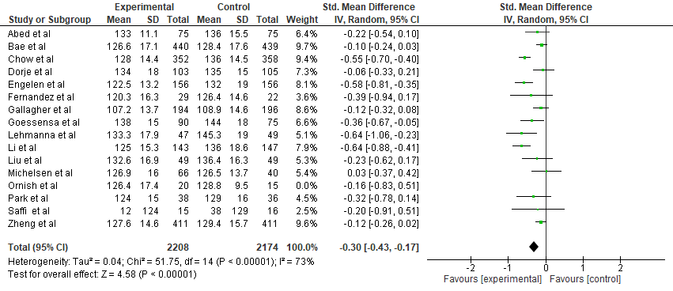

3.1. 2. Forest Plot showing the effect of lifestyle modification interventions on SBP (excluding studies at high risk of bias)
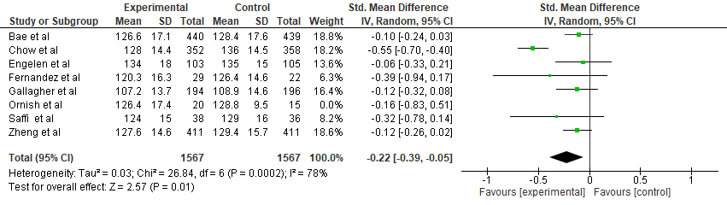

3.1. 3. Forest Plot showing the effect of lifestyle modification interventions on SBP (excluding studies at high risk of bias)
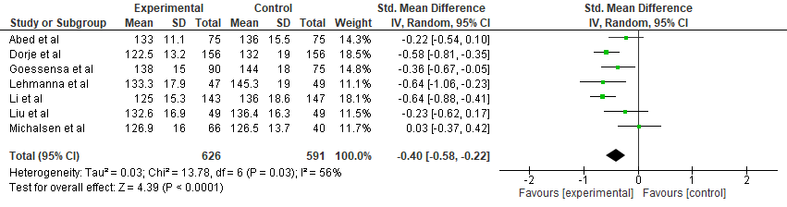

3.2.1. Forest Plot showing the effect of overall intervention on DBP (excluding studies at high risk of bias)
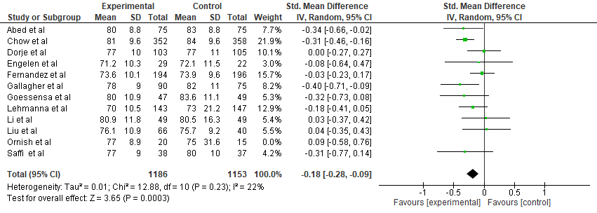

3.2.2. Forest Plot showing the effect of Lifestyle modification interventions on DBP (excluding studies at high risk of bias)
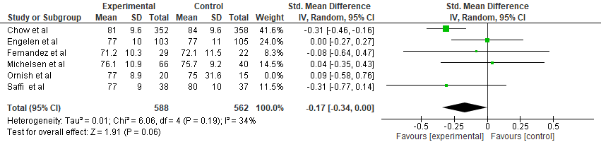
3.2.3. Forest Plot showing the effect of combined interventions on DBP (excluding studies at high risk of bias)

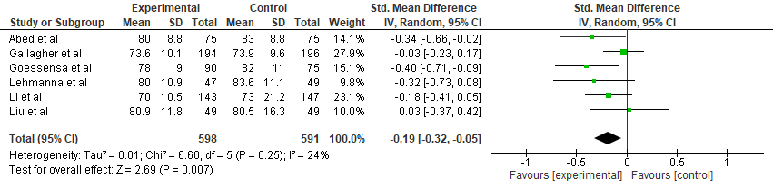

3.3.1. Forest Plot showing the effect of overall intervention on LDL-C (excluding studies at high risk of bias)
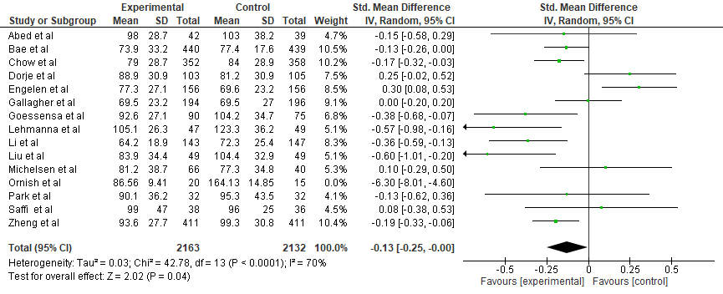

3.3.2. Forest Plot showing the effect of lifestyle interventions on LDL-C (excluding studies at high risk of bias)
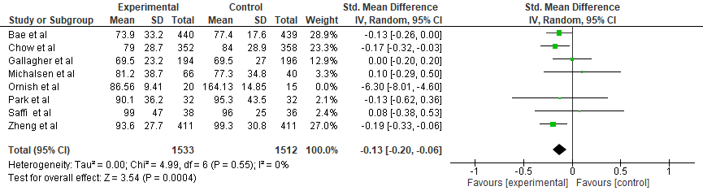

3.3.3. Forest Plot showing the effect of combined interventions on LDL-C (excluding studies at high risk of bias)
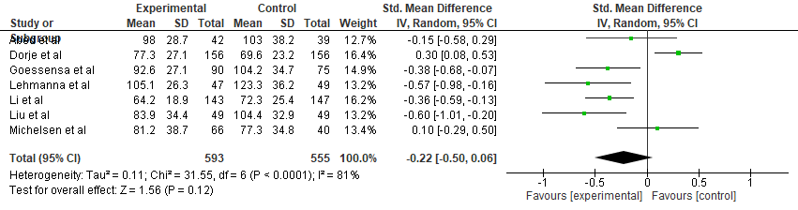
3.4. 1. Forest Plot showing the effect of overall intervention on Total cholesterol (excluding studies at high risk of bias)
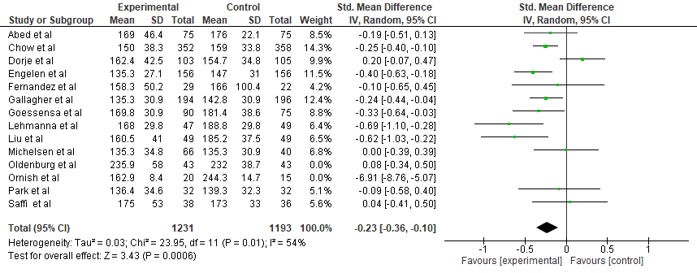

3.4. 2. Forest Plot showing the effect of lifestyle interventions alone on Total cholesterol (excluding studies at high risk of bias)
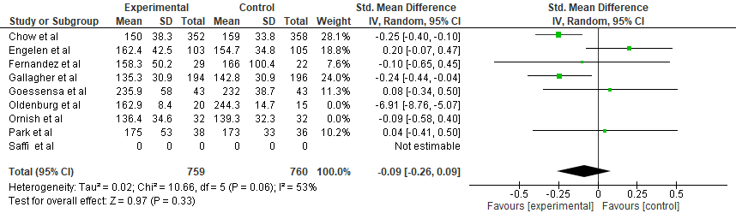

3.4. 3. Forest Plot showing the effect of lifestyle interventions alone on Total cholesterol (excluding studies at high risk of bias)
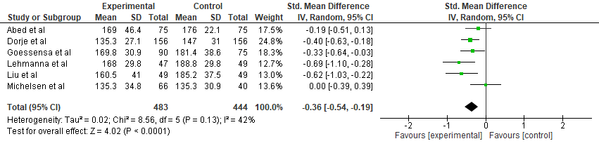

4. Subgroup analyses of primary and secondary outcomes based on specific mode of intervention delivery components
4.1.1. Forest Plot showing the effect of overall intervention with patient education on SBP
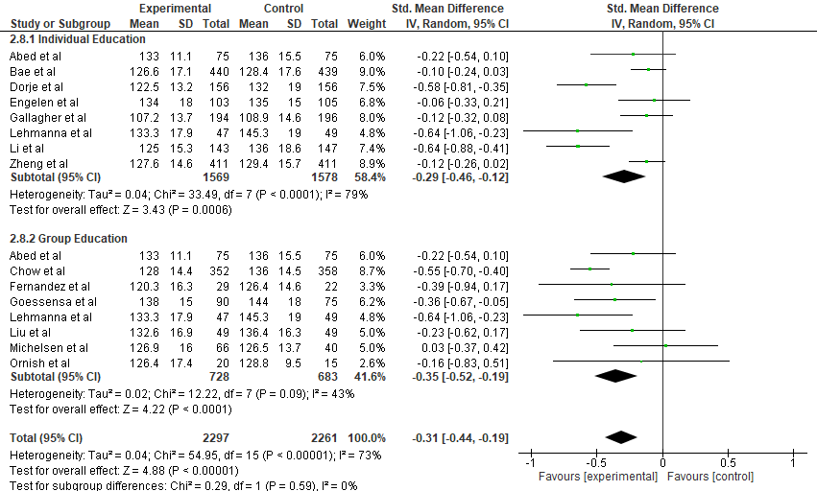

4.1.2. Forest Plot showing the effect of overall interventions with monitoring of risk factors on SBP
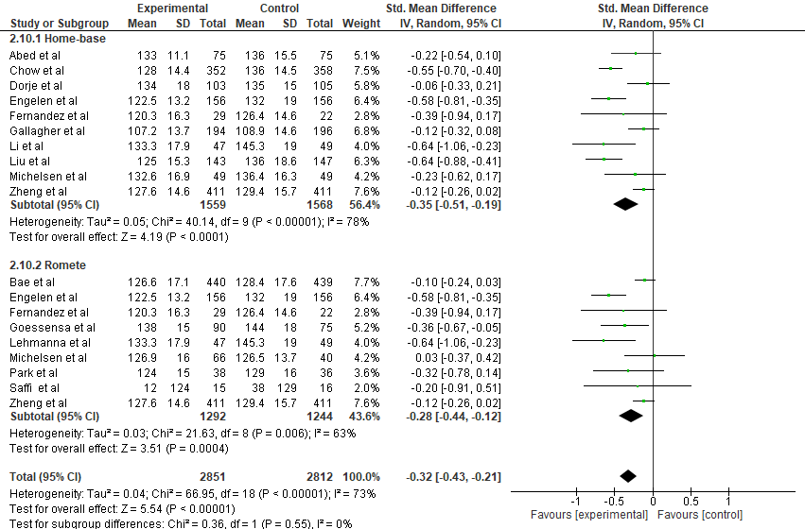

4.1.3. Forest Plot showing the effect of overall intervention with coaching for risk factor modification on SBP
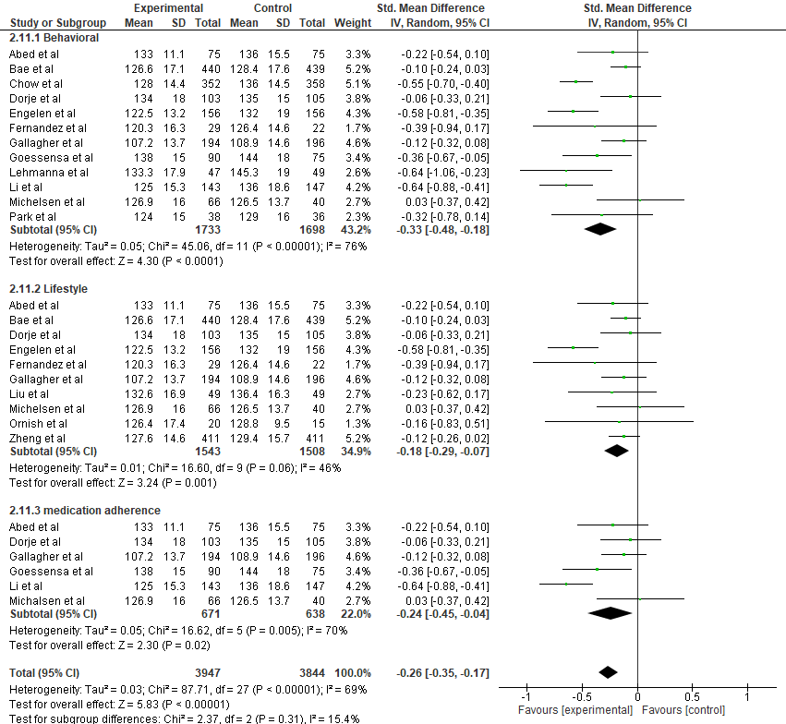
4.1.4. Forest Plot showing the effect of overall intervention with consultation on SBP
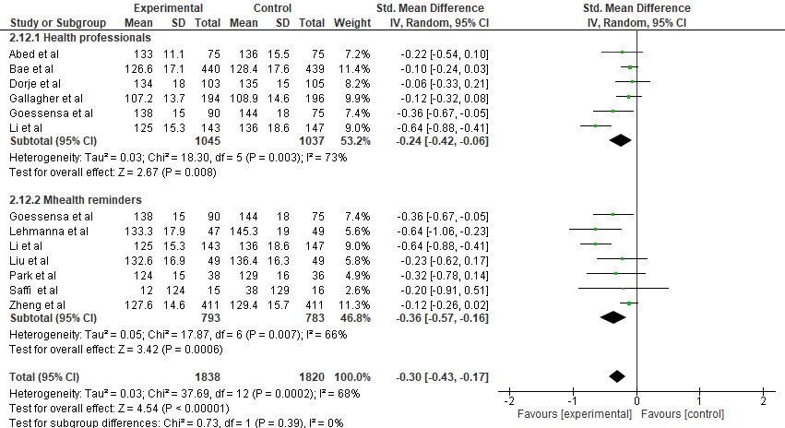
5.1.1. Forest plot showing the subgroup analysis of systolic blood pressure by follow up duration
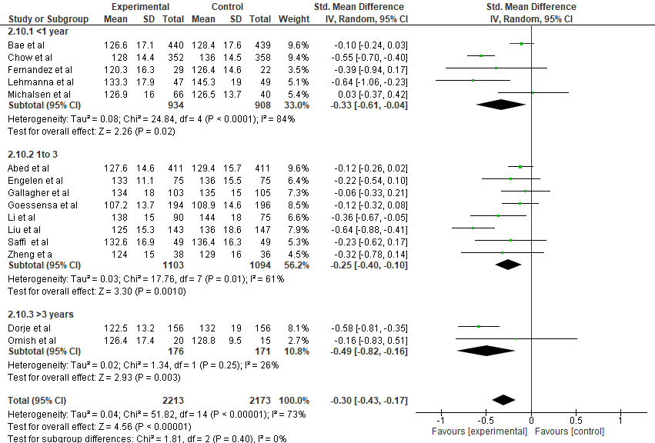
4.2.1. Forest Plot showing the effect of overall intervention with patient education on DBP
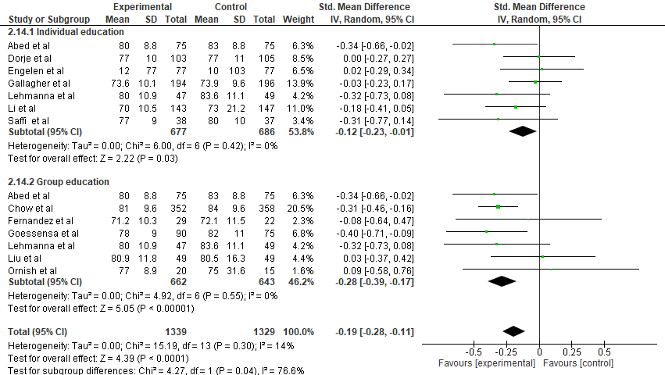

4.2.2. Forest Plot showing the effect of overall intervention with monitoring of risk factors on DBP
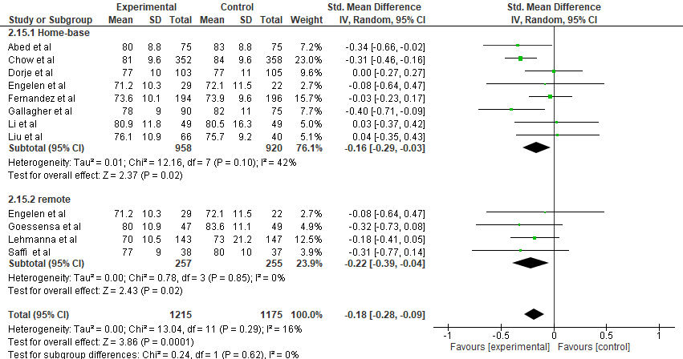

4.2.3. Forest Plot showing the effect of overall intervention with coaching for risk factor modification on DBP
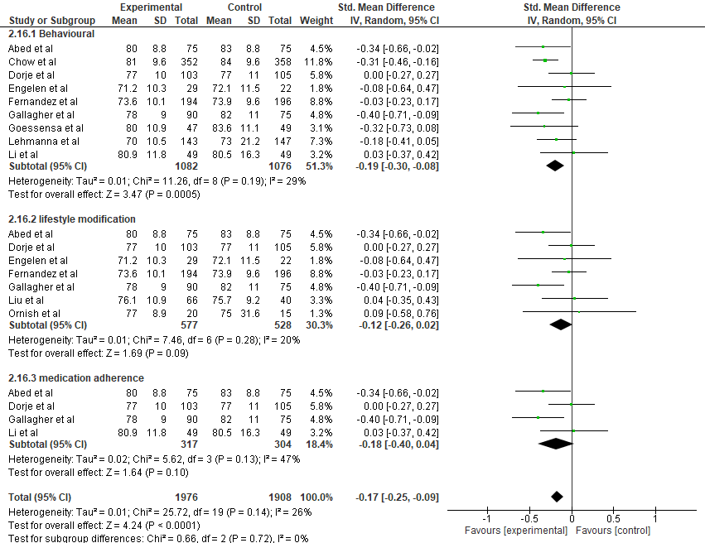

4.2.4. Forest Plot showing the effect of overall intervention with consultation on DBP
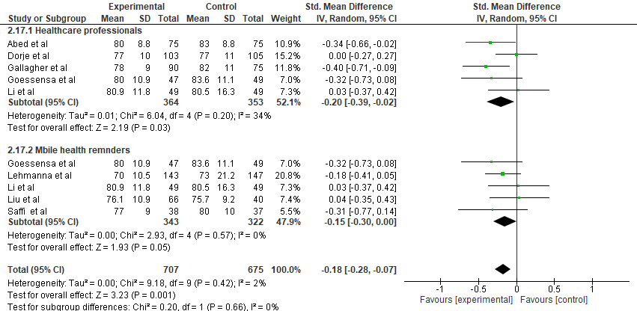
4.3.1. Forest Plot showing the effect of overall intervention with patient education on LDL-C
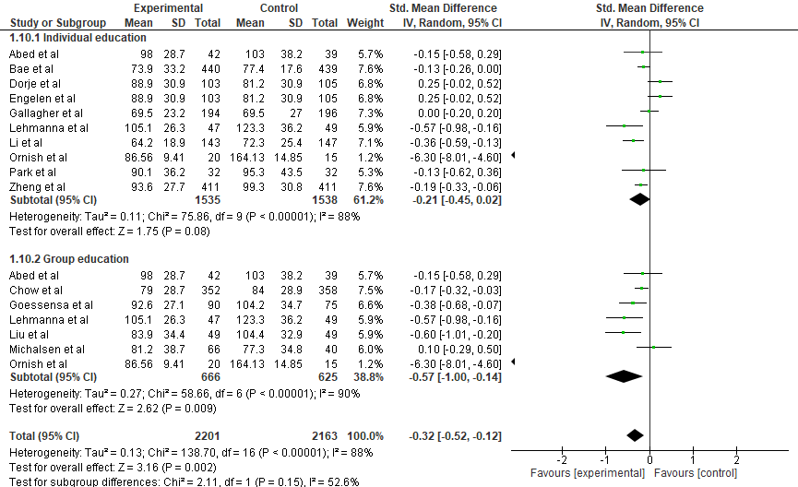

4.3.2. Forest Plot showing the effect of overall intervention with monitoring of risk factors on LDL-C
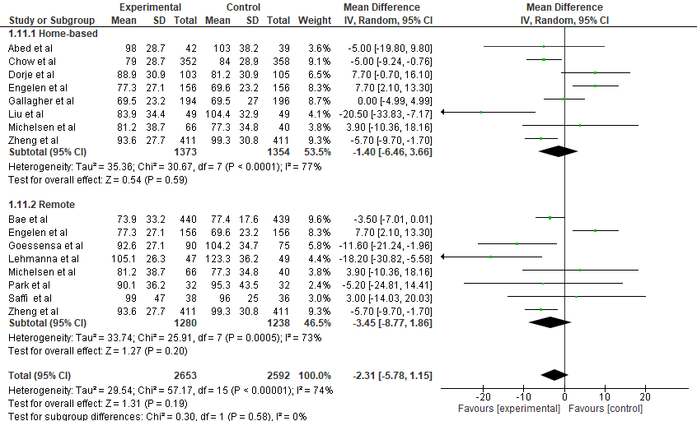

4.3.3. Forest Plot showing the effect of overall intervention with coaching for risk factor modification on LDL-C
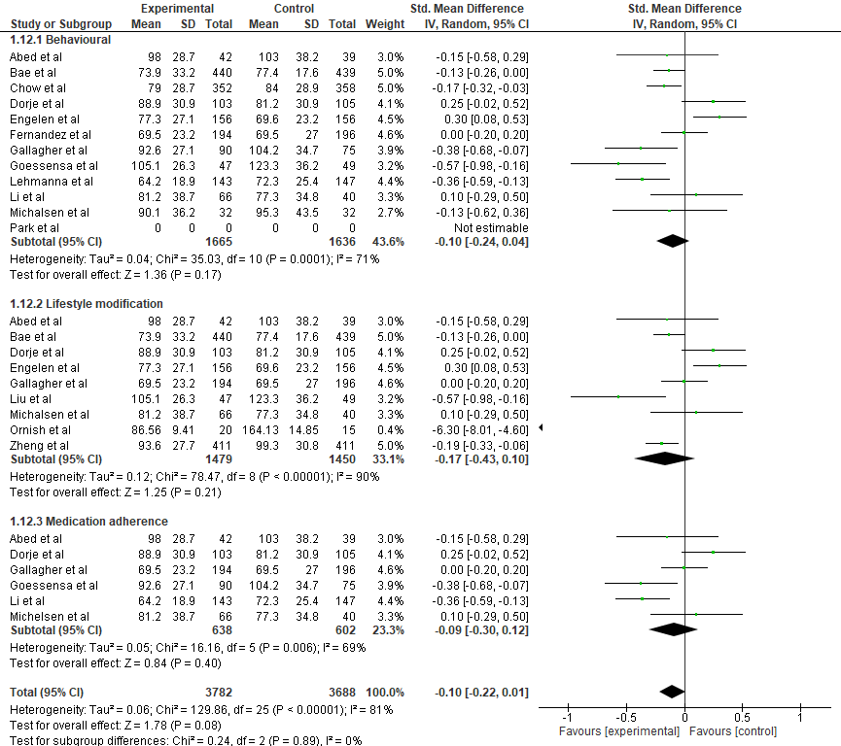

4.3.4. Forest Plot showing the effect of overall intervention with consultation on LDL-C
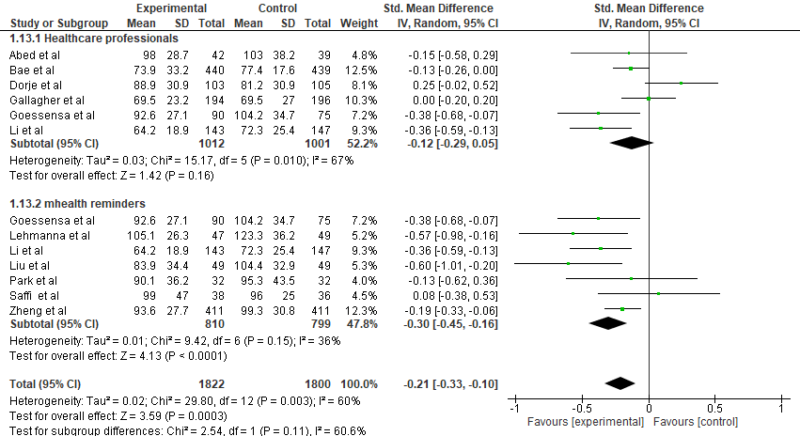

5.3.1.: Forest plot showing the subgroup analysis of meta-analysis for LDL-C by duration of follow up
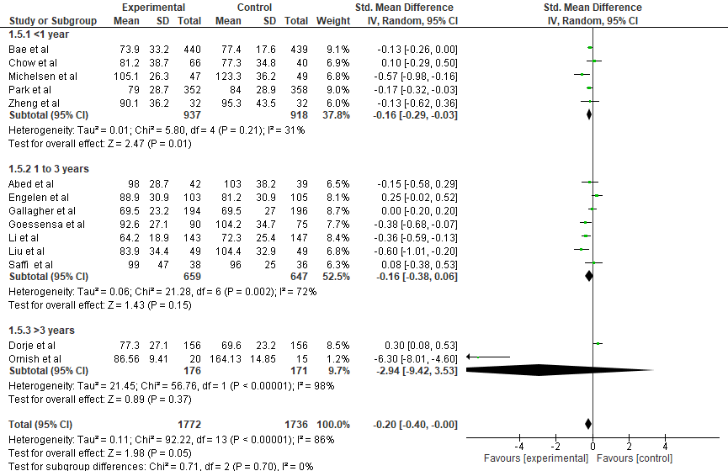

4.4.1. Forest Plot showing the effect of overall intervention with patient education on Total cholesterol
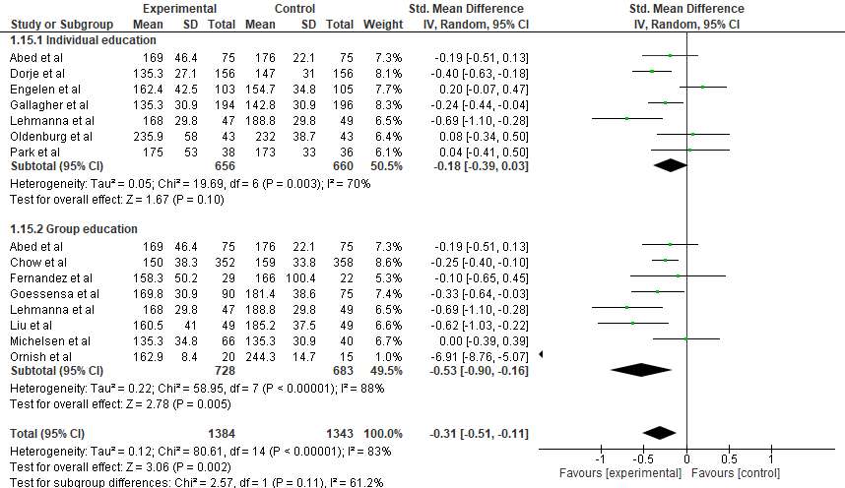
4.4.2.. Forest Plot showing the effect of overall intervention with monitoring of risk factors on Total cholesterol
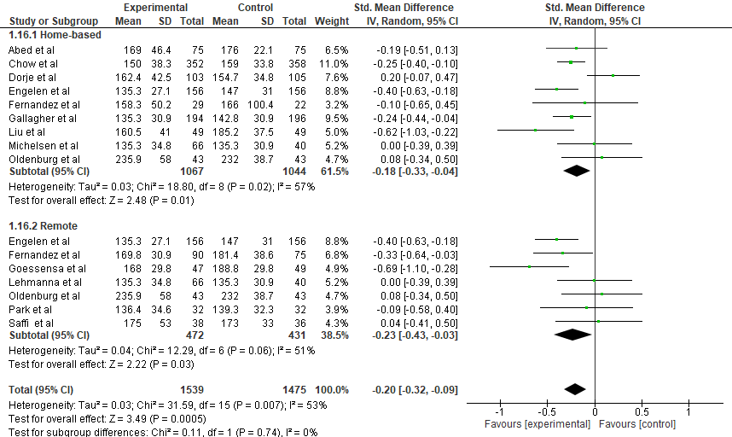
4.4.3. Forest Plot showing the effect of overall intervention with coaching for risk factor modification on Total cholesterol
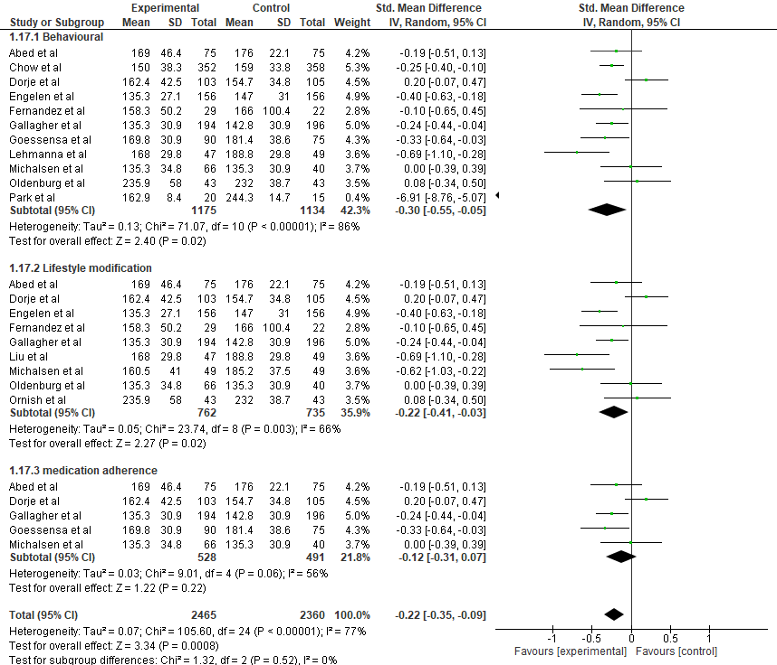
4.4.4. Forest Plot showing the effect of overall intervention with consultation on Total cholesterol
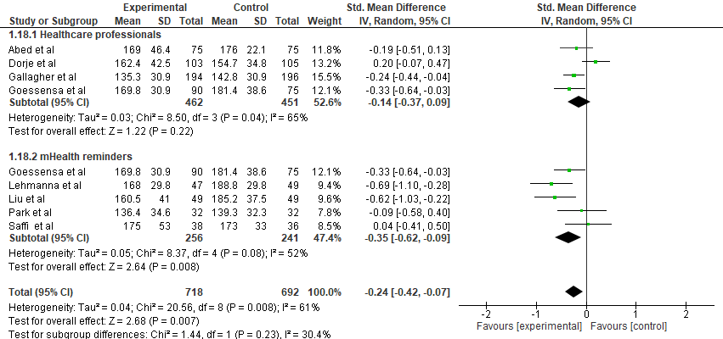

6. Forest plot for Major Adverse Cardiovascular Events. A: Percutaneous coronary intervention (PCI), B: Myocardial infarction); C: Coronary artery by-pass graft (CABG)
A
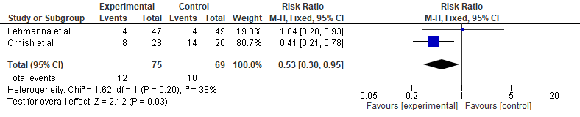
B
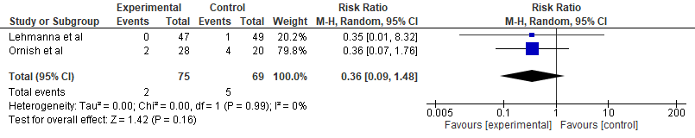
C
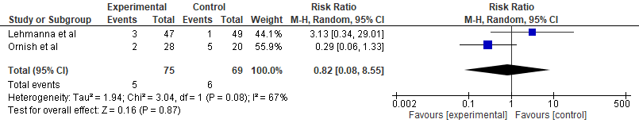

7. Trial sequential analysis to investigate the conclusiveness of integrated lifestyle and medical optimization interventions among patients with established CVD
7.1. Trial sequential analysis to investigate the conclusiveness of overall interventions on total cholesterol
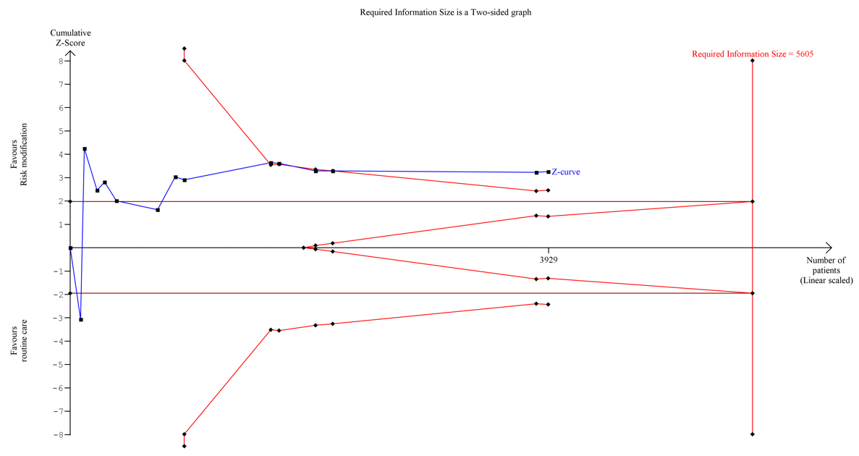
7.2. Trial sequential analysis to investigate the conclusiveness of overall interventions on LDL-C
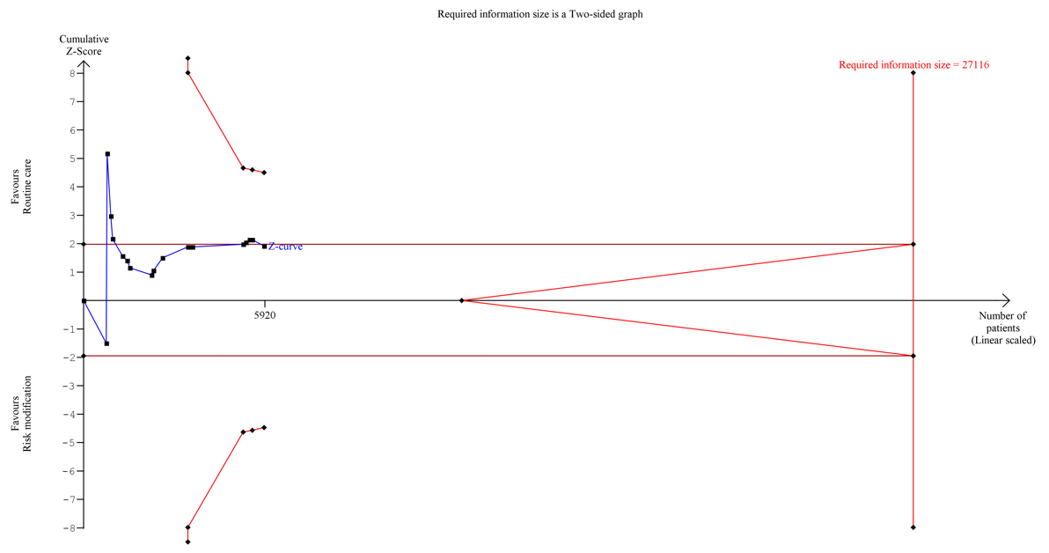

7.3. Trial sequential analysis to investigate the conclusiveness of overall interventions on DBP
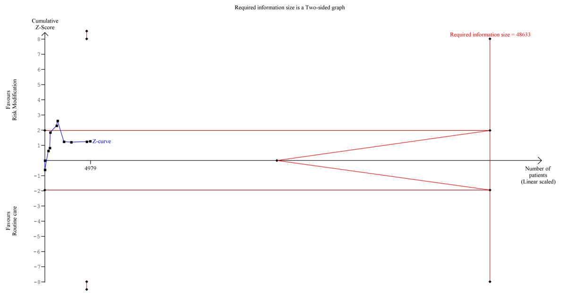
7.4. Trial sequential analysis to investigate the conclusiveness of integrated lifestyle interventions on medication Adherence
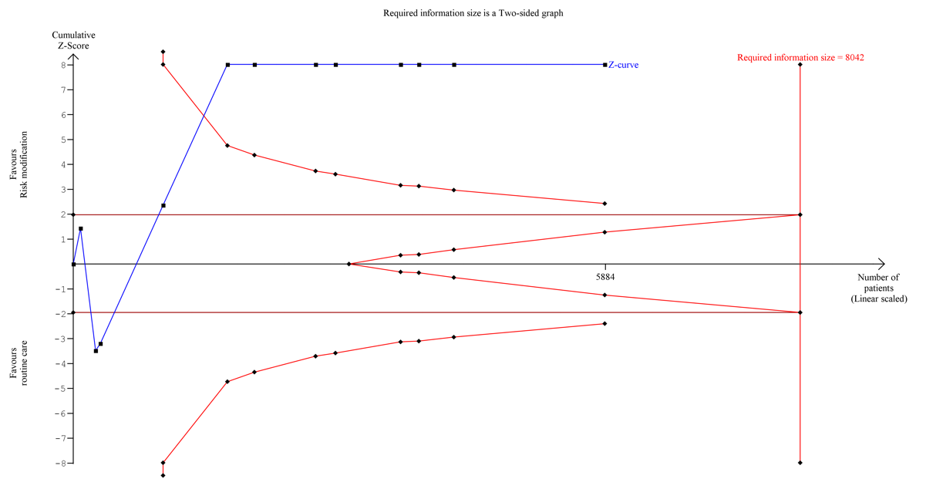

1. Higgins JPT TJ, Chandler J, Cumpston M, Li T, Page MJ, Welch VA (editors). Cochrane Handbook for Systematic Reviews of Interventions version 6.2 (updated February 2021). Available from www.training.cochrane.org/handbook.: Cochrane, 2021. ; 2021 [cited 2021 5th July].
2. Rugge B, Balshem H, Sehgal R, Relevo R, Gorman P, Helfand M. Screening and treatment of subclinical hypothyroidism or hyperthyroidism. 2012.
3. Takeshima N, Sozu T, Tajika A, Ogawa Y, Hayasaka Y, Furukawa TA. Which is more generalizable, powerful and interpretable in meta-analyses, mean difference or standardized mean difference? BMC Medical Research Methodology. 2014;14(1):30.
4. Cohen JA. Statistical power analysis for the behavioral sciences (2nd edition ed. Mahwah N, editor: Lawrence Erlbaum Associates; 1988.
5. Higgins JP, Thompson SG. Quantifying heterogeneity in a meta-analysis. Statistics in medicine. 2002;21(11):1539-58.
6. Sterne JAC, Savović J, Page MJ, Elbers RG, Blencowe NS, Boutron I, et al. RoB 2: a revised tool for assessing risk of bias in randomised trials. Bmj. 2019;366:l4898.
7. Abd El-Hamid AM, Alrabiey MI, Abd El-Fattah MH. A comparison of the postoperative analgesic effects of intravenous dexmedetomidine with a combination of dexmedetomidine and bupivacaine wound infiltration for lower segment cesarean section: A prospective, randomized study. Ain-Shams Journal of Anaesthesiology. 2016;9(2):235.
8. Guyatt GH, Oxman AD, Kunz R, Brozek J, Alonso-Coello P, Rind D, et al. GRADE guidelines 6. Rating the quality of evidence—imprecision. Journal of clinical epidemiology. 2011;64(12):1283-93.
9. Abed HS, Wittert GA, Leong DP, Shirazi MG, Bahrami B, Middeldorp ME, et al. Effect of weight reduction and cardiometabolic risk factor management on symptom burden and severity in patients with atrial fibrillation: a randomized clinical trial. Jama. 2013;310(19):2050-60.
10. Bae J-W, Woo S-I, Lee J, Park S-D, Kwon SW, Choi SH, et al. mHealth interventions for lifestyle and risk factor modification in coronary heart disease: randomized controlled trial. JMIR mHealth and uHealth. 2021;9(9):e29928.
11. Chow CK, Redfern J, Hillis GS, Thakkar J, Santo K, Hackett ML, et al. Effect of lifestyle-focused text messaging on risk factor modification in patients with coronary heart disease: a randomized clinical trial. Jama. 2015;314(12):1255-63.
12. Dorje T, Zhao G, Tso K, Wang J, Chen Y, Tsokey L, et al. Smartphone and social media-based cardiac rehabilitation and secondary prevention in China (SMART-CR/SP): a parallel-group, single-blind, randomised controlled trial. The Lancet Digital Health. 2019;1(7):e363-e74.
13. Engelen MM, van Dulmen S, Puijk-Hekman S, Vermeulen H, Nijhuis-van der Sanden MW, Bredie SJ, et al. Evaluation of a web-based self-management program for patients with cardiovascular disease: explorative randomized controlled trial. Journal of Medical Internet Research. 2020;22(7):e17422.
14. Fernandez RS, Davidson P, Griffiths R, Juergens C, Stafford B, Salamonson Y. A pilot randomised controlled trial comparing a health-related lifestyle self-management intervention with standard cardiac rehabilitation following an acute cardiac event: Implications for a larger clinical trial. Australian Critical Care. 2009;22(1):17-27.
15. Gallagher R, Chow CK, Parker H, Neubeck L, Celermajer DS, Redfern J, et al. The effect of a game-based mobile app ‘MyHeartMate’to promote lifestyle change in coronary disease patients: a randomized controlled trial. European Heart Journal-Digital Health. 2023;4(1):33-42.
16. Goessens BM, Visseren FL, Sol BG, de Man-van Ginkel JM, van der Graaf Y. A randomized, controlled trial for risk factor reduction in patients with symptomatic vascular disease: the multidisciplinary Vascular Prevention by Nurses Study (VENUS). European Journal of Preventive Cardiology. 2006;13(6):996-1003.
17. Lehmann N, Paul A, Moebus S, Budde T, Dobos GJ, Michalsen A. Effects of lifestyle modification on coronary artery calcium progression and prognostic factors in coronary patients—3-Year results of the randomized SAFE-LIFE trial. Atherosclerosis. 2011;219(2):630-6.
18. Li Y, Gong Y, Zheng B, Fan F, Yi T, Zheng Y, et al. Effects on adherence to a Mobile app–based self-management digital therapeutics among patients with coronary heart disease: pilot randomized controlled trial. JMIR mHealth and uHealth. 2022;10(2):e32251.
19. Liu T, Chan AWK, Chair SY. Group-plus home-based Tai Chi program improves functional health among patients with coronary heart disease: a randomized controlled trial. European Journal of Cardiovascular Nursing. 2022;21(6):597-611.
20. Ögmundsdóttir Michelsen H, Sjölin I, Bäck M, Gonzalez Garcia M, Olsson A, Sandberg C, et al. Effect of a lifestyle-focused web-based application on risk factor management in patients who have had a myocardial infarction: randomized controlled trial. Journal of Medical Internet Research. 2022;24(3):e25224.
21. Ornish D, Scherwitz LW, Billings JH, Gould KL, Merritt TA, Sparler S, et al. Intensive lifestyle changes for reversal of coronary heart disease. Jama. 1998;280(23):2001-7.
22. Park M, Song R, Jeong J-O. Effect of goal attainment theory based education program on cardiovascular risks, behavioral modification, and quality of life among patients with first episode of acute myocardial infarction: Randomized study. International journal of nursing studies. 2017;71:8-16.
23. Saffi MAL, Polanczyk CA, Rabelo-Silva ER. Lifestyle interventions reduce cardiovascular risk in patients with coronary artery disease: a randomized clinical trial. European Journal of Cardiovascular Nursing. 2014;13(5):436-43.
24. Zheng X, Spatz ES, Bai X, Huo X, Ding Q, Horak P, et al. Effect of text messaging on risk factor management in patients with coronary heart disease: the CHAT randomized clinical trial. Circulation: Cardiovascular Quality and Outcomes. 2019;12(4):e005616.
25. Michalsen A, Lehmann N, Pithan C, Knoblauch N, Moebus S, Kannenberg F, et al. Mediterranean diet has no effect on markers of inflammation and metabolic risk factors in patients with coronary artery disease. European journal of clinical nutrition. 2006;60(4):478-85.

