Supplementary file 1
Additional Methods
PubMed search strategy
For PubMed search the following strategy was used: (((“Lung Cancer”[Title/Abstract]) OR (“Lung Neoplasms”[MeSH Terms]) OR (“Small Cell Lung Carcinoma”[MeSH Terms]) OR (“Carcinoma, Non-Small-Cell Lung” [MeSH Terms])) AND ((“Nucleic Acids”[MeSH Terms]) OR (“CpG islands”[MeSH Terms]) OR (“DNA Methylation”[MeSH Terms]) OR (“Epigenomics”[MeSH Terms]) OR (“Methylation”[MeSH Terms]) OR (“Promoter Regions, Genetic”[MeSH Terms]) OR (“DNA Methylation”[MeSH Terms])) AND ((“Body Fluids” [MeSH Terms]) OR (“Plasma” [MeSH Terms]) OR (“Serum”[MeSH Terms]) OR (“Blood”[MeSH Terms]) OR (“Liquid Biopsy”[MeSH Terms])) AND ((“Early Detection of Cancer”[MeSH Terms]) OR (“Diagnosis”[MeSH Terms]) OR (“Early Diagnosis”[MeSH Terms]) OR (“Screening” [Title/Abstract]) OR (“Cancer Detection”[title/abstract])))
Scopus search strategy
For Scopus search the following strategy was used: (((Lung Cancer) OR (Lung Neoplasms) OR (Small Cell Lung Carcinoma) OR (Carcinoma, Non-Small-Cell Lung)) AND ((Nucleic Acids) OR (CpG islands) OR (DNA Methylation) OR (Epigenomics) OR (Methylation) OR (Promoter Regions, Genetic) OR (DNA methylation)) AND ((Body Fluids) OR (Plasma) OR (Serum) OR (Blood) OR (Liquid Biopsy)) AND ((Early Detection of Cancer) OR (Diagnosis) OR (Early diagnosis) OR (Screening) OR (Cancer Detection)))
MedLine search strategy
For Medline search the following strategy was used: (((AB Lung Cancer) OR (MH Lung Neoplasms) OR (MH Small Cell Lung Carcinoma) OR (MH Carcinoma, Non-Small-Cell Lung)) AND ((MH Nucleic Acids) OR (MH CpG islands) OR (MH DNA Methylation) OR (MH Epigenomics) OR (MH Methylation) OR (MH Promoter Regions, Genetic) OR (MH DNA methylation)) AND ((MH Body Fluids) OR (MH Plasma) OR (MH Serum) OR (MH Blood) OR (MH Liquid Biopsy)) AND ((MH Early Detection of Cancer) OR (MH Diagnosis) OR (MH Early diagnosis) OR (AB Screening) OR (AB Cancer Detection)))

Additional Figures
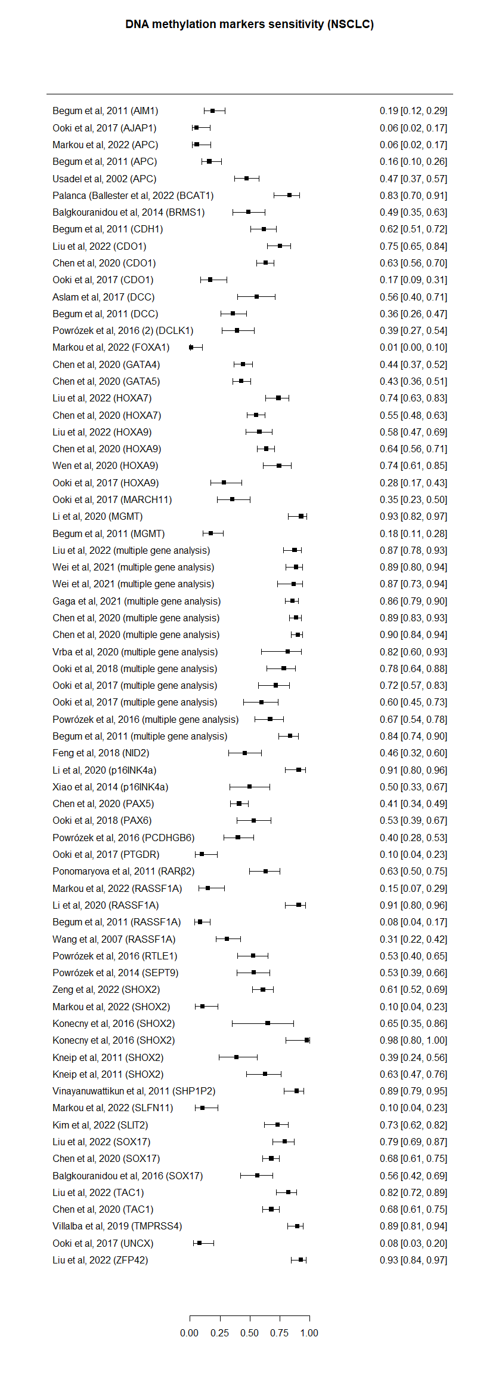
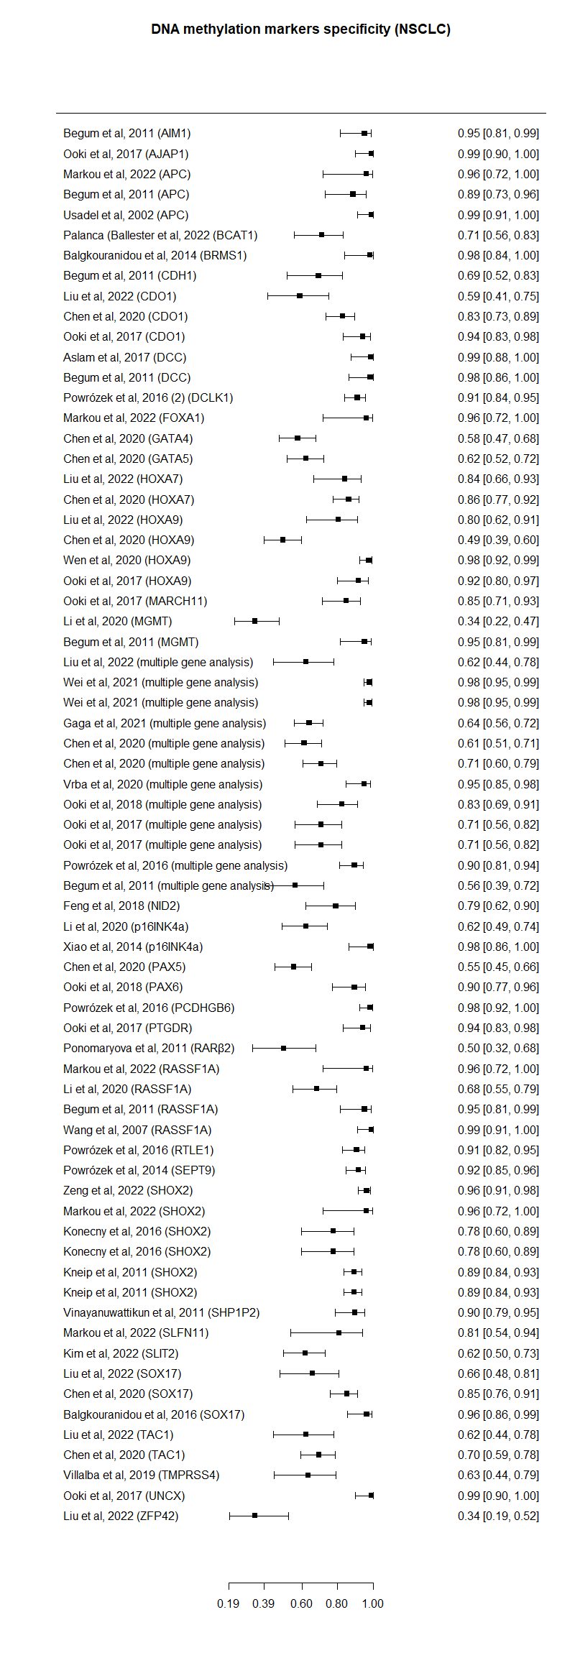
Supplementary Figure S1- Forest plot of individual studies depicting sensitivity (left panel) and specificity (right panel) for non-small cell lung cancer (NSCLC).
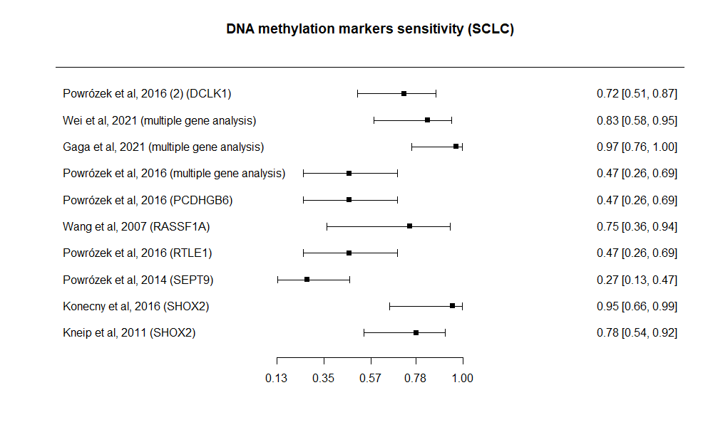
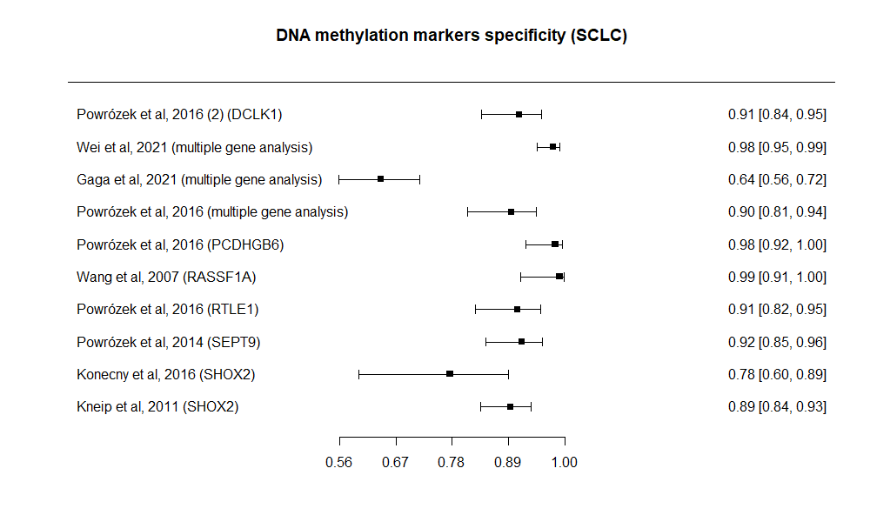
Supplementary Figure S2- Forest plot of individual studies depicting sensitivity (upper panel) and specificity (bottom panel) for small cell lung cancer (SCLC).

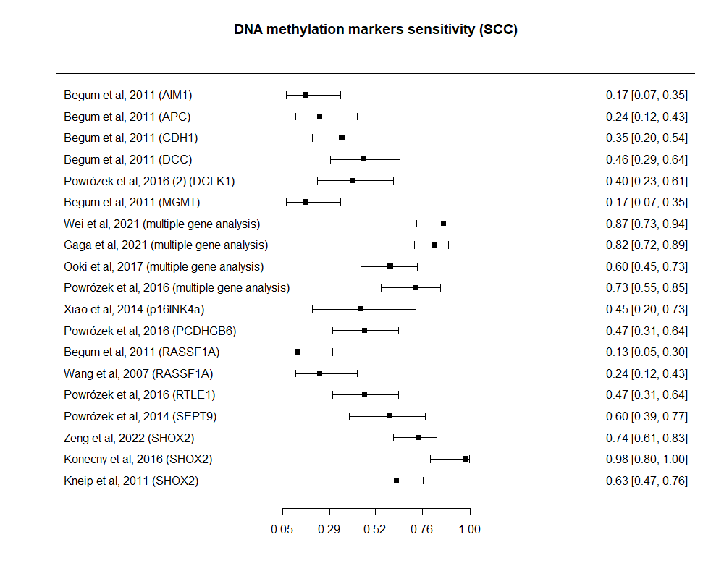
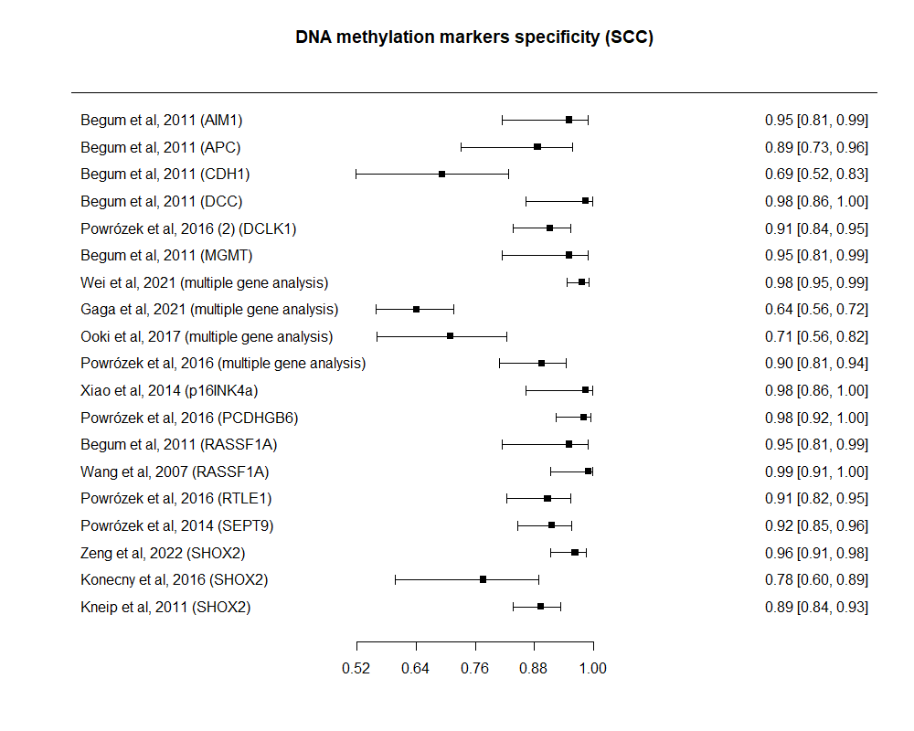
Supplementary Figure S3- Forest plot of individual studies depicting sensitivity (upper panel) and specificity (bottom panel) for squamous cell carcinoma (SCC).

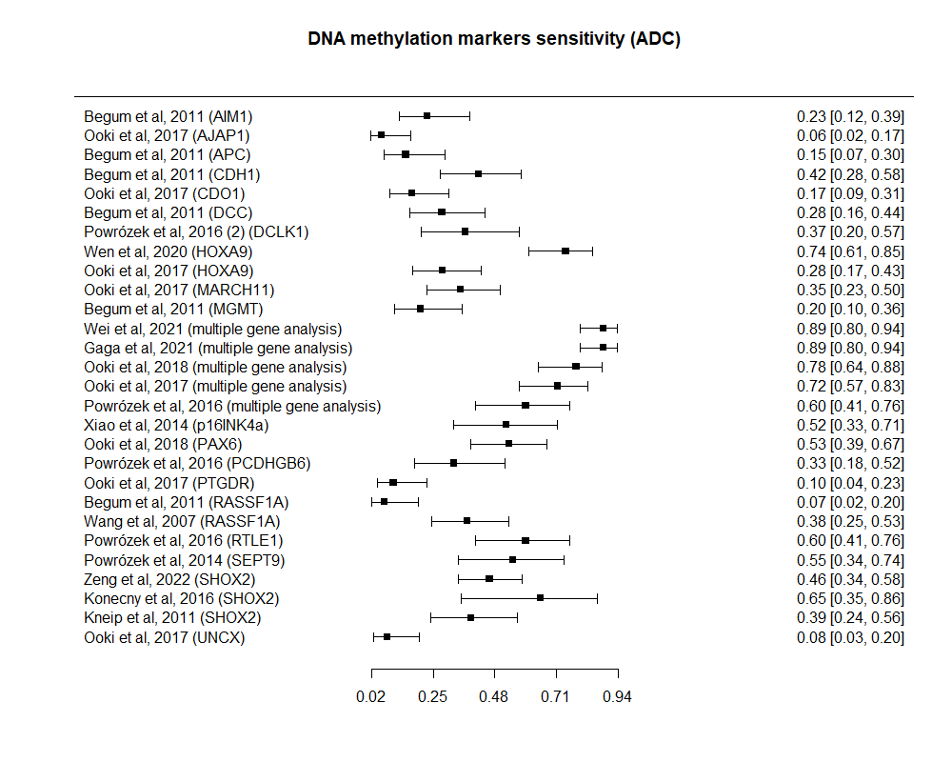
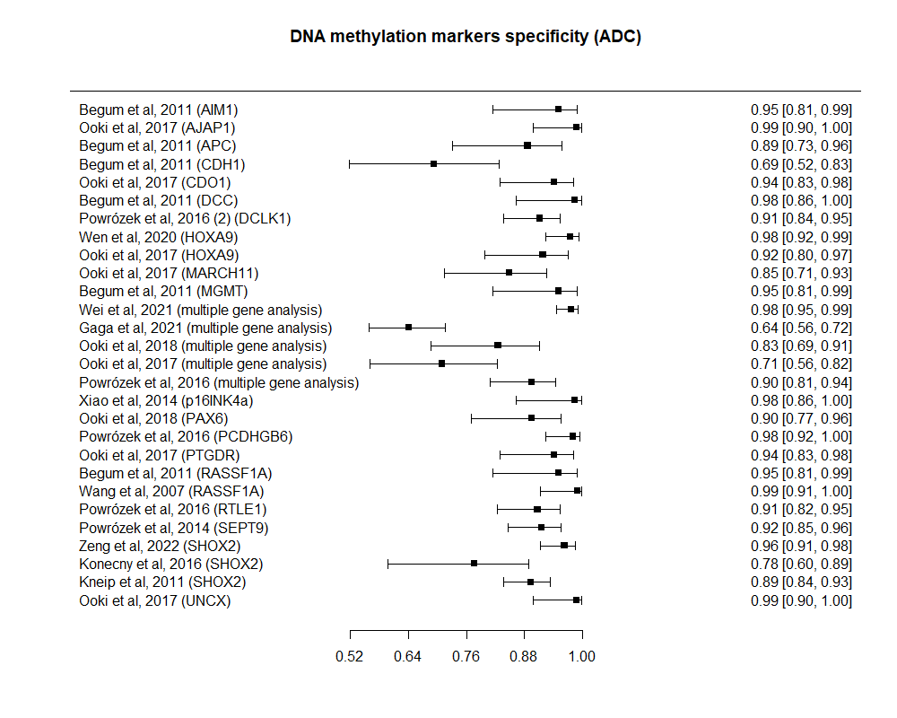
Supplementary Figure S4- Forest plot of individual studies depicting sensitivity (upper panel) and specificity (bottom panel) for adenocarcinoma (ADC).

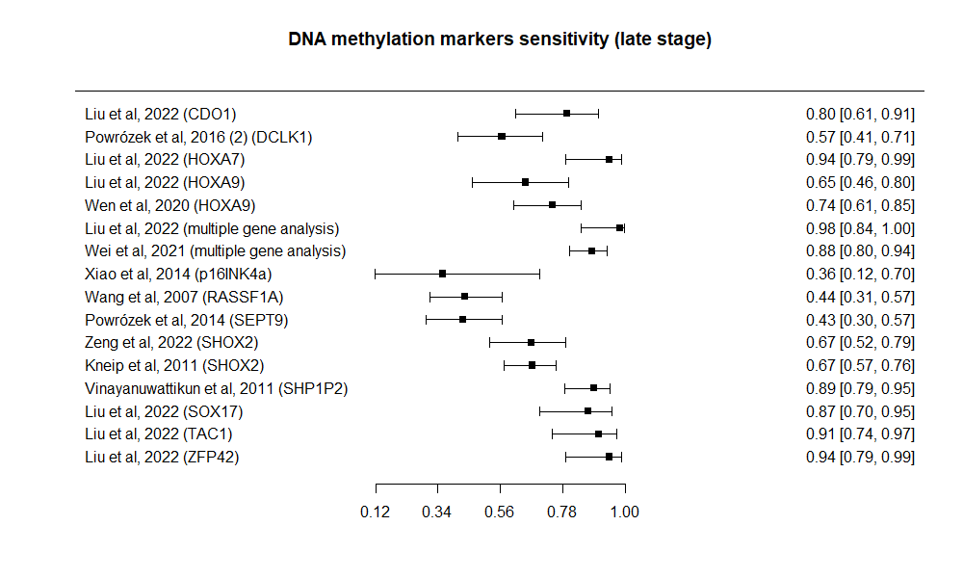
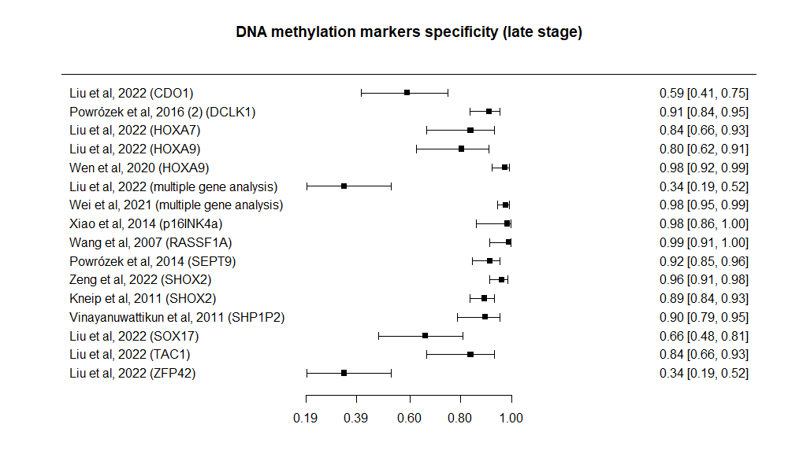
Supplementary Figure S5- Forest plot of individual studies depicting sensitivity (left panel) and specificity (right panel) for late stage disease.

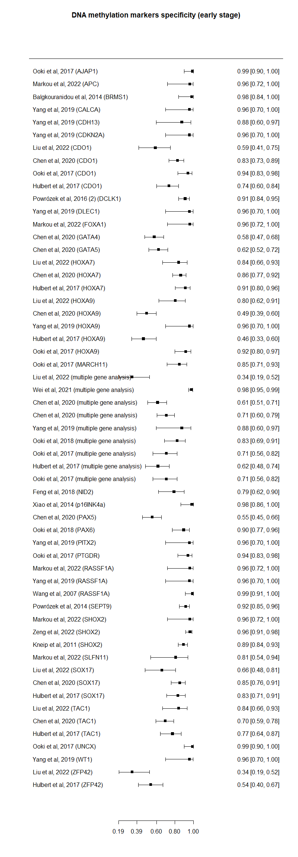
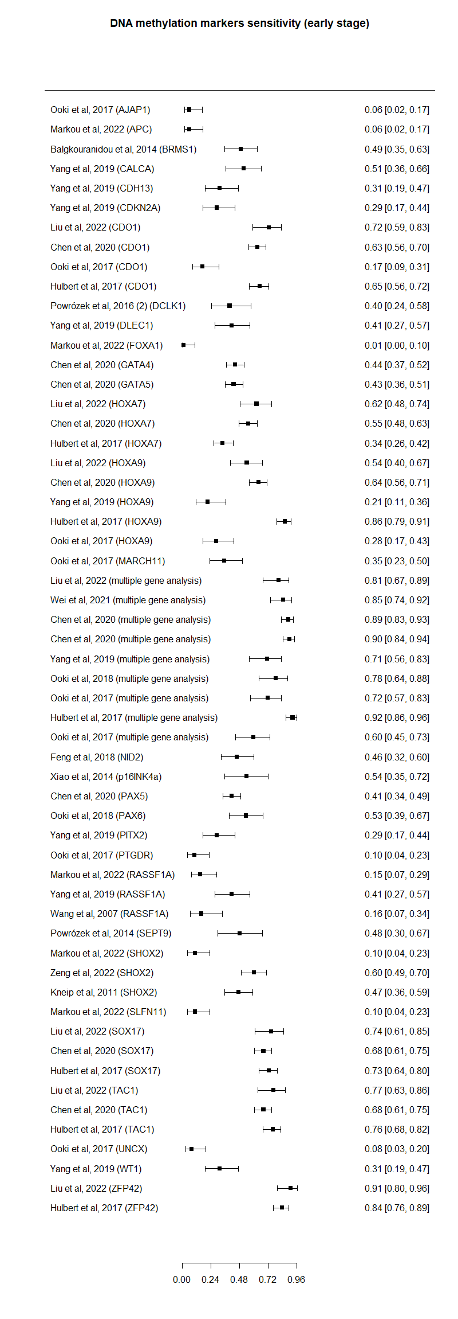
Supplementary Figure S6- Forest plot of individual studies depicting sensitivity (left panel) and specificity (right panel) for early stage disease.
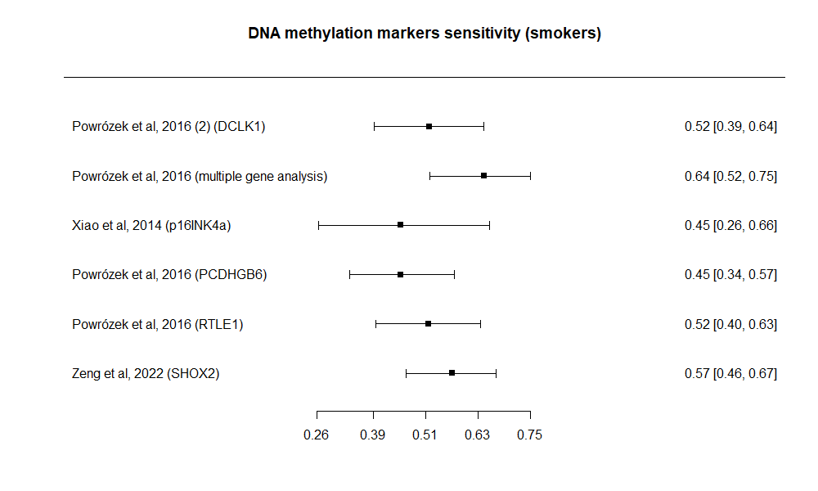
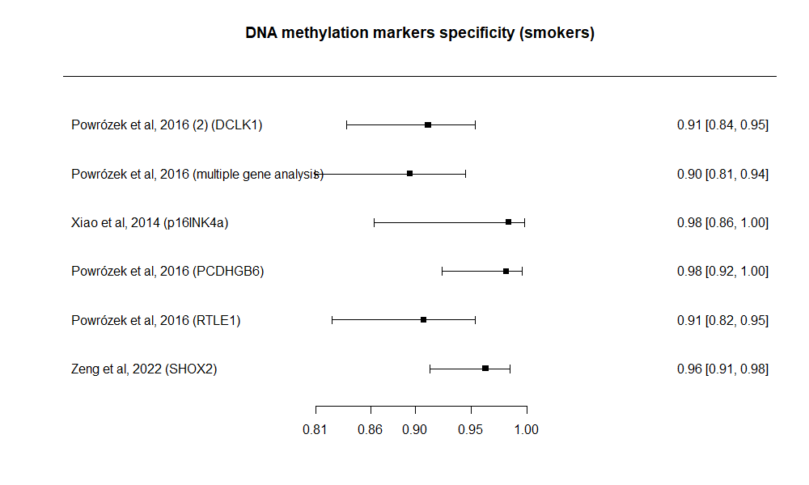
Supplementary Figure S7- Forest plot of individual studies depicting sensitivity (upper panel) and specificity (bottom panel) for smoker status.

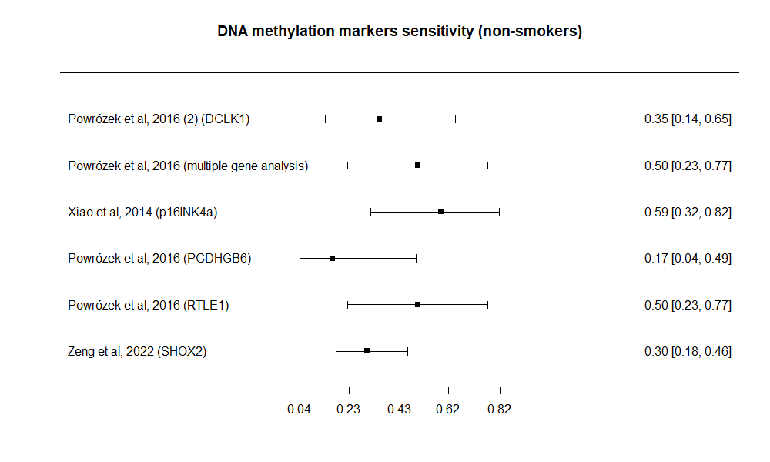
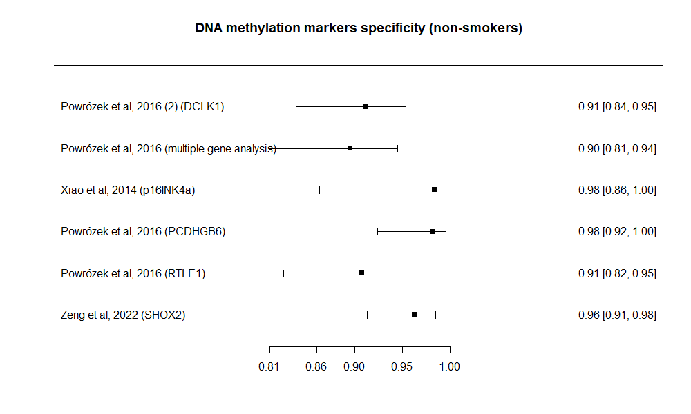
Supplementary Figure S8- Forest plot of individual studies depicting sensitivity (upper panel) and specificity (bottom panel) for non-smoker status.

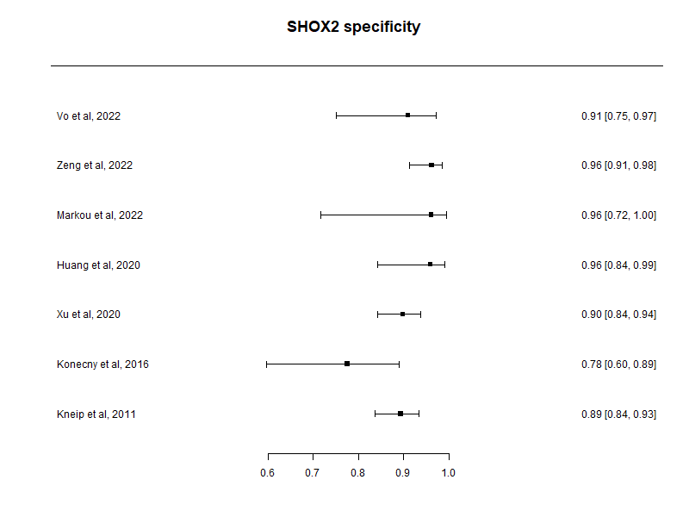
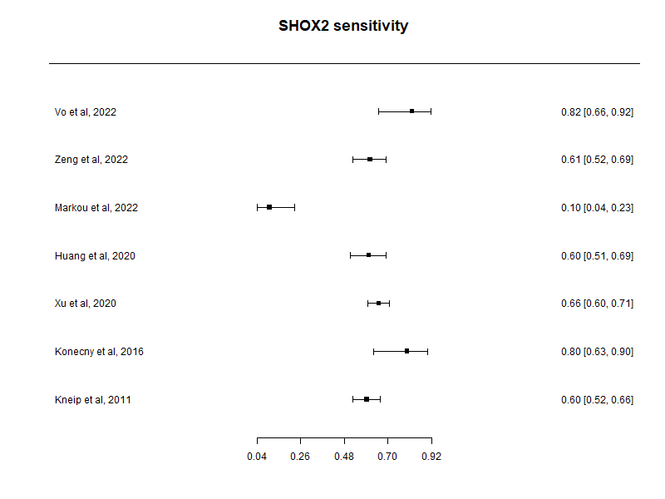
Supplementary Figure S9- Forest plot of individual studies depicting sensitivity (upper panel) and specificity (bottom panel) of SHOX2 methylation.

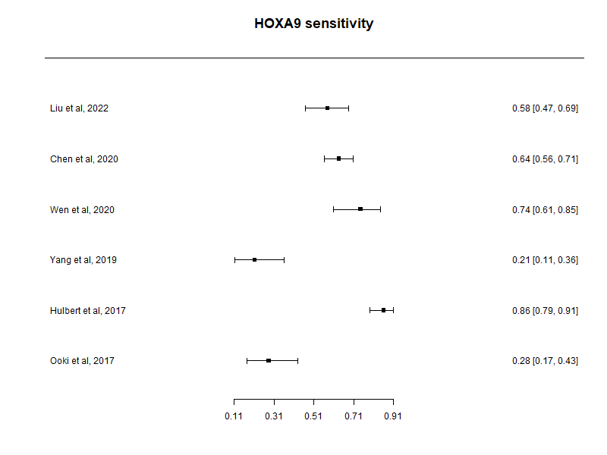
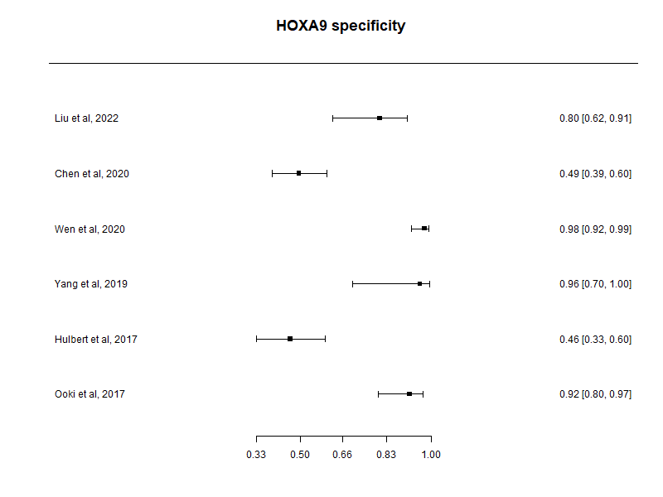
Supplementary Figure S10- Forest plot of individual studies depicting sensitivity (upper panel) and specificity (bottom panel) of HOXA9 methylation.

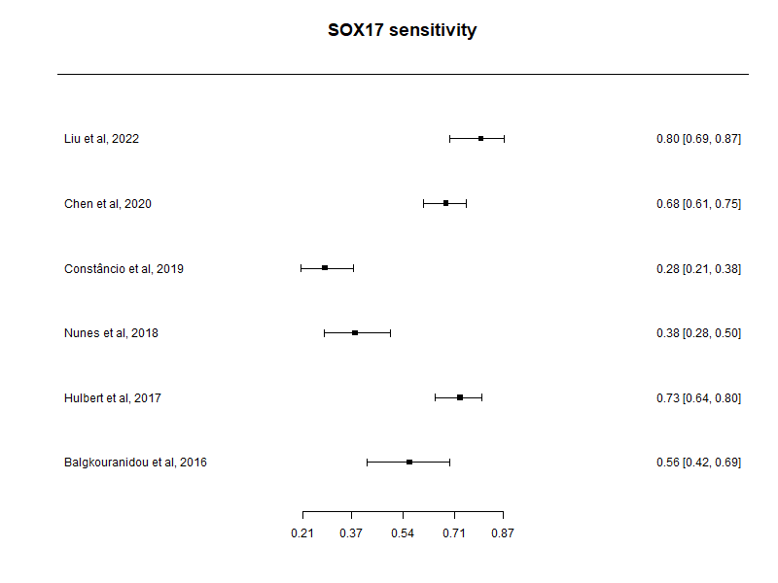
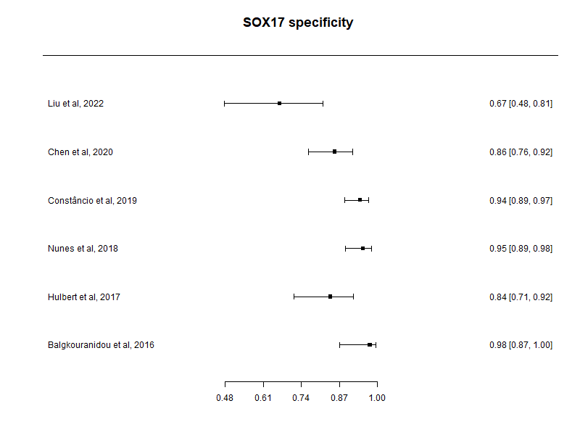
Supplementary Figure S11- Forest plot of individual studies depicting sensitivity (upper panel) and specificity (bottom panel) for SOX17 methylation.

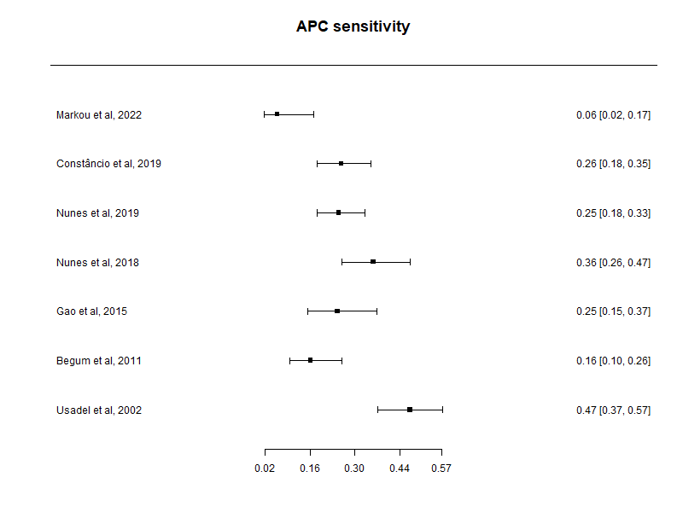
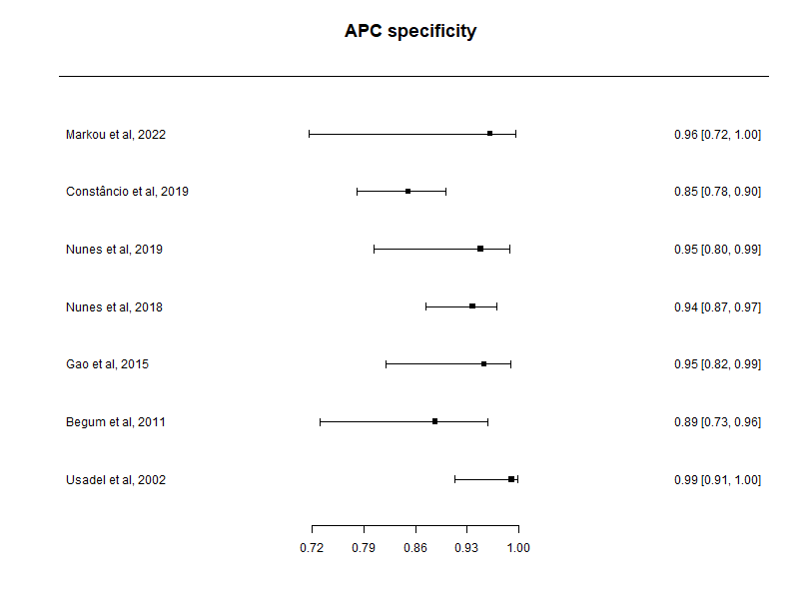
Supplementary Figure S12- Forest plot of individual studies depicting sensitivity (upper panel) and specificity (bottom panel) for APC methylation.

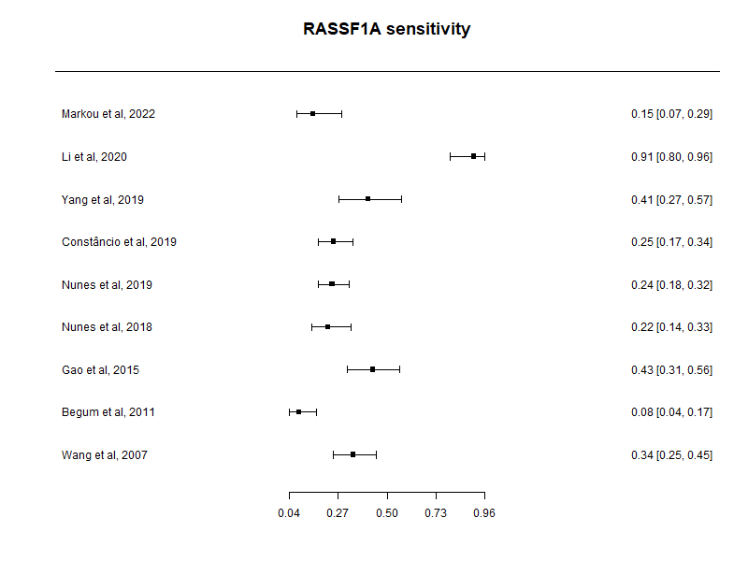
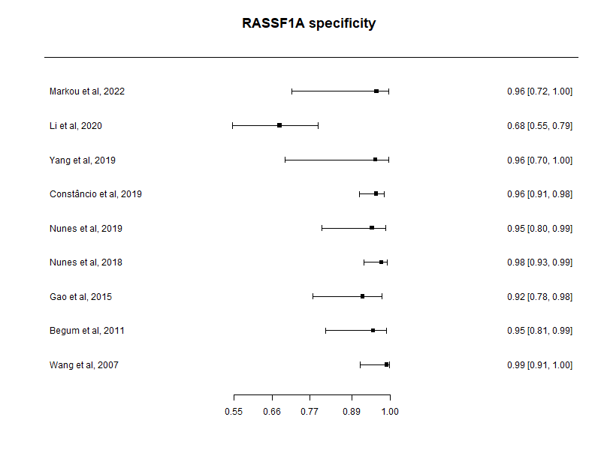
Supplementary Figure S13- Forest plot of individual studies depicting sensitivity (upper panel) and specificity (bottom panel) for RASSF1A methylation.

