Screening for the prevention and early detection of cervical cancer: systematic reviews to inform Canadian recommendations

Pillay J, Gates A, Guitard S, Zakher B, Sim S, Vandermeer B, Hartling L.

Supplementary File 5: Evidence for Key Question 5 on effectiveness of primary care-based interventions screening uptake of under/never screened individuals
Table of Contents
Characteristics of included trials 2
Risk of bias assessment of trials 33
Summary of findings for interventions to increase uptake of cervical cancer screening among under- or never screened individuals with a cervix 36
Subgroup analyses 41
Supplementary Figure 1. Written contact vs. usual care to increase uptake of cervical cancer screening 44
Supplementary Figure 2. Personal contact vs. usual care 45
Supplementary Figure 3. Composite intervention vs. usual care 46
Supplementary Figure 4. Universal mail-out HPV self-sample vs. usual care 47
Supplementary Figure 5. Opt-in HPV self-sample vs. usual care 48
Funnel plots 49
Between trial comparisons by pre-specified populations 54
Within trial comparisons by pre-specified populations 56

Characteristics of included trials
Author & Year  Setting  Design  Funding source | Population characteristics (including definition of under-screened)  N randomized | Interventions and Comparators  Outcome ascertainment  Length of follow-up | Pre-specified populationª  Subgroup analysis^{b}
Abdullah 2013  Kuala Lumpur, Malaysia (40 public secondary schools)  Programmatic details: opportunistic  screening (details NR)  Design: cluster RCT  Funding: Non-industry | Secondary teachers with a cervix working in national secondary schools in Kuala Lumpur who were either naïve to Pap smear or had their last test >3 years ago  Exclusion: NR  Randomized: 403 (40 schools/clusters) | Intervention arm: personal invitation letter with an information pamphlet, and a telephone reminder with counselling after 4 weeks.  Screening test: Pap smear  Comparator arm: usual care - opportunistic  Screening test: Pap smear  Outcome ascertainment: self-report  Length of follow-up: 24 weeks | No  No subgroup analysis
Acera 2017  Cerdanyola, Barcelona, Spain (Cerdanyola Primary Health Care Service)  Programmatic details: majority opportunistic screening (details NR)  Design: cluster RCT  Funding: Non-industry | People with a cervix aged 30 to 70 years whose healthcare provider was assigned to the Cerdanyola SAP area, were residents in the area for more than 6 months and had no record of a cervical cytology result in the medical registry of cervical cancer screening in the last 3.5 years  Exclusion: not residents in the area; hysterectomy; current history of cervical disease; HIV positive; immunosuppressed or dead; screened in private system; basic healthcare centre with high socioeconomic status  Randomized: 15,965 (4 clusters) | Intervention arms: (1) mailed personalized letter signed by the patient’s primary care physician and professionals from public health centre with a pre-assigned date for screening visit; (2) intervention 1 plus an informative leaflet; (3) intervention 1 and 2, plus a telephone call 3 days prior to the appointment date in the invitation letter as a reminder  Screening test: cytology or HPV test  Comparator arm: usual care - opportunistic  Screening test: cytology or HPV test  Outcome ascertainment: registry/records  Length of follow-up: NR (Follow-up not clearly reported; between 3 to 5.5 years) | No  No subgroup analysis
Bais 2007  Netherlands (Amstelland/de Meerlanden and Kennemerland region)  Programmatic details: organized screening at 5-year intervals  Design: RCT  Funding: Industry and non-industry | Non-responder people with a cervix between 30 and 50 years of age at invitation, who according to the Regional Health Council Database (in the area Amstelland/de Meerlanden and Kennemerland) had neither responded to the regular invitation at 5 years nor to the first 6 months reminder between January 2003 and April 2004  Exclusion: pregnancy, breast feeding, prior hysterectomy, treatment by gynecologist or ‘‘other reasons’’ (e.g., emigration, deceased, other illness)  Randomized: 2,830 | Intervention arm: mailed HPV self-sampling kit with a Viba-brush, instructions, an explanatory letter and a pre-paid return envelope  Screening test: HPV self-sampling test or Pap smear  Comparator arm: usual care – organized (mailed an extra recall letter for regular cytology and an explanatory letter)  Screening test: Pap smear  Outcome ascertainment: registry/records  Length of follow-up: 6 months | No  No subgroup analysis
Broberg 2013  Sweden (western region, 71 antenatal health clinics)  Programmatic details: organized and opportunistic screening; Pap smear at 3-year intervals; 5-year intervals for people with a cervix age 51-60 years  Design: RCT  Funding: Non-industry | People with a cervix aged 30 to 53 years with no Pap smear registered for >6 years, People with a cervix aged 54 years with no Pap smear registered for >7 years, and people with a cervix aged 55 to 62 years with no Pap smear registered for >8 years  Exclusion: people with a cervix with a hysterectomy, those not confirmed to be residents of the region during the whole period  Randomized: 8,000 | Intervention arm: mailed invitation letter indicating a midwife would contact them by telephone in 14 days to offer an appointment for screening. Midwives encouraged screening and helped schedule appointments; maximum of 10 attempts were made to contact.  Screening test: Pap smear  Comparator arm: usual care - organized (annual mailed invitations to screening program)  Screening test: Pap smear  Outcome ascertainment: registry/records  Length of follow-up: 12 months | No  No subgroup analysis
Broberg 2014  Sweden (Western region)  Programmatic details: organized and opportunistic screening; Pap smear at 3-year intervals; 5-year intervals for people with a cervix 51-60 years  Design: RCT  Funding: Non-industry | People with a cervix with no registered Pap smear for >6 years if aged 30–53, >7 years if aged 54, and >8 years if aged 55–62, evidence in the regional population register that People with a cervix have been living in the west region of Sweden during this time.  Exclusion: the people with a cervix who had not been invited for screening due to hysterectomy; those not confirmed to be residents in the region during the whole 6–8-year period were excluded from the study.  Randomized: 8,800 | Intervention arm: (1) mailed invitation letter for HPV self-sampling, including information about screening and the cost. Those who accepted (returned a coupon in pre-paid envelope) received the HPV self-test kit. A reminder was sent if a kit was ordered but not returned. Non-attenders were repeatedly contacted, if possible by phone. Ad hoc intervention: People with a cervix not responding to first offer went sent a second invitation 10 weeks after the first invitation, with a reminder for those who ordered but did not return the self-test. 3 months after the ad-hoc reminder annual invitations sent (routine care); (2) mailed information letter about the study and that a midwife would contact them by telephone in 14 days to offer an appointment for screening. The midwife encouraged participation and to help schedule an appointment.  Screening test: (1) HPV self-sampling test or Pap smear, (2) Pap smear.  Comparator arm: usual care – organized (mailed annual invitation for screening).  Screening test: Pap smear.  Outcome ascertainment: registry/records  Length of follow-up: 12 months. | No  No subgroup analysis
Cadman 2015  United Kingdom (Newcastle upon Tyne region)  Programmatic details: organized screening; conventional cytology at 3 or 5-year intervals  Design: RCT  Funding: Non-industry | People with a cervix classified as non-responders (3 or 5 years) according to the North East Primary Care Services Agency (NEPCSA) recall process, previously received their initial screening letter, plus a first reminder letter, plus at least two non-responder cards will have been sent to their General Practitioner, identified using the NEPCSA Exeter National Health Applications and Infrastructure Services (NHAISs) System.  Exclusion: people with a cervix who have written to the NEPCSA to document their refusal to take part in the NHSCSP, contacted the trial team and ask to be excluded from the trial, pregnancy, total abdominal hysterectomy, never been sexually active, identified as becoming pregnant or undergoing hysterectomy following the initial test will be excluded from the analysis of data for secondary outcomes, HPV self-sample returned without a signed Informed Consent Form (ICF) (the Participant Information Leaflet (PIL) will state that samples returned without a signed consent form cannot be processed), or ICF returned with incomplete contact details whereby the test results cannot be sent.  Randomized: 6,000 | Intervention arm: mailed HPV self-sampling kit, Dacron swab, instructions, trial information, and consent form.  Screening test: HPV self-sampling test or conventional cytology.  Comparator arm: usual care - organized (standard mailed invitation for screening).  Screening test: conventional cytology.  Outcome ascertainment: register/records  Length of follow-up: 3 months. | No  Subgroup analysis by socioeconomic status (deprivation quintile)
Decker 2013  Manitoba, Canada  Programmatic details: organized screening; Pap smear at 3-year intervals  Design: cluster RCT  Funding: Non-industry | Unscreened People with a cervix aged 30 to 69 years of age at the date of the invitation letter (index date for the control group) who had no prior invasive gynecological cancer diagnosis or complete hysterectomy, were covered by provincial health care insurance, and had not had mail returned to Manitoba Health.  Exclusion: people with a cervix who may not have been unscreened (i.e., people with a cervix who recently moved to the province).  Randomized: 17,068 | Intervention arm: mailed personal invitation letter and a brochure. 20 of the 27 intervention-group forward sortation areas (clusters) held a Pap test clinic approximately 2 weeks after letters were mailed.  Screening test: Pap smear.  Comparator arm: usual care – organized (nothing received during trial)  Screening test: Pap smear.  Outcome ascertainment: registry/records  Length of follow-up: 6 months. | No  No subgroup analysis
Eaker 2004 (1)  Sweden (Uppsala county)  Programmatic details: organized screening; conventional cytology at 3-year intervals  Design: RCT  Funding: Non-industry | People with a cervix aged 25 to 59 years who were residents in Uppsala County, had not had a Pap smear during the previous 3 years, and had not asked to be excluded from the call-recall system (<1%/year); people with a cervix who did not attend cervical screening, on average, within 5 months after the first intervention.  Exclusion: people with a cervix who recently requested to be excluded from the call-recall system, and people with a cervix who had a Pap smear just before the first intervention.  Randomized: 8,953  Loss to follow-up: 380 (4.2%) | Intervention arm: mailed reminder letter.  Screening test: Pap smear.  Comparator arm: usual care - organized (standard invitation to organized screening)  Screening test: Pap smear.  Outcome ascertainment: registry/records  Length of follow-up: 2 months. | No  Subgroup analysis by socioeconomic status (social welfare [yes/no]), immigrant status (country of birth)
Eaker 2004 (2)  Sweden (Uppsala county)  Programmatic details: organized screening; conventional cytology at 3-year intervals  Design: RCT  Funding: Non-industry | People with a cervix aged 25 to 59 years who were residents in Uppsala County, had not had a Pap smear during the previous 3 years, and had not asked to be excluded from the call-recall system (<1%/year); People with a cervix who did not attend cervical screening, on average, within 5 months after the first intervention; People with a cervix who remained non-compliant 2 months after reminder letter and who had received their first intervention during the first 8 weeks of the study.  Exclusion: people with a cervix who recently requested to be excluded from the call-recall system, people with a cervix who had a Pap smear just before the first intervention, living outside Uppsala municipality.  Randomized: 1,920 | Intervention arm: telephone reminder (2 months after reminder letter non-response) from research assistant to give information and offer to schedule screening.  Screening test: Pap smear.  Comparator arm: usual care - organized (standard invitation to organized screening, no letter reminder, no phone reminder)  Screening test: Pap smear.  Outcome ascertainment: registry/records  Length of follow-up: 1 month. | No  Subgroup analysis by socioeconomic status (social welfare [yes/no]), immigrant status (country of birth)
Elfstrom 2019  Sweden (Stockholm region)  Programmatic details: organized screening; every 3 years for people with a cervix ages 23–50; every 5 years for people with a cervix ages 51–60 years  Design: RCT  Funding: Non-industry | People with a cervix who (i) did not have an organized screening test on record for ≥10 years (people with a cervix ages 33–60, by definition), (ii) had been sent at least 10 annual renewed invitations and (iii) were not blocked from invitations due to hysterectomy or actively opting-out of the screening program.  Exclusion: active refusers  Randomized: 8,000 | Intervention arm: (1) HPV self-sampling kit sent directly to people with a cervix with a study invitation letter and instructions (2) invitation to order a HPV self-sampling kit through an online application (3) invitation to call the region’s coordinating midwife with potential questions and concerns about screening  Screening test: HPV self-sample or Pap smear  Comparator arm: usual care - organized (standard annual renewed invitation).  Screening test: Pap smear  Outcome ascertainment: register/records  Length of follow-up: 90 days | No  No subgroup analysis
Enerly 2016  Oslo, Norway  Programmatic details: organized screening; conventional or liquid-based cytology at 3-year intervals  Design: RCT  Funding: Non-industry | People with a cervix 26-69 years of age without any cytology, HPV, or histology result recorded in the Norwegian Cervical Cancer Screening Programme registries within 12 months of the 1st reminder, i.e. those who were due to receive the 2nd reminder (4 years).  Exclusion: NR.  Randomized: 3,393 | Intervention arm: mailed invitation letter and 3 weeks later received one of two HPV self-sampling devices (Evalyn brush or Delphi screener), with instructions, informed consent form, pre-paid return envelope, and questionnaire.  Screening test: HPV self-sampling test or Pap smear.  Comparator arm: usual care – organized (second mailed reminder letter).  Screening test: Pap smear.  Outcome ascertainment: registry/records  Length of follow-up: 9 months. | No  No subgroup analysis
Fujiwara 2015  Japan (local medical association’s network, 8 urban clinics)  Programmatic details: organized screening; Pap smear at 3-year intervals  Design: RCT  Funding: Non-industry | People with a cervix aged 20 to 39 years who had not participated in the screening in 2013 (not screened in 1 year).  Exclusion: NR.  Randomized: 1,912 | Intervention arm: (1) mailed reminder letter with information on benefits of screening; (2) mailed reminder letter with information on benefits and risks of screening.  Screening test: HPV test or Pap smear.  Comparator arm: usual care – organized (mailed reminder letter with simple information).  Screening test: HPV test or Pap smear.  Outcome ascertainment: registry/records  Length of follow-up: 4 months. | No  No subgroup analysis
Giorgi Rossi 2011  Italy (3 regions: Florence [Tuscany], Rome southern city [Lazio] & Teramo [Abruzzo])  Programmatic details: organized screening; Pap smear at 3-year intervals  Design: RCT  Funding: Non-industry | People with a cervix aged 35 to 64 years who had been invited by the screening programme in the previous months and had failed to respond were eligible for mail recall (i.e., had not be screened in >3 years).  Exclusion: NR.  Randomized: 2,480 | Intervention arm: (1) mailed letter indicating a self-sampling test would be sent. 1 week later sent an HPV self-sampling kit, instructions, presentation letter, information leaflet, informed consent form, questionnaire, and pre-paid return envelope; (2) mailed invitation to call to receive a self-sampling device (at clinic or mailed) and an information leaflet; those requesting the test received the HPV self-sampling kit as intervention 1.  Screening test: HCII HPV self-sampling test or Pap smear.  Comparator arm: usual care - organized ([1] standard recall letter to perform Pap test at a pre-fixed date at the clinic; [2] standard recall letter to perform HPV test at a pre-fixed date at the clinic).  Screening test: HPV self-sampling test or Pap smear.  Outcome ascertainment: registry/records  Length of follow-up: 3 months. | No  Subgroup analysis by area of residence (rural/urban)
Giorgi Rossi 2015  Italy (six local health authorities in Bologna, Rome, Teramo, Molise, Este-Monselice & Pieve di Soligo)  Programmatic details: organized screening; Bologna, Pieve di Soligo & Molise: conventional cytology at 3-year intervals; Teramo, Rome & Este-Monselice: HPV screening & cytology triage at 5-year intervals  Design: RCT  Funding: NR | People with a cervix aged 30 to 64 years who had been invited by the screening programme in the previous months and had failed to respond were eligible for mail recall (i.e., had not be screened in >3 years).  Exclusion: NR.  Randomized: 14,041 | Intervention arm: (1) mailed letter indicating a self-sampling test would be sent. 1 week later sent an HPV self-sampling kit, Delphi Screener, instructions, presentation letter, information leaflet, informed consent form, short questionnaire, and pre-paid return envelope; (2) mailed letter offering opportunity to pick up HPV self-sampling kit at a pharmacy and an information leaflet; those requesting the test received the HPV self-sampling kit as intervention 1.  Screening test: HPV self-sampling test.  Comparator arm: usual care – organized (mailed recall letter for Pap smear or HPV test at a clinic on a scheduled date).  Screening test: HPV test or Pap smear.  Outcome ascertainment: registry/records  Length of follow-up: 3 months. | Yes (rural)  Subgroup analysis by area of residence (rural/urban)
Gok 2010  Netherlands (Noord-Holland and Flevoland regions)  Programmatic details: organized screening; Pap smear at 5-year intervals  Design: RCT  Funding: Industry & non-industry | People with a cervix invited for the cervical cancer screening program (ages 30 to 60 years), but who are not responding to their invitation as well as their recall (three months after), residing in the region covered by district health authorities of North Holland and Flevoland (in the Netherlands) (i.e., had not been screened in >5 years).  Exclusion: not called for screening, i.e., ages under 30 years, or over 60 years, actively responded to the invitation or first recall of the cervical screening program by undergoing a cervical smear at the general practitioner, living outside the region covered by district health authorities of North Holland and Flevoland, under follow-up by gynaecologist for previous non-normal cytology, i.e., abnormal cytology and/or CIN three lesion or worse less than two years before inclusion, current pregnancy, status after extirpation of the uterus or amputation of the portio.  Randomized: 28,073 | Intervention arm: mailed an HPV self-sampling kit with lavage device (delphi screener), with an explanatory letter, instructions, informed consent form and a return box.  Screening test: HPV self-sampling kit.  Comparator arm: usual care – organized (mailed an official second reminder to visit their physician for conventional cytology screening, an explanatory letter and informed consent form).  Screening test: Pap smear (conventional cytology).  Outcome ascertainment: registry/records  Length of follow-up: 12 months. | No  Subgroup analysis by immigrant status (country of birth; Gok 2012).
Gok 2012  Netherlands (Noord-Holland and Flevoland regions)  Programmatic details: organized screening; screening at 5-year intervals  Design: RCT  Funding: Non-industry | People with a cervix age 30-60 years who lived in the region Noord-Holland or Flevoland and, according to the database of the Regional Health Council, had not attended the organised cervical screening program in the year 2006 after the regular and reminder invitation (3 months later) (i.e., had not been screened in >5 years).  Exclusion: not called for screening (i.e., ages under 30 years, or over 60 years), actively responded to the invitation or first recall of the cervical screening program by undergoing a cervical smear at the general practitioner, living outside the region covered by district health authorities of North Holland and Flevoland, under follow-up by gynaecologist for previous abnormal cytology, and/or CIN3 lesion or worse less than 2 years before inclusion, current pregnancy, status after extirpation of the uterus or amputation of the portio.  Randomized: 26,409 | Intervention arm: mailed notice of study and possibility of receiving an HPV self-sampling kit or second re-invitation for regular cytology. 1 week later mailed an HPV self-sampling kit with a Viba-brush, instructions, an explanatory letter, informed consent form and a return envelope.  Screening test: HPV self-sampling test.  Comparator arm: usual care – organized (official mailed second reminder to visit their physician for cytology, an explanatory letter and informed consent form).  Screening test: conventional cytology.  Outcome ascertainment: registry/records  Length of follow-up: 12 months. | No  Subgroup analysis by immigrant status (country of birth; Gok 2012).
Haguenoer 2014  Indre-et-Loire, France  Programmatic details: organized screening; Pap smear at 3-year intervals  Design: RCT  Funding: Non-industry | People with a cervix aged 30 to 65 years and had not had a recent Pap smear despite an invitation 9 months previously (i.e., had not been screened in >3 years).  Exclusion: had a smear in the past 3 years, had a hysterectomy (including cervix), had never had sexual intercourse, had a cervical abnormality that was under exploration and/or treatment.  Randomized: 6,000 | Intervention arm: (1) mailed HPV self-sampling kit, nylon-flocked swab, instructional leaflet, recall invitation letter, identification sheet, pre-paid return envelope (if uninterpretable, sent a second test); (2) mailed recall invitation letter to receive screening at gynecologist or midwife.  Screening test: (1) HPV self-sampling or Pap smear; (2) Pap smear.  Comparator arm: usual care – organized (nothing received during trial)  Screening test: Pap smear.  Outcome ascertainment: registry/records  Length of follow-up: 12 months. | No  No subgroup analysis
Heranney 2011  Alsace, France (Association Eve centre)  Programmatic details: organized screening; Pap smear at 3-year intervals for persons with a cervix ages 26 to 65 years  Design: RCT  Funding: NR | Alsatian people with a cervix aged 50 to 65 years who had no smear within the previous 3 years and all non-screened people with a cervix aged 25 to 65 years living in the 3 sectors that were the direct target of sensitization efforts (rural areas), could be contacted by telephone.  Exclusion: smear within the last 3 years; a total hysterectomy for a non-malignant cause; no sexual activity; refusal to participate; death since invitation.  Randomized: 10,662 | Intervention arm: telephone reminder to encourage making an appointment for screening; 10 attempts were made to contact.  Screening test: Pap smear.  Comparator arm: usual care – organized (mailed reminder letter signed by the president of Association Eve with a reply coupon and prepaid return envelope).  Screening test: Pap smear.  Outcome ascertainment: registry/records  Length of follow-up: 8 months. | Yes (rural)  No subgroup analysis
Ivanus 2018  Slovenia (Celje & Maribor regions)  Programmatic details: organized screening; conventional cytology at 3-year intervals  Design: pilot RCT  Funding: Industry and non-industry | People with a cervix aged 30 to 64 years, had no cytology result registered in the National Cervical Cancer Screening Registry (ZORA) in the last 4 years, and their permanent residence in the Celje or Maribor regions, no recorded hysterectomy in the ZORA registry.  Exclusion: none reported for the outcome of interest, however, some enrolled people with a cervix were later excluded from further involvement in the study for various reasons such as: returned mail due to unknown address, rejection of participation in the study, death during study; pregnancy, never had an intimate relationship (virgins), living abroad, or new information regarding a hysterectomy prior year 2004.  Randomized: 26,556 | Intervention arm: (1) mailed invitation letter to order an HPV self-sampling kit or make an appointment with their personal gynecologist, an information leaflet, questionnaire and pre-paid return envelope. 1 week after ordering, people with a cervix were sent the HPV self-sampling kit. Non-responders sent two reminders within a month, and a reminder sent 3 weeks after the kit was sent to people with a cervix who ordered but did not return the kit; (2) mailed letter informing people with a cervix they would be sent an HPV self-sampling kit if they opt-out, and an information leaflet, questionnaire, and pre-paid return envelope. Self-sampling kits mailed 2 weeks after the invitation was sent.  Screening test: HPV self-sampling test or conventional cytology.  Comparator arm: standard mailed invitation for screening, information leaflet, questionnaire and pre-paid return envelope (usual care).  Screening test: conventional cytology.  Outcome ascertainment: registry/records  Length of follow-up: 12 months. | No  No subgroup analysis
Jalili 2019  Manitoba, Canada  Programmatic details: organized screening; Pap smear at 3-year intervals  Design: RCT  Funding: Industry | Under-screened and non-responding alive people with a cervix aged 30 to 65 years, with valid health coverage in Manitoba (i.e., not screened in ≥3 years).  Exclusion: out-of-province address, record of a Pap test, colposcopy, or hysterectomy, invasive gynecologic cancer diagnosis in the registry, people with a cervix whose mail had previously been returned to the screening program.  Randomized: 1,100 | Intervention arm: mailed HPV self-sampling kit, instructions, invitation letter, educational brochure, consent form, pre-paid return envelope; 8 weeks later mailed a reminder letter to non-responders.  Screening test: Cobas 4800 HPV self-sampling test or Pap smear.  Comparator arm: usual care – organized (nothing received during trial)  Screening test: Pap smear.  Outcome ascertainment: registry/records  Length of follow-up: 6 months. | No  Subgroup analysis by area of residence (rural/urban).
Jibaja-Weiss 2003  Houston, Texas (2 urban community health centres)  Programmatic details: opportunistic screening (details NR)  Design: RCT  Funding: Non-industry | African-American, Mexican-American, and non-Hispanic white People with a cervix aged 18 to 64 years who were registered as patients at two urban community health centers, had not received a mammogram or Pap test during the past 2 years, had no more than two visits for an acute or chronic illness within the past 2 years, had a mailing address verified by a telephone contact.  Exclusion: people with a cervix who had active cervical or breast cancer, had other serious illnesses likely to result in hospitalization or recurring clinic visits, had received a Pap test from a local provider.  Randomized: 1,574 | Intervention arm: (1) mailed personally tailored letter; (2) mailed generic letter.  Screening test: Pap smear.  Comparator arm: usual care - opportunistic  Screening test: Pap smear.  Outcome ascertainment: registry/records  Length of follow-up: 12 months. | Yes (low-income)  No subgroup analysis
Kellen 2018  Belgium (13 Flemish municipalities)  Programmatic details: organized screening; Pap smear at 3-year intervals  Design: RCT  Funding: Non-industry | People with a cervix, invited by the Centre for Cancer Detection at least once, aged 30–64 years, eligible for screening, without any cytology, histology or pathological result recorded since 2008, residing in the study region (i.e., not screened in ≥3 years).  Exclusion: being pregnant, having had a hysterectomy, a recent Pap smear or cervical cancer.  Randomized: 35,895 | Intervention arm: (1) mailed HPV self-sampling kit, Qvintip brush, instructions, a recommendation letter, consent form, informative flyer and a pre-paid return envelope. After 4 months a reminder letter was sent to non-responders; (2) mailed letter with offer of ordering an HPV self-sampling kit, an informative flyer and a link to the study website with instructions how to use the self-sampling device; After 4 months a reminder letter was sent to non-responders.  Screening test: HPV self-sampling test or Pap smear.  Comparator arm: usual care – organized ([1] nothing received during trial intervention; [2] normal mailed invitation letter of Flemish screening program to have a Pap smear).  Screening test: Pap smear.  Outcome ascertainment: registry/records  Length of follow-up: 12 months. | No  No subgroup analysis
Kiran 2018  Toronto, Canada (large primary care organization, 6 clinics)  Programmatic details: organized screening (details NR)  Design: RCT  Funding: Non-industry | People with a cervix aged 21 to 74 years who were enrolled to a physician at St. Michael's Hospital Academic Family Health Team as of March 31, 2015, eligible and overdue for cervical, breast, and/or colorectal cancer screening, were verified by their physician as appropriate for outreach. People with a cervix were due for cervical screening if they had not been screened in at least 3 years.  Exclusion: people with a cervix whose physician noted that they should not be contacted for screening; the physician requested a specific mode of outreach; the patient did not have an address and phone number on file.  Randomized: 5,270 | Intervention arm: telephone call reminder from trained undergraduate student or clerical staff; 2 attempts to call.  Screening test: Pap smear.  Comparator arm: usual care – organized (mailed reminder letter signed by their physician and educational brochure).  Screening test: Pap smear.  Outcome ascertainment: registry/records  Length of follow-up: 6 months. | No  No subgroup analysis
Kitchener 2016  Greater Manchester, England & Grampian, Scotland  Programmatic details: organized screening (details NR)  Design: cluster RCT  Funding: Non-industry | People with a cervix aged 25 years in three Greater Manchester Primary Care Trusts, and people with a cervix aged 20 years in Grampian, both of which had not been screened six months after the initial phase 1 invitation (i.e., had not responded to their first invitation to be screened).  General practices (cluster randomization unit) were eligible if they engaged in cervical screening as part of the NHS national programme.  Exclusion: People with a cervix not aged 25 (or 20) and receiving their first invitation for screening, pregnant People with a cervix, no cervix, People with a cervix who have made an informed decision not to participate in the cervical screening programme, screened in phase 1, three-month delay in starting phase 2, change of address.  Randomized: 10,126 | Intervention arm: (1) mailed HPV self-sampling kit, either the Delphi lavage or Rovers Evalyn-brush, instructions, information sheet, consent form, and return packaging; (2) mailed invitation to receive a self-sampling kit. If requested sent an HPV self-sampling kit as described in intervention 1; (3) mailed information letter about the trial, a second standard reminder letter with ways to contact a study nurse and book a screening appointment; (4) mailed invitation for screening from the general practice with a scheduled appointment for screening, (5) mailed letter offering choice between having access to a nurse navigator or a self-sampling kit on request.  Screening test: Cobas 4800 HPV self-sampling test or Pap smear.  Comparator arm: usual care – organized (standard invitation).  Screening test: Cobas 4800 HPV self-sampling test or Pap smear.  Length of follow-up: 10.5 months since the start of phase 2 (18 months since start of phase 1) | No  No subgroup analysis
Lilliecreutz 2020  Ostergotland, Sweden  Programmatic details: organized screening; Pap smear at 3-year intervals  Design: RCT  Funding: Non-industry | People with a cervix who had not participated in the cervical cancer screening programme during the last 6 years if aged 30-49 and the last 8 years if aged 50-64.  Exclusion: all people with a cervix 30-64 years old that had participated after the last invitation as recommended in the cervical cancer screening program.  Randomized: 10,614 | Intervention arm: (1) mailed invitation letter and telephone call within a month by midwives offering either a Pap smear at clinic or mailed HPV self-sampling kit. 3 attempts made to contact by telephone; (2) mailed invitation letter with an HPV self-sampling kit and pre-paid return envelope, followed by a reminder letter for non-responders. Both interventions also received usual care.  Screening test: (1) HPV self-sampling test or Pap smear; (2) HPV self-sampling test.  Comparator arm: usual care – organized (yearly mailed invitation to people with a cervix)  Screening test: Pap smear.  Outcome ascertainment: registry/records  Length of follow-up: 6 months. | No  No subgroup analysis
Lonnberg 2016  Norway (3 screening centres)  Programmatic details: organized screening; conventional or liquid-based cytology at 3-year intervals  Design: pilot RCT  Funding: Non-industry | People with a cervix aged 25-69 years due to receive their reminder to screen after having failed to participate in the past ~4 years, and 12 months after having received their primary invitation; current address with a postal code designating an area close to one of three participating screening centres.  Exclusion: NR  Randomized: 1,087 | Intervention arm: mailed reminder letter with pre-scheduled appointment; letters mailed 2-4 weeks before scheduled appointments.  Screening test: cytology (conventional or liquid-based).  Comparator arm: usual care – organized (standard reminder letter).  Screening test: cytology (conventional or liquid-based).  Outcome assessment: registry/records  Length of follow-up: 6 months. | No  No subgroup analysis
Morrell 2005  New South Wales, Australia  Programmatic details: organized screening; Pap smear at 2-year intervals  Design: RCT  Funding: NR | A random sample of people with a cervix aged 20-69 years whose last Pap test occurred ≥48 months ago.  Exclusion: NR  Randomized: 90,247 | Intervention arm: mailed reminder letter (2 interventions combined in analysis; 1 letter had a more sympathetic tone, but no difference in effect was detected between letter types so they were analyzed together).  Screening test: Pap smear.  Comparator arm: usual care – organized (nothing received during trial)  Screening test: Pap smear.  Outcome ascertainment: register/records  Length of follow-up: 90 days. | No  Subgroup analysis by area of residence (rural/urban), socioeconomic status (socioeconomic quintile)
Mullins 2009  Victoria, Australia  Programmatic details: organized screening; Pap smear at 2-year intervals  Design: RCT  Funding: NR | People with a cervix aged 65–69 who had not had a Pap test for ≥3 years, and were not known to have had a hysterectomy.  Exclusion: NR  Randomized: 15,000 | Intervention arm: (1) targeted personal mailed reminder letter with a fact sheet; (2) general personal mailed reminder letter with a fact sheet.  Screening test: Pap smear.  Comparator arm: usual care – organized (nothing received during trial)  Screening test: Pap smear.  Length of follow-up: 10 to 11 weeks. | No  No subgroup analysis
Murphy 2016  Baltimore, Maryland, United States (John Hopkins Hospital Moore Clinic for HIV Care)  Programmatic details: opportunistic screening  Design: RCT  Funding: Non-industry | People with a cervix over age 18, with HIV infection, attending the Adult HIV Clinic for a primary HIV care visit, whose last cervical cancer screening occurred ≥18 months from the baseline visit date, and who agreed to have a cytology test for cervical cancer screening at the hospital where the HIV clinic is based, can speak and read English.  Exclusion: history of hysterectomy, current pregnancy or recent cervical screening.  Randomized: 94 | Intervention arm: HPV self-sampling device given with cytobrush at HIV clinic with instructions given and a $15 gift card for participation.  Screening test: HPV self-sampling test.  Comparator arm: encouragement to have a Pap test during HIV clinic visit, 2-3 weeks later received phone call reminder and $15 gift card for participation in baseline visit (routine care).  Screening test: Pap smear.  Outcome ascertainment: HPV self-sample done at clinic visit/Pap test based on medical records  Length of follow-up: 6 months (183 days) for Pap test. | No  No subgroup analysis
Oscarsson 2007  Kalmar County, Sweden  Programmatic details: organized screening; Pap smear at 3-year intervals  Design: RCT  Funding: Non-industry | People with a cervix age 28–65 years in Kalmar County, January 2004, who had no registered cervical smear during the last 5 years.  Exclusion: people with a cervix who underwent a cervical smear in another county, had hysterectomy, or were handicapped.  Randomized: 800 | Intervention arm: resource-intensive intervention including mailed invitation letters, telephone interviews and promotional efforts by study midwife.  Screening test: Pap smear.  Comparator arm: usual care – organized (normal contacts according to screening program).  Screening test: Pap smear.  Outcome ascertainment: registry/records  Length of follow-up: 12 months. | Yes (rural)  No subgroup analysis
Paulauskiene 2019  Lithuania (personal healthcare centers of the Hospital of Lithuanian University of Health Sciences Kauno Klinikos)  Programmatic details: opportunistic and some organized screening; conventional cytology at 3-year intervals (each healthcare centre chooses their preferred invitation method)  Design: RCT  Funding: no external funding | All eligible people with a cervix aged 25-60 years registered at the primary healthcare centre and have not had screening for ≥3 years.  Exclusion: People with a cervix aged 59-60 years or older, had a Pap smear in private clinic, changed clinic, refused to participate, pregnant or have other health issues, other reasons.  Randomized: 3,294 | Intervention arm: mailed personal invitation letter with an information leaflet, pre-booked appointment and a second identical reminder letter after 12 months of non-response.  Screening test: conventional cytology.  Comparator arm: usual care - opportunistic  Screening test: conventional cytology.  Outcome ascertainment: registry/records  Length of follow-up: 12 months (first invitation, NR for reminder letter). | No  No subgroup analysis
Peeters 2020  Schepdaal, Belgium (1 practice, Flemish municipality)  Programmatic details: organized screening; Pap smear at 3-year intervals  Design: RCT  Funding: Non-industry | People with a cervix between 25 and 64 years old who did not have a Pap smear taken in the last 3 years at the day of her consultation.  Exclusion: NR.  Randomized: 88 | Intervention arm: HPV self-sampling kit with instructions, pre-paid envelope and an Evalyn brush at GP visit. Samples taken at home and mailed to the laboratory or brought back to GP practice.  Screening test: HPV self-sampling test.  Comparator arm: usual care – organized (GPs also encouraged participants to make an appointment for a Pap smear)  Screening test: Pap smear.  Outcome ascertainment: registry/records  Length of follow-up: Up to 5 months | No  No subgroup analysis
Peitzmeier 2016  Boston, Massachusetts, United States (Fenway health)  Programmatic details: opportunistic screening; Pap smear at 3-year intervals; people with a cervix ≥30 years may receive HPV co-testing at 5-year intervals  Design: RCT  Funding: Non-industry | Patients overdue for a Pap test as of 31 December 2012 (from January 2010) with a cervix (female or female-to-male transgender), and with a medical appointment at Fenway Community Health during calendar year 2012. Patients were considered overdue if they had not been screened in 3 years.  Exclusion: people with a cervix with HIV, male-to-female transgender patients, patients with a history of hysterectomy (unless specified as partial or supracervical), patients aged 30-64 who had a negative Pap test in the past 5 years with simultaneous negative HPV co-testing, cervical cancer diagnosis, no cervix.  Randomized: 1,100 | Intervention arm: 3 waves of outreach at 1-month intervals for each intervention. (1) mailed invitation letter signed by provider and Centres for Disease Control and Prevention educational flyer; (2) e-mailed personal invitation from provider e-mail and Center for Disease Control and Prevention educational flyer; (3) telephone invitation to schedule screening; (4) multimodal invitations (interventions 1, 2 and 3 used in sequence at 1-month intervals).  Screening test: Pap smear.  Comparator arm: usual care - opportunistic (potentially some ad-hoc outreach by providers, but not standard practice)  Screening test: Pap smear.  Outcome ascertainment: registry/records  Length of follow-up: 17.3 months | Yes (low-income)  No subgroup analysis
Piana 2011  France  Programmatic details: organized screening (details NR)  Design: pilot RCT  Funding: Non-industry | People with a cervix age 35-69 years, resident of Vitrolles and Marignane, and have not had a cervical smear for >2 years according to the Primary Health Insurance fund and who did not respond to a first invitation for screening.  Exclusion: refusal to participate or already received a Pap smear, pregnancy, and hysterectomy.  Randomized: 9,334 | Intervention arm: mailed invitation letter indicating a self-sampling test would be sent, information and reply form to refuse participation. One month later sent an HPV self-sampling kit, swab, instructions, information sheet and pre-paid return envelope.  Screening test: HPV self-sampling test.  Comparator arm: usual care – organized (mailed reminder letter, information sheet on how to obtain free screening, reply form to refuse participation and a pre-paid return envelope).  Screening test: Pap smear.  Outcome ascertainment: registry/records  Length of follow-up: 7 months. | No  No subgroup analysis
Racey 2016  Ontario, Canada (rural community of Mount Forest)  Programmatic details: opportunistic screening; Pap smear at 3-year intervals  Design: RCT  Funding: none. | People with a cervix age 30-70 years old who (1) had a current Ontario Health Insurance Program (OHIP) card, which the majority of active and enrolled patients possessed, and (2) were overdue for cervical cancer screening, which was defined as not having had a Pap test recorded in the preceding 30 months.  Exclusion: residing in a long-term care facility, had a past medical history of a hysterectomy, or another medical contraindication, an invalid mailing address, or had an inactivated medical chart (a standard practice when patients leave the clinic).  Randomized: 964 | Intervention arm: (1) mailed information letter and 2 weeks later sent an HPV self-sampling kit, Dacron swab, instructions, questionnaire, information on HPV and cervical cancer, and a pre-paid return envelope. 1 month after, non-responders received a reminder telephone call; (2) mailed invitation to book an appointment for a Pap smear. After 1 month, non-responders received a reminder telephone call.  Screening test: (1) HPV self-sampling test, (2) Pap smear.  Comparator arm: usual care - opportunistic screening  Screening test: Pap smear.  Outcome ascertainment: registry/records  Length of follow-up: NR | Yes (rural)  No subgroup analysis
Sancho-Garnier 2013  France (Bouches du Rhone area)  Programmatic details: organized screening; Pap smear at 2-year intervals  Design: RCT  Funding: Non-industry | People with a cervix aged 35-69 from the Couverture Maladie Universelle-Complementaire (CMU-C) database (CMU-C provides free access to health care for the poorest people living in the region), people with a cervix were living in Bouches du Rhone area and had not had a Pap smear for ≥2 years, and people with a cervix had not responded to a first personal invitation to have a free of charge Pap smear at a health centre close to their home.  Exclusion: NR.  Randomized: 18,730 | Intervention arm: mailed information letter on HPV infection, risk and cervical cancer, and notifying them they would be sent an HPV self-sampling test. Shortly after sent an HPV self-sampling kit with a Dacron swab, instructions, and a pre-paid return envelope.  Screening test: HPV self-sampling test.  Comparator arm: usual care – organized (second mailed reminder letter).  Screening test: Pap smear.  Outcome ascertainment: registry/records  Length of follow-up: NR. | Yes (low-income)  No subgroup analysis
Stein 2005  Devon County, England  Programmatic details: organized screening; standard call and recall procedures every 54 months  Design: RCT  Funding: Non-industry | People with a cervix aged 39-64 years who were considered eligible for screening but did not have a screening history for the previous 15 years.  Exclusion: people with a cervix that have had a hysterectomy, were deceased, had a physical or learning disability, or other reasons decided by the general practitioner.  Randomized: 1,140 | Intervention arm: (1) telephone call from a research nurse with 3 attempts made for contact; (2) mailed invitation letter by screening commissioner on behalf of the screening program; (3) mailed letter from a celebrity (Claire Rayner).  Screening test: NR.  Comparator arm: usual care – organized (nothing received during trial)  Screening test: NR.  Outcome ascertainment: registry/records  Length of follow-up: 90 days. | No  No subgroup analysis
Sultana 2016  Victoria, Australia  Programmatic details: organized screening; Pap smear at 2-year intervals  Design: RCT  Funding: Non-industry | Victorian residents, 30–69 years, never-screened or under-screened (not screened in past 5 years), were not pregnant, and had not had a hysterectomy.  Exclusion: pregnant people with a cervix, people with a cervix with a history of hysterectomy, incomplete or incorrect address, left Victoria, previous known two Pap tests abnormal, subjects who asked their correspondence to be sent to their doctor, deceased, cancer diagnosis, or follow up ceased or inappropriate.  Randomized: 16,320 | Intervention arm: mailed pre-invitation letter and after 3 weeks mailed an HPV self-sampling kit with a nylon-tipped flocked swab, instructions and a brochure.  Screening test: HPV self-sampling test or Pap smear.  Comparator arm: usual care – organized (single invitation letter [never-screened people with a cervix] or standard reminder letter [under-screened people with a cervix] to have a Pap test)  Screening test: Pap smear.  Outcome ascertainment: registry/records  Length of follow-up: 6 months. | No  Subgroup analysis by socioeconomic status (socioeconomic quintile)
Szarewski 2011  Westminster, London, England (Westminster Primary Care Trust area)  Programmatic details: organized screening (details NR)  Design: RCT  Funding: Non-industry. | People with a cervix aged 25-64 years who were eligible for routine screening that were persistent non-responders (i.e., had not responded to at least two invitations to attend for screening, normally the number sent in the screening programme; actual time since last screening episode unknown, but presumed >3 years or >5 years, depending on age, based on screening program in place in the United Kingdom at the time of the study).  Exclusion: people with a cervix who have written to the primary care trust to document their refusal to take part in the cervical screening program, people with a cervix who are not due routine screening as part of the screening program, pregnancy, total abdominal hysterectomy, never been sexually active.  Randomized: 3,000 | Intervention arm: mailed HPV self-sampling kit with a cotton swab, instructions, initial contact letter with consent form, information leaflet, and questionnaire survey.  Screening test: HPV self-sampling test or cervical cytology.  Comparator arm: usual care – organized (mailed standard Primary Care Trust invitation letter and questionnaire survey).  Screening test: cervical cytology.  Outcome ascertainment: registry/records  Length of follow-up: 6 months. | No  Subgroup analysis by socioeconomic status (social deprivation scores)
Tranberg, 2018  Denmark (central region)  Programmatic details: organized screening; liquid-based cytology at 3-year intervals; 5-year intervals for people with a cervix age 50-64 years  Design: RCT  Funding: Non-industry | People with a cervix age 30-64 years old, and are a resident in the Central Denmark Region who have not participate in cervical cancer screening after an invitation and one reminder (i.e., had not been screened in ≥3 years or ≥5 years).  Exclusion: people with a cervix younger than 30 years.  Randomized: 9,791 | Intervention arm: (1) mailed HPV self-sampling kit with an Evalyn brush, modified second reminder letter with instructions to self-sample or obtain cytology at their GP, an information leaflet, and a pre-paid return envelope; (2) modified second reminder letter with information on how to obtain cytology at their GP, and a leaflet on how to order the HPV self-sampling kit. If requested, the self-sample kit was mailed within 2-4 business days.  Screening test: HPV self-sampling or liquid-based cytology.  Comparator arm: usual care – organized (mailed standard second reminder letter without information on self-sampling).  Screening test: liquid-based cytology.  Outcome ascertainment: registry/records  Length of follow-up: 6 months | No  No subgroup analysis
Valanis 2003  Southwest Washington & Portland, Oregon, United States & Vancouver, British Columbia, Canada  Programmatic details: organized screening; Pap smear at 3-year intervals  Design: RCT  Funding: Non-industry | People with a cervix aged 52-69 years, who had been Kaiser Permanente Northwest Health Plan members for at least the prior 3 years, no record of hysterectomy or bilateral mastectomy, overdue for both mammography (in past 2 years) and Pap tests (in past 3 years).  Exclusion: people with a cervix who self-reported screening dates within the appropriate time window, hysterectomy or bilateral mastectomy.  Randomized: 510  Loss to follow-up: 9 (1.8%) | Intervention arm: (1) motivational interview after regular primary care visit (intercepted by study personnel with subject’s recruitment survey barriers to screening); (2) mailed letter (tailored to subject’s recruitment survey barriers to screening) and a self-referral form for screening. If no response at 6 months, a follow-up telephone call was made to try and schedule an appointment to screen; (3) combined interventions 1 and 2.  Screening test: Pap smear.  Comparator arm: usual care – organized (non-tailored mailed reminder letters for screening [some clinics attempted to call or intercept people with a cervix during clinic visits]).  Screening test: Pap smear.  Outcome ascertainment: registry/records  Length of follow-up: 24 months. | No  No subgroup analysis
Viviano 2017  Geneva, Switzerland  Programmatic details: organized screening (aim of the Swiss National Cancer Control Program was implementation of national cervical cancer screening system during trial period); Pap smear at 3-year intervals for people with a cervix aged 30 to 70 years and every 2 years for those aged 21 to 29 years  Design: RCT  Funding: Non-industry | People with a cervix aged between 25 and 69 years, who had never taken part in a cervical screening program or who had not undergone Pap testing in the preceding 3 years (and consenting to participate by responding to the campaign’s advertisements).  Exclusion: pregnancy or previous hysterectomy.  Randomized: 667  Loss to follow-up: 43 (6.4%) | Intervention arm: mailed HPV self-sampling kit, instructions and a pre-paid return envelope (people with a cervix consented to participate via telephone call with research nurse before HPV self-sampling kit mailed).  Screening test: Cobas 4800 HPV self-sampling test.  Comparator arm: usual care – organized (mailed invitation letter to undergoing screening by clinician).  Screening test: liquid-based cytology.  Length of follow-up: 12 months. | No  No subgroup analysis
Vogt 2003  Portland, Oregon, United States (Northwest Kaiser Permanente)  Programmatic details: organized screening (details NR)  Design: RCT  Funding: Non-industry | People with a cervix aged 18-70 years with no previous history of cervical cancer, cervical dysplasia, or hysterectomy and also had not received a Pap smear during the same 3-year period; ≥3 years of continuous health plan membership.  Exclusion: people with a cervix who no longer had a valid local address or phone.  Randomized: 1,200 | Intervention arm: (1) mailed invitation letter signed by two study investigators with a brochure. Another letter sent after 6 weeks without being screened; (2) mailed invitation letter signed by two study investigators with a brochure. A follow-up telephone call after 6 weeks if not screened with offer to schedule appointment and provide more information; (3) telephone call with offer to schedule appointment and provide more information. A follow-up telephone call after 6 weeks for those who had not receiving screening.  Screening test: Pap smear.  Comparator arm: usual care – organized (routine system and environmental reminders).  Screening test: Pap smear.  Outcome ascertainment: registry/records  Length of follow-up: 12 weeks. | No  No subgroup analysis
Wikstrom 2011  Sweden (Uppsala University Hospital)  Programmatic details: organized screening; Pap smear at 3-yearly intervals  Design: RCT  Funding: Non-industry | People with a cervix aged 39 to 60 years who had not participated in the organised Pap-smear screening for ≥6 years.  Exclusion: NR.  Randomized: 4,060 | Intervention arm: mailed invitation letter, and a few days later received HPV self-sampling kit, instructions and a pre-paid return envelope. A reminder letter was also sent.  Screening test: HPV self-sampling kit or Pap smear.  Comparator arm: usual care – organized (mailed invitation to receive screening from a midwife).  Screening test: Pap smear.  Outcome ascertainment: registry/records  Length of follow-up: 12 months. | No  No subgroup analysis
Winer 2019  United States (Kaiser Permanente Washington)  Programmatic details:  organized screening; Pap smear at 3-yearly interval  Design: RCT  Funding: Non-industry | People with a cervix aged 30 to 64 years, had not had a hysterectomy, had a Kaiser Permanente Washington primary care physician, had been continuously enrolled for 3 years and 5 months or longer, had not had a Pap test within 3 years and 5 months (people with a cervix became eligible 5 months after receiving an annual preventive care reminder letter indicating they were due or overdue for their Pap screening).  Exclusion: people with a cervix who previously indicated they did not want to be contacted for research studies, had a pregnancy-related procedure or diagnosis code within 3 months or less, or had an "interpreter needed" flag in the electronic medical record.  Randomized: 20,230 | Intervention arm: mailed HPV self-sampling kit, instructions, invitation letter, research information sheet, and pre-paid return envelope; up to 3 reminder phone calls if not mailed back in 3 weeks. Advised to receive Pap smear if rejecting self-sampling test.  Screening test: Cobas 4800 HPV self-sampling test or Pap smear.  Comparator arm: usual care – organized (mailed reminder letter on subject’s birthday, clinician-targeted alerts for overdue people with a cervix until Pap smear registered, primary care team communication that varies by clinic.  Screening test: Pap smear.  Outcome ascertainment: registry/records  Length of follow-up: 6 months. | No  No subgroup analysis
Yamasaki 2019  Goto Islands, Nagasaki, Japan  Programmatic details: organized screening; Pap smear at 2-year intervals  Design: RCT  Funding: Industry & non-industry | People with a cervix aged 20 to 49 years who had identified as non-attenders (i.e., had not be screened in >2 years) and who were scheduled for participation in the cervical cancer screening program from April 2014 to May 2015.  Exclusion: NR.  Randomized: 249 | Intervention arm: mailed invitation letter requesting consent to perform HPV self-sampling; once consented sent an HPV self-sampling kit with instructions, pre-paid return envelope and a letter to attend regular cytology screening.  Screening test: HPV self-sampling test or Pap smear.  Comparator arm: usual care – organized (mailed invitation letter requesting consent to perform HPV self-sampling; once consented sent an invitation letter to attend regular cytology screening).  Screening test: Pap smear.  Outcome ascertainment: unclear (HPV self-sampling test); registry/records (Pap smear)  Length of follow-up: 1 month (HPV self-sampling test) & 3 months (Pap smears). | No  No subgroup analysis
CIN = cervical intraepithelial neoplasia; GP = general practitioner; HIV = human immunodeficiency virus; HPV = human papillomavirus; ITT = intention to treat; NR = not reported; RCT = randomized controlled trial.
ªTrials in which at least 80% of included persons were from a pre-specified population of interest (i.e. at least 80% of participants qualified as being low socioeconomic status, were immigrants, had indigenous status, or were residents of rural/remote communities) to allow comparisons between trials by population characteristics.
^{b}Trials that reported outcomes by pre-specified populations of interest among trial participants to allow comparison within trials by population subgroups.

Risk of bias assessment of trials
Study | Random sequence generation | Allocation concealment | Blinding – participants and personnel | Blinding – outcome assessment | Incomplete outcome data | Selective reporting | Other sources of bias
Abdullah 2013 | Low | Low | High | High | Low | Unclear | Low
Acera 2017 | Unclear | Unclear | Low | Unclear | High | Unclear | Low
Bais 2007 | Unclear | Unclear | Unclear | Unclear | Low | Unclear | Low
Broberg 2013 | Low | Unclear | Unclear | Unclear | Low | Unclear | Low
Broberg 2014 | Low | Unclear | Unclear | Unclear | Low | Unclear | Low
Cadman 2015 | Low | Low | Unclear | Unclear | Low | Low | Low
Decker 2013 | High | Unclear | Low | Unclear | Low | Unclear | Low
Eaker 2004 (letter reminder vs no reminder) | Unclear | Unclear | Low | Low | Low | Unclear | Low
Eaker 2004 (phone reminder vs no reminder | Unclear | Unclear | Low | Low | Low | Unclear | Low
Elfstrom 2016 | Low | Low | Unclear | Unclear | Low | Unclear | Low
Enerly 2016 | Unclear | High | Unclear | Unclear | Low | Unclear | Low
Fujiwara 2015 | Low | Unclear | Unclear | Unclear | Low | Unclear | Low
Giorgi Rossi 2011 | Low | Low | Unclear | Unclear | Low | Low | Low
Giorgi Rossi 2015 | Low | Low | Unclear | Unclear | Low | Low | Low
Gok 2010 | Low | Unclear | Unclear | Unclear | Low | Unclear | Low
Gok 2012 | Low | Unclear | Unclear | Unclear | Low | Unclear | Low
Haguenoer 2014 | Low | Low | Unclear | Unclear | Low | Unclear | Low
Heranney 2011 | Unclear | Unclear | Unclear | Unclear | Low | Unclear | Low
Ivanus 2018 | Low | Unclear | Unclear | Unclear | Low | Unclear | Low
Jalili 2019 | Unclear | Unclear | Unclear | Unclear | Low | Unclear | Low
Jibaja-Weiss 2003 | Low | Unclear | Low | Unclear | Low | Unclear | Low
Kellen 2018 | Low | Unclear | Unclear | Unclear | Low | Unclear | Low
Kiran 2018 | Low | Unclear | Unclear | Unclear | Low | Low | Low
Kitchener 2016 | Low | Low | Low | Unclear | Low | Low | Low
Lilliecreutz 2020 | Low | Low | Unclear | Unclear | Low | Unclear | Low
Lonnberg 2016 | Low | Unclear | Unclear | Unclear | Low | Unclear | Low
Morrell 2005 | Unclear | Unclear | Unclear | Unclear | Low | Unclear | Low
Mullins 2009 | Low | Unclear | Unclear | Unclear | Low | Unclear | Low
Murphy 2016 | Low | Unclear | Unclear | Unclear | Low | Low | Low
Oscarsson 2007 | Low | Unclear | Unclear | Unclear | Low | Unclear | Low
Paulauskiene 2019 | Unclear | Unclear | Unclear | Unclear | Low | Unclear | Low
Peeters 2020 | Low | Unclear | Unclear | Unclear | Low | Unclear | Low
Peitzmeier 2016 | Low | Unclear | Unclear | Unclear | Low | Low | Low
Piana 2011 | High | Unclear | Unclear | Unclear | Low | Unclear | Low
Racey 2016 | Unclear | Unclear | Unclear | Unclear | Low | Unclear | Low
Sancho-Garnier 2013 | Unclear | Unclear | Unclear | Unclear | Low | Unclear | Low
Stein 2005 | Low | Low | Unclear | Unclear | Low | Unclear | Low
Sultana 2016 | Low | Low | Unclear | Unclear | Low | Unclear | Unclear
Szarewski 2011 | Unclear | Unclear | Unclear | Unclear | Low | Unclear | Low
Tranberg 2018 | Low | Low | Unclear | Unclear | Low | Low | Low
Valanis 2002 | Unclear | Unclear | Unclear | Unclear | Low | Unclear | Low
Valanis 2003 | Unclear | Unclear | Unclear | Unclear | Low | Unclear | Low
Viviano 2017 | Low | Low | Unclear | Unclear | Low | Unclear | Low
Vogt 2003 | Unclear | Unclear | Unclear | Unclear | Low | Unclear | Low
Wikstrom 2011 | Unclear | Unclear | Unclear | Unclear | Low | Unclear | Low
Winer 2019 | Low | Unclear | Unclear | Low | Low | Low | Low
Yamasaki 2019 | Unclear | Unclear | Unclear | Unclear | Low | Unclear | Low

Summary of findings for interventions to increase uptake of cervical cancer screening among under- or never screened individuals with a cervixª
Outcome  No. participants  (studies)  Follow-up | Relative effects (95 % CI) | Anticipated absolute effects |  |  | Certainty of evidence (GRADE)^{d} | What happens?
Outcome  No. participants  (studies)  Follow-up | Relative effects (95 % CI) | With intervention^{b} (95% CI) | With usual care^{c} | Difference | Certainty of evidence (GRADE)^{d} | What happens?
Written contact vs. usual care
Participation in cervical cancer screening  138,880 (16 RCTs; 23 comparisons)  Follow-up < 6 months: 7 RCTs  Follow-up > 6 months: 8 RCTs  Follow-up NR: 1 RCT | RR 1.50 (1.22 to 1.84) | Event rate per 1000 |  |  | ⊕⊕⊕⊕  HIGH^{e} | Among people with a cervix who were never or under-screened for cervical cancer, encouraging screening using written (usually via mail) contact increases participation in cervical cancer screening
 | RR 1.50 (1.22 to 1.84) | 186 (151 to 228) | 124 | 62 (27 to 104 more) | ⊕⊕⊕⊕  HIGH^{e}
Personal contact vs. usual care
Participation in cervical cancer screening  17,034 (7 RCTs; 7 comparisons)  Follow-up < 6 months: 2 RCTs  Follow-up > 6 months: 5 RCTs | RR 1.50 (1.07 to 2.11) | Event rate per 1000 |  |  | ⊕⊕⊕⊕  HIGH^{f} | Among people with a cervix who were never or under-screened for cervical cancer, encouraging screening using personal contact increases participation in cervical cancer screening
 | RR 1.50 (1.07 to 2.11) | 239 (171 to 337) | 160 | 79 (11 to 177 more) | ⊕⊕⊕⊕  HIGH^{f}
Composite intervention vs. usual care
Participation in cervical cancer screening  17,738 (8 RCTs; 9 comparisons)  Follow-up < 6 months: 1 RCT  Follow-up > 6 months: 7 RCTs | RR 1.73 (1.33 to 2.27) | Event rate per 1000 |  |  | ⊕⊕⊕⊕  HIGH^{g} | Among people with a cervix who were never or under-screened for cervical cancer, encouraging screening through multiple interventions (e.g. letters followed by phone calls) increases participation in cervical cancer screening
 | RR 1.73 (1.33 to 2.27) | 320 (246 to 420) | 185 | 135 (61 to 235 more) | ⊕⊕⊕⊕  HIGH^{g}
Universal mail-out HPV self-sample vs. usual care
Participation in cervical cancer screening  211,031 (22 RCTs; 24 comparisons)  Follow-up < 6 months: 4 RCTs  Follow-up > 6 months: 16 RCTs  Follow-up NR: 2 RCTs | RR 2.56 (2.10 to 3.12) | Event rate per 1000 |  |  | ⊕⊕⊕⊕  HIGH^{h} | Among people with a cervix who were never or under-screened for cervical cancer, encouraging screening by mailing HPV self-sample kits increases participation in cervical cancer screening
 | RR 2.56 (2.10 to 3.12) | 252 (207 to 307) | 98 | 154 (109 to 209 more) | ⊕⊕⊕⊕  HIGH^{h}
Opt-in HPV self-sample vs. usual care
Participation in cervical cancer screening  71,433 (11 RCTs; 14 comparisons)  Follow-up < 6 months: 5 RCTs  Follow-up > 6 months: 6 RCTs | RR 1.56 (1.19 to 2.03) | Event rate per 1000 |  |  | ⊕⊕⊕⊝  MODERATE^{i} due to inconsistency | Among people with a cervix who were never or under-screened for cervical cancer, encouraging screening by offering HPV self-samples to those who agree to the offer probably increases participation in cervical cancer screening, although findings may be most applicable to strategies that limit effort on the part of participants
 | RR 1.56 (1.19 to 2.03) | 203 (155 to 264) | 130 | 73 (25 to 134 more) | ⊕⊕⊕⊝  MODERATE^{i} due to inconsistency
Abbreviations: CI = confidence interval; HPV = human papillomavirus; NR = not reported; RR = risk ratio; vs. = versus.
ªParticipation in screening included any screening test done (e.g. HPV or cytology)
^{b}Intervention event rate and 95% CI calculated from product of control event rate (CER) and RR from meta-analysis
^{c}Control event rate calculated from the median of control event rate for each trial in comparison
^{d}We rated down by 1 for “serious concerns”, and 2 for “very serious concerns”. We did not apply decision thresholds with respect to an important magnitude of effect and rated our certainty about conclusions of a direction rather than magnitude of effect.

Explanations:
^{e}Written contact vs. usual care: No serious concerns about risk of bias: no trials were rated low risk of bias but this was not judged to bias the conclusions of an effect; there was no difference in conclusions in subgroup analysis comparing studies with high risk vs. some concerns. No serious concerns about inconsistency: only 2 of 23 comparisons indicated no effect or an opposite direction of effect. No serious concerns about indirectness: most trials undertaken in organized screen settings and used interventions amenable to primary care due to pre-specified eligibility criteria. No serious concerns about imprecision: entire 95% CI was in the direction of an effect. No other serious concerns: no detection of possible small study effects or other reporting biases.
^{f}Personal contact vs. usual care: No serious concerns about risk of bias: no trials were rated low risk of bias but this was not judged to bias the conclusions of an effect. No serious concerns about inconsistency: only 1 of 7 comparisons indicated no effect or an opposite direction of effect. No serious concerns about indirectness: most trials undertaken in organized screen settings and used interventions amenable to primary care due to pre-specified eligibility criteria. No serious concerns about imprecision: entire 95% CI was in the direction of an effect. No other serious concerns: no detection of possible small study effects or other reporting biases.
^{g}Composite intervention vs. usual care: No serious concerns about risk of bias: no trials were rated low risk of bias but this was not judged to bias the conclusions of an effect; there was no difference in conclusions in subgroup analysis comparing studies with high risk vs. some concerns. No serious concerns about inconsistency: no comparisons had a finding of no effect or an opposite direction of effect. No serious concerns about indirectness: most trials undertaken in organized screen settings and used interventions amenable to primary care due to pre-specified eligibility criteria. No serious concerns about imprecision: entire 95% CI was in the direction of an effect. No other serious concerns: no detection of possible small study effects or other reporting biases.
^{h}Universal mail-out HPV self-sample vs. usual care. No serious concerns about risk of bias: no trials were rated low risk of bias but this was not judged to bias the conclusions of an effect; there was no difference in conclusions in subgroup analysis comparing studies with high risk vs. some concerns. No serious concerns about inconsistency: no trials had a finding of no effect or an opposite direction of effect. No serious concerns about indirectness: most trials undertaken in organized screen settings and used interventions amenable to primary care due to pre-specified eligibility criteria. No serious concerns about imprecision: entire 95% CI was in the direction of an effect. No other serious concerns: no detection of possible small study effects or other reporting biases.
^{I}Opt-in HPV self-sample vs. usual care: No serious concerns about risk of bias: no trials were rated low risk of bias but this was not judged to bias the conclusions of an effect. Serious concerns about inconsistency: inconsistency from 4 of 14 comparisons indicating no effect or an opposite direction of effect; although none of the a priori subgroup analyses were highly credible, there was some indication from one large RCT that interventions that required in-person pick-up of the HPV kit may not be effective (n=9,525; RR, 1.00 [0.90 to 1.12]) No serious concerns about indirectness: most trials undertaken in organized screen settings and used interventions amenable to primary care due to pre-specified eligibility criteria. No serious concerns about imprecision: entire 95% CI was in the direction of an effect. No other serious concerns: no detection of possible small study effects or other reporting biases.

Subgroup analysesª
 | N studies; comparisons^{b} | n | RR (95% CI)^{c} | I²
Written contact vs. usual care^{d}
Any screening test – all studies | 16; 23 | 138,880 | 1.50 (1.22, 1.84) | 94%
Between study subgroup: follow up duration^{e} (test for subgroup differences, p=0.04)
< 6 months | 7; 10 | 121,556 | 1.92 (1.50, 2.45) | 86%
≥ 6 months | 8; 13 | 16,760 | 1.25 (0.91, 1.71) | 95%
Between study subgroup: underscreened definition (test for subgroup differences, p=0.48)
< 3 years | 3; 5 | 4,050 | 1.28 (0.75, 2.20) | 92%
> 3 years | 13; 18 | 134,830 | 1.58 (1.28, 1.95) | 93%
Between study subgroup: comparator/setting (test for subgroup differences, p=0.45)
Usual care – organized^{f} | 11; 15 | 132,673 | 1.62 (1.32, 2.00) | 92%
Usual care – opportunistic | 5; 8 | 6,207 | 1.28 (0.73, 2.26) | 96%
Between study subgroup: intervention intensity (test for subgroup differences, p=0.96)
With offer to schedule | 5; 7 | 8,721 | 1.51 (0.95, 2.38) | 96%
Without offer to schedule | 11; 16 | 130,159 | 1.49 (1.18, 1.90) | 93%
Between study subgroup: risk of bias (test for subgroup differences, p=0.30)
High | 2; 3 | 2,485 | 1.84 (1.29, 2.62) | 0%
Unclear/Low^{g} | 14; 20 | 136,395 | 1.48 (1.19, 1.83) | 95%
Personal contact^{h} vs. usual care^{d}
Any screening test – all studies | 7; 7 | 17,034 | 1.50 (1.07, 2.11) | 93%
Between study subgroup: follow up duration (test for subgroup differences, p=0.08)
< 6 months | 2; 2 | 2,524 | 2.62 (1.10, 6.25) | 95%
≥ 6 months | 5; 5 | 14,510 | 1.21 (1.10, 1.33) | 9%
Between study subgroup: underscreened definition (test for subgroup differences, p=N/A)
< 3 years | 0; 0 | -- | -- | --
> 3 years | 7; 7 | -- | -- | --
Between study subgroup: comparator/setting (test for subgroup differences, p=0.62)
Usual care – organized^{f} | 6; 6 | 16,594 | 1.53 (1.04, 2.25) | 94%
Usual care – opportunistic | 1; 1 | 440 | 1.34 (0.95, 1.89) | N/A
Between study subgroup: intervention intensity^{i} (test for subgroup differences, p=0.12)
> 3 calls | 3; 3 | 11,672 | 1.12 (0.98, 1.29) | 0%
< 3 calls | 3; 3 | 5112 | 2.06 (0.98, 4.32) | 97%
Between study subgroup: risk of bias (test for subgroup differences, p=N/A)
High | 0; 0 | -- | -- | --
Unclear/Low^{g} | 7; 7 | -- | -- | --
Composite intervention vs. usual care^{d}
Any screening test – all studies | 8; 9 | 17,738 | 1.73 (1.33, 2.27) | 90%
Between study subgroup: follow up duration (test for subgroup differences, p=0.46)
< 6 months | 1; 1 | 609 | 2.00 (1.47, 2.71) | N/A
≥ 6 months | 7; 8 | 17,129 | 1.70 (1.26, 2.29) | 90%
Between study subgroup: underscreened definition (test for subgroup differences, p=N/A
< 3 years | 0; 0 | -- | -- | --
> 3 years | 8; 8 | -- | -- | --
Between study subgroup: comparator/setting (test for subgroup differences, p=1.00)
Usual care – organized^{f} | 5; 6 | 16,863 | 1.72 (1.23, 2.41) | 94%
Usual care – opportunistic | 3; 3 | 875 | 1.72 (1.32, 2.24) | 0%
Between study subgroup: risk of bias (test for subgroup differences, p=0.87)
High | 2; 2 | 435 | 1.80 (1.14, 2.86) | 0%
Unclear/Low^{g} | 6; 7 | 17,303 | 1.72 (1.27, 2.32) | 92%
Universal mail-out HPV self-sample vs. usual care^{d}
Any screening test | 22; 24 | 211,031 | 2.56 (2.10, 3.12) | 98%
Between study subgroup: follow up duration^{j} (test for subgroup differences, p=0.93)
< 6 months | 4; 5 | 21,386 | 2.38 (1.45, 3.91) | 97%
≥ 6 months | 16; 18 | 171,403 | 2.44 (2.01, 2.95) | 97%
Between study subgroup: underscreened definition (test for subgroup differences, p=0.09)
< 3 years | 3; 3 | 28,628 | 4.78 (2.15, 10.61) | 98%
> 3 years | 19; 21 | 182,403 | 2.33 (1.96, 2.78) | 97%
Between study subgroup: comparator/setting (test for subgroup differences, p=0.34)
Usual care – organized^{f} | 21; 23 | 210,467 | 2.54 (2.08, 3.10) | 98%
Usual care – opportunistic | 1; 1 | 564 | 3.37 (1.95, 5.83) | N/A
Between study subgroup: intervention intensity (test for subgroup differences, p=0.24)
With reminder | 6; 7 | 59,779 | 3.10 (2.17, 4.44) | 99%
Without reminder | 16; 17 | 151,252 | 2.38 (1.82, 3.10) | 98%
Between study subgroup: risk of bias (test for subgroup differences, p=0.72)
High | 2; 2 | 12,727 | 2.21 (0.93, 5.22) | 99%
Unclear/Low^{g} | 20; 22 | 198,304 | 2.60 (2.11, 3.21) | 98%
Opt-in HPV self-sample^{k} vs. usual care^{d}
Any screening test – all studies | 11; 14 | 71,433 | 1.56 (1.19, 2.03) | 99%
Between study subgroup: follow up duration (test for subgroup differences, p=0.80)
< 6 months | 5; 6 | 15,720 | 1.66 (0.81, 3.38) | 97%
≥ 6 months | 6; 8 | 55,713 | 1.50 (1.06, 2.14) | 99%
Between study subgroup: underscreened definition (test for subgroup differences, p<0.00001)
< 3 years | 1; 1 | 249 | 6.28 (3.87, 10.20) | N/A
> 3 years | 10; 13 | 71,184 | 1.42 (1.09, 1.86) | 99%
Between study subgroup: comparator/setting (test for subgroup differences, p=N/A)
Usual care – organized^{f} | 11; 11 | -- | -- | --
Usual care – opportunistic | 0; 0 | -- | -- | --
Between study subgroup: intervention intensity (test for subgroup differences, p=0.006)
With reminder | 3; 4 | 48,577 | 2.04 (1.77, 2.36) | 88%
Without reminder | 8; 10 | 22,856 | 1.36 (1.06, 1.75) | 96%
Between study subgroup: opt-in method (test for subgroup differences, p=0.004)
Mail/link^{l} | 10; 13 | 61,908 | 1.61 (1.19, 2.18) | 99%
In-person | 1; 1 | 9,525 | 1.00 (0.90, 1.12) | N/A
Between study subgroup: risk of bias (test for subgroup differences, p=N/A
High | 0; 0 | -- | -- | --
Unclear/Low^{g} | 11; 11 | -- | -- | --
CI = confidence interval; HPV = human papillomavirus; I² = measure of statistical heterogeneity; N = number of; n = total participants included in analysis and adjusted for effective sample size in cluster trials; N/A = not applicable; RR=relative risk

ªOutcome defined as uptake of any cervical screening test (e.g. HPV testing or cytology)
^{b}Includes trials that contribute multiple intervention or control groups for the same comparison
^{c}Adjusted for cluster randomization (n=4; see figures for specific studies) using intra-class correlation coefficient of 0.0211 based on data from Kitchener 2016 to calculate an effect sample size for use in analysis
^{d}Usual care includes trials with universal and opportunistic screening programs
^{e}Excludes one trial that did not report enough information to ascertain follow-up timing or categorization
^{f}Includes trials with any standard reminder provided to control group either by the trialists or the existing program
^{g}No trial was assessed as low risk of bias
^{h}Includes one trial of an in-person intervention (motivational interviewing) done opportunistically following clinic visit
^{i}Excludes one trial in which a call was not applicable to the intervention (ie.. the participants received in-person intervention)
^{j}Excludes two trials that did not report enough information to ascertain follow-up timing or categorization
^{k}Includes one trial that offered a choice between access to a nurse navigator or self-sampling kit on request
^{l}Includes one trial that offered the self-sampling HPV testing kit (for testing at home) while at clinic opportunistically and one trial that offered choice between mail or clinic pick-up to capture trials that did not require participants to make additional effort to get screening

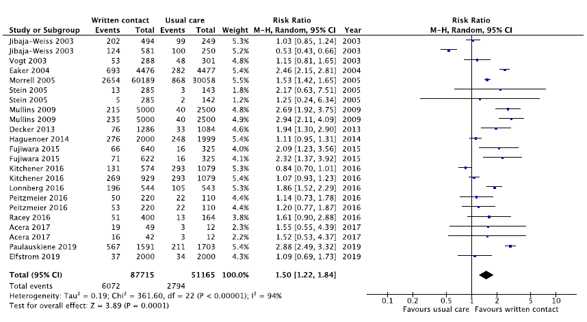

Supplementary Figure 1. Written contact vs. usual care to increase uptake of cervical cancer screening

Footnote 1: Trials shown twice contributed multiple intervention arms to the comparison; trial arms that were repeated in a given comparison were divided by the number of repeating arms to ensure that total participants in the meta-analysis was accurate (e.g. if a trial included two interventions compared with the same control, the control sample size would be divided by two)
Footnote 2: Cluster randomized trials (Kitchener, 2016; Decker; 2013; Acera 2017) were adjusted by an intra-class correlation coefficient of 0.0211 based on data from Kitchener 2016

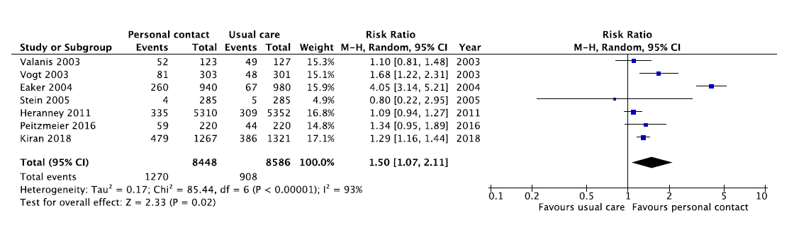

Supplementary Figure 2. Personal contact vs. usual care
Footnote 1: Valanis 2003 provided an in-person intervention (motivational interviewing) opportunistically following clinic visit (in-person), whereas the other trials used telephone calls

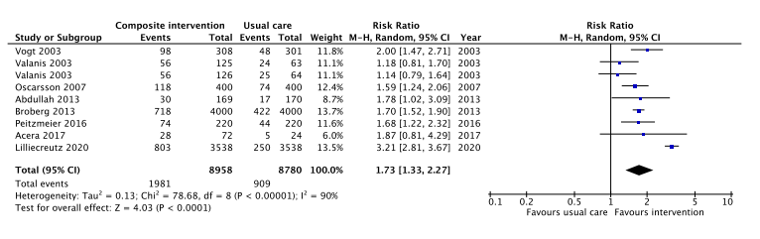

Supplementary Figure 3. Composite intervention vs. usual care
Footnote 1: Trials shown twice contributed multiple intervention arms to the comparison; trial arms that were repeated in a given comparison were divided by the number of repeating arms to ensure that total participants in the meta-analysis was accurate (e.g. if a trial included two interventions compared with the same control, the control sample size would be divided by two)
Footnote 2: Cluster randomized trials (Acera 2017; Abdullah, 2013) were adjusted by an intra-class correlation coefficient of 0.0211 based on data from Kitchener 2016

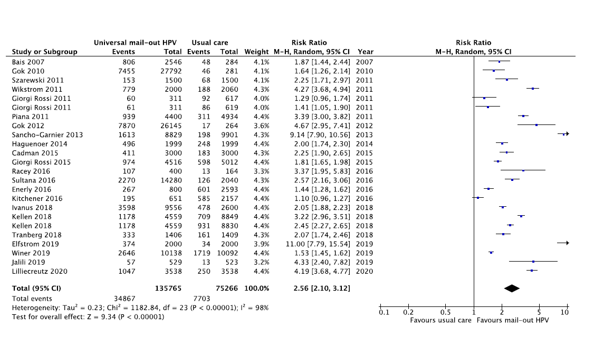

Supplementary Figure 4. Universal mail-out HPV self-sample vs. usual care
Footnote 1: Trials shown twice contributed multiple intervention or control arms (Kellen 2018 and Giorgi Rossi 2011) to the comparison; trial arms that were repeated in a given comparison were divided by the number of repeating arms to ensure that total participants in the meta-analysis was accurate (e.g. if a trial included two interventions compared with the same control, the control sample size would be divided by two)
Footnote 2: Cluster randomized trial (Kitchener, 2016) adjusted by an intra-class correlation coefficient of 0.0211 based on data from Kitchener 2016

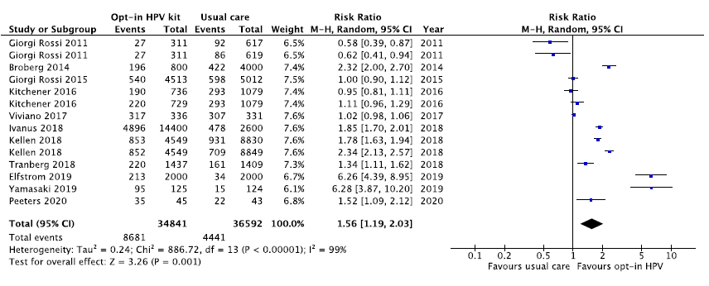

Supplementary Figure 5. Opt-in HPV self-sample vs. usual care
Footnote 1: Trials shown twice contributed multiple intervention or control arms (Kellan 2018 and Giorgi Rossi 2011) to the comparison; trial arms that were repeated in a given comparison were divided by the number of repeating arms to ensure that total participants in the meta-analysis was accurate (e.g. if a trial included two interventions compared with the same control, the control sample size would be divided by two)
Footnote 2: Cluster randomized trial (Kitchener, 2016) adjusted by an intra-class correlation coefficient of 0.0211 based on data from Kitchener 2016
Footnote 3: One arm of Kitchener 2016 offered a choice between access to a nurse navigator or self-sampling kit on request

Funnel plots

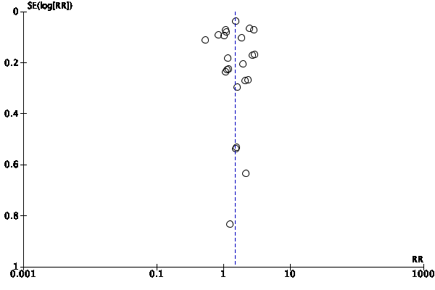
Written vs control

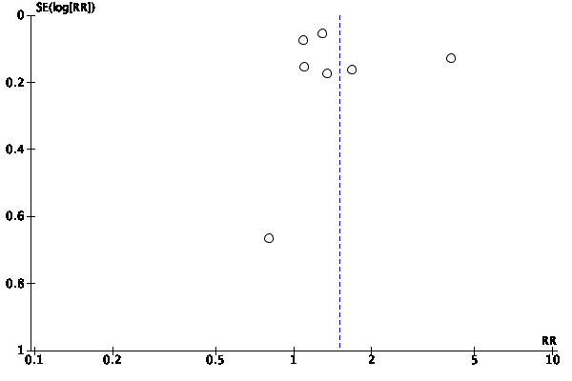
Personal vs control

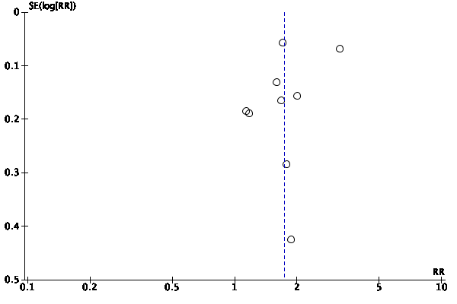
Composite vs control

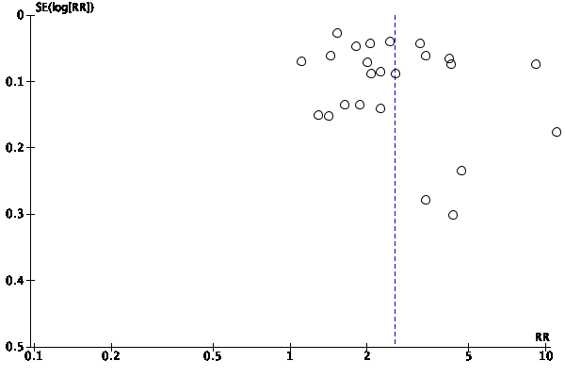
Mail out vs control

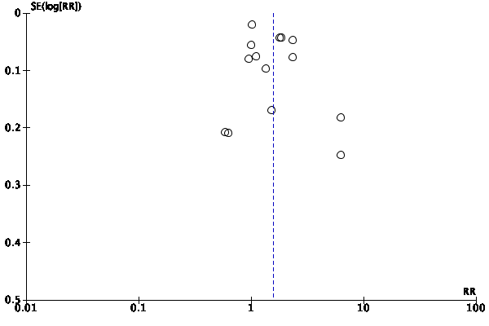
Opt in vs. control

Between trial comparisons by pre-specified populations^{ab}

Summary
- Between group data was sparse and no subgroup analyses (i.e., stratified analyses) were undertaken.
- At most, 2 trials contributed to any one category (i.e. > 80% participants meeting criteria); many trials did not provide sufficient data to determine grouping.
- Universal mail-out of HPV self-samples showed effect in a single trial of low SES participants (Sancho-Garnier, 2013) and two trials from rural communities (Racey, 2016; Giorgi Rossi, 2015).
- Personal contact and composite interventions showed an effect in one trial of low SES individuals (Peitzmeier, 2016) and single trials set in a rural community (Heranney, 2011; Oscarsson, 2007)
- Written contact and opt-in HPV self-sampling interventions demonstrated inconsistent effects across two trials of low-income persons (Jibaja-Weiss 2003; Peitzmeier, 2016) and two trials of undertaken in rural/remote communities (Giorgi Rossi, 2015; Yamasaki, 2019), respectively.
Population
No. of trials; RR (95% CI)
Intervention  Pooled RR (95% CI)^{c} | Low SES^{d} | High SES | Mixed^{e} | NR | Indigenous^{f} | Non-indigenous | Mixed^{e} | NR
Written contact  1.50 (1.22, 1.84) | 2 trials  Arm 1: 1.03 (0.85, 1.24)  Arm 2: 0.53 (0.43, 0.66)  --------------------------------  Arm 1: 1.14 (0.73, 1.78)  Arm 2: 1.20 (0.77, 1.87) | 0 | 5 | 9 | 0 | 0 | 0 | 16
Personal contact  1.50 (1.07, 2.11) | 1 trial  1.34 (0.95, 1.89) | 0 | 4 | 2 | 0 | 1 | 0 | 6
Composite  1.73 (1.33, 2.27) | 1 trial  1.68 (1.22, 2.32) | 0 | 2 | 5 | 0 | 1 | 0 | 7
Universal mail-out HPV  2.56 (2.10, 3.12) | 1 trial  9.14 (7.90, 10.56) | 0 | 6 | 15 | 0 | 1 | 0 | 21
Opt-in HPV  1.56 (1.19, 2.03) | 0 | 0 | 1 | 9 | 0 | 0 | 0 | 11
CI = confidence interval; HPV = human papillomavirus; No. = number; NR = not reported; RR = risk ratio; SES = socioeconomic status

Population
No. of trials; RR (95% CI)
Intervention  Pooled RR (95% CI) | Immigrant^{g} | Non-immigrant | Mixed^{e} | NR | Rural/remote | Urban | Mixed^{e} | NR
Written contact  1.50 (1.22, 1.84) | 0 | 1 | 1 | 14 | 1 trial  1.61 (0.90, 2.88) | 5 | 2 | 8
Personal contact  1.50 (1.07, 2.11) | 0 | 1 | 0 | 6 | 1 trial  1.09 (0.94, 1.27) | 4 | 0 | 2
Composite  1.73 (1.33, 2.27) | 0 | 0 | 0 | 8 | 1 trial  1.59 (1.24, 2.06) | 5 | 0 | 2
Universal mail-out HPV  2.56 (2.10, 3.12) | 0 | 0 | 1 | 21 | 2 trials  3.37 (1.95, 5.83)  1.81 (1.65, 1.98) | 1 | 4 | 15
Opt-in HPV  1.56 (1.19, 2.03) | 0 | 0 | 0 | 11 | 2 trials  6.28 (3.87, 10.20)  1.00 (0.90, 1.12) | 1 | 1 | 7
CI = confidence interval; HPV = human papillomavirus; NR = not reported; RR = risk ratio; SES = socioeconomic status
ªTrials in which at least 80% of included persons were from a pre-specified population of interest (i.e. at least 80% of participants qualified as being low socioeconomic status, were immigrants, had indigenous status, or were residents of rural/remote communities)
^{b}Table numbers are number of trials unless otherwise indicated
^{c}Risk ratio calculated from main analysis
^{d}Based on income, social welfare, and/or insurance status as reported by trials
^{e}Trials in which less than 80% of included persons were from a pre-specified population of interest but characteristics were reported
^{f}Includes American Indian, Alaska Natives, and Native Pacific Islanders
^{g}Based on country of birth
Within trial comparisons by pre-specified populationsª
Summary
- Screening rates across pre-specified populations within trials were not commonly reported
- Socioeconomic status:
  - Four trials (Morrel, 2005; Szarewski, 2011; Cadman, 2015; Sultana, 2016) described outcomes by SES deprivation quintiles and one trial (Eaker, 2004) provided difference in proportion participating by social welfare status and disposable income; one trial used a written intervention, three trials used universal mail-out of HPV self-sample kits; and one trial included both a written and a personal intervention
  - All trials reporting SES showed increased participation in the intervention group versus usual care. The proportions of individuals who engaged in screening did not vary greatly between SES categories within each trial aside from one (Eaker, 2004), which demonstrated greater uptake among individuals in the intervention arms (written and personal contact) who were not on social welfare compared with those on social welfare. However, this difference in uptake within the intervention arms was not seen when comparing individuals in the same trial by disposable income above and below the median.
- Immigrant status:
  - One publication (Gok, 2012) that pooled data from two consecutive trials (Gok, 2010; Gok, 2012) to analyze screening rates by characteristics of responders demonstrated improved screening uptake among non-attenders in the Netherlands using mail-out HPV self-sampling and reported greater screening uptake among native Dutch participants compared with immigrants, defined by birth outside the country; immigrants from developed countries other than the Netherlands had higher rates of uptake versus those from developing countries
  - A second trial (Eaker, 2004) that provided outcomes by country of birth reported improved screening overall and no difference in the proportion participating in screening among immigrant and non-immigrant populations using a written or a personal intervention
- Setting:
  - Four trials (Morrel, 2005; Giorgi Rossi, 2011; Giorgi Rossi, 2015; Jalili, 2019) described outcomes by community setting; one trial used a letter intervention, one trial used universal mail-out of HPV self-sample kits, and two trials included both universal mail-out and opt-in for HPV self-sample kits as interventions.
  - The written intervention and two universal HPV mail-out trials demonstrated increased screening rates in their intervention group compared with usual care, regardless of setting. However, one universal mail-out trial (Giorgi Rossi, 2011) showed improved screening uptake only in urban centers.
  - The opt-in intervention did not improve uptake in two trials, regardless of setting

Note: Because of the overall GRADE assessments focus on whether or not interventions improved outcomes the only finding about difference in direction of affect is:
- Among four trials reporting on community setting, one universal mail-out trial (Giorgi Rossi, 2011) showed improved screening uptake only in urban centers

Socioeconomic status of participants
 | Intervention |  |  | Usual care
Written contact | No. screened^{b} | No. analyzed^{c} | Rate | No. screened^{b} |  | No. analyzed^{c} |  | Rate
Morrel 2005
SES  QI (highest)  QII  QIII  QIV  QV | 547  525  545  462  575 | 13,283  11,228  12,115  9,824  13,330 | 4.12%  4.68%  4.50%  4.70%  4.31% | 202  195  150  147  175 |  | 6,570  5,719  6,122  4,862  6,646 |  | 3.07%  3.41%  2.45%  3.02%  2.63%
Eaker 2004
Social welfare  Yes  No  Disposable income  0-199 of median  ≥200 of median | Difference in proportion participating (95% CI)  4.2% (0.6, 7.9)  9.7% (8.3, 11.0)  0-199: 9.1% (7.3, 10.9)  ≥200: 9.2% (7.4, 11.0)
Personal contact | -- | -- | -- | -- |  | -- |  | --
Eaker 2004
Social welfare  Yes  No  Disposable income  0-199 of median  ≥200 of median | Difference in proportion participating (95% CI)  17.3% (5.2, 29.5)  33.1% (28.3, 37.9)  29.8% (23.8, 36.0)  32.7% (26.1, 39.2)
Composite | -- | -- | -- | -- |  | -- |  | --
Universal mail-out HPV
Szarewski 2011
Deprivation status  Q1 (most deprived)  Q2  Q3  Q4  Q5 | 23  26  23  24  0 | 453  393  359  288  7 | 5.1%  6.6%  6.4%  8.3%  0% | 16  17  17  18  0 |  | 402  420  374  296  8 |  | 4.0%  4.0%  4.5%  6.1%  0%
Cadman 2015
Deprivation status  Q1 (most deprived)  Q2  Q3  Q4  Q5 | 198  70  42  59  42 | 1,375  562  321  406  336 | 14.4%  12.5%  13.1%  14.5%  12.5% | 73  27  29  28  26 |  | 1,372  574  324  389  341 |  | 5.3%  4.7%  9.0%  7.2%  7.6%
Sultana 2016^{d}
SES  Q1 (lowest)  Q2  Q3  Q4  Q5 | 466  431  467  461  431 | 2,841  2,958  2,769  2,931  2,780 | 16.4%  14.6%  16.9%  15.7%  15.5% | 25  17  31  24  29 |  | 425  383  443  376  413 |  | 5.9%  4.4%  7.0%  6.4%  7.0%
Opt-in HPV | -- | -- | -- | -- |  | -- |  | --
Immigrant status of participants
Written contact
Eaker 2004
Country of birth  Sweden  Other | Difference in proportion participating (95% CI)  9.1% (7.6, 10.5)  10.0% (6.9, 12.9)
Personal contact
Eaker 2004
Country of birth  Sweden  Other | Difference in proportion participating (95% CI)  32.2% (27.1, 37.2)  28.0% (18.6, 37.3)
Composite | -- | -- | -- | -- |  | -- |  | --
Universal mailed HPV
Gok, 2012e
Country of birth  The Netherlands  Other developed country^{f}  Developing country^{g} | 11,705  969  2,600 | 36,072  4,036  12,339 | 32%  24%  21% | 45  5  13 |  | 382  40  116 |  | 11.8%  12.5%  11.2%
Opt-in HPV | -- | -- | -- | -- |  | -- |  | --
Setting of trial
Written contact
Morrel 2005
Urban  Rural/remote | 1,988  650 | 46,769  13,011 | 4.25%  5.00% | 669  199 |  | 23,420  6,499 |  | 2.86%  3.06%
Personal contact | -- | -- | -- | -- |  | -- |  | --
Composite | -- | -- | -- | -- |  | -- |  | --
Universal mail-out HPV
Giorgi Rossi 2011 |  |  |  | Pap^{h} | HPV^{h} | Pap^{h} | HPV^{h} | Pap^{h} | HPV^{h}
Urban  Rural | 91  30 | 438  178 | 20.8%  16.9% | 54  34 | 58  32 | 438  181 | 434  182 | 12.3%  18.8% | 13.4%  17.6%
Giorgi Rossi 2015
Urban  Rural | 73  901 | 500  4016 | 14.6%  22.4% | 87  511 |  | 1000  4012 |  | 8.7%  12.7%
Jalili 2019
Urban  Rural | 24  27 | 268  261 | 9.0%  10.3% | 7  6 |  | 261  262 |  | 2.7%  2.3%
Opt-in HPV
Giorgi Rossi 2011 |  |  |  | Pap^{h} | HPV^{h} | Pap^{h} | HPV^{h} | Pap^{h} | HPV^{h}
Urban  Rural | 35  19 | 440  182 | 8.0%  10.4% | 54  34 | 58  32 | 438  181 | 434  182 | 12.3%  18.8% | 13.4%  17.6%
Giorgi Rossi 2015
Urban  Rural | 23  517 | 500  4013 | 4.6%  12.9% | 87  511 |  | 1000  4012 |  | 8.7%  12.7%

CI = confidence interval; HPV = human papillomavirus; n = number of persons; SES = socioeconomic status; Q = quintile
ªBased on trial description of characteristics
^{b}Number who completed screening as reported by trial; some trials only reported number completing HPV self-sample by population characteristic, excluding individuals in the HPV self-sampling arms that attended clinic for testing
^{c}Number analyzed as reported by trial; does not always include all randomized participants (i.e. not all trials presented outcomes by characteristic for the intention-to-treat population)
^{d}Pooled data from under and never screened participants
^{e}Pooled data from two trials with identical methods but different start dates (Gok 2010; Gok 2012) published in separate publication (Gok, 2012)
^{f}Included Europe, United States, Canada, Australia, New Zealand
^{g}Included the Netherlands Antilles, Surinam, Turkey, Morocco (major immigrant populations in the Netherlands) plus any other developing countries
^{h}Testing done in clinic with test as standard for that clinic

