Supplementary Information

Effects of photobiomodulation on multiple health outcomes: an umbrella review of randomized clinical trials

Subtitle: Photobiomodulation and health outcomes

Yejun Son, ^{1,2}† Hyeri Lee, ^{1,3}† Seungyeong Yu,⁴† Hyeon Jin Kim, ^{1,2} Jaeyu Park, ^{1,2} Selin Woo,¹ Hayeon Lee,^{1,5} Guillaume Fond,⁶ Laurent Boyer,⁶ Masoud Rahmati,^{6,7,8} Lee Smith,⁹ Guillermo F. López Sánchez,¹⁰ Elena Dragioti,¹¹ Jiseung Kang,^{12,13,14*} Tae Kim,^{4*} Dong Keon Yon^{1,2,3,15*}

†These authors contributed equally as the first authors.
*These authors contributed equally as the corresponding authors:
Dong Keon Yon, MD, Ph.D., FACAAI, FAAAAI, ATSF
Department of Pediatrics, Kyung Hee University College of Medicine, 23 Kyungheedae-ro, Dongdaemun-gu, Seoul 02447, South Korea
E-mail: yonkkang@gmail.com

Tae Kim, MD, Ph.D.
Department of Biomedical Science and Engineering, Gwangju Institute of Science and Technology, 123, Cheomdangwagi-ro, Buk-gu, Gwangju, Gwangju 61005, South Korea
E-mail: tae-kim@gist.ac.kr

Jiseung Kang, Ph.D.
School of Health and Environmental Science, College of Health Science, Korea University, Seoul, South Korea
E-mail: wltmd1006@gmail.com

Supplementary Table 1. Search strategies for each database
Database | Search Strategy
PubMed/MEDLINE | ("meta-analysis"[Publication Type] OR "systematic review"[Publication Type]) AND ("photobiomodulation"[MeSH Terms] OR "low-level laser therapy"[MeSH Terms] OR "low-intensity laser light" OR "LLLT")
Embase | 'meta analysis'/exp OR 'systematic review'/exp AND ('photobiomodulation' OR 'low level laser therapy' OR 'low intensity laser light' OR 'LLLT')
CINAHL (via EBSCO) | MH "Meta Analysis" OR MH "Systematic Review" AND (TX "photobiomodulation" OR TX "low-level laser therapy" OR TX "low-intensity laser light" OR TX "LLLT")
Web of Science | TS=("meta-analysis" OR "systematic review") AND TS=("photobiomodulation" OR "low-level laser therapy" OR "low-intensity laser light" OR "LLLT")
Google Scholar | "meta-analysis" OR "systematic review" AND photobiomodulation OR "low-level laser therapy" OR "low-intensity laser light" OR LLLT
Abbreviation: LLLT, low-intensity laser light.

Supplementary Table 2. AMSTAR 2 quality assessment of meta-analyses
Author, Year | AMSTAR 2 items ^{a, c}
Author, Year | 1 | 2 ^{b} | 3 | 4 ^{b} | 5 | 6 | 7 ^{b} | 8 | 9 ^{b} | 10 | 11 ^{b} | 12 | 13 ^{b} | 14 | 15 ^{b} | 16 | Overall rating  (based on critical domains)^{d}
C Lu et al., 2023 | Y | PY | Y | PY | Y | Y | Y | Y | PY | N | Y | Y | N | Y | Y | Y | Low
R Hanna et al., 2021 | Y | PY | Y | PY | Y | Y | Y | Y | PY | Y | Y | Y | Y | Y | Y | Y | High
I Lourinho et al., 2023 | Y | PY | Y | Y | Y | Y | Y | Y | Y | Y | Y | Y | Y | N | N | Y | Low
JV Ferlito et al., 2023 | Y | PY | Y | Y | N | N | N | PY | Y | N | Y | N | N | N | N | N | Low
N Tripodi et al., 2021 | Y | Y | Y | Y | Y | Y | Y | Y | Y | N | Y | Y | Y | Y | N | Y | Low
MB Stausholm et al., 2019 | Y | Y | Y | Y | Y | Y | Y | Y | Y | N | Y | Y | Y | Y | Y | N | Moderate
SW Yeh et al., 2019 | Y | Y | Y | PY | Y | Y | Y | Y | Y | N | Y | N | Y | Y | N | N | Low
MR Tehrani et al., 2022 | Y | Y | Y | Y | Y | Y | N | Y | Y | Y | Y | N | N | Y | Y | N | Low
ALC Martimbianco et al., 2020 | Y | Y | Y | Y | Y | Y | Y | Y | Y | N | Y | N | Y | N | N | N | Low
FCJ Neto et al., 2020 | Y | PY | Y | Y | Y | Y | Y | Y | Y | N | Y | N | N | N | N | N | Low
AH Bekhet et al., 2017 | Y | N | Y | Y | Y | Y | Y | Y | Y | N | Y | N | Y | Y | N | Y | Low
J Huang et al., 2021 | Y | PY | Y | PY | Y | Y | PY | Y | Y | N | Y | Y | Y | Y | Y | N | Moderate
CH Chen et al., 2020 | Y | Y | Y | PY | Y | Y | PY | Y | Y | N | Y | N | Y | Y | N | N | Low
KH Liu et al., 2019 | Y | Y | Y | Y | Y | Y | N | Y | Y | N | Y | N | Y | Y | Y | Y | Low
Y Gao et al., 2023 | Y | Y | Y | Y | Y | Y | Y | Y | Y | N | Y | Y | N | Y | Y | Y | Low
^{b} Critical Domains
^{c} AMSTAR 2 items:
^{d} Rating overall confidence in the results of the review:
HIGH: no on one non-critical weakness: The systematic review provides an accurate and comprehensive summary of the results of the available studies that address the question of interest.
MODERATE: more than one non-critical weakness (multiple non-critical weaknesses may diminish confidence in the review, and it may be appropriate to move the overall appraisal down from moderate to low confidence), and the systematic review has more than one weakness but no critical flaws. This may provide an accurate summary of the results of the studies included in the review.
LOW: one critical flaw with or without non-critical weaknesses: The review has a critical flaw and may not provide an accurate and comprehensive summary of the available studies that address the question of interest.
CRITICALLY LOW: more than one critical flaw with or without non-critical weaknesses: The review has more than one critical flaw and should not be relied on to provide an accurate and comprehensive summary of the available studies.

- Did the research questions and inclusion criteria for the review include the components of PICO (Population, Intervention, Comparator group, Outcome)? YES/NO. For yes, must have all four items.
- Did the report of the review contain an explicit statement that the review methods were established prior to the conduct of the review and did the report justify any significant deviations from the protocol? YES, PARTIAL YES, NO. For Partial YES, the authors state that they had a written protocol or guide that included ALL (review question(s), a search strategy, inclusion/exclusion criteria, and risk of bias assessment). For YES, as for partial yes, plus the protocol should be registered and should also have specified a meta-analysis/synthesis plan, if appropriate, and a plan for investigating causes of heterogeneity, justification for any deviations from the protocol.
- Did the review authors explain their selection of the study designs for inclusion in the review? YES/NO. For YES, the review should satisfy one of the following criteria: explanation for including only RCTs, explanation for including only NRSI, or explanation for including both RCTs and NRSI.
- Did the review authors use a comprehensive literature search strategy? YES, PARTIAL YES, NO. for PARTIAL YES must have all of the following: searched at least two databases (relevant to the research question), provided key words and/or search strategy, justified publication restrictions (eg. Language). The YES should also have all of the following: searched the reference lists/biographies of included studies, searched trial/study registries, included/consulted content experts in the field, searched for grey literature where relevant, and conducted a search within 24 months of the completion of the review.
- Did the review authors perform study selection in duplicate? YES/NO. for YES, either ONE of the following: at least two reviewers independently agreed on the selection of eligible studies and achieved consensus on which studies to include OR two reviewers selected a sample of eligible studies and achieved good agreement (at least 80 percent) with the remainder selected by one reviewer.
- Did the review authors perform data extraction in duplicate? YES/NO. For YES, either one of the following: at least two reviewers achieved consensus on which data to extract from included studies, or two reviewers extracted data from a sample of eligible studies and achieved good agreement (at least 80 per cent) with the remainder extracted by one reviewer.
- Did the review authors provide a list of excluded studies to justify the exclusions? YES, PARTIAL YES, NO. Partial yes must provide a list of all potentially relevant studies that were read in full-text form but were excluded from the review. The YES must also justify exclusion from the review of each potentially relevant study.
- Did the review authors describe the included studies in adequate detail? YES, PARTIAL YES, NO. For PARTIAL, the YES must describe all of the following: populations, interventions, comparators, outcomes, and research designs. YES should also include all of the following: described populations in detail, described intervention and comparator in detail (including doses where relevant), described study setting, timeframe, or follow-up.
- Did the review authors use a satisfactory technique for assessing the risk of bias (RoB) in individual studies that were included in the review? For RCTs: YES, PARTIAL YES, NO, INCLUDES ONLY NRSI. For PARTIAL, YES must have assessed RoB from unconcealed allocation and lack of blinding of patients and assessors when assessing outcomes (unnecessary for objective outcomes such as all-cause mortality); YES must also have assessed RoB from the allocation sequence that was not truly random and selection of the reported result from among multiple measurements or analyses of a specified outcome. For NRSI (non-randomized studies of intervention (NRSI): YES, PARTIAL YES, NO, INCLUDES ONLY RCTs. For PARTIAL, the YES must have assessed RoB for confounding and selection bias. For YES, one must also have assessed methods used to ascertain exposures and outcomes, and select the reported results from among multiple measurements or analyses of a specified outcome.
- Did the review authors report on the sources of funding for the studies included in the review? YES/NO. For YES, we must have reported the sources of funding for the individual studies included in the review. Note: Reporting that the reviewers looked for this information, but it was not reported by the study authors also qualifies.
- If meta-analysis was performed, did the review authors use appropriate methods for statistical combination of results? For RCTs: YES, NO, and NO META-ANALYSIS. For YES, the authors justified combining the data in a meta-analysis and used an appropriate weighted technique to combine study results and adjusted for heterogeneity if present, and investigated the causes of heterogeneity. For NRSI: YES, NO, NO META-ANALYSIS CONDUCTED. For YES, the authors justified combining the data in a meta-analysis and used an appropriate weighted technique to combine study results, adjusting for heterogeneity if present; they statistically combined effects estimates from NRSI that were adjusted for confounding, rather than combining raw data, or justified combining raw data when adjusted effect estimates were not available, and they reported separate summary estimates for RCTs and NRSI separately when both were included in the review.
- If meta-analysis was performed, did the review authors assess the potential impact of RoB in individual studies on the results of the meta-analysis or other evidence synthesis? YES, NO, NO META-ANALYSIS INCLUDED. For YES, we included only low risk of bias RCTs or, if the pooled estimate was based on RCTs and/or NRSI at variable RoB, the authors performed an analysis to investigate the possible impact of RoB on summary estimates of effect.
- Did the review authors account for RoB in individual studies when interpreting/discussing the results of the review? YES/NO. for YES: included only low risk of bias RCTs or, if RCTs with moderate or high RoB or NRSI were included, the review provided a discussion of the key impact of RoB on the results.
- Did the review authors provide a satisfactory explanation for, and discussion of, any heterogeneity observed in the results of the review? YES/NO. For Yes: There was no significant heterogeneity in the results OR if heterogeneity was present, the authors investigated the sources of any heterogeneity in the results and discussed the impact of this on the results of the review.
- If they performed quantitative synthesis did the review authors carry out an adequate investigation of publication bias (small study bias) and discuss its likely impact on the results of the review? YES, NO, NO META-ANALYSIS CONDUCTED. For YES, we performed graphical statistical tests for publication bias and discussed the likelihood and magnitude of its impact.
- Did the review authors report any potential sources of conflict of interest, including any funding they received for conducting the review? YES/NO. For Yes, the authors reported no competing interests OR the authors described their funding sources and how they managed potential conflicts of interest.

Supplementary Table 3. Grading of Recommendations Assessment, Development and Evaluation assessment of each association
Outcome | First author | Imprecision | Inconsistency | Risk of bias | Indirectness | Publication bias | Upgrade | GRADE
1. Burning mouth syndrome
Pain intensity in patients with burning mouth syndrome | Lu C | 0 | 0 | -1 | -1 | -1 | 0 | Moderate
Quality of life in patients with burning mouth syndrome | Lu C | 0 | -1 | -2 | -1 | -1 | 0 | Low
2. Temporomandibular disorders
Pain levels (VAS score) in patients with temporomandibular disorders | Hanna R | 0 | -1 | -2 | -1 | 0 | 0 | Low
3. Rheumatoid arthritis
Pain levels in patients with rheumatoid arthritis | Lourinho I | -1 | -1 | -2 | -2 | 0 | 0 | Very low
Morning stiffness in patients with rheumatoid arthritis | Lourinho I | 0 | 0 | -2 | -2 | 0 | 0 | Low
Handgrip strength in patients with rheumatoid arthritis | Lourinho I | -2 | -1 | -2 | -2 | 0 | 0 | Very low
Functional capacity in patients with rheumatoid arthritis | Lourinho I | -2 | 0 | -2 | -2 | 0 | 0 | Very low
Inflammation in patients with rheumatoid arthritis | Lourinho I | -1 | 0 | -2 | -2 | 0 | 0 | Low
Activity score in patients with rheumatoid arthritis | Lourinho I | -2 | 0 | -2 | -2 | 0 | 0 | Very low
4. Plantar fasciitis
Pain intensity in patients with plantar fasciitis | Ferlito JV | -1 | 0 | -2 | -1 | 0 | 0 | Low
5. Tendinopathy
Pain levels (VAS score) in patients with tendinopathy | Tripodi N | 0 | -1 | -2 | -1 | -1 | 0 | Low
Muscle strength in patients with tendinopathy | Tripodi N | -2 | -1 | -1 | -1 | -1 | 0 | Very low
6. Knee osteoarthritis
Pain levels in patients with knee osteoarthritis | Stausholm MB | 0 | -2 | -2 | 0 | 0 | 0 | Low
Disability in patients with knee osteoarthritis | Stausholm MB | -2 | 0 | -1 | 0 | 0 | 0 | Moderate
7. Fibromyalgia
Changes in FIQ score in patients with fibromyalgia | Yeh SW | -2 | 0 | -2 | -1 | 0 | 1 | Low
Changes in pain severity in patients with fibromyalgia | Yeh SW | -2 | -2 | -2 | -1 | 0 | 0 | Very low
Changes in number of tender points in patients with fibromyalgia | Yeh SW | -2 | -2 | -2 | -1 | 0 | 0 | Very low
Changes in severity of fatigue in patients with fibromyalgia | Yeh SW | -2 | 0 | -2 | -1 | 0 | 2 | Moderate
Changes in severity of stiffness difference in patients with fibromyalgia | Yeh SW | -2 | 0 | -2 | -1 | 0 | 1 | Low
Changes in severity of depression in patients with fibromyalgia | Yeh SW | -2 | 0 | -2 | -1 | 0 | 0 | Low
Changes in severity of anxiety in patients with fibromyalgia | Yeh SW | -2 | 0 | -2 | -1 | 0 | 0 | Low
8. Myofascial neck pain
Neck pain level in patients with myofascial neck pain syndrome | Tehrani MR | 0 | -2 | -2 | -1 | 0 | 0 | Low
Pressure pain threshold in patients with myofascial neck pain syndrome | Tehrani MR | -2 | -2 | -2 | -1 | 0 | 0 | Very low
9. Achilles tendinopathy
Pain intensity in patients with Achilles tendinopathy | Martimbianco ALC | -1 | -1 | -2 | -1 | 0 | 0 | Low
Function in patients with Achilles tendinopathy | Martimbianco ALC | -2 | 0 | -1 | -1 | 0 | 0 | Low
10. Fractures
Pain levels (VAS score) in patients with fractures | Neto FCJ | -1 | 0 | -2 | -1 | 0 | 0 | Low
11. Carpal tunnel syndrome
Pain levels (VAS score) in patients with carpal tunnel syndrome | Bekhet AH | 0 | -2 | -2 | 0 | -1 | 0 | Low
Symptom severity scale in patients with carpal tunnel syndrome | Bekhet AH | 0 | -2 | -2 | 0 | -1 | 0 | Low
Functional severity scale in patients with carpal tunnel syndrome | Bekhet AH | 0 | -2 | -2 | 0 | -1 | 0 | Low
12. Diabetic foot ulcers
Complete healing rate in diabetic foot ulcers | Huang J | 0 | 0 | -2 | -1 | -1 | 0 | Low
Ulcer area reduction percentage in diabetic foot ulcers | Huang J | -2 | -2 | -2 | -1 | -1 | 2 | Very low
Mean healing time in diabetic foot ulcers | Huang J | -2 | 0 | -1 | -1 | -1 | 0 | Low
13. Tinnitus
Overall symptoms (THI score) in patients with tinnitus | Chen CH | 0 | 0 | -2 | 0 | 0 | 0 | Moderate
14. Androgenetic alopecia
Hair density in patients with androgenic alopecia | Liu KH | -2 | 0 | -2 | 0 | 0 | 2 | Moderate
15. Cognitive function
The effects on age-related cognitive impairment | Gao Y | 0 | 0 | -2 | 0 | 0 | 0 | Moderate

* The GRADE, categorizing evidence from systematic reviews and meta-analysis, was modified as follows; moderate for large-scale prospective cohort studies and low for retrospective cohort studies. Each item was judged;
1. Imprecision was rated as follows: no downgrade (0) if the total sample size was ≥200 and the 95% confidence interval (CI) did not overlap with the clinical decision threshold (e.g., SMD ±0.1 or RR outside 0.9–1.1); downgraded by one level (-1) if the sample size was between 100 and 199 or if the CI included the threshold; and downgraded by two levels (-2) if the sample size was <100 or the CI was too wide to judge clinical relevance.
2. Inconsistency was assessed based on heterogeneity (I²): no downgrade (0) if I² was <75%; downgraded by one level (-1) if I² was between 75% and 89%; and downgraded by two levels (-2) if I² was ≥90%.
3. Risk of Bias was determined by the proportion of included RCTs with low risk of bias: no downgrade (0) if ≥75% were low RoB; downgraded by one level (-1) if 50–74% were low RoB; and downgraded by two levels (-2) if <50% were low RoB or if no RoB assessment was conducted.
4. Indirectness was rated based on alignment with the PICO framework: no downgrade (0) if the population, intervention, comparator, and outcomes were clearly aligned; downgraded by one level (-1) if there was partial indirectness (e.g., mixed comparators such as placebo and active controls); and downgraded by two levels (-2) if multiple sources of indirectness were present (e.g., mixed interventions and heterogeneous populations).
5. Publication Bias was assessed based on funnel plot symmetry, Egger’s test, and search strategy: no downgrade (0) if publication bias was not detected and a comprehensive search across multiple databases with no language restrictions was performed; downgraded by one level (-1) if publication bias was suggested by Egger’s test (p < 0.10), funnel plot asymmetry, limited database coverage, or language restrictions.
6. Upgrade was considered for large or very large effect sizes: upgraded by one level (+1) if the effect size was large (SMD >0.8), the CI did not cross the null, and there were no serious concerns regarding RoB, imprecision, or indirectness; upgraded by two levels (+2) if the effect size was very large (SMD >1.2) under the same conditions.
Supplementary Table 4. Studies excluded, with reason for exclusion.
Author, year | Reason for exclusion
Abesi F,2023¹ | Not RCT article
Aguiar BRL,2021² | Not RCT article
Akram Z,2018³ | Not eligible for the full text
Alayat MSM,2022⁴ | Not RCT article
Al-Rudayni AHM,2021⁵ | Not eligible for the full text
AlShahrani I,2019⁶ | Not RCT article
Ansari S,2022⁷ | Articles reporting overlapped results
Anschau F,2019⁸ | Not eligible for the full text
Arjmand B,2023⁹ | Not eligible for the full text
Awotidebe AW,2019¹⁰ | Not RCT article
Ayar Z,2022¹¹ | Not eligible for the full text
Bakdach WMM,2020¹² | Not eligible for the full text
Barros AWP,2022¹³ | Not RCT article
Bensadoun RJ,2012¹⁴ | Not RCT article
Bjordal JM,2011¹⁵ | Not eligible for the full text
Bjordal JM,2008¹⁶ | Not eligible for the full text
Camolesi GCV,2022¹⁷ | Not eligible for the full text
Campos TM,2020¹⁸ | Not RCT article
Chang WD,2014¹⁹ | Articles reporting overlapped results
Chaves IC,2023²⁰ | Not eligible for the full text
Chen J,2015²¹ | Articles reporting overlapped results
Chen Y,2019²² | Not RCT article
Cheung WKW,2020²³ | Articles reporting overlapped results
Cho Y,2023²⁴ | Not RCT article
Chow RT,2009²⁵ | Not eligible for the full text
Clijsen R,2017²⁶ | Not RCT article
Costa ACF,2021²⁷ | Not RCT article
Cronshaw M,2020²⁸ | Not RCT article
Cruz AR,2023²⁹ | Not RCT article
da Silva BM,2022³⁰ | Not RCT article
de Almeida VL,2016³¹ | Not eligible for the full text
de Arruda JAA,2022³² | Not eligible for the full text
de Barros DD,2022³³ | Not eligible for the full text
de Barros DD,2022³⁴ | Articles reporting overlapped results
de Barros Silva PG,2022³⁵ | Not RCT article
de Carvalho MM,2022³⁶ | Not RCT article
de Lima VHS,2020³⁷ | Not RCT article
De Marchi T,2022³⁸ | Not eligible for the full text
de Oliveira-Souza AIS,2023³⁹ | Not RCT article
Deana NF,2023⁴⁰ | Not RCT article
Deana NF,2021⁴¹ | Not RCT article
Deana NF,2017⁴² | Not eligible for the full text
Domah F,2021⁴³ | Not eligible for the full text
Dos Santos Mendes-Costa L,2021⁴⁴ | Not RCT article
Dos Santos SA,2019⁴⁵ | Articles reporting overlapped results
Duarte de Oliveira FJ,2021⁴⁶ | Not eligible for the full text
Dutra YM,2022⁴⁷ | Not RCT article
Ebrahimi P,2021⁴⁸ | Not RCT article
Eslamipour F,2017⁴⁹ | Not eligible for the full text
Ferlito JV,2022⁵⁰ | Not eligible for the full text
Firoozi P,2020⁵¹ | Not RCT article
Franco R,2023⁵² | Not RCT article
Freire BL,2023⁵³ | Not RCT article
Gál P,2018⁵⁴ | Not eligible for the full text
Galiano-Castillo N,2021⁵⁵ | Not RCT article
Gam AN,1993⁵⁶ | Not RCT article
Ge MK,2015⁵⁷ | Not RCT article
Glazov G,2016⁵⁸ | Not eligible for the full text
Gobbo M,2023⁵⁹ | Not eligible for the full text
Grajales M,2023⁶⁰ | Not eligible for the full text
Gross AR,2013⁶¹ | Not RCT article
Guimarães JS,2022⁶² | Articles reporting overlapped results
Gupta AK,2021⁶³ | Not RCT article
Hanna R,2021⁶⁴ | Not eligible for the full text
Haslerud S,2015⁶⁵ | Articles reporting overlapped results
He M,2018⁶⁶ | Not RCT article
He W,2015⁶⁷ | Not eligible for the full text
He W,2013⁶⁸ | Not eligible for the full text
He WL,2015⁶⁹ | Not eligible for the full text
He WL,2013⁷⁰ | Not RCT article
Hoseinpour Jajarm H,2018⁷¹ | Not RCT article
Huang T,2023⁷² | Not RCT article
Huang Z,2015⁷³ | Not eligible for the full text
Huang Z,2015⁷⁴ | Articles reporting overlapped results
Huang ZY,2017⁷⁵ | Not eligible for the full text
Imani MM,2018⁷⁶ | Not eligible for the full text
Jedliński M,2020⁷⁷ | Not RCT article
Jing G,2021⁷⁸ | Articles reporting overlapped results
Jnaneshwar PR,2023⁷⁹ | Not eligible for the full text
Kadhim-Saleh A,2013⁸⁰ | Not eligible for the full text
Kheiri A,2020⁸¹ | Not RCT article
Lacerda-Santos JT,2023⁸² | Not eligible for the full text
Lai CC,2021⁸³ | Not eligible for the full text
Leal-Junior EC,2015⁸⁴ | Not eligible for the full text
Li BM,2023⁸⁵ | Not eligible for the full text
Li J,2021⁸⁶ | Not RCT article
Li X,2018⁸⁷ | Not eligible for the full text
Li ZJ,2016⁸⁸ | Articles reporting overlapped results
Lin L,2021⁸⁹ | Not eligible for the full text
Long H,2015⁹⁰ | Not RCT article
Louzeiro GC,2020⁹¹ | Not RCT article
Luo WT,2022⁹² | Not eligible for the full text
Ma Y,2023⁹³ | Not eligible for the full text
Malik S,2023⁹⁴ | Not eligible for the full text
Máximo CFGP,2022⁹⁵ | Articles reporting overlapped results
Michelogiannakis D,2022⁹⁶ | Not eligible for the full text
Munguia FM,2018⁹⁷ | Not RCT article
Nambi G,2021⁹⁸ | Not eligible for the full text
Naterstad IF,2022⁹⁹ | Articles reporting overlapped results
Nayyer N,2022¹⁰⁰ | Not eligible for the full text
Oberoi S,2014¹⁰¹ | Not eligible for the full text
Olmedo-Hernández OL,2022¹⁰² | Not RCT article
Pacheco JA,2022¹⁰³ | Not RCT article
Passos RM,2023¹⁰⁴ | Not eligible for the full text
Penberthy WT,2021¹⁰⁵ | Not RCT article
Peng J,2020¹⁰⁶ | Not eligible for the full text
Peralta-Mamani M,2019¹⁰⁷ | Not RCT article
Petrucci A,2011¹⁰⁸ | Articles reporting overlapped results
Qu C,2022¹⁰⁹ | Not RCT article
Raji H,2022¹¹⁰ | Not RCT article
Ramezani F,2020¹¹¹ | Not eligible for the full text
Rayegani SM,2019¹¹² | Not eligible for the full text
Rayegani SM,2017¹¹³ | Articles reporting overlapped results
Razaghi P,2022¹¹⁴ | Not RCT article
Reis CLB,2022¹¹⁵ | Not RCT article
Ren C,2017¹¹⁶ | Not RCT article
Ren H,2022¹¹⁷ | Not eligible for the full text
Salehpour F,2019¹¹⁸ | Not RCT article
Santos CMD,2021¹¹⁹ | Articles reporting overlapped results
Shafaee H,2023¹²⁰ | Not eligible for the full text
Shafaee H,2020¹²¹ | Not RCT article
Shi Q,2015¹²² | Not RCT article
Smoot B,2015¹²³ | Not RCT article
Sobral AP,2021¹²⁴ | Articles reporting overlapped results
Sourvanos D,2023¹²⁵ | Not RCT article
Stausholm MB,2017¹²⁶ | Not eligible for the full text
Stevens AR,2023¹²⁷ | Not RCT article
Tumilty S,2010¹²⁸ | Not RCT article
Vande A,2022¹²⁹ | Not RCT article
Vanin AA,2018¹³⁰ | Not RCT article
Wang B,2021¹³¹ | Not eligible for the full text
Wang JY,2022¹³² | Not eligible for the full text
Wang W,2019¹³³ | Articles reporting overlapped results
Xiang A,2020¹³⁴ | Not eligible for the full text
Xu GZ,2018¹³⁵ | Articles reporting overlapped results
Yan B,2014¹³⁶ | Not eligible for the full text
Yavagal CM,2021¹³⁷ | Not RCT article
Zhang B,2021¹³⁸ | Not eligible for the full text
Zhang W,2021¹³⁹ | Not eligible for the full text
Zhang Y,2022¹⁴⁰ | Not RCT article
Zhao H,2021¹⁴¹ | Not eligible for the full text
Zheng DH,2023¹⁴² | Not RCT article
Zhi C,2021¹⁴³ | Not eligible for the full text

Supplementary Table 5. Reanalysis of the estimated continuous using Der Simonian and Laird (DL) method and Hartung-Knapp-Sidik-Jonkman (HS) method, heterogeneity I², egger’s p-value, 95% prediction interval, and GRADE
Outcome | Included studies | Metrics | Total sample | Reported summary estimated effect (95% CI); random effect model | Re-analysed summary estimated effect (95% CI) DL method |  |  | Re-analysed summary estimated effect (95% CI), HS method; random-effect model | Heterogeneity I² (%) | Egger’s p-value |  | Tau² | 95% prediction interval | eSMD*
 |  |  |  |  | Fixed-effect model | Random-effect model | Largest study
1. Burning mouth syndrome
Pain intensity in patients with burning mouth syndrome | 10 | SMD | 321 | -0.92 (-1.38 to 0.46) | -0.84 (-1.07 to -0.61) | -0.92 (-1.38 to -0.46) | 0.36 (-0.24 to 0.95) | -0.95 (-1.45 to -0.44) | 74.79 | 0.13 | 0.40 |  | (-2.49, 0.64) | -0.92 (-1.38 to -0.46)
Quality of life in patients with burning mouth syndrome | 9 | SMD | 346 | 0.03 (-0.63 to 0.70) | -0.07 (-0.28 to 0.15) | 0.03 (-0.63 to 0.69) | -1.14 (-1.59 to -0.69) | 0.03 (-0.73 to 0.78) | 88.74 | 0.37 | 0.89 |  | (-2.34, 2.40) | 0.03 (-0.73 to 0.78)
2. Temporomandibular disorders
Pain levels (VAS score) in patients with temporomandibular disorders | 36 | SMD | 1109 | -0.55 (-0.83 to -0.28) | -0.42 (-0.53 to -0.30) | -0.56 (-0.83 to -0.29) | -0.11 (-0.61 to 0.40) | -0.56 (-1.06 to -0.05) | 80.03 | 0.00 | 0.51 |  | (-2.03, 0.92) | -0.56 (-0.83 to -0.29)
3. Rheumatoid arthritis
Pain levels in patients with rheumatoid arthritis | 4 | MD | 176 | -0.36 (-1.50 to 0.78) | -0.66 (-1.16 to -0.17) | -0.37 (-1.50 to 0.77) | -1.30 (-2.00 to -0.60) | -0.35 (-1.91 to 1.22) | 75.39 | 0.44 | 0.97 |  | (-5.28, 4.55) | -0.03 (-0.16 to 0.10)
Morning stiffness in patients with rheumatoid arthritis | 4 | MD | 209 | -10.84 (-49.29 to 27.61) | 2.77 (-11.51 to 17.06) | -11.37 (-50.64 to 27.91) | 7.78 (-7.50 to 23.06) | -10.47 (-67.95 to 47.01) | 41.79 | 0.53 | 632.02 |  | (-149.70, 126.96) | -0.02 (-0.15 to 0.10)
Handgrip strength in patients with rheumatoid arthritis | 3 | SMD | 169 | -0.15 (-0.85 to 0.54) | -0.35 (-0.65 to -0.05) | -0.13 (-0.85 to 0.58) | -0.62 (-1.06 to -0.18) | -0.03 (-2.15 to 2.09) | 79.31 | 0.06 | 0.31 |  | (-8.55, 8.29) | -0.03 (-2.15 to 2.09)
Functional capacity in patients with rheumatoid arthritis | 3 | SMD | 136 | -0.08 (-0.60 to 0.43) | 0.00 (-0.34 to 0.34) | -0.10 (-0.63 to 0.42) | 0.21 (-0.23 to 0.64) | -0.19 (-1.45 to 1.07) | 49.87 | 0.24 | 0.11 |  | (-5.53, 5.32) | -0.19 (-1.45 to 1.07)
Inflammation in patients with rheumatoid arthritis | 4 | SMD | 176 | 0.08 (-0.30 to 0.47) | 0.12 (-0.17 to 0.42) | 0.07 (-0.33 to 0.46) | 0.28 (-0.15 to 0.72) | -0.01 (-0.77 to 0.75) | 38.59 | 0.17 | 0.06 |  | (-1.33, 1.46) | -0.01 (-0.77 to 0.75)
Activity score in patients with rheumatoid arthritis | 2 | SMD | 108 | 0.35 (-0.06 to 0.76) | 0.35 (-0.05 to 0.75) | 0.35 (-0.05 to 0.75) | 0.38 (-0.10 to 0.86) | 0.35 (-0.28 to 0.98) | 0.00 |  | 0.00 |  | (0.00, 0.00) | 0.35 (-0.28 to 0.98)
4. Plantar fasciitis
Pain intensity in patients with plantar fasciitis | 3 | MD | 130 | -22.02 (-35.21 to -8.83) | -21.96 (-30.87 to -13.06) | -21.91 (-35.07 to -8.74) | -22.00 (-34.48 to -9.52) |  | 48.92 | 0.98 | 66.67 |  | (-156.25, 112.43) | -0.10 (-0.24 to 0.05)
5. Tendinopathy
Pain levels (VAS score) in patients with tendinopathy | 9 | MD | 459 | 1.06 (0.57 to 1.55) | 1.12 (0.94 to 1.31) | 1.06 (0.57 to 1.56) | 1.60 (1.28 to 1.92) |  | 84.01 | 0.63 | 0.46 |  | (-0.64, 2.77) | 0.16 (0.07 to 0.24)
Muscle strength in patients with tendinopathy | 6 | SMD | 299 | 0.66 (0.11 to 1.21) | 0.56 (0.33 to 0.79) | 0.66 (0.11 to 1.22) | -0.16 (-0.67 to 0.35) | 0.68 (-0.06 to 1.43) | 82.33 | 0.01 | 0.40 |  | (-1.25, 2.58) | 0.68 (-0.06 to 1.43)
6. Knee osteoarthritis
Pain levels in patients with knee osteoarthritis | 15 | MD | 581 | 15.92 (6.47 to 25.37) | 20.37 (18.02 to 22.71) | 15.88 (6.44 to 25.31) | 39.15 (33.42 to 44.88) | 0.11 (0.04 to 0.17) | 93.13 | 0.28 | 305.19 |  | (-23.27, 55.02) | 0.02 (0.01 to 0.03)
Disability in patients with knee osteoarthritis | 8 | SMD | 289 | 0.66 (0.23 to 1.09) | 0.68 (0.45 to 0.92) | 0.65 (0.22 to 1.08) | 0.34 (-0.23 to 0.90) | 0.65 (0.14 to 1.15) | 68.70 | 0.50 | 0.26 |  | (-0.70, 2.01) | 0.65 (0.14 to 1.15)
7. Fibromyalgia
Changes in FIQ score in patients with fibromyalgia | 5 | SMD | 173 | 1.15 (0.75 to 1.54) | 1.15 (0.83 to 1.47) | 1.15 (0.75 to 1.54) | 1.75 (1.09 to 2.41) | 1.15 (0.61 to 1.69) | 35.10 | 0.99 | 0.07 |  | (0.08, 2.21) | 1.15 (0.61 to 1.69)
Changes in pain severity in patients with fibromyalgia | 5 | SMD | 181 | 2.18 (0.90 to 3.47) | 1.40 (1.06 to 1.75) | 2.19 (0.91 to 3.47) | 1.37 (0.75 to 2.00) | 2.49 (-1.19 to 6.18) | 91.93 | 0.05 | 1.87 |  | (-2.63, 7.02) | 2.49 (-1.19 to 6.18)
Changes in number of tender points in patients with fibromyalgia | 5 | SMD | 182 | 1.86 (0.66 to 3.05) | 1.24 (0.91 to 1.58) | 1.86 (0.67 to 3.06) | 1.27 (0.66 to 1.89) | 2.00 (-0.61 to 4.61) | 91.48 | 0.05 | 1.66 |  | (-2.67, 6.40) | 2.00 (-0.61 to 4.61)
Changes in severity of fatigue in patients with fibromyalgia | 5 | SMD | 181 | 1.25 (0.82 to 1.68) | 1.24 (0.93 to 1.56) | 1.25 (0.82 to 1.68) | 1.42 (0.79 to 2.04) | 1.25 (0.63 to 1.87) | 45.47 | 0.89 | 0.11 |  | (-0.01, 2.51) | 1.25 (0.63 to 1.87)
Changes in severity of stiffness difference in patients with fibromyalgia | 5 | SMD | 182 | 1.04 (0.55 to 1.54) | 1.03 (0.72 to 1.33) | 1.04 (0.55 to 1.54) | 1.15 (0.55 to 1.76) | 1.06 (0.36 to 1.77) | 61.28 | 0.71 | 0.20 |  | (-0.58, 2.67) | 1.06 (0.36 to 1.77)
Changes in severity of depression in patients with fibromyalgia | 3 | SMD | 110 | 1.11 (0.45 to 1.77) | 1.07 (0.68 to 1.47) | 1.12 (0.46 to 1.78) | 0.53 (-0.10 to 1.16) | 1.15 (-0.20 to 2.50) | 61.72 | 0.72 | 0.21 |  | (-6.08, 8.32) | 1.15 (-0.20 to 2.50)
Changes in severity of anxiety in patients with fibromyalgia | 2 | SMD | 60 | 1.65 (1.05 to 2.25) | 1.64 (1.07 to 2.22) | 1.64 (1.07 to 2.22) | 1.75 (1.01 to 2.49) | 1.64 (-0.13 to 3.42) | 0.00 |  | 0.00 |  | (0.00, 0.00) | 1.64 (-0.13 to 3.42)
8. Myofascial neck pain
Neck pain level in patients with myofascial neck pain syndrome | 13 | MD | 556 | -1.29 (-2.36 to -0.23) | -1.06 (-1.11 to -1.02) | -1.39 (-2.03 to -0.76) | -0.40 (-0.47 to -0.33) | -1.11 (-2.50 to 0.28) | 99.29 | 0.41 | 1.25 |  | (-3.95, 1.17) | -0.02 (-0.03 to -0.01)
Pressure pain threshold in patients with myofascial neck pain syndrome | 9 | SMD | 324 | 2.68 (0.30 to 5.07) | 1.22 (0.93 to 1.51) | 2.62 (0.98 to 4.26) | 0.92 (0.32 to 1.52) | 2.75 (-0.11 to 5.61) | 96.70 | 0.01 | 5.97 |  | (-3.48, 8.72) | 2.75 (-0.11 to 5.61)
9. Achilles tendinopathy
Pain intensity in patients with Achilles tendinopathy | 3 | MD | 108 | -0.38 (-2.10 to 1.33) | -0.30 (-0.81 to 0.21) | -0.37 (-2.07 to 1.32) | 0.48 (-0.21 to 1.17) | -0.33 ( -3.49 to 2.84) | 88.06 | 0.90 | 1.89 |  | (-21.00, 20.26) | -0.02 (-0.16 to 0.13)
Function in patients with Achilles tendinopathy | 2 | MD | 56 | -9.19 (-16.16 to -2.23) | -9.12 (-15.77 to -2.47) | -8.79 (-16.32 to -1.27) | -10.90 (-18.58 to -3.22) | -6.35 (-64.17 to 51.46) | 11.71 |  | 4.85 |  | (0.00, 0.00) | -0.02 (-0.20 to 0.16)
10. Fractures
Pain levels (VAS score) in patients with fractures | 2 | MD | 106 | 1.19 (0.61 to 1.77) | 1.19 (0.62 to 1.76) | 1.19 (0.62 to 1.76) | 1.27 (0.51 to 2.03) | 1.19 (0.00 to 2.38) | 0.00 |  | 0.00 |  | (0.00, 0.00) | 0.18 (0.00 to 0.36)
11. Carpal tunnel syndrome
Pain levels (VAS score) in patients with carpal tunnel syndrome | 4 | MD | 232 | -1.11 (-2.60 to 0.37) | -1.25 (-1.38 to -1.12) | -1.10 (-2.59 to 0.38) | -0.40 (-0.58 to -0.22) | -0.98 (-2.73 to 0.77) | 98.61 | 0.97 | 1.94 |  | (-7.92, 5.71) | -0.07 (-0.20 to 0.06)
Symptom severity scale in patients with carpal tunnel syndrome | 5 | MD | 233 | -1.42 (-5.17 to 2.33) | -1.62 (-1.86 to -1.38) | -1.39 (-5.15 to 2.37) | -0.28 (-0.59 to 0.03) | -0.66 (-5.97 to 4.64) | 99.27 | 0.85 | 14.96 |  | (-15.12, 12.35) | -0.01 (-0.13 to 0.10)
Functional severity scale in patients with carpal tunnel syndrome | 5 | MD | 233 | -1.33 (-3.30 to 0.65) | -0.78 (-1.03 to -0.53) | -1.32 (-3.29 to 0.64) | -0.14 (-0.45 to 0.17) | -1.25 (-3.22 to 0.72) | 96.77 | 0.65 | 3.84 |  | (-8.33, 5.68) | -0.07 (-0.19 to 0.04)
12. Diabetic foot ulcers
Complete healing rate in diabetic foot ulcers | 9 | RR | 468 | 2.10 (1.56 to 2.83) | 1.81 (1.36 to 2.40) | 1.81 (1.36 to 2.40) | 1.17 (0.65 to 2.08) | 0.67 (0.32 to 1.01) | 0.00 | 0.01 | 0.00 |  | (1.09, 2.52) | -0.22 (-0.62 to 0.01)
Ulcer area reduction percentage in diabetic foot ulcers | 5 | SMD | 166 | 3.52 (1.65 to 5.38) | 2.92 (2.44 to 3.39) | 3.52 (1.66 to 5.39) | 0.93 (-0.06 to 1.91) | 3.65 (0.54 to 6.76) | 93.01 | 0.26 | 4.10 |  | (-3.60, 10.64) | 3.65 (0.54 to 6.76)
Mean healing time in diabetic foot ulcers | 2 | SMD | 80 | -1.40 (-1.90 to -0.91) | -1.41 (-1.89 to -0.92) | -1.41 (-1.89 to -0.92) | -1.27 (-1.97 to -0.57) | -1.41 (-3.19 to 0.37) | 0.00 |  | 0.00 |  | (0.00, 0.00) | -1.41 (-3.19 to 0.37)
13. Tinnitus
Overall symptoms (THI score) in patients with tinnitus | 5 | MD | 229 | -2.85 (-8.99 to 3.28) | -2.85 (-8.82 to 3.12) | -2.85 (-8.82 to 3.12) | 0.80 (-10.96 to 12.56) | -3.44 (-10.57 to 3.70) | 0.00 | 0.33 | 0.00 |  | (-12.54, 6.84) | -0.05 (-0.17 to 0.06)
14. Androgenetic alopecia
Hair density in patients with androgenic alopecia | 11 | SMD | 284 | 1.32 (0.99 to 1.64) | 1.24 (1.08 to 1.41) | 1.31 (0.99 to 1.63) | 0.64 (0.31 to 0.97) | 1.32 (1.03 to 1.61) | 70.59 | 0.23 | 0.20 |  | (0.24, 2.39) | 1.32 (1.00 to 1.63)
15. Cognitive function
The effects on age-related cognitive impairment | 11 | SMD | 417 | 0.51 (0.16 to 0.86) | 0.55 (0.35 to 0.75) | 0.49 (0.14 to 0.84) | 0.22 (-0.30 to 0.74) | 0.45 (0.04 to 0.85) | 65.12 | 0.25 | 0.22 |  | (-0.64, 1.62) | 0.49 (0.14 to 0.84)
Abbreviation: CI, confidence interval; eSMD, equivalent standard mean difference; MD, mean difference; RR, relative risk; SMD, standard mean difference;
The numbers in bold indicate a significant difference (P <0.05).
* eSMD was used to estimate the pooled effect size for each association. When the number of included studies was ≥10, the DerSimonian and Laird method was applied; for fewer than 10 studies, the Hartung-Knapp-Sidik-Jonkman method was used under a random-effects model.

Supplementary Figure 1. Association between PBM and pain intensity in patients with burning mouth syndrome
- Forest plot
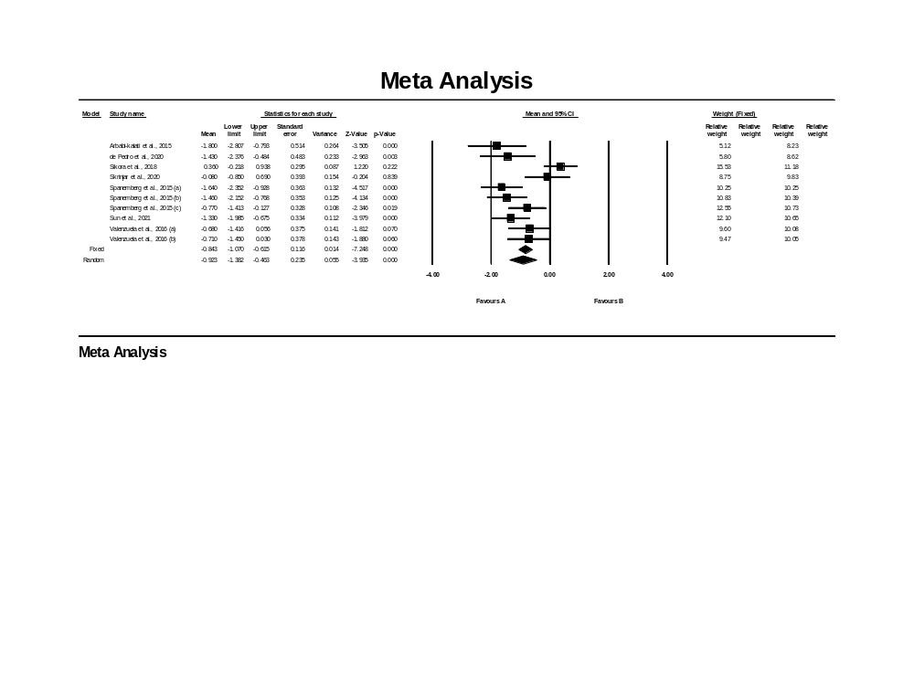

- Funnel plot
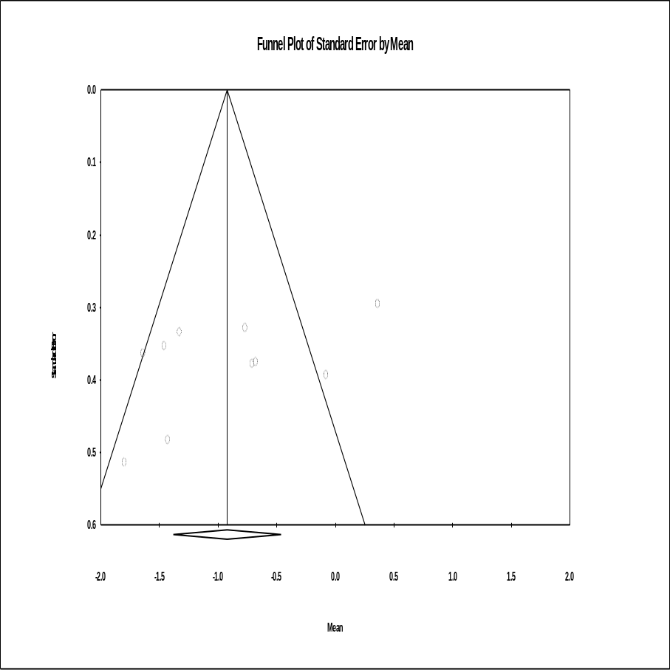

- P-curve
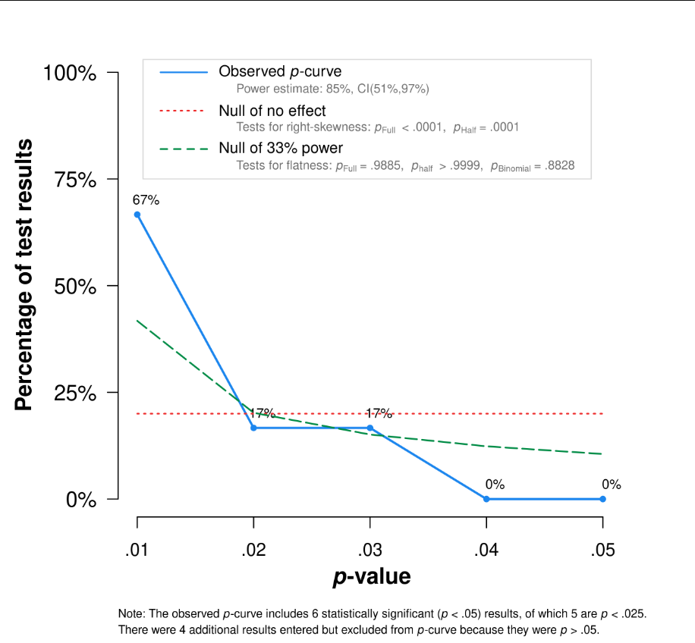

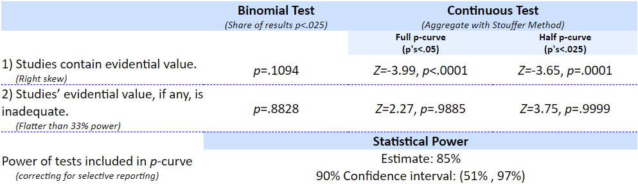

Supplementary Figure 2. Association between PBM and quality of life in patients with burning mouth syndrome
- Forest plot
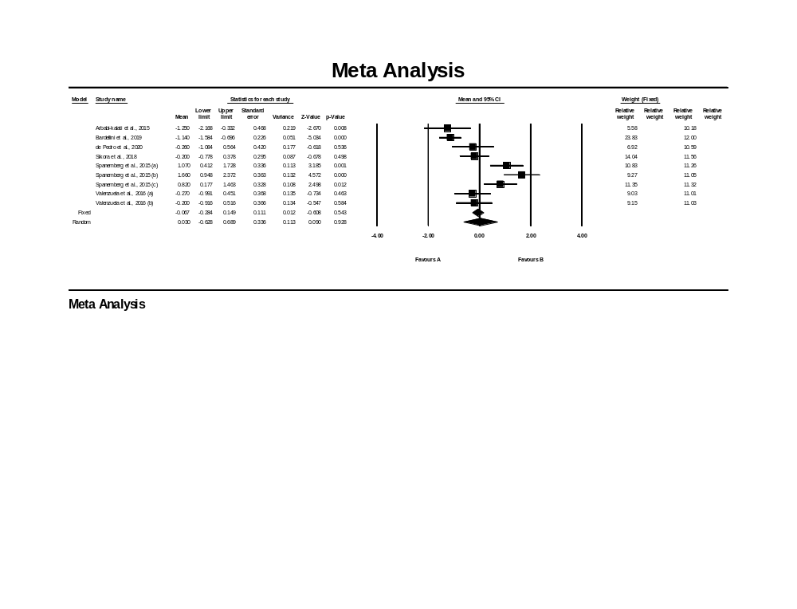

- Funnel plot
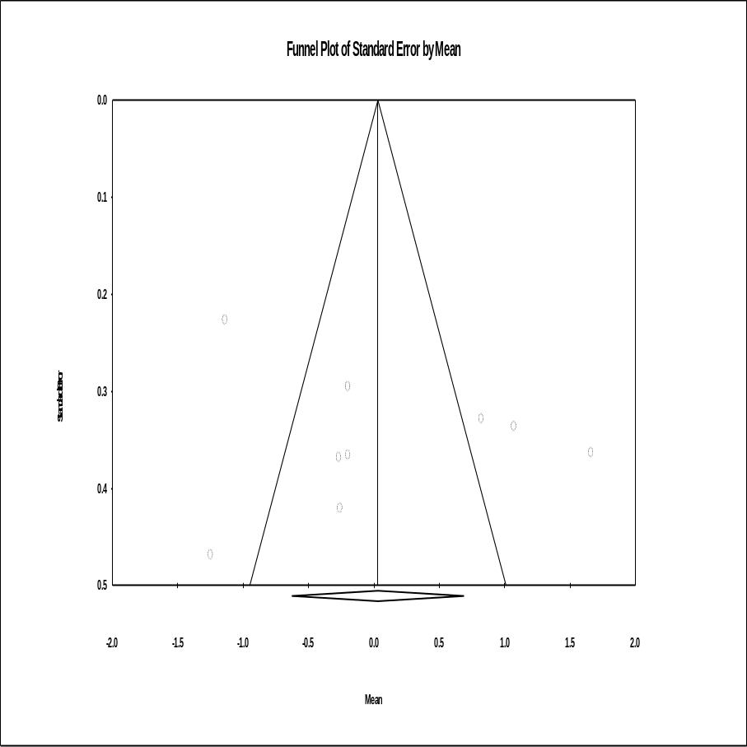

- P-curve
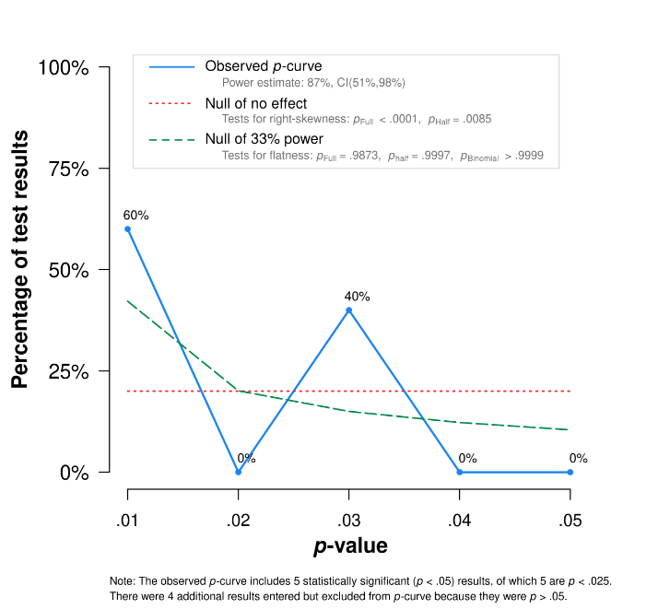
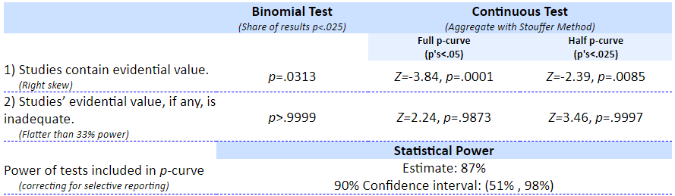

Supplementary Figure 3. Association between PBM and pain levels (VAS score) in patients with temporomandibular disorders
- Forest plot
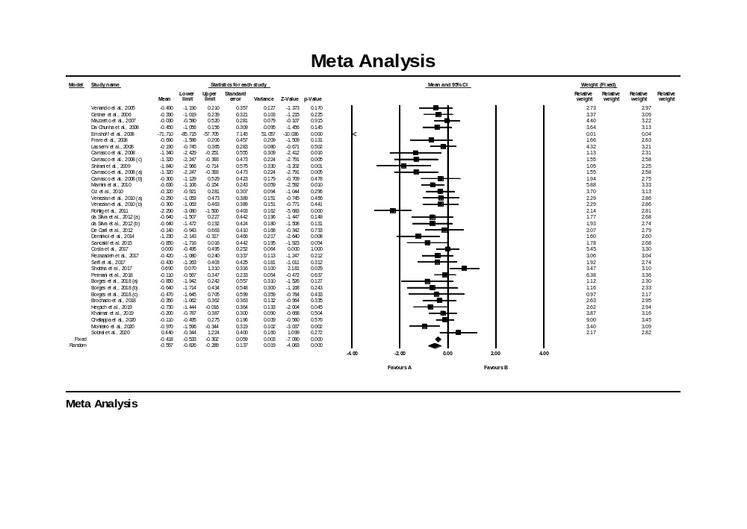
- Funnel plot
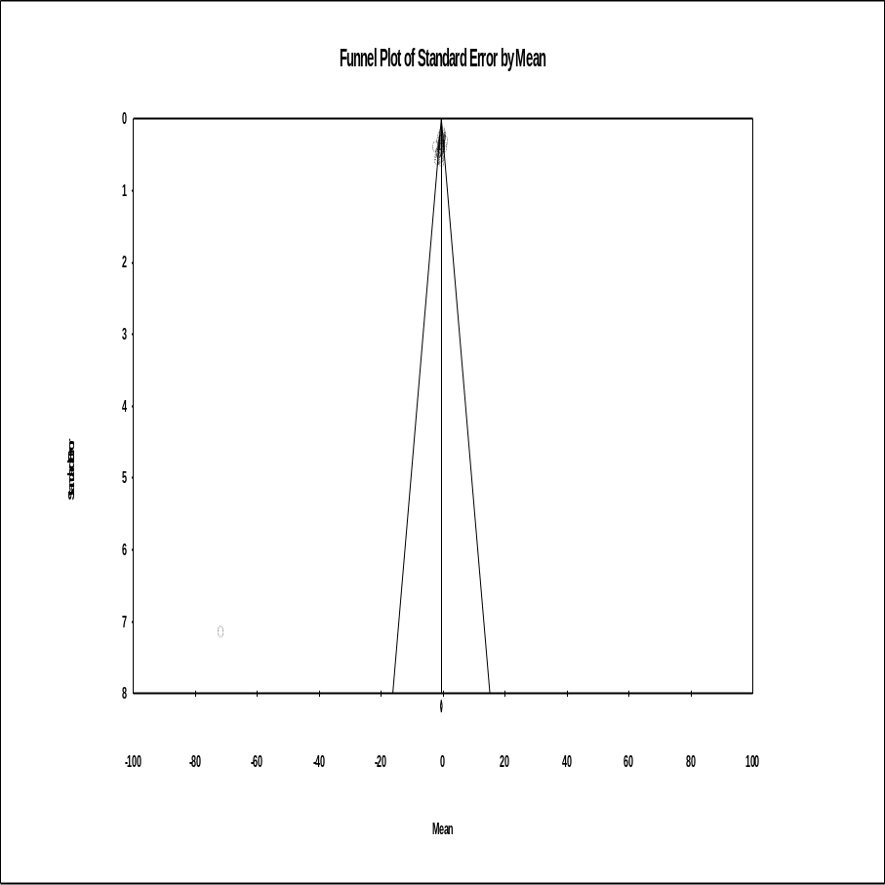

- P-curve
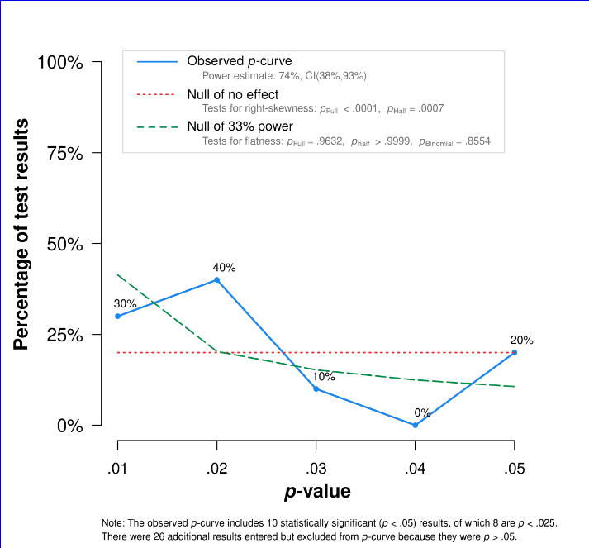
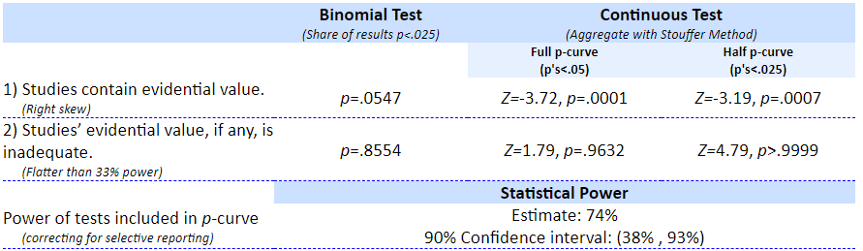

Supplementary Figure 4. Association between PBM and pain levels in patients with rheumatoid arthritis
- Forest plot
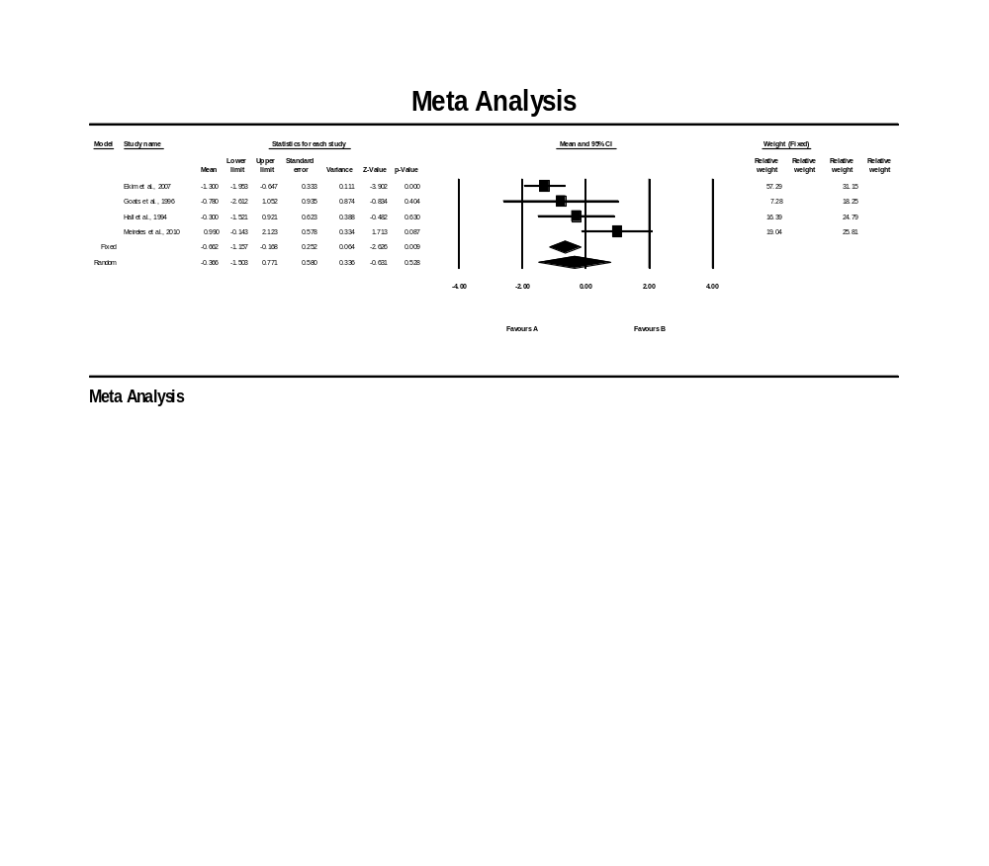

- Funnel plot
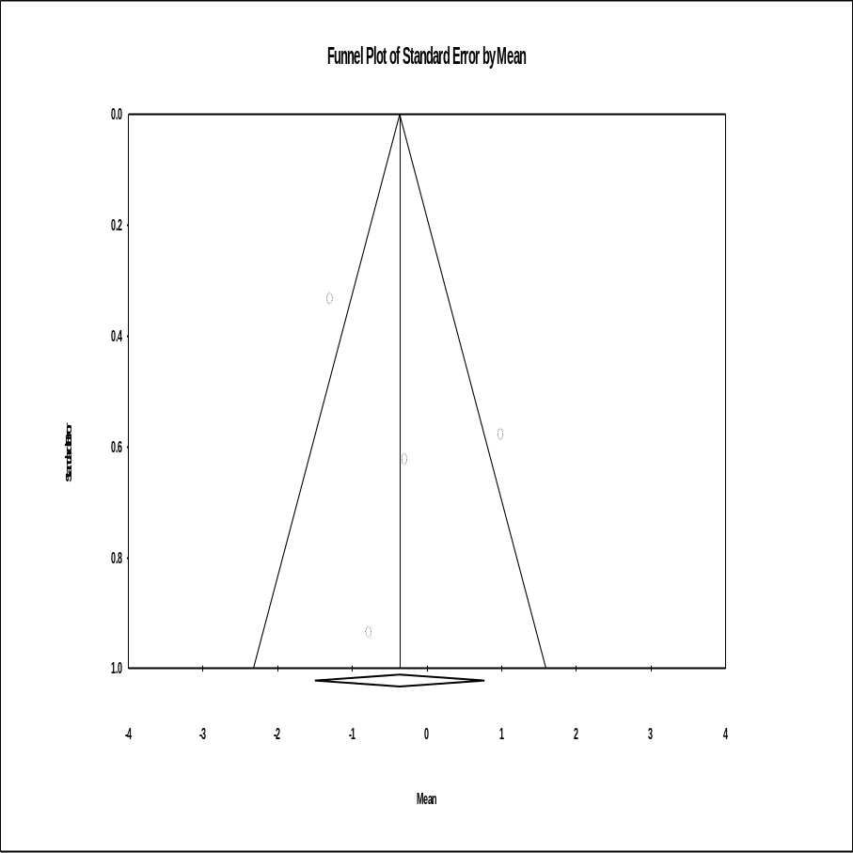

- P-curve
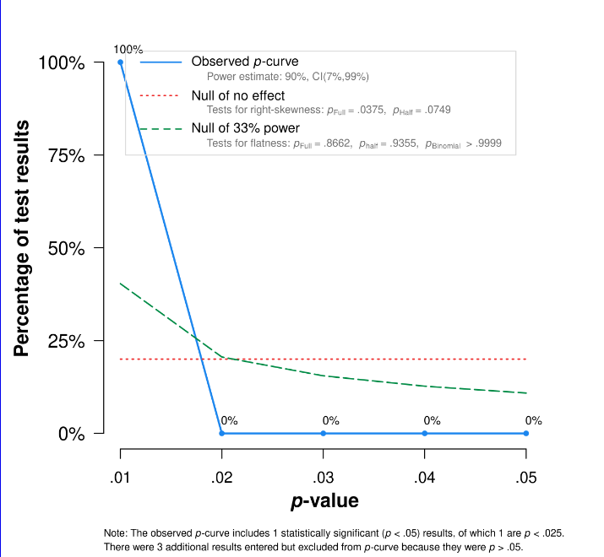

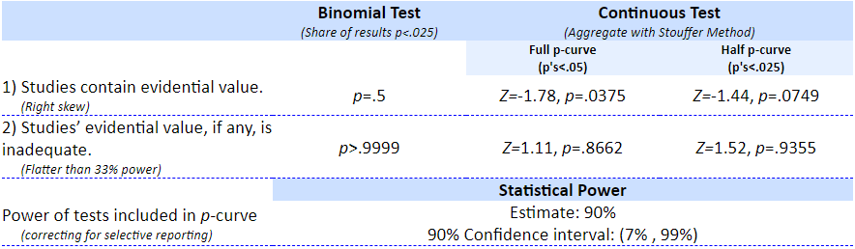

Supplementary Figure 5. Association between PBM and morning stiffness in patients with rheumatoid arthritis
- Forest plot
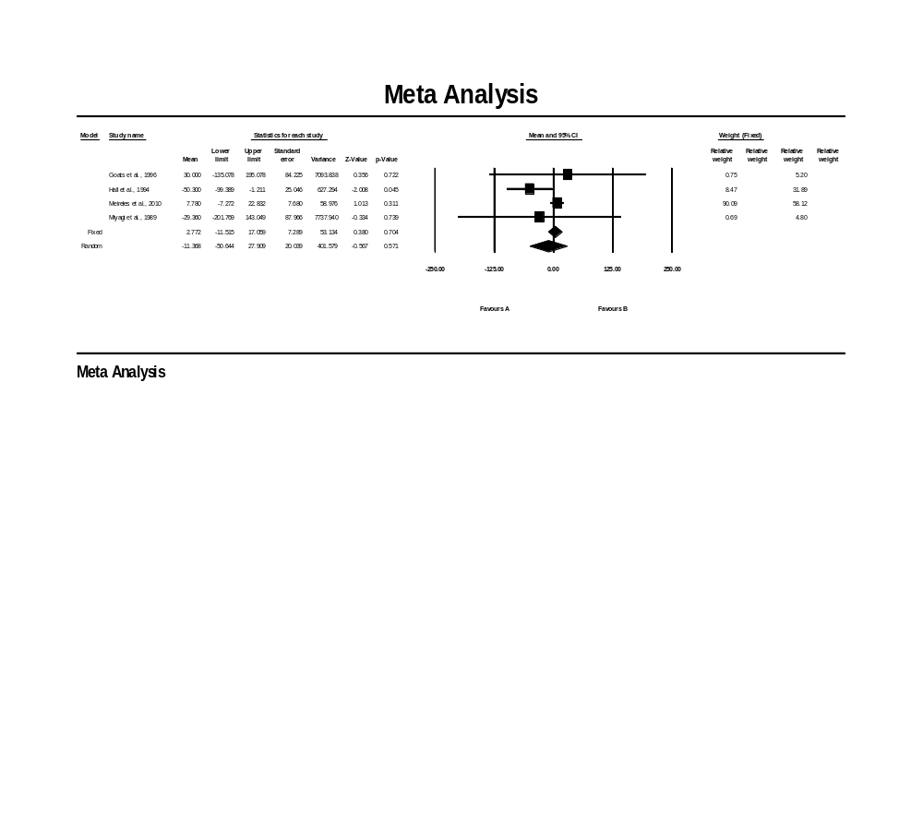

- Funnel plot
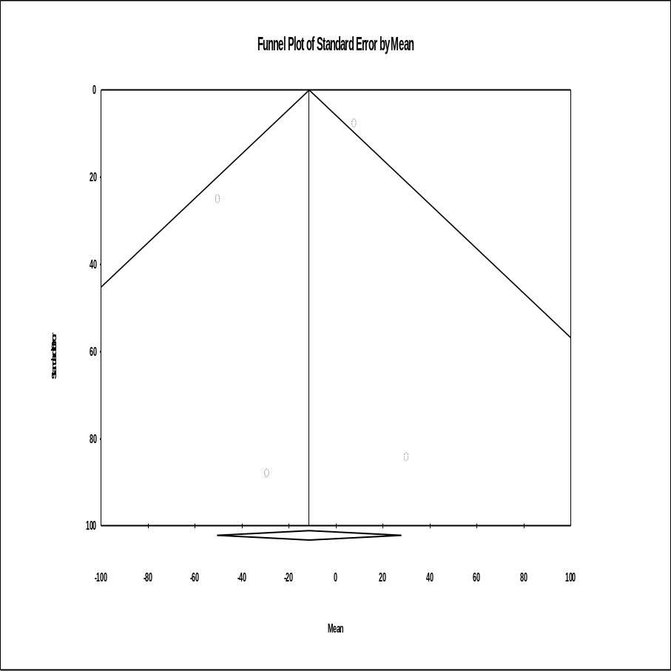

Supplementary Figure 6. Association between PBM and handgrip strength in patients with rheumatoid arthritis
- Forest plot
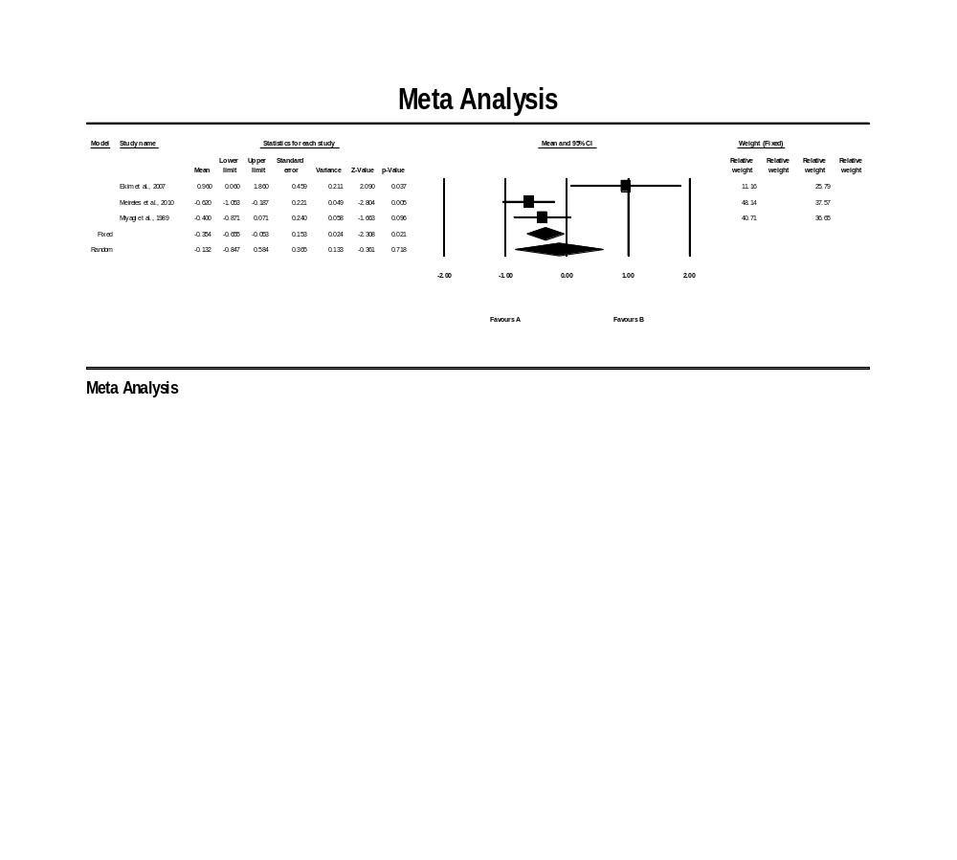

- Funnel plot
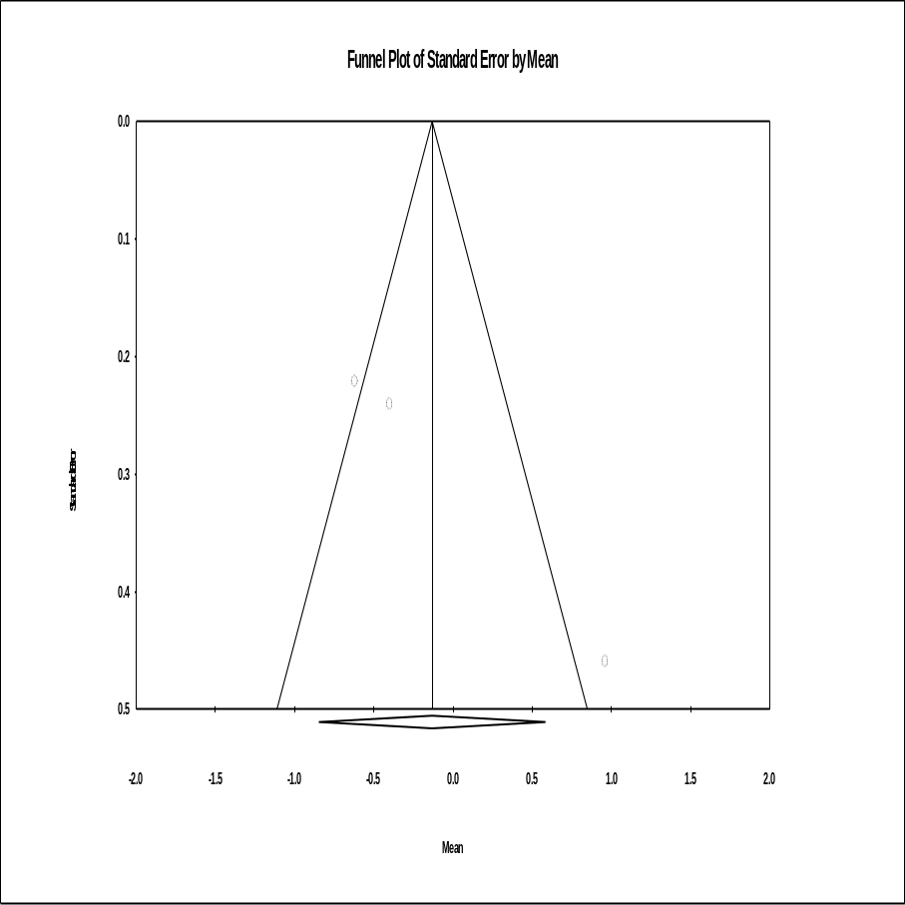

- P-curve
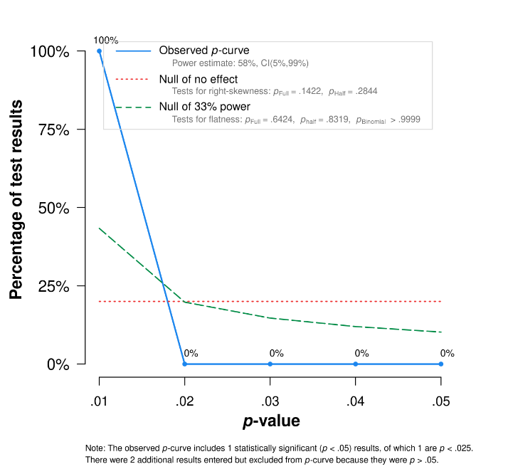

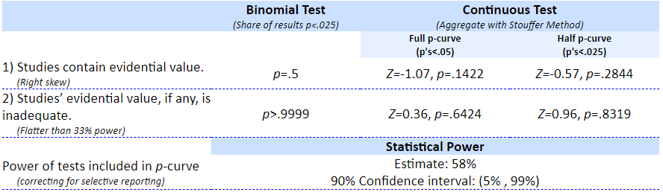

Supplementary Figure 7. Association between PBM and functional capacity in patients with rheumatoid arthritis
- Forest plot
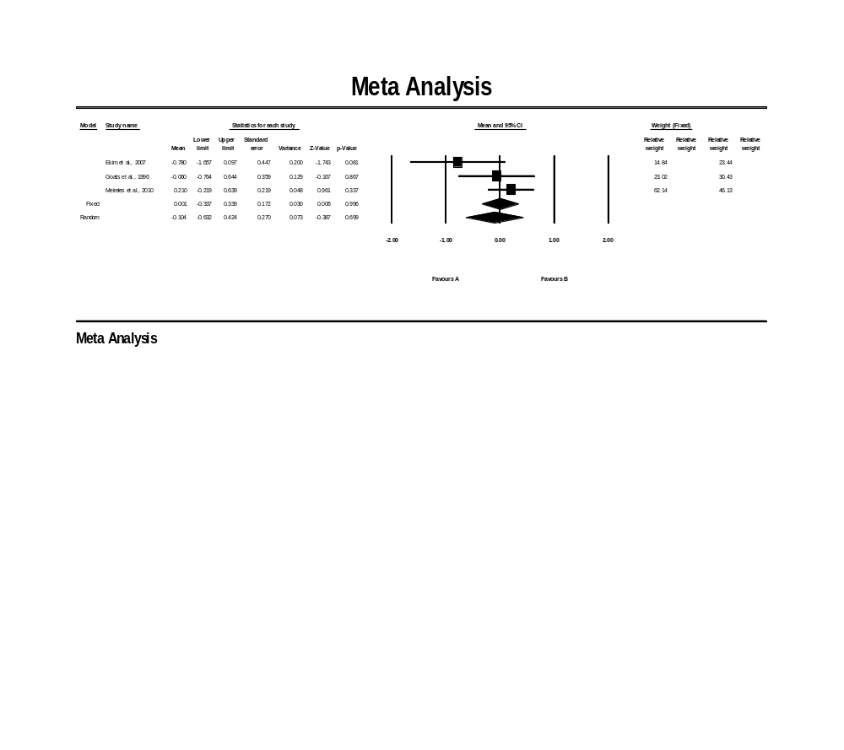

- Funnel plot
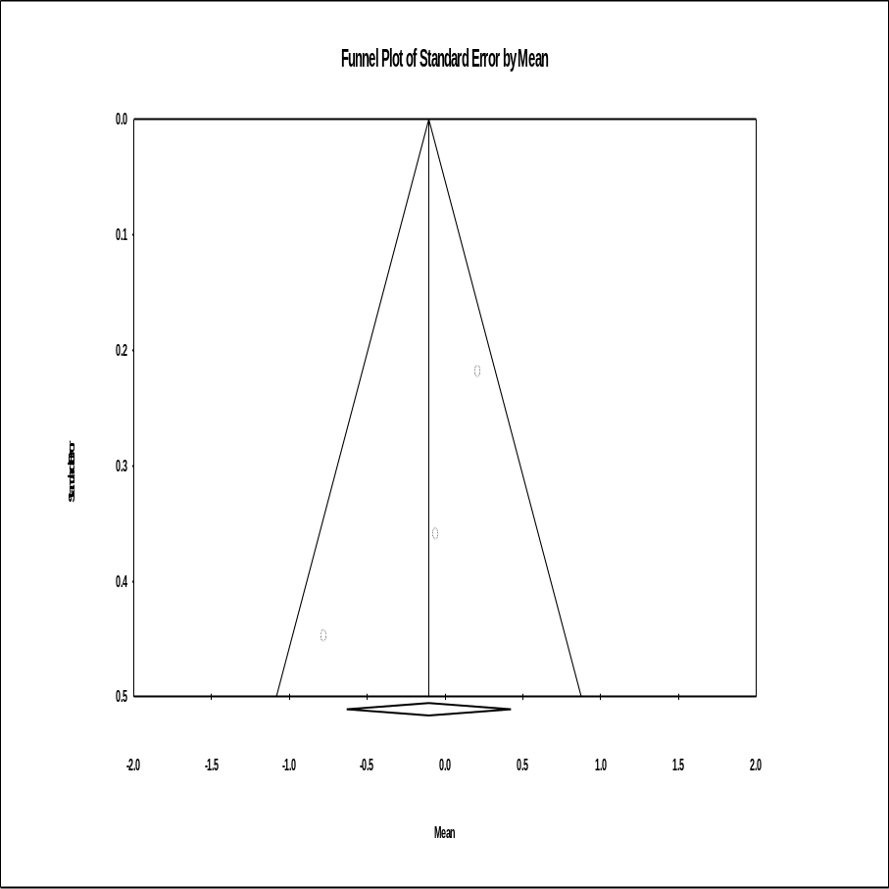

Supplementary Figure 8. Association between PBM and inflammation in patients with rheumatoid arthritis
- Forest plot
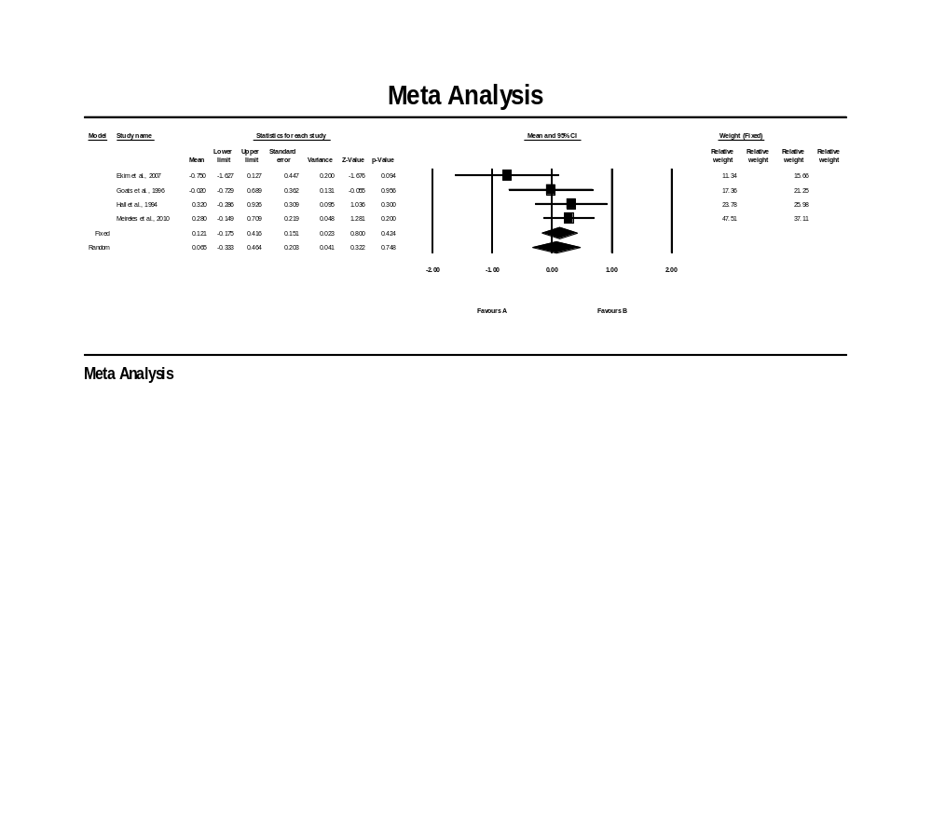

- Funnel plot
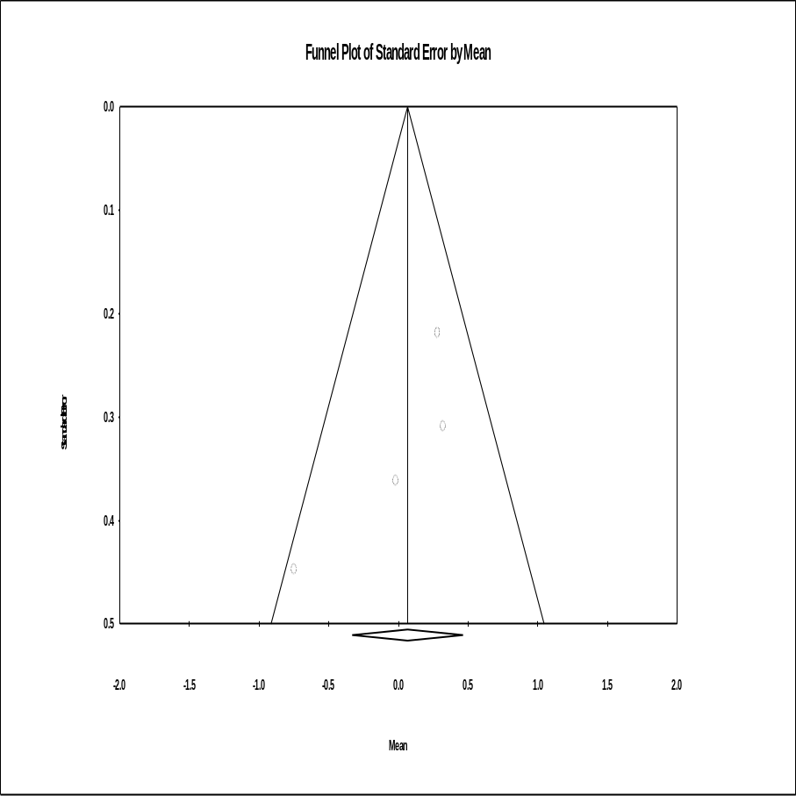

Supplementary Figure 9. Association between PBM and activity score in patients with rheumatoid arthritis
- Forest plot
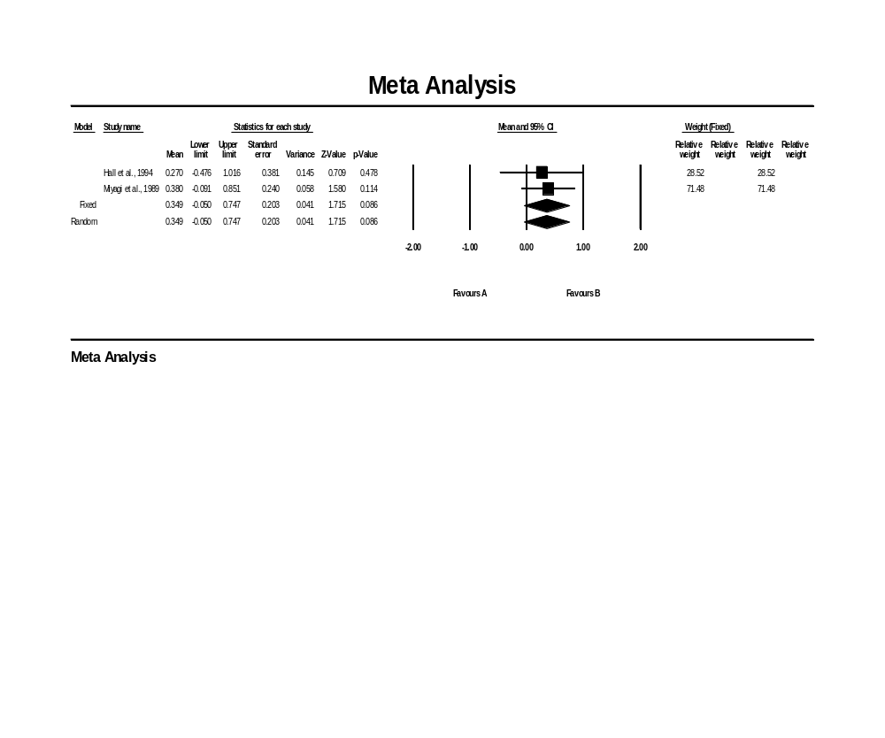

Supplementary Figure 10. Association between PBM and pain intensity in patients with plantar fasciitis
- Forest plot
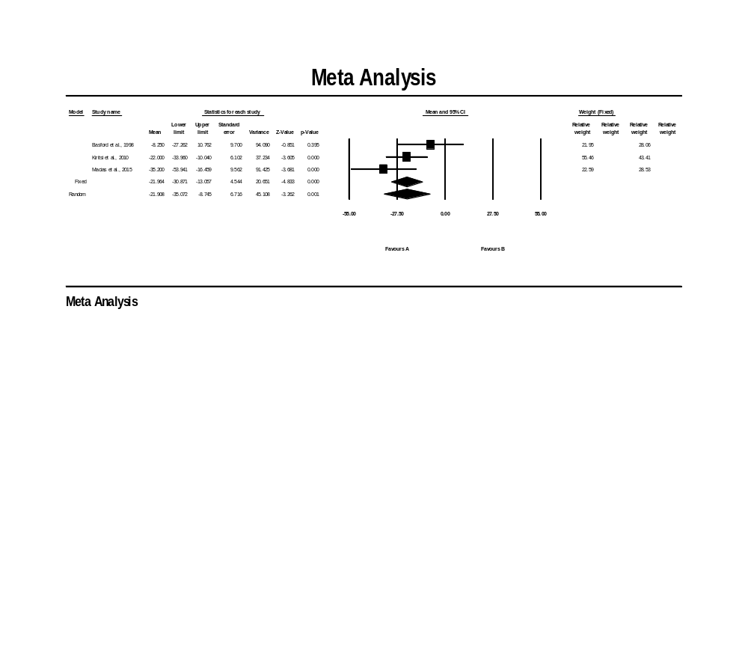

- Funnel plot
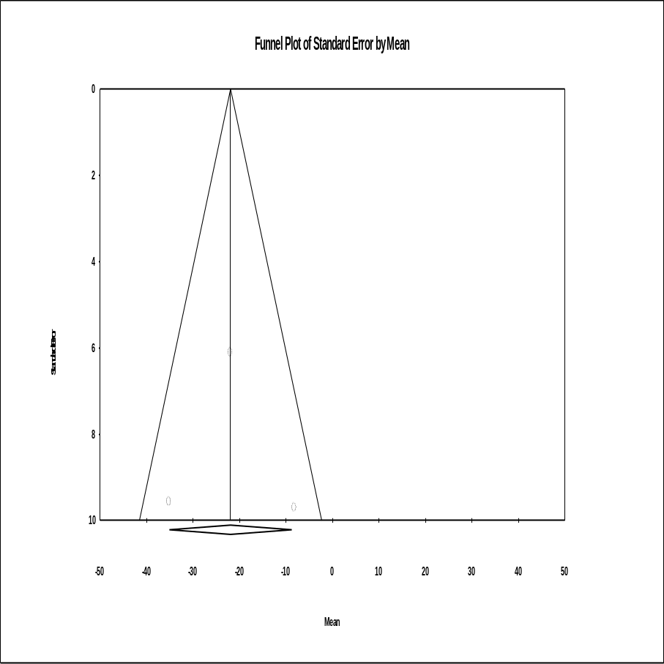

- P-curve
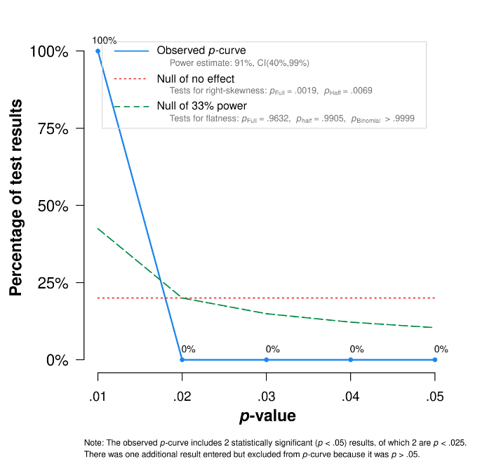
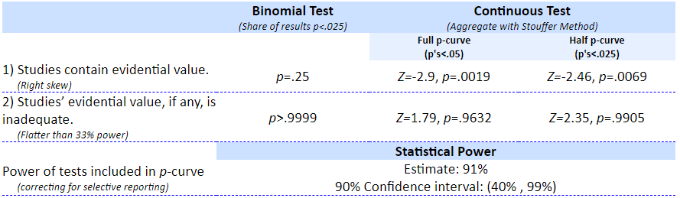

Supplementary Figure 11. Association between PBM and pain levels (VAS score) in patients with tendinopathy
- Forest plot
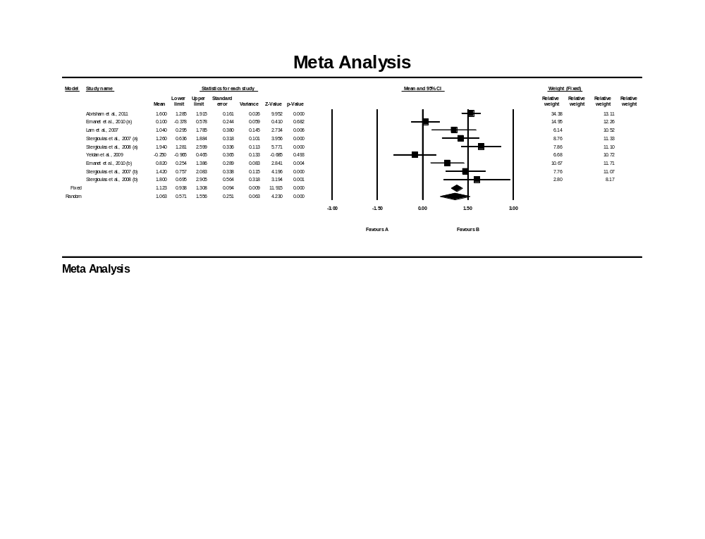

- Funnel plot
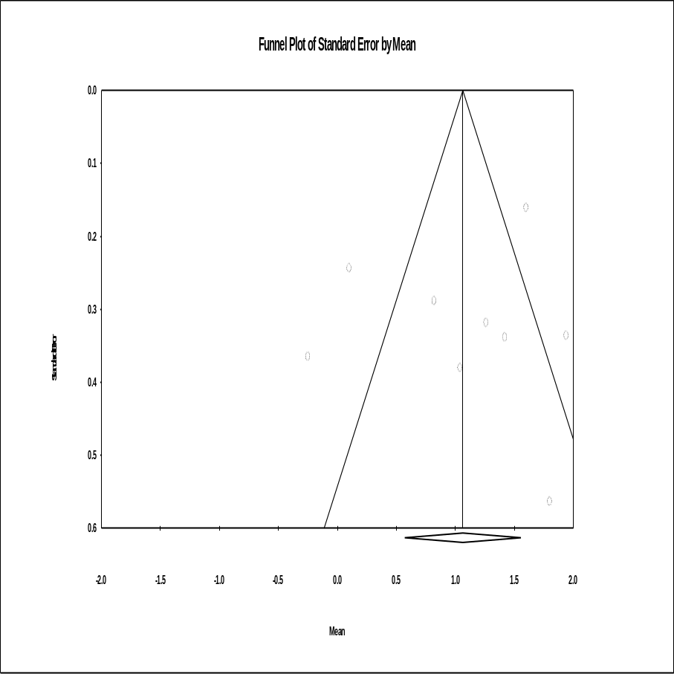

- P-curve
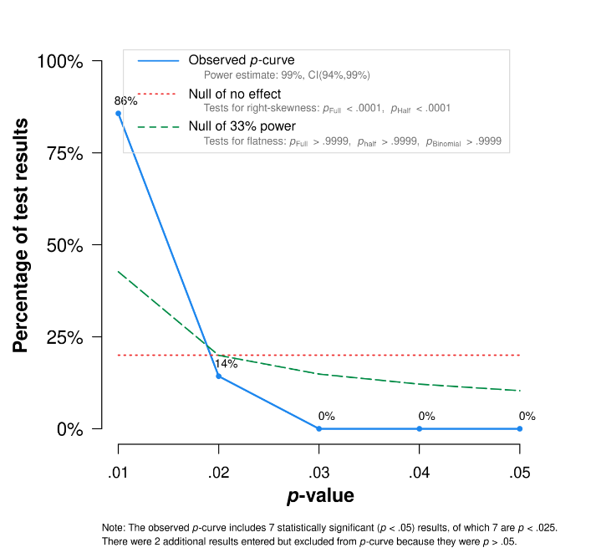

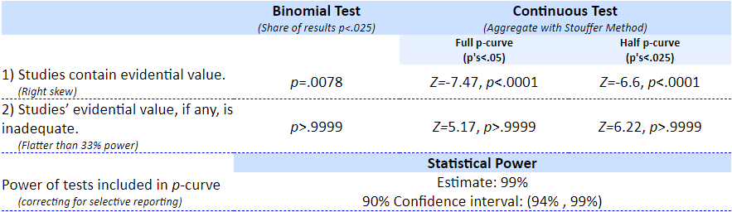

Supplementary Figure 12. Association between PBM and muscle strength in patients with tendinopathy
- Forest plot
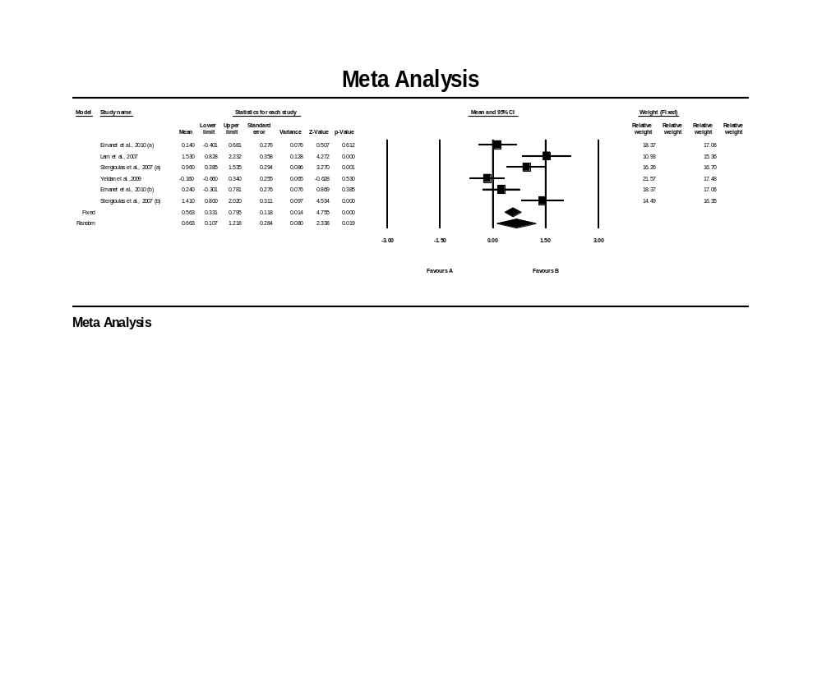

- Funnel plot
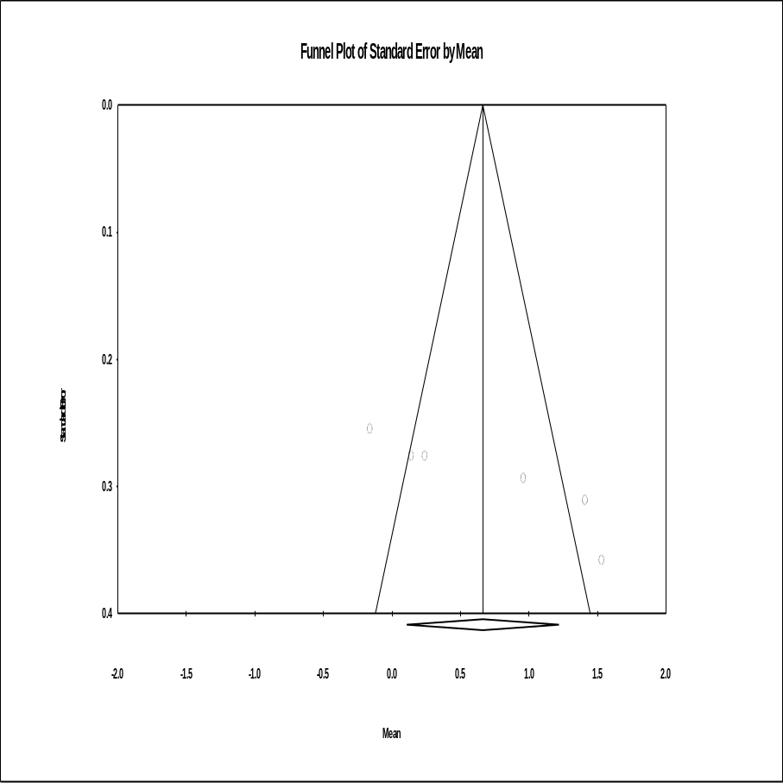

- P-curve
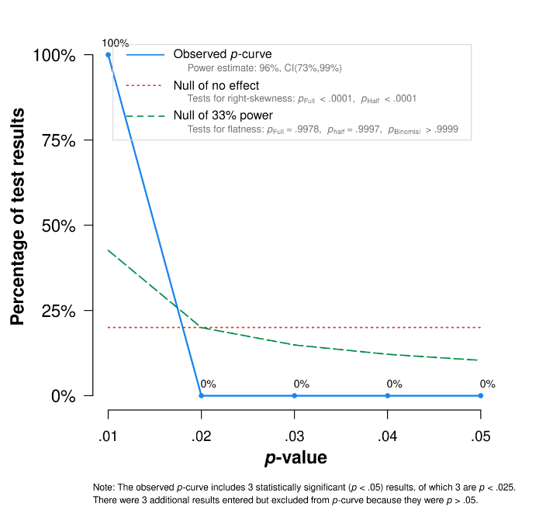

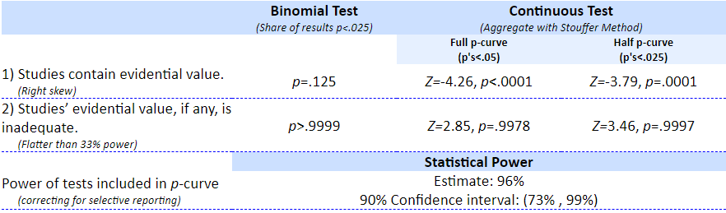

Supplementary Figure 13. Association between PBM and pain levels in patients with knee osteoarthritis
- Forest plot
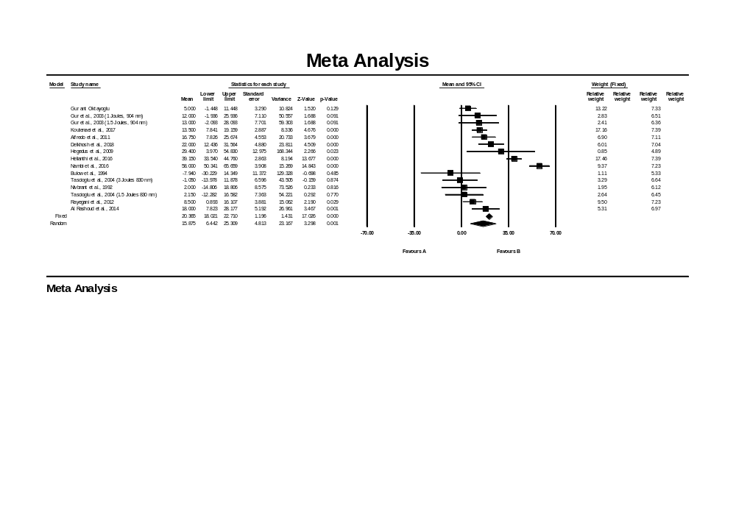

- Funnel plot
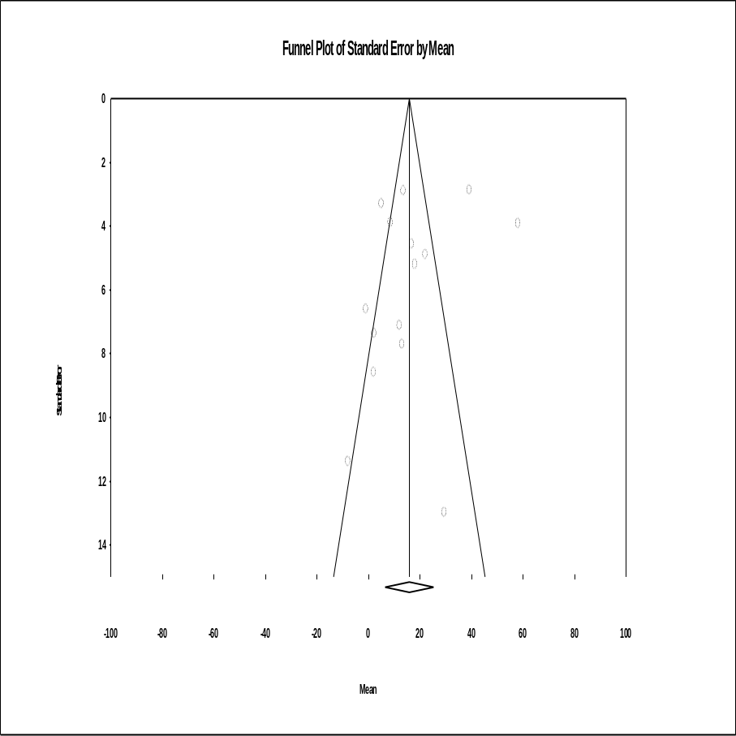

- P-curve
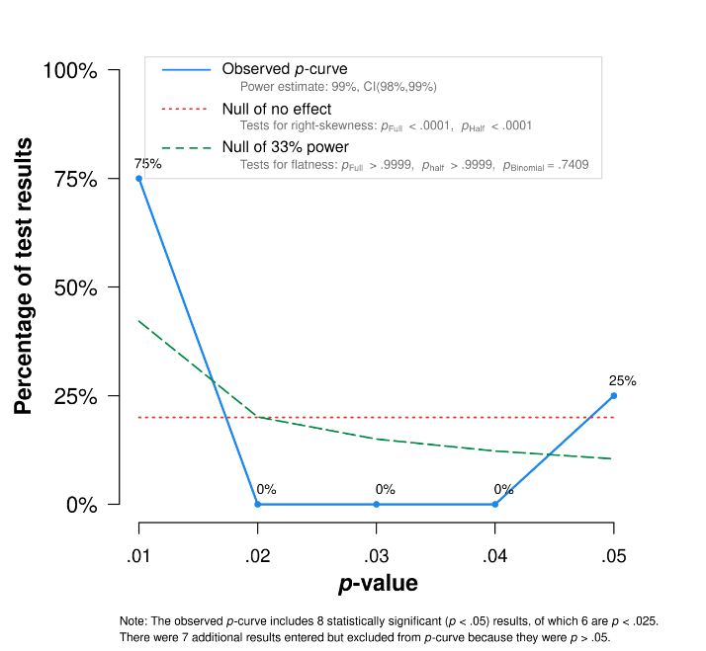

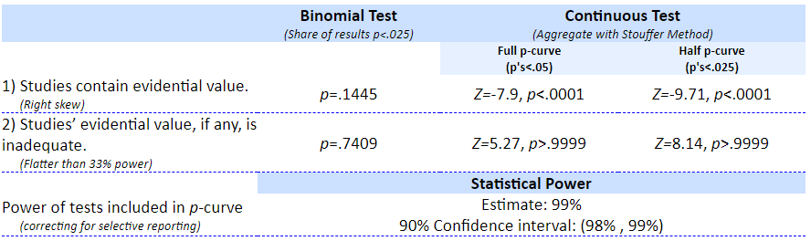

Supplementary Figure 14. Association between PBM and disability in patients with knee osteoarthritis
- Forest plot
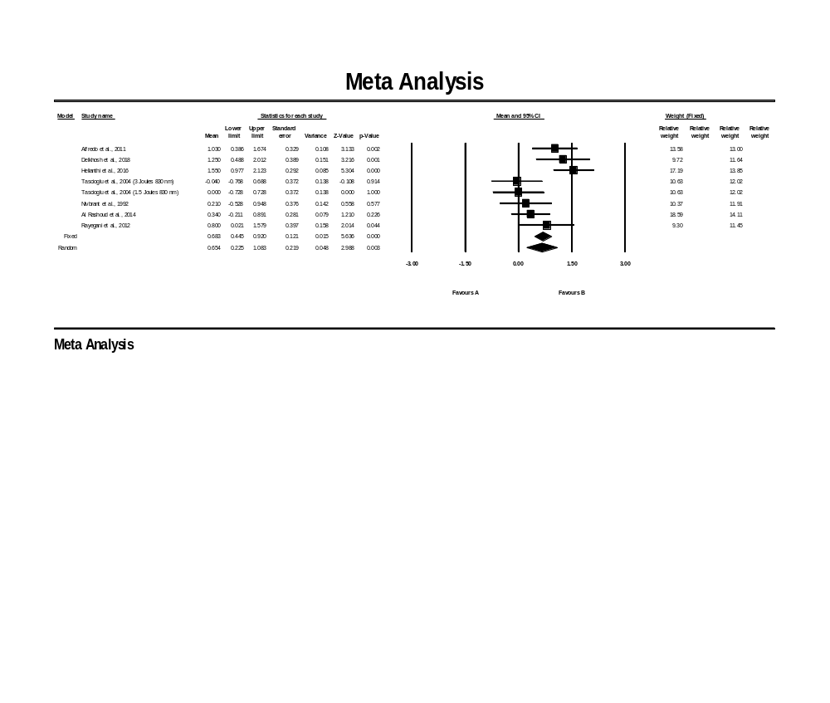

- Funnel plot
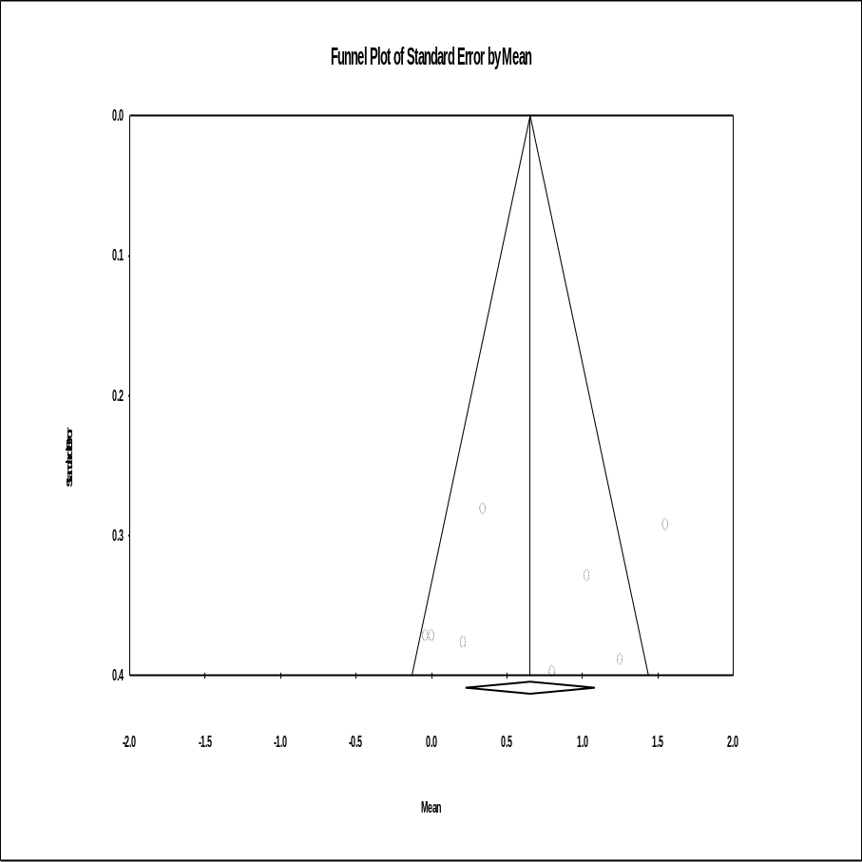

- P-curve
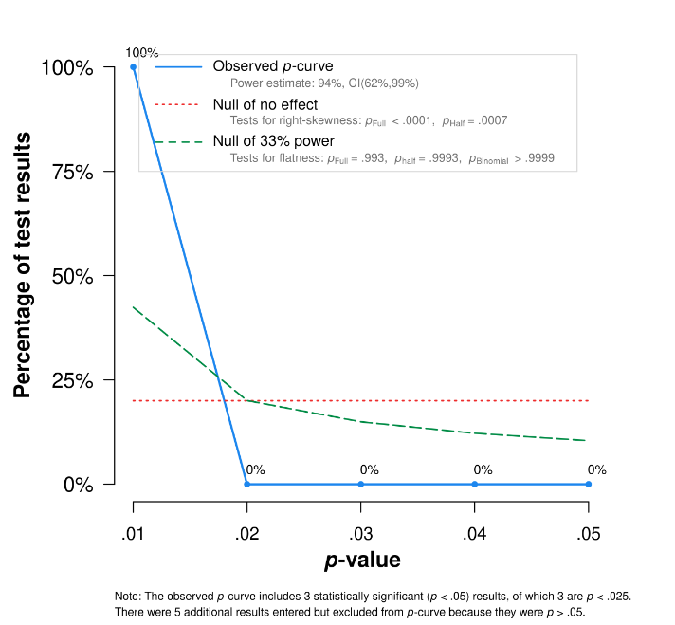
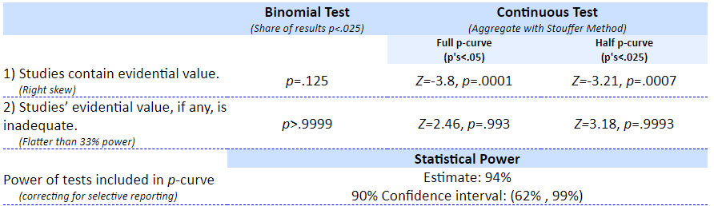

Supplementary Figure 15. Association between PBM and changes in FIQ score in patients with fibromyalgia
- Forest plot
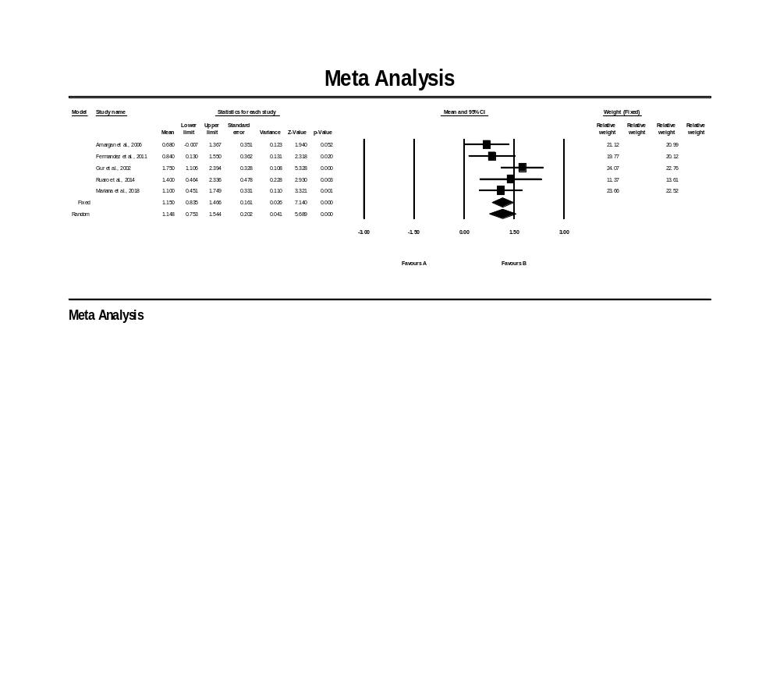

- Funnel plot
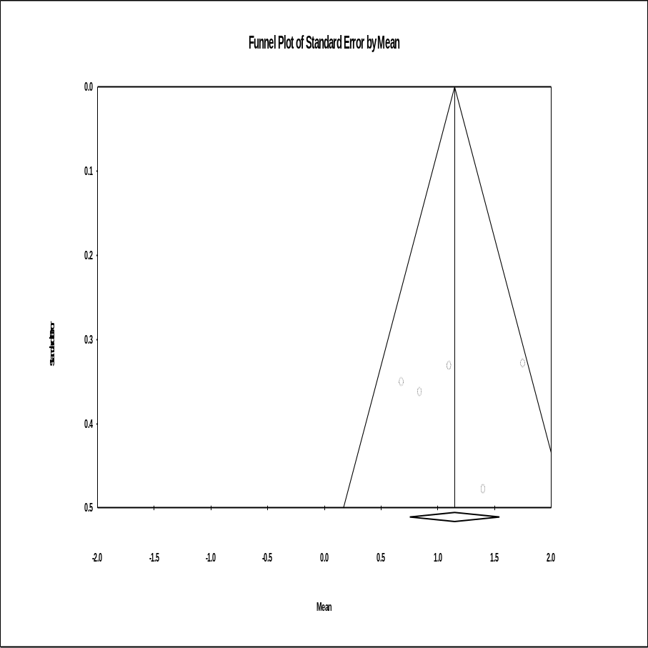

- P-curve
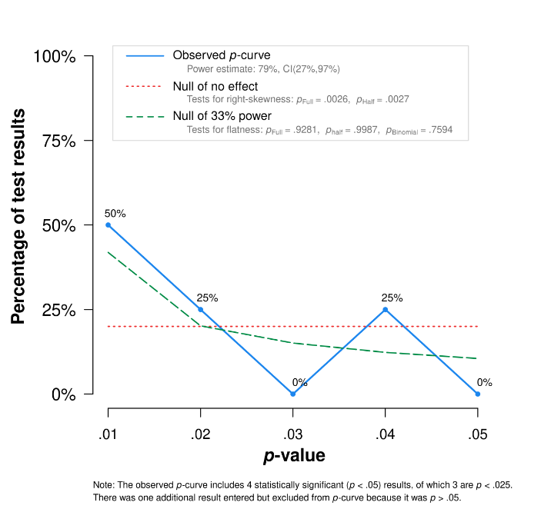

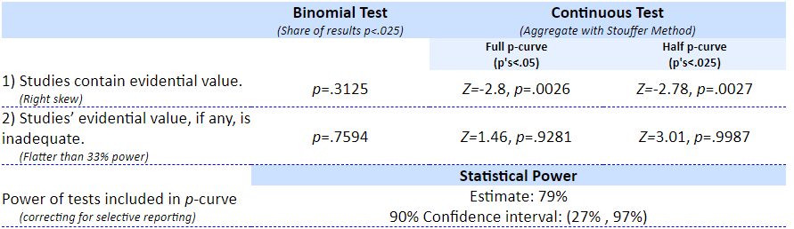

Supplementary Figure 16. Association between PBM and changes in pain severity in patients with fibromyalgia
- Forest plot
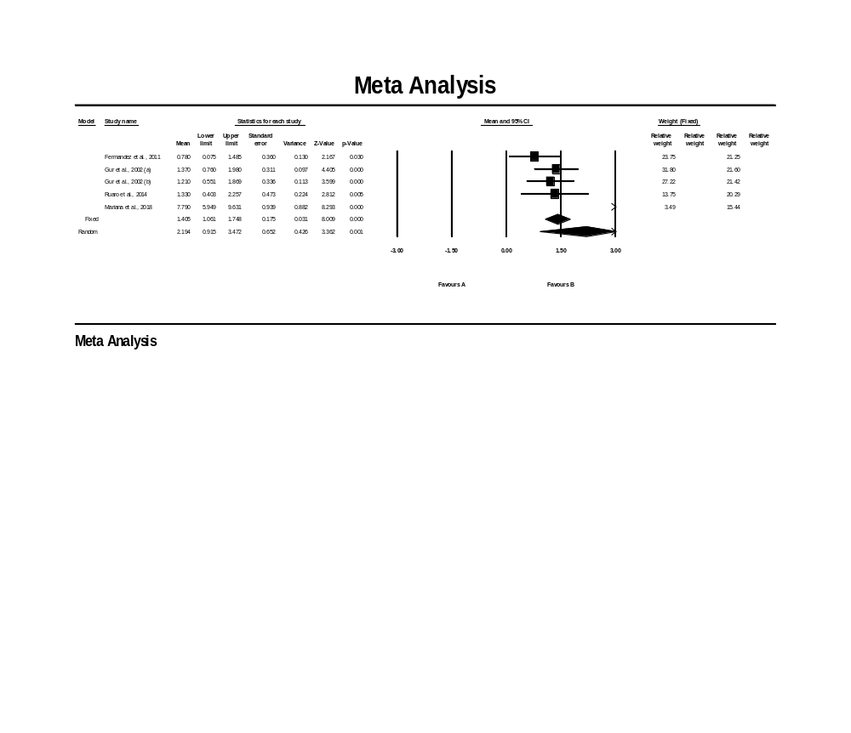

- Funnel plot
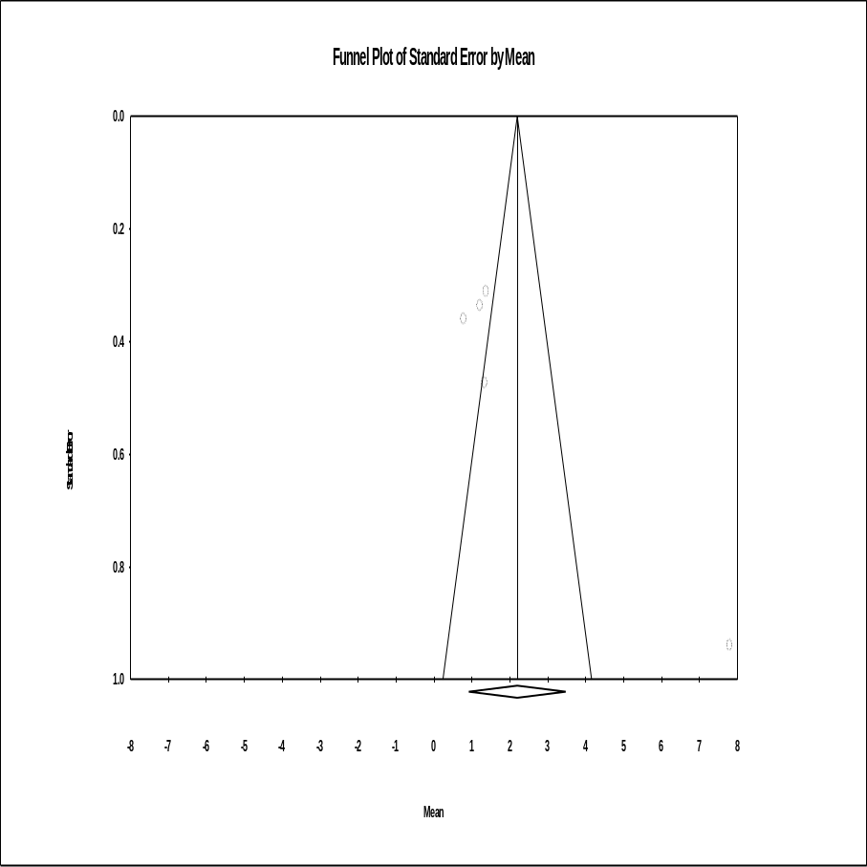
- P-curve
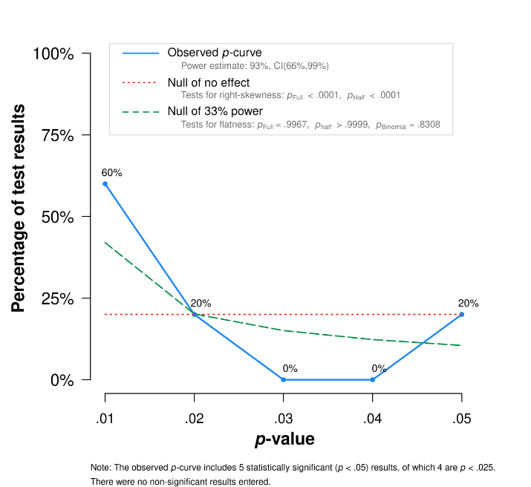

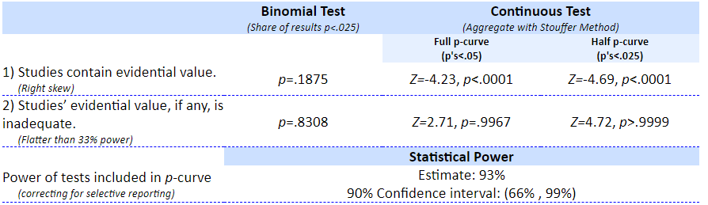

Supplementary Figure 17. Association between PBM and changes in number of tender points in patients with fibromyalgia
- Forest plot
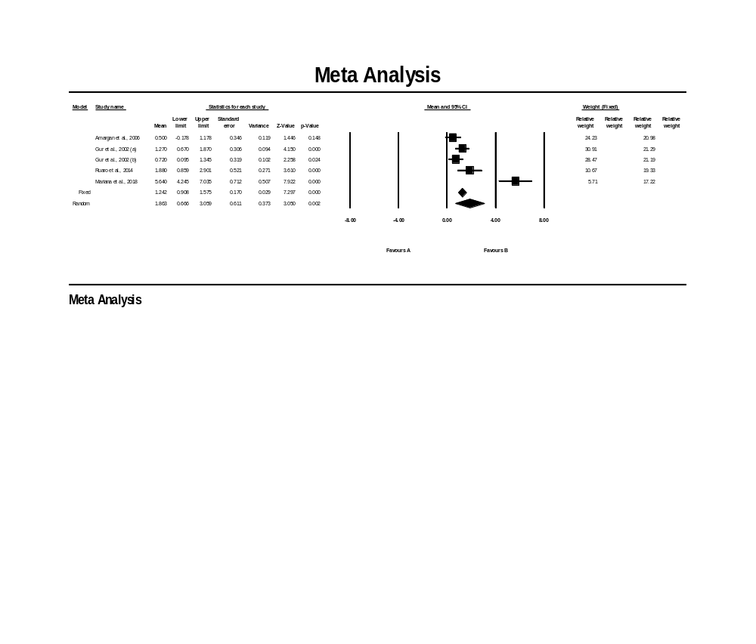

- Funnel plot
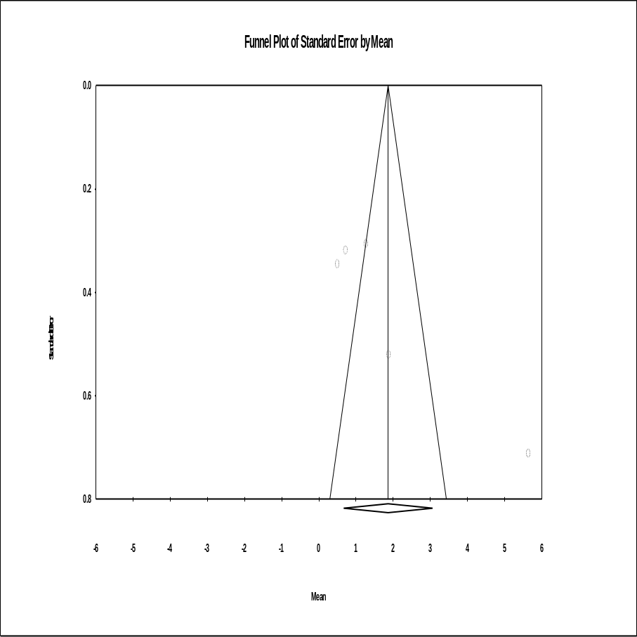

- P-curve
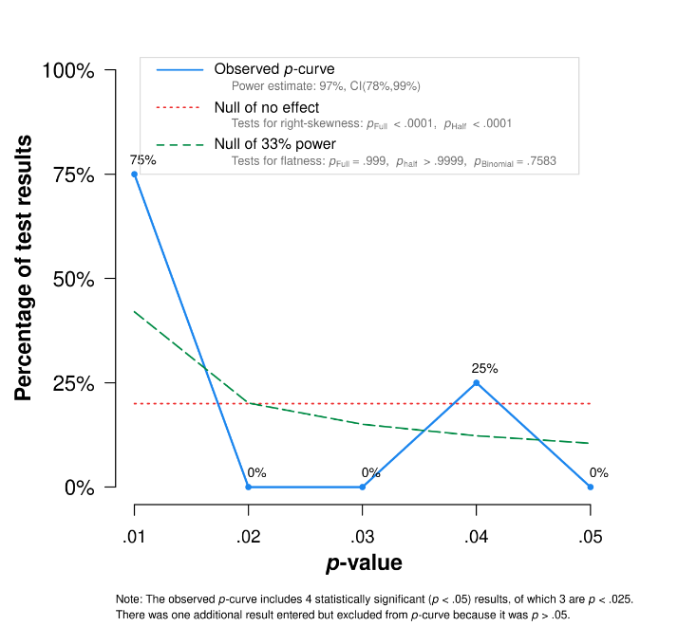

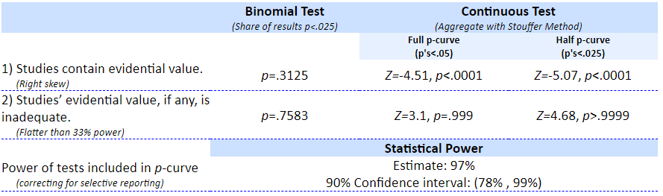

Supplementary Figure 18. Association between PBM and changes in severity of fatigue in patients with fibromyalgia
- Forest plot
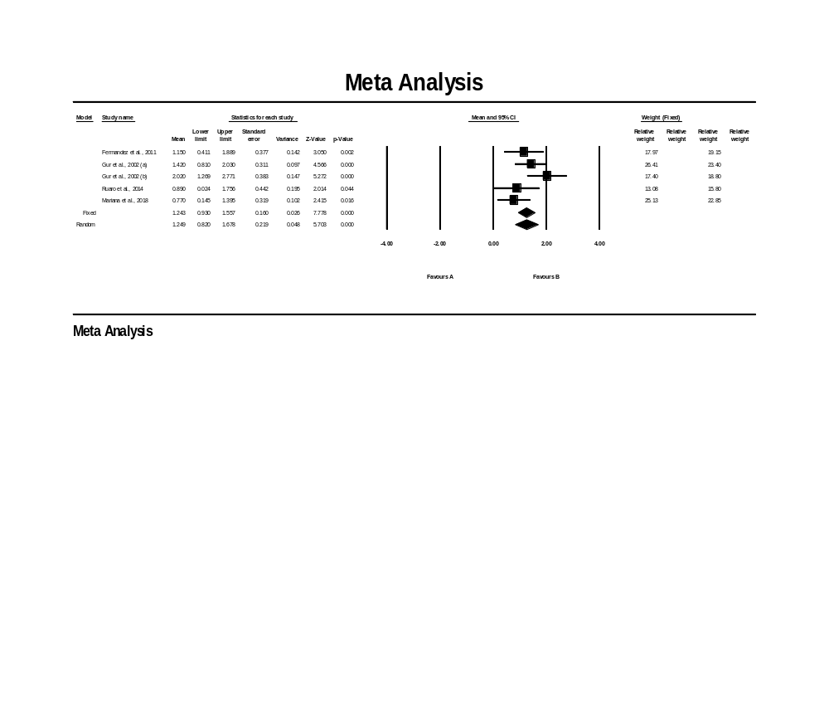

- Funnel plot
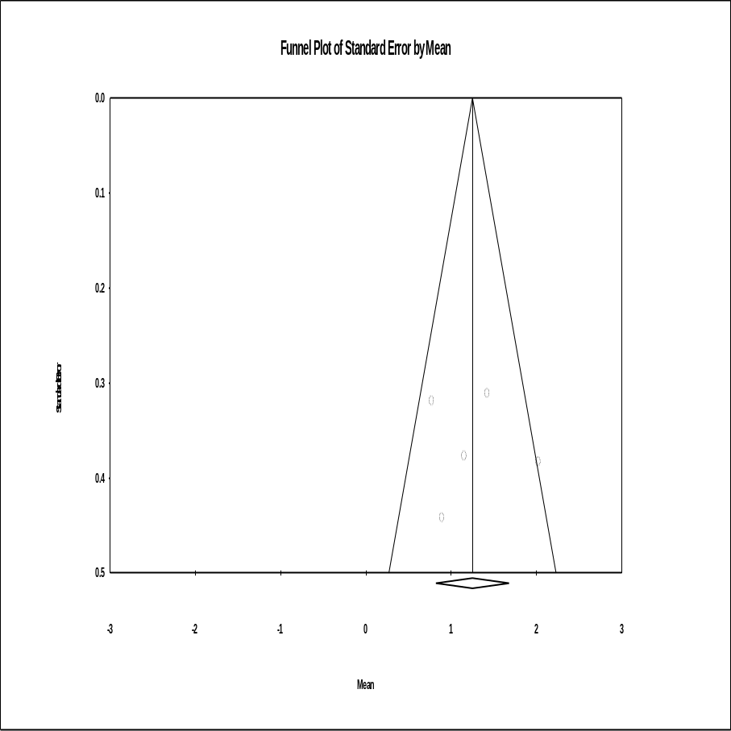
- P-curve
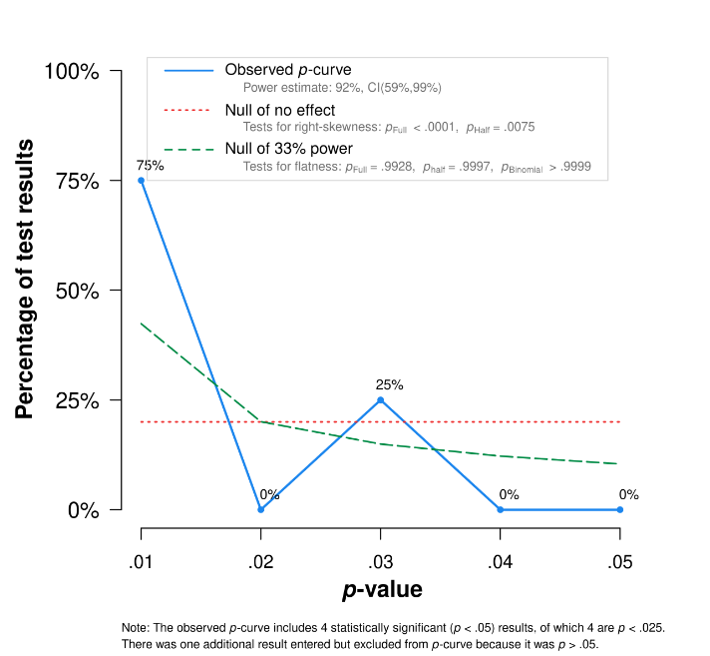
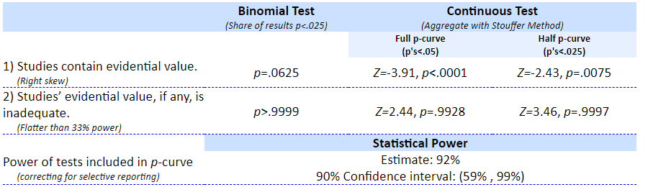

Supplementary Figure 19. Association between PBM and changes in severity of stiffness difference in patients with fibromyalgia
- Forest plot
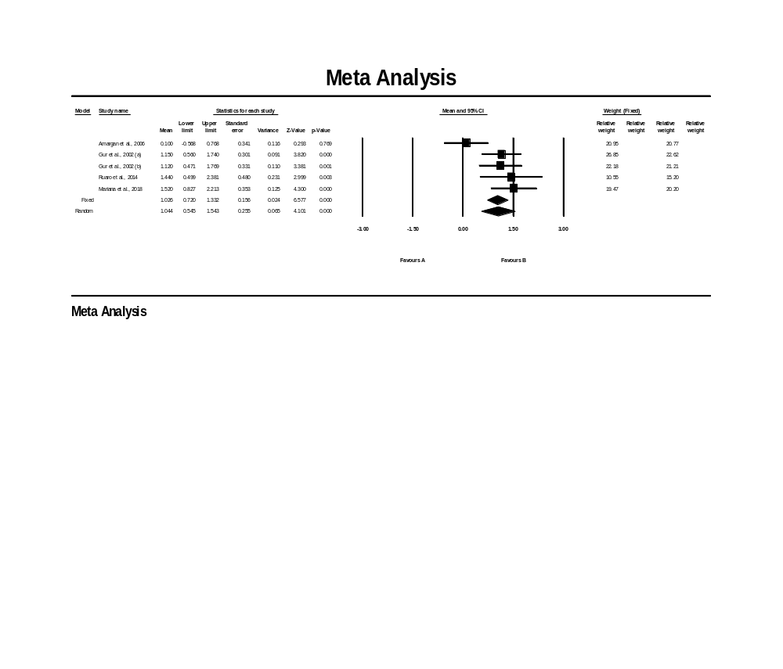

- Funnel plot
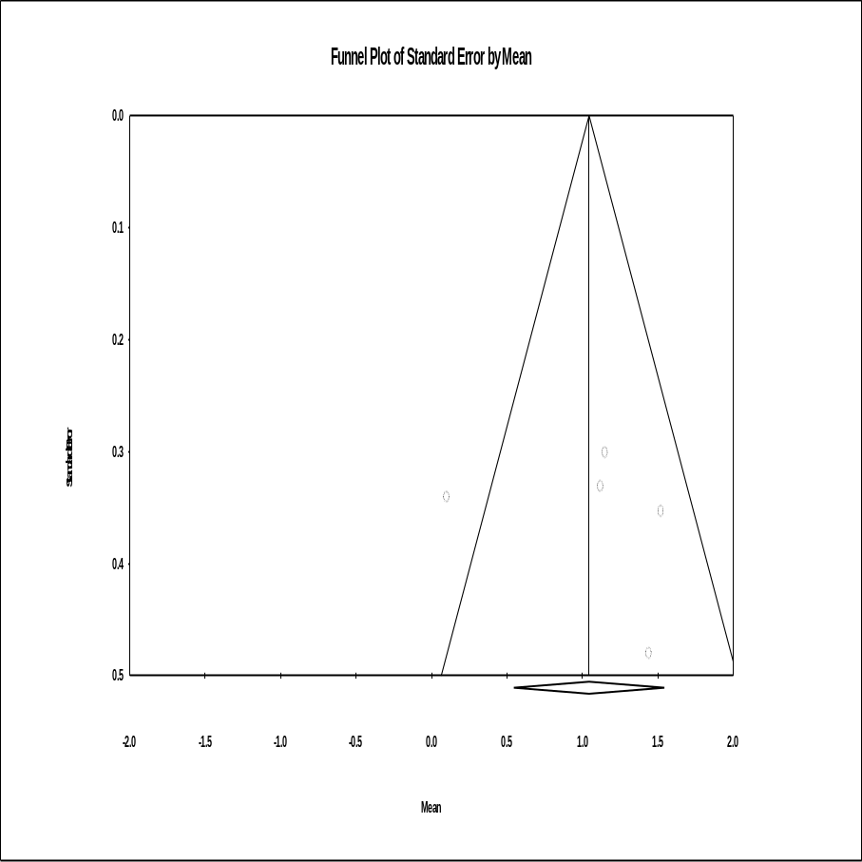

- P-curve
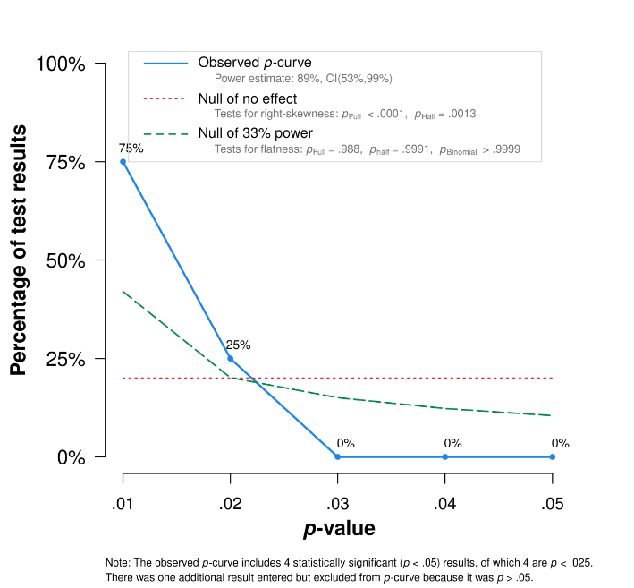

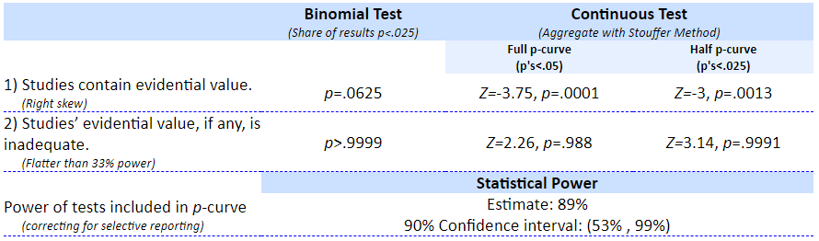

Supplementary Figure 20. Association between PBM and changes in severity of depression in patients with fibromyalgia
- Forest plot
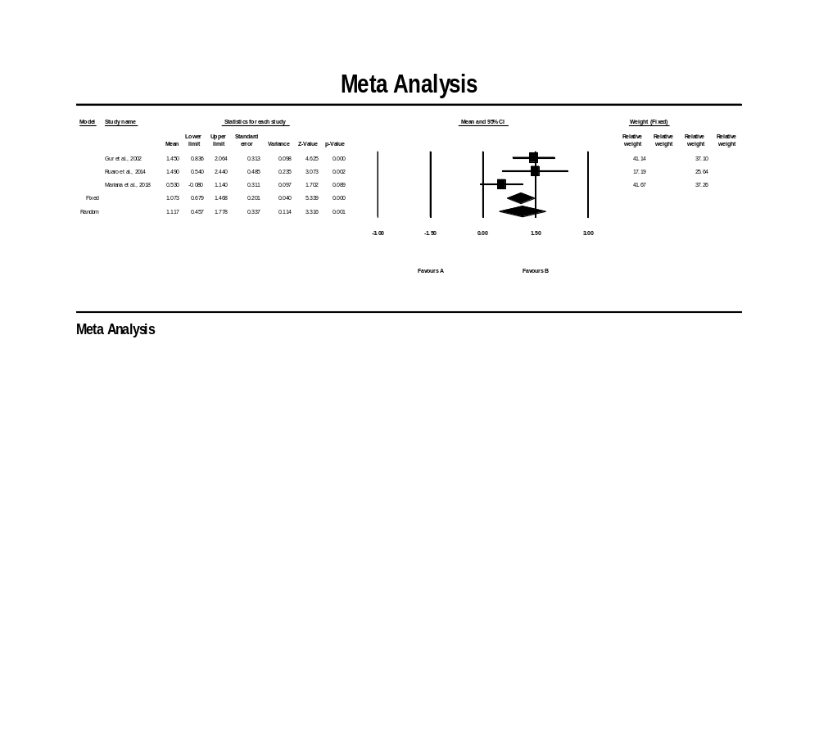

- Funnel plot
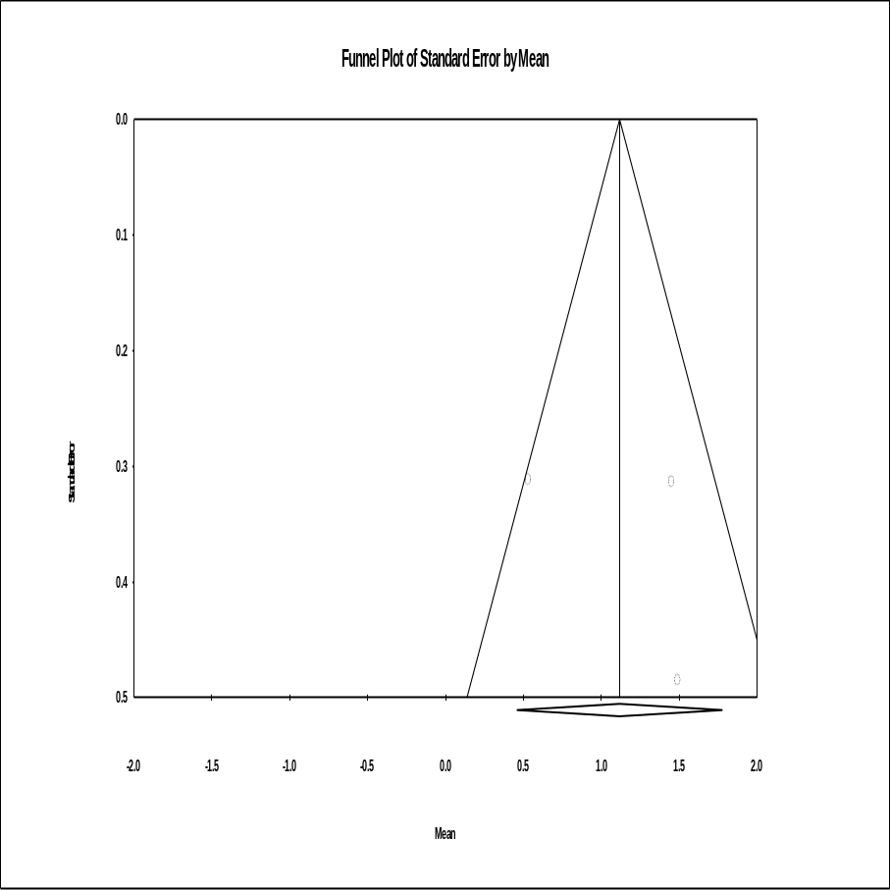

- P-curve
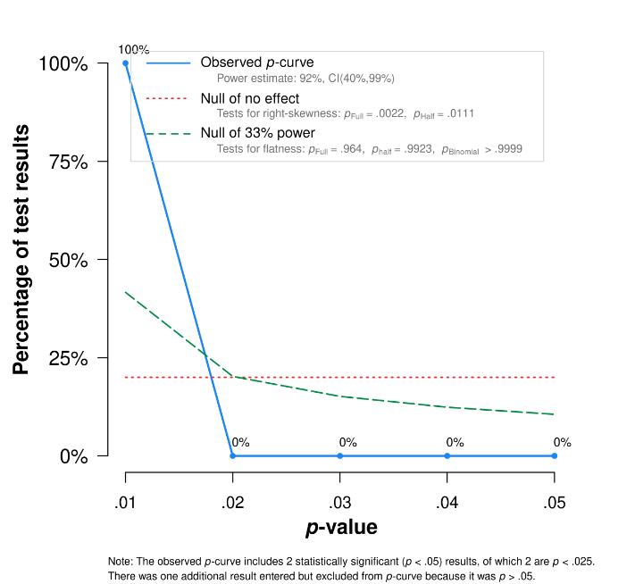

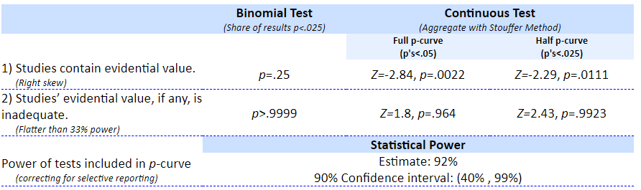

Supplementary Figure 21. Association between PBM and changes in severity of anxiety in patients with fibromyalgia
- Forest plot
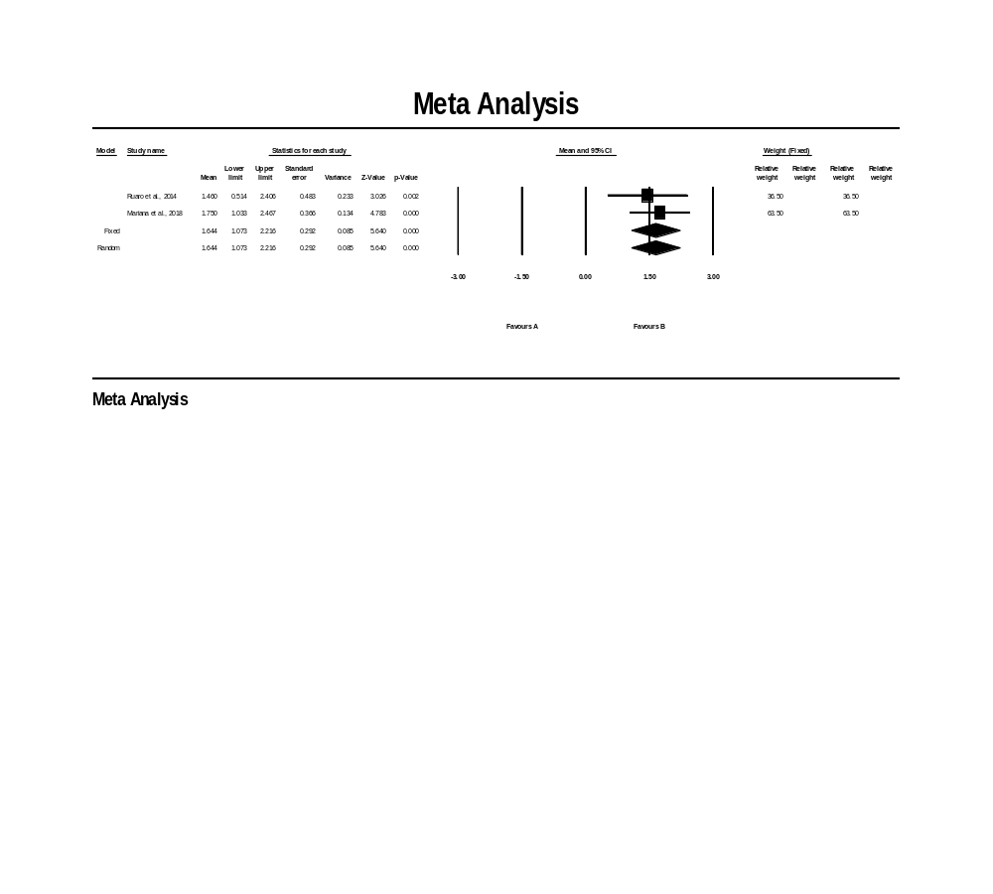

- P-curve
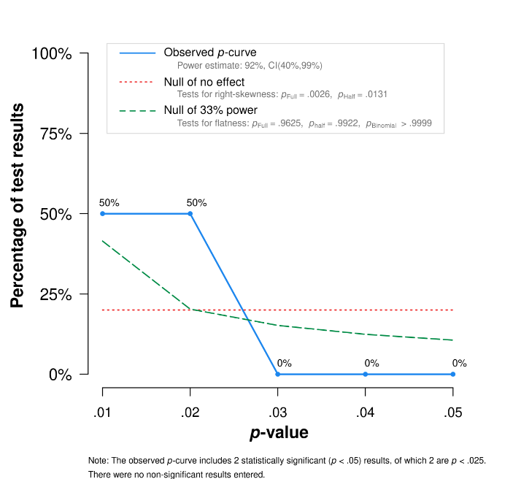

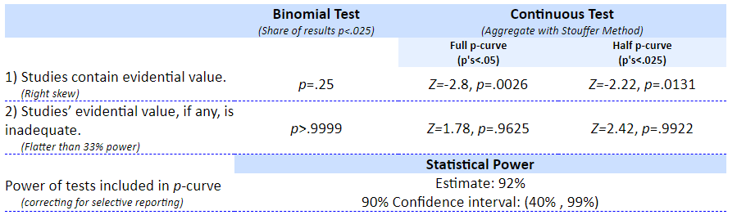

Supplementary Figure 22. Association between PBM and neck pain level in patients with myofascial neck pain syndrome
- Forest plot
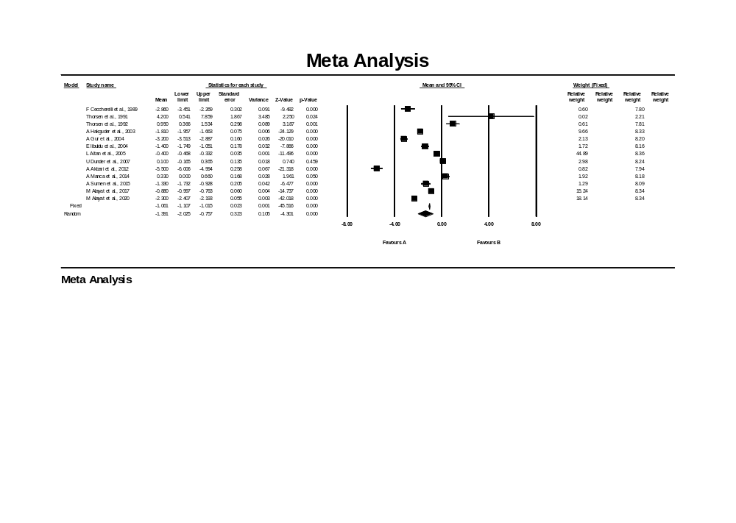

- Funnel plot
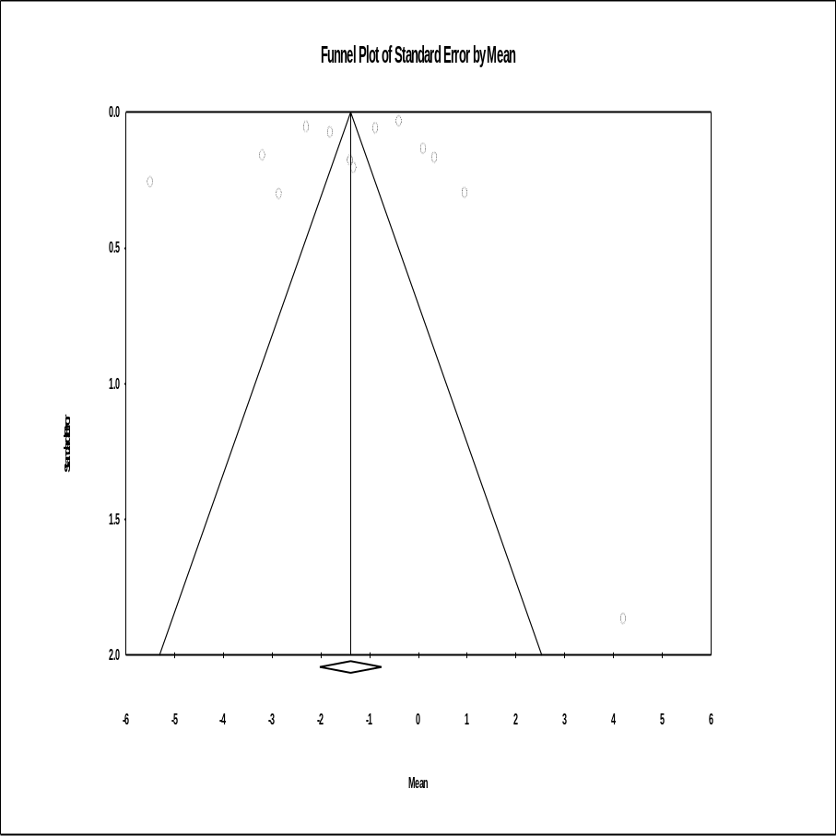

- P-curve
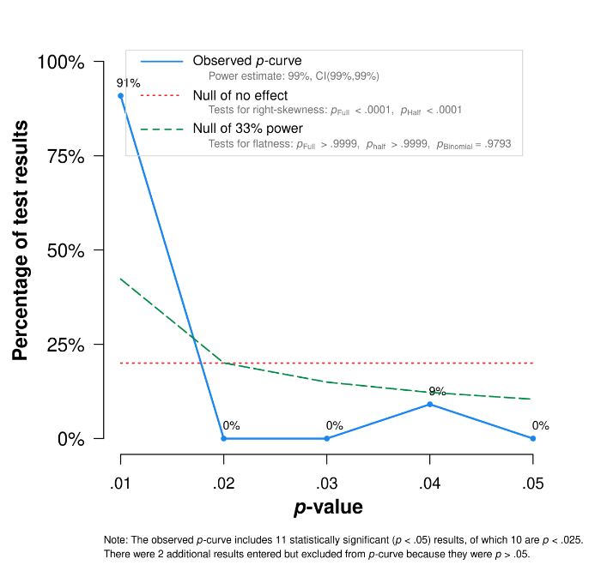

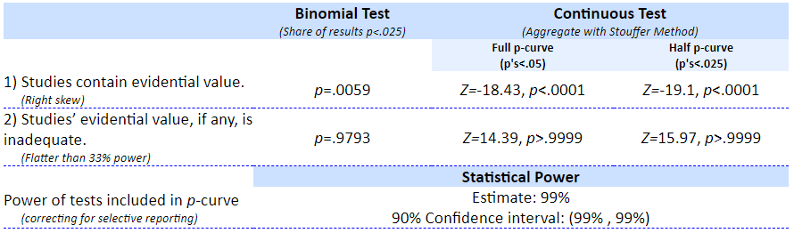

Supplementary Figure 23. Association between PBM and pressure pain threshold in patients with myofascial neck pain syndrome
- Forest plot
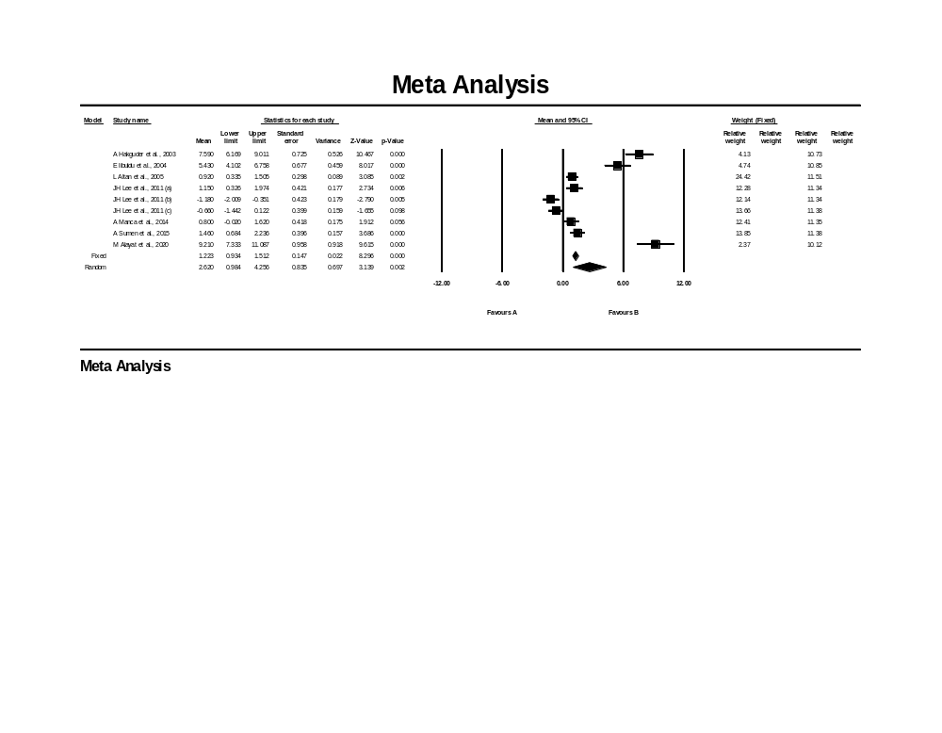

- Funnel plot
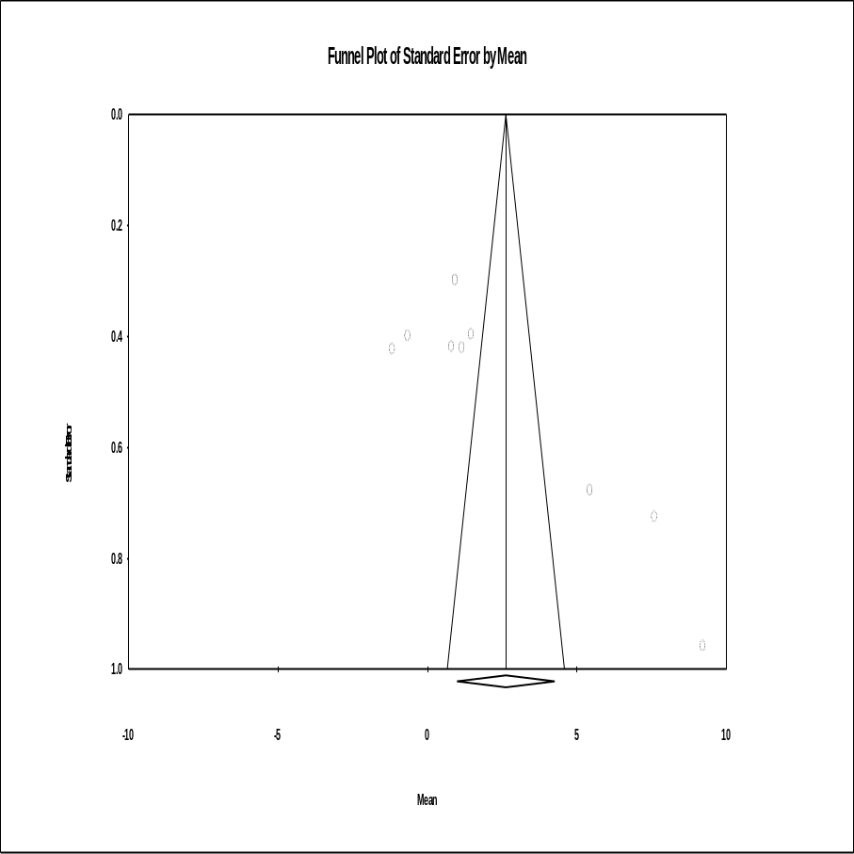

- P-curve
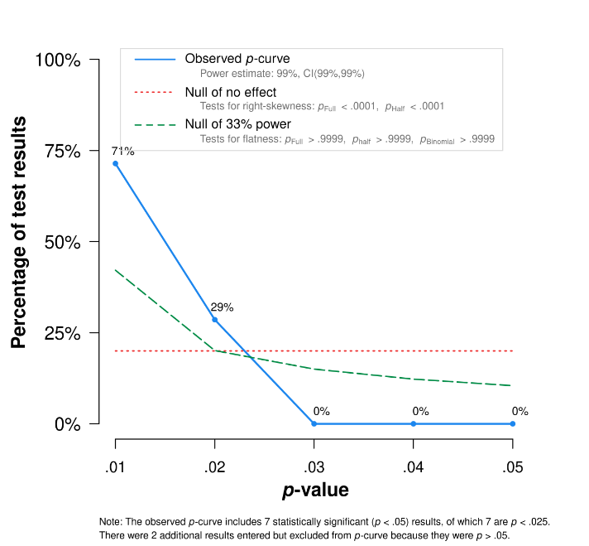

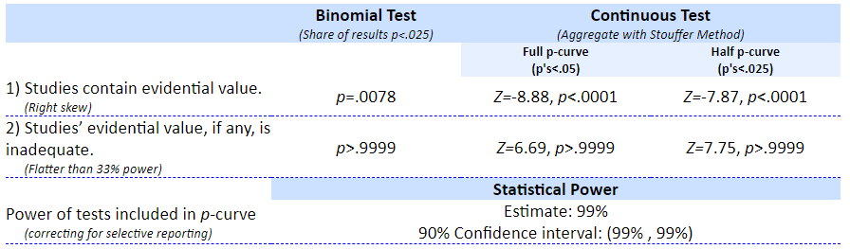

Supplementary Figure 24. Association between PBM and pain intensity in patients with Achilles tendiopathy
- Forest plot
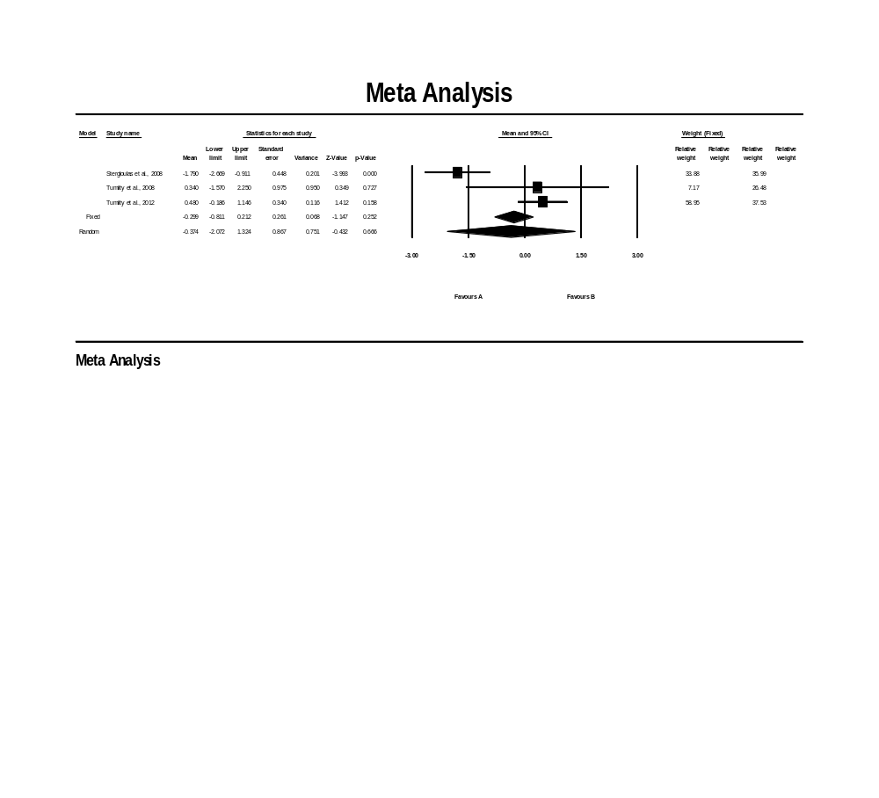

- Funnel plot
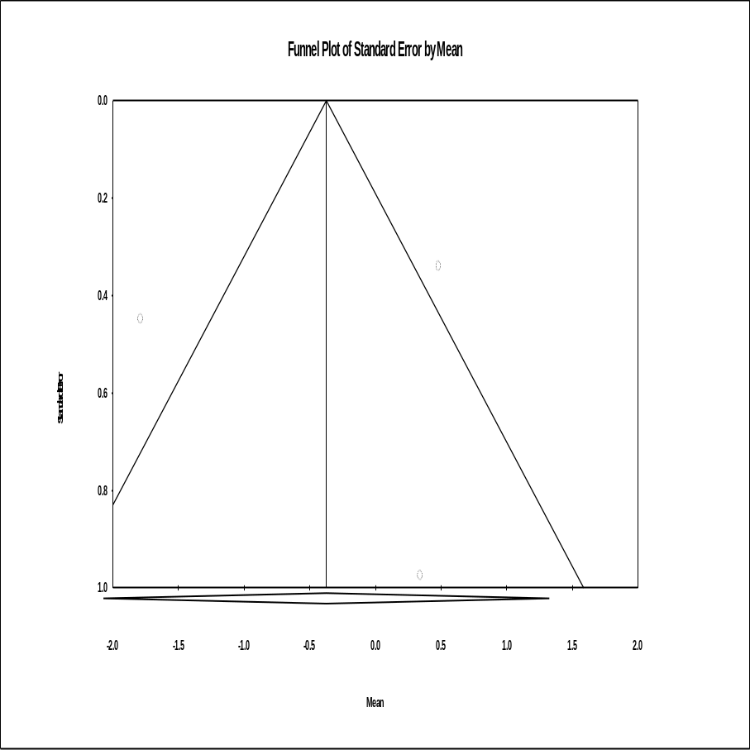

- P-curve
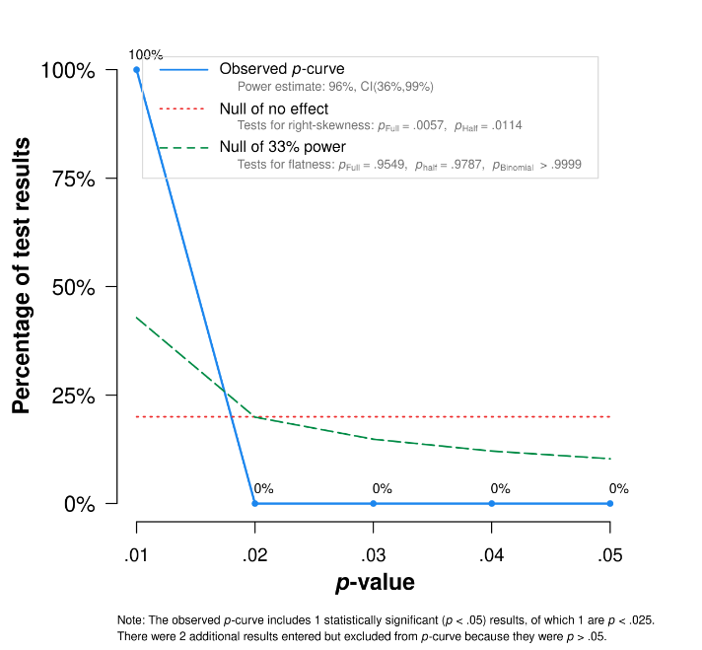

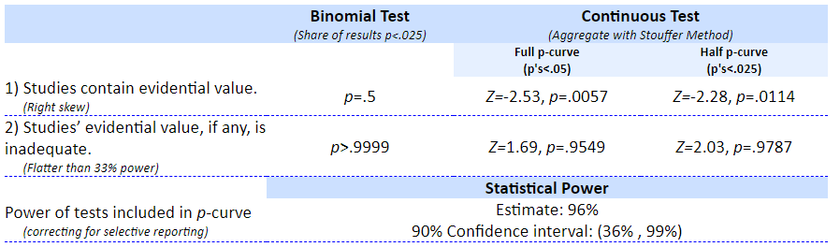

Supplementary Figure 25. Association between PBM and function in patients with Achilles tendiopathy
- Forest plot
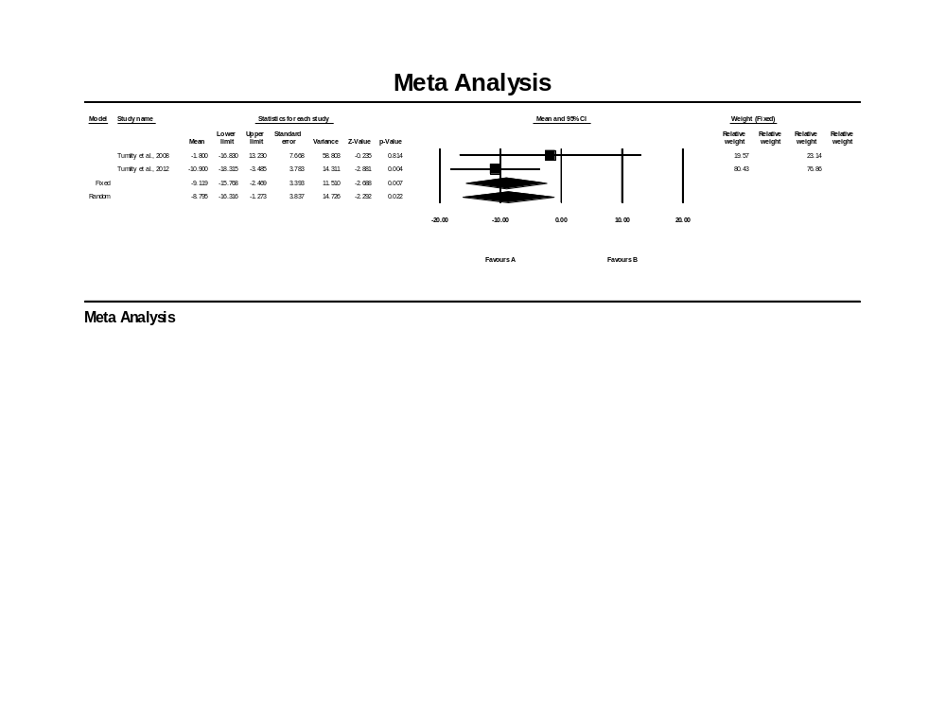

- P-curve
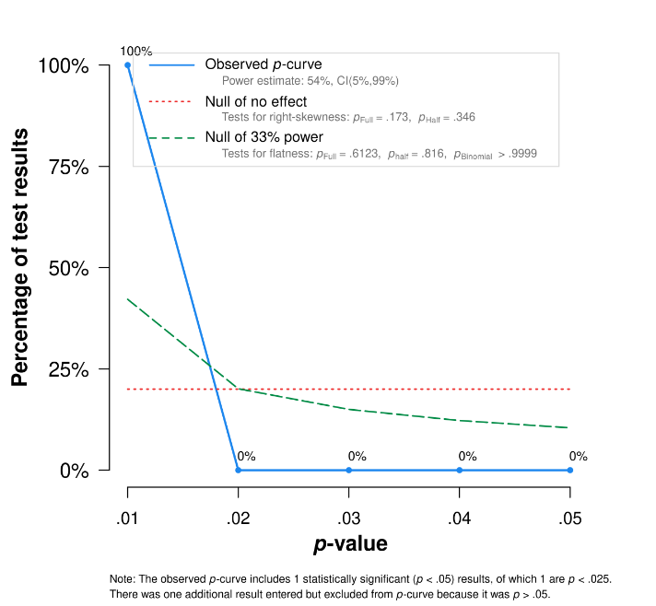

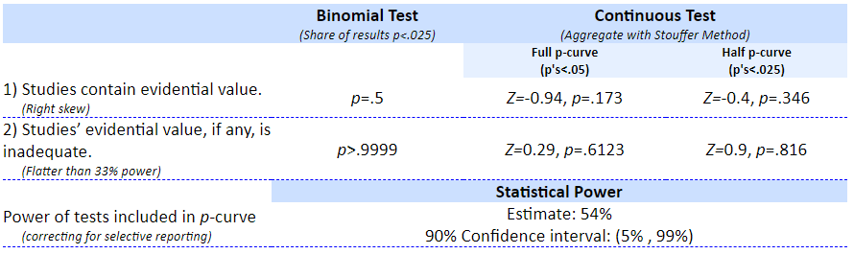

Supplementary Figure 26. Association between PBM and pain levels (VAS score) in patients with fractures
- Forest plot
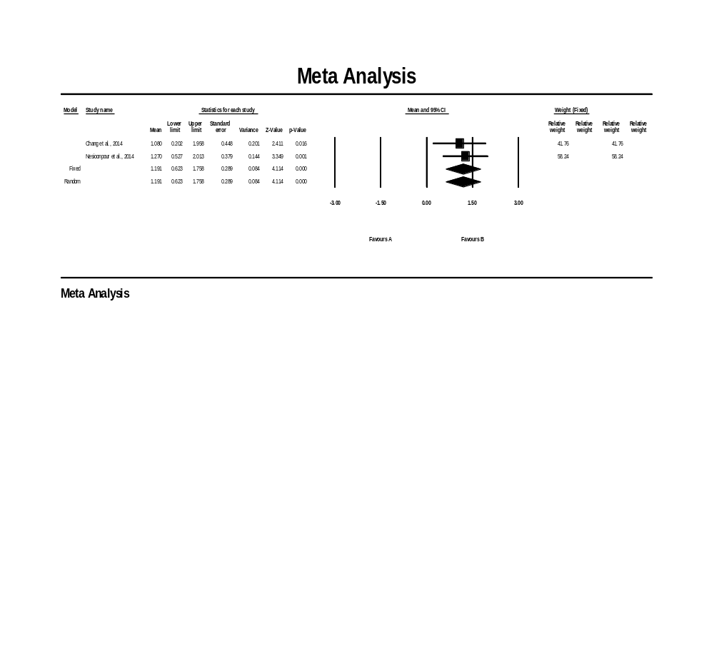

- P-curve
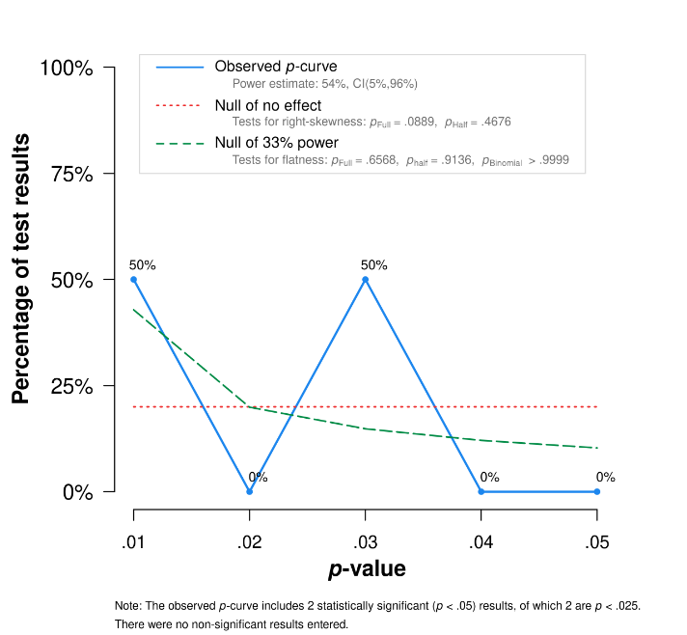

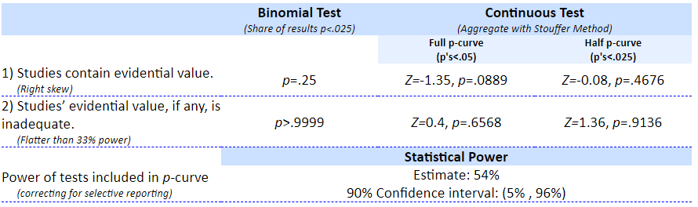

Supplementary Figure 27. Association between PBM and pain levels (VAS score) in patients with carpal tunnel syndrome
- Forest plot
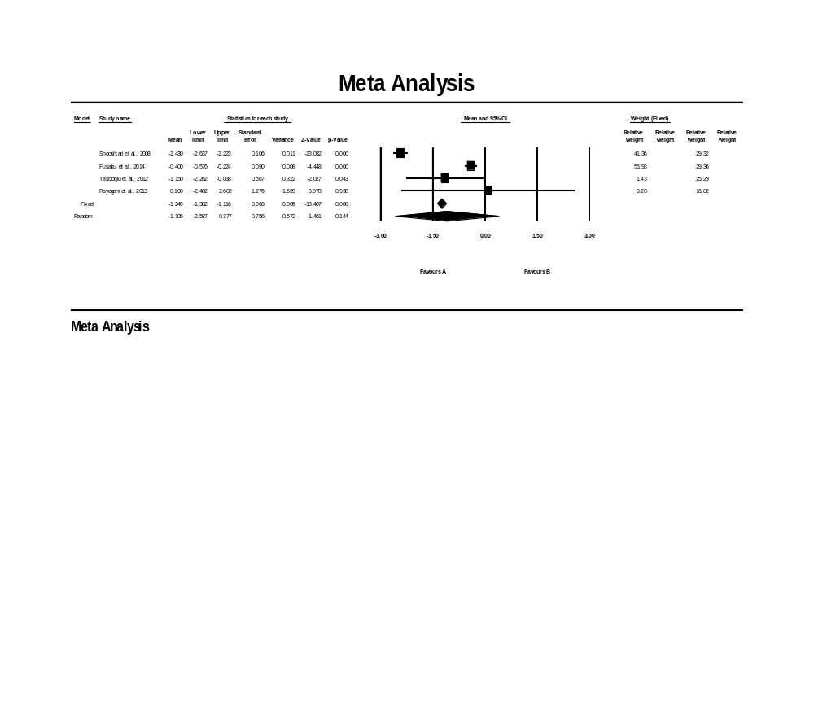

- Funnel plot
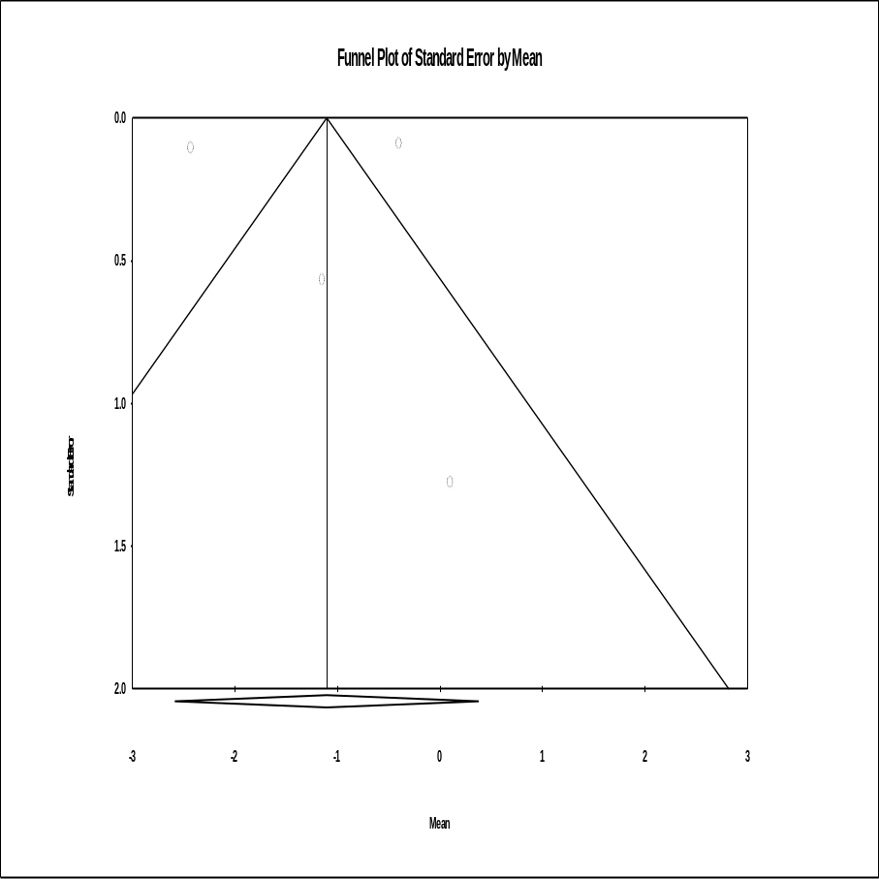

- P-curve
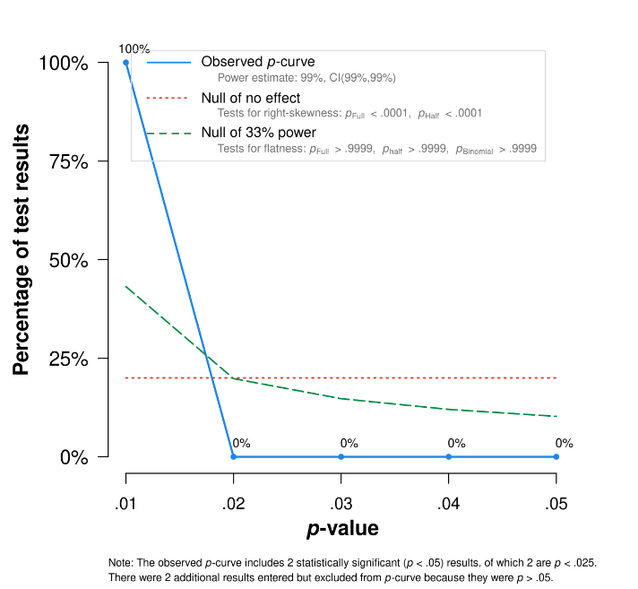

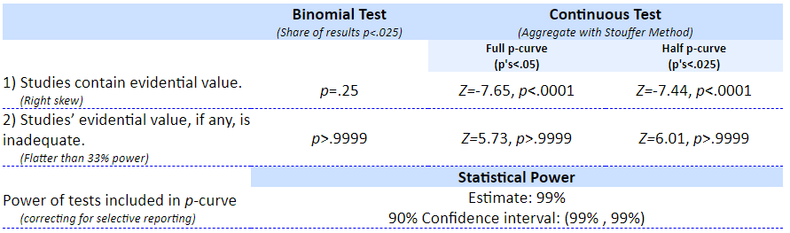

Supplementary Figure 28. Association between PBM and symptom severity scale in patients with carpal tunnel syndrome
- Forest plot
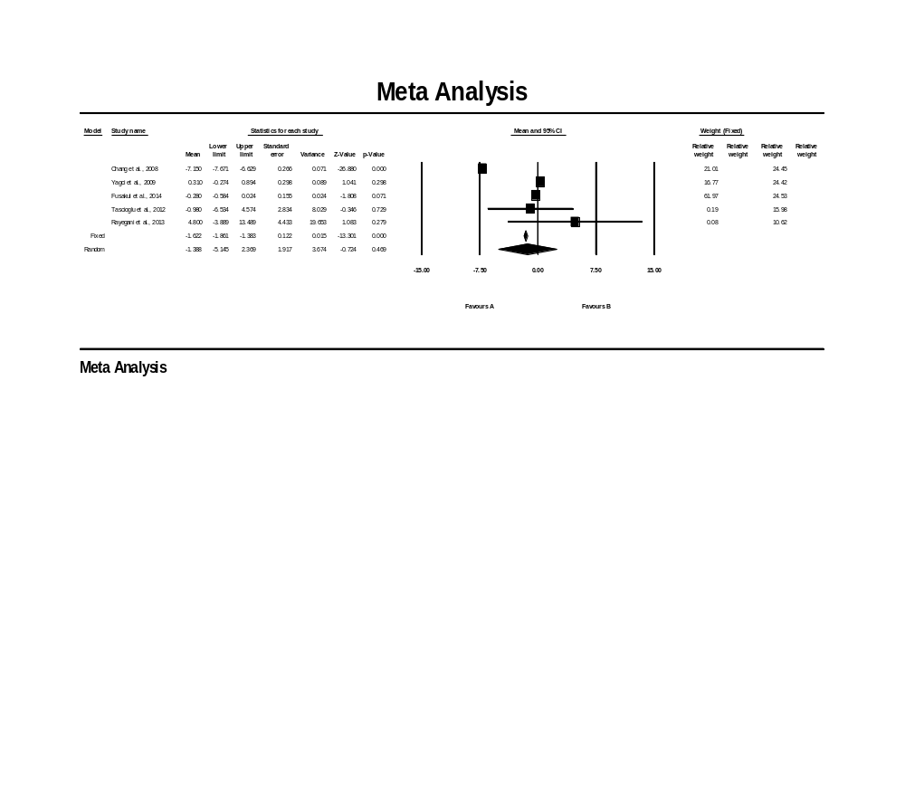

- Funnel plot
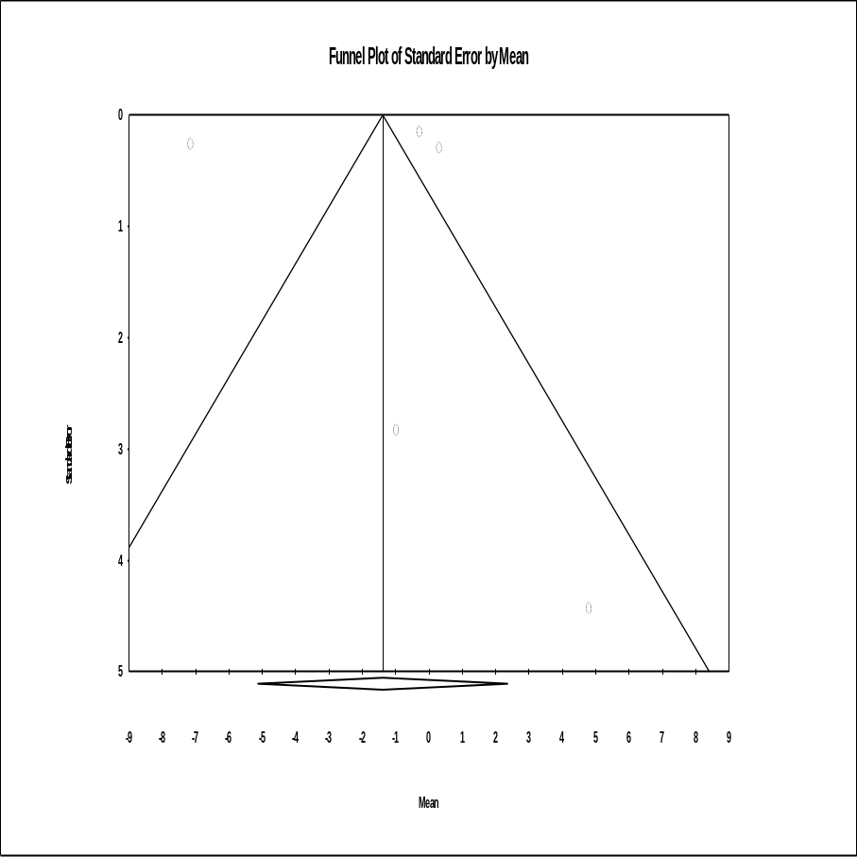

- P-curve
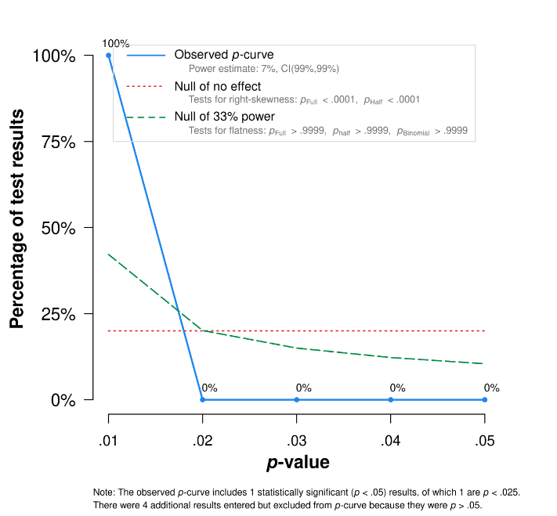

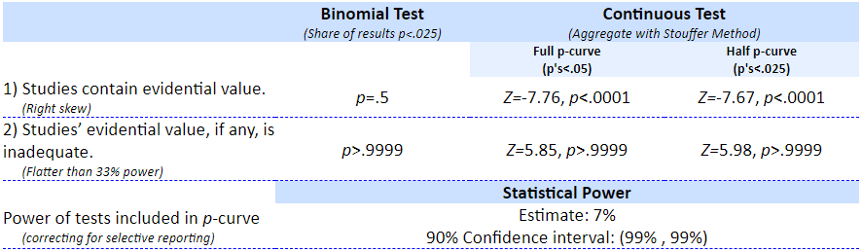

Supplementary Figure 29. Association between PBM and functional severity scale in patients with carpal tunnel syndrome
- Forest plot
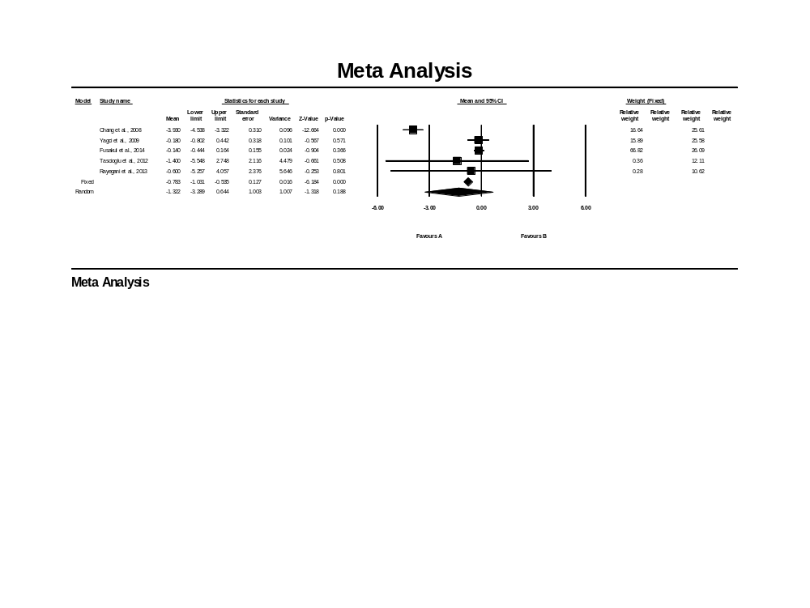

- Funnel plot
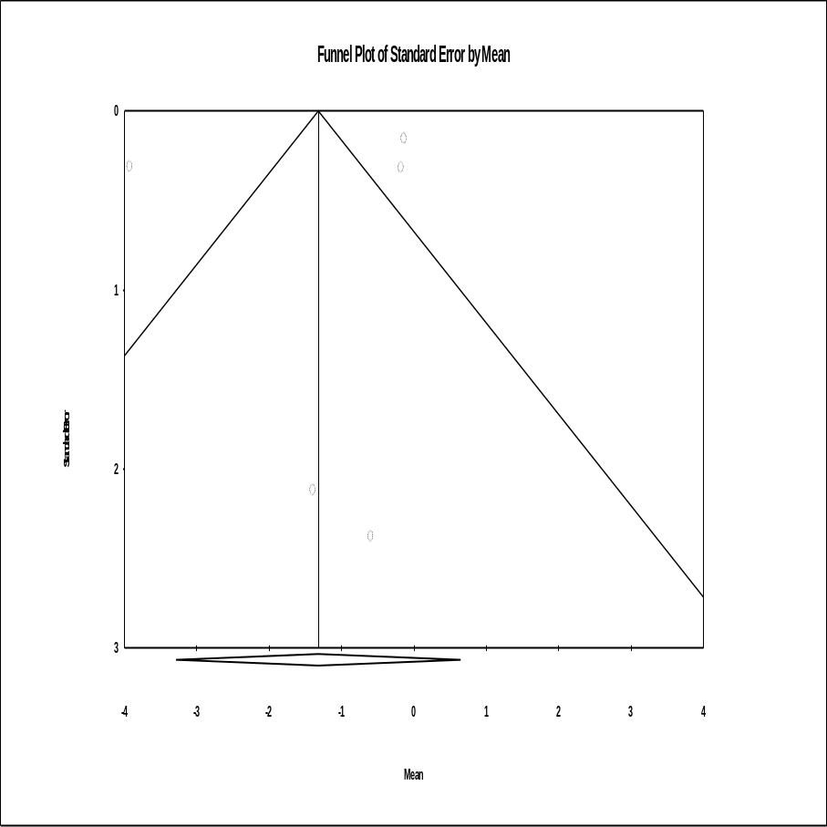

- P-curve
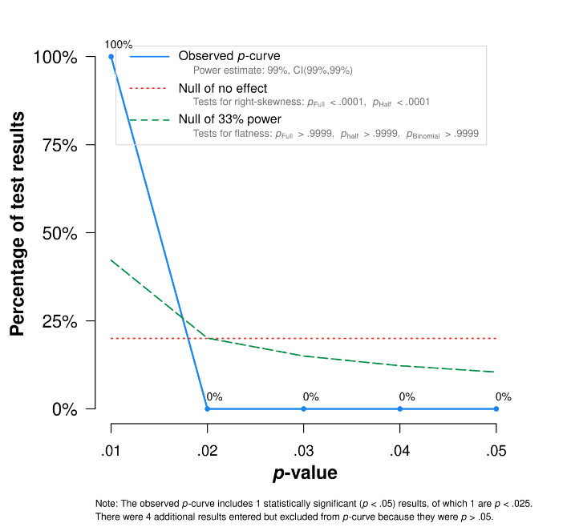

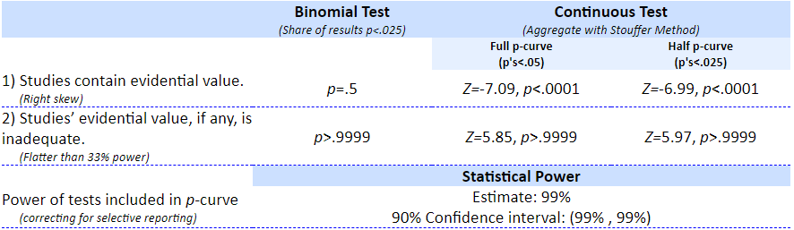

Supplementary Figure 30. Association between PBM and complete healing rate in diabetic foot ulcers
- Forest plot
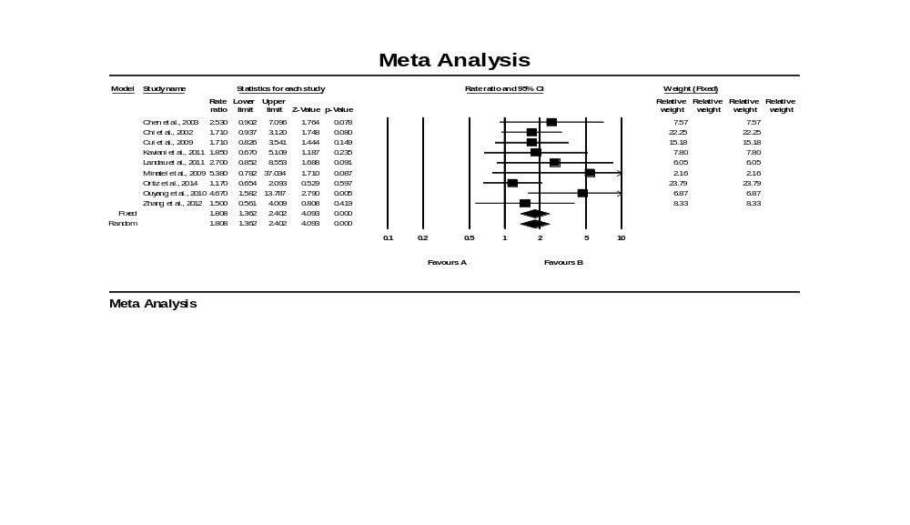

- Funnel plot
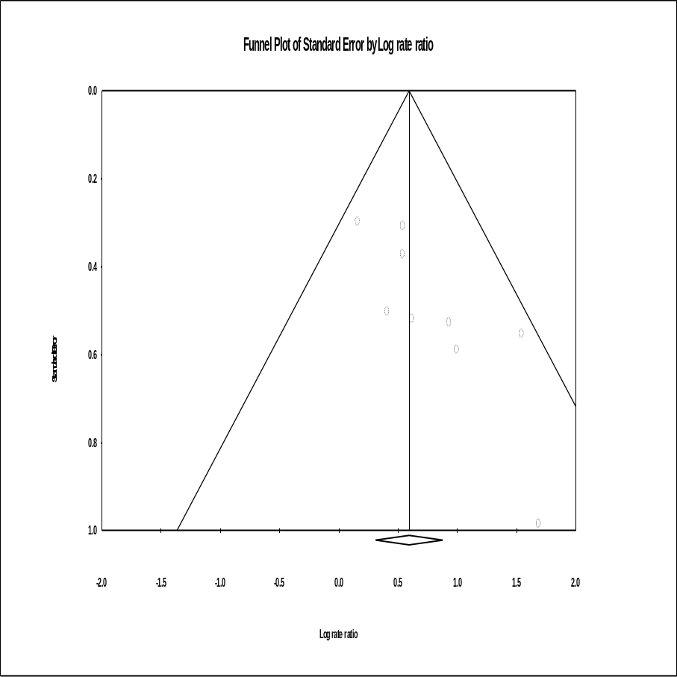

- P-curve
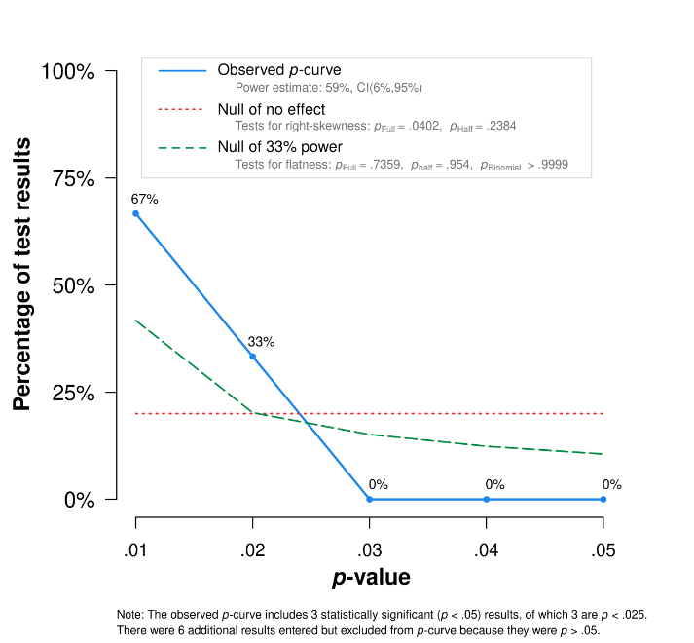

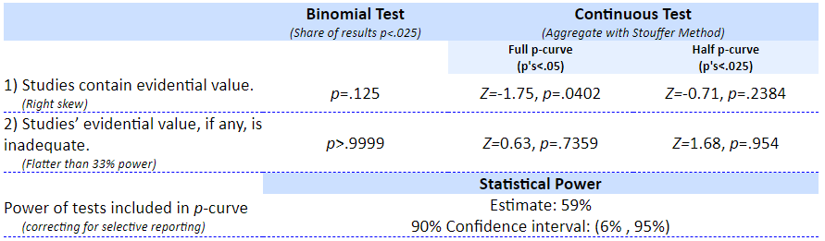

Supplementary Figure 31. Association between PBM and ulcer area reduction percentage in diabetic foot ulcers
- Forest plot
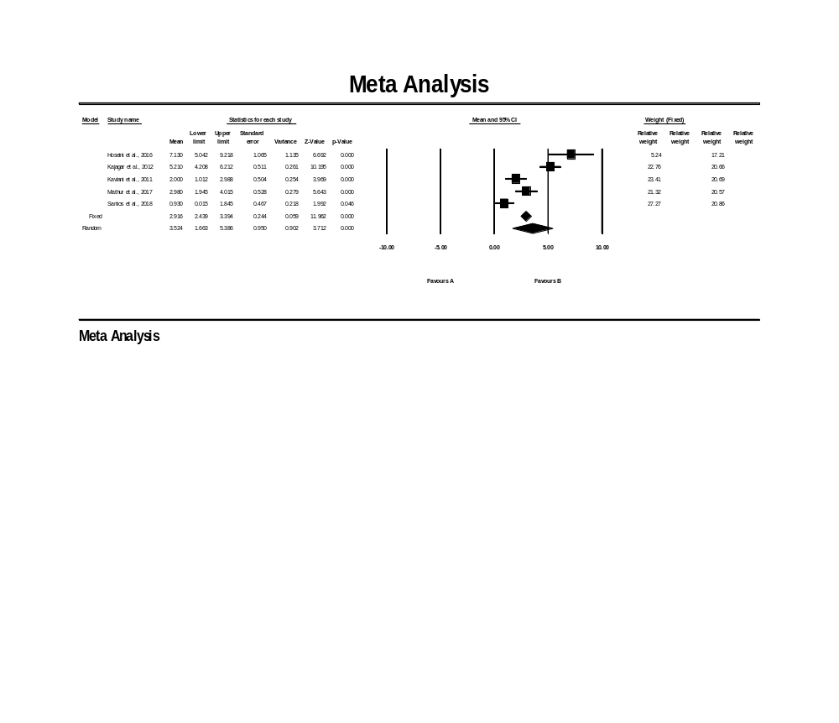

- Funnel plot
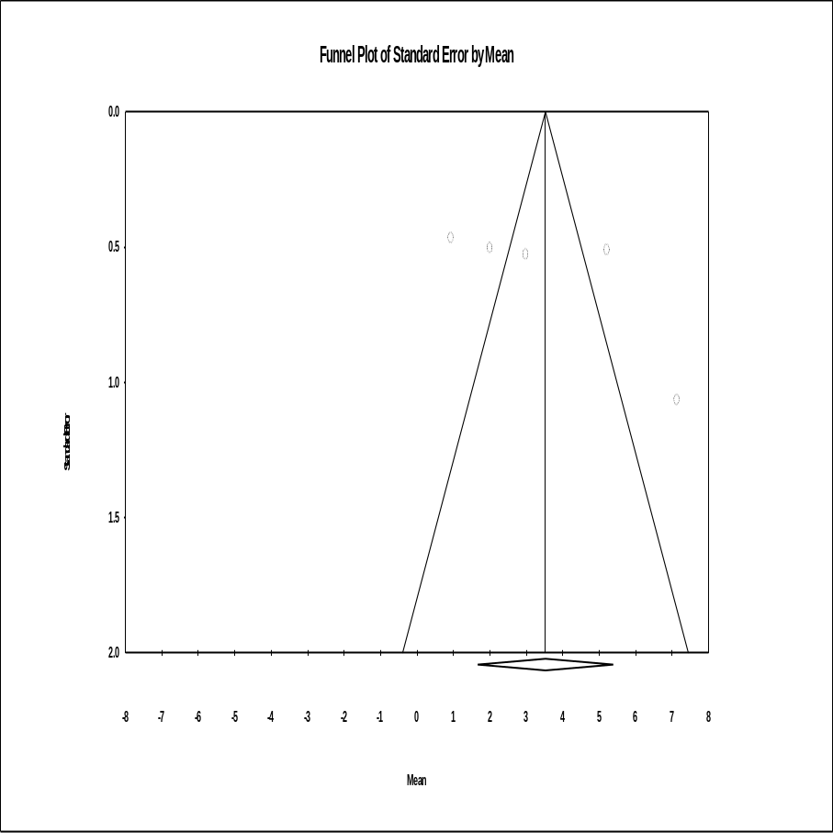

- P-curve
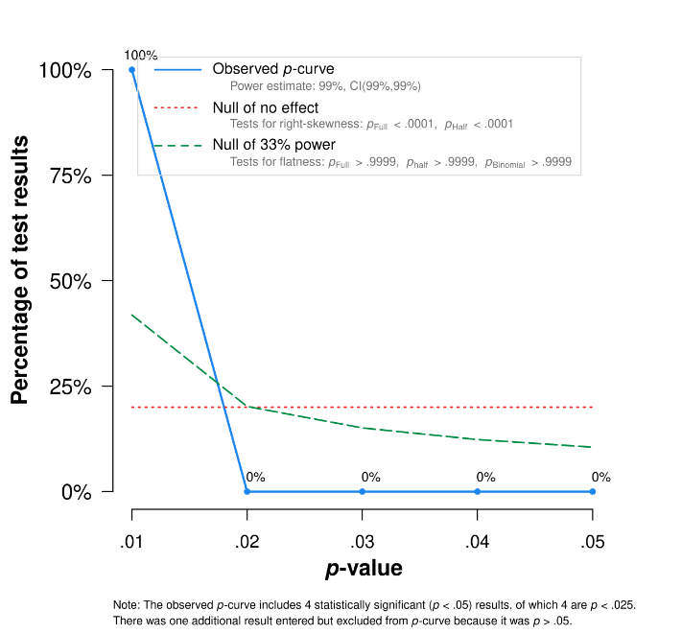
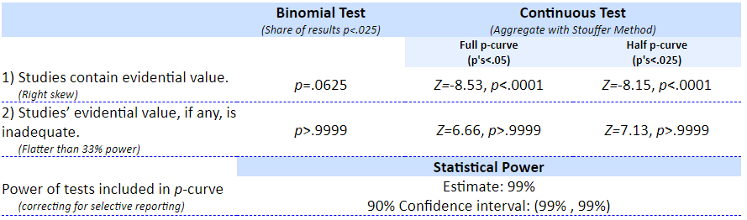

Supplementary Figure 32. Association between PBM and mean healing time in diabetic foot ulcers
- Forest plot
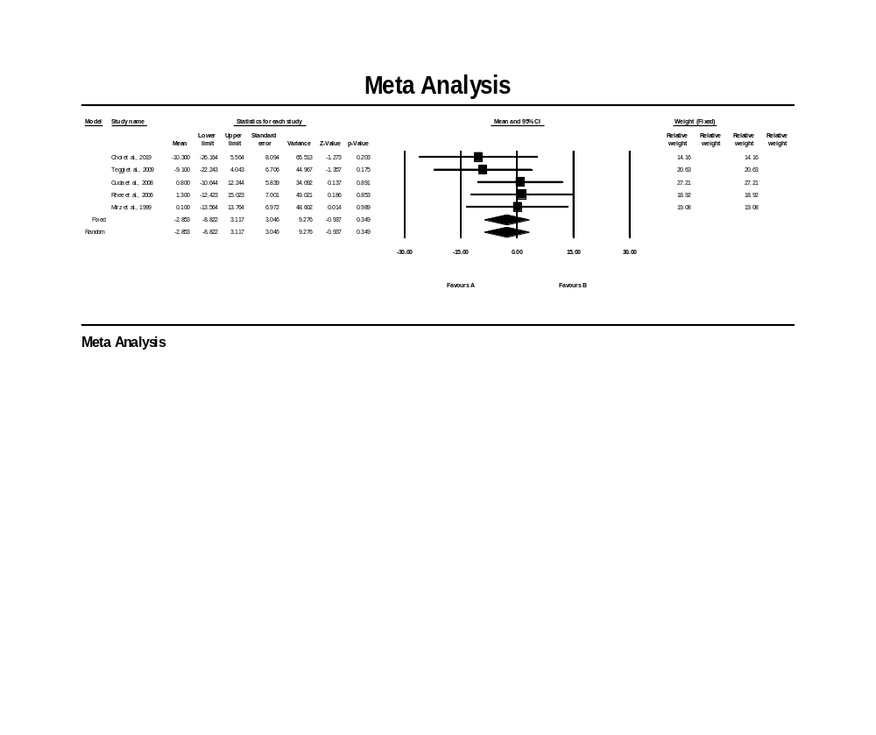

- P-curve
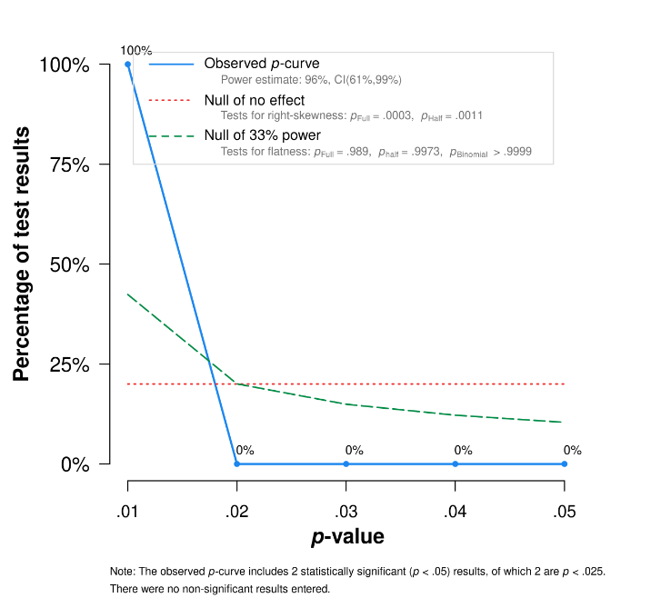

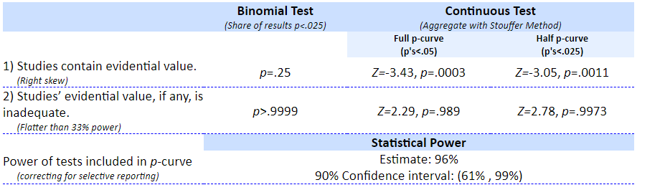

Supplementary Figure 33. Association between PBM and overall symptoms (THI score) in patients with tinnitus
- Forest plot
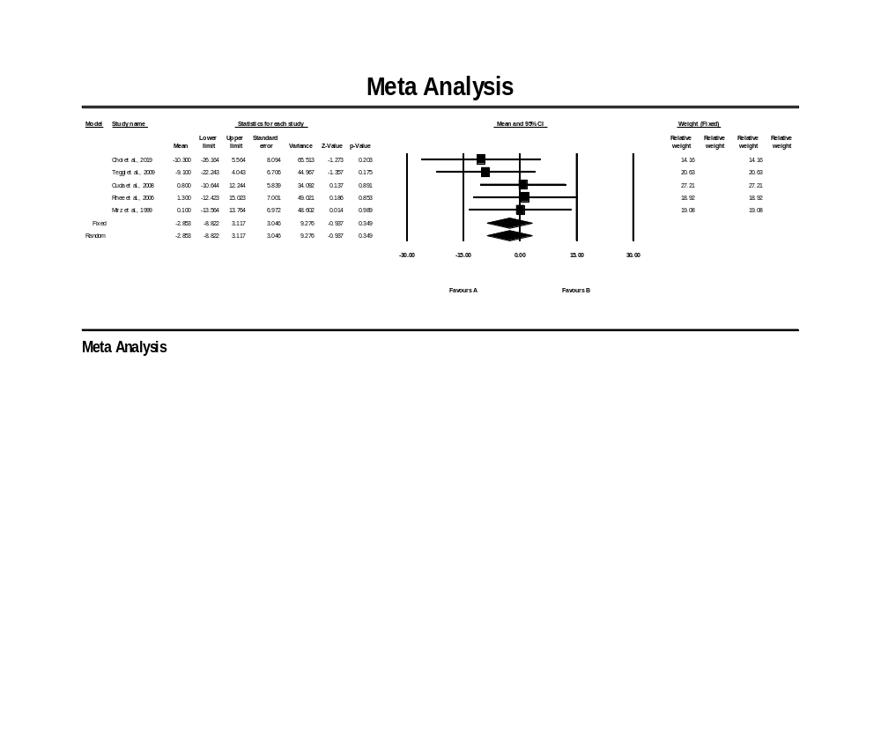

- Funnel plot
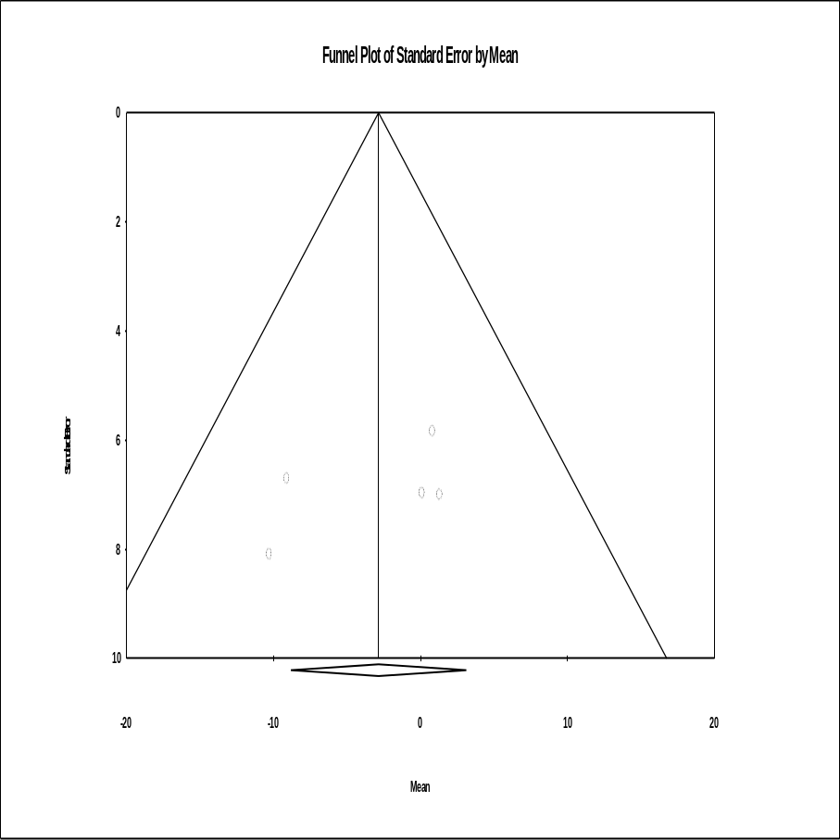

Supplementary Figure 34. Association between PBM and hair desity in patients with androgenic alopecia
- Forest plot
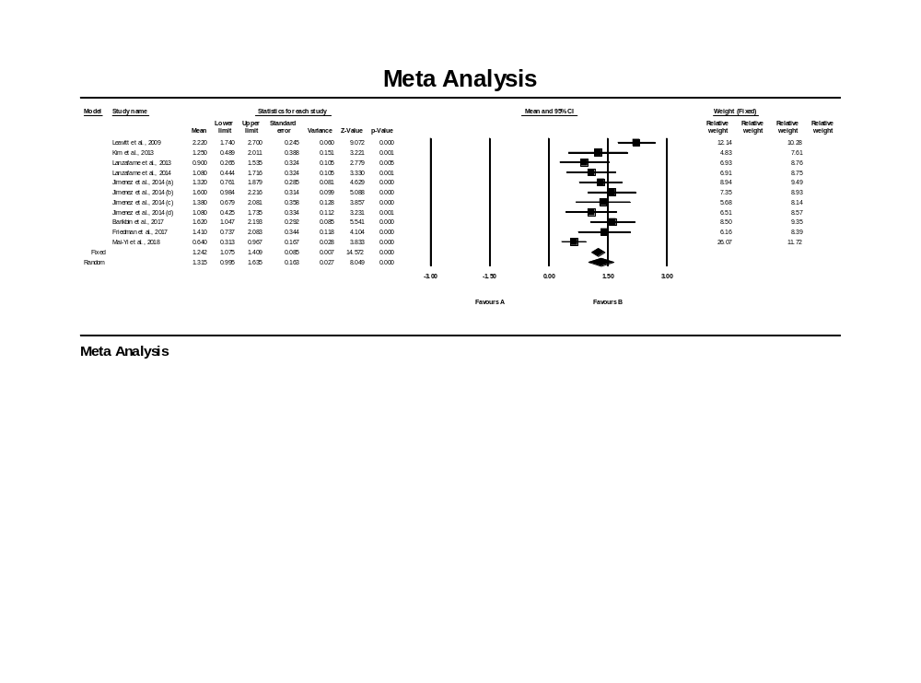

- Funnel plot
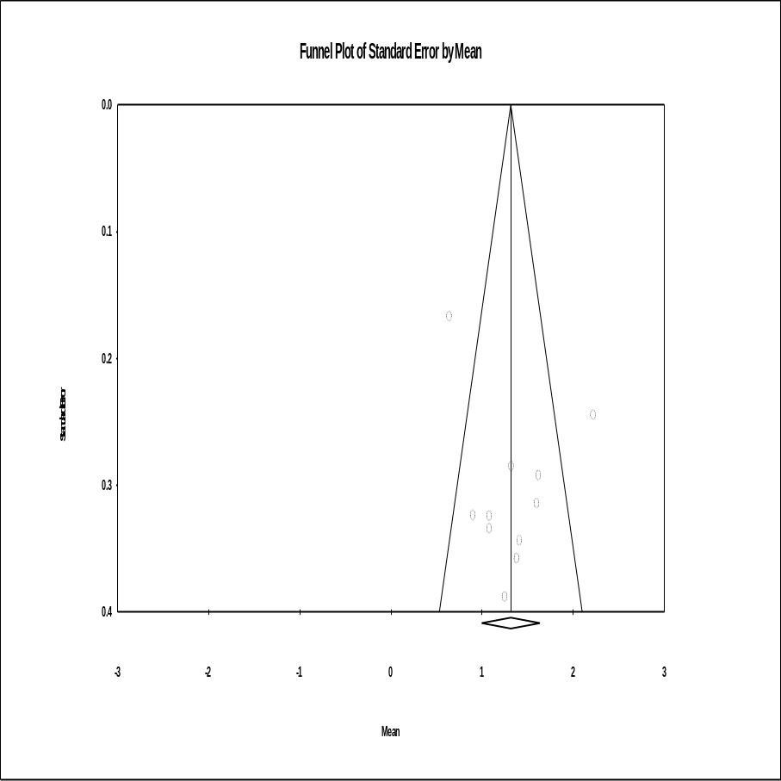

- P-curve
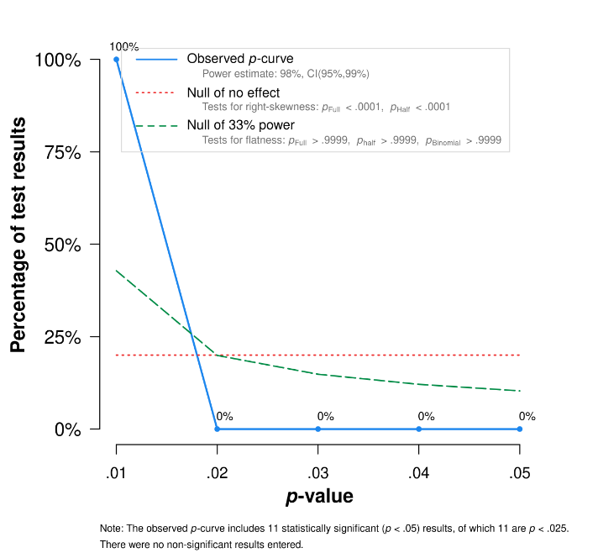

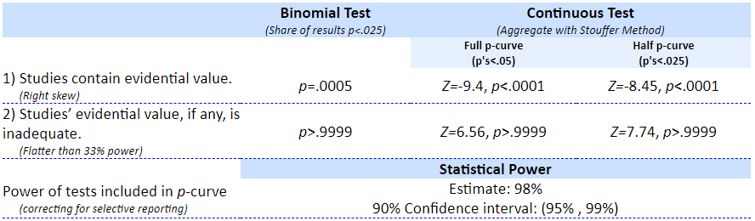

Supplementary Figure 35. Association between PBM and the effects on age-related cognitive impairment
- Forest plot
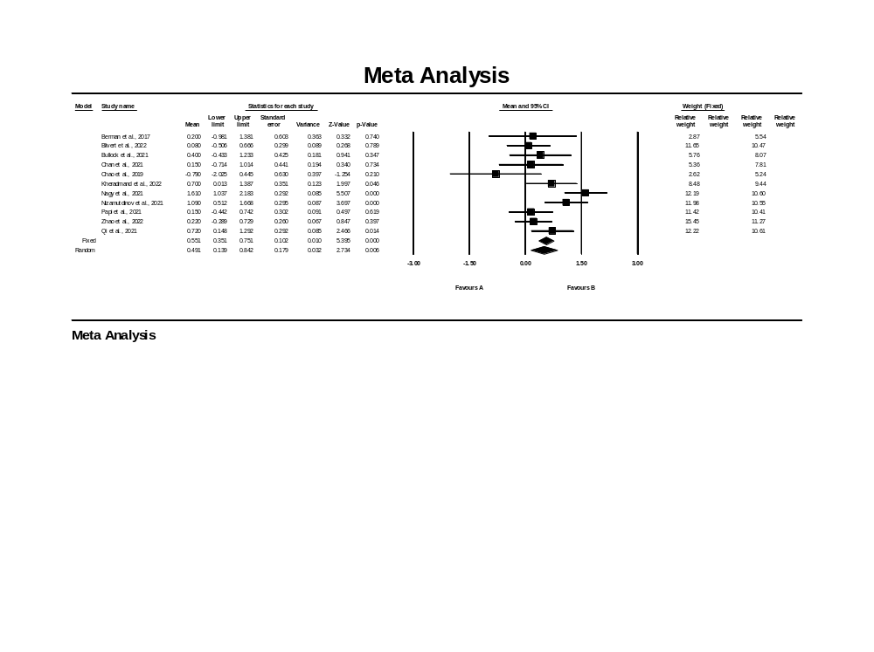

- Funnel plot
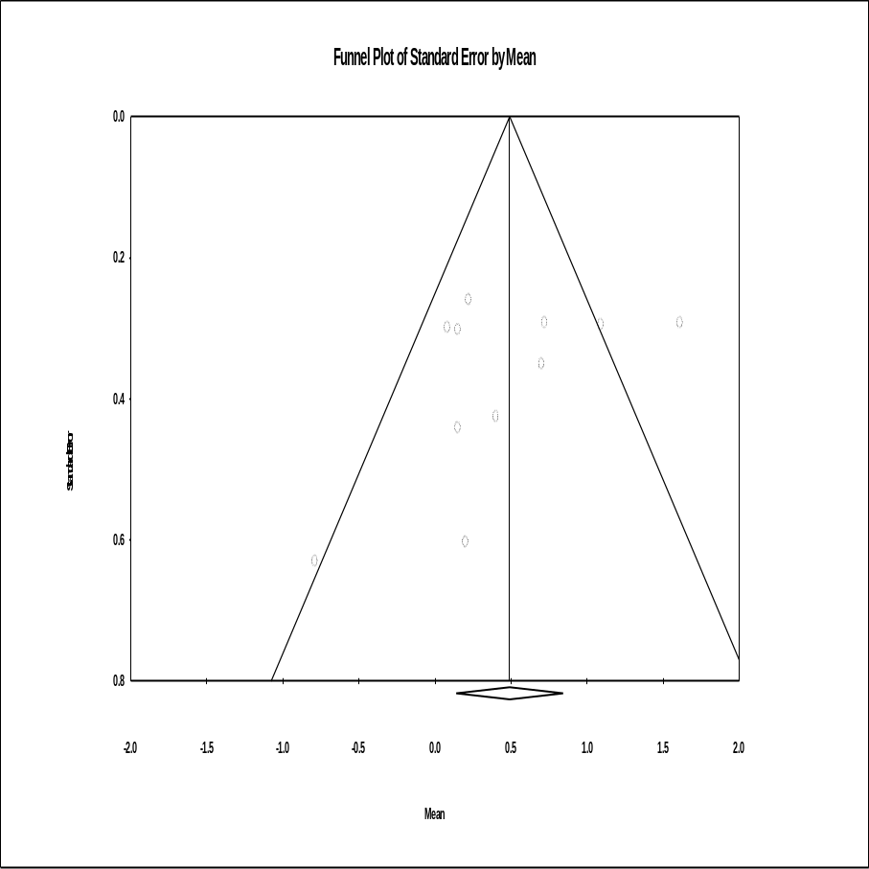

- P-curve
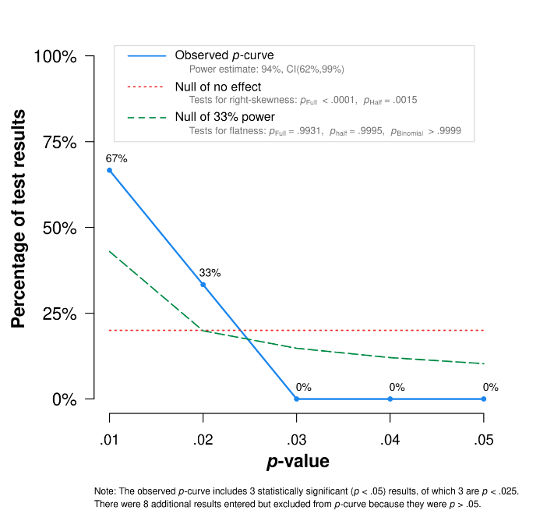

Supplementary references
1. Abesi F, Derikvand N. Efficacy of Low-Level Laser Therapy in Wound Healing and Pain Reduction After Gingivectomy: A Systematic Review and Meta-analysis. J Lasers Med Sci 2023; 14: e17.
2. Aguiar BRL, Guerra ENS, Normando AGC, Martins CC, Reis P, Ferreira EB. Effectiveness of photobiomodulation therapy in radiation dermatitis: A systematic review and meta-analysis. Crit Rev Oncol Hematol 2021; 162: 103349.
3. Akram Z, Vohra F, Javed F. Low-level laser therapy as an adjunct to connective tissue graft procedure in the treatment of gingival recession defects: A systematic review and meta-analysis. J Esthet Restor Dent 2018; 30(4): 299-306.
4. Alayat MSM, Battecha KH, Elsodany AM, et al. Effectiveness of Photobiomodulation Therapy in the Treatment of Myofascial Pain Syndrome of the Upper Trapezius Muscle: A Systematic Review and Meta-Analysis. Photobiomodul Photomed Laser Surg 2022; 40(10): 661-74.
5. Al-Rudayni AHM, Gopinath D, Maharajan MK, Veettil SK, Menon RK. Efficacy of Photobiomodulation in the Treatment of Cancer Chemotherapy-Induced Oral Mucositis: A Meta-Analysis with Trial Sequential Analysis. Int J Environ Res Public Health 2021; 18(14).
6. AlShahrani I, Togoo RA, Hosmani J, Alhaizaey A. Photobiomodulation in acceleration of orthodontic tooth movement: A systematic review and meta analysis. Complement Ther Med 2019; 47: 102220.
7. Ansari S, Charantimath S, Lagali-Jirge V, Keluskar V. Comparative efficacy of low-level laser therapy (LLLT) to TENS and therapeutic ultrasound in management of TMDs: a systematic review & meta-analysis. Cranio 2022: 1-10.
8. Anschau F, Webster J, Capra MEZ, de Azeredo da Silva ALF, Stein AT. Efficacy of low-level laser for treatment of cancer oral mucositis: a systematic review and meta-analysis. Lasers Med Sci 2019; 34(6): 1053-62.
9. Arjmand B, Rahim F. The Probable Protective Effect of Photobiomodulation on the Immunologic Factor's mRNA Expression Level in the Lung: An Extended COVID-19 Preclinical and Clinical Meta-analysis. Clin Pathol 2023; 16: 2632010x221127683.
10. Awotidebe AW, Inglis-Jassiem G, Young T. Does Low-level Laser Therapy Provide Additional Benefits to Exercise in Patients with Shoulder Musculoskeletal Disorders? A Meta-analysis of Randomised Controlled Trials. Ortop Traumatol Rehabil 2019; 21(6): 407-16.
11. Ayar Z, Gholami B, Piri SM, et al. The effect of low-level laser therapy on pathophysiology and locomotor recovery after traumatic spinal cord injuries: a systematic review and meta-analysis. Lasers Med Sci 2022; 37(1): 61-75.
12. Bakdach WMM, Hadad R. Effectiveness of low-level laser therapy in accelerating the orthodontic tooth movement: A systematic review and meta-analysis. Dent Med Probl 2020; 57(1): 73-94.
13. Barros AWP, Sales P, Silva PGB, Gomes ACA, Carvalho AAT, Leão JC. Is low-level laser therapy effective in the treatment of herpes labialis? Systematic review and meta-analysis. Lasers Med Sci 2022; 37(9): 3393-402.
14. Bensadoun RJ, Nair RG. Low-level laser therapy in the prevention and treatment of cancer therapy-induced mucositis: 2012 state of the art based on literature review and meta-analysis. Curr Opin Oncol 2012; 24(4): 363-70.
15. Bjordal JM, Bensadoun RJ, Tunèr J, Frigo L, Gjerde K, Lopes-Martins RA. A systematic review with meta-analysis of the effect of low-level laser therapy (LLLT) in cancer therapy-induced oral mucositis. Support Care Cancer 2011; 19(8): 1069-77.
16. Bjordal JM, Lopes-Martins RA, Joensen J, et al. A systematic review with procedural assessments and meta-analysis of low level laser therapy in lateral elbow tendinopathy (tennis elbow). BMC Musculoskelet Disord 2008; 9: 75.
17. Camolesi GCV, Marichalar-Mendía X, Padín-Iruegas ME, et al. Efficacy of photobiomodulation in reducing pain and improving the quality of life in patients with idiopathic burning mouth syndrome. A systematic review and meta-analysis. Lasers Med Sci 2022; 37(4): 2123-33.
18. Campos TM, do Prado Tavares Silva CA, Sobral APT, et al. Photobiomodulation in oral mucositis in patients with head and neck cancer: a systematic review and meta-analysis followed by a cost-effectiveness analysis. Support Care Cancer 2020; 28(12): 5649-59.
19. Chang WD, Lee CL, Lin HY, Hsu YC, Wang CJ, Lai PT. A Meta-analysis of Clinical Effects of Low-level Laser Therapy on Temporomandibular Joint Pain. J Phys Ther Sci 2014; 26(8): 1297-300.
20. Chaves IC, de Paula DS, Mota MRL, Sousa FB, de Barros Silva PG, Nunes Alves APN. Is photobiomodulation effective during maxillary expansion? A systematic review and meta-analysis. Orthod Craniofac Res 2023; 26(1): 13-26.
21. Chen J, Huang Z, Ge M, Gao M. Efficacy of low-level laser therapy in the treatment of TMDs: a meta-analysis of 14 randomised controlled trials. J Oral Rehabil 2015; 42(4): 291-9.
22. Chen Y, Liu C, Chen X, Mo A. Clinical evidence of photobiomodulation therapy (PBMT) on implant stability and success: a systematic review and meta-analysis. BMC Oral Health 2019; 19(1): 77.
23. Cheung WKW, Wu IXY, Sit RWS, et al. Low-level laser therapy for carpal tunnel syndrome: systematic review and network meta-analysis. Physiotherapy 2020; 106: 24-35.
24. Cho Y, Tural U, Iosifescu DV. Efficacy of Transcranial Photobiomodulation on Depressive Symptoms: A Meta-Analysis. Photobiomodul Photomed Laser Surg 2023; 41(9): 460-6.
25. Chow RT, Johnson MI, Lopes-Martins RA, Bjordal JM. Efficacy of low-level laser therapy in the management of neck pain: a systematic review and meta-analysis of randomised placebo or active-treatment controlled trials. Lancet 2009; 374(9705): 1897-908.
26. Clijsen R, Brunner A, Barbero M, Clarys P, Taeymans J. Effects of low-level laser therapy on pain in patients with musculoskeletal disorders: a systematic review and meta-analysis. Eur J Phys Rehabil Med 2017; 53(4): 603-10.
27. Costa ACF, Maia TAC, de Barros Silva PG, Abreu LG, Gondim DV, Santos PCF. Effects of low-level laser therapy on the orthodontic mini-implants stability: a systematic review and meta-analysis. Prog Orthod 2021; 22(1): 6.
28. Cronshaw M, Parker S, Anagnostaki E, Mylona V, Lynch E, Grootveld M. Photobiomodulation Dose Parameters in Dentistry: A Systematic Review and Meta-Analysis. Dent J (Basel) 2020; 8(4).
29. Cruz AR, Minicucci EM, Betini M, Almeida-Lopes L, Tieghi Neto V, Cataneo AJM. Efficacy of photobiomodulation in the treatment of oral mucositis in patients undergoing antineoplastic therapy: systematic review and meta-analysis. Support Care Cancer 2023; 31(12): 645.
30. da Silva BM, Prosdócimo ML, Gasparini LR, da Silva BM, de Araujo MR, Amenábar JM. Most used photobiomodulation dosimetry parameters to treat oral mucositis after preconditioning for hematopoietic stem cell transplantation: systematic review and meta-analysis. Support Care Cancer 2022; 30(5): 3721-32.
31. de Almeida VL, de Andrade Gois VL, Andrade RN, et al. Efficiency of low-level laser therapy within induced dental movement: A systematic review and meta-analysis. J Photochem Photobiol B 2016; 158: 258-66.
32. de Arruda JAA, Sampaio GC, de Sena A, et al. Does photobiomodulation therapy improve the postoperative outcomes of tonsillectomy? A systematic review and meta-analysis. J Lasers Med Sci 2022; 13: e7.
33. de Barros DD, Dos Santos Barros Catão JS, Ferreira ACD, Simões TMS, de Albuquerque Cavalcanti Almeida R, de Vasconcelos Catão MHC. Correction to: Low‑level laser therapy is effective in controlling postoperative pain in lower third molar extractions: a systematic review and meta‑analysis. Lasers Med Sci 2022; 37(5): 2379.
34. de Barros DD, Dos Santos Barros Catão JS, Ferreira ACD, Simões TMS, Almeida RAC, de Vasconcelos Catão MHC. Low-level laser therapy is effective in controlling postoperative pain in lower third molar extractions: a systematic review and meta-analysis. Lasers Med Sci 2022; 37(5): 2363-77.
35. de Barros Silva PG, Filho ELC, Nigri FMN, Dantas TS, de Miranda Candeiro GT, Neri JR. Photobiomodulation Reduces Pain-Related Symptoms Without Interfering in the Efficacy of In-Office Tooth Bleaching: A Systematic Review and Meta-Analysis of Placebo-Controlled Clinical Trials. Photobiomodul Photomed Laser Surg 2022; 40(3): 163-77.
36. de Carvalho MM, Hidalgo MAR, Scarel-Caminaga RM, et al. Photobiomodulation of gingival lesions resulting from autoimmune diseases: systematic review and meta-analysis. Clin Oral Investig 2022; 26(5): 3949-64.
37. de Lima VHS, de Oliveira-Neto OB, da Hora Sales PH, da Silva Torres T, de Lima FJC. Effectiveness of low-level laser therapy for oral mucositis prevention in patients undergoing chemoradiotherapy for the treatment of head and neck cancer: A systematic review and meta-analysis. Oral Oncol 2020; 102: 104524.
38. De Marchi T, Ferlito JV, Ferlito MV, Salvador M, Leal-Junior ECP. Can Photobiomodulation Therapy (PBMT) Minimize Exercise-Induced Oxidative Stress? A Systematic Review and Meta-Analysis. Antioxidants (Basel) 2022; 11(9).
39. de Oliveira-Souza AIS, Mohamad N, de Castro Carletti EM, et al. What are the best parameters of low-level laser therapy to reduce pain intensity and improve mandibular function in orofacial pain? A systematic review and meta-analysis. Disabil Rehabil 2023; 45(20): 3219-37.
40. Deana NF, Zaror C, Del Sol M, Bagnato VS, Alves N. Wound contraction rate in excised and unexcised burn wounds with laser photobiomodulation: Systematic review and meta-analysis of preclinical studies. Burns 2023; 49(2): 261-74.
41. Deana NF, Alves N, Zaror C, Del Sol M, Bagnato VS. Photobiomodulation Therapy in Burn Wound Healing: Systematic Review and Meta-Analysis of Preclinical Studies. Photobiomodul Photomed Laser Surg 2021; 39(7): 439-52.
42. Deana NF, Zaror C, Sandoval P, Alves N. Effectiveness of Low-Level Laser Therapy in Reducing Orthodontic Pain: A Systematic Review and Meta-Analysis. Pain Res Manag 2017; 2017: 8560652.
43. Domah F, Shah R, Nurmatov UB, Tagiyeva N. The Use of Low-Level Laser Therapy to Reduce Postoperative Morbidity After Third Molar Surgery: A Systematic Review and Meta-Analysis. J Oral Maxillofac Surg 2021; 79(2): 313.e1-.e19.
44. Dos Santos Mendes-Costa L, de Lima VG, Barbosa MPR, Dos Santos LE, de Siqueira Rodrigues Fleury Rosa S, Tatmatsu-Rocha JC. Photobiomodulation: systematic review and meta-analysis of the most used parameters in the resolution diabetic foot ulcers. Lasers Med Sci 2021; 36(6): 1129-38.
45. Dos Santos SA, Sampaio LM, Caires JR, et al. Parameters and Effects of Photobiomodulation in Plantar Fasciitis: A Meta-Analysis and Systematic Review. Photobiomodul Photomed Laser Surg 2019; 37(6): 327-35.
46. Duarte de Oliveira FJ, Brasil G, Araújo Soares GP, Fernandes Paiva DF, de Assis de Souza Júnior F. Use of low-level laser therapy to reduce postoperative pain, edema, and trismus following third molar surgery: A systematic review and meta-analysis. J Craniomaxillofac Surg 2021; 49(11): 1088-96.
47. Dutra YM, Malta ES, Elias AS, Broatch JR, Zagatto AM. Deconstructing the Ergogenic Effects of Photobiomodulation: A Systematic Review and Meta-analysis of its Efficacy in Improving Mode-Specific Exercise Performance in Humans. Sports Med 2022; 52(11): 2733-57.
48. Ebrahimi P, Hadilou M, Naserneysari F, et al. Effect of photobiomodulation in secondary intention gingival wound healing-a systematic review and meta-analysis. BMC Oral Health 2021; 21(1): 258.
49. Eslamipour F, Motamedian SR, Bagheri F. Ibuprofen and Low-level Laser Therapy for Pain Control during Fixed Orthodontic Therapy: A Systematic Review of Randomized Controlled Trials and Meta-analysis. J Contemp Dent Pract 2017; 18(6): 527-33.
50. Ferlito JV, Ferlito MV, Leal-Junior ECP, Tomazoni SS, De Marchi T. Comparison between cryotherapy and photobiomodulation in muscle recovery: a systematic review and meta-analysis. Lasers Med Sci 2022; 37(3): 1375-88.
51. Firoozi P, Keyhan SO, Kim SG, Fallahi HR. Effectiveness of low-level laser therapy on recovery from neurosensory disturbance after sagittal split ramus osteotomy: a systematic review and meta-analysis. Maxillofac Plast Reconstr Surg 2020; 42(1): 41.
52. Franco R, Lupi E, Iacomino E, et al. Low-Level Laser Therapy for the Treatment of Oral Mucositis Induced by Hematopoietic Stem Cell Transplantation: A Systematic Review with Meta-Analysis. Medicina (Kaunas) 2023; 59(8).
53. Freire BL, Abreu LG, Costa FO, Cota LOM, Esteves-Lima RP. Effect of photobiomodulation adjunct to periodontal therapy on individuals with type 2 diabetes mellitus regarding periodontal clinical parameters: a systematic review and meta-analysis. Lasers Med Sci 2023; 38(1): 116.
54. Gál P, Stausholm MB, Kováč I, et al. Should open excisions and sutured incisions be treated differently? A review and meta-analysis of animal wound models following low-level laser therapy. Lasers Med Sci 2018; 33(6): 1351-62.
55. Galiano-Castillo N, Liu L, Lozano-Lozano M, Tumilty S, Cantarero-Villanueva I, Baxter GD. Acute and cumulative benefits of Photobiomodulation for xerostomia: A systematic review and meta-analysis. Oral Dis 2021; 27(5): 1115-26.
56. Gam AN, Thorsen H, Lønnberg F. The effect of low-level laser therapy on musculoskeletal pain: a meta-analysis. Pain 1993; 52(1): 63-6.
57. Ge MK, He WL, Chen J, et al. Efficacy of low-level laser therapy for accelerating tooth movement during orthodontic treatment: a systematic review and meta-analysis. Lasers Med Sci 2015; 30(5): 1609-18.
58. Glazov G, Yelland M, Emery J. Low-level laser therapy for chronic non-specific low back pain: a meta-analysis of randomised controlled trials. Acupunct Med 2016; 34(5): 328-41.
59. Gobbo M, Rico V, Marta GN, et al. Photobiomodulation therapy for the prevention of acute radiation dermatitis: a systematic review and meta-analysis. Support Care Cancer 2023; 31(4): 227.
60. Grajales M, Ríos-Osorio N, Jimenez-Peña O, Mendez-Sanchez J, Sanchez-Fajardo K, García-Perdomo HA. Effectiveness of photobiomodulation with low-level lasers on the acceleration of orthodontic tooth movement: a systematic review and meta-analysis of split-mouth randomised clinical trials. Lasers Med Sci 2023; 38(1): 200.
61. Gross AR, Dziengo S, Boers O, et al. Low Level Laser Therapy (LLLT) for Neck Pain: A Systematic Review and Meta-Regression. Open Orthop J 2013; 7: 396-419.
62. Guimarães JS, Arcanjo FL, Leporace G, et al. Effect of low-level laser therapy on pain and disability in patients with plantar fasciitis: A systematic review and meta-analysis. Musculoskelet Sci Pract 2022; 57: 102478.
63. Gupta AK, Carviel JL. Meta-analysis of photobiomodulation for the treatment of androgenetic alopecia. J Dermatolog Treat 2021; 32(6): 643-7.
64. Hanna R, Dalvi S, Bensadoun RJ, Raber-Durlacher JE, Benedicenti S. Role of Photobiomodulation Therapy in Neurological Primary Burning Mouth Syndrome. A Systematic Review and Meta-Analysis of Human Randomised Controlled Clinical Trials. Pharmaceutics 2021; 13(11).
65. Haslerud S, Magnussen LH, Joensen J, Lopes-Martins RA, Bjordal JM. The efficacy of low-level laser therapy for shoulder tendinopathy: a systematic review and meta-analysis of randomized controlled trials. Physiother Res Int 2015; 20(2): 108-25.
66. He M, Zhang B, Shen N, Wu N, Sun J. A systematic review and meta-analysis of the effect of low-level laser therapy (LLLT) on chemotherapy-induced oral mucositis in pediatric and young patients. Eur J Pediatr 2018; 177(1): 7-17.
67. He W, Li C, Zou S. Reply to comments on: “Efficacy of low-level laser therapy in the management of orthodontic pain: a systematic review and meta-analysis”. Lasers Med Sci 2015; 30(2): 941-2.
68. He W, Li C, Zou S. Reply to comments on: "Efficacy of low-level laser therapy in the management of orthodontic pain: a systematic review and meta-analysis". Lasers Med Sci 2013.
69. He WL, Yu FY, Li CJ, Pan J, Zhuang R, Duan PJ. A systematic review and meta-analysis on the efficacy of low-level laser therapy in the management of complication after mandibular third molar surgery. Lasers Med Sci 2015; 30(6): 1779-88.
70. He WL, Li CJ, Liu ZP, et al. Efficacy of low-level laser therapy in the management of orthodontic pain: a systematic review and meta-analysis. Lasers Med Sci 2013; 28(6): 1581-9.
71. Hoseinpour Jajarm H, Asadi R, Bardideh E, Shafaee H, Khazaei Y, Emadzadeh M. The effects of photodynamic and low-level laser therapy for treatment of oral lichen planus-A systematic review and meta-analysis. Photodiagnosis Photodyn Ther 2018; 23: 254-60.
72. Huang T, Wang Z, Li J. Efficiency of photobiomodulation on accelerating the tooth movement in the alignment phase of orthodontic treatment-A systematic review and meta-analysis. Heliyon 2023; 9(2): e13220.
73. Huang Z, Ma J, Chen J, Shen B, Pei F, Kraus VB. The effectiveness of low-level laser therapy for nonspecific chronic low back pain: a systematic review and meta-analysis. Arthritis Res Ther 2015; 17: 360.
74. Huang Z, Chen J, Ma J, Shen B, Pei F, Kraus VB. Effectiveness of low-level laser therapy in patients with knee osteoarthritis: a systematic review and meta-analysis. Osteoarthritis Cartilage 2015; 23(9): 1437-44.
75. Huang ZY, Kraus VB. Reply to Stausholm et al.'s letter to the editor regarding our published study entitled, "Effectiveness of low-level laser therapy in patients with knee osteoarthritis: a systematic review and meta-analysis". Osteoarthritis Cartilage 2017; 25(4): e11-e4.
76. Imani MM, Golshah A, Safari-Faramani R, Sadeghi M. Effect of Low-level Laser Therapy on Orthodontic Movement of Human Canine: a Systematic Review and Meta-analysis of Randomized Clinical Trials. Acta Inform Med 2018; 26(2): 139-43.
77. Jedliński M, Romeo U, Del Vecchio A, Palaia G, Galluccio G. Comparison of the Effects of Photobiomodulation with Different Lasers on Orthodontic Movement and Reduction of the Treatment Time with Fixed Appliances in Novel Scientific Reports: A Systematic Review with Meta-Analysis. Photobiomodul Photomed Laser Surg 2020; 38(8): 455-65.
78. Jing G, Zhao Y, Dong F, et al. Effects of different energy density low-level laser therapies for temporomandibular joint disorders patients: a systematic review and network meta-analysis of parallel randomized controlled trials. Lasers Med Sci 2021; 36(5): 1101-8.
79. Jnaneshwar PR, Venkatesan K, Prince T, Pethuraj V, Rajaram K, Bhat S. Assessment of the effect of frequency of low-level laser therapy exposure at different intervals on orthodontic tooth movement - A systematic review and meta-analysis. J Orthod Sci 2023; 12: 14.
80. Kadhim-Saleh A, Maganti H, Ghert M, Singh S, Farrokhyar F. Is low-level laser therapy in relieving neck pain effective? Systematic review and meta-analysis. Rheumatol Int 2013; 33(10): 2493-501.
81. Kheiri A, Amid R, Kheiri L, Namdari M, Mojahedi M, Kadkhodazadeh M. Effect of Low- Level Laser Therapy on Bone Regeneration of Critical-Size Bone Defects: A Systematic Review of In Vivo Studies and Meta-Analysis. Arch Oral Biol 2020; 117: 104782.
82. Lacerda-Santos JT, Granja GL, Firmino RT, et al. Use of Photobiomodulation to Reduce Postoperative Pain, Edema, and Trismus After Third Molar Surgery: A Systematic Review and Meta-Analysis. J Oral Maxillofac Surg 2023; 81(9): 1135-45.
83. Lai CC, Chen SY, Tu YK, Ding YW, Lin JJ. Effectiveness of low level laser therapy versus cryotherapy in cancer patients with oral mucositis: Systematic review and network meta-analysis. Crit Rev Oncol Hematol 2021; 160: 103276.
84. Leal-Junior EC, Vanin AA, Miranda EF, de Carvalho Pde T, Dal Corso S, Bjordal JM. Effect of phototherapy (low-level laser therapy and light-emitting diode therapy) on exercise performance and markers of exercise recovery: a systematic review with meta-analysis. Lasers Med Sci 2015; 30(2): 925-39.
85. Li BM, Zhang CK, He JH, Liu YQ, Bao XY, Li FH. The Effects of Photobiomodulation on Knee Function, Pain, and Exercise Tolerance in Older Adults: A Meta-analysis of Randomized Controlled Trials. Arch Phys Med Rehabil 2023.
86. Li J, Ge X, Guan H, Jia L, Chang W, Ma W. The Effectiveness of Photobiomodulation on Accelerating Tooth Movement in Orthodontics: A Systematic Review and Meta-Analysis. Photobiomodul Photomed Laser Surg 2021; 39(4): 232-44.
87. Li X, Zhang L, Gu S, et al. Comparative effectiveness of extracorporeal shock wave, ultrasound, low-level laser therapy, noninvasive interactive neurostimulation, and pulsed radiofrequency treatment for treating plantar fasciitis: A systematic review and network meta-analysis. Medicine (Baltimore) 2018; 97(43): e12819.
88. Li ZJ, Wang Y, Zhang HF, Ma XL, Tian P, Huang Y. Effectiveness of low-level laser on carpal tunnel syndrome: A meta-analysis of previously reported randomized trials. Medicine (Baltimore) 2016; 95(31): e4424.
89. Lin L, Li J, Lin J, Tang S, Li Y. Effectiveness and safety of low-level laser therapy in diabetic peripheral neuropathy: a protocol for a systematic review and meta-analysis. Syst Rev 2021; 10(1): 96.
90. Long H, Zhou Y, Xue J, et al. The effectiveness of low-level laser therapy in accelerating orthodontic tooth movement: a meta-analysis. Lasers Med Sci 2015; 30(3): 1161-70.
91. Louzeiro GC, Teixeira DDS, Cherubini K, de Figueiredo MAZ, Salum FG. Does laser photobiomodulation prevent hyposalivation in patients undergoing head and neck radiotherapy? A systematic review and meta-analysis of controlled trials. Crit Rev Oncol Hematol 2020; 156: 103115.
92. Luo WT, Lee CJ, Tam KW, Huang TW. Effects of Low-Level Laser Therapy on Muscular Performance and Soreness Recovery in Athletes: A Meta-analysis of Randomized Controlled Trials. Sports Health 2022; 14(5): 687-93.
93. Ma Y, Yang M, Chen X, Qu W, Qu X, He P. The effectiveness of photobiomodulation therapy on inferior alveolar nerve injury: A systematic review and META-analysis. PLoS One 2023; 18(8): e0287833.
94. Malik S, Sharma S, Dutta N, Khurana D, Sharma RK, Sharma S. Effect of low-level laser therapy plus exercise therapy on pain, range of motion, muscle strength, and function in knee osteoarthritis - a systematic review and meta-analysis. Somatosens Mot Res 2023; 40(1): 8-24.
95. Máximo C, Coêlho JF, Benevides SD, Alves GÂ DS. Effects of low-level laser photobiomodulation on the masticatory function and mandibular movements in adults with temporomandibular disorder: a systematic review with meta-analysis. Codas 2022; 34(3): e20210138.
96. Michelogiannakis D, Jabr L, Barmak AB, Rossouw PE, Kotsailidi EA, Javed F. Influence of low-level-laser therapy on the stability of orthodontic mini-screw implants. A systematic review and meta-analysis. Eur J Orthod 2022; 44(1): 11-21.
97. Munguia FM, Jang J, Salem M, Clark GT, Enciso R. Efficacy of Low-Level Laser Therapy in the Treatment of Temporomandibular Myofascial Pain: A Systematic Review and Meta-Analysis. J Oral Facial Pain Headache 2018; 32(3): 287–97.
98. Nambi G. Does low level laser therapy has effects on inflammatory biomarkers IL-1β, IL-6, TNF-α, and MMP-13 in osteoarthritis of rat models-a systemic review and meta-analysis. Lasers Med Sci 2021; 36(3): 475-84.
99. Naterstad IF, Joensen J, Bjordal JM, Couppé C, Lopes-Martins RAB, Stausholm MB. Efficacy of low-level laser therapy in patients with lower extremity tendinopathy or plantar fasciitis: systematic review and meta-analysis of randomised controlled trials. BMJ Open 2022; 12(9): e059479.
100. Nayyer N, Tripathi T, Ganesh G, Rai P. Impact of photobiomodulation on external root resorption during orthodontic tooth movement in humans - A systematic review and meta-analysis. J Oral Biol Craniofac Res 2022; 12(4): 469-80.
101. Oberoi S, Zamperlini-Netto G, Beyene J, Treister NS, Sung L. Effect of prophylactic low level laser therapy on oral mucositis: a systematic review and meta-analysis. PLoS One 2014; 9(9): e107418.
102. Olmedo-Hernández OL, Mota-Rodríguez AN, Torres-Rosas R, Argueta-Figueroa L. Effect of the photobiomodulation for acceleration of the orthodontic tooth movement: a systematic review and meta-analysis. Lasers Med Sci 2022; 37(5): 2323-41.
103. Pacheco JA, Molena KF, Martins C, Corona SAM, Borsatto MC. Photobiomodulation (PBMT) and antimicrobial photodynamic therapy (aPDT) in oral manifestations of patients infected by Sars-CoV-2: systematic review and meta-analysis. Bull Natl Res Cent 2022; 46(1): 140.
104. Passos RM, Pimentel KF, de Barros Silva PG, Sousa FB, Costa FWG, Cetira Filho EL. Effectiveness of low-intensity laser photobiomodulation in reducing inflammatory events (pain, edema, and trismus) after orthognathic surgery: a systematic review and meta-analysis of randomized clinical trials. Clin Oral Investig 2023; 27(10): 5771-92.
105. Penberthy WT, Vorwaller CE. Utilization of the 1064 nm Wavelength in Photobiomodulation: A Systematic Review and Meta-Analysis. J Lasers Med Sci 2021; 12: e86.
106. Peng J, Shi Y, Wang J, et al. Low-level laser therapy in the prevention and treatment of oral mucositis: a systematic review and meta-analysis. Oral Surg Oral Med Oral Pathol Oral Radiol 2020; 130(4): 387-97.e9.
107. Peralta-Mamani M, da Silva BM, da Silva Pinto AC, et al. Low-level laser therapy dosimetry most used for oral mucositis due to radiotherapy for head and neck cancer: a systematic review and meta-analysis. Crit Rev Oncol Hematol 2019; 138: 14-23.
108. Petrucci A, Sgolastra F, Gatto R, Mattei A, Monaco A. Effectiveness of low-level laser therapy in temporomandibular disorders: a systematic review and meta-analysis. J Orofac Pain 2011; 25(4): 298-307.
109. Qu C, Luo F, Hong G, Wan Q. Effects of photobiomodulation therapy on implant stability and postoperative recovery: a systematic review and meta-analysis. Br J Oral Maxillofac Surg 2022; 60(5): e712-e21.
110. Raji H, Arjmand B, Rahim F. The Probable Protective Effect of Photobiomodulation on the Inflammation of the Airway and Lung in COVID-19 Treatment: A Preclinical and Clinical Meta-Analysis. Adv Exp Med Biol 2022; 1376: 29-44.
111. Ramezani F, Razmgir M, Tanha K, et al. Photobiomodulation for spinal cord injury: A systematic review and meta-analysis. Physiol Behav 2020; 224: 112977.
112. Rayegani SM, Moradi-Joo M, Raeissadat SA, Bahrami MH, Seyed-Nezhad M, Heidari S. Effectiveness of Low-Level Laser Therapy compared to Ultrasound in Patients With Carpal Tunnel Syndrome: A Systematic Review and Meta-analysis. J Lasers Med Sci 2019; 10(Suppl 1): S82-s9.
113. Rayegani SM, Raeissadat SA, Heidari S, Moradi-Joo M. Safety and Effectiveness of Low-Level Laser Therapy in Patients With Knee Osteoarthritis: A Systematic Review and Meta-analysis. J Lasers Med Sci 2017; 8(Suppl 1): S12-s9.
114. Razaghi P, Moradi Haghgou J, Khazaei S, Farhadian N, Fekrazad R, Gholami L. The Effect of Photobiomodulation Therapy on the Stability of Orthodontic Mini-implants in Human and Animal Studies: A Systematic Review and Meta-analysis. J Lasers Med Sci 2022; 13: e27.
115. Reis CLB, de Souza Furtado TC, Mendes WD, et al. Photobiomodulation impacts the levels of inflammatory mediators during orthodontic tooth movement? A systematic review with meta-analysis. Lasers Med Sci 2022; 37(2): 771-87.
116. Ren C, McGrath C, Jin L, Zhang C, Yang Y. The effectiveness of low-level laser therapy as an adjunct to non-surgical periodontal treatment: a meta-analysis. J Periodontal Res 2017; 52(1): 8-20.
117. Ren H, Liu J, Liu Y, Yu C, Bao G, Kang H. Comparative effectiveness of low-level laser therapy with different wavelengths and transcutaneous electric nerve stimulation in the treatment of pain caused by temporomandibular disorders: A systematic review and network meta-analysis. J Oral Rehabil 2022; 49(2): 138-49.
118. Salehpour F, Majdi A, Pazhuhi M, et al. Transcranial Photobiomodulation Improves Cognitive Performance in Young Healthy Adults: A Systematic Review and Meta-Analysis. Photobiomodul Photomed Laser Surg 2019; 37(10): 635-43.
119. Santos CMD, Rocha RBD, Hazime FA, Cardoso VS. A Systematic Review and Meta-Analysis of the Effects of Low-Level Laser Therapy in the Treatment of Diabetic Foot Ulcers. Int J Low Extrem Wounds 2021; 20(3): 198-207.
120. Shafaee H, Asgari R, Bardideh E, Rangrazi A, Sedigh S, Kerayechian N. The effects of low-level laser therapy and photodynamic therapy on oral health of fixed orthodontics patients. A systematic review and meta-analysis. Photodiagnosis Photodyn Ther 2023; 44: 103759.
121. Shafaee H, Bardideh E, Nazari MS, Asadi R, Shahidi B, Rangrazi A. The effects of photobiomodulation therapy for treatment of alveolar osteitis (Dry Socket): Systematic review and meta-analysis. Photodiagnosis Photodyn Ther 2020; 32: 102000.
122. Shi Q, Yang S, Jia F, Xu J. Does low level laser therapy relieve the pain caused by the placement of the orthodontic separators?--A meta-analysis. Head Face Med 2015; 11: 28.
123. Smoot B, Chiavola-Larson L, Lee J, Manibusan H, Allen DD. Effect of low-level laser therapy on pain and swelling in women with breast cancer-related lymphedema: a systematic review and meta-analysis. J Cancer Surviv 2015; 9(2): 287-304.
124. Sobral AP, Sobral SS, Campos TM, et al. Photobiomodulation and myofascial temporomandibular disorder: Systematic review and meta-analysis followed by cost-effectiveness analysis. J Clin Exp Dent 2021; 13(7): e724-e32.
125. Sourvanos D, Poon J, Lander B, et al. Improving Titanium Implant Stability with Photobiomodulation: A Review and Meta-Analysis of Irradiation Parameters. Photobiomodul Photomed Laser Surg 2023; 41(3): 93-103.
126. Stausholm MB, Bjordal JM, Lopes-Martins RAB, Joensen J. Methodological flaws in meta-analysis of low-level laser therapy in knee osteoarthritis: A letter to the editor. Osteoarthritis Cartilage 2017; 25(4): e9-e10.
127. Stevens AR, Hadis M, Milward M, et al. Photobiomodulation in Acute Traumatic Brain Injury: A Systematic Review and Meta-Analysis. J Neurotrauma 2023; 40(3-4): 210-27.
128. Tumilty S, Munn J, McDonough S, Hurley DA, Basford JR, Baxter GD. Low level laser treatment of tendinopathy: a systematic review with meta-analysis. Photomed Laser Surg 2010; 28(1): 3-16.
129. Vande A, Sanyal PK, Nilesh K. Effectiveness of the photobiomodulation therapy using low-level laser around dental implants: A systematic review and meta-analysis. Dent Med Probl 2022; 59(2): 281-9.
130. Vanin AA, Verhagen E, Barboza SD, Costa LOP, Leal-Junior ECP. Photobiomodulation therapy for the improvement of muscular performance and reduction of muscular fatigue associated with exercise in healthy people: a systematic review and meta-analysis. Lasers Med Sci 2018; 33(1): 181-214.
131. Wang B, Fan J, Wang L, Chai L. Photobiomodulation Therapy/Photodynamic Therapy Versus Steroid Therapy for Oral Lichen Planus: A Systematic Review and Meta-Analysis. Photobiomodul Photomed Laser Surg 2021; 39(3): 145-54.
132. Wang JY, Huang ZQ, Deng HP, et al. Low level light therapy/photobiomodulation for diabetic peripheral neuropathy: protocol of a systematic review and meta-analysis. BMJ Open 2022; 12(9): e059476.
133. Wang W, Jiang W, Tang C, Zhang X, Xiang J. Clinical efficacy of low-level laser therapy in plantar fasciitis: A systematic review and meta-analysis. Medicine (Baltimore) 2019; 98(3): e14088.
134. Xiang A, Deng H, Cheng K, et al. Laser photobiomodulation for cartilage defect in animal models of knee osteoarthritis: a systematic review and meta-analysis. Lasers Med Sci 2020; 35(4): 789-96.
135. Xu GZ, Jia J, Jin L, Li JH, Wang ZY, Cao DY. Low-Level Laser Therapy for Temporomandibular Disorders: A Systematic Review with Meta-Analysis. Pain Res Manag 2018; 2018: 4230583.
136. Yan B. Comments on: "efficacy of low-level laser therapy in the management of orthodontic pain: a systematic review and meta-analysis". Lasers Med Sci 2014; 29(4): 1531.
137. Yavagal CM, Matondkar SP, Yavagal PC. Efficacy of Laser Photobiomodulation in Accelerating Orthodontic Tooth Movement in Children: A Systematic Review with Meta-analysis. Int J Clin Pediatr Dent 2021; 14(Suppl 1): S94-s100.
138. Zhang B, Huang X, Huo S, Zhang C, Cen X, Zhao Z. Effect of photobiomodulation therapy on mini-implant stability: a systematic review and meta-analysis. Lasers Med Sci 2021; 36(8): 1557-66.
139. Zhang W, Hu L, Zhao W, Yan Z. Effectiveness of photobiomodulation in the treatment of primary burning mouth syndrome-a systematic review and meta-analysis. Lasers Med Sci 2021; 36(2): 239-48.
140. Zhang Y, Su J, Ma K, Fu X, Zhang C. Photobiomodulation Therapy With Different Wavebands for Hair Loss: A Systematic Review and Meta-Analysis. Dermatol Surg 2022; 48(7): 737-40.
141. Zhao H, Hu J, Zhao L. The effect of low-level laser therapy as an adjunct to periodontal surgery in the management of postoperative pain and wound healing: a systematic review and meta-analysis. Lasers Med Sci 2021; 36(1): 175-87.
142. Zheng DH, Du YQ, Zhang QQ, et al. Effect of low-level laser therapy on orthodontic dental alignment: a systematic review and meta-analysis. Lasers Med Sci 2023; 38(1): 184.
143. Zhi C, Wang T, Guo Z, et al. The Optimal Energy Density of Photobiomodulation Therapy in Decreasing Orthodontic-Related Pain: A Systematic Review and Network Meta-Analysis. Photobiomodul Photomed Laser Surg 2021; 39(10): 642-53.

