Search term
Search terms for MEDLINE
- randomized controlled trial.pt
- randomized controlled trial$.mp
- controlled clinical trial.pt
- controlled clinical trial$.mp
- random allocation.mp
- exp double-blind method/
- double-blind.mp
- exp single-blind method/
- single-blind.mp
- or/1-9
- clinical trial.pt
- clinical trial$.mp
- exp clinical trial/
- (clin$ adj25 trial$).mp
- ((singl$ or doubl$ or tripl$ or trebl$) adj25 (blind$ or mask$)).mp
- random$.mp
- exp research design/
- research design.mp
- or/11-18
- 10 or 19
- Case report.tw.
- Letter.pt.
- Historical article.pt.
- Review.pt.
- or/21-24
- 20 not 25
- Exp remifentanil/
- Remifentanyl.mp.
- Ultiva.mp
- GI 87084B or GI87084B or GI-87084B
- or/27-30
- exp sufentanil/
- sulfent$.mp
- sufent$.mp
- R 30730 or R30730 or R-30730
- Dsuvia.mp
- Zalviso.mp
- Or/32-37
- 31 and 38
- 26 and 39

Search terms for Embase
- randomi?ed controlled trial$.mp.
- 'controlled clinical trial (topic)'/exp
- controlled AND clinical AND trials
- controlled clinical trial$.mp.
- 'randomization'/exp
- 'random allocation'/exp
- random allocation.mp.
- double-blind.mp.
- single-blind.mp.
- #1 OR #2 OR #3 OR #4 OR #5 OR #6 OR #7 OR #8 OR #9
- 'clinical trial (topic)'/exp
- clinical AND trial$.mp.
- random$.mp.
- rct
- #11 OR #12 OR #13 OR #14
- #10 OR #15
- 'case study'/exp
- 'case report'/exp
- 'abstract report'/exp
- 'letter'/exp
- #16 NOT #20
- 'remifentanil'/exp
- remifentanyl:ab,ti
- Ultiva:ab,ti
- GI 87084B or GI87084B or GI-87084B
- #22 OR #23 OR #24 OR #25
- #21 AND #26
- 'sufentanil'/exp
- sulfent$:ab,ti
- sufent$:ab,ti
- R 30730 or R30730 or R-30730
- Dsuvia:ab,ti
- Zalviso:ab,ti
- #28 OR #29 OR #30 OR #31 OR #32 OR #33
- #27 AND #34

Supplementary Figure 1. Schematic flow diagram of the study selection
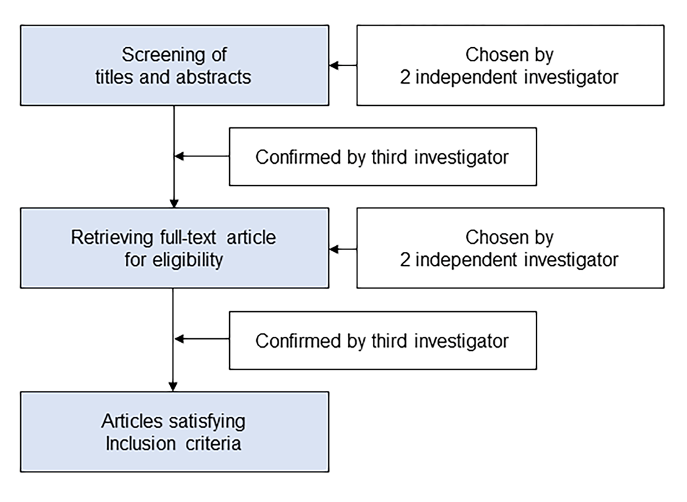

Supplementary Figure 2. Qualitative postoperative pain score. (A) Forest plot. The figure depicts individual trials as filled squares with relative sample size and the 95% confidence interval (CI) of the difference as a solid line. The diamond shape indicates the pooled estimate and uncertainty for the combined effect. The combined result showed no evidence of difference between remifentanil and sufentanil. (B) Trial sequential analysis plot. Horizontal dotted red line represents the conventional boundaries for statistical significance. The blue solid line represents the cumulative z-curve. The number on the x-axis indicates required information size. The Z-curve does not cross the conventional boundary.

Supplementary Figure 3. Meta-regression analysis showing the correlation between quantitative postoperative pain scores and (A) patient age, (B) duration of operation or anesthesia. and (C) the ratio of sufentanil to remifentanil dosage. The slopes represent the strength and direction of the correlation, with the corresponding 95% confidence intervals (CIs) and P-values indicating statistical significance.
Supplementary Figure 4. Meta-regression analysis showing the correlation between the incidence of patients who needed postoperative analgesics and (A) patient age, (B) duration of operation or anesthesia. and (C) the ratio of sufentanil to remifentanil dosage. The slopes represent the strength and direction of the correlation, with the corresponding 95% confidence intervals (CIs) and P-values indicating statistical significance.
Supplementary Figure 5. Incidence of patients who needed postoperative analgesics. (A) Forest plot. The figure depicts individual trials as filled squares with relative sample size and the 95% confidence interval (CI) of the difference as a solid line. The diamond shape indicates the pooled estimate and uncertainty for the combined effect. The pooled estimate indicates no significant difference in the incidence of patients who needed postoperative analgesics. (B) Trial sequential analysis plot. Uppermost and lowermost complete red curves represent trial sequential monitoring boundary lines for benefit and harm respectively. Horizontal dotted red line represents the conventional boundaries for statistical significance. Triangular red lines on the right side reflects the futility boundaries. The blue solid line represents the cumulative z-curve. The number on the x-axis indicates required information size (RIS). The TSA suggests insufficient evidence, with only 23.2% of the RIS accrued, as the Z-curve does not cross the trial sequential monitoring boundary.

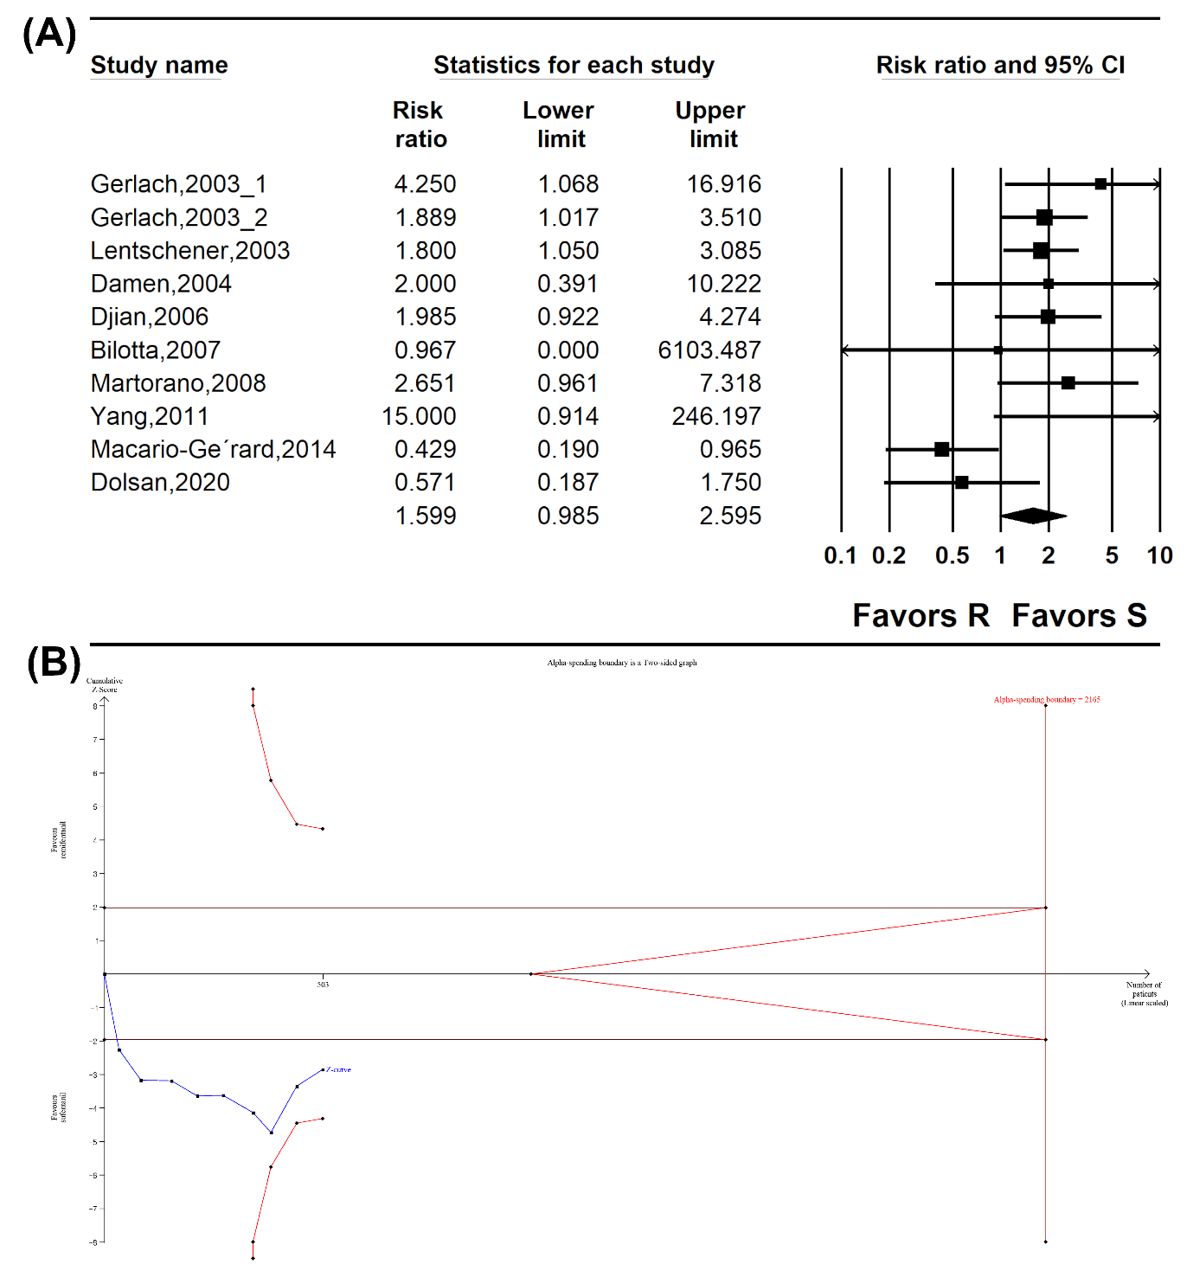

Supplementary Figure 6. Time to 1st analgesic administration. (A) Forest plot. The figure depicts individual trials as filled squares with relative sample size and the 95% confidence interval (CI) of the difference as a solid line. The diamond shape indicates the pooled estimate and uncertainty for the combined effect. The pooled estimate showed that remifentanil exhibited a shorter time to first analgesic administration compared to sufentanil. (B) Trial sequential analysis plot. Uppermost and lowermost complete red curves represent trial sequential monitoring boundary lines for benefit and harm respectively. Horizontal dotted red line represents the conventional boundaries for statistical significance. Triangular red lines on the right side reflects the futility boundaries. The blue solid line represents the cumulative z-curve. The number on the x-axis indicates required information size. The results show that only 32.9% of the Required Information Size (RIS) was attained, yet the cumulative Z curve intersects both conventional and trial sequential monitoring boundaries, suggesting potential significance despite the study not reaching its required sample size.

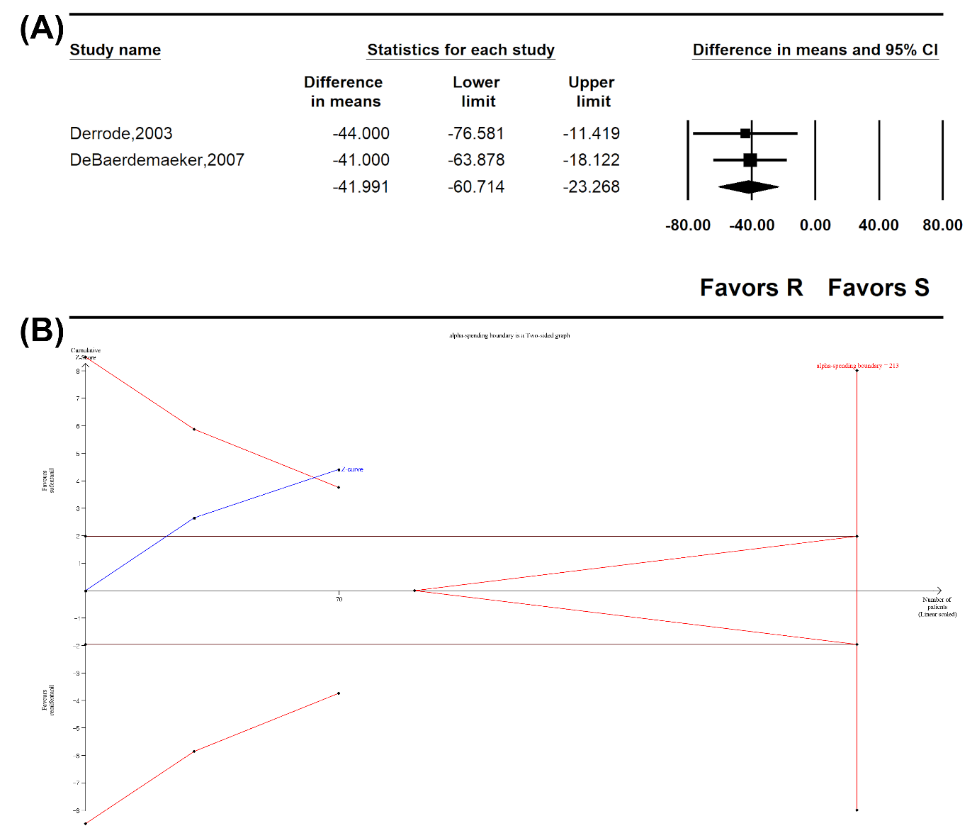
Supplementary Figure 7. Preoperative systolic blood pressure. (A) Forest plot. The figure depicts individual trials as filled squares with relative sample size and the 95% confidence interval (CI) of the difference as a solid line. The diamond shape indicates the pooled estimate and uncertainty for the combined effect. The combined result showed no evidence of differences between remifentanil and sufentanil for preoperative systolic blood pressure. (B) Trial sequential analysis plot. Uppermost and lowermost complete red curves represent trial sequential monitoring boundary lines for benefit and harm respectively. Horizontal dotted red line represents the conventional boundaries for statistical significance. Triangular red lines on the right side reflects the futility boundaries. The blue solid line represents the cumulative z-curve. The number on the x-axis indicates required information size. The results show that 94.7% f the Required Information Size (RIS) was attained, yet the cumulative Z curve intersects futility boundary, suggesting no further studies were needed.

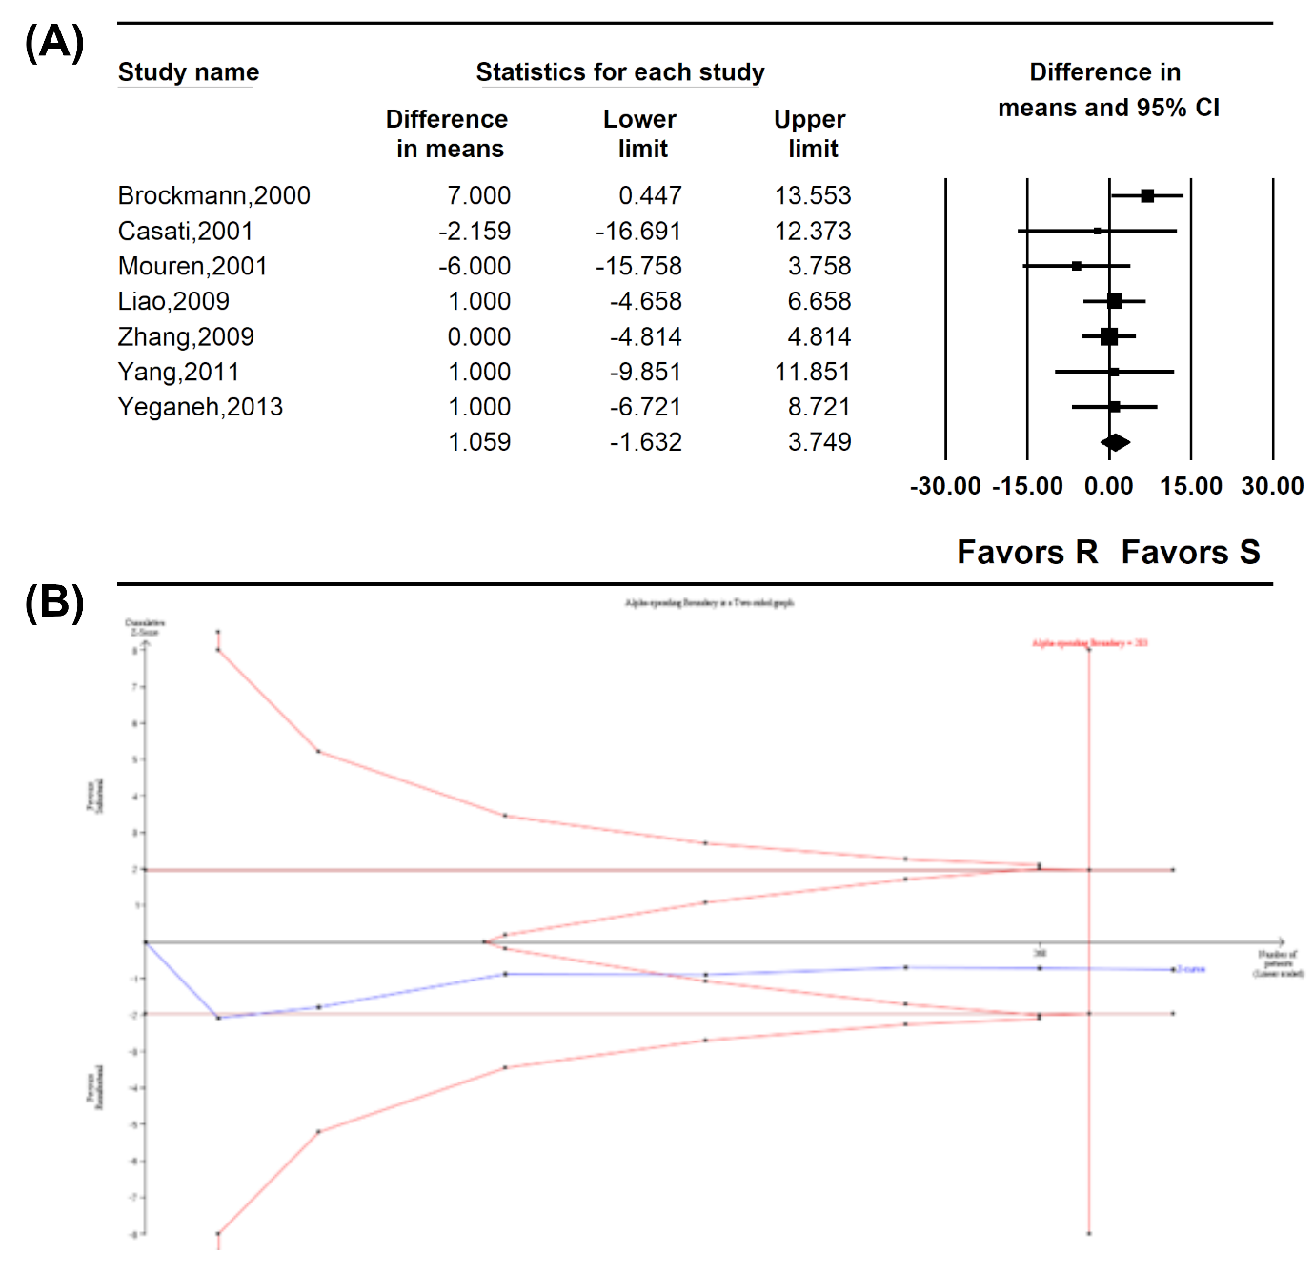

Supplementary Figure 8. Intraoperative systolic blood pressure. (A) Forest plot. The figure depicts individual trials as filled squares with relative sample size and the 95% confidence interval (CI) of the difference as a solid line. The diamond shape indicates the pooled estimate and uncertainty for the combined effect. The overall pooled estimate of sufentanil shows significantly higher intraoperative systolic blood pressure compared to sufentanil. (B) The trial sequential analysis plot. Uppermost and lowermost complete red curves represent trial sequential monitoring boundary lines for benefit and harm respectively. Horizontal dotted red line represents the conventional boundaries for statistical significance. Triangular red lines on the right side reflects the futility boundaries. The blue solid line represents the cumulative z-curve. The number on the x-axis indicates required information size. The cumulative Z curve crossed the conventional test boundary but did not cross the trial sequential monitoring boundary.

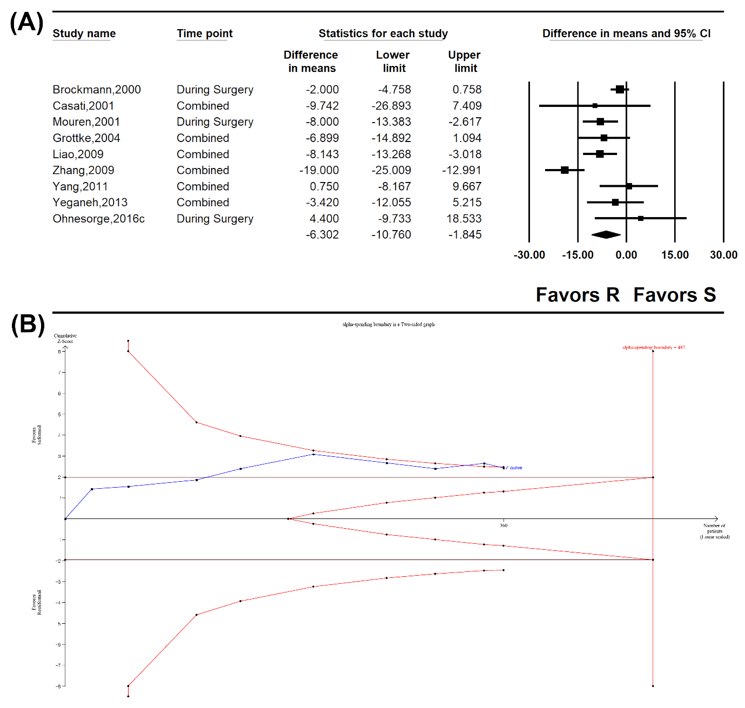
Supplementary Figure 9. Postoperative systolic blood pressure. (A) Forest plot. The figure depicts individual trials as filled squares with relative sample size and the 95% confidence interval (CI) of the difference as a solid line. The diamond shape indicates the pooled estimate and uncertainty for the combined effect. The combined result showed no evidence of differences between remifentanil and sufentanil for postoperative systolic blood pressure. (B) Trial sequential analysis plot. Horizontal dotted red line represents the conventional boundaries for statistical significance. The blue solid line represents the cumulative z-curve. The number on the x-axis indicates required information size. The cumulative Z curve crossed neither the conventional test boundary nor cross the trial sequential monitoring boundary.

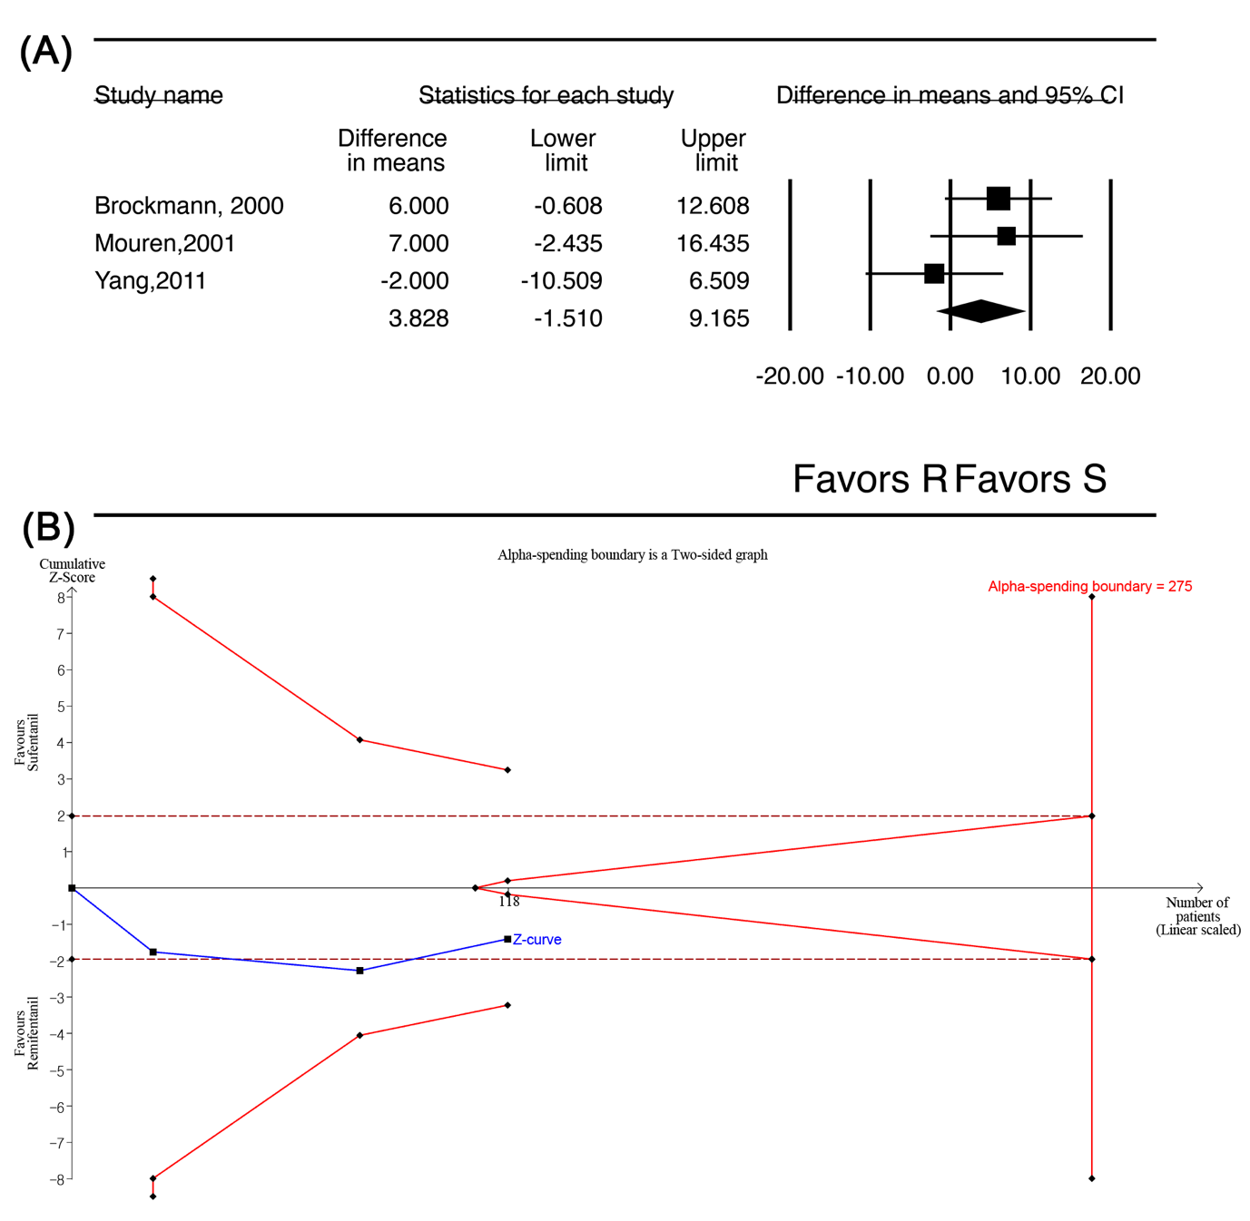

Supplementary Figure 10. Preoperative mean arterial pressure. (A) Forest plot. The figure depicts individual trials as filled squares with relative sample size and the 95% confidence interval (CI) of the difference as a solid line. The diamond shape indicates the pooled estimate and uncertainty for the combined effect. The combined result showed no evidence of differences between remifentanil and sufentanil for preoperative mean arterial pressure. (B) Trial sequential analysis plot. Uppermost and lowermost complete red curves represent trial sequential monitoring boundary lines for benefit and harm respectively. Horizontal dotted red line represents the conventional boundaries for statistical significance. Triangular red lines on the right side reflects the futility boundaries. The blue solid line represents the cumulative z-curve. The number on the x-axis indicates required information size. The results show that patients enrolled exceeds RIS (735 of 446 patients), yet the cumulative Z curve intersects futility boundary, suggesting no further studies were needed.

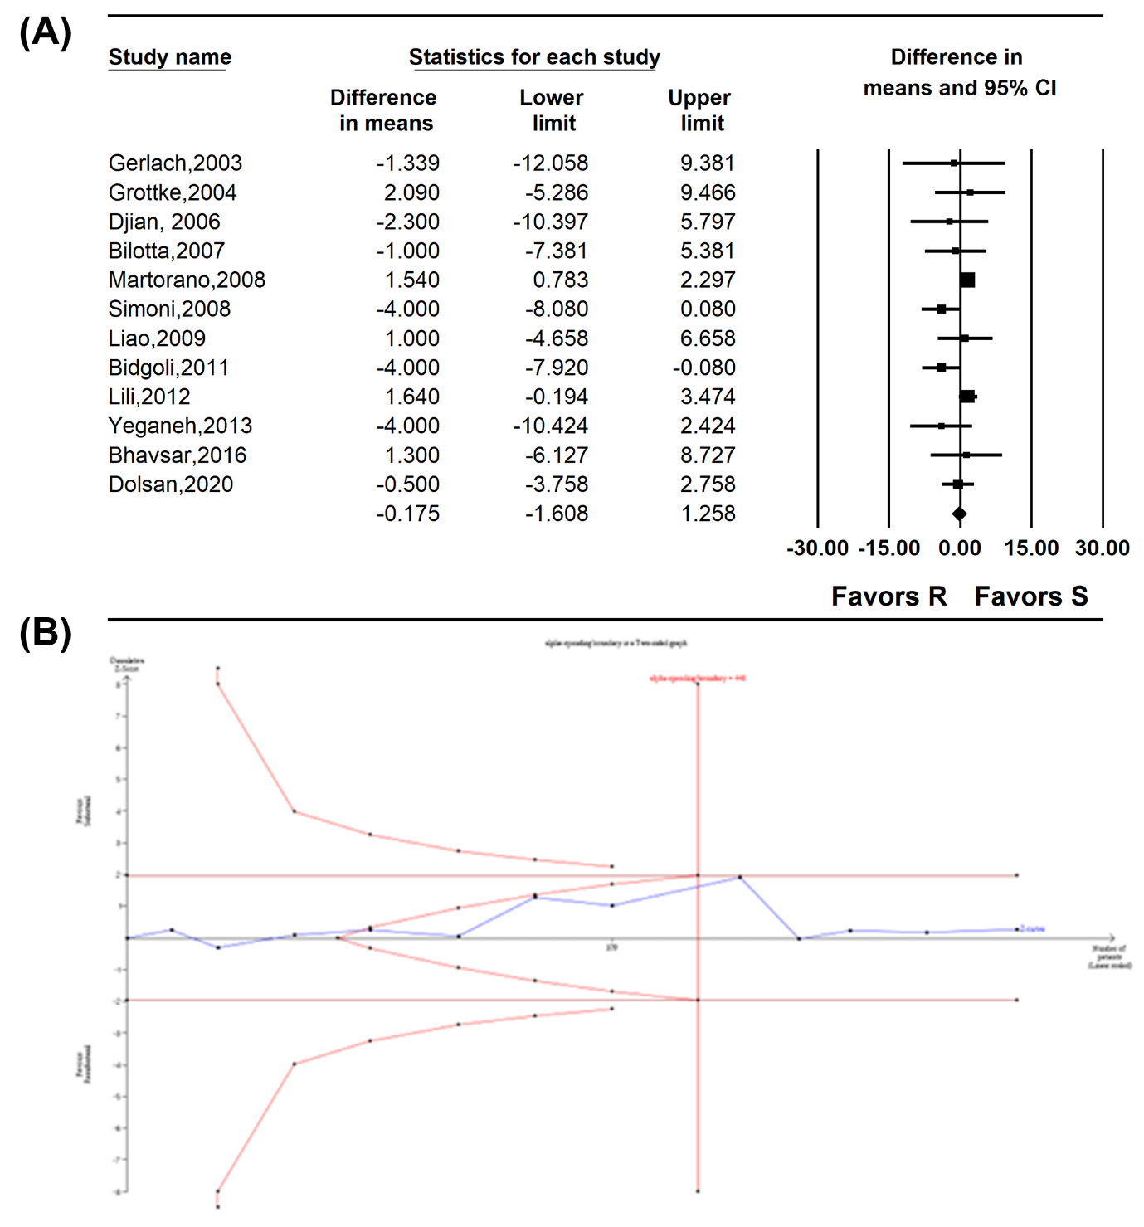

Supplementary Figure 11. Meta-regression analysis showing the correlation between preoperative mean arterial pressure and (A) patient age and (B) the ratio of sufentanil to remifentanil dosage. The slopes represent the strength and direction of the correlation, with the corresponding 95% confidence intervals (CIs) and P-values indicating statistical significance.

Supplementary Figure 12. Meta-regression analysis showing the correlation between intraoperative mean arterial pressure and (A) patient age and (B) the ratio of sufentanil to remifentanil dosage. The slopes represent the strength and direction of the correlation, with the corresponding 95% confidence intervals (CIs) and P-values indicating statistical significance.
Supplementary Figure 13. Postoperative mean arterial pressure. (A) Forest plot. The figure depicts individual trials as filled squares with relative sample size and the 95% confidence interval (CI) of the difference as a solid line. The diamond shape indicates the pooled estimate and uncertainty for the combined effect. The combined result showed no evidence of differences between remifentanil and sufentanil for postoperative mean arterial pressure. (B) Trial sequential analysis plot. Uppermost and lowermost complete red curves represent trial sequential monitoring boundary lines for benefit and harm respectively. Horizontal dotted red line represents the conventional boundaries for statistical significance. Triangular red lines on the right side reflects the futility boundaries. The blue solid line represents the cumulative z-curve. The number on the x-axis indicates required information size. The cumulative Z curve crossed neither the conventional test boundary nor cross the trial sequential monitoring boundary.

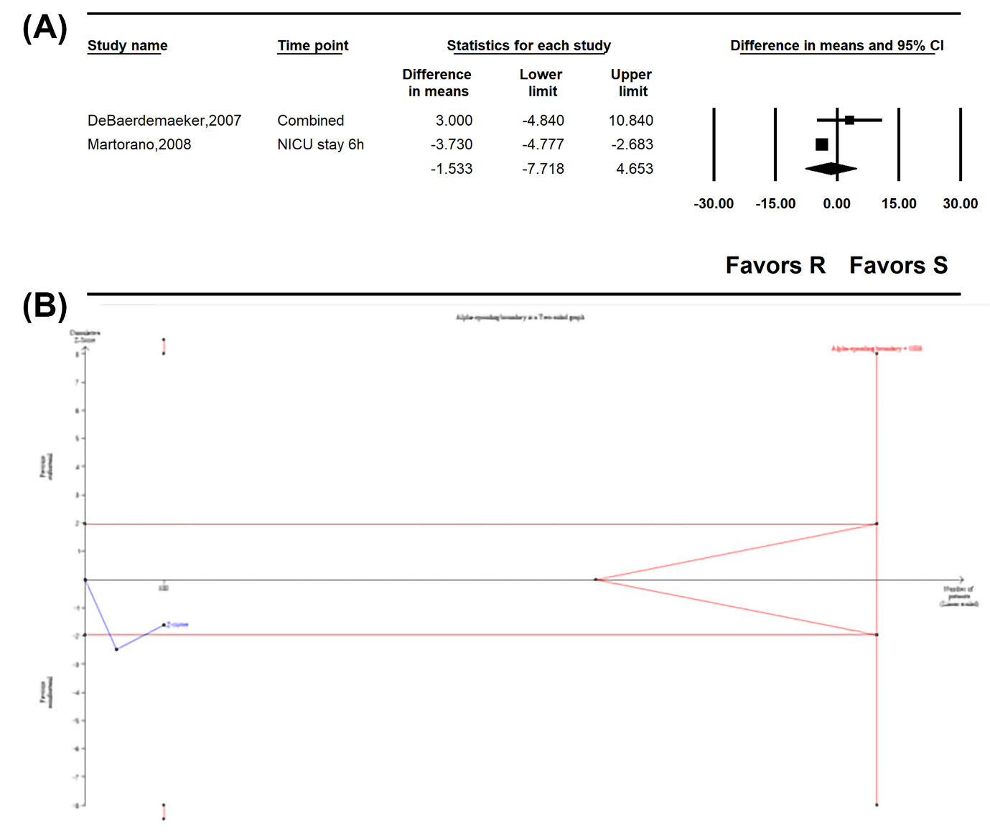

Supplementary Figure 14. Preoperative diastolic blood pressure. (A) Forest plot. The figure depicts individual trials as filled squares with relative sample size and the 95% confidence interval (CI) of the difference as a solid line. The diamond shape indicates the pooled estimate and uncertainty for the combined effect. The combined result showed no evidence of differences between remifentanil and sufentanil for preoperative diastolic blood pressure. (B) Trial sequential analysis plot. Uppermost and lowermost complete red curves represent trial sequential monitoring boundary lines for benefit and harm respectively. Horizontal dotted red line represents the conventional boundaries for statistical significance. Triangular red lines on the right side reflects the futility boundaries. The blue solid line represents the cumulative z-curve. The number on the x-axis indicates required information size. The cumulative Z curve crossed neither the conventional test boundary nor cross the trial sequential monitoring boundary.

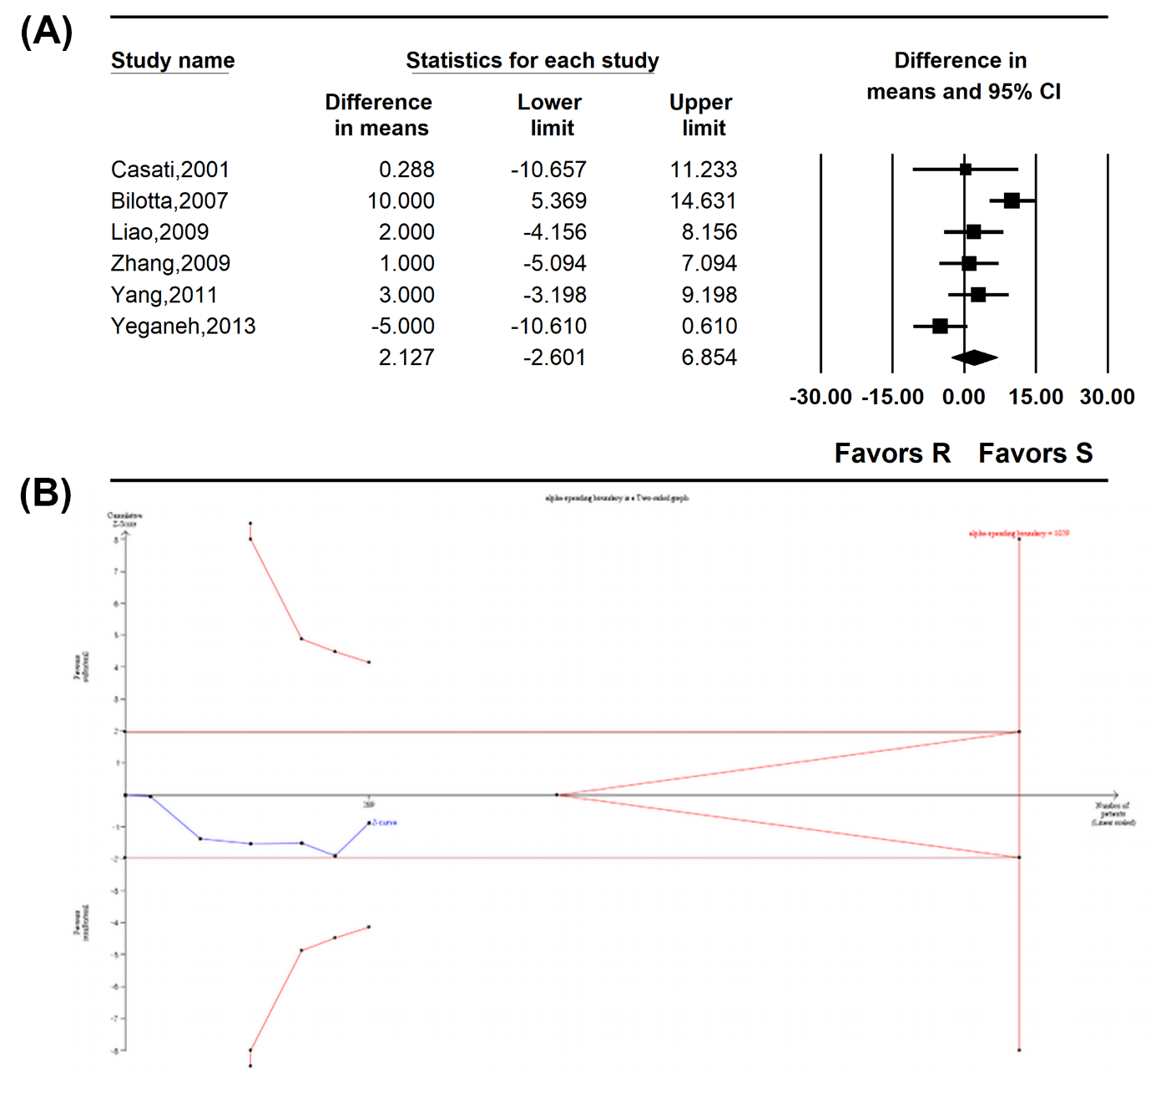

Supplementary Figure 15. Intraoperative diastolic blood pressure. (A) Forest plot. The figure depicts individual trials as filled squares with relative sample size and the 95% confidence interval (CI) of the difference as a solid line. The diamond shape indicates the pooled estimate and uncertainty for the combined effect. The combined result showed no evidence of differences between remifentanil and sufentanil for intraoperative diastolic blood pressure. (B) Trial sequential analysis plot. Uppermost and lowermost complete red curves represent trial sequential monitoring boundary lines for benefit and harm respectively. Horizontal dotted red line represents the conventional boundaries for statistical significance. Triangular red lines on the right side reflects the futility boundaries. The blue solid line represents the cumulative z-curve. The number on the x-axis indicates required information size. The cumulative Z curve crossed neither the conventional test boundary nor cross the trial sequential monitoring boundary.

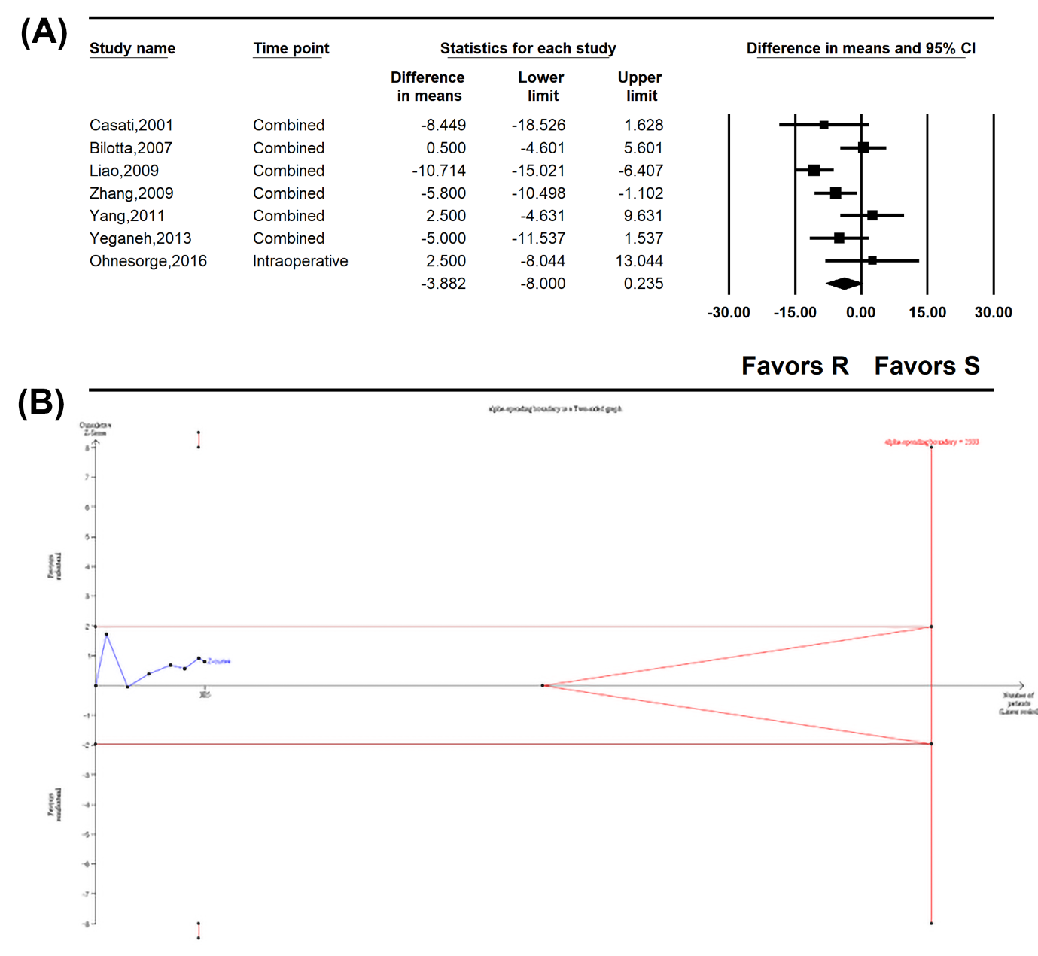

Supplementary Figure 16. Forest plot for postoperative diastolic blood pressure. The figure depicts individual trials as filled squares with relative sample size and the 95% confidence interval (CI) of the difference as a solid line. The diamond shape indicates the pooled estimate and uncertainty for the combined effect. The overall pooled estimate of remifentanil shows significantly higher postoperative diastolic blood pressure compared to sufentanil. (B) Trial sequential analysis for postoperative diastolic blood pressure. Uppermost and lowermost complete red curves represent trial sequential monitoring boundary lines for benefit and harm respectively. Horizontal dotted red line represents the conventional boundaries for statistical significance. Triangular red lines on the right side reflects the futility boundaries. The blue solid line represents the cumulative z-curve. The number on the x-axis indicates required information size. The cumulative Z curve crossed neither the conventional test boundary nor cross the trial sequential monitoring boundary.

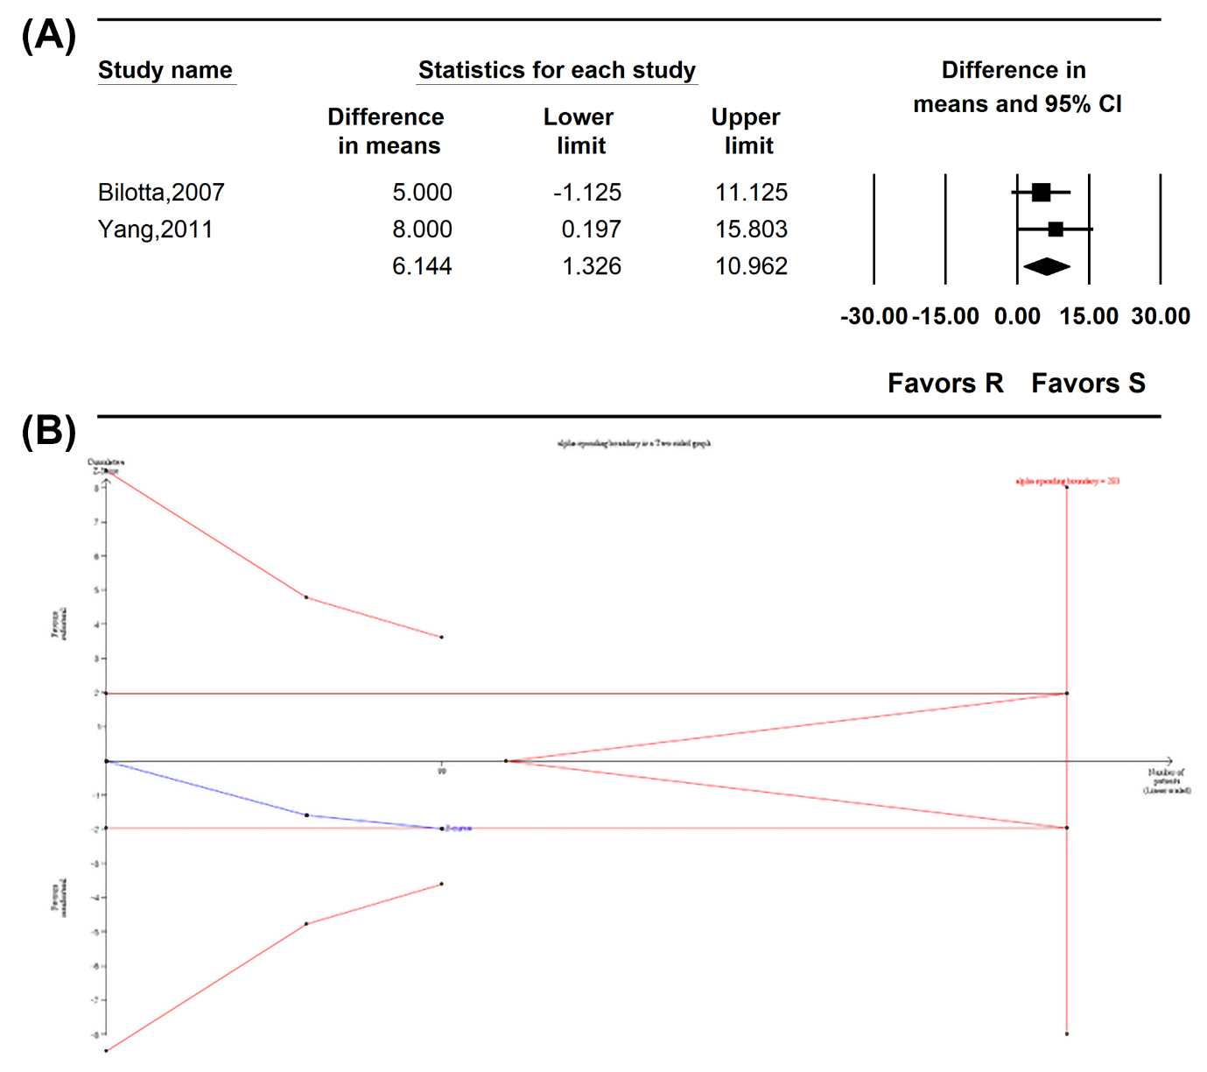

Supplementary Figure 17. Preoperative heart rate. (A) Forest plot. The figure depicts individual trials as filled squares with relative sample size and the 95% confidence interval (CI) of the difference as a solid line. The diamond shape indicates the pooled estimate and uncertainty for the combined effect. The combined result showed no evidence of differences between remifentanil and sufentanil for preoperative heart rate. (B) Trial sequential analysis plot. Uppermost and lowermost complete red curves represent trial sequential monitoring boundary lines for benefit and harm respectively. Horizontal dotted red line represents the conventional boundaries for statistical significance. Triangular red lines on the right side reflects the futility boundaries. The blue solid line represents the cumulative z-curve. The number on the x-axis indicates required information size. The cumulative Z curve crossed neither the conventional test boundary nor cross the trial sequential monitoring boundary.
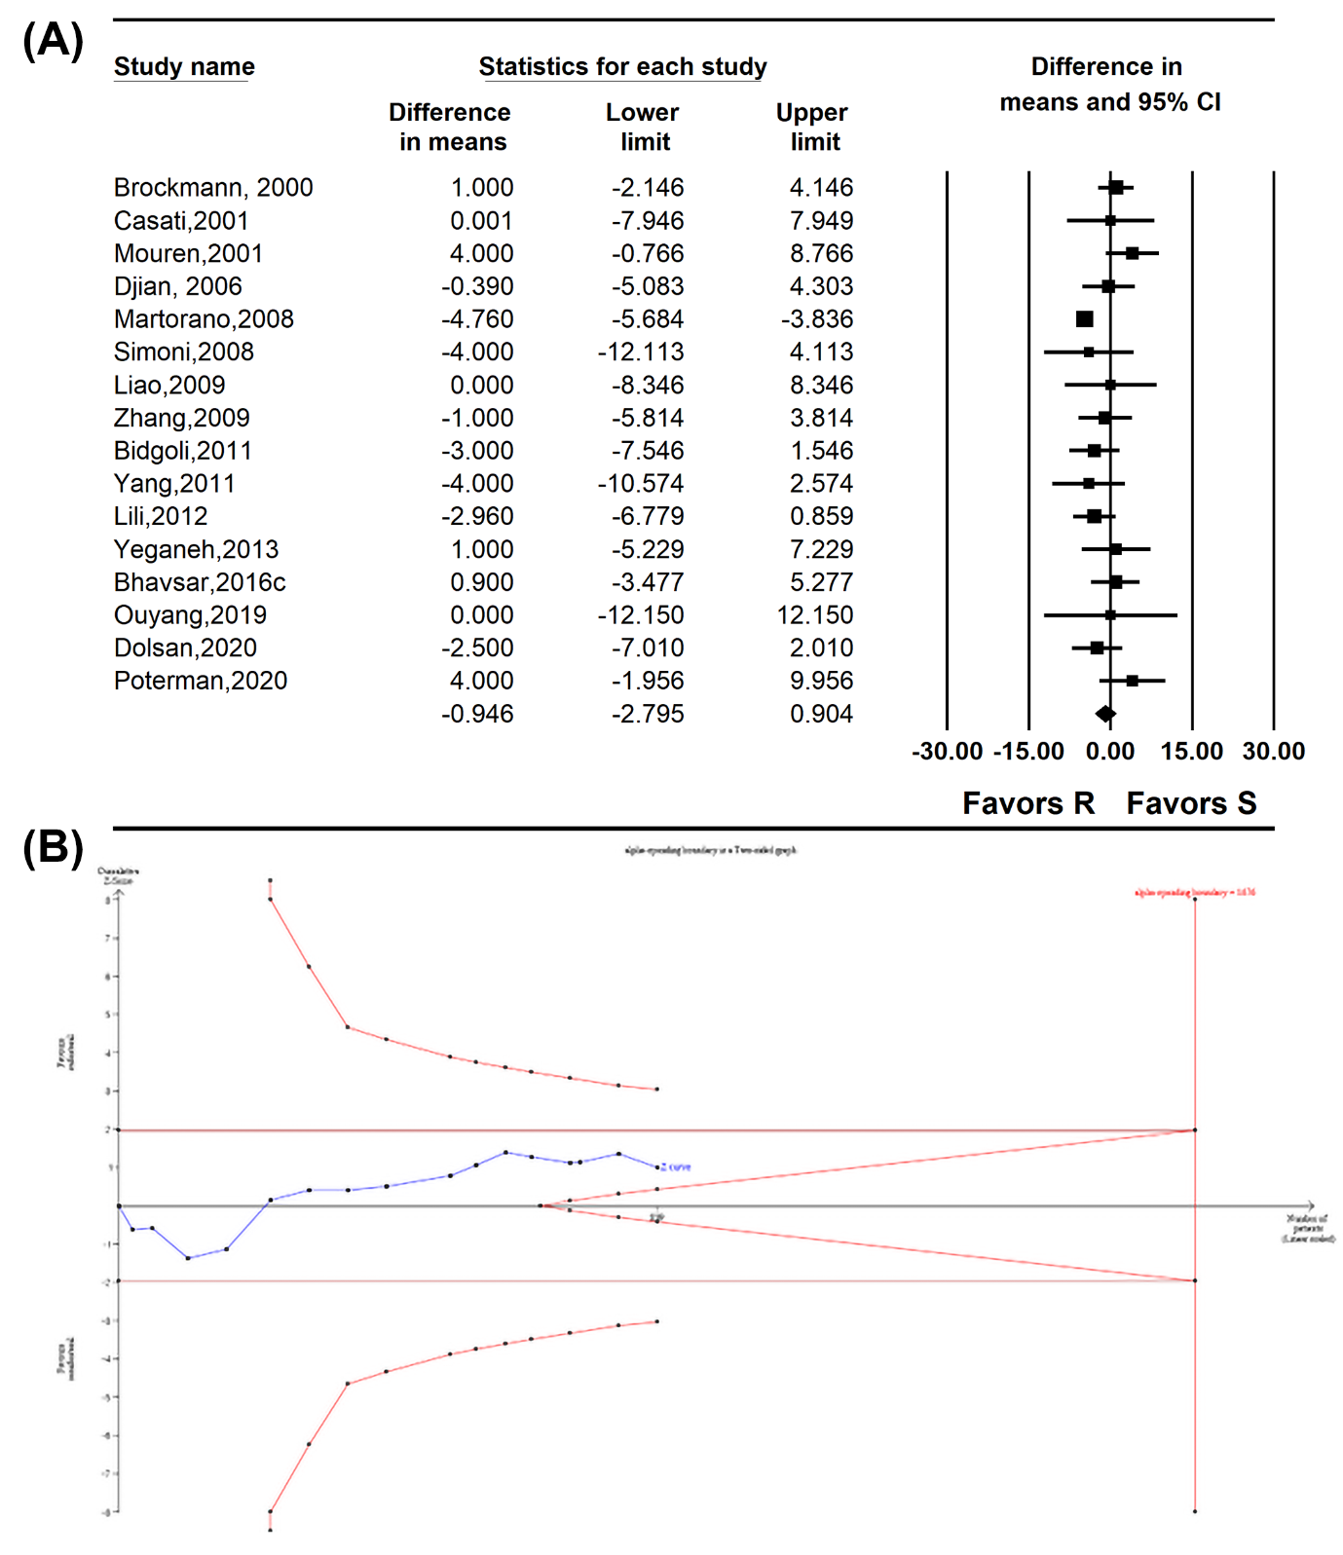
Supplementary Figure 18. Meta-regression analysis showing the correlation between preoperative heart rate and (A) patient age and (B) the ratio of sufentanil to remifentanil dosage. The slopes represent the strength and direction of the correlation, with the corresponding 95% confidence intervals (CIs) and P-values indicating statistical significance.

Supplementary Figure 19. Meta-regression analysis showing the correlation between intraoperative heart rate and (A) patient age and (B) the ratio of sufentanil to remifentanil dosage. The slopes represent the strength and direction of the correlation, with the corresponding 95% confidence intervals (CIs) and P-values indicating statistical significance.

Supplementary Figure 20. Postoperative heart rate. (A) Forest plot. The figure depicts individual trials as filled squares with relative sample size and the 95% confidence interval (CI) of the difference as a solid line. The diamond shape indicates the pooled estimate and uncertainty for the combined effect. The combined result showed no evidence of differences between remifentanil and sufentanil for postoperative heart rate. (B) Trial sequential analysis plot. Uppermost and lowermost complete red curves represent trial sequential monitoring boundary lines for benefit and harm respectively. Horizontal dotted red line represents the conventional boundaries for statistical significance. Triangular red lines on the right side reflects the futility boundaries. The blue solid line represents the cumulative z-curve. The number on the x-axis indicates required information size. The cumulative Z curve crossed neither the conventional test boundary nor cross the trial sequential monitoring boundary.

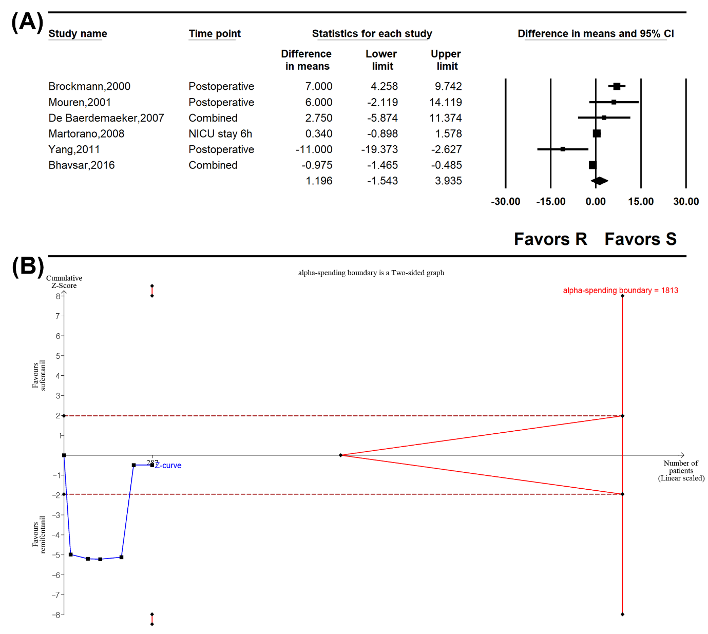

Supplementary Figure 21. Incidence of postoperative nausea. (A) Forest plot. The figure depicts individual trials as filled squares with relative sample size and the 95% confidence interval (CI) of the difference as a solid line. The diamond shape indicates the pooled estimate and uncertainty for the combined effect. The overall pooled estimate of remifentanil shows significantly higher incidence of postoperative nausea compared to sufentanil. (B) Trial sequential analysis plot. Uppermost and lowermost complete red curves represent trial sequential monitoring boundary lines for benefit and harm respectively. Horizontal dotted red line represents the conventional boundaries for statistical significance. Triangular red lines on the right side reflects the futility boundaries. The blue solid line represents the cumulative z-curve. The number on the x-axis indicates required information size. The cumulative Z curve crossed the conventional test boundary but did not cross the trial sequential monitoring boundary.
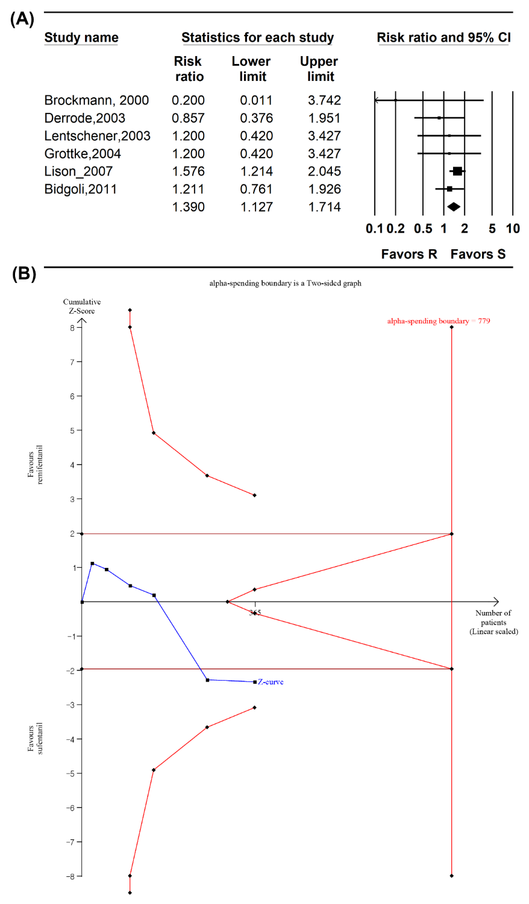

Supplementary Figure 22. Incidence of postoperative vomiting. (A) Forest plot. The figure depicts individual trials as filled squares with relative sample size and the 95% confidence interval (CI) of the difference as a solid line. The diamond shape indicates the pooled estimate and uncertainty for the combined effect. The combined result showed no evidence of differences between remifentanil and sufentanil for the incidence of postoperative vomiting. (B) Trial sequential analysis plot. Uppermost and lowermost complete red curves represent trial sequential monitoring boundary lines for benefit and harm respectively. Horizontal dotted red line represents the conventional boundaries for statistical significance. Triangular red lines on the right side reflects the futility boundaries. The blue solid line represents the cumulative z-curve. The number on the x-axis indicates required information size. The cumulative Z curve crossed neither the conventional test boundary nor cross the trial sequential monitoring boundary.

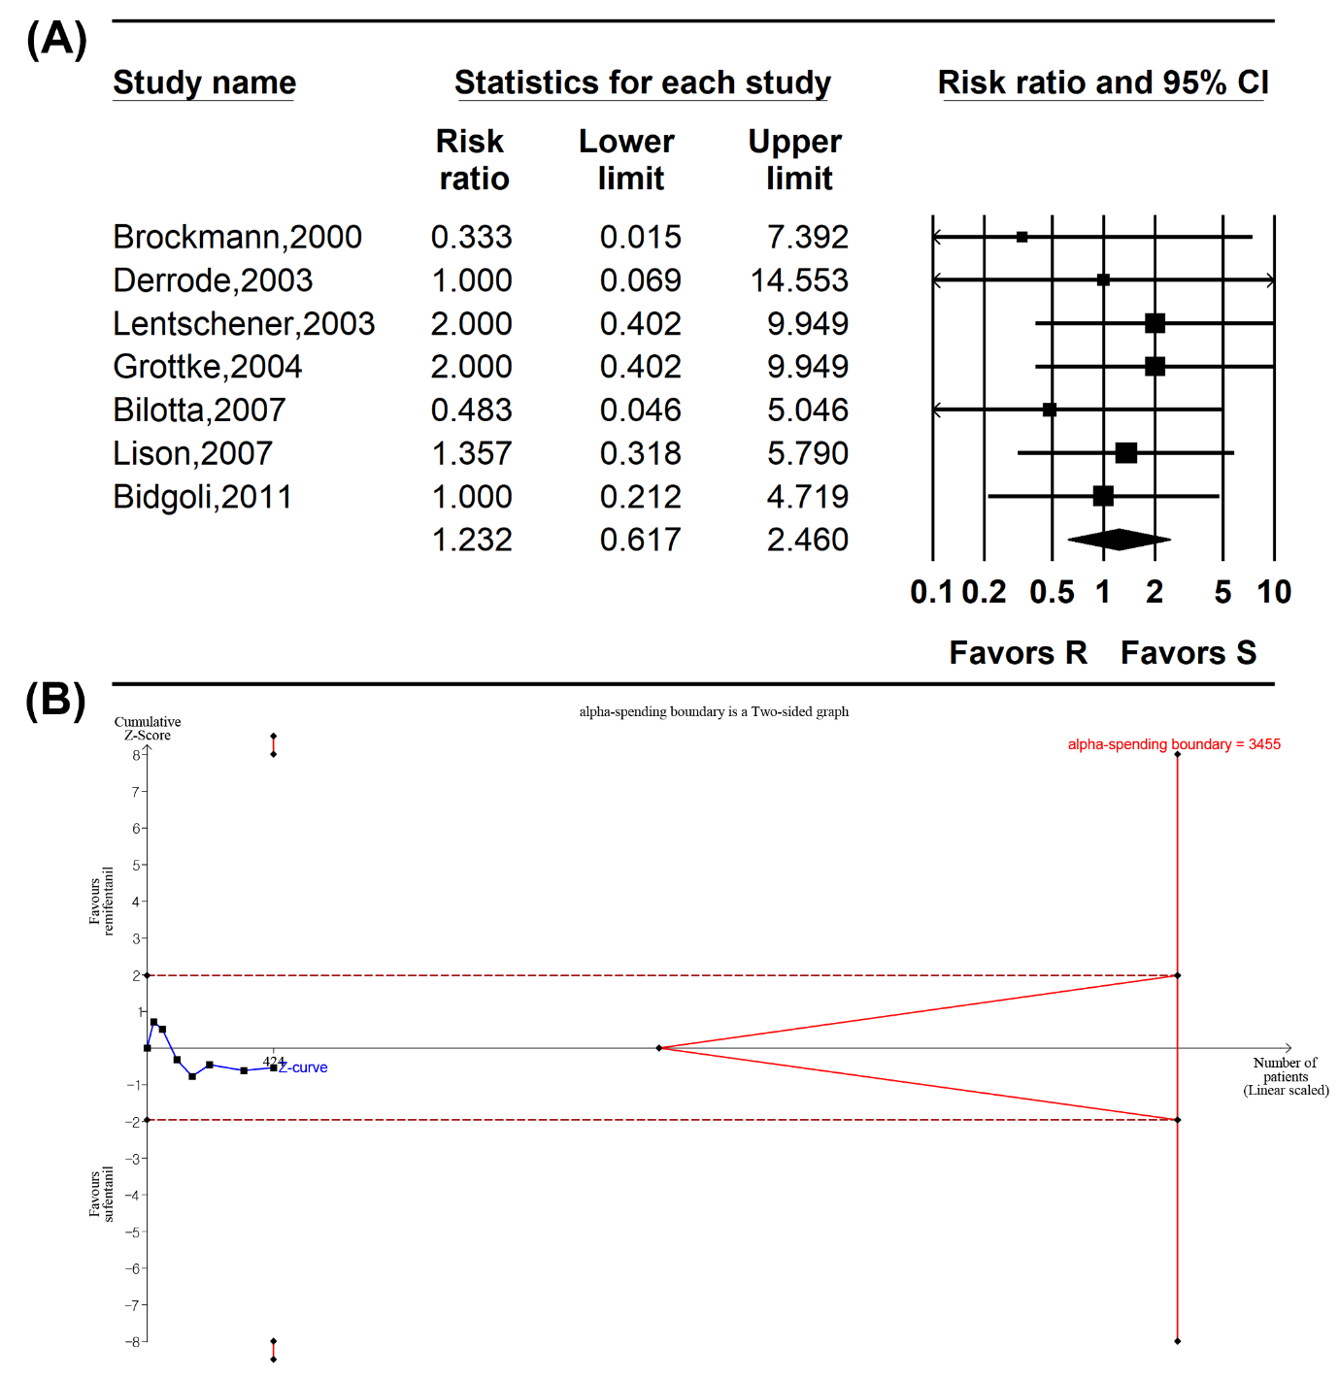

Supplementary Figure 23. Postoperative nausea and vomiting. (A) Forest plot. The figure depicts individual trials as filled squares with relative sample size and the 95% confidence interval (CI) of the difference as a solid line. The diamond shape indicates the pooled estimate and uncertainty for the combined effect. The combined result showed no evidence of differences between remifentanil and sufentanil for the incidence of postoperative nausea and vomiting. (B) Trial sequential analysis plot. Uppermost and lowermost complete red curves represent trial sequential monitoring boundary lines for benefit and harm respectively. Horizontal dotted red line represents the conventional boundaries for statistical significance. Triangular red lines on the right side reflects the futility boundaries. The blue solid line represents the cumulative z-curve. The number on the x-axis indicates required information size. The cumulative Z curve crossed neither the conventional test boundary nor cross the trial sequential monitoring boundary.

Supplementary Figure 24. Meta-regression analysis showing the correlation between postoperative nausea and vomiting and (A) patient age and (B) the ratio of sufentanil to remifentanil dosage. The slopes represent the strength and direction of the correlation, with the corresponding 95% confidence intervals (CIs) and P-values indicating statistical significance.

Supplementary Figure 25. Use of rescue anti-emetics. (A) Forest plot. The figure depicts individual trials as filled squares with relative sample size and the 95% confidence interval (CI) of the difference as a solid line. The diamond shape indicates the pooled estimate and uncertainty for the combined effect. The combined result showed no evidence of differences between remifentanil and sufentanil for the use of rescue anti-emetics. (B) Trial sequential analysis plot. Uppermost and lowermost complete red curves represent trial sequential monitoring boundary lines for benefit and harm respectively. Horizontal dotted red line represents the conventional boundaries for statistical significance. Triangular red lines on the right side reflects the futility boundaries. The blue solid line represents the cumulative z-curve. The number on the x-axis indicates required information size. The cumulative Z curve crossed neither the conventional test boundary nor cross the trial sequential monitoring boundary.

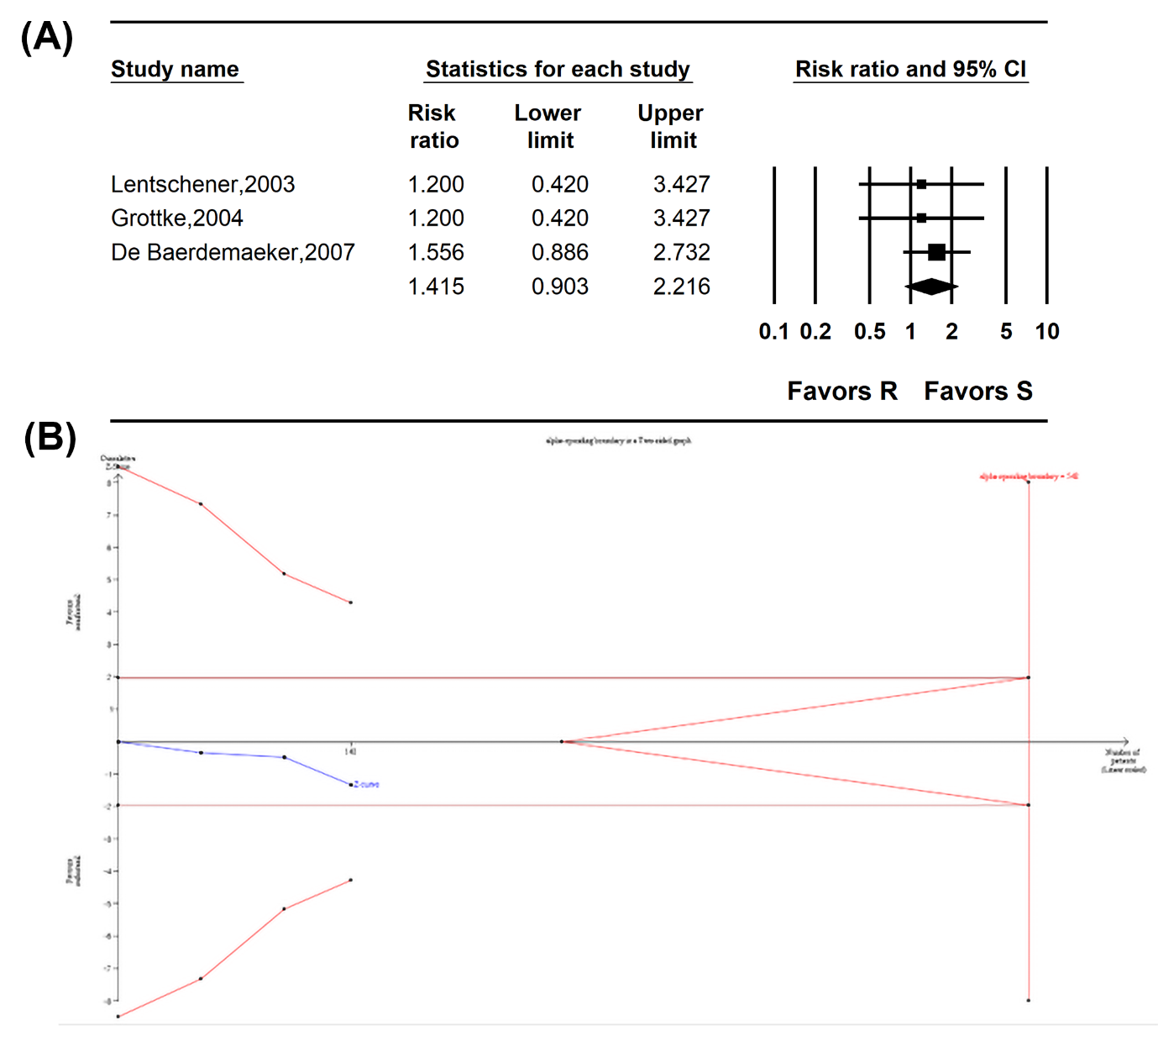

Supplementary Figure 26. Incidence of respiratory depression. (A) Forest plot. The figure depicts individual trials as filled squares with relative sample size and the 95% confidence interval (CI) of the difference as a solid line. The diamond shape indicates the pooled estimate and uncertainty for the combined effect. The combined result showed no evidence of differences between remifentanil and sufentanil for the incidence of respiratory depression. (B) Trial sequential analysis plot. Uppermost and lowermost complete red curves represent trial sequential monitoring boundary lines for benefit and harm respectively. Horizontal etched red line represents the conventional boundaries for statistical significance. Triangular red lines on the right side reflects the futility boundaries. The blue solid line represents the cumulative z-curve. The number on the x-axis indicates required information size. The cumulative Z curve neither crossed the conventional test boundary nor crossed the trial sequential monitoring boundary.

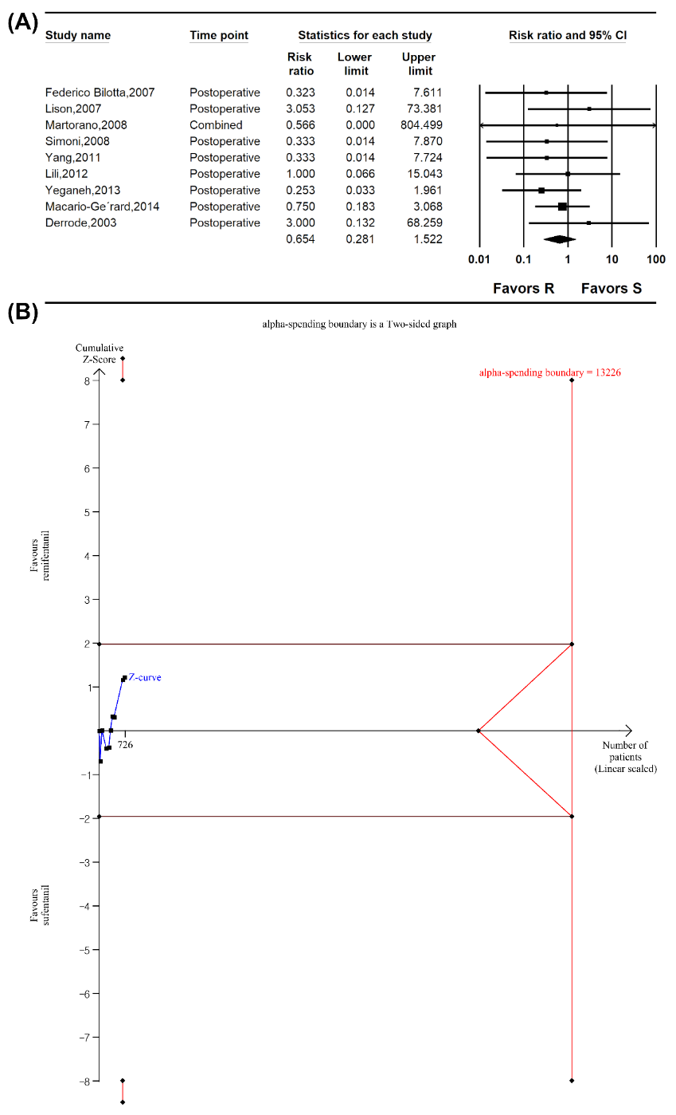

Supplementary Figure 27. Percutaneous oxygen saturation level. (A) Forest plot. The figure depicts individual trials as filled squares with relative sample size and the 95% confidence interval (CI) of the difference as a solid line. The diamond shape indicates the pooled estimate and uncertainty for the combined effect. The combined result showed no evidence of differences between remifentanil and sufentanil for the incidence of respiratory depression. (B) Trial sequential analysis plot. Uppermost and lowermost complete red curves represent trial sequential monitoring boundary lines for benefit and harm respectively. Horizontal etched red line represents the conventional boundaries for statistical significance. Triangular red lines on the right side reflects the futility boundaries. The blue solid line represents the cumulative z-curve. The number on the x-axis indicates required information size. The cumulative Z curve neither crossed the conventional test boundary nor crossed the trial sequential monitoring boundary.

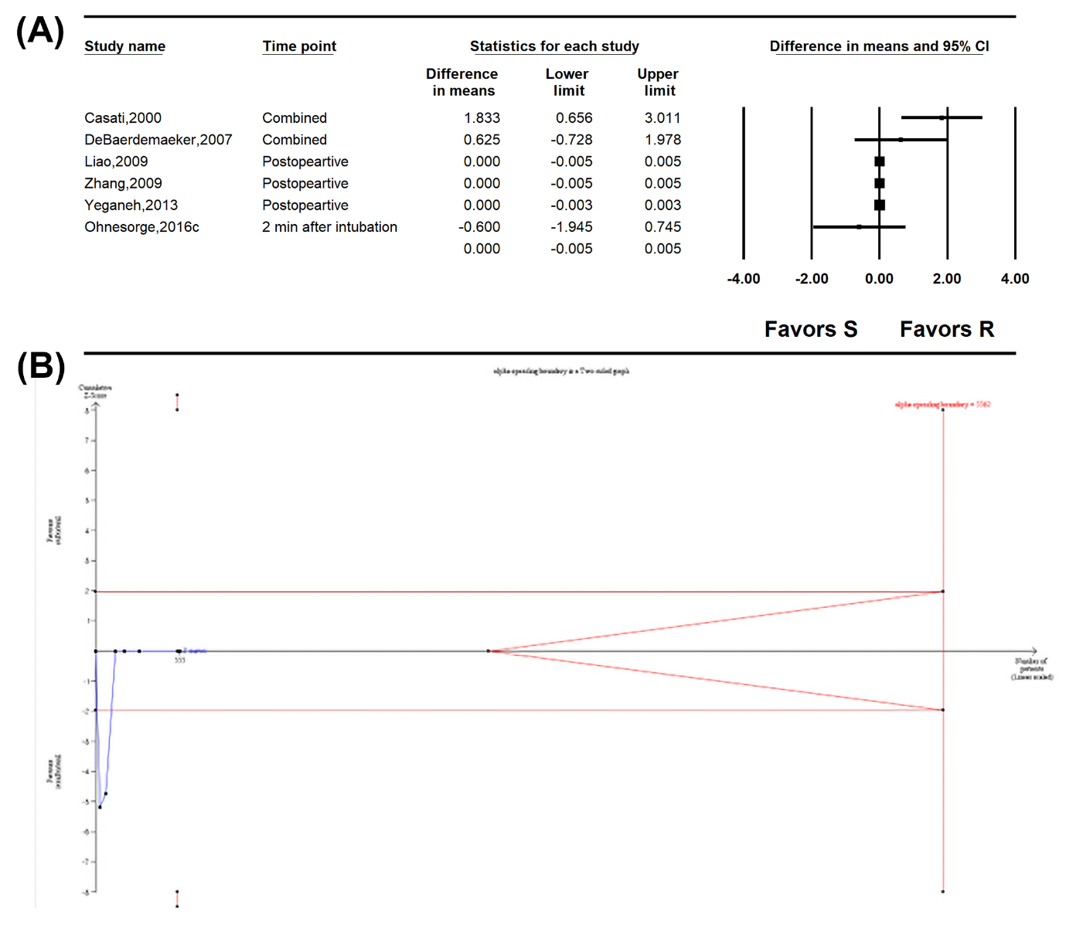

Supplementary Figure 28. Meta-regression analysis showing the correlation between time to extubation and (A) patient age, (B) duration of operation or anesthesia, and (C) the ratio of sufentanil to remifentanil dosage. The slopes represent the strength and direction of the correlation, with the corresponding 95% confidence intervals (CIs) and P-values indicating statistical significance.

Supplementary Figure 29. Time to eye opening. (A) Forest plot. The figure depicts individual trials as filled squares with relative sample size and the 95% confidence interval (CI) of the difference as a solid line. The diamond shape indicates the pooled estimate and uncertainty for the combined effect. The combined result showed no evidence of differences between remifentanil and sufentanil for time for eye opening. (B) Trial sequential analysis plot. Uppermost and lowermost complete red curves represent trial sequential monitoring boundary lines for benefit and harm respectively. Horizontal dotted red line represents the conventional boundaries for statistical significance. Triangular red lines on the right side reflects the futility boundaries. The blue solid line represents the cumulative z-curve. The number on the x-axis indicates required information size. The cumulative Z curve crossed the conventional test boundary but did not cross the trial sequential monitoring boundary.

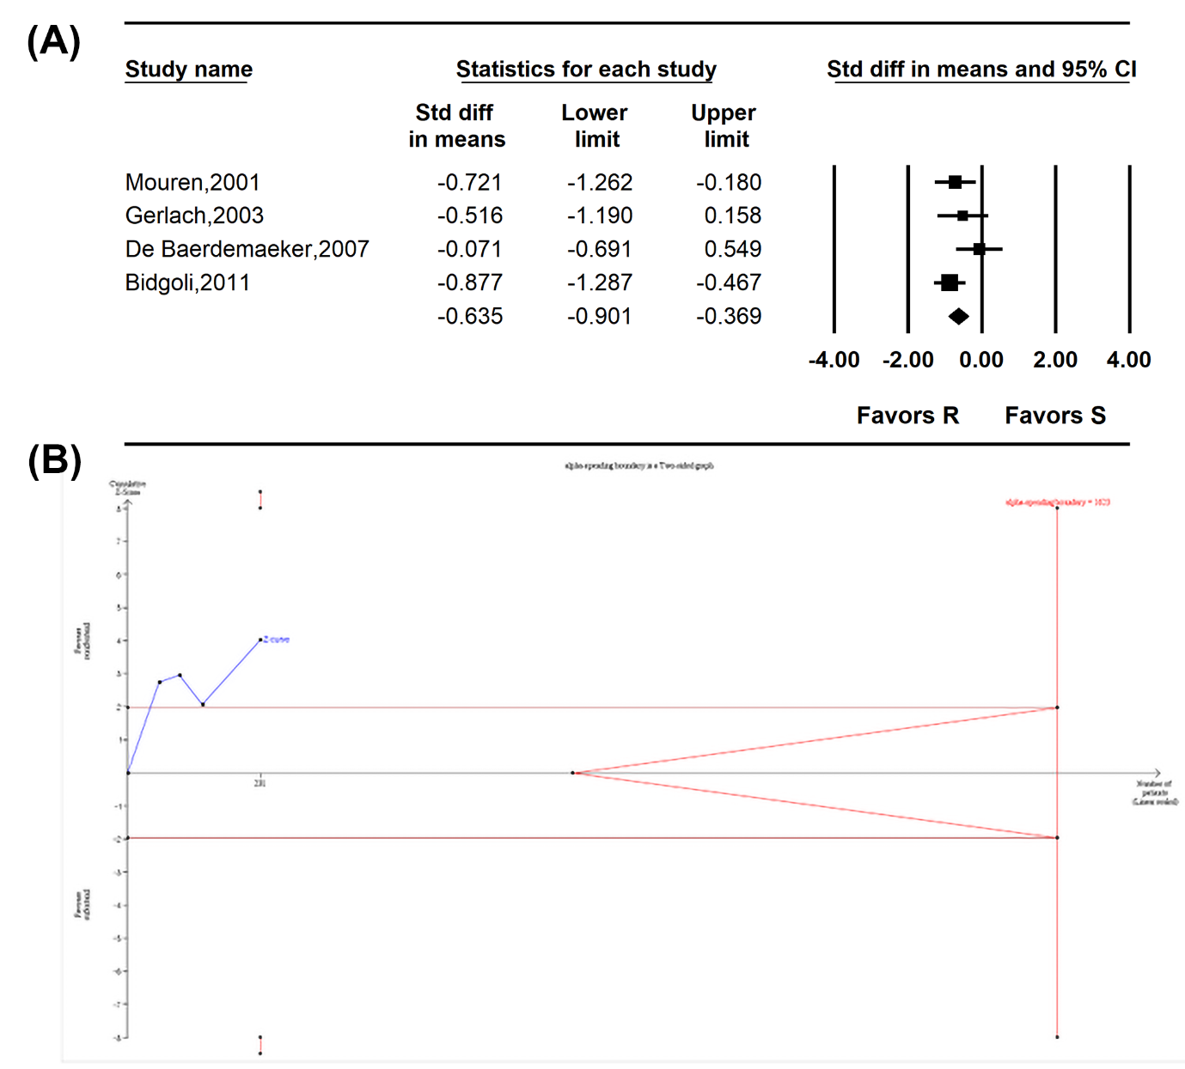

Supplementary Figure 30. Time to spontaneous respiration. (A) Forest plot. The figure depicts individual trials as filled squares with relative sample size and the 95% confidence interval (CI) of the difference as a solid line. The diamond shape indicates the pooled estimate and uncertainty for the combined effect. The combined result showed no evidence of differences between remifentanil and sufentanil for time for spontaneous respiration. (B) Trial sequential analysis plot. Uppermost and lowermost complete red curves represent trial sequential monitoring boundary lines for benefit and harm respectively. Horizontal etched red line represents the conventional boundaries for statistical significance. Triangular red lines on the right side reflects the futility boundaries. The blue solid line represents the cumulative z-curve. The number on the x-axis indicates required information size. The cumulative Z curve neither crossed the conventional test boundary nor crossed the trial sequential monitoring boundary.

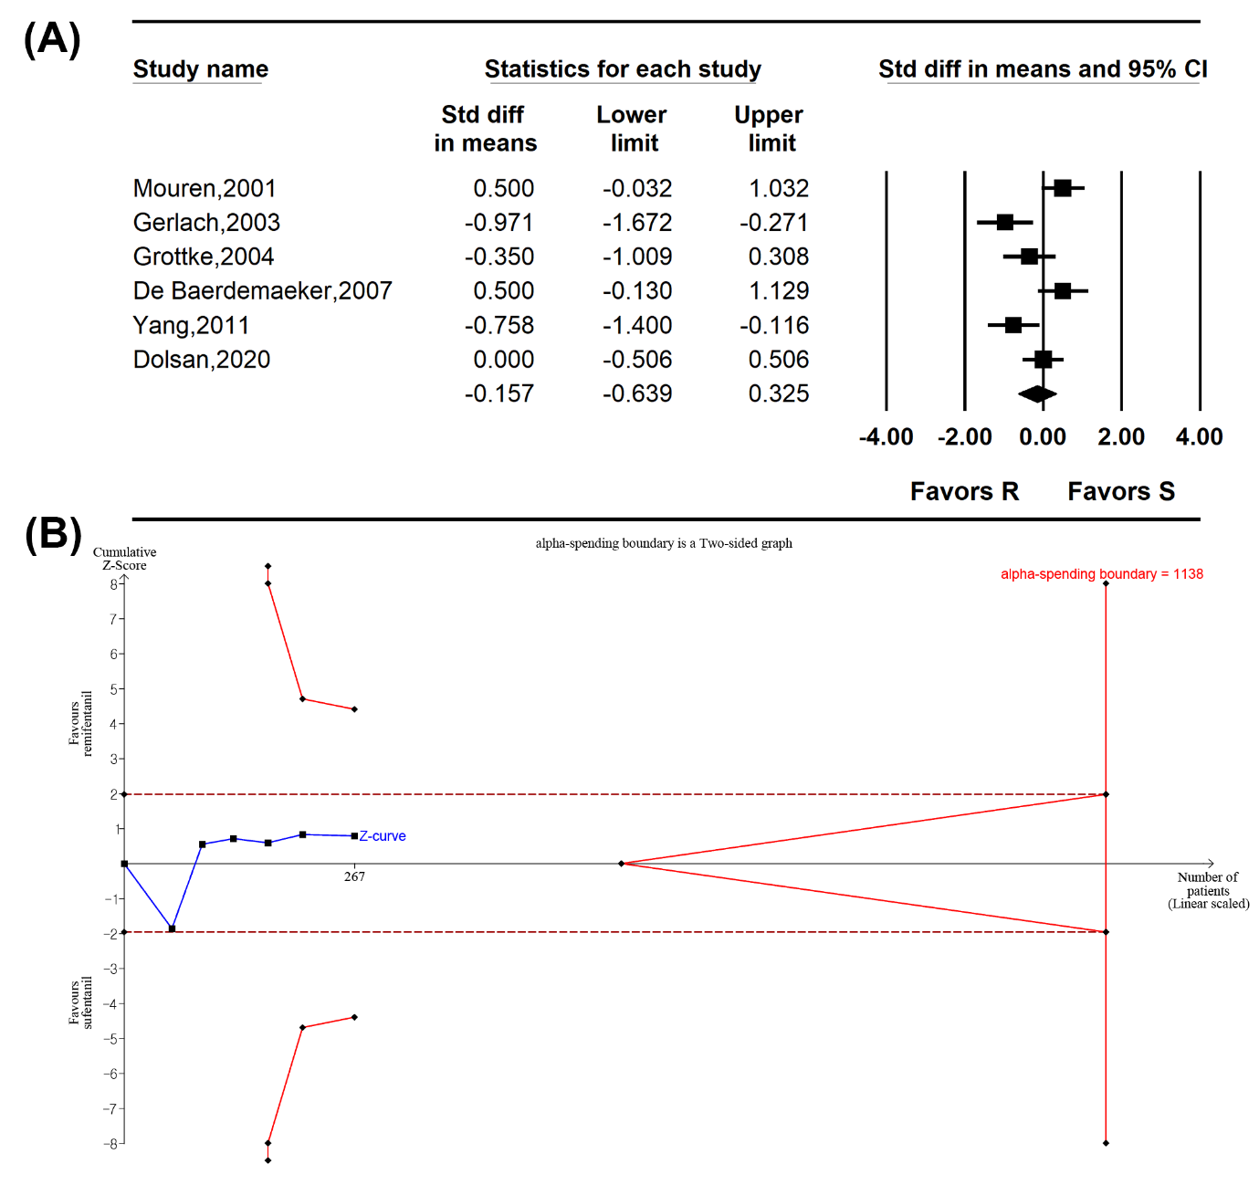

Supplementary Figure 31. Time to orientation. (A) Forest plot. The figure depicts individual trials as filled squares with relative sample size and the 95% confidence interval (CI) of the difference as a solid line. The diamond shape indicates the pooled estimate and uncertainty for the combined effect. The overall pooled estimate of remifentanil shows significantly shorter time to orientation compared to remifentanil. (B) Trial sequential analysis plot. Horizontal dotted red line represents the conventional boundaries for statistical significance. Triangular red lines on the right side reflects the futility boundaries. The blue solid line represents the cumulative z-curve. The number on the x-axis indicates required information size. The cumulative Z curve crossed the conventional test boundary but did not cross the trial sequential monitoring boundary.

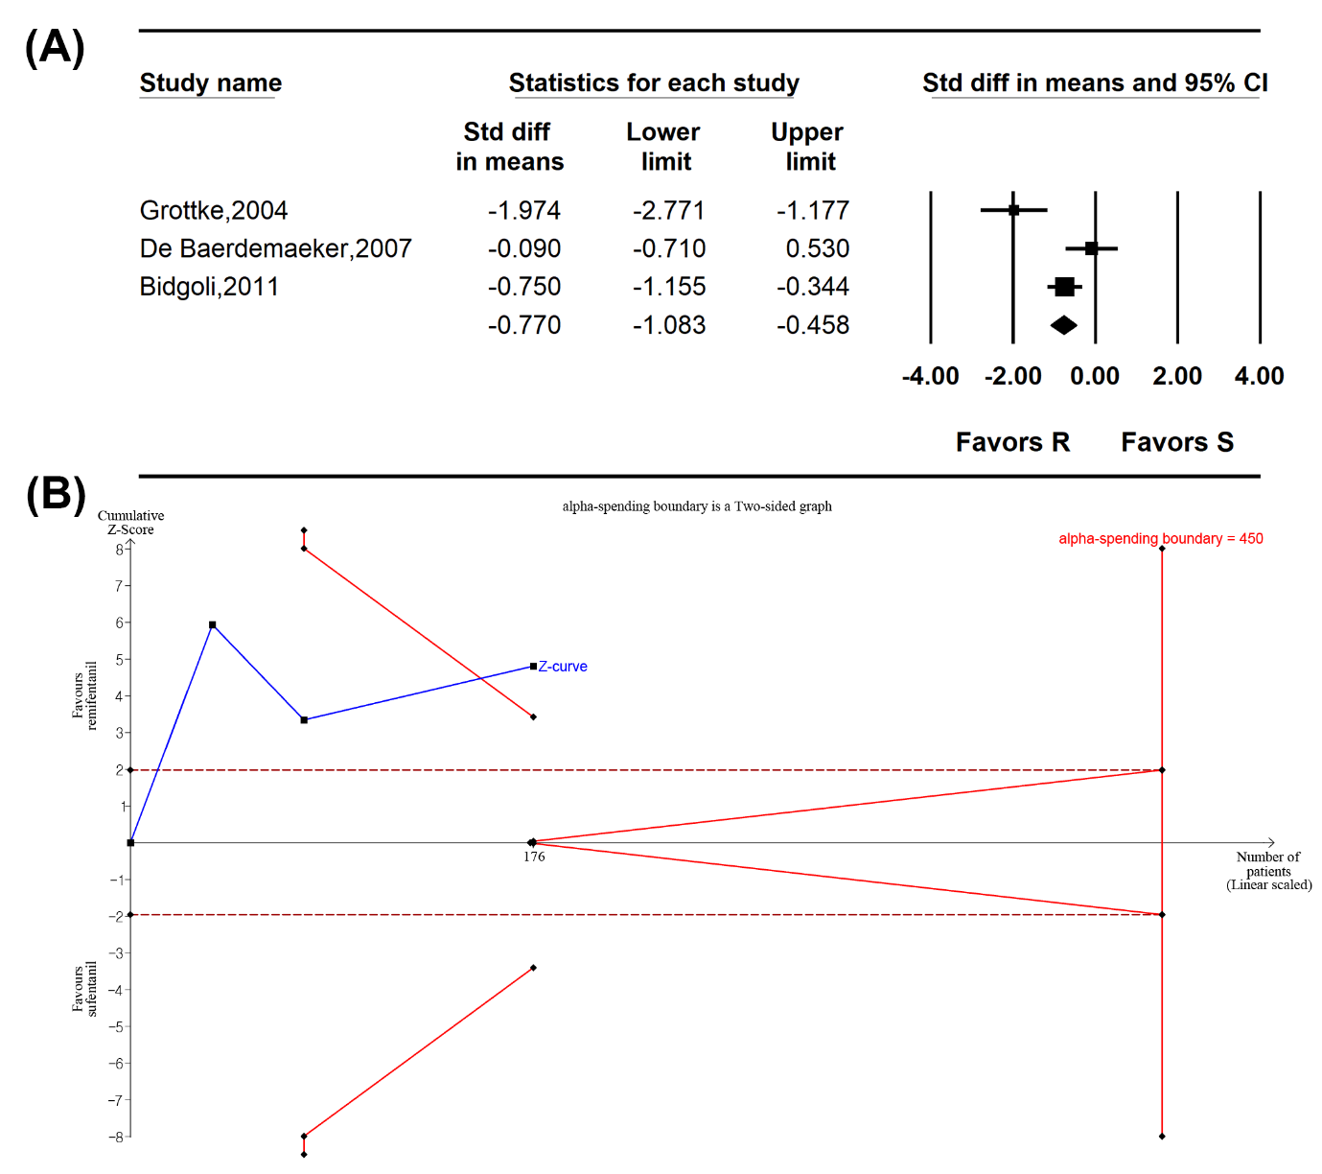

Supplementary Figure 32. Time to emergence. (A) Forest plot. The figure depicts individual trials as filled squares with relative sample size and the 95% confidence interval (CI) of the difference as a solid line. The diamond shape indicates the pooled estimate and uncertainty for the combined effect. The overall pooled estimate of remifentanil shows significantly shorter time to emergence compared to remifentanil. (B) Trial sequential analysis plot. Uppermost and lowermost complete red curves represent trial sequential monitoring boundary lines for benefit and harm respectively. Horizontal dotted red line represents the conventional boundaries for statistical significance. Triangular red lines on the right side reflects the futility boundaries. The blue solid line represents the cumulative z-curve. The number on the x-axis indicates required information size. The cumulative Z curve crossed both the conventional test boundary and the trial sequential monitoring boundary.

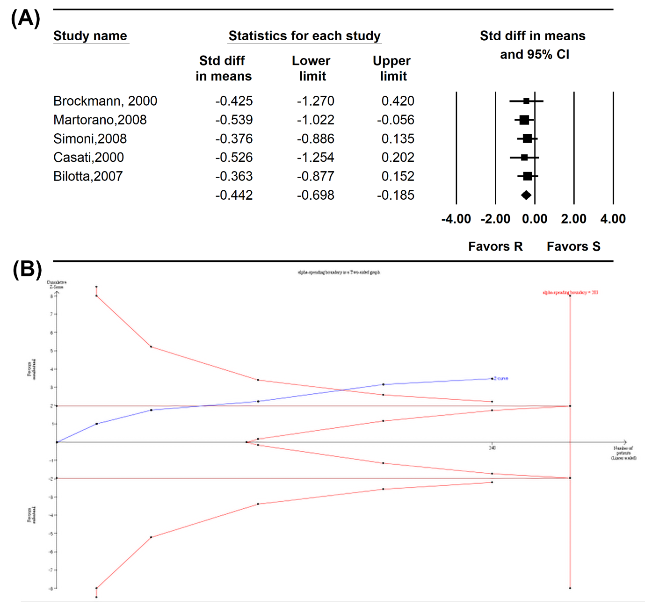

Supplementary Figure 33. Funnel plots of (A) postoperative pain score, (B) amount of postoperative analgesic used, (C) incidence of requirement of postoperative analgesics, (D) incidence of PONV, (E) preoperative MAP, (F) preoperative HR, (G) time to extubation, (H) intraoperative MAP, and (I) intraoperative HR. The horizontal axis demonstrates the log of risk ratio and the vertical axis shows the inverse of the standard error.

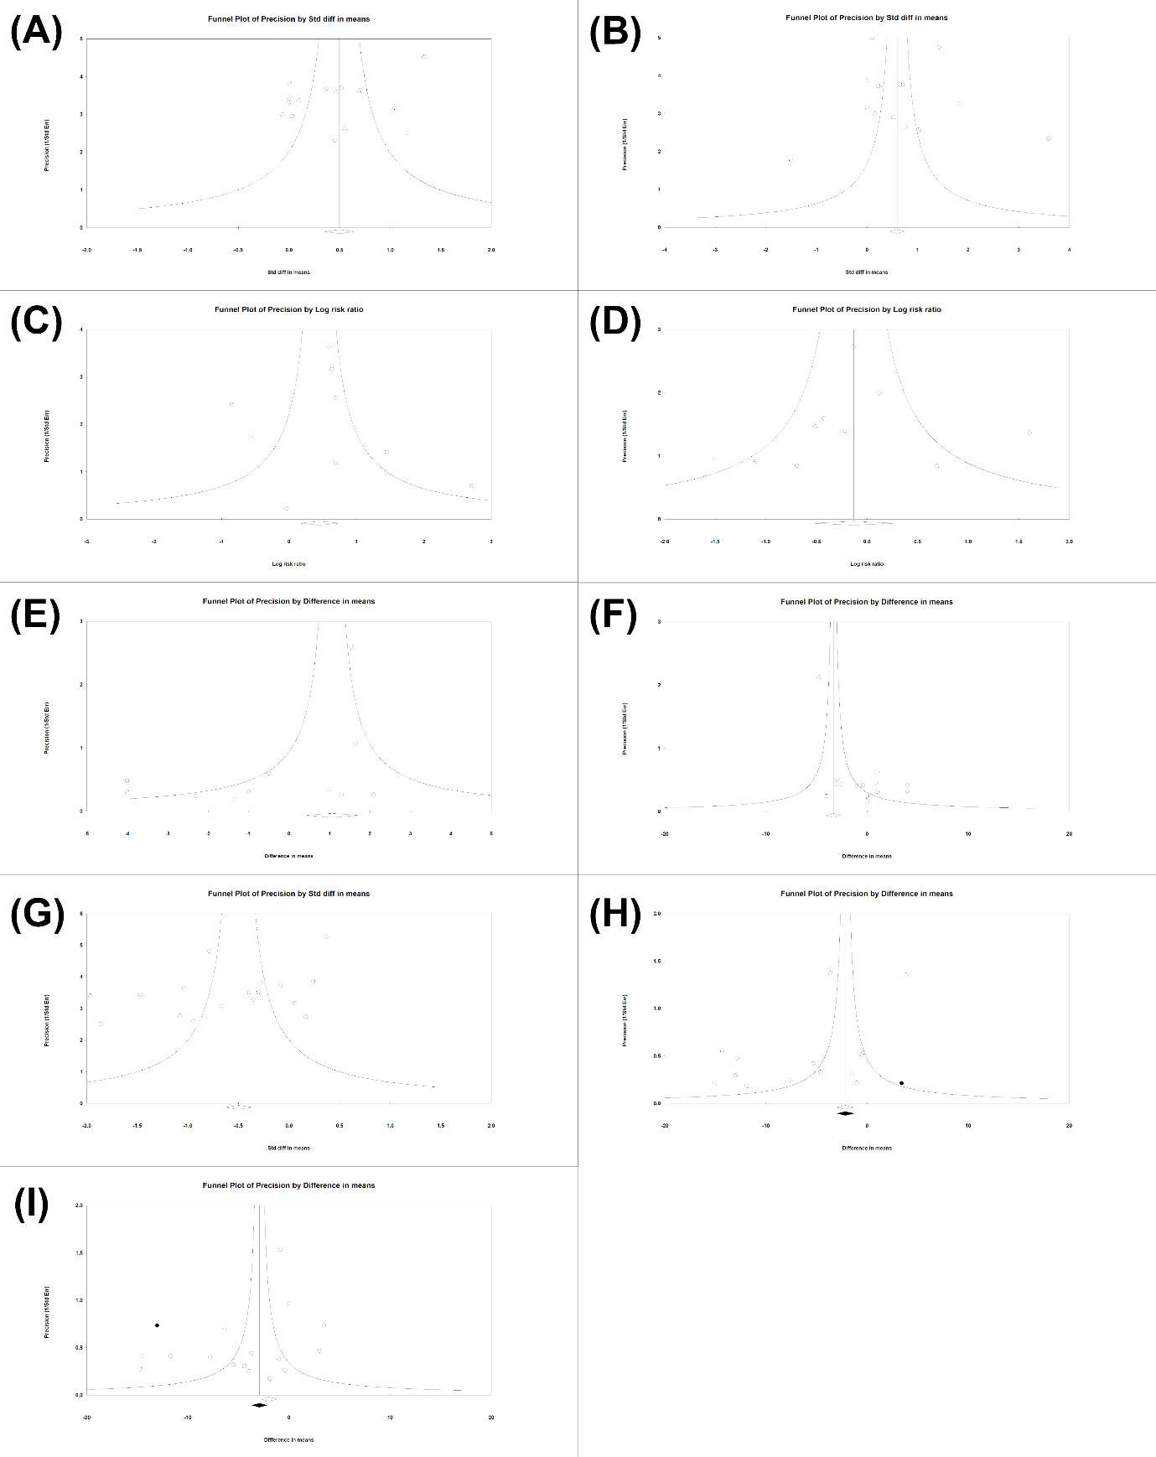
Supplementary Figure 34. Risk of Bias assessment for postoperative pain-related outcomes. Traffic light plots summarize the risk of bias for each outcome: (A) Quantitative postoperative pain score, (B) qualitative postoperative pain score, (C) time to 1st analgesic administration, (D) incidence of patients who needed postoperative analgesics, and the amount of postoperative analgesic used.

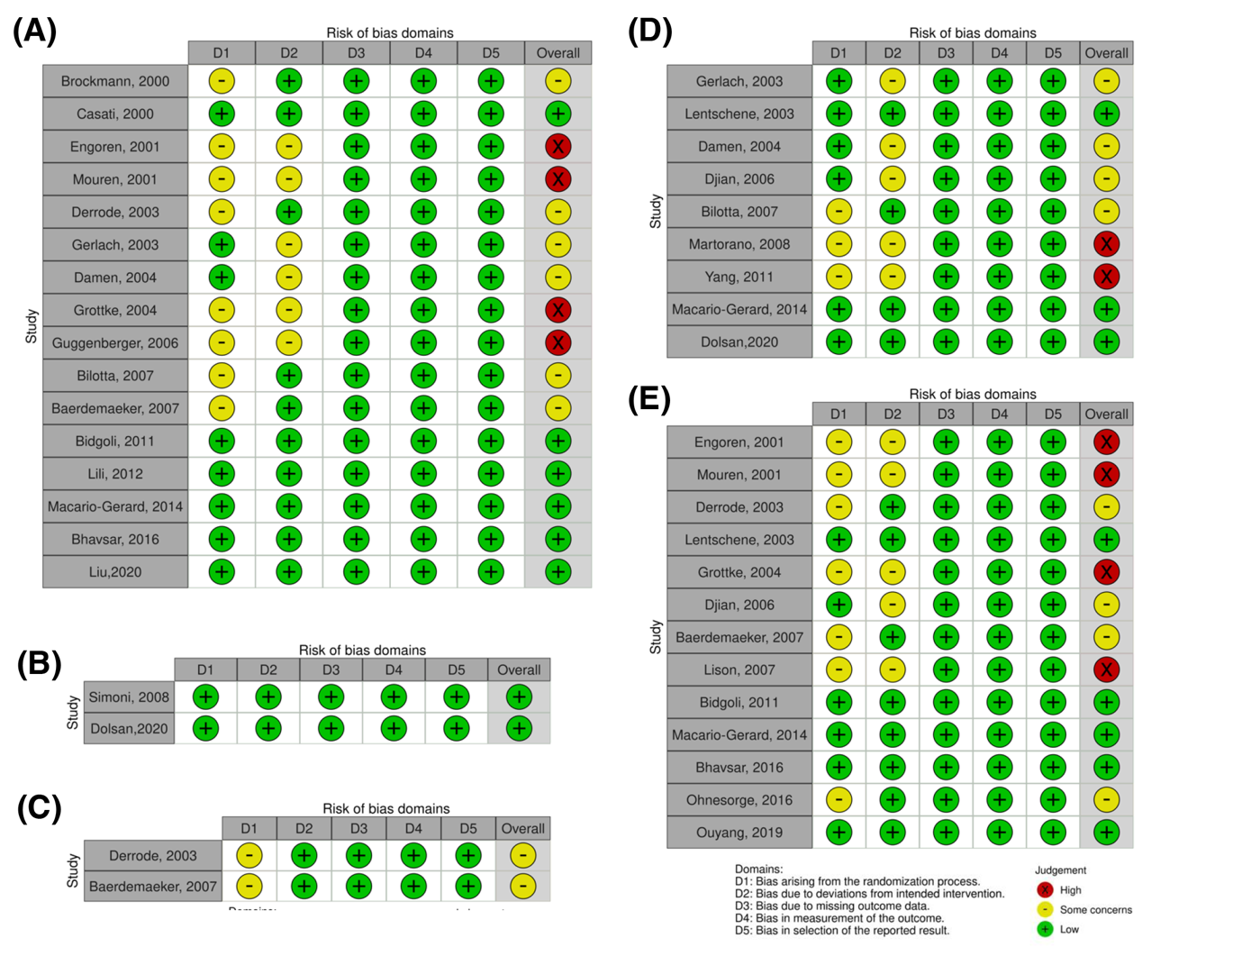

Supplementary Figure 35. Risk of Bias assessment for hemodynamic parameter-related outcomes. Traffic light plots summarize the risk of bias for each outcome: (A) intraoperative systolic blood pressure, (B) intraoperative mean blood pressure, (C) intraoperative diastolic blood pressure, and (D) intraoperative heart rate.

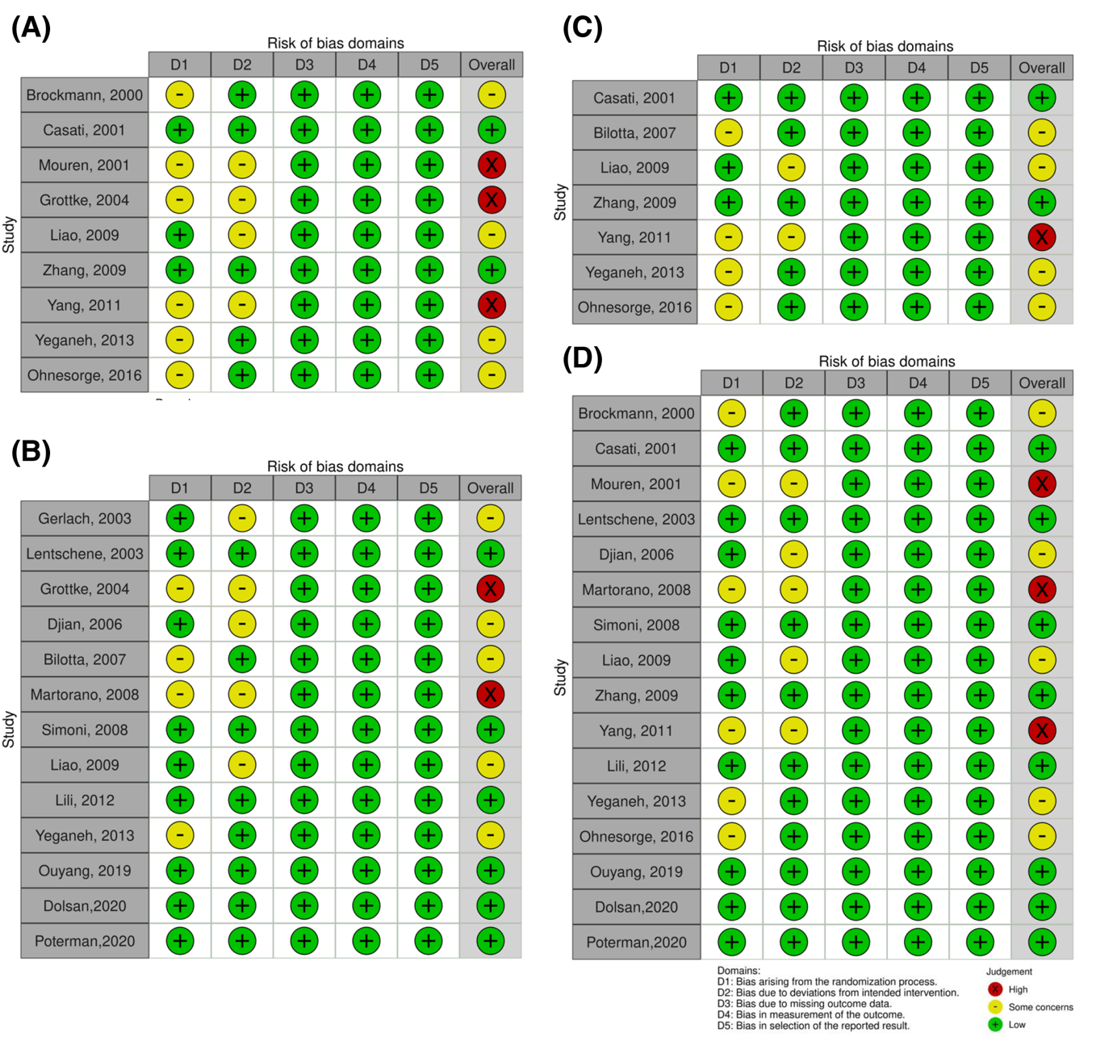

Supplementary Figure 36. Risk of Bias assessment for adverse event-related outcomes. Traffic light plots summarize the risk of bias for each outcome: (A) incidence of postoperative nausea, (B) incidence of postoperative vomiting, (C) incidence of postoperative nausea and vomiting, (D) use of rescue anti-emetics, (E) incidence of respiratory depression, and (F) percutaneous oxygen saturation level.

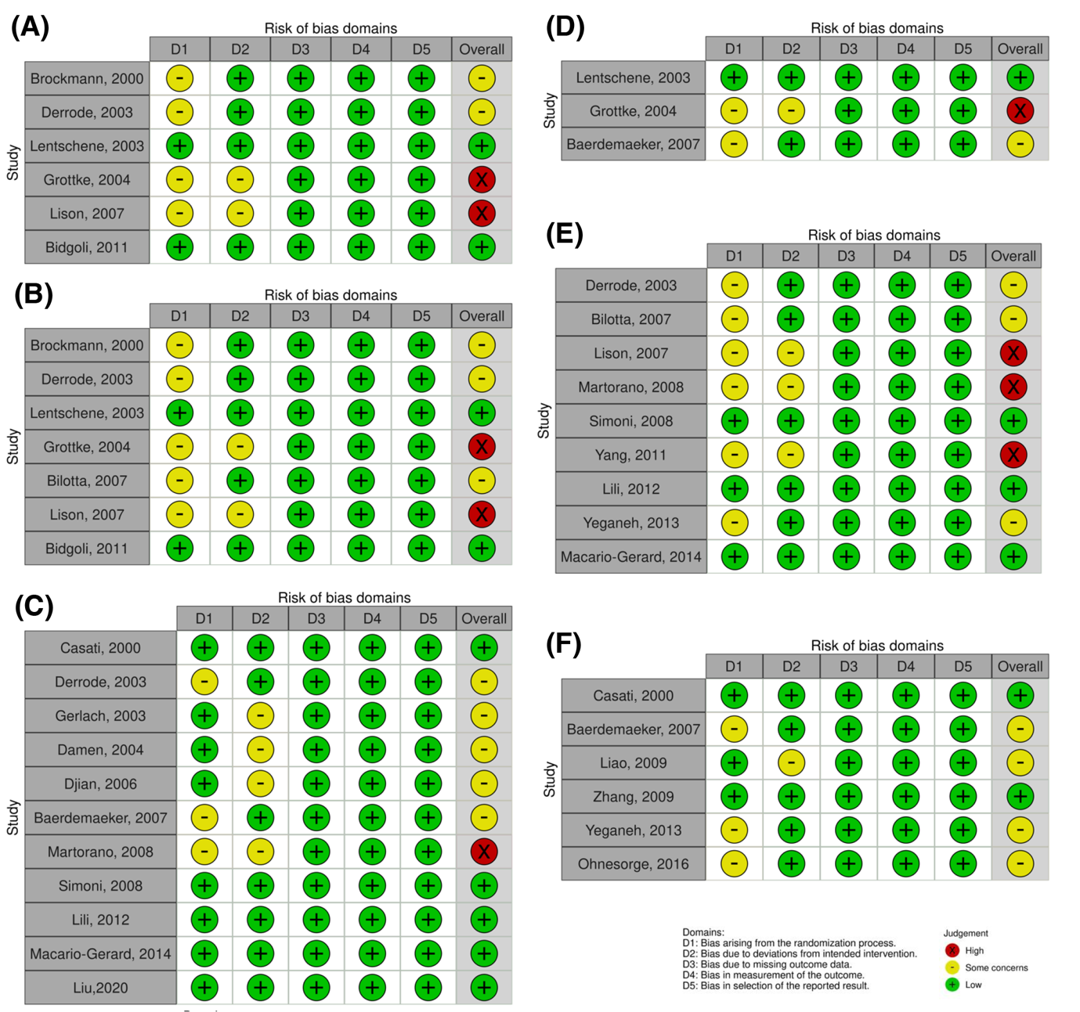

Supplementary Figure 37. Risk of Bias assessment for recovery profile-related outcomes. Traffic light plots summarize the risk of bias for each outcome: (A) time to extubation, (B) time to eye opening, (C) time to spontaneous respiration, (D) time to orientation, (E) time to emergence.

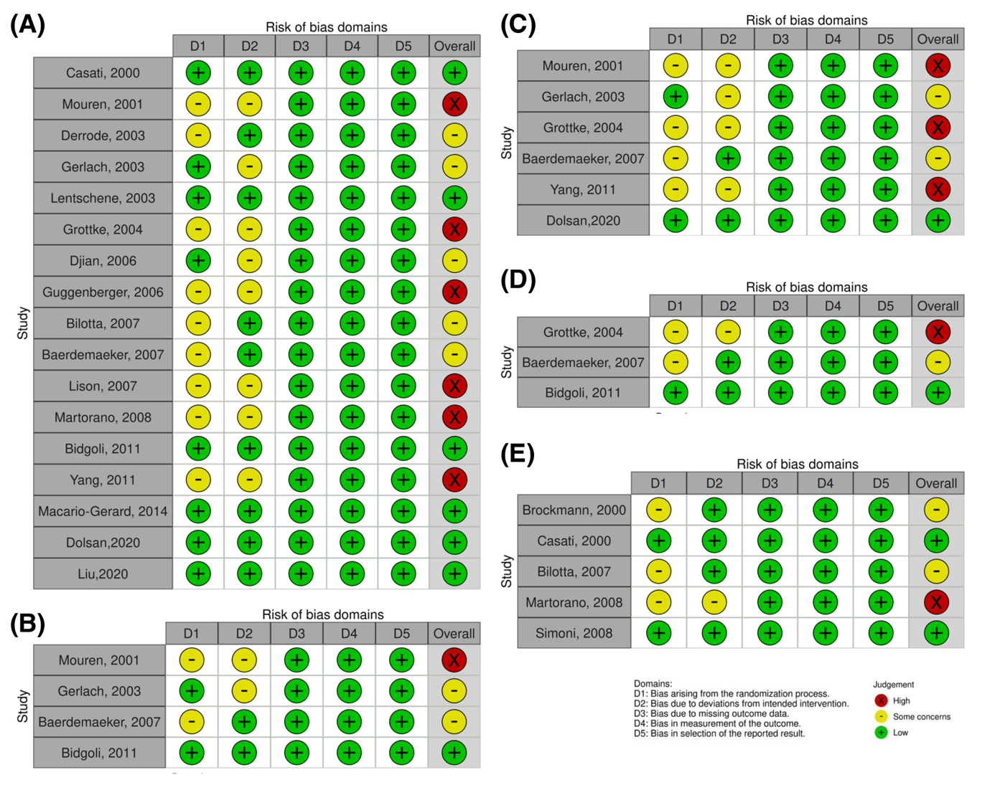

Supplementary Table 1. Postoperative pain score
Author, year | Type of pain scale | Measure | Time point | Evaluation
Brockmann, 2000 [71] | VRS | None, light, moderate, strong, very strong pain | 30min after extubation | quantitative
Casati, 2000 [47] | VRS | 0= no pain, 1=mild pain,  2=moderate, 3=severe pain | PACU discharge, postop. 1hr, 3hr, 6hr and 12hr | quantitative
Engoren, 2001 [62] | NRS | 0=no pain  100=worst pain | 30 min after extubation and POD#1 AM 6:30 | quantitative
Mouren, 2001 [72] | VAS | 0-100 mm | 10min, 20min, 30min, 40min, 60min, 90min and 120min after extubation | quantitative
Derrode, 2003 [49] | VAS | 0=no pain  10=worst imaginable pain | 0.5hr, 1hr, 1.5hr, 2hr, 2.5hr, 3hr, 3.5hr, 4hr, 5hr, 6hr, 7hr, 8hr, 9hr, 10hr, 11hr and 12hr after extubation | quantitative
Gerlach, 2003 [56] | NRS | 0=no pain  15=worst imaginable pain | postop. 1-5hr | quantitative
Damen, 2004 [50] | VRS | 0=no pain  10=extreme pain | postop. 0hr, 1hr, 3hr, 6hr, 12hr, 24hr, 48hr, 72hr, 72hr, 96hr and 120hr | quantitative
Grottke, 2004 [74] | PRS | 0=no relief from pain  100=total relief from pain | postop. 30min, 1hr, 2hr, 4hr, 8hr, 12hr and 24hr | quantitative
Guggenberger, 2006 [63] | VAS | 1=no pain  10=worst pain | prior to extubation, 1hr, 24hr and 72hr after extubation | quantitative
Bilotta, 2007 [58] | VAS | 1=no pain  10=worst pain | 30min and 3hr after extubation | quantitative
De Baerdemaeker, 2007 [51] | VAS | 0=no pain  10=worst pain | at rest/post-spirometry  PACU 0min, 30min, 60min and 120min | quantitative
Simoni, 2008 [52] | VAS | Number of patients with a VAS≥4 | at PACU | qualitative
Bidgoli, 2011 [54] | VAS | NR | at awakening | quantitative
Lili, 2012 [77] | VAS | 0=no pain  10=worst imaginable pain | intraop. wake-up test onset, extremities response, verbal response and the end of wake-up test | quantitative
Macario-Gerard, 2014 [70] | Simple numerical scale | 0=no pain  10=worst pain | postop. 10min, 20min, 30min, 40min, 50min, 60min, 120min, 180min, 240min, 300min, 300min, 360min and 420min | quantitative
Bhavsar, 2016 [64] | ICU Pain Score | 0=none (VAS 0-1)  1=light (VAS 2-4)  2=moderate (VAS 5-7)  3=severe (VAS 8-10) | 0hr, 1hr, 2hr, 3hr, 4hr, 5hr, 6hr, 7hr, 8hr, 9hr, 10hr, 11hr after extubation and ICU discharge | quantitative
Dolsan, 2020 [69] | VAS | Number of patients with a VAS>3 | at PACU | qualitative
Liu, 2020 [61] | NRS | 0=no pain  10=worst imaginable pain | at PACU | quantitative
VRS; Verbal rating scale, min; minute, PACU; post-anesthesia care unit, postop.; postoperative, hr; hour, NRS; Numeric rating pain scale, POD; postoperative day, VAS; Visual analogue scale, PRS; pain relief score, intraop.; intraoperative, ICU; intensive care unit

Supplementary Table 2. The results of meta-regression analysis
 | Age | Duration of operation or anesthesia | Ratio of sufentanil and remifentanil dosage
Postoperative pain score (quantitative) | Slope, -0.00859; 95% CI, -0.01708 to -0.00010; P = 0.04727 | Slope, -0.00252; 95% CI, -0.00439 to -0.00065; P = 0.00817 | Slope, 4.76018; 95% CI, 0.14402 to 9.37634; P = 0.04327
Amount of postoperative analgesic used | Slope, -0.00038; 95% CI, -0.01049 to 0.00973; P = 0.94165 | Slope, 0.00084; 95% CI, 0.00067 to 0.00396; P = 0.00591 | Slope, -8.11301; 95% CI, -12.39657 to -3.82944; P = 0.000021
MAP-Pre | Slope, 0.00093; 95% CI, -0.00725 to 0.00911; P = 0.82419 |  | Slope, -4.18159; 95% CI, -8.75668 to 0.39349; P = 0.07323
MAP -Intra | Slope, -0.00685; 95% CI, -0.01638 to 0.00269; P = 0.15920 | Slope, -0.00275; 95% CI, -0.00500 to -0.00049; P = 0.01690 | Slope, 6.04224; 95% CI, 1.23623 to 10.84825; P = 0.01374
HR-Pre | Slope, 0.00435; 95% CI, -0.00294 to 0.01164; P = 0.24255 |  | Slope, 2.36045; 95% CI, -1.73664 to 6.45753; P = 0.25882
HR -Intra | Slope, 0.00600; 95% CI, -0.00218 to 0.01418; P = 0.15081 |  | Slope, -7.63972; 95% CI, -11.70005 to -3.57940; P = 0.00023
PONV | Slope, -0.00539; 95% CI, -0.04127 to 0.03049; P = 0.76846 |  | Slope, 5.74618; 95% CI, -18.53772 to 30.03008; P = 0.64281
Time to extubation | Slope, 0.00495; 95% CI, -0.00504 to 0.01494; P = 0.33144 | Slope, 0.00079; 95% CI, -0.00076 to 0.00234; P = 0.31889 | Slope, 0.83120; 95% CI, -3.28930 to 4.95170; P = 0.69257
CI; confidence interval, MAP; mean arterial pressure, Pre; preoperative, Intra; intraoperative, Post; postoperative, HR; heart rate, PONV; postoperative nausea and vomiting.

Supplementary Table 3. Risk of bias.
Author, Year | Bias Arising from the Randomization Process | Bias Due to Deviations from Intended Intervention | Bias Due to Missing Outcome Data | Bias in Measurement of the Outcome | Bias in Selection of the Reported Results | Overall Bias
Brockmann, 2000 [71] | Some concern ª | Low risk | Low risk | Low risk | Low risk | Some concern
Casati, 2000 [47] | Low risk | Low risk | Low risk | Low risk | Low risk | Low risk
Casati, 2001 [48] | Low risk | Low risk | Low risk | Low risk | Low risk | Low risk
Engoren, 2001 [62] | Some concern ª | Some concern ^{b} | Low risk | Low risk | Low risk | High risk
Mouren, 2001 [72] | Some concern ª | Some concern ^{b} | Low risk | Low risk | Low risk | High risk
Derrode, 2003 [49] | Some concern ª | Low risk | Low risk | Low risk | Low risk | Some concern
Gerlach, 2003 [56] | Low risk | Some concern ^{b} | Low risk | Low risk | Low risk | Some concern
Lentschene, 2003 [73] | Low risk | Low risk | Low risk | Low risk | Low risk | Low risk
Damen, 2004 [50] | Low risk | Some concern ^{b} | Low risk | Low risk | Low risk | Some concern
Grottke, 2004 [74] | Some concern ª | Some concern ^{b} | Low risk | Low risk | Low risk | High risk
Djian, 2006 [57] | Low risk | Some concern ^{b} | Low risk | Low risk | Low risk | Some concern
Guggenberger, 2006 [63] | Some concern ª | Some concern ^{b} | Low risk | Low risk | Low risk | High risk
Bilotta, 2007 [58] | Some concern ª | Low risk | Low risk | Low risk | Low risk | Some concern
Baerdemaeker, 2007 [51] | Some concern ª | Low risk | Low risk | Low risk | Low risk | Some concern
Lison, 2007 [59] | Some concern ª | Some concern ^{b} | Low risk | Low risk | Low risk | High risk
Martorano, 2008 [60] | Some concern ª | Some concern ^{b} | Low risk | Low risk | Low risk | High risk
Simoni, 2008 [52] | Low risk | Low risk | Low risk | Low risk | Low risk | Low risk
Liao, 2009 [75] | Low risk | Some concern ^{b} | Low risk | Low risk | Low risk | Some concern
Zhang, 2009 [53] | Low risk | Low risk | Low risk | Low risk | Low risk | Low risk
Bidgoli, 2011 [54] | Low risk | Low risk | Low risk | Low risk | Low risk | Low risk
Yang, 2011 [76] | Some concern ª | Some concern ^{b} | Low risk | Low risk | Low risk | High risk
Lili, 2012 [77] | Low risk | Low risk | Low risk | Low risk | Low risk | Low risk
Yeganeh, 2013 [55] | Some concern ª | Low risk | Low risk | Low risk | Low risk | Some concern
Macario-Gerard, 2014 [70] | Low risk | Low risk | Low risk | Low risk | Low risk | Low risk
Bhavsar, 2016 [64] | Low risk | Low risk | Low risk | Low risk | Low risk | Low risk
Ohnesorge, 2016 [67] | Some concern ª | Low risk | Low risk | Low risk | Low risk | Some concern
Rasmussen, 2016 [65] | Low risk | Low risk | Low risk | Low risk | Low risk | Low risk
Ouyang, 2019 [68] | Low risk | Low risk | Low risk | Low risk | Low risk | Low risk
Dolsan,2020 [69] | Low risk | Low risk | Low risk | Low risk | Low risk | Low risk
Liu,2020 [61] | Low risk | Low risk | Low risk | Low risk | Low risk | Low risk
Poterman,2020 [66] | Low risk | Low risk | Low risk | Low risk | Low risk | Low risk
ª We classified the bias arising from the randomization process domain as "some concern" because there was no information regarding allocation concealment and no evidence of baseline imbalance.
^{b} We classified the bias due to deviations from the intended intervention as "some concern" because there was no information regarding the blinding of personnel, no information on any deviations from the intended intervention, and it was not analyzed in the wrong group.

Supplementary Table 4. The GRADE evidence quality for each outcome
Outcomes | Number of studies | Quality assessment |  |  |  |  | Quality
Outcomes | Number of studies | ROB | Inconsistency | Indirectness | Imprecision | Publication bias | Quality
Postoperative pain score (quantitative) | 16 | not serious | seriousª | not serious | not serious | NA | ⨁⨁⨁◯  Moderate
Postoperative pain score (qualitative) | 2 | serious | seriousª | not serious | not serious | NA | ⨁⨁◯◯  Low
Postoperative analgesic used | 13 | not serious | seriousª | not serious | not serious | not serious | ⨁⨁⨁◯  Moderate
Patients needed postoperative analgesics | 9 | not serious | seriousª | not serious | not serious | NA | ⨁⨁⨁◯  Moderate
Time to 1st analgesic | 2 | not serious | not serious | not serious | not serious | NA | ⨁⨁⨁⨁  High
SBP-Pre | 7 | not serious | not serious | not serious | serious^{b} | NA | ⨁⨁⨁◯  Moderate
SBP -Intra | 9 | not serious | seriousª | not serious | not serious | NA | ⨁⨁⨁◯  Moderate
SBP -Post | 3 | not serious | not serious | not serious | serious^{b} | NA | ⨁⨁⨁◯  Moderate
MAP-Pre | 12 | not serious | not serious | not serious | not serious | not serious | ⨁⨁⨁⨁  High
MAP -Intra | 13 | not serious | seriousª | not serious | not serious | not serious | ⨁⨁⨁◯  Moderate
MAP -Post | 2 | not serious | seriousª | not serious | serious^{b} | NA | ⨁⨁◯◯  Low
DBP-Pre | 6 | not serious | seriousª | not serious | serious^{b} | NA | ⨁⨁◯◯  Low
DBP -Intra | 7 | not serious | seriousª | not serious | not serious | NA | ⨁⨁⨁◯  Moderate
DBP -Post | 2 | not serious | not serious | not serious | serious^{b} | NA | ⨁⨁⨁◯  Moderate
HR-Pre | 16 | not serious | seriousª | not serious | not serious | not serious | ⨁⨁⨁◯  Moderate
HR -Intra | 16 | not serious | seriousª | not serious | not serious | not serious | ⨁⨁⨁◯  Moderate
HR -Post | 6 | not serious | seriousª | not serious | serious^{b} | NA | ⨁⨁◯◯  Low
PON | 6 | not serious | not serious | not serious | serious^{b} | NA | ⨁⨁⨁◯  Moderate
POV | 7 | not serious | not serious | not serious | not serious | NA | ⨁⨁⨁⨁  High
PONV | 11 | not serious | not serious | not serious | not serious | not serious | ⨁⨁⨁⨁  High
Use of rescue anti-emetics | 3 | not serious | not serious | not serious | serious^{b} | NA | ⨁⨁⨁◯  Moderate
Respiratory depression | 9 | not serious | not serious | not serious | not serious | NA | ⨁⨁⨁⨁  High
SpO₂ | 6 | not serious | seriousª | not serious | serious^{b} | NA | ⨁⨁◯◯  Low
Time to extubation | 17 | not serious | seriousª | not serious | not serious | not serious | ⨁⨁⨁◯  Moderate
Time to eye opening | 4 | not serious | not serious | not serious | serious^{b} | NA | ⨁⨁⨁◯  Moderate
Time to spontaneous respiration | 6 | not serious | seriousª | not serious | serious^{b} | NA | ⨁⨁◯◯  Low
Time to orientation | 3 | not serious | seriousª | not serious | serious^{b} | NA | ⨁⨁◯◯  Low
Time to emergence | 5 | not serious | not serious | not serious | serious^{b} | NA | ⨁⨁⨁◯  Moderate
ROB; Risk of bias, SBP; systolic blood pressure, Pre; preoperative, Intra; intraoperative, Post; postoperative, MAP; mean arterial pressure, DBP; diastolic blood pressure, HR; heart rate, PON; postoperative nausea, POV; postoperative vomiting, NNTH; number needed to treat to harm, PONV; postoperative nausea and vomiting, SpO₂: saturation of percutaneous oxygen.
GRADE Working Group grades of evidence
High certainty: we are very confident that the true effect lies close to that of the estimate of the effect.
Moderate certainty: we are moderately confident in the effect estimate: the true effect is likely to be close to the estimate of the effect, but there is a possibility that it is substantially different.
Low certainty: our confidence in the effect estimate is limited: the true effect may be substantially different from the estimate of the effect.
Very low certainty: we have very little confidence in the effect estimate: the true effect is likely to be substantially different from the estimate of effect.

ª We downgraded the certainty of evidence by one level for inconsistency due to heterogeneity among studies, with an I² statistic over 50% or P_{chi2} less than 0.05.
^{b} We downgraded imprecision by one levels for serious imprecision due to very wide confidence intervals, including both substantial harms and benefits.

