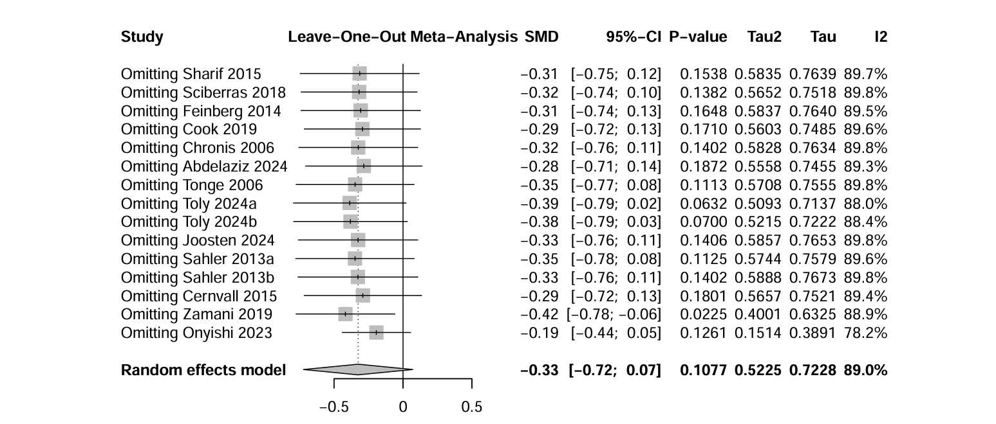
​​Sensitivity Analysis Chart​​

Table 2. Subgroup Analysis Results of Cognitive Behavioral Therapy on Depression in Parents of Children with Special Needs​
Dimensionality | sort | K | N | I² | Effect model | SMD and 95%CI | P | P-interaction​​​
Nation |  |  |  |  |  |  |  | 0.067
 | Australia | 3 | 106 | 27.2% | Random | -0.30(-0.85,0.24) | 0.278
 | Egypt | 1 | 60 | * | Random | -0.86(-1.39,-0.33) | 0.001
 | Iran | 1 | 60 | * | Random | -0.43(-0.95,0.08) | 0.097
 | Netherlands | 1 | 86 | * | Random | -0.28(-0.71,0.14) | 0.20
 | Sweden | 1 | 58 | * | Random | -0.76(-1.30,-0.23) | 0.005
 | USA | 4 | 668 | 82.2% | Random | -0.03(-0.33,0.27) | 0.83
Intervention cycle/week |  |  |  |  |  |  |  | 0.510
 | 6-8 | 4 | 566 | 53.7% | Random | -0.27(-0.54,-0.00) | 0.047
 | 9-12 | 6 | 402 | 83.30% | Random | -0.41(-0.88,0.06) | 0.089
 | 20 | 1 | 70 | * | Random | 0.00(-0.47,0.47) | 1
 | follow-up at 3 months​ | 2 | 506 | 91.10% | Random | 0.04(-0.56,0.66) | 0.891
Intervention time/minute |  |  |  |  |  |  |  | 0.515
 | 45-60 | 5 | 541 | 49.8% | Random | -0.32(-0.55,-0.08) | 0.009
 | 90-120 | 5 | 497 | 81.2% | Random | -0.17(-0.55,0.21) | 0.39
Subject type |  |  |  |  |  |  |  | 0.001
 | P_NDD | 7 | 388 | 13.50% | Random | -0.45(-0.69,-0.21) | 0.001
 | P_CI | 1 | 97 | * | Random | 0.39(0.19,0.59) | 0.001
 | P_SI | 3 | 453 | 59.1% | Random | -0.26(-0.51,-0.00) | 0.046
Intervention mode2 |  |  |  |  |  |  |  | 0.039
 | Control-NoInt | 7 | 409 | 30.6% | Random | -0.45(-0.70,-0.20) | 0.001
 | Control-Int | 4 | 629 | 81.8% | Random | -0.02(-0.34,0.30) | 0.90
Intervention mode1 |  |  |  |  |  |  |  | 0.749
 | CBT+ | 6 | 687 | 52.0% | Random | -0.28(-0.48,-0.08) | 0.006
 | CBT only | 5 | 351 | 81.60% | Random | -0.19(-0.67,0.28) | 0.42
Parental type |  |  |  |  |  |  |  | 0.019
 | Both | 2 | 82 | 0.0% | Random | -0.77(-1.22,-0.32) | 0.001
 | More mothers (> 90%) | 9 | 956 | 75.7% | Random | -0.16(-0.40,0.07) | 0.176
Scale type |  |  |  |  |  |  |  | 0.027
 | DASS | 4 | 156 | 0.0% | Random | -0.65(-0.97,-0.32) | 0.001
 | BDI | 3 | 418 | 58.9% | Random | -0.26(-0.54,0.01) | 0.06
 | Other scales | 4 | 464 | 81.5% | Random | 0.012(-0.35,0.38) | 0.949

