1. Decomposition of the clinical questions into PICOS components
1.1. PICOS 1:
Population: women attending cervical cancer screening.
Index test: assays that detect HPV E6/E7 mRNA on cervical specimens.
Comparator tests: assays that detect HPV DNA on cervical specimens.
Outcomes: relative sensitivity and specificity for ASCUS, CIN1+ and CIN2+ of HPV E6/E7 mRNA vs HPV DNA assays.
Studies: primary screening studies (cross-sectional test accuracy studies, baseline results of cohort studies or randomized trials) reporting sensitivity and specificity of index and comparator HPV assays.

1.2 PICOS 2:
Population: women attending cervical cancer screening.
Index test: test at baseline with a HPV E6/E7 mRNA assay.
Comparator tests: assays that detect HPV DNA on cervical specimens.
Outcomes: longitudinal relative sensitivity and specificity (HPV E6/E7 mRNA vs HPV DNA assays) among women. The denominator contains all women who had CIN3+ lesions detected at baseline or detected later, including at a subsequent round or rounds.
Studies: cohort studies included screened cohorts (preferentially linked to a comprehensive screening registry capturing all screening and follow-up data; preferentially cohorts with index and comparator testing on the same women [paired data]).

2. Search strategies
2.1. PUBMED:
# | Searches
1 | e6e7 OR e6/e7 OR mRNA
2 | smear* OR test [tw] OR tests [tw] OR testing [tw] OR tested [tw] OR swab* OR scrap*
3 | “Uterine Cervical Neoplasms”[MeSH Terms] OR “cervical cancer”[Tiab] OR “Cancer of Cervix” [TiAb] OR “Cancer of the Cervix” [TiAB] OR Cervical Neoplasia* [TiAB] OR Cervix Neoplasm*[tiab] OR “Neoplastic Cervix” [TiAB] OR ((Cervix[tiab] OR Cervical[tiab]) AND (Cancer[tiab] OR Cancers[tiab] OR Cancerous[tiab] OR Carcinoma[tiab] OR Neoplasia*[tiab] OR Neoplasm*[tiab] OR Neoplastic[tiab]))
4 | ((Cervix[tiab] OR Cervical[tiab]) AND (preCancer[tiab] OR preCancerous[tiab] OR dysplasia[tiab] OR abnormal growth[tiab] OR "atypical squamous"[tiab] OR "Intraepithelial lesions"[tiab])) OR "Atypical Squamous Cells of the Cervix"[Mesh] OR "Squamous Intraepithelial Lesions of the Cervix"[Mesh] OR "Uterine Cervical Dysplasia"[Mesh]
5 | Papillomaviridae [MeSH Terms] OR papillomaviridae[Tiab] "human papilloma virus infection"[TIAB] OR "human papillomavirus infection"[TiAb] OR hpv[TiAb] OR "Human papillomaviruses"[Tiab]
6 | #1 AND #2
7 | #6 AND (#3 OR #4 OR #5)
8 | NOT ("animals"[MeSH] NOT "humans"[MeSH]) AND "humans"[MeSH]

2.2. EBM Reviews - Cochrane Central Register of Controlled Trials and EMBASE (OVID):
papillomavirus/
exp alphapapillomavirus/
exp Papillomavirus Infections/
exp Tumor Virus Infections/
exp uterine cervix tumor/
uterine cervix dysplasia/
uterine cervix carcinoma in situ/
(cervi$ adj3 (cancer or carcinoma or adenocarcinoma or neoplasm$ or dysplas$ or dyskaryo$ or squamous or CIN$ or HSIL or LSIL or ASCUS)).mp.
or/1‐8
e6e7.mp.
mRNA.mp.
or/10-11
((pap or papanicolaou or vagina$ or cervical or cervix or cervico$ or cytology$) adj3 (smear$ or test or tests or testing or tested or swab$ or scrap$)).mp.
9 and 12 and 13

2.3. WEB OF SCIENCE
# | Searches
1 | TS=( e6e7 OR e6/e7 OR mRNA)
2 | TS=(“cervical cancer” OR “Cancer of Cervix” OR “Cancer of the Cervix” OR Cervical Neoplasia* OR Cervix Neoplasm* OR “Neoplastic Cervix” OR ((Cervix OR Cervical) AND (Cancer OR Cancers OR Cancerous OR Carcinoma OR Neoplasia* OR Neoplasm* OR Neoplastic)))
3 | TS=(“cervical cancer” OR “Cancer of Cervix” OR “Cancer of the Cervix” OR Cervical Neoplasia* OR Cervix Neoplasm* OR “Neoplastic Cervix” OR ((Cervix OR Cervical) AND (Cancer OR Cancers OR Cancerous OR Carcinoma OR Neoplasia* OR Neoplasm* OR Neoplastic)))
4 | TS=(Papillomaviridae OR papillomaviridae "human papilloma virus infection" OR "human papillomavirus infection" OR hpv OR "Human papillomaviruses")
5 | TS=(smear* OR test [tw] OR tests [tw] OR testing [tw] OR tested [tw] OR swab* OR scrap*)
6 | #1 AND (#2 OR #3 OR #4) AND #5
7 | w/ numerical filter

2.4. Global Index Medicus (GIM)
# | Searches
1 | (Cervix OR Cervical)
2 | (precancer* OR squamous OR Intraepithelial OR Cancer* OR Carcinoma OR Neoplasia OR Neoplasm* OR Neoplastic)
3 | Papillomaviridae OR papilloma OR papillomavirus* OR hpv
4 | e6e7 OR e6/e7 OR mRNA
5 | smear* OR test [tw] OR tests [tw] OR testing [tw] OR tested [tw] OR swab* OR scrap*
6 | (#1 AND #2) OR #3
7 | #4 AND #5 AND #6
8 | LILACS (Americas) (80)  IMSEAR (South-East Asia) (18)  WPRIM (Western Pacific) (11)  AIM (Africa) (3)  IMEMR (Eastern Mediterranean) (1)

3. Study characteristics
3.1. PICOS 1: Diagnostic Performance of HPV E6/E7 mRNA Versus HPV DNA Testing in ASCUS Cases as Detected by TCT
Study  (country) | Study population | Design | Age range | Selection criteria | Criteria of outcome verification | mRNA assay | Comparator assay | Cytological diagnoses |  | mRNA assay |  | Comparator assay
 |  |  |  |  |  |  |  | Positive | Negative | true positive | true negative | true positive | true negative
Guo, 2021  China | In this study, a total of 312 patients diagnosed with ASCUS by TCT were included. | Cross-sectional screening study. All tested with cytology, APTIMA and PCR. | 27 to 64 years (52.6 ± 7.3) | Inclusion criteria: (1) Age ≥ 21 years; (2) Provision of signed informed consent, agreeing to the collection of cervical epithelial cells and cervical tissue; (3) Absence of clinical symptoms suggestive of pregnancy, with pregnant women eligible to participate in the screening 8 weeks post-partum; (4) No history of cervical surgery (e.g., hysterectomy). | All had colposcopy and histology verification. | APTIMA | PCR | 21 | 290 | 13 | 226 | 14 | 204
Mark H, 2013  USA | Atotal of 13,495 subjects were included in this clinical study. | Cross-sectional screening study. All tested with cytology, APTIMA and HC2. | 21 to 71 years. | Women were excluded from the study if they were pregnant, reported prior vaccination against HPV, had a history of cervical disease (cancer or precancerous) or an abnormal Papanicolaou test result in the previous 12 months, or had a history of illness that could interfere with the study or create an unacceptable risk to the subject. | All had colposcopy and histology verification. | APTIMA | HC2 | 91 | 848 | 79 | 533 | 79 | 505
Wang, 2018  China | A total of 500 participants were enrolled in the study with 18 participants missing age information. | Cross-sectional screening study. All tested with cytology, QuantiVirus and HC2. | 20 to 84 years (41.2 ± 11.1) | Participants who had unsatisfied smear, had a recent history of hormone use, were pregnant or in menstrual period, had a history of pelvic radiotherapy, had a history of any prior types of cancer, or had a history of hysterectomy were excluded from this study. | All had histology verification. | QuantiVirus | HC2 | 40 | 460 | 36 | 282 | 38 | 184
Waldstrom, 2011  Denmark | We identified 369 consecutive samples from women with an age of 30 years or more, who had had a cytological diagnosis of ASC-US and a reflex HPV DNA test. | Cross-sectional screening study. All tested with cytology, APTIMA and PCR. | 30 to 69 yearrs. | Not reported. | All had histology verification. | APTIMA | PCR | 48 | 277 | 42 | 216 | 45 | 178
Zhu, 2019  China | A total of 300 women with ASCUS underwent cervical histopathology diagnosis. | Cross-sectional screening study. All tested with cytology, QuantiVirus and HC2. | 18 to 70 years. | Women meeting these conditions are enrolled in our study:(1) Cytological diagnosis for ASCUS; (2) non-pregnancy; (3) No immunodeficiency disease; (4) No cervical surgery or chemo and/or radiotherapy for cervical malignant dis ease. | All had colposcopy and histology verification. | QuantiVirus | HC2 | 54 | 246 | 47 | 105 | 53 | 43
Maria, 2011  Italy | The data stratified by cytological grades of the study population of 1,265 women with a breakdown of HPV DNA and mRNA results along with histological diagnoses. | Cross-sectional screening study. All tested with cytology, PreTect and HC2. | 18 to 83 years (39.5 ± 11.3) | The inclusion criteria were an mRNA test and an age 18 years. Exclusion criteria were treatment for cervical lesions in the previous 5 years or a history of any prior type of cancer. | All had colposcopy and histology verification. | PreTect | HC2 | 26 | 110 | 22 | 90 | 25 | 32
Frega, 2019  Italy | A total of 118 women with ASCUS. | Cross-sectional screening study. All tested with cytology, PreTect and HC2. | 21 to 24 years. | The exclusion criteria were: oral contraceptive treat ment longer than 5 years, previous ablative or excisional cervical treatments, systemic disease (e.g., metabolic disorders, immunodepression, in fections), pregnancy, smoke, alcohol or substance abuse. | All had colposcopy and histology verification. | PreTect | HC2 | 19 | 99 | 16 | 68 | 19 | 22

3.2. PICOS 2: Diagnostic Performance of HPV E6/E7 mRNA Compared with HPV DNA Testing for the Recurrence of CIN II+ After Conization Surgery
Study  (country) | Design, follow-up | Population | Outcome | mRNA assay | Comparator assay | Cytological diagnoses |  | mRNA assay |  | DNA+TCT
 |  |  |  |  |  | Positive | Negative | true positive | true negative | true positive | true negative
Zhao, 2016  China | Retrospective cohort study  FU: 1Y | A total of 154 patients who underwent LEEP cervical conization and were histopathologically confirmed as CIN II or CIN III were followed up at 3-6 months and 12 months post-conization. During the follow-up, TCT examination, HPV-DNA testing, and quantification of HPV E6/E7 mRNA copy numbers were conducted. Patients presenting with cytological abnormalities (≥ASC-US), high-risk HPV-DNA positivity, or HPV E6/E7 mRNA positivity underwent further colposcopic examination and cervical biopsy for pathological diagnosis. | Postoperative follow-up within 3 to 6 months indicating the presence of CIN lesions is classified as residual disease. If no CIN lesions are detected within 6 months postoperatively but are identified again after 6 months, this is considered a recurrence of CIN lesions. If the HPV subtype found postoperatively is the same as preoperatively, it is classified as residual or recurrent. If the HPV subtype differs from the preoperative type, it is considered a new HPV reinfection. | QuantiVirus | PCR | 31 | 123 | 30 | 96 | 24 | 121
Fausto, 2020  Greece | Retrospective cohort study  FU: 6M | A cohort of 101 patients underwent colposcopy due to abnormal cervical smear results, including conventional and liquid-based cytology smears. All patients received cervical conization, primarily under local anesthesia, performed under colposcopic guidance with the intent to excise the entire lesion and the transformation zone. Subsequently, all women were discharged and scheduled for a follow-up colposcopy six months later. | The lesion grade, status of resection margins, and extent of involvement were evaluated through histological examination of biopsy and excised cells. The final confirmation of recurrence was determined based on these assessments. | PreTect | PCR | 14 | 87 | 13 | 58 | 11 | 86
Antonio, 2014  Italy | Prospective multicentric cohort study  FU: 3Y | The study included 553 women who were diagnosed with cervical intraepithelial neoplasia (CIN) 2/3 and subsequently treated with the loop electrosurgical excision procedure (LEEP). During the follow-up period, 25 patients were lost to follow-up, and 53 were excluded due to positive cone margins, leaving 475 patients for the study. These patients had an average age of 37.75 years (standard deviation 9.675). Over a three-year follow-up period, they underwent check-ups at 3, 6, 12, 24, and 36 months, including cytology, colposcopy, HPV-DNA testing, and HPV-mRNA testing. | The primary outcome measures of the study were the prediction of residual and recurrent disease in patients previously treated for CIN 2/3. The study employed regular cytological exams, colposcopy, HPV-DNA testing using the LiPA test, and HPV-mRNA testing using the PreTect HPV Proofer Kit. These tests were conducted at 3, 6, 12, 24, and 36 months during the follow-up period to evaluate their sensitivity, specificity, positive predictive value (PPV), and negative predictive value (NPV) in predicting relapse, recurrent, and residual disease. | PreTect | HC2 | 99 | 376 | 80 | 252 | 59 | 322
Fausto, 2021  Greece | Retrospective cohort study  FU: 6M | A total of 180 patients with high-grade abnormalities detected by Pap smear (either conventional or liquid-based cytology (LBC)), who were diagnosed with high-grade CIN lesions through colposcopy, underwent a follow-up cervical examination six months after undergoing a Loop Electrosurgical Excision Procedure (LEEP). | The primary outcome is the recurrence of high-risk HPV following surgical treatment of cervical intraepithelial neoplasia (CIN). The study utilized various diagnostic methods, including liquid-based cytology (LBC), punch biopsy, cold knife conization (CKC), loop electrosurgical excision procedure (LEEP), HPV-DNA testing, HPV E6/E7 mRNA testing, and p16/Ki67 immunocytochemistry. | PreTect | PCR | 3 | 194 | 2 | 161 | 3 | 188

4. Quality of included studies
4.1. Evaluation of the quality of the screening studies included in the meta-analysis using 15 study design items according to the QUADAS
Author, year | Patient selection |  | Index & comparator tests |  | Reference test |  |  | Flow & timing |  |  |  |  |  | Concerns of applicability
Author, year | P1 | P2 | I1 | I2 | R1 | R2 | R3 | F1 | F2 | F3 | F4 | F5 | F6 | Patient  selection | Test | Reference  test
Zhen Guo， 2021 | Y | Y | Y | U | Y | Y | Y | U | Y | Y | U | U | U | Low | Moderate | Low
Qing Wang， 2018 | Y | Y | Y | U | Y | N | Y | Y | U | U | Y | Y | Y | Low | Moderate | Moderate
Maria Benevolo，2011 | U | Y | Y | U | Y | U | Y | Y | Y | Y | U | U | U | Moderate | Low | Low
A. FREGA， 2019 | N | Y | Y | U | Y | U | Y | Y | U | Y | U | U | U | Moderate | Moderate | Moderate
Mark H， 2013 | U | Y | Y | Y | Y | Y | Y | Y | U | Y | Y | N | N | Low | Low | Low
M. Waldstrom， 2011 | U | U | Y | U | Y | U | Y | U | U | Y | Y | U | U | Moderate | Moderate | Moderate
Yuanhang Zhu， 2019 | Y | Y | Y | U | Y | Y | Y | U | U | U | U | U | U | Low | Moderate | Low

4.2. PICOS-1: The 13 QUADAS items (P1-F6)
Item | Explanation
P1 | Was enrolment consecutive or random? If so, then Y.
P2 | The exclusion criteria did not make the population unrepresentative. If so, then Y.
I1 | Was the test cut-off for HPV testing clear on both RNA index & DNA comparator tests? If so, then Y.
I2 | Were the results of RNA and DNA tests blinded to each other? If so, then Y. If results are generated by the machine, then Y can be reasonably assumed.
R1 | Was there a valid reference standard? If colposcopy followed by biopsy yes. Normal satisfactory colposcopy without biopsy can be accepted as acceptable for <CIN2.
R2 | Was disease outcome (CIN2+ or <CIN1) blinded to the RNA and DNA test results? If so, then Y.
R3 | Results of the test were not included in the definition of the reference result. If so, then Y.
F1 | Was the delay between test & reference test sufficiently short to consider the ref test as reflecting the true disease status at the date of testing on clinician/self-samples? If so, then Y. If samples stored in biobank, Y may be chosen.
F2 | Were all women submitted to the ref test? If not was a random fraction of test- women used for VB correction? If so, then Y.
F3 | Was the ref standard the same for RNA and DNA test results. If so, then Y.
F4 | Were withdrawals explained? If so, then Y.
F5 | Uninterpretable/invalid test results were reported. If so, then Y.
F6 | Uninterpretable/invalid colposcopy/histology results were reported. If so, then Y.

4.3. PICOS 2: Diagnostic Performance of HPV E6/E7 mRNA Compared with HPV DNA Testing for the Recurrence of CIN II+ After Conization Surgery
Author, year | Risk of bias
Author, year | at enrolment |  | at testing | during follow-up
Author, year | E1 | E2 | T1 | F1 | F2 | F3 | F4
Zhao, 2016 | M | M | L | L | M | L | M
Fausto, 2020 | L | L | L | L | M | L | M
Fausto, 2021 | H | H | L | M | H | L | M
Antonio, 2014 | M | H | L | L | H | L | L
*E1: Differential testing; E2: Selection at enrolment; T1: Misclassification of intervention status (here testing); f1: Bias due to deviations from intended interventions; F2: Bias due to missing data; F3: Measurement of outcome; F4: Selective/correct reporting.

5. Heterogeneity (The following shows the original content from Stata 15.0)
5.1. PICOS 1
****************************************************************************************
Between-study heterogeneity statistics
covar rho
-0.02 -0.24
Tau.sq I^2(%)
Generalized 0.01 .
Sensitivity 0.12 .
Specificity 0.07 .

LR Test: RE vs FE model
Chi2 degrees of
statistic freedom p-val
45.58 3 0.0000
****************************************************************************************

6.3. PICOS 2
****************************************************************************************
Between-study heterogeneity statistics
covar rho
-0.00 -1.00
Tau.sq I^2(%)
Generalized 0.00 .
Sensitivity 0.00 .
Specificity 0.00 .

LR Test: RE vs FE model
Chi2 degrees of
statistic freedom p-val
0.00 3 1.0000
****************************************************************************************

6. Sensitivity analysis

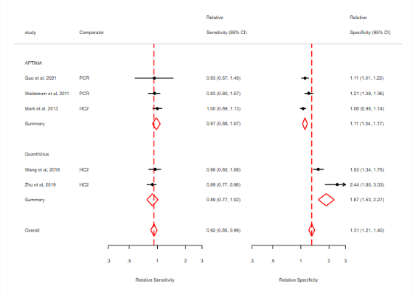
a: PICOS 1

7. Absolute sensitivity/specificity
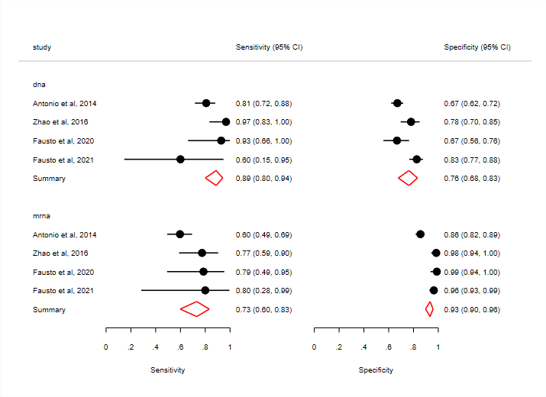
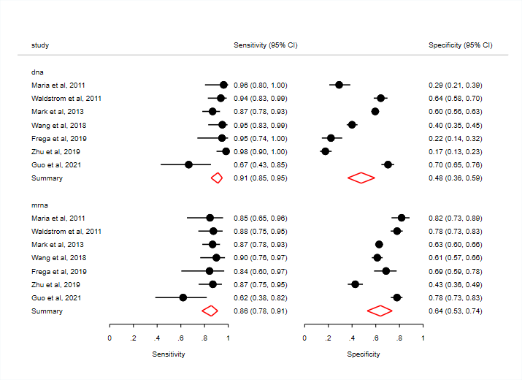

a: PICOS 1 b: PICOS 2

