Appendix
The following material accompanies the artic Acupuncture improves migraine and quality of life in patients with migraine: a systematic review with meta-analysis

Content
Text S1. Search strategies
Text S2. PRISMA 2020 Checklist
Text S3. Subgroup Analysis
Text S4. List of reading full text excluded articles

Text S1. Search strategies

PubMed
#1 "Acupuncture Therapy"[Mesh] OR "Electroacupuncture"[ Mesh] OR "Acupuncture, Ear"[ Mesh]
#2 Acupuncture [Title/Abstract] OR Electroacupuncture [Title/Abstract] OR "Auricular acupuncture"[Title/Abstract] OR "Acupoint injection"[Title/Abstract] OR "Acupuncture point injection"[Title/Abstract]
#3 #1 OR #2
#4 "Migraine Disorders"[Mesh]
#5 Migraine [Title/Abstract] OR "Migraine with aura"[Title/Abstract] OR "Migraine without aura"[Title/Abstract]
#6 #4 OR #5
#7 "Randomized Controlled Trial" [Publication Type] OR "Randomized Controlled Trials as Topic"[Mesh] OR "Random Allocation"[Mesh] OR "Controlled Clinical Trial" [Publication Type]
OR "Controlled Clinical Trials as Topic"[Mesh]
#8 Random*[Title/Abstract] OR Trial*[Title/Abstract]
#9 #7 OR #8
#10 #3 AND #6 AND #9

Embase
#1 'acupuncture'/exp OR 'electroacupuncture'/exp OR 'auricular acupuncture'/exp
#2 acupuncture:ab,ti OR electroacupuncture:ab,ti OR 'auricular acupuncture':ab,ti OR 'acupoint injection':ab,ti OR 'acupuncture point injection':ab,ti
#3 #1 OR #2
#4 'migraine'/exp
#5 migraine:ab,ti OR 'migraine with aura':ab,ti OR 'migraine without aura':ab,ti
#6 #4 OR #5
#7 'randomized controlled trial topic'/exp OR 'controlled clinical trial'/exp OR 'clinical trial'/exp OR 'randomization'/exp
#8 random*:ab,ti OR trial*:ab,ti
#9 #7 OR #8
#10 #3 AND #6 AND #9
#11 #10 AND [embase]/lim NOT [embase]/lim AND [medline]/lim

Cochrane Library
#1(Acupuncture OR Electroacupuncture OR Auricular acupuncture OR Acupoint injection OR Acupuncture point injection):ti,ab,kw
#2 MeSH descriptor: [Acupuncture Therapy] explode all trees
#3 MeSH descriptor: [Electroacupuncture] explode all trees
#4 MeSH descriptor: [Acupuncture, Ear] explode all trees
#5 #1OR#2OR#3OR#4
#6 (Migraine OR Migraine with aura OR Migraine without aura):ti,ab,kw
#7 MeSH descriptor: [Migraine Disorders] explode all trees
#8 #6OR#7
#9 (Random* OR Trial*):ti,ab,kw
#10 MeSH descriptor: [Randomized Controlled Trial] explode all trees
#11 MeSH descriptor: [Randomized Controlled Trials as Topic] explode all trees
#12 MeSH descriptor: [Random Allocation] explode all trees
#13 MeSH descriptor: [Controlled Clinical Trial] explode all trees
#14 MeSH descriptor: [Controlled Clinical Trials as Topic] explode all trees
#15 #9OR#10OR#11OR#12OR#13OR#14
#16 #5AND#8AND#15

CBM
#1"偏头痛"[不加权:扩展]
#2"无先兆偏头痛"[不加权:扩展]
#3"先兆偏头痛"[不加权:扩展]
#4 "偏头痛"[常用字段:智能] OR "无先兆偏头痛"[常用字段:智能] OR "先兆偏头痛"[常用字段:智能]
#5 #1OR#2OR#3OR#4
#6 "针刺"[常用字段:智能] OR "电针"[常用字段:智能] OR "耳针"[常用字段:智能] OR "穴位注射"[常用字段:智能]
#7 "针刺疗法"[不加权:扩展]
#8 "电针"[不加权:扩展]
#9 "耳针"[不加权:扩展]
#10 #6OR#7OR#8OR#9
#11 "随机"[常用字段:智能]
#12 "随机对照试验"[不加权:扩展]
#13 #11 OR#12
#14 #5 AND#10AND#13

CNKI
#1: (主题=偏头痛 或者 主题=无先兆偏头痛 或者 主题=先兆偏头痛)
#2: (主题=针刺 或者 主题=电针 或者 主题=耳针 或者 主题=穴位注射 )
#3: (全文=随机 或者 主题=随机对照试验)
#4: #1 AND #2 AND #3

VIP
#1 题名或关键词=偏头痛 或者 题名或关键词=无先兆偏头痛 或者 题名或关键词=先兆偏头痛
#2题名或关键词=针刺 或者 题名或关键词=电针 或者 题名或关键词=耳针 或者 题名或关键词=穴位注射
#3任意字段=随机 或者 任意字段=随机对照试验
#4 #1 AND #2 AND #3

Wanfang
#1题名或关键词:(针刺+电针+耳针+穴位注射)
#2题名或关键词:(偏头痛+无先兆偏头痛+先兆偏头痛)
#3全部:(随机+随机对照试验)
#4 #1 AND #2 AND #3


Text S2. PRISMA 2020 Checklist
Section and Topic | Item # | Checklist item | Location where item is reported
TITLE
Title | 1 | Identify the report as a systematic review. | 1
ABSTRACT
Abstract | 2 | See the PRISMA 2020 for Abstracts checklist. | 1-2
INTRODUCTION
Rationale | 3 | Describe the rationale for the review in the context of existing knowledge. | 2-3
Objectives | 4 | Provide an explicit statement of the objective(s) or question(s) the review addresses. | 2-3
METHODS
Eligibility criteria | 5 | Specify the inclusion and exclusion criteria for the review and how studies were grouped for the syntheses. | 3-4
Information sources | 6 | Specify all databases, registers, websites, organisations, reference lists and other sources searched or consulted to identify studies. Specify the date when each source was last searched or consulted. | 3
Search strategy | 7 | Present the full search strategies for all databases, registers and websites, including any filters and limits used. | 3
Selection process | 8 | Specify the methods used to decide whether a study met the inclusion criteria of the review, including how many reviewers screened each record and each report retrieved, whether they worked independently, and if applicable, details of automation tools used in the process. | 4
Data collection process | 9 | Specify the methods used to collect data from reports, including how many reviewers collected data from each report, whether they worked independently, any processes for obtaining or confirming data from study investigators, and if applicable, details of automation tools used in the process. | 4
Data items | 10a | List and define all outcomes for which data were sought. Specify whether all results that were compatible with each outcome domain in each study were sought (e.g. for all measures, time points, analyses), and if not, the methods used to decide which results to collect. | 4
Data items | 10b | List and define all other variables for which data were sought (e.g. participant and intervention characteristics, funding sources). Describe any assumptions made about any missing or unclear information. | 4
Study risk of bias assessment | 11 | Specify the methods used to assess risk of bias in the included studies, including details of the tool(s) used, how many reviewers assessed each study and whether they worked independently, and if applicable, details of automation tools used in the process. | 4-5
Effect measures | 12 | Specify for each outcome the effect measure(s) (e.g. risk ratio, mean difference) used in the synthesis or presentation of results. | 5
Synthesis methods | 13a | Describe the processes used to decide which studies were eligible for each synthesis (e.g. tabulating the study intervention characteristics and comparing against the planned groups for each synthesis (item #5)). | 5
Synthesis methods | 13b | Describe any methods required to prepare the data for presentation or synthesis, such as handling of missing summary statistics, or data conversions. | 5
Synthesis methods | 13c | Describe any methods used to tabulate or visually display results of individual studies and syntheses. | 5
Synthesis methods | 13d | Describe any methods used to synthesize results and provide a rationale for the choice(s). If meta-analysis was performed, describe the model(s), method(s) to identify the presence and extent of statistical heterogeneity, and software package(s) used. | 5
Synthesis methods | 13e | Describe any methods used to explore possible causes of heterogeneity among study results (e.g. subgroup analysis, meta-regression). | 5
Synthesis methods | 13f | Describe any sensitivity analyses conducted to assess robustness of the synthesized results. | 5
Reporting bias assessment | 14 | Describe any methods used to assess risk of bias due to missing results in a synthesis (arising from reporting biases). | 5
Certainty assessment | 15 | Describe any methods used to assess certainty (or confidence) in the body of evidence for an outcome. | NA
RESULTS
Study selection | 16a | Describe the results of the search and selection process, from the number of records identified in the search to the number of studies included in the review, ideally using a flow diagram. | 5
Study selection | 16b | Cite studies that might appear to meet the inclusion criteria, but which were excluded, and explain why they were excluded. | 5
Study characteristics | 17 | Cite each included study and present its characteristics. | 5-6
Risk of bias in studies | 18 | Present assessments of risk of bias for each included study. | 6
Results of individual studies | 19 | For all outcomes, present, for each study: (a) summary statistics for each group (where appropriate) and (b) an effect estimate and its precision (e.g. confidence/credible interval), ideally using structured tables or plots. | 6-7
Results of syntheses | 20a | For each synthesis, briefly summarise the characteristics and risk of bias among contributing studies. | 6-7
Results of syntheses | 20b | Present results of all statistical syntheses conducted. If meta-analysis was done, present for each the summary estimate and its precision (e.g. confidence/credible interval) and measures of statistical heterogeneity. If comparing groups, describe the direction of the effect. | 6-7
Results of syntheses | 20c | Present results of all investigations of possible causes of heterogeneity among study results. | 7-8
Results of syntheses | 20d | Present results of all sensitivity analyses conducted to assess the robustness of the synthesized results. | 7-8
Reporting biases | 21 | Present assessments of risk of bias due to missing results (arising from reporting biases) for each synthesis assessed. | NA
Certainty of evidence | 22 | Present assessments of certainty (or confidence) in the body of evidence for each outcome assessed. | NA
DISCUSSION
Discussion | 23a | Provide a general interpretation of the results in the context of other evidence. | 8-9
Discussion | 23b | Discuss any limitations of the evidence included in the review. | 9-10
Discussion | 23c | Discuss any limitations of the review processes used. | 10
Discussion | 23d | Discuss implications of the results for practice, policy, and future research. | 10-11
OTHER INFORMATION
Registration and protocol | 24a | Provide registration information for the review, including register name and registration number, or state that the review was not registered. | NA
Registration and protocol | 24b | Indicate where the review protocol can be accessed, or state that a protocol was not prepared. | NA
Registration and protocol | 24c | Describe and explain any amendments to information provided at registration or in the protocol. | NA
Support | 25 | Describe sources of financial or non-financial support for the review, and the role of the funders or sponsors in the review. | 11
Competing interests | 26 | Declare any competing interests of review authors. | 11
Availability of data, code and other materials | 27 | Report which of the following are publicly available and where they can be found: template data collection forms; data extracted from included studies; data used for all analyses; analytic code; any other materials used in the review. | 11

From: Page MJ, McKenzie JE, Bossuyt PM, Boutron I, Hoffmann TC, Mulrow CD, et al. The PRISMA 2020 statement: an updated guideline for reporting systematic reviews. BMJ 2021;372:n71. doi: 10.1136/bmj.n71
For more information, visit: http://www.prisma-statement.org/
Text S3. Subgroup Analysis
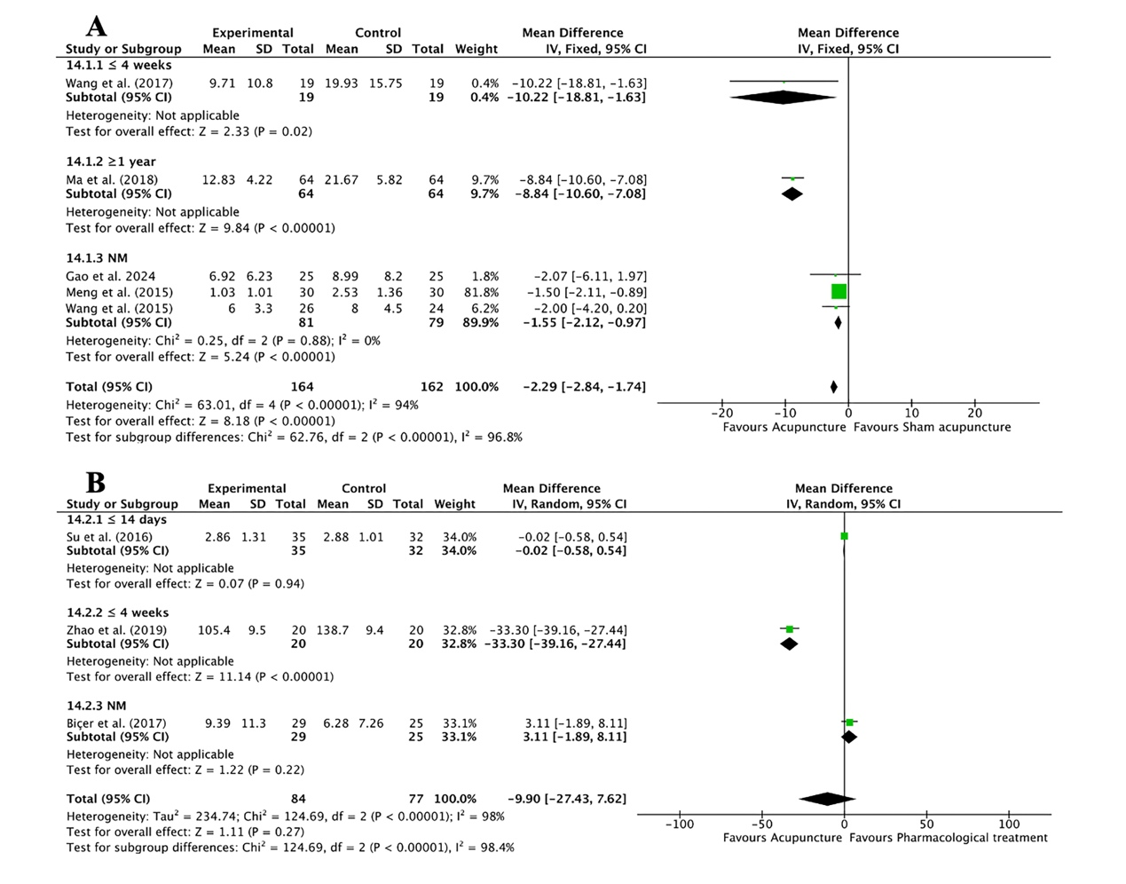
Fig. 1 Subgroup analysis of migraine duration for acupuncture versus the control group (treatment duration)
Fig. 2 Subgroup analysis of the number of mean migraine attacks for acupuncture versus the control group (treatment duration)
Fig. 3 Subgroup analysis of days with migraine per 4 weeks for acupuncture versus the control group (treatment duration)
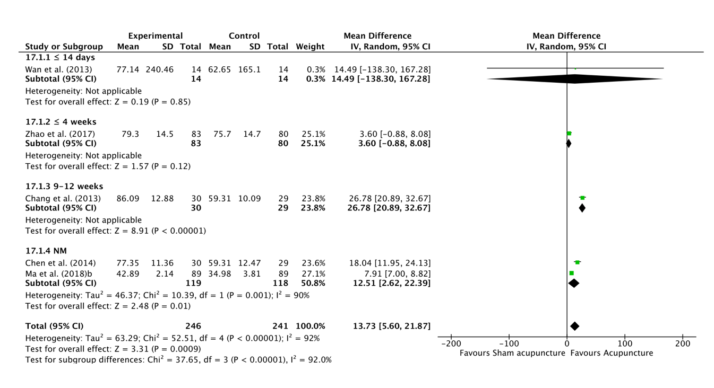 Fig. 4 Subgroup analysis of the MSQ restrictive subscale for acupuncture versus the control group (treatment duration)
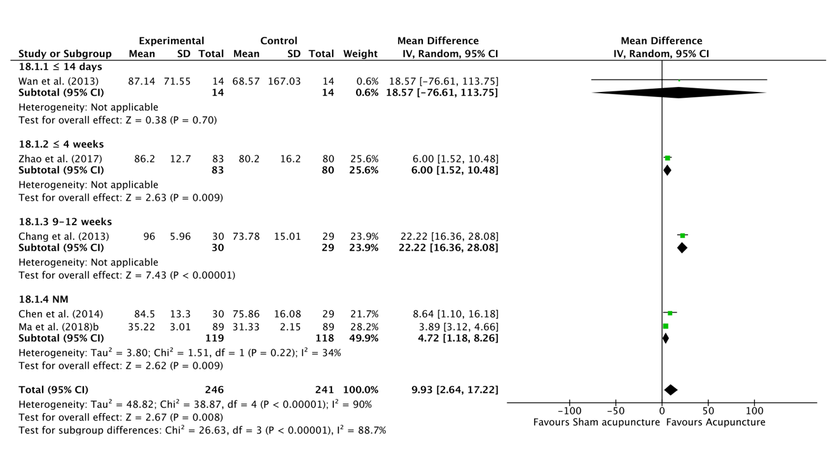
Fig. 5 Subgroup analysis of the MSQ emotional function for acupuncture versus the control group (treatment duration)
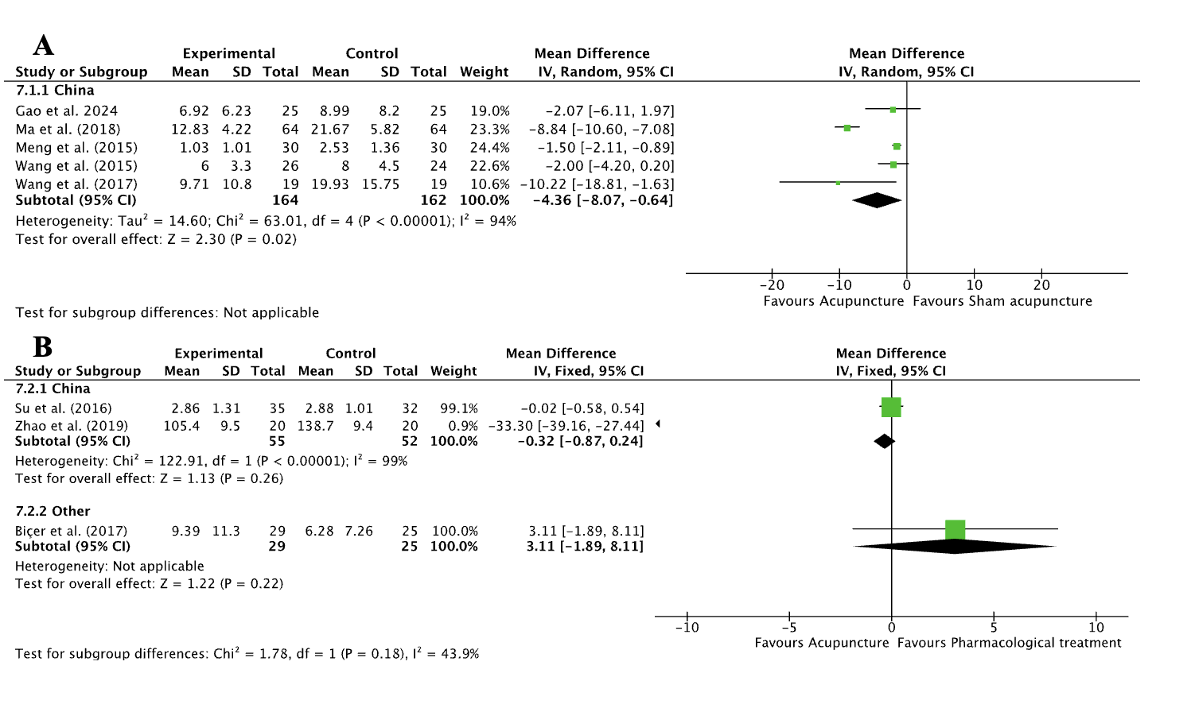
Fig. 6 Subgroup analysis of migraine duration for acupuncture versus the control group (regional differences)
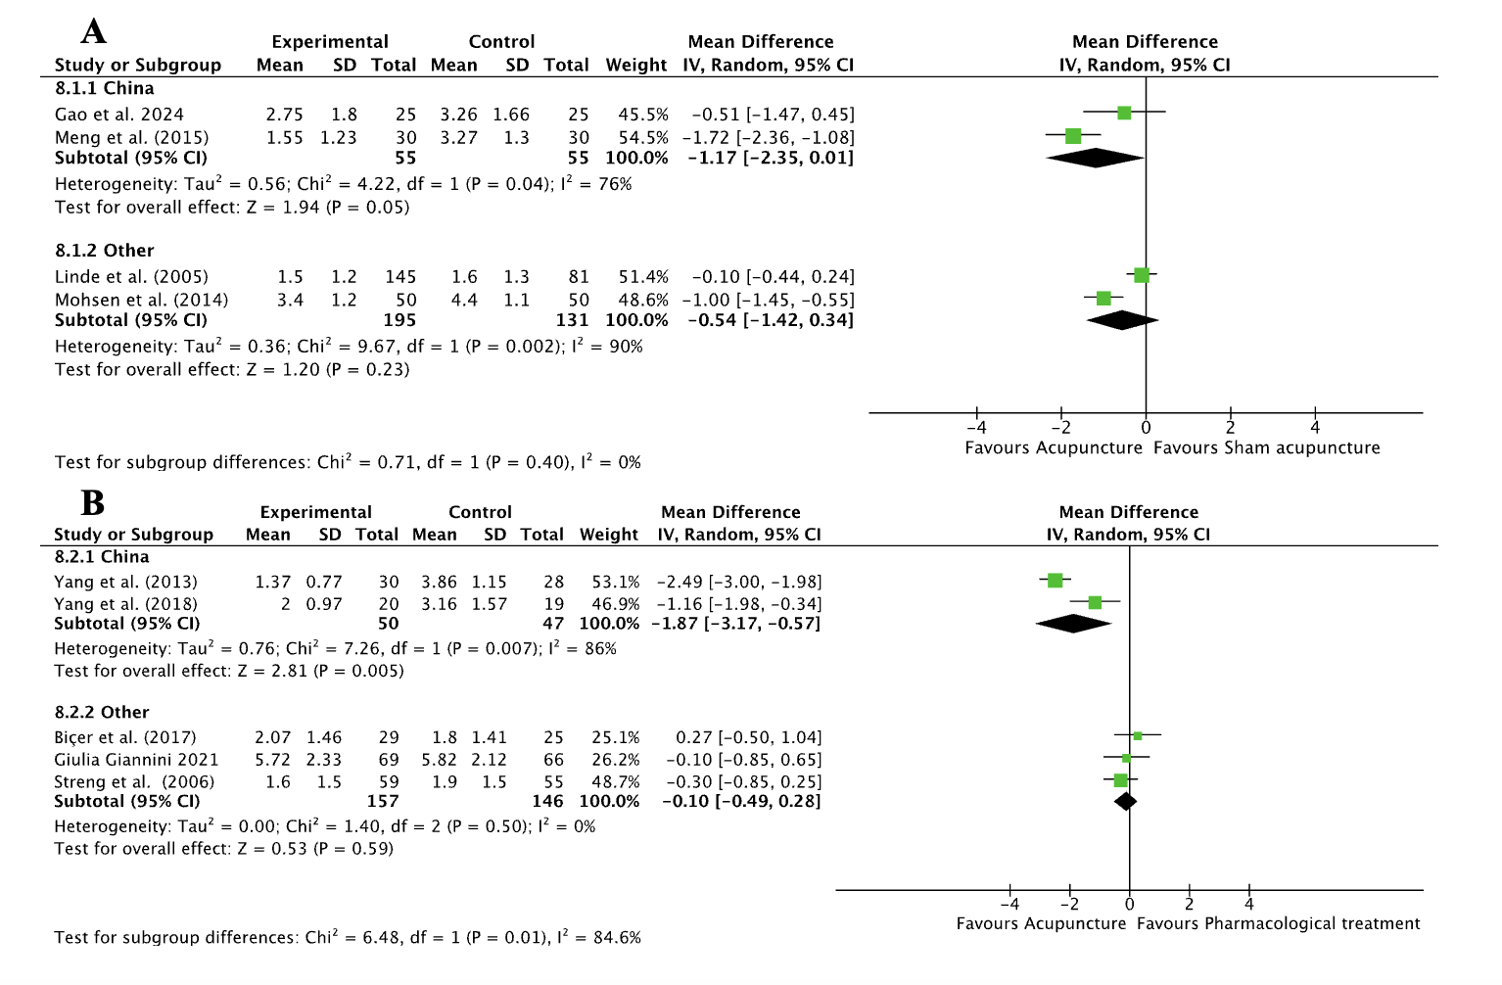
Fig. 7 Subgroup analysis of the number of mean migraine attacks for acupuncture versus the control group (regional differences)
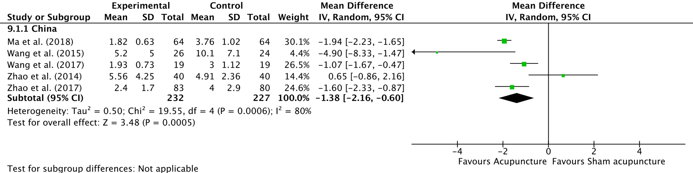
Fig. 8 Subgroup analysis of days with migraine per 4 weeks for acupuncture versus the control group (regional differences)
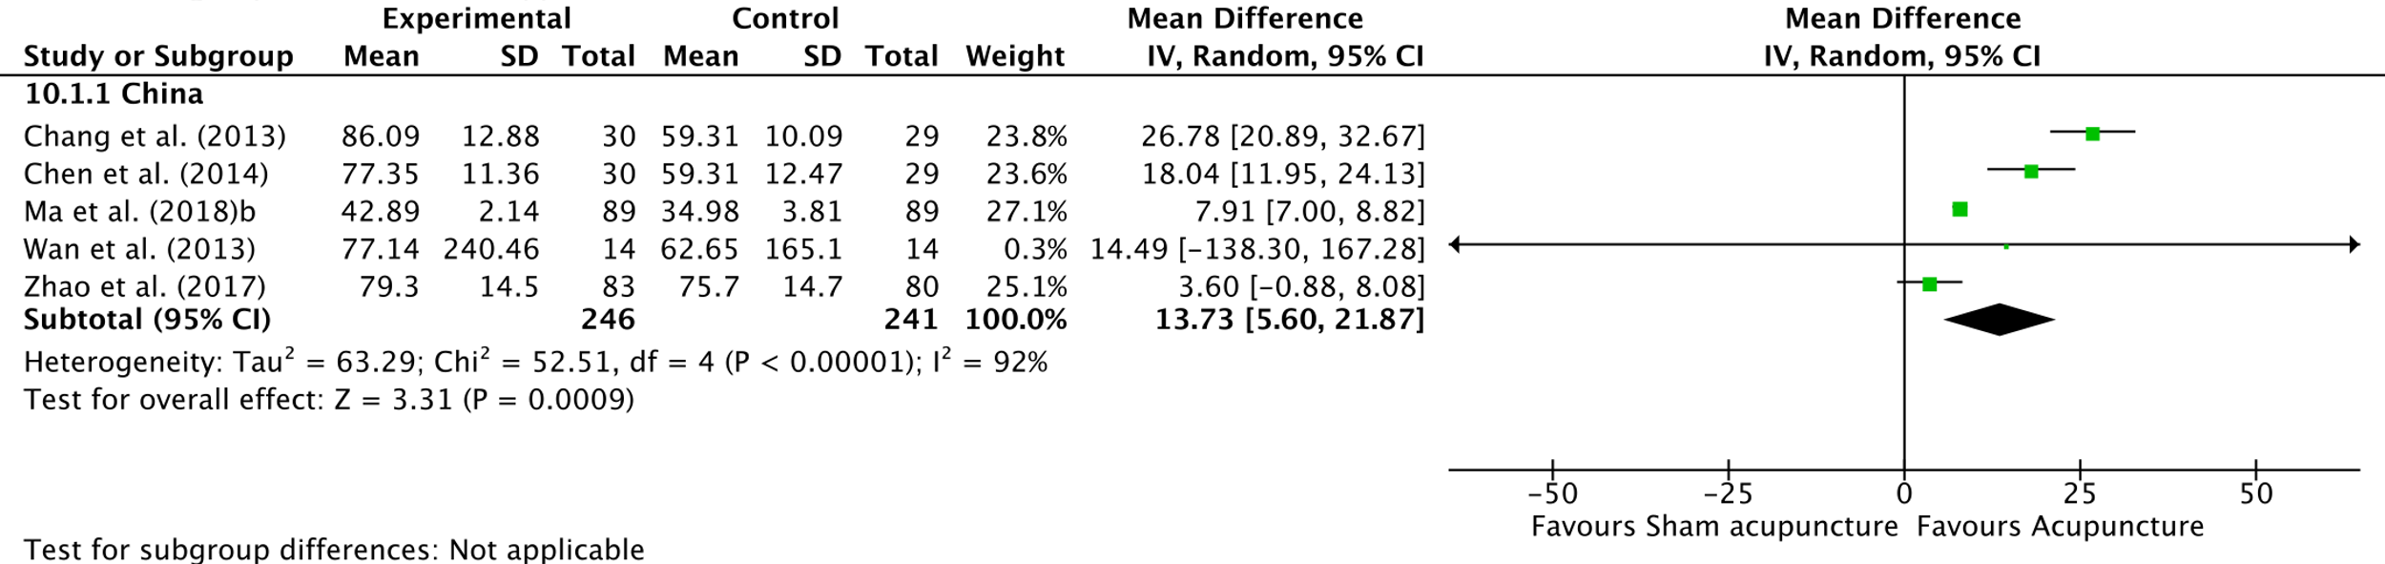
Fig. 9 Subgroup analysis of the MSQ restrictive subscale for acupuncture versus the control group (regional differences)
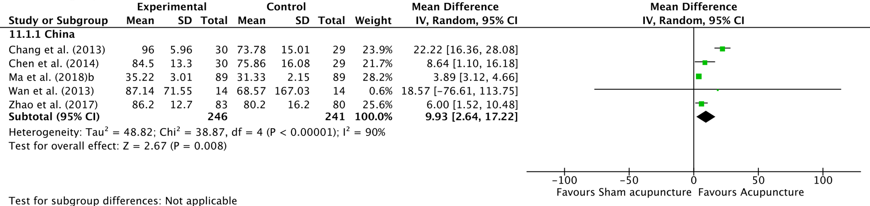
Fig. 10 Subgroup analysis of the MSQ emotional function for acupuncture versus the control group (regional differences)

Text S4. List of reading full text excluded articles
Title | Reasons
1.Efficacy of acupuncture in migraine prophylaxis: results from a placebo-controlled pilot trial | Conference abstracts
2. Arterial effects of acupuncture in migraine: a randomized, double-blind, placebo-controlled trial | Conference abstracts
3. Acupuncture prophylaxis of migraine no better than sham acupuncture for decreasing frequency of headaches | Comment
4. Acupuncture in migraine prevention: a randomized sham controlled study with 6-months post-treatment follow-up | Conference abstracts
5. Complex Approach to the Chronic Migraine Treatment: Connection Between Western and Oriental Medicine | Conference abstracts
6. Acupuncture to treat migraine: A multi-center randomized controlled trial | Conference abstracts
7. The effect of acupuncture on migraine headache | Conference abstracts
8. EHMTI-0026. Neuroprolotherapy and acupuncture for clinical trial of acute and chronic migraine treatment | Conference abstracts
9. Ear acupuncture for migraine | Note
10. Acupuncture in migraine prevention: a randomized sham controlled study with 6-months post-treatment follow-up | Clinical Trials
11. Contralateral acupuncture for migraine without aura: a randomized trial protocol with multimodal MRI | Protocol
12. Determining the Efficacy and Safety of Acupuncture for the Preventive Treatment of Menstrual Migraine: A Protocol for a PRISMA-Compliant Systematic Review and Meta-Analysis | Protocol
13. Central Mechanism of Acupuncture Treatment in Patients with Migraine: Study Protocol for Randomized Controlled Neuroimaging Trial | Protocol
14. Immediate analgesic effect of acupuncture intervention within 10 min during acute migraine attacks: protocol of a randomised controlled trial | Protocol
15. Acupuncture for migraine prophylaxis: A protocol for systematic review and Bayesian network meta-analysis | Protocol
16. Efficacy of Acupuncture Treatment of Migraine Delivered by Senior or Junior Acupuncturists: study Protocol for a Randomized Controlled Trial | Protocol
17. Acupuncture Based on Regulating Autonomic Nerves for the Prevention of Migraine Without Aura: A Prospective, Double-Dummy, Randomized Controlled Clinical Trial | Clinical Trials
18. Efficacy of contralateral acupuncture in women with migraine without aura: protocol for a randomised controlled trial | Protocol
19. Efficacy of scalp acupuncture for migraine: A protocol for systematic review and meta-analysis | Protocol
20. Neurological mechanism and treatment effects prediction of acupuncture on migraine without aura: study protocol for a randomized controlled trial | Protocol
21. Efficacy prediction of acupuncture treatment for migraine without aura based on multimodal MRI: A study protocol | Protocol
22. Manual acupuncture as prophylaxis for migraine without aura: study protocol for a multi-center, randomized, single-blinded trial | Protocol
23. Efficacy of Acupuncture Treatment of Migraine Delivered by Senior or Junior Acupuncturists: study Protocol for a Randomized Controlled Trial | Protocol
24. Comparative effect of electroacupuncture with different frequency on headache attacks in migraine outpatients: study protocol for a randomised placebo-controlled trial | Protocol
25. The Efficacy and Safety of Acupuncture for Prophylaxis of Vestibular Migraine: a Study Protocol for a Randomized Controlled Trial | Protocol
26. Acupuncture for emotional disorders in patients with migraine: a systematic review protocol | Protocol
27. Auricular acupuncture for migraine: A systematic review protocol | Protocol
28. Acupuncture methods for acute migraine attack: a Bayesian network meta-analysis protocol | Protocol
29. Effectiveness of dry needling for improving pain and disability in adults with tension-type, cervicogenic, or migraine headaches: protocol for a systematic review | Protocol
30. Acupuncture for migraine: a protocol for a meta-analysis and meta-regression of randomised controlled trials | Protocol
31. Acupuncture as prophylaxis for chronic migraine: a protocol for a single-blinded, double-dummy randomised controlled trial | Protocol
32. Electroacupuncture for migraine protocol for a systematic review of controlled trials | Protocol
33. Interventions for migraine prophylaxis: protocol of an umbrella systematic review and network meta-analysis | Protocol
34. Acupuncture for acute migraine attacks in adults: a systematic review protocol | Protocol
35. Study protocol for a pragmatic randomised controlled trial in general practice investigating the effectiveness of acupuncture against migraine | Protocol
36. Randomized controlled trial to treat migraine with acupuncture: design and protocol | Protocol
37. Acupuncture Randomized Trials (ART) in patients with migraine or tension-type headache--design and protocols | Protocol
38. Immediate analgesic effect of acupuncture intervention within 10 min during acute migraine attacks: protocol of a randomised controlled trial | Protocol
39. Mechanistic investigation of acupuncture treatment in patients with migraine: Evidence from brain imaging study (I) | Clinical Trials
40. A Randomized Controlled Trial of Acupuncture in Treating Migraine | Clinical Trials
41. Effect of Acupressure in Migraine: single-blinded, Randomized, Controlled Clinical Trial | Clinical Trials
42. Acupuncture for Prophylaxis of Vestibular Migraine | Clinical Trials
43. A randomized controlled trial of â€œuplifting yang and dispersing stagnation, activating the channel and alleviating painâ€ acupuncture therapy for migraine | Clinical Trials
44. Brain Connectome for Acupuncture-treated Migraine Patients: randomized, Controlled Study With Magnetic Resonance Imaging | Clinical Trials
45. A study on the neurobiological mechanism of acupuncture treatment for migraine | Clinical Trials
46. Is pain relief from acupuncture reflected in the flow of blood-oxygen in the brain and muscles of migraine patients? | Clinical Trials
47. Acupuncture for the prevention of chronic migraine attacks | Clinical Trials
48. Preventing of auricular acupuncture for migraine: a randomized controlled trial | Clinical Trials
49. Treatment of non-premonitory migraine with transcutaneous stimulation of the auricular branch of the vagal nerve (auricular t-VNS): a randomized, monocentric clinical trial on efficacy and the central mechanism of multimodality fMRI | Clinical Trials
50. Effectiveness of Acupuncture as treatment on Headache | Clinical Trials
51. Efficacy Study of Acupuncture in the Prevention of Migraine Without Aura | Clinical Trials
52. Auricular Acupuncture vs SOC in Migraine HA | Clinical Trials
53. The Target Symptom/disease-guided Randomized Controlled Trial to Evaluate the Acupuncture for Migraine Prophylaxis | Clinical Trials
54. Acupuncture for Migraine Prophylaxis | Clinical Trials
55. Acupuncture in Chronic Migraine: a Randomized Controlled Trial | Clinical Trials
56. A Randomised Control Trial to evaluate the efficacy of Acupuncture and "sham-acupuncture" for migraine | Clinical Trials
57. Randomized Controlled Trial of Treating Migraine With Acupuncture | Clinical Trials
58. Evaluation of acupuncture efficacy for prophylaxis of migraine attacks - phase II trial | Clinical Trials
59. Study of electroacupuncture with different frequencies for the treatment of headache and anxiety-depression symptoms in patients with migraine: a randomized clinical trial | Clinical Trials
60. Aerobic Exercise Verus Acupuncture on the Quality of Life in Women Suffering From Irritable Bowel Syndrome | Clinical Trials
61. Investigating the Impact of Acupuncture on the Quality of Life of Primitive Headaches Patients | Clinical Trials
62. Intramuscular Electrical Stimulation for the Treatment of Trigger Points in Patients With Migraine | Clinical Trials
63. Laser Acupuncture for Chronic Migraine | Clinical Trials
64. Auriculotherapy in prevention of migraine attacks: an open randomized trial | Clinical Trials
65. Enhancing chronic migraine preventive therapy: laser acupuncture as an add-on treatment for patients with unsatisfactory pharmacological effect | Clinical Trials
66. Heat-sensitive moxibustion for migraine without aura: a randomized controlled trial | Clinical Trials
67. Qihuang Needle therapy Combined with Flunarizine Hydrochloride in the Treatment of Vestibular Migraine: a randomized controlled trial | Clinical Trials
68. The "Harmony" mechanism of the integration of the periaqueductal gray (PAG) functional network in migraine by opposing needling at Shaoyang acupoints | Clinical Trials
69. Acupuncture Technique for Migraine Treatment Based on "Gen-Jie" Theory Standardization and clinical evaluation study | Clinical Trials
70. A two-arm, randomized, controlled, multimodal neuroimaging-based study to investigate the clinical mechanisms of acupuncture in the treatment of migraine without aura | Clinical Trials
71. Contralateral acupuncture for migraine without aura: a randomized trial protocol with multimodal MRI | Clinical Trials
72. A randomized controlled trial for TCM combined with acupuncture of Qing-Gan Xie-Huo in preventing migraine | Clinical Trials
73. A randomized controlled trial for modified Wu-Zhu-Yu Decoction integrated with acupuncture at Shaoyang acupoint in the treatment of migraine with cold and stasis obstructing meridian | Clinical Trials
74. Circulating exosomal microRNA profiles in migraine patients receiving acupuncture treatment: a placebo-controlled clinical trial | Non outcomes
75. Discovery of the mechanisms of acupuncture in the treatment of migraine based on functional magnetic resonance imaging and omics | Non outcomes
76. Clinical efficacy of the shallow puncture and more-twirling acupuncture method in migraine treatment and its effects on serum 5-HT and β-EP levels | Non outcomes
77. Cerebral fractional amplitude of low-frequency fluctuations may predict headache intensity improvement following acupuncture treatment in migraine patients | Non outcomes
78. Economic analysis of acupuncture for migraine prophylaxis | Non outcomes
79. Acupuncture and botulinum toxin A injection in the treatment of chronic migraine: A randomized controlled study | Non outcomes
80. Acupuncture modulates the abnormal brainstem activity in migraine without aura patients | Non outcomes
81. The altered right frontoparietal network functional connectivity in migraine and the modulation effect of treatment | Non outcomes
82. Clinical curative effect evaluation of acupuncture treatment of migraine in acute stage | Non outcomes
83. Effects of long-term acupuncture treatment on resting-state brain activity in migraine patients: a randomized controlled trial on active acupoints and inactive acupoints | Non outcomes
84. Efficacy of Acupuncture for Acute Migraine Attack: a Multicenter Single Blinded, Randomized Controlled Trial | Non outcomes
85. A PET-CT study on the specificity of acupoints through acupuncture treatment in migraine patients | Non outcomes
86. Discovery of the mechanisms of acupuncture in the treatment of migraine based on functional magnetic resonance imaging and omics | Non outcomes
87. 针刺对无先兆偏头痛患者中医体质的影响 | Non outcomes
88. 无先兆偏头痛患者针刺治疗后双侧楔叶的镜像同伦功能连接改变 | Non outcomes
89. 基于"气血同治"理论针刺治疗偏头痛的疗效观察 | Non outcomes
90. 针刺治疗急性期无先兆偏头痛的临床疗效 | Non outcomes
91. 针刺疗法治疗普通型偏头痛的效果 | Non outcomes
92. 朱琏针灸抑制Ⅱ型手法治疗慢性偏头痛及对血清5-HT、VEGF、CGRP的影响 | Non outcomes
93. 调神针刺法预防性治疗偏头痛的临床效果 | Non outcomes
94. 针刺对偏头痛患者疼痛及脑血流动力学的影响:随机对照研究 | Non outcomes
95. 穴位注射治疗急性偏头痛疗效分析 | Non outcomes
96. 运用fMRI技术探究针刺对月经性偏头痛患者脑功能连接网络的影响 | Non outcomes
97. 手针与假针刺和常规护理在预防发作性无先兆偏头痛方面的比较：多中心随机临床试验 | Non outcomes
98. 针灸治疗偏头痛患者的效果及其对血清基质金属蛋白酶-2活性的影响 | Non outcomes
99. 循经针刺对偏头痛的即刻疗效及其机制探讨 | Non outcomes
100. 针刺治疗偏头痛临床观察 | Non outcomes
101. 畲医针刺疗法治疗头风痧(偏头痛)的临床研究 | Non outcomes
102. 针刺治疗偏头痛急性发作疗效观察 | Non outcomes
103. Effect of auricular acupuncture with semi-permanent ear needles on controlling migraine symptoms: A single-blind randomized clinical trial | Unavailable data or full-text
104. A comparative study on the treatment of migraine headache with combined distant and local acupuncture points versus conventional drug therapy | Unavailable data or full-text
105. A central analgesic mechanism of acupuncture for migraine: An ongoing functional MRI study | Unavailable data or full-text
106. Acupuncture for migraine prophylaxis: a randomized controlled trial | Unavailable data or full-text
107. FPIN's clinical inquiries. Acupuncture for migraine headaches | Unavailable data or full-text
108. Acupuncture in migraine prevention - A randomized sham controlled study with 6-months posttreatment follow-up | Unavailable data or full-text
109. Acupuncture and medications of equal efficacy for migraine | Unavailable data or full-text
110. Modified Banxia Baizhu Tianmatang Combined with Acupuncture for Migraine (Wind-phlegm Upset Syndrome) Observe | Combine therapies or compare different acupoints
112. Napex acupoint thread-embedding combined with metoprolol tartrate tablet for prophylactic treatment of migraine without aura: a randomized controlled trial | Combine therapies or compare different acupoints
113. Observation on the effect difference in migraine treated with the combination of acupuncture and blood-letting therapy and medication with carbamazepine | Combine therapies or compare different acupoints
114. A Meta-analysis of Acupuncture's Improvement of Mood Disorders, Pain and Quality of Life in Migraine Patients | Combine therapies or compare different acupoints
115. Study of electroacupuncture with different frequencies for the treatment of headache and anxiety-depression symptoms in patients with migraine: A randomized clinical trial | Combine therapies or compare different acupoints
116. Clinical study of scalp acupuncture treatment for migraine without aura | Combine therapies or compare different acupoints
117. A clinical observation on treating migraine by the combination of scalp acupuncture and craniosacral therapy | Combine therapies or compare different acupoints
118. "颈部七线"取穴法针刺预防性治疗肝阳上亢型无先兆偏头痛:随机对照试验 | Combine therapies or compare different acupoints

