Supplementary materials

Supplementary Table 1. The Boolean formula in searching PubMed, Web of Science, and Scopus
PubMed | ((Pulse Wave Velocity) OR (PWV) OR (intima-media thickness) OR (cIMT) OR (Arterial Intima-media Thickness) OR (ABI) OR (ankle-brachial index) OR (cAIx) OR (Central Aortic Reflective Wave Pressure Augmentation Index) OR (FMD) OR (flow-mediated dilation) OR (reactive hyperemia index) OR (RHI) OR (augmentation index) OR (foveal avascular zone) OR (FAZ) OR (Endothelial microparticles) OR (EMP) OR (EPC) OR (Endothelial Progenitor Cells) OR (vascular stiffness) OR (arterial stiffness) OR (arteriosclerosis) OR (PSV) OR (peak systolic velocity)) AND ((PDE5 Inhibitors) OR (PDE5i) OR (Sildenafil) OR (Vardenafil) OR (Tadalafil) OR (Lodenafil) OR (Udenafil) OR (Avanafil))
Web of Science
Scopus

Supplementary Table 2. Description of outcome measures.
Outcome | Description and Explanation
systolic blood pressure (SBP), diastolic blood pressure (DBP), mean arterial pressure (MAP) | Blood pressures are measured non-invasively using a sphygmomanometer and stethoscope. The SBP reading shows the maximum pressure in the arteries during ventricular contraction. The DBP reading indicates the minimum pressure, or resting pressure, in the arteries between heartbeats (1). MAP = DBP + 1/3(SBP - DBP). MAP represents the perfusion pressure of the microcirculation. (2).
carotid intima-media thickness (cIMT) | The patient is supine with a slight hyperextension of the neck and rotation of the neck in the opposite direction of the probe. A linear array transducer with a multi-frequency (7-12 MHz) probe connected to a high-quality ultrasound system acquires images by a single sonographer who is not aware of the subject's clinical data (3).
flow-mediated dilation (FMD), brachial artery diameter (BAD) | FMD and BAD are commonly used to assess endothelial function, providing information on endothelial-dependent vasodilation by examining the brachial artery during resting and reactive congestion (4). FMD was calculated as the percentage change in brachial artery diameter from the baseline.
peak systolic velocity (PSV) | PSV is a Doppler ultrasound measurement of the maximum velocity of blood flow during systole. PSV is measured in centimeters per second (cm/s) and provides an indication of the severity of stenosis or intra-arterial pressure gradients. Higher PSV values suggest greater obstruction to blood flow (5,6).
pulse wave velocity (PWV) | PWV is a measurement of the speed at which the pulse pressure wave propagates through the arteries. It is considered an important indicator of arterial stiffness and a predictor of cardiovascular risk. Higher PWV values indicate stiffer, less compliant arteries as the pulse wave travels faster through them. PWV assessment provides a non-invasive measure of arterial health and is useful in evaluating patients at risk of cardiovascular diseases(7).
augmentation index (AI) | AI is a measure of arterial stiffness obtained through pulse wave analysis. A higher AI value indicates earlier or greater wave reflection occurring, suggesting stiffer arteries. An elevated AI is associated with increased risk of heart disease and all-cause mortality (9,10).
reactive hyperemia index (RHI) | RHI is a non-invasive measurement of macrovascular endothelial function obtained through peripheral arterial tonometry. RHI is calculated as the ratio of the average pulse volume during the 1-minute following reperfusion over the average pulse volume at baseline. A higher RHI ratio (>1.67) indicates better endothelial function through reactive hyperemia, mediated by endothelium-dependent vasodilation in response to ischemia. Impaired RHI is associated with cardiovascular risk factors (11).
endothelial progenitor cells (EPCs) | EPCs are bone marrow-derived precursor cells that contribute to neovascularization and endothelial repair. Measuring levels of circulating EPCs can indicate endothelial regenerative capacity. Mononuclear cells are isolated from peripheral blood by density gradient centrifugation. Cells are then dual-stained with fluorochrome-conjugated monoclonal antibodies against surface antigens characteristic of EPCs - CD34, CD133 and vascular endothelial growth factor receptor 2 (VEGFR2/KDR) (12). Flow cytometric analysis is performed to quantify the number of cells positive for both CD34 and CD133 or CD34 and KDR within the monocyte gate, which represent early EPCs. Late outgrowth EPCs are identified in colony forming unit assays as adherent cells that take on a characteristic hill-shale endothelial morphology when cultured with endothelial growth medium. Higher numbers of circulating early or late EPCs suggest greater capacity for endothelial repair and regeneration through angiogenic and vasculogenic processes (13).
endothelial microparticles (EMP) | EMPs are submicron membrane vesicles shed from the cell membranes of activated or apoptotic endothelial cells. Measurement of circulating EMP levels provides an indicator of endothelial damage/dysfunction. Higher EMP levels suggest greater endothelial injury/apoptosis occurring systemically. Serial measurements can monitor therapeutic responses (14).

References
1. Smulyan H, Safar ME. Blood pressure measurement: retrospective and prospective views. Am J Hypertens. 2011 Jun;24(6):628–34.
2. Sheng S. Mean arterial pressure and arterial stiffness in Japanese population: a secondary analysis based on a cross-sectional study. Blood Press Monit. 2020 Dec;25(6):310–7.
3. Nezu T, Hosomi N, Aoki S, Matsumoto M. Carotid Intima-Media Thickness for Atherosclerosis. J Atheroscler Thromb. 2016;23(1):18–31.
4. Thijssen DHJ, Bruno RM, van Mil ACCM, Holder SM, Faita F, Greyling A, et al. Expert consensus and evidence-based recommendations for the assessment of flow-mediated dilation in humans. Eur Heart J. 2019 Aug 7;40(30):2534–47.
5. Simpson TF, Tyler JM, Thomas RC, Fang Q, Bibby D, Schiller NB. Mitral annular peak systolic and diastolic velocities are characteristic of healthy hearts: A Doppler tissue imaging study. Echocardiogr Mt Kisco N. 2019 Mar;36(3):433–8.
6. Støylen A, Mølmen HE, Dalen H. Over all variability of mitral annular plane peak systolic velocity and peak global longitudinal strain rate in relation to age, body size, and sex: The HUNT Study. Echocardiogr Mt Kisco N. 2020 Apr;37(4):578–85.
7. Milan A, Zocaro G, Leone D, Tosello F, Buraioli I, Schiavone D, et al. Current assessment of pulse wave velocity: comprehensive review of validation studies. J Hypertens. 2019 Aug;37(8):1547–57.
8. Aboyans V, Criqui MH, Abraham P, Allison MA, Creager MA, Diehm C, et al. Measurement and interpretation of the ankle-brachial index: a scientific statement from the American Heart Association. Circulation. 2012 Dec 11;126(24):2890–909.
9. Kaya M, Balasubramanian V, K-J Li J. Augmentation index in the assessment of wave reflections and systolic loading. Comput Biol Med. 2019 Oct;113:103418.
10. Nichols WW, Singh BM. Augmentation index as a measure of peripheral vascular disease state. Curr Opin Cardiol. 2002 Sep;17(5):543–51.
11. Motozato K, Suematsu Y, Norimatsu K, Kusumoto T, Miura SI. Reactive Hyperemia Index Associated With Atherosclerotic Cardiovascular Disease Under Treatment for Lifestyle Diseases. J Clin Med Res. 2020 May;12(5):293–9.
12. Sun S, Meng Y, Li M, Tang X, Hu W, Wu W, et al. CD133+ endothelial-like stem cells restore neovascularization and promote longevity in progeroid and naturally aged mice. Nat Aging. 2023 Nov;3(11):1401–14.
13. Mak A, Chan JKY. Endothelial function and endothelial progenitor cells in systemic lupus erythematosus. Nat Rev Rheumatol. 2022 May;18(5):286–300.
14. van Ierssel SH, Hoymans VY, Van Craenenbroeck EM, Van Tendeloo VF, Vrints CJ, Jorens PG, et al. Endothelial microparticles (EMP) for the assessment of endothelial function: an in vitro and in vivo study on possible interference of plasma lipids. PloS One. 2012;7(2):e31496.

Supplementary Table 3. Description of studies included in the meta-analysis, including basic information of the studies such as the researcher and publication time, study arms, the age and region of the subjects, as well as their physical condition, types of drugs, dose and duration of medication, and measurement indicators.
Author | Publication year | Study arms  (PDE5i/placebo) | Physical condition | Age  (mean±SD) | Region | PDE5i | Dose | Duration of medication | Measures
Katz | 2000 | 12/12 | CHF | 54±10 | America | sildenafil | 25mg | single dose | FMD, MAP
Dishy | 2001 | 13/13 | healthy | 25±1 | America | sildenafil | 50mg | single dose | SBP, DBP
Dishy | 2001 | 11/11 | healthy | 25±1 | America | sildenafil | 50mg | single dose | BAD, FMD, SBP, DBP
Mahmud | 2001 | 8/8 | hypertension | 61±3 | Ireland | sildenafil | 50mg | single dose | SBP, DBP
Desouza | 2002 | 14/14 | DM | 44±26 | America | sildenafil | 25mg,qd | 2w | BAD
Halcox | 2002 | 24/24 | healthy | 54±10 | America | sildenafil | 100mg | single dose | MAP
Halcox | 2002 | 24/24 | CAD | 65±10 | America | sildenafil | 100mg | single dose | SBP, DBP
Halcox | 2002 | 12/12 | healthy | 32±7 | America | sildenafil | 100mg | single dose | BAD, SBP, DBP
Thadani | 2002 | 41/41 | CAD | unclear | America | vardenafil | 10mg | single dose | SBP, DBP
Kimura | 2003 | 10/10 | smoker | 28.1±3.9 | Japan | sildenafil | 100mg | single dose | SBP, DBP
Kimura | 2003 | 10/10 | healthy | 28.3±3.6 | Japan | sildenafil | 100mg | single dose | SBP, DBP
Schofield | 2003 | 15/15 | hypertension | 55±10 | America | sildenafil | 50mg | single dose | FMD, MAP, SBP, DBP, AI
Stanopoulos | 2003 | 41/41 | ED | 52.3±8.6 | Greece | sildenafil | 100mg | single dose | SBP, DBP
Vlachopoulos | 2003 | 24/24 | CAD | 69±8 | Australia | sildenafil | 50mg | single dose | MAP, SBP, DBP, AI
Dishy | 2004 | 9/9 | smoker | 21±9 | America | sildenafil | 50mg | single dose | BAD, FMD, SBP, DBP
Guazzi | 2004 | 8/8 | healthy | 57.6±7.2 | Italy | sildenafil | 50mg | single dose | SBP, DBP, AI
Guazzi | 2004 | 16/16 | CHF | 55.1±8.2 | Italy | sildenafil | 50mg | single dose | SBP, DBP, AI
Guazzi | 2004 | 10/10 | CHF | 57.9±7.3 | Italy | sildenafil | 50mg | single dose | BAD, FMD, SBP, DBP
Guazzi | 2004 | 10/10 | healthy | 56.8±6.8 | Italy | sildenafil | 50mg | single dose | BAD, FMD, SBP, DBP
Vlachopoulos | 2004 | 14/14 | smoker | 33±4.1 | Greece | sildenafil | 50mg | single dose | BAD, FMD, SBP, DBP
Diomedi | 2005 | 14/14 | ED | 56.6±8.7 | Italy | sildenafil | 50mg | single dose | SBP, DBP
Gori | 2005 | 5/5 | healthy | unclear | Italy | sildenafil | 50mg | single dose | BAD, MAP
Hirata | 2005 | 20/20 | CHF | 68 | Australia | sildenafil | 50mg | single dose | MAP, SBP, DBP, AI, PWV
Hryniewicz | 2005 | 12/9 | CHF | 57±10.4 | America | sildenafil | 50mg | single dose | BAD, FMD, MAP
Rosanoa | 2005 | 16/16 | CAD | 65.4±6.3 | Italy | tadalafil | 20mg,q2d | 4w | FMD
Sommer | 2005 | 14/2 | ED | unclear | Germany | tadalafil | 20mg,q2d | 4w | FMD
Foresta | 2006 | 26/26 | ED | 50.1±8.2 | Italy | tadalafil | 20mg | single dose | FMD, EPCs
Foresta | 2006 | 23/23 | healthy | 47.6±5.7 | Italy | tadalafil | 20mg | single dose | FMD, EPCs
Mazo | 2006 | 83/82 | healthy | 50.8±14.1 | Russia | vardenafil | 20mg | single dose | FMD
Aversa | 2007 | 20/20 | ED | 54±8 | Italy | tadalafil | 20mg,q2d | 4w | FMD, PSV
Foresta | 2007 | 26/26 | ED | 52.8±3.7 | Italy | vardenafil | 20mg | single dose | EPCs
Foresta | 2007 | 23/23 | healthy | 52.5±4.3 | Italy | vardenafil | 20mg | single dose | EPCs
Guazzi | 2007 | 19/17 | CHF | 62±3 | Italy | sildenafil | 50mg,bid | 24w | FMD, SBP, DBP, RHI
Aversa | 2008 | 10/10 | DM | 64.2±5.4 | Italy | sildenafil | 25mg,tid | 4w | BAD, FMD
Behling | 2008 | 11/8 | CHF | 48±12 | Brazil | sildenafil | 50mg,tid | 4w | MAP, SBP
Bocchio | 2008 | 18/18 | ED | 52.05±9.98 | Italy | tadalafil | 20mg,qd | 4w | SBP, DBP, cIMT
Guazzi | 2008 | 16/16 | healthy | 57.2±5.1 | Italy | sildenafil | 50mg | single dose | FMD, SBP, DBP
Guazzi | 2008 | 16/16 | CHF | 56.6±4.3 | Italy | sildenafil | 50mg | single dose | FMD, SBP, DBP
Stirban | 2009 | 35/35 | DM | 55.1±7 | Germany | sildenafil | 100mg | single dose | BAD, FMD
Vardi | 2009 | 34/19 | ED | 55.4±10.5 | Israel | sildenafil | 50mg,qd | 4w | SBP, DBP
Shenoy | 2010 | 24/24 | MCTD | 36.87 | India | tadalafil | 20mg,q2d | 6w | FMD
Javaroni | 2011 | 39/39 | ED | 57.3±4.8 | Brazil | vardenafil | 20mg | single dose | FMD, SBP, DBP, cIMT
La Vignera | 2011 | 50/50 | ED | 56±14 | Italy | tadalafil | 5mg,qd | 12w | cIMT, EMP
Javaroni | 2012 | 18/17 | ED | 62±6 | Brazil | vardenafil | 10mg,qd | 5w | FMD, SBP, DBP, cIMT
La Vignera | 2012 | 25/25 | ED | 56±12 | Italy | tadalafil | 5mg,qd | 12w | EMP
Porst | 2012 | 146/69 | ED | 52.2±10.9 | Germany | tadalafil | 5mg,qd | 12w | AI, EPCs, RHI
Vlachopoulos | 2012 | 12/12 | ED | 58±9 | Greece | vardenafil | 20mg | single dose | SBP, DBP, PWV, AI
Attina | 2013 | 15/15/ | healthy | 45±11.6 | UK | sildenafil | 50mg,tid | 1w | SBP, DBP, PWV
Attina | 2013 | 15/15 | hypertension | 48±15.5 | UK | sildenafil | 50mg,tid | 1w | SBP, DBP, PWV
Quinaglia | 2013 | 26/26 | hypertension | 57±8.2 | Brazil | sildenafil | 50mg | single dose | FMD
McLaughlin | 2014 | 12/12 | CHF | 22 | Canada | sildenafil | 50mg | single dose | FMD
Roseguini | 2014 | 12/12 | hypertension | unclear | Brazil | sildenafil | 50mg | single dose | ABI
Santos | 2014 | 19/19 | hypertension | unclear | Brazil | tadalafil | 20mg,qd | 2w | FMD, SBP, DBP
Simsek | 2014 | 50/50 | ED | 59.1±2.3 | Turkey | tadalafil | 20mg,q2d | 4w | FMD, SBP, DBP
Morisawa | 2015 | 25/25 | CHF | 70±15 | Japan | sildenafil | 20mg | single dose | SBP, DBP
Sabri | 2016 | 15/15 | Fortan procedure | 15 | Iran | tadalafil | 1mg/kg,qd | 6w | FMD, SBP, DBP, cIMT
Santi | 2016 | 20/20 | ED | 55.8±5 | Italy | vardenafil | 10mg,bid | 24w | FMD
Rodriguez | 2018 | 15/15 | CF | 23±11 | Georgia | sildenafil | 20mg,qd | 4w | FMD, SBP, DBP, BAD
Sabri | 2018 | 18/18 | TOF cardiac surgery | 10.11±4.03 | Iran | tadalafil | 1mg/kg,qd | 8w | FMD, cIMT
Pattanaik | 2019 | 41/41 | ED | 31.3±8.9 | India | tadalafil | 10mg,qd | 4w | FMD
Pelit | 2019 | 31/31 | ED | 49.8±6.9 | Turkey | tadalafil | 10mg,qd | 8w | cIMT
Goldberg | 2020 | 200/200 | healthy | 15.5±2 | America | udenafil | 87.5mg,bid | 26w | SBP, DBP, RHI
Larios | 2022 | 39/41 | Obesity | unclear | Mexico | tadalafil | 20mg | single dose | SBP, DBP, AI, PWV

SD: standard deviation, CHF: chronic heart failure, DM: diabetes mellitus, CAD: cardiovascular disease, ED: erectile dysfunction, MCTD: mixed connective tissue disease, TOF: tetralogy of Fallot, MAP: mean arterial pressure, SBP: systolic blood pressure, DBP: diastolic blood pressure, cIMT: carotid intima-media thickness, PSV: peak systolic velocity, PWV: pulse wave velocity, AI: augmentation index, BAD: brachial artery diameter, FMD: flow-mediated dilation, RHI: reactive hyperemia index, EPCs: endothelial progenitor cells, EMP: endothelial microparticles.

Figure S1. PRISMA flow diagram of the selection process.

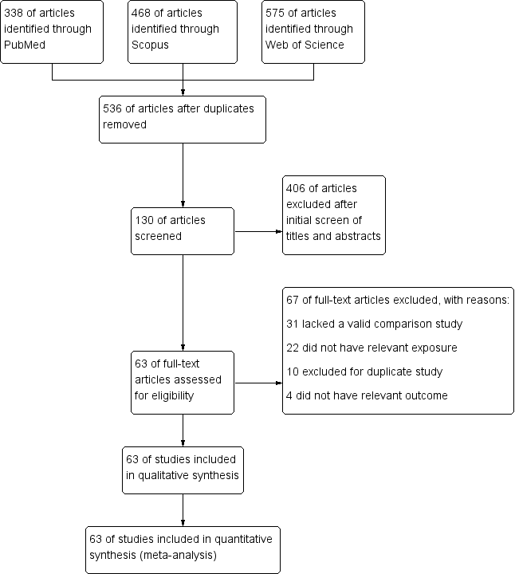

Figure S2. (A) Meta-analysis of studies on the relationship between PDE5is and SBP. (B) Meta-analysis of studies on the relationship between PDE5is and DBP.
PDE5is: phosphodiesterase-5 inhibitors, SBP: systolic blood pressure, DBP: diastolic blood pressure, CAD: coronary artery disease, ED: erectile dysfunction, CF: cystic fibrosis, SD: standard deviation, CI: confidence interval.

Figure S3. Meta-analysis of studies on the association between PDE5is and MAP.
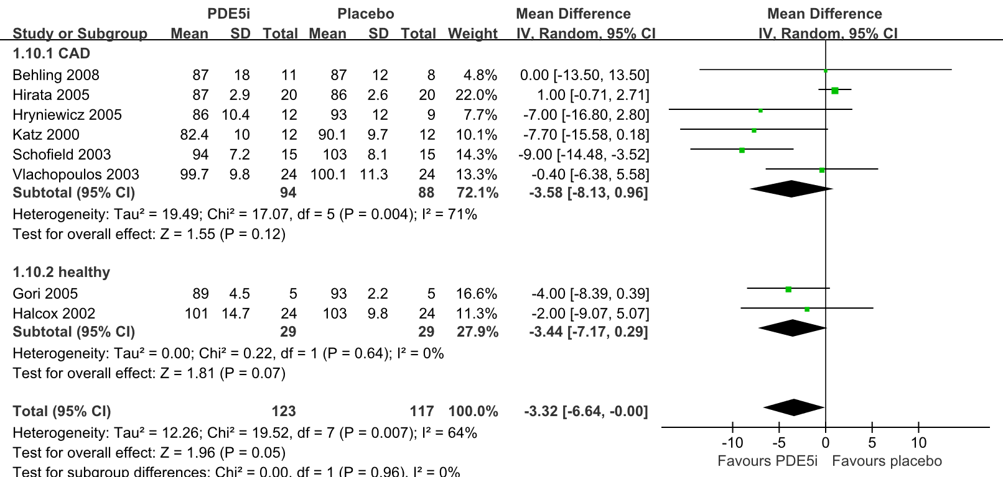

PDE5i: phosphodiesterase-5 inhibitor, MAP: mean arterial pressure, SD: standard deviation, CI: confidence interval.

Figure S4. Sensitivity analysis of studies on the relationship between PDE5is and MAP.
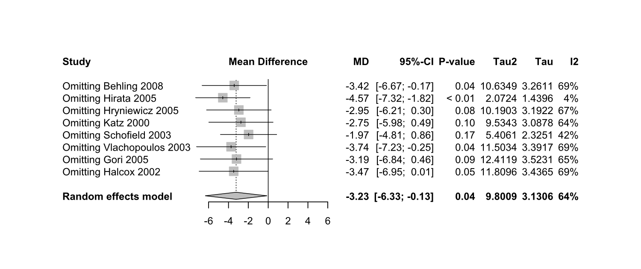
MD: mean difference, CI: confidence interval, MAP: mean arterial pressure.

Figure S5. Sensitivity analysis of studies on the relationship between PDE5is and SBP.
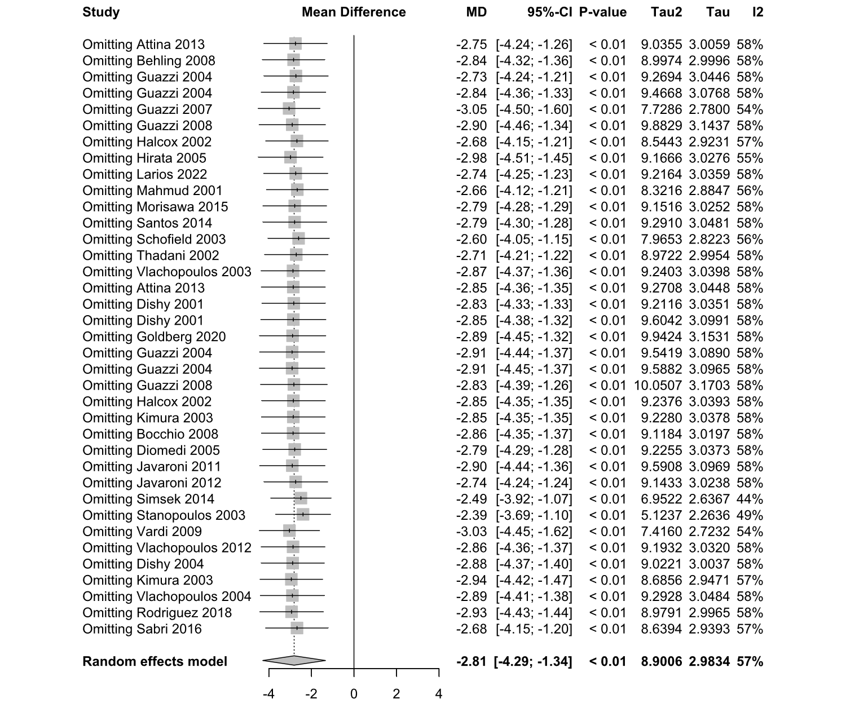
MD: mean difference, CI: confidence interval, SBP: systolic blood pressure.

Figure S6. Sensitivity analysis of studies on the relationship between PDE5is and DBP.
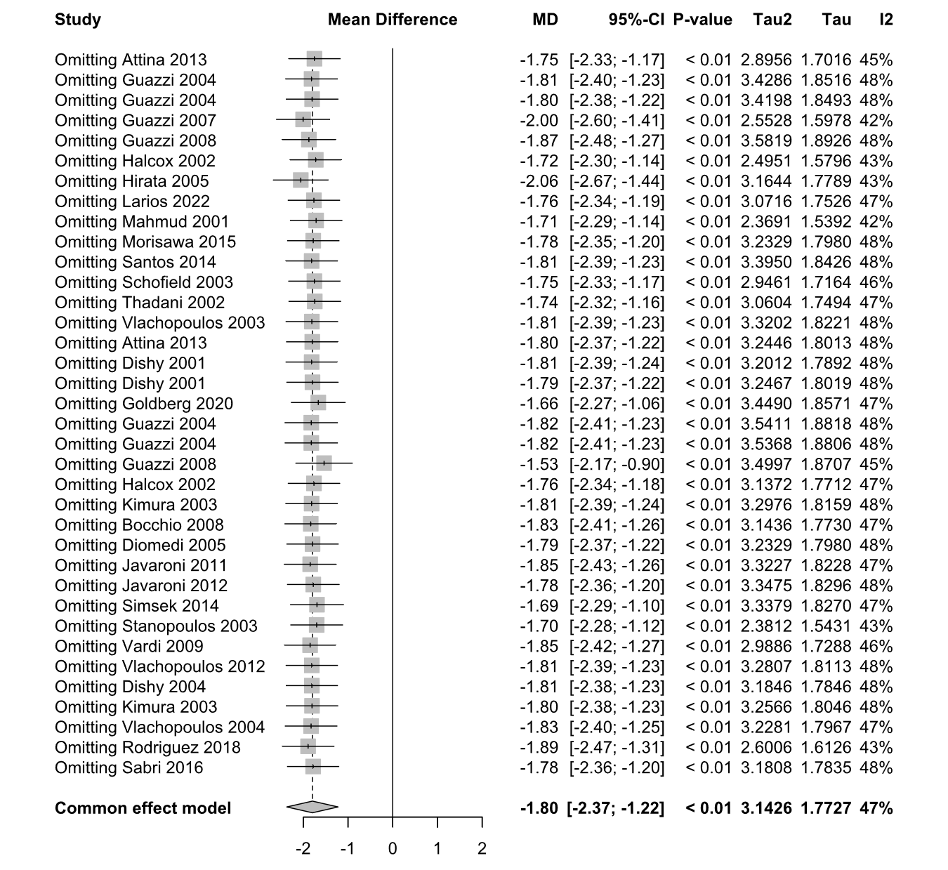
MD: mean difference, CI: confidence interval, DBP: diastolic blood pressure.

Figure S7. Meta-analysis of studies on the relationship between PDE5is and cIMT.
PDE5is: phosphodiesterase-5 inhibitors, cIMT: carotid intima–media thickness, ED: erectile dysfunction, TOF: Tetralogy of Fallot, SD: standard deviation, CI: confidence interval.

Figure S8. Sensitivity analysis of studies on the relationship between PDE5is and cIMT.
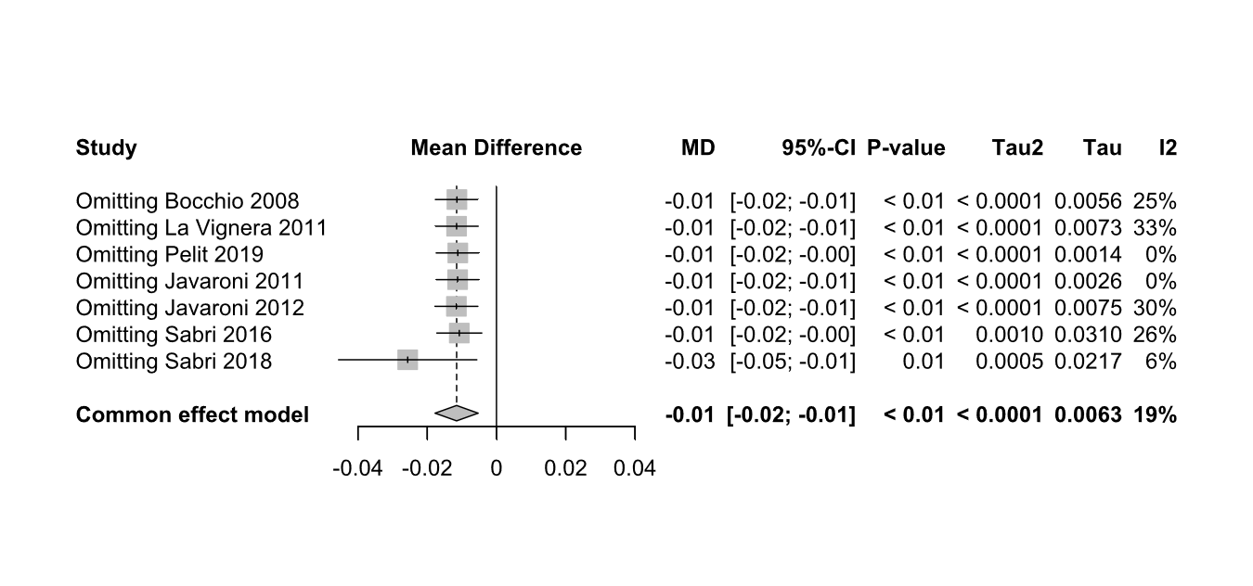
MD: mean difference, CI: confidence interval, cIMT: carotid intima-media thickness.

Figure S9. Meta-analysis of studies on the relationship between PDE5is and the AI.
PDE5is: phosphodiesterase-5 inhibitors, AI: augmentation index, CAD: coronary artery disease, ED: erectile dysfunction, SD: standard deviation, CI: confidence interval.

Figure S10. Sensitivity analysis of studies on the relationship between PDE5is and PWV.
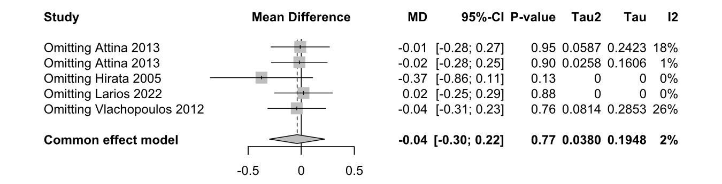
MD: mean difference, CI: confidence interval, PWV: pulse wave velocity.

Figure S11. Sensitivity analysis of studies on the relationship between PDE5is and AI.
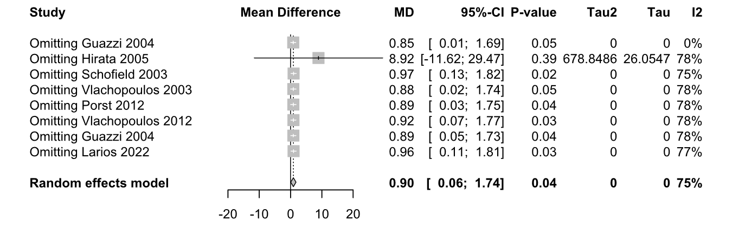
MD: mean difference, CI: confidence interval, AI: augmentation index.

Figure S12. (A) Meta-analysis of studies on the relationship between PDE5is and BAD. (B) Meta-analysis of studies on the relationship between PDE5is and RHI. (C) Meta-analysis of studies on the relationship between PDE5is and FMD.
PDE5is: phosphodiesterase-5 inhibitors, BAD: brachial artery diameter, RHI: reactive hyperemia index, FMD: flow-mediated dilation, DM: diabetes mellitus, CHF: chronic heart failure, CF: cystic fibrosis, CAD: coronary artery disease, ED: erectile dysfunction, MCTD: mixed connective tissue disease, TOF: Tetralogy of Fallot, SV: single ventricle, SD: standard deviation, CI: confidence interval.

Figure S13. Sensitivity analysis of studies on the relationship between PDE5is and FMD.
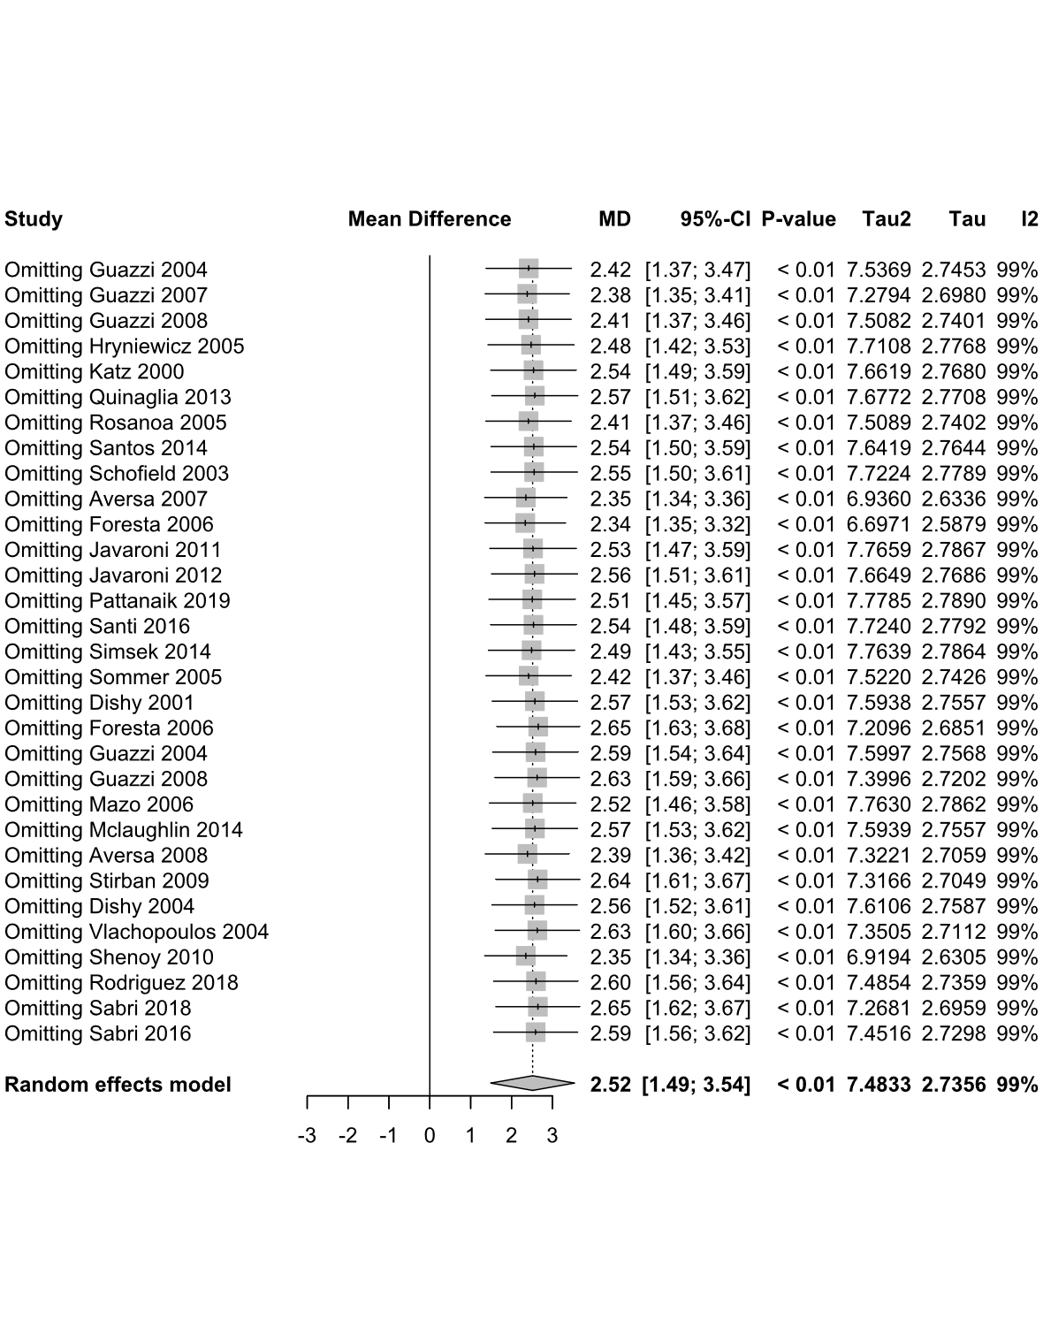
MD: mean difference, CI: confidence interval, FMD: flow-mediated dilation.

Figure S14. (A) Meta-analysis of studies on the relationship between PDE5is and EPCs. (B) Meta-analysis of studies on the relationship between PDE5is and EMP.
PDE5is: phosphodiesterase-5 inhibitors, EPCs: endothelial progenitor cells, EMP: endothelial microparticles, ED: erectile dysfunction, SD: standard deviation, CI: confidence interval.

Figure S15. Sensitivity analysis of studies on the relationship between PDE5is and EPCs.
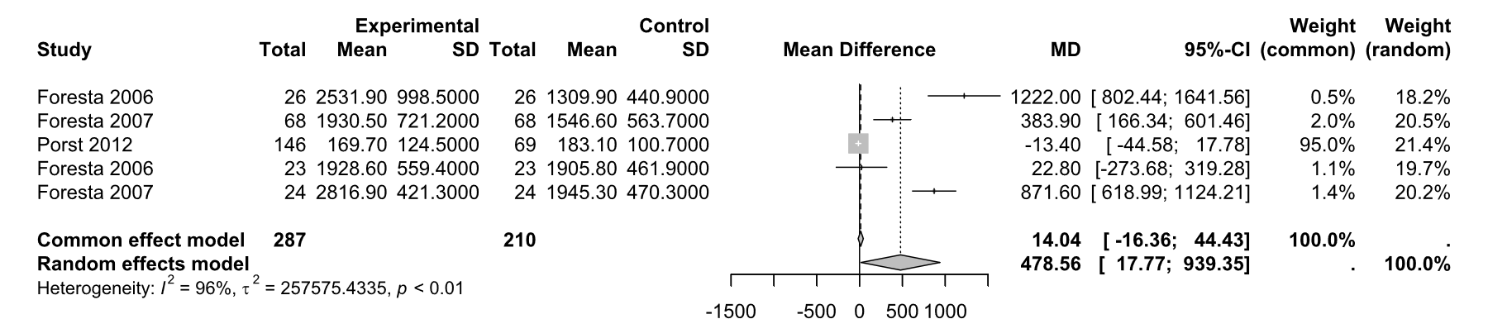
MD: mean difference, SD: standard deviation, CI: confidence interval, EPCs: endothelial progenitor cells.

Figure S16. Risk of bias graph in this meta-analysis
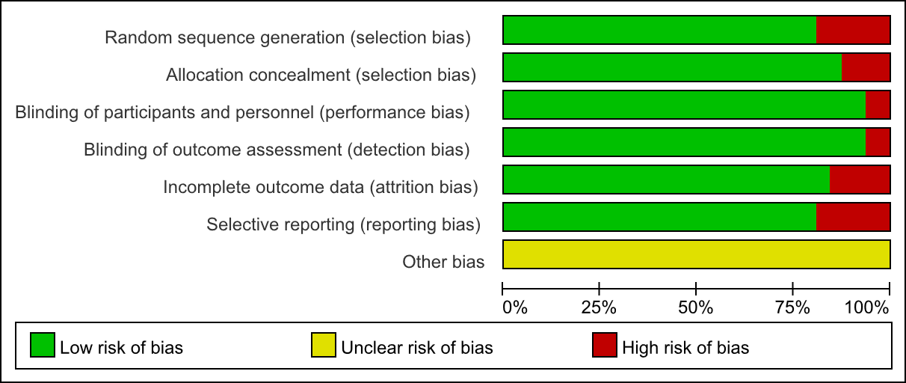

Figure S17. Risk of bias summary in this meta-analysis
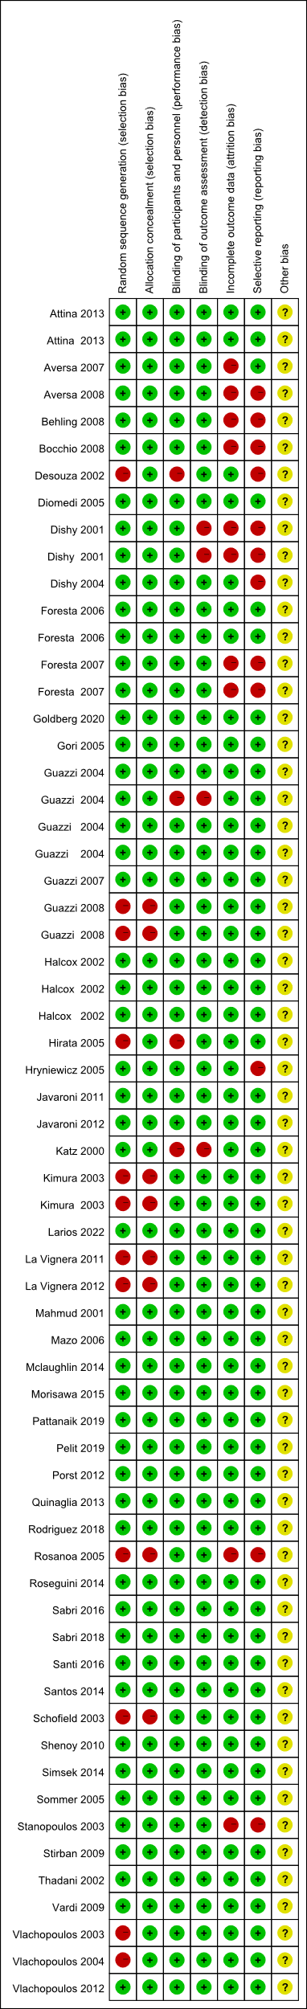

Figure S18. Below are funnel plots of the meta-analysis between phosphodiesterase type 5 inhibitors (PDE5is) and MAP (A), SBP (B), DBP (C), cIMT (D), PSV (E), PWV (F), AI (G), BAD (H), FMD (I), RHI (J), EPCs (K) and EMP (L).
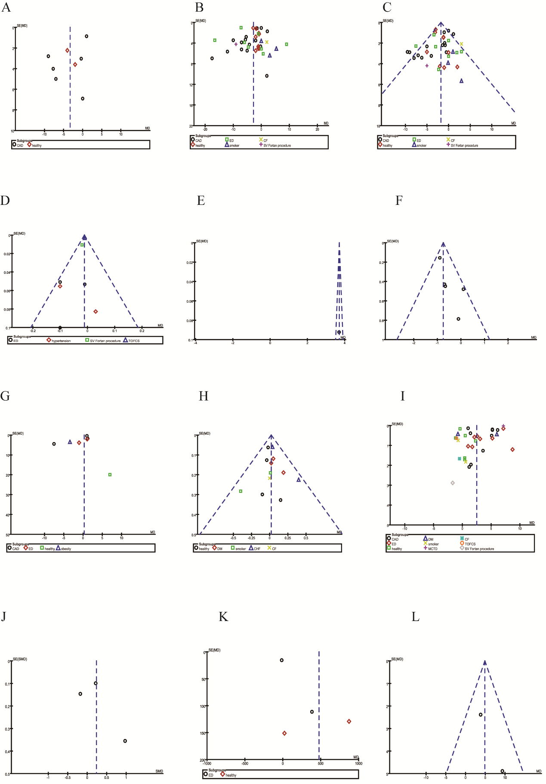
MAP: mean arterial pressure, SBP: systolic blood pressure, DBP: diastolic blood pressure, cIMT: carotid intima-media thickness, PSV: peak systolic velocity, PWV: pulse wave velocity, AI: augmentation index, BAD: brachial artery diameter, FMD: flow-mediated dilation, RHI: reactive hyperemia index, EPCs: endothelial progenitor cells, EMP: endothelial microparticle.

