Supplementary Figure S1: Subgroup analysis of one-year OS: (A) tumor diameter. (B) number of tumors. (C) number of patients. (D) study type.
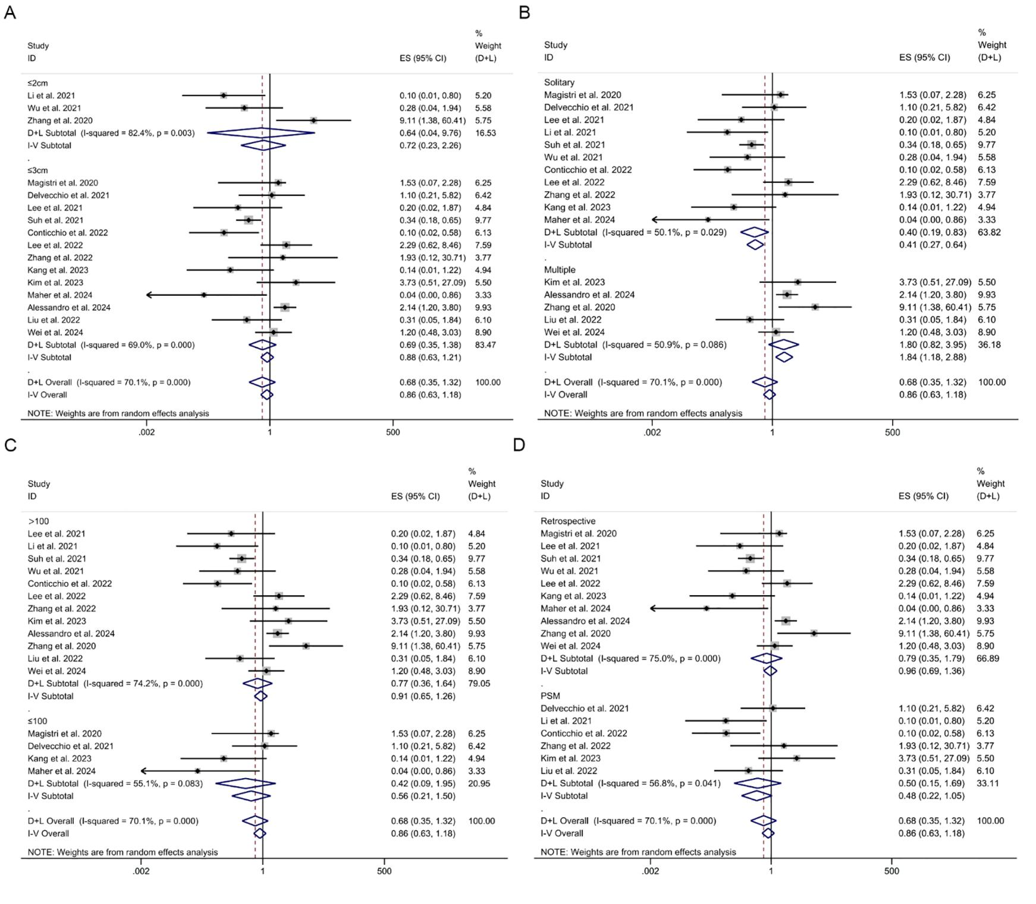

Supplementary Figure S2: Subgroup analysis of three-year OS: (A) tumor diameter. (B) number of tumors. (C) number of patients. (D) study type.
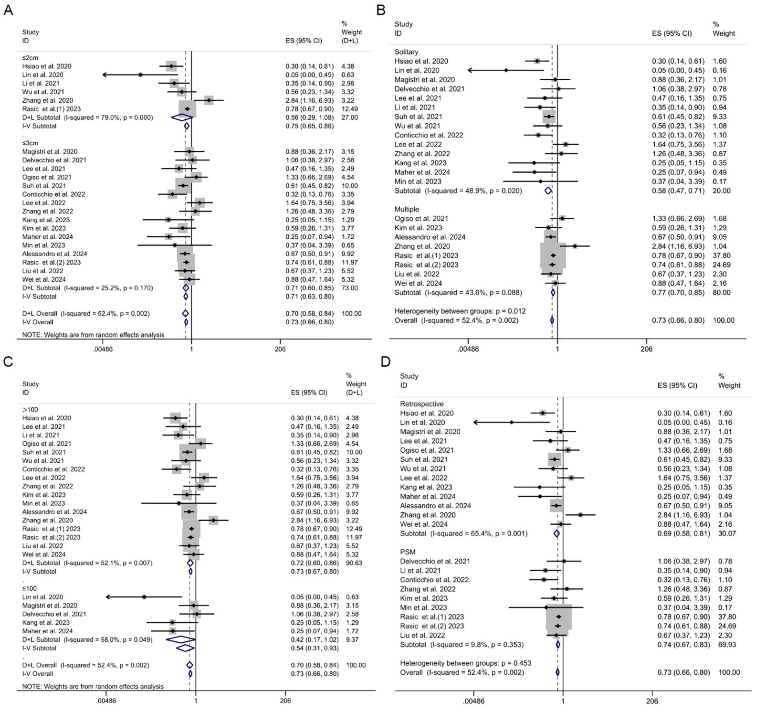

Supplementary Figure S3: Subgroup analysis of five years of (A) tumor diameter. (B) number of tumors. (C) number of patients. (D) study type.
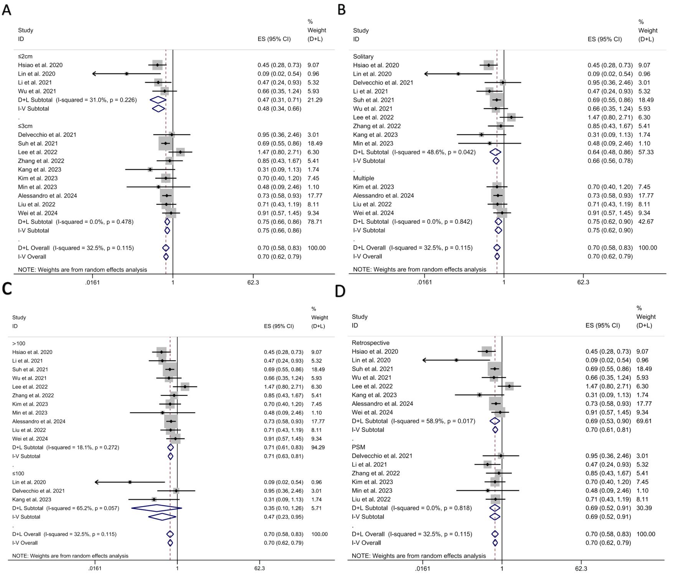

Supplementary Figure S4: Subgroup analysis of one-year RFS: (A) tumor diameter. (B) number of tumors. (C) number of patients. (D) study type.
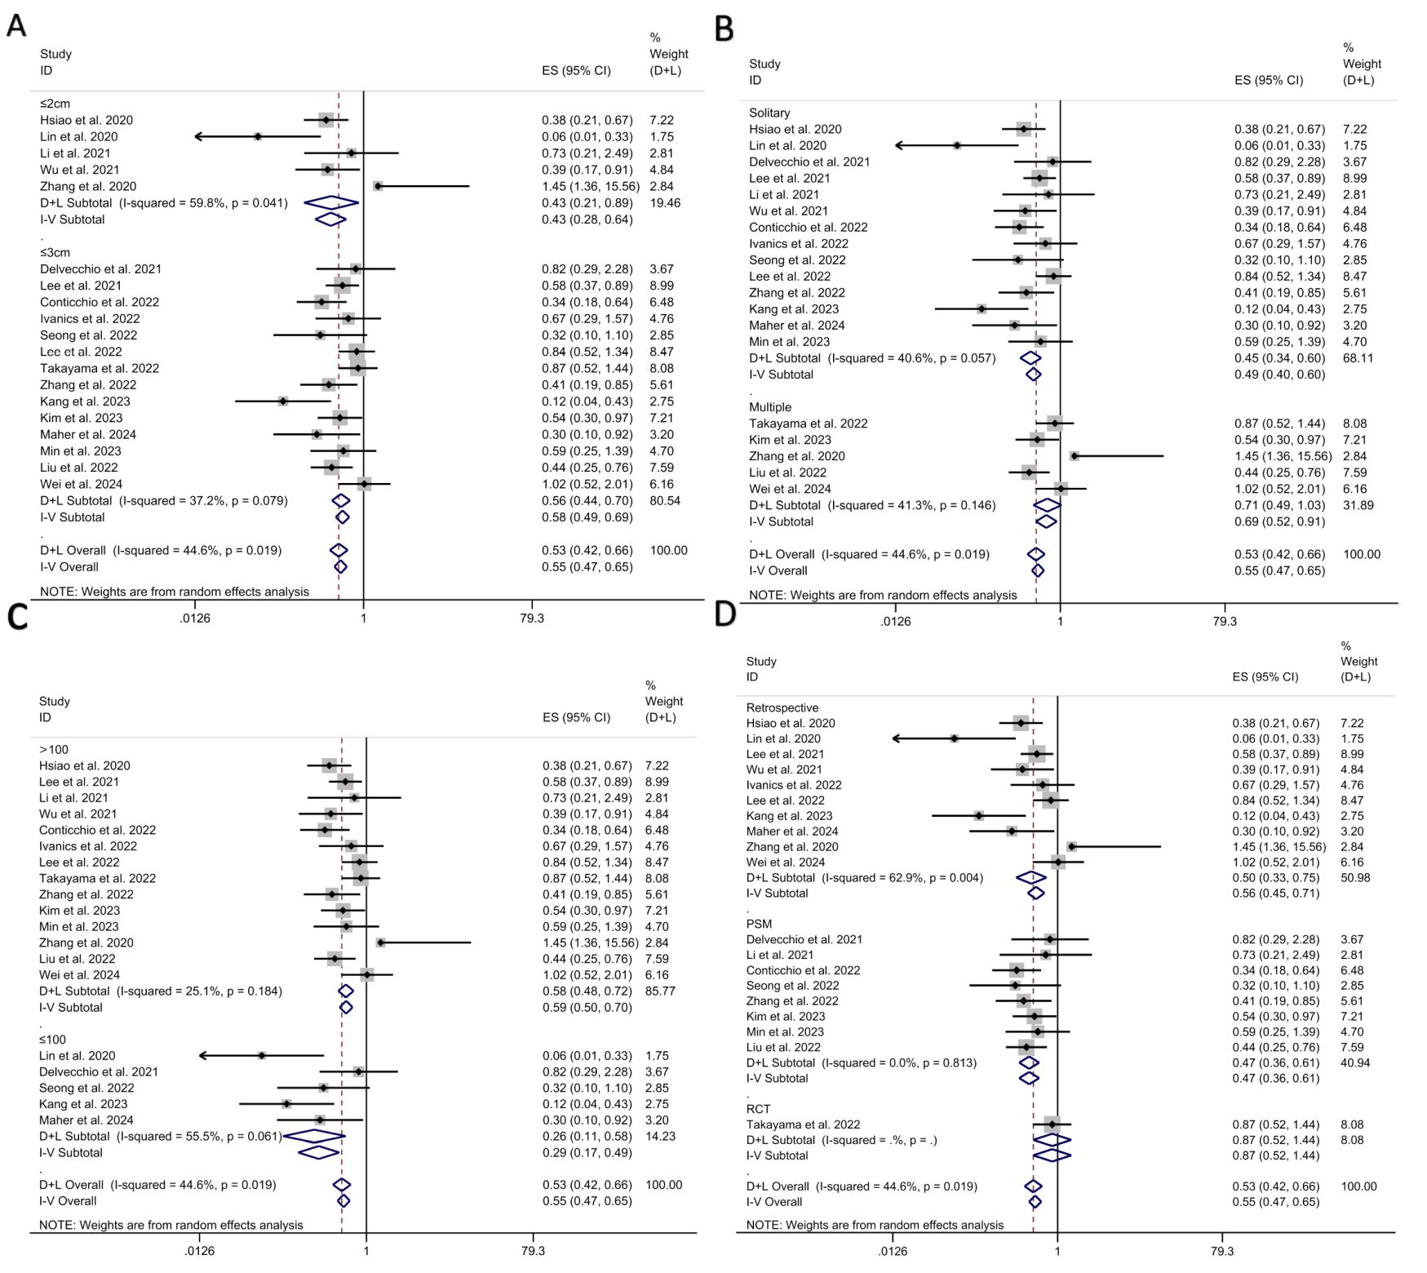

Supplementary Figure S5: Subgroup analysis of three-year RFS: (A) tumor diameter. (B) number of tumors. (C) number of patients. (D) study type.
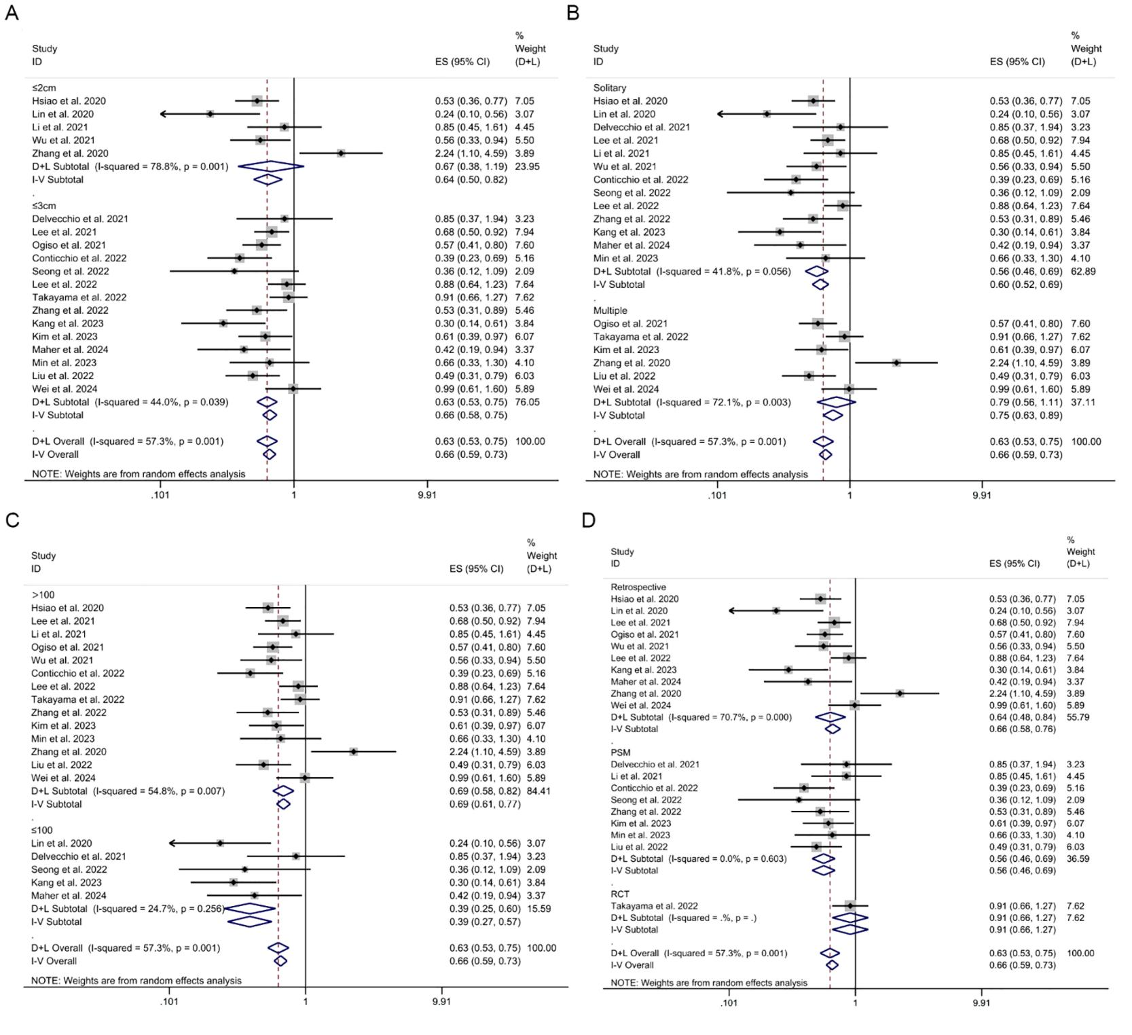

Supplementary Figure S6: Subgroup analysis of five-year RFS: (A) tumor diameter. (B) number of tumors. (C) number of patients. (D) study type.
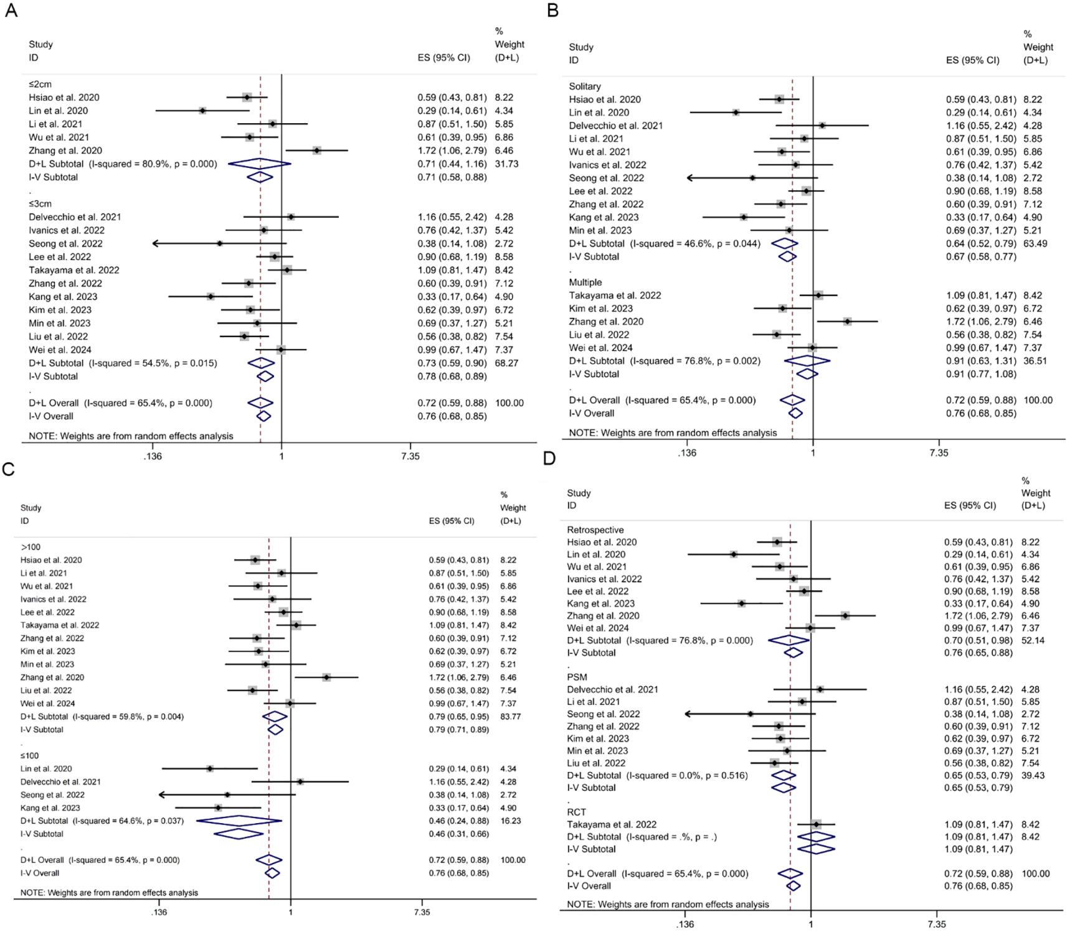

Supplementary Table S1. Risk of Bias Assessment for Included Randomized Controlled Trials via the Cochrane RoB 2.0 Tool
 | D1 | D2 | D3 | D4 | D5 | Overall
Takayama et al.  2022 | Low risk | Low risk | Low risk | Some concerns | Low risk | Some concerns

Supplementary Table S2. Search strategy.
Database | No | PICOS | Strategy | Results
PubMed | #1 | P | ((("Carcinoma, Hepatocellular"[Mesh]) OR ((((((((((((((((((Carcinomas, Hepatocellular[Title/Abstract]) OR (Hepatocellular Carcinomas[Title/Abstract])) OR (Hepatocellular Carcinoma[Title/Abstract])) OR (Hepatoma[Title/Abstract])) OR (Hepatomas[Title/Abstract])) OR (Liver Cancer, Adult[Title/Abstract])) OR (Adult Liver Cancer[Title/Abstract])) OR (Adult Liver Cancers[Title/Abstract])) OR (Cancer, Adult Liver[Title/Abstract])) OR (Cancers, Adult Liver[Title/Abstract])) OR (Liver Cancers, Adult[Title/Abstract])) OR (Liver Cell Carcinoma[Title/Abstract])) OR (Carcinoma, Liver Cell[Title/Abstract])) OR (Carcinomas, Liver Cell[Title/Abstract])) OR (Cell Carcinoma, Liver[Title/Abstract])) OR (Cell Carcinomas, Liver[Title/Abstract])) OR (Liver Cell Carcinomas[Title/Abstract])) OR (Liver Cell Carcinoma, Adult[Title/Abstract]))) | 176519
 | #2 | I | ((((((("Hepatectomy"[Mesh]) OR (Hepatectomies[Title/Abstract])) OR (hepatic resection[Title/Abstract])) OR (surgical resection[Title/Abstract])) OR (resection[Title/Abstract])) OR (liver surgery[Title/Abstract])) OR (Partial hepatectomy[Title/Abstract]))) | 390869
 | #3 | C | ((((((((("Radiofrequency Ablation"[Mesh]) OR (Ablation, Radiofrequency[Title/Abstract])) OR (Radio-Frequency Ablation[Title/Abstract])) OR (Ablation, Radio-Frequency[Title/Abstract])) OR (Radio Frequency Ablation[Title/Abstract])) OR (Ablation, Radio Frequency[Title/Abstract])) OR (RFA[Title/Abstract])) OR (ablation[Title/Abstract])) OR (radiofrequency[Title/Abstract])) | 154764
 | #4 | O | NA
 | #5 | S | ("2020"[dp] : "2024"[dp]) | 7310470
 | #6 = #1AND#2 AND#3 AND#5 | NA | (((("Carcinoma, Hepatocellular"[Mesh]) OR ((((((((((((((((((Carcinomas, Hepatocellular[Title/Abstract]) OR (Hepatocellular Carcinomas[Title/Abstract])) OR (Hepatocellular Carcinoma[Title/Abstract])) OR (Hepatoma[Title/Abstract])) OR (Hepatomas[Title/Abstract])) OR (Liver Cancer, Adult[Title/Abstract])) OR (Adult Liver Cancer[Title/Abstract])) OR (Adult Liver Cancers[Title/Abstract])) OR (Cancer, Adult Liver[Title/Abstract])) OR (Cancers, Adult Liver[Title/Abstract])) OR (Liver Cancers, Adult[Title/Abstract])) OR (Liver Cell Carcinoma[Title/Abstract])) OR (Carcinoma, Liver Cell[Title/Abstract])) OR (Carcinomas, Liver Cell[Title/Abstract])) OR (Cell Carcinoma, Liver[Title/Abstract])) OR (Cell Carcinomas, Liver[Title/Abstract])) OR (Liver Cell Carcinomas[Title/Abstract])) OR (Liver Cell Carcinoma, Adult[Title/Abstract]))) AND ((((((("Hepatectomy"[Mesh]) OR (Hepatectomies[Title/Abstract])) OR (hepatic resection[Title/Abstract])) OR (surgical resection[Title/Abstract])) OR (resection[Title/Abstract])) OR (liver surgery[Title/Abstract])) OR (Partial hepatectomy[Title/Abstract]))) AND ((((((((("Radiofrequency Ablation"[Mesh]) OR (Ablation, Radiofrequency[Title/Abstract])) OR (Radio-Frequency Ablation[Title/Abstract])) OR (Ablation, Radio-Frequency[Title/Abstract])) OR (Radio Frequency Ablation[Title/Abstract])) OR (Ablation, Radio Frequency[Title/Abstract])) OR (RFA[Title/Abstract])) OR (ablation[Title/Abstract])) OR (radiofrequency[Title/Abstract]))) AND (("2020"[dp] : "2024"[dp])) | 875
Embase | #1 | P | 'liver cell carcinoma'/exp OR 'carcinoma, hepatocellular':ab, ti OR 'carcinomas hepatocellular':ab, ti OR 'hepatocellular carcinomas':ab, ti OR 'hepatocellular carcinoma':ab, ti OR 'hepatoma':ab, ti OR 'hepatomas':ab, ti OR 'liver cancer, adult':ab, ti OR 'adult liver cancer':ab, ti OR 'adult liver cancers':ab, ti OR 'cancer, adult liver':ab, ti OR 'cancers, adult liver':ab, ti OR 'liver cancers, adult':ab, ti OR 'liver cell carcinoma':ab, ti OR 'carcinoma, liver cell':ab, ti OR 'carcinomas, liver cell':ab, ti OR 'cell carcinoma, liver':ab, ti OR 'cell carcinomas, liver':ab, ti OR 'liver cell carcinomas':ab, ti OR 'liver cell carcinoma, adult':ab, ti | 266658
 | #2 | I | 'hepatectomy'/exp OR 'hepatectomies':ab, ti OR 'hepatic resection':ab, ti OR 'surgical resection':ab, ti OR 'resection':ab, ti OR 'liver surgery':ab, ti OR 'partial hepatectomy':ab, ti | 577332
 | #3 | C | 'radiofrequency ablation'/exp OR 'ablation, radiofrequency':ab, ti OR 'radio-frequency ablation':ab, ti OR 'ablation, radio-frequency':ab, ti OR 'radiofrequency ablation':ab, ti OR 'ablation, radiofrequency':ab, ti OR 'rfa':ab, ti OR 'ablation':ab, ti OR 'radiofrequency':ab, ti | 226257
 | #4 | O | NA
 | #5 | S | [2020-2024]/py | 8635707
 | #6 = #1 AND #2 AND #3 AND #5 | NA |  | 1118
Cochrane | #1 |  | MeSH descriptor: [Carcinoma, Hepatocellular] explode all trees | 2730
 | #2 |  | (Carcinoma, Hepatocellular):ti, ab, kw OR (Carcinomas, Hepatocellular):ti, ab, kw OR (Hepatocellular Carcinomas):ti, ab, kw OR (Hepatocellular Carcinoma):ti, ab, kw OR (Hepatoma):ti, ab, kw OR (Hepatomas):ti, ab, kw OR (Liver Cancer, Adult):ti, ab, kw OR (Adult Liver Cancer):ti, ab, kw OR (Adult Liver Cancers):ti, ab, kw OR (Cancer, Adult Liver):ti, ab, kw OR (Cancers, Adult Liver):ti, ab, kw OR (Liver Cancers, Adult):ti, ab, kw OR (Liver Cell Carcinoma):ti, ab, kw OR (Carcinoma, Liver Cell):ti, ab, kw OR (Carcinomas, Liver Cell):ti, ab, kw OR (Cell Carcinoma, Liver):ti, ab, kw OR (Cell Carcinomas, Liver):ti, ab, kw OR (Liver Cell Carcinomas):ti, ab, kw OR (Liver Cell Carcinoma, Adult):ti, ab, kw | 12157
 | #3 |  | #1 OR #2 | 12157
 | #4 |  | MeSH descriptor: [Hepatectomy] explode all trees | 961
 | #5 |  | (Hepatectomy):ti, ab, kw OR (Hepatectomies):ti, ab, kw OR (hepatic resection):ti, ab, kw OR (surgical resection):ti, ab, kw OR (resection):ti, ab, kw OR (liver surgery):ti, ab, kw OR (Partial hepatectomy):ti, ab, kw | 37166
 | #6 |  | #4 OR #5 | 37166
 | #7 |  | MeSH descriptor: [Hepatectomy] explode all trees | 961
 | #8 |  | (radiofrequency ablation):ti, ab, kw OR (Ablation, Radiofrequency):ti, ab, kw OR (Radio-Frequency Ablation):ti, ab, kw OR (Ablation, Radio-Frequency):ti, ab, kw OR (Radio Frequency Ablation):ti, ab, kw OR (Ablation, Radio Frequency):ti, ab, kw OR (RFA):ti, ab, kw OR (ablation):ti, ab, kw OR (radiofrequency):ti, ab, kw | 13533
 | #9 |  | #7 OR #8 | 14429
 | #10 |  | Publication Year from 2020 to 2024 | 3825
 | #11 |  | #3 AND #6 AND #9 AND #10 | 648
Web of Science | #1 | P | TS=(Carcinoma, Hepatocellular or Carcinomas, Hepatocellular or Hepatocellular Carcinomas or Hepatocellular Carcinoma or Hepatoma or Hepatomas or Liver Cancer, Adult or Adult Liver Cancer or Adult Liver Cancers or Cancer, Adult Liver or Cancers, Adult Liver or Liver Cancers, Adult or Liver Cell Carcinoma or Carcinoma, Liver Cell or Carcinomas, Liver Cell or Cell Carcinoma, Liver or Cell Carcinomas, Liver or Liver Cell Carcinomas or Liver Cell Carcinoma, Adult) | 194673
 | #2 | I | TS=(Hepatectomy or hepatectomy or Hepatectomies or hepatic resection or surgical resection or resection or liver surgery or Partial hepatectomy) | 437706
 | #3 | C | TS=(radiofrequency ablation or Ablation, Radiofrequency or Radio-Frequency Ablation or Ablation, Radio-Frequency or Radio Frequency Ablation or Ablation, Radio Frequency or RFA or ablation or radiofrequency) | 268210
 | #4 | O | NA
 | #5 | S | PY=(2020-2024) | 16557942
 | #6 = #1 AND #2 AND #3 AND #5 | NA |  | 1932

Abbreviations: NA, not applicable

Supplementary Table S3. Reasons for the exclusion of literature.
Exclusion | Reason | Number | Description
 | Reports not retrieved | 5
Excluded title | Duplicate literature | 1192
 | Case report | 144
 | Meta-analysis | 78
Excluded abstract | Animal research | 5
 | Review/comment | 619
 | Content irrelevant | 2349
 | Basic research | 32
Excluded full text | Data not available | 2
 | Conference Abstract | 89
 | No data on outcome of interest | 12
 | Not complete data | 21
All exclusion | Total | 4548

Supplementary Table S4. PRISMA checklist.
Section/topic | # | Checklist item | Reported on page #
TITLE
Title | 1 | Identify the report as a systematic review, meta-analysis, or both. | 1
ABSTRACT
Structured summary | 2 | Provide a structured summary including as applicable: background; objectives; data sources; study eligibility criteria, participants, and interventions; study appraisal and synthesis methods; results; limitations; conclusions and implications of key findings; systematic review registration number. | 2
INTRODUCTION
Rationale | 3 | Describe the rationale for the review in the context of what is already known. | 3
Objectives | 4 | Provide an explicit statement of questions being addressed with reference to participants, interventions, comparisons, outcomes, and study design (PICOS). | 3
METHODS
Protocol and registration | 5 | Indicate if a review protocol exists, if and where it can be accessed (e.g., Web address), and, if available, provide registration information including registration number. | 4
Eligibility criteria | 6 | Specify study characteristics (e.g., PICOS, length of follow-up) and report characteristics (e.g., years considered, language, publication status) used as criteria for eligibility, giving rationale. | 5
Information sources | 7 | Describe all information sources (e.g., databases with dates of coverage, contact with study authors to identify additional studies) in the search and date last searched. | 4
Search | 8 | Present full electronic search strategy for at least one database, including any limits used, such that it could be repeated. | 5
Study selection | 9 | State the process for selecting studies (i.e., screening, eligibility, included in systematic review, and, if applicable, included in the meta-analysis). | 5
Data collection process | 10 | Describe method of data extraction from reports (e.g., piloted forms, independently, in duplicate) and any processes for obtaining and confirming data from investigators. | 5
Data items | 11 | List and define all variables for which data were sought (e.g., PICOS, funding sources) and any assumptions and simplifications made. | 5
Risk of bias in individual studies | 12 | Describe methods used for assessing risk of bias of individual studies (including specification of whether this was done at the study or outcome level), and how this information is to be used in any data synthesis. | 6
Summary measures | 13 | State the principal summary measures (e.g., risk ratio, difference in means). | 6
Synthesis of results | 14 | Describe the methods of handling data and combining results of studies, if done, including measures of consistency (e.g., I²) for each meta-analysis. | 6

Page 1 of 2

Section/topic | # | Checklist item | Reported on page #
Risk of bias across studies | 15 | Specify any assessment of risk of bias that may affect the cumulative evidence (e.g., publication bias, selective reporting within studies). | 7
Additional analyses | 16 | Describe methods of additional analyses (e.g., sensitivity or subgroup analyses, meta-regression), if done, indicating which were prespecified. | 7
RESULTS
Study selection | 17 | Give numbers of studies screened, assessed for eligibility, and included in the review, with reasons for exclusions at each stage, ideally with a flow diagram. | 7
Study characteristics | 18 | For each study, present characteristics for which data were extracted (e.g., study size, PICOS, follow-up period) and provide the citations. | 7
Risk of bias within studies | 19 | Present data on risk of bias of each study and, if available, any outcome level assessment (see item 12). | 10
Results of individual studies | 20 | For all outcomes considered (benefits or harms), present, for each study: (a) simple summary data for each intervention group (b) effect estimates and confidence intervals, ideally with a forest plot. | 7
Synthesis of results | 21 | Present results of each meta-analysis done, including confidence intervals and measures of consistency. | 7
Risk of bias across studies | 22 | Present results of any assessment of risk of bias across studies (see Item 15). | 10
Additional analysis | 23 | Give results of additional analyses, if done (e.g., sensitivity or subgroup analyses, meta-regression [see Item 16]). | 10
DISCUSSION
Summary of evidence | 24 | Summarize the main findings including the strength of evidence for each main outcome; consider their relevance to key groups (e.g., healthcare providers, users, and policy makers). | 11
Limitations | 25 | Discuss limitations at study and outcome level (e.g., risk of bias), and at review-level (e.g., incomplete retrieval of identified research, reporting bias). | 13
Conclusions | 26 | Provide a general interpretation of the results in the context of other evidence, and implications for future research. | 14
FUNDING
Funding | 27 | Describe sources of funding for the systematic review and other support (e.g., supply of data); role of funders for the systematic review. | 14

From: Moher D, Liberati A, Tetzlaff J, Altman DG, The PRISMA Group (2009). Preferred Reporting Items for Systematic Reviews and Meta-Analyses: The PRISMA Statement. PLoS Med 6(7): e1000097. doi:10.1371/journal.pmed1000097
For more information, visit: www.prisma-statement.org.
Page 2 of 2

