Supplementary Results
Secondary endpoint: intraoperative core temperature at prespecified time points
At 30 min after anesthesia induction
Of the 16 studies (972 patients) that measured core temperature 30 min after anesthesia induction, five studies [75-77,85,90] were disconnected from the network (Supplementary Fig. 2E) and thus excluded from the NMA. Consequently, the analysis included 11 studies (610 patients).
As shown in Fig. 2E, although all nine warming management strategies (nodes) were connected to the network, two (control and HH) were more directly comparable with the other seven nodes. We observed no evidence of network inconsistency [χ² (2) = 1.16, P = 0.559]. Twelve closed triangular loops were present in the network based on the comparison of the temperatures at 30 min.
Eight loops (Con/H-stat/PI, Con/H-stat/FAW, Con/PI/FAW, HH/H-stat/PI, HH/H-stat/FAW, HH/PI/FAW, H-stat/PI/FAW [84], and HH/MAK/HH + IV [74]) were formed only in multi-arm trials. We observed no evidence of significant local inconsistencies between the direct and indirect point estimates (Fig. 3E).
HH, PI, HH + IV, HME + FAW, and MAK showed higher temperatures than the controls in terms of 95% CIs (Fig. 4E). Based on the SUCRA values in Fig. 5E, the temperature at this time point was the highest for MAK (96.4%), followed by HME + FAW (86.6%), HH + IV (69.8%), and PI (57.7%). The comparison-adjusted funnel plots were symmetrical around the zero line, suggesting a less likely publication bias (Fig. 6E).

At 90 min after anesthesia induction
Although 14 studies (759 patients) measured core temperatures 90 min after anesthesia induction, three [75-77] were separated from the network loops (Supplementary Fig. 2F). After excluding these studies from the NMA, 11 studies (517 patients) were included in the analysis.
Although all nine warming management strategies (nodes) were connected to the network, two (control and HH) were more directly comparable with the other seven nodes (Fig. 2F). We observed no evidence of network inconsistency [χ² (2) = 1.38, P = 0.502]. Twelve closed triangular loops were present in the network based on the comparison of the temperatures at 90 min. Eight loops (Con/H-stat/PI, Con/H-stat/FAW, Con/PI/FAW, HH/H-stat/PI, HH/H-stat/FAW, HH/PI/FAW, H-stat/PI/FAW [84], HH/MAK/HH + IV [74]) were formed only in multi-arm trials. We observed no evidence of significant local inconsistencies between the direct and indirect point estimates (Fig. 3F).
HH, FAW, HH + IV, HME + FAW, and MAK showed higher temperatures than the controls only in terms of the 95% CI (Fig. 4F). According to the SUCRA value in Fig. 5F, the temperature at 90 min was the highest in MAK (93.8%), followed by HME + FAW (85.9%), HH + IV (64.7%), and FAW (64.3%). The comparison-adjusted funnel plots indicated a low probability of publication bias (Fig. 6F).

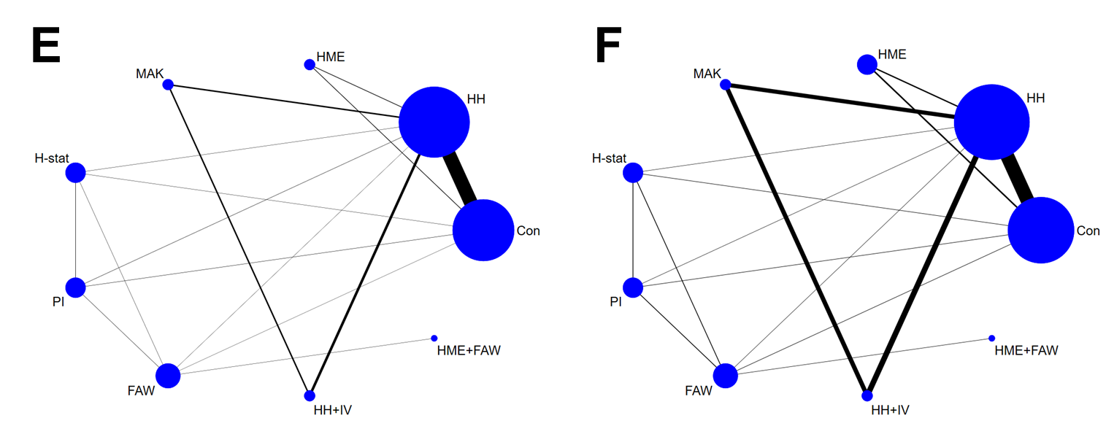
Figure 2. Network plots illustrating all relevant comparisons included in the analysis, with disconnected loops excluded, for each timepoint: at 30 (E) and 90 (F) min after anesthesia induction.

The nodes show each warming strategy, and the edges show the available direct comparisons among these strategies. The nodes and edges are weighted according to the number of patients and the inverse of the standard error of the effect. Con, control; HH, heated humidifier; HME, heat and moisture exchanger; MAK, Mega Acer Kit; H-stat, humidistat; PI, passive insulation; IV, intravenous fluid warmer; WM, water mattress; FAW, forced air warmer.

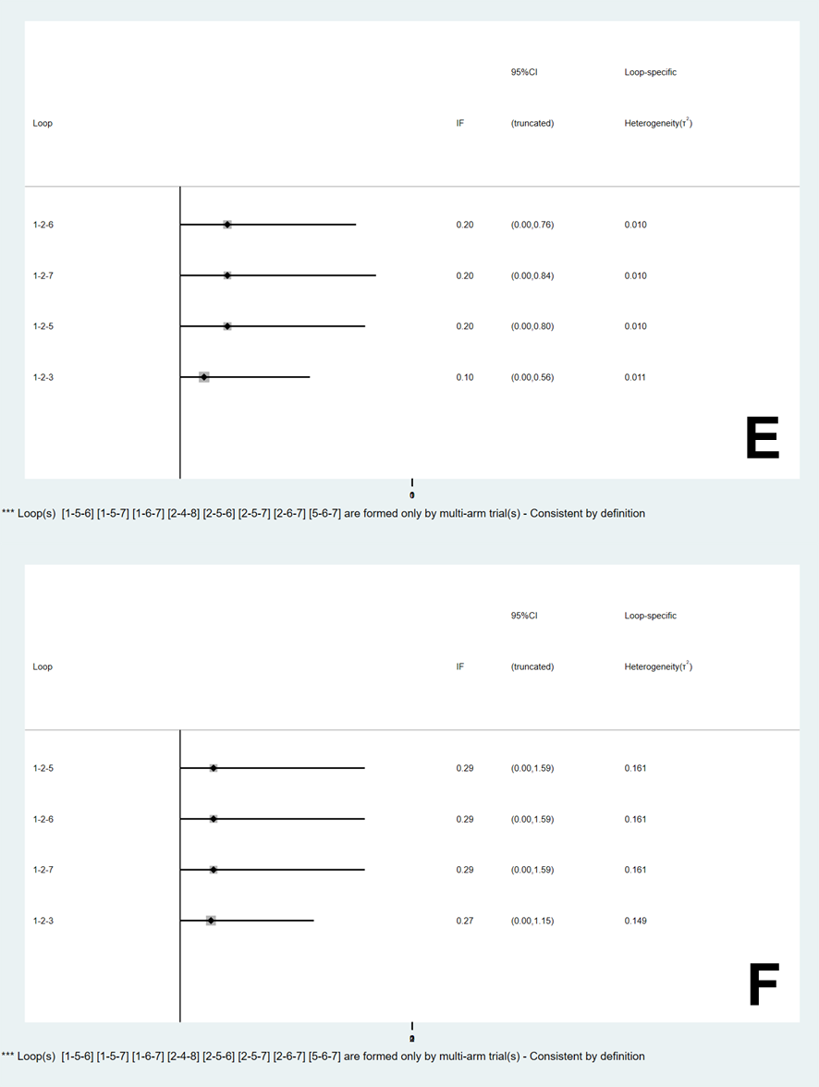
Figure 3. Inconsistency plots comparing the direct and indirect effect estimates for each comparison at 30 (E) and 90 (F) min after anesthesia induction.

The inconsistency factor (IF), presented as the absolute difference between the direct and indirect estimates with a 95% confidence interval (CI), is shown for each comparison. IF values close to 0 indicate a good agreement between the two sources.

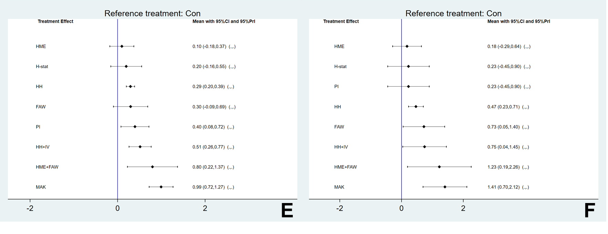
Figure 4. Confidence intervals (CI) and predictive intervals (PrI) for each intervention compared with the control at 30 (E) and 90 (F) min after anesthesia induction.

Solid black lines: CIs for each comparison; blue vertical line: no effect (mean difference = 0). Con, control; HH, heated humidifier; HME, heat and moisture exchanger; MAK, Mega Acer Kit; H-stat, humidistat; PI, passive insulation; IV, intravenous fluid warmer; WM, water mattress; FAW, forced air warmer.

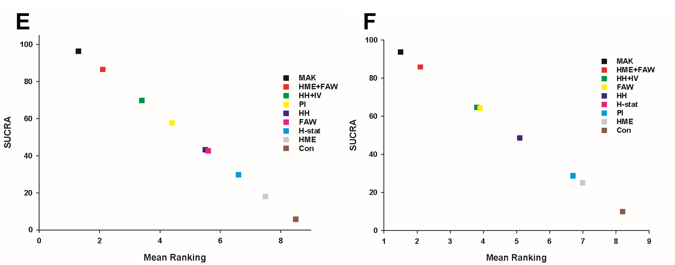
Figure 5. Expected mean rankings and surface under the cumulative ranking curve (SUCRA) values from the frequentist model for each intervention at 30 (E) and 90 (F) min after anesthesia induction.

Y-axis: SUCRA values; X-axis: corresponding expected mean rankings. Con, control; HH, heated humidifier; HME, heat and moisture exchanger; MAK, Mega Acer Kit; H-stat, humidistat; PI, passive insulation; IV, intravenous fluid warmer; WM, water mattress; FAW, forced air warmer.

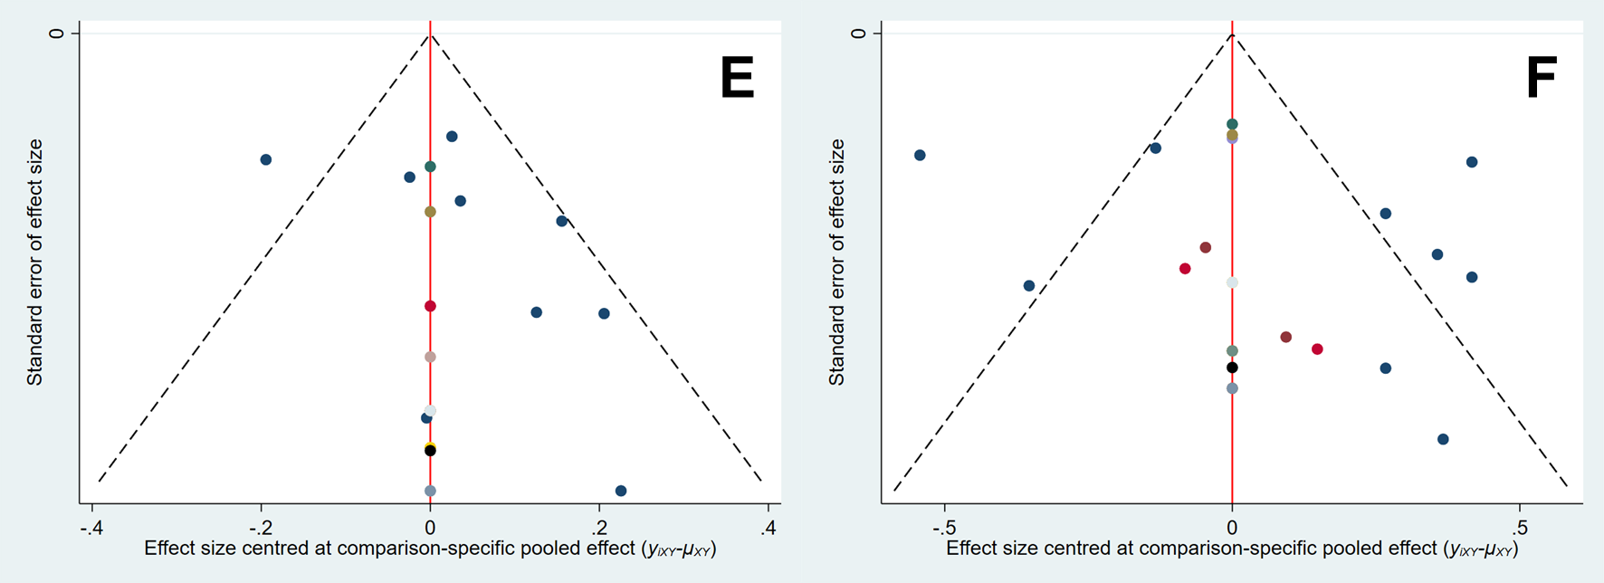
Figure 6. Comparison-adjusted funnel plots for each timepoint: at 30 (E) and 90 (F) min after anesthesia induction.

A symmetrical distribution around the zero line indicates a low risk of publication bias.

Figure 7. Comparison of the surface under the cumulative ranking curve (SUCRA) values derived from the Bayesian and frequentist models for each timepoint: at 30 (E) and 90 (F) min after anesthesia induction.
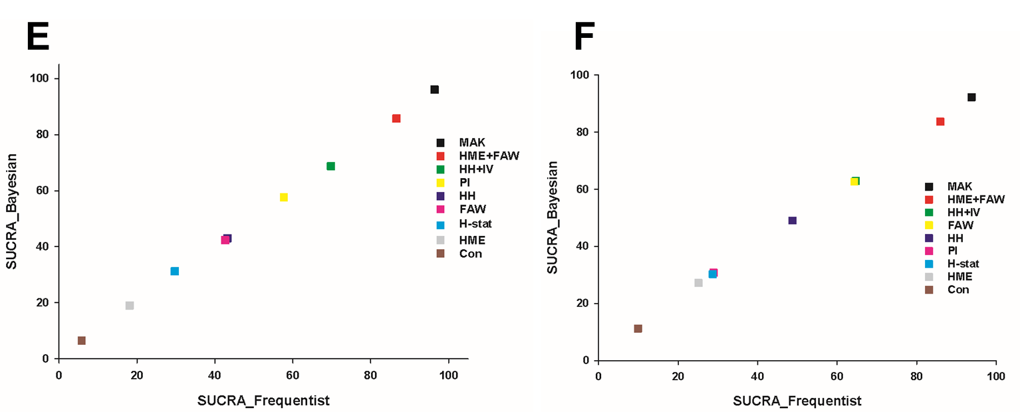
X-axis: SUCRA values from the frequentist model; Y-axis: SUCRA values from the Bayesian model. Con, control; HH, heated humidifier; HME, heat and moisture exchanger; MAK, Mega Acer Kit; H-stat, humidistat; PI, passive insulation; IV, intravenous fluid warmer; WM, water mattress; FAW, forced air warmer.

