Additional file 2. Additional material for key question 1

Table of Contents
Additional details on KQ1 methods 4
Figure S2.1 KQ1 Literature flow diagram 7
Additional Details on KQ1 Study Characteristics 8
Detailed results for KQ1 Important outcomes 9
Detailed Results for Targeted Screening Strategies 15
Table S2.1 Characteristics of the trials on benefits and harms of screening for lung cancer with computed tomography 17
Table S2.2. Characteristics table, observational studies and trials without benefit data 26
Table S2.3. Risk of bias (comparative outcomes in trials): Mortality, overdiagnosis, HRQoL, and psychosocial consequences, 1-step CT screening 58
Table S2.4. Risk of bias: Harms (screening arm only), trials 63
Table S2.5. Risk of bias: Observational harms studies, case series 75
Table S2.6. Risk of bias: Observational harms studies, cohort 94
Table S2.7 CT screening: Critical outcome sensitivity and subgroup analyses 95
Figure S2.2 Lung cancer mortality, sensitivity analysis excluding high ROB studies (DANTE trial) 106
Figure S2.3 Lung cancer mortality, by comparator strategy 107
Figure S2.4 Lung cancer mortality, by number of screening rounds 108
Figure S2.5 Lung cancer mortality, by screening interval 109
Figure S2.6 Lung cancer mortality, by 6-year lung cancer detection rate in comparator (≤2% vs >2%) 110
Figure S2.7 Lung cancer mortality, by 6-year lung cancer detection rate in comparator (≤3% vs >3%) 111
Figure S2.8 Lung cancer mortality, by nodule management strategy 112
Figure S2.9 Lung cancer mortality, by sex 113
Figure S2.10 Lung cancer mortality, within study ratio of ratios by sex 114
Figure S2.11 All-cause mortality, sensitivity analysis excluding high ROB studies (DANTE trial) 115
Figure S2.12 All-cause mortality, by comparator strategy 116
Figure S2.13 All-cause mortality, by number of screening rounds 117
Figure S2.14 All-cause mortality, by screening interval 118
Figure S2.15 All-cause mortality, by 6-year lung cancer detection rate in comparator (≤2% vs >2%) 119
Figure S2.16 All-cause mortality, by 6-year lung cancer detection rate in comparator (≤3% vs >3%) 120
Figure S2.17 All-cause mortality, by nodule management strategy 121
Figure S2.18 All-cause mortality, by sex 122
Figure S2.19 All-cause mortality, within study ratio of ratios by sex 123
Figure S2.20 Overdiagnosis, sensitivity analysis excluding high ROB studies and those with an X-ray screen at baseline (DANTE trial) 124
Figure S2.21 Overdiagnosis, by number of screening rounds 125
Figure S2.22 Overdiagnosis, by screening interval 126
Figure S2.23 Overdiagnosis, by 6-year lung cancer detection rate in comparator (≤2% vs >2%) 127
Figure S2.24 Overdiagnosis, by 6-year lung cancer detection rate in comparator (≤3% vs >3%) 128
Figure S2.25 Overdiagnosis, by sex 129
Figure S2.26 Overdiagnosis, within study ratio of ratios by sex 130
Table S2.8 Additional overdiagnosis definitions and findings 131
Table S2.9 CT screening: Summary of findings for important outcomes 132
Figure S2.27 Proportion with a false positive at round 1 148
Figure S2.28 Proportion with a false positive over 2/3 rounds 149
Figure S2.29 Proportion with a false positive over 4/5 rounds 150
Figure S2.30 Proportion with incidental findings at round 1 151
Figure S2.31 Proportion with incidental findings over 2/3 rounds 152
Figure S2.32 Proportion with incidental findings over 4/5 rounds 153
Figure S2.33 Proportion with clinically significant incidental findings at round 1 154
Figure S2.34 Proportion with clinically significant incidental findings over 2/3 rounds 155
Figure S2.35 Proportion with clinically significant incidental findings over 4/5 rounds 156
Figure S2.36 Proportion with major complications from invasive testing at round 1 157
Figure S2.37 Proportion with major complications from invasive testing over 2/3 rounds 158
Figure S2.38 Proportion with major complications from invasive testing over 4/5 rounds 159
Figure S2.39 Proportion with major complications from invasive testing among false positives at round 1 160
Figure S2.40 Proportion with major complications from invasive testing among false positives over 2/3 rounds 161
Figure S2.41 Proportion with major complications from invasive testing among false positives over 4/5 rounds 162
Figure S2.42 Proportion of deaths from invasive testing among false positives at round 1 163
Figure S2.43 Proportion of deaths from invasive testing among false positives over 2/3 rounds 164
Figure S2.44 Proportion of deaths from invasive testing among false positives over 4/5 rounds 165
Table S2.10 CT screening: Important outcomes sensitivity and subgroup analyses 166
Table S2.11 Additional harms outcome data 171
Table S2.12 Targeted CT screening: Summary of findings for benefit outcomes 175
Figure S2.45 Lung cancer mortality, ECLS trial 177
Figure S2.46 Lung cancer mortality, LungSEARCH trial 177
Figure S2.47 All-cause mortality, ECLS trial 177
Figure S2.48 All-cause mortality, LungSEARCH trial 178
Comparison with previous review 179
References 180

Additional details on KQ1 methods

Data extraction
For mortality outcomes and overdiagnosis, per protocol we used crude data on the cumulative number of events from the longest follow-up time point unless there was substantial contamination after a previous time point (>20% in the no screening group receiving screening). Because of poor reporting on contamination, we revised this to be based on overall risk of bias for the outcome (i.e., used longest follow-up unless a shorter follow-up had lower risk of bias). For incidence (cumulative detection from baseline) rates, used when calculating overdiagnosis, we required follow-up beyond the active phase of screening and a control group receiving no screening (vs. chest X-ray). For HRQoL, we extracted the mean baseline and endpoint or change scores (at longest follow-up without substantial contamination), standard deviations (SDs), or other measures of variability, and the number analyzed in each group.
All other outcomes (except in some cases for psychosocial harms) are reported only for those receiving screening; very few, if any, studies reported on these outcomes among the no screening arms, and risks among those receiving chest X-ray were not of interest. Our protocol stated that for binary events that could occur more than once we would use a hierarchy, prioritizing proportions (i.e., the proportion of individuals having one or more events) over events (i.e., the number of events across individuals). For more meaningful interpretation and because many studies reported both results, we revised our methods to keep these outcomes separate but considered the proportion data for our main conclusions. Further, because most of the non-randomized studies only reported on results of one round of screening, we used data after one round in addition to that across rounds from the RCTs.
For the outcome of major complications (defined through clinical input rather than as reported by study authors) from invasive testing as a result of screening, we captured events among those who later received a negative diagnosis (FPs) as well as for anyone receiving invasive testing (i.e., those with lung cancer and FPs). For incidental findings, we captured all incidental findings and clinically significant incidental findings, as well as several specific incidental findings of interest to the working group. Apart from specific incidental findings, studies were required to report findings in at least two different body systems to reduce the possibility of selective outcome reporting.
For FPs and psychosocial harms from screening, we examined results for i) anyone receiving a recommendation for early recall (e.g., indeterminate result with repeat CT screening at 3 or 6 months) or for a diagnostic follow-up (e.g., result suspicious of lung cancer) as well as ii) only those recommended to have diagnostic follow-up. Because screening results can take many months to resolve, even though we required at least 6 months’ follow-up after screening we made sure to record the proportion of individuals with a positive screening test that had diagnostic resolution, for consideration in our risk of bias assessment. For psychosocial harms, we extracted the mean baseline and endpoint or change scores, standard deviations (SDs) or other measures of variability, and the number analyzed (by group if a control group was used). Results considered consistent with the outcome of psychosocial harms included data from patient-reported outcome measurements of symptoms of anxiety, depression, distress, and concern about lung cancer. In cases where composite scores meeting these concepts were available, we used these and not subscales. Single-question items were not eligible. Subscales of overall HRQoL scales (e.g., mental health) were considered to measure psychosocial harm if other tools measuring the same symptoms were not reported. For this outcome we extracted data at all reported time points during the active phase of screening to primarily capture these harms from undertaking screening itself and from receiving a FP result. For data from non-randomized studies (including subgroup analysis from RCTs), we relied, when possible, on results adjusted for potential confounders.
Across KQs
For missing results data for any outcome, including additional information on interventions, exposures (e.g., contents of decision aids in KQ2 studies), or measures of variance, we contacted authors by email with two reminders over 1 month. If variance measures were not reported or obtained from authors, we computed missing SDs or standard errors (SEs) from other study data, or as a last resort, imputed based on other studies in the review. When computing SDs for change from baseline values, we assumed a correlation of 0.5 (1), unless other information was present in the study that allowed us to compute it more precisely. We used available software (i.e., Plot Digitizer, http://plotdigitizer.sourceforge.net/) to estimate effects from figures where no numerical values were provided.
Data analysis
The decision to pool studies was not based solely on statistical heterogeneity; the I² statistic was reported, but it is recognized that the I² is influenced by the number of studies and the magnitude and direction of effects (2). Rather, we relied on interpretations of the clinical and methodological differences between studies.
Unit of analysis issues
There were no cluster-randomized trials, therefore we did not have to account for unit-of-analysis errors when reporting their findings and/or incorporating them into meta-analysis.
Assessment of heterogeneity
For the population, we compared findings based on control event rates for cancer incidence across the studies (above and below 2% and 3% 6-year risk of cancer, assuming rates in a control group would be similar across years when making any calculations). For interventions we used the following variables to create strata: i) comparator (no screening vs. chest X-ray), ii) nodule classification (highly sensitive [>4 mm nodule and no growth accounted for until third round] vs. not highly sensitive [others which had quite similar systems]), iii) number of rounds (1 vs. 2-3 vs. 4-5), and iv) screening interval (only one round vs. annually vs. less than annually).
Reporting bias
When meta-analyses of trials contained at least 10 studies of varying size for comparative outcomes, we planned to test for small study bias (3, 4). We also explored missing outcome bias (i.e., data missing from an analysis due to selective non-reporting by other studies), especially harms data that came from observational studies without a protocol outlining pre-planned outcome measurement. For major complications and deaths from invasive testing, we examined whether at least half of the total sample size of all studies reporting FPs also reported these outcomes, as those attending diagnostic work-up after a positive scan would incur these complications at this time or within a short window of time afterwards.

Identification of studies via databases and trial registries
Identification of studies via databases and trial registries
Identification of studies via other methods
Identification of studies via databases and trial registries

Records identified from:
Systematic reviews and Canadian Task Force review (n = 38)
Snowball searches (n = 34)
Other sources (n = 7)
Records removed before screening:
Duplicate records removed
(n = 6,450)

Records identified from:
EMBASE (n = 10,659)
MEDLINE (n = 5,949)
CENTRAL (n = 1,948)
Cochrane (n = 9)
Total (n = 18,565)

Identification

Records screened
(n = 12,115)
Records excluded
(n = 11,776)

Reports not retrieved
(n = 0)
Reports sought for retrieval
(n = 79)

Reports sought for retrieval
(n = 339)
Reports not retrieved
(n = 0)

Reports assessed for eligibility
(n = 79)
Screening

Reports excluded (n = 23):
Duplicate (n = 4)
Not primary study (n = 1)
No relevant outcome (n = 10)
No exposure of interest (n = 2)
Study design (n = 1)
Cohort study, assoc. publ., no additional data (n = 2)
Trial assoc. publ., no data of interest (n = 3)
Reports excluded (n = 263):
≥25% abnormal screen at baseline (n = 3)
Country (n = 15)
Duplicate (n = 4)
Study design (n = 19)
Wrong exposure/Exposure not LDCT (n = 35)
Language (n = 3)
RCT no benefits or harms (n = 3)
No outcome of interest (n = 48)
Not primary study (n = 22)
Cohort study, assoc. publ., no additional data (n = 5)
Other nodule classification system (n = 17)
Population (n = 14)
Protocol (cohort) (n = 8)
Protocol (RCT) (n = 20)
Trial assoc. publ., no data of interest (n = 36)
Unclear number of screening rounds (n = 5)
Other reasons (n = 6)

Reports assessed for eligibility
(n = 339)

Studies included in review:
(n = 85): 54 studies from database searches; 31 studies from other methods
Reports of included studies:
(n = 132): 76 reports from database searches; 56 reports from other methods

Included

Figure S2.1 KQ1 Literature flow diagram

Additional Details on KQ1 Study Characteristics

Critical outcomes
The mean age across studies was 61.4 years (range 49.5 to 67.7) and the total number of participants was 640,537 (range 72 to 152,918). The average proportion of male participants was 63.0% (range 41.6% to 100%), and among the third of studies reporting on race or ethnicity there was an average of 79.0% Caucasian participants. The largest trial (NLST (5)) enrolled 91% Caucasian, 4.4% Black, and 4.8% “other” individuals. Of the included studies, 39 came from the United States (5-43), nine from the United Kingdom (44-54), seven from Italy (55-61), seven from South Korea (62-68), five from Canada (69-73), three from Poland (74-76), three from multiple countries (77-79), two from Australia (80, 81), two from France (82, 83), and one study each from Denmark (84), Germany (85), Spain (86), Sweden (87), Finland (88), Japan (89), Estonia (90), and Lithuania (91).
Two trials used a chest X-ray comparator at each screening round (5, 9), and six did not offer any form of screening in the control arm (51, 56, 58, 78, 84, 85). One trial offered chest X-ray to both trial arms at baseline (55). Most trials offered smoking cessation regardless of trial allocation. Six trials offered at least 4 rounds of screening (55, 56, 58, 78, 84, 85), two offered 2-3 rounds (5, 9), and one had a single round (51). Of the trials with multiple rounds, a majority screened at 1-year intervals (5, 9, 55, 56, 84, 85) and two screened less frequently (e.g., NELSON screened at baseline then after 1, 2 and 2.5 years) (58, 78). Our estimated 6-year lung-cancer diagnosis rate in the control arm was >2% for eight trials (5, 9, 51, 55, 56, 58, 85), and >3% for four trials (5, 9, 55, 56). Nodule management was considered highly sensitive for the LSS and NLST trials because a positive scan was defined as a non-calcified nodule ≥3mm (at LSS baseline scan) or ≥4mm (NLST, and LSS at round 2), or other findings that were deemed suspicious of lung cancer (5, 9). Additionally, the NLST did not account for nodule growth starting in the second round. The seven other trials used less sensitive criteria with all using larger nodules, and with the exception of the UKLS trial (51), accounted for new nodules or nodule growth starting at round two (55, 56, 58, 78, 84, 85). All trials were eligible for analysis of lung-cancer mortality and all-cause mortality, whereas data from seven trials were used to calculate overdiagnosis (51, 55, 56, 58, 78, 84, 85). The NLST and LSS trials were ineligible for overdiagnosis; they both compared LDCT with chest X-ray, which may have had a small impact on incidence rates, and the LSS did not report cancer incidence after the screening phase.
Important outcomes
We included 11 RCTs (48, 82, 92-100) and 72 observational studies (6-8, 10-45, 47, 52, 54, 57, 59-77, 79-81, 83, 86-91) that reported on at least one of the important outcomes. False positives, incidental findings, major complications and deaths from invasive testing were only extracted for those receiving LDCT, whereas psychosocial harms could be extracted for both groups and HRQoL (a benefit outcome) required data from both arms in RCTs. The eligibility criteria for observational studies were generally similar to the trials, and rarely included individuals at lower risk (never-smokers and individuals under 50 years of age). Mean age across all studies was 61.4 years, and the median sample size was 1,715 (range 72 to 152,918). On average, 63.3% of the participants were male, and across 31 studies reporting race or ethnicity, 19 included ≥80% Caucasian individuals. Other races or ethnicities were rarely reported.

Detailed results for KQ1 Important outcomes

False positives
Data on the proportion of individuals with a FP result (requiring recall for imaging or a diagnostic follow-up) was grouped based on a single round of screening (11 trials, N=48,888 (48, 82, 92-96, 98-101)); 18 observational, N=40,757 (13, 17, 30, 44, 45, 47, 57, 60, 72-75, 80, 81, 83, 86, 88, 102)), or cumulative effects across 2-3 rounds (2 trials, N=28,382 (92, 103); 8 observational, N=55,308 (13, 30, 47, 63, 72, 76, 86, 88)) or 4-5 rounds (2 trials, N=2,877 (55, 101); 1 observational, n=1,267 (20)). Pooled findings for 1, 2-3 and 4-5 rounds of screening were 190 per 1,000 (95% CI, 160 to 220), 310 per 1,000 (95% CI 180 to 440), and 350 per 1,000 (95% CI, 220 to 480), respectively. Findings were similar between trials and observational studies. There was high risk of bias in six studies at the first screening round (17, 44, 74, 83, 92, 94, 101) and both studies over 2-3 rounds (92, 103), though findings were similar when excluding these studies in sensitivity analysis. Subgroups based on study design and nodule management, and within-study subgroups based on age, sex, and risk quintile all surpassed the threshold of effect.
Considering all data, there was high certainty evidence that for people 50-74 years of age who are current or former smokers, screening with LDCT 3-4 times causes at least 75 people to have one or more FP results per 1,000 screened. Our certainty would be moderate for effects up to 225 people per 1,000 after 3-4 rounds because we would have serious concerns about inconsistency among studies. A large majority of FPs only require recall and not invasive diagnostic procedures; though not reported in detail here or assessed for its certainty, the proportions requiring diagnostic follow-up were between 20 and 30 per 1000 screened (e.g., <10% of FPs) from one or across multiple rounds (Table S2.11).
Incidental findings
At round 1, no trials and 13 observational studies (N=14,549 (11, 14, 17, 18, 21, 27, 41, 47, 59, 77, 86, 90)) had findings of 550 incidental findings per 1,000 (95% CI, 370 to 730). Across 2-3 rounds a single trial (n=26,722 (104)) reported 570 per 1,000 (95% CI 560 to 570), and across 4-5 rounds there were two trials (N=2,877 (55, 105)) and one observational study (n=519 (59)) with findings of 400 per 1,000 (95% CI, 50 to 750). We concluded that for individuals 50-74 years of age who are current or former smokers, screening with LDCT 3-4 times causes at least 150 people to have one or more incidental finding per 1,000 screened. We had high certainty in these effects, as well as for the lower threshold of 100 per 1,000 screened. Sensitivity analysis showed that findings were similar and continued to surpass the threshold of effect after excluding six high risk of bias studies at round 1 (11, 14, 17, 18, 27, 37, 59, 77) and one study over 4-5 rounds (59). A between-study subgroup analysis by study design yielded similar results for both trials and observational studies. The certainty was moderate for effects of at least 450 people having an incidental finding per 1,000 screened as we would have serious concerns of inconsistency among studies contributing to analyses at both round 1 and across 4-5 rounds of screening.
Clinically significant incidental findings
Clinically significant incidental findings were those having high suggestibility that further review or intervention was required. Round 1 included two trials (N=27,582 (104, 106)), and 26 observational studies (N=81,843 (12, 15-18, 21, 26, 27, 34, 35, 37, 38, 40-42, 47, 52, 59, 69, 71, 81, 90, 91, 107)), whereas over 2-3 rounds there was one trial (n=26,722 (104)), and over 4-5 rounds there were four observational studies (N=12,026 (26, 36, 59, 108)) that reported on this outcome (Table S2.9). From 1, 2-3, and 4-5 rounds, absolute findings were 220 per 1,000 (95% CI 180 to 260), 340 per 1,000 (95% CI 330 to 340), and 80 per 1,000 (95% CI, 30 to 120), respectively. Findings indicate that among people 50-74 years of age who are current or former smokers, screening with LDCT 3-4 times causes at least 50 (high certainty), and probably causes at least 100 (moderate certainty) people to have one or more clinically significant incidental finding per 1,000 screened. For our larger threshold of 100 per 1,000 we rated down once due to serious concerns about inconsistency among studies contributing to analyses at round 1 and across 4-5 rounds of screening. We compared our overall findings to a sensitivity analysis excluding 24 studies at round 1 (12, 15-18, 26, 27, 35, 37, 38, 40, 42, 52, 59, 69, 71, 81, 91, 106, 107), and three studies over 4-5 rounds (26, 36, 59) at high risk of bias. The sensitivity analysis resulted in similar absolute findings that passed both thresholds of effect; further, any impact from risk of bias was considered to contribute to inconsistency for which we rated down. Additionally, between- and within-study subgroup analysis findings were consistent with overall findings at each timepoint.
Major complications from invasive diagnostic testing
Major complications that occurred during invasive diagnostic testing after a positive LDCT screen were analyzed for those who either received a FP result or a lung cancer diagnosis as well among only those with a FP result. Using clinical input, we identified reported complications and determined which were considered “major”. We did not find evidence of missing outcome bias for these outcomes, as they were reported among 64% (87,804/136,997) of the total sample size of studies contributing to a FP analysis.
Major complications from invasive diagnostic testing were reported at round 1 (4 trials, N=9,829 (78, 82, 94, 96); 7 observational, N=19,795 (10, 17, 22, 29, 39, 64, 81)), across 2-3 rounds (1 trial, N=26,722 (109); 4 observational, n=48,344 (36, 63, 76, 80)) and across 4-5 rounds (2 trials, n=8,196 (78, 101); 1 observational, n=2,471 (40)). Results showed 0.7 per 1,000 (95% CI, 0.0 to 2.40) for round 1, 3.0 per 1,000 (95% CI 1.3 to 5.1) over 2-3 rounds, and 1.8 per 1,000 (95% CI, 0.0 to 7.9) over 4-5 rounds. Based on this data we have low certainty evidence that screening with LDCT 3-4 times may not cause at least 2.5 people to have at least one major complication from invasive diagnostic testing per 1,000 screened. We rated down twice due to very serious concerns of inconsistency within and between the analyses at each timepoint. Between-study subgroups by study design were generally consistent, and within-study subgroup findings were based on single studies. Two studies at round 1 were high risk of bias (17, 64), but findings were consistent whether these studies were included or not.
Considering only major complications in participants with a FP result, we included five trials (N=10,751 (48, 78, 82, 94, 96)) and six observational studies (N=13,040 (7, 10, 17, 22, 39, 80)) at round 1, one trial (n=26,722 (109)) and two observational studies (n=2,259 (36, 80)) across 2-3 rounds, and one trial (n=6,583 (78)) and one observational study (n=2,471 (40)) across 4-5 rounds. Events were low, with 0.0 per 1,000 (95% CI, 0.0 to 0.3) at round 1, 0.0 per 1,000 (95% CI, 0.0 to 0.2) over 2-3 rounds, and 0.1 per 1,000 (95% CI, 0.0 to 0.4) over 4-5 rounds. Findings were similar between trials and observational study designs, and when removing from round 1 data the study at high risk of bias (17). We found that screening with LDCT 3-4 times does not cause at least 2.5 people to have a major complication from invasive testing among those without cancer per 1,000 screened. We had no serious concerns in any GRADE domain. The certainty would be moderate for a threshold of fewer than 1 per 1,000 screened, where we would have serious concerns about inconsistency among studies.
Deaths from invasive diagnostic testing among those without cancer
For deaths as a result of invasive diagnostic testing among FPs, at round 1 (3 trials, N=3,309 (55, 82, 94); 3 observational, N=44,123 (63, 64, 110)) absolute findings were 0.0 per 1,000 (95% CI, 0.0 to 0.0), over 2-3 rounds (1 trial, n=26,722 (92); 1 observational, N=2,003 (36)) findings were 0.1 per 1,000 (95% CI, 0.0 to 0.3), and over 4-5 rounds (1 trial, N=1,264 (55)) findings were 0.0 per 1,000 (95% CI, 0.0 to 2.9). There were no serious concerns of missing outcome bias, as 50% (69,080/136,997) of the sample reporting on FPs also reported on this outcome. One observational study was at high risk of bias at round 1 (64), but its findings did not change conclusions. Among people 50-74 years of age who are current or former smokers, screening with LDCT 3-4 times may not cause at least 0.1 deaths from invasive testing among those without a diagnosis of lung cancer per 1,000 screened. There was moderate certainty evidence due to serious concerns of imprecision due to inadequate sample size for this very rare outcome. We did not rate own for inconsistency; the only finding above our threshold was from the NLST (0.2 per 1000) which used 60-day mortality from any cause to define the outcome which could have captured deaths attributable to other causes.
Health-related quality of life
Authors of two trials used subsamples to evaluate whether HRQoL was impacted by screening for lung cancer (111, 112). The NELSON trial (n=1,125 (112)) used the EQ-VAS and SF-12 mental and physical component scores (both having scales 0-100) in those randomized to CT screening or no screening at 1.5 years follow-up after the first screen. For the EQ-VAS, there was a difference in change scores of 1.39 (95% CI, -0.46 to 3.24; 1.4% increase from screening), and for the SF-12 differences of 1.05 (95% CI, -0.13 to 2.23; 1.1% increase) and 0.87 (95% CI, -0.58 to 2.32; 0.9% increase) on the physical and mental component scores, respectively. The NLST (n=2,812 (111)) used the SF-36 tool at 6 months’ follow-up after receiving the first screen. For the SF-36 mental component score, a difference in change score of 0.07 (95% CI, -0.61 to 0.74; 0.5% increase from LDCT vs. X-ray screening) was found, whereas for the physical component score there was a difference in change score of 0.50 (95% CI -0.06, 1.07; 0.1% increase).
In summary, both trials found little-to-no difference in HRQoL between trial arms over time based on our thresholds of 5% to <10% as a small, and 10% to <20% as a moderate difference between groups. The evidence was of very low certainty based on serious concerns of risk of bias and very serious concerns about indirectness. The trial arms were no longer randomized for these analyses, with the outcome measured among a small fraction (~10-20%) of the original randomized groups. The indirectness resulted from the outcomes being measured after only one round of screening rather than across 3-4 rounds of screening (and into follow-up) as was desired, and the NLST used an active screening control rather than a no screening comparator.
Psychosocial harms
Participating in a lung cancer screening program We first compared the psychosocial harm across the screening process between screening and control arms. Three studies (N=9,205) were included, with two using randomized trial arms (113, 114) and one using a subsample of the original randomized groups (112). All studies reported on differences between groups before and after the first round of screening was completed (e.g., roughly 1 year after baseline) and all participants knew their screening results. One trial (113) also reported on differences between groups at a shorter time-frame (only 2 weeks after screening results were known), and another (114) reported differences between groups before screening at each of 5 rounds of screening. When compared with our thresholds, studies found little-to-no difference in psychosocial harm across several different measurements. The study using the non-randomized subsample was at high risk of bias (112), but results were consistent with the two randomized comparisons only having some concerns of bias. There was moderate-certainty evidence due to serious concerns of indirectness as only one study provided results for greater than 1 round of screening.
Undergoing a LDCT scan (after screening, before results are known) Two studies (N=1,645 (106, 115)) were included for this outcome. One study at high risk of bias (n=1,014 (106)) comparing a LDCT screening group to an unscreened community sample, matched for age and smoking history, found a small psychosocial harm in lung-cancer worry right after receiving the scan. Within the screening arm in this study (n=631), and in the screening arm of one trial subsample (N=630 (115)), there was little-to-no difference across various measurement tools before and after screening. We determined that undergoing a LDCT scan may cause little-to-no psychosocial harm. There was low-certainty evidence due to serious concerns of risk of bias and inconsistency. Only one study had a no screening comparator (106), and it was at high risk of bias, therefore, we mainly relied on data from pre-post analyses. Additionally, there were inconsistent findings between studies.
Positive screen (before repeat LDCT or diagnostic results known) Seven studies (N=4,794 (6, 73, 111-113, 116, 117)) were included for this outcome. One study contributed to both a comparison with a non-screening control, and a before-after comparison among screening participants (112). Three studies with a no screening comparator (112, 113, 117), and five studies with a pre-post comparison (6, 73, 111, 112, 116) generally found small psychosocial harm when using lung-cancer specific measurements, whereas other tools were somewhat inconsistent (e.g., State-Trait anxiety subscales). Across all comparisons and tools, we had low certainty evidence that among people 50-74 years of age who are current or former smokers, undergoing a LDCT scan and receiving a positive screening result may cause small psychosocial harm. There were serious concerns of risk of bias as all studies had some concerns of bias. Additionally, there was inconsistency in findings between measurement tools.
Positive screen, requiring diagnostic follow-up (before diagnostic results known) Psychosocial harm of a positive screening result, before receiving diagnostic work-up (excluding those only requiring recall for repeat LDCT) was evaluated in two studies (N=1,651 (6, 113)). One study (n=1,627 (113)) that used an unscreened comparator found moderate psychosocial harm (i.e., 18% increase in cancer worry) from a positive screen. An additional pre-post study (n=24 (6)) used three different tools, with two suggesting small psychosocial harm and the other suggesting moderate harm. For individuals 50-74 years of age who are current or former smokers, receiving a positive screening result requiring diagnostic follow-up probably causes a small, and may cause moderate psychosocial harm. We had moderate certainty for small psychosocial harm, due to risk of bias concerns, and low certainty for moderate psychosocial harm where there were additional concerns about inconsistency.
False positive screening result (≤6 months after diagnostic results known) The impact of a FP on psychosocial harm was evaluated in six studies (N=1,860 (6, 73, 106, 111, 116, 117)) within 6 months from the notification of benign results. Two studies (N=791 (106, 117)) compared the findings for these participants to an unscreened comparator group. One of these studies also reported on a pre-post comparison in the screening arm (n=131 (106)), along with four other studies (N=1,069 (6, 73, 111, 116)). Across all comparisons, there was generally little-to-no psychosocial harm. There was low certainty evidence that receiving a FP screening result may cause little-to-no psychosocial harm within 6 months after the diagnostic results are known. There were serious concerns about risk of bias as four of the six studies (including one of the two comparative studies) were at high risk of bias (73, 104, 106, 116), and the majority of data came from pre-post analyses. There were also serious concerns about inconsistency as one study (106) found moderate psychosocial harm in a comparative analysis, and two studies (106, 116) found small or moderate psychosocial harm in pre-post analysis that disagreed with all other studies.
False positive screening result (≥6 months after diagnostic results known) Six studies (N=4,553 (6, 73, 87, 112, 113, 117)) were included for psychosocial harm of a FP at 6 or more months after diagnostic results were known. One study had both a comparative and pre-post analysis (112), three studies had only a comparison with an unscreened control (87, 113, 117), and two only had a pre-post analysis (6, 73). Findings across all studies and comparisons consistently showed little-to-no psychosocial harm. The evidence was at moderate certainty because two of four comparative studies were at high risk (112, 113), and all other studies had some concerns of bias.

Detailed Results for Targeted Screening Strategies

Two trials used a targeted strategy for lung-cancer screening (Table S2.1 (49, 53)). The ECLS trial (n=12,209 (53)) enrolled participants with a mean age of 60.5 years in Scotland. Intervention arm participants were randomized to receive an earlyCDT-Lung test (an enzyme-linked immunosorbent assay that measures 7 autoantibodies), and if positive they received a chest X-ray and LDCT scan. Screening continued for 5 rounds at 6-month intervals. The control arm received standard clinical care and both arms received smoking cessation advice. Follow-up time was up to 5 years. The LungSEARCH trial (n=1,568 (49)) recruited participants with mild chronic-obstructive pulmonary disease (COPD) from ten sites across the United Kingdom, with a mean age of 63 years. The intervention arm received annual sputum cytology and cytometry, and those who had a positive test received both LDCT and autofluorescence bronchoscopy. The control arm received usual care and an exit chest X-ray after 5 years from randomization if no lung cancer developed.
Both trials reported on lung-cancer and all-cause mortality. Neither trial was at high risk of bias for mortality outcomes (Table S2.3). Both trials had some concerns of bias due to insufficient reporting of contamination, and unblinded outcome measurement specifically for lung-cancer mortality. The LungSEARCH trial published mortality outcome data at a median of 5 years follow-up, and has not yet had sufficient follow-up to publish data for their pre-specified timepoint of 15 years.
Lung-cancer and all-cause mortality
Results from the two trials were not pooled due to differences in their screening strategies. From the ECLS trial data (53), we were very uncertain about the effects of this targeted screening strategy on lung-cancer mortality (Table S2.12). Absolute findings of 2.7 fewer per 1,000 (95% CI, 5.9 fewer to 1.6 more) were considered very indirect from an insufficient follow-up time of 5 years, and very imprecise as the upper limit of the 95% CI crossed both thresholds of fewer and more deaths. We were also very uncertain about the effects of screening on all-cause mortality (7.0 fewer per 1,000 [14.6 fewer to 1.9 more]) for the same reasons.
Evidence from the LungSEARCH trial (49) was also very uncertain for both outcomes (Table S2.12). Participants were only followed for a median of 5 years follow-up and the trial included only patients with COPD, so there were very serious concerns of indirectness. There was also very serious imprecision for both lung-cancer mortality (6.4 fewer per 1,000 [95% CI, 16.1 fewer to 12.1 more]) and all-cause mortality (33.1 fewer per 1,000 [95% CI 56.4 fewer to 3.7 fewer]), with the inadequate sample size a major consideration for the latter outcome (118)).
Per protocol, as benefit outcomes had very low certainty, the harm outcomes were not explored.

Table S2.1 Characteristics of the trials on benefits and harms of screening for lung cancer with computed tomography
Characteristic | NLST | NELSON | DLCST | DANTE | ITALUNG | LUSI | MILD | UKLS | LSS* | ECLS | LungSEARCH
Country | USA | Netherland, Belgium | Denmark | Italy | Italy | Germany | Italy | UK | USA | UK | UK
Eligibility
Age range, years | 55-74 | 50-74 | 50-70 | 60-74 | 55-69 | 50-69 | 49-75 | 50-75 | 55-74 | 50-75 | Adults  *Mean 63.0 at randomization
Smoking history | Current or former (had quit within 15 years) smokers & with ≥30 person years | Current or former (quit ≤10 years ago) smokers who smoked >15 cigarettes/ day for >25 years or >10 cigarettes/day for >30 years | Current or former (quit after the age of 50 years & within 10 years) smokers with ≥20 person years | Current or former male smokers with ≥20 person years who had quit within 10 years | Current or former smokers with ≥20 person years during the preceding 10 years | Current or former smokers (quit within 10 years) with ≥25 years smoking of ≥15 cigarettes/day, or ≥30 years smoking of ≥10 cigarettes/day | Current or former smokers (quit within 10 years) with ≥20 person years | NA but >99% current or former (as per high-risk criteria) | Current or former smokers (had quit within 10 years), & with ≥30 person years | Current or former smokers with ≥20 person years, or with a history of <20 person years & immediate family  history of lung cancer | Current or former smokers (had quit within 8 years) with ≥20 person years and/or had smoked for ≥20 years
Other criteria | - | - | FEV1 ≥30% of the predicted value at baseline | - | - | - | - | High risk of lung cancer (i.e., ≥4.5% over 5 years) based on the LLP_{v2} Risk Prediction Model | - | Eastern Cooperative Oncology Group performance status of 0-2 at recruitment | Mild (FEV1/ FVC <70%; FEV1 ≥80% predicted) or moderate (FEV1/FVC <70%; FEV1 50-80% predicted) COPD
Total randomized, N  - Intervention  - Comparator | 53,454  - 26,722  - 26,732 | 15,792  - 7,900  - 7,892 | 4,104  - 2,052  - 2,052 | 2,450  - 1,264  - 1,186 | 3,206  - 1,613  - 1,593 | 4,052  - 2,029  - 2,023 | 4,099  - 2,376**  - 1,723 | 4,055  - 2,028  - 2,027 | 3,318  - 1,660  - 1,658 | 12,209  - 6,088  - 6,121 | 1,568  - 785  - 783
Male, % | 59.0 | 83.6 | 55.2 | 100.0 | 64.7 | 64.7 | 66.3 | 76.0 | 58.6 | 50.9 | 52.2
Ethnicity, % | White: 90.8  Black: 4.4  Others: 4.8 | NR | NR | NR | NR | NR | NR | White: 99.0  Non-white: 1.0 | NR | NR | NR
Intervention | LDCT | LDCT | LDCT | LDCT | LDCT | LDCT | LDCT | LDCT | LDCT | LDCT  * If EarlyCDT-Lung test was positive, baseline CXR & LDCT were undertaken | LDCT & AFB  *If sputum cytology was abnormal
Number of rounds | 3 | 4 | 5 | 5 | 4 | 5 | 4 or 7 | 1 | 2 | 5 | Variable  *Depended on sputum test and nodule size
Screening interval(s) | 1-year | 1-, 2-, & 2.5-years (i.e., year 1, 3, & 5.5) | 1-year | 1-year | 1-year | 1-year | 1- or 2-years | NA | 1-year | 6-month | 1-year
Screening attendance rate, %‡  - Baseline  - Final round | - 98.5  - 94 | - 95.6  - 66.8 | - 99.8  - 90.2 | - 100.0  - 93.7 | - 87.1  - 79.8 | - 99.9  - 89.2 | - 100.0  - 80.5 | - 98.3  - NA | - 96.0  - 84.2 | - 97.0  - 83.0  - (of those assigned to LDCT) | - LDCT uptake at any time: 91.6%
Comparator | CXR at 1-year intervals for 3 rounds | No screening | No screening | No screening (both arms received CXR at baseline) | No screening | No screening | No screening | No screening | CXR at 1-year intervals for 2 rounds | No screening | No screening
Received by both arms | - | Computer-tailored smoking cessation for current smokers | Minimal smoking cessation counselling  (<5 min); annual visits included spirometry | CXR and 3-day sputum cytology testing at baseline; annual clinical review | Free-access invitation to smoking cessation program | Quit-smoking counseling; blood sample taken at baseline for concomitant biomarker research | Primary prevention program (smoking cessation) | Smoking cessation advice in current smokers | - | Smoking cessation advice | Exit chest radiograph 5 years post-randomization, offered if no lung cancer developed
Image interpretation technique | Built-in reader functions on clinical workstation (CWS) without computer-assisted image analysis | Semiautomated software  (LungCare, version Somaris/5 VA70C-W) | Cine/slab-viewing supplied with Maximum Intensity Projection | Hard copies of scans complemented by use of workstations later in the study (in 2004) | Nodule size, measured manually with electronic callipers on the work station | 2D image representation & subsequent evaluation with 3D depiction using CAD (MEDIAN) | Semi-automatic CAD software  (LungCare, Oncology) | Syngo Siemens  (Forcheim, Germany) workstation; no computer aided detection software used | NR | NR | Computer workstations with standard lung /soft  tissue and bone settings
Reader(s) | Radiologists certified by American  Board of Radiology or equivalent & had training & experience (including the interpretation of 300 chest CT scans in previous  3 years); comparative interpretations to determine scan results | First two rounds: independent dual reading by radiologists (first reader: 0-20 years of experience, second reader: 6 years of experience) with third reader in case of discrepancy; last two rounds: single reading by radiologist (≥6 years of experience) | Two experienced chest radiologists | Double independent readings by two experienced chest radiologists; consensus readings with  local coordinator if in disagreement | Double independent reading by two  radiologists (≥5 years of experience); consensus reading in case of disagreement | Two-step evaluation  by a trained radiologist & senior radiologist | Reading by two radiologists, one of whom was equipped  with the CAD software | Two local radiologists (6 and 25 years’ experience); consensus  nodule category assigned following central reading at hospital | Radiologists certified by the American Registry of Radiologic Technologists | Panel of experienced thoracic radiologists & respiratory physicians | Double reading at trial beginning which was changed to single reading (due to high concordance); double blind reviews of  randomly selected LDCT scans, LDCT case report forms were also audited
Definition of a positive scan at first screening round | Any NCN ≥4 mm (based on the longest axial perpendicular diameter) (“suspicious for” lung cancer); other abnormalities suggestive of lung cancer such as adenopathy or effusion  See below for recall vs workup | Indeterminate (for recall): solid nodules with volume of 50-500 mm³ (4.6-9.8-mm diameter; not defined); pleural-based solid nodules with minimal diameter of 5-10 mm; solid nodule with non-solid component or nonsolid with mean diameter of 8+ mm  Positive (for workup): Solid nodules with volume of >500 mm³ (> 9.8 mm diameter [not defined]); pleural-based solid nodule >10 mm; solid component in partial solid nodule with volume of >500 mm³ or nodule that grows fast i.e., >25% increase in volume (& VDT < 400 days) | Category 3 (indeterminate; for recall): nodules between 5-15 mm (linear measurement of the maximal diameter in axial slices) without benign characteristics  Category 4: nodules >15 mm & Category 5: all growing nodules, i.e., >25% increase in volume (for workup). | Abnormalities suggestive of malignancy, such as noncalcified  pulmonary nodules ≥10mm or smaller (measurement not defined)  but showing spiculated margins, or non-nodular lesions such  as a hilar mass, focal ground-glass opacities, major  atelectasis, endobronchial lesions, mediastinal adenopathy,  pleural effusion or pleural masses | At least one non-calcified solid or part-solid (solid component) ≥5 mm (mean diameter) or non-calcified non-solid nodule ≥10 mm (mean diameter) | Newly observed nodules ≥5 mm (in largest diameter) were classified as suspicious implying early recall | Indeterminate (recall): Nodules 60–250 mm³ volume (about 5-8 mm, respectively [not defined])  Positive (for workup): NCNs > 250 mm³, or part-solid nodules with new or growing  solid component; “non-nodular findings”  such as non-calcified hilar or mediastinal lymphadenomegaly, atelectasis, consolidation and pleural  findings | Category 2: solid with volume 15-49mm³ or 3-4.9 mm (in maximal diameter when volumetric not possible), part solid with a solid component <15mm³ or  <3mm, nonsolid 3-4.9 mm; Category 3: solid with a volume of 50-500mm³ or 5-9·9 mm, non-solid or part-solid, with the ground-glass component of >5mm, part solid with the solid component of 15-500 mm³ or 5-9·9 mm; Category 4: solid with volume >500mm³ or ≥100mm, part solid with solid component ≥10 mm or volume >500mm³ | Any NCN ≥3 mm at T0 and ≥4mm T1 scan (measurement not defined), and other findings suspicious  of lung cancer | Based on ECLS radiology schema: monitorable abnormalities  (pulmonary  nodules ≤ 8mm were classified as abnormal scan) | Nodule size ≥9 mm
Definition of a positive scan at subsequent rounds | At 3rd round, abnormalities  that were stable across the 3 rounds could be classified as minor abnormalities rather than positive results | At round 1: VDT <400 days; new solid component in previously existing non-solid nodule (GROWCAT C^{ꝉ})  At rounds 2-3: GROWCAT C^{ꝉ}; new and NODCAT IV^{ꝉ}  At round 4: GROWCAT C^{ꝉ}; NODCAT IV^{ꝉ} | Growth was defined as an increase in volume of at  least 25% | NR | New solid, part-solid or non-solid nodule or growth of solid or non-solid component of a preexisting nodule | Newly observed nodules (same as above) or preexisting nodules with VDT within 400-600 days  or VDT <400 days | Indeterminate nodules with 25% volume growth at the 3-month LDCT | NA | Any NCN ≥4mm, and other findings suspicious  of lung cancer | Same as above | Growth of  >25%
Management protocol of a positive scan | (Guideline but not mandated)  Nodules 4-10 mm or enlarging nodules <7 mm: repeat LDCT at 3, 6,  (3 to 6), 12, or 24 months, depending on size & level of lung cancer suspicion  Nodules >10 mm or enlarging nodules ≥7 mm: encouraged to undergo workup  Participants negative at 2nd incident scan (3rd screen) if nodules were stable | Indeterminant: recall  Positive:  Referral to pulmonologist for diagnostic workup followed by treatment according to (inter)national guidelines if lung cancer diagnosed or repeat scan if no lung cancer  Growth reviewed at all incident scans; subjects with no growth or new nodule were negative | Category 3: rescanned after 3 months followed by biopsy or repeat scan 9 months later depending on the expansion of the opacity; category 4 or 5: referred to chest physician for diagnostic investigation  Opacity growth reviewed at each subsequent screen | Lesion ≥6mm but ≤10mm or >10mm but ≤20 mm: oral antibiotics and repeat  HRCT after 6-8 weeks followed by PET scan or evaluation on a case-by-case basis; lesion >20mm: discretional oral antibiotics and HRCT or  standard contrast-enhanced CT and PET scan  No differences reported between rounds | Based on the International-ELCAP Study: solid component  5-7 mm or non-solid nodule ≥10 mm: follow-up 3 months; ≥10mm suspected Inflammatory disease: follow-up 1 month + antibiotic; solid component 8-10 mm: FDG-PET; solid component ≥10 mm: Immediate diagnostic evaluation  Growth reviewed at all incident scans; subjects with no growth or new nodule were negative | Depending upon size of the largest observed nodule: re-invitation with repeat scan after 6 months in case of largest nodule 5-7 mm, after 3 months in case of largest nodule 8-10 mm, and immediate recall with nodules >10 mm  Growth reviewed at all incident scans; subjects with no growth or new nodule were negative | Nodules with volume of 60-250mm³: repeat CT after 3 months;  > 250mm³: referred for additional workup  No differences reported between rounds | Category 2: repeat CT scan at 12 months;  Category 3: repeat CT scan at 3 months & (if required) at 12 months; Category 4: immediate referral to multidisciplinary team for work-up & clinical management  Growth reviewed at all incident scans; subjects with no growth or new nodule were negative | Referred  to their personal HCP for diagnostic follow-up;  did not specify a diagnostic algorithm  Slight size difference between rounds | Based on the Fleischner Society guidelines; follow-up scan or referred for NHS clinical care as appropriate | Benign nodules: CT at 4, 8, 12 & 24 months; malignant nodules: CT  with contrast
Diagnostic workup | Chest CT with nodule densitometry; FDG-PET or  Scintigraphy; biopsy | Baseline NODCAT IV^{ꝉ}, baseline or incidence GROWCAT C^{ꝉ}: biopsy followed by surgical resection, if needed | The first step was normally HRCT; individual  diagnostic plan involving a variety of invasive procedures (e.g., bronchoscopy, biopsy) | Varied case-by-case involving bronchoscopy, percutaneous fine-needle or core biopsy, VATS, or PET-scan | FDG-PET, & fine needle aspiration biopsy, surgical removal | At discretion of pulmonologist (CXR, full-dose CT, PET, bronchoscopy, VATS, biopsy, antibiotic treatment) | FDG-PET  and/or contrast enhanced CT, biopsy and/or surgery | Further CT, needle biopsy, PET, EBUS, surgical referral | Clinical evaluation, further CT, CXR, pulmonary function test, bronchoscopy, biopsy or resection | CXR, contrast CT scan & bronchoscopy or biopsy | CT with contrast, PET/CT or other investigations for cancer  according to local practice
Planned follow-up duration for primary endpoint  - Outcome assessment | Median 6.5 years (through December 31, 2009)  - Annual or semiannual questionnaires and linkage with NDI; lung-cancer mortality evaluated by death review panel in blinded manner | Minimum of 10 years since randomization  - Blinded clinical expert committee; cause of death established from medical files in first 266 cases, after that (due to high concordance) national death registries used | 10 years for mortality; 5 years for incidence  - Cause of death established by blinded local review board & classified based on ICD-10 codes; review of death certificates & national registries data | 5 years from randomization  - Data from local health registries; deaths due to treatment complications were considered as deaths from lung cancer | ≥8 years of average follow up since randomization  - Tuscany Region Registry of causes of death & cancer registry | Up to 5 years after the last screening round  - Combination of annual follow-up questionnaires (self-reports), & record linkages to cancer & mortality registries; information cross-checked with medical records | 10 years  - Hospital/physician records & periodic inquiry to national registries; vital status determined blindly | 2 years after randomization  - Cancer & death registry data provided by NHS Digital & the National Cancer Registration & Analysis Service who were not aware of participants’ allocated trial arm | 1-year after the final screening  - Abstraction of medical records & study update form to identify any lung cancers diagnosed; a certified tumor registrar confirmed all reported lung cancers | 2 years after randomization  - Linkage with health services data repository & cancer registries | Median 5 years  - The primary end-point was lung cancers diagnosed at stage I/II or limited disease; linkage with cancer registries & research nurses periodically checked patient records for cancer diagnoses
Longest follow-up duration, lung-cancer mortality  - Outcome assessment  - Attrition, % | Median 12.3 years  - Death panel classification for previous deaths & NDI linkage to determine underlying cause of death for subsequent deaths  - NR | 11 years  - Unblinded clinical expert committee, through linkage with national registries  - <1.0 at 10 years | Median 11.2 years  - Same as above  - 3.0 | Median 8.35 years  - Death certificates from health registries cross-checked with hospital/physician reports in 78% (of deaths); if several competing causes of death, cases reviewed by a blinded panel | Median 11.3 years  - Linkage with national registries; causes of deaths reviewed by blinded panel (two experts, & a third expert in case of disagreement)  - 20.2% | Median 9.96 years post randomization  - Linkage with municipal population registers; cross-checked with physician reports; lung-cancer mortality established by blinded endpoint committee  - 0.3 | 10 years (>90% with 9 years follow-up)  - Hospital/physician records & periodic inquiry to national registries; vital status determined blindly  - 9.0 | Median 9.9 years  - Death during follow-up period where lung cancer was listed as the underlying cause of death in UK civil registrations data provided by NHS Digital  - 10.3 | Median 5.2 years  - Linkage with NDI; underlying cause of death variable used to classify deaths into lung-cancer- or non-lung cancer-related; no endpoint verification (death review)  - NR | 5 years  - Same as above  - 10.1 | 8 years since randomization  - Identified through patient records or national cancer registry  - 48.6
Longest follow-up duration, all-cause mortality  - Outcome assessment  - Attrition, % | Median 12.3 years  - Probabilistic linkage with NDI  - 2.2 | Same as above | Same as above | Same as above | Same as above | Same as above  - Linkage with municipal population registers; cross-checked with physician reports  - 0.3 | Same as above | Median 9.9 years  - NHS digital for mortality  from all causes, all cancers, & non-lung cancer causes  - NR | Same as above | Same as above | Same as above
Longest follow-up duration, incidence  - Outcome assessment  - Attrition, % | Median 11.3 years  - Probabilistic linkage with home state cancer registries  - 12.4 | 11 years  - Medical files & linkage with national registries  - NR | Median 9.8 person-years  - Linkage with national cancer registries  - 0.9 | Same as above | Median 11.3 years  - Linkage to the Tuscan Cancer Registry; if multiple lung cancer diagnoses in same subject, only the first is considered  - 20.2% | Median 9.77 years  - Combination of active follow-up & record linkage with national registries | Same as above (median 6.2 years of screening and >90% with 9 years total follow-up [from randomization]) | Median 9.1 years  - Cancer & death registry data provided by NHS Digital & the National Cancer Registration & Analysis Service (blind to trial arm)  - 24.3 | 1-year after the final screening  - Diagnostic evaluation of all positive screens tracked by collection & abstraction of medical records  - 2.0 | Same as above | 8 years since randomization  - Linkage with cancer registries & periodic checking of patient records  - 49.0
Screening outside trial | CG: 4.3% during active phase (in LSS cohort) | NR (“35 lung cancers were classified as interval cancer, some diagnosed by screening received outside the trial”) | IG: 16.5% during follow-up phase;  CG: 7.4% during active phase, 12.9% during follow-up phase | IG: 24.3% during active phase;  CG: 23.3% during active phase | NR | IG: 0.6% during active phase, 6.5% during follow-up phase;  CG: 4.8% during active phase, 8.2% during follow-up phase | IG: NR  CG: 1.2% overall | NR | IG: 18.0% overall;  CG: 3.5% overall  *Based on assessment in random sample of 120 LDCT & 240 CXR | NR | NR
Studies used for critical outcomes [Subgroups] | All-cause mortality: (5)[(119)]  Lung cancer mortality: (5)[(5, 119-125)]  Overdiagnosis: NA | All-cause mortality:  (78)[(78)]  Lung cancer mortality: (78)[(78)]  Overdiagnosis: (78) | All-cause mortality:  (84)  Lung cancer mortality: (84)[(84)]  Overdiagnosis: (84) | All-cause mortality: (55)[(126); DANTE&  MILD trials pooled]  Lung cancer mortality: (55)[(126); DANTE&  MILD trials pooled]  Overdiagnosis: (55) | All-cause mortality:  (105)  Lung cancer mortality:  (56)  Overdiagnosis: (56) | All-cause mortality: (85)[(93)]  Lung cancer mortality: (85)[(93)]  Overdiagnosis:  (85)[(85)] | All-cause mortality:  (58)  Lung cancer mortality: (58)  Overdiagnosis: (58) | All-cause mortality: (51)[(51)]  Lung cancer mortality: (51)[(46)]  Overdiagnosis: (51)[(51); (46) -alternative overdiagnosis definitions] | All-cause mortality:  (9)  Lung cancer mortality: (9)  Overdiagnosis: NA | All-cause mortality: (53)  Lung cancer mortality: (53)  Overdiagnosis: NA | All-cause mortality: (49)  Lung cancer mortality: (49)  Overdiagnosis: NA
Studies used for important outcomes [Subgroups] | HRQoL: NR  Major complications from invasive testing: (92, 109, 127)[(109, 127)]  Deaths from invasive testing: (92)  False positives: (92)[(120, 127, 128)]  Psychosocial consequences of screening: (111)  Incidental findings: (104)[(127)] | HRQoL: (112)  Major complications from invasive testing: (78)  Deaths from invasive testing: NR  False positives: (78, 95)  Psychosocial consequences of screening: (112, 115)  Incidental findings: NR | HRQoL: NR  Major complications from invasive testing: NR  Deaths from invasive testing: NR  False positives: (100, 129)  Psychosocial consequences of screening: (114, 117)  Incidental findings: NR | HRQoL: NR  Major complications from invasive testing: (55)  Deaths from invasive testing: (55)  False positives: (55, 96)  Psychosocial consequences of screening: NR  Incidental findings: (55, 130) | HRQoL: NR  Major complications from invasive testing: (101)  Deaths from invasive testing: (131)  False positives: (97, 101)  Psychosocial consequences of screening: NR  Incidental findings: (101, 105) | HRQoL: NR  Major complications from invasive testing: NR  Deaths from invasive testing: NR  False positives: (93)  Psychosocial consequences of screening: NR  Incidental findings: NR | HRQoL: NR  Major complications from invasive testing: NR  Deaths from invasive testing: NR  False positives: (99, 132)  Psychosocial consequences of screening: NR  Incidental findings: NR | HRQoL: NR  Major complications from invasive testing: NR  Deaths from invasive testing: NR  False positives: (46, 98)  Psychosocial consequences of screening: (113)  Incidental findings: (133) | HRQoL: NR  Major complications from invasive testing: (94, 134)  Deaths from invasive testing: (94)  False positives: (94, 103, 134)  Psychosocial consequences of screening: NR  Incidental findings: NR | HRQoL: NR  Important outcomes:  NA | HRQoL: NR  Important outcomes:  NA
AFB: Autofluorescence bronchoscopy; CAD: Computer-aided detection; CG: Comparator group; COPD: Chronic obstructive pulmonary disease; CXR: Chest X-ray; DANTE: Detection and Screening of Early Lung Cancer by Novel Imaging Technology and Molecular Essays; DLCST: Danish Lung Cancer Screening Trial; EBUS: Endobronchial ultrasound; ECLS: Early Detection of Cancer of the Lung Scotland; FEV: Forced expiratory volume; FVC: Forced vital capacity; GROWCAT: growth category; HCP: healthcare practitioner; HRCT: High-resolution CT scan; HRQoL: health-related quality of life; IG: Intervention group; ITALUNG: Italian Lung Cancer Screening Trial; LDCT: Low-dose computed tomography; LLP: Liverpool lung project; LSS: Lung Screening Study; LUSI: Lung Cancer Screening Intervention trial; MILD: Multicentric Italian Lung Detection; NA: Not applicable; NCN: Non-calcified nodule; NDI: National death registry; NELSON: Dutch–Belgian lung-cancer screening trial; NLST: National Lung Screening; Trial; NODCAT: Nodule category; NR: Not reported; PET: Positron Emission Tomography; PY: Pack-years; UKLS: UK Lung Cancer Screening; VATS: Video assisted thoracoscopic surgery; VDT: Volume doubling time
*Pilot trial for NLST
**Annual screening n=1,190; biennial screening n=1,186
^{ꝉ} NELSON trial nodule categories: NODCAT IV: solid nodules with a volume of >500 mm³, pleural-based solid nodule with a minimal diameter of >10 mm, solid component in a partial solid nodule with a volume of >500 mm³; GROWCAT C: volume doubling time <400 days; new solid component in previously existing non-solid nodule
‡ Number screened at each round by the number randomized/enrolled at baseline, multiplied by 100.

Table S2.2. Characteristics table, observational studies and trials without benefit data
Author, Year  Country (setting) | Inclusion criteria  Eligible for CT screening, n  Enrolled, n  Analyzed, n  Age, mean ± SD/median ± IQR (yr)  Gender, % male  Smoking status, current vs former smoker vs never smoker  Pack-years smoking history | Screening Strategy:  Type of CT scan  Number of rounds  Nodule management for a positive CT scan  Other relevant details  of screening process | Outcomes
Andersson, 2021  Sweden (Five sites from Gothenburg, Linköping, Malmö, Stockholm and Umeå) | Inclusion criteria:  - 50-64 years old at enrollment,  - Ability to speak Swedish  Eligible, n: 2,842  Enrolled, n: 1,604  Analyzed, n: 1,604  Age, Mean (SD): 61.0 (4.56)  Gender, % male: 52.6%  Current smoker & Former smoker, %: 49.7%  Never smoker, %: 50.3%  Pack-years smoking history, median (IQR): NR | LDCT  One round of LDCT (Referred to pulmonary specialist for diagnostic work-up: 10.1%;  One follow-up LDCT: 61.0%)  Nodule management: Solid nodules ≥300mm3, or high risk for lung cancer; Solid nodules 100-299 mm3 and ≥ 10 pack-years; Non-solid or part-solid nodules, ≥ 5 mm | Psychosocial consequences of screening
Bartlett, 2020  England (17 general practices in West London, England [hospital site or mobile CT scanner]) | Inclusion criteria:  - Smokers and ex-smokers aged 60-75 from general practices in West London  - LLPv2 5-year lung cancer risk threshold ≥2.0%  - PLCOM2012 6-year risk threshold ≥1.51%  Eligible, n: NR  *8366 invitation sent to participate (unclear how many met criteria for LDCT)  Enrolled, n: 1,159 (eligible for screening)  Analyzed, n: 1,145  Age, Range: 60-75 years  Gender, % male: NR  Current smoker, %: NR (included smokers and ex-smokers)  Former smoker, %: NR  Never smoker, %: NR  Pack-years smoking history, median (IQR): NR | LDCT  One round of LDCT  BTS nodule management guideline (updated for screening). For solid nodules, positive findings included:  - Nodule >=300mm3 (>=8mm) + Brock >10% PET CT required  - Nodule >=300mm3 (>=8mm) + Brock <10% or nodule >=125mm3-<300mm3 (>=6mm - <8mm) received 3-month follow-up CT  - Nodule >=80mm3-<125mm3 (>=5mm - <6mm) received 6-month follow-up  - At 3- or 6-month follow-up if volume growth >=25% VDT <=600 days or unequivocal growth and nodule >200mm3 then PET-CT required, or if <=200mm3 CT at 3 months again  For sub-solid nodules, positive findings included:  - Nodular consolidation >=8mm or suspicious endobronchial lesion, and suspicious features PET CT required (if more likely to be inflammatory appears CT at 3 months and if growing/altered morphology or solid component >=8mm/pGGN>30mm then PET CT required)  If any part solid nodule or pGGN >=5mm with altered morphology or pGGN >30mm then CT scan at 3 months (follow-up based on resolved or shrinking nodule or back to annual screening if unchanged) | False positives
Bartlett, 2021 (associated to Bartlett 2020)  England (17 general practices in West London, England [hospital site or mobile CT scanner]) | Inclusion criteria (from Bartlett, 2020):  - Smokers and ex-smokers aged 60-75 from general practices in West London  - LLPv2 5-year lung cancer risk threshold ≥2.0%  - PLCOM2012 6-year risk threshold ≥1.51%  Eligible, n: NR  *8366 invitation sent to participate (unclear how many met criteria for LDCT)  Enrolled, n: 1,159 (eligible for screening)  Analyzed, n: 1,145  Age, Range: 60-75 years  Gender, % male: NR  Current smoker, %: NR (included smokers and ex-smokers)  Former smoker, %: NR  Never smoker, %: NR  Pack-years smoking history, median (IQR): NR | LDCT  One round of LDCT  BTS nodule management guideline (updated for screening). For solid nodules, positive findings included:  - Nodule >=300mm3 (>=8mm) + Brock >10% PET CT required  - Nodule >=300mm3 (>=8mm) + Brock <10% or nodule >=125mm3-<300mm3 (>=6mm - <8mm) received 3 month follow-up CT  - Nodule >=80mm3-<125mm3 (>=5mm - <6mm) received 6 month follow-up  - At 3 or 6 month follow-up if volume grouwth >=25% VDT <=600 days or unequivocal growth and nodule >200mm3 then PET-CT required, or if <=200mm3 CT at 3 months again  For sub-solid nodules, positive findings included:  - Nodular consolidation >=8mm or suspicious endobronchial lesion, and suspicious features PET CT required (if more likely to be inflammatory appears CT at 3 months and if growing/altered morphology or solid component >=8mm/pGGN>30mm then PET CT required)  If any part solid nodule or pGGN >=5mm with altered morphology or pGGN >30mm then CT scan at 3 months (follow-up based on resolved or shrinking nodule or back to annual screening if unchanged) | Clinically significant incidental findings
DEPISCAN trial (Blanchon, 2007)  France (Practices of participating general and occupational physicians in France) | Inclusion criteria:  - Patients aged 50-75 years  - Asymptomatic  - Current or former smokers (having quit <15 years from enrollment)  - ≥15 cigarettes per day for at least 20 years  Eligible, n: 830  Enrolled, n (LDCT arm): 385  Analyzed, n (LDCT arm): 330  Age, Median (range) (LDCT arm): 56.0 (47.0-75.0)  Gender, % male (LDCT arm): 71.0%  Current smoker, %: 65%  Former smoker, %: 35%  Never smoker, %: NR  Pack per day, median (range):  - Current smokers (LDCT arm): 1 (0.25-3)  - Former smokers (LDCT arm): 1.5 (0.5-4) | LDCT  One round of LDCT  Nodule management criteria: Nodules >5 to <10 mm had repeat LDCT 3 months later, and if no change observed, LDCT scans were performed again at 6, 12, and 24 months from baseline. Nodules ≥10 mm had a CT with injection, a PET scan and/or histological diagnosis discussed in multidisciplinary clinic. | 1) False positives  2) Incidental findings
Byrne, 2008  USA (Mailed survey; local setting) | Inclusion criteria:  - Patients aged 50 to 79 year  - No personal history of lung cancer  - Smoking history of at least 25 year  - No self-reported screening lung CT within 1 year  - Weight of less than 400 lb  Eligible, n: 408  Enrolled, n: 400  Analyzed, n: 393  Age, Mean (SD): 60.2 (6.8)  Gender, % male: 50.7%  Current smoker, %: 59.0%  Former smoker, %: NR  Never smoker, %: NR  Years smoked, mean (SD): 40.8 (7.4) | CT scan  Baseline spiral CT screening 1-4 weeks after enrollment and at 1-year follow up  Nodule management criteria:  Initial CT: Low suspicion: non-calcified nodules of 0.5-0.9 cm average diameter with non-spiculated border. Moderate to high suspicion: 0.5–0.9 cm average diameter with spiculated border or ≥ 1.0 cm average diameter. The radiologist used subjective criteria for noncalcified nodules ≥ 1.0 cm average diameter.  Repeat CT: The radiologist used subjective criteria for interpretation. | Psychological consequences of screening
Callol, 2007  Spain (Autonomous community of Madrid) | Inclusion criteria:  - over 50 years of age  - Active smokers (or who had stopped smoking up to 6 months previously)  - Smoked more than 30 cigarettes daily for at least 15 years, or 20 cigarettes for 20 years, or more than 10 pack/years and in contact with asbestos at work  - Absence of neoplastic antecedents or tumor symptoms  - In good physical condition  Eligible, n: 482  Enrolled, n: 466  Analyzed, n: Baseline: 466, First annual scan: 406  Age, Mean: 60.5  Gender, % male: 64.7%  Current smoker, %: NR  Former smoker, %: NR  Never smoker, %: NR  Pack-years smoking history, mean: Males 40, Females 30 | LDCT  One baseline LDCT and second round of screening at 2-year interval  Nodule management criteria: 5-7mm and 8-10mm nodules 6 and 3 months follow up respectively and >10mm receive immediate intervention | 1) False positives  2) Incidental findings
Cattaneo, 2018  USA (Anne Arundel Medical Center, Maryland) | Inclusion criteria: According to NLST criteria,  - Age 55-77 years  - At least 30 packs per year smoking  - Smoking cessation less than 15 years  - No cancer symptoms  Eligible, n: 1,241  Enrolled, n: 1,241  Analyzed, n: 1,241  Age, Median: 66 years  Gender, % male: 47.5%  Current smoker, %: 49.1%  Former smoker, %: 48.2%  Never smoker, %: NR  Pack-years smoking history, median: 40 | LDCT  One baseline LDCT scan and reported adherence to follow-up up to 1 year+90 days.  Nodule management criteria: Noncalcified nodules with any diameter of at least 4 mm or greater, any noncalcified mass, adenopathy, or effusion were classified as positive, which were suspicious for lung cancer. Management of scans was according to LungRADs criteria.  All active smokers were referred to their local smoking cessation program. | Major complications from invasive diagnostic testing
Crestanello, 2004  USA (Mayo medical clinic) | Inclusion criteria:  - Asymptomatic men and women 50 years or older  - Had a 20 pack-years of smoking history within previous 10 years  Eligible, n: NR  Enrolled, n: 1520  Analyzed, n: Baseline: 1520  First annual incidence: 1478/1520  Second annual incidence: 1441/1520  Third annual incidence: 1358/1520  Age, Mean (Range): 59 (50-85)  Gender, % male: 51.6%  Current smoker, %: 61%  Former smoker, %: 39%  Never smoker, %: NR  Pack-years smoking history, median (Range): 45 (20-230) | LDCT  One baseline LDCT scan and three annual incidence scans  Nodule management criteria: Perform CT scan in 3 months for nodules 4-8mm, perform CT scan as soon as possible and consider a CT nodule enhancement protocol or positron emission tomography, perform biopsy for nodules >20 mm  Other relevant details, NR | Clinically significant incidental findings
Crosbie, 2019  UK (Community based LHC) | Inclusion criteria:  - Ever smokers (current or former)  - Age 55-74 years  - Registered at participating general practitioner practices (n=14)  - Were invited to community-based LHC  - 6-year risk of lung cancer score ≥1.51% (using PLCOM2012 risk model)  Eligible, n: 1,429  Enrolled, n: 1,429  Analyzed, n: 1,384  Age, Mean (SD): 64.7 (5.4)  Gender, % male: 49.4%  Current smoker, %: 27.9%  Former smoker, %: 72.1%  Never smoker, %: NR  Pack-years smoking history, mean (SD): 51.6 (26.8) | LDCT  One baseline LDCT scan and recall in those with intermediate scans  BTS nodule management guidelines: A positive scan was defined as any solid nodule ≥8mm with a risk of malignancy ≥10% or any other finding concerning for malignancy requiring immediate assessment. | False positives
Darling, 2021  Canada (Four hospitals in Ontario with level 1 thoracic surgery centers) | Inclusion criteria:  - Age 55 to 74 years  - Current or former daily cigarette smoker for greater than or equal to 20 years  - PLCOm2012 risk greater than or equal to 2% in 6 years  Eligible, n: 2,151 (Originally recruited 4205 but not all eligible for screening)  Enrolled, n: 2,151  Analyzed, n: 1,624  Age, Mean (SD): NR  Gender, % male: NR  Current smoker, %: NR  Former smoker, %: NR  Never smoker, %: NR  Pack-years smoking history, median (IQR): NR | LDCT  One round of LDCT and some receiving recall scans during first year of the program.  LungRADS version 1.1: categories 3 or 4 were positive.  Current smoker participants were automatically enrolled to smoking cessation program. | Clinically significant incidental findings
Erkmen, 2022  USA (Temple University Hospital [Urban, safety-net health system]) | Inclusion criteria: USPSTF 2013 criteria,  - Age 55 to 80 years  - Minimum 30 pack-years of smoking  - Currently smoking or quit within 15 years  - Signed informed consent  Eligible, n: 1,571  Enrolled, n: 1,569  Analyzed, n: 1,509  Age, Mean (SD): NR  Gender, % male: 53.0%  Current smoker, %: 62.8%  Former smoker, %: 37.2%  Never smoker, %: NR  Pack-years smoking history, median (IQR): 40 (17) | LDCT  One baseline LDCT scan  LungRADS version 1.0: categories 3 or 4 were positive.  Smoking cessation counseling for active smokers. | Major complications from invasive diagnostic testing
Fabbrini, 2018  USA (The Minneapolis Veterans Affairs Health Care System [MVAHCS]) | Inclusion criteria:  - Age 55 to 80 years  - Having no diagnosis codes in the EHR for hospice care or lung, esophageal, pancreatic, or liver cancer  - No chest CT in the previous year  - Not being previously coded in the EHR as not expected to live more than 6 months  - ≥30 pack-years and either currently smoking or quit <15 years ago  Eligible, n: 918  Enrolled, n: 178  Analyzed, n: 178  Age, Mean (SD): 64.2 (5.2)  Gender, % male: 96.1%  Current smoker, %: 48.9%  Former smoker, %: 51.1%  Never smoker, %: NR  Pack-years smoking history, Mean (SD): 54.3 pack-years (23.7) | LDCT  One round of LDCT scan  Nodule management criteria: Any lung nodule with a diameter of 2 mm or greater as requiring follow-up LDCT. LDCT scans were classified as: diagnostic evaluation needed for possible malignancy (any nodule with suspicious features, known to be new, or growing based on prior imaging).  Patients were offered to consult with tobacco cessation team. | Incidental findings
Fisher-Dortmann, 2024  Canada (Alberta lung cancer screening project pilot within Alberta primary care networks) | Inclusion criteria:  - 50-74 years old  - currently smoke or had quit smoking with a six-year risk of lung cancer of  ≥ 1.5% using the PLCOm2012 3-race model lung cancer risk calculator  Eligible, n: 2,686  Enrolled, n: 2,101  Analyzed: 2, 101  Age, Mean (SD): NR  Gender, % male: NR  Current smoker, %: NR  Former smoker, %: NR  Pack-years smoking history, Mean (SD): NR | LDCT  One round of LDCT scan  LungRADS version 2022: categories 3 and 4 are considered positive. | Incidental findings
Guichet, 2018  USA (Community partner clinics in an underserved region of south Los Angeles County, California) | Inclusion criteria: NCCN eligibility criteria,  - 55-74 years old  - Either current or former smokers who had quit smoking with past 15 years  - At least a 30-pack-year smoking history  - 50-80 years old with 20-pack-year smoking history were also included if they had one additional lung cancer risk factor other than second hand smoke exposure.  Eligible, n: 329  Enrolled, n: 275  Analyzed, n: 275  Age, Mean (range): 59.0 (50-78)  Gender, % male: 96.3%  Current smoker, %: 81.0%  Former smoker, %: NR  Never smoker, %: NR  Pack-years smoking history, median (range): 40 (20-195) | LDCT  One round of LDCT  LungRADS version 1.0: categories 3 and 4 are considered positive. | Clinically significant incidental findings
LSUT trial (secondary analysis: Hall, 2022)  UK (Two hospitals in London, UK) | Inclusion criteria:  - Individuals aged 60 to 75 years  - Recorded as ‘current smokers’ within the seven preceding years were sent an invitation letter from their usual general practice doctor inviting them to an LHC.  - ≥30 pack-years  - a former smoker had quit ≤15 years ago, or  - a lung cancer risk of ≥1.51% as determined by PLCOm2012 criteria, or  - ≥2.5% as per the Liverpool Lung Project model  Eligible, n: NR  Enrolled, n: 770  Analyzed, n: 770  Age, Median (IQR):  - Positive CT scan: 67 (63 to 69)  - Negative CT scan: 66 (63 to 69)  - Other result on CT: 65 (62 to 68)  Gender, % male: 55.4%  Current smoker, %: 72.4%  Former smoker, %: 27.6%  Never smoker, %: NR  Pack-years smoking history, median (IQR):  - Positive CT scan: 41 (27 to 56)  - Negative CT scan: 38 (25 to 50)  - Other result on CT: 42 (34 to 80) | LDCT  One baseline LDCT scan and 11.9% undergoing 3 month and 4.3% undergoing 12-month surveillance for indeterminate nodules  BTS guidelines for nodule management: Positive findings: use the Brock model (full, with spiculation) for initial risk assessment of pulmonary nodules (≥8 mm or ≥300 mm3) at presentation in people aged ≥50 who are smokers or former smokers. | Incidental findings
Henschke, 2001  USA (Cornell University Medical College and New York University Medical Center) | Inclusion criteria:  - Asymptomatic persons  - 60 years of age or older  - At least 10 pack-years of cigarette smoking  - No prior cancer  - Medically fit to undergo thoracic surgery  Eligible, n: NR  Enrolled, n: 1000  Analyzed, n: Baseline: 1000  First annual repeat scan: 841/1000  Second annual repeat scan in those with a first annual scan: 461/841  Age, Median: 67.0  Gender, % male: 54.0%  Current smoker, %: NR  Former smoker, %: NR  Never smoker, %: NR  Pack-years smoking history, median: 45 | LDCT  One baseline LDCT scan and 2 repeat CT scans at 6-18 months intervals.  I-ELCAP nodule management: For NCN 5 mm or less in size (average of length and width), follow-up by HRCT 3 months later, and given no growth, at 6, 12, and 24 months. If no growth was noted over 2 years, the nodule was considered to be benign.  B) For NCN 6-10 mm in size, assessment on a case-by-case basis of the possibility of obtaining a biopsy using either percutaneous transthoracic CT-guided fine-needle aspiration or video-assisted thoracoscopic biopsy procedures. | False positives
Hirsch, 2023  USA (University of Colorado Hospital LCS clinic) | Inclusion criteria:  -Cohort 1 (not CMS 2015 eligible): Study enrollment was offered to individuals 40–82 years of age with a 6-year risk score of ≥ 1.5% if < 77 years old or > 4% if 78–82 years old (calculated by the PLCOm2012 model) who did not meet 2015 CMS screening criteria.  -Cohort 2: CMS eligible: 55-77 years of age, and 30 pack-years smoking history.  Eligible, n: NR  Enrolled, n: 642  Analyzed, n: 642  Non-CMS cohort:  Age, Mean (SD): 69.0 (9.0)  CMS cohort:  Age, Mean (SD): 64.3 (6.0)  Gender, % male: 56.5%  Current smoker, %: 51.2%  Non-CMS cohort: Median (IQR) pack-years: 33.4 (23.5-45.0)  CMS cohort: Median (IQR) pack-years: 41.0 (36.0-54.0) | LDCT  One round of LDCT  LungRADS version 1.0: categories 3 and 4 are considered positive. | Clinically significant incidental findings
Janssen, 2019  USA (University of Minnesota Health LCS program [community partner practices or university]) | Inclusion criteria:  - Individuals who participated in the lung cancer screening program.  - 86.9% met USPSTF criteria at first exam  95% met NCCN Group 2 lung cancer screening eligibility:  - At least 50 years of age  - At least 20 pack-years smoking history  - Additional risk factor  Eligible, n: 1,715  Enrolled, n: 1,715  Analyzed, n: 1,715  Age, Median (range): 63.0 (36-81)  Gender, % male: 46.4%  Current smoker, %: 58.6%  Former smoker, %: 39.0%  Never smoker, %: NR  Pack-years smoking history, median (range): 40.0 (1-260) | LDCT  One round of LDCT  23.2% undergoing a second scan or more  LungRADS version 1.0: categories 3 and 4 are considered positive. | Incidental findings
Kapoor, 2020  USA (Single institution [accredited LCS program]) | Inclusion criteria: USPSTF criteria,  - Age between 55 and 77 years  - Smoking history 30 pack-years or greater  - Being a current smoker or having quit smoking in the past 15 years  - Having no symptoms or signs of lung cancer  Eligible, n: NR  Enrolled, n: 1,458  Analyzed, n:1,458  Age, Mean (SD): No actionable IF present (n n=1,320): 64.6 (5.3)  Actionable IF present (n=138): 65.7 (5.7)  Gender, % male: 55.1%  Current smoker, %: 57.8%  Former smoker, %: NR  Never smoker, %: NR  Pack-years smoking history, Mean (SD):  No actionable IF present: 47.9 (19.7)  Actionable IF present: 48.6 (16.0) | LDCT  One round of LDCT  LungRADS criteria: Level 3 and 4 lung cancer results were reviewed by the program nurse practitioner, and follow-up care was coordinated in each case on the basis of guidelines. Additional imaging for level 3 and nodule clinic visits with pulmonologist review for level 4. | Incidental findings (+ clinically significant incidental findings)
Kim, 2020  South Korea (The Health Promotion Centre of Seoul National University Bundang Hospital [tertiary center in South Korea]) | Inclusion criteria:  - Adults aged ⩾18 years who voluntarily underwent LDCT screening for lung cancer, regardless of their smoking history.  - All were asymptomatic at time of first visit.  Eligible, n: 37,436  Enrolled, n: 37,436  Analyzed, n: 37,436  Age, Mean (SD): 49.5 (11.2)  Gender, % male: 63.6%  Ever-smoker %: 52.0%  Never-smoker, %: 48.0%  Pack-years smoking history, median (IQR): NR | LDCT  One round of unenhanced LDCT scan  Nodule management criteria: Any noncalcified nodule with a longest diameter of ⩾4 mm was considered as positive. Participants with positive nodules were further classified using LungRADS criteria. Images before 2014 were re-evaluated. | 1) False positives  2) Major complications from invasive diagnostic testing
Kinsinger, 2017  USA (8 academic Veteran's Health Administration [VHA] hospitals) | Inclusion criteria:  - Aged 55 to 80 years  - Without a diagnosis of esophageal, liver, or pancreatic or lung cancer  - Without a documented estimated life expectance of less than 6 months  - Current or former smokers (less than 15 years ago),  - Cigarette smokers who had smoked a minimum of 30 pack-years  Eligible, n: 4,246  Enrolled, n: 2,452  Analyzed, n: 2,106  Age, Mean (SD): 64.9 (5.1)  Gender, % male: 61.9%  Current smoker, %: 6.5%  Former smoker, %: 57.2%  Never smoker, %: 36.4%  Pack-years smoking history, Mean (SD): 17.1 (25.0) | LDCT  One round of LDCT scan  Nodule management criteria: “Nodules needing to be tracked” was designated based on Fleischner Society guidelines. These were,  - Solid nodules 8 mm or smaller without suspicious features (eg, irregular or spiculated borders)  - Not known to be new or growing based on results of prior imaging (if available)  - Ground glass nodules larger than 5 mm, or mixed solid and ground glass nodules of any size  - Patients with solid nodules 8 mm or smaller with suspicious features or nodules known to be new or growing and those with nodules larger than 8 mm were referred for further evaluation | Clinically significant incidental findings
Kucharczyk, 2011  Canada (Department of Medical Imaging at the Princess Margaret Hospital in Toronto) | Inclusion criteria:  - At least 10 pack-years history of smoking  - Age between 50 to 80 years  - In good health  - No history of cancer except non-melanotic skin cancer  Eligible, n: NR  Enrolled, n: 4,073  Analyzed, n: 4,073  Age, Median (Range): 62 (46-80)  Gender, % male: 46.0%  Current smoker, %: NR  Former smoker, %: NR  Never smoker, %: NR  Pack-years smoking history, median (Range): 33 (10-189 pack-years) | LDCT  One baseline LDCT and some interim and annual repeat scans (details, NR)  Nodule management criteria: Solid nodule 8 mm or larger; solid nodule 5 mm or larger) | Clinically significant incidental findings
LSUT trial (106)  United Kingdom (Two hospitals in London) | Inclusion criteria:  - Individuals aged 60 to 75 years  - Current smokers  - ≥30 pack-years  - Former smoker had quit ≤15 years ago  Or,  - A lung cancer risk of ≥1.51% as determined by the Prostate, Lung, Colorectal and Ovarian study  Or,  - A lung cancer risk of ≥2.5% as per the Liverpool Lung Project model.  Eligible, n (Screening sample): 1,005  Enrolled, n (Screening sample): 1,005  Enrolled, n (Community sample): 400  Analyzed, n (Screening sample): 744-787 (Number varies responding to each questionnaire)  Analyzed, n (Community sample): 383  Age, Mean (SD) (Screening Sample): 65.75 (4.01)  Age, Mean (SD) (Community Sample): 66.24 (4.18)  Gender, % male: 54.0%  Current smoker, % (*n=1,164): 72.7%  Former smoker, % (*n=1,164): 27.3%  Never smoker, %: NR  Pack-years smoking history, median (IQR): NR | LDCT  One round of LDCT  BTS guidelines: Pulmonary nodules ≥8 mm or ≥300 mm3 at presentation in participants aged ≥50 who are smokers or former smokers. | 1) Psychological consequences of screening  2) Clinically significant incidental findings
Laisaar, 2025  Estonia (92 family physician practices in Tartu County) | Inclusion criteria: Individuals aged 55–74 years who had ever smoked were considered potential study participants.  Two LCS inclusion criteria [smoking status and a modified version of  the lung cancer (LC) risk prediction model PLCOm2012noRace score]  were used in parallel. Participants who met either one or both of the  following LCS criteria were recruited:  •Currently or ever-smoking individual (quit <15 years ago) who had  smoked at least 20 pack-years, and  a PLCOm2012noRace risk score >1.5 %/6 years.  Eligible, n: 3,708  Enrolled, n: 3,444  Analyzed, n: 3,444  Age, range: 55-74  Gender, % male: NR  Current smoker, %: NR  Former smoker, %: NR  Never smoker, %: NR  Pack-years smoking history, median (IQR): NR | LDCT  One round of LDCT  LungRADS version 1.1: categories 3 and 4 are considered positive. | Incidental findings (+ clinically significant incidental findings)
Lam, 2015  USA (El Camino Hospital, Mountain View, California [large suburban community hospital]) | Inclusion criteria: Eligible participants were,  - At least 50 years old  - Had a history of cigarette smoking of at least 20 pack-years at the time of study enrollment  - All former smokers were eligible regardless of when they had quit  Eligible, n: NR  Enrolled, n: 154  Analyzed, n: 154  Age, Mean (SD): 64.4 (8.0)  Gender, % male: 41.6%  Current smoker, %: 27.9%  Former smoker, %: 72.1%  Never smoker, %: NR  Pack-years smoking history, Mean (SD): 45.4 (25.0) | LDCT  One round LDCT scan (46.1% underwent a diagnostic follow-up scan)  Nodule management criteria: Any non-calcified nodule measuring at least 4 mm in any diameter was classified as ‘‘positive’’ (NLST criteria). CT scans with any other abnormalities suspicious for lung cancer, such as adenopathy or effusion, could be classified as positive as well.  Recommendations for diagnostic follow-up of positive scans generally followed International Early Lung Cancer Action Program (I-ELCAP) guidelines.  All were also referred to an affiliated smoking cessation program. All received prognostic genomic-based testing but not the focus of this publication. | 1) False positives  2) Incidental findings (+ clinically significant)  3) Major complications from invasive diagnostic testing
Ledford, 2016  USA (Radiology department of community hospital) | Inclusion criteria: Lung cancer screening was ordered when,  - The patient was between 55 to 79 years old,  - Must had a documented smoking history (30 pack-years) with recent smoking behavior (smoked within 15 years).  Eligible, n: 72  Enrolled, n: 72  Analyzed, n: 72  Age, Mean (SD): 62.48 (5.93)  Gender, % male: 73.6%  Current smoker, %: NR  Former smoker, %: NR  Never smoker, %: NR  Pack-years smoking history, median (IQR): NR | LDCT  One round of LDCT scan  Fleischner Society guidelines: Nodules considered positive ranged from <4mm to >8mm, and some categorized as 0-no findings received additional imaging. | Incidental findings (+ clinically significant incidental findings)
Lee, 2021  South Korea (National health screening program or smoking cessation clinics in South Korea) | Inclusion criteria:  - Smokers or former smokers (who quit smoking for less than 15 years)  - Aged 55-74 years  - At least 30-pack-years smoking history  Eligible, n: 6,754  Enrolled, n: 5,692  Analyzed, n: 5,692  Age, (Range): 55-74 years  Gender, % male: 97.9%  Current smoker, %: 53.6%  Former smoker, %:46.4%  Never smoker, %: NR  Pack-years smoking history, median (IQR): NR | LDCT  One round of LDCT  LungRADS criteria: LungRADS criteria category 3 and 4 are considered positive.  Mandatory smoking cessation counseling was provided to current smokers by a physician. | - Major complications from invasive diagnostic testing  - Deaths from invasive diagnostic testing
Lutzow, 2022 (associated to Erkmen 2022)  USA (Temple University Hospital [Urban, safety-net health system]) | Inclusion criteria: USPSTF 2013 criteria,  - Age 55 and 80  - Minimum of 30 pack-years of smoking and currently smoking or quit within 15 years  - Those who signed informed consent  Eligible, n: NR  Enrolled, n: 995  Analyzed, n: 995  Age, Mean (SD): NR  Gender, % male: 51.0%  Current smoker, %: 62.6%  Former smoker, %: 37.4%  Never smoker, %: NR  Pack-years smoking history, median (IQR): 42 (18) | LDCT  One round of LDCT  LungRADS version 1.0: categories 3 or 4 are considered positive. Patients discussed smoking cessation at follow-up visit to discuss screening results. | 1) Specific incidental findings  2) Deaths from invasive diagnostic testing
MacRedmond, 2006  Ireland (Clinical Research Centre, Beaumont Hospital) | Inclusion criteria:  - Aged 50 years or over with a history of at least 10-pack-years smoking  - Current smokers at the age of 45  - No prior history of cancer  - Medically fit for thoracic surgery (no chronic medical condition, not oxygen dependent, and could hold breath for 20 seconds)  Eligible, n: NR  Enrolled, n: 449  Analyzed, n:  - Baseline: 449  - Annual repeat: 413  Age, Median (Range): 56.4 (50-74)  Gender, % male: 49.9%  Current smoker, %: 68.4%  Former smoker, %: NR  Never smoker, %: NR  Pack-years smoking history, mean (range): 53.4 (10-160) | LDCT  Annual LDCT for 2 years  Nodule management criteria: Non-calcified nodules (NCNs) of >=10 mm in diameter were referred for biopsy; noncalcified nodules < 10 mm in diameter were followed with LDCT scans at 6, 12 and 24 months, larger nodules or those showing interval growth were referred for fine needle aspiration biopsy.  Smoking cessation advice was provided to participants at each follow-up. | 1) False positives  2) Incidental findings (+ clinically significant incidental findings)
Marshall, 2015  Australia (A single tertiary institute, The Prince Charles Hospital) | Inclusion criteria:  - Age 60-74 years and 364 days  - Current or previous cumulative cigarette smoking history of >30 pack years (packs per day multiplied by the number of years smoked)  - Former smokers must have quit smoking within the previous 15 years  - With or without asbestos exposure  Eligible, n: 512  Enrolled, n: 256  Analyzed, n: T0 (baseline) – 256  T1 – 239  T2 – 233  Age, Media: 64.5  Gender, % male: 66.8%  Current smoker, %: 47.3%  Former smoker, %: NR  Never smoker, %: NR  Pack-years smoking history, median (Range): 55 (25-235) | LDCT  One baseline LDCT scan (T0) and two annual incidence scans (T1 & T2)  NLST criteria: Baseline scans were considered positive if one or more nodules ≥4 mm diameter were detected; incidence scans were considered positive if one or more new nodules of any size was detected, or a previously identified nodule demonstrated growth. Suspicious non-nodule findings also constituted a positive scan. | - False positives  - Major complications from invasive diagnostic testing
Mendoza, 2020  USA (Department of Radiology, Massachusetts General Hospital) | Inclusion criteria:  - 55 to 80 years of age  - 30 pack-years or more of smoking history  - Current or former smokers who have quit smoking in the last 15 years  Eligible, n: 3,110  Enrolled, n: 3,110  Analyzed, n: 3,110  Age, Mean (SD): NR  Gender, % male: NR  Current smoker, %: NR  Former smoker, %: NR  Never smoker, %: NR  Pack-years smoking history, median (IQR): NR | LDCT  One baseline LDCT scan  LungRADS criteria: category 3 and 4 are considered positive. | Specific incidental findings
Menezes, 2010  Canada (Department of Medical Imaging at the University Health Network in Toronto) | Inclusion criteria:  - Age 50 years or older  - Smoking history of at least 10-pack-years  - No previous cancer  - General good health  Eligible, n: NR  Enrolled, n: 3,352  Analyzed, n: 3,352  Age, Mean (SD): 60.8 (6.7)  Gender, % male: 46.0%  Current smoker, %: NR  Former smoker, %: NR  Never smoker, %: NR  Pack-years smoking history, median (range): 30 (10-189) | LDCT  One LDCT scan at baseline and 5 annual screens at 1-year intervals  DLCST criteria: At least one indeterminate non-calcified nodule 5mm or larger in size, or non-solid nodule 8mm or larger in size was identified; annual repeat scans were regarded as positive if a pre-existing nodule was found to have grown or if a new nodule was detected. | False positives
Miller, 2016  USA (Five hospitals, three health perks, 140 outpatient medical offices, and 12 imaging centers within the WellStar Health System) | Inclusion criteria: From 2008-2010 International Early Lung Cancer Action Program (I-ELCAP) screening criteria.  From 2011-2013 National Comprehensive Cancer Network (NCCN).  Eligible, n: 1,267  Enrolled, n: 1,267  Analyzed, n: 1,267  Age, Mean (SD): NR  Gender, % male: 53.0%  Current smoker, %: 32%  Former smoker, %: 51%  Never smoker, %: 17%  Pack-years smoking history, median (IQR): NR | LDCT  One baseline LDCT scan  Nodule management criteria: Screened positive nodules were defined as greater or equal to 6 mm in LDCT.  All the current smoker participants were referred to smoking cessation program. | False positives
Morgan, 2017  USA (Cleveland Clinic Lung Cancer Screening Program) | Inclusion criteria:  - Age between 55 to 77 years  - 30 pack-years or greater smoking history  - Being a current smoker or someone who quit smoking within the past 15 years  - Having no symptoms or signs of lung cancer  - Being healthy enough to tolerate curative intent treatment of early-stage lung cancer  - Not having had a CT scan of the chest within 12 months  Eligible, n: NR  Enrolled, n: 320  Analyzed, n: 320  Age, Mean (SD): 64.4 (5.5)  Gender, % male: 61.9%  Current smoker, %: 48.1%  Former smoker, %: 51.9%  Never smoker, %: NR  Pack-years smoking history, mean (SD): 52.1 (19.8) | LDCT  One baseline LDCT scan  LungRADS version 1.0: categories 3 or 4 are considered positive. | Incidental findings (+ clinically significant incidental findings)
Munoz-Largacha, 2018  USA (Boston University Medical Center) | Inclusion criteria:  - Age between 55 and 80 years  - Minimum of 30 pack-years of smoking and currently smoking or quit within 15 years  - Signed informed consent  Eligible, n: 554  Enrolled, n: 554  Analyzed, n: 554  Age, Mean (Range): 63 (47-85)  Gender, % male: 60.0%  Current smoker, %: 52%  Former smoker, %: 25%  Undetermined, %: 23%  Pack-years smoking history, median (IQR): NR | LDCT  One baseline LDCT for all participants and three-month follow-up LDCT or PET scans for patients with Lung-RADS 4 criteria.  LungRADs criteria: category 4 was considered positive. | Major complications from invasive diagnostic testing
Murray, 2016  Australia (Asbestos Review Programme in Western Australia [single site]) | Inclusion criteria:  - Former workers of the Wittenoom crocidolite mine and mill  - Ex-residents of the town of Wittenoom (the mine-service town, which was heavily contaminated with mine tailings)  - Any worker with greater than 3 months cumulative full-time equivalent occupational exposure to asbestos and/or with evidence of pleural plaques.  Eligible, n: 1,308  Enrolled, n: 906  Analyzed, n: 906  Age, Mean (SD): 68.8 (9.94)  Gender, % male: 83.6%  Current smoker, %: 6.5%  Former smoker, %: 57.2%  Never smoker, %: 36.4%  Pack-years smoking history, mean (SD): 17.1 (25.0) | LDCT  One baseline LDCT scan and three months repeat CT scan of participants with intermediate nodule  Nodule management criteria: Potentially significant nodules (termed ‘indeterminate’) were defined as solid nodules without benign-type calcification greater than 50mm3 and part-solid or non-solid nodules (for which accurate volumetric assessment is not technically possible) with a mean dimension of at least 5 mm. | 1) Incidental findings (+ clinically significant incidental findings)  2) Major complications from invasive diagnostic testing  3) False positives
Nahorecki, 2015  Poland (A teaching Hospital in Wroclaw, Poland) | Inclusion criteria:  - Age 55-70 years  - Asymptomatic  - Who had not previously suffered from cancer  - Smoked at least 10 packs of cigarettes a year  Eligible, n: NR  Enrolled, n: 332  Analyzed, n: 332  Age, Mean (SD): NR  Gender, % male: 49.6%  Current smoker, %: NR  Former smoker, %: NR  Never smoker, %: NR  Pack-years smoking history, median (IQR): NR | LDCT  One baseline LDCT scan  Nodule management criteria: The result was considered positive if the identified nodule was non-calcified, solid, non-solid or partly solid and ≥5 mm in diameter, semi-positive if the identified nodule was non-calcified, solid, non-solid or partly solid, and <5 mm in diameter, negative result consisted of no nodules observed (modified I-ELCAP protocol).  Participants were referred to a clinic for nicotine-addicts based on the questionnaire. | False positives
Nunez, 2022  USA (Veterans Health Administration locations) | Inclusion criteria:  - Veterans 55 to 80 years of age  - > 30 years of smoking history  - Who underwent initial LCS in any VA facility from January 1, 2013, through December 31, 2019.  Eligible, n: 82,641  Enrolled, n: 82,641  Analyzed, n: 82,641  Age, Mean (SD): 65.2 (5.6)  Gender, % male: 95.4%  Current smoker, %: NR  Former smoker, %: NR  Never smoker, %: NR  Pack-years smoking history, median (IQR): NR  >30 years of smoking history: 100% | LDCT  One baseline LDCT scan  Lung-RADS criteria: category 3 or 4 were considered positive. | 1) Major complications from invasive diagnostic testing  2) Deaths from invasive diagnostic testing
Ostrowski, 2019  Poland (Department of Thoracic Surgery, Medical University of Gdansk) | Inclusion criteria:  - Age 50–75 years with performance status 0  - Smoking history of >30 pack-years  Eligible, n: 5,534  Enrolled, n: 5,534  Analyzed, n: 5,534  Age, Median (range): 62 (50-79)  Gender, % male: 51.0%  Current smoker, %: 68.9%  Former smoker, %: 31.1%  Never smoker, %: NR  Pack-years smoking history, median (range): 44.0 (3-200) | LDCT  One baseline LDCT scan for all participants and 17.6% underwent more than 1 round of screening. Screening followed a modified UK Lung Screening protocol with 1-year follow-up including 2 screening rounds.  Nodule management criteria: All the patients with nodules >500mm3 or with a volume doubling time (VDT) <400 days calculated after the second round were referred for review by the tumor board meeting. After MTB review, all the patients with nodules suggestive of malignancy or with ambiguous appearance underwent a diagnostic work-up.  Participants were offered an appointment at a smoking cessation clinic. | 1) False positives  2) Incidental findings
Pastorino, 2003  Italy (several screening sites) | Inclusion criteria:  - Age 50 years or older  - Current or former smokers, with a minimum of 20 pack-years smoking history  - No history of malignant disease, and adequate performance status (assessed on the basis of the patient’s eligibility to undergo thoracic surgery).  Eligible, n: NR  Enrolled, n: 1,035  Analyzed, n: 1,035  Age, Median (range): 58 (50-84)  Gender, % male: 71.0%  Current smoker, %: 86%  Former smoker, %: 14%  Pack-years smoking history, median: 40  (average tobacco consumption: 26 cigarettes daily for 37 years) | LDCT  One baseline LDCT scan and one follow-up scan at a 1-year interval.  Nodule management criteria: Patients with nodules >7mm with contrast enhancement CT but negative on PET, or if the nodule >7mm with no enhancement but positive on PET, they received biopsy. Spiral thin-section CT limited to the area of interest and 3D analysis was done within 1 month in every case of non-calcified lesion >5 mm, with assessment of contrast enhancement in nodular lesions that had density ≥0 Hounsfield Units (HU). Lesions with positive enhancement (>30 HU) or positive PET scan were candidates for biopsy, as well as non-calcified lesions of ≥20 mm, unless unequivocally benign at high-resolution CT. Further examinations for growth assessment were completed within 6 months of baseline CT.  At baseline collection of blood, urine, and sputum samples was also done. | False positives
Priola, 2013  Italy (The radiology department of San Luigi Gonzaga University Hospital) | Inclusion criteria:  - Either sex  - Age ≥55 years  - Current daily smokers or former (up to 10 years before) smokers of 20 pack-years  - Negative personal history of malignancy  Eligible, n: NR  Enrolled, n: 519  Analyzed, n: 519  Age, Mean (SD): 60.4 (4.4)  Gender, % male: 73.4%  Current smoker, %: 91.1%  Former smoker, %: 8.9%  Never smoker, %: NR  Pack-years smoking history, median (IQR): NR | LDCT  One baseline LDCT scan and four follow-up scans at 1-year intervals  Nodule management criteria: NR. | Incidental findings (+ clinically significant incidental findings)
Raghavan, 2020  USA (Mobile CT scanner at underserved community clinics that are part of Atrium Health in North and South Carolina [multisite safety-net organization, consisting of more than 40 hospitals]) | Inclusion criteria:  - age over 55 years (up to 64 years)  - Provided informed consent  Eligible, n: NR  Enrolled, n: 550  Analyzed, n: 550  Age, Mean (Range): 61.0 (55-64)  Gender, % male: 52.3%  Current smoker, %: NR  Former smoker, %: NR  Never smoker, %: NR  Pack-years smoking history, mean (range): 46.1 (30-220) | LDCT  One baseline LDCT scan  LungRADs criteria: Lung-RADS categories 3 to 4 constitute positive results.  Smoking cessation programs were offered to active smokers. | Specific incidental findings
Rampinelli, 2011  Italy (Single screening center in Milan) | Inclusion criteria:  - Age 50 years or older  - Current or former heavy smokers (≥20 pack-years)  - Ex-smokers had stopped smoking not more than 10 years previously  Eligible, n: NR  Enrolled, n: 5,203 (from Rampinelli 2017)  Analyzed, n: Baseline - 5,201  Round 2 – 4,825  Round 3 – 4,586  Round 4 – 4,389  Round 5 – 4,127  Age, Mean (SD): NR  Gender, % male: NR  Current smoker, %: NR  Former smoker, %: NR  Never smoker, %: NR  Pack-years smoking history, median (IQR): NR | LDCT  Baseline LDCT scan and four follow-up scans at 1-year intervals  Nodule management criteria: Patients with nodules between 5.1 and 8 mm were scheduled for repeating CT 3 to 6 months later. Patients with nodules greater than 8.1 mm, or growing lesions less than 8mm after repeated scan, were scheduled for PET-CT. Further investigations (repeat LDCT 6 months later, PET-CT, or surgical biopsy) for patients with growing nodules at subsequent annual screening depended on nodule density (non-solid, solid, or partially solid), growth rate and size. | Clinically significant incidental findings
Rampinelli, 2017 (associated Veronesi 2008; Veronesi 2012, FPs at different timepoints)  Italy (Single screening center in Milan) | Inclusion criteria:  - Asymptomatic participants  - Age >50 years  - Smoking history with ≥20 pack years  - No history of cancer in the past five years  Eligible, n: 5,203  Enrolled, n: 5,203  Analyzed, n:  - Baseline: 5203  - First annual: 4822  - Second annual: 4583  - Third annual: 4380  - Fourth annual: 4120  - Fifth annual: 3856  - Sixth annual: 3654  - Seventh annual: 3449  - Eighth annual: 3182  - Ninth annual: 2732  Age, Mean (SD): 57.7 (5.6)  Gender, % male: 66.0%  Current smoker, %: 80.3%  Former smoker, %:NR  Never smoker, %: NR  Pack-years smoking history, median (range): 44 (20-255) | LDCT  One baseline LDCT and 9 follow-up scans at 1-year interval  Nodule management criteria: Patients with nodules between 5.1 and 8 mm were scheduled for repeating CT 3 to 6 months later. Patients with nodules greater than 8.1 mm, or growing lesions less than 8mm after repeated scan, were scheduled for PET-CT. Further investigations (repeat LDCT 6 months later, PET-CT, or surgical biopsy) for patients with growing nodules at subsequent annual screening depended on nodule density (non-solid, solid, or partially  solid), growth rate and size. | False positives
Regan, 2019  USA (Genetic Epidemiology of COPD [COPDGene] study at 21 clinical centers) | Inclusion criteria:  - Age 55-79 years  - Current or former smokers who quit fewer than 15 years age  - Had at least a 30 pack-year smoking history  Eligible, n: 4,078  Enrolled, n: 4,078  Analyzed, n: varies by specific IF,  CAC: 4,078/4,078  Emphysema: 3,909/4,078 (95.9%)  Osteoporosis: 3,877/4,078 (95.1%)  Age, Mean (SD): 63.9 (5.9) (*n=4,055)  Gender, % male: 57% (*n=4,055)  Current smoker, %: 49%  Former smoker, %: NR  Never smoker, %: NR  Pack-years smoking history, mean (SD): 58.6 (25.0) (*n=4,055) | High dose CT scan  One baseline high dose CT scan  Nodule management criteria: NR | Incidental findings
Regis, 2022  USA (Single center [Lahey Hospital and Medical Center, Massachusetts]) | Inclusion criteria: Either,  - Individuals aged 55 to 74 years with a 30 or more pack-year history of smoking tobacco who currently smoke or, if former smoker, have quit within 15 years; or,  - Individuals aged 50 years or older with a 20 or more pack-year history of smoking tobacco and with one additional risk factor (These additional risk factors include personal history of cancer or lung disease, family history of lung cancer, radon exposure, and occupational exposure to carcinogens)  Eligible, n: 4,301  Enrolled, n: 4,301  Analyzed, n: T0 – 4,301  T1 – 2,682  T2 – 1,773  T3 – 1,144  T4+ - 997  Age, Mean: 63.1  Gender, % male: 55.6%  Current smoker, %: NR  Former smoker, %: 52.6%  Never smoker, %: NR  Pack-years smoking history, mean: 48.5 pack-years | CT  One baseline CT scan and 3 follow-up scans at 11+ months (>=335 days) after a negative exam.  LungRADS v1.1 criteria: Category 3 and 4 are considered positive. | Incidental findings (+ clinically significant incidental findings)
Reiter, 2018  USA (Single center academic university hospital) | Inclusion criteria:  - Group one comprises individuals aged 55–77 with 30 or more pack year smoking history and current or former smokers within past 15 years;  - Group two includes individuals aged 50 years or older with at least a 20-pack year history and one additional risk factor (family history, asbestosis exposure, etc.).  Eligible, n: NR  Enrolled, n: 581  Analyzed, n: 581  Age, Mean (SD):  - LungRADS S modifier negative: 59.9 (6.2)  - LungRADS S modifier positive: 61.6 (6.4)  Gender, % male: 66.8%  Current smoker, %: 43.5%  Former smoker, %: NR  Never smoker, %: NR  Pack-years smoking history, mean (SD):  S modifier negative: 45.7 (24.4)  S modifier positive: 46.8 (22.8) | LDCT  One baseline LDCT scan  LungRADs version 1.0: categories 3 and 4 are considered positive. | Incidental findings (+ clinically significant incidental findings)
LSUT trial (Ruparel, 2020)  UK (Two hospitals in London, UK) | Inclusion criteria:  - Aged 60 to 75 years  - Recorded as current smokers within the seven preceding years were sent an invitation letter from their usual general practice doctor inviting them to an LHC  - ≥30 pack-years and if a former smoker had quit ≤15 years ago, or  - PLCOm2012 criteria: a lung cancer risk of ≥1.51%  Eligible, n: 859 (eligible for screening)  Enrolled, n: 859  Analyzed, n: 768  Age, Mean (SD): NR  Gender, % male: 54.9%  Current smoker, %: 70.9%  Former smoker, %: 29.1%  Never smoker, %: NR  Pack-years smoking history, median (IQR):36 (21-50) | LDCT  One baseline LDCT scan (11.9% undergoing 3 month and 4.3% undergoing 12-month surveillance for indeterminate nodules).  BTS guideline: Used the Brock model (full, with spiculation) for initial risk assessment of pulmonary nodules (≥8 mm or ≥300 mm3) at presentation in people aged ≥50 who are smokers or former smokers. | 1) False positives  2) Major complications from invasive diagnostic testing
Rzyman, 2015  Poland (19 radiological centers in Pomerania, Poland) | Inclusion criteria:  - Healthy asymptomatic participants  - Aged between 50 and 75 years  - Smoking history of 20 pack-years  - Minimum smoking history of 10 pack-years among participants with family history of lung cancer  Eligible, n: NR  Enrolled, n: 8,649  Analyzed, n: 8,649  Age, Median: 60.6  Gender, % male: 52.0%  Current smoker, %: 68%  Former smoker, %: 32%  Never smoker, %: NR  Pack-years smoking history, mean (range): 35 (0-200) | LDCT  One baseline LDCT scan with one-year follow-up. 34.7% had annual repeat scan (2 rounds)  Nodule management criteria: Nodules with a diameter of 5 to 10 mm required follow-up visits 3, 6, and 12 months after the first LDCT; nodules >10 mm in diameter required further diagnostic workup. | 1) False positives  2) Major complications from invasive diagnostic testing  3) Incidental findings
Salvatore, 2016  USA (Icahn School of Medicine at Mount Sinai, New York) | Inclusion criteria: Participants aged 40-85 years old or older.  Eligible, n: 951  Enrolled, n: 951  Analyzed, n: 951  Age, Mean (SD): NR  Gender, % male: 46.7%  Current smoker, %: NR  Former smoker, %: NR  Never smoker, %: NR  - Pack-years smoking history, median: 34.8 pack-years | CT  Most recent CT scans of all the participants were used.  Nodule management criteria: NR | Specific incidental findings
Shah, 2024  USA (Chicago Fire Department Local 2 Union) | Inclusion criteria: Members of the Chicago Fire Department Local 2 Union  were invited to undergo lung cancer screening with LDCT scans at a single institution between April 2022 and June  2023 within the pre-existing lung cancer screening program.  Eligible, n: NR  Enrolled, n: 1,347  Analyzed, n: 1,347  Age, Median (IQR): 51 (42-58)  Gender, % male: 95.8%  Current smoker, %: 7.7%  Former smoker, %: 25.6%  Never smoker, %: 66.7%  Pack-years smoking history, median (IQR): 0 (0-4) | LDCT  One baseline LDCT scan  LungRADs version v2022: category 3 or 4 are considered positive. | Incidental findings (+clinically significant incidental findings)
Song, 2018  South Korea (Hallym University hospital) | Inclusion criteria: Current smokers visiting Hallym University hospital to quit smoking and underwent LDCT, and a control group of non-smokers who underwent LDCT for general health screening.  Eligible, n: 304  Enrolled, n: 304  Analyzed, n: 304  Age, Mean:  - Non-smoker: 49.78  - Smoker: 54.26  Gender, % male: 79.3%  Current smoker, %: 57.2%  Former smoker, %: NR  Never smoker, %: NR  Pack-years smoking history, median (IQR): NR | LDCT  One baseline LDCT scan  Nodule management criteria: NR | Incidental findings
Steiger, 2021  Multiple participating sites including USA, Canada, China, Israel, Italy, Japan, Spain, and Switzerland | Inclusion criteria: Participants were 40-85 years old at the time of enrollment without any symptoms of lung cancer.  Eligible, n: NR  Enrolled, n: 52,726  Analyzed, n: 52,726  Age, Mean (SD): 60.3 (8.8)  Gender, % male: 55.8%  Current smoker, %: 37.4%  Former smoker, %:48.2%  Never smoker, %: 14.4%  Pack-years smoking history, mean (SD): 31.2 (25.3) | LDCT  One baseline LDCT scan  Nodule management criteria: According to I-ELCAP protocol. | Specific incidental findings
Taghizadeh, 2019  Canada (8 study centers across Canada [Calgary, Halifax, Hamilton, Laval, Ottawa, St.John's, Toronto, and Vancouver]) | Inclusion criteria:  - Current or former smokers  - Age between 50 to 75 years  - With a 2% or greater lung cancer risk over 6 years using a risk-prediction model developed using PLCO Cancer Screening Trial data  Eligible, n: NR  Enrolled, n: 1,237  Analyzed, n: Among all screened,  - 1-month post-baseline CT scan: 284/1,237  - 12 months after baseline CT scan: 1,066/1,237  Age, Mean (SD): 62.9(6.1)  Gender, % male: 45.1%  Current smoker, %: 62.1%  Former smoker, %: 37.9%  Never smoker, %: NR  Pack-years smoking history, median (IQR): 51.3 (21.6) | LDCT  One baseline LDCT (and repeat LDCT at year 1 and year 4 in additional to scans as appropriate for nodule follow-up)  Nodule management criteria: Participants with any semisolid or solid nodule 5–10mm or ground-glass opacity 8–10mm were to receive an additional LDCT at 3 months, with larger lesions being referred for clinical consultation. Any participant requiring repeat LDCT or investigation for a lung lesion other than a planned 12-month follow-up examination were considered to have a positive screening exam for the purpose of this analysis. | 1) False positives  2) Psychosocial consequences of screening
Walker, 2015  USA (Lahey Hospital & Medical Center [single center], Burlington, Massachusetts) | Inclusion criteria: NCCN lung cancer screening guideline group 1 and 2 criteria.  Group 1:  - 55- 74 years old  - current or former smokers who had quit within the past 15 years  Group 2:  - 50-74 years old  - Had a 20 pack-year or more smoking history  - Were current or former smokers who had quit for any length of time  - Had one additional lung cancer risk factor excluding second-hand smoke exposure  Eligible, n: 1,654  Enrolled, n: 1,654  Analyzed, n: 1,654  Age, Mean (SD): NR  Gender, % male: NR  Current smoker, %: NR  Former smoker, %: NR  Never smoker, %: NR  Pack-years smoking history, median (IQR): NR | LDCT  Baseline LDCT scan and recall scans at 3-6 months in 45 individuals.  LungRADS criteria: category 4 was considered positive. | Major complications from invasive diagnostic testing
Wilson, 2008  USA | Inclusion criteria:  - Aged 50-79 years  - No personal lung cancer history  - Non-participation in concurrent lung cancer screening studies  - No chest computed tomography within 12 months.  - Current or ex-cigarette smoker of at least one-half pack per day for at least 25 years  - Quit for no more than 10 years before study enrollment  - Body weight less than 400 pounds  Eligible, n: 5,034  Enrolled, n: 3,755  Analyzed, n:  - Baseline LDCT: 3642/3755 (97.0%)  - Repeat LDCT: 3423/3642 (94.0%)  Age, Mean: 59.0  Gender, % male: 51.4%  Current smoker, %: 60.2%  Former smoker, %: 39.8%  Never smoker, %: NR  Pack-years smoking history, median (IQR): NR | Spiral CT scan  One CT scan at baseline and one annual repeat  Nodule management criteria:  Initial CT: Low suspicion: < 0.5 cm average diameter or 0.5–0.9 cm average diameter with nonspiculated border; Moderate or high suspicion: 0.5–0.9 cm average diameter with speculated border or ≥ 1.0 cm average diameter.  Repeat CT: The radiologist applied subjective criteria to interpret temporal change according to a forced choice format. | 1) False positives  2) Clinically significant incidental findings
Zhao, 2020  USA (Centers for Medicare and Medicaid Services) | Inclusion criteria:  - Age 55 – 77 years  - Asymptomatic (no signs or symptoms of lung cancer);  - Tobacco smoking history of at least 30 pack-years (one pack-year = smoking one pack per day for one year; 1 pack = 20 cigarettes);  - Current smoker or one who has quit smoking within the last 15 years  Eligible, n: 18,887  Enrolled, n: 18,887  Analyzed, n: 18,887  Age, Median (IQR): 61.0 (58-63)  Gender, % male: 52.8%  Current smoker or one who has quit smoking within the last 15 year: 100%  Tobacco smoking history of at least 30 pack-years: 100% | LDCT  One baseline LDCT scan  Nodule management criteria: NR | Major complications from invasive diagnostic testing
Abbreviations: BTS: British Thoracic Society; IQR: interquartile range; LDCT = low dose CT; NR = not reported; SD =standard deviation.

Table S2.3. Risk of bias (comparative outcomes in trials): Mortality, overdiagnosis, HRQoL, and psychosocial consequences, 1-step CT screening
Author, Year  Outcome | Domain 1: Randomization process | Domain 2: Deviations from intended intervention | Domain 3: Missing outcome data | Domain 4: Outcome measurement | Domain 5: Selection bias | Overall risk of bias
NLST
Pinsky, 2019  All-cause mortality | + | ? | + | + | ? | Some concerns
Pinsky, 2019  Lung cancer mortality | + | ? | + | + | + | Some concerns
Gareen, 2014  HRQoL | ? | ? | - | ? | + | High
NELSON
De Koning, 2020  All-cause mortality | + | ? | + | + | + | Some concerns
De Koning, 2020  Lung cancer mortality | + | ? | + | ? | + | Some concerns
De Koning, 2020  Overdiagnosis (men only) | + | ? | + | + | + | Some concerns
van den Bergh, 2011  HRQoL | + | ? | - | ? | + | High
van den Bergh, 2011  Psychosocial consequences  (Positive screen [before repeat CT or diagnostic results known, screen +ve]);  (Before dx results vs. control arm, before randomization]) | + | ? | + | ? | + | Some concerns
van den Bergh, 2011  Psychosocial consequences  (Participating in screening program  [screening arm at 1.5 yrs vs. control arm at 2 yrs]); (False positive screening result [>6 months after diagnostic results known  vs. control arm]) | + | ? | - | ? | + | High
van den Bergh, 2011  Psychosocial consequences (Participating in screening program [screening arm, before randomization vs. control arm before randomization]) | + | + | + | - | + | High
DLCST
Wille, 2016  All-cause mortality | ? | ? | + | + | + | Some concerns
Wille, 2016  Lung cancer mortality | ? | ? | + | + | + | Some concerns
Wille, 2016  Overdiagnosis | ? | ? | + | + | + | Some concerns
Rasmussen, 2015  Psychosocial consequences (Participating in screening program [screen arm before each round, 1-5 vs. control arm before each round 1-5]) | ? | ? | + | ? | + | Some concerns
Rasmussen, 2020  Psychosocial consequences  (Positive screen [before repeat CT or diagnostic results known vs. control arm]);  False positive screening result [≤6 months after diagnostic results known vs. control arm]);  (False positive screening result [>6 months after diagnostic results known  vs. control arm]) | ? | ? | + | ? | + | Some concerns
DANTE
Infante, 2015  All-cause mortality (men only) | - | ? | + | + | ? | High
Infante, 2015  Lung cancer mortality (men only) | - | ? | + | ? | ? | High
Overdiagnosis (men only) | - | ? | + | - | ? | High
ITALUNG
Puliti, 2019  All-cause mortality | + | ? | + | + | ? | Some concerns
Paci, 2021  Lung cancer mortality | + | ? | + | ? | ? | Some concerns
Overdiagnosis | + | ? | + | + | + | Some concerns
LUSI
Maldonado, 2021  All-cause mortality | ? | ? | + | + | + | Some concerns
Maldonado, 2021  Lung cancer mortality | ? | ? | + | + | + | Some concerns
Maldonado, 2021  Overdiagnosis | ? | ? | + | ? | + | Some concerns
MILD
Pastorino, 2019  All-cause mortality | ? | ? | + | + | + | Some concerns
Pastorino, 2019  Lung cancer mortality | ? | ? | + | + | + | Some concerns
Pastorino, 2019  Overdiagnosis | ? | ? | + | - | + | High
UKLS
Davies, 2024  All-cause mortality | + | ? | + | + | + | Some concerns
Davies, 2024  Lung cancer mortality | + | ? | + | + | + | Some concerns
Davies, 2024  Overdiagnosis | + | ? | + | + | + | Some concerns
Brain, 2016  Psychosocial harms (Participating in screening program  [screen arm at 2 yrs vs. control arm at 2 yrs]) | + | ? | + | ? | + | Some concerns
Brain, 2016  Psychosocial harms (False positive screening result [>6 months after diagnostic results known vs. control arm]) | + | ? | - | ? | + | High
Brain, 2016  Psychosocial harms  (Positive screen [before repeat CT or diagnostic results known,  vs. control arm at 2 wks]) | + | ? | + | ? | + | Some concerns
Brain, 2016  Psychosocial harms (Participating in screening program  [screen arm, after randomization but before allocation known vs. control arm, after randomization but before allocation known]) | + | ? | + | + | + | Some concerns
LSS
Doroudi, 2018  All-cause mortality | + | ? | + | + | ? | Some concerns
Doroudi, 2018  Lung cancer mortality | + | ? | + | ? | ? | Some concerns
Targeted CT screening trials
ECLS
Sullivan, 2025  All-cause mortality | + | ? | + | + | + | Some concerns
Sullivan, 2025  Lung cancer mortality | + | ? | + | ? | + | Some concerns
LungSEARCH
Spiro, 2019  All-cause mortality | + | ? | + | + | ? | Some concerns
Spiro, 2019  Lung cancer mortality | + | ? | + | ? | ? | Some concerns
Abbreviations: “+”=low risk of bias; “?”=some concerns of bias; “-”=high risk of bias.

Table S2.4. Risk of bias: Harms (screening arm only), trials
Author Year  Outcome  (Screening rounds or timepoints for psychosocial harms) | Q1. Clear inclusion criteria? | Q2. Exposure (screening method) measured in standard, reliable way? | Q3. Valid methods for identification of exposure (screening method)? | Q4. Prospective: attempt to enroll all eligible?  Retrospective: enroll more than just attenders to screening? | Q5a. Complete inclusion of eligible participants? | Q5b. Acceptable attrition rate for outcome being assessed? | Q6. Clear reporting of demographics? | Q7a. Outcome clearly defined and appropriate? | Q7b. Structured method of identifying outcomes? | Q7c. Follow-up duration adequate? | Overall ROB
NLST (Aberle 2011)  Any FPs  (round 1) | Y | Y | Y | Y | U | Y | Y | Y | N | Y | High
NLST (Aberle 2011)  Any FPs & #Any FPs/person  (2/3 rounds) | Y | Y | Y | Y | U | Y | Y | Y | N | Y | High
NLST (Gareen 2023)  Any Ifs & #Any Ifs/person  (2/3 rounds) | Y | Y | Y | Y | U | Y | Y | Y | Y | Y | Some concerns
NLST (Gareen 2023)  Clinically significant Ifs  (round 1) | Y | Y | Y | Y | U | Y | Y | Y | Y | Y | Some concerns
NLST (Gareen 2023)  Clinically significant Ifs & #Clinically significant Ifs/person  (2/3 rounds) | Y | Y | Y | Y | U | Y | Y | Y | Y | Y | Some concerns
NLST (Pinsky 2014)  #Any MCs (FPs only)  (round 1) | Y | Y | Y | Y | U | U | Y | Y | Y | Y | Some concerns
NLST (Iaccarino 2019; Aberle 2011; Pinsky 2014)  Any MCs & #Any MCs (LCs+FPs)  (2/3 rounds) | Y | Y | Y | Y | U | U | Y | Y | Y | Y | Some concerns
NLST (Aberle 2011)  Deaths from IPs  (round 1) | Y | Y | Y | Y | U | U | Y | U | Y | Y | Some concerns
NLST (Gareen 2014)  Psychosocial consequences (Positive screen [before repeat CT or diagnostic results known  vs. before randomization [in screen +ve]) | Y | Y | Y | Y | Y | Y | U | Y | Y | Y | Some concerns
NLST (Gareen, 2014)  Psychosocial consequences (False positive screening result [≤6 months after diagnostic results known  vs. before randomization [in FPs]) | Y | Y | Y | Y | Y | N | U | Y | Y | Y | High
NELSON (Horeweg 2013)  Any FPs  (1 round) | Y | Y | Y | Y | Y | Y | U | Y | Y | Y | Some concerns
NELSON (Horeweg 2013)  Any FPs @ dx  (1 round) | Y | Y | Y | Y | Y | Y | U | Y | Y | Y | Some concerns
NELSON (Horeweg 2013)  #Any FPs/person  (2/3 rounds) | Y | Y | Y | Y | Y | Y | U | Y | Y | Y | Some concerns
NELSON (Horeweg 2013)  Any FPs @ dx & #Any FPs @ dx/person  (2/3 rounds) | Y | Y | Y | Y | Y | U | U | Y | Y | Y | Some concerns
NELSON (de Koning 2020: men only)  #Any FPs/person (4/5 rounds) | Y | Y | Y | Y | Y | U | U | Y | U | Y | Some concerns
NELSON (de Koning 2020: men only)  #Any FPs @ dx/person  (4/5 rounds) | Y | Y | Y | Y | Y | U | U | Y | U | Y | Some concerns
NELSON  (Horeweg 2013)  #Any IFs/person  (2/3 rounds) | Y | Y | Y | Y | Y | Y | U | N | Y | Y | High
NELSON (de Koning 2020: men only)  Any MCs  (1 round) | Y | Y | Y | Y | Y | U | U | U | U | Y | Some concerns
NELSON (de Koning 2020: men only)  Any MCs  (4/5 rounds) | Y | Y | Y | Y | Y | U | U | U | U | U | Some concerns
NELSON (van den Bergh 2010)  Psychosocial consequences of screening (Undergoing CT scan [after screening, before results are known, screen arm, after screening with scan results unknown vs. before randomization]) | Y | Y | Y | Y | Y | Y | U | Y | Y | Y | Some concerns
NELSON (van den Bergh 2011)  Psychosocial consequences of screening (Positive screen [before repeat CT or diagnostic results known, vs. before randomization]); (False positive screening result [>6 months after diagnostic results known  vs. before randomization]) | Y | Y | Y | Y | Y | U | U | Y | Y | Y | Some concerns
ITALUNG (Lopes Pegna 2013)  Any FPs  (1 round) | Y | Y | Y | Y | Y | N | U | Y | Y | Y | High
ITALUNG (Lopes Pegna 2013)  Any FPs @ dx  (1 round) | Y | Y | Y | Y | Y | N | U | U | Y | Y | High
ITALUNG (Lopes Pegna 2013)  Any FPs & #Any FPs/person  (4/5 rounds) | Y | Y | Y | Y | Y | Y | U | Y | Y | Y | Some concerns
ITALUNG (Lopes Pegna 2013)  Any FPs @ dx  (4/5 rounds) | Y | Y | Y | Y | Y | Y | U | U | Y | Y | Some concerns
ITALUNG (Puliti 2019 & Lopes Pegna 2013)  Any IFs  (4/5 rounds) | Y | Y | Y | Y | Y | U | U | Y | U | Y | Some concerns
ITALUNG (Lopes Pegna 2013)  Any MCs  (4/5 rounds) | Y | Y | Y | Y | Y | U | U | U | Y | Y | Some concerns
ITALUNG (Paci 2017)  Deaths from IPs  (4/5 rounds) | Y | Y | Y | Y | Y | U | U | Y | Y | Y | Some concerns
LUSI (Becker 2020)  Any FPs  (1 round) | Y | Y | Y | Y | Y | U | U | Y | Y | Y | Some concerns
LUSI (Becker 2020)  Any FPs @ dx  (1 round) | Y | Y | Y | Y | Y | Y | U | Y | Y | Y | Some concerns
LUSI (Becker 2020)  #Any FPs/person  (4/5 rounds) | Y | Y | Y | Y | Y | U | U | Y | Y | Y | Some concerns
LUSI (Becker 2020)  #Any FPs @ dx/person  (4/5 rounds) | Y | Y | Y | Y | Y | Y | U | Y | Y | Y | Some concerns
DLCST (Pederson 2009)  Any FPs  (1 round) | Y | Y | Y | N | Y | Y | Y | Y | Y | Y | Some concerns
DLCST (Pederson 2009)  Any FPs @ dx  (1 round) | Y | Y | Y | N | Y | U | Y | Y | Y | Y | Some concerns
DLCST (Saghir 2012)  #Any FPs/person  (4/5 rounds) | Y | Y | Y | N | Y | U | Y | Y | Y | Y | Some concerns
DANTE (Infante 2008: men only)  Any FPs  (1 round) | Y | Y | Y | U | Y | Y | Y | Y | Y | Y | Some concerns
DANTE (Infante 2008: men only)  Any FPs @ dx  (1 round) | Y | Y | Y | U | Y | Y | Y | Y | Y | Y | Some concerns
DANTE (Infante 2015: men only)  Any FPs  (4/5 rounds) | Y | Y | Y | U | Y | U | Y | Y | Y | Y | Some concerns
DANTE (Infante 2015: men only)  Any FPs @ dx  (4/5 rounds) | Y | Y | Y | U | Y | U | Y | Y | Y | Y | Some concerns
DANTE (Infante 2008: men only)  Any MCs  (1 round) | Y | Y | Y | U | Y | U | Y | U | U | Y | Some concerns
DANTE (Infante 2015: men only)  Deaths from IPs  (1 round) | Y | Y | Y | U | Y | U | Y | Y | Y | Y | Some concerns
DANTE (Infante 2015: men only)  Deaths from IPs  (4/5 rounds) | Y | Y | Y | U | Y | U | Y | Y | Y | Y | Some concerns
LSS (Gohagan 2004)  Any FPs  (1 round) | Y | Y | Y | Y | U | Y | U | Y | N | Y | High
LSS (Gohagan 2004)  Any FPs @ dx  (1 round) | Y | Y | Y | Y | U | Y | U | Y | N | Y | High
LSS (Croswell 2010)  Any FPs & #Any FPs/person  (2/3 rounds) | Y | Y | Y | Y | U | Y | U | Y | N | Y | High
LSS (Croswell 2010)  Any FPs @ dx & #Any FPs @ dx/person  (2/3 rounds) | Y | Y | Y | Y | U | Y | U | Y | N | Y | High
LSS (Gohagan 2004)  Any MCs & #Any MCs/person  (round 1) | Y | Y | Y | Y | U | U | U | Y | Y | Y | Some concerns
LSS (Gohagan 2004)  Deaths from IPs  (1 round) | Y | Y | Y | Y | U | U | U | Y | Y | Y | Some concerns
LSS (Gohagan 2004 & Gohagan 2005)  #Any MCs/person  (2/3 rounds) | Y | Y | Y | Y | U | U | U | Y | Y | Y | Some concerns
UKLS (Mascalchi 2016)  Any FPs  (1 round) | Y | Y | Y | Y | N | U | Y | Y | Y | Y | Some concerns
UKLS (Field 2021)  Any FPs @ dx  (1 round) | Y | Y | Y | Y | N | U | Y | Y | Y | Y | Some concerns
UKLS (Field 2021)  #Clinically significant Ifs/person  (1 round) | Y | Y | Y | Y | N | U | Y | Y | Y | Y | Some concerns
MILD (Pastorino 2012)  Any FPs  (1 round) | Y | Y | Y | Y | U | Y | U | Y | Y | Y | Some concerns
MILD (Sverzellati 2016)  Any FPs @ dx  (1 round) | Y | Y | Y | N | U | Y | U | Y | Y | Y | Some concerns
MILD (Sverzellati 2016)  #Any FPs/person  (4/5 rounds) | Y | Y | Y | N | U | Y | U | Y | Y | Y | Some concerns
MILD (Sverzellati 2016)  #Any FPs @ dx/person  (4/5 rounds) | Y | Y | Y | N | U | Y | U | Y | Y | Y | Some concerns
Trials with no benefit data reported
LSUT (Ruparel 2020)  Any FPs  (1 round) | Y | Y | Y | Y | Y | Y | Y | Y | Y | Y | Low
LSUT (Ruparel 2020)  Any FPs @ dx  (1 round) | Y | Y | Y | Y | Y | Y | Y | U | Y | Y | Some concerns
LSUT (Ruparel 2020)  Any MCs & #Any MCs/person  (1 round) | Y | Y | Y | Y | Y | Y | Y | Y | Y | U | Some concerns
LSUT (Hall 2022)  #Any Ifs/person  (1 round) | Y | Y | Y | N | Y | Y | Y | N | Y | Y | High
LSUT (Kummer 2020)  Clinically significant Ifs  (1 round) | Y | Y | Y | Y | Y | N | U | N | U | U | High
LSUT (Kummer 2020)  Psychosocial consequences of screening (screen arms [pooled], Undergoing CT scan (after screening, before results are known) vs. after randomization, before screening) | Y | Y | Y | Y | U | N | U | Y | Y | Y | High
LSUT (Kummer 2020)  Psychosocial consequences of screening (False positive screening result [≤6 months after diagnostic results known vs. after randomization, before screening]) | Y | Y | Y | Y | U | N | U | Y | Y | Y | High
DEPISCAN (Blanchon 2007)  Any FPs  (1 round) | Y | Y | Y | Y | Y | Y | U | Y | Y | Y | Some concerns
DEPISCAN (Blanchon 2007)  #Any Ifs/person  (1 round) | Y | Y | Y | Y | Y | Y | U | N | Y | Y | High
DEPISCAN  (Blanchon 2007)  Any MCs  (1 round) | Y | Y | Y | Y | Y | Y | U | Y | Y | Y | Some concerns
DEPISCAN (Blanchon 2007)  Deaths from IPs  (1 round) | Y | Y | Y | Y | Y | Y | U | Y | Y | Y | Some concerns
Abbreviations: FPs: False positives; IFs: Incidental findings; @dx: At diagnostic follow-up (excluding repeat scans); IPs: invasive diagnostic procedures; MCs: major complications (from invasive diagnostic procedures); N: No; RoB: Risk of bias; U: Unclear; Y: Yes
Notes on RoB:
- Overall RoB was rated as: low if all domains were rated as Y; some concerns if any domains was rated as U; high if at least one of the main domains was rated as N (5b, 7a, and 7b for FP, MC and psychosocial consequences; 7a and 7b for IF).
- Q5a was rated as Y if ≥80% of eligible participants were enrolled.
- Q5b was rated as Y if ≥90% of those who were recalled (for FP) or referred for additional diagnostic workup (for FP@ dx or for IF) attended the subsequent follow-up.
- Q6 was rated as: Y if age, sex, smoking, and at least one comorbidity were reported, U if three of the four variables were reported, and N if less than three of variables were reported.

Table S2.5. Risk of bias: Observational harms studies, case series
Author Year  Outcome  (Screening rounds or timepoints for psychosocial harms) | Q1. Clear inclusion criteria? | Q2. Exposure (screening method) measured in standard, reliable way? | Q3. Valid methods for identification of exposure (screening method)? | Q4. Prospective: attempt to enroll all eligible?  Retrospective: enroll more than just attenders to screening? | Q5a. Complete inclusion of eligible participants? | Q5b. Acceptable attrition rate for outcome being assessed? | Q6. Clear reporting of demographics? | Q7a. Outcome clearly defined and appropriate? | Q7b. Structured method of identifying outcomes? | Q7c. Follow-up duration adequate? | Overall ROB
Antonicelli 2024  Specific Ifs  (1 rounds) | Y | Y | Y | Y | U | Y | Y | Y | Y | Y | Some concerns
Bartlett 2020  Any FPs  (1 round) | Y | Y | Y | U | Y | Y | N | Y | N | Y | High
Bartlett 2020  Any FPs @ dx  (1 round) | Y | Y | Y | U | Y | Y | N | Y | N | Y | High
Bartlett 2021  Clinically significant IF & #Clinically significant IF/person  (1 round) | Y | Y | Y | U | Y | Y | N | N | N | U | High
Bhamani 2025  Specific Ifs  (1 round) | Y | Y | Y | Y | Y | Y | Y | N | U | U | High
Bhamani 2025  Any FPs  (1 round) | Y | Y | Y | Y | Y | Y | Y | Y | U | Y | Some concerns
Bonney 2024  Psychosocial consequences  (1 round) | Y | Y | Y | Y | U | N | U | U | Y | Y | High
Bonney 2025  Any IF  (1 round) | Y | Y | Y | Y | U | Y | Y | U | N | U | High
Bonney 2025  Clinically significant Ifs  (1 round) | Y | Y | Y | Y | U | Y | Y | U | N | U | High
Byrne 2008  Psychosocial consequences  (Positive screen [before repeat CT or diagnostic results known  vs. before screening, in screen +ve]); (False positive screening result [≤6 months after diagnostic results known  vs. before screening, in FPs]);  (False positive screening result [>6 months after diagnostic results known  vs. before screening, in FPs]) | Y | Y | Y | Y | Y | Y | U | Y | Y | Y | Some concerns
Callol 2007  Any FPs  (1 round) | Y | Y | Y | U | Y | Y | U | Y | U | Y | Some concerns
Callol 2007  Any FPs @ dx  (1 round) | Y | Y | Y | U | Y | Y | U | Y | U | Y | Some concerns
Callol 2007  Any IFs  (1 round) | Y | Y | Y | U | Y | Y | U | U | U | Y | Some concerns
Callol 2007  Any FPs  (2/3 rounds) | Y | Y | Y | U | Y | Y | U | Y | U | Y | Some concerns
Callol 2007  Any FPs @ dx  (2/3 rounds) | Y | Y | Y | U | Y | Y | U | Y | U | Y | Some concerns
Cattaneo 2018  Any MCs among FPs  (round 1) | U | Y | Y | N | U | U | U | Y | U | Y | Some concerns
Crestanello 2004  #Clinically significant IFs/person  (2/3 rounds) | Y | Y | Y | U | U | Y | U | U | U | Y | Some concerns
Crosbie 2019  Any FPs  (1 round) | Y | Y | Y | Y | Y | Y | Y | Y | Y | U | Some concerns
Crosbie 2019  Any FPs @ dx  (1 round) | Y | Y | Y | Y | Y | Y | Y | Y | Y | U | Some concerns
Danila 2025  Clinically significant Ifs  (1 round) | Y | Y | Y | Y | U | Y | U | U | U | U | Some concerns
Darling 2021  Clinically significant IFs  (1 round) | Y | Y | Y | Y | Y | Y | N | N | U | Y | High
Erkmen 2022  Any MCs & #Any MCs/person  (1 round) | Y | U | Y | Y | Y | Y | Y | Y | Y | U | Some concerns
Fabbrini 2018  Any Ifs & #Any Ifs/person  (1 round) | Y | Y | Y | Y | N | Y | U | N | U | U | High
Fisher-Dortmann 2024  #Any Ifs/person  (1 round) | Y | Y | Y | Y | U | U | N | U | U | Y | Some concerns
Guichet 2018  Clinically significant IFs & #Clinically significant IFs/person  (1 round) | Y | Y | Y | U | Y | Y | Y | N | Y | U | High
Hammer 2023  Specific Ifs  (1 round) | Y | Y | Y | N | Y | Y | Y | N | U | U | High
Henderson 2023  Clinically significant Ifs  (1 round) | U | Y | Y | N | Y | Y | Y | N | U | U | High
Henschke 2001  Any FPs  (1 round) | Y | Y | U | U | U | U | Y | Y | Y | Y | Some concerns
Henschke 2001  Any FPs @ dx  (1 rounds) | Y | Y | U | U | U | U | Y | Y | Y | Y | Some concerns
Henschke 2001  Any FPs  (2/3 roundS) | Y | Y | U | U | U | U | Y | Y | Y | Y | Some concerns
Henschke 2001  Any FPs @ dx  (2/3 rounds) | Y | Y | U | U | U | U | Y | Y | Y | Y | Some concerns
Hirsch 2023  Clinically significant Ifs  (1 round) | Y | Y | Y | Y | U | Y | U | N | U | U | High
Janssen 2019  Any IFs & #Any IFs/person  (1 round) | N | U | Y | N | Y | Y | U | N | U | U | High
Kapoor 2020  #Any IFs/person  (1 round) | Y | Y | Y | N | Y | Y | Y | N | Y | U | High
Kapoor 2020  Clinically significant IFs & #Clinically significant IFs/person  (1 round) | Y | Y | Y | N | Y | Y | Y | N | Y | Y | High
Kearney 2023  Clinically significant Ifs  (1 round) | Y | Y | Y | N | Y | Y | N | N | U | U | High
Kim 2020  Any FPs  (2/3 rounds) | Y | Y | Y | N | Y | U | U | U | U | U | Some concerns
Kim 2020  Any FPs @ dx  (2/3 rounds) | Y | Y | Y | N | Y | U | U | Y | U | U | Some concerns
Kim 2020  #Any MCs/person  (2/3 rounds) | Y | Y | Y | N | Y | U | U | Y | U | Y | Some concerns
Kim 2020  Deaths from IPs  (1 round) | Y | Y | Y | N | Y | U | U | Y | U | U | Some concerns
Kim 2020  Deaths from IPs  (2/3 rounds) | Y | Y | Y | N | Y | U | U | Y | U | U | Some concerns
Kim 2025  Specific Ifs  (1 round) | Y | Y | Y | N | Y | Y | Y | N | U | U | High
Kinsinger 2017  Clinically significant IFs & #Clinically significant IFs/person  (1 round) | Y | U | Y | U | Y | Y | U | N | U | U | High
Kucharczyk 2011  Clinically significant IFs & #Clinically significant IFs/person  (1 round) | Y | Y | Y | N | U | Y | U | N | Y | U | High
Laisaar 2025  Any IFs  (1 round) | Y | Y | Y | Y | Y | Y | N | N | U | Y | High
Laisaar 2025  Clinically significant IFs  (1 round) | Y | Y | Y | Y | Y | Y | N | N | U | Y | High
Lam 2015  Any IFs  (1 round) | Y | Y | Y | Y | U | Y | U | N | Y | Y | High
Lam 2015  Clinically significant IFs  (1 rounds) | Y | Y | Y | Y | U | Y | U | N | Y | Y | High
Lam 2015  Any FPs  (1 round) | Y | Y | Y | Y | U | N | U | Y | Y | U | High
Lam 2015  Any FPs @ dx  (1 round) | Y | Y | Y | Y | U | N | U | Y | Y | U | High
Lam 2015  Any MCs  (2/3 rounds) | Y | Y | Y | Y | U | N | U | Y | U | U | High
Ledford 2016  Any IFs  (1 round) | Y | U | Y | N | Y | Y | N | N | U | U | High
Ledford 2016  Clinically significant IFs  (1 round) | Y | U | Y | N | Y | Y | N | N | U | U | High
Lee 2013  Specific Ifs  (1 round) | U | Y | Y | N | Y | Y | N | U | U | U | Some concerns
Lee 2021  Any MCs  (1 round) | Y | Y | Y | Y | U | N | Y | Y | U | Y | High
Lee 2021  Deaths from IPs  (1 round) | Y | Y | Y | Y | U | N | Y | Y | U | Y | High
Leleu 2024  Any FPs  (1 round) | Y | Y | Y | Y | Y | N | U | Y | U | Y | High
Lutzow 2022  Deaths from IPs  (1 round) | U | U | Y | U | U | U | U | Y | Y | U | Some concerns
Lutzow 2022  Specific IFs  (1 round) | U | U | Y | U | U | Y | U | N | U | Y | High
MacRedmond 2006  Any FPs  (1 round) | Y | Y | Y | Y | U | Y | U | Y | Y | Y | Some concerns
MacRedmond 2006  Any FPs @ dx  (1 round) | Y | Y | Y | Y | U | U | U | Y | Y | Y | Some concerns
MacRedmond 2006  Any IFs  (1 round) | Y | Y | Y | Y | U | Y | U | U | Y | Y | Some concerns
MacRedmond 2006  Clinically significant IFs  (1 round) | Y | Y | Y | Y | U | Y | U | U | Y | Y | Some concerns
MacRedmond 2006  Any FPs  (2/3 rounds) | Y | Y | Y | Y | U | Y | U | Y | Y | Y | Some concerns
MacRedmond 2006  Any FPs @ dx  (2/3 rounds) | Y | Y | Y | Y | U | U | U | Y | Y | Y | Some concerns
Manyak 2023  Any MCs  (2/3 rounds) | Y | Y | Y | N | Y | U | Y | U | Y | U | Some concerns
Manyak 2023  Any deaths from Ips  (2/3 rounds) | Y | Y | Y | N | Y | U | Y | U | Y | U | Some concerns
Manyak 2023  Clinically significant Ifs  (2/3 rounds) | Y | Y | Y | N | Y | Y | Y | N | U | U | High
Marshall 2015  Any FPs  (1 round) | Y | Y | Y | Y | U | Y | Y | Y | Y | Y | Some concerns
Marshall 2015  Any MCs  (1 round) | Y | Y | Y | Y | U | Y | Y | Y | Y | Y | Some concerns
Marshall 2015  #FPs/person  (2/3 rounds) | Y | Y | Y | Y | U | U | Y | Y | Y | Y | Some concerns
Marshall 2015  Any FPs @ dx  (2/3 rounds) | Y | Y | Y | Y | U | U | Y | Y | Y | Y | Some concerns
Marshall 2015  Any MCs  (2/3 rounds) | Y | Y | Y | Y | U | U | Y | Y | Y | Y | Some concerns
Matthews 2024  Clinically significant Ifs  (1 round) | Y | Y | Y | N | Y | Y | N | N | Y | U | High
Mazzei 2017  Specific IFs  (1 round) | Y | Y | Y | N | U | Y | N | U | Y | U | Some concerns
Melzer 2024  Any Ifs  (1 round) | Y | Y | Y | N | Y | Y | U | N | U | U | High
Melzer 2024  Clinically significant Ifs  (1 round) | Y | Y | Y | N | Y | Y | U | N | U | U | High
Mendoza 2020  Specific IFs  (1 round) | Y | Y | Y | N | Y | Y | N | N | Y | Y | High
Menezes 2010  Any FPs  (1 round) | Y | Y | Y | U | U | Y | Y | Y | U | Y | Some concerns
Menezes 2010  Any FPs @ dx  (1 round) | Y | Y | Y | U | U | Y | Y | Y | U | Y | Some concerns
Menezes 2010  Any FPs & #Any FPs/person  (2/3 rounds) | Y | Y | Y | U | U | Y | Y | Y | U | Y | Some concerns
Menezes 2010  Any FPs @ dx  (2/3 rounds) | Y | Y | Y | U | U | Y | Y | Y | U | Y | Some concerns
Miller 2016  Any FPs  (4/5 rounds) | U | U | Y | N | Y | Y | U | Y | U | U | Some concerns
Miller 2016  Any FPs @ dx  (4/5 rounds) | U | U | Y | N | Y | Y | U | Y | U | U | Some concerns
Morgan 2017  Any IFs & #Any IFs/person  (1 round) | Y | Y | Y | N | U | Y | Y | U | Y | U | Some concerns
Morgan 2017  Clinically significant IFs  (1 round) | Y | Y | Y | N | U | Y | Y | U | Y | U | Some concerns
Munoz-Largarcha 2018  Any MCs  (1 round) | U | U | U | N | Y | Y | U | Y | U | U | Some concerns
Murray 2016  #Any IFs/person  (1 round) | Y | Y | Y | U | U | Y | Y | N | U | U | High
Murray 2016  Clinically significant IFs  (1 round) | Y | Y | Y | U | U | Y | Y | N | U | U | High
Murray 2016  Any FPs  (1 round) | Y | Y | Y | U | U | Y | Y | Y | U | U | Some concerns
Murray 2016  Any FPs @ dx  (1 round) | Y | Y | Y | U | U | Y | Y | Y | U | U | Some concerns
Murray 2016  Any MCs & #Any MCs/person  (1 round) | Y | Y | Y | U | U | Y | Y | Y | U | U | Some concerns
Nahorecki 2015  Any FPs  (1 round) | Y | Y | U | U | Y | N | N | Y | Y | Y | High
Nahorecki 2015  Any FPs @ dx  (1 round) | Y | Y | U | U | Y | N | N | Y | Y | Y | High
Nunez 2022  #Any MCs/person  (1 round) | Y | Y | Y | N | Y | U | Y | Y | Y | U | Some concerns
Nunez 2022  Any deaths from IPs  (1 round) | Y | Y | Y | N | Y | U | Y | Y | Y | U | Some concerns
Ohmoto-Sekine 2016  Specific Ifs  (1 round) | U | Y | Y | N | Y | Y | Y | U | U | U | Some concerns
Ostrowski 2019  Any FPs  (1 round) | Y | Y | Y | N | Y | Y | U | Y | Y | Y | Some concerns
Ostrowski 2019  Any FPs @ dx  (1 round) | Y | Y | Y | N | Y | Y | U | Y | Y | Y | Some concerns
Ostrowski 2019  #Any IFs/person  (1 round) | Y | Y | Y | N | Y | Y | U | U | U | Y | Some concerns
Park 2024  Specific Ifs  (1 round) | Y | Y | Y | N | Y | Y | Y | U | Y | U | Some concerns
Pastorino 2003  Any FPs  (1 round) | Y | Y | Y | U | U | Y | U | Y | Y | Y | Some concerns
Pastorino 2003  Any FPs @ dx  (1 round) | Y | Y | Y | U | U | Y | U | Y | Y | Y | Some concerns
Pastorino 2003  #Any FPs/person  (round 2/3) | Y | Y | Y | U | U | Y | U | Y | Y | Y | Some concerns
Pastorino 2003  #Any FPs @ dx/person (round 2/3) | Y | Y | Y | U | U | Y | U | Y | Y | Y | Some concerns
Priola 2013  Any IFs & #Any IFs/person  (1 round) | Y | Y | Y | U | U | Y | U | N | Y | Y | High
Priola 2013  Clinically significant IFs &Clinically significant IFs/person  (1 round) | Y | Y | Y | U | U | Y | U | N | Y | Y | High
Priola 2013  Any IFs & #Any IFs/person  (4/5 rounds) | Y | Y | Y | U | U | Y | U | N | Y | Y | High
Priola 2013  Clinically significant IFs & #Clinically significant IFs/person  (4/5 rounds) | Y | Y | Y | U | U | Y | U | N | Y | Y | High
Pua 2024 [hospital site]  Clinically significant Ifs  (1 round) | U | Y | Y | Y | U | Y | U | U | U | U | Some concerns
Pua 2024  [mobile site]  Clinically significant Ifs  (1 round) | Y | Y | Y | Y | U | Y | U | N | U | U | High
Raghaven 2020  Specific IFs  (1 round) | Y | Y | Y | U | U | U | U | U | Y | N | Some concerns
Rampinelli 2011  #Clinically significant IFs/person  (1 round) | Y | Y | Y | N | Y | U | N | U | Y | Y | Some concerns
Rampinelli 2011  Clinically significant IFs & #Clinically significant IFs/person  (4/5 rounds) | Y | Y | Y | N | Y | U | N | U | Y | Y | Some concerns
Rampinelli 2017  #Any FPs/person  (4/5 rounds) | Y | Y | Y | N | Y | Y | U | U | Y | Y | Some concerns
Regan 2019  #Any IFs/person  (1 round) | Y | Y | Y | U | Y | Y | Y | N | U | U | High
Regis 2022  #Any IFs/person  (1 round) | U | Y | Y | N | Y | Y | U | N | U | Y | High
Regis 2022  Clinically significant IFs  (1 round) | U | Y | Y | N | Y | Y | U | N | U | Y | High
Regis 2022  #Any IFs/person  (4/5 rounds) | U | Y | Y | N | Y | Y | U | N | U | Y | High
Regis 2022  Clinically significant IFs  (4/5 rounds) | U | Y | Y | N | Y | Y | U | N | U | Y | High
Reiter 2018  Any IFs & #Any IFs/person  (1 round) | Y | Y | Y | N | Y | Y | Y | N | N | U | High
Reiter 2018  Clinically significant IFs & #Clinically significant IFs/person  (1 round) | Y | Y | Y | N | Y | Y | Y | N | N | U | High
Rendle 2024  Any MCs  (1 round) | Y | Y | Y | N | Y | U | Y | Y | Y | Y | Some concerns
Rode 2025  Clinically significant Ifs  (1 round) | Y | Y | Y | Y | U | Y | Y | N | U | Y | High
Rode 2025  Any MCs  (4/5 rounds) | Y | Y | Y | Y | U | U | Y | Y | Y | Y | Some concerns
Rzyman 2015  Any FPs @ dx  (1 round) | Y | Y | Y | Y | U | Y | U | Y | Y | Y | Some concerns
Rzyman 2015  #Any IFs/person  (2/3 rounds) | Y | Y | Y | Y | U | Y | U | U | Y | Y | Some concerns
Rzyman 2015  Any FPs  (2/3 rounds) | Y | Y | Y | Y | U | Y | U | Y | Y | Y | Some concerns
Rzyman 2015  Any FPs @ dx  (2/3 rounds) | Y | Y | Y | Y | U | Y | U | Y | Y | Y | Some concerns
Rzyman 2015  Any MCs  (2/3 rounds) | Y | Y | Y | Y | U | Y | U | Y | U | U | Some concerns
Salvatore 2016  Specific IFs & #Specific IFs/person  (1 round) | N | Y | U | N | Y | Y | U | N | Y | U | High
Seo 2023  Specific IFs  (1 round) | Y | Y | Y | N | Y | Y | U | U | Y | U | Some concerns
Shah 2024  Any IFs  (1 round) | Y | Y | Y | Y | U | Y | U | N | U | U | High
Shah 2024  Clinically significant IFs  (1 round) | Y | Y | Y | Y | U | Y | U | N | U | U | High
Song 2018  #Any IF/person  (1 round) | U | Y | Y | N | Y | Y | U | N | Y | U | High
Steiger 2021  Specific IFs  (1 round) | Y | U | U | N | Y | Y | Y | N | Y | N | High
Taghizadeh 2019  Any FPs  (1 round) | Y | Y | Y | U | U | Y | Y | Y | Y | Y | Some concerns
Taghizadeh 2019  Any FPs @ dx  (1 round) | Y | Y | Y | U | U | Y | Y | Y | Y | Y | Some concerns
Taghizadeh 2019  Psychosocial consequences  (Positive screen [before repeat CT or diagnostic results known  vs. before screening, in screen +ve]); (False positive screening result [>6 months after diagnostic results known  vs. before screening, in FPs]) | Y | Y | Y | U | U | Y | Y | Y | Y | Y | Some concerns
Taghizadeh 2019  Psychosocial consequences (False positive screening result [≤6 months after diagnostic results known,  vs. before screening, in FPs]) | Y | Y | Y | U | U | N | Y | Y | Y | Y | High
Tisi 2023  Specific Ifs  (1 round) | Y | Y | Y | Y | Y | Y | Y | N | U | U | High
Triplette 2024  Clinically significant Ifs  (1 round) | Y | Y | Y | N | U | Y | U | N | U | U | High
van Gerwen 2024  Specific Ifs  (1 round) | Y | Y | Y | N | Y | Y | Y | N | U | U | High
van Gerwen 2024  Specific Ifs  (2/3 rounds) | Y | Y | Y | N | Y | Y | Y | N | N | U | High
Veronesi 2008  Any FPs  (1 round) | Y | Y | Y | N | Y | Y | U | Y | Y | Y | Some concerns
Veronesi 2008  Any FPs @ dx  (1 round) | Y | Y | Y | N | Y | Y | U | Y | Y | Y | Some concerns
Veronesi 2012  Any FPs @ dx  (4/5 rounds) | Y | Y | Y | N | Y | Y | U | Y | Y | Y | Some concerns
Walker 2015  Any MCs & #Any MCs/person  (1 round) | Y | Y | Y | N | Y | Y | N | Y | Y | U | Some concerns
Wichmann 2025  Any FPs  (1 round) | Y | Y | Y | Y | U | Y | Y | Y | Y | Y | Some concerns
Wilson 2008  Any FPs  (1 round) | Y | Y | Y | Y | U | Y | Y | Y | Y | Y | Some concerns
Wilson 2008  Any FPs @ dx  (1 round) | Y | Y | Y | Y | U | Y | Y | Y | Y | Y | Some concerns
Wilson 2008  #Clinically significant IFs/person  (1 round) | Y | Y | Y | Y | U | Y | Y | N | Y | Y | High
Wilson 2008  Any FPs  (2/3 rounds) | Y | Y | Y | Y | U | Y | Y | Y | Y | Y | Some concerns
Wilson 2008  Any FPs  (2/3 rounds) | Y | Y | Y | Y | U | Y | Y | Y | Y | Y | Some concerns
Wilson 2008  Any FPs @ dx  (2/3 rounds) | Y | Y | Y | Y | U | Y | Y | Y | Y | Y | Some concerns
Wilson 2008  #Clinically significant IFs/person  (2/3 rounds) | Y | Y | Y | Y | U | Y | Y | U | Y | Y | Some concerns
Zhao 2020  #Any MCs/person  (1 round) | Y | Y | Y | N | U | N | N | Y | U | U | High
Abbreviations: FPs = false positives; IFs= incidental findings; MC = major complication; N = No; U = Unclear; Y=Yes.
Notes on ROB:
- Overall ROB was rated as: low if all domains were rated as Y; some concerns if any domains were rated as U; high if at least one of the main domains was rated as N (5b, 7a, and 7b for FP, MC and psychosocial consequences; 7a and 7b for IF).
- Q5a was rated as: Y if ≥80% of eligible participants were enrolled.
- Q5b was rated as: Y if ≥90% of those who were recalled (for FP) or referred for additional diagnostic workup (for FP@ dx or for IF) attended the subsequent follow-up.
- Q6 was rated as: Y if age, sex, smoking, and at least one comorbidity were reported, U if three of the four variables were reported, and N if less than three of variables were reported.

Table S2.6. Risk of bias: Observational harms studies, cohort
Author Year  Outcome  (Timepoints for psychosocial harms) | Q1. Groups similar and from same population? | Q2. Exposures measured similarly? | Q3. Exposure measured in valid and reliable way? | Q4. Confounding factors identified? | Q5. Strategies for confounding stated? | Q6. Participants free of outcome at moment of exposure? | Q7. Outcomes measured valid and reliable? | Q8. Follow-up time sufficient for outcomes to occur? | Q9. Follow-up complete? | Q10. Strategies to address incomplete follow-up used? | Q11. Appropriate statistical analysis? | Overall ROB
Andersson, 2021  Psychosocial consequences  (False positive screening result [>6 months after diagnostic results known vs. control group]) | Y | Y | Y | Y | Y | Y | Y | U | U | Y | Y | Some concerns
LSUT (106)  (Undergoing CT scan [after screening, before results are known in pooled screening arms  vs. community control]); (False positive screening result [≤6 months after diagnostic results known vs. community control]) | N | Y | Y | U | N | Y | Y | U | N | N | U | High
Abbreviations: N = No; U = Unclear; Y=Yes.
Notes on ROB:
- Overall ROB was rated as: low if all domains were rated as Y; some concerns if any domains were rated as U; high if at least one of the main domains was rated as N (7, 8, 9, 11)
- Q4 was rated as: Y if age, sex, smoking, and at least one comorbidity were reported, U if three of the four variables were reported, and N if less than three of variables were reported.
- Q9 was rated as: Y if ≥90% of those who enrolled had complete follow-up.

Table S2.7 CT screening: Critical outcome sensitivity and subgroup analyses
Comparison | N trials | n | RR (95% CI) | Mean control event rate | I² | Absolute difference (95% CI) per 1,000
Lung cancer mortality
Longest follow-up vs longest follow-up <10 years
Longest follow-up | 9 (5, 9, 51, 55, 56, 58, 78, 84, 85) | 94,530 | 0.87 [0.79, 0.96] | 0.03053 | 14% | -3.97 [-6.41, -1.22]
Longest follow-up <10 years for NLST (6.5 yrs follow-up) | 9 (9, 51, 55, 56, 58, 78, 84, 85, 119) | 94,530 | 0.83 [0.76, 0.91] | 0.02769 | 0% | -4.71 [-6.65, -2.49]
Sensitivity analysis: risk of bias (Fig. S2.2)
All trials | 9 (5, 9, 51, 55, 56, 58, 78, 84, 85) | 94,530 | 0.87 [0.79, 0.96] | 0.03053 | 14% | -3.97 [-6.41, -1.22]
Some concerns of bias trials | 8 (5, 9, 51, 56, 58, 78, 84, 85) | 92,080 | 0.86 [0.77, 0.95] | 0.02855 | 21% | -4.00 [-6.57, -1.43]
Between study subgroup: comparator strategy (test for subgroup differences, p=0.07) (Fig. S2.3)
No screening | 7 (51, 55, 56, 58, 78, 84, 85) | 37,758 | 0.80 [0.71, 0.90] | 0.03041 | 0% | -6.08 [-8.82, -3.04]
CXR screening | 2 (5, 9) | 56,772 | 0.95 [0.82, 1.10] | 0.03096 | 11% | -1.55 [-5.57, 3.10]
Between study subgroup: number of screening rounds (test for subgroup differences, p=0.20) (Fig. S2.4)
1 round | 1 (51) | 4,055 | 0.76 [0.51, 1.15] | 0.02516 | NA | -6.04 [-12.33, 3.77]
2-3 rounds | 2 (5, 9) | 56,772 | 0.95 [0.82, 1.10] | 0.03096 | 11% | -1.55 [-5.57, 3.10]
4+ rounds | 6 (55, 56, 58, 78, 84, 85) | 33,703 | 0.80 [0.70, 0.91] | 0.03129 | 0% | -6.26 [-9.39, -2.82]
Between study subgroup: screening interval (test for subgroup differences, p=0.08) (Fig. S2.5)
Annual | 7 (5, 9, 55, 56, 58, 84, 85) | 72,636 | 0.92 [0.86, 0.99] | 0.03117 | 0% | -2.49 [-4.36, -0.31]
>Annual | 2 (58, 78) | 17,840 | 0.75 [0.63, 0.90] | 0.02731 | 0% | -6.83 [-10.11, -2.73]
Only one round | 1 (51) | 4,055 | 0.76 [0.51, 1.15] | 0.02516 | NA | -6.04 [-12.33, 3.77]
Between study subgroup: ≤2% vs >2% 6-year lung cancer detection rate in comparator group (test for subgroup differences, p=0.004) (Fig. S2.6)
>2% | 8 (5, 9, 51, 55, 56, 58, 78, 85) | 90,426 | 0.86 [0.78, 0.95] | 0.03204 | 22% | -4.49 [-7.05, -1.60]
≤2% | 1 (84) | 4,104 | 1.03 [0.66, 1.60] | 0.01852 | NA | 0.56 [-6.30, 11.11]
Between study subgroup: ≤3% vs >3% 6-year lung cancer detection rate in comparator group (test for subgroup differences, p=0.02) (Fig. S2.7)
>3% | 4 (5, 9, 55, 56) | 62,428 | 0.77 [0.67, 0.89] | 0.03869 | 0% | -8.90 [-12.77, -4.26]
≤3% | 5 (51, 58, 78, 84, 85) | 32,102 | 0.93 [0.86, 1.00] | 0.02401 | 0% | -1.68 [-3.36, 0.00]
Between study subgroup: nodule management strategy (test for subgroup differences, p=0.07) (Fig. S2.8)
Most sensitive (3 to <5mm) | 2 (5, 9) | 56,772 | 0.95 [0.82, 1.10] | 0.03096 | 11% | -1.55 [-5.57, 3.10]
Less sensitive (>5mm) | 7 (51, 55, 56, 58, 78, 84, 85) | 37,758 | 0.80 [0.71, 0.90] | 0.03041 | 0% | -6.08 [-8.82, -3.04]
Between study subgroup: sex (test for subgroup differences, p=0.31) (Fig. S2.9)
Men | 5 (5, 46, 55, 78, 93) | 52,833 | 0.88 [0.76, 1.02] | 0.03385 | 37% | -4.06 [-8.12, 0.68]
Women | 4 (5, 46, 78, 93) | 26,965 | 0.75 [0.56, 1.00] | 0.02871 | 30% | -7.18 [-12.63, 0.00]
Within study subgroup: sex (test for subgroup differences, p=0.14) (Fig. S2.10)
Men vs. women | 4 (5, 46, 78, 93) | 77,348 | Ratio of RRs: 1.21 [0.93, 1.57] | NA | 45.4% | NA
Within study subgroup: age
<65 years | 1 (NLST) (5) | 39,234 | 0.87 [0.78, 0.96] | 0.03766 | NA | -4.90 [-8.29, -1.51]
≥65 years | 1 (NLST) (5) | 14,218 | 1.02 [0.90, 1.15]  Test for subgroup differences: p=0.05 | 0.06992 | NA | 1.40 [-6.99, 10.49]
≤60 years | 2 (DANTE+MILD pooled) (126) | 3,158 | Adjusted HR: 0.52 [0.23, 1.21] | NR | NA | NR
>60 years | 2 (DANTE+MILD pooled) (126) | 3,445 | Adjusted HR: 0.88 [0.64, 1.23]  Test for subgroup differences: p=0.24 | NR | NA | NR
Within study subgroup: age in men only (test for subgroup differences, p=0.81)
Men, 50-54 years | 1 (NELSON) (78) | 3,305 | 0.85 [0.50, 1.43] | 0.018300 | NA | -2.74 [-9.15, 7.87]
Men, 55-59 years | 1 (NELSON) (78) | 4,457 | 0.70 [0.46, 1.08] | 0.02241 | NA | -6.72 [-12.10, 1.79]
Men, 60-64 years | 1 (NELSON) (78) | 3,029 | 0.83 [0.57, 1.21] | 0.03797 | NA | -6.45 [-16.33, 7.97]
Men, 65-69 years | 1 (NELSON) (78) | 1,578 | 0.59 [0.37, 0.95] | 0.05506 | NA | -22.57 [-34.69, -2.75]
Men, 70-74 years | 1 (NELSON) (78) | 666 | 0.81 [0.45, 1.45] | 0.07122 | NA | -13.53 [-39.17, 32.05]
Within study subgroup: smoking status
Current smoker | 1 (NLST) (5) | 25,760 | 0.89 [0.81, 0.98] | 0.06341 | NA | -4.90 [-8.29, -1.51]
Former smoker | 1 (NLST) (5) | 27,692 | 1.01 [0.88, 1.15]  Test for subgroup differences:  p=0.13 | 0.03022 | NA | 1.40 [-6.99, 10.49]
Current smoker | 2 (DANTE+MILD pooled) (126) | 4,508 | Adjusted HR: 0.78 [0.54, 1.11] | NR | NA | NR
Former smoker | 2 (DANTE+MILD pooled) (126) | 2,041 | Adjusted HR: 1.32 [0.63, 2.75]  Test for subgroup differences: p=0.21 | NR | NA | NR
Within study subgroup: COPD status
COPD | 1 (DLCST) (84) | 1,750 | 0.85 [0.49, 1.47] | 0.03037 | NA | -4.56 [-15.49, 14.28]
No COPD | 1 (DLCST) (84) | 2,353 | 1.38 [0.65, 2.90]  Test for subgroup differences: p=0.30 | 0.01003 | NA | 3.81 [-3.51, 19.06]
COPD | 1 (NLST) (125) | 6,160 | Mortality reduction ratio: 0.83 [0.63, 1.09] | NR | NA | NR
No COPD | 1 (NLST) (125) | 12,303 | Mortality reduction ratio: 0.74 [0.55, 1.00]  Test for subgroup differences: p=0.52 | NR | NA | NR
Within study subgroup: pack-years smoking history
≥35 pack-years smoking history | 1 (DLCST) (84) | 1,955 | 0.92 [0.54, 1.54] | 0.02941 | NA | -2.35 [-13.53, 15.88]
<35 pack-years smoking history | 1 (DLCST) (84) | 2,148 | 1.26 [0.55, 2.90]  Test for subgroup differences: p=0.52 | 0.00909 | NA | 2.36 [-4.09, 17.27]
≥40 pack-years smoking history | 2 (DANTE+MILD pooled) (126) | 3,743 | Adjusted HR: 0.94 [0.66, 1.33] | NR | NA | NR
<40 pack-years smoking history | 2 (DANTE+MILD pooled) (126) | 2,806 | Adjusted HR: 0.53 [0.27, 1.04]  Test for subgroup differences: p=0.14 | NR | NA | NR
Within study subgroup: COPD and pack-years smoking history (test for subgroup differences: p=0.76)
COPD and ≥35 pack-years smoking history | 1 (DLCST) (84) | 803 | 0.81 [0.43, 1.52] | 0.04338 | NA | -8.24 [-24.73, 22.56]
No COPD and ≥35 pack-years smoking history | 1 (DLCST) (84) | 1,345 | 1.19 [0.47, 2.98] | 0.01629 | NA | 3.10 [-8.64, 32.26]
COPD and <35 pack-years smoking history | 1 (DLCST) (84) | 947 | 0.97 [0.31, 2.98] | 0.01519 | NA | -0.46 [-10.48, 30.08]
No COPD and <35 pack-years smoking history | 1 (DLCST) (84) | 1,008 | 1.65 [0.47, 5.83] | 0.00567 | NA | 3.69 [-3.01, 27.40]
Within study subgroup: Race (test for subgroup differences: p=0.29)
White | 1 (NLST) (124) | 47,902 | Adjusted HR: 0.86 [0.75, 0.99] | NR | NA | NR
Black | 1 (NLST) (124) | 2,361 | Adjusted HR: 0.61 [0.37, 1.01] | NR | NA | NR
Other/missing race | 1 (NLST) (124) | 3,189 | Adjusted HR: 0.72 [0.53, 0.98] | NR | NA | NR
Within study subgroup: Index of multiple deprivation (IMD) quintile (test for subgroup differences: p=0.81)
Quintile 1-2 | 1 (UKLS) (51) | 1,540 | 0.82 [0.48, 1.39] | 0.03846 | NA | -6.92 [-20.00, 15.00]
Quintile 3-5 | 1 (UKLS) (51) | 2,430 | 0.74 [0.38, 1.43] | 0.01699 | NA | -4.42 [-10.53, 7.31]
Within study subgroup: Co-existing pulmonary conditions
≥2 vs. 1 vs. no co-existing pulmonary conditions | 1 (NLST) (120) | 53,158 | NR | NR | NA | CT-prevented lung cancer deaths per 10,000-person years (95% CI):  6.2 (1.7 to 10.7) with no pulmonary condition;  9.6 (1.5 to 17.7) with 1 condition;  -0.5 (-15.4 to 14.3) with ≥2 conditions
Within study subgroup: NLST-eligibility (test for subgroup differences: p=0.82)
NLST-eligible | 2 (DANTE+MILD pooled) (126) | 2,338 | Adjusted HR: 0.82 [0.59, 1.14] | NR | NA | NR
Not NLST-eligible | 2 (DANTE+MILD pooled) (126) | 4,211 | Adjusted HR: 0.91 [0.40, 2.06] | NR | NA | NR
Within study subgroup: sex in those NLST-eligible only (test for subgroup differences: p=0.25)
NLST-eligible men | 1 (NELSON) (78) | NR | Cumulative rate ratio: 0.82 [0.64, 1.05] | NR | NA | NR
NLST-eligible women | 1 (NELSON) (78) | NR | Cumulative rate ratio: 0.61 [0.30, 1.21] | NR | NA | NR
Within study subgroup: smoking status in those NLST-eligible only (test for subgroup differences: p=0.07)
NLST-eligible and current smoker | 2 (DANTE+MILD pooled) (126) | 2,579 | Adjusted HR: 0.71 [0.48, 1.06] | NR | NA | NR
NLST-eligible and former smoker | 2 (DANTE+MILD pooled) (126) | 1,445 | Adjusted HR: 1.59 [0.74, 3.39] | NR | NA | NR
Within study subgroup: 5-year lung cancer death risk quintile (test for trend, p=0.80)
Risk quintile 1 to 5  5-year risk of lung-cancer death: 0.15 to 0.55% in quintile 1 to more than 2.00% in quintile 5  N~10,000 per quintile | 1 (NLST) (120) | 53,158 | Lung cancer mortality ratio (ratio of expected to observed lung cancer deaths): 0.97 in quintile 1, 0.78 in quintile 2, 0.75 in quin tile 3, 0.70 in quintile 4, and 0.84 in quintile 5; p=0.80 for trend  Overall rate of death from lung cancer: 24.6 per 10,000 py vs. 30.9 per 10,000py  77 of 88 CT-prevented lung-cancer deaths (88%) occurred among the 60% of participants with a 5-year risk of lung-cancer death of 0.85% or more (i.e., in quintiles 3 through 5), whereas only 1% of prevented lung-cancer deaths occurred among the 20% of participants at lowest risk (i.e., in quintile 1).  Relative reduction of 20.4% in the CT group (RR: 0.80; 95% CI: 0.69 to 0.92; p=0.001) and 6.3 fewer lung-cancer deaths per 10,000 person-years (95% CI: 2.4 to 10.1; p=0.001)  Relative reduction of 20.4% in the CT group (RR: 0.80; 95% CI: 0.69 to 0.92; p=0.001) and 6.3 fewer lung-cancer deaths per 10,000 person-years (95% CI: 2.4 to 10.1; p=0.001)  NNS: 5276 in quintile 1, 531 in quintile 2, 415 in quintile 3, 171 in quintile 4, and 161 in quintile 5; p<0.001 for trend | NR | NA | Per 10,000 py:  0.2 in quintile 1, 3.5 in quintile 2, 5.1 in quintile 3, 11.0 in quintile 4, and 12.0 in quintile 5; p=0.01 for trend)
Within study subgroup: PLCO 6-year cancer risk (test for interaction, p=0.61)
Quartiles 1 to 4  Quartiles based on PLCO_{M}2012 6-year risk for cancer (roughly equally sized groups; risks not reported) | 1 (NLST) (123) | 53,202 | Hazard ratios (by increasing risk):  Quintile 1: 0.86 (95% CI, 0.50 to 1.48);  Quintile 2: 0.71 (95% CI, 0.49 to 1.04);  Quintile 3: 0.70 (95% CI, 0.53 to 0.91);  Quntile 4: 0.88 (95% CI, 0.73 to 1.06); p-value for interaction=0.61  At all four levels of risk, the screening effect  was protective. Random variation may explain  differences in hazard ratios according to risk quartiles. | NR | NA | NR
Within study subgroup: Sex, and PLCO 6-year cancer risk (test for interaction, p=NR)
Women vs men, quintiles 1 to 5  Quintiles based on PLCO_{M}2012 6-year risk for cancer | 1 (NLST) (121) | 53,452 | Odds ratios (by increasing risk, and men as reference group), p-value:  Quintile 1: 1.63 (95% CI 0.79 to 2.49), p=0.15  Quintile 2: 0.78 (95% CI 0.59 to 1.37), p=0.46  Quintile 3: 1.38 (95% CI 0.93 to 1.82), p=0.11  Quintile 4: 1.09 (95% CI 0.73 to 1.47), p=0.62  Quintile 5: 1.45 (95% CI 1.17 to 1.72), p=0.002  OR (95% CI) data estimated from a figure | NR | NA | NR
Within study subgroup: PLCO lung cancer risk percentile (test for subgroup difference, p=NR)
Risk percentile: 0 to 10 | 1 (NLST) (122) | 1 | NA (zero in denominator) | NR | NA | NR
Risk percentile: >10 to 20 | 1 (NLST) (122) | 8 | NA (zero in denominator) | NR | NA | NR
Risk percentile: >20 to 30 | 1 (NLST) (122) | 154 | NA (zero in denominator) | NR | NA | NR
Risk percentile: >30 to 40 | 1 (NLST) (122) | 997 | 1.76 [0.09, 103.71] | NR | NA | 2.48 [-7.74, 12.68] per 10,000 py
Risk percentile: >40 to 50 | 1 (NLST) (122) | 3,094 | 0.73 [0.18, 2.68] | NR | NA | -1.82 [-8.50, 4.87] per 10,000 py
Risk percentile: >50 to 60 | 1 (NLST) (122) | 5,940 | 0.62 [0.28, 1.36] | NR | NA | -3.68 [-9.31, 1.95] per 10,000 py
Risk percentile: >60 to 70 | 1 (NLST) (122) | 8,581 | 1.01 [0.61, 1.66] | NR | NA | 0.14 [-5.74, 6.01] per 10,000 py
Risk percentile: >70 to 80 | 1 (NLST) (122) | 10,819 | 0.74 [0.52, 1.04] | NR | NA | -6.06 [-12.74, 0.62] per 10,000 py
Risk percentile: >80 to 90 | 1 (NLST) (122) | 10,997 | 0.76 [0.58, 0.99] | NR | NA | -9.38 [-18.07, -0.70] per 10,000 py
Risk percentile: >90 to 100 | 1 (NLST) (122) | 11,374 | 0.92 [0.76, 1.10] | NR | NA | -5.94 [-18.17, 6.30] per 10,000 py
At PLCOm2012 risk ≥0.0151 (1.5%), the 65th percentile of risk, the NLST CT arm mortality rates are consistently below the CXR arm’s rates. The NNS to prevent one lung cancer death in the 65th to 100th percentile risk group is 255 (95% CI 143 to 1,184; ARD 6.43 per 10,000 person-years), and in the 30th to <65th percentile risk group is 963 (95% CI 291 to 2754; ARD 1.60 fewer per 10,000 person-years); the NNS could not be estimated in the <30th percentile risk group because of absence of lung cancer deaths (122).
All-cause mortality
Sensitivity analysis: risk of bias (Fig. S2.11)
All trials | 9 (5, 9, 51, 55, 58, 78, 84, 85, 105) | 94,530 | 0.97 [0.93, 1.01] | 0.1218 | 15% | -3.66 [-8.53, 1.22]
Some concerns of bias trials | 8 (5, 9, 51, 58, 78, 84, 85, 105) | 92,080 | 0.97 [0.92, 1.02] | 0.1185 | 25% | -3.56 [-9.48, 2.37]
Between study subgroup: comparator strategy (test for subgroup differences, p=0.34) (Fig S2.12)
X-ray screening | 2 (5, 9) | 56,722 | 1.04 [0.87, 1.26] | 0.13535 | 63% | 5.41 [-17.60, 35.19]
No screening | 7 (51, 55, 58, 78, 84, 85, 105) | 37,758 | 0.95 [0.90, 1.01] | 0.11798 | 0% | -5.90 [-11.80, 1.18]
Between study subgroup: number of screening rounds (test for subgroup differences, p=0.40) (Fig. S2.13)
1 round | 1 (51) | 4,055 | 0.89 [0.78, 1.03] | 0.1727 | NA | -18.99 [-37.99, 5.18]
2-3 rounds | 2 (5, 9) | 56,772 | 1.04 [0.87, 1.26] | 0.13535 | 63% | 5.41 [-17.60, 35.19]
4+ rounds | 6 (55, 58, 78, 84, 85, 105) | 33,703 | 0.96 [0.91, 1.02] | 0.10887 | 0% | -4.35 [-9.80, 2.18]
Between study subgroup: screening interval (test for subgroup differences, p=0.49) (Fig. S2.14)
Annual | 7 (5, 9, 55, 58, 84, 85, 105) | 72,636 | 0.98 [0.92, 1.05] | 0.11435 | 23% | -2.29 [-9.15, 5.72]
>Annual | 2 (58, 78) | 17,840 | 0.98 [0.90, 1.06] | 0.09245 | 0% | -1.85 [-9.25, 5.55]
Only one round | 1 (51) | 4,055 | 0.89 [0.78, 1.03] | 0.1727 | NA | -18.99 [-37.99, 5.18]
Between study subgroup: ≤2% vs >2% 6-year lung cancer detection rate in comparator group (test for subgroup differences, p=0.68) (Fig. S2.15)
≤2% | 1 (84) | 4,104 | 1.01 [0.82, 1.25] | 0.07943 | NA | 0.79 [-14.30, 19.86]
>2% | 8 (5, 9, 51, 55, 58, 78, 85, 105) | 90,426 | 0.97 [0.92, 1.02] | 0.1271 | 24% | -3.81 [-10.17, 2.54]
Between study subgroup: ≤3% vs >3% 6-year lung cancer detection rate in comparator group (test for subgroup differences, p=0.94) (Fig. S2.16)
≤3% | 5 (51, 58, 78, 84, 85) | 32,102 | 0.97 [0.91, 1.03] | 0.1046 | 0% | -3.14 [-9.41, 3.14]
>3% | 4 (5, 9, 55, 105) | 62,428 | 0.97 [0.86, 1.08] | 0.1434 | 58% | -4.30 [-20.07, 11.47]
Between study subgroup: nodule management strategy (test for subgroup differences, p=0.34) (Fig. S2.17)
Most sensitive (3 to <5mm) | 2 (5, 9) | 56,722 | 1.04 [0.87, 1.26] | 0.13535 | 63% | 5.41 [-17.60, 35.19]
Less sensitive (>5mm) | 7 (51, 55, 58, 78, 84, 85, 105) | 37,758 | 0.95 [0.90, 1.01] | 0.11798 | 0% | -5.90 [-11.80, 1.18]
Between study subgroup: sex (test for subgroup differences, p=0.19) (Fig. S2.18)
Men | 4 (55, 78, 93, 119) | 49,797 | 0.97 [0.92, 1.02] | 0.11567 | 0% | -3.47 [-9.25, 2.31]
Women | 3 (78, 93, 119) | 25,946 | 0.90 [0.81, 1.00] | 0.06114 | 0% | -6.11 [-11.62, 0.00]
Within study subgroup: sex (test for subgroup differences, p=0.03) (Fig. S2.19)
Men vs. women | 3 (78, 93, 119) | 73,293 | Ratio of RRs: 1.15 [0.94, 1.42] | NA | 72% | NA
Within study subgroup: age
<65 years | 1 (NLST) (119) | 39,234 | 0.95 [0.87, 1.03] | 0.05693 | NA | -2.85 [-7.40, 1.71]
≥65 years | 1 (NLST) (119) | 14,218 | 0.92 [0.85, 1.01]  Test for subgroup differences: p=0.68 | 0.12971 | NA | -10.38 [-19.46, 1.30]
≤60 years | 2 (DANTE+MILD pooled) (126) | 3,158 | Adjusted HR: 0.86 [0.55, 1.33] | NR | NA | NR
>60 years | 2 (DANTE+MILD pooled) (126) | 3,445 | Adjusted HR: 0.90 [0.74, 1.08]  Test for subgroup differences: p=0.86 | NR | NA | NR
Within study subgroup: smoking status
Current smoker | 1 (NLST) (119) | 25,760 | 0.95 [0.88, 1.03] | 0.09349 | NA | -4.67 [-11.22, 2.80]
Former smoker | 1 (NLST) (119) | 27,692 | 0.92 [0.83, 1.01]  Test for subgroup differences: p=0.54 | 0.06023 | NA | -4.82 [-10.24, 0.60]
Current smoker | 2 (DANTE+MILD pooled) (126) | 4,508 | Adjusted HR: 0.87 [0.70, 1.07] | NR | NA | NR
Former smoker | 2 (DANTE+MILD pooled) (126) | 2,041 | Adjusted HR: 1.21 [0.84, 1.74]  Test for subgroup differences: p=0.13 | NR | NA | NR
Within study subgroup: pack-years smoking history (test for subgroup differences: p=0.35)
<40 pack-years | 2 (DANTE+MILD pooled) (126) | 2,806 | Adjusted HR: 1.03 [0.73, 1.45] | NR | NA | NR
≥40 pack-years | 2 (DANTE+MILD pooled) (126) | 3,743 | Adjusted HR: 0.85 [0.69, 1.05] | NR | NA | NR
Within study subgroup: race (test for subgroup differences: p=0.13)
White | 1 (NLST) (124) | 47,902 | Adjusted HR: 0.95 [0.89, 1.02] | NR | NA | NR
Black | 1 (NLST) (124) | 2,361 | Adjusted HR: 0.81 [0.65, 1.00] | NR | NA | NR
Other/missing race | 1 (NLST) (124) | 3,189 | Adjusted HR: 0.78 [0.62, 0.99] | NR | NA | NR
Within study subgroup: Index of multiple deprivation (IMD) quintile (test for subgroup differences: p=0.36)
Quintile 1-2 | 1 (UKLS) (51) | 1,540 | 0.86 [0.69, 1.06] | 0.20128 | NA | -28.18 [-62.40, 12.08]
Quintile 3-5 | 1 (UKLS) (51) | 2,430 | 0.98 [0.81, 1.18] | 0.15615 | NA | -3.12 [-29.67, 28.11]
Within study subgroup: NLST-eligibility (test for subgroup differences: p=0.04)
NLST-eligible | 2 (DANTE+MILD pooled) (126) | 4,211 | Adjusted HR: 0.80 [0.66, 0.97] | NR | NA | NR
Not NLST-eligible | 2 (DANTE+MILD pooled) (126) | 2,338 | Adjusted HR: 1.31 [0.85, 2.02] | NR | NA | NR
Within study subgroup: smoking status in those NLST-eligible (test for subgroup differences: p=0.01)
Current smokers in those NLST-eligible | 2 (DANTE+MILD pooled) (126) | 2,579 | Adjusted HR: 0.73 [0.57, 0.93] | NR | NA | NR
Ex-smokers in those NLST-eligible | 2 (DANTE+MILD pooled) (126) | 1,445 | Adjusted HR: 1.27 [0.88, 1.84] | NR | NA | NR
Overdiagnosis
Sensitivity analysis: risk of bias and comparator (Fig. S2.20)
All trials | 7 (51, 55, 56, 58, 78, 84, 85) | 35,161 | 1.19 [1.03, 1.37] | 0.044160 | 50% | 8.39 [1.32, 16.34]
Some concerns of bias trials with no X-ray at baseline | 5 (51, 56, 78, 84, 85) | 28,612 | 1.17 [0.97, 1.42] | 0.042717 | 63% | 7.26 [-1.28, 17.94]
Sensitivity analysis: X-ray comparator at each screening round
All trials | 7 (51, 55, 56, 58, 78, 84, 85) | 35,161 | 1.19 [1.03, 1.37] | 0.044160 | 50% | 8.39 [1.32, 16.34]
All trials + NLST with X-ray comparator | 8 (124) | 88,615 | 1.15 [1,02, 1.30] | 0.046503 | 62% | 6.98 [0.93, 13.95]
Between study subgroup: number of screening rounds (test for subgroup differences, p=0.41) (Fig. S2.21)
1 round | 1 (51) | 4,055 | 1.06 [0.79, 1.41] | 0.04243 | NA | 2.55 [-8.91, 17.40]
4+ rounds | 6 (55, 56, 58, 78, 84, 85) | 31,106 | 1.22 [1.03, 1.43] | 0.04444 | 56% | 9.78 [1.33, 19.11]
Between study subgroup: screening interval (test for subgroup differences, p=0.67) (Fig. S2.22)
Annual | 4 (55, 56, 84, 85) | 13,812 | 1.27 [0.96, 1.68] | 0.04647 | 72% | 12.55 [-1.86, 31.60]
>Annual | 2 (58, 78) | 17,294 | 1.15 [1.00, 1.31] | 0.04040 | 0% | 6.06 [0.00, 12.52]
Only one round | 1 (51) | 4,055 | 1.06 [0.79, 1.41] | 0.04243 | NA | 2.55 [-8.91, 17.40]
Between study subgroup: ≤2% vs >2% 6-year lung cancer detection rate in comparator group (test for subgroup differences, p=0.007) (Fig. S2.23)
≤2% | 1 (84) | 4,104 | 1.81 [1.30, 2.52] | 0.02583 | NA | 20.92 [7.75, 39.26]
>2% | 6 (51, 55, 56, 58, 78, 85) | 31,057 | 1.13 [1.02, 1.25] | 0.04817 | 0% | 6.26 [0.96, 12.04]
Between study subgroup: ≤3% vs >3% 6-year lung cancer detection rate in comparator group (test for subgroup differences, p=0.62) (Fig. S2.24)
≤3% | 5 (51, 58, 78, 84, 85) | 29,505 | 1.23 [1.05, 1.44] | 0.03995 | 45% | 9.19 [2.00, 17.58]
>3% | 2 (55, 56) | 5,656 | 1.10 [0.74, 1.65] | 0.06174 | 75% | 6.17 [-16.05, 40.13]
Between study subgroup: sex (test for subgroup differences, p=0.80) (Fig. S2.25)
Men | 4 (46, 55, 78, 85) | 21,305 | 1.17 [1.04, 1.32] | 0.04568 | 0% | 7.76 [1.83, 14.62]
Women | 2 (46, 85) | 2,449 | 1.24 [0.83, 1.85] | 0.03407 | 0% | 8.18 [-5.79, 28.96]
Within study subgroup: sex (test for subgroup differences, p=0.28) (Fig. S2.26)
Men vs. women | 2 (46, 85) | 8,107 | Ratio of RRs: 0.93 [0.65, 1.33] | NA | 14% | NA
Within study subgroup: Index of multiple deprivation (IMD) quintile (test for subgroup differences: p=0.64)
Quintile 1-2 | 1 (UKLS) (51) | 1,540 | 1.03 [0.70, 1.50] | 0.06410 | NA | 1.92 [-19.23, 32.05]
Quintile 3-5 | 1 (UKLS) (51) | 2,430 | 1.18 [0.76, 1.83] | 0.02913 | NA | 5.24 [-6.99, 24.17]

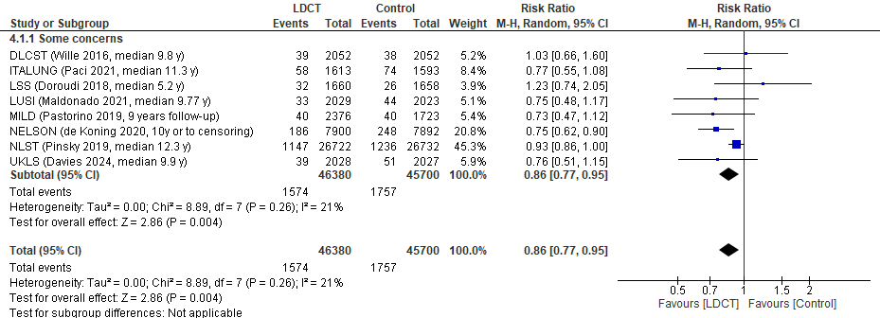

Figure S2.2 Lung cancer mortality, sensitivity analysis excluding high ROB studies (DANTE trial)

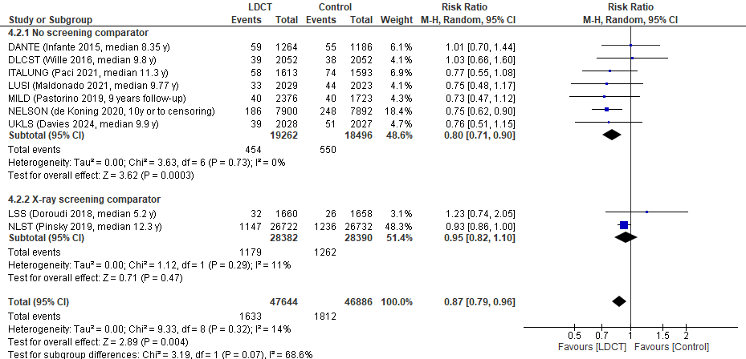

Figure S2.3 Lung cancer mortality, by comparator strategy

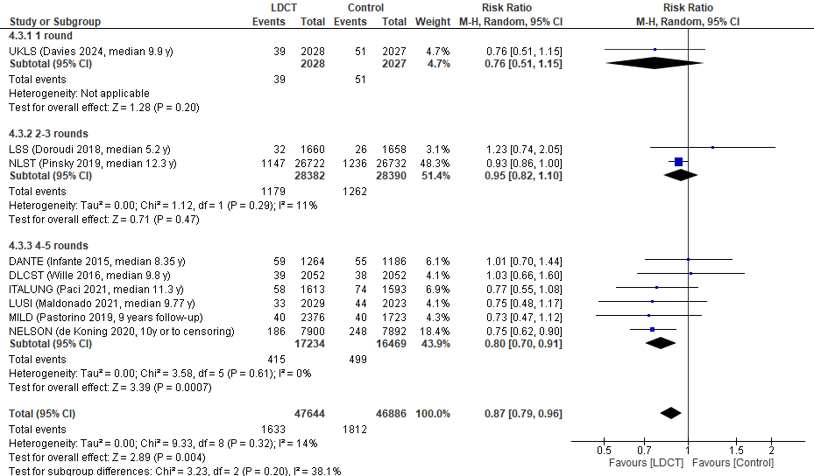

Figure S2.4 Lung cancer mortality, by number of screening rounds

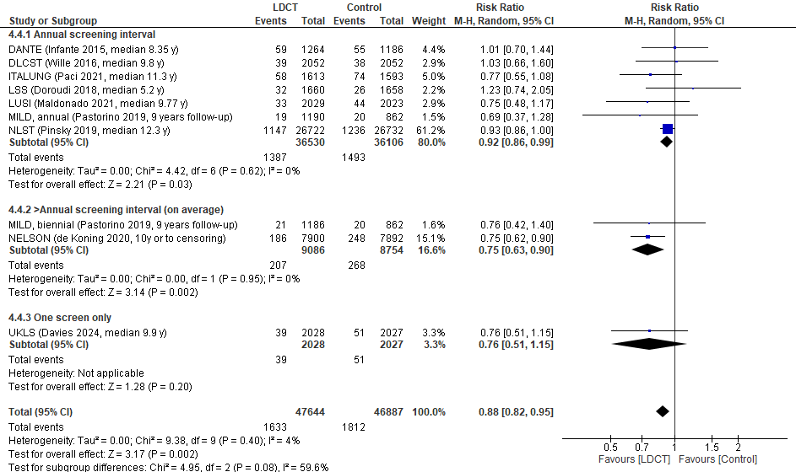

Figure S2.5 Lung cancer mortality, by screening interval

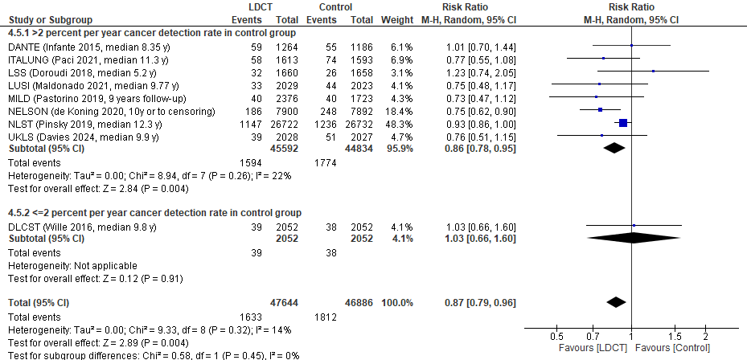

Figure S2.6 Lung cancer mortality, by 6-year lung cancer detection rate in comparator (≤2% vs >2%)

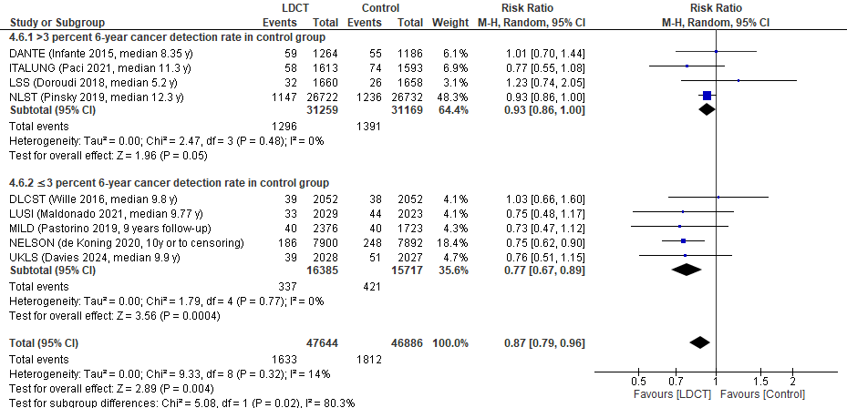

Figure S2.7 Lung cancer mortality, by 6-year lung cancer detection rate in comparator (≤3% vs >3%)

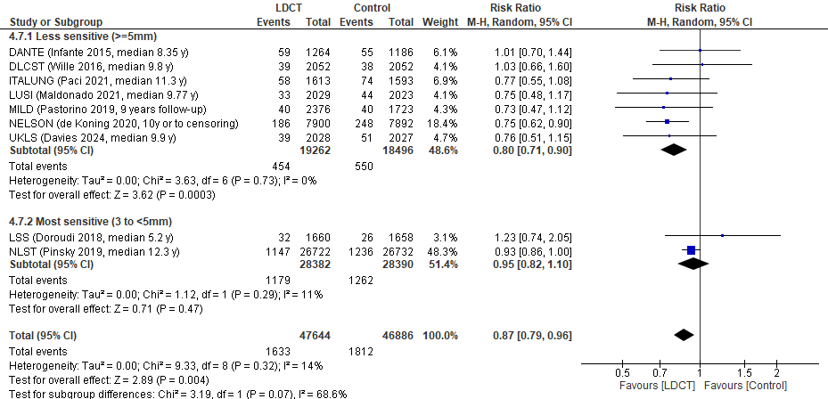

Figure S2.8 Lung cancer mortality, by nodule management strategy

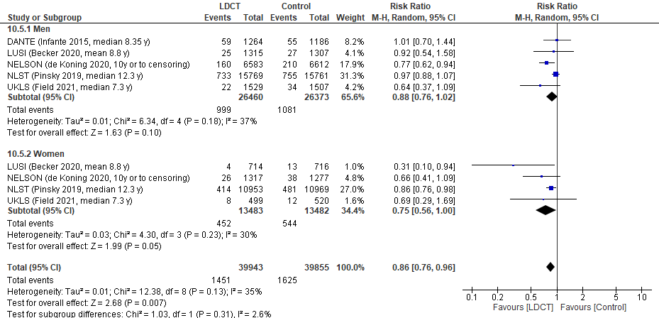

Figure S2.9 Lung cancer mortality, by sex
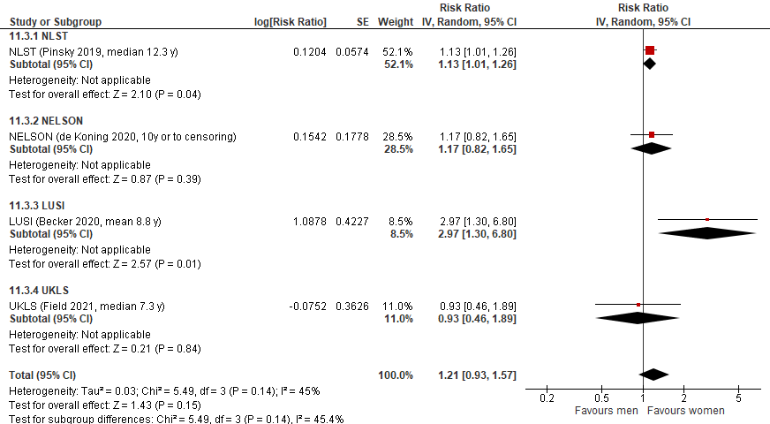

Figure S2.10 Lung cancer mortality, within study ratio of ratios by sex

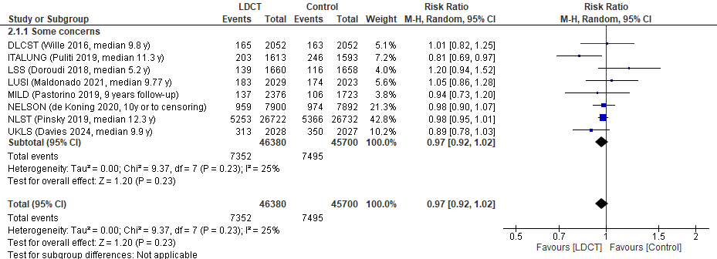

Figure S2.11 All-cause mortality, sensitivity analysis excluding high ROB studies (DANTE trial)

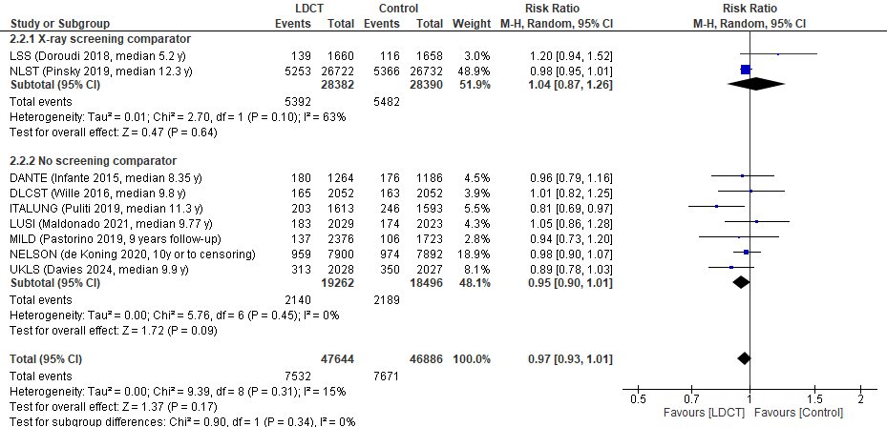

Figure S2.12 All-cause mortality, by comparator strategy

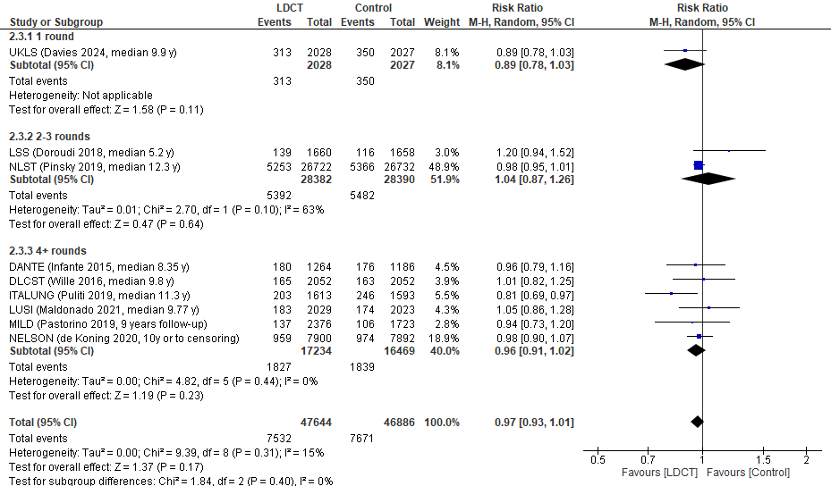

Figure S2.13 All-cause mortality, by number of screening rounds

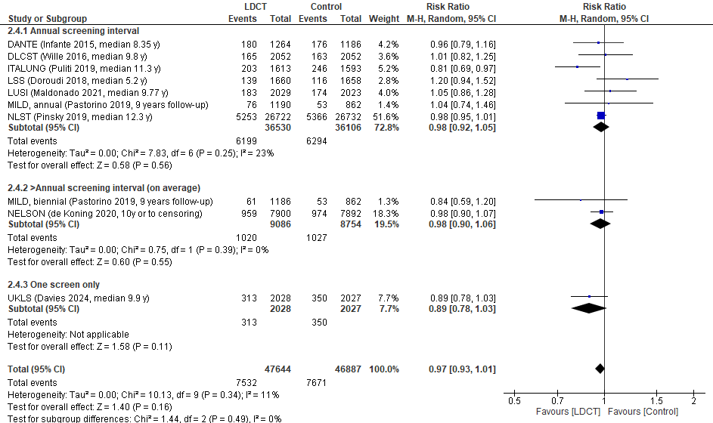

Figure S2.14 All-cause mortality, by screening interval

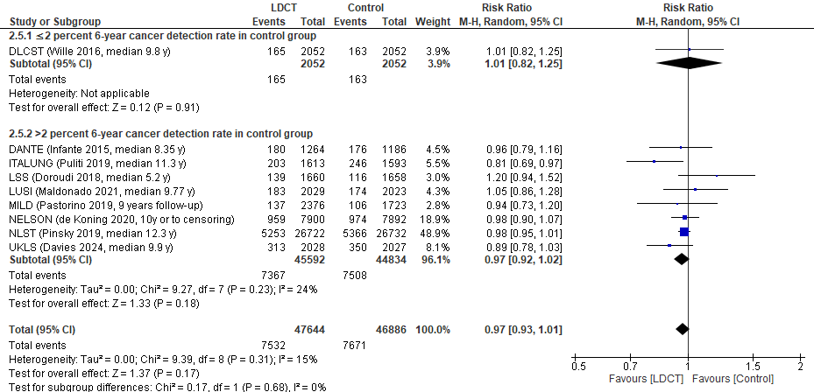

Figure S2.15 All-cause mortality, by 6-year lung cancer detection rate in comparator (≤2% vs >2%)

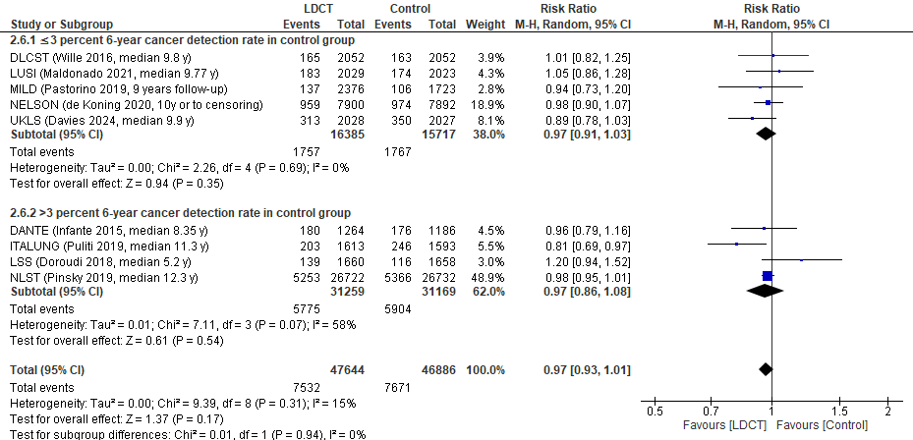

Figure S2.16 All-cause mortality, by 6-year lung cancer detection rate in comparator (≤3% vs >3%)

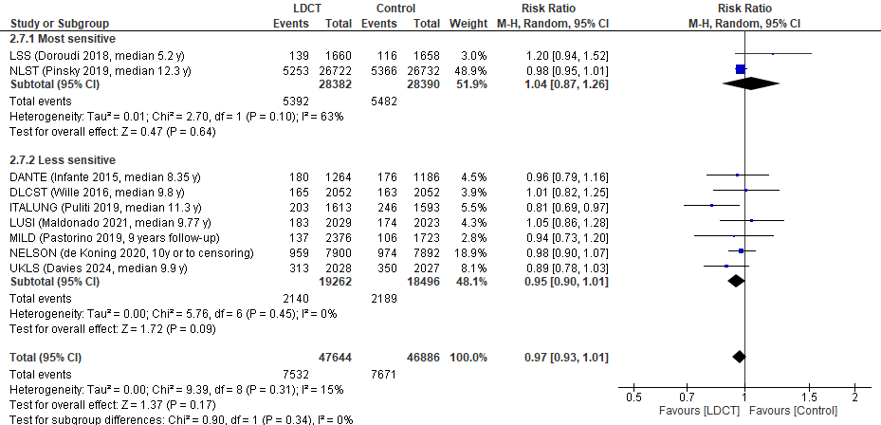

Figure S2.17 All-cause mortality, by nodule management strategy

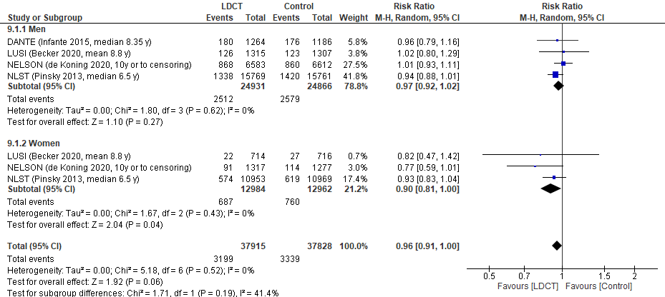

Figure S2.18 All-cause mortality, by sex

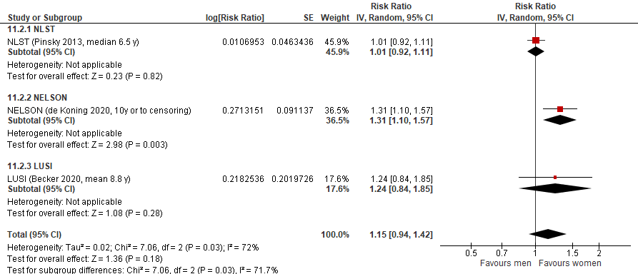

Figure S2.19 All-cause mortality, within study ratio of ratios by sex

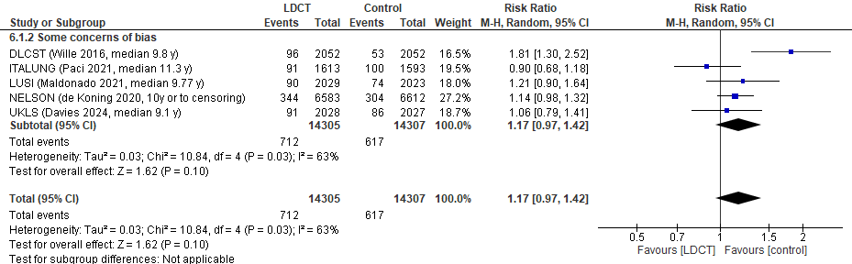

Figure S2.20 Overdiagnosis, sensitivity analysis excluding high ROB studies and those with an X-ray screen at baseline (DANTE trial)

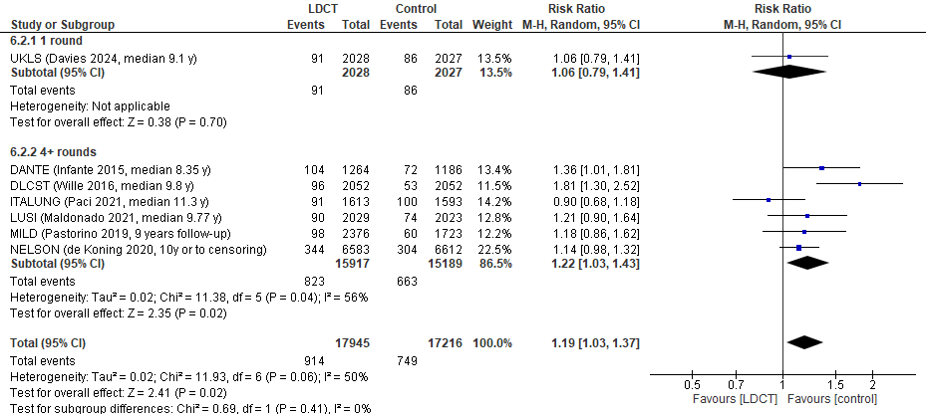

Figure S2.21 Overdiagnosis, by number of screening rounds

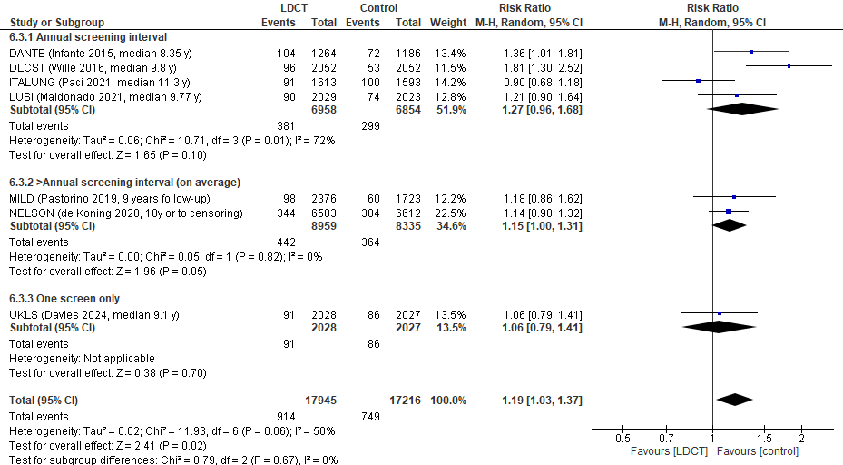

Figure S2.22 Overdiagnosis, by screening interval

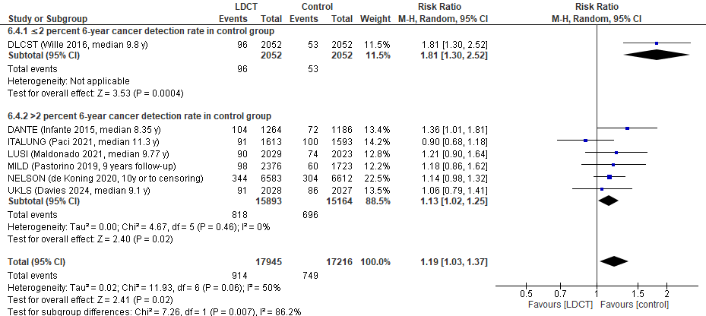

Figure S2.23 Overdiagnosis, by 6-year lung cancer detection rate in comparator (≤2% vs >2%)

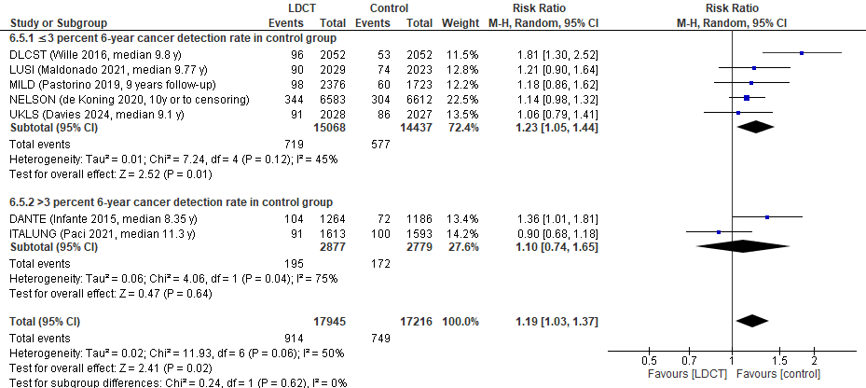

Figure S2.24 Overdiagnosis, by 6-year lung cancer detection rate in comparator (≤3% vs >3%)

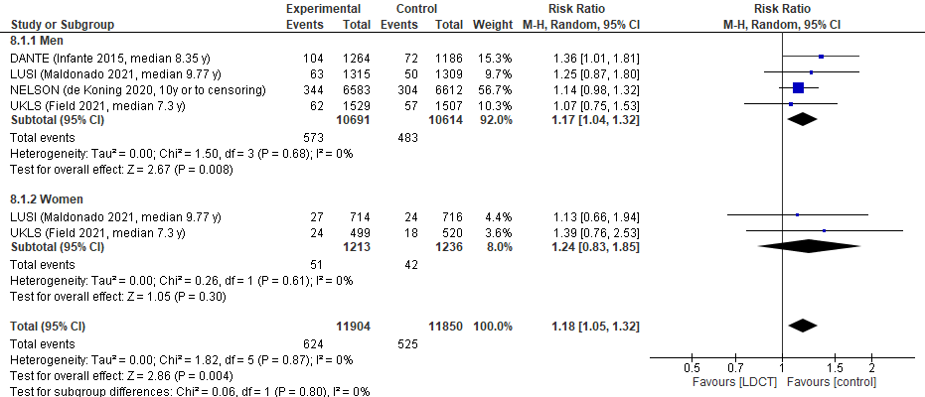

Figure S2.25 Overdiagnosis, by sex

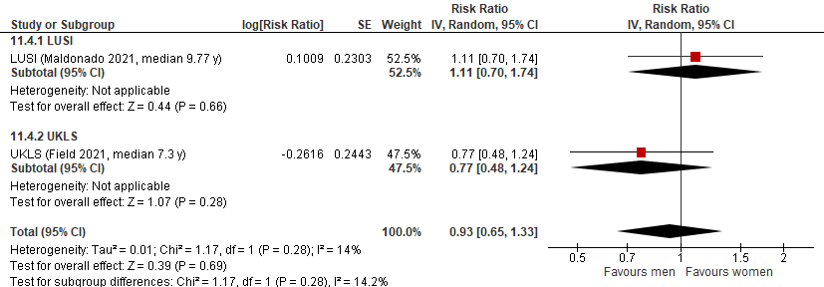

Figure S2.26 Overdiagnosis, within study ratio of ratios by sex

Table S2.8 Additional overdiagnosis definitions and findings
Number of studies; Number enrolled/randomized to CT screening | Overdiagnosis calculations (excess incidence or fraction overdiagnosed)
Overdiagnosis: excess incidence from screening
Trials: 7 studies; N=35,161 (46, 55, 56, 58, 78, 84, 85) | Excess incidence:  NELSON: -1.51  DANTE: -0.85  LUSI: -0.55  ITALUNG: -3.92  DLCST: 0.73  UKLS: -1.63  MILD: -0.49
Overdiagnosis: excess incidence of lung cancer from screening among those having cancer diagnosed in the screening arm
Trials: 7 studies; N=35,161 (46, 55, 56, 58, 78, 84, 85) | Excess incidence:  NELSON: -0.000044  DANTE: -0.000082  LUSI: -0.000061  ITALUNG: -0.00043  DLCST: 0.000076  UKLS: -0.00019  MILD: -0.000050
Overdiagnosis: excess incidence of lung cancer from screening among those having cancer diagnosed through screening in the screening arm
Trials: 7 studies; N=35,161 (46, 55, 56, 58, 78, 84, 85) | Excess incidence:  NELSON: -0.000075  DANTE: -0.00013  LUSI: -0.000088  ITALUNG: -0.0010  DLCST: 0.00011  UKLS: -0.00039  MILD: -0.000070
Overdiagnosis: overdiagnosis of screen-detected cancer
Trials: 7 studies; N=35,161 (46, 55, 56, 58, 78, 84, 85) | Fraction of overdiagnosed cases:  Weighted average (multiplied by 100%): 24% (range 20% to 63%)  NELSON: 0.20  DANTE: 0.41  LUSI: 0.25  ITALUNG: -0.27  DLCST: 0.63  UKLS: 0.26  MILD: 0.22

Table S2.9 CT screening: Summary of findings for important outcomes
Number of studies; Number enrolled/randomized to CT screening | Absolute events (95% CI) per 1000 |  | Certainty of evidence (GRADE^{ⱡ}) |  | What happens?
Proportion with a false positive (threshold 75 per 1000)
Round 1 (Fig. S2.27):  Trials: 11 studies; N=48,888  Observational: 18 studies; N=40,757 | 190 [160, 220] |  | High  ⊕⊕⊕⊕ª |  | Among people 50-74 years of age who are current or former smokers, screening with low-dose CT 3-4 times causes at least 75 false positives per 1000 screened.  Our certainty would be moderate for effects of at least 225 false positives per 1000 screened.
Over 2/3 rounds (Fig. S2.28):  Trials: 2 studies; N=28,382  Observational: 8 studies; N=55,308 | 310 [180, 440]
Over 4/5 rounds (Fig. S2.29):  Trials: 2 studies; N=2,877  Observational: 1 study; N=1,267 | 350 [220, 480]
Proportion with incidental findings (threshold 100 or 150 per 1000)
Round 1 (Fig. S2.30):  Trials: 0 studies  Observational: 13 studies; N=14,549 | 550 [370, 730] |  | High  ⊕⊕⊕⊕^{b} |  | Among people 50-74 years of age who are current or former smokers, screening with low-dose CT 3-4 times causes at least 150 incidental findings per 1000 screened.  Our certainty would be moderate for effects of at least 450 incidental findings per 1000 screened.
Over 2/3 rounds (Fig. S2.31):  Trials: 1 study; N=26,722  Observational: 0 studies | 570 [560, 570]
Over 4/5 rounds (Fig. S2.32):  Trials: 2 studies; N=2,877  Observational: 1 study; N=519 | 400 [50, 750]
Proportion with clinically significant incidental findings (threshold 50 or 100 per 1000)
Round 1 (Fig. S2.33):  Trials: 2 studies; N=27,582  Observational: 26 studies; N=81,843 | 220 [180, 260] |  | Threshold: 50 per 1000  High  ⊕⊕⊕⊕ ^{c}  Threshold: 100 per 1000:  Moderate  ⊕⊕⊕⊝^{c}  Due to inconsistency |  | Among people 50-74 years of age who are current or former smokers, screening with low-dose CT 3-4 times causes at least 50, and probably causes at least 100 clinically significant incidental findings per 1000 screened.
Over 2/3 rounds (Fig. S2.34):  Trials: 1 study; N=26,722  Observational: 0 studies | 340 [330, 340]
Over 4/5 rounds (Fig. S2.35):  Trials: 0 studies  Observational: 4 studies; N=12,026 | 80 [30, 120]
Proportion with major complications from invasive testing (lung cancers and false positives) (threshold 2.5 per 1000)
Round 1 (Fig. S2.36):  Trials: 4 studies; N=9,829  Observational: 7 studies; N=19,795 | 0.70 [0.00, 2.40] |  | Low  ⊕⊕⊝⊝^{d}  Due to very serious inconsistency |  | Among people 50-74 years of age who are current or former smokers, screening with low-dose CT 3-4 times may not cause at least 2.5 major complications from invasive testing among those with and without lung cancer per 1000 screened.
Over 2/3 rounds (Fig. S2.37):  Trials: 1 study; N=26,722  Observational: 4 studies; N=48,344 | 3.00 [1.30, 5.10]
Over 4/5 rounds (Fig. S2.38):  Trials: 2 studies; N=8,196  Observational: 1 study; N=2,471 | 1.80 [0.00, 7.90]
Proportion with major complications from invasive testing among false positives (threshold 2.5 per 1000)
Round 1 (Fig. S2.39):  Trials: 5 studies; N=10,751  Observational: 6 studies; N=13,040 | 0.00 [0.00, 0.30] |  | High  ⊕⊕⊕⊕^{e} |  | Among people 50-74 years of age who are current or former smokers, screening with low-dose CT 3-4 times does not cause at least 2.5 major complications from invasive testing for those without cancer per 1000 screened.  Our certainty would be moderate for effects of as low as 1 per 1000 screened.
Over 2/3 rounds (Fig. S2.40):  Trials: 1 study; N=26,722  Observational: 2 studies; N=2,259 | 0.00 [0.00, 0.20]
Over 4/5 rounds (Fig. S2.41):  Trials: 1 study; N=6,583  Observational: 1 study; N=2,471 | 0.10 [0.00, 0.40]
Proportion of deaths from invasive testing among false positives (threshold 0.1 per 1000)
Round 1 (Fig. S2.42):  Trials: 3 studies; N=3,309  Observational: 3 studies; N=44,123 | 0.00 [0.00, 0.00] |  | Moderate  ⊕⊕⊕⊝^{f}  Due to inconsistency |  | Among people 50-74 years of age who are current or former smokers, screening with low-dose CT 3-4 times may not cause 0.1 deaths from invasive testing among those without cancer per 1000 screened.
Over 2/3 rounds (Fig. S2.43):  Trials: 1 study; N=26,722  Observational: 1 study; N=2,003 | 0.10 [0.00, 0.30]
Over 4/5 rounds (Fig. S2.44): Trials: 1 study; N=1,264 | 0.00 [0.00, 2.91]
Number of studies; Number enrolled/randomized to CT screening | Mean difference (95% CI) |  | Findings | Certainty of evidence (GRADE^{ⱡ}) | What happens?
Health-related quality of life (thresholds: small=5 to <10% difference; moderate=10 to 20% difference)
Follow-up: 6 months and 1.5 years  N=3,937 (subsamples of 2 RCTs) | Difference in change scores between groups:  NELSON [(112); N=1,125]: mean scores in each arm were adjusted for age, gender, education, smoking status, and smoking pack-years:  EQ-VAS (scale 0-100): 1.39 (-0.46, 3.24); p=0.14  1.4% increase  SF-12 PCS (scale 0-100): 1.05 (-0.13, 2.23); p=0.08  1.1% increase  SF-12 MCS (scale 0-100): 0.87 (-0.58, 2.32); p=0.24  0.9% increase  NLST [(111); N=2,812]: adjusted for days since baseline evaluation, baseline age, sex, years of education, marital status, smoking status, race, ethnicity, number of prior suspicious for lung cancer  screens, number of prior SIFs screens  SF-36 PCS (scale 0-100): 0.50 (-0.06, 1.07)  0.5% increase  SF-36 MCS (scale 0-100): 0.07 (-0.61, 0.74)  0.1% increase |  | Subsamples from the NELSON (N=1,125) and NLST (N=2,812) trials found little-to-no difference between groups in health-related quality of life scores at 6-month and 1.5-year follow-up after randomization | Very low  ⊕⊝⊝⊝^{g}  Due to ROB, and very serious indirectness | Among people 50-74 years of age who are current or former smokers, we are very uncertain whether screening with low-dose CT 3-4 times impacts health-related quality of life.
Psychosocial consequences of screening (thresholds: small=5 to <10% difference; moderate=10 to 20% difference)
Participating in screening program  3 studies (N=9,205) | NELSON (112)  Spielberger State-trait anxiety (scale 20-80)  N=1,125; Comparative with unscreened control arm  ROB, before randomization: Some concerns  ROB, after first screening round: High | Before randomization and screening:  -0.48 [-1.64, 0.68]  0.8% difference  After first screening round (6 months into 2nd screening round), difference in change score:  -0.27 [-1.47, 0.93]  0.5% decrease | Three studies (N=9,205) comparing screened and unscreened participants at different timepoints during the screening program found little-to-no difference across measures of psychosocial harm. The applicability of the findings to 3-4 rounds of screening is limited. | Moderate  ⊕⊕⊕⊝^{h}  Due to indirectness | Among people 50-74 years of age who are current or former smokers, screening with low-dose CT 3-4 times probably causes little-to-no psychosocial harm.
Participating in screening program  3 studies (N=9,205) | NELSON (112)  Impact of events scale - LC specific (scale 0-75)  N=1,125; Comparative with unscreened control arm  ROB, before randomization: Some concerns  ROB, after first screening round: High | Before randomization and screening: 0.03 [-0.88, 0.94]  0.0% difference  After first screening round (6 months into 2nd screening round), difference in change score:  -0.34 [-1.29, 0.61]  0.5% decrease |  | Moderate  ⊕⊕⊕⊝^{h}  Due to indirectness
Participating in screening program  3 studies (N=9,205) | UKLS (113)  Cancer worry (scale 6-24)  N=4,037; Comparative with unscreened control arm  ROB, at both timepoints: Some concerns | After randomization (allocation unknown) and before screening: 0.01 [-0.07, 0.09]  0.1% difference  2 weeks after screening or 2-week follow-up in unscreened arm (N=3,232), difference in change score:  0.11 [-0.00, 0.20]  0.6% increase  Up to 2 years from screening (N=2,855), difference in change score:  0.10 [-0.00, 0.20]  0.6% increase |  | Moderate  ⊕⊕⊕⊝^{h}  Due to indirectness
Participating in screening program  3 studies (N=9,205) | DLCST (114)  Consequences of LC subscales: anxiety (scale 0-21), behavior (scale 0-21), dejection (scale 0-18), negative impact on sleep (scale 0-12)  N=4,043; Comparative with unscreened control arm  ROB, at all timepoints: Some concerns | Before each screening round:  Anxiety:  Round 1 (n=3,988): 0.14 [0.00, 0.28]  0.7% increase;  Round 2 (n=3,352):  0.27 [0.07, 0.47]  1.3% increase;  Round 3 (n=3,555): 0.34 [0.14, 0.54]  1.6% increase;  Round 4 (n=3,017): 0.26 [0.03, 0.49]  1.2% increase;  Round 5 (n=3,185): 0.65 [0.41, 0.89]  3.1% increase  Behavior:  Round 1 (n=4,030): 0.13 [0.01, 0.25]  0.7% increase;  Round 2 (n=3,337): 0.33 [0.12, 0.55]  1.6% increase;  Round 3 (n=3,540): 0.61 [0.38, 0.84]  Round 4 (n=3,010): 0.40 [0.16, 0.64]  1.9% increase;  Round 5 (n=3,180): 0.72 [0.45, 1.00]  3.4% increase  Dejection:  Round 1 (n=4,035): 0.15 [0.02, 0.28]  0.8% increase;  Round 2 (n=3,377): 0.31 [0.10, 0.51]  1.7% increase;  Round 3 (n=3,573): 0.45 [0.24, 0.67]  2.5% increase;  Round 4 (n=3,032): 0.28 [0.05, 0.52]  1.5% increase;  Round 5 (n=3,195): 0.73 [0.47, 0.99]  4.1% increase  Negative impact on sleep:  Round 1 (n=4,043): 0.08 [-0.02, 0.18]  0.7% increase;  Round 2 (n=3,389): 0.22 [0.04, 0.40]  1.8% increase;  Round 3 (n=3,577): 0.43 [0.24, 0.61]  3.6% increase;  Round 4 (n=3,029): 0.34 [0.14, 0.55]  2.8% increase;  Round 5 (n=3,198): 0.78 [0.53, 1.03]  6.5% increase  *The adjusted analyses had very similar results to the unadjusted analysis, therefore only the unadjusted analysis was reported |  | Moderate  ⊕⊕⊕⊝^{h}  Due to indirectness
Undergoing CT scan (after screening, before results are known)  2 non-randomized studies (N=1,645) | LSUT (106)  LC worry (scale 7-29)  N=1,014; Comparative with unscreened community sample, matched for age and smoking history  ROB: High | 1.76 [1.27, 2.25]  8.0% increase | Study data found there may be little-to-no difference before and after screening, although there was some inconsistency.  One study (N=1,014) comparing a screening group to an unscreened community sample, matched for age and smoking history found a small increase in lung cancer worry right after receiving a CT scan. Among those being screened in this study (N=631), and in the NELSON trial (N=630), there was little-to-no change across various measures from before to after screening. | Low  ⊕⊕⊝⊝^{i}  Due to ROB and inconsistency | Among people 50-74 years of age who are current or former smokers, undergoing a low-dose CT scan may cause little-to-no psychosocial harms.
 | LSUT (106)  LC worry (scale 7-29)  N=631; Pre-post  ROB: High | -0.35 [-0.66, -0.04]  1.6% decrease |  | Low  ⊕⊕⊝⊝^{i}  Due to ROB and inconsistency
 | NELSON (115)(only indeterminate and negative)  Spielberger State-trait anxiety (scale 20-80)  N=630; Pre-post  ROB: Some concerns | -0.49 [-1.17, 0.19]  0.8% decrease  Subgroup (van den Bergh 2008, n=324):  Men: -1.40 [-2.58, -0.22]  Women: -1.3 (-2.62, 0.02] |  | Low  ⊕⊕⊝⊝^{i}  Due to ROB and inconsistency
 | NELSON (115)(only indeterminate and negative)  Impact of events scale - LC specific (scale 0-75) N=630; Pre-post  ROB: Some concerns | 0.40 [-0.19, 0.99]  0.5% increase  Subgroup (van den Bergh 2008, n=324):  Men: -0.90 [-2.09, 0.29]  Women: -1.40 [-3.06, 0.26] |  | Low  ⊕⊕⊝⊝^{i}  Due to ROB and inconsistency
Positive screen (before repeat CT or diagnostic results known)  7 non-randomized studies (N=4,794) | NELSON (112)  Spielberger State-trait anxiety (scale 20-80)  N=595; Comparative with unscreened control arm  ROB: Some concerns | To recall:  0.80 [-1.04, 2.64]  1.3% increase | Data from seven non-randomized studies (N=4,794) suggested that receiving a positive screening result may cause a small psychosocial harm, particularly when measured by scales specific to lung cancer. | Low  ⊕⊕⊝⊝^{j}  Due to ROB, and inconsistency | Among people 50-74 years of age who are current or former smokers, undergoing a low-dose CT scan and receiving a positive screening result may cause small psychosocial harm.
 | NELSON (112)  Impact of events scale - LC specific (scale 0-75)  N=595; Comparative with unscreened control arm  ROB: Some concerns | To recall:  3.78 [2.32, 5.24]  5.0% increase |  | Low  ⊕⊕⊝⊝^{j}  Due to ROB, and inconsistency
 | UKLS (113)  Cancer worry (scale 6-24)  N=2,415; Comparative with unscreened control arm  ROB: Some concerns | 0.89 [0.72, 1.06]  4.9% increase |  | Low  ⊕⊕⊝⊝^{j}  Due to ROB, and inconsistency
 | DLCST (117)  Consequences of LC subscales: anxiety (scale 0-21), behavior (scale 0-21), dejection (scale 0-18), negative impact on sleep (scale 0-12)  N=295; Comparative with unscreened control arm, matched 1:2 on sex, age, and time of clinic visit  ROB: Some concerns | Anxiety:  FPs: 2.77 (1.63 to 3.92)  13.2% increase;  TPs: 1.89 (0.01 to 3.78)  9.0% increase;  Behavior:  FPs: 1.21 (0.19 to 2.23)  5.8% increase;  TPs: 0.65 (0.65 to 1.94)  3.1% increase;  Dejection:  FPs: 2.63 (1.53 to 3.74)  14.6% increase;  TPs: 2.20 (0.28 to 4.12)  12.2% increase;  Negative impact on sleep:  FPs: 0.65 (-0.14 to 1.44)  5.4% increase;  TPs: 0.47 (-0.61 to 1.54)  3.9% increase  All MDs are adjusted |  | Low  ⊕⊕⊝⊝^{j}  Due to ROB, and inconsistency
 | NELSON (112)  Spielberger State-trait anxiety (scale 20-80)  N=135; Pre-post  ROB: Some concerns | To recall:  1.27 [-0.34, 2.88]  2.1% increase |  | Low  ⊕⊕⊝⊝^{j}  Due to ROB, and inconsistency
 | NELSON (112)  Impact of events scale - LC specific (scale 0-75)  N=135; Pre-post  ROB: Some concerns | To recall:  3.80 [2.55, 5.05]  5.1% increase |  | Low  ⊕⊕⊝⊝^{j}  Due to ROB, and inconsistency
 | NLST (111)  Short form-36 mental component subscale (scale 0 to 100)  N=617 (CT arm); N=266 (CXR arm); Pre-post  ROB: Some concerns | LDCT arm: -1.56 [-2.39, -0.73]  1.6% decrease;  CXR arm: -0.99 [-2.17, 0.19]  1.0% decrease  Higher score = better mental health |  | Low  ⊕⊕⊝⊝^{j}  Due to ROB, and inconsistency
 | (116) Consequences of LC subscales:  anxiety (scale 0-21), behavior (scale 0-21), dejection (scale 0-18), negative impact on sleep (scale 0-12); N=203; Pre-post  Adjusted for age, sex, smoking status, pack-years, education, employment, PLCOm2012 score and baseline responses  ROB: High | To recall (3 months):  Anxiety: 0.29 [-0.22, 0.80]  1.38% increase  Behavior:  0.53 [0.03, 1.02]  2.52% increase  Dejection:  0.30 [-0.19, 0.78]  1.67% increase  Negative impact on sleep:  0.29 [-0.08, 0.66]  2.42% increase  To recall (6 months):  Anxiety:  0.45 [-0.28, 1.17]  2.14% increase  Behavior:  0.67 [-0.36, 1.71]  3.19% increase  Dejection:  0.44 [-0.27, 1.15]  2.44% increase  Negative impact on sleep:  0.07 [-0.75, 0.89]  0.58% increase  All MDs are adjusted |  | Low  ⊕⊕⊝⊝^{j}  Due to ROB, and inconsistency
 | (6) State Trait Anxiety: State anxiety subscore (scale 20-80)  N=165; Pre-post  ROB: Some concerns | 3.65 [1.63, 5.67]  6.1% increase |  | Low  ⊕⊕⊝⊝^{j}  Due to ROB, and inconsistency
 | (6) State Trait Anxiety: Trait anxiety subscore (scale 20-80)  N=165; Pre-post  ROB: Some concerns | 1.08 [-0.73, 2.89]  1.8% increase |  | Low  ⊕⊕⊝⊝^{j}  Due to ROB, and inconsistency
 | (6) Fear of LC (adapted from psychosocial consequences questionnaire) (scale 3-15)  N=165; Pre-post  ROB: Some concerns | 0.57 [0.15, 0.99]  4.8% increase |  | Low  ⊕⊕⊝⊝^{j}  Due to ROB, and inconsistency
 | (73)  Spielberger State-trait anxiety (scale 20-80)  N=238; Pre-post  ROB: Some concerns | 3.28 [-0.42, 6.97]  5.5% increase  Adjusted p-value: p>0.05 |  | Low  ⊕⊕⊝⊝^{j}  Due to ROB, and inconsistency
Positive screen, requiring diagnostic follow-up (before diagnostic results known)  2 non-randomized studies (N=1,651) | UKLS (113)  Cancer worry (scale 6-24)  N=1,627; Comparative with unscreened control arm  ROB: Some concerns | 3.28 [2.52, 4.04]  18.2% increase | Data from two non-randomized studies (N=1,651) suggested that receiving a positive screening result may cause moderate psychosocial harm, particularly when measured by scales specific to lung cancer. | Small harm:  Moderate  ⊕⊕⊕⊝^{k}  Due to ROB  Moderate harm:  Low  ⊕⊕⊝⊝^{k}  Due to ROB, and inconsistency | Among people 50-74 years of age who are current or former smokers, undergoing a low-dose CT scan and receiving a positive screening result requiring diagnostic follow-up probably causes small, and may cause moderate psychosocial harm.
 | (6)  State Trait Anxiety: State anxiety subscore (scale 20-80)  N=24; Pre-post  ROB: Some concerns | 5.70 [0.01, 11.39]  9.5% increase
 | Byrne, 2008  State Trait Anxiety: Trait anxiety subscore (scale 20-80)  N=24; Pre-post  ROB: Some concerns | 2.70 [-1.76, 7.16]  4.5% increase
 | (6)  Fear of LC (adapted from psychosocial consequences questionnaire) (scale 3-15)  N=24; Pre-post  ROB: Some concerns | 2.10 [1.69, 2.51]  17.5% increase
False positive screening result (≤6 months after diagnostic results known)  6 non-randomized studies (N=1,860) | DLCST (117)  Consequences of LC subscales: anxiety (scale 0-21), behavior (scale 0-21), dejection (scale 0-18), negative impact on sleep (scale 0-12)  N=277; Comparative with unscreened control arm, matched 1:2 on sex, age, and time of clinic visit  ROB: Some concerns | Anxiety: -0.25 [-1.25, 0.75]  1.2% decrease;  Behavior: -0.09 [-1.34, 1.16]  0.4% decrease;  Dejection: -0.09 [-1.21, 1.04]  0.5% decrease;  Negative impact on sleep: -0.10 [-1.01, 0.81]  0.8% decrease  All MDs are adjusted | Findings across six non-randomized studies (N=1,860) indicated little-to-no difference on average, but there was inconsistency with two of the studies finding at least a small amount of harm among a sample that likely included some lung cancer patients. | Low  ⊕⊕⊝⊝^{l}  Due to ROB, and inconsistency | Among people 50-74 years of age who are current or former smokers, undergoing a low-dose CT scan and receiving a false positive screening result may cause little-to-no psychosocial harm under 6 months after the diagnostic results are known.
 | LSUT (106)  LC worry (scale 7-29)  N=514; Comparative with unscreened community sample, matched on age and smoking history.  Unclear if some participants had lung cancer  ROB: High | Any FPs:  3.65 [2.71, 4.59]  16.6% increase |  | Low  ⊕⊕⊝⊝^{l}  Due to ROB, and inconsistency
 | LSUT (106)  LC worry (scale 7-29)  N=131; Pre-post  ROB: High | Any FPs:  1.71 [0.93, 2.49]  7.8% increase |  | Low  ⊕⊕⊝⊝^{l}  Due to ROB, and inconsistency
 | NLST (111)  Short form-36 mental component subscale (scale 0 to 100)  N=489 (CT arm); N=214 (CXR arm); Pre-post  ROB: High | LDCT arm: -1.38 [-2.33, -0.43]  1.4% decrease  CXR arm: -0.55 [-1.57, 0.47]  0.6% decrease  Higher score = better mental health |  | Low  ⊕⊕⊝⊝^{l}  Due to ROB, and inconsistency
 | (73)  Spielberger State-trait anxiety (scale 20-80)  N=168; Pre-post  2.8% had lung cancer  ROB: High | 2.42 [-1.14, 5.99]  4.0% increase |  | Low  ⊕⊕⊝⊝^{l}  Due to ROB, and inconsistency
 | (116)  Consequences of LC subscales:  anxiety (scale 0-21), behavior (scale 0-21), dejection (scale 0-18), negative impact on sleep (scale 0-12); N=33; Pre-post  Adjusted for age, sex, smoking status, pack-years, education, employment, PLCOm2012 score and baseline responses.  Unclear if some participants had lung cancer  ROB: High | High malignancy risk (after biopsy results):  Anxiety:  0.50 [-1.58, 2.58]  2.38% increase  Behavior:  1.22 [-0.44, 2.87]  5.81% increase  Dejection:  -0.39 [-1.47, 0.70]  2.17% decrease  Negative impact on sleep:  0.89 [-0.08, 1.85]  7.42% increase  Suspicious for lung cancer (after biopsy results):  Anxiety:  0.36 [-0.26, 0.97]  1.71% increase  Behavior:  1.25 [-0.15, 2.66]  5.95% increase  Dejection:  0.47 [-0.10, 1.04]  2.61% increase  Negative impact on sleep:  1.52 [0.28, 2.76]  12.67% increase |  | Low  ⊕⊕⊝⊝^{l}  Due to ROB, and inconsistency
 | (6)  State Trait Anxiety: State anxiety subscore (scale 20-80)  N=165; Pre-post  ROB: Some concerns | Any FPs:  2.48 [0.57, 4.39]  4.1% increase |  | Low  ⊕⊕⊝⊝^{l}  Due to ROB, and inconsistency
 | (6)  State Trait Anxiety: Trait anxiety subscore (scale 20-80)  N=165; Pre-post  ROB: Some concerns | Any FPs:  0.22 [-1.57, 2.01]  0.4% increase |  | Low  ⊕⊕⊝⊝^{l}  Due to ROB, and inconsistency
 | (6)  Fear of LC (adapted from psychosocial consequences questionnaire) (scale 3-15)  N=165; Pre-post  ROB: Some concerns | Any FPs:  0.06 [-0.35, 0.47]  0.5% increase |  | Low  ⊕⊕⊝⊝^{l}  Due to ROB, and inconsistency
False positive screening result (>6 months after diagnostic results known)  6 non-randomized studies (N=4,553) | DLCST (117)  Consequences of LC subscales: anxiety (scale 0-21), behavior (scale 0-21), dejection (scale 0-18), negative impact on sleep (scale 0-12)  N=277; Comparative with unscreened control arm, matched 1:2 on sex, age, and time of clinic visit  ROB: Some concerns | Any FPs:  Anxiety: -0.26 [-1.16, 0.65]  1.2% decrease;  Behavior: -0.07 [-1.30, 1.17]  0.3% decrease;  Dejection: -0.01 [-1.04, 1.03]  0.1% decrease;  Negative impact on sleep: 0.11 [-0.68, 0.90]  0.9% increase | Findings across 6 non-randomized studies (N=4,553) consistently showed little-to-no impact on psychosocial harms. | Moderate  ⊕⊕⊕⊝^{m}  Due to ROB | Among people 50-74 years of age who are current or former smokers, undergoing a low-dose CT scan and receiving a false positive screening result probably cause little-to-no psychosocial harm over 6 months after the diagnostic results are known.
 | NELSON (112)  Spielberger State-trait anxiety (scale 20-80)  N=595; Comparative with unscreened control arm  ROB: High | To recall:  Difference in change score:  0.29 [-1.55, 2.13]  0.5% increase |  | Moderate  ⊕⊕⊕⊝^{m}  Due to ROB
 | NELSON (112)  Impact of events scale - LC specific (scale 0-75)  N=595; Comparative with unscreened control arm  ROB: High | To recall:  Difference in change score:  0.54 [-0.89, 1.97]  0.7% increase |  | Moderate  ⊕⊕⊕⊝^{m}  Due to ROB
 | UKLS (113)  Cancer worry (scale 6-24)  N=1,747; Comparative with unscreened control arm  ROB: High | Any FPs:  -0.07 [-0.26, 0.12]  0.4% decrease |  | Moderate  ⊕⊕⊕⊝^{m}  Due to ROB
 | (87)  Consequences of LC (scores dichotomized: 0=no consequences; >0=psychosocial consequences)  N=1,523; Comparative with matched by CT date, gender and site  ROB: Some concerns | Odds ratio (95% CI):  Sense of dejection: 1.35 [1.06, 1.72]  Anxiety: 1.22 [0.97, 1.54]  Behavioral: 1.21 [0.95, 1.54]  Sleep: 1.17 [0.93, 1.45] |  | Moderate  ⊕⊕⊕⊝^{m}  Due to ROB
 | NELSON (112)  Spielberger State-trait anxiety (scale 20-80)  N=135; Pre-post  ROB: Some concerns | To recall:  -0.04 [-1.64, 1.56]  0.1% decrease |  | Moderate  ⊕⊕⊕⊝^{m}  Due to ROB
 | NELSON (112)  Impact of events scale - LC specific (scale 0-75)  N=135; Pre-post  ROB: Some concerns | To recall:  0.55 [-0.68, 1.78]  0.7% increase |  | Moderate  ⊕⊕⊕⊝^{m}  Due to ROB
 | (73)  Spielberger State-trait anxiety (scale 20-80)  N=246; Pre-post  ROB: Some concerns | Any FPs:  1.79 [-0.62, 4.19]  3.0% increase |  | Moderate  ⊕⊕⊕⊝^{m}  Due to ROB
 | (6)  State Trait Anxiety: State anxiety subscore (scale 20-80)  N=165; Pre-post  ROB: Some concerns | Any FPs:  1.13 [-0.92, 3.18]  1.9% increase |  | Moderate  ⊕⊕⊕⊝^{m}  Due to ROB
 | (6)  State Trait Anxiety: Trait anxiety subscore (scale 20-80)  N=165; Pre-post  ROB: Some concerns | Any FPs:  -0.18 [-2.08, 1.72]  0.3% decrease |  | Moderate  ⊕⊕⊕⊝^{m}  Due to ROB
 | (6)  Fear of LC (adapted from psychosocial consequences questionnaire) (scale 3-15)  N=165; Pre-post  ROB: Some concerns | Any FPs:  0.02 [-0.40, 0.44]  0.2% increase |  | Moderate  ⊕⊕⊕⊝^{m}  Due to ROB
^{ⱡ}GRADE ratings (all outcomes started at high certainty):
ª False positives: No serious concerns about risk of bias: 6 studies at round one, two studies at 2-3 rounds, and all studies at 4-5 rounds of screening were at high risk of bias, but findings did not change when excluded in sensitivity analysis. No serious concerns about inconsistency: Findings were consistent across rounds of screening and subgroup findings. No serious concerns about indirectness: The study data was direct for this outcome; findings are applicable to contemporary nodule management approaches, which are less sensitive than used in the NLST trial. No serious concerns about imprecision: The confidence intervals are precise for our threshold of effects over 3-4 screening rounds. No serious concerns about reporting bias: No serious concerns about reporting bias. Our certainty would be moderate for effects of at least 225 false positives per 1000 as there would be serious concerns about inconsistency among studies contributing to analyses at both round one and over 2/3 rounds of screening (figures S2.27 and S2.28).
^{b} Incidental findings: No serious concerns about risk of bias: 8 studies at round one, and three studies at 4-5 rounds of screening were at high risk of bias, but findings did not change when excluded in sensitivity analysis. No serious concerns about inconsistency: Findings were consistent across rounds of screening and subgroup findings. No serious concerns about indirectness: The study data was direct for this outcome. No serious concerns about imprecision: The confidence intervals are precise for our threshold of effects over 3-4 screening rounds. No serious concerns about reporting bias: No serious concerns about reporting bias. Our certainty would be the same for the lower threshold of 100 per 1000. Our certainty would be moderate for effects of at least 450 incidental findings per 1000 as there would be serious concerns of inconsistency among studies contributing to analyses at both round one and over 4/5 rounds of screening (figures S2.30 and S2.32).
^{c} Clinically significant incidental findings: No serious concerns about risk of bias: 20 studies at round one, and two studies at 4-5 rounds of screening were at high risk of bias (usually due to a poorly defined or ascertained outcome), but findings did not change when excluded in sensitivity analysis. No serious concerns about inconsistency: Findings were consistent across rounds of screening and subgroup findings. No serious concerns about indirectness: The study data was direct for this outcome. No serious concerns about imprecision: The confidence intervals are precise for our threshold of effects over 3-4 screening rounds. No serious concerns about reporting bias: No serious concerns about reporting bias. Our certainty would be moderate for effects of at least 100 clinically significant incidental findings per 1000 screened as there would be serious concerns about inconsistency among studies contributing to analyses at both round one and over 4/5 rounds of screening (figures S2.33 and S2.35).
^{d} Major complications from invasive testing (lung cancers and false positives): No serious concerns about risk of bias: Two studies at round one of screening were at high risk of bias, but findings were similar among studies not at high risk of bias. Very serious concerns about inconsistency: There were very serious concerns of inconsistency among studies contributing to each analysis (figures S2.36, S2.37, and S2.38). No serious concerns about indirectness: The study data was direct for this outcome. No serious concerns about imprecision: The confidence intervals are reasonably precise for our threshold of effects over 3-4 screening rounds. No serious concerns about reporting bias: No serious concerns about reporting bias.
^{e} Major complications from invasive testing (false positives): No serious concerns about risk of bias: One study at round one of screening was at high risk of bias, but findings were similar among studies not at serious risk of bias. No serious concerns about inconsistency: Findings were consistent across rounds of screening and subgroup findings. No serious concerns about indirectness: The study data was direct for this outcome. No serious concerns about imprecision: The confidence intervals are precise for our threshold of effects over 3-4 screening rounds. No serious concerns about reporting bias: No serious concerns about reporting bias. Our certainty would be moderate for effects as low as 1 major complication from invasive testing among false positives per 1000 screened as there would be serious concerns about inconsistency among studies contributing to round 1 of screening (figure S2.39).
^{f} Deaths from invasive testing among false positives: No serious concerns about risk of bias: One study at round one of screening was at high risk of bias, but findings were similar among studies not at high risk of bias. Serious concerns about inconsistency: One large trial at 2-3 rounds of screening is inconsistent with findings at round one, and 4-5 rounds of screening. No serious concerns about indirectness: The study data was direct for this outcome. No serious concerns about imprecision: The confidence intervals are precise for our threshold of effects over 3-4 screening rounds. No serious concerns about reporting bias: No serious concerns about reporting bias.
^{g} Health-related quality of life: Serious concerns about risk of bias: both studies included for this outcome were non-randomized subsamples of the original trials. No serious concerns about inconsistency: Both studies had consistent findings. Very serious concerns about indirectness: both studies were indirect for 3-4 rounds of screening (insufficient follow-up). Also, one study (NLST) is comparing CT screening to screening with a chest X-ray, rather than an unscreened comparator. No serious concerns about imprecision: The confidence intervals were precise for little-to-no difference. No serious concerns about reporting bias: No serious concerns about reporting bias.
^{h} Psychosocial harms: Participating in screening program: No serious concerns about risk of bias: Only one of the three studies was a non-randomized sample (subsample of NELSON trial, and smallest sample in analysis), at high risk of bias. No serious concerns about inconsistency: All three studies had consistent findings. Serious concerns about indirectness: two of the three studies were less than 3-4 rounds of screening; one study with 5 rounds of screening indicated a trend for increasing effects over time but effects, on average, still did not meet our threshold so we did not judge this as very serious concerns. No serious concerns about imprecision: The confidence intervals were precise for little-to-no difference. No serious concerns about reporting bias: No serious concerns about reporting bias.
^{i} Psychosocial harms: Undergoing CT scan (after screening, before results are known): Serious concerns about risk of bias: One of the two studies are at high risk of bias (the single comparative study was high risk of bias), and the majority of data came from pre-post analyses. Serious concerns of inconsistency: Findings were inconsistent between studies, and based on the comparator. No serious concerns about indirectness: Findings are from one round of screening but there were no serious concerns the results would differ over 3-4 screening rounds. One study (sample from the NELSON trial) included only those with indeterminate or negative screening results, but the sample is still applicable as results were not yet known. No serious concerns about imprecision: The confidence intervals were generally precise for little-to-no difference. No serious concerns about reporting bias: No serious concerns about reporting bias.
^{j} Psychosocial harms: Positive screen (before repeat CT or diagnostic results known): Serious concerns about risk of bias: One study had high risk of bias, and all other studies had some concerns of risk of bias. Serious concerns about inconsistency: There was serious concerns of inconsistency across tools and comparisons. No serious concerns of indirectness: There were no serious concerns of indirectness. Two studies included only those with screening results requiring a recall scan, however lung-cancer specific tool from the trial subset (sample from the NELSON trial) and observational study (116) showed similar results to other studies including both those requiring recall scans and diagnostic workup. No serious concerns about imprecision: The confidence intervals were generally precise for a small increase. No serious concerns about reporting bias: No serious concerns about reporting bias.
^{k} Psychosocial harms: Positive screen, requiring diagnostic follow-up (before diagnostic results known): Small effect threshold, Serious concerns about risk of bias: Both studies had some concerns of risk of bias. No serious concerns about inconsistency: Both studies had consistent findings, when considering this small effect. No serious concerns about indirectness: The study data was direct for this outcome. No serious concerns about imprecision: The confidence intervals were generally precise for a moderate increase. No serious concerns about reporting bias: No serious concerns about reporting bias. For a moderate effect threshold, we had serious concerns about inconsistency in effects between studies, and heavy reliance on one study with adequate sample size.
^{l} Psychosocial harms: False positive screening result (≤6 months after diagnostic results known): Serious concerns about risk of bias: Four of the six studies are at high risk of bias (one of two comparative studies were high risk of bias), and the majority of data came from pre-post analyses. Serious concerns about inconsistency: There were serious concerns about inconsistency. Four of the six studies showed little-to-no difference, whereas two studies with an unknown number of lung cancer patients found at least a small increase in the overall score (LSUT trial) or in two of the four subscores (Bonney, 2024). No serious concerns about indirectness: The study data was direct for this outcome. No serious concerns about imprecision: The confidence intervals were generally precise for little-to-no difference. No serious concerns about reporting bias: No serious concerns about reporting bias.
^{m} Psychosocial harms: False positive screening result (>6 months after diagnostic results known): Serious concerns about risk of bias: Two of the six included studies were at high risk of bias (two of four comparative studies were high risk of bias). No serious concerns about inconsistency: All six studies had consistent findings. No serious concerns about indirectness: The study data was direct for this outcome. No serious concerns about imprecision: The confidence intervals were generally precise for little-to-no difference. No serious concerns about reporting bias: No serious concerns about reporting bias.

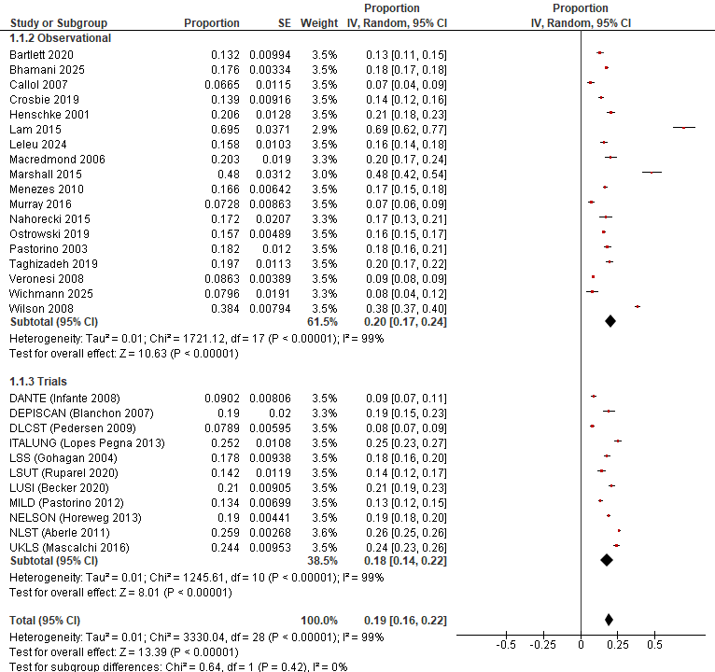

Figure S2.27 Proportion with a false positive at round 1
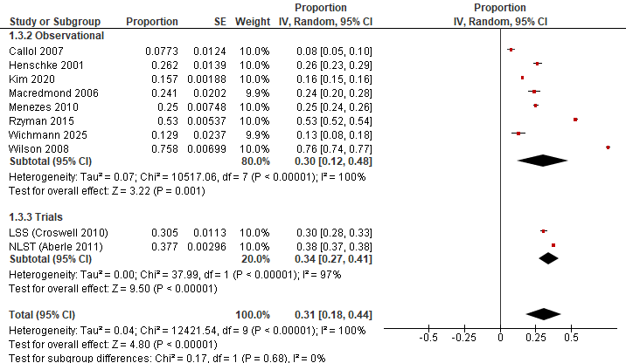

Figure S2.28 Proportion with a false positive over 2/3 rounds

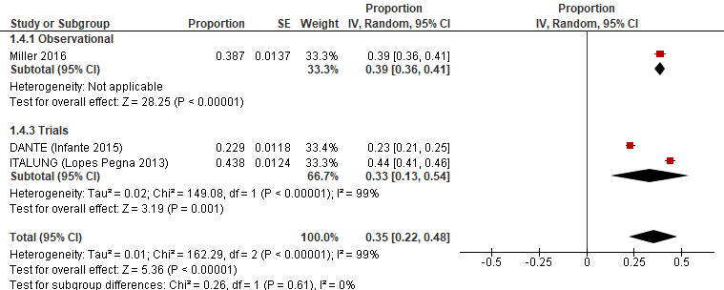

Figure S2.29 Proportion with a false positive over 4/5 rounds

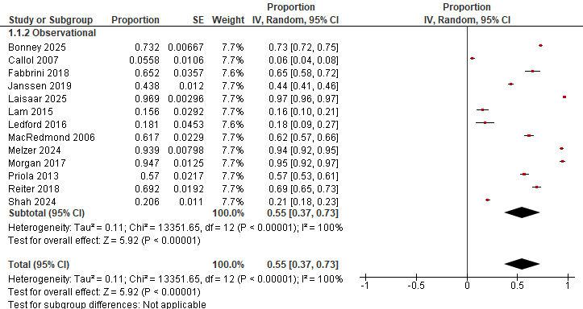

Figure S2.30 Proportion with incidental findings at round 1

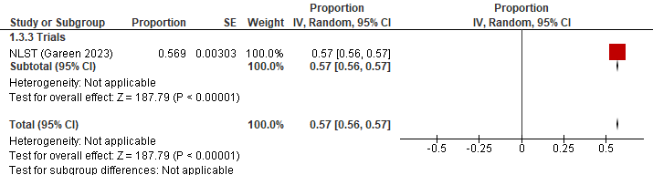

Figure S2.31 Proportion with incidental findings over 2/3 rounds

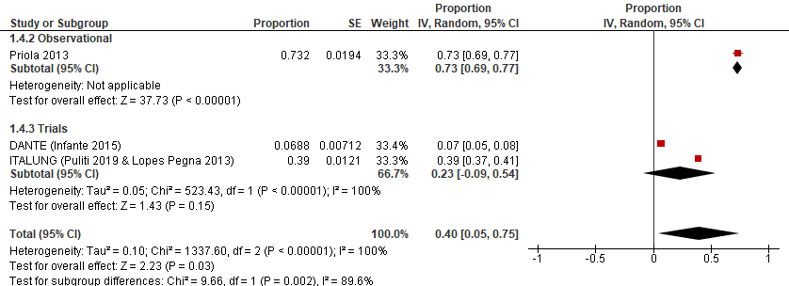

Figure S2.32 Proportion with incidental findings over 4/5 rounds

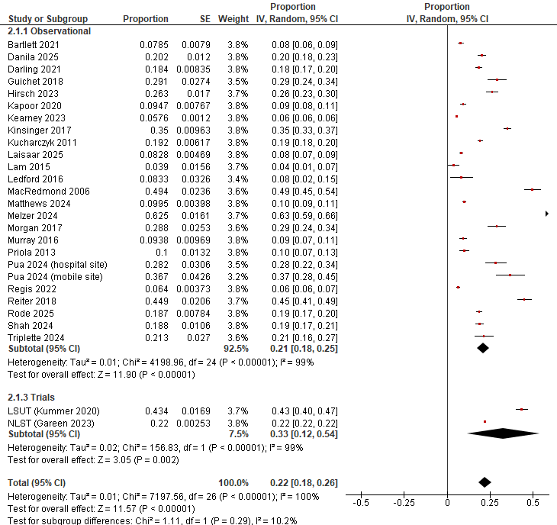

Figure S2.33 Proportion with clinically significant incidental findings at round 1
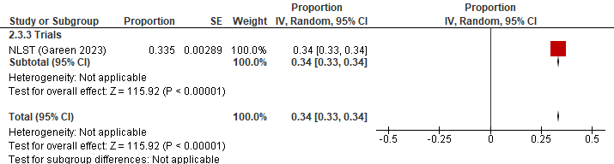

Figure S2.34 Proportion with clinically significant incidental findings over 2/3 rounds

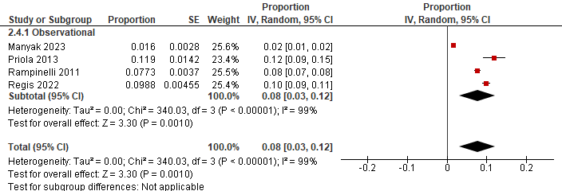

Figure S2.35 Proportion with clinically significant incidental findings over 4/5 rounds

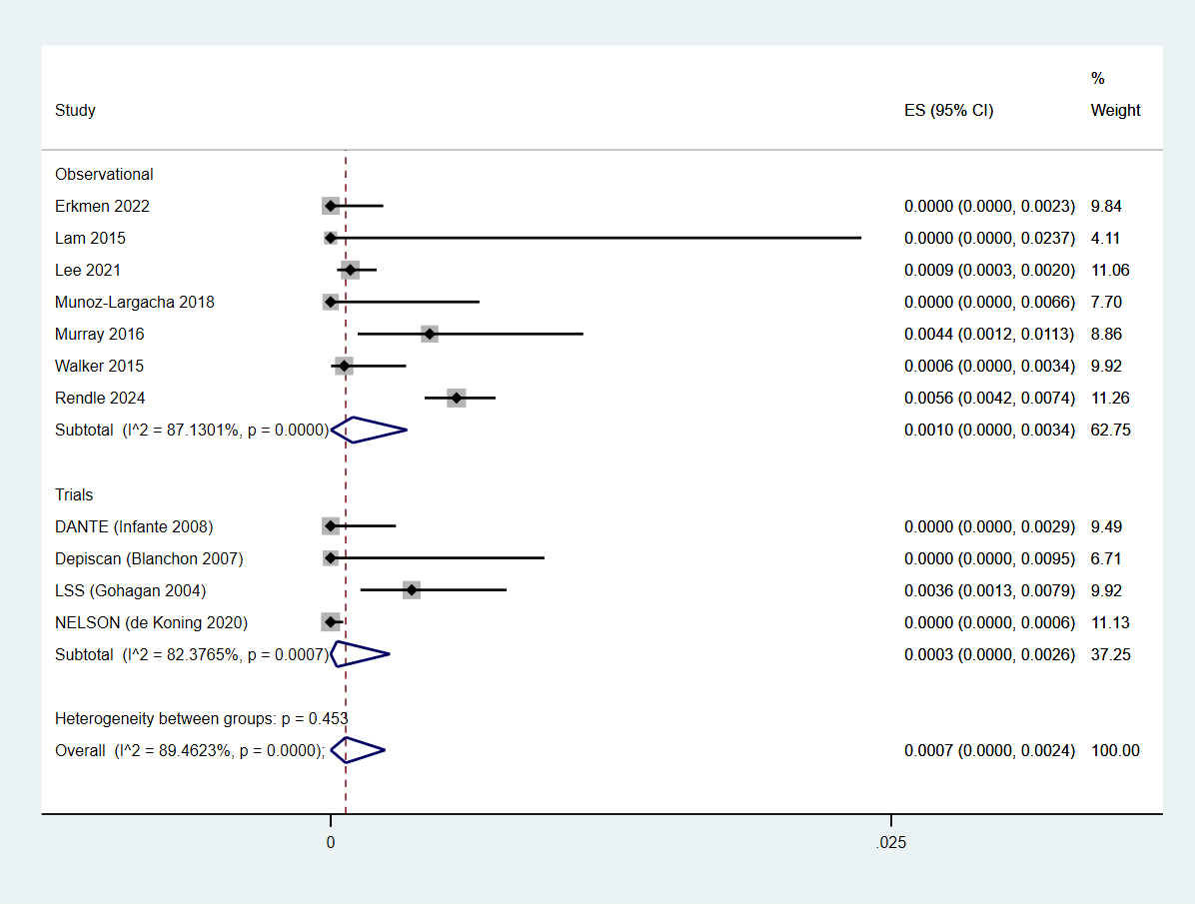

Figure S2.36 Proportion with major complications from invasive testing at round 1
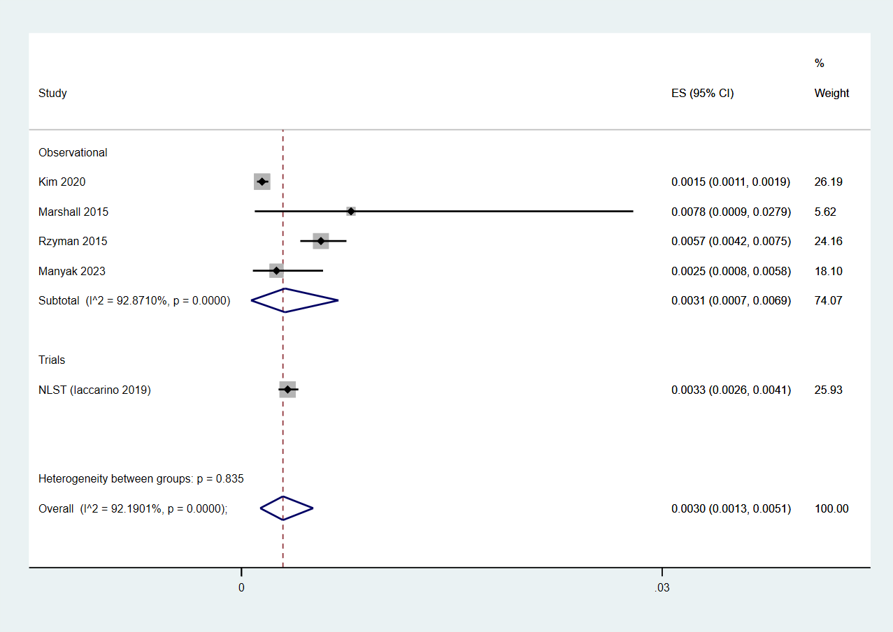

Figure S2.37 Proportion with major complications from invasive testing over 2/3 rounds

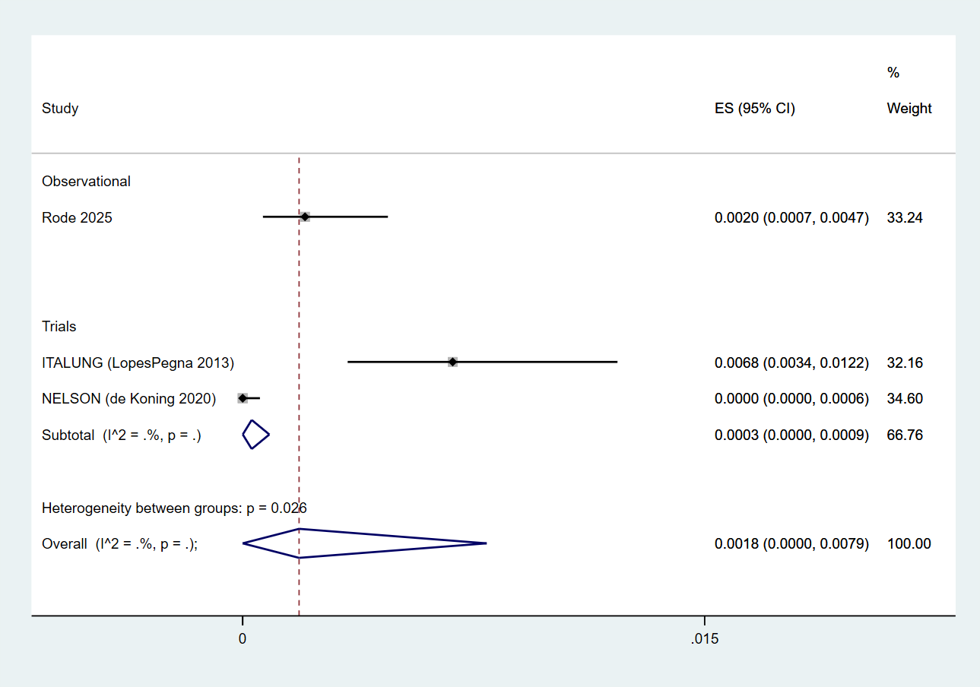

Figure S2.38 Proportion with major complications from invasive testing over 4/5 rounds

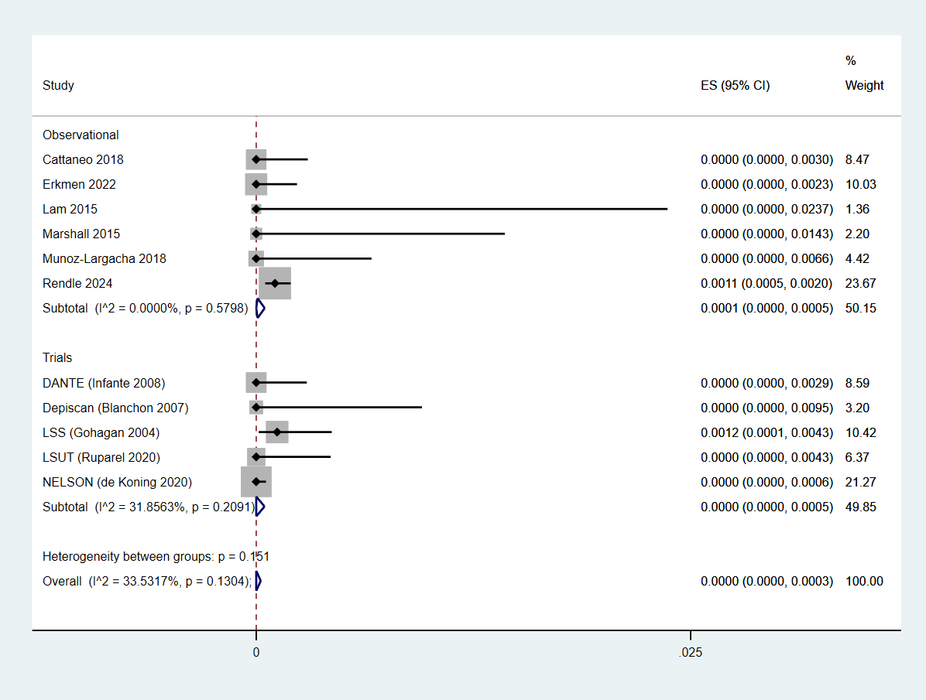

Figure S2.39 Proportion with major complications from invasive testing among false positives at round 1

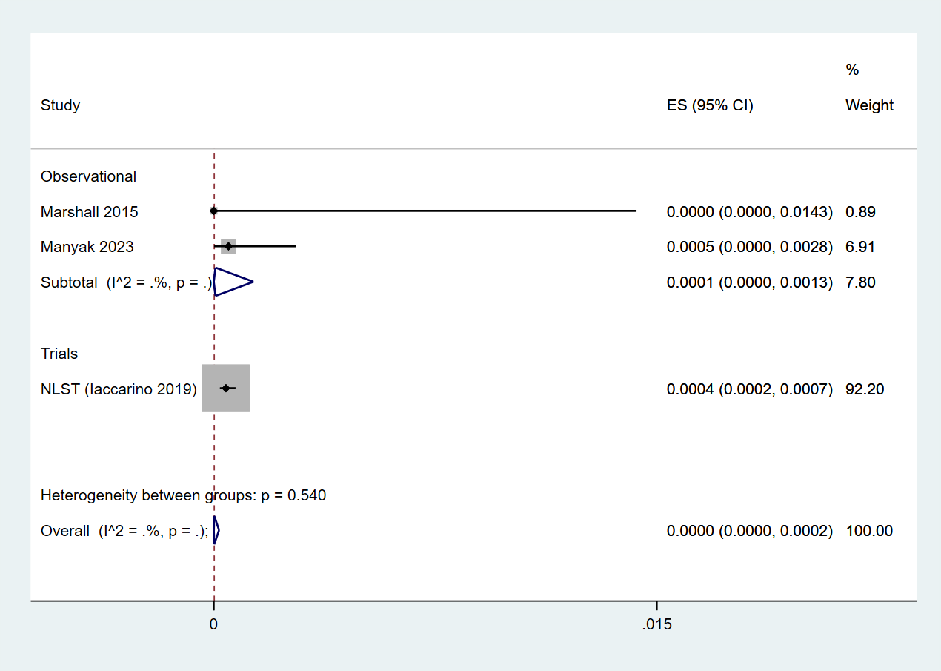

Figure S2.40 Proportion with major complications from invasive testing among false positives over 2/3 rounds

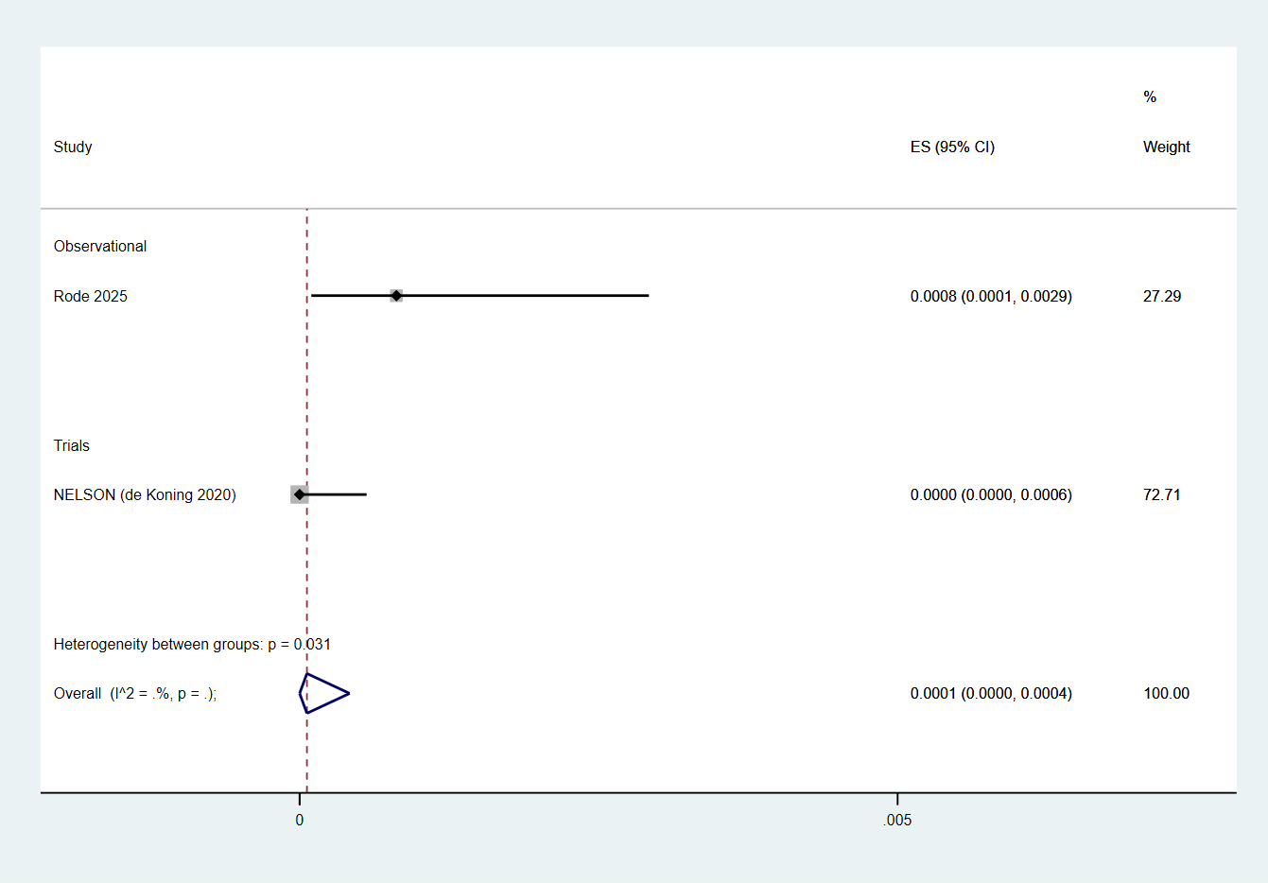

Figure S2.41 Proportion with major complications from invasive testing among false positives over 4/5 rounds

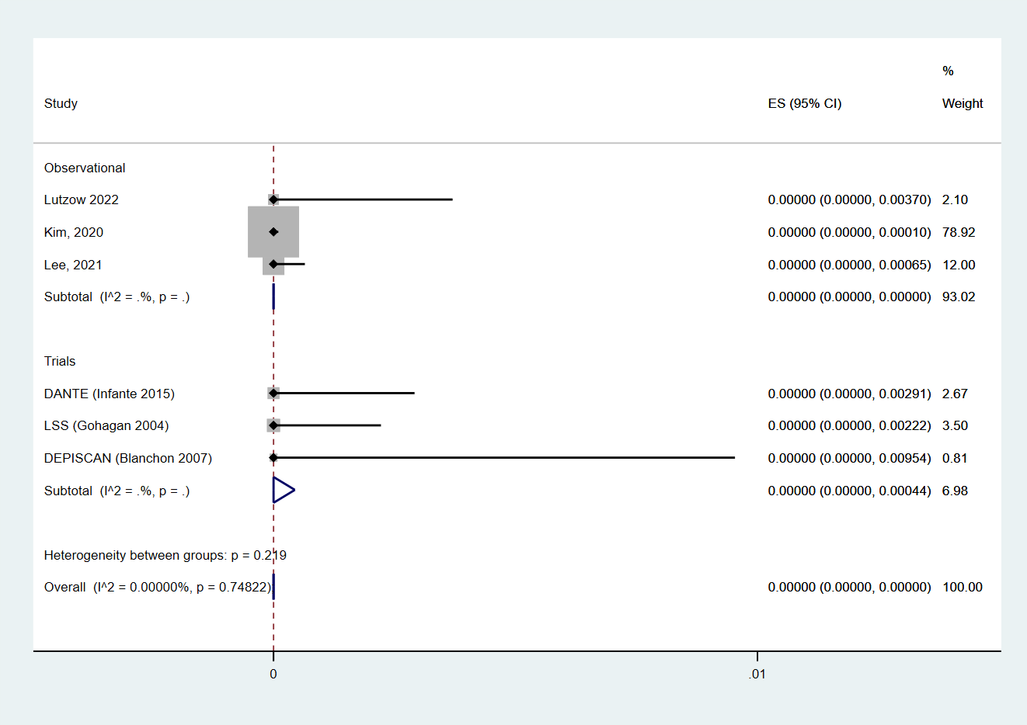

Figure S2.42 Proportion of deaths from invasive testing among false positives at round 1

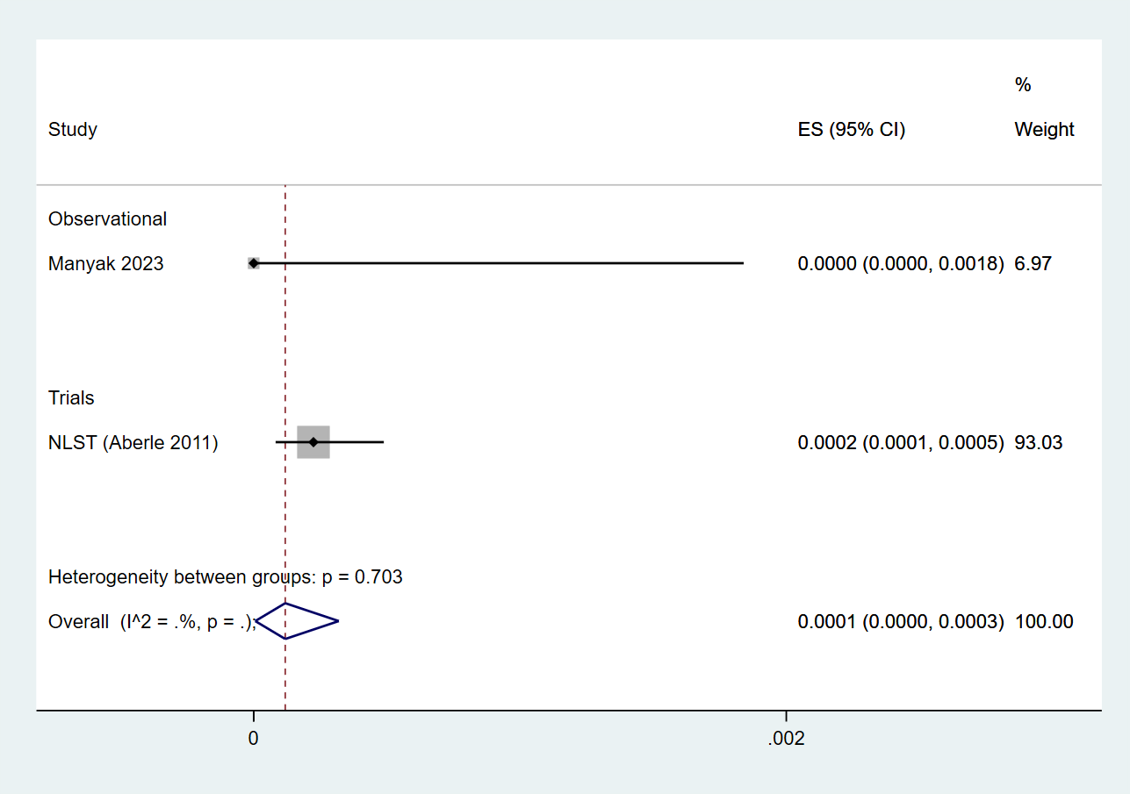

Figure S2.43 Proportion of deaths from invasive testing among false positives over 2/3 rounds

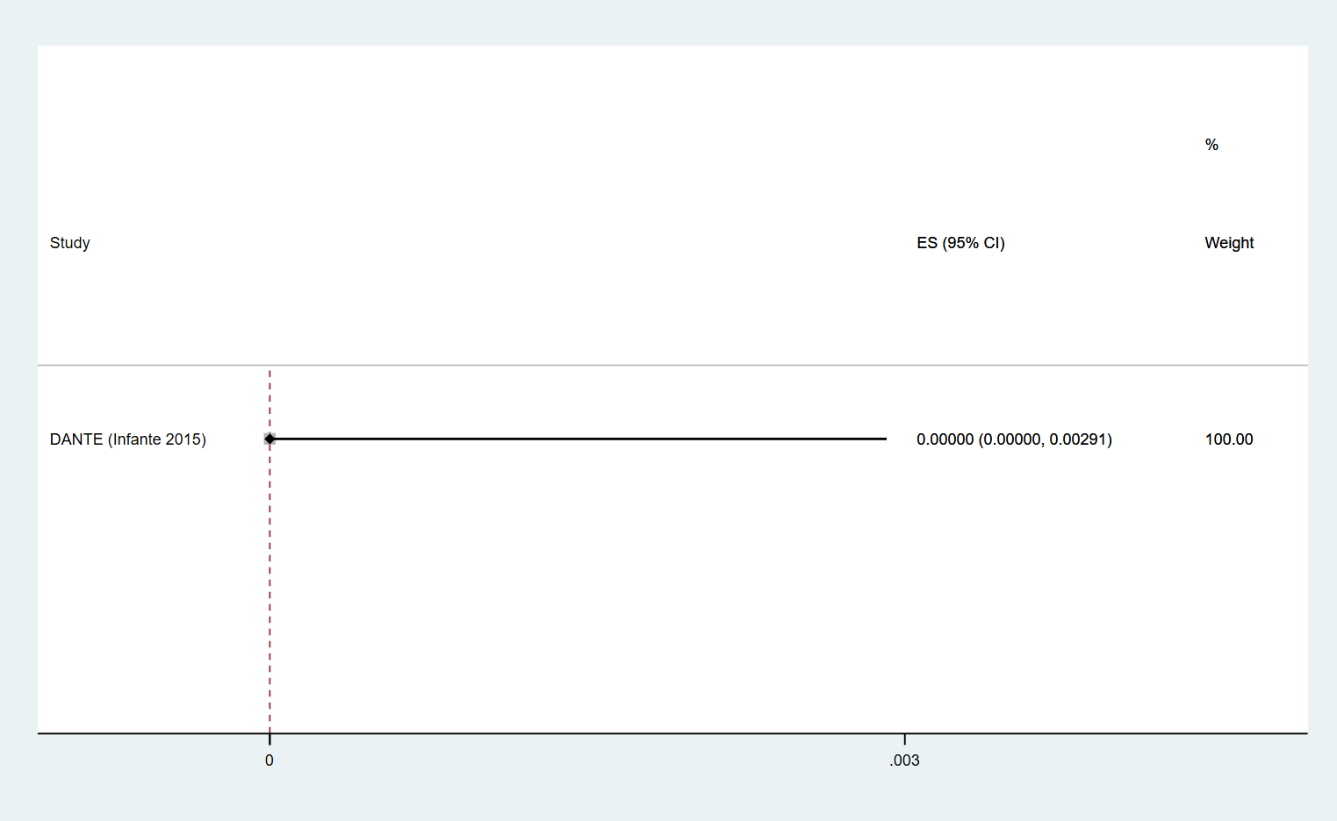

Figure S2.44 Proportion of deaths from invasive testing among false positives over 4/5 rounds

Table S2.10 CT screening: Important outcomes sensitivity and subgroup analyses
Comparison | N studies | n | I² | Absolute number (95% CI) per 1,000
False positives
Between study subgroup: Round 1: Proportion with a false positive, by study design (test for subgroup differences, p=0.42)
Observational | 18 (13, 17, 30, 44, 45, 47, 57, 60, 72-75, 80, 81, 83, 86, 88, 102) | 40,757 | 99% | 200 [170, 240]
Trials | 11 (48, 82, 92-96, 98-101) | 48,888 | 99% | 180 [140, 220]
Sensitivity analysis: Round 1: Proportion with a false positive, excluding high risk of bias studies
All studies | 29 (13, 17, 30, 44, 45, 47, 48, 57, 60, 72-75, 80-83, 86, 88, 92-96, 98-102) | 89,645 | 99% | 200 [170, 240]
Not high risk of bias | 22 (13, 30, 45, 47, 48, 57, 60, 72, 73, 75, 80-82, 86, 88, 93, 95, 96, 98-100, 102) | 56,751 | 99% | 170 [140, 200]
Between study subgroup: Round 1: Proportion with a false positive, by nodule management (test for subgroup differences, p<0.0001)
Highly sensitive | 4 (17, 80, 92, 94) | 28,792 | 99% | 390 [290, 500]
Less sensitive | 25 (13, 30, 44, 45, 47, 48, 57, 60, 72-75, 81-83, 86, 88, 93, 95, 96, 98-102) | 60,853 | 99% | 160 [140, 190]
Within study subgroup: Round 1: Proportion with a false positive, by age (test for subgroup differences, p<0.00001)
<65 years | Trials: 1 (127) | 19,612 | NA | 250 [240, 250]
≥65 years | Trials: 1 (127) | 7,110 | NA | 300 [290, 310]
Within study subgroup: Round 1: Proportion with a false positive, by 5-year lung cancer death risk quintile (test for subgroup differences, p<0.00001)
Risk quintile 1 | Trials: 1 (120) | 5,276 | NA | 220 [210, 230]
Risk quintile 2 | Trials: 1 (120) | 5,310 | NA | 240 [230, 250]
Risk quintile 3 | Trials: 1 (120) | 5,396 | NA | 250 [240, 260]
Risk quintile 4 | Trials: 1 (120) | 5,314 | NA | 270 [260, 280]
Risk quintile 5 | Trials: 1 (120) | 5,308 | NA | 290 [280, 310]
Between study subgroup: 2/3 Rounds: Proportion with a false positive, by study design (test for subgroup differences, p=0.68)
Observational | 8 (13, 30, 47, 63, 72, 76, 86, 88) | 55,308 | 100% | 300 [120, 480]
Trials | 2 (92, 103) | 28,382 | 97% | 340 [270, 410]
Sensitivity analysis: 2/3 Rounds: Proportion with a false positive, excluding high risk of bias studies
All studies | 10 (13, 30, 47, 63, 72, 76, 86, 88, 92, 103) | 83,680 | 100% | 310 [180, 440]
Not high risk of bias | 8 (13, 30, 47, 63, 72, 76, 86, 88) | 55,308 | 100% | 300 [120, 480]
Between study subgroup: 2/3 Rounds: Proportion with a false positive, by nodule management (test for subgroup differences, p=0.75)
Highly sensitive | 3 (63, 92, 103) | 65,818 | 100% | 280 [110, 450]
Less sensitive | 7 (13, 30, 47, 72, 76, 86, 88) | 17,872 | 100% | 320 [130, 510]
Within study subgroup: 2/3 Rounds: Proportion with a false positive, by age (test for subgroup differences, p<0.00001)
<65 years | Trials: 1 (127) | 19,612 | NA | 350 [340, 350]
≥65 years | Trials: 1 (127) | 7,110 | NA | 410 [400, 430]
Within study subgroup: 2/3 Rounds: Proportion with a false positive, by smoking status (test for subgroup differences, p=0.79)
Never-smoker | Observational: 1 (63) | 17,968 | NA | 160 [150, 160]
Ever-smoker | Observational: 1 (63) | 19,468 | NA | 160 [150, 160]
Within study subgroup: 2/3 Rounds: Proportion with a false positive, by 5-year lung cancer death risk quintile (test for subgroup differences, p<0.00001)
Risk quintile 1 | Trials: 1 (120) | 5,276 | NA | 310 [300, 320]
Risk quintile 2 | Trials: 1 (120) | 5,310 | NA | 340 [330, 350]
Risk quintile 3 | Trials: 1 (120) | 5,396 | NA | 350 [340, 370]
Risk quintile 4 | Trials: 1 (120) | 5,314 | NA | 370 [360, 380]
Risk quintile 5 | Trials: 1 (120) | 5,308 | NA | 400 [390, 420]
Within study subgroup: 2/3 Rounds: Proportion with a false positive, by 6-year lung cancer risk prediction decile (test for subgroup differences, p=NR)
1 trial; N=26,309 overall (NLST): “Cumulative false-positive proportion increased with risk decile, ranging from 29.7% in the lowest to 41.4% in the highest decile.” (128)
Between study subgroup: 4/5 Rounds: Proportion with a false positive, by study design (test for subgroup differences, p=0.61)
Observational | 1 (20) | 1,267 | NA | 390 [360, 410]
Trials | 2 (55, 101) | 2,877 | 99% | 330 [130, 540]
Sensitivity analysis: 4/5 Rounds: Proportion with a false positive, excluding high risk of bias studies
All studies | 3 (20, 55, 101) | 4,144 | 99% | 350 [220, 480]
Not high risk of bias | NA (None at high risk of bias) | NA | NA | NA
Between study subgroup: 4/5 Rounds: Proportion with a false positive, by nodule management (test for subgroup differences, p=NA)
Highly sensitive | None (All less sensitive nodule management) | NA | NA | NA
Less sensitive | 3 (20, 55, 101) | 4,144 | 99% | 350 [220, 480]
Incidental findings
Between study subgroup: Round 1: Proportion with an incidental finding, by study design (test for subgroup differences, p=NA)
Observational | 13 (11, 14, 17, 18, 21, 27, 37, 41, 47, 59, 77, 86, 90) | 14,549 | 100% | 550 [370, 730]
Trials | None (all observational studies) | NA | NA | NA
Sensitivity analysis: Round 1: Proportion with an incidental finding, excluding high risk of bias studies
All studies | 13 (11, 14, 17, 18, 21, 27, 37, 41, 47, 59, 77, 86, 90) | 14,549 | 100% | 550 [370, 730]
Not high risk of bias | 3 (21, 47, 86) | 1,235 | 100% | 540 [0, 1000]
Between study subgroup: 2/3 Rounds: Proportion of incidental findings, by study design (test for subgroup differences, p=NA)
Observational | None (all trials) | NA | NA | NA
Trials | 1 (104) | 26,722 | NA | 570 [560, 570]
Sensitivity analysis: 2/3 Rounds: Proportion of incidental findings, excluding high risk of bias studies
All studies | 1 (104) | 26,722 | NA | 570 [560, 570]
Not high risk of bias | NA (no high risk of bias studies) | NA | NA | NA
Between study subgroup: 4/5 Rounds: Proportion of incidental findings, by study design (test for subgroup differences, p=0.002)
Observational | 1 (59) | 519 | NA | 730 [690, 770]
Trials | 2 (55, 101, 105) (2 publications for 1 trial used for this outcome) | 2,877 | 100% | 230 [0, 540]
Sensitivity analysis: 4/5 Rounds: Proportion of incidental findings, excluding high risk of bias studies
All studies | 3 (55, 59, 101, 105) | 3,396 | 100% | 400 [50, 750]
Not high risk of bias | 2 (55, 101, 105) | 2,877 | 100% | 230 [0, 540]
Clinically significant incidental findings
Between study subgroup: Round 1: Proportion of clinically significant incidental findings, by study design (test for subgroup differences, p=0.29)
Observational | 26 (12, 15-18, 21, 26, 27, 34, 35, 37, 38, 40-42, 47, 52, 59, 69, 71, 81, 90, 91, 107) | 81,843 | 99% | 210 [180, 250]
Trials | 2 (104, 106) | 27,582 | 99% | 330 [120, 540]
Sensitivity analysis: Round 1: Proportion of clinically significant incidental findings, excluding high risk of bias
All studies | 28 (12, 15-18, 21, 26, 27, 34, 35, 37, 38, 40-42, 47, 52, 59, 69, 71, 81, 90, 91, 104, 106, 107) | 109,425 | 100% | 220 [180, 260]
Not high risk of bias | 5 (38, 47, 91, 104, 106) | 28,821 | 97% | 290 [220, 370]
Within study subgroup: Round 1: Proportion of clinically significant incidental findings, by sex (test for subgroup differences, p<0.00001)
Men | Observational: 1 (71) | 1,874 | NA | 230 [210, 250]
Women | Observational: 1 (71) | 2,199 | NA | 160 [140, 170]
Within study subgroup: Round 1: Proportion of clinically significant incidental findings, by asbestos exposure (test for subgroup differences, p=0.0005)
Asbestos exposure (>1 year) | Trials: 1 (135) | 1,228 | NA | 130 [110, 150]
No asbestos exposure | Trials: 1 (135) | 25,290 | NA | 100 [100, 100]
Between study subgroup: 2/3 Rounds: Proportion of clinically significant incidental findings, by study design (test for subgroup differences, p=NA)
Observational | None (only a trial) | NA | NA | NA
Trials | 1 (104) | 26,722 | NA | 340 [330, 340]
Sensitivity analysis: 2/3 Rounds: Proportion of clinically significant incidental findings, excluding high risk of bias studies
All studies | 1 (104) | 26,722 | NA | 340 [330, 340]
Not high risk of bias | None (no high risk of bias studies) | NA | NA | NA
Within study subgroup: 2/3 Rounds: Proportion of clinically significant incidental findings, by age (test for subgroup differences, p<0.00001)
<65 years | Trials: 1 (127) | 19,612 | NA | 150 [140, 150]
≥65 years | Trials: 1 (127) | 7,110 | NA | 190 [180, 200]
Between study subgroup: 4/5 Rounds: Proportion of clinically significant incidental findings, by study design (test for subgroup differences, p=NA)
Observational | 4 (26, 36, 59, 108) | 12,026 |  | 80 [30, 120]
Trials | None (all observational studies) | NA | NA | NA
Sensitivity analysis: 4/5 Rounds: Proportion of clinically significant incidental findings, excluding high risk of bias studies
All studies | 4 (26, 36, 59, 108) | 12,026 | 99% | 80 [30, 120]
Not high risk of bias | 1 (108) | 5,203 | NA | 80 [70, 80]
Major complications from invasive diagnostic testing
Between study subgroup: Round 1: Proportion of major complications from invasive testing (LCs+FPs), by study design (test for subgroup differences, p=0.453)
Observational | 7 (10, 17, 22, 29, 39, 64, 81) | 19,795 | 87% | 1.00 [0.00, 3.4]
Trials | 4 (78, 82, 94, 96) | 9,892 | 82% | 0.30 [0.00, 2.60]
Between study subgroup: Round 1: Proportion of major complications from invasive testing among false positives, by study design (test for subgroup differences, p=0.151)
Observational | 6 (7, 10, 17, 22, 39, 80) | 13,040 | 0% | 0.10 [0.00, 0.50]
Trials | 5 (48, 78, 82, 94, 96) | 10,751 | 32% | 0.00 [0.00, 0.50]
Between study subgroup: 2/3 Rounds: Proportion of major complications from invasive testing (LCs+FPs), by study design (test for subgroup differences, p=0.835)
Observational | 4 (36, 63, 76, 80) | 48,344 | 93% | 3.10 [0.70, 6.90]
Trials | 1 (109) | 26,722 | NA | 3.30 [0.70, 4.10]
Within study subgroup: 2/3 Rounds: Proportion of major complications from invasive testing (LCs+FPs), by COPD status (test for subgroup differences, p=0.001)
COPD | Trials: 1 (109) | 4,632 | NA | 6.26 [4.20, 8.98]
No COPD | Trials: 1 (109) | 21,821 | NA | 2.70 [2.06, 3.49]
Within study subgroup: 2/3 Rounds: Proportion of major complications from invasive testing (LCs+FPs), by smoking status (test for subgroup differences, p=0.084)
Never-smoker | Observational: 1 (63) | 17,968 | NA | 1.11 [0.68, 1.72]
Ever-smoker | Observational: 1 (63) | 19,468 | NA | 1.80 [1.25, 2.50]
Between study subgroup: 2/3 Rounds: Proportion of major complications from invasive testing among false positives, by study design (test for subgroup differences, p=0.540)
Observational | 2 (36, 80) | 2,259 | NA | 0.10 [0.00, 1.30]
Trials | 1 (109) | 26,722 | NA | 0.40 [0.20, 0.70]
Between study subgroup: 4/5 Rounds: Proportion of major complications from invasive testing (LCs+FPs), by study design (test for subgroup differences, p=0.026)
Observational | 1 (40) | 2,471 | NA | 2.00 [0.70, 4.70]
Trials | 2 (78, 101) | 8,196 | NA | 0.30 [0.00, 0.90]
Between study subgroup: 4/5 Rounds: Proportion of major complications from invasive testing among false positives, by study design (test for subgroup differences, p=0.031)
Observational | 1 (40) | 2,471 | NA | 0.80 [0.10, 2.90]
Trials | 1 (78) | 6,583 | NA | 0.00 [0.00, 0.60]
Death from invasive diagnostic testing
Between study subgroup: Round 1: Proportion of deaths from invasive testing among false positives, by study design (test for subgroup differences, p=0.219)
Observational | 3 (63, 64, 110) | 44,123 | NA | 0.00 [0.00, 0.00]
Trials | 3 (55, 82, 94) | 3,309 | NA | 0.00 [0.00, 0.44]
Between study subgroup: 2/3 Rounds: Proportion of deaths from invasive testing among false positives, by study design (test for subgroup differences, p=0.703)
Observational | 1 (36) | 2,003 | NA | 0.00 [0.00, 1.80]
Trials | 1 (92) | 26,722 | NA | 0.20 [0.10, 0.50]
Between study subgroup: 4/5 Rounds: Proportion of deaths from invasive testing among false positives, by study design (test for subgroup differences, p=NA)
Observational | None (only a single trial) | NA | NA | NA
Trials | 1 (55) | 1,264 | NA | 0.00 [0.00, 2.91]

Table S2.11 Additional harms outcome data
Number of studies; Number enrolled/randomized to CT screening | Absolute numbers (95% CI) per 1000
Number of false positive events
Over 2/3 rounds: Trials: 3 studies; N=34,622 (92, 94, 95, 134) (2 publications from 1 trial were used for this outcome)  Observational: 3 studies; N=4,643 (57, 72, 80) | 500 [330, 680]
Over 4/5 rounds: Trials: 5 studies; N=14,653 (78, 93, 101, 129, 132)  Observational: 1 study; N=5,203 (136) | 350 [270, 420]
Proportion of false positive requiring diagnostic follow-up
Round 1: Trials: 9 studies; N=21,781 (46, 48, 93-97, 100, 132)  Observational: 15 studies; N=34,660 (13, 17, 30, 44, 45, 47, 57, 60, 72-76, 81, 86) | 20 [10, 20]
Over 2/3 rounds: Trials: 2 studies; N=4,780 (95, 103)  Observational: 8 studies; N=55,363 (13, 30, 47, 63, 72, 76, 80, 86) | 20 [10, 30]
Over 4/5 rounds: Trials: 2 studies; N=2,877 (55, 101)  Observational: 2 studies; N=6,470 (20, 137) | 30 [10, 50]
Number of false positive events requiring diagnostic follow-up
Over 2/3 rounds: Trials: 1 study; N=1,660 (94, 134) (2 publications from 1 trial were used for this outcome)  Observational: 1 study; N=1,035 (57) | 30 [20, 40]
Over 4/5 rounds: Trials: 3 studies; N=10,988 (78, 93, 132)  Observational: 0 studies | 40 [30, 50]
Number of incidental finding events
Round 1: Trials: 2 studies; N=1,155 (82, 138)  Observational: 12 studies; n=21,995 (11, 14, 15, 21, 25, 26, 59, 68, 70, 75, 81) | 790 [630, 950]
Over 2/3 rounds: Trials: 1 study; N=26,722 (104)  Observational: 1 study; N=8,649 (76) | 500 [10, 1000]
Over 4/5 rounds: Trials: 0 studies  Observational: 2 studies; N=4,820 (26, 59) | 720 [0, 1570]
Number of clinically significant incidental finding events
Round 1: Trials: 1 study; N=2,028 (46)  Observational: 9 studies; N=19,475 (12, 15, 16, 27, 30, 59, 71, 107, 108) | 200 [140, 250]
Over 2/3 rounds: Trials: 1 study; N=26,722 (104)  Observational: 2 studies; N=5,275 (8, 30) | 350 [0, 700]
Over 4/5 rounds: Trials: 0 studies  Observational: 2 studies; N=5,722 (59, 108) | 100 [60, 140]
Proportion^{ⱡ} with specific incidental finding – coronary artery calcification
Round 1: Trials: 1 study; N=770 (138)  Observational: 24 observational; N=54,665 (12, 14, 15, 19, 21, 24, 25, 27, 32-34, 37, 38, 43, 47, 54, 59, 66, 68, 77, 89-91, 107) | 340 [230, 450]
Over 2/3 rounds: Trials: 1 study; N=26,722 (104)  Observational: 0 studies | 70 [60, 70]
Over 4/5 rounds: Trials: 1 study; N=1,613 (105)  Observational: 1 study; N=519 (59) | 240 [0, 520]
Proportion with specific incidental finding - emphysema
Round 1: Trials: 3 studies; N=3,183 (82, 133, 138)  Observational: 18 studies; N=242,526 (12, 18, 21, 25, 28, 33, 37, 38, 43, 47, 59, 63, 68, 77, 79, 90, 91, 102) | 240 [180, 290]
Over 2/3 rounds: Trials: 1 study; N=26,722 (104)  Observational: 0 studies | 210 [210, 220]
Over 4/5 rounds: Trials: 0 studies  Observational: 1 study; N=519 (59) | 120 [90, 140]
Proportion with specific incidental finding – thyroid abnormalities║
Round 1: Trials: 1 study; N=2,028 (133)  Observational: 18 studies; N=28,340 (14-16, 21, 27, 33, 37, 38, 43, 47, 59, 65, 67, 71, 77, 81, 86, 91) | 15.9 [0.0, 22.2]
Over 2/3 rounds: Trials: 1 study; N=26,722 (104)  Observational: 1 study; N=2,309 (43) | 9.0 [8.0, 10.0]
Over 4/5 rounds: Trials: 0 studies  Observational: 1 study; N=519 (59) | 52.0 [36.0, 74.6]
Proportion with specific incidental finding – lymph node abnormalities║
Round 1: Trials: 1 study; N=2,028 (133)  Observational: 10 studies; N=14,559 (14, 15, 21, 27, 30, 37, 38, 68, 77, 81) | 19.0 [11.0, 29.0]
Over 2/3 rounds: Trials: 1 study; N=26,722 (104)  Observational: 3 studies; N=13,924 (8, 30, 76) | 50.7 [7.4, 129.3]
Over 4/5 rounds: no data | No data
Proportion with specific incidental finding – aortic aneurysm║
Round 1: Trials: 0 studies  Observational: 10 studies; N=20,023 (12, 14, 16, 37, 47, 54, 59, 81, 86, 107) | 14.0 [7.0, 22.0]
Over 2/3 rounds: Trials: 1 study; N=26,722 (104)  Observational: 1 study; N=1,520 (8) | 9.3 [8.2, 10.5]
Over 4/5 rounds: Trials: 0 studies  Observational: 1 study; N=519 (59) | 11.6 [5.3, 25.0]
Proportion with specific incidental finding – cancer (excluding primary lung cancer)║
Round 1: Trials: 1 study; N=1,264 (130)  Observational: 8 studies; N=162,874 (21, 37, 59, 61, 62, 81, 108, 110)  Specific cancers:  Thymoma (n=3)  Renal cell cancer (n=9)  Gastric cancer (n=3)  Thyroid cancer (n=3)  Malignant lymphoma (n=1)  Malignant mesothelioma (n=6)  Urinary tract malignancy (n=1)  Adrenal gland malignancy (n=1)  Metastases (n=5)  Non-LC malignancy (details NR, n=136)  Total cancers: 168 | 5.0 [1.0, 11.0]
Over 2/3 rounds: Trials: 0 studies  Observational: 2 studies; N=5,275 (8, 30)  Specific cancers:  Hodgkin’s disease (n=2)  Lymphoma (n=4)  Metastasis (n=6)  Renal cell cancer (n=4)  Bronchial cancer (n=2)  Ovarian cancer (n=1)  Pancreatic cancer (n=1)  Breast cancer (n=3)  Total cancers: 23 | 4.2 [2.6, 6.2]
Over 4/5 rounds: Trials: 1 study; N=1,613 (101)  Observational: 3 studies; N=7,725 (36, 59, 108)  Specific cancers:  Thymoma (n=5)  Metastases (n=1)  Malignant lymphoma (n=7)  Malignant schwannoma (n=1)  Hepatocellular cancer (n=1)  Gastrointestinal cancer (n=1),  Pancreatic cancer (n=2)  Prostate cancer (n=1)  Renal cancer (n=12)  Urinary tract malignancy (n=1)  Thyroid cancer (n=3)  Breast cancer (n=1)  Adrenal gland malignancy (n=1)  Ovarian cancer (n=1)  Malignant mesothelioma (n=2)  Breast cancer (n=2)  Kidney cancer (n=1)  Esophageal cancer (n=2)  Head and neck cancer (n=1)  Total cancers: 46 | 5.0 [3.0, 8.0]
Number of major complication events from invasive testing (LCs+FPs)║
Round 1: Trials: 4 studies; N=9,892 (78, 82, 94, 96)  Observational: 8 studies; N=112,057 (10, 17, 22, 23, 29, 31, 64, 81) | 1.41 [0.00, 5.10]
Over 2/3 rounds: Trials: 2 studies; N=28,382 (92, 94)  Observational: 2 studies; N=37,692 (63, 80) | 5.34 [1.19, 12.00]
Over 4/5 rounds: Trials: 1 study; N=6,583 (78)  Observational: 0 studies | 0.00 [0.00, 0.56]
Number of major complication events from invasive testing among FPs║
Round 1: Trials: 5 studies; N=35,813 (48, 78, 82, 96, 127)  Observational: 5 studies; N=3,774 (7, 10, 17, 22, 80) | 0.00 [0.00, 0.00]
Over 2/3 rounds: Trials: 2 studies; N=28,382 (92, 94)  Observational: 1 study; N=256 (80) | 0.85 [0.47, 1.31]
Over 4/5 rounds: no evidence | No evidence.
Proportion with deaths from invasive testing (LCs+FPs)║
Round 1: Trials: 2 studies; N=2,045 (82, 94)  Observational: 3 studies; N=125,769 (23, 63, 64) | 0.00 [0.00, 0.12]
Over 2/3 rounds: Trials: 1 study; N=26,722 (92)  Observational: 1 study; N=37,436 (63) | 0.13 [0.05, 0.23]
Over 4/5 rounds: Trials: 1 study; N=1,613 (131)  Observational: 0 studies | 3.72 [1.37, 8.08]
^{ⱡ} Specific incidental findings were assumed to be proportions (proportions and events are pooled together).
║Rare events were analyzed in STATA with the exact method.

Table S2.12 Targeted CT screening: Summary of findings for benefit outcomes
Outcome  Trial  Number of participants; follow-up  Threshold | Relative effects, RR (95% CI) | Anticipated absolute effects |  |  | Certainty of evidence (GRADE^{ⱡ}) | What happens?
Outcome  Trial  Number of participants; follow-up  Threshold | Relative effects, RR (95% CI) | With screening | Without screening | Difference | Certainty of evidence (GRADE^{ⱡ}) | What happens?
Lung cancer mortality (Fig. S2.45)  ECLS (Early-CDT test autoantibodies (CT for positive screen and x-ray normal/negative every 6 mos x 4)  N=12,209; 5 years follow-up  Threshold: 1 fewer per 1000 | 0.82 [0.60, 1.11] | 12.1 per 1000  (8.8 to 16.3) | 14.7 per 1000 | 2.7 fewer (5.9 fewer to 1.6 more) per 1000 | Very low  ⊕⊝⊝⊝ª  Due to very serious indirectness (timing insufficient), and very serious imprecision | We are very uncertain about the effects from targeted screening strategies on lung-cancer mortality.
Lung cancer mortality (Fig. S2.46)  LungSEARCH (Annual sputum cytology/cytometry (CT and autofluorescence bronchoscopy if positive), all COPD  N=1,568; 5 years follow-up  Threshold: 1 fewer per 1000 | 0.76 [0.40, 1.45] | 20.4 per 1000  (10.7 to 38.9) | 26.8 per 1000 | 6.44 fewer (16.09 fewer to 12.07 more) per 1000 | Very low  ⊕⊝⊝⊝^{b}  Due to very serious indirectness (timing insufficient and population), and very serious imprecision
All-cause mortality (Fig. S2.47)  ECLS  N=12,209; 5 years follow-up  Thresholds: 0.5 and 1 fewer per 1000 | 0.89 [0.77, 1.03] | 56.4 per 1000  (48.8 to 65.3) | 63.4 per 1000 | 7.0 fewer (14.6 fewer to 1.9 more) per 1000 | Very low  ⊕⊝⊝⊝^{c}  Due to very serious indirectness (timing insufficient), and very serious imprecision | We are very uncertain about the effects from targeted screening strategies on all-cause mortality.
All-cause mortality (Fig. S2.48)  LungSEARCH  N=1,568; 5 years follow-up  Thresholds: 0.5 and 1 fewer per 1000 | 0.73 [0.54, 0.97] | 89.50 per 1000 (66.2 to 118.9) | 122.6 per 1000 | 33.1 fewer (56.4 to 3.7 fewer) per 1000 | Very low  ⊕⊝⊝⊝^{d}  Due to very serious indirectness (timing insufficient and population), and imprecision
^{ⱡ}GRADE ratings:
ª Lung cancer mortality (ECLS trial): No serious concerns about risk of bias: The ECLS trial was not high risk of bias for this outcome. No serious concerns about inconsistency: No evidence of inconsistency (a single trial contributed to this outcome). Very serious concerns about indirectness: There were serious concerns about insufficient timing for this outcome (up to 5 years follow-up). Very serious concerns about imprecision: The upper confidence interval crosses two thresholds (1 fewer and 1 more). No serious concerns about reporting bias: No serious concerns about reporting bias.
^{b} Lung cancer mortality (LungSEARCH trial): No serious concerns about risk of bias: The LungSEARCH trial was not high risk of bias for this outcome. No serious concerns about inconsistency: No evidence of inconsistency (a single trial contributed to this outcome). Very serious concerns about indirectness: There were very serious concerns about insufficient timing for this outcome (median 5 years follow-up), and the population all has COPD. Very serious concerns about imprecision: The upper confidence interval crosses the threshold. No serious concerns about reporting bias: No serious concerns about reporting bias.
^{c} All-cause mortality (ECLS trial): No serious concerns about risk of bias: The ECLS trial was not high risk of bias for this outcome. No serious concerns about inconsistency: No evidence of inconsistency (a single trial contributed to this outcome). Very serious concerns about indirectness: There were very serious concerns about insufficient timing for this outcome (up to 5 years follow-up). Very serious concerns about imprecision: The upper confidence interval crosses two thresholds (1 fewer and 1 more). No serious concerns about reporting bias: No serious concerns about reporting bias.
^{d} All-cause mortality (LungSEARCH trial): No serious concerns about risk of bias: The LungSEARCH trial was not high risk of bias for this outcome. No serious concerns about inconsistency: No evidence of inconsistency (a single trial contributed to this outcome). Very serious concerns about indirectness: There were very serious concerns about insufficient timing for this outcome (median 5 years follow-up), and the population all has COPD. Serious concerns about imprecision: The trial sample size was inadequate (as per GRADE guideline 11). No serious concerns about reporting bias: No serious concerns about reporting bias.

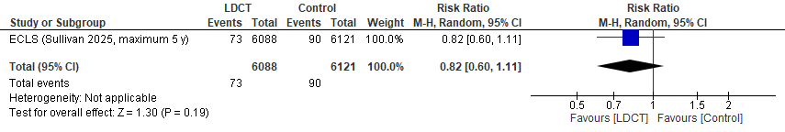

Figure S2.45 Lung cancer mortality, ECLS trial

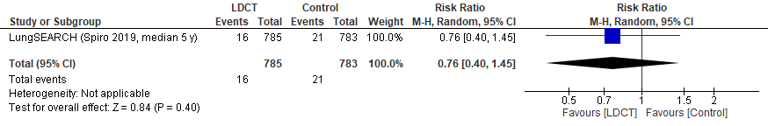

Figure S2.46 Lung cancer mortality, LungSEARCH trial

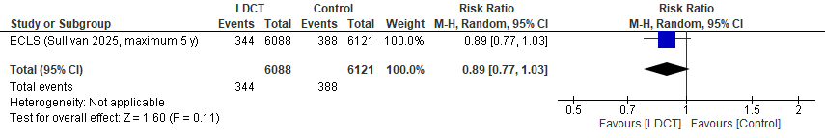

Figure S2.47 All-cause mortality, ECLS trial

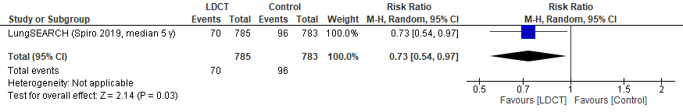

Figure S2.48 All-cause mortality, LungSEARCH trial

Comparison with previous review

There are some differences in the methods and results between this review and that previously used by the CTFPHC for their 2016 recommendations (139). We did not examine the effects from screening with X-ray since the 2016 review as well as others have found no benefit (RR 0.99 for lung-cancer mortality). The previous review did not pool the results of the NLST (and LSS) using an X-ray comparison with other studies using comparators with no screening, but we chose to pool these (and undertake subgroup analysis) when considering the lack of benefit from X-ray. We included five additional RCTs (including the NELSON trial), longer-term results for the NLST and other trials, and at least 50 more observational studies on harms and incidental findings. The latter is likely in part due to our more comprehensive search strategy (e.g., adding incidental findings and psychosocial outcomes).
The point estimates for lung-cancer mortality (3 fewer per 1000), all-cause mortality (4.6 fewer) and FPs (23% [though the guideline focused on the 35% from the NLST]) are quite similar between reviews, though we make different conclusions based on newer GRADE guidance defining the targets of certainty (i.e., decision thresholds) and recognition that precision around the point estimate requires consideration from absolute effects. We also closely investigated between- and within-study findings for key variables of interest, including sex and baseline risk for cancer and mortality. Our review focused much more on incidental findings; though difficult to define in terms of potential patient-important benefit and harms, these findings will likely be a major consideration for making decisions about screening. For the outcomes of major complications and deaths from invasive procedures, we focus on events among those without cancer to better capture the harms from screening and to avoid confounding due to these deaths also being captured for lung-cancer mortality. Our review followed more recent guidance from GRADE for reviewing patient preferences, which has a strong focus on preference-based data (e.g., HSUVs) and informed decision making. We also added data for the use of newer nodule classification system (e.g., LungRADs) to understand how this may impact the benefits and harms found in the existing trials.

References
1. Follmann D, Elliott P, Suh I, Cutler J. Variance imputation for overviews of clinical trials with continuous response. J Clin Epidemiol. 1992;45(7):769–73.
2. Fu R GG, Grant M, Shamliyan T, Sedrakyan A, Wilt TJ, Griffith L, Oremus M, Raina P, Ismaila A, Santaguida P, Lau J, Trikalinos T,. Conducting quantitative synthesis when comparing medical interventions: AHRQ and the Effective Health Care Program. In: Agency for Healthcare Research and Quality. Methods Guide for Comparative Effectiveness Reviews. Rockville, MD: AHRQ; 2010. Available from: http://effectivehealthcare.ahrq.gov/.
3. Egger M, Smith GD, Schneider M, Minder C. Bias in meta-analysis detected by a simple, graphical test. BMJ. 1997;315(7109):629.
4. Harbord RM, Egger M, Sterne JA. A modified test for small-study effects in meta-analyses of controlled trials with binary endpoints. Stat Med. 2006;25(20):3443–57.
5. Pinsky P, Team NLSTR. Lung Cancer Incidence and Mortality with Extended Follow-up in the National Lung Screening Trial. J Thorac Oncol. 2019;14(10):1732–42.
6. Byrne MM, Weissfeld J, Roberts MS. Anxiety, fear of cancer, and perceived risk of cancer following lung cancer screening. Med Decis Making. 2008;28(6):917–25.
7. Cattaneo SM, Meisenberg BR, Geronimo MCM, Bhandari B, Maxted JW, Brady-Copertino CJ. Lung Cancer Screening in the Community Setting. Ann Thorac Surg. 2018;105(6):1627–32.
8. Crestanello JA, Allen MS, Jett JR, Cassivi SD, Nichols FC, 3rd, Swensen SJ, et al. Thoracic surgical operations in patients enrolled in a computed tomographic screening trial. J Thorac Cardiovasc Surg. 2004;128(2):254–9.
9. Doroudi M, Pinsky PF, Marcus PM. Lung cancer mortality in the Lung Screening Study feasibility trial. JNCI Cancer Spectr. 2018;2(3):pky042.
10. Erkmen CP, Randhawa S, Patterson F, Kim R, Weir M, Ma GX. Quantifying Benefits and Harms of Lung Cancer Screening in an Underserved Population: Results From a Prospective Study. Semin Thorac Cardiovasc Surg. 2022;34(2):691–700.
11. Fabbrini AE, Lillie SE, Partin MR, Fu SS, Clothier BA, Bangerter AK, et al. Initial results of a lung cancer screening demonstration project: a local program evaluation. Am J Mamag Care. 2018;24(6):272–7.
12. Guichet PL, Liu BY, Desai B, Surani Z, Cen SY, Lee C. Preliminary results of lung cancer screening in a socioeconomically disadvantaged population. Am J Roentgenol. 2018;210(3):489–96.
13. Henschke CI, McCauley DI, Yankelevitz DF, Naidich DP, McGuinness G, Miettinen OS, et al. Early lung cancer action project: a summary of the findings on baseline screening. Oncologist. 2001;6(2):147–52.
14. Janssen K, Schertz K, Rubin N, Begnaud A. Incidental findings in a decentralized lung cancer screening program. Ann Am Thorac Soc. 2019;16(9):1198–201.
15. Kapoor S, Deppen SA, Paulson AB, Haddad D, Cook JP, Sandler KL. Education Level Predicts Appropriate Follow-Up of Incidental Findings From Lung Cancer Screening. J Am Coll Radiol. 2020;17(5):613–9.
16. Kinsinger LS, Anderson C, Kim J, Larson M, Chan SH, King HA, et al. Implementation of lung cancer screening in the Veterans Health Administration. JAMA Intern Med. 2017;177(3):399–406.
17. Lam VK, Miller M, Dowling L, Singhal S, Young RP, Cabebe EC. Community Low-Dose CT Lung Cancer Screening: A Prospective Cohort Study. Lung. 2015;193(1):135–9.
18. Ledford CJW, Gawrys BL, Wall JL, Saas PD, Seehusen DA. Translating new lung cancer screening guidelines into practice: The experience of one community hospital. J Am Board Fam Med. 2016;29(1):152–5.
19. Mendoza DP, Kako B, Digumarthy SR, Shepard JO, Little BP. Impact of Significant Coronary Artery Calcification Reported on Low-Dose Computed Tomography Lung Cancer Screening. J Thorac Imaging. 2020;35(2):129–35.
20. Miller DL, Mayfield WR, Luu TD, Helms GA, Muster AR, Beckler VJ, et al. Community-Based Multidisciplinary Computed Tomography Screening Program Improves Lung Cancer Survival. Ann Thorac Surg. 2016;101(5):1864–9.
21. Morgan L, Choi H, Reid M, Khawaja A, Mazzone PJ. Frequency of incidental findings and subsequent evaluation in low-dose computed tomographic scans for lung cancer screening. Ann Am Thorac Soc. 2017;14(9):1450–6.
22. Muñoz-Largacha JA, Steiling KA, Kathuria H, Charlot M, Fitzgerald C, Suzuki K, et al. Initial surgical experience following implementation of lung cancer screening at an urban safety net hospital. J Thorac Cardiovasc Surg. 2018;155(6):2674–81.
23. Nunez ER, Caverly TJ, Zhang S, Glickman ME, Qian SX, Boudreau JH, et al. Invasive Procedures and Associated Complications After Initial Lung Cancer Screening in a National Cohort of Veterans. Chest. 2022;162(2):475–84.
24. Raghavan D, Wheeler M, Doege D, Doty JD, Levy H, Dungan KA, et al. Initial Results from Mobile Low-Dose Computerized Tomographic Lung Cancer Screening Unit: Improved Outcomes for Underserved Populations. Oncologist. 2020;25(5):e777–e81.
25. Regan EA, Lowe KE, Make BJ, Lynch DA, Kinney GL, Budoff MJ, et al. Identifying smoking-related disease on lung cancer screening CT scans: Increasing the value. Chronic Obstr Pulm Dis. 2019;6(3):233–45.
26. Regis SM, Borondy-Kitts A, McKee AB, Rieger-Christ K, Sands J, Afnan J, et al. Outcomes of Positive and Suspicious Findings in Clinical Computed Tomography Lung Cancer Screening and the Road Ahead. Ann Am Thorac Soc. 2022;19(8):1371–8.
27. Reiter MJ, Nemesure A, Madu E, Reagan L, Plank A. Frequency and distribution of incidental findings deemed appropriate for S modifier designation on low-dose CT in a lung cancer screening program. Lung Cancer. 2018;120:1–6.
28. Salvatore M, Henschke CI, Yip R, Jacobi A, Eber C, Padilla M, et al. JOURNAL CLUB: Evidence of Interstitial Lung Disease on Low-Dose Chest CT Images: Prevalence, Patterns, and Progression. AJR Am J Roentgenol. 2016;206(3):487–94.
29. Walker BL, Williamson C, Regis SM, McKee AB, D'Agostino RS, Hesketh PJ, et al. Surgical outcomes in a large, clinical, low-dose computed tomographic lung cancer screening program. Ann Thorac Surg. 2015;100(4):1218–23.
30. Wilson DO, Weissfeld JL, Fuhrman CR, Fisher SN, Balogh P, Landreneau RJ, et al. The Pittsburgh Lung Screening Study (PLuSS): outcomes within 3 years of a first computed tomography scan. Am J Respir Crit Care Med. 2008;178(9):956–61.
31. Zhao H, Xu Y, Huo J, Burks AC, Ost DE, Shih YCT. Updated Analysis of Complication Rates Associated with Invasive Diagnostic Procedures after Lung Cancer Screening. JAMA Netw Open. 2020;3(12):29874.
32. Hammer MM, Byrne SC, Blankstein R. Reporting and Outcomes of Coronary Calcification on Lung Cancer Screening CT. Acad Radiol. 2023;30(8):1614–9.
33. Henderson LM, Chiles C, Perera P, Durham DD, Lamb D, Lane LM, et al. Variability in Reporting of Incidental Findings Detected on Lung Cancer Screening. Ann Am Thorac Soc. 2023;20(4):617– 20.
34. Hirsch EA, New ML, Brown SL, Malkoski SP. Results of a pilot risk-based lung cancer screening study: outcomes and comparisons to a Medicare eligible cohort. Discov Oncol. 2023;14(1):160.
35. Kearney LE, Butler C, Nunez ER, Qian S, Slatore CG, Spalluto L, et al. Highly variable reporting of incidental findings in a national cohort of US veterans screened for lung cancer. Clin Imaging. 2023;100:21–3.
36. Manyak A, Seaburg L, Bohreer K, Kirtland SH, Hubka M, Gerbino AJ. Invasive Procedures Associated With Lung Cancer Screening in Clinical Practice. Chest. 2023;164(2):544–55.
37. Melzer AC, Atoma B, Fabbrini AE, Campbell M, Clothier BA, Fu SS. Variation in Reporting of Incidental Findings on Initial Lung Cancer Screening and Associations With Clinician Assessment. J Am Coll Radiol. 2024;21(1):118–27.
38. Pua BB, O'Neill BC, Ortiz AK, Wu A, D'Angelo D, Cahill M, et al. Results from Lung Cancer Screening Outreach Utilizing a Mobile CT Scanner in an Urban Area. J Am Coll Radiol. 2024;21(5):778 – 88.
39. Rendle KA, Saia CA, Vachani A, Burnett-Hartman AN, Doria-Rose VP, Beucker S, et al. Rates of Downstream Procedures and Complications Associated With Lung Cancer Screening in Routine Clinical Practice : A Retrospective Cohort Study. Ann Intern Med. 2024;177(1):18–28.
40. Rode MM, Sykes A-MG, Allen MS, Ingalls LA, Rehman H, Deetz DC, et al. Risk-Based Lung Cancer Screening in Clinical Practice. J Thorac Oncol. 2025.
41. Shah SK, Kim S, Khan AA, Krishnan V, Lally AM, Shah PN, et al. Examination of Firefighting as an Occupational Exposure Criteria for Lung Cancer Screening. Lung. 2024;202(5):649–55.
42. Triplette M, Kross EK, Snidarich M, Shahrir S, Hippe DS, Crothers K. An alternating-intervention pilot trial on the impact of an informational handout on patient-reported outcomes and follow-up after lung cancer screening. PloS One. 2024;19(4):e0300352.
43. van Gerwen M, Ma T, Yip R, Choi C, Paksashvili N, Yankelevitz D, et al. Thyroid abnormalities identified on CT screening for lung cancer. Clin Imaging. 2024;110:110162.
44. Bartlett EC, Kemp SV, Ridge CA, Desai SR, Mirsadraee S, Morjaria JB, et al. Baseline Results of the West London lung cancer screening pilot study - Impact of mobile scanners and dual risk model utilisation. Lung Cancer. 2020;148:12–9.
45. Crosbie PA, Balata H, Evison M, Atack M, Bayliss-Brideaux V, Colligan D, et al. Implementing lung cancer screening: baseline results from a community-based 'Lung Health Check' pilot in deprived areas of Manchester. Thorax. 2019;74(4):405–9.
46. Field JK, Vulkan D, Davies MPA, Baldwin DR, Brain KE, Devaraj A, et al. Lung cancer mortality reduction by LDCT screening: UKLS randomised trial results and international meta-analysis. Lancet Reg Health Eur. 2021;10:100179.
47. MacRedmond R, McVey G, Lee M, Costello RW, Kenny D, Foley C, et al. Screening for lung cancer using low dose CT scanning: results of 2 year follow up. Thorax. 2006;61(1):54–6.
48. Ruparel M, Quaife SL, Dickson JL, Horst C, Tisi S, Hall H, et al. Lung Screen Uptake Trial: results from a single lung cancer screening round. Thorax. 2020;75(10):908–12.
49. Spiro SG, Shah PL, Rintoul RC, George J, Janes S, Callister M, et al. Sequential screening for lung cancer in a high-risk group: Randomised controlled trial. Eur Respir J. 2019;54(4):1900581.
50. Sullivan FM, Mair FS, Anderson W, Armory P, Briggs A, Chew C, et al. Earlier diagnosis of lung cancer in a randomised trial of an autoantibody blood test followed by imaging. Eur Respir J. 2021;57(1):00670.
51. Davies MPA, Vulkan D, Gabe R, Duffy SW, Field JK. Impact of single round of low dose CT lung cancer screening on cause of mortality in different socio-economic groups: a post-hoc analysis of long-term follow-up of the UKLS trial.Lancet Reg Health Eur. 2024;42:100936.
52. Matthews S, Kyi M, Nasimudeen A, Marusic A, Johns CS, Page J. Targeted Lung Health Check: breast related incidental findings-imaging appearances and lessons learned. Br J Radiol. 2024;97(1154):371–6.
53. Sullivan FM, Mair FS, Anderson W, Chew C, Dorward A, Haughney J, et al. Five year mortality in an RCT of a lung cancer biomarker to select people for low dose CT screening. PloS One. 2025;20(1):e0306163.
54. Tisi S, Creamer AW, Dickson J, Horst C, Quaife S, Hall H, et al. Prevalence and clinical characteristics of non-malignant CT detected incidental findings in the SUMMIT lung cancer screening cohort. BMJ Open Respir Res. 2023;10(1).
55. Infante M, Cavuto S, Lutman FR, Passera E, Chiarenza M, Chiesa G, et al. Long-Term Follow-up Results of the DANTE Trial, a Randomized Study of Lung Cancer Screening with Spiral Computed Tomography. Am J Respir Crit Care Med. 2015;191(10):1166–75.
56. Paci E, Puliti D, Carozzi FM, Carrozzi L, Falaschi F, Pegna AL, et al. Prognostic selection and long-term survival analysis to assess overdiagnosis risk in lung cancer screening randomized trials. J Med Screen. 2021;28(1):39–47.
57. Pastorino U, Bellomi M, Landoni C, De Fiori E, Arnaldi P, Picchio M, et al. Early lung-cancer detection with spiral CT and positron emission tomography in heavy smokers: 2-year results. Lancet. 2003;362(9384):593–7.
58. Pastorino U, Silva M, Sestini S, Sabia F, Boeri M, Cantarutti A, et al. Prolonged lung cancer screening reduced 10-year mortality in the MILD trial: new confirmation of lung cancer screening efficacy. Ann Oncol. 2019;30(7):1162–9.
59. Priola AM, Priola SM, Giaj-Levra M, Basso E, Veltri A, Fava C, et al. Clinical implications and added costs of incidental findings in an early detection study of lung cancer by using low-dose spiral computed tomography. Clin Lung Cancer. 2013;14(2):139–48.
60. Veronesi G, Bellomi M, Mulshine JL, Pelosi G, Scanagatta P, Paganelli G, et al. Lung cancer screening with low-dose computed tomography: a non-invasive diagnostic protocol for baseline lung nodules. Lung Cancer. 2008;61(3):340–9.
61. Antonicelli A, Muriana P, Favaro G, Mangiameli G, Lanza E, Profili M, et al. The Smokers Health Multiple ACtions (SMAC-1) Trial: Study Design and Results of the Baseline Round. Cancers. 2024;16(2).
62. Kim H, Jo E, Kim J, Lee N, Goo JM, Kim Y. Diagnostic Performance of the Modified Lung CT Screening Reporting and Data System in a TB-Endemic Country: The Korean National Lung Cancer Screening Program. Chest. 2025;167(6):1778–87.
63. Kim YW, Kang HR, Kwon BS, Lim SY, Lee YJ, Park JS, et al. Low-dose chest computed tomographic screening and invasive diagnosis of pulmonary nodules for lung cancer in never-smokers. Eur Respir J. 2020;56(5):2000177.
64. Lee J, Kim Y, Kim HY, Goo JM, Lim J, Lee CT, et al. Feasibility of implementing a national lung cancer screening program: Interim results from the Korean Lung Cancer Screening Project (K-LUCAS). Transl Lung Cancer Res. 2021;10(2):723–36.
65. Lee JH, Jeong SY, Kim YH. Clinical significance of incidental thyroid nodules identified on low-dose CT for lung cancer screening. Multidiscip Respir Med. 2013;8(1):56.
66. Park C, Lee BC, Jeong WG, Park W-J, Jin GY, Kim Y-H. Coronary Artery Calcification on Low-Dose Lung Cancer Screening CT in South Korea: Visual and Artificial Intelligence-Based Assessment and Association With Cardiovascular Events. AJR Am J Roentgenol. 2024;222(5):e2430852.
67. Seo H, Jin KN, Park JS, Kang KM, Lee EK, Lee JY, et al. Risk of thyroid cancer in a lung cancer screening population of the National Lung Screening Trial according to the presence of incidental thyroid nodules detected on low-dose chest CT. Ultrasonography. 2023;42(2):275–85.
68. Song H, Lee IJ. Differences of low-dose chest computed tomography findings between smokers and nonsmokers based on smoking cessation program. Iran J Radiol. 2018;15(4):e64340.
69. Darling GE, Tammemägi MC, Schmidt H, Buchanan DN, Leung Y, McGarry C, et al. Organized Lung Cancer Screening Pilot: Informing a Province-Wide Program in Ontario, Canada. Ann Thorac Surg. 2021;111(6):1805–11.
70. Fisher-Dortman S, Tremblay, A. Alberta Lung Cancer Screening Program Pilot: Preliminary Evaluation Report. 2024.
71. Kucharczyk MJ, Menezes RJ, McGregor A, Paul NS, Roberts HC. Assessing the impact of incidental findings in a lung cancer screening study by using low-dose computed tomography. Can Assoc Radiol J. 2011;62(2):141–5.
72. Menezes RJ, Roberts HC, Paul NS, McGregor M, Chung TB, Patsios D, et al. Lung cancer screening using low-dose computed tomography in at-risk individuals: the Toronto experience. Lung Cancer. 2010;67(2):177–83.
73. Taghizadeh N, Tremblay A, Cressman S, Peacock S, McWilliams AM, MacEachern P, et al. Health-related quality of life and anxiety in the PAN-CAN lung cancer screening cohort. BMJ Open. 2019;9(1):e024719.
74. Nahorecki A, Chabowski M, Kuźniar T, Kędzierski B, Jaźwiec P, Szuba A, et al. Low-dose computer tomography as a screening tool for lung cancer in a high risk population. Adv Exp Med Biol. 2015;852:31–7.
75. Ostrowski M, Marjanski T, Dziedzic R, Jelitto-Gorska M, Dziadziuszko K, Szurowska E, et al. Ten years of experience in lung cancer screening in Gdansk, Poland: A comparative study of the evaluation and surgical treatment of 14 200 participants of 2 lung cancer screening programmes. Interat Cardiovasc Thorac Surg. 2019;29(2):266–73.
76. Rzyman W, Dziedzic R, Jelitto-Górska M, Biadacz I, Książek J, Siebert J, et al. Results of an open-access lung cancer screening program with low-dose computed tomography: the Gdańsk experience. Pol Arch Med Wewn. 2015;125(4):232–9.
77. Bonney A, Pascoe DM, McCusker MW, Steinfort D, Marshall H, McWilliams A, et al. Incidental findings during lung low-dose computed tomography cancer screening in Australia and Canada, 2016-21: a prospective observational study. Med J Aust. 2025;222(8):403–11.
78. De Koning HJ, Van Der Aalst CM, De Jong PA, Scholten ET, Nackaerts K, Heuvelmans MA, et al. Reduced lung-cancer mortality with volume CT screening in a randomized trial. N Engl J Med. 2020;382(6):503–13.
79. Steiger D, Siddiqi MF, Yip R, Yankelevitz DF, Henschke CI. The importance of low-dose CT screening to identify emphysema in asymptomatic participants with and without a prior diagnosis of COPD. Clin Imaging. 2021;78:136–41.
80. Marshall HM, Bowman RV, Ayres J, Crossin J, Lau M, Slaughter RE, et al. Lung cancer screening feasibility in Australia. Eur Respir J. 2015;45(6):1734–7.
81. Murray CP, Wong PM, Teh J, de Klerk N, Rosenow T, Alfonso H, et al. Ultra low dose CT screen-detected non-malignant incidental findings in the Western Australian Asbestos Review Programme. Respirology. 2016;21(8):1419–24.
82. Blanchon T, Bréchot JM, Grenier PA, Ferretti GR, Lemarié E, Milleron B, et al. Baseline results of the Depiscan study: a French randomized pilot trial of lung cancer screening comparing low dose CT scan (LDCT) and chest X-ray (CXR). Lung Cancer. 2007;58(1):50–8.
83. Leleu O, Storme N, Basille D, Auquier M, Petigny V, Berna P, et al. Lung cancer screening by low-dose CT scan in France: final results of the DEP KP80 study after three rounds. EBioMedicine. 2024;109:105396.
84. Wille MM, Dirksen A, Ashraf H, Saghir Z, Bach KS, Brodersen J, et al. Results of the Randomized Danish Lung Cancer Screening Trial with Focus on High-Risk Profiling. Am J respir Crit Care Med. 2016;193(5):542–51.
85. Maldonado SG, Motsch E, Trotter A, Kauczor HU, Heussel CP, Hermann S, et al. Overdiagnosis in lung cancer screening: Estimates from the German Lung Cancer Screening Intervention Trial. Int J Cancer. 2021;148(5):1097–105.
86. Callol L, Roig F, Cuevas A, de Granda JI, Villegas F, Jareño J, et al. Low-dose CT: a useful and accessible tool for the early diagnosis of lung cancer in selected populations. Lung Cancer. 2007;56(2):217–21.
87. Andersson E, Dai Ydrefelt Y, Johannesson M, Lundback M, Mannila M, Persson M, et al. Surveillance of indeterminate pulmonary nodules detected with CT in a Swedish population-based study (SCAPIS): Psychosocial consequences and impact on health-related quality of life - A multicentre prospective cross-sectional study. BMJ Open. 2021;11(9):e048721.
88. Wichmann V, Iivanainen S, Mattila L, Kokkonen V-P, Jartti A, Kurtti A, et al. Lung cancer screening in Finland: a prospective randomized trial. Acta Oncol (Stockholm, Sweden). 2025;64:769–74.
89. Ohmoto-Sekine Y, Yanagibori R, Amakawa K, Ishihara M, Tsuji H, Ogawa K, et al. Prevalence and distribution of coronary calcium in asymptomatic Japanese subjects in lung cancer screening computed tomography. J Cardiol. 2016;67(5):449–54.
90. Laisaar T, Kallavus K, Poola A, Rappo M, Taur M, Makke V, et al. Population-based systematic enrolment of individuals ensures high lung cancer screening uptake. Cancer Treat Res Commun. 2025;43:100889.
91. Danila E, Krynke L, Ciesiuniene A, Zucenkiene E, Kantautas M, Griciene B, et al. The Lithuanian Lung Cancer Screening Model: Results of a Pilot Study. Cancers. 2025;17(12).
92. Aberle DR, Adams AM, Berg CD, Black WC, Clapp JD, Fagerstrom RM, et al. Reduced lung-cancer mortality with low-dose computed tomographic screening. N Engl J Med. 2011;365(5):395–409.
93. Becker N, Motsch E, Trotter A, Heussel CP, Dienemann H, Schnabel PA, et al. Lung cancer mortality reduction by LDCT screening-Results from the randomized German LUSI trial. Int J Cancer. 2020;146(6):1503–13.
94. Gohagan J, Marcus P, Fagerstrom R, Pinsky P, Kramer B, Prorok P. Baseline findings of a randomized feasibility trial of lung cancer screening with spiral CT scan vs chest radiograph: the Lung Screening Study of the National Cancer Institute. Chest. 2004;126(1):114–21.
95. Horeweg N, van der Aalst CM, Vliegenthart R, Zhao Y, Xie X, Scholten ET, et al. Volumetric computed tomography screening for lung cancer: three rounds of the NELSON trial. Eur Respir J. 2013;42(6):1659–67.
96. Infante M, Lutman FR, Cavuto S, Brambilla G, Chiesa G, Passera E, et al. Lung cancer screening with spiral CT: baseline results of the randomized DANTE trial. Lung Cancer. 2008;59(3):355–63.
97. Lopes Pegna A, Picozzi G, Mascalchi M, Maria Carozzi F, Carrozzi L, Comin C, et al. Design, recruitment and baseline results of the ITALUNG trial for lung cancer screening with low-dose CT. Lung Cancer. 2009;64(1):34–40.
98. Mascalchi M, Pegna AL, Carrozzi L, Carozzi F, Falaschi F, Picozzi G, et al. Does UKLS strategy increase the yield of screen-detected lung cancers? A comparison with ITALUNG. Thorax. 2016;71(10):950–1.
99. Pastorino U, Rossi M, Rosato V, Marchianò A, Sverzellati N, Morosi C, et al. Annual or biennial CT screening versus observation in heavy smokers: 5-year results of the MILD trial. Eur J Cancer Prev. 2012;21(3):308–15.
100. Pedersen JH, Ashraf H, Dirksen A, Bach K, Hansen H, Toennesen P, et al. The Danish randomized lung cancer CT screening trial--overall design and results of the prevalence round. J Thorac Oncol. 2009;4(5):608–14.
101. Lopes Pegna A, Picozzi G, Falaschi F, Carrozzi L, Falchini M, Carozzi FM, et al. Four-year results of low-dose CT screening and nodule management in the ITALUNG trial. J Thorac Oncol. 2013;8(7):866–75.
102. Bhamani A, Creamer A, Verghese P, Prendecki R, Horst C, Tisi S, et al. Low-dose CT for lung cancer screening in a high-risk population (SUMMIT): a prospective, longitudinal cohort study. Lancet Oncol. 2025;26(5):609–19.
103. Croswell JM, Baker SG, Marcus PM, Clapp JD, Kramer BS. Cumulative incidence of false-positive test results in lung cancer screening: a randomized trial. Ann Intern Med. 2010;152(8):505–12, w176–80.
104. Gareen IF, Gutman R, Sicks J, Tailor TD, Hoffman RM, Trivedi AN, et al. Significant Incidental Findings in the National Lung Screening Trial. JAMA Intern Med. 2023;183(7):677–84.
105. Puliti D, Mascalchi M, Carozzi FM, Carrozzi L, Falaschi F, Paci E, et al. Decreased cardiovascular mortality in the ITALUNG lung cancer screening trial: Analysis of underlying factors. Lung Cancer. 2019;138:72–8.
106. Kummer S, Waller J, Ruparel M, Duffy SW, Janes SM, Quaife SL. Psychological outcomes of low-dose CT lung cancer screening in a multisite demonstration screening pilot: The Lung Screen Uptake Trial (LSUT). Thorax. 2020;75(12):1065–73.
107. Bartlett EC, Belsey J, Derbyshire J, Morris K, Chen M, Addis J, et al. Implications of incidental findings from lung screening for primary care: data from a UK pilot. NPJ Prim Care Respir Med. 2021;31(1):36.
108. Rampinelli C, Preda L, Maniglio M, Sirica L, Travaini LL, Veronesi G, et al. Extrapulmonary malignancies detected at lung cancer screening. Radiology. 2011;261(1):293–9.
109. Iaccarino JM, Silvestri GA, Wiener RS. Patient-Level Trajectories and Outcomes After Low-Dose CT Screening in the National Lung Screening Trial. Chest. 2019;156(5):965–71.
110. Lutzow LK, Magarinos J, Dass C, Ma GX, Erkmen CP. Lung Cancer Screening in a Safety-Net Hospital: Rare Harms Inform Decision Making. Ann Thorac Surg. 2022;114(4):1168–75.
111. Gareen IF, Duan F, Greco EM, Snyder BS, Boiselle PM, Park ER, et al. Impact of lung cancer screening results on participant health-related quality of life and state anxiety in the National Lung Screening Trial. Cancer. 2014;120(21):3401–9.
112. van den Bergh KA, Essink-Bot ML, Borsboom GJ, Scholten ET, van Klaveren RJ, de Koning HJ. Long-term effects of lung cancer computed tomography screening on health-related quality of life: the NELSON trial. Eur Respir J. 2011;38(1):154–61.
113. Brain K, Lifford KJ, Carter B, Burke O, McRonald F, Devaraj A, et al. Long-term psychosocial outcomes of low-dose CT screening: Results of the UK Lung Cancer Screening randomised controlled trial. Thorax. 2016;71(11):996–1005.
114. Rasmussen JF, Siersma V, Pedersen JH, Brodersen J. Psychosocial consequences in the Danish randomised controlled lung cancer screening trial (DLCST). Lung Cancer. 2015;87(1):65–72.
115. van den Bergh KA, Essink-Bot ML, Borsboom GJ, Th Scholten E, Prokop M, de Koning HJ, et al. Short-term health-related quality of life consequences in a lung cancer CT screening trial (NELSON). Br J Cancer. 2010;102(1):27–34.
116. Bonney A, Brodersen J, Siersma V, See K, Marshall HM, Steinfort D, et al. Validation of the psychosocial consequences of screening in lung cancer questionnaire in the international lung screen trial Australian cohort. Health Qual Life Outcomes. 2024;22(1):10.
117. Rasmussen JF, Siersma V, Malmqvist J, Brodersen J. Psychosocial consequences of false positives in the Danish Lung Cancer CT Screening Trial: A nested matched cohort study. BMJ Open. 2020;10(6):e034682.
118. Guyatt G, Oxman AD, Sultan S, Brozek J, Glasziou P, Alonso-Coello P, et al. GRADE guidelines: 11. Making an overall rating of confidence in effect estimates for a single outcome and for all outcomes. J Clin Epidemiol. 2013;66(2):151–7.
119. Pinsky PF, Church TR, Izmirlian G, Kramer BS. The National Lung Screening Trial: results stratified by demographics, smoking history, and lung cancer histology. Cancer. 2013;119(22):3976–83.
120. Kovalchik SA, Tammemagi M, Berg CD, Caporaso NE, Riley TL, Korch M, et al. Targeting of low-dose CT screening according to the risk of lung-cancer death. N Engl J Med. 2013;369(3):245–54.
121. Silvestri GA, Ward RC, Scott RJ, Katki H, Landy R, Young RP. Why Women Appear to Have Better Outcomes When Undergoing Screening for Lung Cancer. Ann Am Thorac Soc. 2025;22(6):925–33.
122. Tammemägi MC, Church TR, Hocking WG, Silvestri GA, Kvale PA, Riley TL, et al. Evaluation of the lung cancer risks at which to screen ever- and never-smokers: screening rules applied to the PLCO and NLST cohorts. PLoS Med. 2014;11(12):e1001764.
123. Tammemägi MC, Katki HA, Hocking WG, Church TR, Caporaso N, Kvale PA, et al. Selection criteria for lung-cancer screening. N Engl J Med. 2013;368(8):728–36.
124. Tanner NT, Gebregziabher M, Halbert CH, Payne E, Egede LE, Silvestri GA. Racial differences in outcomes within the National Lung Screening Trial: Implications for widespread implementation. Am J Respir Crit Care Med. 2015;192(2):200–8.
125. Young RP, Scott RJ, Duan F, Chiles C, Gamble G, Aberle D. Lung cancer-specific mortality reduction with CT screening sub-grouped according to spirometry-defined airflow limitation: why high risk smokers with gold 3-4 grade do badly. Am J Crit Care Med. 2021;203(9).
126. Infante M, Sestini S, Galeone C, Marchiano A, Lutman FR, Angeli E, et al. Lung cancer screening with low-dose spiral computed tomography: Evidence from a pooled analysis of two Italian randomized trials. Eur J Cancer Prev. 2017;26(4):324–9.
127. Pinsky PF, Gierada DS, Hocking W, Patz EF, Jr., Kramer BS. National Lung Screening Trial findings by age: Medicare-eligible versus under-65 population. Ann Intern Med. 2014;161(9):627–33.
128. Pinsky PF, Bellinger CR, Miller DP, Jr. False-positive screens and lung cancer risk in the National Lung Screening Trial: Implications for shared decision-making. J Med Screen. 2018;25(2):110–2.
129. Saghir Z, Dirksen A, Ashraf H, Bach KS, Brodersen J, Clementsen PF, et al. CT screening for lung cancer brings forward early disease. The randomised Danish Lung Cancer Screening Trial: status after five annual screening rounds with low-dose CT. Thorax. 2012;67(4):296–301.
130. Infante MV, Fabio LR, Cavuto S, Brambilla G, Chiesa G, Passera E, et al. DANTE: A RANDOMIZED STUDY ON LUNG CANCER SCREENING WITH LOW-DOSE SPIRAL CT (LDCT): END OF ACCRUAL AND PRELIMINARY RESULTS. CHEST. 2006;130(4):114S.
131. Paci E, Puliti D, Lopes Pegna A, Carrozzi L, Picozzi G, Falaschi F, et al. Mortality, survival and incidence rates in the ITALUNG randomised lung cancer screening trial. Thorax. 2017;72(9):825–31.
132. Sverzellati N, Silva M, Calareso G, Galeone C, Marchianò A, Sestini S, et al. Low-dose computed tomography for lung cancer screening: comparison of performance between annual and biennial screen. Eur Radiol. 2016;26(11):3821–9.
133. Field JK, Duffy SW, Baldwin DR, Brain KE, Devaraj A, Eisen T, et al. The UK lung cancer screening trial: A pilot randomised controlled trial of low-dose computed tomography screening for the early detection of lung cancer. Health Technol Assess. 2016;20(40):1–146.
134. Gohagan JK, Marcus PM, Fagerstrom RM, Pinsky PF, Kramer BS, Prorok PC, et al. Final results of the Lung Screening Study, a randomized feasibility study of spiral CT versus chest X-ray screening for lung cancer. Lung Cancer. 2005;47(1):9–15.
135. Donatelli C, May AM, Matta M, Jacono F. Outcomes of lung cancer screening with low-dose computed tomography among individuals with self-reported asbestos exposure in the national lung screening trial. Am J Crit Care Med. 2018;197(MeetingAbstracts).
136. Rampinelli C, De Marco P, Origgi D, Maisonneuve P, Casiraghi M, Veronesi G, et al. Exposure to low dose computed tomography for lung cancer screening and risk of cancer: secondary analysis of trial data and risk-benefit analysis. BMJ (Clinical research ed). 2017;356:j347.
137. Veronesi G, Maisonneuve P, Bellomi M, Rampinelli C, Durli I, Bertolotti R, et al. Estimating overdiagnosis in low-dose computed tomography screening for lung cancer: a cohort study. Ann Intern Med. 2012;157(11):776–84.
138. Hall H, Ruparel M, Quaife SL, Dickson JL, Horst C, Tisi S, et al. The role of computer-assisted radiographer reporting in lung cancer screening programmes. Eur Radiol. 2022;32(10):6891–9.
139. Usman Ali M, Miller J, Peirson L, Fitzpatrick-Lewis D, Kenny M, Sherifali D, et al. Screening for lung cancer: A systematic review and meta-analysis. Prev Med. 2016;89:301–14.

