Additional file 11. Comparison adjusted funnel plots
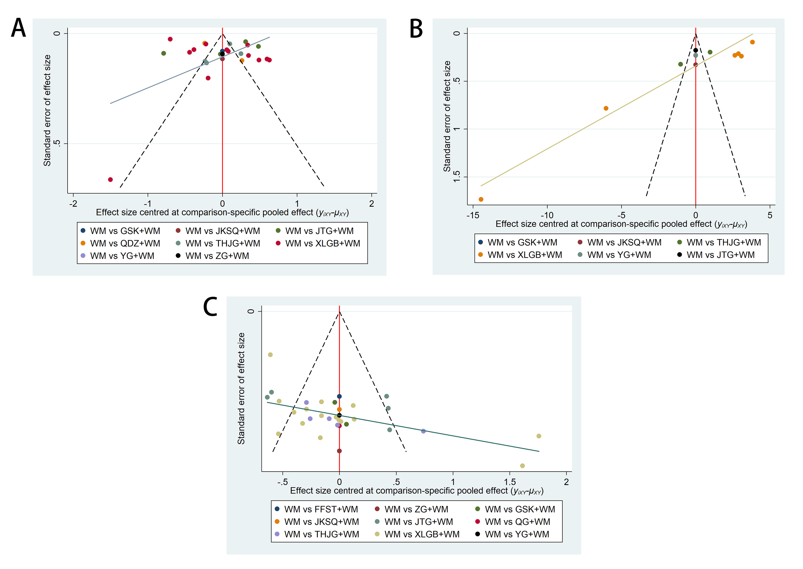
(A) Funnel plots of VAS; (B) Funnel plots of ODI; (C) Funnel plots of BMD; VAS: Visual Analogue Scale; ODI: Oswestry Dability Index; BMD: Bone Mineral Density; QDZ: Quan Duzhong capsule; XLGB: Xianling Gubao capsule; QG: Qi Gu capsule; JTG: Jin Tiange capsule; YG: You Gui pill; THJG: Tenghuang Jiangu capsule; GSK: Gu Shukang granule; JKSQ: Jinkui Shenqi pill; ZG: Zuo Gui pill; FFST: Fufang Shangtong capsule; WM: Western medicine.

