Additional file 4. Forest plots of all comparisons
(1) Forest plots of VAS (MD)
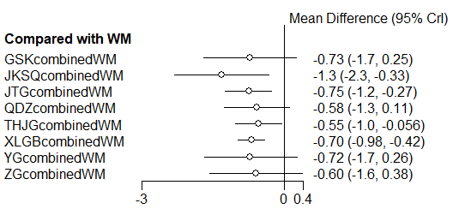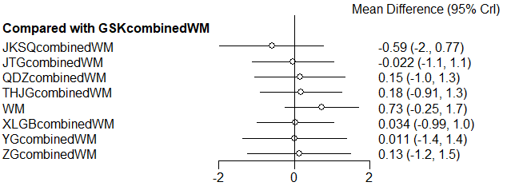
(A) (B)
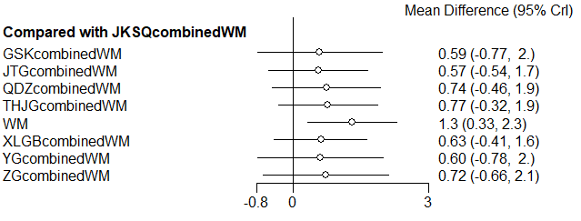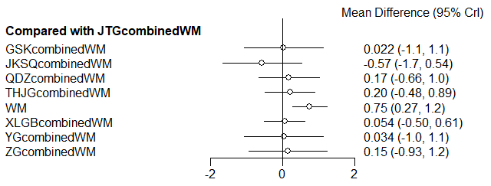
(C) (D)
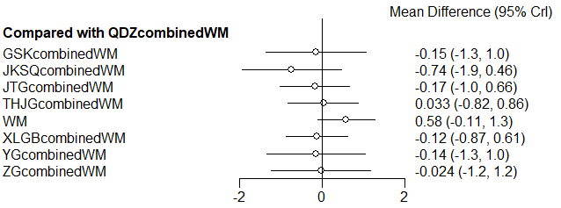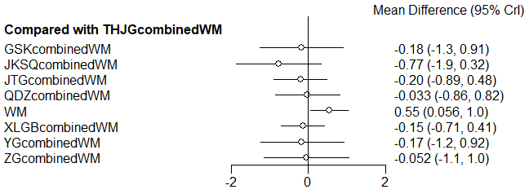
(E) (F)
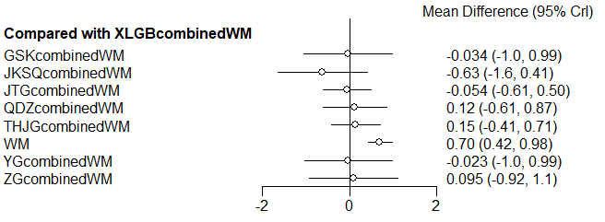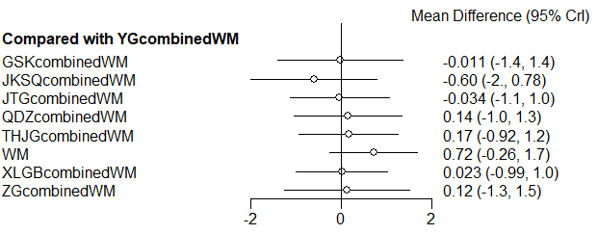
(G) (H)
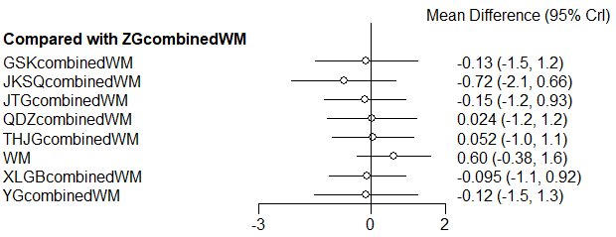
(I)
(2) Forest plots of ODI (SMD)
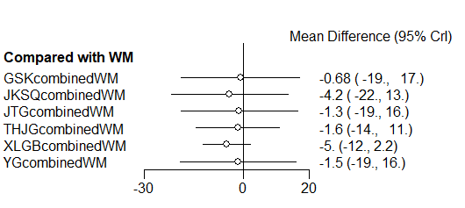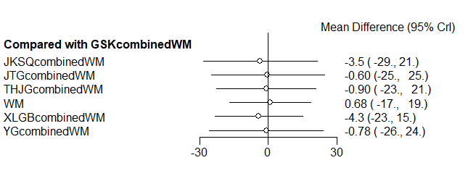
(A) (B)
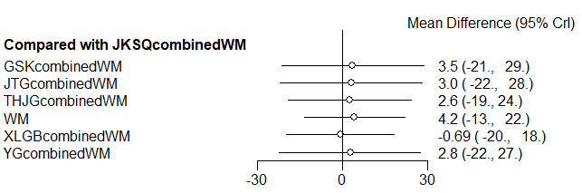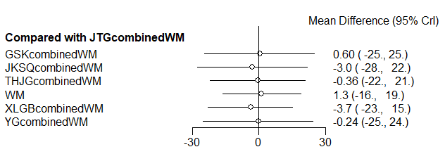
(C) (D)
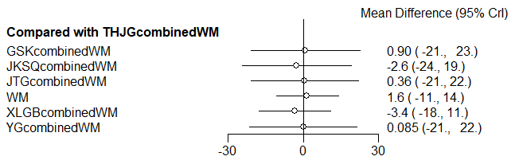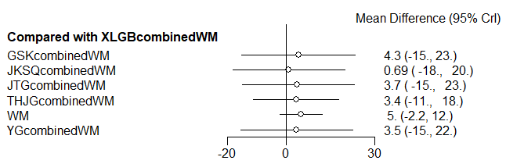
(E) (F)
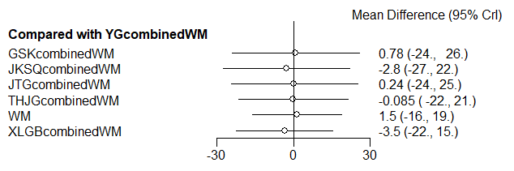
(G)

(3) Forest plots of BMD (SMD)
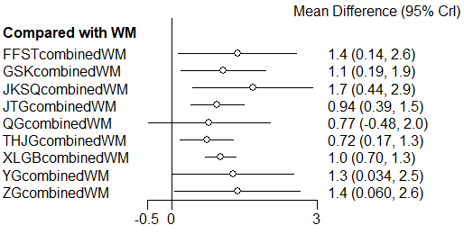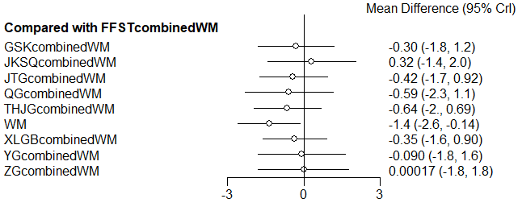(A) (B)
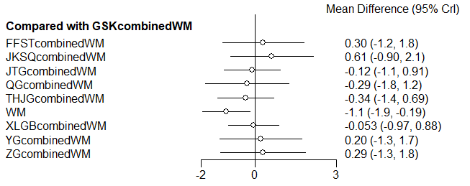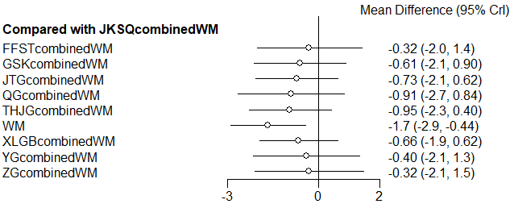
(C) (D)
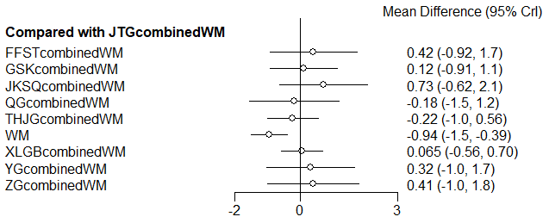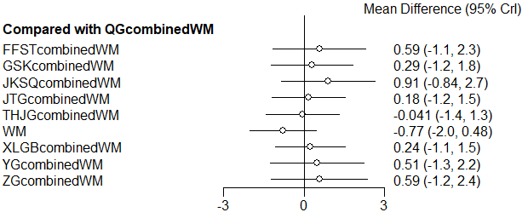
(E) (F)
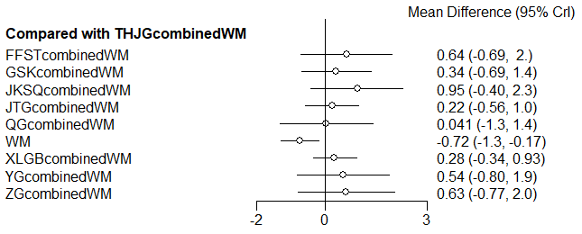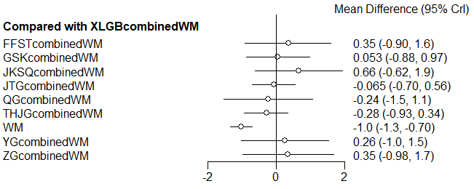
(G) (H)
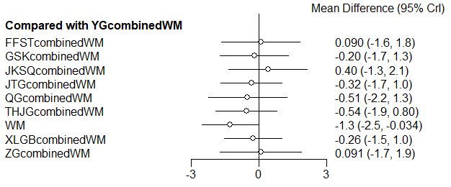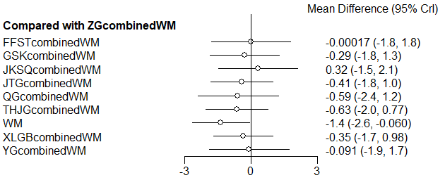
(I) (J)
SMD: Standardized Mean Difference; MD: Mean Difference; VAS: Visual Analogue Scale; ODI: Oswestry Dability Index; BMD: Bone Mineral Density; QDZ: Quan Duzhong capsule; XLGB: Xianling Gubao capsule; QG: Qi Gu capsule; JTG: Jin Tiange capsule; YG: You Gui pill; THJG: Tenghuang Jiangu capsule; GSK: Gu Shukang granule; JKSQ: Jinkui Shenqi pill; ZG: Zuo Gui pill; FFST: Fufang Shangtong capsule; WM: Western medicine

