Contents of Appendix for
Predictors of mortality in patients with Klebsiella pneumoniae infection: a systematic review and meta-analysis

Table of Contents
Supplemental Table S1. PRISMA 2020 checklist | Page 3-7
Supplemental Table S2. Definitions of therapies in our review  Supplemental Table S3. Eligibility criteria of included studies  Supplemental Text S1. Literature search strategy  Supplemental Table S4. Modified Newcastle-Ottawa Quality Assessment Scale for Cohort Studies  Supplemental Table S5. Modified Newcastle-Ottawa Quality Assessment Scale for Case-control Studies  Supplemental Table S6. Key studies excluded at full-text review and reasons for exclusion  Supplemental Table S7. Risk of bias assessments according to Modified Newcastle-Ottawa Scale  Supplemental Table S8. Characteristics of the studies included in the meta-analysis  Supplemental Table S9. Results of studies that included multivariate analysis of risk factors for 28/30-day mortality of patients infected with Klebsiella pneumoniae  Supplemental Table S10. Results of studies that included multivariate analysis of risk factors for in-hospital mortality of patients infected with Klebsiella pneumoniae  Supplemental Table S11. Results of studies that included multivariate analysis of risk factors for 14/15-day mortality of patients infected with Klebsiella pneumoniae  Supplemental Table S12. Results of studies that included multivariate analysis of risk factors for 90-day mortality of patients infected with Klebsiella pneumoniae  Supplemental Table S13. Subgroup analysis for the risk factors of 28/30-day mortality  Supplemental Table S14. Subgroup analysis for the risk factors of in-hospital mortality  Supplemental Table S15. Univariable meta-regression analysis for the risk factors of 28/30-day mortality  Supplemental Table S16. The results of Egger’s test  Supplemental Figure S1. Forest plot of in-hospital mortality of Klebsiella pneumoniae infections  Supplemental Figure S2. Forest plot of 14/15-day mortality of Klebsiella pneumoniae infections  Supplemental Figure S3. Forest plot of 90-day mortality of Klebsiella pneumoniae infections | Page 8  Page 9  Page 10-11  Page 12-13  Page 14-15  Page 16-23  Page 24-27  Page 28-30  Page 31-52  Page 53-59  Page 60-62  Page 63-65  Page 66-69  Page 70  Page 71-72  Page 73  Page 74  Page 75  Page 76
Supplemental Figure S4. Forest plot of adjusted effect estimates for in-hospital mortality in patients with Klebsiella pneumoniae infection.  Supplemental Figure S5. Forest plot of adjusted effect estimates for 14/15-day mortality in patients with Klebsiella pneumoniae infection.  Supplemental Figure S6. Forest plot of adjusted effect estimates for 90-day mortality in patients with Klebsiella pneumoniae infection.  Supplemental Figure S7. Meta-analysis of risk factors for 28/30-day mortality of Klebsiella pneumoniae infections  Supplemental Figure S8. Meta-analysis of risk factors for in-hospital mortality of Klebsiella pneumoniae infections  Supplemental Figure S9. Meta-analysis of risk factors for 14/15-day mortality of Klebsiella pneumoniae infections  Supplemental Figure S10. Meta-analysis of risk factors for 90-day mortality of Klebsiella pneumoniae infections  Supplemental Figure S11. Sensitivity analysis of 28/30-day mortality by omitting individual study  Supplemental Figure S12. Sensitivity analysis of in-hospital mortality by omitting individual study  Supplemental Figure S13. Sensitivity analysis of 14/15-day mortality by omitting individual study  Supplemental Figure S14. Sensitivity analysis of 90-day mortality by omitting individual study  Supplemental Figure S15. Funnel plots for 28/30-day mortality | Page 71  Page 78  Page 79  Page 80-94  Page 95-100  Page 101  Page 102  Page 103-116  Page 117-121  Page 122  Page 123  Page 124
Supplemental Text S2. References of all included studies | Page 125-133

Supplemental Table S1 PRISMA 2020 checklist
Section and Topic | Item # | Checklist item | Location where item is reported
TITLE
Title | 1 | Identify the report as a systematic review. | Page 1
ABSTRACT
Abstract | 2 | See the PRISMA 2020 for Abstracts checklist. | Pages 2-3
INTRODUCTION
Rationale | 3 | Describe the rationale for the review in the context of existing knowledge. | Page 5
Objectives | 4 | Provide an explicit statement of the objective(s) or question(s) the review addresses. | Pages 5-6
METHODS
Eligibility criteria | 5 | Specify the inclusion and exclusion criteria for the review and how studies were grouped for the syntheses. | Pages 7-8; Supplementary Table S3
Information sources | 6 | Specify all databases, registers, websites, organisations, reference lists and other sources searched or consulted to identify studies. Specify the date when each source was last searched or consulted. | Page 7; Supplementary Text S1
Search strategy | 7 | Present the full search strategies for all databases, registers and websites, including any filters and limits used. | Supplementary Text S1
Selection process | 8 | Specify the methods used to decide whether a study met the inclusion criteria of the review, including how many reviewers screened each record and each report retrieved, whether they worked independently, and if applicable, details of automation tools used in the process. | Pages 7-8
Data collection process | 9 | Specify the methods used to collect data from reports, including how many reviewers collected data from each report, whether they worked independently, any processes for obtaining or confirming data from study investigators, and if applicable, details of automation tools used in the process. | Pages 8-9
Data items | 10a | List and define all outcomes for which data were sought. Specify whether all results that were compatible with each outcome domain in each study were sought (e.g., for all measures, time points, analyses), and if not, the methods used to decide which results to collect. | Pages 9-10
Data items | 10b | List and define all other variables for which data were sought (e.g. participant and intervention characteristics, funding sources). Describe any assumptions made about any missing or unclear information. | Pages 8-9; Table 1; Supplementary Table S8
Study risk of bias assessment | 11 | Specify the methods used to assess risk of bias in the included studies, including details of the tool(s) used, how many reviewers assessed each study and whether they worked independently, and if applicable, details of automation tools used in the process. | Page 9, Supplementary Table S4-5
Effect measures | 12 | Specify for each outcome the effect measure(s) (e.g., risk ratio, mean difference) used in the synthesis or presentation of results. | Pages 9-10
Synthesis methods | 13a | Describe the processes used to decide which studies were eligible for each synthesis (e.g., tabulating the study intervention characteristics and comparing against the planned groups for each synthesis (item #5)). | Pages 9-10
Synthesis methods | 13b | Describe any methods required to prepare the data for presentation or synthesis, such as handling of missing summary statistics, or data conversions. | Pages 9-10
Synthesis methods | 13c | Describe any methods used to tabulate or visually display results of individual studies and syntheses. | Pages 10-11
Synthesis methods | 13d | Describe any methods used to synthesize results and provide a rationale for the choice(s). If meta-analysis was performed, describe the model(s), method(s) to identify the presence and extent of statistical heterogeneity, and software package(s) used. | Pages 10-11
Synthesis methods | 13e | Describe any methods used to explore possible causes of heterogeneity among study results (e.g., subgroup analysis, meta-regression). | Pages 10-11
Synthesis methods | 13f | Describe any sensitivity analyses conducted to assess robustness of the synthesized results. | Page 10
Reporting bias assessment | 14 | Describe any methods used to assess risk of bias due to missing results in a synthesis (arising from reporting biases). | Pages 10-11
Certainty assessment | 15 | Describe any methods used to assess certainty (or confidence) in the body of evidence for an outcome. | Not applicable
RESULTS
Study selection | 16a | Describe the results of the search and selection process, from the number of records identified in the search to the number of studies included in the review, ideally using a flow diagram. | Page 8; Figure 1
Study selection | 16b | Cite studies that might appear to meet the inclusion criteria, but which were excluded, and explain why they were excluded. | Supplementary Table S6
Study characteristics | 17 | Cite each included study and present its characteristics. | Pages 12-14; Table 1; Supplementary Table S8; Supplementary Text S2
Risk of bias in studies | 18 | Present assessments of risk of bias for each included study. | Supplementary Table S7
Results of individual studies | 19 | For all outcomes, present, for each study: (a) summary statistics for each group (where appropriate) and (b) an effect estimate and its precision (e.g. confidence/credible interval), ideally using structured tables or plots. | Figures 2; Table 2; Supplementary Tables S9-S12; Supplementary Figures S1-S10
Results of syntheses | 20a | For each synthesis, briefly summarise the characteristics and risk of bias among contributing studies. | Pages 12-14; Table 1; Supplementary Table S7-S8
Results of syntheses | 20b | Present results of all statistical syntheses conducted. If meta-analysis was done, present for each the summary estimate and its precision (e.g. confidence/credible interval) and measures of statistical heterogeneity. If comparing groups, describe the direction of the effect. | Pages 14-21; Table 2; Figures 2-3; Supplementary Figures S1-S10
Results of syntheses | 20c | Present results of all investigations of possible causes of heterogeneity among study results. | Pages 19-20; Supplementary Tables S13-S15
Results of syntheses | 20d | Present results of all sensitivity analyses conducted to assess the robustness of the synthesized results. | Pages 20; Supplementary Figures S11-S14
Reporting biases | 21 | Present assessments of risk of bias due to missing results (arising from reporting biases) for each synthesis assessed. | Page 21; Supplementary Table S16; Supplementary Figure S15
Certainty of evidence | 22 | Present assessments of certainty (or confidence) in the body of evidence for each outcome assessed. | Not applicable
DISCUSSION
Discussion | 23a | Provide a general interpretation of the results in the context of other evidence. | Pages 22-26
Discussion | 23b | Discuss any limitations of the evidence included in the review. | Page 27-28
Discussion | 23c | Discuss any limitations of the review processes used. | Page 27-28
Discussion | 23d | Discuss implications of the results for practice, policy, and future research. | Pages 25-26 and 29
OTHER INFORMATION
Registration and protocol | 24a | Provide registration information for the review, including register name and registration number, or state that the review was not registered. | Page 7
Registration and protocol | 24b | Indicate where the review protocol can be accessed, or state that a protocol was not prepared. | Page 7
Registration and protocol | 24c | Describe and explain any amendments to information provided at registration or in the protocol. | Not applicable
Support | 25 | Describe sources of financial or non-financial support for the review, and the role of the funders or sponsors in the review. | Page 30
Competing interests | 26 | Declare any competing interests of review authors. | Page 30
Availability of data, code and other materials | 27 | Report which of the following are publicly available and where they can be found template data collection forms; data extracted from included studies; data used for all analyses; analytic code; any other materials used in the review. | Page 30

Supplemental Table S2. Definitions of therapies in our review
Therapy | Definition
Empirical therapy | Empirical therapy was defined as treatment administered within 72 h following the collection of blood cultures and prior to determining the susceptibility of the isolate.
Targeted therapy | Treatment that was initiated or maintained after receiving the susceptibility results was considered targeted therapy.
Appropriate therapy | Appropriate treatment was defined as one that included at least one antibacterial agent with in vitro activity against the infecting isolate for ≥48 h, at an adequate dosage.
Monotherapy | Monotherapy was defined as the administration of one antibacterial agent with in vitro activity against the infecting isolate.
Combination therapy | Combination therapy was defined as the administration of at least two antibacterial agents with in vitro activity against the infecting isolate.

Supplemental Table S3. Eligibility criteria of included studies
 | Inclusion criteria | Exclusion criteria
Participants | Adults (≥18 years old); with Klebsiella pneumoniae infection; ≥ 50 patients in total. | Animals; other microbial infections; < 50 patients in total.
Intervention | Patients who died of Klebsiella pneumoniae infection. | Patients who die of other infections (non-K. pneumoniae infection).
Comparators | Patients who survive Klebsiella pneumoniae infection. | Patients who die of other infections (non-K. pneumoniae infection).
Outcomes | Primary outcome: 28/30-day mortality  Secondary outcomes: 14/15-day mortality; 90-day mortality; in-hospital mortality | No primary or secondary outcome data available, either effect estimate for compared groups or number/rate of events in each group.
Study design/Settings | Observational cohort studies and case-control studies conducted after 1991 | Studies before 1991; reviews; systematic reviews; meta-analyses; guidelines; editorials; letters to the editor; comments; case reports; animal research; in-vitro studies; any repeated literature; uncompleted or withdrawn studies

Supplemental Text S1. Literature search strategy
Search strategy:
To maximize the number of papers found, both medical subject headings and free text terms were used in the search strategy. The search was last updated on 19 June 2025.
PubMed
((case control study) OR (Cross-Sectional Study) OR (cohort study) OR (observational study) OR (prospective study) OR (retrospective study)) AND (((Klebsiella pneumoniae) OR (K. pneumoniae)) AND ((mortality) OR (death))) AND (1991:2025[pdat])
Embase
('case control study'/exp OR 'case control study' OR 'prospective study'/exp OR 'prospective study' OR 'retrospective study'/exp OR 'retrospective study' OR 'cohort study'/exp OR 'cohort study' OR 'observational study'/exp OR 'observational study' OR 'cross-sectional study'/exp OR 'cross-sectional study') AND ('Klebsiella pneumoniae'/exp OR 'Klebsiella pneumoniae') AND ('mortality'/exp OR 'mortality' OR 'death'/exp OR 'death') AND [1991-2025]/py
Web of science
1: TS=(Klebsiella pneumoniae) OR TS=(K. pneumoniae)
2: TS=(mortality) OR TS=(death)
3: TS=(case control study) OR TS=(prospective study) OR TS=(retrospective study) OR TS=(cohort study) OR TS=(observational study) OR TS=(cross-sectional study)
4: #1 AND #2 AND #3 and 1991 or 1992 or 1993 or 1994 or 1995 or 1996 or 1997 or 1998 or 1999 or 2000 or 2001 or 2002 or 2003 or 2004 or 2005 or 2006 or 2007 or 2008 or 2009 or 2010 or 2011 or 2012 or 2013 or 2014 or 2015 or 2016 or 2017 or 2018 or 2019 or 2020 or 2021 or 2022 or 2023 or 2024 or 2025 (Publication Years)
Cochrane
1: (mortality):ti,ab,kw OR (death):ti,ab,kw (Word variations have been searched)
2: (Klebsiella pneumoniae):ti,ab,kw OR (K. pneumoniae):ti,ab,kw (Word variations have been searched)
3: (case control study):ti,ab,kw OR (prospective study):ti,ab,kw OR (retrospective study):ti,ab,kw OR (cohort study):ti,ab,kw OR (cross sectional study):ti,ab,kw (Word variations have been searched)
4: (observational study):ti,ab,kw
5: #1 AND #2 AND (#3 OR #4) with Cochrane Library publication date Between Jan 1991 and Dec 2025
Supplemental Table S4. Modified Newcastle-Ottawa Quality Assessment Scale For Cohort Studies
Note: A study can be awarded a maximum of 1 star for each numbered item within the selection, comparability and outcomes categories.
No. | Criterion | Decision rule | Score ★=1
SELECTION (max 1 star per criterion)
1 | Representativeness of the exposed cohort | - truly representative of the average prevalence of Klebsiella pneumoniae in the community★  - Somewhat representative of the average prevalence of Klebsiella pneumoniae the community★  - selected group of users such as the elderly, ICU, patients with liver transplantation, etc.  - no description of how the cohort was selected
2 | Selection of the non-exposed cohort | - drawn from the same community as the exposed cohort ★  - drawn from a different source  - no description of how the non-exposed cohort was selected
3 | Ascertainment of exposure | - secure record (e.g. hospital medical records) ★  - structured interview  - written self report  - no description
4 | Demonstration that outcome of interest was not present at start of study | - Yes (In the case of mortality studies, outcome of interest is still the presence of a disease/ incident, rather than death; that is a statement of no history of disease or incident earns a star) ★  - no
COMPARABILITY (max 1 star per criterion)
1 | Comparability of cohorts on the basis of patient demographics | - Study reports patient demographics in survivors and non-survivors (must include age and gender)★  - Survivors and non-survivors not separated, or not reported
2 | Comparability of cohorts on the basis of clinical presentation | - Study reports clinical presentation in survivors and non-survivors★  - Survivors and non-survivors not separated, or not reported
OUTCOME (max 1 star per criterion)
1 | Assessment of outcome | - independent or blind assessment stated in the paper, or confirmation of the outcome by reference to secure records (medical records, etc.)★  - record linkage (e.g. identified through ICD codes on database records) ★  - self-report (i.e. no reference to original medical records to confirm the outcome)  - no description.
2 | Was follow-up long enough for outcomes to occur | - yes (all subjects were followed up until post-infection mortality defined in the article) ★  b) no
3 | Adequacy of follow up of cohorts | - complete follow up - all subjects accounted for ★  - subjects lost to follow up unlikely to introduce bias – small number lost (>90 % follow up, or description provided of those lost) ★  - follow up rate ≤90% and no description of those lost  d) no statement
 |  | TOTAL SCORE (maximum= 9)

Supplemental Table S5. Modified Newcastle-Ottawa Quality Assessment Scale For Case-control Studies
Note: A study can be awarded a maximum of 1 star for each numbered item within the selection, comparability and outcomes categories.
No. | Criterion | Decision rule | Score ★=1
SELECTION (max 1 star per criterion)
1 | Is the case definition adequate? | - yes, with independent validation (e.g. >1 person/record/time/process to extract information, or reference to primary record source such as x-rays or medical/hospital records)★  - yes, record linkage (e.g. ICD codes in database) or self-report with no reference to primary record  - no description
2 | Representativeness of the cases | - consecutive or obviously representative series of cases of Klebsiella pneumoniae in the community ★  - potential for selection biases (e.g. the elderly, ICU, patients with liver transplantation, etc) or not stated
3 | Selection of Controls | - community controls ★  - hospital controls  - no description
4 | Definition of Controls | - no history of mortality ★  - no description of source
COMPARABILITY (max 1 star per criterion)
1 | Comparability of cases and controls on the basis of patient demographics | - Study reports patient demographics in survivors and non-survivors (must include age and gender)★  - Survivors and non-survivors not separated, or not reported
2 | Comparability of cases and controls on the basis of clinical presentation | - Study reports clinical presentation in survivors and non-survivors★  - Survivors and non-survivors not separated, or not reported
EXPOSURE (max 1 star per criterion)
1 | Assessment of exposure | - secure record (eg surgical records)★  - structured interview where blind to case/control status ★  - interview not blinded to case/control status  - written self report or medical record only  - no description.
2 | Same method of ascertainment for cases and controls | - yes ★  b) no
3 | Non-Response Rate | - same rate for both groups ★  - non respondents described  - rate different and no designation
 |  | TOTAL SCORE (maximum= 9)

Supplemental Table S6. Key studies excluded at full text review and reasons for exclusion (listed by publishing year)
No. | Reasons for Exclusion | Title
1 | Absence of multivariate analysis of risk factors for mortality | Characteristics of bacteremia between community-acquired and nosocomial Klebsiella pneumoniae infection - Risk factor for mortality and the impact of capsular serotypes as a herald for community-acquired infection.
2 | Patients with multiple microbial infections | Risk factors for and clinical outcomes of bloodstream infections caused by extended-spectrum beta-lactamase-producing Klebsiella pneumoniae.
3 | Presence of patients under 18 years old | Antibiotic therapy for Klebsiella pneumoniae bacteremia: Implications of production of extended-spectrum β-lactamases.
4 | Presence of patients under 18 years old | Community-acquired versus nosocomial Klebsiella pneumoniae bacteremia: Clinical features, treatment outcomes, and clinical implication of antimicrobial resistance.
5 | A study on Klebsiella Genus | Clinical outcome and risk factors related to extended-spectrum beta-lactamase-producing Klebsiella spp. infection among hospitalized patients.
6 | Presence of patients under 18 years old | Nosocomial bloodstream infections caused by Klebsiella pneumoniae: Impact of extended-spectrum β-lactamase (ESBL) production on clinical outcome in a hospital with high ESBL prevalence.
7 | A study on Klebsiella Genus | Predictors of carbapenem-resistant Klebsiella pneumoniae acquisition anions hospitalized adults and effect of acquisition on mortality.
8 | Presence of patients under 18 years old | Prospective observational study of the impact of VIM-1 metallo-β- lactamase on the outcome of patients with Kebsiella pneumoniae bloodstream infections.
9 | Presence of patients under 18 years old | Incidence, Risk Factors, and Outcomes of Klebsiella pneumoniae Bacteremia.
10 | Patients with multiple microbial infections | Prospective study of Klebsiella pneumoniae bacteremia: Risk factors and clinical significance of type VIM-1 metallo-beta-lactamases.
11 | Absence of multivariate analysis of risk factors for mortality | Bacteremic community-acquired pneumonia due to Klebsiella pneumoniae: Clinical and microbiological characteristics in Taiwan, 2001-2008.
12 | Patients with multiple microbial infections | Characteristics of Klebsiella pneumoniae bacteremia in community-acquired and nosocomial infections in diabetic patients.
13 | Presence of patients under 18 years old | Bloodstream infections caused by metallo-β-lactamase/Klebsiella pneumoniae carbapenemase-producing K. pneumoniae among intensive care unit patients in Greece: risk factors for infection and impact of type of resistance on outcomes.
14 | Patients with multiple microbial infections | Nosocomial Klebsiella pneumoniae bacteraemia in adult cancer patients-characteristics of neutropenic and non-neutropenic patients.
15 | A study on Klebsiella Genus | Cefotaxime resistance and outcome of Klebsiella spp bloodstream infection.
16 | Absence of multivariate analysis of risk factors for mortality | Klebsiella ESBL bacteremia-mortality and risk factors.
17 | Presence of patients under 18 years old | Predictors of mortality in patients with bloodstream infections caused by KPC-producing Klebsiella pneumoniae and impact of appropriate antimicrobial treatment.
18 | Presence of patients under 18 years old | [Multidrug-resistant Klebsiella pneumoniae, predisposing factors and associated mortality in a tertiary-care hospital in Colombia].
19 | Patients with multiple microbial infections | Differences in characteristics between healthcare-associated and community-acquired infection in community-onset Klebsiella pneumoniae bloodstream infection in Korea.
20 | Number of patients infected with Klebsiella pneumoniae is less than 50 | Discrepancy between effects of carbapenems and flomoxef in treating nosocomial hemodialysis access-related bacteremia secondary to extended spectrum beta-lactamase producing Klebsiella pneumoniae in patients on maintenance hemodialysis.
21 | Presence of patients colonized with Klebsiella pneumoniae | KPC-producing Klebsiella pneumoniae enteric colonization acquired during intensive care unit stay: the significance of risk factors for its development and its impact on mortality.
22 | Presence of patients under 18 years old | Risk factors for bacteriuria with carbapenem-resistant Klebsiella pneumoniae and its impact on mortality: a case-control study.
23 | Patients with multiple microbial infections | Clinical characteristics and outcome of patients with community-onset Klebsiella pneumoniae bacteremia requiring intensive care.
24 | Patients with multiple microbial infections | Molecular epidemiology of extended-spectrum beta-lactamase (ESBL)-positive Klebsiella pneumoniae from bloodstream infections and risk factors for mortality.
25 | Absence of multivariate analysis of risk factors for mortality | Carbapenemase-producing Klebsiella pneumoniae bloodstream infections: lowering mortality by antibiotic combination schemes and the role of carbapenems.
26 | Number of patients infected with Klebsiella pneumoniae is less than 50 | Nosocomial extended-spectrum beta-lactamase-producing Klebsiella pneumoniae bacteremia in hemodialysis patients and the implications for antibiotic therapy.
27 | Absence of multivariate analysis of risk factors for mortality | Mortality risk score for Klebsiella pneumoniae bacteraemia.
28 | A study on Klebsiella Genus | Outcomes and risk factors for mortality among patients treated with carbapenems for klebsiella spp. bacteremia.
29 | Patients with multiple microbial infections | Risk factors and outcome of infections with Klebsiella pneumoniae carbapenemase-producing K. pneumoniae in kidney transplant recipients.
30 | Patients with multiple microbial infections | Risk factors for in-hospital mortality in patients with type 2 diabetes complicated by community-acquired Klebsiella pneumoniae bacteremia.
31 | Patients with multiple microbial infections | Efficacy of Appropriate Antimicrobial Therapy on the Survival of Patients With Carbapenem Nonsusceptible Klebsiella pneumoniae Infection: A Multicenter Study in Taiwan.
32 | Patients include those not infected with Klebsiella pneumoniae | Risk factors and outcomes of carbapenem-resistant Klebsiella pneumoniae infections in liver transplant recipients.
33 | Absence of multivariate analysis of risk factors for mortality | Impact of therapy and strain type on outcomes in urinary tract infections caused by carbapenem-resistant Klebsiella pneumoniae.
34 | Number of patients infected with Klebsiella pneumoniae is less than 50 | Risk factors for carbapenem-resistant Klebsiella pneumoniae infection/colonization and predictors of mortality: a retrospective study.
35 | Patients with multiple microbial infections | Oral decontamination with aminoglycosides is associated with lower risk of mortality and infections in high-risk patients colonized with colistin-resistant, KPC-producing Klebsiella pneumoniae.
36 | Patients with multiple microbial infections | High minimum inhibitory concentration of imipenem as a predictor of fatal outcome in patients with carbapenem non-susceptible Klebsiella pneumoniae.
37 | Patients with multiple microbial infections | Epidemiology of Klebsiella pneumoniae bloodstream infections in a teaching hospital: factors related to the carbapenem resistance and patient mortality.
38 | Patients with multiple microbial infections | Carbapenemase-producing Klebsiella pneumoniae bloodstream infections in neutropenic patients with haematological malignancies or aplastic anaemia: Analysis of 50 cases.
39 | Absence of multivariate analysis of risk factors for mortality | Clinical retrospective analysis of Klebsiella pneumoniae bloodstream infection.
40 | Patients with multiple microbial infections | Double carbapenem as a rescue strategy for the treatment of severe carbapenemase-producing Klebsiella pneumoniae infections: a two-center, matched case-control study.
41 | Presence of patients under 18 years old | Risk factors of mortality in bloodstream infections caused by Klebsiella pneumonia A single-center retrospective study in China.
42 | Presence of patients under 18 years old | A retrospective study of risk factors and outcome for carbapenem-nonsusceptible Klebsiella pneumoniae bacteremia among ICU patients.
43 | Presence of patients under 18 years old | Impact of the ST101 clone on fatality among patients with colistin-resistant Klebsiella pneumoniae infection.
44 | Absence of multivariate analysis of risk factors for mortality | Epidemiology and risk factors for mortality in bloodstream infection by CP-Kp, ESBL-E, Candida and CDI: A single center retrospective study.
45 | Patients with multiple microbial infections | Risk factors and clinical outcomes of hypervirulent Klebsiella pneumoniae induced bloodstream infections.
46 | Presence of patients under 18 years old | A retrospective, comparative analysis of risk factors and outcomes in carbapenem-susceptible and carbapenem-nonsusceptible Klebsiella pneumoniae bloodstream infections: tigecycline significantly increases the mortality.
47 | Patients with multiple microbial infections | Clinical characteristics of carbapenem-resistant Klebsiella pneumoniae bloodstream infection and the risk factors of mortality.
48 | Patients with multiple microbial infections | Clinical and epidemiological characteristics of KPC-producing Klebsiella pneumoniae from bloodstream infections in a tertiary referral center in Italy.
49 | Absence of multivariate analysis of risk factors for mortality | Risk factors and survival of patients infected with carbapenem-resistant Klebsiella pneumoniae in a KPC endemic setting: a case-control and cohort study.
50 | Absence of multivariate analysis of risk factors for mortality | Evaluation of the therapeutic effectiveness of polymyxin B versus colistin in carbapenem-resistanct Klebsiella pneumoniae-associated bacteremia.
51 | Patients with multiple microbial infections | Antimicrobial resistance and virulence factors of Klebsiella pneumoniae affecting 30 day mortality in patients with bloodstream infection.
52 | Patients with multiple microbial infections | Appropriate Treatment for Bloodstream Infections Due to Carbapenem-Resistant Klebsiella pneumoniae and Escherichia coli: A Nationwide Multicenter Study in Taiwan.
53 | Patients with multiple microbial infections | Antimicrobial resistance and risk factors for mortality of pneumonia caused by Klebsiella pneumoniae among diabetics: a retrospective study conducted in Shanghai, China.
54 | Presence of patients under 18 years old | The effect of colistin resistance and other predictors on fatality among patients with bloodstream infections due to Klebsiella pneumoniae in an OXA-48 dominant region.
55 | Absence of multivariate analysis of risk factors for mortality | Clinical characteristics of bacteremia caused by hypermucoviscous Klebsiella pneumoniae at a tertiary hospital.
56 | Presence of patients under 18 years old | Infections Caused by Carbapenemase-Producing Klebsiella pneumoniae: Microbiological Characteristics and Risk Factors.
57 | Patients with multiple microbial infections | Efficacy of Ceftazidime-Avibactam Salvage Therapy in Patients With Infections Caused by Klebsiella pneumoniae Carbapenemase-producing K. pneumoniae.
58 | Absence of multivariate analysis of risk factors for mortality | Clinical epidemiology and outcomes of biliary tract infections caused by Klebsiella pneumoniae.
59 | Presence of patients under 18 years old | Risk factors and outcomes for carbapenem-resistant Klebsiella pneumoniae bacteremia in onco-hematological patients.
60 | Patients with multiple microbial infections | Risk factors and mortality for patients with Bloodstream infections of Klebsiella pneumoniae during 2014–2018: Clinical impact of carbapenem resistance in a large tertiary hospital of China.
61 | Patients with multiple microbial infections | Biofilm Production by Carbapenem-Resistant Klebsiella pneumoniae Significantly Increases the Risk of Death in Oncological Patients.
62 | Presence of patients under 18 years old | Risk Factors of Mortality in Patients with Bloodstream Infections Due to Carbapenem Resistant Klebsiella pneumoniae.
63 | Patients with multiple microbial infections | Risk Factors Affecting Clinical Outcome in Patients with Carbapenem-Resistant K. pneumoniae: A Retrospective Study.
64 | Number of patients infected with Klebsiella pneumoniae is less than 50 | Clinical Characteristics and Risk Factors for Bloodstream Infection Due to Carbapenem-Resistant Klebsiella pneumoniae in Patients with Hematologic Malignancies.
65 | Absence of multivariate analysis of risk factors for mortality | Risk factors for carbapenem-resistant Klebsiella pneumoniae infection and associated clinical outcomes.
66 | Patients with multiple microbial infections | Efficacy of Ceftazidime-Avibactam Versus Polymyxin B and Risk Factors Affecting Clinical Outcomes in Patients With Carbapenem-Resistant Klebsiella pneumoniae Infections a Retrospective Study.
67 | Patients with multiple microbial infections | Bloodstream Infections Caused by Klebsiella pneumoniae Carbapenemase–Producing P. aeruginosa Sequence Type 463, Associated With High Mortality Rates in China: A Retrospective Cohort Study.
68 | Presence of patients colonized with Klebsiella pneumoniae | Carbapenemase-Producing Klebsiella pneumoniae Colonization and Infection in Solid Organ Transplant Recipients: A Single-Center, Retrospective Study.
69 | Patients with multiple microbial infections | Predictors of mortality in acute pancreatitis complicated with multidrug-resistant Klebsiella pneumoniae infection.
70 | Patients with multiple microbial infections | Risk Factors for and Clinical Outcomes of Carbapenem-Resistant Klebsiella pneumoniae Nosocomial Infections: A Retrospective Study in a Tertiary Hospital in Beijing, China.
71 | Absence of multivariate analysis of risk factors for mortality | Risk Factors, Molecular Epidemiology, and Outcomes of Carbapenem-Resistant Klebsiella pneumoniae Infection for Hospital-Acquired Pneumonia: A Matched Case-Control Study in Eastern China During 2015-2017.
72 | Absence of multivariate analysis of risk factors for mortality | Ceftazidime-avibactam in the treatment of infections from carbapenem-resistant Klebsiella pneumoniae: Ceftazidime-avibactam against CR-KP infections.
73 | Presence of patients under 18 years old | The risk factors for complications and survival outcomes of Klebsiella pneumoniae Bacteraemia in Hospital Canselor Tuanku Muhriz Universiti Kebangsaan Malaysia.
74 | Presence of patients under 18 years old | A Novel Nomogram for Predicting Risk Factors and Outcomes in Bloodstream Infections Caused by Klebsiella pneumoniae.
75 | Patients with multiple microbial infections | Prognostic factors of OXA-48 carbapenemase-producing Klebsiella pneumoniae infection in a tertiary-care Spanish hospital: A retrospective single-center cohort study.
76 | A study on Klebsiella Genus | Characteristics and outcomes of carbapenemase harbouring carbapenem-resistant Klebsiella spp. bloodstream infections: a multicentre prospective cohort study in an OXA-48 endemic setting.
77 | Presence of patients under 18 years old | Outcomes and Risk Factors of Bloodstream Infections Caused by Carbapenem-Resistant and Non-Carbapenem-Resistant Klebsiella pneumoniae in China.
78 | A study on Klebsiella Genus | Epidemiology and clinical characteristics of Klebsiella spp. meningitis in France.
79 | Patients with multiple microbial infections | Predicting mortality in intensive care unit patients infected with Klebsiella pneumoniae: A retrospective cohort study.
80 | Patients with multiple microbial infections | Adipose tissue is a predictor of 30-days mortality in patients with bloodstream infection caused by carbapenem-resistant Klebsiella pneumoniae.
81 | Absence of multivariate analysis of risk factors for mortality | Risk factors of death in patients with carbapenem-resistant Klebsiella pneumoniae infections in respiratory intensive care unit.
82 | Patients with multiple microbial infections | Ceftazidime/Avibactam-Based Versus Polymyxin B-Based Therapeutic Regimens for the Treatment of Carbapenem-Resistant Klebsiella pneumoniae Infection in Critically Ill Patients: A Retrospective Cohort Study.
83 | Patients with multiple microbial infections | Rapid diagnostics and ceftazidime/avibactam for KPC-producing Klebsiella pneumoniae bloodstream infections: impact on mortality and role of combination therapy.
84 | Patients with multiple microbial infections | Mortality in KPC-producing Klebsiella pneumoniae bloodstream infections: a changing landscape.
85 | Patients with multiple microbial infections | Prognostic models for estimating severity of disease and predicting 30-day mortality of Hypervirulent Klebsiella pneumoniae infections: a bicentric retrospective study.
86 | Patients with multiple microbial infections | The Efficacy and Influencing Factors of Polymyxin B in High-Level Carbapenem-Resistant Klebsiella pneumoniae Infections.
87 | Patients with multiple microbial infections | Clinical Characteristics, Drug Resistance, and Risk Factors for Death of Klebsiella pneumoniae Infection in Patients with Acute Pancreatitis: A Single-Center Retrospective Study from China.
88 | Patients with multiple microbial infections | Clinical characteristics and manifestations in patients with hypermucoviscous Klebsiella pneumoniae bacteremia from extra-hepatobiliary tract infection.
89 | Presence of patients under 18 years old | Combination Therapy of Ceftazidime/Avibactam for the Treatment of Patients Infected with Carbapenem-Resistant Klebsiella pneumoniae: A Multicenter Retrospective Study.

Supplemental Table S7. Risk of bias assessments according to Modified Newcastle-Ottawa Scale
Reference | Study design | Selection | Comparability | Exposure/Outcome | Total | Risk of bias
Anderson (2006)¹ | retrospective cohort study | 4 | 2 | 3 | 9 | Low
Lee (2008)² | case-control study | 3 | 2 | 3 | 8 | Low
Patel (2008)³ | case-control study | 4 | 2 | 3 | 9 | Low
Liao (2009)⁴ | prospective cohort study | 4 | 1 | 3 | 8 | Low
Szilágyi (2009)⁵ | retrospective cohort study | 4 | 2 | 3 | 9 | Low
Tumbarello (2012)⁶ | retrospective cohort study | 4 | 2 | 3 | 9 | Low
Capone (2013)⁷ | prospective cohort study | 4 | 2 | 3 | 9 | Low
Hussein (2013)⁸ | case-control study | 3 | 2 | 3 | 8 | Low
Girometti (2014)⁹ | retrospective cohort study | 4 | 2 | 3 | 9 | Low
Papadimitriou-Olivgeris (2014)¹⁰ | retrospective cohort study | 4 | 1 | 3 | 8 | Low
Yoon (2014)¹¹ | retrospective cohort study | 3 | 2 | 3 | 8 | Low
Freire (2015)¹² | retrospective cohort study | 3 | 2 | 3 | 8 | Low
Gonzalez-Padilla (2015)¹³ | retrospective cohort study | 4 | 1 | 3 | 8 | Low
Melot (2015)¹⁴ | retrospective cohort study | 3 | 2 | 3 | 8 | Low
Tumbarello (2015)¹⁵ | retrospective cohort study | 4 | 2 | 3 | 9 | Low
Vardakas (2015)¹⁶ | retrospective cohort study | 4 | 2 | 3 | 9 | Low
Falcone (2016)¹⁷ | retrospective cohort study | 3 | 1 | 3 | 7 | Medium
Gomez-Simmonds (2016)¹⁸ | case-control study | 4 | 2 | 3 | 9 | Low
Trecarichi (2016)¹⁹ | retrospective cohort study | 3 | 1 | 3 | 7 | Medium
Liao (2017)²⁰ | retrospective cohort study | 3 | 1 | 3 | 7 | Medium
Machuca (2017)²¹ | retrospective cohort study | 4 | 2 | 3 | 9 | Low
Man (2017)²² | prospective cohort study | 4 | 2 | 3 | 9 | Low
Papadimitriou-Olivgeris (2017)²³ | case-control study | 3 | 1 | 3 | 7 | Medium
Cheng (2018)²⁴ | case-control study | 4 | 2 | 3 | 9 | Low
Cristina (2018)²⁵ | case-control study | 4 | 2 | 3 | 9 | Low
Giannella (2018)²⁶ | case-control study | 3 | 2 | 3 | 8 | Low
Su (2018)²⁷ | retrospective cohort study | 4 | 2 | 3 | 9 | Low
Wang (2018)²⁸ | case-control study | 4 | 1 | 3 | 8 | Low
Xu (2018)²⁹ | retrospective cohort study | 4 | 2 | 3 | 9 | Low
Rodriguez-Gómez (2019)³⁰ | case-control study | 3 | 2 | 3 | 8 | Low
Namikawa (2019)³¹ | retrospective cohort study | 4 | 2 | 3 | 9 | Low
Yang (2019)³² | retrospective cohort study | 4 | 1 | 3 | 8 | Low
Buyuktuna (2020)³³ | retrospective cohort study | 3 | 2 | 3 | 8 | Low
Chuang (2020)³⁴ | case-control study | 4 | 2 | 3 | 9 | Low
Falcone (2020)³⁵ | case-control study | 3 | 1 | 3 | 7 | Medium
Rivera-Espinar (2020)³⁶ | case-control study | 3 | 1 | 3 | 7 | Medium
Hwang (2020)³⁷ | retrospective cohort study | 4 | 2 | 3 | 9 | Low
Lee (2020)³⁸ | retrospective cohort study | 4 | 1 | 3 | 8 | Low
Li (2020)³⁹ | case-control study | 4 | 1 | 3 | 8 | Low
Liu (2020a)⁴⁰ | case-control study | 3 | 2 | 3 | 8 | Low
Liu (2020b)⁴¹ | case-control study | 3 | 1 | 3 | 7 | Medium
Nham (2020)⁴² | case-control study | 3 | 2 | 3 | 8 | Low
Shen (2020)⁴³ | case-control study | 3 | 1 | 3 | 7 | Medium
Tang (2020)⁴⁴ | case-control study | 4 | 1 | 3 | 8 | Low
Wu (2020)⁴⁵ | case-control study | 3 | 2 | 3 | 8 | Low
Xiao (2020)⁴⁶ | case-control study | 3 | 2 | 3 | 8 | Low
Zha (2020)⁴⁷ | retrospective cohort study | 4 | 1 | 3 | 8 | Low
Zhang (2020a)⁴⁸ | case-control study | 4 | 1 | 3 | 8 | Low
Zhang (2020b)⁴⁹ | case-control study | 4 | 2 | 3 | 9 | Low
Zou (2020)⁵⁰ | case-control study | 3 | 1 | 3 | 7 | Medium
Balkan (2021)⁵¹ | retrospective cohort study | 4 | 2 | 3 | 9 | Low
Chen (2021)⁵² | prospective cohort study | 4 | 2 | 3 | 9 | Low
Karaiskos (2021)⁵³ | retrospective cohort study | 4 | 2 | 3 | 9 | Low
Lee (2021)⁵⁴ | case-control study | 4 | 2 | 3 | 9 | Low
Liu (2021a)⁵⁵ | case-control study | 4 | 2 | 3 | 9 | Low
Liu (2021b)⁵⁶ | case-control study | 3 | 2 | 3 | 8 | Low
Luan (2021)⁵⁷ | retrospective cohort study | 3 | 2 | 3 | 8 | Low
Man (2021)⁵⁸ | case-control study | 4 | 2 | 3 | 9 | Low
Papadimitriou-Olivgeris (2021)⁵⁹ | retrospective cohort study | 3 | 1 | 3 | 7 | Medium
Rodríguez (2021)⁶⁰ | case-control study | 3 | 2 | 3 | 8 | Low
Shen (2021)⁶¹ | retrospective cohort study | 4 | 2 | 3 | 9 | Low
Tumbarello (2021)⁶² | retrospective cohort study | 4 | 2 | 3 | 9 | Low
Wu (2021)⁶³ | case-control study | 4 | 2 | 3 | 9 | Low
Zhang (2021)⁶⁴ | retrospective cohort study | 3 | 2 | 3 | 8 | Low
Zhu (2021)⁶⁵ | retrospective cohort study | 3 | 1 | 3 | 7 | Medium
Aslan (2022)⁶⁶ | retrospective cohort study | 4 | 2 | 3 | 9 | Low
Atalay (2022)⁶⁷ | case-control study | 4 | 2 | 3 | 9 | Low
Cao (2022)⁶⁸ | retrospective cohort study | 3 | 1 | 3 | 7 | Medium
Chen (2022a)⁶⁹ | case-control study | 4 | 1 | 3 | 8 | Low
Chen (2022b)⁷⁰ | prospective cohort study | 4 | 2 | 3 | 9 | Low
Chen (2022c)⁷¹ | case-control study | 3 | 2 | 3 | 8 | Low
Komiya (2022)⁷² | case-control study | 3 | 2 | 3 | 8 | Low
Liu (2022)⁷³ | retrospective cohort study | 4 | 2 | 3 | 9 | Low
Lou (2022)⁷⁴ | case-control study | 4 | 1 | 3 | 8 | Low
Lu (2022)⁷⁵ | case-control study | 3 | 1 | 3 | 7 | Medium
Meng (2022)⁷⁶ | case-control study | 3 | 2 | 3 | 8 | Low
Onorato (2022)⁷⁷ | case-control study | 4 | 2 | 3 | 9 | Low
Ouyang (2022)⁷⁸ | case-control study | 3 | 2 | 3 | 8 | Low
Wang (2022)⁷⁹ | case-control study | 4 | 1 | 3 | 8 | Low
Wu (2022a)⁸⁰ | case-control study | 4 | 2 | 3 | 9 | Low
Wu (2022b)⁸¹ | case-control study | 4 | 2 | 3 | 9 | Low
Yang (2022a)⁸² | retrospective cohort study | 4 | 2 | 3 | 9 | Low
Yang (2022b)⁸³ | retrospective cohort study | 4 | 1 | 3 | 8 | Low
Chen (2023)⁸⁴ | case-control study | 3 | 2 | 3 | 8 | Low
Cheng (2023)⁸⁵ | case-control study | 4 | 2 | 3 | 9 | Low
Cui (2023)⁸⁶ | case-control study | 4 | 1 | 3 | 8 | Low
Fang (2023)⁸⁷ | retrospective cohort study | 4 | 2 | 3 | 9 | Low
Hou (2023)⁸⁸ | retrospective cohort study | 4 | 1 | 3 | 8 | Low
Li (2023a)⁸⁹ | retrospective cohort study | 3 | 2 | 3 | 8 | Low
Li (2023b)⁹⁰ | retrospective cohort study | 3 | 2 | 3 | 8 | Low
Oliva (2023)⁹¹ | retrospective cohort study | 4 | 2 | 3 | 9 | Low
Onal (2023)⁹² | case-control study | 3 | 2 | 3 | 8 | Low
Tong (2023)⁹³ | retrospective cohort study | 4 | 2 | 2 | 8 | Low
Xu (2023)⁹⁴ | retrospective cohort study | 4 | 2 | 3 | 9 | Low
Abu Jaber (2024)⁹⁵ | retrospective cohort study | 4 | 2 | 3 | 9 | Low
Mert (2024)⁹⁶ | retrospective cohort study | 4 | 2 | 2 | 8 | Low
Chen (2024a)⁹⁷ | retrospective cohort study | 3 | 2 | 3 | 8 | Low
Chen (2024b)⁹⁸ | retrospective cohort study | 4 | 2 | 3 | 9 | Low
Li (2024)⁹⁹ | retrospective cohort study | 3 | 2 | 3 | 8 | Low
Lumbreras-Iglesias (2024)¹⁰⁰ | case-control study | 3 | 2 | 2 | 7 | Medium
Ma (2024)¹⁰¹ | case-control study | 4 | 2 | 3 | 9 | Low
Wang (2024a)¹⁰² | retrospective cohort study | 4 | 2 | 2 | 8 | Low
Wang (2024b)¹⁰³ | case-control study | 3 | 2 | 3 | 8 | Low
Yang (2024)¹⁰⁴ | retrospective cohort study | 4 | 2 | 3 | 9 | Low
Yao (2024a)¹⁰⁵ | retrospective cohort study | 3 | 2 | 2 | 7 | Medium
Yao (2024b)¹⁰⁶ | case-control study | 3 | 2 | 3 | 8 | Low
Yu (2024)¹⁰⁷ | retrospective cohort study | 3 | 2 | 2 | 7 | Medium
Zhang (2024a)¹⁰⁸ | retrospective cohort study | 3 | 2 | 3 | 8 | Low
Zhang (2024b)¹⁰⁹ | case-control study | 3 | 2 | 3 | 8 | Low
Şimşek Bozok (2025)¹¹⁰ | case-control study | 3 | 2 | 3 | 8 | Low
Chen (2025)¹¹¹ | case-control study | 4 | 2 | 2 | 8 | Low
Huang (2025)¹¹² | retrospective cohort study | 4 | 2 | 2 | 8 | Low
Kong (2025)¹¹³ | case-control study | 4 | 2 | 3 | 9 | Low
Lin (2025)¹¹⁴ | case-control study | 4 | 2 | 2 | 8 | Low
Ayan (2025)¹¹⁵ | case-control study | 4 | 2 | 2 | 8 | Low
Itani (2025)¹¹⁶ | retrospective cohort study | 4 | 2 | 3 | 9 | Low
Kanaujia (2025)¹¹⁷ | case-control study | 3 | 2 | 2 | 7 | Medium
Sun (2025)¹¹⁸ | case-control study | 3 | 2 | 3 | 8 | Low
Wang (2025)¹¹⁹ | retrospective cohort study | 3 | 2 | 2 | 7 | Medium
Yang (2025)¹²⁰ | prospective cohort study | 3 | 2 | 3 | 8 | Low
Yu (2025)¹²¹ | case-control study | 3 | 2 | 3 | 8 | Low

Supplemental Table S8. Characteristics of the studies included in the meta-analysis
All-cause mortality rate | 14/15-day mortality (10 studies) |  | 28/30-day mortality (78 studies) |  | 90-day mortality (6 studies) |  | In-hospital mortality (29 studies)
Characteristic | Survival  (n=1952) | Non-survival  (n=593) | Survival  (n=9228) | Non-survival  (n=3895) | Survival  (n=1362) | Non-survival  (n=593) | Survival  (n=2883) | Non-survival  (n=1052)
No. of centres (No (%))
Single centre | 727 (37.2) | 143 (24.1) | 7640 (82.8) | 3321 (85.3) | 1276 (93.7) | 531 (89.5) | 2230 (77.3) | 838 (79.7)
Multi-centre | 1225 (62.8) | 450 (75.9) | 1540 (16.7) | 511 (13.1) | 86 (6.3) | 62 (10.5) | 653 (22.7) | 214 (20.3)
Not specified | 0 (0.0) | 0 (0.0) | 48 (0.5) | 63 (1.6) | 0 (0.0) | 0 (0.0) | 0 (0.0) | 0 (0.0)
Setting (No (%))
Academic tertiary care hospitals | 1287 (65.9) | 285 (48.1) | 8298 (89.9) | 3407 (87.5) | 1276 (93.7) | 531 (89.5) | 2537 (88.0) | 935 (88.9)
Academic and community hospitals | 229 (11.7) | 83 (14.0) | 431 (4.73) | 146 (3.7) | 86 (6.3) | 62 (10.5) | 285 (9.9) | 92 (8.7)
Community hospitals | 0 (0.0) | 0 (0.0) | 43 (0.5) | 46 (1.2) | 0 (0.0) | 0 (0.0) | 61 (2.1) | 25 (2.4)
Not specified | 436 (22.3) | 225 (37.9) | 456 (4.9) | 296 (7.6) | 0 (0.0) | 0 (0.0) | 0 (0.0) | 0 (0.0)
Country status (No (%))
Developed | 1681 (86.1) | 517 (87.2) | 4011 (43.5) | 1488 (38.2) | 1179 (86.6) | 481 (81.1) | 599 (20.8) | 299 (28.4)
Developing | 271 (13.9) | 76 (12.8) | 5217 (56.5) | 2407 (61.8) | 183 (13.4) | 112 (18.9) | 2284 (79.2) | 753 (71.6)
Risk of bias (No (%))
Low | 1952 (100.0) | 593 (0.0) | 8397 (91.0) | 3484 (89.4) | 1362 (100.0) | 593 (100.0) | 2302 (79.8) | 756 (71.9)
Medium | 0 (0.0) | 0 (0.0) | 831 (9.0) | 411 (10.6) | 0 (0.0) | 0 (0.0) | 581 (20.2) | 296 (28.1)
Methods (No (%))
Multivariate logistic regression | 929 (47.6) | 339 (57.2) | 6188 (67.1) | 2630 (67.5) | 700 (51.4) | 271 (45.7) | 2194 (76.1) | 771 (73.3)
Multivariate Cox regression | 1023 (52.4) | 254 (42.8) | 3040 (32.9) | 1265 (32.5) | 662 (49.7) | 322 (54.3) | 689 (23.9) | 281 (26.7)
Study design (No (%))
Case-control study | 1170 (59.9) | 274 (46.2) | 4399 (47.7) | 1921 (49.3) | 827 (60.7) | 449 (75.7) | 1553 (53.9) | 504 (47.9)
Cohort study | 782 (40.1) | 319 (53.8) | 4829 (52.3) | 1974 (50.7) | 535 (39.3) | 144 (24.3) | 1330 (46.1) | 548 (52.1)
Funding (No (%))
Not funded | 825 (42.3) | 236 (39.8) | 2135 (23.1) | 835 (21.4) | 1179 (86.6) | 481 (81.1) | 627 (21.7) | 339 (32.2)
Research grants | 231 (11.8) | 54 (9.1) | 3386 (36.7) | 1528 (39.2) | 0 (0.0) | 0 (0.0) | 1005 (34.9) | 350 (33.3)
Government | 643 (32.9) | 280 (47.2) | 1441 (15.6) | 608 (15.65) | 48 (3.5) | 20 (3.4) | 345 (12.0) | 111 (10.6)
Pharmaceutical industry | 0 (0.0) | 0 (0.0) | 59 (0.6) | 65 (1.7) | 0 (0.0) | 0 (0.0) | 0 (0.0) | 0 (0.0)
Not specified | 253 (13.20) | 23 (3.9) | 2207 (23.9) | 859 (22.1) | 135 (9.9) | 92 (15.5) | 906 (31.4) | 252 (24.0)
Publication period (No (%))
Prior to 2010 | 0 (0.0) | 0 (0.0) | 311 (3.4) | 120 (3.1) | 0 (0.0) | 0 (0.0) | 184 (6.4) | 85 (8.1)
2010 to 2020 | 1079 (87.6) | 527 (88.9) | 3438 (37.3) | 1295 (33.2) | 152 (11.2) | 67 (11.3) | 1262 (43.8) | 449 (42.7)
2020 onwards | 243 (12.4) | 66 (11.1) | 5479 (59.4) | 2480 (63.7) | 1210 (88.8) | 526 (88.7) | 1621 (56.2) | 603 (57.3)
Overall mortality rate | 21.7% (16.4%-27.5%) |  | 33.3% (29.9%-36.8%) |  | 34.6% (24.1%-45.8%) |  | 29.3% (23.0%-36.0%)

Supplemental Table S9. Results of studies that included multivariate analysis of risk factors for 28/30-day mortality of patients infected with Klebsiella pneumoniae
Author（year） | No.of patients(N) | Methods | Risk factors for prognosis | Adjusted effect estimate | 95% CI | P-value
Liao (2009) | 231 | Multivariate logistic regression | PBS  Primary bacteraemia (/no)  Active malignancy (/no)  TTP(time to positivity)<7 h (≥7h) | 1.07  1.71  2.21  2.46 | 1.01-1.14  0.86-3.38  1.03-4.73  1.20-5.05 | 0.033  0.124  0.041  0.014
Szilágyi (2009) | 200 | Multivariate logistic regression | ESBL (/no)  Age: 50–70 (/<50)  Age: 71– (<50)  Pulmonary disease (/no)  Mechanical ventilation (/no)  Urinary catheter (/no)  ICU (/no)  Parenteral nutrition (/no)  Pneumonia (/no)  Surgical site infection (/no)  Urinary tract infection (/no) | 2.469  1.407  2.793  2.625  1.441  1.419  1.451  1.713  2.132  5.753  0.915 | 1.129-5.401  0.526-3.767  1.026-7.599  1.091-6.315  0.553-3.756  0.444-4.537  0.538-3.910  0.691-4.244  0.918-4.956  1.721-19.233  0.242-3.456 | 0.02  0.50  0.04  0.03  0.45  0.55  0.46  0.24  0.04  0.004  0.89
Hussein (2013) | 317 | Multivariate logistic regression | Bedridden (/no)  Chronic liver disease (/no)  CCI score 1-4 (/0 and ≥5)  CCI score ≥5 (/<5)  Mechanical ventilation (/no)  Dialysis (/no) | 2  5  2  6.7  4.1  2.9 | 1-3.9  1.9-13.3  0.8-4.8  2.4-18.8  2.3-7.3  1.3-6.5 | 0.043  <0.001  0.15  <0.001  <0.001  0.011
Girometti (2014) | 217 | Multivariate Cox regression | Underlying hematologic malignancy (/no)  Cirrhosis (/no)  APACHE II score | 2.5  2.4  1.2 | 1.1-5.7  1.2-5.1  1.1-1.2 | 0.03  0.02  <0.0001
Papadimitriou-Olivgeris (2014) | 53 | Multivariate logistic regression | Age  Septic shock (/no)  SAPS II upon day 1 of infection  Appropriate treatment with at least 2 antibiotics (/no)  Resistance to gentamicin, colistin and/or tigecycline (/no) | 1.2  78.5  1.2  0.002  46.2 | 1.0-1.3  1.8-3490.8  1.0-1.4  0.000-0.725  2.4-906.7 | 0.017  0.024  0.023  0.039  0.012
Freire (2015) | 83 | Multivariate logistic regression | BSI (/no)  Removal of invasive device or control deep infection (/no)  SOFA score at HAI diagnosis, median  Received effective therapy for KPC-Kp infection (/no)  ICU admission for HAI (/no)  Acute kidney injury within 30 days after HAI diagnosis (/no) | 4.08  0.02  1.64  0.03  4.35  4.76 | 0.78-21.20  0.002-0.33  1.18-2.27  0.002-0.28  1.10-17.96  1.23-19.77 | 0.09  0.005  0.003  0.003  0.04  0.03
Gonzalez-Padilla (2015) | 50 | Multivariate Cox regression | Optimal targeted treatment with gentamicin (/no) | 0.21 | 0.08-0.57 | 0.002
Gomez-Simmonds (2016) | 141 | Multivariate logistic regression | CCI score ≥4 (/<4)  Immunosuppression (/no)  PBS ≥4 (/<4)  Single active agent plus a beta-lactam antibiotic (/Single active agent without a beta-lactam antibiotic)  Multiple active agents without a beta-lactam antibiotic (/Single active agent without a beta-lactam antibiotic)  Multiple active agents plus a beta-lactam antibiotic (/Single active agent without a beta-lactam antibiotic) | 1.9  0.4  7.7  0.6  1.8  1.1 | 0.8-4.5  0.2-1.0  3.2-18.1  0.2-2.1  0.6-5.6  0.3-3.6 | 0.1  0.04  <0.0001  0.4  0.3  0.9
Machuca (2017) | 104 | Multivariate Cox regression | Septic shock (/no)  Urinary tract infection (/primary bacteremia)  Pneumonia (/primary bacteremia)  Surgical ward (/medical ward)  ICU (/medical ward)  Appropriate empirical therapy (/no)  Combination therapy (/monotherapy)  Interaction of septic shock and combination therapy (/monotherapy) | 6.03  1.9  2.5  2.04  2.87  0.53 | 1.65-21.9  0.71-5.33  0.9-6.97  0.5-8.9  0.99-8.27  0.26-1.1 | 0.006  0.2  0.08  0.34  0.05  0.09
Man (2017) | 853 | Multivariate Cox regression | Respiratory tract infection (/no)  Gastrointestinal infection (excluded hepatobiliary sepsis) (/no)  Use of mechanical ventilation (/no)  Medical specialty (/no)  Non-diabetes mellitus patients (/no)  Inappropriate empirical antibiotics (/no)  Female (/male)  Age >65 years (≤65）  Presence of solid tumour (/no) | 2.990  2.763  2.202  1.830  1.762  1.716  1.699  1.692  1.457 | 2.061-4.337  1.761-4.337  1.506-3.221  1.253-2.672  1.239-2.506  1.267-2.324  1.251-2.307  1.160-2.467  1.056-2.009 | <0.001  <0.001  <0.001  0.002  0.002  <0.001  0.001  0.006  0.022
Papadimitriou-Olivgeris (2017) | 139 | Multivariate logistic regression | Septic shock (/no)  SAPS II upon onset of infection (/no)  Corticoid administration during treatment of bacteraemi (/no)  Parenteral nutrition (/no)  Combination antibiotic treatment (/no) | 6.5  1.1  3.1  2.8  0.237 | 2.2-19.5  1.0-1.2  1.1-8.6  1.0-7.7  0.075-0.750 | <0.001  <0.001  0.027  0.048  0.014
Cheng (2018) | 53 | Multivariate logistic regression | Renal insufficiency (/no) | 6.87 | 1.08-43.56 | <0.05
Rodriguez-Gómez (2019) | 142 | Multivariate Cox regression | KPC-Kp (/no)  Female (/male)  CCI socre  PBS  Inappropriate empirical therapy (/no) | 3.8  2.58  1.15  1.51  2.61 | 1.69–8.49  1.10–6.03  1.01–1.30  1.15–1.98  1.16–5.89 | 0.001  0.02  0.02  0.003  0.02
Namikawa (2019) | 129 | Multivariate logistic regression | C-reactive protein ≥ 10 (mg/dL) (/<10)  Albumin ≤ 2.5 (g/dL) (/>2.5)  Sepsis (/no)  iutA (/no) | 1.54  2.60  7.46  4.47 | 0.39-6.03  0.70-9.64  1.85-30.1  1.03-19.5 | 0.53  0.15  0.005  0.046
Yang (2019) | 182 | Multivariate logistic regression | Age  BSI  APACHE II score  Monotherapy (/no) | 2.155  1.674  1.585  1.164 | 1.131-12.655  1.252-15.794  1.215-17.365  1.164-10.885 | 0.018  0.032  0.037  0.031
Buyuktuna (2020) | 88 | Multivariate logistic regression | Presence of OXA-48 (/no)  Chronic obstructive pulmonary disease (/no) | 5.146  0.215 | 1.839-14.398  0.064-0.721 | 0.002  0.013
Chuang (2020） | 107 | Multivariate Cox regression | Age  Male (/female)  Heart failure (/no)  Immunocompromised state (/no)  APACHE II score ≥20 (/<20)  Appropriate antimicrobial therapy (/no)  Shock (/no) | 1.00  2.57  1.06  2.99  3.05  0.97  2.27 | 0.97-1.02  1.06-6.24  0.46-2.47  0.99-8.99  1.21-7.69  0.41-2.27  0.66-7.81 | 0.889  0.037  0.889  0.052  0.018  0.935  0.195
Falcone (2020) | 102 | Multivariate Cox regression | Primary bacteremia (/no)  Cardiovascular disease (/no)  Time from blood culture collection to appropriate therapy (/24-h increments)  SOFA score (/1-point increments)  Age (/1-year increments)  Diabetes (/no)  COPD (/no) | 2.662  2.196  1.382  1.122  1.030  1.960  1.303 | 1.118-6.336  1.082-4.457  1.132-1.687  1.036-1.216  1.006-1.054  0.793-4.849  0.513-3.306 | 0.027  0.029  0.001  0.005  0.012  0.145  0.578
Rivera-Espinar (2020) | 69 | Multivariate Cox regression | Age  CCI score  Malignant tumors (/no)  Bloodstream infection (/no)  KPC-producing K. pneumoniae (/no)  Adequate targeted therapy (/no) | 1.01  1.12  0.79  0.69  1.25  0.03 | 0.97-1.05  0.88-1.42  0.16-3.87  0.27-1.74  0.46-3.41  0.00-0.23 | 0.63  0.35  0.77  0.69  0.65  <0.01
Hwang (2020) | 91 | Multivariate logistic regression | Bacteremia (/no)  Altered mental status (/no)  Respiratory rate >30 breaths/min (/no) | 38.1  8.8  4.8 | 2.5-570.2  1.7-45.0  1.2-20.0 | 0.008  0.009  0.031
Lee (2020) | 171 | Multivariate logistic regression | Age  Pneumonia (/no)  Urosepsis (/no)  PBS ≥4 (/<4)  Rapidly fatal underlying disease (/no)  Meropenem MIC > 8 mg/L (/≤8）  Colistin-based therapy (/no)  Appropriate therapy (/no)  Combination therapy (/no) | 1.01  6.05  0.15  9.15  6.54  2.3  0.87  0.06  0.11 | 0.98-1.03  1.93-18.98  0.04-0.54  3.63-23.08  1.37-31.1  2.0-275.9  0.23-3.32  0.009-0.43  003-0.43 | 0.73  0.002  0.004  <0.001  0.02  0.01  0.84  0.005  0.001
Liu (2020b) | 112 | Multivariate logistic regression | Age  Delayed-onset VAP (/no)  PCT  Secondary tracheal intubation (/no)  Albumin | 5.378  2.987  2.841  6.691  9.899 | 2.168-13.336  1.024-8.535  1.165-6.928  2.590-17.288  3.834-25.558 | <0.001  0.045  0.022  <0.001  <0.001
Nham (2020) | 267 | Multivariate logistic regression | Neutropenia (/no)  Mechanical ventilation (/no)  Hemodialysis (/no) | 1.81  10.67  8.29 | NA | 0.09  0.008  0.02
Shen (2020) | 99 | Multivariate logistic regression | Nosocomial infection (/no)  CRP  SOFA score  PCT | 16.424  1.010  1.272  1.025 | 2.954-91.322  1.002-1.018  1.036-1.562  0.994-1.058 | 0.001  0.020  0.022  0.116
Xiao (2020) | 371 | Multivariate logistic regression | CCI score  CRKP infection (/no)  Prior ICU stay (/no)  Total protein  PBS  Tigecycline (/no)  Inappropriate definitive treatments after BSI (/no) | 1.646  2.777  0.516  0.965  1.588  3.915  3.327 | 1.355-1.999  1.241-6.21  0.24-1.111  0.005-0.936  1.338-1.884  1.509-10.158  1.535-7.213 | <0.001  0.013  0.091  0.023  <0.001  0.005  0.002
Zhang (2020a) | 496 | Multivariate logistic regression | Age  CCI score  Respiratory failure (/no)  Renal failure (/no)  Septic shock (/no)  Pneumonia (/no)  ICU stay (/no)  Mechanical ventilation (/no)  Central Line (/no)  CRKP infection (/no)  Higher than Recommended Dose of Antimicrobial Agents (/no)  Monotherapy with carbapenem (/untreated)  Combine therapy without carbapenem or tigecycline (/untreated)  Combine therapy with carbapenems (/untreated)  Combine therapy with tigecycline (/untreated)  Combine therapy with carbapenems and tigecycline (/untreated) | 1.01  1.26  2.73  4.13  8.77  1.78  0.64  4.41  0.60  3.04  2.76  5.64  0.10  0.89  1.05  0.43  0.49 | 0.99-1.03  1.12-1.43  1.28-5.84  1.93-8.83  3.60-21.32  0.84-3.77  0.24-1.73  1.59-12.25  0.23-1.58  1.28-7.22  0.91-8.37  0.11-286.94  0-7.93  0.02-43.78  0.02-46.99  0.01-23.06  0.01-22.20 | 0.383  <0.001  0.010  <0.001  <0.001  0.134  0.380  0.004  0.302  0.012  0.072  0.388  0.305  0.954  0.980  0.680  0.715
Zhang (2020b) | 297 | Multivariate logistic regression | Trachea cannula (/no)  Respiratory failure (/no)  Hypoalbuminemia (/no)  Multiple organ dysfunction syndrome (/no)  SOFA score >6 (≤6)  CRKP (/no) | 2.986  4.067  2.408  3.720  3.757  2.942 | 1.484-6.009  1.674-9.883  1.245-4.658  1.206-11.479  1.932-7.305  1.585-5.461 | 0.002  0.002  0.009  0.022  <0.001  0.001
Balkan (2021) | 82 | Multivariate Cox regression | Age  ICU stay preceding bacteremia (/no)  Antibiotic use within the last 3 months (/yes)  Abdominal surgery within last 3 months (/no)  Other surgery within last 3 months (/no)  Removal of infected central venous catheter (in case of indication) (/no)  Colistin resistance (/no)  Double combination (/monotherapy)  Triple combination (/monotherapy)  Quadruple combination (/monotherapy)  Microbiological response within 7 days (/yes)  Presence of OXA-48-like carbapenemase (/no) | 1.041  1.730  5.407  1.613  0.984  0.047  3.700  0.311  0.342  0.356  2.484  1.980 | 1.013-1.070  0.602-4.971  0.478-61.190  0.642-4.050  0.303-3.196  0.006-0.355  1.459-9.387  0.097-0.995  0.077-1.525  0.064-1.989  1.080-5.711  0.785-4.998 | 0.004  0.309  0.173  0.309  0.978  0.003  0.006  0.049  0.159  0.239  0.032  0.148
Karaiskos (2021) | 142 | Multivariate Cox regression | Ultimately fatal underlying disease(/non-fatal)  Rapidly fatal underlying disease(/non-fatal)  CCI score≥2 (/<2)  Septic shock/sepsis (/no)  Ceftazidime/avibactam- based therapy (/other antimicrobials) | 2.25  6.4  2.44  1.67  0.37 | 1.08-4.70  2.0-20.5  1.08-5.52  0.90-3.12  0.19-0.71 | 0.03  0.001  0.032  0.100  0.003
Lee (2021) | 114 | Multivariate logistic regression | Age (/1-point increments)  Male (/female)  Diabetes mellitus (/no)  Chronic kidney disease (/no)  Malignancy (/no)  Liver cirrhosis (/no)  Pneumonia (/no)  PBS ≥4 (/<4)  Rapidly fatal underlying disease (/no)  Combination definitive therapy (/no)  Carbapenemase-producing isolate (/no)  ESBL-producing isolate (/no)  Cefepime-based therapy (/no)  Colistin-based therapy (/no) | 1.01  1.75  1.02  1.15  1.11  2.2  5.97  12.89  6.43  0.09  1.71  3.88  0.03  0.81 | 0.98-1.03  0.75-4.10  0.40-2.59  0.49-2.72  0.38-3.26  0.72-6.75  1.65-21.76  3.88-42.83  1.30-31.09  0.02-0.36  0.61-4.85  0.44-34.44  0.003-0.38  0.26-2.54 | 0.57  0.20  0.97  0.75  0.84  0.17  0.007  <0.001  0.02  0.001  0.31  0.23  0.006  0.71
Liu (2021a) | 89 | Multivariate Cox regression | Microbiologic eradication >7 days (/≤7）  Lower platelet count (per 1 × 104/mm3)  Higher PBS (per 1 unit) | 0.09  0.95  1.40 | 0.03-0.26  0.92-0.98  1.21-1.61 | <0.001  0.92-0.98  1.21-1.61
Luan (2021) | 89 | Multivariate logistic regression | Lactic acid  APACHE II score  Tigecycline combined with fosfomycin treatment (/no) | 3.04  1.20  0.15 | 1.38-6.68  1.09-1.33  0.04-0.65 | 0.006  <0.001  0.011
Papadimitriou-Olivgeris (2021) | 115 | Multivariate logistic regression | The development of septic shock (/no)  CCI score  Bacteraemia other than primary or catheter-related (/primary and catheter-related BSIs)  Combination of at least three antimicrobials (/<3) | 5.2  1.2  6.4  0.105 | 1.8-15.0  1.0-1.3  2.0-20.2  0.032-0.344 | 0.002  0.012  0.001  <0.001
Shen (2021) | 89 | Multivariate Cox regression | Hematological malignancy (/no)  Solid organ transplantation (/no)  PBS  Severe sepsis or septic shock (/no)  Appropriate therapy (/no) | 5.698  1.086  1.303  3.545  0.551 | 2.405-13.504  0.450-2.623  1.109-1.532  0.402-31.225  0.259-1.171 | 0.000  0.854  0.001  0.254  0.121
Tumbarello (2021) | 577 | Multivariate logistic regression | An INCREMENT score ≥8 (/<8)  Septic shock at infection onset (/no)  Neutropenia (/no)  Lower respiratory tract infection (LRTI) (/no)  CAZ-AVI by prolonged infusion (/no)  CAZ-AVI dose adjustment for renal function (/no) | 2.06  2.72  6.37  1.90  0.52  2.39 | 1.18-3.59  1.45-5.09  2.42-16.74  1.03-3.53  0.34-0.79  1.42-4.03 | 0.01  0.002  <0.001  0.04  0.003  0.001
Wu (2021) | 79 | Multivariate logistic regression | APACHE II score  Septic shock (/no) | 1.44  1.29 | 1.18-1.74  1.05-1.59 | <0.001  0.019
Zhang (2021) | 54 | Multivariate logistic regression | CAZ-AVI contamin (/no) | 0.148 | 0.027-0.800 | 0.026
Zhu (2021) | 175 | Multivariate Cox regression | Tumor (/no)  Nervous system disease (/no)  Circulatory system diseases (/no)  Respiratory diseases (/no)  Digestive system diseases (/no)  Genitourinary system diseases (/no)  Pregnancy, childbirth and puerperium (/no)  Congenital malformations, deformations and chromosomal abnormalities (/no)  Injury, poisoning and externally related diseases (/no)  Mechanical Ventilation (/no)  Age | 0.933  0.316  0.069  0.617  1.057  0.000  0.000  0.000  0.238  7.222  1.034 | 0.292-2.978  0.035-2.833  0.013-0.361  0.225-1.688  0.295-3.788  NA  NA  NA  0.056-1.013  1.721-30.309  1.006-1.062 | 0.907  0.303  0.002  0.347  0.932  0.994  0.990  0.986  0.052  0.007  0.018
Aslan (2022) | 124 | Multivariate logistic regression | INCREMENT CPE mortality score  Sepsis (/no)  Colistin resistance (/no)  Meropenem resistance (/no)  Inappropriate therapy (/no)  ICU admission (/no) | 1.16  2.90  1.00  1.13  4.65  1.19 | 1.01-1.33  1.02-8.27  0.35-2.86  0.45-2.85  1.50-14.40  0.45-3.08 | 0.029  0.046  1.0  0.779  0.008  0.734
Atalay (2022) | 111 | Multivariate Cox regression | Hypertension (/no)  SOFA score  Total parenteral nutrition use (/no)  Meropenem MIC >32 mg/L (/≤32) | 0.260  1.384  0.130  0.156 | 0.066-1.022  1.168-1.641  0.025-0.663  0.029-0.827 | 0.054  <0.001  0.014  0.029
Cao (2022) | 171 | Multivariate logistic regression | CRKP BSI (/no)  Septic shock (/no)  Mechanical ventilation > 96 hours (/no)  PLT counts <100×109/L (/no) | 5.562  4.862  8.765  4.464 | 1.540-20.082  1.765-13.394  1.407-54.588  1.651-12.071 | 0.009  0.002  0.020  0.003
Chen (2022a) | 150 | Multivariate logistic regression | Nosocomial pneumonia (/no)  CCI score  Malignancy (/no)  SOFA score  Appropriate definitive therapy (/no) | 2.5  1.14  2.25  1.29  0.08 | 1.09-5.75  0.99-1.32  0.91-5.56  1.16-1.44  0.01-0.75 | 0.031  0.071  0.080  <0.001  0.026
Chen (2022b) | 212 | Multivariate logistic regression | Congestive heart failure (/no)  ICU acquired infection (/no)  Blood purification (/no)  Mechanical ventilation (/no)  Corticosteroids use preceding infection onset (/no)  Inadequate empirical antibiotic therapy (/no)  APACHE II score > 15 (/≤15)  Severe sepsis/septic shock (/no)  Combination with high doses of carbapenem (/no) | 7.576  3.774  2.893  2.457  6.451  15.006  2.189  8.435  0.114 | 0.479-119.913  0.840-16.969  0.265-31.623  0.452-13.344  1.122-37.081  3.704-60.786  0.506-9.464  1.854-38.385  0.026-0.508 | 0.151  0.083  0.384  0.298  0.037  <0.001  0.294  0.006  0.004
Chen (2022c) | 252 | Multivariate logistic regression | Carbapenem resistance (/no)  KP isolated in ICU (/no) | 2.881  11.731 | 1.228-6.756  4.226-32.563 | 0.015  <0.001
Liu (2022) | 103 | Multivariate logistic regression | Ceftazidime–avibactam Resistant CRKP (/no)  Mechanical ventilation (/no)  Platelet | 20.308  14.950  0.987 | 1.461-282.293  1.034-216.212  0.975-0.999 | 0.025  0.047  0.032
Lou (2022) | 422 | Multivariate Cox regression | Age (years)  Female (/male)  Stay in the ICU (/no)  Diabetes (/no)  Chronic renal disease (/no)  Intra-abdominal infection (/no)  Respiratory infection (/no)  Appropriate antibiotic therapy within 24h (/no appropriate antibiotic therapy within 28 days )  Appropriate antibiotic therapy during 24–48 h (/no appropriate antibiotic therapy within 28 days )  Appropriate antibiotic therapy during 48–72 h (/no appropriate antibiotic therapy within 28 days )  Appropriate antibiotic therapy during 72 h-28 days (/no appropriate antibiotic therapy within 28 days )  Tigecycline-containing regimens (/no) | 1.009  1.644  3.286  1.250  1.843  0.259  0.487  2.459  1.161  1.612  1.158  2.639 | 0.994-1.023  1.055-2.561  2.007-5.380  0.780-2.002  0.985-3.449  0.099-0.676  0.302-0.784  0.562-10.747  0.539-2.500  0.603-4.312  0.418-3.209  0.613-11.363 | 0.249  0.028  <0.001  0.353  0.056  0.006  0.003  0.232  0.702  0.341  0.621  0.001
Lu (2022) | 94 | Multivariate Cox regression | Older age  allograft failure (/no)  septic shock (/no)  Appropriate targeted therapy (/no) | 1.044  3.962  8.512  0.245 | 1.007-1.083  1.628-9.644  3.294-21.998  0.111-0.543 | 0.02  0.002  <0.001  0.001
Meng (2022) | 129 | Multivariate Cox regression | ANC < 500 at discharge (/≥500)  ICU admission (/no)  higher PBS | 6.386  1.834  1.185 | 3.074-13.266  1.065-3.157  1.118-1.255 | <0.001  0.029  <0.001
Wu (2022b) | 134 | Multivariate logistic regression | Appropriate initial therapy (/no)  Antibiotic exposure (/no)  Neutrophil-to-lymphocyte ratio on 4th day  APACHE II score on 4th day  SOFA score on 4th day | 0.073  3.847  1.148  1.096  1.020 | 0.017-0.307  1.322-11.196  1.076-1.225  0.987-1.218  0.814-1.277 | <0.001  0.013  <0.001  0.086  0.863
Yang (2022a) | 100 | Multivariate logistic regression | DTR-Kp (/no)  Usage of invasive catheters (/no)  Mechanical ventilation (/no) | 4.196  2.796  2.580 | 1.089-16.173  0.267-29.245  0.809-8.223 | 0.037  0.391  0.109
Yang (2022b) | 139 | Multivariate logistic regression | ST11 Kp infection (/no)  CCI score | 2.786  1.418 | 1.089-7.126  1.048-1.918 | 0.032  0.024
Chen (2023) | 101 | Multivariate logistic regression | Age  Male (/female)  PBS  Cirrhosis (/no)  Chronic kidney disease (/no)  Malignancy (/no)  Hemoglobin (/no)  Lactate (/no)  TTP (hour) | 1.10  0.58  2.19  2.58  3.94  4.18  0.62  1.06  0.82 | 0.91-1.33  0.20–1.14  1.22–3.94  0.85–4.57  0.72–10.24  0.82–14.57  0.33–1.02  0.99–1.13  0.67–0.98 | 0.32  0.39  <0.01  0.25  0.11  0.14  0.07  0.10  0.04
Cheng (2023) | 87 | Multivariate logistic regression | The length of hospitalization  ICU admission (/no)  Emergency state (/no)  Appropriate empirical treatment (/no)  ST11 (/no) | 0.961  0.381  1.19  11.301  0.193 | 0.935-0.988  0.095-1.52  0.283-5.007  2.47-51.71  0.056-0.669 | 0.004  0.171  0.812  0.002  0.01
Cui (2023) | 480 | Multivariate logistic regression | Hemopathy (/no)  Age >60 years (/≤60）  Solid tumors (/no)  Diabetes (/no)  Septic shock (/no)  Acute kidney injury and stroke (/no) | 9.19  2.70  2.31  1.97  6.02  3.38  0.56 | 2.56-33.05  1.58-4.59  1.17-4.55  1.15-3.36  3.03-11.99  1.78-6.41  0.33-0.97 | 0.001  <0.001  0.016  0.013  <0.001  <0.001  0.037
Fang (2023) | 184 | Multivariate logistic regression | Multiple organ failure (/no)  Central venous catheterization (/no)  Mechanical ventilation (/no)  Urinary catheterization (/no)  SOFA score  PBS  Cold weather (/no) | 0.736  0.361  2.365  0.701  1.310  1.138  3.658 | 0.256-2.203  0.098-1.328  0.582-9.617  0.229-2.143  1.157-1.483  0.924-1.402  1.474-9.081 | 0.584  0.125  0.299  0.533  <0.001  0.225  0.005
Li (2023a) | 60 | Multivariate logistic regression | Inapproriate empirical therapy (/no)  aCCI score ≥5.0 (/<5.0)  SOFA score≥5.0 (/<5.0)  Hypoproteinaemia (/no)  Cerebral vascular disease (/no) | 7.46  4.37  7.86  6.29  6.08 | 1.72-41.42  1.04-22.41  1.50-61.02  1.30-39.12  1.32-37.38 | 0.012  0.055  0.026  0.031  0.031
Li (2023b) | 285 | Multivariate logistic regression | ALB ≤28.8 (/>28.8)  LAC >2.2 (/≤2.2)  GCS ≤5 (/>5)  Inappropriate empirical antimicrobial therapy (/no) | 4.867  4.728  5.917  2.627 | 2.217-10.684  2.295-9.741  2.758-12.695  1.060-6.512 | <0.01  <0.01  <0.01  0.037
Oliva (2023) | 59 | Multivariate Cox regression | Septic shock at infection onset (/no)  INCREMENT-CPE Score ≥8 at infection onset (/<8)  Infection due to MEM-susceptible KPC variant (/no) | 6.02  2.03  1.79 | 1.66-21.89  0.48-8.59  0.49-6.42 | 0.006  0.332  0.370
Onal (2023) | 62 | Multivariate logistic regression | SOFA score  CVVHF treatment (/no) | 1.497  6.409 | 1.103-2.032  1.395-29.433 | 0.010  0.017
Tong (2023) | 118 | Multivariate logistic regression | Mechanical ventilation (/no)  Continuous renal replacement therapy (/no)  Combined antibiotic therapy (/no)  PBS  APACHE Ⅱ score  SOFA score  Time from admission to positive blood culture result | 3.782  1.888  0.191  4.940  1.630  1.879  0.920 | 0.181-18.350  0.262-9.860  0.042-0.872  2.720-8.968  1.361-1.952  1.451-2.422  0.801-1.081 | 0.401  0.523  0.028  0.008  0.010  0.009  0.320
Xu (2023) | 279 | Multivariate logistic regression | Age  Male (/female)  Pulmonary disease (/no)  Bleeding and coagulation disorders (/no)  Hyperlipidemia (/no)  Respiratory failure (/no)  Invasive line (/no)  Ventilation (/no)  Hospitalization (/no)  Treated with Quinolones (/no)  Vasoactive agent use (/no)  Statins use (/no)  Septic shock (/no) | 0.965  1.786  1.274  0.719  1.272  0.368  2.431  1.703  1.347  1.378  0.356  7.377  0.220  0.903 | 0.932-0.999  0.700-4.552  0.463-3.508  0.272-1.901  0.464-3.489  0.112-1.204  0.725-8.151  0.384-7.554  0.338-5.367  0.511-3.717  0.143-0.887  1.775-30.651  0.060-0.801  0.285-2.860 | 0.041  0.225  0.639  0.506  0.640  0.098  0.150  0.484  0.673  0.527  0.027  0.006  0.022  0.863
Abu Jaber (2024) | 64 | Multivariate logistic regression | Male (/female)  ICU admissions (/no)  Inotropes (/no)  Soft tissues (/no)  Septic shock/sepsis (/no)  CAZ-AVI cumulative  WBC counts  Neutrophil counts  C-reactive protein  Fervescence (/no) | 0.105  0.141  0.449  1.002  0.473  1.005  1.005  1.031  0.998  0.080 | 0.015-0.737  0.030-0.672  0.059-3.397  0.115-8.750  0.051-4.349  0.987-1.024  0.849-1.191  0.975-1.089  0.984-1.012  0.012-0.559 | 0.023  0.014  0.438  0.999  0.508  0.563  0.951  0.282  0.766  0.011
Mert (2024) | 106 | Multivariate Cox regression | Male (/female)  Age  CCI score  Severe Neutropenia (neutrophil count < 500) (/no)  Patients initiated with CAZ-AVI on the day of blood culture was obtained (/no) | 0.91  1.04  0.96  4.4  0.24 | 0.45-1.81  1.01-1.07  0.83-1.11  1.60-12.56  0.07-0.79 | 0.796  0.004  0.599  0.004  0.019
Chen (2024b) | 73 | Multivariate logistic regression | Male (/female)  CCI score  Previously use of Carbapenem (/no)  APACHE II score  Polymyxin B-containing (/no) | 9.983  1.117  0.180  1.082  0.192 | 1.766-56.421  0.883-1.413  0.047-0.685  0.989-1.184  0.052-0.708 | 0.009  0.357  0.012  0.087  0.013
Li (2024) | 80 | Multivariate Cox regression | ICU stay (/no)  Carbapenem-resistant strains (/no)  SOFA score | 2.88  2.61  1.16 | 1.42-5.82  1.28-5.32  1.09-1.25 | 0.003  0.008  <0.001
Lumbreras-Iglesias (2024) | 76 | Multivariate logistic regression | Age (/group)  Male (/female)  Charlson score  Hematological malignancy (/no)  Respiratory system infection (/no)  Inadequate therapy (/no)  ST147 (/no) | 1.5  10.0  1.2  10.5  9.7  75.8  4.5 | 0.8-2.8  1.4-10.0  0.9-1.7  1.8-61.6  1.3-71.5  2.1-2745.6  1.0-20.0 | 0.197  0.026  0.238  0.009  0.025  0.018  0.045
Ma (2024) | 182 | Multivariate Cox regression | Inappropriate initial antimicrobial therapy (/no)  Septic shock (/no)  ICU (/no) | 4.48  12.56  2.49 | 2.17-9.23  3.45-45.71  1.19-5.22 | <0.001  <0.001  0.016
Wang (2024a) | 87 | Multivariate logistic regression | Age > 55 years (/<55)  Hemodialysis treatment (/no)  Hematological malignancies (/no) | 3.141  8.814  16.048 | 1.098-8.982  2.413-32.200  2.943 -87.510 | 0.033  0.001  0.001
Yang (2024) | 196 | Multivariate Cox regression | Age  Male (/female)  Time to positivity (hour)  qSOFA score  Pitt bacteraemia score  Source control (/no)  Appropriate antibiotic use (/no) | 0.98  0.56  0.79  1.69  1.30  0.06  0.26 | 0.95-1.02  0.19-1.66  0.65-0.96  0.80-3.59  1.08-1.60  0.01-0.25  0.06-1.03 | 0.40  0.30  0.02  0.17  0.03  <0.01  0.054
Yao (2024a) | 467 | Multivariate Cox regression | Age≥65 (/<65)  CCI score  Respiratory failure (/no)  SOFA score  Albumin≤30g/l (/>30)  Appropriate treatments in 3 days (/no) | 2.26  1.10  3.28  1.25  1.54  0.31 | 1.26-4.06  1.00–1.21  2.05–5.24  1.17–1.34  0.97–2.46  0.19–0.49 | 0.006  0.046  <0.001  <0.001  0.067  <0.001
Yu (2024) | 90 | Multivariate logistic regression | Sepsis shock (/no)  Nosocomial infection (/no)  qSOFA score  sul 2 (/no)  rfbA/B/D (/no) | 8.21  8.57  2.98  1.83  7.72 | 1.63-41.93  2.27-32.31  1.21-7.31  0.43-7.83  1.71-34.74 | 0.011  0.002  0.017  0.42  0.008
Zhang (2024a) | 103 | Multivariate Cox regression | Male (/female)  Diabetes mellitus (/no)  ICU admission (/no)  Requirement of continuous renal replacement therapy (/no)  Higher APACHE II score  Lower lymphocyte count  Lower albumin  CAZ-AVI dose reduction  Septic shock (/no)  Combination therapy regimen with carbapenems (/no)  Combination therapy regimen with tigecycline (/no) | 1.088  2.139  0.236  2.458  1.084  0.247  0.997  0.643  2.024  0.273  1.251 | 0.348-3.400  0.903-5.068  0.053-1.057  0.860-7.027  1.024-1.147  0.093-0.655  0.932-1.068  0.150-2.752  0.869-4.714  0.086-0.869  0.540-2.902 | 0.884  0.084  0.059  0.093  0.005  0.005  0.940  0.552  0.102  0.028  0.601
Zhang (2024b) | 152 | Multivariate logistic regression | Septic shock (/no)  Hospital acquired infection (/no)  Length of stay (/no)  Creatinine (/no) | 6.27  4.405  0.82  1.004 | 1.99-19.73  1.19-16.30  0.75-0.89  1.00-1.008 | 0.002  0.026  <0.001  0.046
Şimşek Bozok (2025) | 66 | Multivariate logistic regression | ICU admission (/no)  Intubation (/no)  Mechanical ventilation (/no)  The presence of concomitant pneumonia (/no) | 5.63  5.64  6.60  4.54 | 1.32-23.98  1.09-29.14  1.27-34.23  1.05-19.68 | 0.020  0.039  0.025  0.043
Kong (2025) | 105 | Multivariate logistic regression | Arterial catheters (/no) | 4.03 | 1.76-9.19 | 0.001
Lin (2025) | 135 | Multivariate Cox regression | Age  Malignancy (/no)  Liver cirrhosis (/no)  Urinary Tract Infection (/no)  CCI score  SOFA score  Pitt bacteremia score  INCREMENT score ≥8 (/<8)  Mechanical ventilation (/no) | 1.02  2.50  1.41  0.92  1.08  1.09  0.99  3.49  0.74 | 1.00-1.05  1.23-5.08  0.58-3.41  2.59-3.28  0.95-1.23  0.99-1.19  0.80-1.24  1.16-10.51  0.35-1.57 | 0.031  0.011  0.449  0.891  0.252  0.070  0.985  0.026  0.431
Itani (2025) | 395 | Multivariate logistic regression | Age≥65 (/<65)  Nosocomial infection (/no)  Type II diabetes mellitus (/no)  Coronary artery disease (/no)  Solid cancer (/no)  CRKP (/no)  ESBL (/no)  Inappropriate initial antimicrobial therapy (/no)  CCI score | 4.22  6.66  3.96  4.81  7.82  2.53  1.48  2.96  1.62 | 1.20-14.80  2.68-10.5  1.77-8.86  1.95-11.85  2.71-12.5  0.84-7.63  0.60-3.66  0.66-3.26  1.12-5.9 | 0.02  <0.001  0.01  0.01  <0.001  0.03  0.03  0.39  0.02  0.001
Yu (2025) | 121 | Multivariate logistic regression | Male (/female)  Charlson score  ICU admission (/no)  qSOFA score  Higher APACHE II score | 0.03  1.01  0.05  4.50  1.30 | 0.002-0.471  0.758-1.352  0.004-0.502  1.548-12.755  1.128-1.476 | 0..012  0.934  0.012  0.005  <0.001

ALB, albumin; ANC, absolute neutrophil count; APACHE II, Acute Physiology Chronic Health Evaluation II; BSI, bloodstream infection; CAZ-AVI, ceftazidime-avibactam; CCI, Charlson Comorbidity Index; CI, confidence interval; CK-MB, creatine kinase-MB; cKP, classical K. pneumoniae; COPD, chronic obstructive pulmonary disease; CRKP, carbapenem-resistant Klebsiella pneumoniae; CSKP, carbapenem-susceptible Klebsiella pneumoniae; DTR-Kp, Difficult-to-Treat K. pneumoniae; ESBL, extended-spectrum β-lactamase; GCS, Glasgow Coma Scale; HAI, healthcare-associated infection; HAP, hospital-acquired pneumonia; hvKP, hypervirulent K. pneumoniae; ICU, intensive care unit; IL-6, interleukin-6; KPC-Kp, Klebsiella pneumoniae carbapenemase-producing K. pneumoniae; LAC, lactic acid; MEM, Meropenem; NA, not available; non-ESBL, non-extended-spectrum β-lactamase; OR, odds ratio; PBS, Pitt Bacteremia Score; PCT, procalcitonin; SAPS II, Simplified Acute Physiology Score II; SOFA, Sequential Organ Failure Assessment; SSTI, skin and soft tissue infection; TTP, time to positivity; UTI, urinary tract infection; VAP, ventilator-associated pneumonia
Supplemental Table S10. Results of studies that included multivariate analysis of risk factors for in-hospital mortality of patients infected with Klebsiella pneumoniae
Author（year） | No.of patients(N) | Methods | Risk factors for prognosis | Adjusted effect estimate | 95% CI | P-value
Anderson (2006) | 60 | Multivariate logistic regression | Delay in initiation of effective antibiotic therapy for >72 h after infection (/no) | 3.32 | 1.07-10.3 | 0.04
Lee (2008) | 110 | Multivariate logistic regression | Age ≥64 (/<64)  Male (/female)  Diabetes mellitus (/no)  End-stage renal diease (/no)  Delay in presentation (/no)  rmpA (/no)  magA (/no)  Gas formation on imaging (/no)  APACHE II score ≥16 (/<16)  Metastatic infection (/no)  Septic shock (/no)  Acute respiratory failure (/no)  Pigtail drainage (/no) | 1.30  0.60  1.44  6.37  1.72  0.68  0.79  13.26  11.82  6.73  8.30  69.92  0.14 | 0.22-7.73  0.12-2.96  0.21-9.65  0.48-84.31  0.26-11.37  0.06-8.25  0.05-10.21  1.20-146.51  1.94-72.02  1.39-32.63  1.02-67.37  4.74-834.39  0.03-0.78 | 0.78  0.53  0.71  0.16  0.58  0.76  0.79  0.04  <0.01  0.02  0.05  <0.01  0.02
Patel (2008) | 99 | Multivariate logistic regression | Liver disease (/no)  Use of CVC (/no)  Receipt of mechanical ventilation (/no)  Use of antibiotic with in vitro activity (/no)  Renal insufficiency (/no)  Heart disease (/no)  ICU stay (/no)  Adjunctive therapy (/no) | 2.36  2.41  0.51  2.30  2.75  4.56  11.10  0.14 | 0.80-6.91  0.26-17.43  0.10-2.66  0.73-7.24  0.93-8.17  1.26-16.55  1.85-66.95  0.04-0.49 | 0.12  0.50  0.15  0.15  0.07  0.02  0.009  0.002
Tumbarello (2012) | 125 | Multivariate logistic regression | Presentation with septic shock (/no)  Inadequate initial antimicrobial treatment (/no)  APACHE II score  Postantibiogram therapy with tigecycline + colistin + meropenem (/no) | 7.17  4.17  0.11  1.04 | 1.65-31.03  1.61-10.76  1.02-1.07  0.02-0.69 | 0.008  0.003  <0.001  0.01
Capone (2013) | 91 | Multivariate logistic regression | Infection due to a colistin-resistant strain (/no)  CCI score  Hospitalization in ICU (/no)  BSI (/no) | 4.15  1.42  18.05  4.92 | 1.17-14.74  1.15-1.76  3.90-83.51  1.35-17.28 | 0.02  0.001  <0.001  0.01
Yoon (2014） | 161 | Multivariate logistic regression | APACHE II score | 1.5 | 1.12-2.00 | 0.006
Melot (2015) | 119 | Multivariate logistic regression | Renal impairment (/no)  Chronic liver disease (/no)  Pneumonia (/no)  Isolated bacteremia (/no) | 2.7  2.9  2.9  2.5 | 1.1-3.5  2.1-5.3  2.0-5.9  1.2-5.1 | 0.03  <0.001  <0.001  0.02
Vardakas (2015) | 104 | Multivariate logistic regression | Treatment failure (/no) | NA | NA | 0.003
Falcone (2016) | 111 | Multivariate Cox regression | Colistin-containing antibiotic regimen (/no)  Use of two or more in vitro active antibiotics as definite therapy (/no)  Control of removable source of infection (/no)  Colistin-resistant strain (/no)  Intra-abdominal source of infection (/no) | 0.21  0.08  0.14  8.09  2.92 | 0.05-0.72  0.02-0.21  0.04-0.25  3.14-11.23  2.11-4.12 | <0.001  <0.001  <0.001  0.001  0.002
Liao (2017) | 104 | Multivariate logistic regression | Male (/female)  History of COPD (/no)  Peripheral catheter (/no)  Fosfomycin combination (/no) | 0.278  5.176  5.259  0.301 | 0.084-0.927  1.572-17.042  1.814-15.245  0.061-1.491 | 0.040  0.008  0.003  0.144
Wang (2018) | 96 | Multivariate logistic regression | CCI score  Aminoglycosides (/no)  Age | 4.690  670.252  1.079 | 2.094-10.504  6.577-68307.730  1.005-1.158 | 0.000  0.006  0.036
Li (2020) | 492 | Multivariate logistic regression | Previous hospitalization (/no)  Solid tumor (/no)  Non-invasive ventilation (/no)  Use β-lactamase inhibitor (/no) | 2.484  4.960  4.227  2.007 | 1.269-4.864  2.148-11.454  1.477-12.098  1.012-3.978 | 0.008  <0.001  0.007  0.046
Liu (2020a) | 90 | Multivariate logistic regression | Congestive heart failure (/no) | 25.592 | 2.376-275.629 | 0.008
Tang (2020) | 135 | Multivariate logistic regression | Admission to ICU (/no)  iroN (/no) | 3.452  9.278 | 1.052-11.329  1.654-52.035 | 0.041  0.011
Zou (2020) | 83 | Multivariate logistic regression | Cardiac disorders (/no)  Entral venous catheter (/no)  Indwelling urinary catheter (/no)  Indwelling gastric tube (/no)  Absolute lymphocyte counts <0.9x109/L (/≥0.9） | 5.70  13.94  2.74  43.40  5.49 | 1.02-32.02  2.15-90.40  0.36-20.96  4.01-470.35  1.18-25.46 | 0.048  0.006  0.332  0.002  0.030
Liu (2021b) | 60 | Multivariate logistic regression | ESBL production (/no)  Initial PCT ≥0.5 ng/ml (/<0.5)  Respiratory failure at admission (/no) | 6.793  5.024  4.401 | 1.533-30.102  1.138-22.189  1.030-18.808 | 0.012  0.033  0.046
Komiya (2022) | 86 | Multivariate Cox regression | Alb (g/dL)  AST (U/L)  CRP (mg/dL)  Lobar pneumonia/ Bronchopneumonia (/no) | 0.427  1.003  1.045  3.906 | 0.182-1.001  0.987-1.018  0.970-1.126  1.513-10.079 | 0.050  0.740  0.245  0.005
Ouyang (2022) | 240 | Multivariate logistic regression | Chronic respiratory disease (/no)  Mechanical ventilation (/no)  Disorder of consciousness (/no)  Hormone therapy (/no)  Quinolone treatment (/no) | 3.784  5.085  40.710  14.977  4.102 | 1.420-10.089  1.436-18.011  3.564-464.943  3.819-58.743  1.226-13.726 | 0.008  0.012  0.003  <0.001  0.022
Wang (2022) | 88 | Multivariate logistic regression | Age 60-70 (/<60)  Age 70-80 (/<60)  Age ≥80 (/<60)  APACHE II score 18-20 (/<18)  APACHE II score 20-22 (/<18)  APACHE II score 22-24 (/<18)  APACHE II score >24 (/<18)  Lung disease (/no)  Renal dysfunction (/no)  Diabetes mellitus (/no)  Usage of 3rd generation cephalosporins ≥7 days (/<7)  Usage of Carbapenems (/no)  Using more than 3 antibiotics (/no)  Deep venous catheterization (/no)  Tracheotomy (/no)  Mechanical ventilation (/no)  ICU stay ≥3 days (/<3) | 2.777  8.692  15.721  2.132  9.132  16.751  19.739  1.536  1.785  2.662  2.886  2.326  5.042  2.524  2.149  1.782  3.646 | 0.582-17.782  1.822-67.641  2.521-94.630  0.631-29.247  0.898-78.238  0.856-178.821  0.888-215.561  0.775-5.834  1.224-8.327  0.879-7.152  0.711-8.175  0.886-13.974  0.940-15.125  0.798-10.321  1.103-10.262  0.852-4.931  2.101-19.126 | 0.109  <0.001  <0.001  0.154  0.081  0.061  0.068  0.087  0.015  0.088  0.101  0.079  0.070  0.096  0.005  0.094  <0.001
Wu (2022a) | 214 | Multivariate Cox regression | CRKP isolation (/no)  Total protein (g/L)  Antibiotic days of therapy >15 (/≤15)  Length of stay >30 days (/≤30） | 12.26  10.50  0.08  0.03 | 2.43-61.68  1.33-82.76  0.01-0.56  0.002-0.61 | 0.02  0.03  0.01  0.02
Hou (2023) | 148 | Multivariate logistic regression | Age >60 years (/≤60）  SCR >106 μmol/l (/≤106)  TBIL >22.24 μmol/l (/≤22.24)  PCT >2 ng/ml (/≤2)  WBC <4/>20^109/l (/no)  CRP >100 mg/l (/≤100)  Early time to positivity (/no)  CRKp (/no drug resistance)  MDRKp (/no drug resistance)  Antibiotic therapy (/no)  Transfusion (/no) | 3.6  6.1  1.4  1.5  4.4  4.0  2.7  1.4  1.0  2.4  2.6 | 1.0-12.2  2.0-18.4  0.5-3.8  0.5-4.5  1.5-12.4  1.3-12.0  1.0-7.4  0.4-4.6  0.2-4.5  0.7-8.1  0.8-8.4 | 0.04  <0.01  0.49  0.43  <0.01  0.01  0.06  0.55  0.99  0.16  0.11
Wang (2024b) | 218 | Multivariate logistic regression | Total number of comorbidities  Cardiovascular/tumor/metabolic disease patterns (/no)  Age  CCI score  Concomitant heart failure (/no)  Concomitant arrhythmia (/no)  Chronic liver disease (/no)  Chronic kidney disease (/no) | 0.841  3.030  1.014  1.155  3.696  3.734  1.380  2.439 | 0.591-1.196  1.116-8.227  0.983-1.046  1.007-1.325  1.346-10.152  1.363-10.227  0.501-3.807  0.987-6.029 | 0.335  0.030  0.392  0.040  0.011  0.010  00.533  0.054
Yao (2024b) | 282 | Multivariate Cox regression | Carbapenem-resistant (/no)  Central venous catheter-associated infection (/bacteraemia)  Pneumonia (/bacteraemia)  Ventilator-associated pneumonia (/bacteraemia)  Intra-abdominal (/bacteraemia)  Surgicalinfection (/bacteraemia)  Soft tissue (/bacteraemia)  Urinary tract (/bacteraemia)  APACHE II score | 1.767  0.178  0.289  0.285  0.406  0.454  0.441  0.089  1.099 | 1.038-3.005  0.022-1.438  0.132-0.632  0.083-0.977  0.143-1.155  0.119-1.729  0.093-2.105  0.021-0.374  1.063-1.136 | 0.036  0.105  0.002  0.046  0.091  0.247  0.305  0.001  <0.001
Chen (2025) | 113 | Multivariate Cox regression | Age > 60 years old (/≤60)  Carbapenem resistance (/no)  Surgery (/no)  Mechanical ventilation (/no)  PCT > 5 ng/ml (/≤5) | 1.84  1.92  0.38  2.93  0.97 | 0.94-3.63  0.86-4.26  0.20-0.75  1.10-7.82  0.39-2.41 | 0.075  0.111  0.005  0.032  0.947
Huang (2025) | 101 | Multivariate Cox regression | Ceftazidime-avibactam (/no)  Age  Shock (/no)  ICU admission (/no)  WBC  CRP  Creatinine  CCI score  Underlying of CKD (/no)  Underlying of leukemia (/no) | 0.601  0.987  4.281  0.718  1.042  1.066  1.057  1.177  0.643  6.850 | 0.329-1.098  0.958-1.017  0.706-25.973  0.373-1.383  1.009-1.075  1.028-1.106  0.834-1.341  1.047-1.322  0.328-1.261  1.232-38.083 | 0.098  0.382  0.114  0.322  0.012  <0.001  0.642  0.006  0.199  0.028
Kanaujia (2025) | 79 | Multivariate logistic regression | Presence of CVC (/no)  APACHE II score  SOFA score | 0.518  1.208  0.984 | 0.15-1.8  1.04-1.4  0.17-5.6 | 0.311  0.009  0.986
Sun (2025) | 63 | Multivariate Cox regression | IL-6  CK-MB  SOFA score | 1.00  1.01  1.16 | 1.00-1.00  1.01-1.02  1.03-1.31 | 0.023  0.040  0.017
Wang (2025) | 218 | Multivariate logistic regression | Age  HbA1c ≥7% (/<7%)  Chronic kidney disease (/no)  Tumor (/no)  Mechanical ventilation (/no)  Sepsis (/no) | 1.024  2.417  8.322  4.562  4.586  2.270 | 1.003-1.044  1.155-5.055  2.534-27.326  1.811-11.492  2.000-10.517  1.110-4.462 | 0.021  0.019  <0.001  0.001  <0.001  0.025
Yang (2025) | 314 | Multivariate logistic regression | Age  Higher drug resistance rate  Lower clinical efficacy rate | 1.029  3.454  0.040 | 1.003-1.055  1.143-10.436  0.019-0.084 | 0.027  0.028  <0.001
ALB, albumin; ANC, absolute neutrophil count; APACHE II, Acute Physiology Chronic Health Evaluation II; BSI, bloodstream infection; CAZ-AVI, ceftazidime-avibactam; CCI, Charlson Comorbidity Index; CI, confidence interval; CK-MB, creatine kinase-MB; cKP, classical K. pneumoniae; COPD, chronic obstructive pulmonary disease; CRKP, carbapenem-resistant Klebsiella pneumoniae; CSKP, carbapenem-susceptible Klebsiella pneumoniae; DTR-Kp, Difficult-to-Treat K. pneumoniae; ESBL, extended-spectrum β-lactamase; GCS, Glasgow Coma Scale; HAI, healthcare-associated infection; HAP, hospital-acquired pneumonia; hvKP, hypervirulent K. pneumoniae; ICU, intensive care unit; IL-6, interleukin-6; KPC-Kp, Klebsiella pneumoniae carbapenemase-producing K. pneumoniae; LAC, lactic acid; MEM, Meropenem; NA, not available; non-ESBL, non-extended-spectrum β-lactamase; OR, odds ratio; PBS, Pitt Bacteremia Score; PCT, procalcitonin; SAPS II, Simplified Acute Physiology Score II; SOFA, Sequential Organ Failure Assessment; SSTI, skin and soft tissue infection; TTP, time to positivity; UTI, urinary tract infection; VAP, ventilator-associated pneumonia
Supplemental Table S11. Results of studies that included multivariate analysis of risk factors for 14/15-day mortality of patients infected with Klebsiella pneumoniae
Author（year） | No.of patients(N) | Methods | Risk factors for prognosis | Adjusted effect estimate | 95% CI | P-value
Tumbarello (2015) | 661 | Multivariate logistic regression | Combination therapy (/no)  BSI (/no)  Septic shock at infection onset (/no)  APACHE III score  Chronic renal failure (/no)  Colistion-resistant isolate (/no)  Inadequate empirical antimicrobial therapy (/no) | 0.52  2.09  2.45  1.05  2.27  2.18  1.48 | 0.35-0.77  1.34-3.29  1.47-4.08  1.04-1.07  1.44-3.58  1.37-3.46  1.01-2.18 | 0.001  <0.001  0.001  <0.001  <0.001  0.001  0.04
Cristina (2018) | 213 | Multivariate logistic regression | Septic shock at presentation of BSI (/no)  Combined therapy including a carbapenem (/no) | 6.70  0.11 | 2.55-17.59  0.03-0.43 | <0.001  0.002
Giannella (2018) | 595 | Multivariate Cox regression | CCI score  Surgical ward admission (/no)  Septic shock at BSI onset (/no)  Colistin-resistant strain (/no)  Combination including carbapenem (/no) | 1.65  3.14  1.52  0.44  0.69 | 1.20-1.43  0.25-0.78  2.19-4.50  1.02-2.24  0.47-1.00 | <0.001  0.005  <0.001  <0.001  0.05
Su (2018) | 99 | Multivariate Cox regression | APACHE II score  Appropriate antimicrobial therapy (/inappropriate therapy)  Appropriate monotherapy (/inappropriate therapy) | 1.09  0.16  0.30 | 1.01-1.18  0.05-0.52  0.13-0.71 | 0.022  0.002  0.005
Xu (2018) | 285 | Multivariate Cox regression | PBS  CCI score  Septic shock (/no)  BlaKPC (/no) | 1.24  1.24  2.61  2.20 | 1.13-1.36  1.09-1.41  1.28-5.35  1.06-4.54 | <0.001  0.001  0.009  0.034
Chuang (2020) | 107 | Multivariate Cox regression | Age  Male (/female)  Diabetes mellitus (/no)  Heart failure (/no)  CCI score  APACHE II score ≥20 (/<20)  Appropriate antimicrobial therapy (/no)  Shock (/no) | 0.98  2.41  2.80  0.94  1.07  6.15  0.57  2.92 | 0.94-1.03  0.75-7.80  0.70-11.26  0.29-3.10  0.87-1.33  1.27-29.73  0.12-2.63  0.70-12.15 | 0.415  0.141  0.146  0.924  0.519  0.024  0.471  0.140
Nham (2020) | 276 | Multivariate logistic regression | Hematologic malignancies (/no)  ESBL (/no)  CCI score  Hemodialysis (/no)  PBS | 5.45  3.89  1.29  10.10  1.57 | NA | 0.01  0.01  0.04  0.03  <0.001
Chen (2021) | 56 | Multivariate logistic regression | Malignancy (/no)  APACHE II score | 8.87  1.12 | 1.66-47.26  1-1.25 | 0.011  0.048
Rodríguez (2021) | 191 | Multivariate Cox regression | INCREMENT-CPE score ≥7 (/<7)  Ultimately fatal prognosis (/Non-fatal)  Dementia (/no)  High-risk source (/no) | 3.05  7.10  5.9  2.7 | 1.50-6.23  2.75-18.37  2.0-17.43  1.06-6.82 | 0.002  <0.001  0.001  0.038
Onal (2023) | 62 | Multivariate logistic regression | Hypokalemia (/no) | 5.651 | 1.109-31.330 | 0.048
ALB, albumin; ANC, absolute neutrophil count; APACHE II, Acute Physiology Chronic Health Evaluation II; BSI, bloodstream infection; CAZ-AVI, ceftazidime-avibactam; CCI, Charlson Comorbidity Index; CI, confidence interval; cKP, classical K. pneumoniae; COPD, chronic obstructive pulmonary disease; CRKP, carbapenem-resistant Klebsiella pneumoniae; CSKP, carbapenem-susceptible Klebsiella pneumoniae; DTR-Kp, Difficult-to-Treat K. pneumoniae; ESBL, extended-spectrum β-lactamase; GCS, Glasgow Coma Scale; HAI, healthcare-associated infection; HAP, hospital-acquired pneumonia; hvKP, hypervirulent K. pneumoniae; ICU, intensive care unit; KPC-Kp, Klebsiella pneumoniae carbapenemase-producing K. pneumoniae; LAC, lactic acid; MEM, Meropenem; NA, not available; non-ESBL, non-extended-spectrum β-lactamase; OR, odds ratio; PBS, Pitt Bacteremia Score; PCT, procalcitonin; SAPS II, Simplified Acute Physiology Score II; SOFA, Sequential Organ Failure Assessment; SSTI, skin and soft tissue infection; TTP, time to positivity; UTI, urinary tract infection; VAP, ventilator-associated pneumonia
Supplemental Table S12. Results of studies that included multivariate analysis of risk factors for 90-day mortality of patients infected with Klebsiella pneumoniae
Author（year） | No.of patients(N) | Methods | Risk factors for prognosis | Adjusted effect estimate | 95% CI | P-value
Wu (2020) | 68 | Multivariate logistic regression | Multiple infected organs or sites (/no)  Septic shock (/no) | 22.034  27.090 | 4.348-111.653  1.841-398.512 | 0.001  0.016
Zha (2020) | 151 | Multivariate logistic regression | Type 2 Diabetes mellitus (/no)  HAP (/no)  ESBL (/no)  CRKP (/no)  ICU (/no)  Temperature  WBC | 0.55  4.86  1.02  5.42  4.30  0.72  1.01 | 0.215-1.389  1.666-14.191  0.262-3.977  1.757-15.103  1.695-10.908  0.471-1.114  0.948-1.067 | 0.204  0.004  0.977  0.003  0.002  0.143  0.849
Man (2021) | 984 | Multivariate Cox regression | Respiratory tract infection (/no)  Gastrointestinal infection (/no)  Inappropriate empirical antibiotics or no antibiotics (/no)  Age >65 years (≤65）  Solid tumor (/no)  ESBL-producing or carbapenem-resistant isolates (/no)  Admitting department  Total SOFA score  Diabetes mellitus (/no) | 2.94  2.77  2.45  1.79  1.77  1.64  1.39  1.09  0.65 | 2.271-3.808  2.055-3.744  1.928-3.124  1.356-2.371  1.401-2.231  1.170-2.297  1.076-1.800  1.058-1.112  0.505-0.830 | <0.001  <0.001  <0.001  <0.001  <0.001  <0.001  0.004  0.012  <0.001  0.001
Onorato (2022) | 148 | Multivariate logistic regression | Age  Male (/female)  KPC or OXA-48 (/no carbapenemase detected)  MBL (/no carbapenemase detected)  At least one risk factor for CRE infection（previous rectal colonization, hospital admission in the last 90 days, first admission to high-risk unit, dialysis or anti-neoplastic chemotherapy in the last 12 months） (/no) | 1.014  1.757  0.53  0.369  2.715 | 0.992-1.036  0.766-4.033  0.163-1.717  0.081-1.68  1.215-6.068 | 0.214  0.184  0.289  0.197  0.015
Chen (2024a) | 528 | Multivariate logistic regression | Age (year)  Male (/female)  Chronic kidney disease (/no)  Malignancy (/no)  CRKP strain (/no)  Recent ICU admission (/no)  Bloodstream infection (/no)  Urinary tract infection (/no)  Respiratory tract infection (/no)  C-reactive protein  SOFA score | 1.01  1.25  1.07  1.98  2.35  3.78  1.69  1.31  2.05  0.003  1.64 | 0.97-1.05  0.61-2.58  0.53-2.16  1.38-3.43  1.92-3.06  0.66-5.81  0.53-3.37  0.41-3.22  0.60-3.96  0.99-1.007  1.38-1.95 | 0.75  0.55  0.86  <0.01  0.04  0.26  0.37  0.65  0.25  0.16  <0.01
Ayan (2025) | 76 | Multivariate logistic regression | Antibiotic use in the last 3 months (/no)  Presence of carbapenemase (/no)  Presence of panresistance (/no) | 0.07  9.178  5.112 | 0.006-0.814  2.227-36.987  1.773-14.744 | 0.034  0.002  <0.0001

ALB, albumin; ANC, absolute neutrophil count; APACHE II, Acute Physiology Chronic Health Evaluation II; BSI, bloodstream infection; CAZ-AVI, ceftazidime-avibactam; CCI, Charlson Comorbidity Index; CI, confidence interval; cKP, classical K. pneumoniae; COPD, chronic obstructive pulmonary disease; CRKP, carbapenem-resistant Klebsiella pneumoniae; CSKP, carbapenem-susceptible Klebsiella pneumoniae; DTR-Kp, Difficult-to-Treat K. pneumoniae; ESBL, extended-spectrum β-lactamase; GCS, Glasgow Coma Scale; HAI, healthcare-associated infection; HAP, hospital-acquired pneumonia; hvKP, hypervirulent K. pneumoniae; ICU, intensive care unit; KPC-Kp, Klebsiella pneumoniae carbapenemase-producing K. pneumoniae; LAC, lactic acid; MEM, Meropenem; NA, not available; non-ESBL, non-extended-spectrum β-lactamase; OR, odds ratio; PBS, Pitt Bacteremia Score; PCT, procalcitonin; SAPS II, Simplified Acute Physiology Score II; SOFA, Sequential Organ Failure Assessment; SSTI, skin and soft tissue infection; TTP, time to positivity; UTI, urinary tract infection; VAP, ventilator-associated pneumonia
Supplemental Table S13. Subgroup analysis for the risk factors of 28/30-day mortality
Outcomes |  | Country status |  |  | Risk of bias |  |  | Study design |  |  | Publication period
 |  | Developed | Developing | Between | Low | Medium | Between | Case-control study | Cohort study | Between | Prior to 2010 | 2010 to 2020 | 2020 onwards | Between
Gender, male (OR) | Studies (n) | 4 | 3 | 0.359 | 6 | 1 | <0.001ª | 4 | 3 | 0.874 | NA | NA | NA | NA
Gender, male (OR) | p-value / I² (%)  (overall 84.5%) | 0.214  I²=83.5% | 0.565  I²=88.8% | 0.359 | 0.748  I²=78.0% | <0.001  I²=0.0% | <0.001ª | 0.948  I²=88.8% | 0.802  I²=83.1% | 0.874 | NA  I²=NA% | NA  I²=NA% | NA  I²=NA% | NA
Gender, male (OR) | Adjusted effect estimate  (95% CI) | 2.031 (0.665, 6.203) | 0.347 (0.009, 12.794) | 0.359 | 0.834 (0.276, 2.517) | 10.000 (3.742, 26.726) | <0.001ª | 1.056 (0.203, 5.494) | 1.312 (0.156, 11.018) | 0.874 | NA | NA | NA | NA
Gender, male (HR) | Studies (n) | 4 | 3 | 0.973 | NA | NA | NA | 3 | 4 | 0.747 | NA | 3 | 4 | 0.883
Gender, male (HR) | p-value / I² (%)  (overall 58.3%) | 0.361  I²=76.2% | 0.064  I²=0.0% | 0.973 | NA  I²=NA% | NA  I²=NA% | NA | 0.612  I²=83.6% | 0.001  I²=0.0% | 0.747 | NA  I²=NA% | 0.569  I²=84.0% | 0.037  I²=0.0% | 0.883
Gender, male (HR) | Adjusted effect estimate  (95% CI) | 0.705 (0.332, 1.494) | 0.715 (0.501, 1.020) | 0.973 | NA | NA | NA | 0.768 (0.277, 2.130) | 0.646 (0.496, 0.841) | 0.747 | NA | 0.754 (0.286, 1.990) | 0.698 (0.498, 0.979) | 0.883
Age (OR) | Studies (n) | 5 | 3 | 0.204 | 7 | 1 | <0.001ª | 4 | 4 | 0.996 | NA | 5 | 3 | 0.185
Age (OR) | p-value / I² (%)  (overall 75.2%) | 0.551  I²=70.2% | 0.197  I²=86.2% | 0.204 | 0.517  I²=60.5% | <0.001  I²=0.0% | <0.001ª | 0.429  I²=78.2% | 0.526  I²=78.0% | 0.996 | NA  I²=NA% | 0.153  I²=81.0% | 0.783  I²=63.3% | 0.185
Age (OR) | Adjusted effect estimate  (95% CI) | 1.011 (0.975, 1.048) | 2.133 (0.675, 6.740) | 0.204 | 1.008 (0.984, 1.033) | 5.378 (2.168, 13.338) | <0.001ª | 1.021 (0.969, 1.076) | 1.021 (0.957, 1.089) | 0.996 | NA | 1.045 (0.984, 1.111) | 0.994 (0.952, 1.038) | 0.185
SOFA (OR) | Studies (n) | 2 | 7 | 0.741 | 7 | 2 | 0.626 | 5 | 4 | 0.136 | NA | 2 | 7 | 0.890
SOFA (OR) | p-value / I² (%)  (overall 65.6%) | 0.003  I²=46.4% | <0.001  I²=71.9% | 0.741 | <0.001  I²=69.9% | 0.180  I²=69.4% | 0.626 | 0.004  I²=61.4% | <0.001  I²=68.4% | 0.136 | NA  I²=NA% | 0.006  I²=39.9% | <0.001  I²=72.1% | 0.890
SOFA (OR) | Adjusted effect estimate  (95% CI) | 1.381 (1.117, 1.708) | 1.450 (1.191, 1.767) | 0.741 | 1.413 (1.212, 1.647) | 1.732 (0.776, 3.862) | 0.626 | 1.289 (1.085, 1.532) | 1.633 (1.261, 2.115) | 0.136 | NA | 1.397 (1.099, 1.777) | 1.427 (1.202, 1.693) | 0.890
PBS (HR) | Studies (n) | 4 | 2 | 0.463 | NA | NA | NA | 4 | 2 | 0.585 | NA | 1 | 5 | 0.256
PBS (HR) | p-value / I² (%)  (overall 55.8%) | <0.001  I²=59.7% | <0.001  I²=15.0% | 0.463 | NA  I²=NA% | NA  I²=NA% | NA | <0.001  I²=71.0% | <0.001  I²=0.0% | 0.585 | NA  I²=NA% | <0.001  I²=0.0% | <0.001  I²=55.7% | 0.256
PBS (HR) | Adjusted effect estimate  (95% CI) | 1.276 (1.113, 1.462) | 1.204 (1.123, 1.292) | 0.463 | NA | NA | NA | 1.240 (1.098, 1.400) | 1.302 (1.149, 1.475) | 0.585 | NA | 1.370 (1.180, 1.590) | 1.236 (1.124, 1.360) | 0.256
APACHE II (OR) | Studies (n) | NA | NA | NA | NA | NA | NA | 3 | 4 | 0.923 | NA | 1 | 6 | 0.730
APACHE II (OR) | p-value / I² (%)  (overall 74.9%) | NA  I²=NA% | NA  I²=NA% | NA | NA  I²=NA% | NA  I²=NA% | NA | 0.005  I²=73.6% | 0.011  I²=81.5% | 0.923 | NA  I²=NA% | 0.497  I²=0.0% | <0.001  I²=78.9% | 0.730
APACHE II (OR) | Adjusted effect estimate  (95% CI) | NA | NA | NA | NA | NA | NA | 1.252 (1.069, 1.466) | 1.267 (1.056, 1.521) | 0.923 | NA | 1.585 (0.419, 5.992) | 1.253 (1.122, 1.399) | 0.730
Catheter presence (OR) | Studies (n) | 1 | 5 | 0.872 | NA | NA | NA | 3 | 3 | 0.178 | 1 | 1 | 4 | 0.396
Catheter presence (OR) | p-value / I² (%)  (overall 71.6%) | 0.555  I²=0.0% | 0.680  I²=77.3% | 0.872 | NA  I²=NA% | NA  I²=NA% | NA | 0.267  I²=80.5% | 0.432  I²=16.0% | 0.178 | 0.555  I²=0.0% | 0.299  I²=0.0% | 0.515  I²=78.7% | 0.396
Catheter presence (OR) | Adjusted effect estimate  (95% CI) | 1.419 (0.444, 4.536) | 1.248 (0.436, 3.571) | 0.872 | NA | NA | NA | 2.241 (0.538, 9.326) | 0.741 (0.350, 1.566) | 0.178 | 1.419 (0.444, 4.536) | 0.600 (0.229, 1.573) | 1.528 (0.427, 5.476) | 0.396
ICU admission (OR) | Studies (n) | 2 | 7 | 0.260 | NA | NA | NA | 4 | 5 | 0.306 | 1 | 2 | 6 | 0.855
ICU admission (OR) | p-value / I² (%)  (overall 81.9%) | 0.133  I²=36.7% | 0.827  I²=85.6% | 0.260 | NA  I²=NA% | NA  I²=NA% | NA | 0.532  I²=77.4% | 0.397  I²=84.3% | 0.306 | 0.462  I²=0.0% | 0.641  I²=79.3% | 0.884  I²=87.3% | 0.855
ICU admission (OR) | Adjusted effect estimate  (95% CI) | 2.240 (0.782, 6.417) | 0.868 (0.243, 3.093) | 0.260 | NA | NA | NA | 0.614 (0.133, 2.838) | 1.747 (0.480, 6.360) | 0.306 | 1.451 (0.538, 3.912) | 1.562 (0.240, 10.169) | 0.892 (0.191, 4.158) | 0.855
Sepsis/septic shock (OR) | Studies (n) | 5 | 9 | 0.852 | 10 | 4 | 0.354 | 5 | 9 | 0.779 | NA | 4 | 10 | 0.042ª
Sepsis/septic shock (OR) | p-value / I² (%)  (overall 81.2%) | 0.003  I²=62.0% | <0.001  I²=84.5% | 0.852 | <0.001  I²=83.2% | <0.001  I²=0.0% | 0.354 | 0.003  I²=90.8% | <0.001  I²=48.2% | 0.779 | NA  I²=NA% | <0.001  I²=0.0% | <0.001  I²=79.8% | 0.042ª
Sepsis/septic shock (OR) | Adjusted effect estimate  (95% CI) | 4.565 (1.687, 12.358) | 4.057 (1.937, 8.497) | 0.852 | 3.688 (1.771, 7.684) | 5.723 (3.238, 10.114) | 0.354 | 4.650 (1.675, 12.909) | 3.910 (2.045, 7.476) | 0.779 | NA | 8.196 (4.454, 15.083) | 3.273 (1.725, 6.211) | 0.042ª
Sepsis/septic shock (HR) | Studies (n) | 4 | 4 | 0.956 | 7 | 1 | 0.102 | 3 | 5 | 0.164 | NA | 2 | 6 | 0.666
Sepsis/septic shock (HR) | p-value / I² (%)  (overall 79.7%) | 0.002  I²=65.0% | 0.233  I²=88.4% | 0.956 | 0.024  I²=79.6% | <0.001  I²=0.0% | 0.102 | <0.001  I²=51.1% | 0.158  I²=82.8% | 0.164 | NA  I²=NA% | 0.005  I²=50.3% | 0.046  I²=83.3% | 0.666
Sepsis/septic shock (HR) | Adjusted effect estimate  (95% CI) | 3.361 (1.536, 7.355) | 3.172 (0.477, 21.102) | 0.956 | 2.845 (1.149, 7.040) | 8.512 (3.294, 21.997) | 0.102 | 6.339 (2.451, 16.396) | 2.238 (0.732, 6.849) | 0.164 | NA | 4.312 (1.568, 11.855) | 3.098 (1.020, 9.410) | 0.666
Inappropriate empirical therapy (OR) | Studies (n) | NA | NA | NA | NA | NA | NA | 2 | 5 | 0.592 | NA | NA | NA | NA
Inappropriate empirical therapy (OR) | p-value / I² (%)  (overall 81.0%) | NA  I²=NA% | NA  I²=NA% | NA | NA  I²=NA% | NA  I²=NA% | NA | 0.968  I²=95.5% | <0.001  I²=26.8% | 0.592 | NA  I²=NA% | NA  I²=NA% | NA  I²=NA% | NA
Inappropriate empirical therapy (OR) | Adjusted effect estimate  (95% CI) | NA | NA | NA | NA | NA | NA | 1.105 (0.008, 155.461) | 4.317 (2.440, 7.636) | 0.592 | NA | NA | NA | NA
Combination therapy (OR) | Studies (n) | 4 | 2 | 0.095 | 5 | 1 | 0.487 | 2 | 4 | 0.810 | NA | 4 | 2 | 0.913
Combination therapy (OR) | p-value / I² (%)  (overall 68.9%) | <0.001  I²=59.7% | 0.276  I²=59.1% | 0.095 | 0.003  I²=75.0% | 0.014  I²=0.0% | 0.487 | <0.001  I²=5.2% | 0.020  I²=79.4% | 0.810 | NA  I²=NA% | 0.018  I²=79.2% | <0.001  I²=0.0% | 0.913
Combination therapy (OR) | Adjusted effect estimate  (95% CI) | 0.087 (0.025, 0.299) | 0.444 (0.103, 1.915) | 0.095 | 0.125 (0.031, 0.498) | 0.237 (0.075, 0.749) | 0.487 | 0.162 (0.064, 0.409) | 0.127 (0.022, 0.726) | 0.810 | NA | 0.143 (0.029, 0.712) | 0.129 (0.045, 0.367) | 0.913
APACHE II, Acute Physiology and Chronic Health Evaluation II; CCI, Charlson Comorbidity Index; CI, confidence interval; HR, hazard ratio; ICU, intensive care unit; NA, not available; OR, odds ratio; PBS, Pitt Bacteremia Score; SOFA, Sequential Organ Failure Assessment.
Subgroup analyses were performed separately for ORs and HRs only for strata containing ≥6 studies and I² >50%.
ªp <0.05, suggesting heterogeneity between subgroups.

Supplemental Table S14. Subgroup analysis for the risk factors of in-hospital mortality
Outcomes |  | Country status |  |  | Risk of bias |  |  | Study design |  |  | Publication period
 |  | Developed | Developing | Between | Low | Medium | Between | Case-control study | Cohort study | Between | Prior to 2010 | 2010 to 2020 | 2020 onwards | Between
Catheter presence (OR) | Studies (n) | 2 | 6 | 0.192 | 3 | 5 | 0.196 | 7 | 1 | 0.329 | 2 | 4 | 2 | 0.042ª
Catheter presence (OR) | p-value / I² (%)  (overall 75.5%) | 0.660  I²=77.3% | 0.017  I²=69.2% | 0.192 | 0.949  I²=75.8% | 0.038  I²=75.1% | 0.196 | 0.229  I²=76.2% | 0.002  I²=0.0% | 0.329 | 0.660  I²=77.3% | <0.001  I²=22.4% | 0.873  I²=67.0% | 0.042ª
Catheter presence (OR) | Adjusted effect estimate  (95% CI) | 0.536 (0.033, 8.673) | 3.960 (1.281, 12.246) | 0.192 | 0.938 (0.136, 6.474) | 4.603 (1.090, 19.439) | 0.196 | 2.255 (0.600, 8.478) | 5.259 (1.814, 15.245) | 0.329 | 0.536 (0.033, 8.673) | 7.726 (2.950, 20.236) | 1.135 (0.240, 5.355) | 0.042ª
CI, confidence interval; NA, not available; OR, odds ratio.
Subgroup analyses were performed separately for ORs and HRs only for strata containing ≥6 studies and I² >50%.
ªp <0.05, suggesting heterogeneity between subgroups.
Supplemental Table S15. Univariable meta-regression analysis for the risk factors of 28/30-day mortality
Variable | Estimate | SE | p | 95% LCI | 95% UCI | tau² | I² (%) | R² (%)
Age (HR; n=10)
Study design: Cohort study vs Case-control study | 0.009528 | 0.011821 | 0.420 | -0.013641 | 0.032697 | 0.000132 | 42.97 | 6.25
Country status: Developing vs Developed | 0.018898 | 0.011706 | 0.106 | -0.004046 | 0.041841 | 0.000150 | 45.18 | 0.00
Publication period: 2020 onwards vs 2010 to 2020 | 0.008797 | 0.013456 | 0.513 | -0.017576 | 0.035170 | 0.000178 | 50.08 | 0.00
Risk of bias: Medium vs Low | 0.014864 | 0.011400 | 0.192 | -0.007480 | 0.037207 | 0.000104 | 37.13 | 26.09
CCI (OR; n=11)
Study design: Cohort study vs Case-control study | -0.007229 | 0.097392 | 0.941 | -0.198114 | 0.183655 | 0.010516 | 45.11 | 0.00
Country status: Developing vs Developed | 0.017809 | 0.101379 | 0.861 | -0.180889 | 0.216507 | 0.011038 | 46.17 | 0.00
Publication period: 2020 onwards vs 2010 to 2020 | -0.157054 | 0.093056 | 0.091 | -0.339441 | 0.025333 | 0.002205 | 15.78 | 70.43
Risk of bias: Medium vs Low | 0.004222 | 0.117495 | 0.971 | -0.226064 | 0.234509 | 0.011022 | 44.82 | 0.00
Sepsis/septic shock (OR; n=14)
Study design: Cohort study vs Case-control study | -0.116473 | 0.511189 | 0.820 | -1.118385 | 0.885439 | 0.528313 | 69.08 | 0.00
Country status: Developing vs Developed | -0.100014 | 0.548971 | 0.855 | -1.175976 | 0.975949 | 0.520381 | 70.66 | 0.00
Publication period: 2020 onwards vs 2010 to 2020 | -0.984696 | 0.532501 | 0.064 | -2.028380 | 0.058987 | 0.364106 | 62.82 | 21.41
Risk of bias: Medium vs Low | 0.502018 | 0.536067 | 0.349 | -0.548655 | 1.552690 | 0.456343 | 67.75 | 1.51
CCI, Charlson Comorbidity Index; CI, confidence interval; HR, hazard ratio; OR, odds ratio.
Meta-regression analyses were performed separately for ORs and HRs and were not conducted for strata containing <10 studies.
tau²: estimated amount of residual heterogeneity;
I²: residual heterogeneity;
R²: means the amount of heterogeneity the meta-regression model accounts for.
Supplemental Table S16. The results of Egger’s test
Risk factors | Studies (No.) | bias | SE | p-value
28/30-day mortality
Age (HR) | 10 | 1.0429 | 1.4914 | 0.504
CCI (OR) | 11 | 0.7384 | 0.8434 | 0.404
Sepsis/septic shock (OR) | 14 | 2.4036 | 0.6208 | 0.002ª
CCI, Charlson comorbidity index; HR, hazard ratio; OR, odds ratio.
Egger’s test was performed separately for ORs and HRs and was not conducted for strata containing <10 studies.
Reference: Egger et al. 1997 (BMJ).
ªp <0.05 suggests small-study effects or funnel-plot asymmetry.

Supplemental Figure S1. Forest plot of in-hospital mortality of Klebsiella pneumoniae infections
Supplemental Figure S2. Forest plot of 14/15-day mortality of Klebsiella pneumoniae infections
Supplemental Figure S3. Forest plot of 90-day mortality of Klebsiella pneumoniae infections

Supplemental Figure S4. Forest plot of adjusted effect estimates for in-hospital mortality of patients with Klebsiella pneumoniae infections
APACHE II, Acute Physiology Chronic Health Evaluation II; CCI, Charlson Comorbidity Index; CI, confidence interval; CRKP, carbapenem-resistant Klebsiella pneumoniae; ICU, intensive care unit.
Supplemental Figure S5. Forest plot of adjusted effect estimates for 14/15-day mortality of patients with Klebsiella pneumoniae infections
CCI, Charlson Comorbidity Index; CI, confidence interval.
Supplemental Figure S6. Forest plot of adjusted effect estimates for 90-day mortality of patients with Klebsiella pneumoniae infections
CI, confidence interval; CRKP, carbapenem-resistant Klebsiella pneumoniae.
Supplemental Figure S7. Meta-analysis of risk factors for 28/30-day mortality of Klebsiella pneumoniae infections
7.1 Age
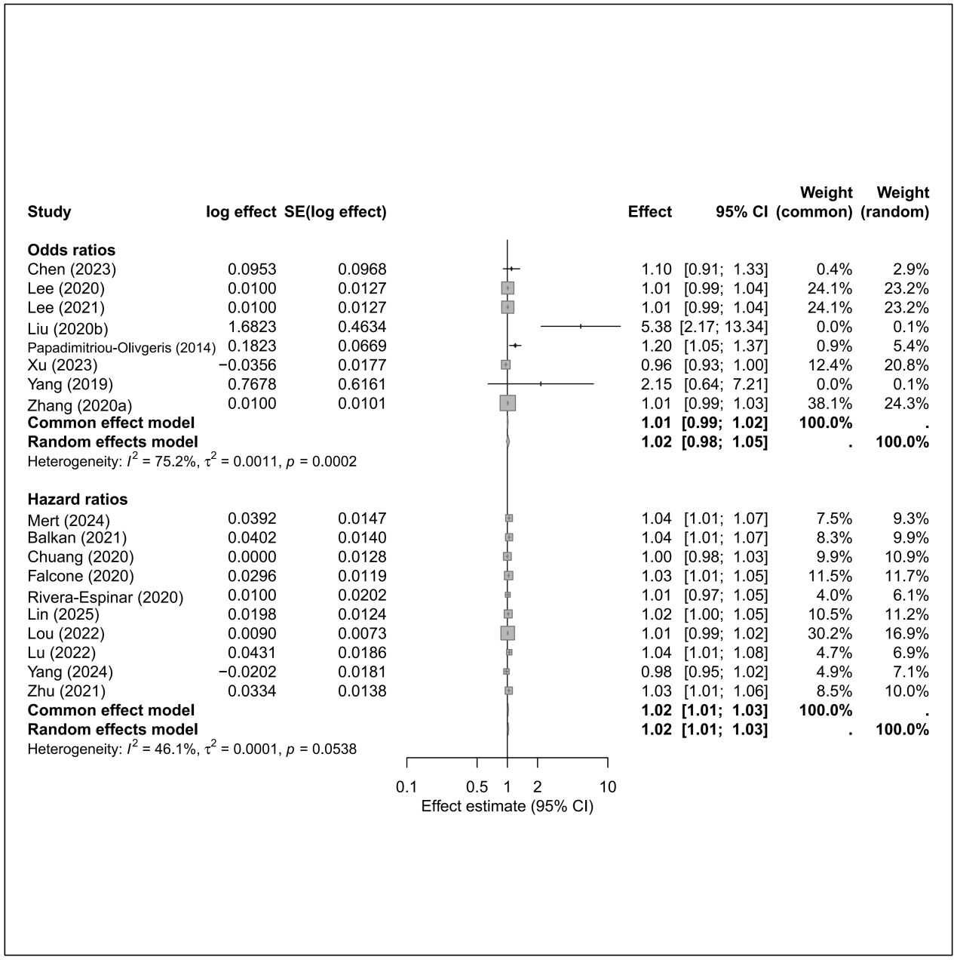
7.2 APACHE II
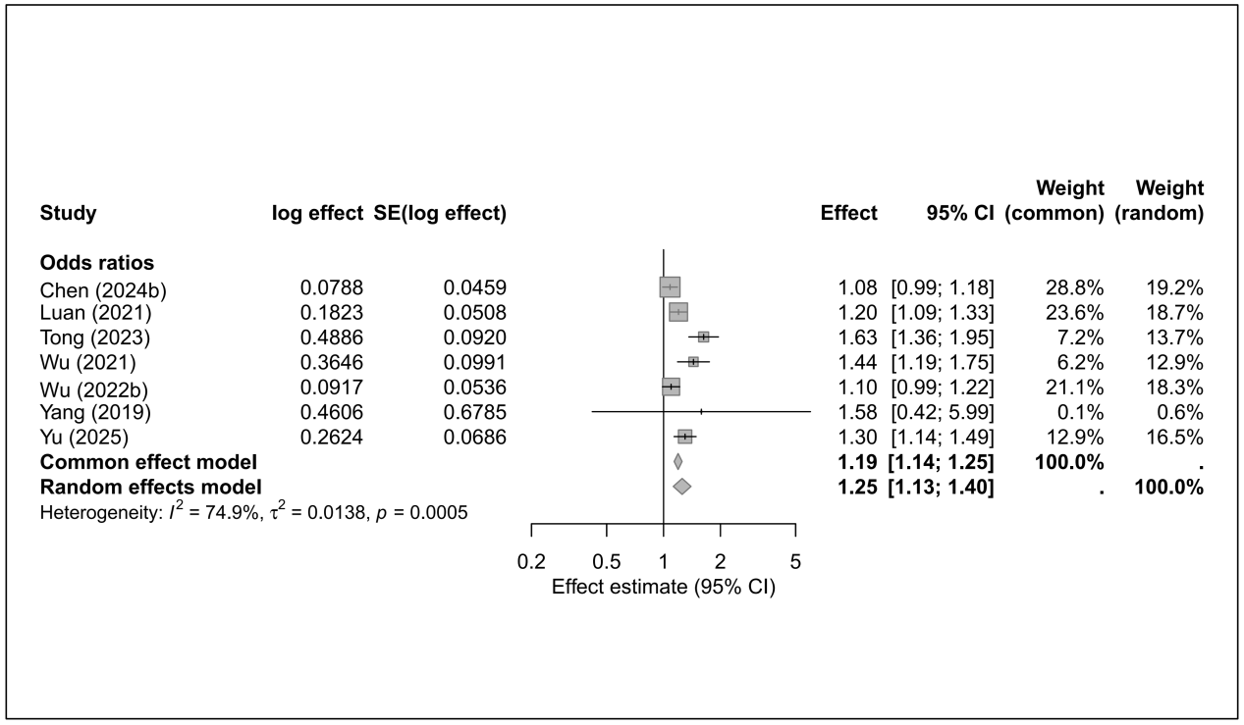

7.3 Appropriate definitive therapy
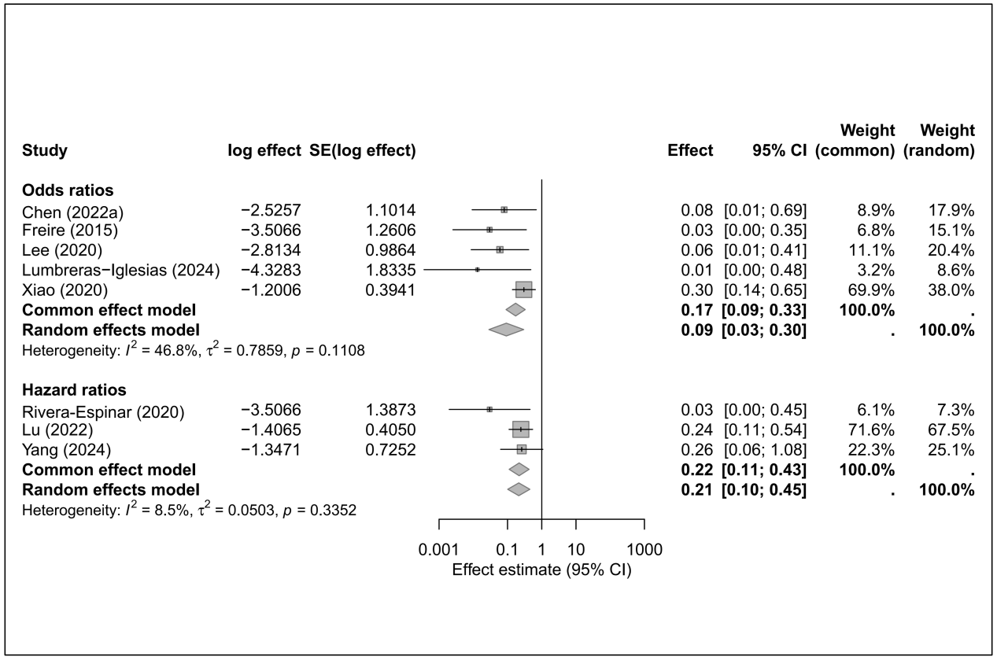

7.4 Bloodstream infection
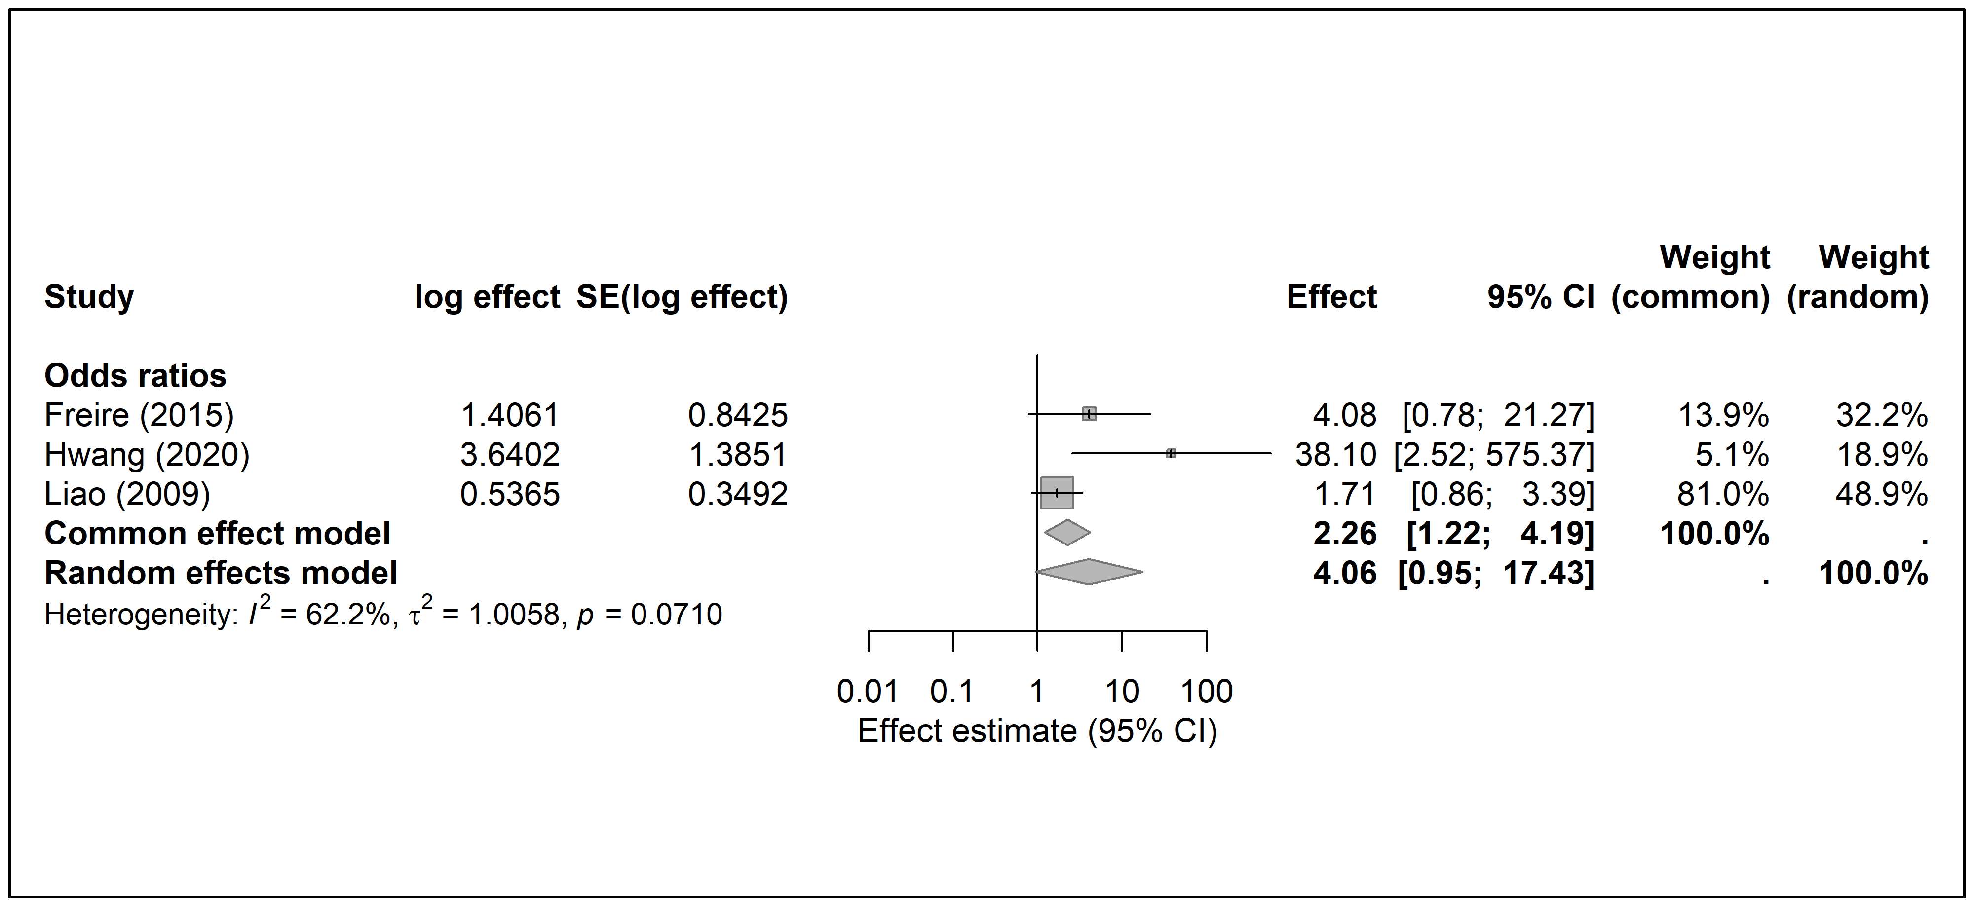

7.5 Cardiovascular disease
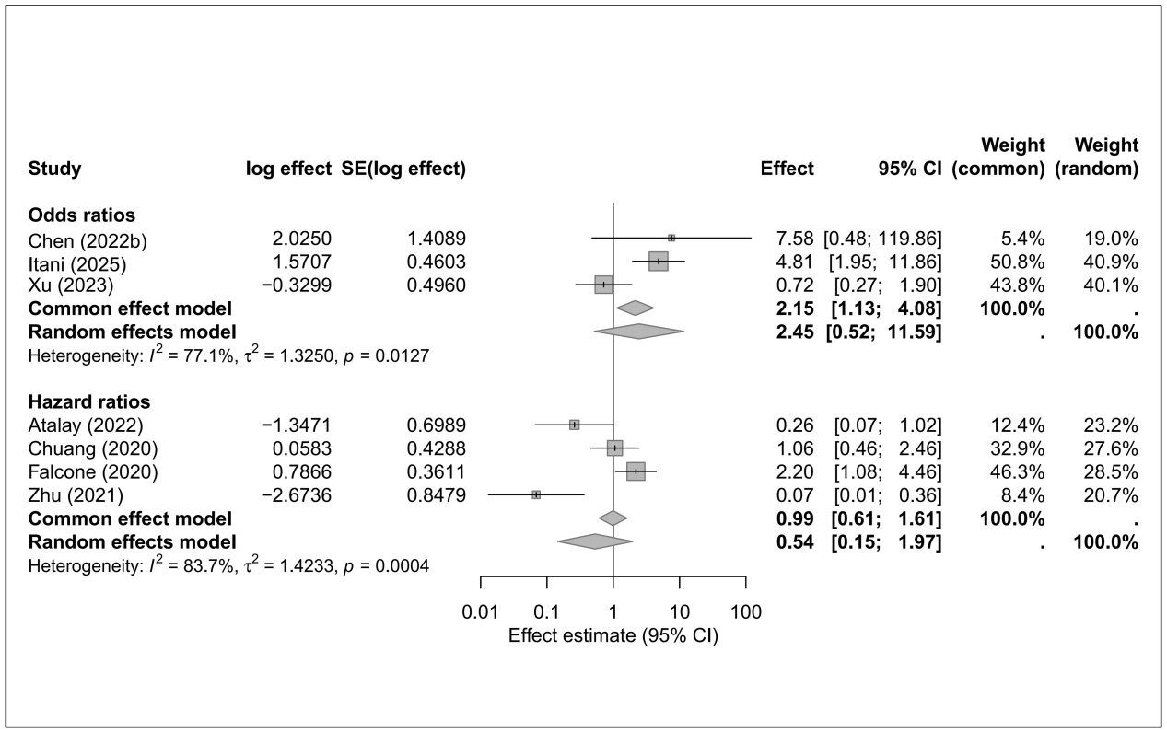

7.6 Catheter presence
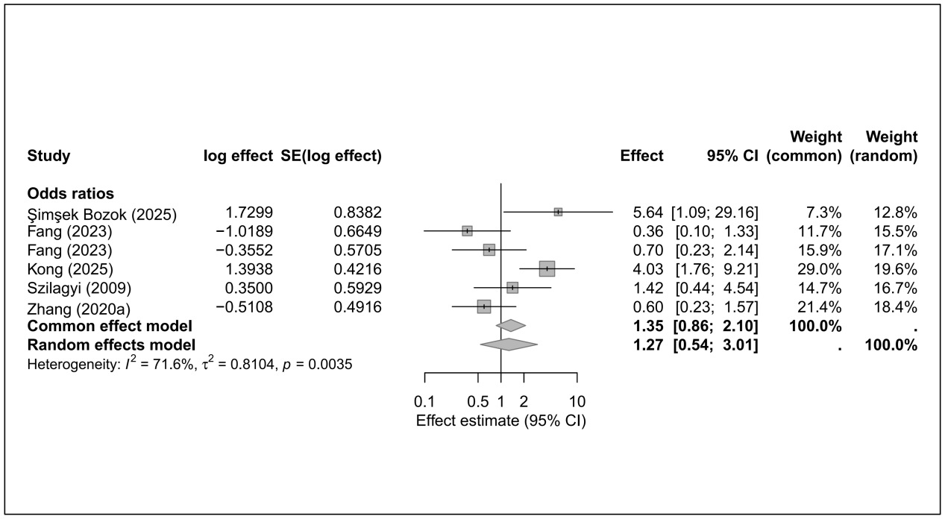

7.7 Charlson Comorbidity Index
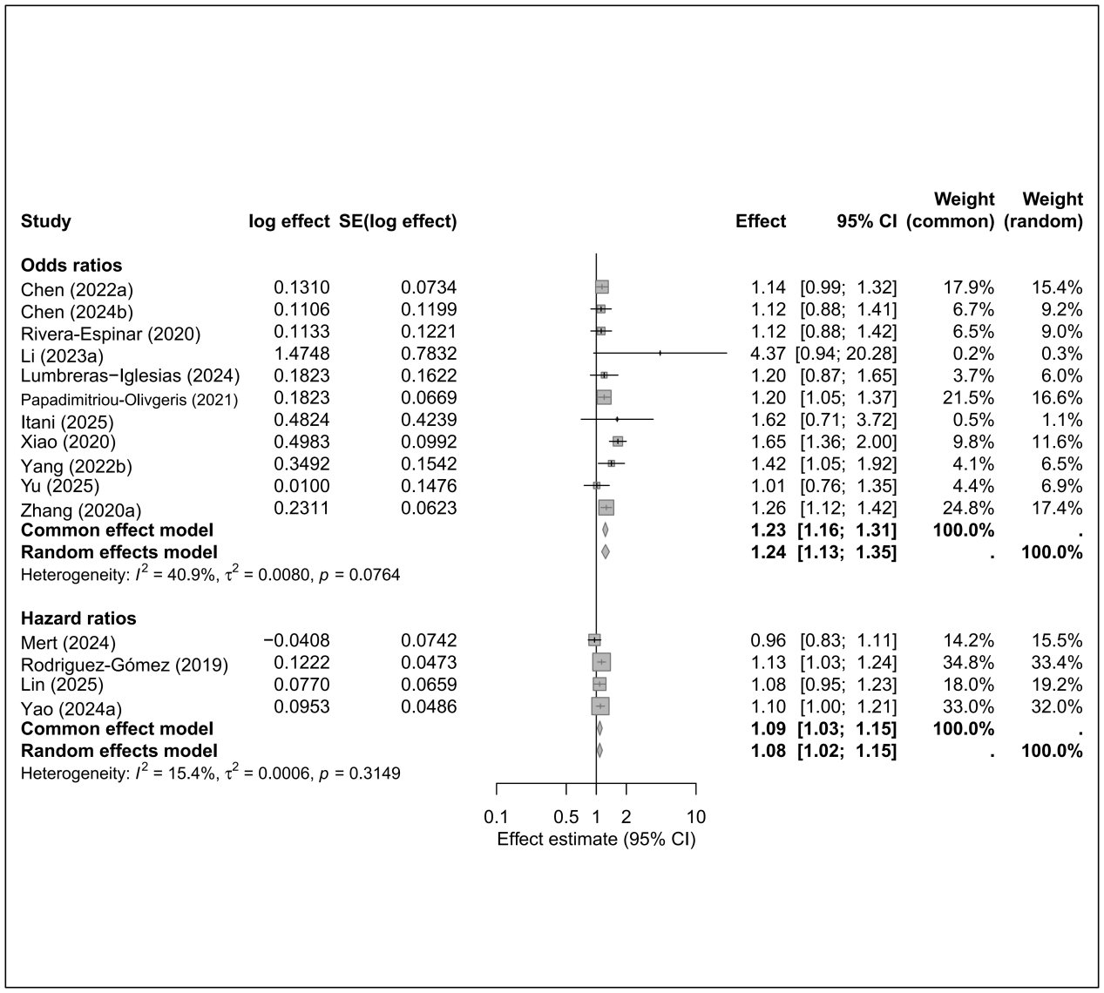

7.8 Combination therapy
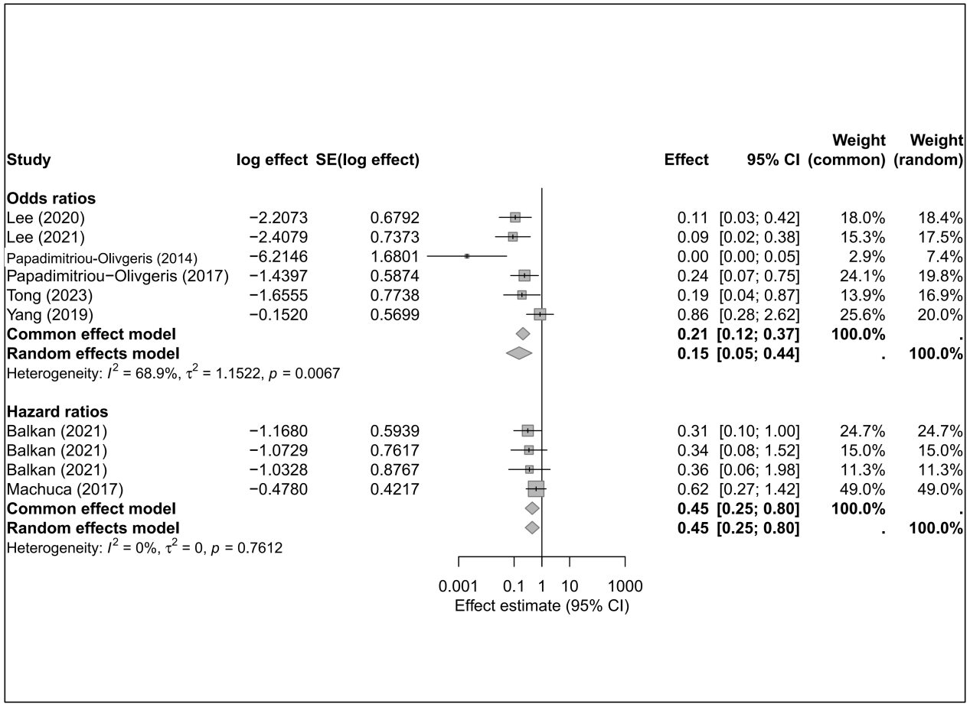

7.9 CRKP
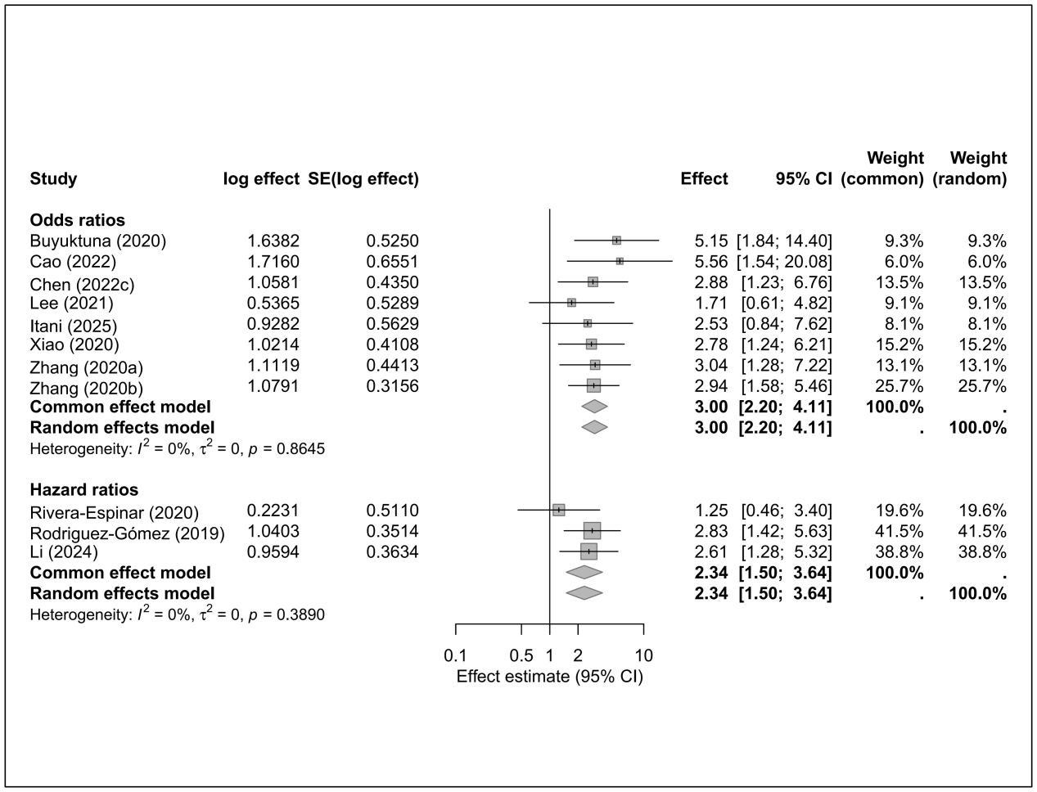

7.10 Diabetes mellitus
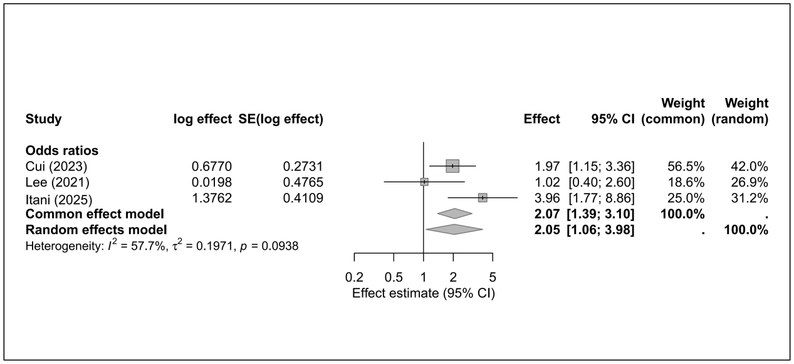

7.11 ESBL
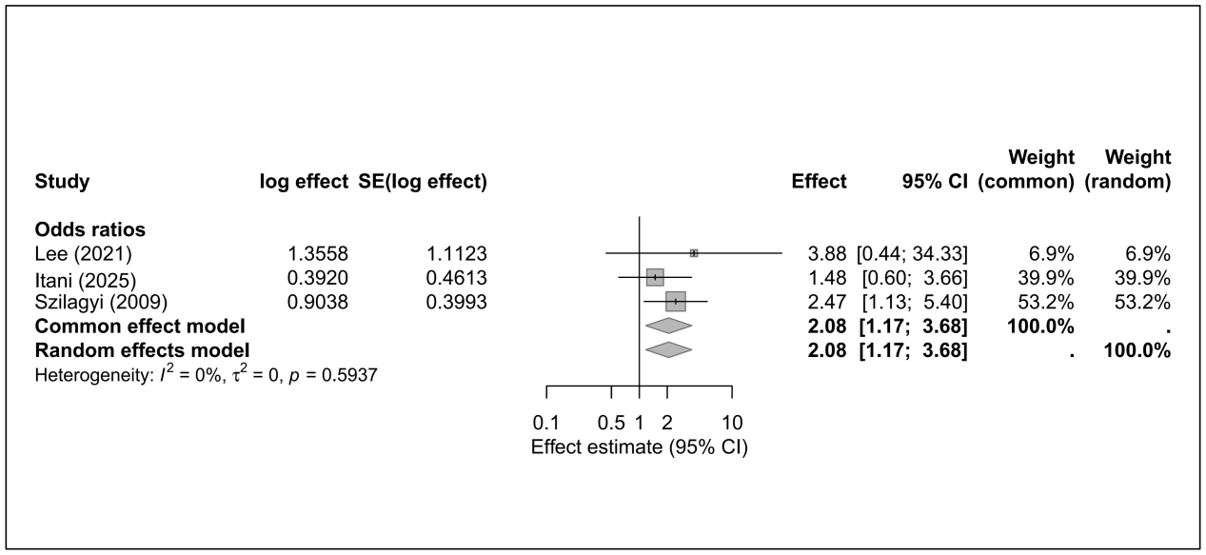

7.12 Hypoalbuminemia
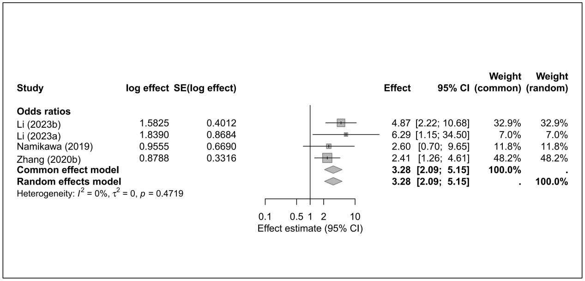

7.13 ICU admission
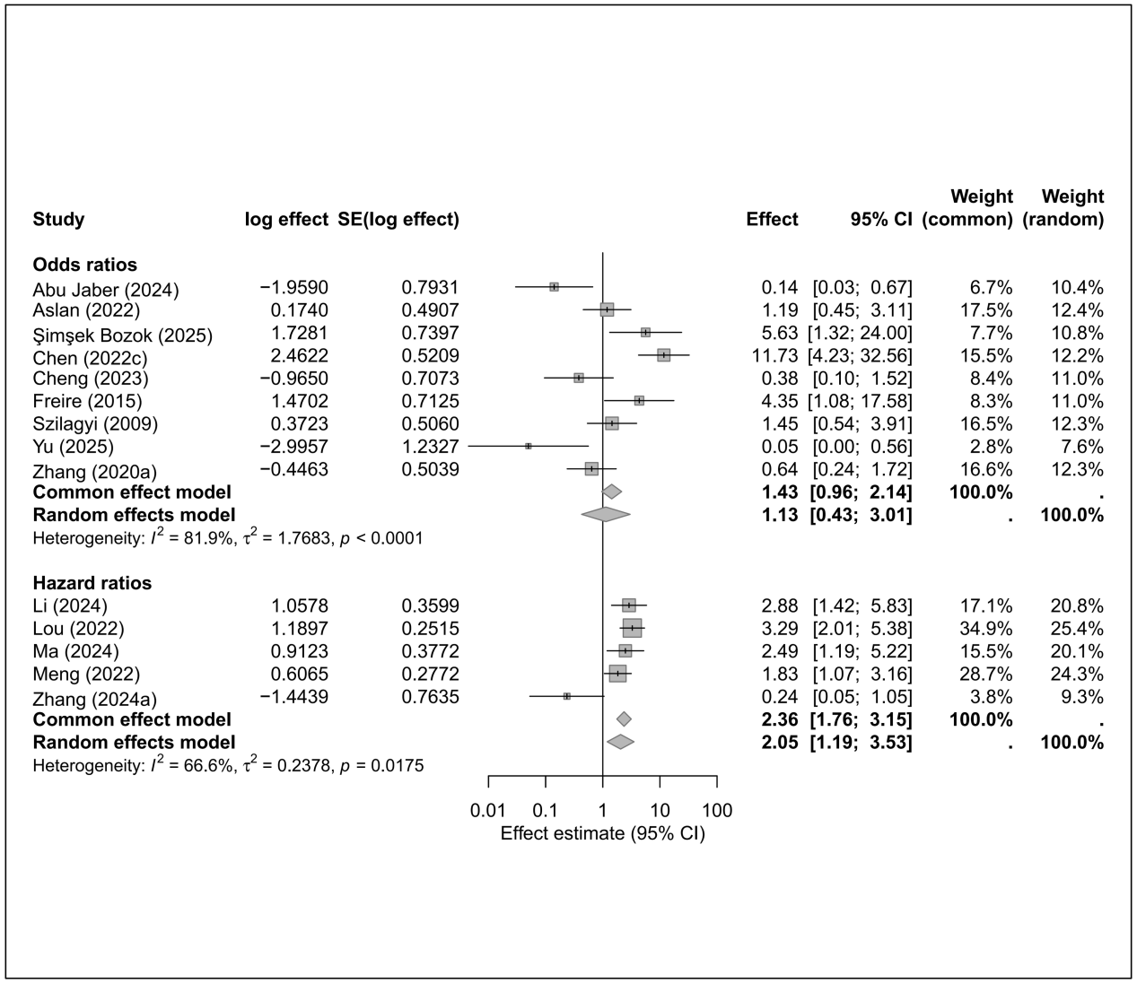

7.14 Inappropriate empirical therapy
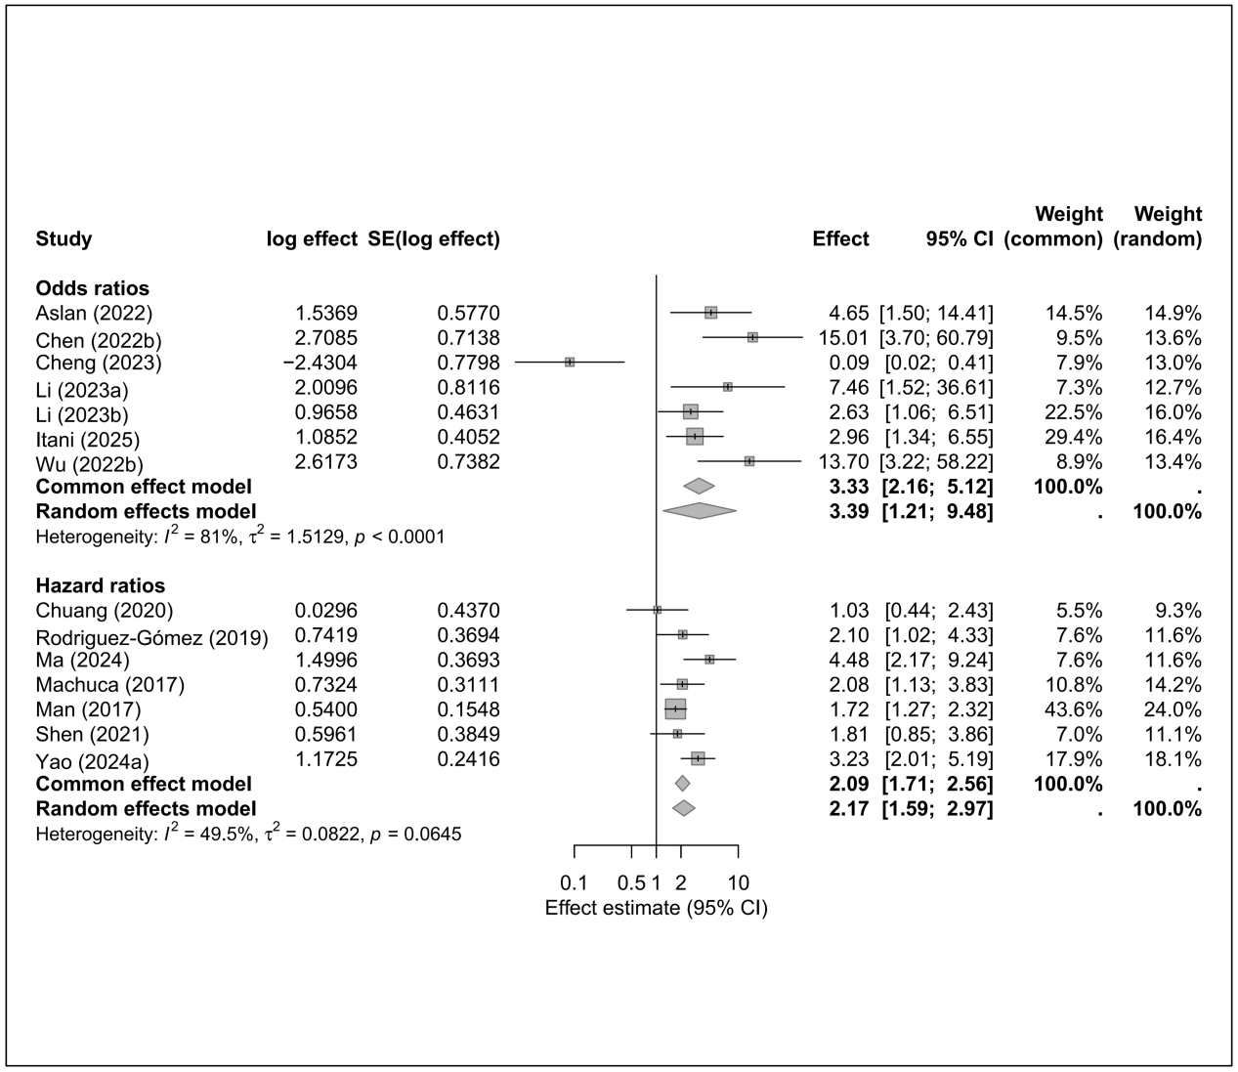

7.15 Liver disease
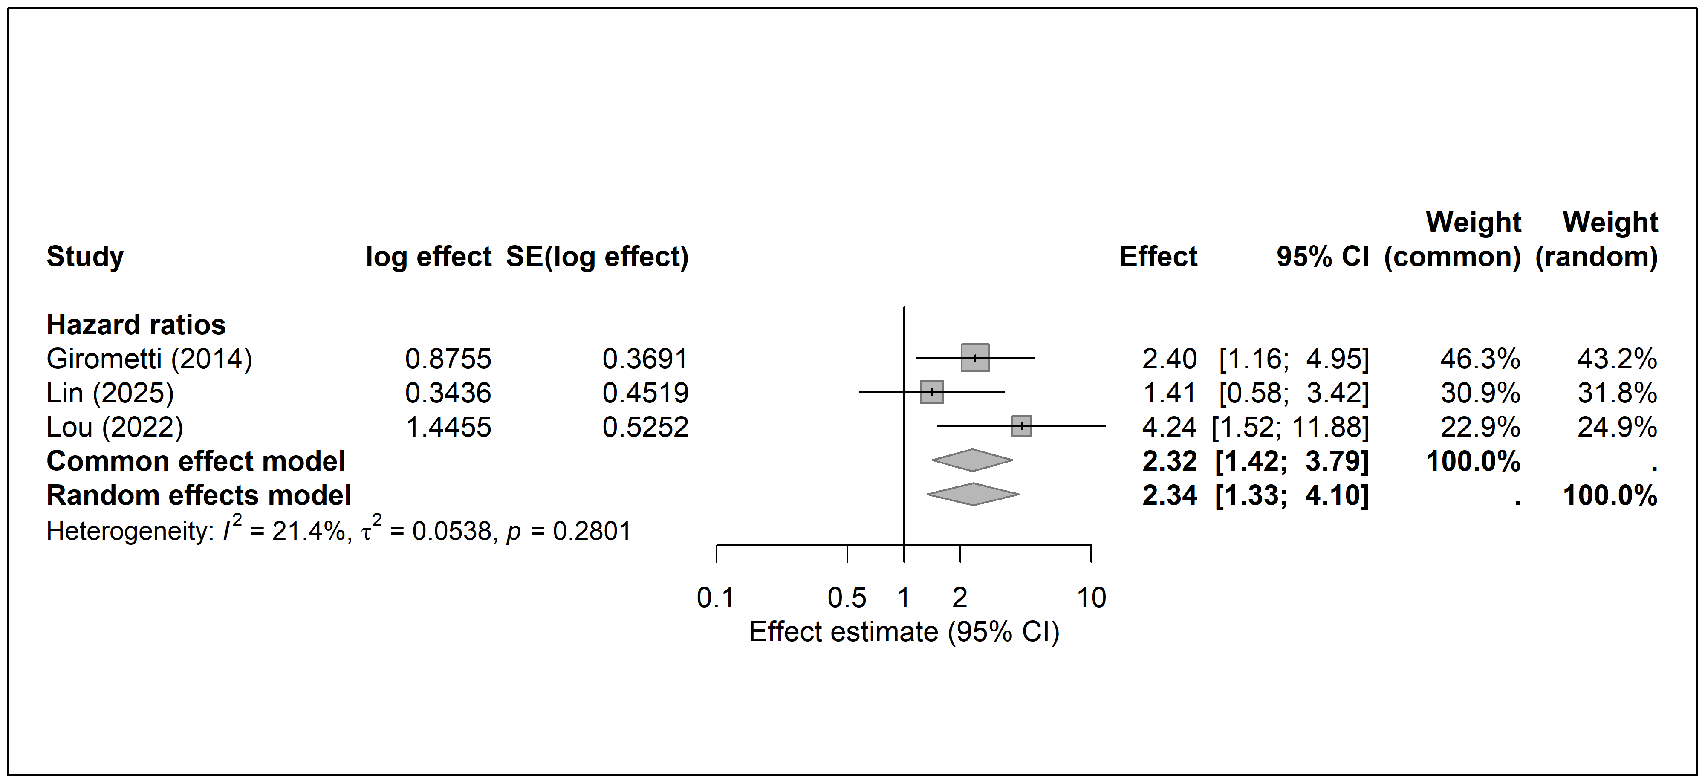

7.16 Male
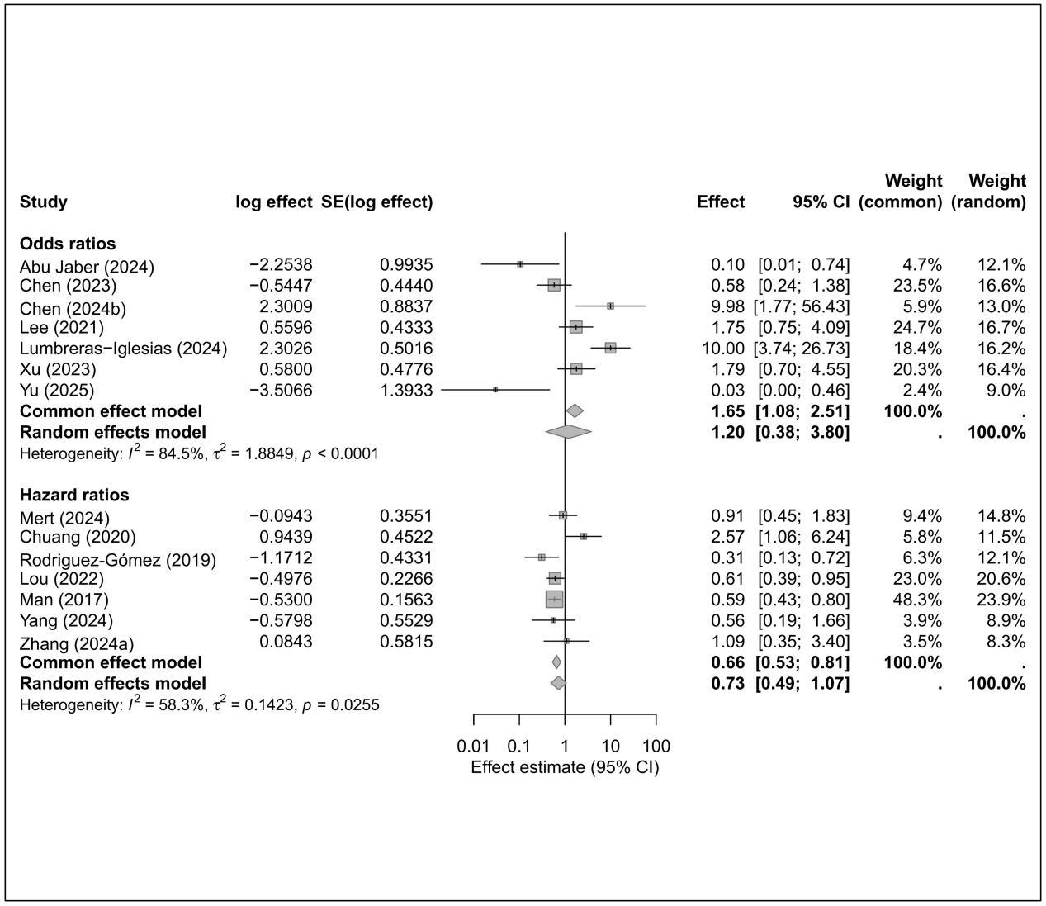

7.17 Malignancy
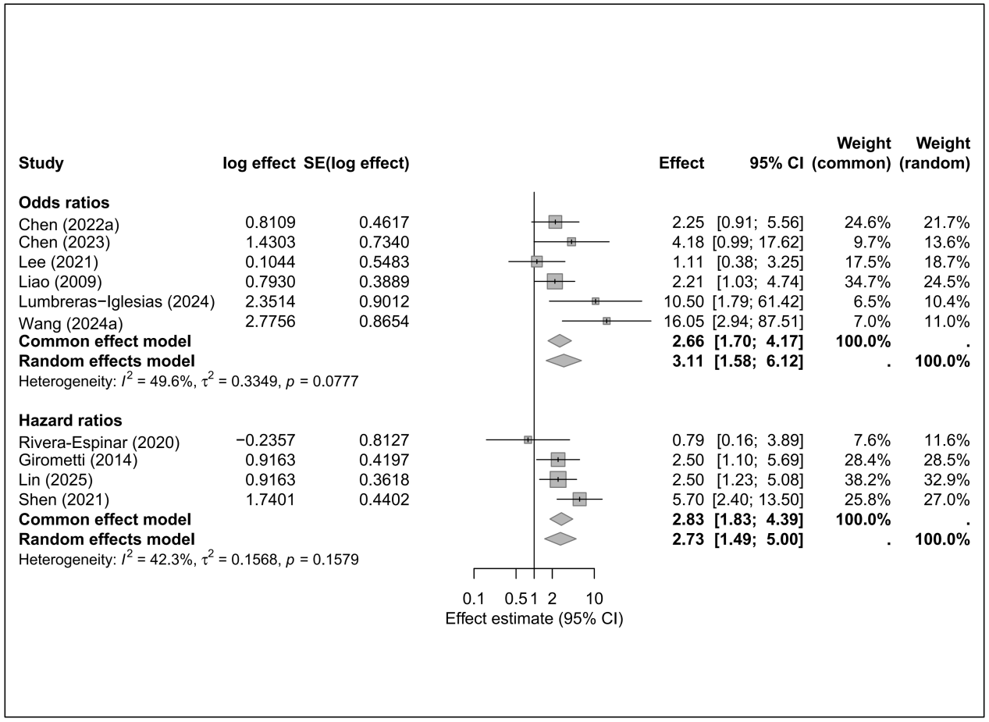

7.18 Mechanical ventilation
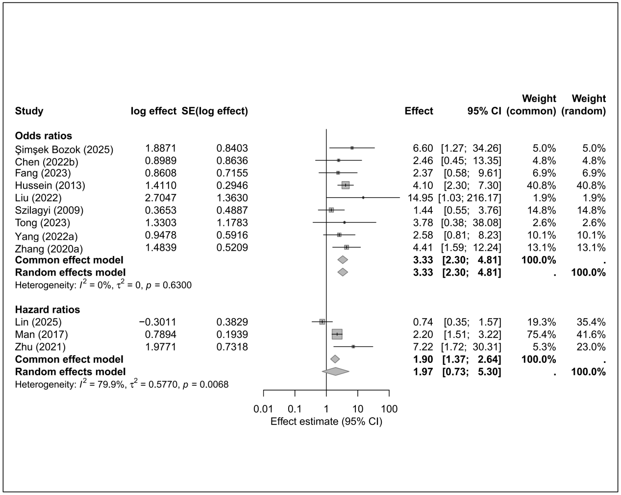

7.19 Nosocomial infection
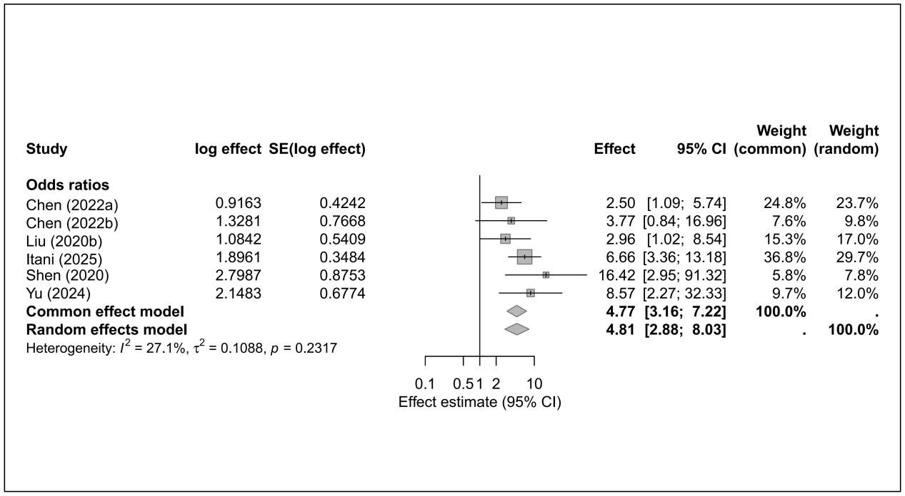

7.20 Pitt bacteremia score
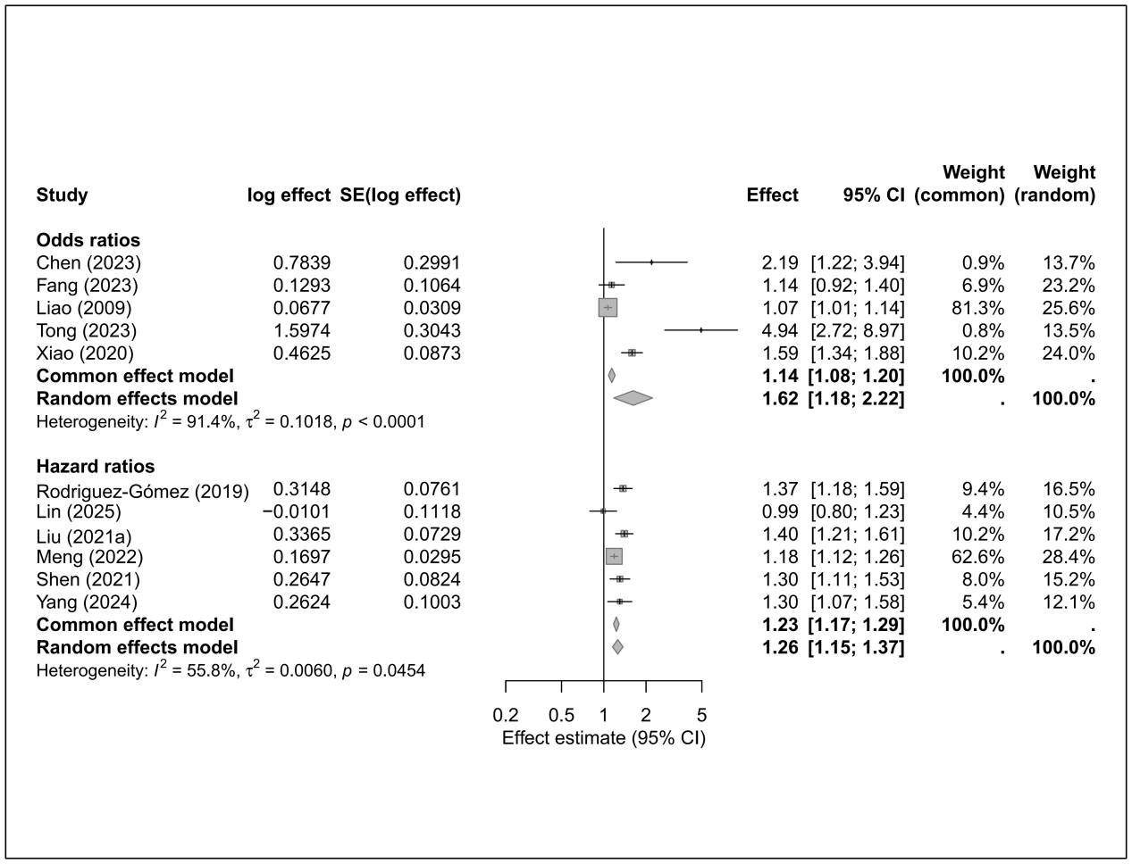

7.21 Renal disease
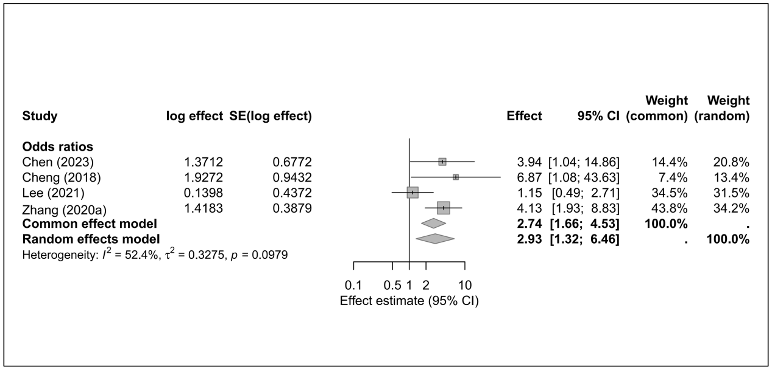

7.22 Respiratory disease
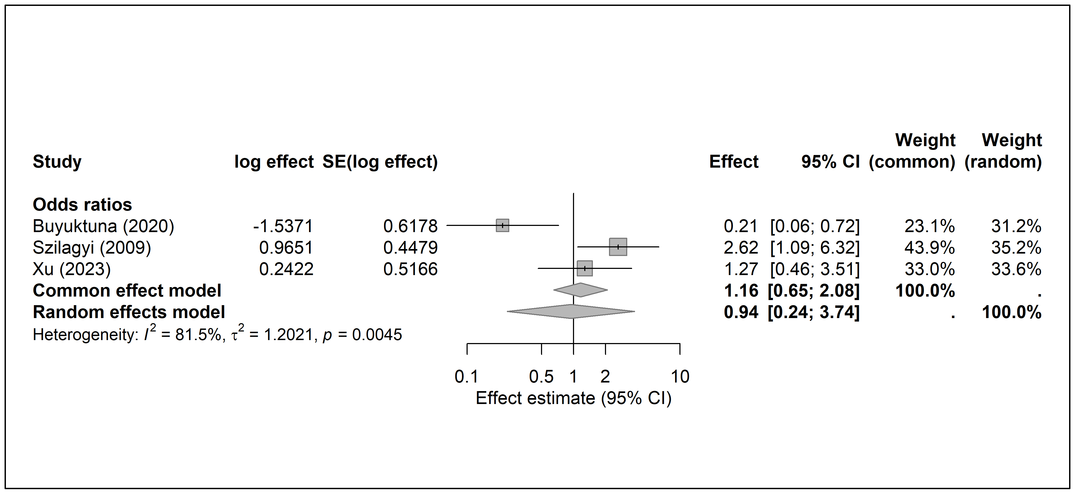

7.23 Respiratory failure
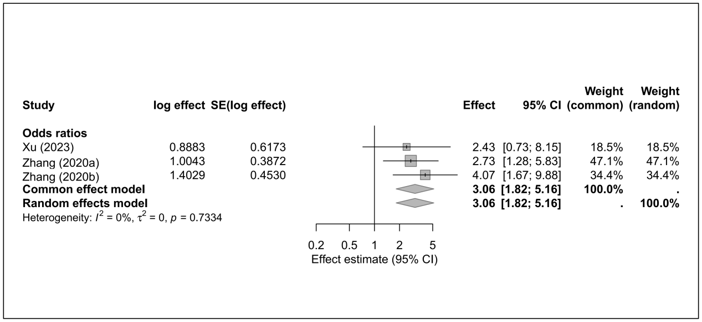
7.24 Respiratory tract infection
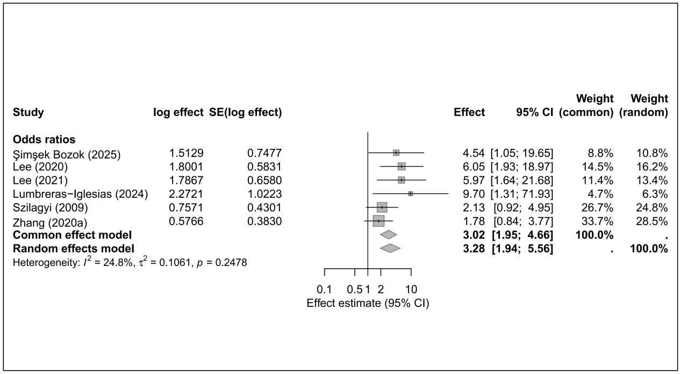

7.25 Septic shock
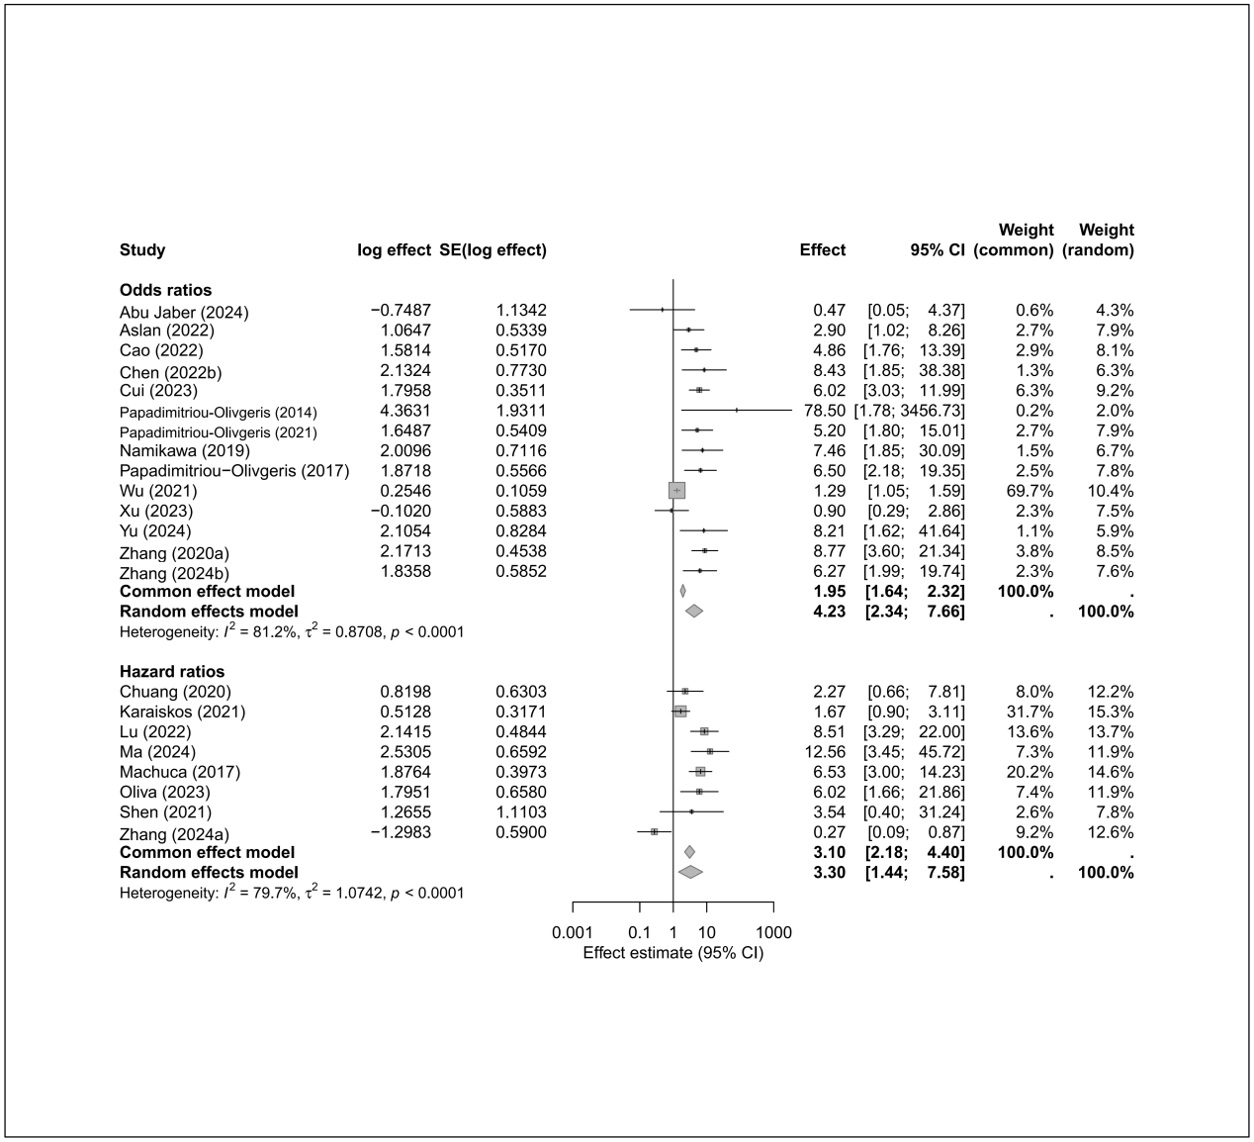

7.26 SOFA
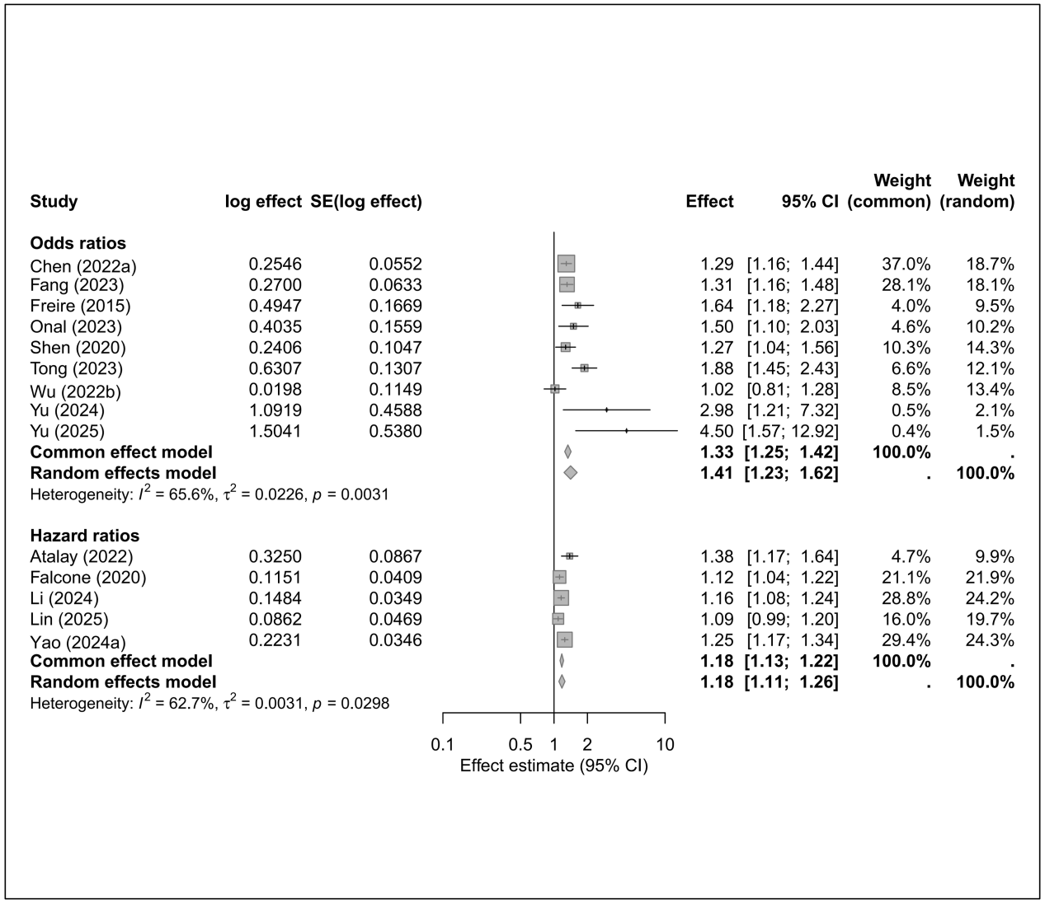

Supplemental Figure S8. Meta-analysis of risk factors for in-hospital mortality of Klebsiella pneumoniae infections
8.1 Age
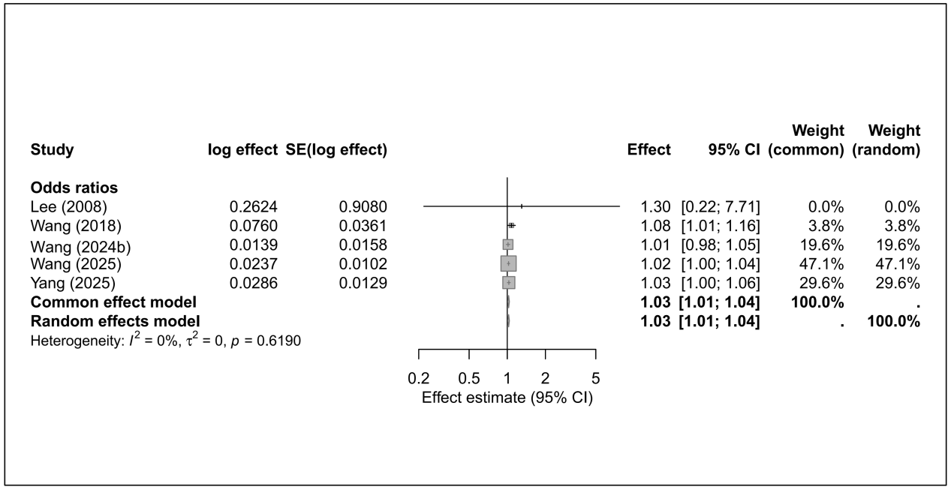

8.2 APACHE II
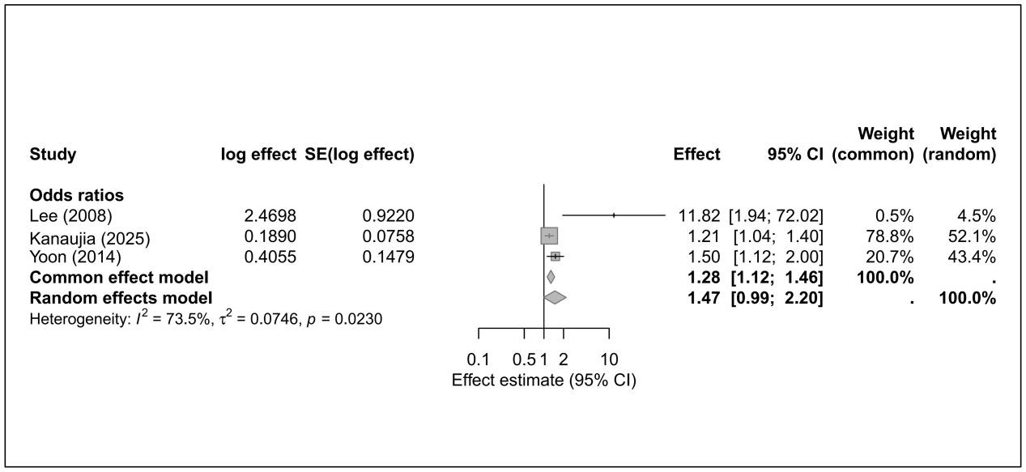

8.3 Cardiovascular disease
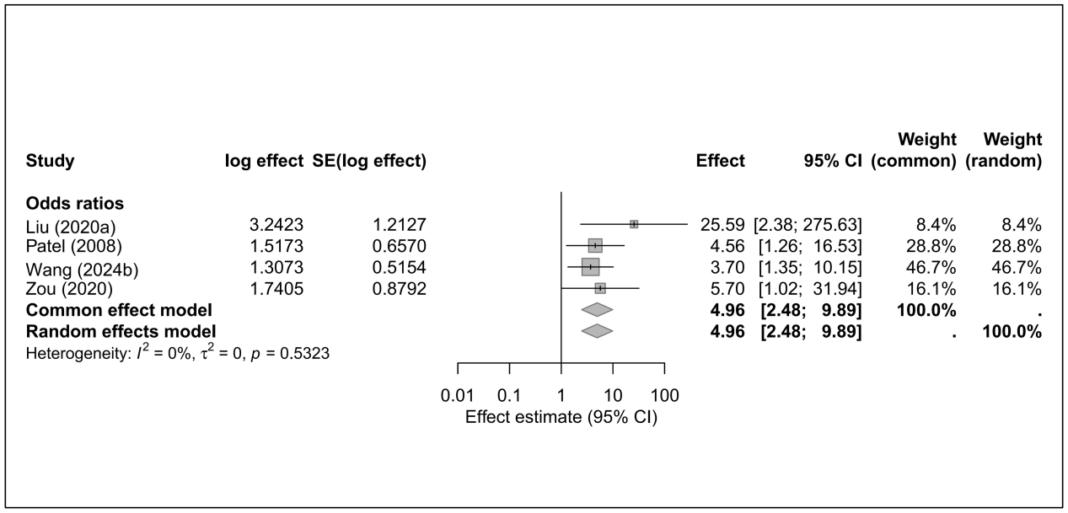

8.4 Catheter presence
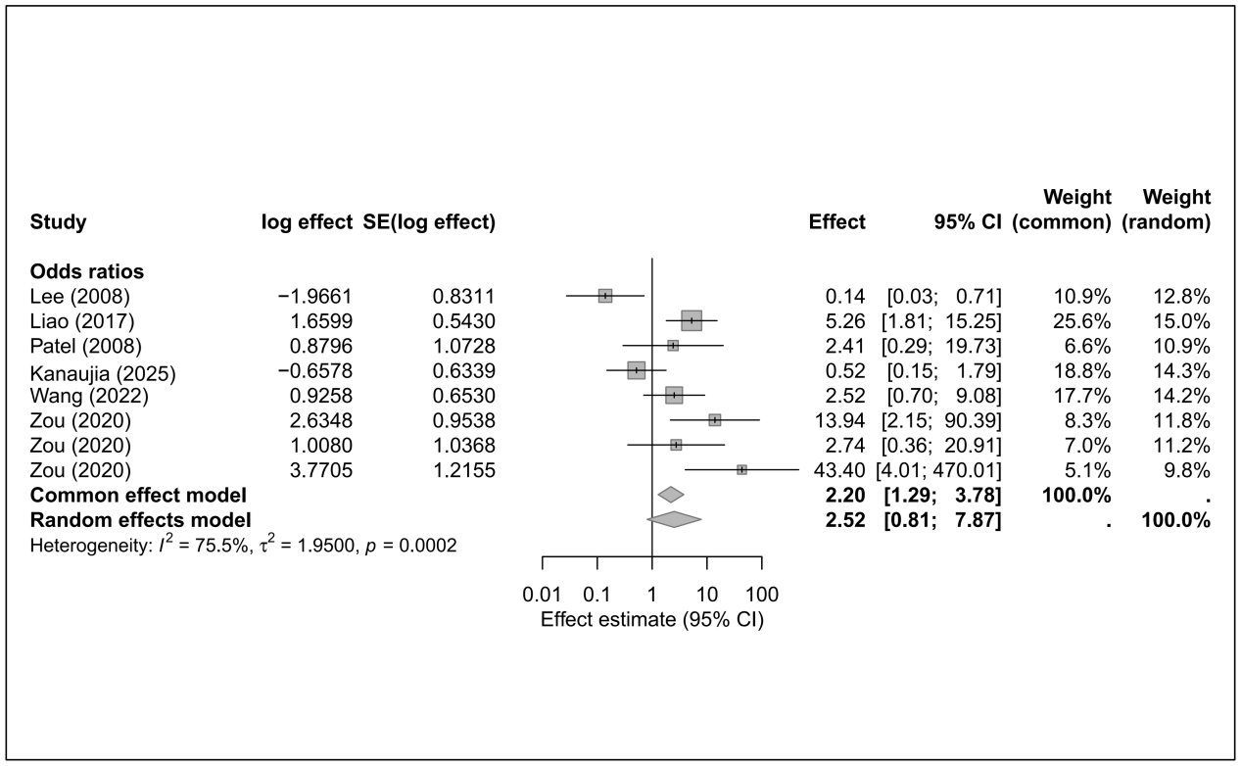

8.5 Charlson Comorbidity Index
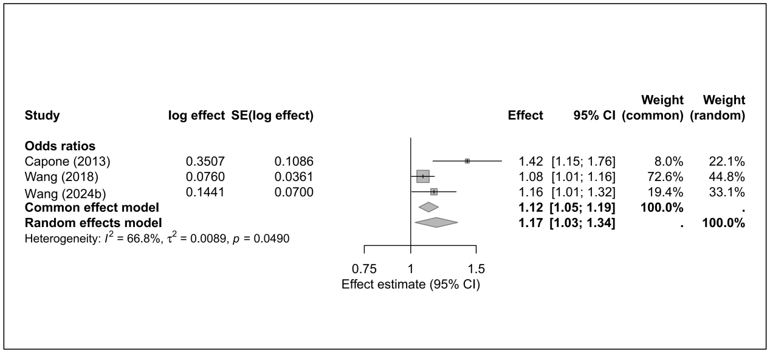

8.6 CRKP
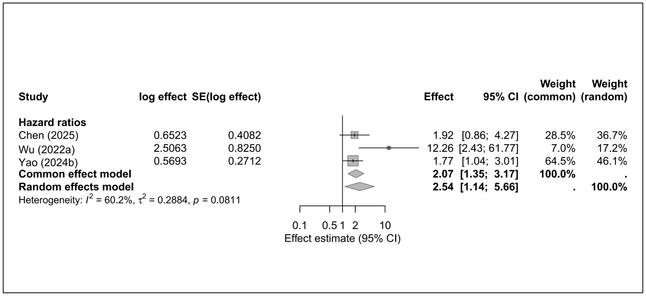

8.7 ICU admission
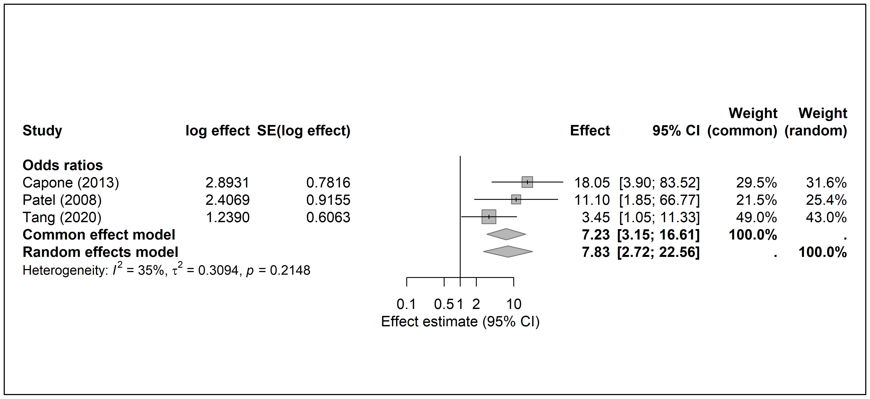

8.8 Liver disease
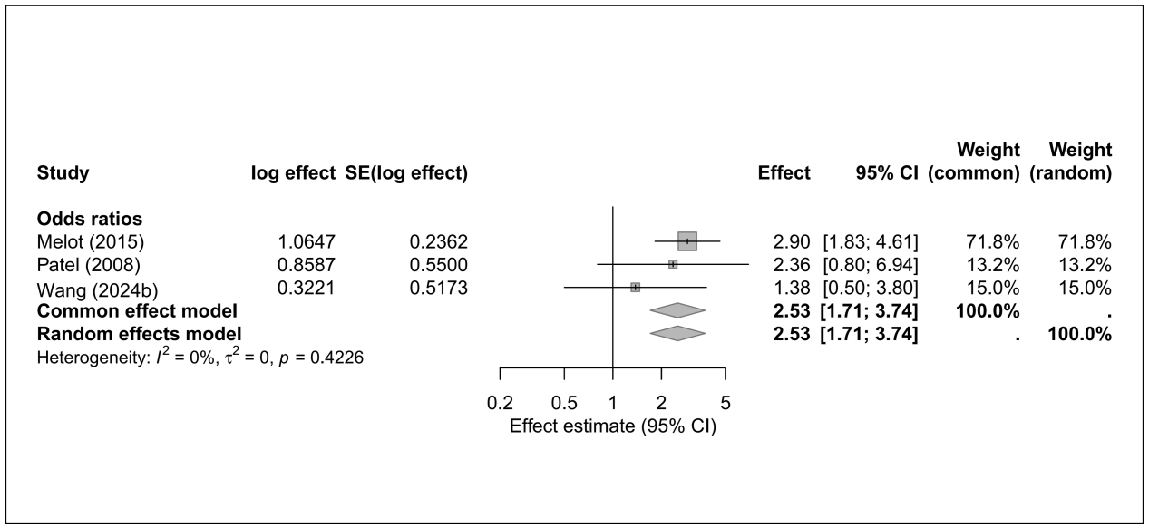

8.9 Mechanical ventilation
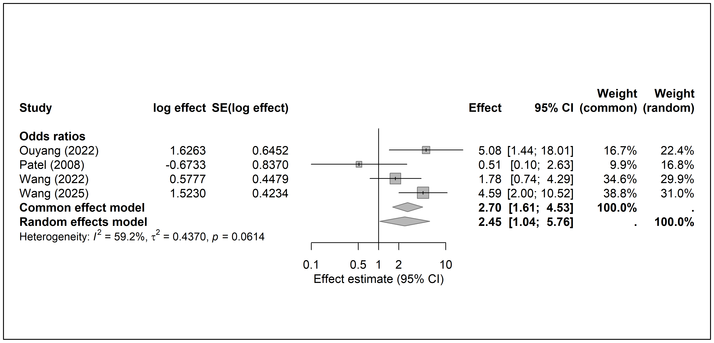

8.10 Renal disease
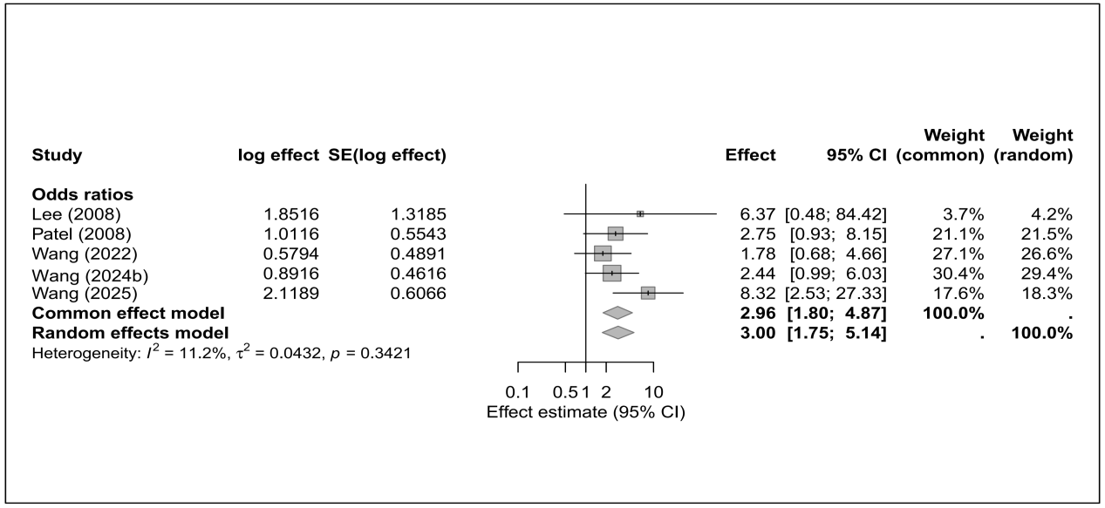

8.11 Respiratory disease
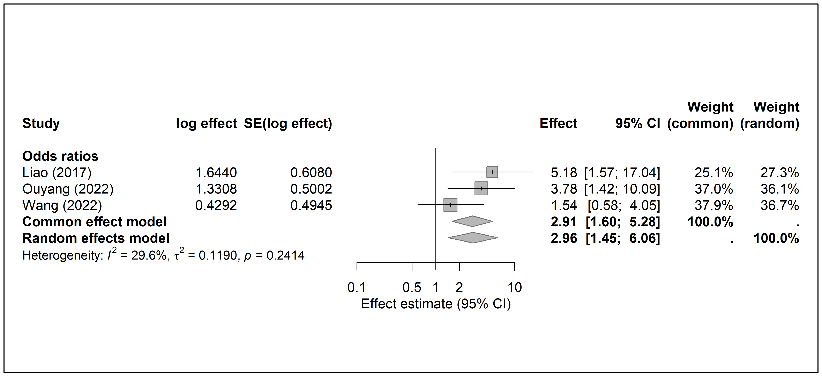
Supplemental Figure S9. Meta-analysis of risk factors for 14/15-day mortality of Klebsiella pneumoniae infections
9.1 Charlson Comorbidity Index
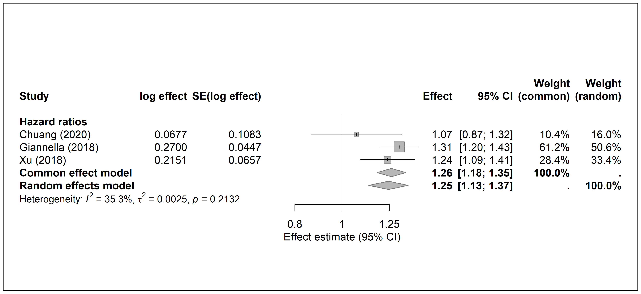

9.2 Septic shock
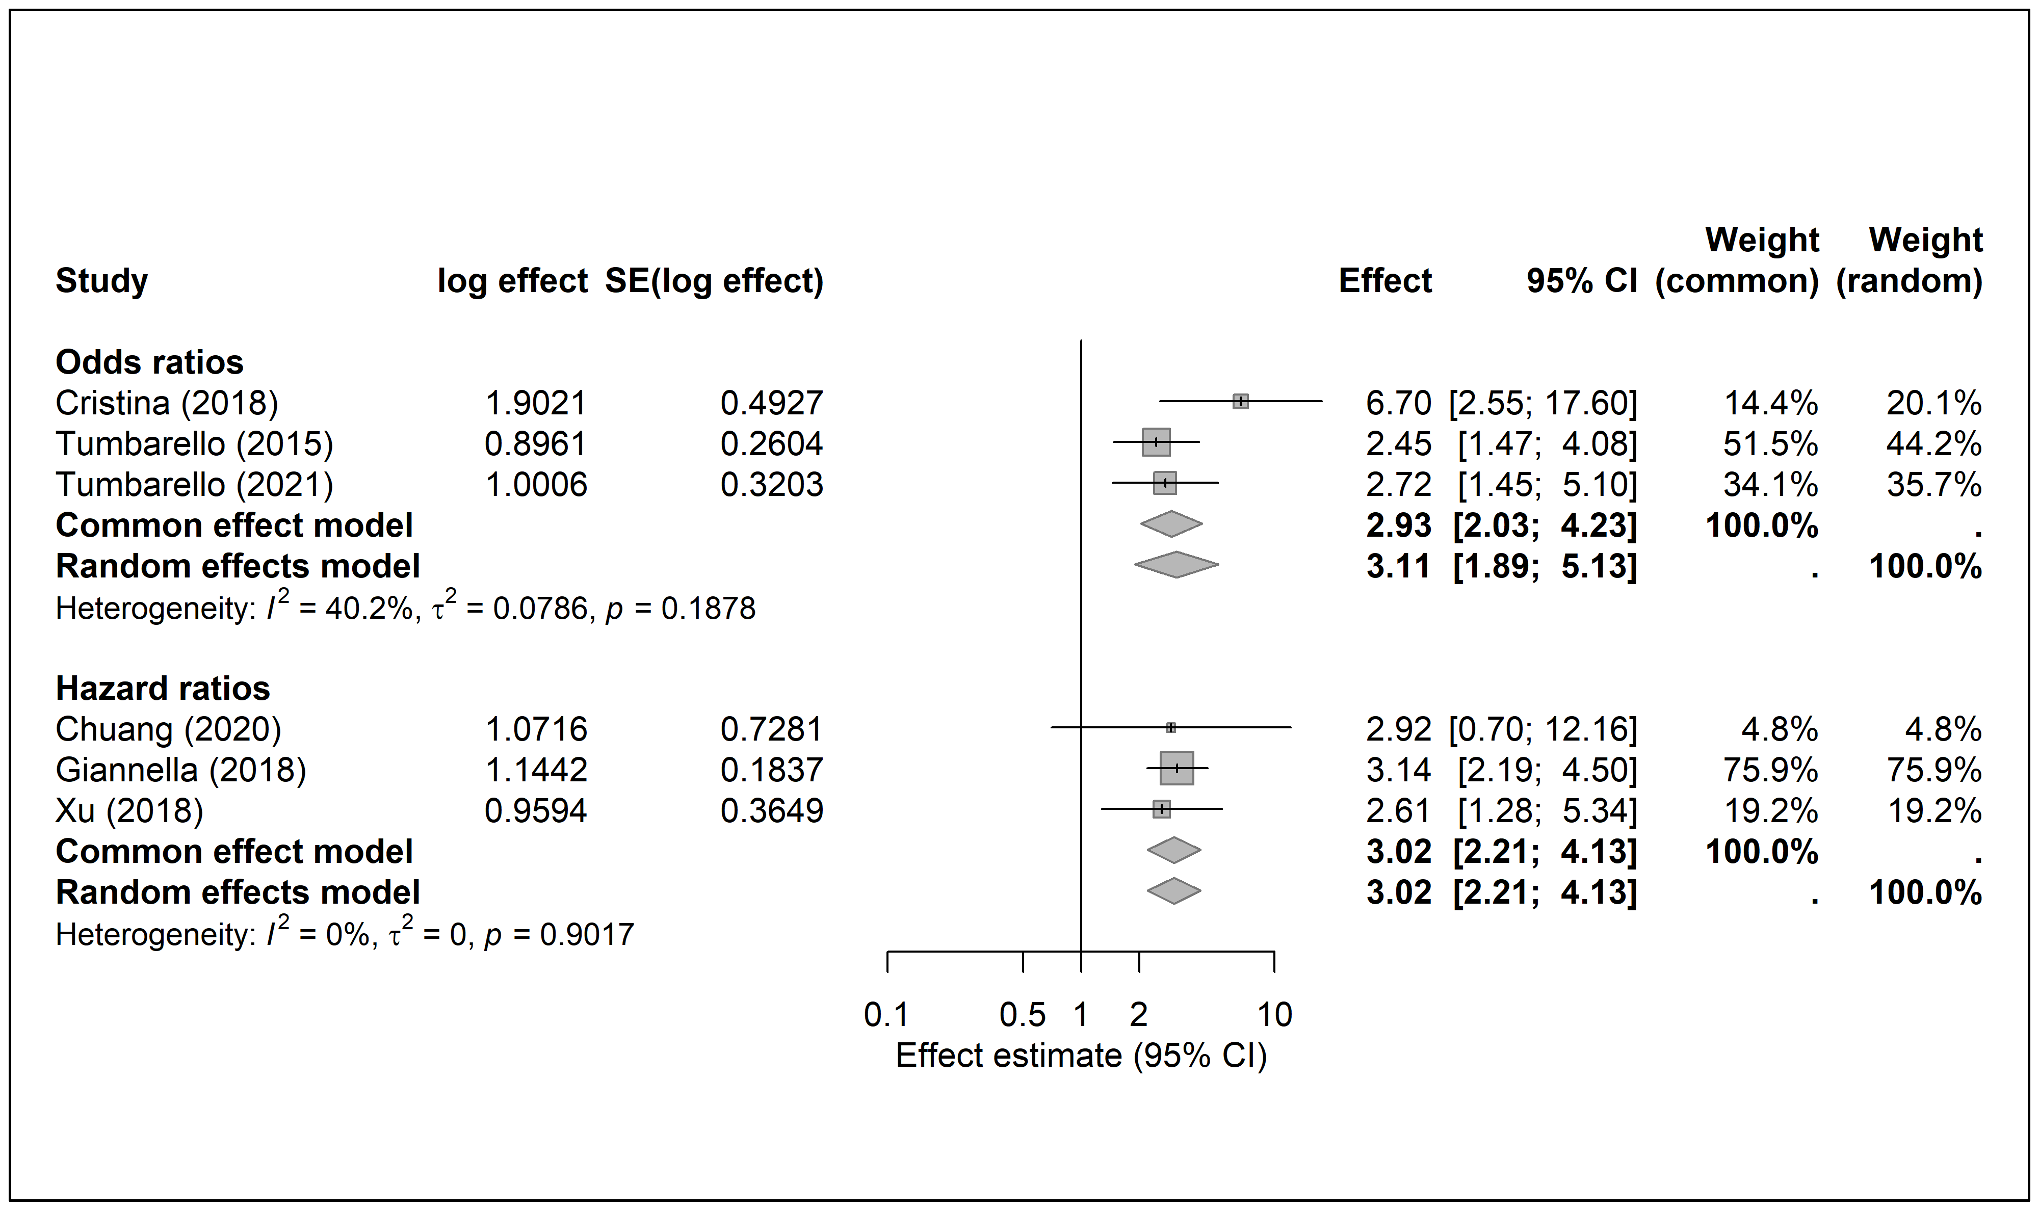
Supplemental Figure S10. Meta-analysis of risk factors for 90-day mortality of Klebsiella pneumoniae infections
10.1 CRKP
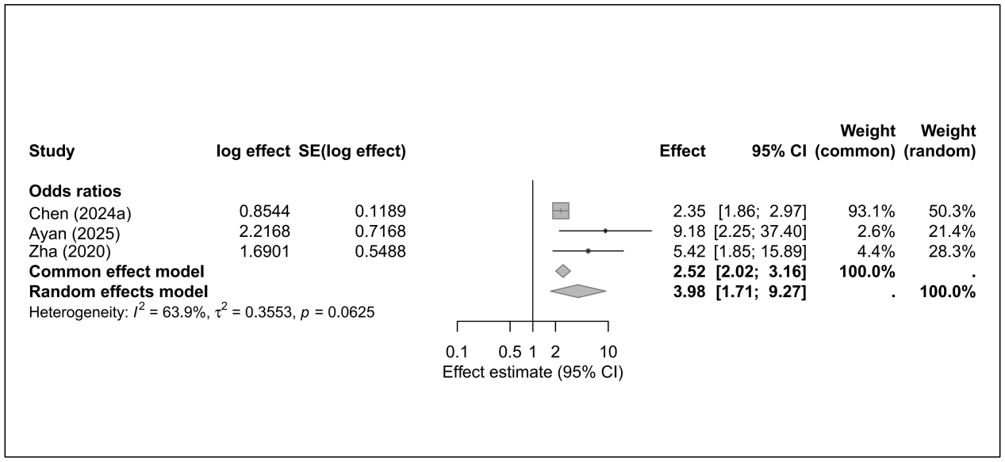
Supplemental Figure S11. Sensitivity analysis of 28/30-day mortality by omitting individual study
11.1 Age
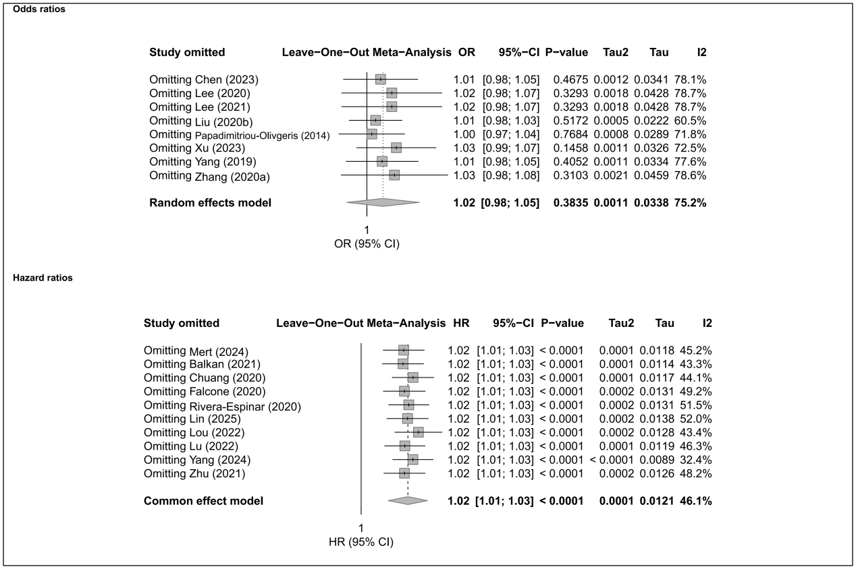

11.2 APACHE II
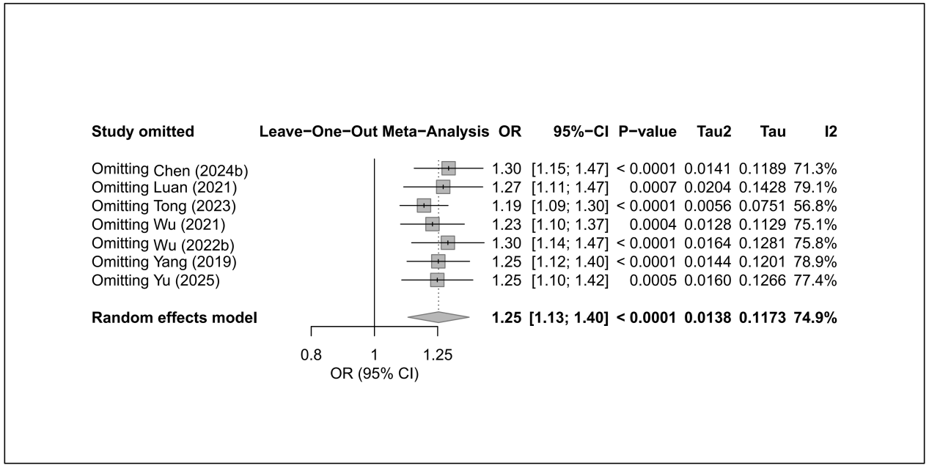
11.3 Appropriate definitive therapy
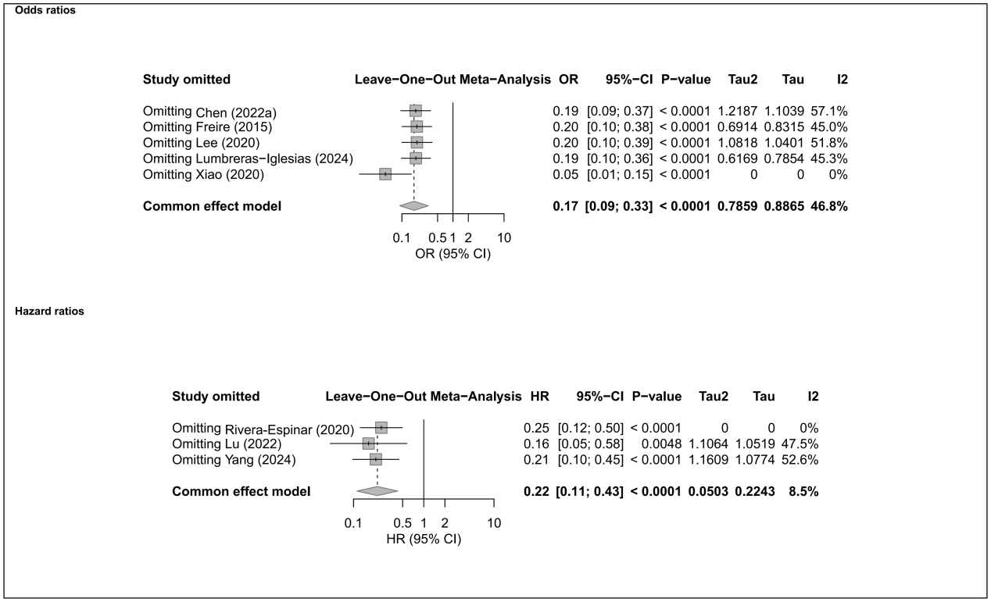

11.4 Bloodstream infection
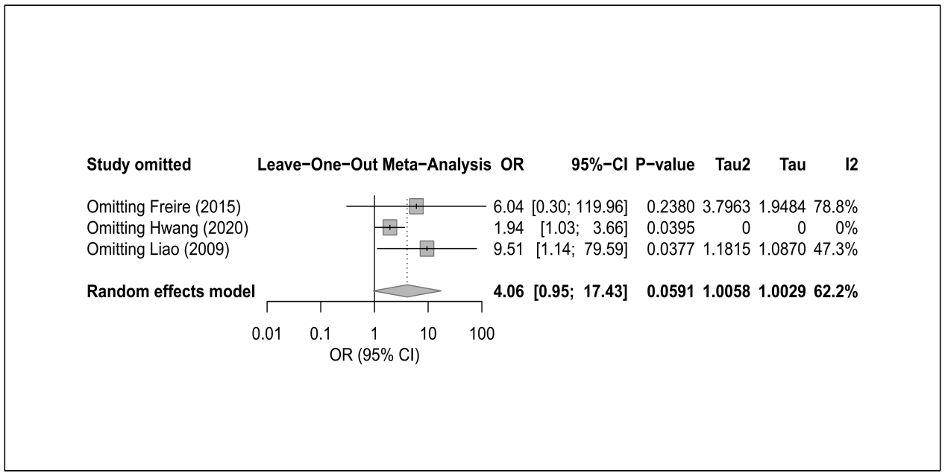

11.5 Cardiovascular disease
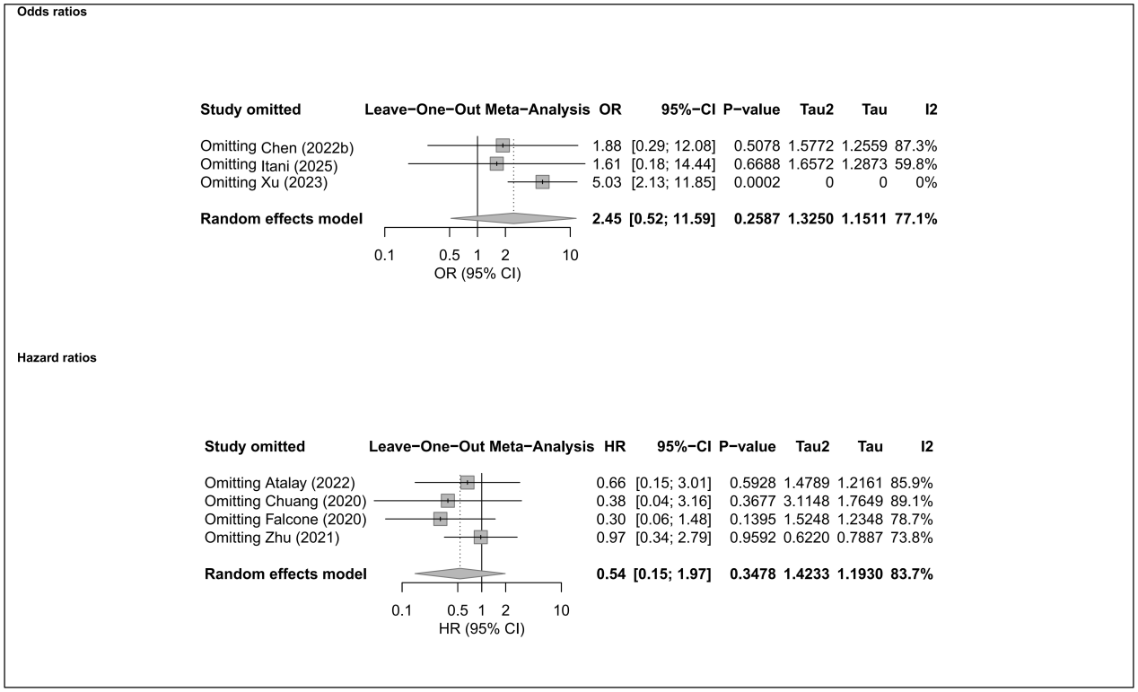

11.6 Catheter presence
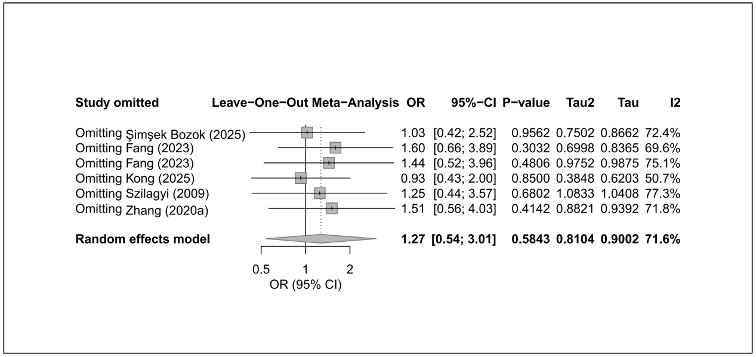

11.7 Charlson Comorbidity Index
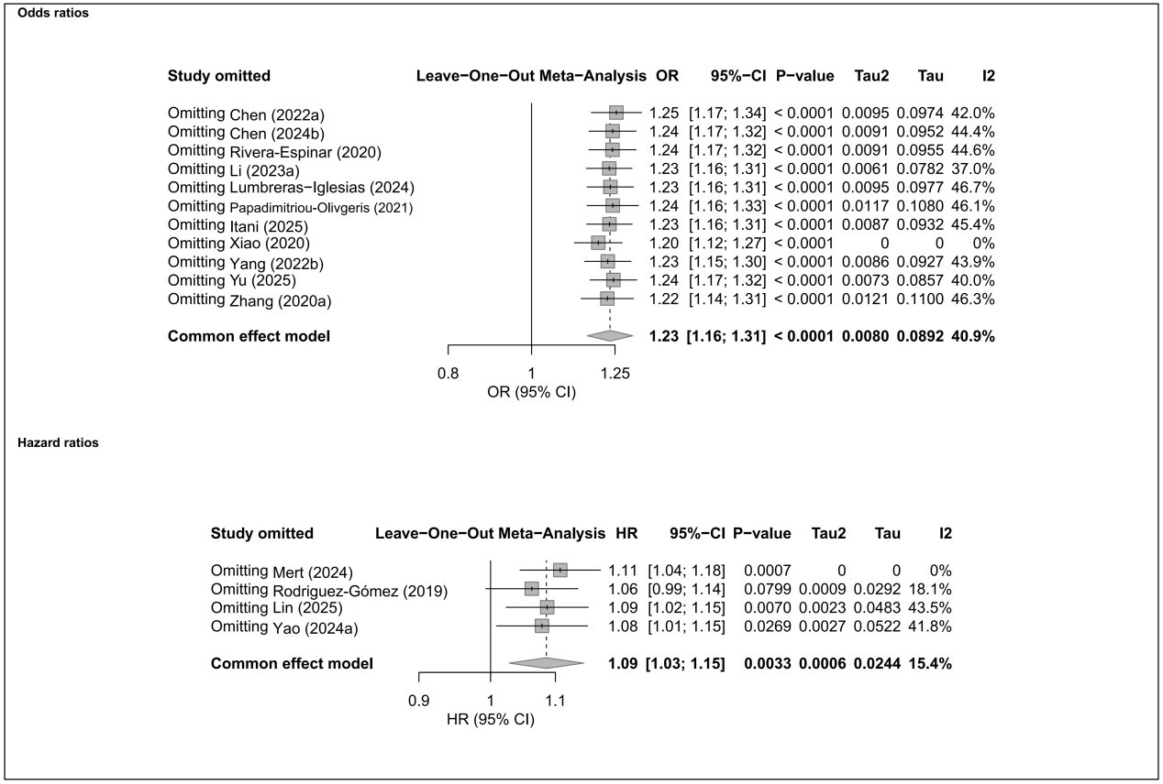

11.8 Combination therapy
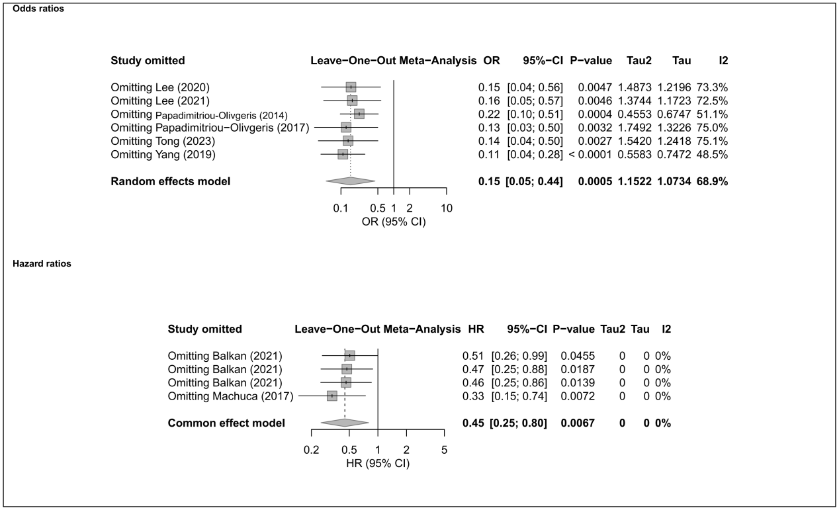

11.9 CRKP
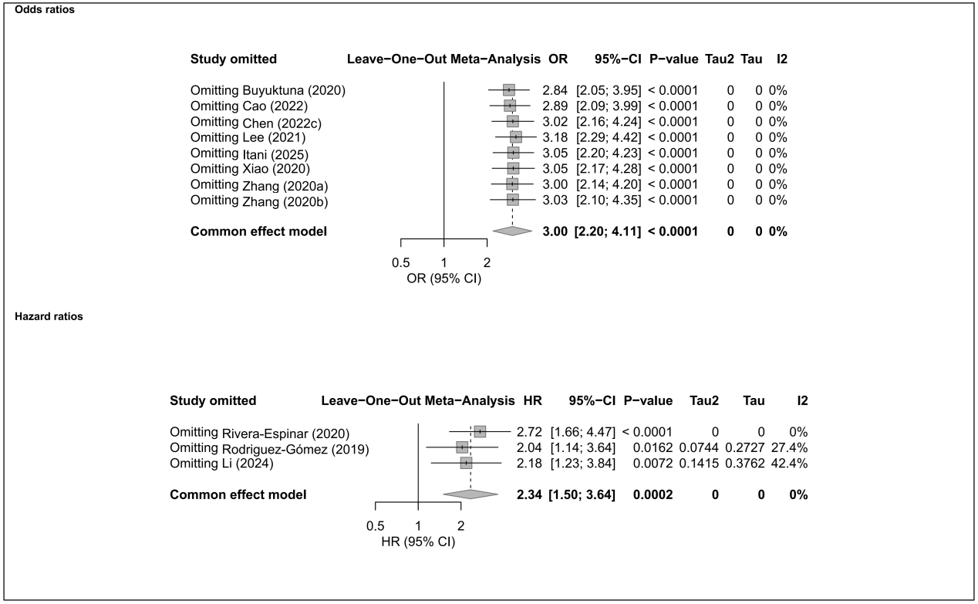

11.10 Diabetes mellitus
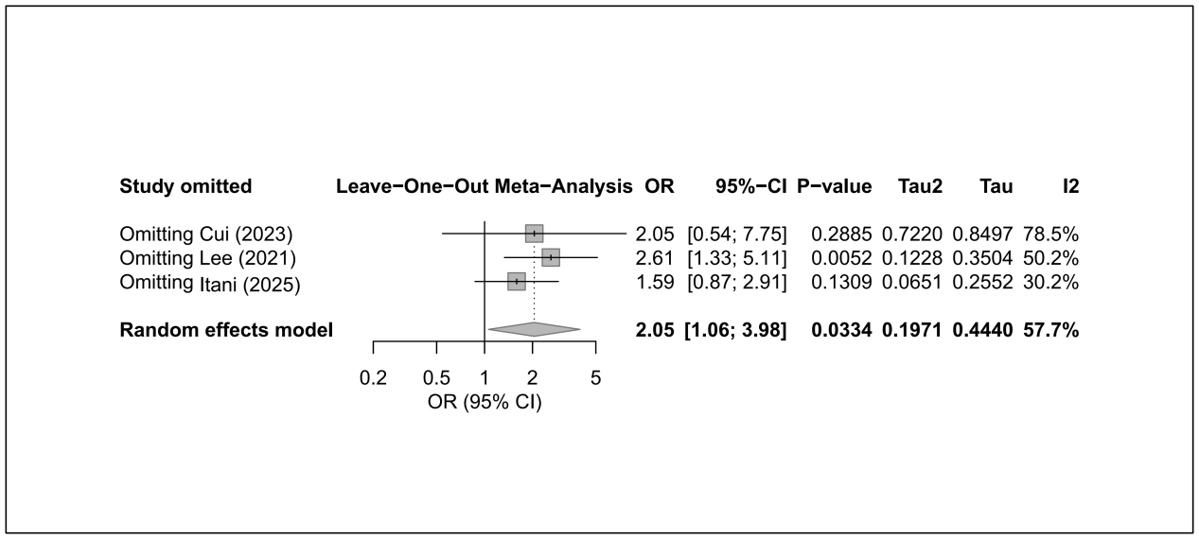

11.11 ESBL
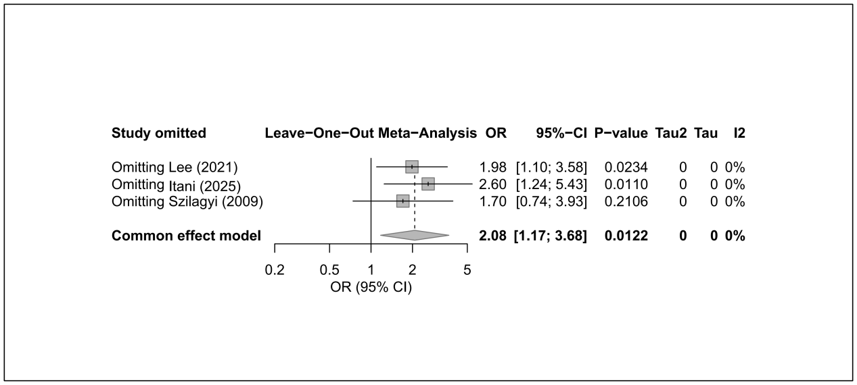
11.12 Hypoalbuminemia
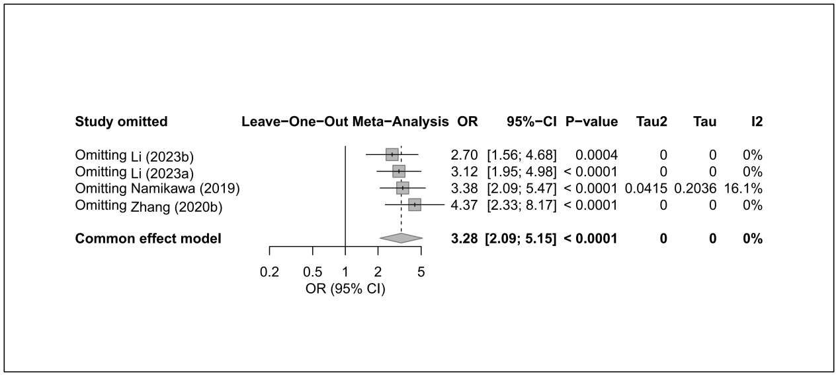

11.13 ICU admission
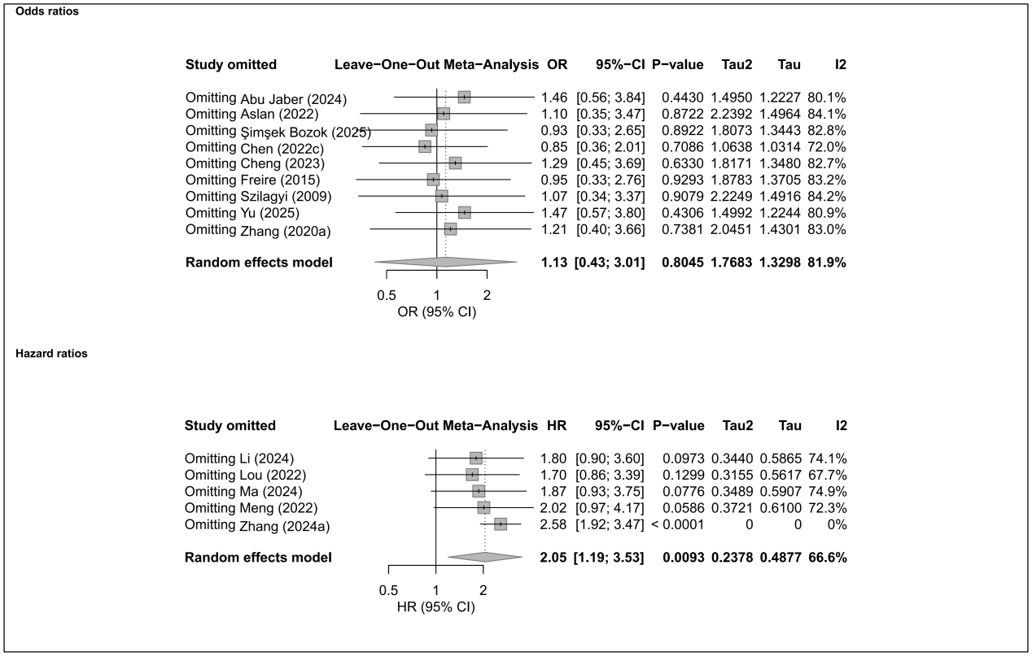

11.14 Inappropriate empirical therapy
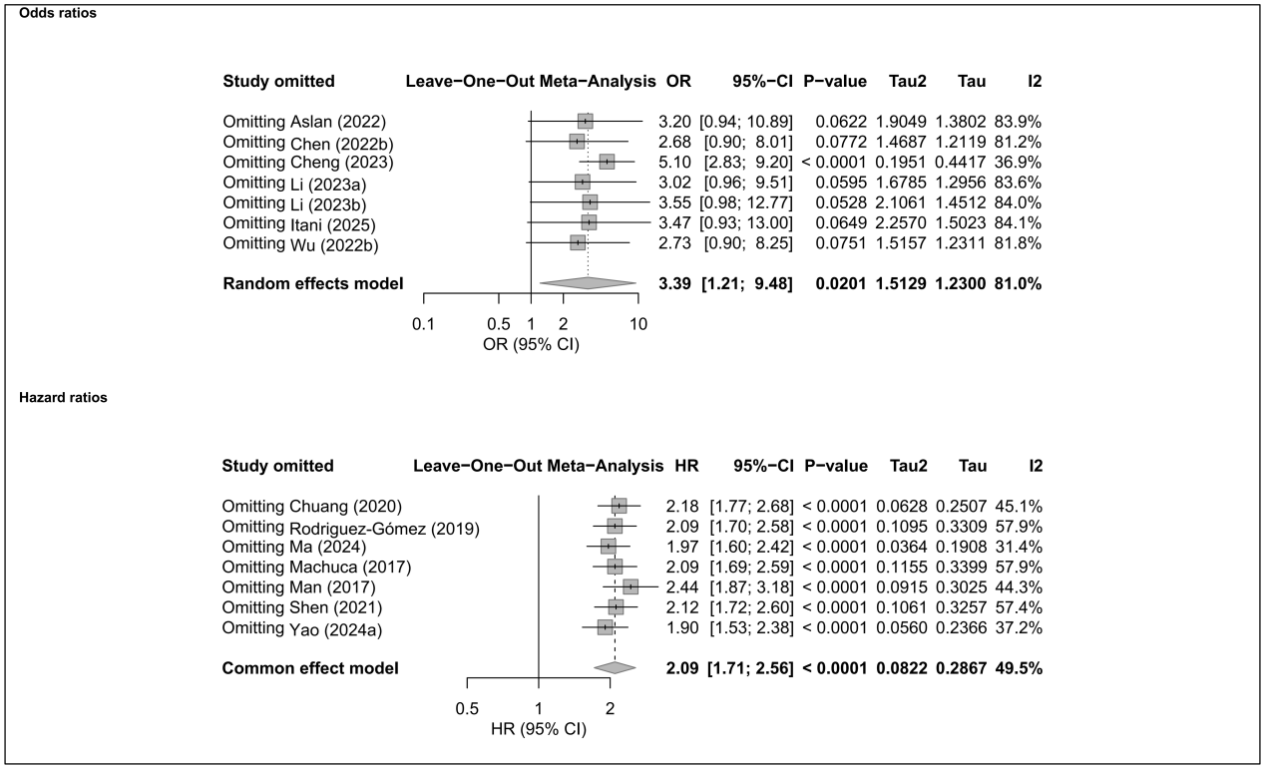

11.15 Liver disease
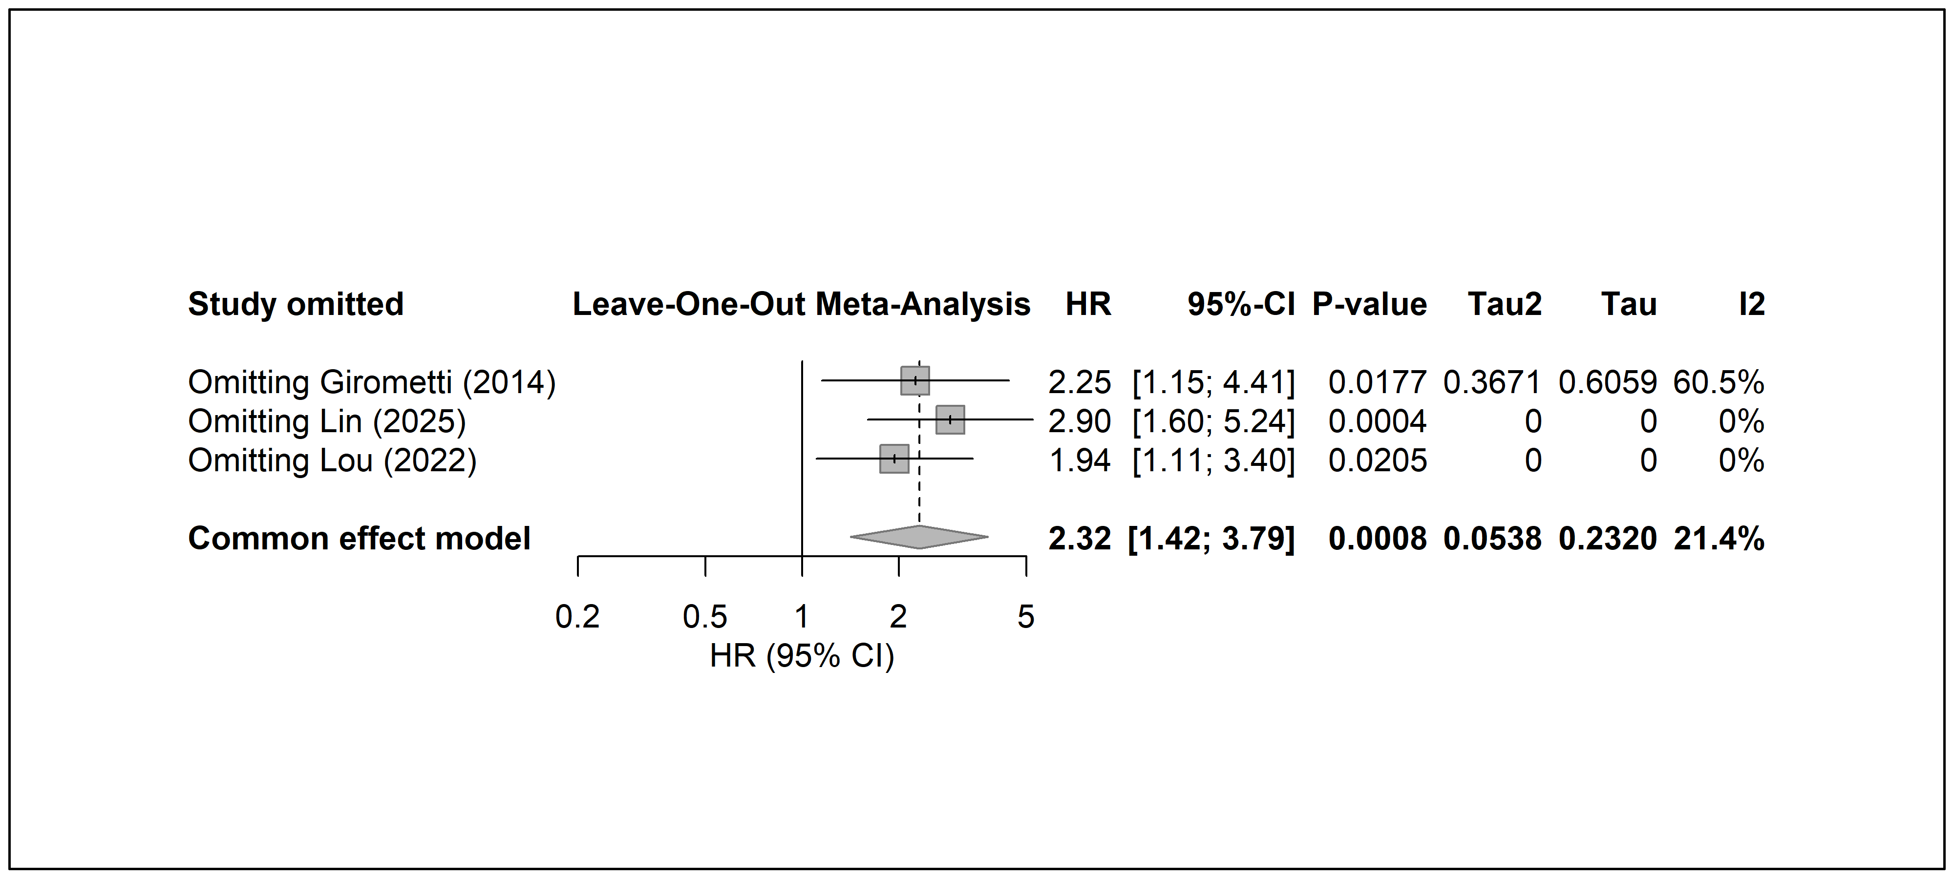

11.16 Male
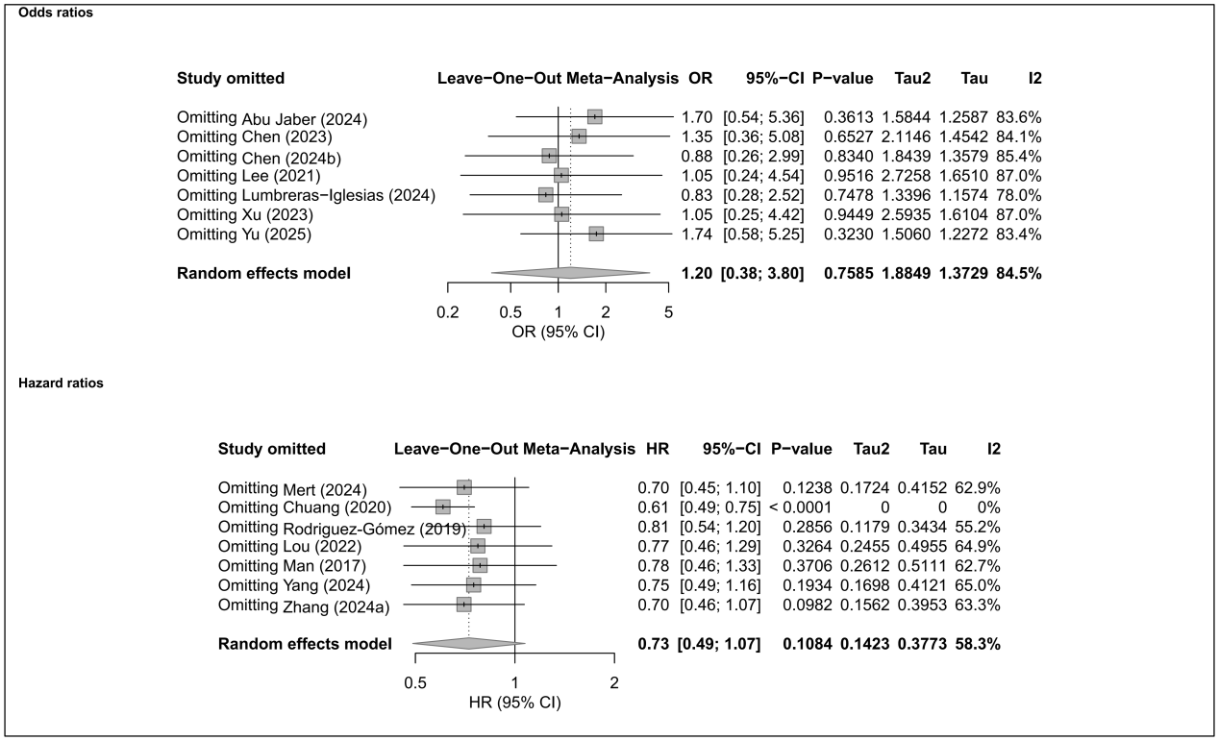

11.17 Malignancy
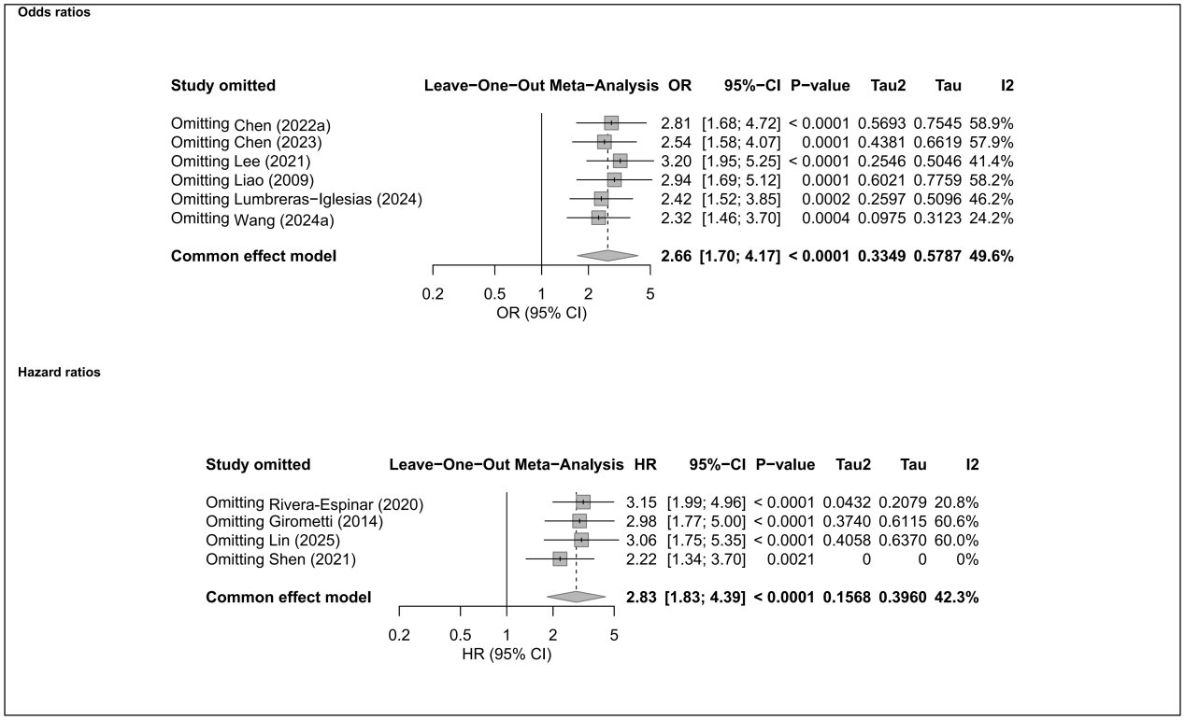

11.18 Mechanical ventilation
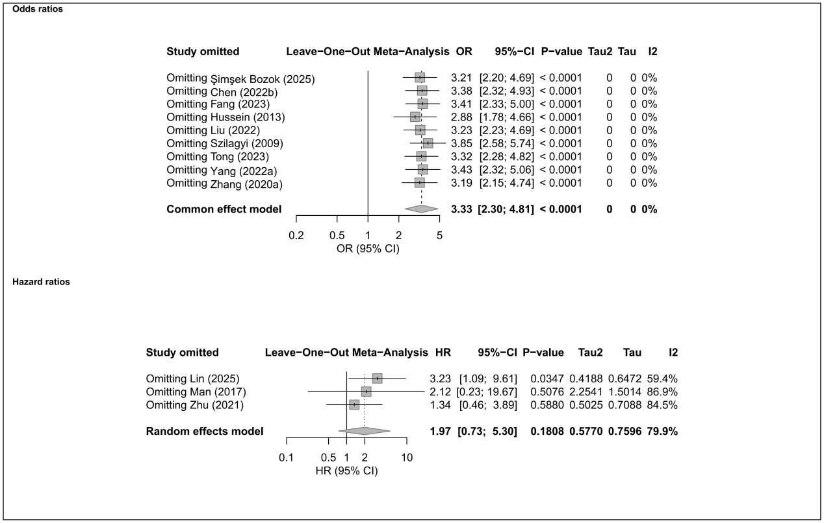

11.19 Nosocomial infection
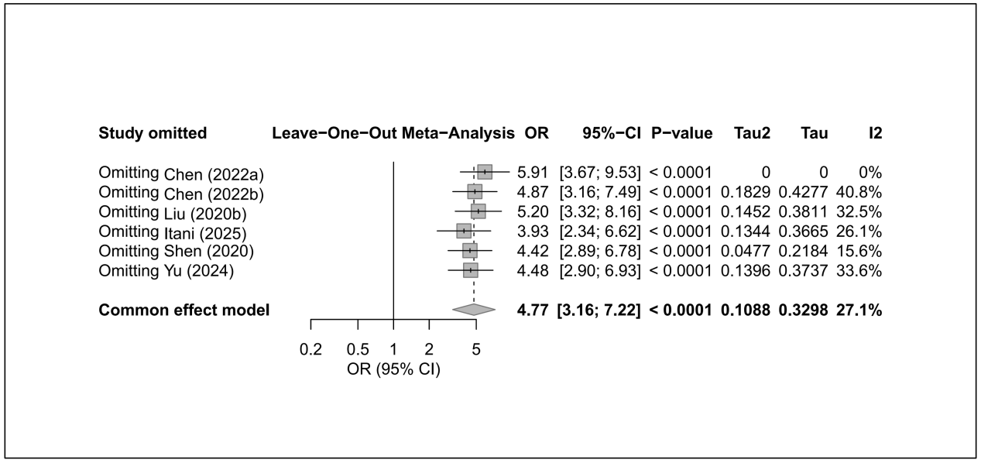

11.20 Pitt bacteremia score
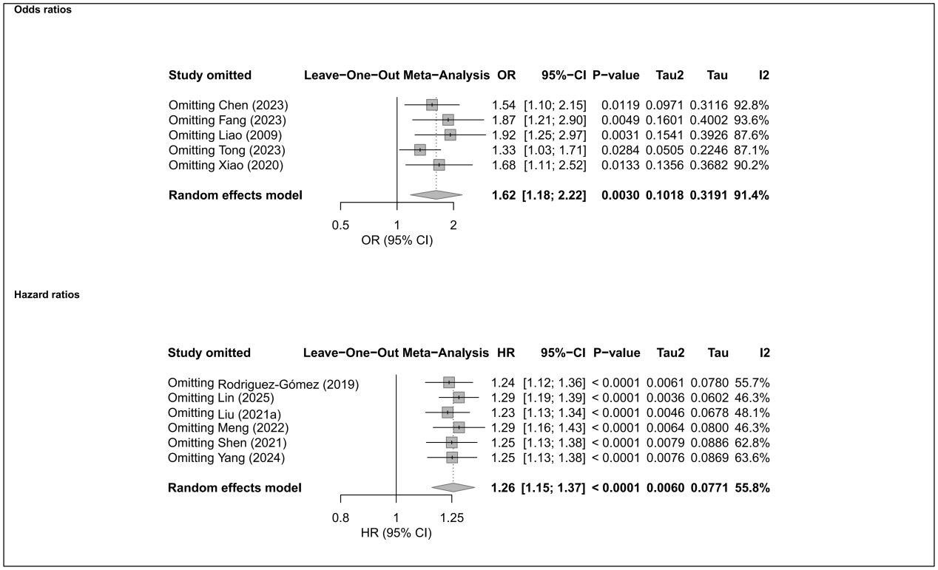

11.21 Renal disease
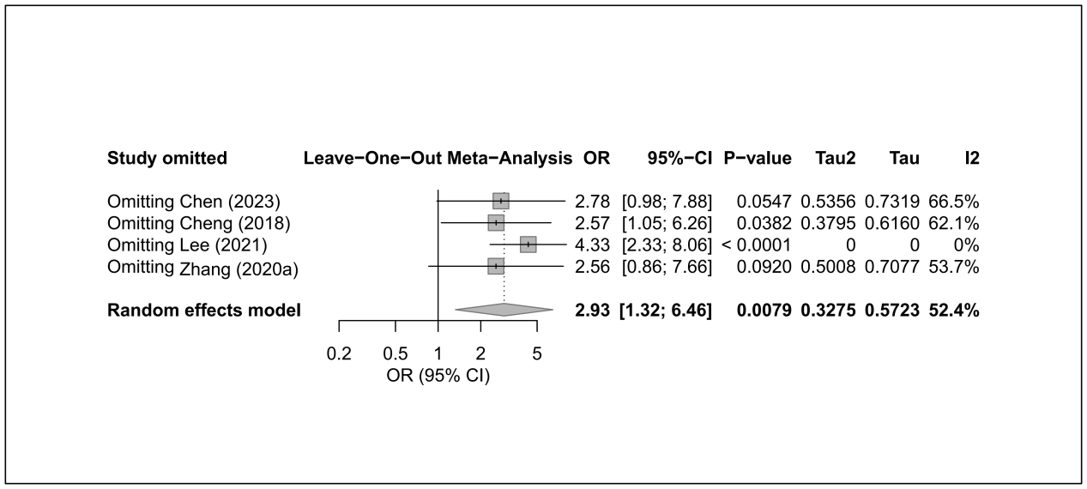

11.22 Respiratory disease
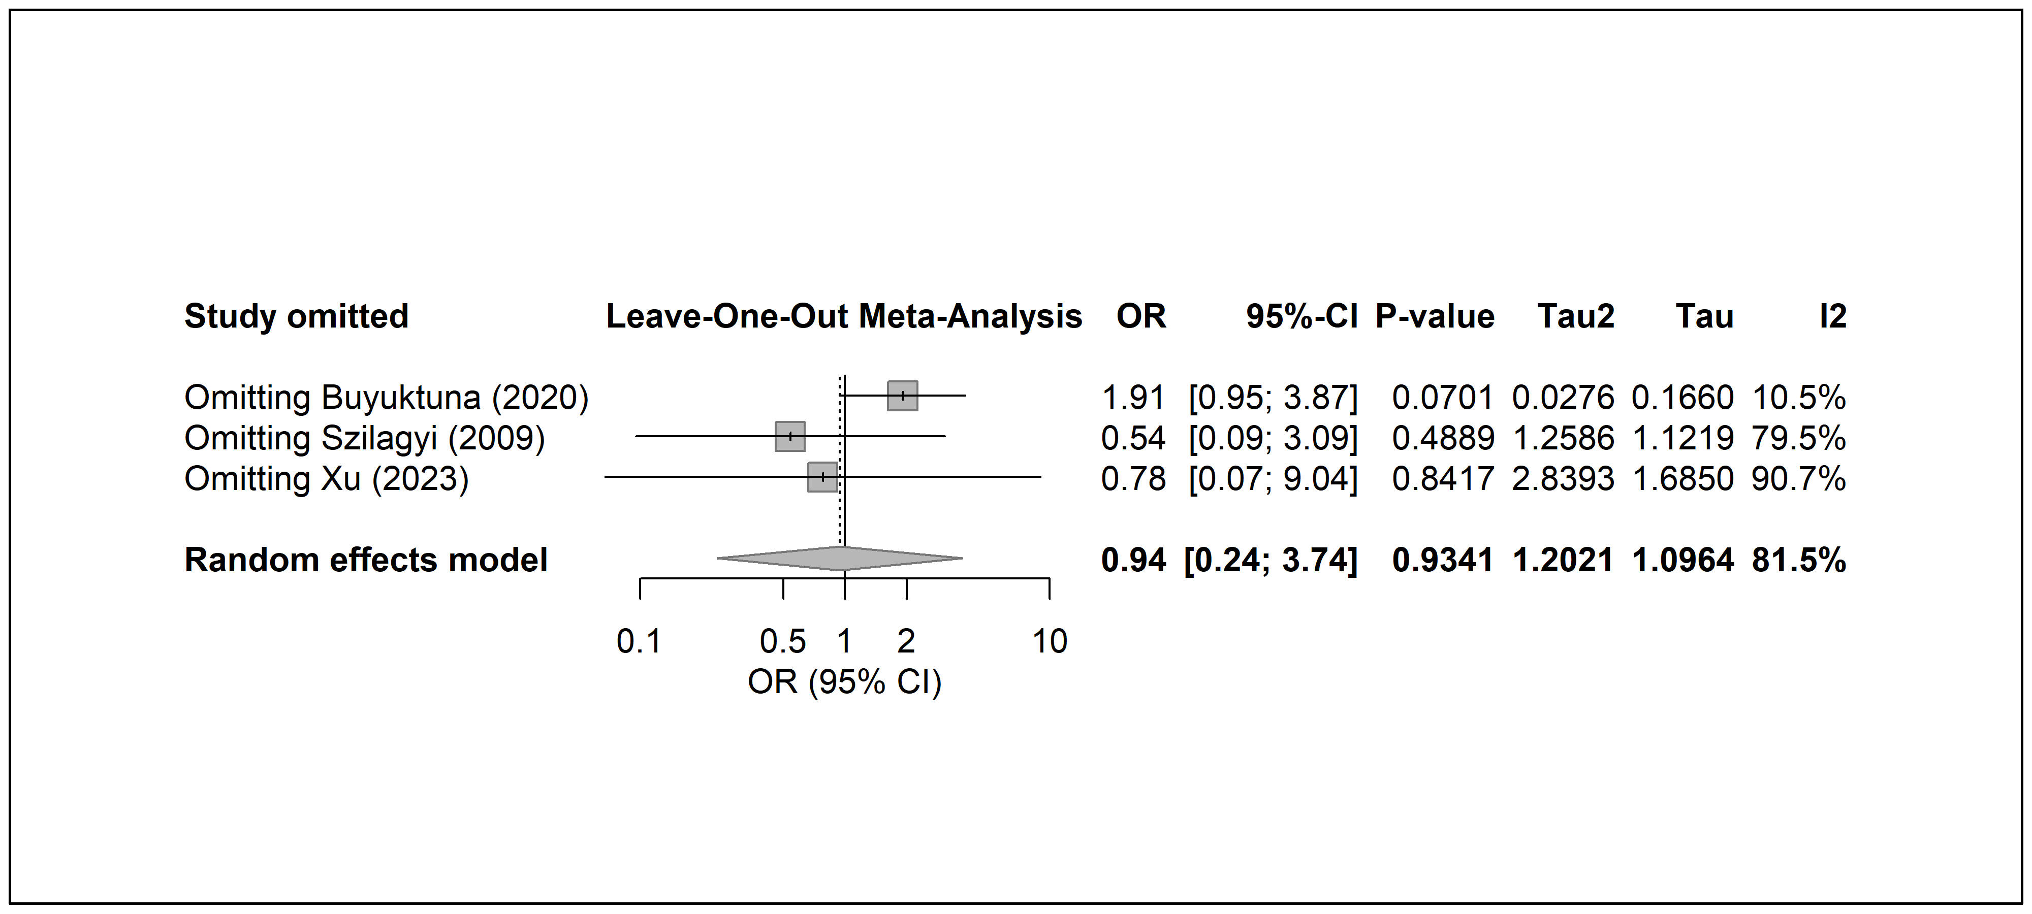

11.23 Respiratory failure
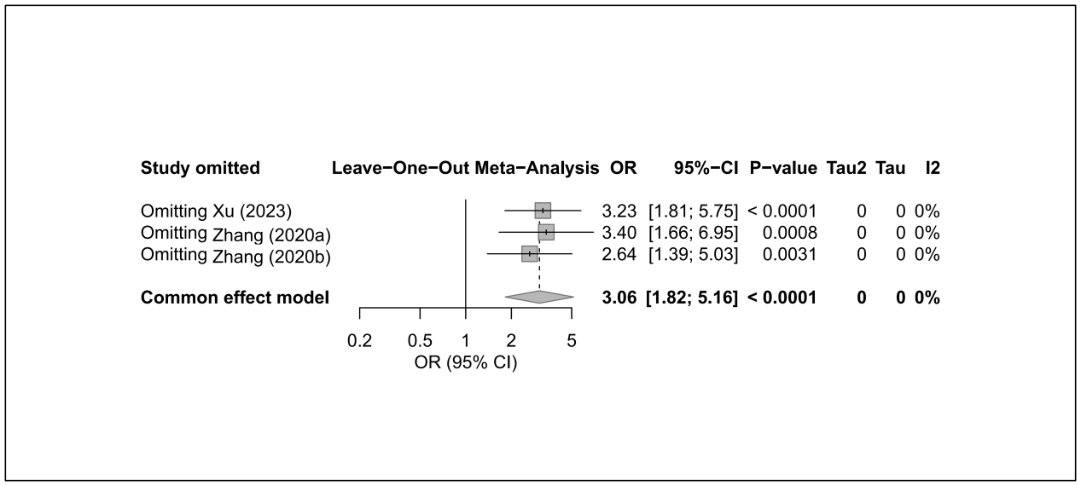

11.24 Respiratory tract infection
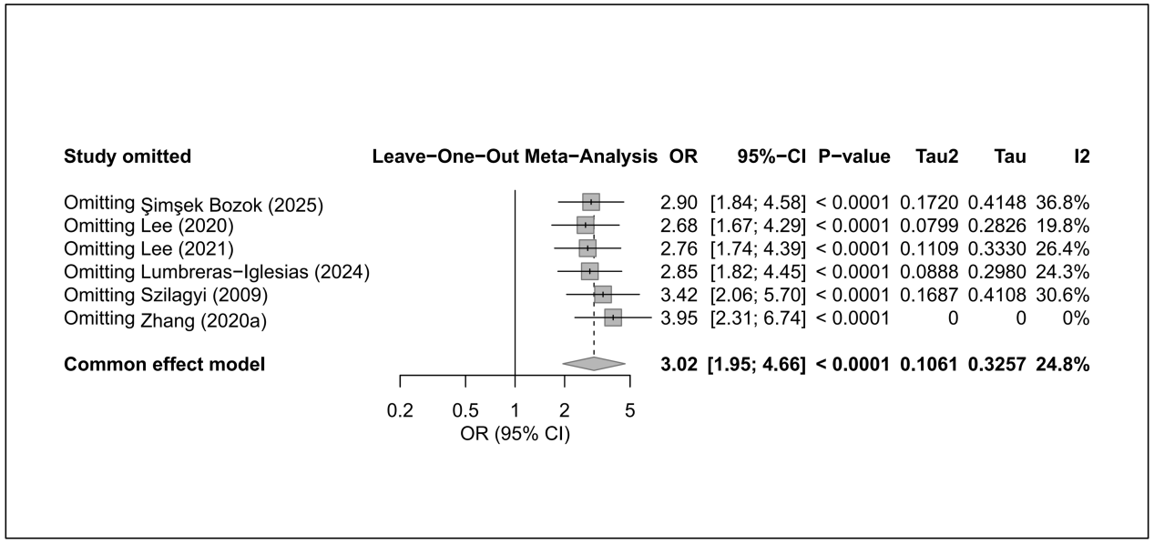

11.25 Septic shock
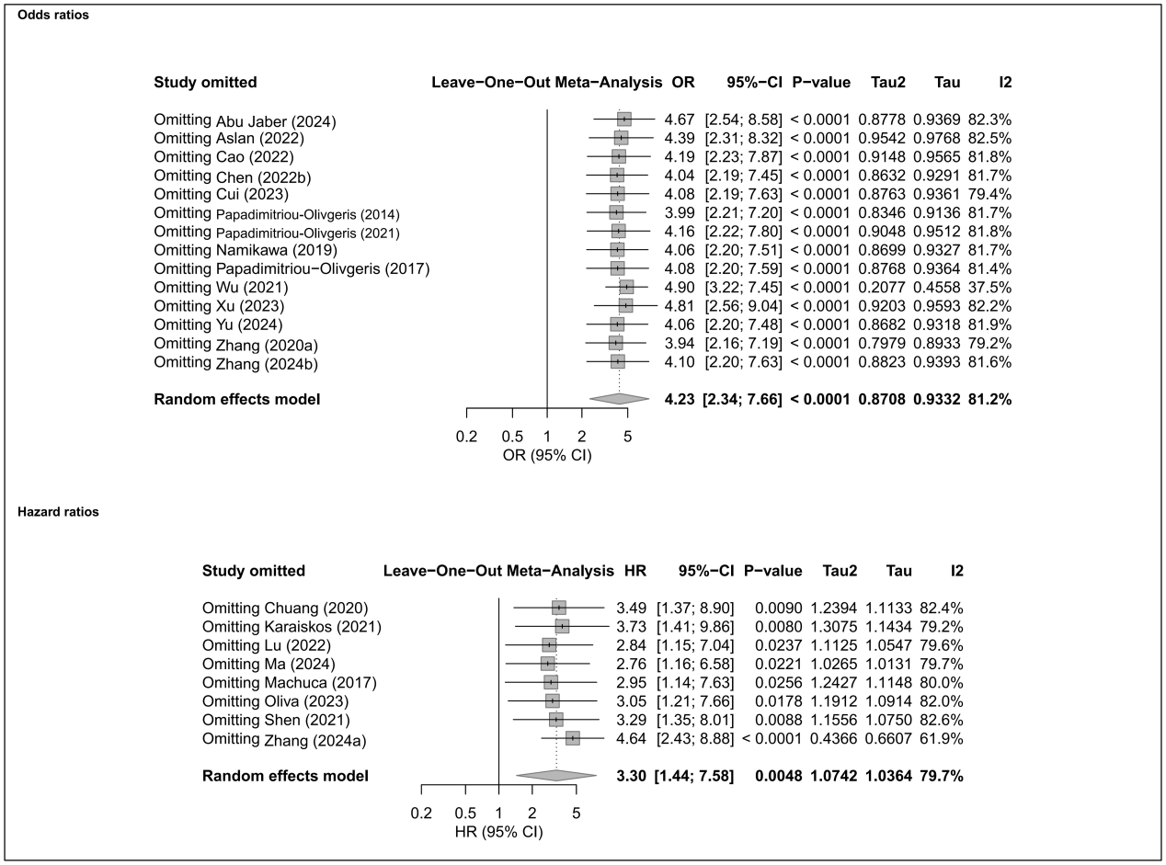

11.26 SOFA
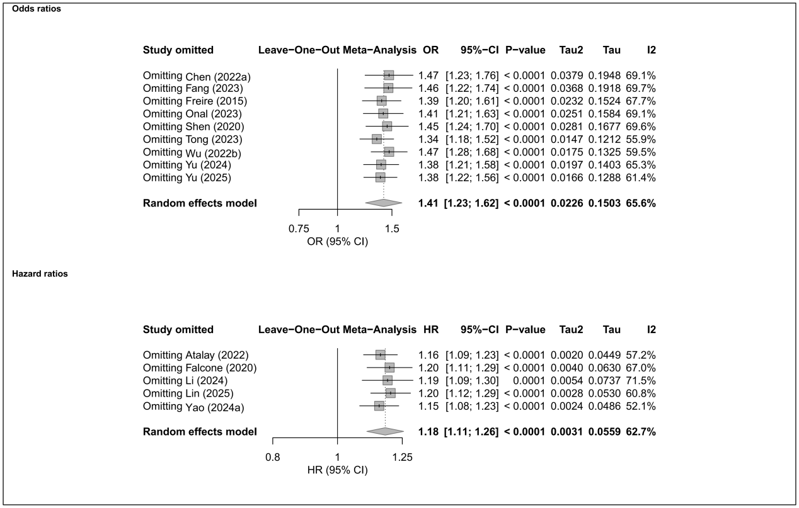

Supplemental Figure S12. Sensitivity analysis of in-hospital mortality by omitting individual study
12.1 Age
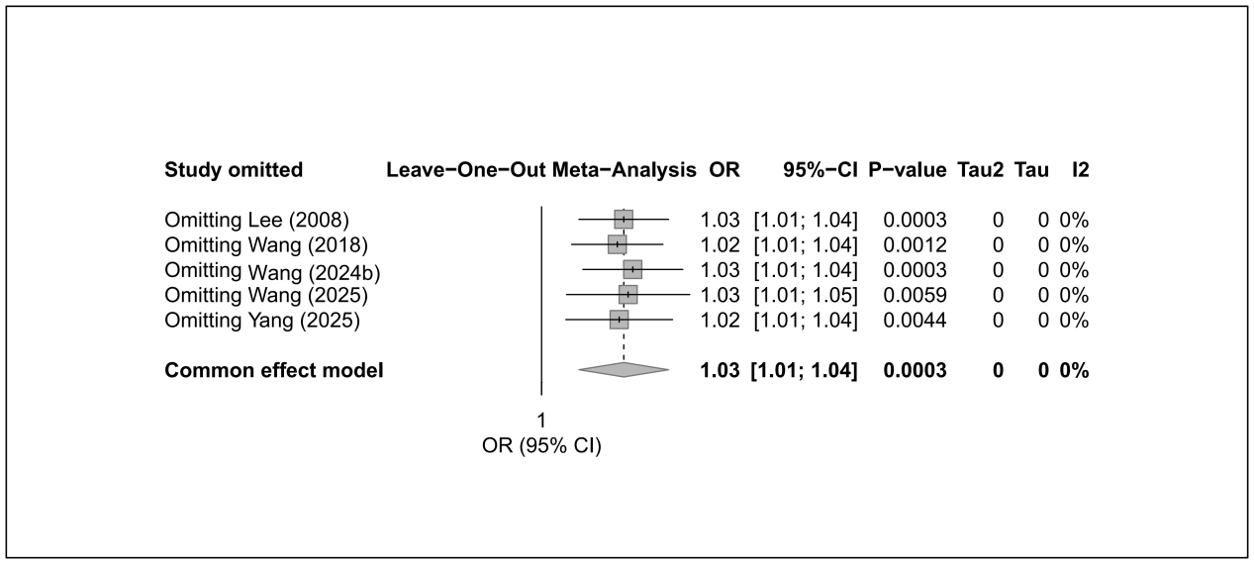

12.2 APACHE II
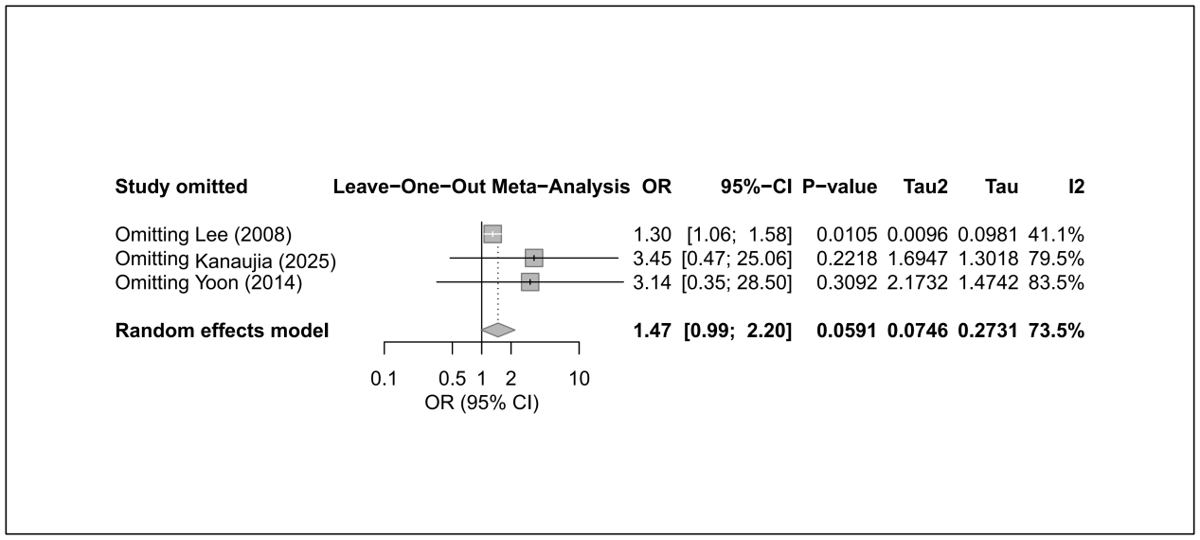

12.3 Cardiovascular disease
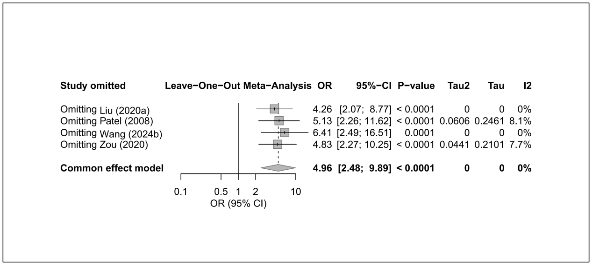

12.4 Catheter presence
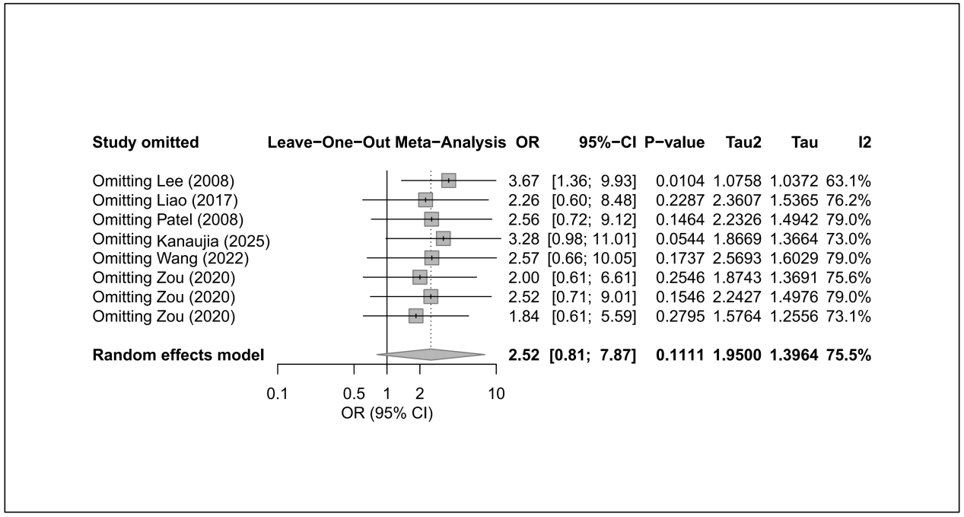

12.5 Charlson Comorbidity Index
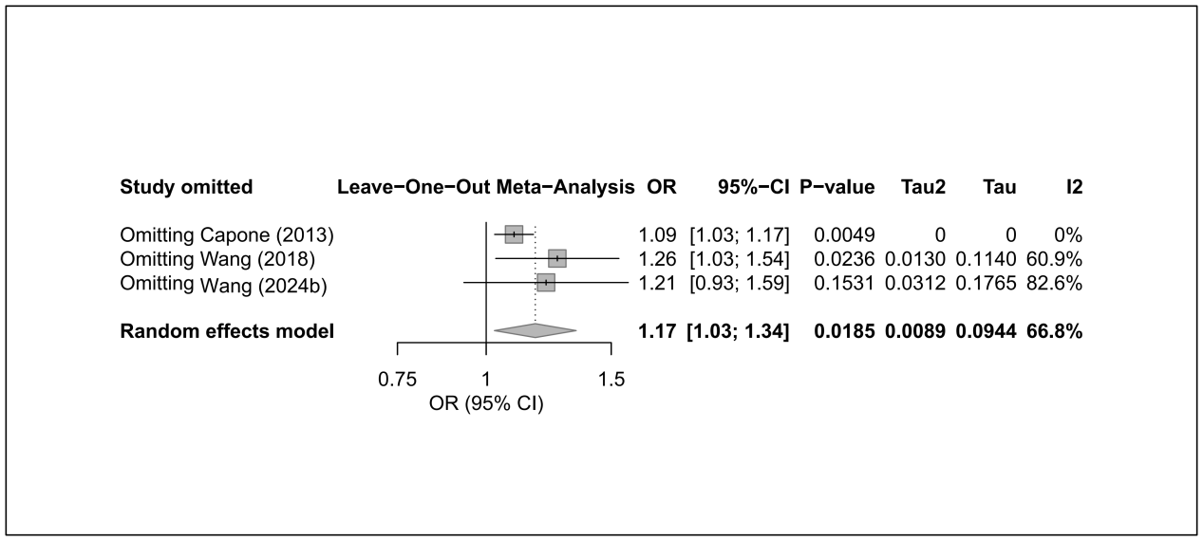

12.6 CRKP
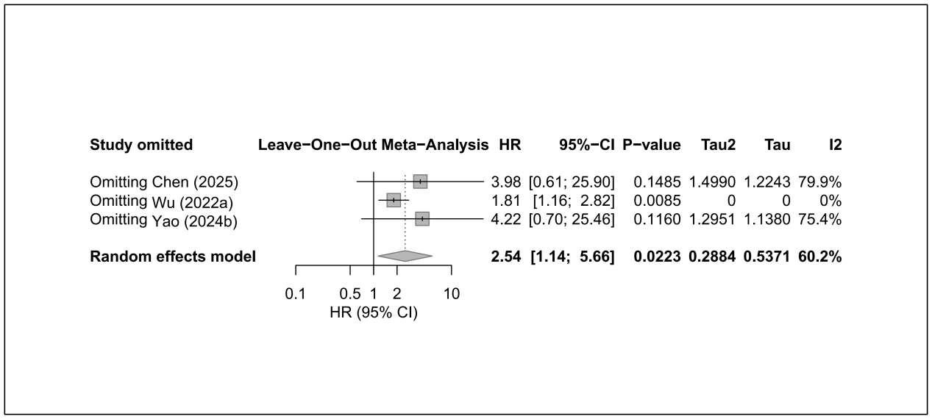

12.7 ICU admission
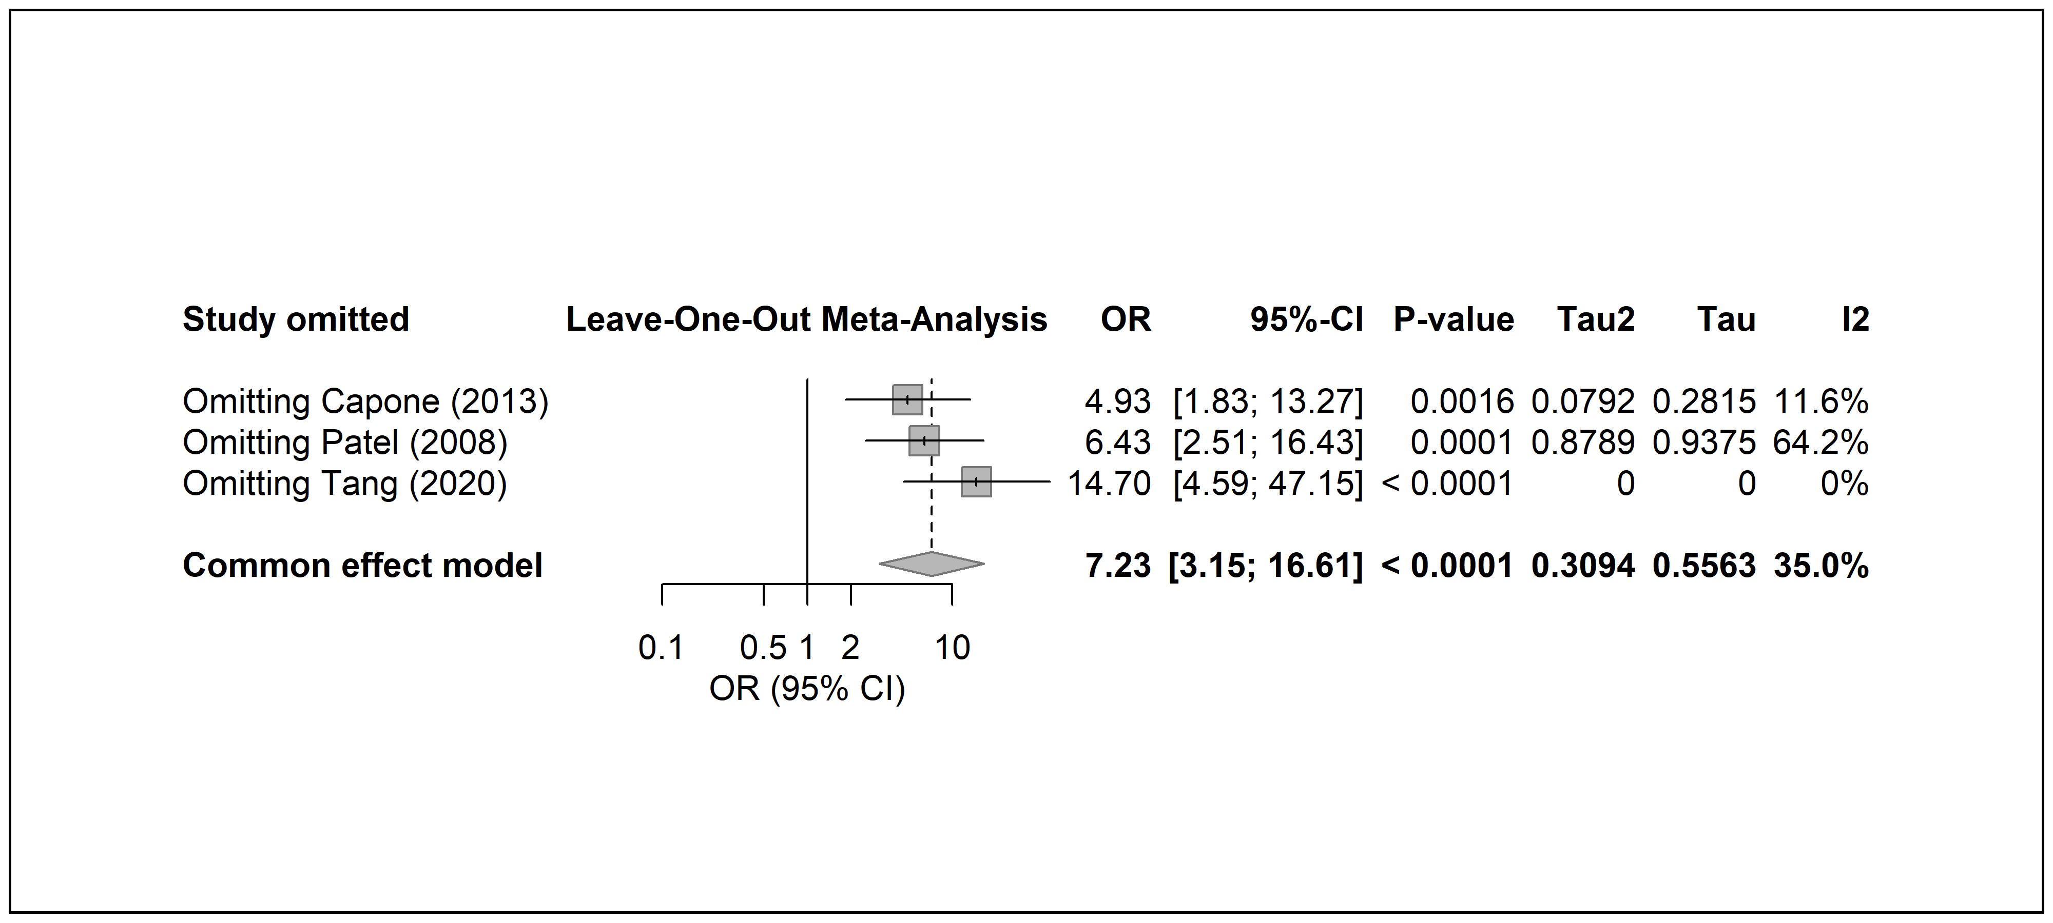

12.8 Liver disease
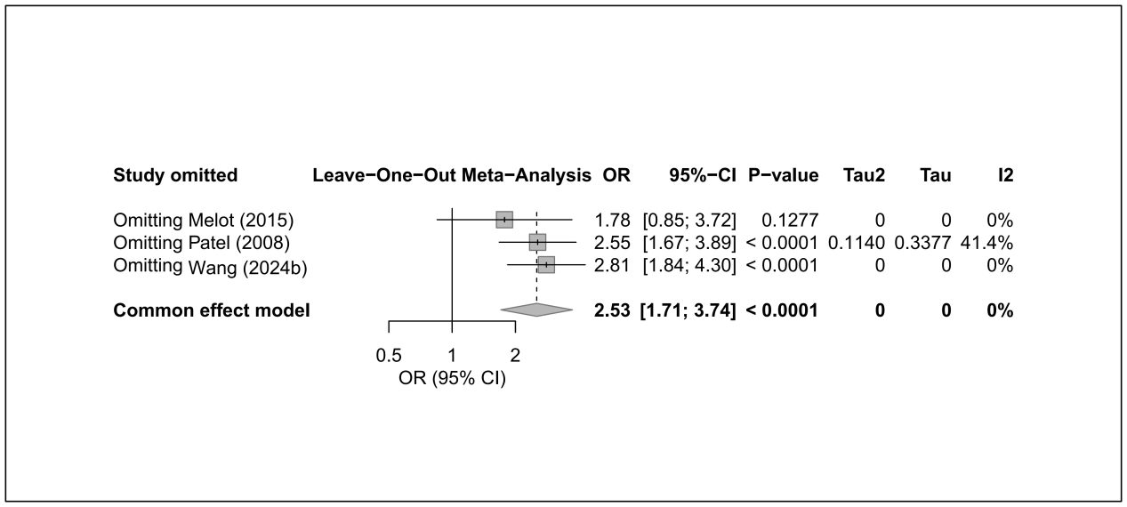

12.9 Mechanical ventilation
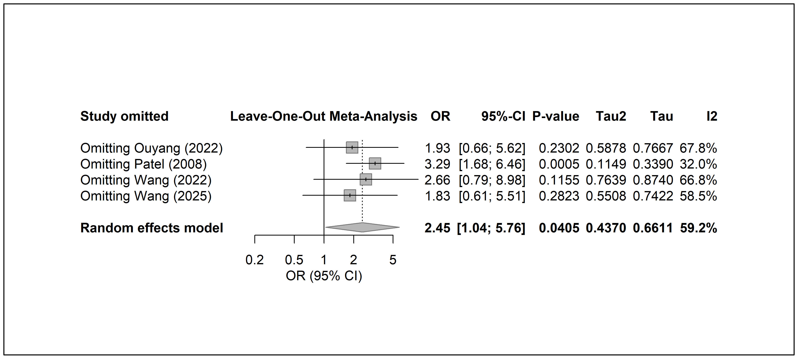

12.10 Renal disease
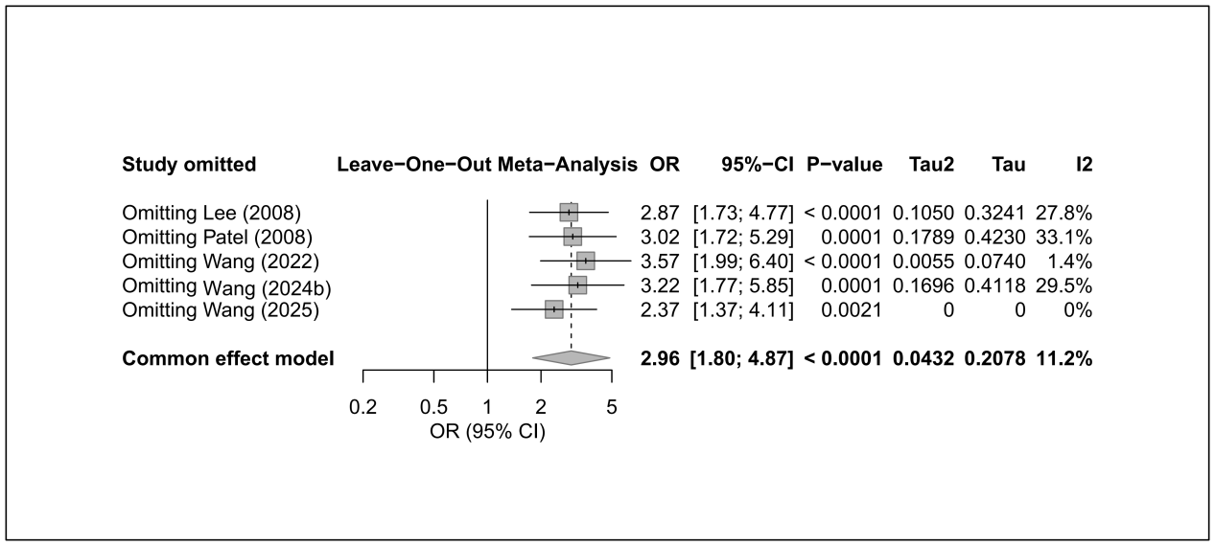

12.11 Respiratory disease
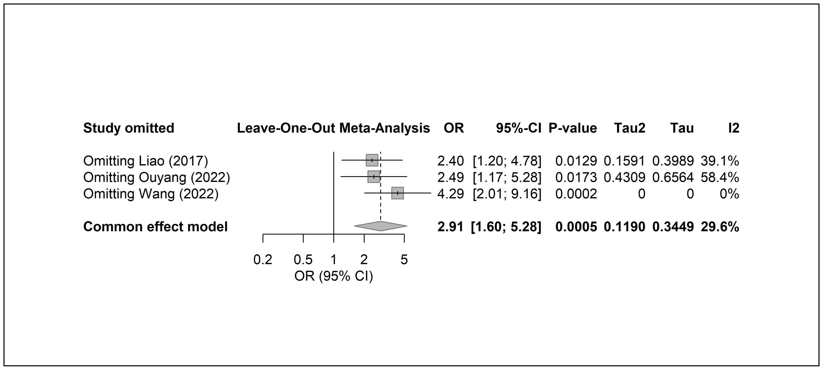

12.12 Sepsis/septic shock
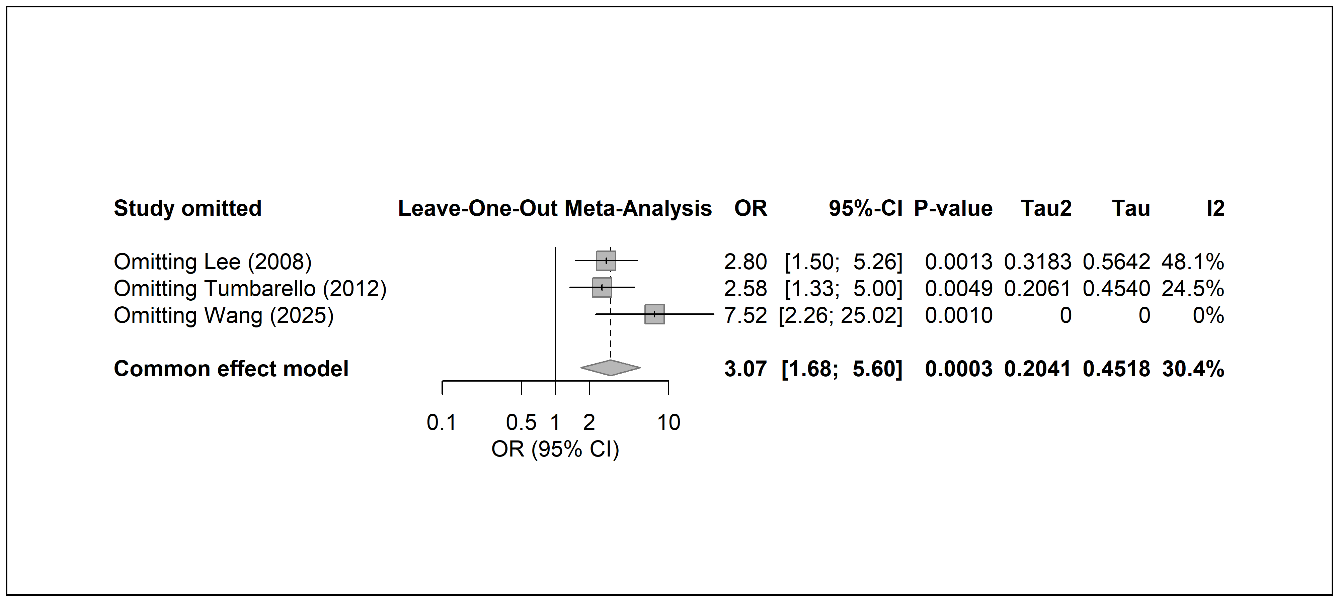

Supplemental Figure S13. Sensitivity analysis of 14/15-day mortality by omitting individual study
13.1 Charlson Comorbidity Index
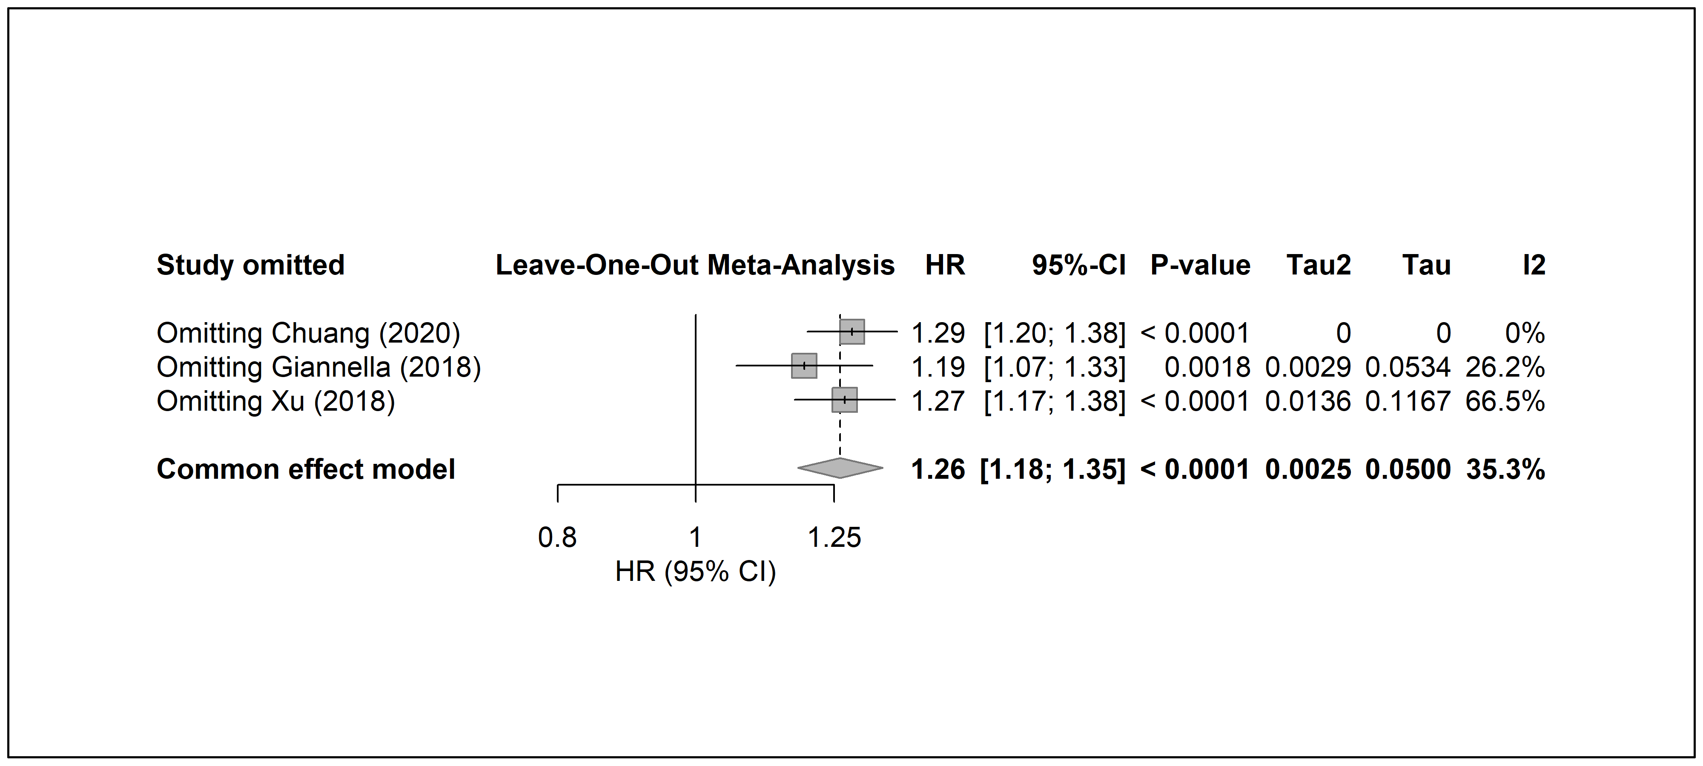

13.2 Septic shock
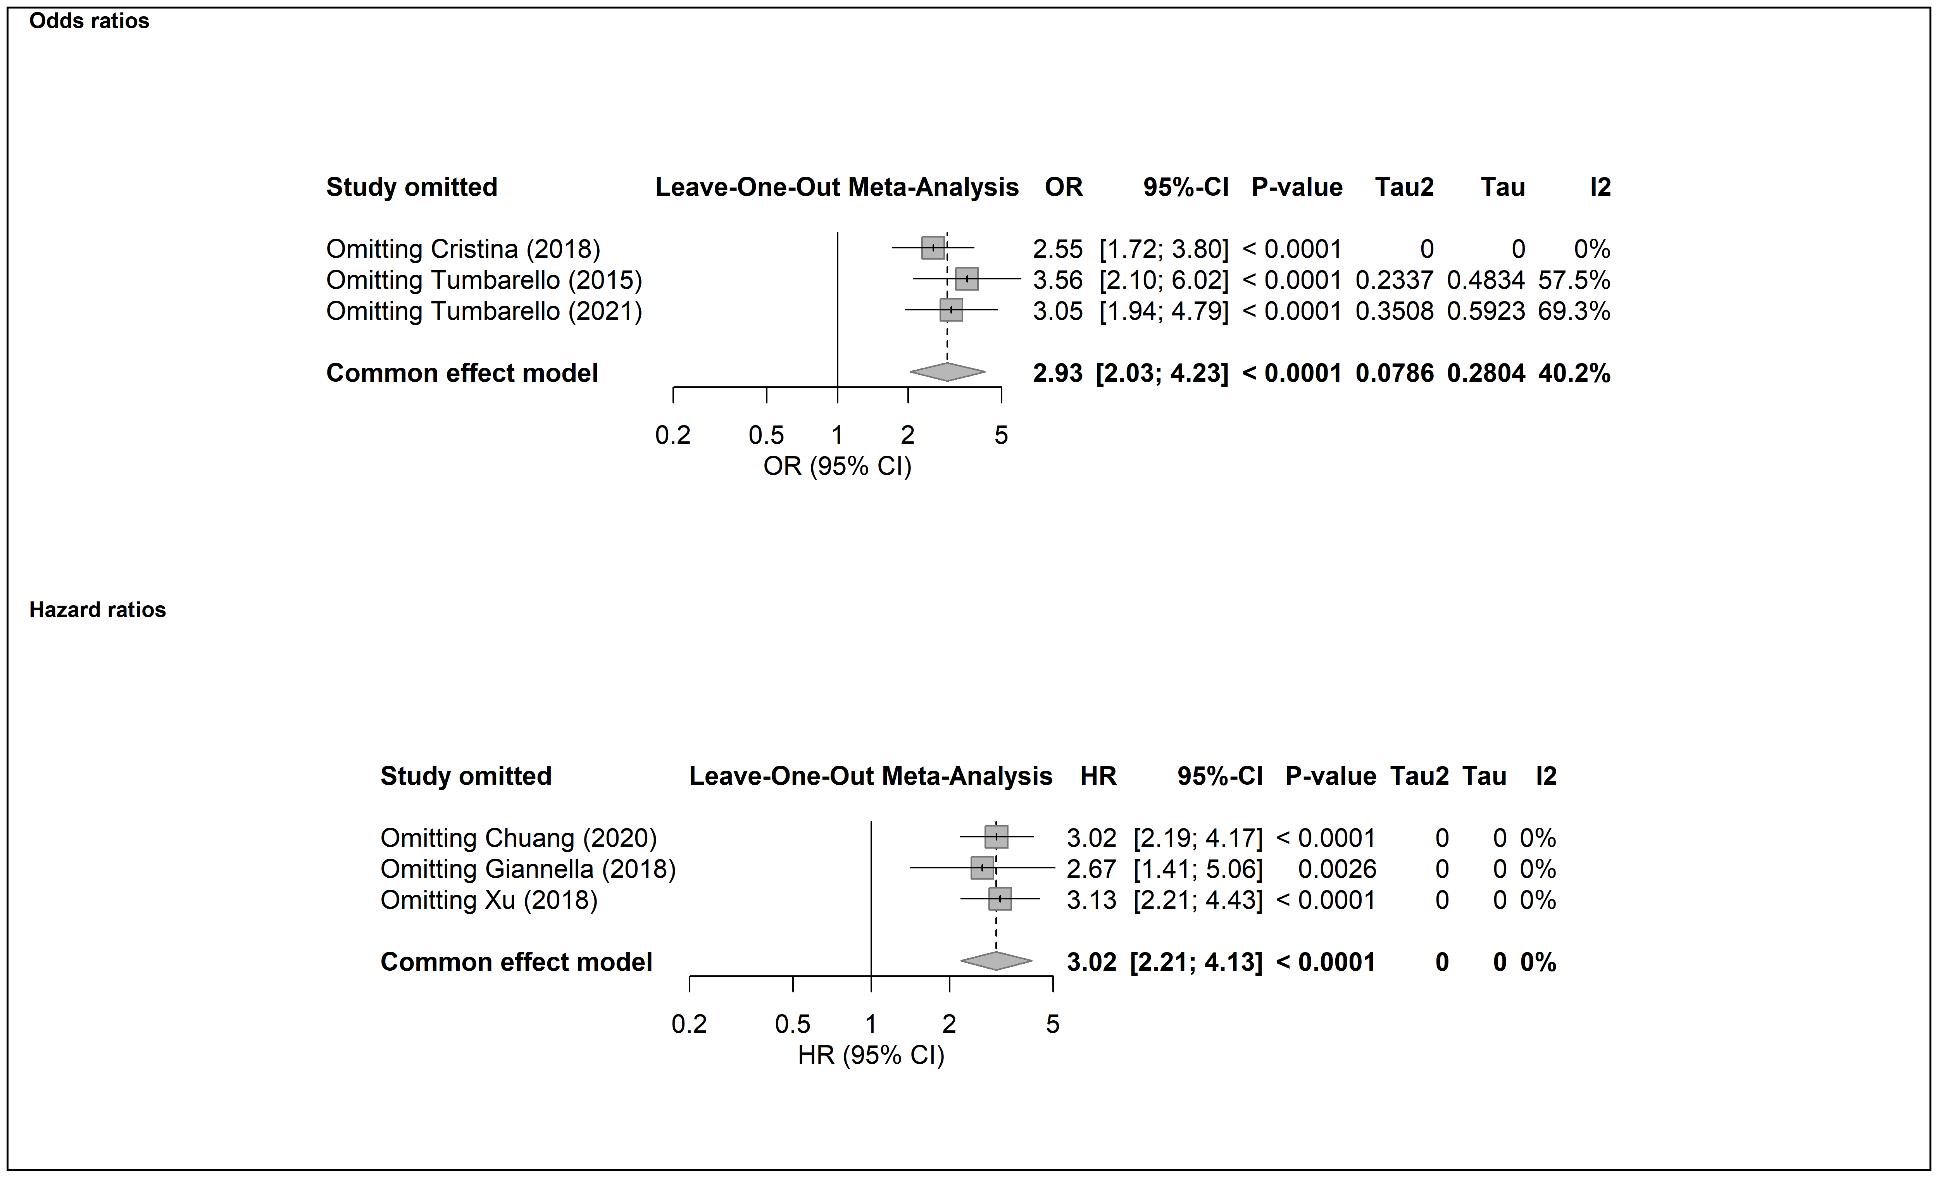

Supplemental Figure S14. Sensitivity analysis of 90-day mortality by omitting individual study
14.1 CRKP
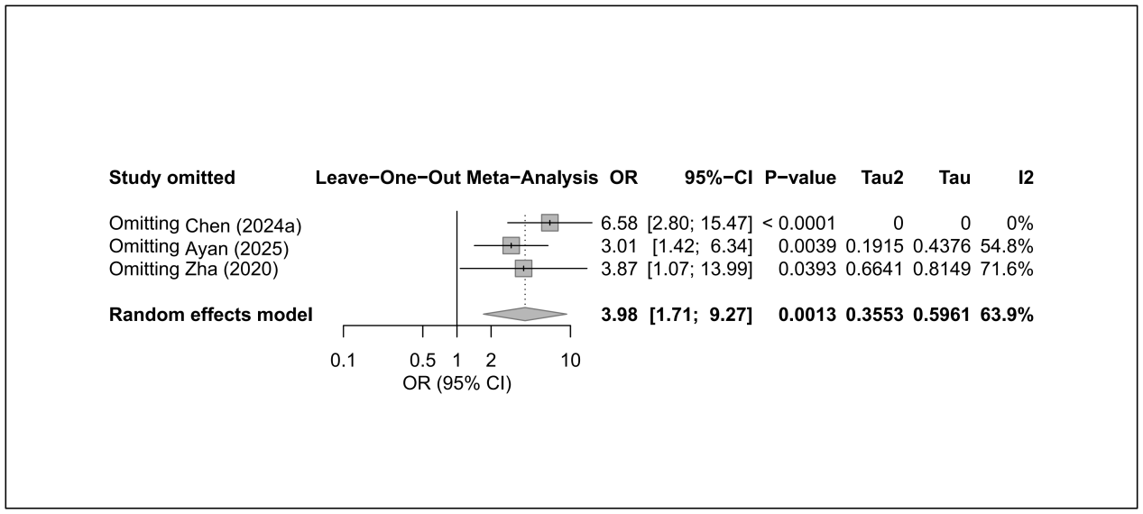
Supplemental Figure S15. Funnel plots for 28/30-day mortality
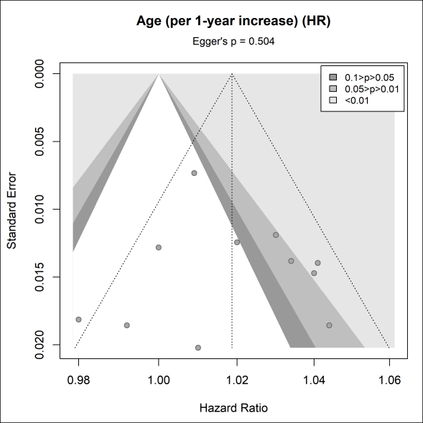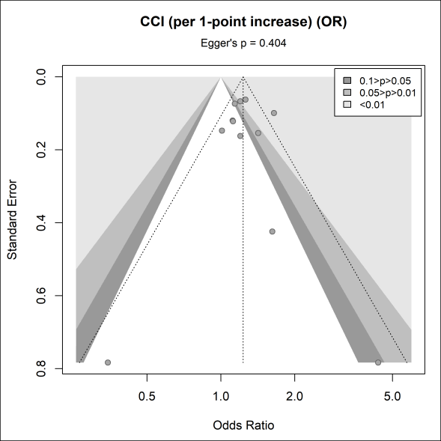
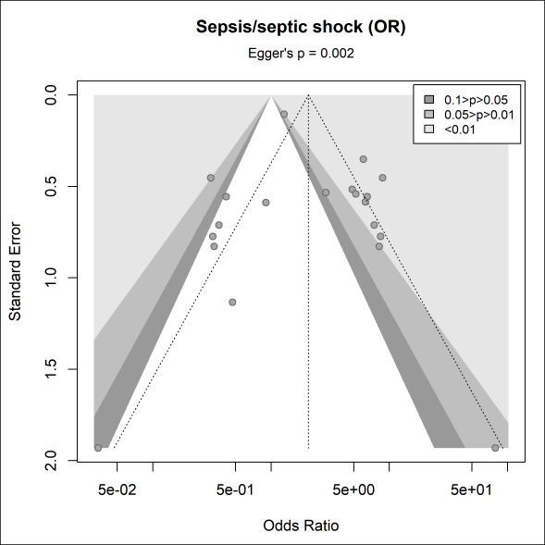

Text S2 References of all included studies.
1. Anderson DJ, Engemann JJ, Harrell LJ, Carmeli Y, Reller LB, Kaye KS. Predictors of mortality in patients with bloodstream infection due to ceftazidime-resistant Klebsiella pneumoniae. Antimicrobial Agents and Chemotherapy. 2006;50(5):1715-20.
2. Lee SS-J, Chen Y-S, Tsai H-C, Wann S-R, Lin H-H, Huang C-K, et al. Predictors of septic metastatic infection and mortality among patients with Klebsiella pneumoniae liver abscess. Clinical Infectious Diseases. 2008;47(5):642-50.
3. Patel G, Huprikar S, Factor SH, Jenkins SG, Calfee DP. Outcomes of carbapenem-resistant Klebsiella pneumoniae infection and the impact of antimicrobial and adjunctive therapies. Infection control and hospital epidemiology. 2008;29(12):1099-106.
4. Liao CH, Lai CC, Hsu MS, Huang YT, Chu FY, Hsu HS, et al. Correlation between time to positivity of blood cultures with clinical presentation and outcomes in patients with Klebsiella pneumoniae bacteraemia: Prospective cohort study. Clinical Microbiology and Infection. 2009;15(12):1119-25.
5. Szilágyi E, Füzi M, Böröcz K, Kurcz A, Tóth A, Nagy K. Risk factors and outcomes for bloodstream infections with extended-spectrum beta -lactamase-producing Klebsiella pneumoniae ; Findings of the nosocomial surveillance system in Hungary. Acta microbiologica et immunologica Hungarica. 2009;56(3):251-62.
6. Tumbarello M, Viale P, Viscoli C, Trecarichi EM, Tumietto F, Marchese A, et al. Predictors of mortality in bloodstream infections caused by Klebsiella pneumoniae carbapenemase-producing K. pneumoniae: Importance of combination therapy. Clinical Infectious Diseases. 2012;55(7):943-50.
7. Capone A, Giannella M, Fortini D, Giordano A, Meledandri M, Ballardini M, et al. High rate of colistin resistance among patients with carbapenem-resistant Klebsiella pneumoniae infection accounts for an excess of mortality. Clinical Microbiology and Infection. 2013;19(1):E23-E30.
8. Hussein K, Raz-Pasteur A, Finkelstein R, Neuberger A, Shachor-Meyouhas Y, Oren I, et al. Impact of carbapenem resistance on the outcome of patients' hospital-acquired bacteraemia caused by Klebsiella pneumoniae. Journal of Hospital Infection. 2013;83(4):307-13.
9. Girometti N, Lewis RE, Giannella M, Ambretti S, Bartoletti M, Tedeschi S, et al. Klebsiella pneumoniae bloodstream infection epidemiology and impact of inappropriate empirical therapy. Medicine (United States). 2014;93(17):298-308.
10. Papadimitriou-Olivgeris M, Marangos M, Christofidou M, Fligou F, Bartzavali C, Panteli ES, et al. Risk factors for infection and predictors of mortality among patients with KPC-producing Klebsiella pneumoniae bloodstream infections in the intensive care unit. Scandinavian journal of infectious diseases. 2014;46(9):642-8.
11. Yoon JH, Kim YJ, Jun YH, Kim SI, Kang JY, Suk KT, et al. Liver abscess due to Klebsiella pneumoniae: Risk factors for metastatic infection. Scandinavian Journal of Infectious Diseases. 2014;46(1):21-6.
12. Freire MP, Pierrotti LC, Filho HHC, Ibrahim KY, Magri ASGK, Bonazzi PR, et al. Infection with Klebsiella pneumoniae carbapenemase (KPC)-producing Klebsiella pneumoniae in cancer patients. European Journal of Clinical Microbiology and Infectious Diseases. 2015;34(2):277-86.
13. Gonzalez-Padilla M, Torre-Cisneros J, Rivera-Espinar F, Pontes-Moreno A, Lopez-Cerero L, Pascual A, et al. Gentamicin therapy for sepsis due to carbapenem-resistant and colistin-resistant Klebsiella pneumoniae. Journal of Antimicrobial Chemotherapy. 2015;70(3):905-13.
14. Melot B, Colot J, Guerrier G. Bacteremic community-acquired infections due to Klebsiella pneumoniae: clinical and microbiological presentation in New Caledonia, 2008-2013. International Journal of Infectious Diseases. 2015;41:29-31.
15. Tumbarello M, Trecarichi EM, De Rosa FG, Giannella M, Giacobbe DR, Bassetti M, et al. Infections caused by KPC-producing Klebsiella pneumoniae: Differences in therapy and mortality in a multicentre study. Journal of Antimicrobial Chemotherapy. 2015;70(7):2133-43.
16. Vardakas KZ, Matthaiou DK, Falagas ME, Antypa E, Koteli A, Antoniadou E. Characteristics, risk factors and outcomes of carbapenem-resistant Klebsiella pneumoniae infections in the intensive care unit. Journal of Infection. 2015;70(6):592-9.
17. Falcone M, Russo A, Iacovelli A, Restuccia G, Ceccarelli G, Giordano A, et al. Predictors of outcome in ICU patients with septic shock caused by Klebsiella pneumoniae carbapenemase-producing K. pneumoniae. Clinical Microbiology and Infection. 2016;22(5):444-50.
18. Gomez-Simmonds A, Nelson B, Eiras DP, Loo A, Jenkins SG, Whittier S, et al. Combination regimens for treatment of carbapenem-resistant Klebsiella pneumoniae bloodstream infections. Antimicrobial Agents and Chemotherapy. 2016;60(6):3601-7.
19. Trecarichi EM, Pagano L, Martino B, Candoni A, Di Blasi R, Nadali G, et al. Bloodstream infections caused by Klebsiella pneumoniae in onco-hematological patients: clinical impact of carbapenem resistance in a multicentre prospective survey. American Journal of Hematology. 2016;91(11):1076-81.
20. Liao Y, Hu G-H, Xu Y-F, Che J-P, Luo M, Zhang H-M, et al. Retrospective analysis of fosfomycin combinational therapy for sepsis caused by carbapenem-resistant Klebsiella pneumoniae. Experimental and therapeutic medicine. 2017;13(3):1003-10.
21. Machuca I, Gutiérrez-Gutiérrez B, Gracia-Ahufinger I, Rivera Espinar F, Cano Á, Guzmán-Puche J, et al. Mortality associated with bacteremia due to colistin-resistant Klebsiella pneumoniae with high-level meropenem resistance: Importance of combination therapy without colistin and carbapenems. Antimicrobial agents and chemotherapy. 2017;61(8).
22. Man MY, Shum HP, Chan YH, Chan KC, Yan WW, Lee RA, et al. Clinical predictors and outcomes of Klebsiella pneumoniae bacteraemia in a regional hospital in Hong Kong. Journal of Hospital Infection. 2017;97(1):35-41.
23. Papadimitriou-Olivgeris M, Fligou F, Bartzavali C, Zotou A, Spyropoulou A, Koutsileou K, et al. Carbapenemase-producing Klebsiella pneumoniae bloodstream infection in critically ill patients: risk factors and predictors of mortality. European Journal of Clinical Microbiology and Infectious Diseases. 2017;36(7):1125-31.
24. Cheng Q, Shen N, Zheng J, He B. Analysis of mortality-related factors in pneumonia patients with carbapenem-resistant Klebsiella pneumoniae infection. The Chinese Journal of Clinical Pharmacology. 2018;34(14):1703-6.
25. Cristina ML, Alicino C, Sartini M, Faccio V, Spagnolo AM, Bono VD, et al. Epidemiology, management, and outcome of carbapenem-resistant Klebsiella pneumoniae bloodstream infections in hospitals within the same endemic metropolitan area. Journal of infection and public health. 2018;11(2):171-7.
26. Giannella M, Trecarichi EM, Giacobbe DR, De Rosa FG, Bassetti M, Bartoloni A, et al. Effect of combination therapy containing a high-dose carbapenem on mortality in patients with carbapenem-resistant Klebsiella pneumoniae bloodstream infection. International journal of antimicrobial agents. 2018;51(2):244-8.
27. Su C-F, Chuang C, Lin Y-T, Chan Y-J, Lin J-C, Lu P-L, et al. Treatment outcome of non-carbapenemase-producing carbapenem-resistant Klebsiella pneumoniae infections: a multicenter study in Taiwan. European Journal of Clinical Microbiology & Infectious Diseases. 2018;37(4):651-9.
28. Wang Z, Qin RR, Huang L, Sun LY. Risk Factors for Carbapenem-resistant Klebsiella pneumoniae Infection and Mortality of Klebsiella pneumoniae Infection. Chinese Medical Journal. 2018;131(1):56-62.
29. Xu M, Fu Y, Kong H, Chen X, Chen Y, Li L, et al. Bloodstream infections caused by Klebsiella pneumoniae: Prevalence of bla KPC, virulence factors and their impacts on clinical outcome. BMC infectious diseases. 2018;18(1).
30. Rodriguez-Gómez J, Pérez-Nadales E, Gutiérrez-Gutiérrez B, Machuca I, Martinez-Martinez L, Rivera F, et al. Prognosis of urinary tract infection caused by KPC-producing Klebsiella pneumoniae: The impact of inappropriate empirical treatment. Journal of Infection. 2019;79(3):245-52.
31. Namikawa H, Niki M, Niki M, Yamada K, Nakaie K, Sakiyama A, et al. Clinical and virulence factors related to the 30-day mortality of Klebsiella pneumoniae bacteremia at a tertiary hospital: a case–control study. European Journal of Clinical Microbiology and Infectious Diseases. 2019;38(12):2291-7.
32. Yang X, Zhang L, Wei Y. Influencing factors for death of patients with carbapenemase-producing Klebsiella pneumoniae infection. Chinese Journal of Nosocomiology. 2019;29(14):2086-9.
33. Buyuktuna SA, Hasbek M, Celik C, Unlusavuran M, Avci O, Baltaci S, et al. Klebsiella pneumoniae Infections in the Intensive Care Unit: Risk Factors Related to Carbapenem Resistance and Patient Mortality. Mikrobiyoloji Bulteni. 2020;54(3):378-91.
34. Chuang C, Su C-F, Lin J-C, Lu P-L, Huang C-T, Wang J-T, et al. Does Antimicrobial Therapy Affect Mortality of Patients with Carbapenem-Resistant Klebsiella pneumoniae Bacteriuria? A Nationwide Multicenter Study in Taiwan. Microorganisms. 2020;8(12).
35. Falcone M, Bassetti M, Tiseo G, Giordano C, Nencini E, Russo A, et al. Time to appropriate antibiotic therapy is a predictor of outcome in patients with bloodstream infection caused by KPC-producing Klebsiella pneumoniae. Critical Care. 2020;24(1).
36. Rivera-Espinar F, Machuca I, Tejero R, Rodriguez J, Mula A, Marfil E, et al. Impact of KPC Production and High-Level Meropenem Resistance on All-Cause Mortality of Ventilator-Associated Pneumonia in Association with Klebsiella pneumoniae. Antimicrobial agents and chemotherapy. 2020;64(6).
37. Hwang JH, Handigund M, Hwang JH, Cho YG, Kim DS, Lee J. Clinical Features and Risk Factors Associated With 30-Day Mortality in Patients With Pneumonia Caused by Hypervirulent Klebsiella pneumoniae (hvKP). Annals of laboratory medicine. 2020;40(6):481-7.
38. Lee NY, Tsai CS, Syue LS, Chen PL, Li CW, Li MC, et al. Treatment Outcome of Bacteremia Due to Non–Carbapenemase-producing Carbapenem-Resistant Klebsiella pneumoniae Bacteremia: Role of Carbapenem Combination Therapy. Clinical therapeutics. 2020;42(3):e33-e44.
39. Li Y, Li J, Hu T, Hu J, Song N, Zhang Y, et al. Five-year change of prevalence and risk factors for infection and mortality of carbapenem-resistant Klebsiella pneumoniae bloodstream infection in a tertiary hospital in North China. Antimicrobial resistance and infection control. 2020;9(1).
40. Liu X, Sai F, Li L, Zhu C, Huang H. Clinical characteristics and risk factors of catheter-associated urinary tract infections caused by Klebsiella Pneumoniae. Annals of palliative medicine. 2020;9(5):2668-77.
41. Liu Y, Wu X, Yang H, Qian X, Liang J, Yu H. Risk factors for ventilator-associated pneumonia caused by carbapenem-resistant Klebsiella pneumoniae and prognosis. Chinese Journal of Nosocomiology. 2020;30(22):3378-83.
42. Nham E, Huh K, Cho SY, Chung DR, Peck KR, Lee NY, et al. Characteristics and Clinical Outcomes of Extended-Spectrum beta-lactamase-producing Klebsiella pneumoniae Bacteremia in Cancer Patients. Infection and Chemotherapy. 2020;52(1):59-69.
43. Shen YF, Chen LY, He F. A Study on clinical outcomes and death risk factors in adult patients with klebsiella pneumoniae septicemia. Acta Medica Mediterranea. 2020;36(5):3167-71.
44. Tang Y, Liu H, Zhao J, Yi M, Yuan Y, Xia Y. Clinical and microbiological prognostic factors of in-hospital mortality caused by hypervirulent klebsiella pneumoniae infections: A retrospective study in a tertiary hospital in southwestern china. Infection and drug resistance. 2020;13:3739-49.
45. Wu D, Chen C, Liu T, Wan Q. Risk Factors for Acquisition of Carbapenem-Resistant Klebsiella pneumoniae and Mortality Among Abdominal Solid Organ Transplant Recipients with K. pneumoniae Infections. Medical science monitor : international medical journal of experimental and clinical research. 2020;26:e922996.
46. Xiao T, Zhu Y, Zhang S, Wang Y, Shen P, Zhou Y, et al. A retrospective analysis of risk factors and outcomes of carbapenem-resistant klebsiella pneumoniae bacteremia in nontransplant patients. Journal of Infectious Diseases. 2020;221:S174-S83.
47. Zha X, Chen C, Chen X, Qiu Y, Zheng W, Guo F, et al. Clinical features and prognostic factors of blood stream infections caused by Klebsiella pneumoniae:A report of 151 cases. Chinese Journal of Antibiotics. 2020;45(12):1279-82.
48. Zhang G, Zhang M, Sun F, Zhou J, Wang Y, Zhu D, et al. Epidemiology, mortality and risk factors for patients with K. pneumoniae bloodstream infections: Clinical impact of carbapenem resistance in a tertiary university teaching hospital of Beijing. Journal of infection and public health. 2020;13(11):1710-4.
49. Zhang S, Yang Z, Sun L, Wang Z, Sun L, Xu J, et al. Clinical Observation and Prognostic Analysis of Patients With Klebsiella pneumoniae Bloodstream Infection. Frontiers in cellular and infection microbiology. 2020;10.
50. Zou M-L, Zou J-F, Hu X-X, Wei C-J, Cheng Z-S. EPIDEMIOLOGY AND PROGNOSTIC FACTORS OF CARBAPENEM-RESISTANT KLEBSIELLA PNEUMONIAE INFECTION IN WUHAN, HUBEI, CHINA (JANUARY 2015-JULY 2017). Southeast Asian Journal of Tropical Medicine and Public Health. 2020;51(4):579-88.
51. Balkan, II, Alkan M, Aygün G, Kuşkucu M, Ankaralı H, Karagöz A, et al. Colistin resistance increases 28-day mortality in bloodstream infections due to carbapenem-resistant Klebsiella pneumoniae. European journal of clinical microbiology & infectious diseases : official publication of the European Society of Clinical Microbiology. 2021;40(10):2161-70.
52. Chen IR, Huang PH, Wu PF, Wang FD, Lin YT. Clinical characteristics and outcomes of 56 patients with pneumonia caused by carbapenem-resistant Klebsiella pneumoniae. Journal of global antimicrobial resistance. 2021;25:326-30.
53. Karaiskos I, Daikos GL, Gkoufa A, Adamis G, Stefos A, Symbardi S, et al. Ceftazidime/avibactam in the era of carbapenemase-producing Klebsiella pneumoniae: experience from a national registry study. Journal of Antimicrobial Chemotherapy. 2021;76(3):775-83.
54. Lee N-Y, Lo C-L, Chen P-L, Syue L-S, Li C-W, Li M-C, et al. Clinical impact of cefepime breakpoint in patients with carbapenem-resistant Klebsiella pneumoniae bacteraemia. International journal of antimicrobial agents. 2021;57(2).
55. Liu KS, Tong YS, Lee MT, Lin HY, Lu MC. Risk factors of 30-day all-cause mortality in patients with carbapenem-resistant klebsiella pneumoniae bloodstream infection. Journal of Personalized Medicine. 2021;11(7).
56. Liu Y, Liu Y, Dai J, Liu A, Li Y, Xu J, et al. Klebsiella pneumoniae pneumonia in patients with rheumatic autoimmune diseases: clinical characteristics, antimicrobial resistance and factors associated with extended-spectrum β-lactamase production. BMC infectious diseases. 2021;21(1).
57. Luan YY, Chen YH, Li X, Zhou ZP, Huang JJ, Yang ZJ, et al. Clinical Characteristics and Risk Factors for Critically Ill Patients with Carbapenem-Resistant Klebsiella pneumoniae (CrKP): A Cohort Study from Developing Country. Infection and drug resistance. 2021;14:5555-62.
58. Man MY, Shum HP, Li KC, Yan WW. Impact of appropriate empirical antibiotics on clinical outcomes in klebsiella pneumoniae bacteraemia. Hong Kong Medical Journal. 2021;27(4):247-57.
59. Papadimitriou-Olivgeris M, Bartzavali C, Georgakopoulou A, Kolonitsiou F, Papamichail C, Spiliopoulou I, et al. Mortality of pandrug-resistant klebsiella pneumoniae bloodstream infections in critically ill patients: A retrospective cohort of 115 episodes. Antibiotics. 2021;10(1):1-8.
60. Rodríguez OL, Sousa A, Pérez-Rodríguez MT, Martínez-Lamas L, Suárez RL, Martínez CT, et al. Mortality-related factors in patients with OXA-48 carbapenemase-producing Klebsiella pneumoniae bacteremia. Medicine (United States). 2021;100(14):E24880.
61. Shen L, Lian C, Zhu B, Yao Y, Yang Q, Zhou J, et al. Bloodstream Infections due to Carbapenem-Resistant Klebsiella pneumoniae: A Single-Center Retrospective Study on Risk Factors and Therapy Options. Microbial Drug Resistance. 2021;27(2):227-33.
62. Tumbarello M, Raffaelli F, Giannella M, Mantengoli E, Mularoni A, Venditti M, et al. Ceftazidime-avibactam use for klebsiella pneumoniae carbapenemase-producing k. pneumoniae infections: A retrospective observational multicenter study. Clinical Infectious Diseases. 2021;73(9):1664-76.
63. Wu X, Shi Q, Shen S, Huang C, Wu H. Clinical and Bacterial Characteristics of Klebsiella pneumoniae Affecting 30-Day Mortality in Patients With Bloodstream Infection. Frontiers in cellular and infection microbiology. 2021;11.
64. Zhang F, Zhong J, Ding H, Liao G. Efficacy of ceftazidime-avibactam in the treatment of carbapenem-resistant klebsiella pneumoniae infection after kidney transplantation. Infection and drug resistance. 2021;14:5165-74.
65. Zhu G, Fang Y, Lyu Y, Yang Y. Economic loss and prognosis of patients with carbapenem-resistant and carbapenem-sensitive Klebsiella pneumoniae infection in intensive care unit. Chinese Journal of Infection Control. 2021;20(5):430-6.
66. Aslan AT, Kirbas E, Sancak B, Tanriverdi ES, Otlu B, Gursoy NC, et al. A retrospective observational cohort study of the clinical epidemiology of bloodstream infections due to carbapenem-resistant Klebsiella pneumoniae in an OXA-48 endemic setting. International journal of antimicrobial agents. 2022;59(4).
67. Atalay E, Bi̇Rengel MS, Çinar G, Balik İ. Investigation of the Effect of Double Carbapenem Therapy on Clinical Outcomes in Patients with Klebsiella pneumoniae Bacteremia. Flora. 2022;27(2):296-304.
68. Cao Z, Yue C, Kong Q, Liu Y, Li J. Risk Factors for a Hospital-Acquired Carbapenem-Resistant Klebsiella pneumoniae Bloodstream Infection: A Five-Year Retrospective Study. Infection and drug resistance. 2022;15:641-54.
69. Chen IR, Lin SN, Wu XN, Chou SH, Wang FD, Lin YT. Clinical and Microbiological Characteristics of Bacteremic Pneumonia Caused by Klebsiella pneumoniae. Frontiers in cellular and infection microbiology. 2022;12.
70. Chen J, Ma H, Huang X, Cui Y, Peng W, Zhu F, et al. Risk factors and mortality of carbapenem-resistant Klebsiella pneumoniae bloodstream infection in a tertiary-care hospital in China: an eight-year retrospective study. Antimicrobial resistance and infection control. 2022;11(1).
71. Chen Y, Chen Y, Liu P, Guo P, Wu Z, Peng Y, et al. Risk factors and mortality for elderly patients with bloodstream infection of carbapenem resistance Klebsiella pneumoniae: a 10-year longitudinal study. BMC geriatrics. 2022;22(1):573.
72. Komiya K, Yoshikawa H, Goto A, Yamamoto T, Yamasue M, Johkoh T, et al. Radiological patterns and prognosis in elderly patients with acute Klebsiella pneumoniae pneumonia: A retrospective study. Medicine. 2022;101(32).
73. Liu X, Chu Y, Yue H, Huang X, Zhou G. Risk factors for and clinical outcomes of ceftazidime-avibactam-resistant carbapenem-resistant Klebsiella pneumoniae nosocomial infections: a single-center retrospective study. Infection. 2022;50(5):1147-54.
74. Lou T, Du X, Zhang P, Shi Q, Han X, Lan P, et al. Risk factors for infection and mortality caused by carbapenem-resistant Klebsiella pneumoniae: A large multicentre case–control and cohort study. Journal of Infection. 2022;84(5):637-47.
75. Lu J, Zhang A, Han L, Guo Z, Cui W, Jiang Y, et al. Clinical Outcomes and Risk Factors for Death following Carbapenem-Resistant Klebsiella pneumoniae Infection in Solid Organ Transplant Recipients. Microbiology spectrum. 2022.
76. Meng H, Han L, Niu M, Xu L, Xu M, An Q, et al. Risk Factors for Mortality and Outcomes in Hematological Malignancy Patients with Carbapenem-Resistant Klebsiella pneumoniae Bloodstream Infections. Infection and drug resistance. 2022;15:4241-51.
77. Onorato L, Sarnelli B, D’agostino F, Signoriello G, Trama U, D’argenzio A, et al. Epidemiological, Clinical and Microbiological Characteristics of Patients with Bloodstream Infections Due to Carbapenem-Resistant K. Pneumoniae in Southern Italy: A Multicentre Study. Antibiotics. 2022;11(5).
78. Pengwen O, Peijuan T, Sheng L, Na P, Rui G, Qiong L, et al. Risk factors and prognosis analysis of carbapenem-resistant Klebsiella pneumoniae infection for inpatients in hepatobiliary surgery. Chinese Journal of Hepatobiliary Surgery. 2022;28(12):924-30.
79. Wang L, Yuan XD, Pang T, Duan SH. The Risk Factors of Carbapenem-Resistant Klebsiella pneumoniae Infection: A Single-Center Chinese Retrospective Study. Infection and drug resistance. 2022;15:1477-85.
80. Wu C, Zheng L, Yao J. Analysis of Risk Factors and Mortality of Patients with Carbapenem-Resistant Klebsiella pneumoniae Infection. Infection and drug resistance. 2022;15:2383-91.
81. Wu H, Mao Y, Du X, Zhao F, Jiang Y, Yu Y. The Value of Neutrophil-To-Lymphocyte Ratio for Evaluating Blood Stream Infection Caused by Carbapenem-Resistant Klebsiella pneumoniae: A Retrospective Cohort Study. Frontiers in medicine. 2022;9.
82. Yang P, Liu C, Wu Z, Zheng J, Yi J, Wu N, et al. Clinical Outcomes, Microbiological Characteristics and Risk Factors for Difficult-to-Treat Resistance to Klebsiella pneumoniae Infection. Infection and drug resistance. 2022;15:5959-69.
83. Yang P, Wu Z, Liu C, Zheng J, Wu N, Wu Z, et al. Clinical Outcomes and Microbiological Characteristics of Sequence Type 11 Klebsiella pneumoniae Infection. Frontiers in medicine. 2022;9.
84. Chen CP, Yang YY, Tsai IT, Hsu YC. The Prognostic Value of Time to Positivity of Klebsiella Pneumoniae in Blood Cultures of Elderly Patients With Intra-Abdominal Infection. Journal of acute medicine. 2023;13(4):137-43.
85. Cheng J, Zhao D, Ma X, Li J. Molecular epidemiology, risk factors, and outcomes of carbapenem-resistant Klebsiella pneumoniae infection in a tertiary hospital in eastern China: for a retrospective study conducted over 4 years. Frontiers in microbiology. 2023;14.
86. Cui Z, Wang L, Feng M. Clinical and Epidemiological Characteristics of Carbapenem-Resistant Klebsiella pneumoniae Infections in a Tertiary Hospital in China. Microbial Drug Resistance. 2023.
87. Fang Y, Zhong Q, Chen Y, Hang Y, Fang X, Xiao Y, et al. Ceftazidime/Avibactam, Polymyxin or Tigecycline as a Rescue Strategy for the Treatment of Carbapenem-Resistant Klebsiella pneumoniae in Bloodstream Infection: A Retrospective Cohort Study. Infection and drug resistance. 2023;16:2963-71.
88. Hou W, Han T, Qu G, Sun Y, Yang D, Lin Y. Is early time to positivity of blood culture associated with clinical prognosis in patients with Klebsiella pneumoniae bloodstream infection? Epidemiology and Infection. 2023;151.
89. Li F, Zhu J, Hang Y, Chen Y, Gu S, Peng S, et al. Clinical Characteristics and Prognosis of Hospital-Acquired Klebsiella pneumoniae Bacteremic Pneumonia versus Escherichia coli Bacteremic Pneumonia: A Retrospective Comparative Study. Infection and drug resistance. 2023;16:4977-94.
90. Li L, Huang L, Liu X, Ye Y, Sai F, Huang H. Intensive care unit-acquired pneumonia caused by Klebsiella pneumoniae in China: Risk factors and prediction model of mortality. Medicine (United States). 2023;102(12):E33269.
91. Oliva A, Campogiani L, Savelloni G, Vitale P, Lodi A, Sacco F, et al. Clinical Characteristics and Outcome of Ceftazidime/Avibactam-Resistant Klebsiella pneumoniae Carbapenemase-Producing Klebsiella pneumoniae Infections: A Retrospective, Observational, 2-Center Clinical Study. Open forum infectious diseases. 2023;10(7).
92. Önal U, Tüzemen NÜ, Kaya PK, İşçimen R, Girgin NK, Özakın C, et al. Evaluation of the combination treatments with intravenous fosfomycin for carbapenem-resistant Klebsiella pneumoniae. Revista da Associacao Medica Brasileira. 2023;69(11).
93. Tong H, Shao B, Liu Y, Wang J, Wang F, Wang W, et al. Prognostic value of Pitt bacteremia score in patients with extensively drug-resistant Klebsiella pneumoniae bloodstream infection. Chinese Journal of Emergency Medicine. 2023;32(1):89-94.
94. Xu Q, Zheng B, Shen P, Xiao Y. Protective efficacy of statins in patients with Klebsiella pneumoniae bloodstream infection. Frontiers in cellular and infection microbiology. 2023;12.
95. Abu Jaber AMR, Basgut B, Hawan AA, Al Shehri AA, AlKahtani SA, Ahmed NJ, et al. The Clinical Efficacy of Adding Ceftazidime/Avibactam to Standard Therapy in Treating Infections Caused by Carbapenem-Resistant Klebsiella pneumonia with blaOXA-48-like Genes. Antibiotics. 2024;13(3).
96. Mert A, Derin O, Akalın H, Dumlu R, Gündeş S, Zengin R, et al. Multicenter evaluation of ceftazidime-avibactam use in carbapenem-resistant Klebsiella pneumoniae bloodstream infections in OXA-48 endemic regions. Scientific reports. 2024;14(1):26337.
97. Chen YC, Tsai IT, Lai CH, Lin KH, Hsu YC. Risk Factors and Outcomes of Community-Acquired Carbapenem-Resistant Klebsiella pneumoniae Infection in Elderly Patients. Antibiotics (Basel, Switzerland). 2024;13(3).
98. Chen J, Xia B, Liu Y, Sun W, Liu F, Pang J, et al. Clinical outcomes and safety of polymyxin B versus tigecycline combination therapy for pneumonia of carbapenem-resistant Klebsiella pneumoniae: a retrospective cohort study. Annals of medicine. 2024;56(1):2397087.
99. Li F, Zhu J, Zheng Y, Fang Y, Hu L, Xiong J. Comparison of bacteremic pneumonia caused by Escherichia coli and Klebsiella pneumoniae: A retrospective study. Saudi medical journal. 2024;45(3):241-51.
100. Lumbreras-Iglesias P, Rodrigo-Arrazola E, López-Amor L, Fernández-Suárez J, Rodicio MR, Fernández J. Clinical and Microbiological Risk Factors for 30-Day Mortality of Bloodstream Infections Caused by OXA-48-Producing Klebsiella pneumoniae. Pathogens (Basel, Switzerland). 2024;13(1).
101. Ma Z, Lai C, Zhang J, Han Y, Xin M, Wang J, et al. High mortality associated with inappropriate initial antibiotic therapy in hematological malignancies with Klebsiella pneumoniae bloodstream infections. Scientific reports. 2024;14(1):13041.
102. Wang L, Zeng C, Li X, Li Y, Liu Z, Hu J. Mortality associated with carbapenem resistance in Klebsiella pneumoniae bloodstream infection: A propensity score–matched study. Infection control and hospital epidemiology. 2024.
103. Wang Y, Cui J, Wang DD, Ge CY, Hu YJ, Ai XM. The relationship between comorbidity factors and in-hospital mortality in patients with carbapenem-resistant Klebsiella pneumoniae pneumonia. Zhonghua yu fang yi xue za zhi [Chinese journal of preventive medicine]. 2024;58(11):1705-10.
104. Yang YY, Tsai IT, Lai CH, Chen CP, Chen C, Hsu YC. Time to positivity of Klebsiella pneumoniae in blood cultures as prognostic marker in patients with intra-abdominal infection: A retrospective study. Virulence. 2024;15(1).
105. Yao Y, Zha Z, Li L, Tan H, Pi J, You C, et al. Healthcare-associated carbapenem-resistant Klebsiella pneumoniae infections are associated with higher mortality compared to carbapenem-susceptible K. pneumoniae infections in the intensive care unit: a retrospective cohort study. The Journal of hospital infection. 2024;148:30-8.
106. Yao H, Yang Y, Yao H, Bu S, Li L, Wang F, et al. Development of prediction models for carbapenem-resistant Klebsiella pneumoniae acquisition and prognosis in adult patients. Frontiers in Pharmacology. 2024;15.
107. Yu X, Zhao Y, Sun X, Luan J, Wang H, Sun T, et al. Association between clinical-biological characteristics of <i>Klebsiella pneumoniae</i> and 28-day mortality in patients with bloodstream infection. BMC microbiology. 2024;24(1).
108. Zhang L, Ma Y, Zhao C, Zhao S, Zhao L, Yang Y, et al. Clinical Outcomes and Risk Factors for Death in Critically Ill Patients with Carbapenem-Resistant Klebsiella pneumoniae Treated with Ceftazidime-Avibactam: A Retrospective Study. Infection and drug resistance. 2024;17:239-48.
109. Zhang Q, Wang P, Shen M, Shan C. Clinical characteristics and risk factors for Klebsiella pneumoniae bloodstream infection in 152 immunocompetent patients. Journal of infection in developing countries. 2024;18(2):219-26.
110. Şimşek Bozok T, Bozok T, Şahinoğlu MS, Kaya H, Horasan EŞ, Kaya A. Bloodstream infections caused by carbapenem-resistant Klebsiella pneumoniae: analysis of risk factors, treatment responses and mortality. Infectious Diseases. 2025;57(4):350-60.
111. Chen J, Xiang Q, Wu JY, Zheng XJ, Jiang XY. Characteristics and risk factors for infection and mortality caused by Klebsiella pneumoniae in patients with acute pancreatitis. Frontiers in public health. 2025;12:1533765.
112. Huang R-C, Chen L-Y, Wang Y-C, Chiu C-H. Effectiveness comparison between ceftazidime-avibactam and carbapenem-based regimens in nosocomial carbapenem-resistant Klebsiella pneumoniae bloodstream infections. Journal of microbiology, immunology, and infection = Wei mian yu gan ran za zhi. 2025.
113. Kong H, Liu Y, Yang L, Chen Q, Li Y, Hu Z, et al. Seven-year change of prevalence, clinical risk factors, and mortality of patients with carbapenem-resistant Klebsiella pneumoniae bloodstream infection in a Chinese teaching hospital: a case-case-control study. Frontiers in microbiology. 2025;16:1531984.
114. Lin YT, Lin SN, Chuang C, Liu SY, Ho YC, Juan CH, et al. Risk factors for mortality in patients treated with ceftazidime-avibactam for ceftazidime-avibactam susceptible carbapenem-resistant Klebsiella pneumoniae bacteremia. Journal of infection and public health. 2025;18(9).
115. Ayan M, Çelik AK. Klebsiella pneumoniae infections in the intensive care unit: risk factors related to carbapenem resistance and mortality. Journal of infection in developing countries. 2025;19(2):248-57.
116. Itani R, Khojah HMJ, Raychouni H, Kibrit R, Shuhaiber P, Dib C, et al. Management practices and mortality predictors among Klebsiella pneumoniae infections across Lebanese hospitals: a multicenter retrospective study. BMC infectious diseases. 2025;25(1):620.
117. Kanaujia R, Jamir I, Arora N, Biswal M, Sharma N, Ray P, et al. Risk factors and clinical outcomes in patients with colistin-resistant Klebsiella pneumoniae bloodstream infection: A retrospective analysis. Indian journal of medical microbiology. 2025;56:100882.
118. Sun H, Zhang H, Lai W, Lei L, Li J, Chen M, et al. Clinical and microbiological characteristics and prognosis of invasive infection caused by Klebsiella pneumoniae in the community. Annals of medicine. 2025;57(1):2450526.
119. Wang Q, Yan T, Ma C, Teng X, Shen C, Wang N, et al. Poor Glycemic Control in Carbapenem-Resistant<i> Klebsiella</i><i> pneumoniae</i> Infections: Impact on Epidemiological Features, Mortality Risks, and Polymyxin Resistance. Infection and drug resistance. 2025;18:647-60.
120. Yang SG, Sun Y, Wang T, Zhang H, Sun W, An YZ, et al. Clinical characteristics of Klebsiella pneumoniae in adult intensive care unit: a nationwide multi-center cohort study in China. Medical Journal of Chinese People's Liberation Army. 2025;50(3):292-300.
121. Yu X, Suo L, Sun X, Sun T, Wang L, Qi X, et al. Analysis of clinical characteristics and mortality risk factors in patients with community-acquired pneumonia caused by Klebsiella pneumoniae. Diagnostic microbiology and infectious disease. 2025;111(3):116660.

