Supplemental Table A: Sociodemographic Characteristics of Participants by Location in Lilongwe, Malawi, June-August 2017
 | Total (N=200) | Market (N=40) | Hospital (N=160) | P-value*
Gender, n (%) |  | 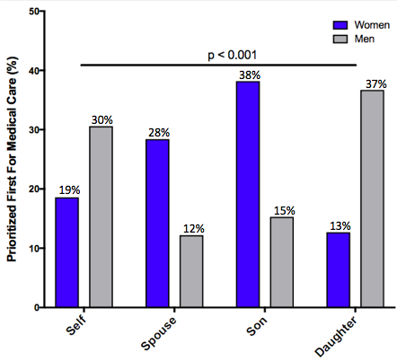 |  | 0.70
Women | 102 (51.0) | 22 (55.0) | 80 (50.0)
Men | 98 (49.0) | 18 (45.0) | 80 (50.0)
Region, n (%) |  |  |  | 0.48
Central Malawi | 176 (88.0) | 37 (92.5) | 139 (86.9)
Other | 24 (22.0) | 3 (7.5) | 21 (13.1)
Tribal Group, n (%) |  |  |  | <0.001
Chewa | 137 (68.5) | 37 (92.5) | 100 (62.5)
Ngoni | 38 (19.0) | 0 (0.0) | 38 (23.8)
Other | 25 (12.5) | 3 (7.5) | 22 (13.8)
Religion, n (%) |  |  |  | 0.45
Protestant | 117 (58.5) | 29 (72.5) | 88 (55.0)
Roman Catholicism | 46 (23.0) | 6 (15.0) | 40 (25.0)
Traditional Tribal | 25 (12.5) | 4 (10.0) | 21 (13.1)
Islam | 9 (4.5) | 1 (2.5) | 8 (5.0)
Other | 3 (1.5) | 0 (0.0) | 3 (1.9)
Marital Status, n (%) |  |  |  | 0.04
Married | 165 (82.5) | 31 (77.5) | 134 (83.8)
Separated | 13 (6.5) | 6 (15.0) | 7 (4.4)
Widowed | 10 (5.0) | 0 (0.0) | 10 (6.3)
Single | 12 (6.0) | 3 (7.5) | 9 (5.6)
Employment Status, n (%) |  |  |  | 0.31
Self-employed/Business | 178 (89.0) | 40 (100.0) | 138 (86.3)
Employed | 12 (6.0) | 0 (0.0) | 12 (7.5)
Unemployed | 2 (1.0) | 0 (0.0) | 2 (1.3)
Never Worked | 6 (3.0) | 0 (0.0) | 6 (3.8)
Other | 2 (1.0) | 0 (0.0) | 2 (1.3)
Education Level, n (%) |  |  |  | 0.93
None | 22 (11.0) | 4 (10.0) | 18 (11.3)
Primary School | 123 (61.5) | 25 (62.5) | 98 (61.3)
Secondary School | 52 (26.0) | 11 (27.5) | 41 (25.6)
Higher Education | 3 (1.5) | 0 (0.0) | 3 (1.9)
Spouse Employment, n (%) |  |  |  | 0.004
Self-employed/Business | 148 (89.2) | 25 (62.5) | 123 (76.9)
Employed | 9 (5.4) | 1 (2.5) | 8 (5.0)
Unemployed | 4 (2.4) | 1 (2.5) | 3 (1.9)
Never Worked | 4 (2.4) | 4 (10.0) | 0 (0.0)
Other | 1 (0.6) | 0 (0.0) | 1 (0.6)
Spouse Education Level, n (%) |  |  |  | 0.10
None | 16 (9.6) | 5 (16.1) | 11 (8.1)
Primary School | 115 (69.3) | 18 (58.1) | 97 (71.9)
Secondary School | 34 (20.5) | 7 (22.6) | 27 (20.0)
Higher Education | 1 (0.6) | 1 (3.2) | 0 (0.0)
Age, year, Mean (SD) | 41.7 (12.1) | 37.2 (11.5) | 42.9 (12.0) | 0.008
Spouse Age, year, Mean (SD) | 41.3 (12.4) | 36.9 (12.4) | 42.3 (12.3) | 0.04
Transport Time, hour, Median (IQR) | 3.0 (2.0, 6.0) | 2.0 (1.0, 4.3) | 3.25 (2.0, 6.6) | <0.001
Income (MWK)**, Median (IQR) | 120000 (60000, 300000) | 180000 (12000, 30000) | 120000 (60000, 300000) | 0.46
Spouse's Income (MWK)**, Median (IQR) | 125000 (60000, 300000) | 180000 (45000, 315000) | 120000 (60000, 300000) | 0.28
Number of Children, Mean (SD) | 4.1 (2.1) | 3.6 (1.7) | 4.2 (2.2) | 0.06
Number in Household, Mean (SD) | 5.7 (2.0) | 5.2 (2.1) | 5.8 (1.9) | 0.12
GEM Raw Score, Mean (SD) | 17.2 (2.9) | 17.7 (3.2) | 17.1 (2.8) | 0.3
GEM Score Level, n (%) |  |  |  | 0.22
High | 71 (35.5) | 18 (45.0) | 53 (33.1)
Low | 129 (64.5) | 22 (55.0) | 107 (66.9)
Missing values: Spouse Employment=34, Spouse Education=34.
*P-values were calculated by chi-square test, Fisher’s exact test, independent sample t-test, or Wilcoxon-Mann-Whitney test.
**MWK indicates Malawian kwacha (1 US Dollar = 765.29 MWK as of July16, 2019)

