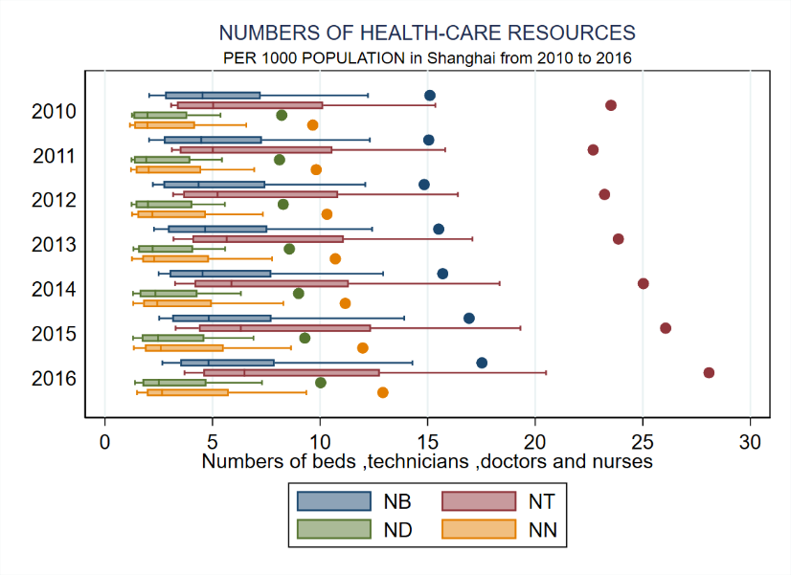
YEAR
YEAR

(a) (b)

Fig.S1 Changes for each indicator with whiskers box plot per every year from 2010 to 2016(per 1000).
(a) presents the number of institutions per 1000 people in Shanghai; (b) presents the number of beds, technicians, doctors and nurses per 1000 people in Shanghai.

