Supplementary materials S1-S4, Figures A-D
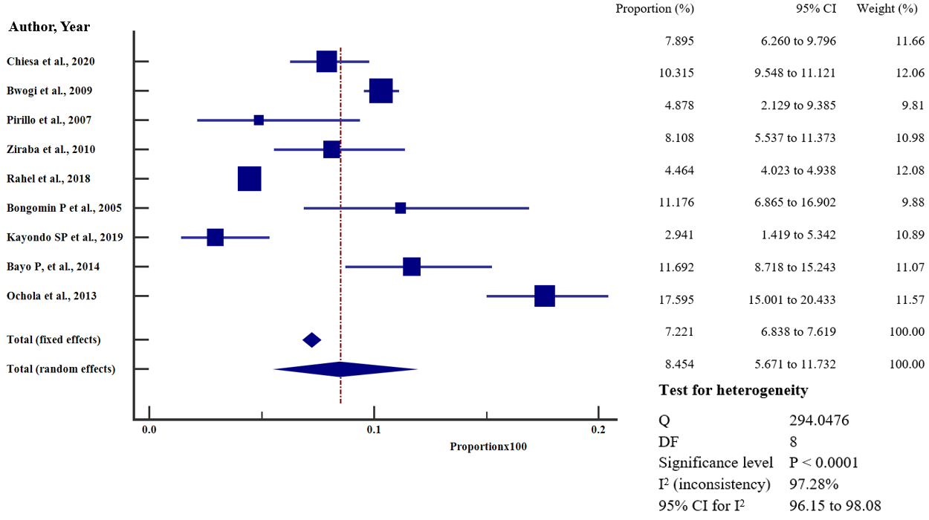
S1 Fig A. Forest plot of sub-group analysis of HBV prevalence for Uganda
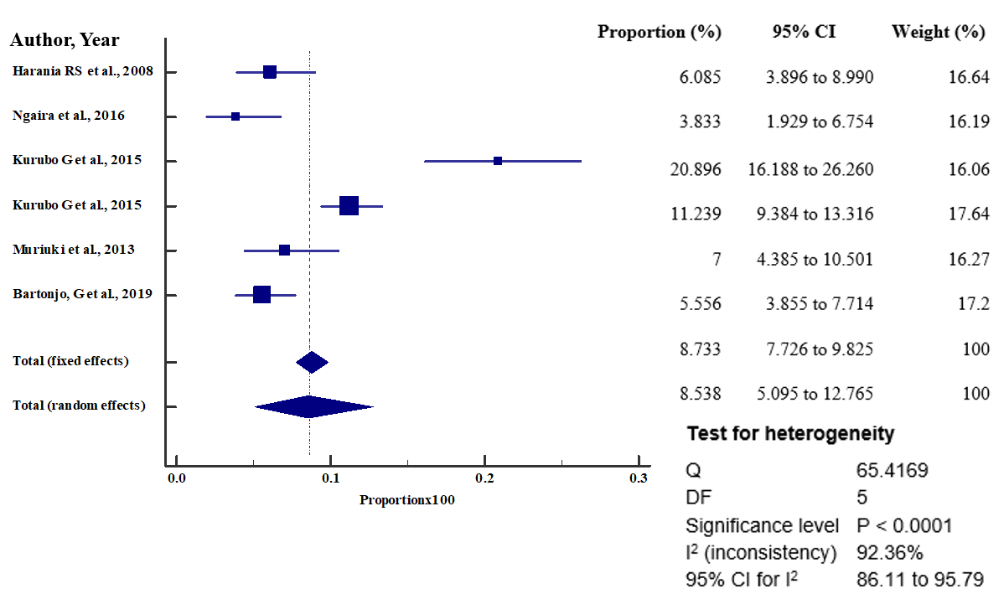
S2 Fig B. Forest plot of sub-group analysis of HBV prevalence for Kenya
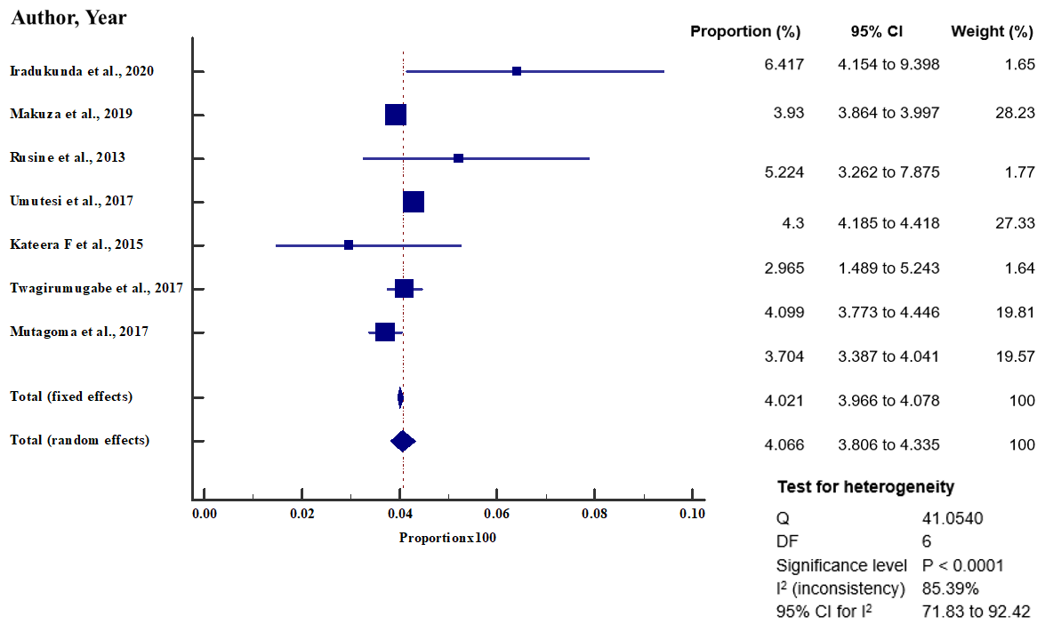
S3 Fig C: Forest plot of sub-group analysis of HBV prevalence for Rwanda
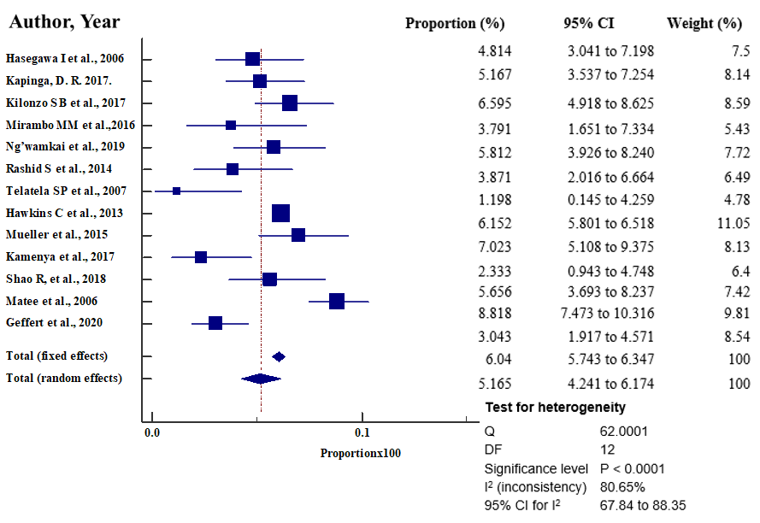
S4 Fig D. Forest plot of sub-group analysis of HBV prevalence for Tanzania

