Supplementary materials S5-S7, Figures E-G
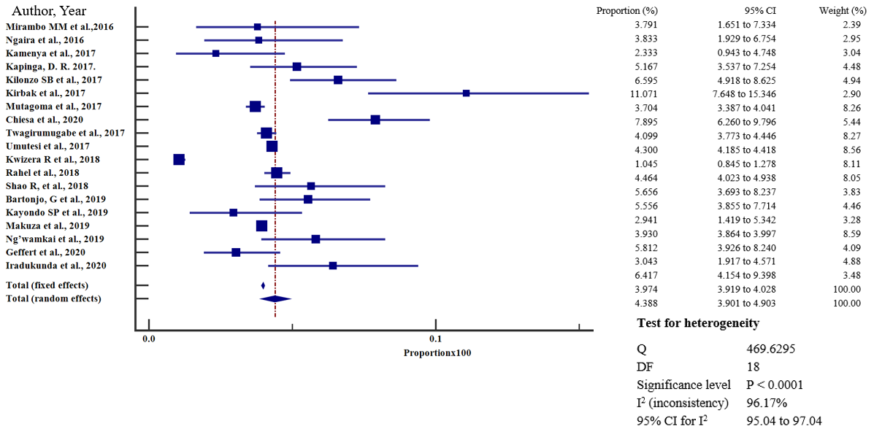
S5 Fig E. Forest plot of sub-group analysis of HBA prevalence in articles published from 2016-2020
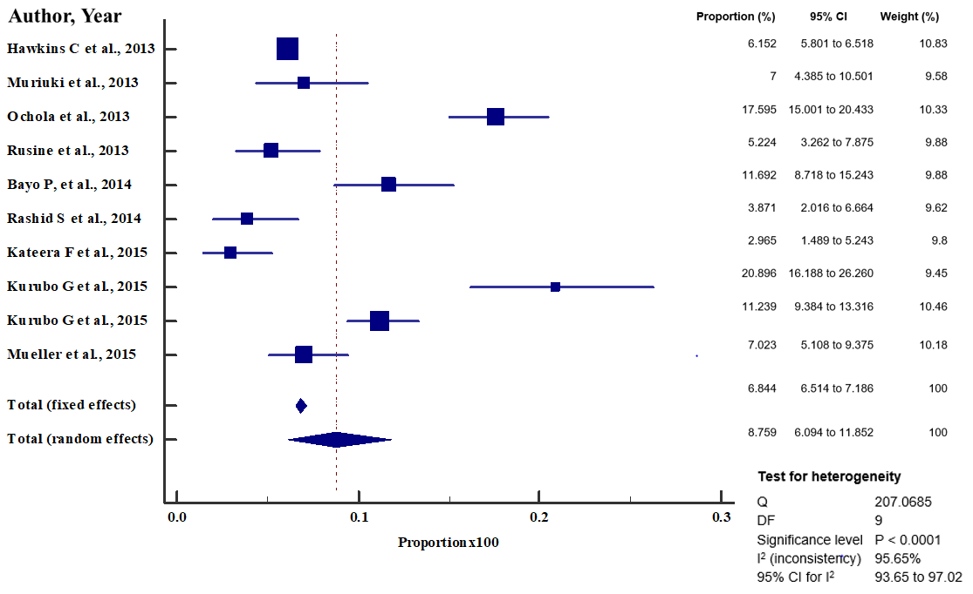
S6 Fig F. Forest plot of sub-group analysis of HBV prevalence in articles published from 2011-2015
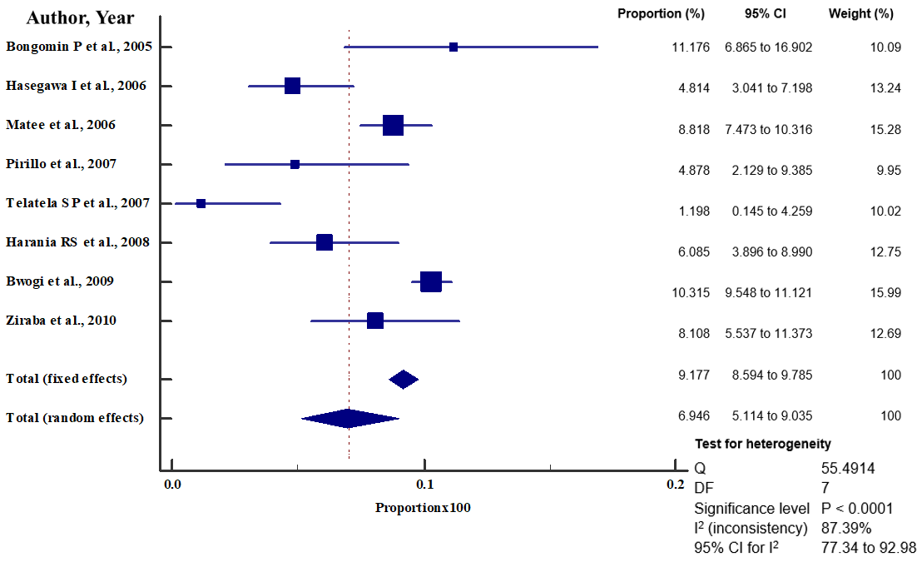
S7 Fig G. Forest plot of sub-group analysis of HBV prevalence in articles published from 2005-2010

