Supplementary materials S8-S11, Figures H-K

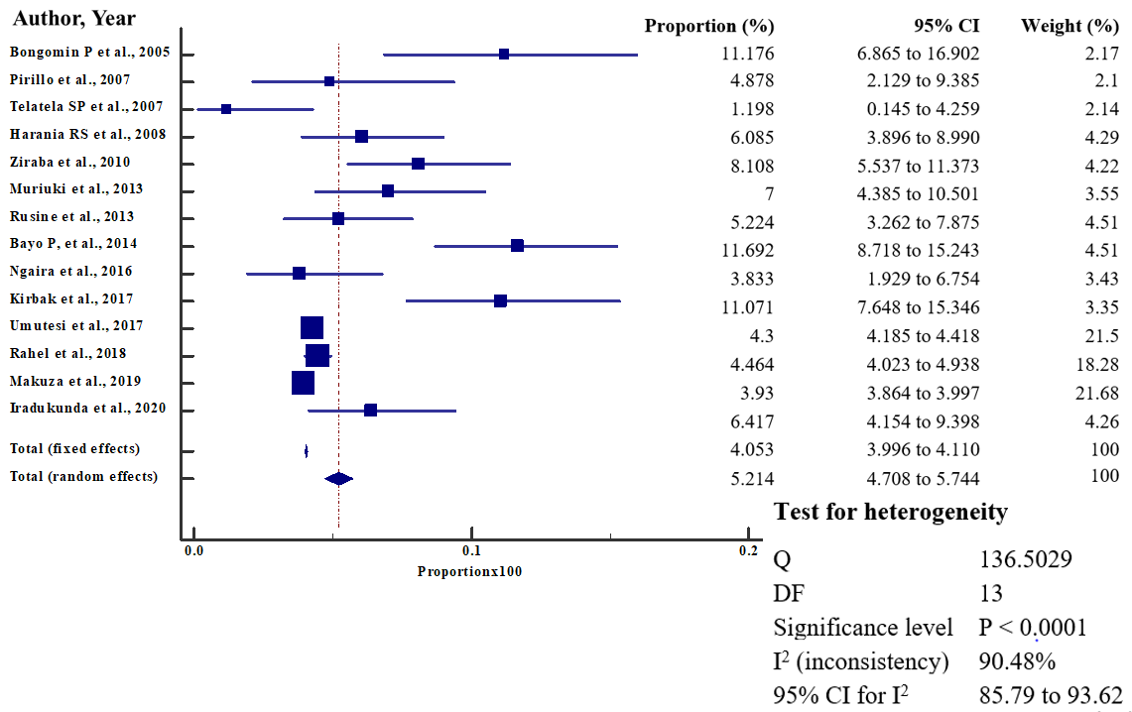
S8 Fig H. Forest plot of sub-group analysis of HBsAg detection by ELISA assay

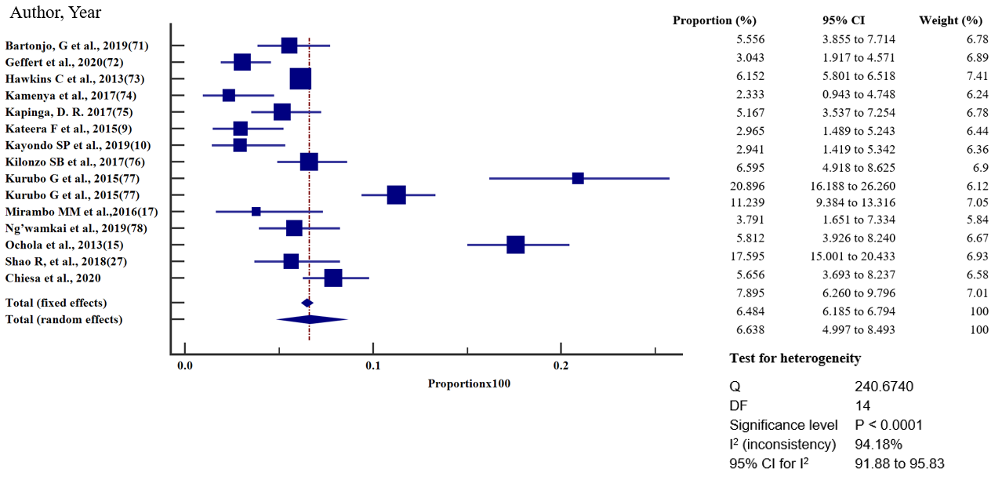
S9 Fig I. Forest plot of sub-group analysis of HBsAg detection by rapid diagnostic test (RDT) assay
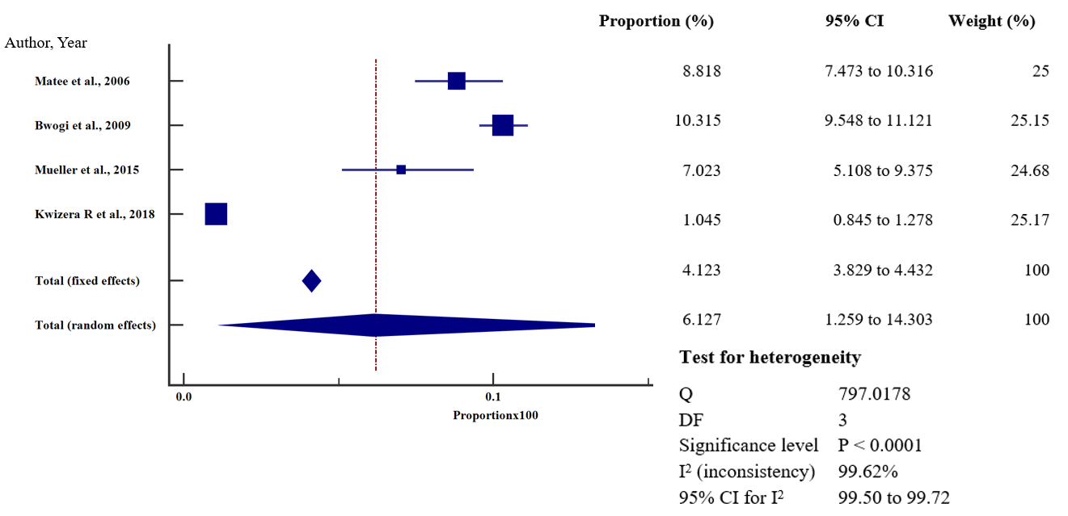

S10 Fig J. Forest plot of sub-group analysis of HBsAg detection by Enzyme Immune Assay (EIA)

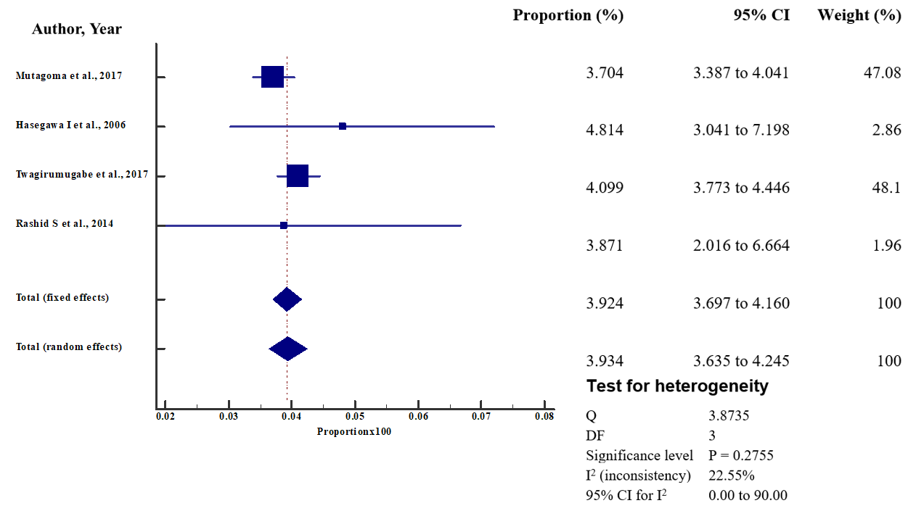

S11 Fig K. Forest plot of sub-group analysis of HBsAg detection by other assays

