Figure S1. Never smoker (A) Leave-one-out plot. (B) Scatter plot. (C)Forest plot. (D) Funnel plot
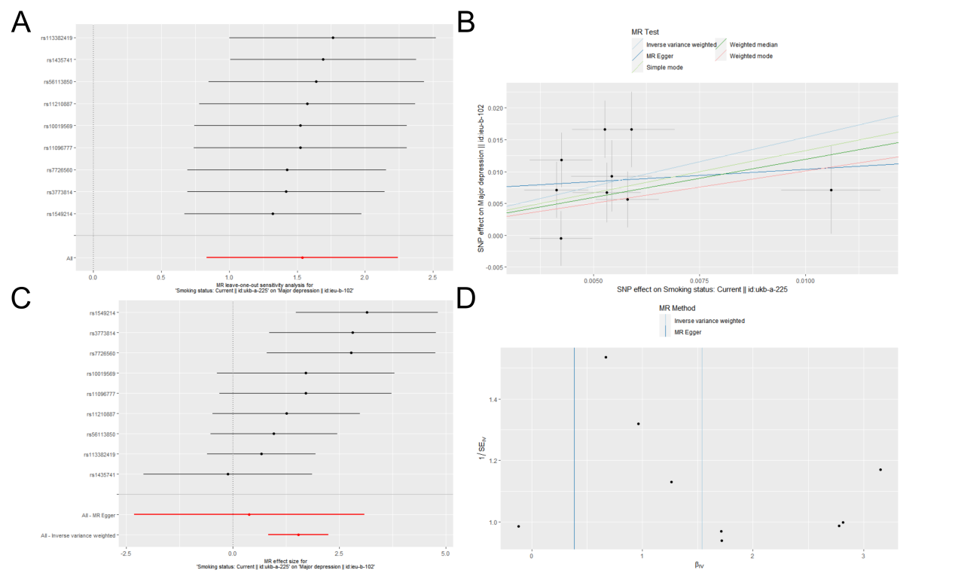
Figure S2. Current smoker (A) Leave-one-out plot. (B) Scatter plot. (C)Forest plot. (D) Funnel plot
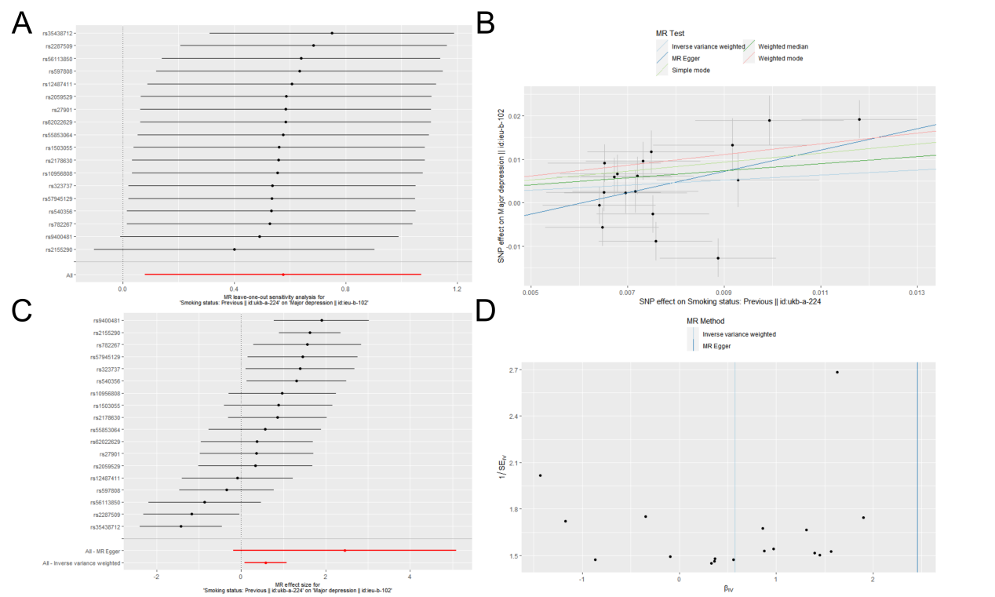
Figure S3. Previous smoker (A) Leave-one-out plot. (B) Scatter plot. (C)Forest plot. (D) Funnel plot
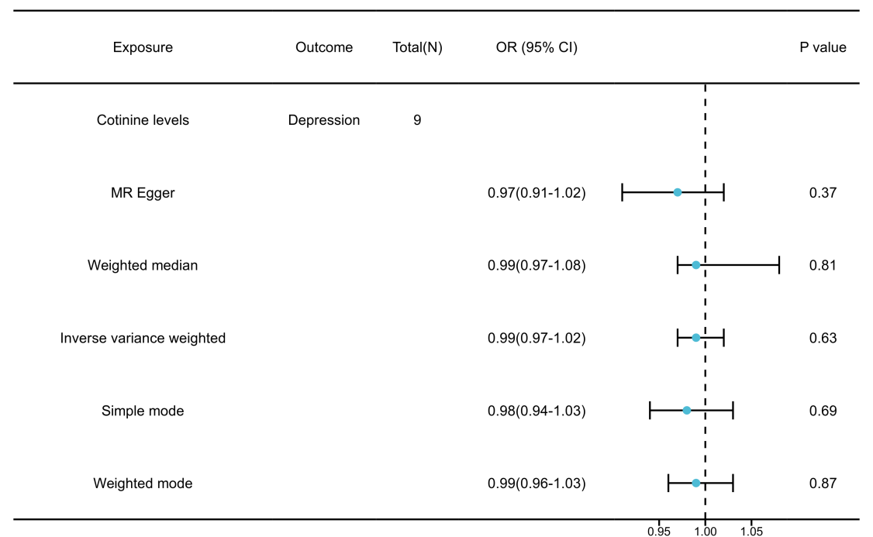
Figure S4. MR forest map
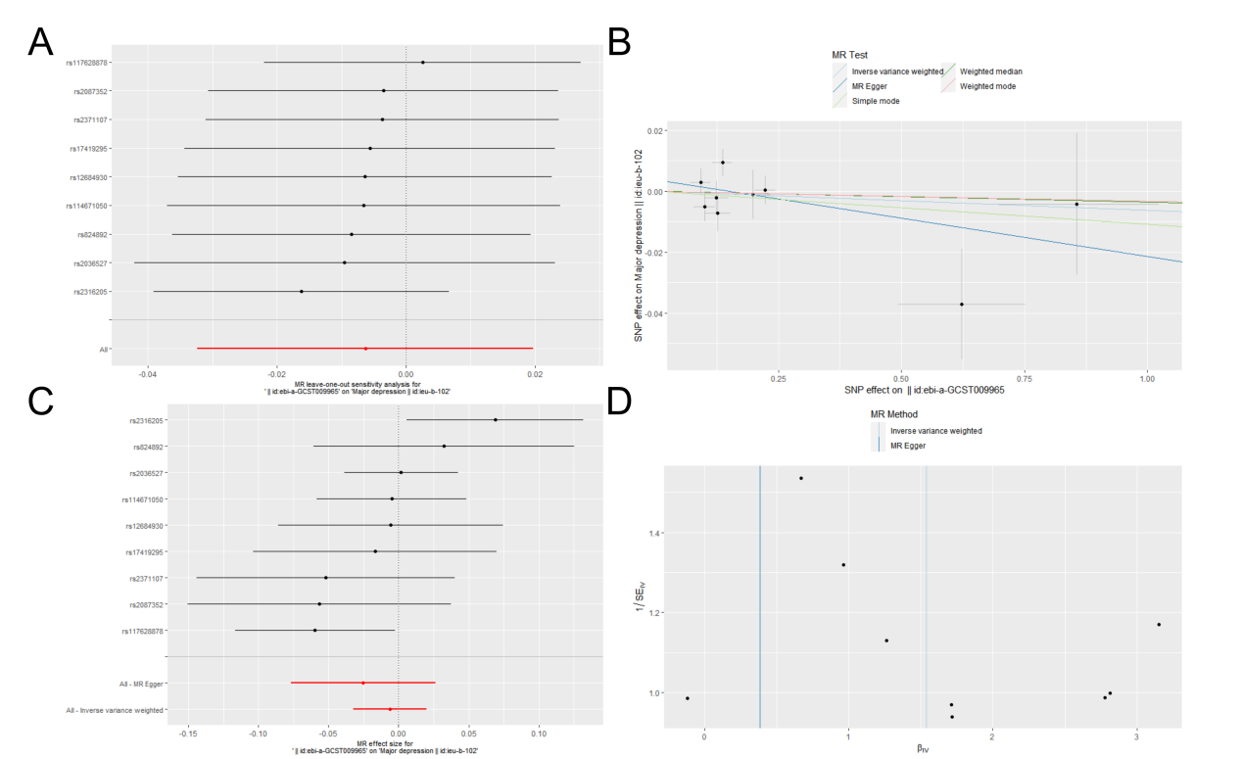
Figure S5. Cotinine level (A) Leave-one-out plot. (B) Scatter plot. (C)Forest plot. (D) Funnel plot

