Fürtjes et al. MHA – Supplementary Material

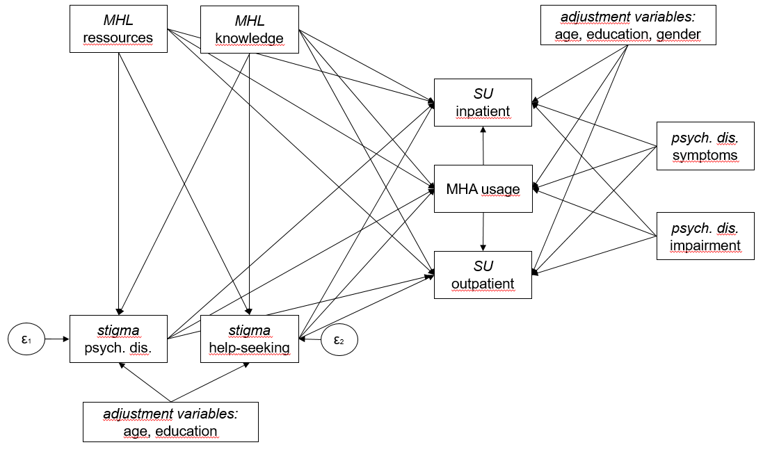
Figure S1. Estimated structural equation model. MHL = mental health literacy, assessed via the Multicomponent Mental Health Literacy Measure. Stigma against individuals with psychological disorders was assessed via the Stig-9. Stigma against help-seeking was assessed via the SSOSH. MHA = mental health application. Psychological disorder was assessed via the CID-5-S; symptoms = only symptoms affirmed; impairment = symptoms and impairment and/or treatment affirmed. SU = service utilization.

Table S1. Results of the structural equation modeling
Outcome | Predictor | β [SE] | p | 95%-CI
Stig-9 | MMHLM knowledge  MMHLM resources  age  high school level educ. | .07 [.03]  -.08 [.03]  .00 [.00]  -.18 [.08] | .028  .012  .868  .018 | [.01; .14]  [-.15; -.02]  [-.01; .005]  [-.33; -.03]
SSOSH | MMHLM knowledge  MMHLM resources  age  high school level educ. | -.04 [.03]  -.12 [.03]  .00 [.00]  -.13 [.08] | .225  < .001  .791  .089 | [-.10; .02]  [-.19; -.06]  [-.01; .004]  [-.28; .02]
MHA usage | MMHLM knowledge  MMHLM resources  Stig-9  SSOSH  CID-5-S symptoms  CID-5-S impairment  age  gender  female (base)  male  diverse  high school level educ. | -.12 [.07]  .07 [.07]  -.05 [.07]  .14 [.07]  .07 [.19]  -.25 [.20]  -.004 [.01]  -.08 [.13]  .01 [.55]  -.21 [.16] | .069  .329  .429  .041  .699  .211  .487  .545  .982  .186 | [-.26; .01]  [-.07; .20]  [-.18; .08]  [.01; .27]  [-.29; .44]  [-.65; .14]  [-.01; .01]  [-.34; .18]  [-1.07; 1.09]  [-.52; .10]
SU inpatient | MMHLM knowledge  MMHLM resources  Stig-9  SSOSH  MHA usage  CID-5-S symptoms  CID-5-S impairment  age  gender  female (base)  male  diverse  high school level educ. | -.14 [.13]  .28 [.14]  .07 [.13]  .01 [.12]  .73 [.24]  .28 [.48]  1.19 [.47]  -.02 [.01]  .08 [.26]  1.02 [.69]  -.64 [.26] | .276  .046  .603  .930  .003  .559  .011  .045  .759  .143  .014 | [-.40; .12]  [.005; .55]  [-.18; .31]  [-.23; .25]  [.25; 1.20]  [-.65; 1.21]  [.27; 2.11]  [-.05; -.001]  [-.43; .59]  [-.34; 2.37]  [-1.26; -.13]
SU outpatient | MMHLM knowledge  MMHLM resources  Stig-9  SSOSH  MHA usage  CID-5-S symptoms  CID-5-S impairment  age  gender  female (base)  male  diverse  high school level educ. | .04 [.09]  .33 [.08]  .14 [.08]  -.33 [.08]  .32 [.15]  .74 [.31]  2.18 [.31]  -.01 [.01]  -.44 [.16]  -.07 [.58]  -.13 [.19] | .670  < .001  .067  < .001  .033  .017  < .001  .095  .007  .898  .497 | [-.13; .21]  [.16; .49]  [-.01; .30]  [-.49; .16]  [.03; .62]  [.13; 1.35]  [1.58; 2.79]  [-.03; .002]  [-.75; -.12]  [-1.20; 1.06]  [-.50; .24]
Notes. Non-dichotomous were standardized. n = 1,069. Stig-9 = stigma against individuals with psychological disorders. SSOHS = Self-Stigma of Help-Seeking. MMHLM = Multicomponent Mental Health Literacy Measure. MHA = mental health application (usage coded yes/no). SU = service utilization (coded yes/no). CID-5-S = Composite International Diagnostic Screener. Age is give in years.

Table S2. Covariance matrix for the SEM-equation with Stig-9 as outcome
 | MMHLM knowledge | MMHLM resources | age | high school level educ.
MMHLM knowledge  MMHLM resources  age  high school level educ. | .001  .000  .000  .000 | .001  .000  .000 | .000  .000 | .006
Notes. Stig-9 = stigma against individuals with psychological disorders. SSOHS = Self-Stigma of Help-Seeking. MMHLM = Multicomponent Mental Health Literacy Measure. Age = years.

Table S3. Covariance matrix for the SEM-equation with SSOSH as outcome
 | MMHLM knowledge | MMHLM resources | age | high school level educ.
MMHLM knowledge  MMHLM resources  age  high school level educ. | .001  .000  .000  .000 | .001  .000  .000 | .000  .000 | .006
Notes. Stig-9 = stigma against individuals with psychological disorders. SSOHS = Self-Stigma of Help-Seeking. MMHLM = Multicomponent Mental Health Literacy Measure. Age = years.

Table S4. Covariance matrix for the SEM-equation with MHA usage as outcome
 | MMHLM knowledge | MMHLM resources | Stig-9 | SSOSH | CID-5-S symptoms | CID-5-S impairment | gender  male | gender  diverse | age | high school level educ.
MMHLM knowledge  MMHLM resources  Stig-9  SSOSH  CID-5-S symptoms  CID-5-S impairment  gender male  gender diverse  age  high school level educ. | .005  -.002  .000  .000  -.001  -.002  .001  .000  .000  -.001 | .005  .000  .000  .000  .001  .000  -.001  .000  .000 | .004  -.002  -.002  -.001  .000  .000  .000  .001 | .005  .001  .001  -.001  .000  .000  .000 | .040  .028  .004  -.005  .000  .003 | .035  .003  -.002  .000  .001 | .018  .006  .000  .001 | .304  .000  .001 | .000  .000 | .095
Notes. Stig-9 = stigma against individuals with psychological disorders. SSOHS = Self-Stigma of Help-Seeking. MMHLM = Multicomponent Mental Health Literacy Measure. MHA = mental health application (usage coded yes/no). SU = service utilization (coded yes/no). CID-5-S = Composite International Diagnostic Screener. Age = years.

Table S5. Covariance matrix for the SEM-equation with SU outpatient as outcome
 | MMHLM know. | MMHLM res. | Stig-9 | SSOSH | CID-5-S symp. | CID-5-S imp. | gender  male | gender  diverse | age | HS level educ. | MHA usage
MMHLM knowledge  MMHLM resources  Stig-9  SSOSH  CID-5-S symptoms  CID-5-S impairment  gender male  gender diverse  age  high school level educ.  MHA usage | .008  -.002  .000  .000  -.001  .000  .001  .000  .000  -.001  .000 | .007  .000  .001  .001  .001  .000  .000  .000  .001  .000 | .006  -.002  -.002  .000  .000  .000  .000  .000  .001 | .007  .001  .001  -.001  -.001  .000  .001  -.001 | .096  .083  .005  -.006  .000  .004  .002 | .096  .004  -.003  .000  .002  -.001 | .026  .009  .000  .002  .000 | .333  .000  .000  .000 | .000  .000  .000 | .036  .002 | .023
Notes. Stig-9 = stigma against individuals with psychological disorders. SSOHS = Self-Stigma of Help-Seeking. MMHLM = Multicomponent Mental Health Literacy Measure. MHA = mental health application (usage coded yes/no). SU = service utilization (coded yes/no). CID-5-S = Composite International Diagnostic Screener. Age = years.

Table S6. Covariance matrix for the SEM-equation with SU inpatient as outcome
 | MMHLM know. | MMHLM res. | Stig-9 | SSOSH | CID-5-S symp. | CID-5-S imp. | gender  male | gender  diverse | age | HS level educ. | MHA usage
MMHLM knowledge  MMHLM resources  Stig-9  SSOSH  CID-5-S symptoms  CID-5-S impairment  gender male  gender diverse  age  high school level educ.  MHA usage | .018  -.007  -.001  .000  -.007  -.005  .003  -.002  .000  -.002  .002 | .019  .001  .002  -.001  .001  -.001  .002  .000  .001  -.001 | .016  -.005  -.007  -.004  .001  -.002  .000  .001  .001 | .015  .005  .005  -.005  -.001  .000  .002  -.003 | .219  .189  .019  -.006  .001  .008  .005 | .227  .015  -.001  .000  .004  -.001 | .067  .023  .000  .004  .001 | .481  .000  .002  .004 | .000  .000  .000 | .070  .004 | .059
Notes. Stig-9 = stigma against individuals with psychological disorders. SSOHS = Self-Stigma of Help-Seeking. MMHLM = Multicomponent Mental Health Literacy Measure. MHA = mental health application (usage coded yes/no). SU = service utilization (coded yes/no). CID-5-S = Composite International Diagnostic Screener. Age = years.

