 | Table S1 Socioeconomic characteristics of Sichuan province and its 21 prefectures, 2020
Region number | Regions | Population (million) | Land -(thousand kilometers²) | GDP per capita ($) | Public medical institutions | Patient visits  (million)
 | Sichuan overall | 83.75 | 20.25 | 8083 | 5364 | 285.36
1 | Chengdu | 16.58 | 486.05 | 14984 | 507 | 84.16
2 | Panzhihua | 1.21 | 14.34 | 11951 | 79 | 5.35
3 | Deyang | 3.56 | 4.38 | 9528 | 168 | 14.27
4 | Mianyang | 4.88 | 7.4 | 8505 | 334 | 24.07
5 | Yibin | 4.57 | 5.91 | 8261 | 217 | 13.00
6 | Leshan | 3.27 | 12.24 | 8261 | 232 | 10.50
7 | Zigong | 2.92 | 16.31 | 7088 | 124 | 9.09
8 | Luzhou | 4.33 | 5.32 | 6972 | 166 | 10.71
9 | Ya'an | 1.54 | 5.38 | 6809 | 156 | 6.60
10 | Meishan | 3.00 | 12.72 | 6691 | 152 | 8.97
11 | Suining | 3.19 | 12.48 | 6103 | 128 | 8.04
12 | Aba | 0.95 | 7.14 | 5982 | 252 | 2.06
13 | Neijiang | 3.70 | 13.27 | 5615 | 144 | 6.96
14 | Guang'an | 3.25 | 6.34 | 5583 | 200 | 9.29
15 | Nanchong | 6.44 | 16.58 | 5228 | 505 | 19.55
16 | Dazhou | 5.74 | 15.05 | 5163 | 345 | 10.46
17 | Guangyuan | 2.68 | 12.29 | 5111 | 289 | 10.55
18 | Liangshan | 4.93 | 5.74 | 4940 | 602 | 10.16
19 | Ganzi | 1.20 | 83.02 | 4702 | 375 | 2.53
20 | Ziyang | 2.50 | 149.6 | 4496 | 139 | 9.72
21 | Bazhong | 3.32 | 60.29 | 3292 | 250 | 9.31

Table S2 Top five antibiotics in consumption proportion in Sichuan province and its 21 prefectures by AWaRe Classification, 2020
Regions | ATC code | Antibiotics | AWaRe classification | Proportion
Sichuan Overall | J01CA04 | amoxicillin | Access | 16.85%
Sichuan Overall | J01DC02 | cefuroxime | Watch | 9.21%
Sichuan Overall | J01DD08 | cefixime | Watch | 8.60%
Sichuan Overall | J01MA12 | levofloxacin | Watch | 8.11%
Sichuan Overall | J01XD01 | metronidazole | Access | 6.16%
Chengdu | J01CA04 | amoxicillin | Access | 11.54%
Chengdu | J01MA12 | levofloxacin | Watch | 10.13%
Chengdu | J01DD08 | cefixime | Watch | 9.36%
Chengdu | J01DC02 | cefuroxime | Watch | 7.37%
Chengdu | J01CR02 | Amoxicillin/clavulanic-acid | Access | 6.47%
Panzhihua | J01MA12 | levofloxacin | Watch | 9.83%
Panzhihua | J01DD08 | cefixime | Watch | 9.26%
Panzhihua | J01XD03 | ornidazole | Access | 8.53%
Panzhihua | J01CA04 | amoxicillin | Access | 7.34%
Panzhihua | J01DC02 | cefuroxime | Watch | 6.99%
Deyang | J01CA04 | amoxicillin | Access | 17.76%
Deyang | J01DD08 | cefixime | Watch | 12.70%
Deyang | J01DC02 | cefuroxime | Watch | 11.70%
Deyang | J01CR02 | Amoxicillin/clavulanic-acid | Access | 8.80%
Deyang | J01MA12 | levofloxacin | Watch | 5.48%
Mianyang | J01CA04 | amoxicillin | Access | 17.40%
Mianyang | J01DC02 | cefuroxime | Watch | 9.08%
Mianyang | J01DD08 | cefixime | Watch | 8.84%
Mianyang | J01MA12 | levofloxacin | Watch | 7.72%
Mianyang | J01XD01 | metronidazole | Access | 6.15%
Yibin | J01CA04 | amoxicillin | Access | 17.36%
Yibin | J01DC02 | cefuroxime | Watch | 10.34%
Yibin | J01DD08 | cefixime | Watch | 7.78%
Yibin | J01CE01 | benzylpenicillin | Access | 7.63%
Yibin | J01MA12 | levofloxacin | Watch | 6.69%
Leshan | J01CE01 | benzylpenicillin | Access | 16.81%
Leshan | J01CA04 | amoxicillin | Access | 13.98%
Leshan | J01MA12 | levofloxacin | Watch | 8.40%
Leshan | J01DC02 | cefuroxime | Watch | 8.34%
Leshan | J01DD08 | cefixime | Watch | 4.82%
Zigong | J01MA12 | levofloxacin | Watch | 10.42%
Zigong | J01CA04 | amoxicillin | Access | 8.85%
Zigong | J01DC02 | cefuroxime | Watch | 8.60%
Zigong | J01DD08 | cefixime | Watch | 7.46%
Zigong | J01CR02 | Amoxicillin/clavulanic-acid | Access | 6.51%
Luzhou | J01MA12 | levofloxacin | Watch | 11.14%
Luzhou | J01DD08 | cefixime | Watch | 10.34%
Luzhou | J01DC02 | cefuroxime | Watch | 8.96%
Luzhou | J01CA04 | amoxicillin | Access | 8.21%
Luzhou | J01XD01 | metronidazole | Access | 7.94%
Ya'an | J01CA04 | amoxicillin | Access | 32.91%
Ya'an | J01XD01 | metronidazole | Access | 15.00%
Ya'an | J01DC02 | cefuroxime | Watch | 9.90%
Ya'an | J01MA12 | levofloxacin | Watch | 4.14%
Ya'an | J01XE01 | nitrofurantoin | Access | 3.81%
Meishan | J01CA04 | amoxicillin | Access | 13.51%
Meishan | J01XD01 | metronidazole | Access | 13.14%
Meishan | J01DD08 | cefixime | Watch | 9.67%
Meishan | J01MA12 | levofloxacin | Watch | 8.96%
Meishan | J01DC02 | cefuroxime | Watch | 6.66%
Suining | J01CA04 | amoxicillin | Access | 23.20%
Suining | J01XD01 | metronidazole | Access | 11.27%
Suining | J01DC02 | cefuroxime | Watch | 9.74%
Suining | J01DD08 | cefixime | Watch | 7.09%
Suining | J01MA12 | levofloxacin | Watch | 5.47%
Aba | J01CA04 | amoxicillin | Access | 20.79%
Aba | J01XD01 | metronidazole | Access | 11.62%
Aba | J01MA12 | levofloxacin | Watch | 11.52%
Aba | J01DD08 | cefixime | Watch | 6.39%
Aba | J01DC02 | cefuroxime | Watch | 4.99%
Neijiang | J01CA04 | amoxicillin | Access | 11.80%
Neijiang | J01DD08 | cefixime | Watch | 11.39%
Neijiang | J01DC02 | cefuroxime | Watch | 9.99%
Neijiang | J01MA12 | levofloxacin | Watch | 9.94%
Neijiang | J01DD04 | ceftriaxone | Watch | 6.08%
Guang'an | J01CA04 | amoxicillin | Access | 22.22%
Guang'an | J01CR02 | Amoxicillin/clavulanic-acid | Access | 11.49%
Guang'an | J01DD08 | cefixime | Watch | 8.98%
Guang'an | J01MA12 | levofloxacin | Watch | 7.55%
Guang'an | J01DC02 | cefuroxime | Watch | 7.07%
Nanchong | J01CA04 | amoxicillin | Access | 21.11%
Nanchong | J01MA12 | levofloxacin | Watch | 11.35%
Nanchong | J01DD08 | cefixime | Watch | 8.58%
Nanchong | J01DC02 | cefuroxime | Watch | 7.50%
Nanchong | J01XD01 | metronidazole | Access | 4.77%
Dazhou | J01DC02 | cefuroxime | Watch | 16.48%
Dazhou | J01CA01 | ampicillin | Access | 13.92%
Dazhou | J01CA04 | amoxicillin | Access | 8.59%
Dazhou | J01MA12 | levofloxacin | Watch | 8.35%
Dazhou | J01CF04 | oxacillin | Access | 7.35%
Guangyuan | J01CA04 | amoxicillin | Access | 19.24%
Guangyuan | J01DD08 | cefixime | Watch | 11.17%
Guangyuan | J01CR02 | Amoxicillin/clavulanic-acid | Access | 10.14%
Guangyuan | J01XD01 | metronidazole | Access | 7.22%
Guangyuan | J01MA12 | levofloxacin | Watch | 7.12%
Liangshan | J01CA04 | amoxicillin | Access | 17.80%
Liangshan | J01DD08 | cefixime | Watch | 10.90%
Liangshan | J01DB09 | cefradine | Access | 7.76%
Liangshan | J01XD01 | metronidazole | Access | 7.40%
Liangshan | J01CE01 | benzylpenicillin | Access | 6.12%
Ganzi | J01CA04 | amoxicillin | Access | 35.09%
Ganzi | J01XD01 | metronidazole | Access | 12.73%
Ganzi | J01EE07 | Sulfamerazine/trimethoprim | Access | 4.37%
Ganzi | J01DD08 | cefixime | Watch | 4.36%
Ganzi | J01CE01 | benzylpenicillin | Access | 3.95%
Ziyang | J01CA04 | amoxicillin | Access | 23.65%
Ziyang | J01DC02 | cefuroxime | Watch | 16.06%
Ziyang | J01DD04 | ceftriaxone | Watch | 6.76%
Ziyang | J01DB09 | cefradine | Access | 6.72%
Ziyang | J01MA12 | levofloxacin | Watch | 6.52%
Bazhong | J01CA04 | amoxicillin | Access | 19.28%
Bazhong | J01DC02 | cefuroxime | Watch | 13.06%
Bazhong | J01GB03 | Gentamicin | Access | 8.60%
Bazhong | J01MA12 | levofloxacin | Watch | 6.42%
Bazhong | J01DD08 | cefixime | Watch | 4.78%

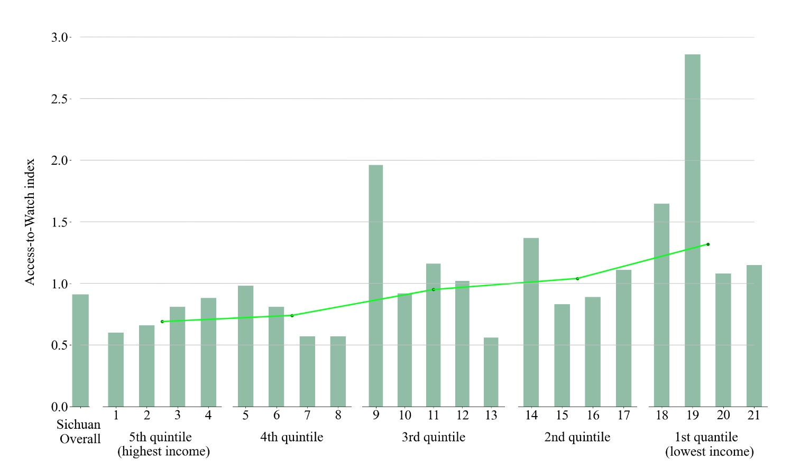
Figure S1: Access-to-Watch index in Sichuan province and its 21 prefectures by AWaRe·Classification, 2020（the green line marks the average Access to Watch Index in each economic development status; Prefectures represented by numbers can be found in Table S1）

