Methodological quality assessment of the level of eHealth literacy for the older adults

Cross-sectional—Agency for Healthcare Research and Quality
Study | Item1 | Item2 | Item3 | Item4 | Item5 | Item6 | Item7 | Item8 | Item9 | Item10 | Item11
Kim [9] | Yes | Yes | Yes | Yes | Unclear | Yes | Yes | No | No | Yes | Unclear
Li [10] | Yes | Yes | Yes | Yes | Unclear | Yes | No | Yes | No | Yes | Unclear
Li [11] | Yes | Yes | Yes | Yes | Unclear | Yes | Yes | Yes | No | Yes | Unclear
Li [13] | Yes | Yes | Yes | Yes | Unclear | Yes | Yes | No | No | No | Unclear
Dai [14] | Yes | Yes | Yes | Yes | Unclear | Yes | No | Yes | No | No | Unclear
Xu [15] | Yes | Yes | Yes | Yes | Unclear | Yes | No | Yes | No | Yes | Unclear
Zhu [16] | Yes | Yes | Yes | Yes | Unclear | Yes | Yes | Yes | No | Yes | Unclear
Mamiko [17] | Yes | Yes | Yes | Yes | Unclear | Yes | Yes | Yes | No | Yes | Unclear
Ghazi [18] | Yes | Yes | Yes | Yes | Unclear | Yes | Yes | Yes | No | Yes | Unclear
Zhang [19] | Yes | Yes | Yes | Yes | Unclear | Yes | No | Yes | No | Yes | Unclear
Yuan [20] | Yes | Yes | Yes | Yes | Unclear | Yes | No | Yes | No | Yes | Unclear
Park [21] | Yes | No | Yes | Yes | Unclear | Yes | No | Yes | No | No | Unclear
Liu [22] | Yes | Yes | Yes | Yes | Unclear | Yes | Yes | Yes | No | Yes | Unclear
Özturk [24] | Yes | Yes | Yes | Yes | Unclear | Yes | No | Yes | No | No | Unclear
Hu [25] | Yes | Yes | Yes | Yes | Unclear | Yes | No | Yes | No | Yes | Unclear
Zhang [26] | Yes | Yes | Yes | Yes | Unclear | Yes | No | Yes | No | Yes | Unclear
Xiong [27] | Yes | Yes | Yes | Yes | Unclear | Yes | No | Yes | No | No | Unclear
Xie [28] | Yes | Yes | Yes | Yes | Unclear | Yes | No | Yes | No | Yes | Unclear
Xie [29] | Yes | Yes | Yes | Yes | Unclear | Yes | No | Yes | No | No | Unclear
Zhu [30] | Yes | Yes | Yes | Yes | Unclear | Yes | Yes | Yes | No | Yes | Unclear
Jiang [31] | Yes | Yes | Yes | Yes | Unclear | Yes | Yes | Yes | No | Yes | Unclear
Cao [32] | Yes | Yes | Yes | Yes | Unclear | Yes | No | Yes | No | Yes | Unclear
Wu [33] | Yes | Yes | Yes | Yes | Unclear | Yes | Yes | Yes | No | Yes | Unclear
Wang [34] | Yes | Yes | Yes | Yes | Unclear | Yes | No | Yes | No | Yes | Unclear
Duan [35] | Yes | Yes | Yes | Yes | Unclear | Yes | No | Yes | No | Yes | Unclear
Moon [36] | Yes | Yes | No | Unclear | Unclear | Yes | No | Yes | No | Yes | Unclear
Chi [37] | Yes | Yes | Yes | Yes | Unclear | Yes | No | Yes | No | Yes | Unclear
Yu [38] | Yes | No | Yes | Yes | Unclear | Yes | No | Yes | No | No | Unclear
Li [39] | Yes | Yes | Yes | Yes | Unclear | Yes | No | Yes | No | Yes | Unclear
Zhang [40] | Yes | Yes | Yes | Yes | Unclear | Yes | No | Yes | No | Yes | Unclear
Zhou [41] | Yes | Yes | Yes | Yes | Unclear | Yes | Yes | Yes | No | Yes | Unclear
Wong [42] | Yes | Yes | Yes | Yes | Unclear | Yes | No | Yes | No | No | Unclear
Lee [43] | Yes | Yes | Yes | Yes | Unclear | Yes | Yes | Yes | No | Yes | Unclear
Liu [44] | Yes | Yes | Yes | Yes | Unclear | Yes | No | Yes | No | Yes | Unclear
Li [45] | Yes | Yes | Yes | Yes | Unclear | Yes | No | Yes | No | Yes | Unclear
Liu [46] | Yes | Yes | Yes | Yes | Unclear | Yes | No | Yes | No | Yes | Unclear
Cui [47] | Yes | Yes | Yes | Yes | Unclear | Yes | No | Yes | No | Yes | Unclear
Auswin [48] | Yes | Yes | Yes | Yes | Unclear | Yes | No | Yes | No | No | Unclear
Guo [49] | Yes | Yes | Yes | Yes | Unclear | Yes | No | Yes | No | Yes | Unclear
Lin [50] | Yes | Yes | Yes | Yes | Unclear | Yes | No | Yes | No | Yes | Yes
Liu [51] | Yes | Yes | Yes | Yes | Unclear | Yes | No | Yes | No | Yes | Unclear
Lee [52] | Yes | No | No | Yes | Unclear | Yes | No | Yes | No | No | Unclear
Hoogland[53] | Yes | Yes | Yes | Yes | Unclear | Yes | No | Yes | No | No | Unclear
Choi [54] | Yes | Yes | Yes | Yes | Unclear | Yes | No | Yes | No | No | Unclear
Kang [55] | Yes | Yes | Yes | Yes | Unclear | Yes | No | Yes | No | Yes | Unclear
Zhou [56] | Yes | Yes | Yes | Yes | Unclear | Yes | No | Yes | No | No | Unclear

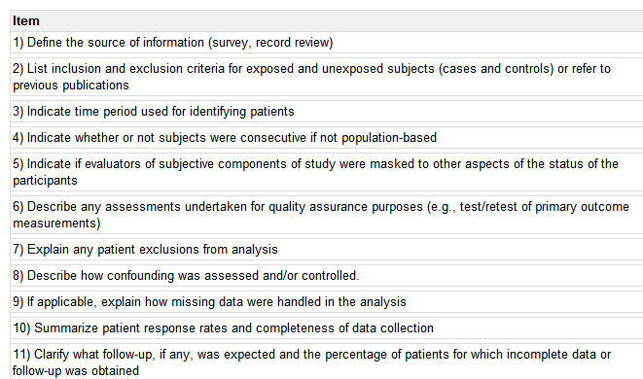

Cohort study——Newcastle-Ottawa scale (NOS)
Study | Selection |  |  |  | Comparability |  | Exposure/Outcome
Study | Item1 | Item2 | Item3 | Item4 | Item5 | Item6 | Item7 | Item8 | Item9
Keles [12] | 0 | 1 | 1 | 1 | 0 | 1 | 1 | 1 | 0
Pang [23] | 0 | 1 | 1 | 1 | 0 | 1 | 1 | 0 | 0
Selection
1)Representativeness of the exposed cohort
2)Selection of the non exposed cohort
3)Ascertainment of exposure
4)Demonstration that outcome of interest was not present at start of study
Comparability
1)Comparability of cohorts on the basis of the design or analysis
Exposure/Outcome
1)Assessment of outcome
2)Was follow-up long enough for outcomes to occur
3)Adequacy of follow up of cohorts

