Supplementary Material

The comparison of the prevalence, awareness, treatment and control of hypertension among adults along the three Provinces of the Lancang–Mekong River countries—China, Laos and Cambodia

Huadan Wang^{1,2†}, Liping He^{2†}, Min Ma², Jiang Lu¹, Mingjing Tang¹, Labee Sikanha³, Sokha Darapiseth⁴, Manli Sun¹, Teng Wang¹, Zhongjie Wang², Yu Xia², Qiuyan Zhu⁵, Da Zhu¹, Lin Duo¹, Linhong Pang^{1*}, Xiangbin Pan^{1,6*}

¹Fuwai Yunnan Hospital, Chinese Academy of Medical Sciences/Affiliated Cardiovascular Hospital of Kunming Medical University, Kunming, China.
² School of Public Health, Kunming Medical University, Kunming, China.
³ Saimangkorm International Hospital, Oudomxay Province, Laos.
⁴Referal Hospital, Borkeo, Ratanakiri Province, Cambodia.
⁵Yunnan Provincial Center for Disease Control and Prevention, Kunming, China.
⁶Department of Structure Heart Center, Fuwai Hospital, National Center for Cardiovascular Diseases, Chinese Academy of Medical Sciences and Peking Union Medical College, Beijing, China.
† Huadan Wang and Liping He contributed equally to this work.

* Joint corresponding authors:
Linhong Pang, Email: plh2835@163.com. Address: No.528 North Shahe Road, Wuhua District, Kunming, Yunnan, China
Xiangbin Pan, Email: panxiangbin@fuwaihospital.org. Address: No.167 North Lishi Road, Xicheng District, Beijing, China

Additional file catalogs
Content | Title | Page
Additional file 1 | Three survey sites from Yunnan Province(China), Oudomxay Province(Laos) and Ratanakiri Province (Cambodia) in Lancang-Mekong region, 2021-2023 | 3
Additional file 2 | Sample size calculations in Yunnan Province(China), Oudomxay Province(Laos) and Ratanakiri Province (Cambodia), 2021-2023 | 4
Additional file 3 | Gender difference in prevalence, awareness, treatment, and control of hypertension in Yunnan Province(China), Oudomxay Province(Laos) and Ratanakiri Province (Cambodia), 2021-2023 | 6
Additional file 4 | Comparison of prevalence, awareness, treatment and control of hypertension among males in Yunnan Province(China), Oudomxay Province(Laos) and Ratanakiri Province (Cambodia), 2021-2023 | 7
Additional file 5 | Comparison of prevalence, awareness, treatment and control of hypertension among females in Yunnan Province(China), Oudomxay Province(Laos) and Ratanakiri Province (Cambodia), 2021-2023 | 8
Additional file 6 | Comparison of prevalence, awareness, treatment and control of hypertension in the 18-34 age group in Yunnan Province(China), Oudomxay Province(Laos) and Ratanakiri Province (Cambodia), 2021-2023 | 9
Additional file 7 | Comparison of prevalence, awareness, treatment and control of hypertension in the 35-49 age group in Yunnan Province(China), Oudomxay Province(Laos) and Ratanakiri Province (Cambodia), 2021-2023 | 10
Additional file 8 | Comparison of prevalence, awareness, treatment and control of hypertension in the 50-64 age group in Yunnan Province(China), Oudomxay Province(Laos) and Ratanakiri Province (Cambodia), 2021-2023 | 11
Additional file 9 | Comparison of prevalence, awareness, treatment and control of hypertension in the ≥ 65 age group in Yunnan Province(China), Oudomxay Province(Laos) and Ratanakiri Province (Cambodia), 2021-2023 | 12
Additional file 10 | Factors associated with hypertension awareness by multivariate logistic regression analysis in Yunnan Province(China), Oudomxay Province(Laos) and Ratanakiri Province (Cambodia), 2021-2023 | 14
Additional file 11 | Factors associated with hypertension treatment by multivariate logistic regression analysis in Yunnan Province(China), Oudomxay Province(Laos) and Ratanakiri Province (Cambodia), 2021-2023 | 15
Additional file 12 | Factors associated with hypertension control by multivariate logistic regression analysis in Yunnan Province(China), Oudomxay Province(Laos) and Ratanakiri Province (Cambodia), 2021-2023 | 17

.

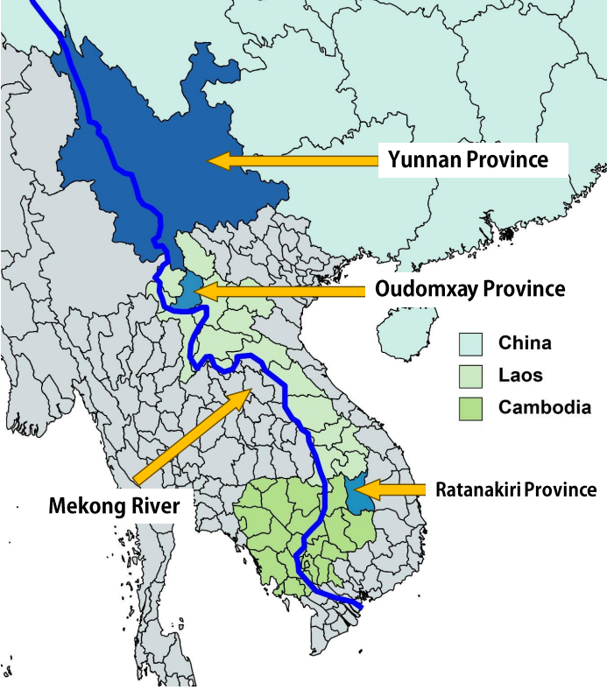
Additional file 1. Three survey sites from Yunnan Province(China), Oudomxay Province(Laos) and Ratanakiri Province (Cambodia) in Lancang–Mekong region, 2021-2023

Additional file 2 Sample size calculations in Yunnan Province (China), Oudomxay Province
(Laos) and Ratanakiri Province (Cambodia), 2021-2023
We estimated the sample content separately in order to ensure that the results of this study are sufficiently reliable.
Minimum sample size was calculated using the formula:
N=$\frac{{{(Z}_{α/2})}^{2}pq}{δ^{2}}$
where,
N = the minimum sample size
$Z_{α/2}$= the standard normal deviate corresponding to a level of significance of 0.05 is 1.96
p = the prevalence rate of hypertension
q = 1-p
$δ$= the desired precision: 0.03
Assuming a 90% response rate for the questionnaire, the sample size is calculated using PASS 15.0 software
(1) Yunnan Province(China)：The overall prevalence of hypertension among adult residents was 23.8% in 2018[1], and the minimum sample size is N _{yunnan}=896.
(2) Oudomxay Province (Laos): According to the 2013 survey of hypertension among adult residents in Laos [2], the prevalence was 20.0%. The minimum sample size is
N _{Oudomxay} =795.
(3) Ratanakiri Province (Cambodia): According to previous studies, the prevalence of hypertension among adult residents in the country in 2016 was 14.2% [3], and the minimum sample size is N _{Ratanakiri} =614.
All the 11005 respondents who participated in the survey were included in this analysis.
References:
[1]Zhang M, Wu J, Zhang X, Hu CH, Zhao ZP, Li C, Huang ZJ, Zhou MG, Wang LM: [Prevalence and control of hypertension in adults in China, 2018]. Zhonghua Liu Xing Bing Xue Za Zhi 2021, 42(10):1780-1789.
[2] Pengpid S, Vonglokham M, Kounnavong S, Sychareun V, Peltzer K: The prevalence, awareness, treatment, and control of hypertension among adults: the first cross-sectional national population-based survey in Laos. Vasc Health Risk Manag 2019, 15:27-33.
[3] WHO. Prevention and control of noncommunicable diseases in Cambodia [R], 2020.
Additional file 3 Gender difference in prevalence, awareness, treatment, and control of hypertension in Yunnan Province (China), Oudomxay Province (Laos) and Ratanakiri Province (Cambodia), 2021-2023
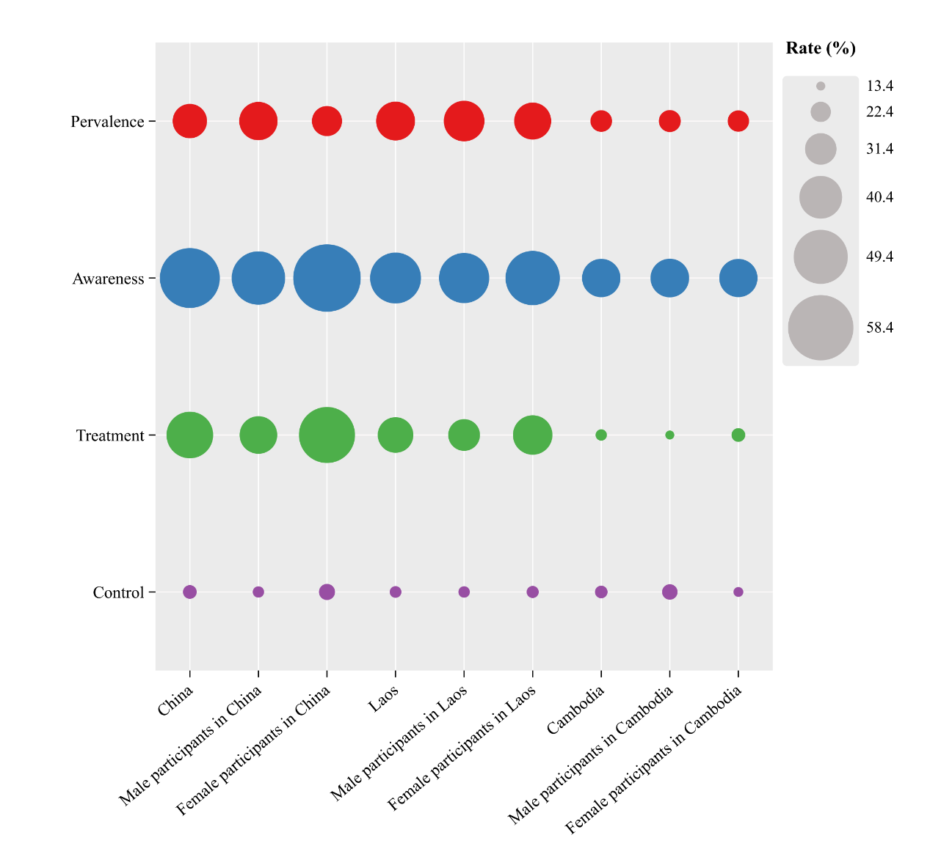

Additional file4. Comparison of prevalence, awareness, treatment and control of hypertension among males in Yunnan Province (China), Oudomxay Province (Laos) and Ratanakiri Province (Cambodia), 2021-2023
Factor | Prevalence | Awareness | Treatment | Control
Yunnan Province (China) | 1616(36.9) | 785(48.9) | 587(36.3) | 247(15.3)
Oudomxay Province (Laos) | 136(38.7) | 63(46.3） | 43(31.6) | 21(15.4)
Ratanakiri Province (Cambodia) | 97(23.8) | 36(37.1) | 13(13.4) | 18(18.6)
p value | <0.001 | 0.036 | <0.001 | 0.688

Additional file 5. Comparison of prevalence, awareness, treatment and control of hypertension among females in Yunnan Province (China), Oudomxay Province (Laos) and Ratanakiri Province (Cambodia), 2021-2023
Factor | Prevalence | Awareness | Treatment | Control
Yunnan Province(China) | 1358(30.3) | 813(60.1) | 692(51.0) | 259(19.1)
Oudomxay Province(Laos) | 246(35.8) | 122(49.6) | 93(37.8) | 39(15.9)
Ratanakiri Province (Cambodia) | 163(23.3) | 60(36.8) | 28(17.2) | 23(14.1)
p value | <0.001 | <0.001 | <0.001 | 0.179

Additional file 6. Comparison of prevalence, awareness, treatment and control of hypertension in the 18-34 age group in Yunnan Province (China), Oudomxay Province (Laos) and Ratanakiri Province (Cambodia), 2021-2023
Factor | Prevalence | Awareness | Treatment | Control
Yunnan Province(China) | 250 (8.1) | 32 (12.8) | 13 (5.2) | 13 (5.2)
Oudomxay Province(Laos) | 34 (11.7) | 7 (20.6) | 5 (14.7) | 5 (14.7)
Ratanakiri Province (Cambodia) | 31 (13.7) | 5 (16.1) | 3 (9.7) | 2 (6.5)
p value | 0.003 | 0.012 | 0.089 | 0.103

Additional file 7. Comparison of prevalence, awareness, treatment and control of hypertension in the 35-49 age group in Yunnan Province (China), Oudomxay Province (Laos) and Ratanakiri Province (Cambodia), 2021-2023
Factor | Prevalence | Awareness | Treatment | Control
Yunnan Province (China) | 700 (28.6) | 266 (38.4) | 153 (21.9) | 72 (10.3)
Oudomxay Province (Laos) | 98 (34.9) | 47 (48.0) | 36 (36.7) | 15 (15.3)
Ratanakiri Province (Cambodia) | 112 (22.5) | 41 (36.6) | 15 (13.4) | 20 (17.9)
p value | <0.001 | 0.144 | <0.001 | 0.036

Additional file8. Comparison of prevalence, awareness, treatment and control of hypertension in the 50-64 age group in Yunnan Province(China), Oudomxay Province(Laos) and Ratanakiri Province (Cambodia), 2021-2023
Factor | Prevalence | Awareness | Treatment | Control
Yunnan Province (China) | 992 (53.7) | 591 (59.6) | 483 (48.7) | 210 (21.2)
Oudomxay Province (Laos) | 152 (53.5) | 83 (54.6) | 59 (38.8) | 28 (18.4)
Ratanakiri Province (Cambodia) | 76 (26.9) | 28 (36.8) | 13 (17.1) | 9 (11.8)
p value | <0.001 | <0.001 | <0.001 | 0.125

Additional file 9. Comparison of prevalence, awareness, treatment and control of hypertension in the ≥65 age group in Yunnan Province (China), Oudomxay Province (Laos) and Ratanakiri Province (Cambodia), 2021-2023
Factor | Prevalence | Awareness | Treatment | Control
Yunnan Province (China) | 1032 (70.2) | 709 (68.7) | 630 (61.0) | 211 (20.4)
Oudomxay Province (Laos) | 98 (53.3) | 56 (57.1) | 36 (36.7) | 12 (12.2)
Ratanakiri Province (Cambodia) | 41 (40.6) | 22 (53.7) | 10 (24.4) | 10 (24.4)
p value | <0.001 | <0.001 | <0.001 | 0.116

Additional file 10. Factors associated with hypertension awareness by multivariable logistic regression analysis in Yunnan Province (China), Oudomxay Province (Laos) and Ratanakiri Province (Cambodia), 2021-2023

Factor | Univariate analysis ^{b} |  |  | Multivariable logistic regression analysis ^{c}
Factor | Yunnan Province (China )  OR (95%CI) | Oudomxay Province (Laos)  OR (95%CI) | Ratanakiri Province (Cambodia) OR (95%CI) | Yunnan Province (China )  OR (95%CI) | Oudomxay Province (Laos)  OR (95%CI) | Ratanakiri Province (Cambodia) OR (95%CI)
Gender
Male | Ref. | Ref. | Ref. | Ref. | Ref. | -
Female | 1.579(1.365-1.827)^{b} | 1.503(1.085-2.294)^{b} | 0.987(0.586-1.661) | 1.146(0.9471-1.386) | 1.511(1.054-3.057)^{c} | -
Age group
18-34 | Ref. | Ref. | Ref. | Ref. | Ref. | Ref.
35-49 | 4.056(2.714-6.062)^{b} | 1.927(0.848-4.377) | 3.003(1.0708-8.423)^{b} | 4.390(2.925-6.588)^{c} | 1.901(0.834-4.334) | 2.390(1.395-7.181)^{c}
50-64 | 5.450(4.013-6.373)^{b} | 2.323(1.059-5.098)^{b} | 3.033(1.046-8.795)^{b} | 5.304(3.223-6.829)^{c} | 2.331(1.059-5.132)^{c} | 1.701(1.545-5.306)^{c}
≥65 | 6.068(3.7892-9.473)^{b} | 1.927(0.848-4.377) | 4.021(1.9319-8.771)^{b} | 5.376(3.370-7.16)^{c} | 2.000(0.876-4.565) | 3.312(1.099-10.551)^{c}
Ethnological
Main nationality | Ref. | Ref. | Ref. | Ref. | - | -
Ethnic minorities | 0.722(0.616-0.8450)^{b} | 1.403(0.722-2.551) | 1.312(0.792-2.174) | 0.838(0.706-0.995)^{c} | - | -
Education
Illiteracy | Ref. | Ref. | Ref. | Ref. | - | -
Primary School | 1.656(1.404-1.953)^{b} | 1.206(0.703-2.068) | 1.113(0.542-2.369) | 0.987(0.7837-1.245) | - | -
Junior high school and above | 2.143(1.753-2.620)^{b} | 1.374(0.784-2.408) | 1.700(0.833-3.470) | 1.071(0.837-1.370) | - | -
Current smokers
No | Ref. | Ref. | Ref. | Ref. | - | Ref.
Yes | 0.697 (0.577-0.843)^{b} | 0.777(0.442-1.364) | 1.848(1.083-3.152)^{b} | 1.116(0.888-1.403) | - | 1.106(0.612-1.998)
Current drinkers
No | Ref. | Ref. | Ref. | Ref. | - | -
Yes | 0.569(0.478-0.679)^{b} | 0.992(0.615-1.601) | 0.767(0.335-1.754) | 0.635(0.516-0.782)^{c} | - | -
Insufficient vegetables and fruits intake
No | Ref. | Ref. | Ref. | - | - | Ref.
Yes | 1.117(0.964-1.293) | 0.932(0.491-1.769) | 0.591(0.350-0.998)^{b} | - | - | 0.778(0.442-1.370)
Inadequate physical activity
No | Ref. | Ref. | Ref. | - | - | Ref.
Yes | 1.075(0.912-1.268) | 0.852(0.564-1.286) | 7.021(3.306-14.909)^{b} | - | - | 5.994(2.636-13.405)^{c}
Hypercholesterolemia
No | Ref. | Ref. | Ref. | - | - | -
Yes | 0.953(0.824-1.103) | 0.745(0.455-1.219) | 1.123(0.642-1.965) | - | - | -
Overweight or obesity
No | Ref. | Ref. | Ref. | - | - | -
Yes | 1.155(0.993-1.343) | 0.885(0.565-1.386) | 1.149(0.604-2.184) | - | - | -
Hyperuricemia
No | Ref. | Ref. | Ref. | - | - | -
Yes | 1.082(0.901-1.299) | 1.076(0.7197-1.610) | 1.252(0.696-2.252) | - | - | -
^{b} indicated p value <0.10, ^{c} indicated p value <0.05, “-” indicated the variable was not statistically significant in univariate analysis, so it was not included in multivariable logistic regression.
Additional file 11. Factors associated with hypertension treatment by multivariable logistic regression analysis in Yunnan Province(China), Oudomxay Province(Laos) and Ratanakiri Province (Cambodia), 2021-2023

Factor | Univariate analysis ^{b} |  |  | Multivariable logistic regression analysis ^{c}
Factor | Yunnan Province (China )  OR (95%CI) | Oudomxay Province (Laos)  OR (95%CI) | Ratanakiri Province (Cambodia) OR (95%CI) | Yunnan Province (China )  OR (95%CI) | Oudomxay Province (Laos)  OR (95%CI) | Ratanakiri Province (Cambodia) OR (95%CI)
Gender
Male | Ref. | Ref. | Ref. | Ref. | - | -
Female | 1.821(1.572-2.110)^{b} | 1.215(0.843-2.049) | 1.340(0.658-2.731) | 1.310(1.078-1.591)^{c} | - | -
Age group
18-34 | Ref. | Ref. | Ref. | Ref. | Ref. | Ref.
35-49 | 5.099(2.837-9.166)^{b} | 3.368(1.197-9.472)^{b} | 1.443(0.390-5.344) | 5.293(2.933-9.553)^{c} | 3.368(1.197-9.472)^{b} | 1.221(0.322-4.630)
50-64 | 5.763(2.883-9.971)^{b} | 3.680(1.349-10.038)^{b} | 1.926(0.508-7.296) | 9.684(7.303-10.915)^{c} | 3.680(1.349-10.038)^{b} | 1.358(0.345-5.341)
≥65 | 6.081 (3.698-10.694)^{b} | 3.368(1.197-9.472)^{b} | 3.020 (1.752-5.360)^{b} | 6.555(3.938-9.879)^{c} | 3.368(1.197-9.472)^{b} | 2.980 (1.752-5.360)^{c}
Ethnological
Main nationality | Ref. | Ref. | Ref. | Ref. | - | -
Ethnic minorities | 0.650(0.552-0.765)^{b} | 1.254(0.665-2.364) | 0.888(0.455-1.732) | 0.776(0.649-0.928)^{c} | - | -
Education
Illiteracy | Ref. | Ref. | Ref. | Ref. | - | -
Primary School | 1.788(1.513-2.112)^{b} | 1.723(0.957-3.100) | 1.486(0.546-4.044) | 1.147(0.911-1.444) | - | -
Junior high school and above | 2.171(1.782-2.645)^{b} | 1.565(0.849-2.884) | 1.372(0.509-3.700) | 1.260(0.979-1.622) | - | -
Current smokers
No | Ref. | Ref. | Ref. | Ref. | - | -
Yes | 0.544(0.445-0.666)^{b} | 0.714(0.389-1.313) | 1.743(0.887-3.427) | 0.929(0.727-1.187) | - | -
Current drinkers
No | Ref. | Ref. | Ref. | Ref. | - | -
Yes | 0.513(0.426-0.617)^{b} | 1.002(0.608-1.650) | 0.633(0.245-1.635) | 0.643(0.516-0.801)^{c} | - | -
Insufficient vegetables and fruits intake
No | Ref. | Ref. | Ref. | - | - | -
Yes | 0.952 (0.821-1.103) | 0.995(0.509-1.942) | 1.016(0.519-1.989) | - | - | -
Inadequate physical activity
No | Ref. | Ref. | Ref. | Ref. | - | Ref.
Yes | 0.809(0.686-0.954)^{b} | 1.020(0.664-1.566) | 2.278(1.105-3.738)^{b} | 0.895(0.756-1.058) | - | 3.191(1.166-8.737)^{c}
Hypercholesterolemia
No | Ref. | Ref. | Ref. | - | - | -
Yes | 0.961(0.830-1.112) | 0.860(0.513-1.443) | 1.259(0.611-2.593) | - | - | -
Overweight or obesity
No | Ref. | Ref. | Ref. | - | - | -
Yes | 1.1271(0.967-1.312) | 0.715(0.442-1.157) | 1.298(0.574-2.937) | - | - | -
Hyperuricemia
No | Ref. | Ref. | Ref. | - | - | -
Yes | 1.006(0.837-1.210) | 1.050(0.689-1.598) | 1.436(0.682-3.021) | - | - | -
^{b} indicated p value <0.10, ^{c} indicated p value <0.05, “-” indicated the variable was not statistically significant in univariate analysis, so it was not included in multivariable logistic regression.

Additional file 12. Factors associated with hypertension control by multivariable logistic regression analysis in Yunnan Province (China), Oudomxay Province (Laos) and Ratanakiri Province (Cambodia), 2021-2023

Factor | Univariate analysis ^{b} |  |  | Multivariable logistic regression analysis ^{c}
Factor | Yunnan Province (China )  OR (95%CI) | Oudomxay Province (Laos)  OR (95%CI) | Ratanakiri Province (Cambodia) OR (95%CI) | Yunnan Province (China )  OR (95%CI) | Oudomxay Province (Laos)  OR (95%CI) | Ratanakiri Province (Cambodia) OR (95%CI)
Gender
Male | Ref. | Ref. | Ref. | Ref. | - | -
Female | 1.306(1.079-1.582)^{b} | 1.032(0.579-1.838) | 0.721(0.367-1.417) | 0.983(0.786-1.230) | - | -
Age group
18-34 | Ref. | Ref. | Ref. | Ref. | - | -
35-49 | 2.055(1.177-3.782)^{b} | 1.048(0.350-3.319) | 3.152(2.695-4.302) | 2.143(1.163-3.950)^{c} | - | -
50-64 | 4.728(2.644-8.454)^{b} | 1.310(0.466-3.683) | 1.948(0.396-9.579) | 4.793(2.676-8.586)^{c} | - | -
≥65 | 4.521(2.5298.082)^{b} | 0.809(0.263-2.493) | 3.677(1.944-5.177) | 4.475(2.498-8.19)^{c} | - | -
Ethnological
Main nationality | Ref. | Ref. | Ref. | Ref. | - | -
Ethnic minorities | 0.739(0.593-0.921)^{b} | 2.393 (0.829-6.910) | 1.792(0.907-3.543) | 0.833(0.664-1.044) | - | -
Education
Illiteracy | Ref. | Ref. | Ref. | - | - | -
Primary School | 1.196(0.967-1.478) | 0.657(0.322-1.342) | 0.828(0.304-2.255) | - | - | -
Junior high school and above | 0.855(0.652-1.122) | 0.825(0.399-1.704) | 1.467 (0.581-3.703) | - | - | -
Current smokers
No | Ref. | Ref. | Ref. | Ref. | - | Ref.
Yes | 0.698(0.531-0.918)^{b} | 1.142(0.542-2.405) | 2.162(1.080-4.328)^{b} | 0.918(0.6745-1.249) | - | 2.212(1.113-4.423)^{c}
Current drinkers
No | Ref. | Ref. | Ref. | Ref. | - | -
Yes | 0.618(0.478-0.798)^{b} | 0.552(0.260-1.172) | 1.621(0.561-4.683) | 0.675(0.508-0.897)^{c} | - | -
Insufficient vegetables and fruits intake
No | Ref. | Ref. | Ref. | Ref. | - | Ref.
Yes | 0.723(0.597-0.877)^{b} | 0.767(0.336-1.751) | 0.500(0.254-0.985)^{b} | 0.625(0.376-1.039) | - | 0.590(0.293-0.990)^{c}
Inadequate physical activity
No | Ref. | Ref. | Ref. | - | - | -
Yes | 0.963(0.773-1.200) | 0.617(0.340-1.119) | 0.837(0.641-2.073) | - | - | -
Hypercholesterolemia
No | Ref. | Ref. | Ref. | - | Ref. | -
Yes | 0.331(0.102-1.075) | 0.621(0.357-0.082)^{b} | 1161(0.596-2.263) | - | 0.621(0.357-0.082)^{b} | -
Overweight or obesity
No | Ref. | Ref. | Ref. | - | - | -
Yes | 0.954(0.781-1.166) | 0.761(0.399-1.451) | 1.298(0.574-2.937) | - | - | -
Hyperuricemia
No | Ref. | Ref. | Ref. | - | - | -
Yes | 0.867(0.676-1.113) | 0.899(0.516-1.567) | 0.629(0.264-1.501) | - | - | -
^{b} indicated p value <0.10, ^{c} indicated p value <0.05, “-” indicated the variable was not statistically significant in univariate analysis, so it was not included in multivariable logistic regression.

