0. Search Strategy 2
1. PRISMA Flowchart 6
2. AMSTAR Risk-Of-Bias Plots 7
3. GROOVE Analyses 9
4. Funnel Plots 12
5. Prepost HbA1c Forest Plots 17
6. Follow-up HbA1c Forest Plots 27
7. Time-In-Range Forest Plots 34
8. Time-Above-Range Forest Plots 38
9. Time-Below-Range Forest Plots 42
10. Patient Reported Outcome Measures (PROM) 46
11. Baujat Plots 49

0. Search Strategy
eMethods(a) Embase
#1 | ("Diabetes Mellitus Type 2" or "Diabetes Type 2" or "Type 2 DM" or "T2DM" or "T2-DM" or "MODY" or "NIDDM" or "T2D" or Diabetes or "Diabetes Mellitus" or "dietary assessment" or "Obesity").ti,ab.
#2 | exp "Diabetes Mellitus, Type 2"/
#3 | exp "Diabetes Mellitus"/
#4 | exp "Continuous Glucose Monitoring"/
#5 | ("glucose monitor*" or "CGM" or "CGMS" or "FGM" or "CGM/FGM" or (glucose adj3 (monitoring or measurement or monitor or measure)) or "GlucoWatch" or "Medtronic" or "guardian" or "glucosemeter" or "dexcom" or (navigator and freestyle)).ti,ab.
#6 | (1 or 2 or 3) and (4 or 5)
#7 | ("Type 1" or "Type One" or T1D or T1DM).ti.
#8 | 6 not 7
#9 | 8 and ("systematic review" or "meta-analysis" or "meta analysis").pt.

eMethods(b) Cochrane Database of Systematic Reviews
#1 | ("Diabetes Mellitus Type 2" or "Diabetes Type 2" or "Type 2 DM" or "T2DM" or "T2-DM" or "MODY" or "NIDDM" or "T2D" or Diabetes or "Diabetes Mellitus" or "dietary assessment" or "Obesity"):ti,ab 123258
#2 | MeSH descriptor: [Diabetes Mellitus] explode all trees 46033
#3 | MeSH descriptor: [Diabetes Mellitus, Type 2] explode all trees 26311
#4 | MeSH descriptor: [Continuous Glucose Monitoring] explode all trees 19
#5 | (("glucose" NEXT monitor*) or "CGM" or "CGMS" or "FGM" or "CGM/FGM" or (glucose NEAR/3 (monitoring or measurement or monitor or measure)) or "GlucoWatch" or "Medtronic" or "guardian" or "glucosemeter" or "dexcom" or (navigator and freestyle)):ti,ab 13548
#6 | #1 or #2 or #3) and (#4 or #5) in Cochrane Reviews 19

eMethods(c) Web of Science
1 | TS=("Diabetes Mellitus" or "Diabetes Mellitus Type 2" or "Type 2 Diabetes Mellitus")
2 | TI=("Diabetes Mellitus Type 2" or "Diabetes Type 2" or "Type 2 DM" or "T2DM" or "T2-DM" or "MODY" or "NIDDM" or "T2D" or Diabetes or "Diabetes Mellitus" or "dietary assessment" or "Obesity") OR AB=("Diabetes Mellitus Type 2" or "Diabetes Type 2" or "Type 2 DM" or "T2DM" or "T2-DM" or "MODY" or "NIDDM" or "T2D" or Diabetes or "Diabetes Mellitus" or "dietary assessment" or "Obesity")
3 | TS=("continuous glucose monitoring")
4 | TI=("glucose monitor*" or "CGM" or "CGMS" or "FGM" or "CGM/FGM" or (glucose NEAR/3 (monitoring or measurement or monitor or measure)) or "GlucoWatch" or "Medtronic" or "guardian" or "glucosemeter" or "dexcom" or (navigator and freestyle)) OR AB=("glucose monitor*" or "CGM" or "CGMS" or "FGM" or "CGM/FGM" or (glucose NEAR/3 (monitoring or measurement or monitor or measure)) or "GlucoWatch" or "Medtronic" or "guardian" or "glucosemeter" or "dexcom" or (navigator and freestyle))
5 | #1 OR #2
6 | #3 OR #4
7 | #5 AND #6
8 | TI = ("Type 1" or "Type One" or T1D or T1DM)
9 | #7 NOT #8
10 | #9 AND (TI=("systematic review" or "meta-analysis" or "meta analysis"))

eMethods(d) PubMed
#1 | "Diabetes Mellitus, Type 2"[Mesh] OR "Diabetes Mellitus Type 2" [tiab:~3] OR "Diabetes Type 2" [tiab:~3] OR "Type 2 DM" [tiab:~3] OR "T2DM" OR "T2-DM" OR "MODY" OR "NIDDM" OR "T2D" OR Diabetes OR "Diabetes Mellitus"[Mesh] OR "dietary assessment" OR Obesity
#2 | "Continuous Glucose Monitoring"[Mesh] OR "glucose monitor*"[Title/Abstract] OR "CGM"[Title/Abstract] OR "CGMS"[Title/Abstract] OR FGM[Title/Abstract] OR "CGM/FGM" OR "glucose monitoring" [tiab:~3] OR "glucose measurement" [tiab:~3] OR "glucose monitor" [tiab:~3] OR "glucose measure" [tiab:~3] OR GlucoWatch[Title/Abstract] OR Medtronic[Title/Abstract] OR guardian[Title/Abstract] OR glucosemeter[Title/Abstract] OR dexcom[Title/Abstract] OR (navigator[Title/Abstract] AND freestyle[Title/Abstract])
#3 | (#1 AND #2)
#4 | “Type 1” [Title] OR “Type One” [Title] OR T1D* [Title]
#5 | (#3 NOT #4) Filters: Meta-Analysis, Systematic Review

eMethods(e) CINAHL
S1 | (MM "Diabetes Mellitus") OR (MM " Diabetes Mellitus, Type 2")
S2 | TI ( ("Diabetes Mellitus Type 2" or "Diabetes Type 2" or "Type 2 DM" or "T2DM" or "T2-DM" or "MODY" or "NIDDM" or "T2D" or Diabetes or "Diabetes Mellitus" or "dietary assessment" or "Obesity") ) OR AB ( ("Diabetes Mellitus Type 2" or "Diabetes Type 2" or "Type 2 DM" or "T2DM" or "T2-DM" or "MODY" or "NIDDM" or "T2D" or Diabetes or "Diabetes Mellitus" or "dietary assessment" or "Obesity") )
S3 | (MM "continuous glucose monitoring")
S4 | TI ( ("glucose monitor*" or "CGM" or "CGMS" or "FGM" or "CGM/FGM" or (glucose N3 (monitoring or measurement or monitor or measure)) or "GlucoWatch" or "Medtronic" or "guardian" or "glucosemeter" or "dexcom" or (navigator and freestyle)) ) OR AB ( ("glucose monitor*" or "CGM" or "CGMS" or "FGM" or "CGM/FGM" or (glucose N3 (monitoring or measurement or monitor or measure)) or "GlucoWatch" or "Medtronic" or "guardian" or "glucosemeter" or "dexcom" or (navigator and freestyle)) )
S5 | (S1 or S2) and (S3 or S4)
S6 | TI (("Type 1" or "Type One" or T1D or T1DM))
S7 | (S5 NOT S6)
S8 | TI (("systematic review" or "meta-analysis" or "meta analysis")) OR AB (("systematic review" or "meta-analysis" or "meta analysis"))

eMethods(f) Epistemonikos
#1 | (title:(( "diabetes mellitus type 2" OR "diabetes type 2" OR "type 2 dm" OR "t2dm" OR "t2-dm" OR "mody" OR "niddm" OR "t2d" OR diabetes OR "diabetes mellitus" OR "dietary assessment" OR "obesity" )) OR abstract:(( "diabetes mellitus type 2" OR "diabetes type 2" OR "type 2 dm" OR "t2dm" OR "t2-dm" OR "mody" OR "niddm" OR "t2d" OR diabetes OR "diabetes mellitus" OR "dietary assessment" OR "obesity" )))
#2 | (title:("continuous glucose monitoring" OR ( ( "glucose monitor*" OR "cgm" OR "cgms" OR "fgm" OR "cgm/fgm" OR ( glucose AND ( monitoring OR measurement OR monitor OR measure ) ) OR "glucowatch" OR "medtronic" OR "guardian" OR "glucosemeter" OR "dexcom" OR ( navigator AND freestyle ) ) )) OR abstract:("continuous glucose monitoring" OR ( ( "glucose monitor*" OR "cgm" OR "cgms" OR "fgm" OR "cgm/fgm" OR ( glucose AND (monitoring OR measurement OR monitor OR measure ) ) OR "glucowatch" OR "medtronic" OR "guardian" OR "glucosemeter" OR "dexcom" OR ( navigator AND freestyle ) ) )))
#3 | title:("Type 1" OR "Type One" OR T1D OR T1DM)
#4 | [#1 AND #2] NOT #3
#5 | #4, Filter - Publication Type: Systematic Review

eMethods(g) SCOPUS
( ( ( ( KEY ( "diabetes mellitus" OR "diabetes mellitus, type 2" ) ) OR ( TITLE-ABS ( ( ( "diabetes mellitus type 2" OR "diabetes type 2" OR "type 2 dm" OR "t2dm" OR "t2-dm" OR "mody" OR "niddm" OR "t2d" OR diabetes OR "diabetes mellitus" OR "dietary assessment" OR "obesity" ) ) ) ) ) AND ( ( KEY ( "continuous glucose monitoring" ) ) OR ( TITLE-ABS ( ( "glucose monitor*" OR "cgm" OR "cgms" OR "fgm" OR "cgm/fgm" OR ( glucose W/3 ( monitoring OR measurement OR monitor OR measure ) ) OR "glucowatch" OR "medtronic" OR "guardian" OR "glucosemeter" OR "dexcom" OR ( navigator AND freestyle ) ) ) ) ) ) AND NOT ( TITLE ( "type 1" OR "type one" OR t1d OR t1dm ) ) ) AND ( TITLE-ABS ( ( "systematic review" OR "meta-analysis" OR "meta analysis" ) ) ) AND ( LIMIT-TO ( SUBJAREA , "medi" ) OR LIMIT-TO ( SUBJAREA , "bioc" ) OR LIMIT-TO ( SUBJAREA , "nurs" ) ))

eMethods: Search strategies for (a) Embase and MEDLINE on Ovid, (b) CENTRAL, (c) Web of Science, (d) PubMed, (e) CINAHL, (f) Epistemonikos and (g) SCOPUS databases.

1. PRISMA Flowchart
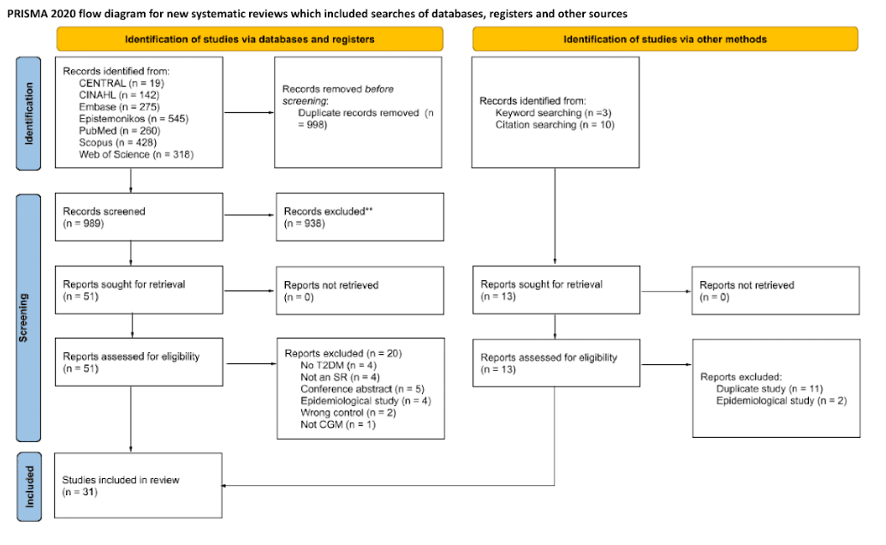
eFigure1: PRISMA flow chart of study inclusion and exclusion for this umbrella review of systematic reviews evaluating the effectiveness of continuous glucose monitoring. Studies included in this review spanned a publication year range of 2011 to 2024.

2. AMSTAR Risk-Of-Bias Plots
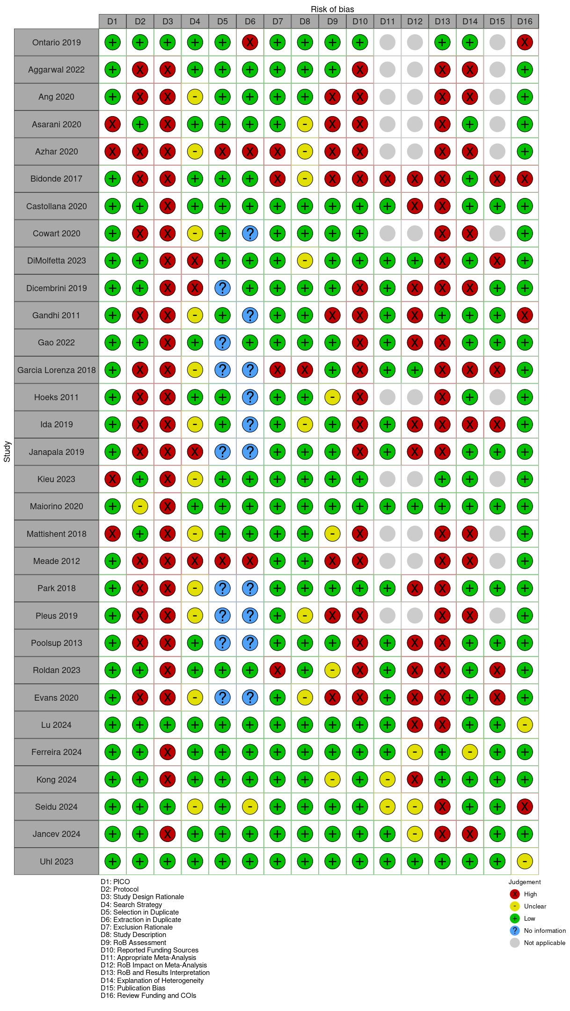
eFigure 2a AMSTAR-2 risk-of-bias assessment, by study, for this umbrella review of systematic reviews evaluating the effectiveness of continuous glucose monitoring. Studies included in this review spanned a publication year range of 2011 to 2024.

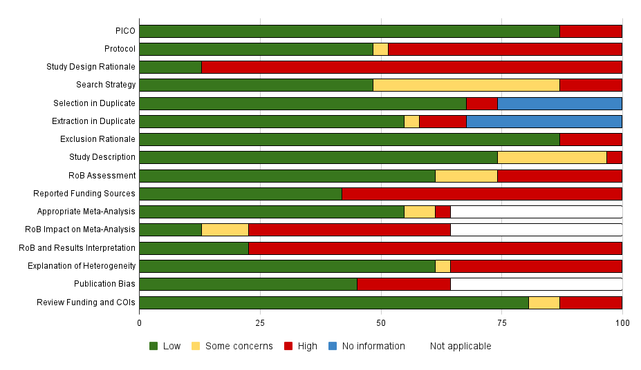
eFigure 2b AMSTAR-2 risk-of-bias assessment, by domain, for this umbrella review of systematic reviews evaluating the effectiveness of continuous glucose monitoring. Studies included in this review spanned a publication year range of 2011 to 2024.

3. GROOVE Analyses
(a) Overall
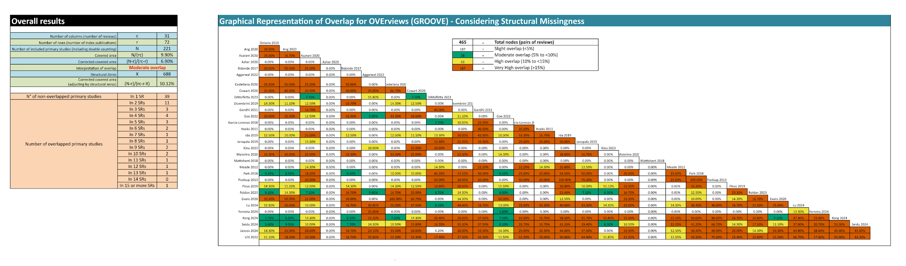
(b) HbA1c
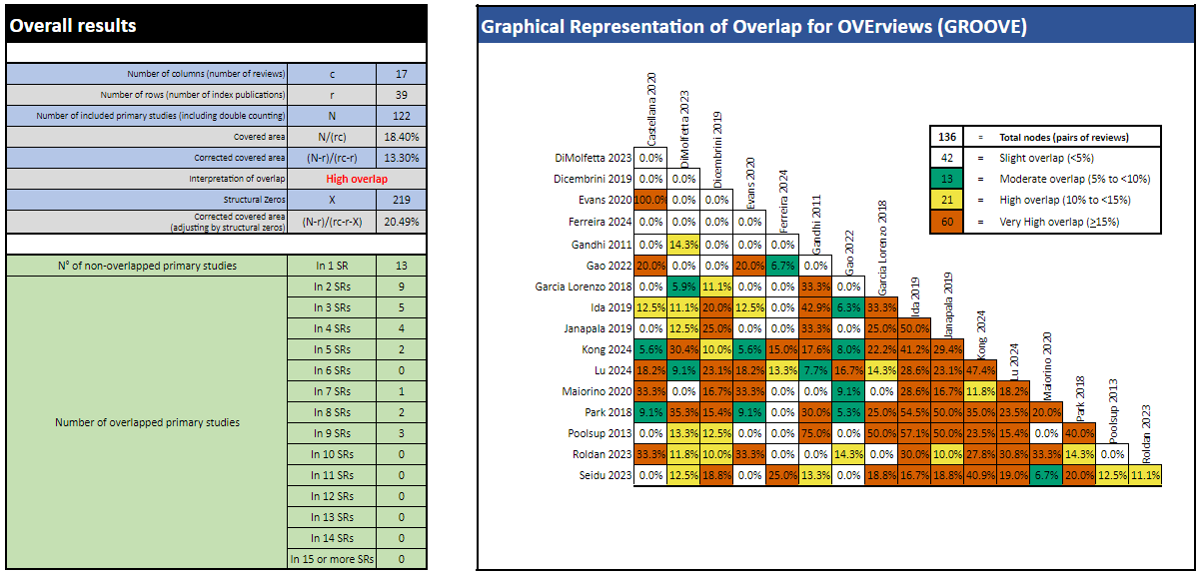
(c) TIR
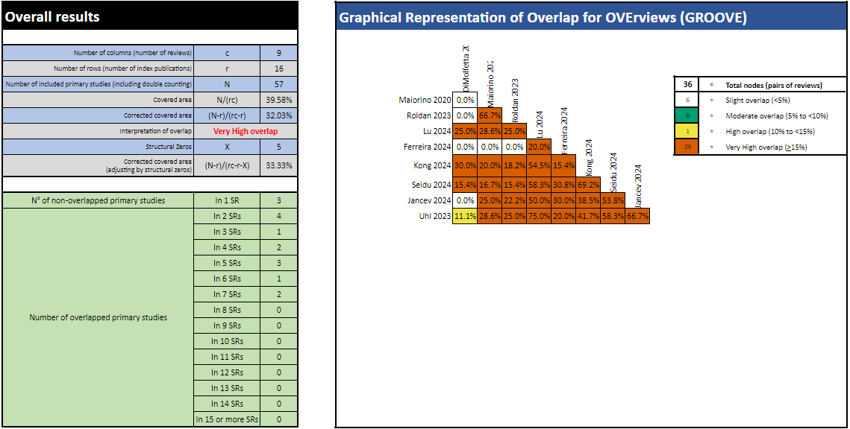
(d) TAR
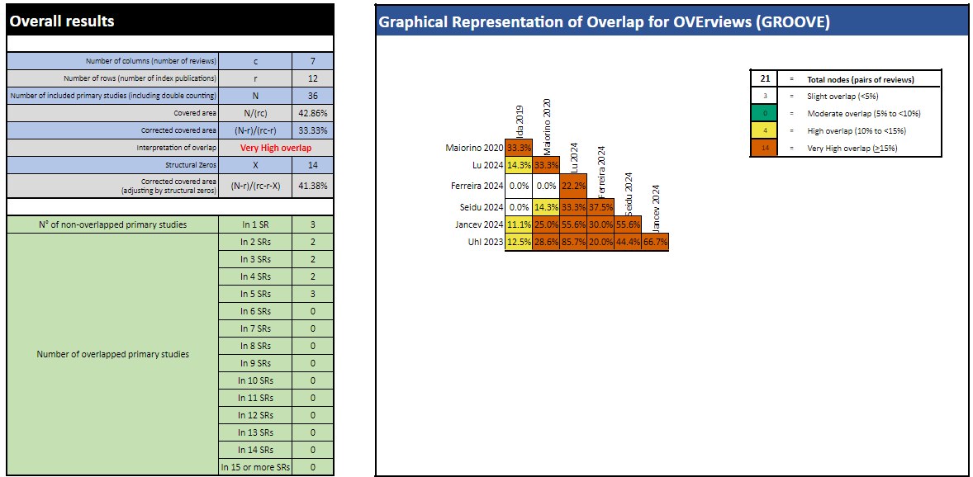
(e) TBR
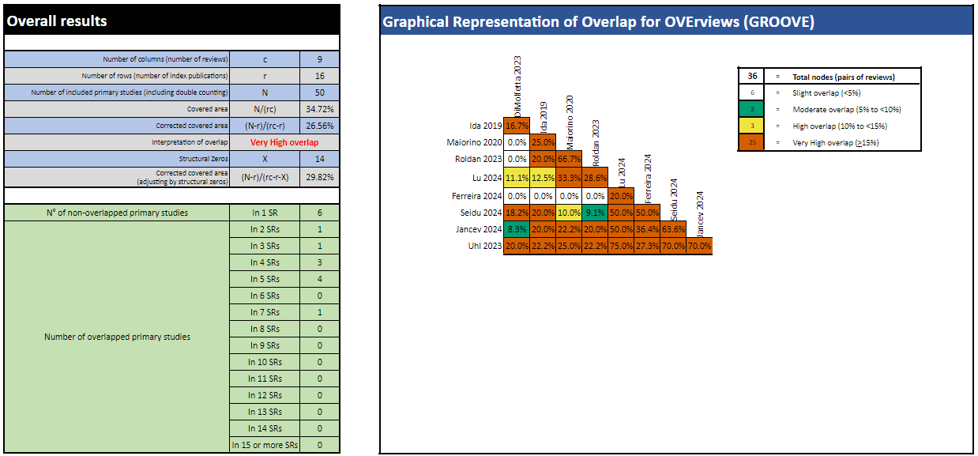
(f) PROM
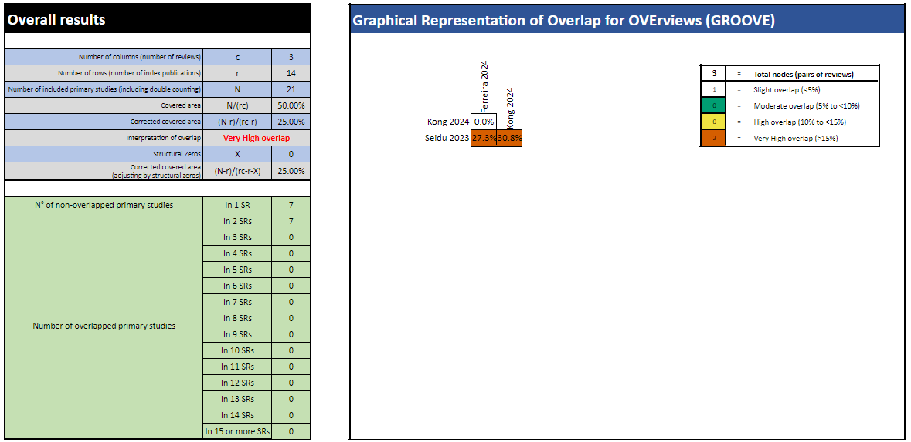

eFigure 3a-e: Overlap analysis summary and GROOVE overlap matrices for (a) overall T2DM studies included across SRs, and meta-analyses pooling (b) HbA1c, (c) TIR, (d) TAR, (e) TBR, (f) PROM, for this umbrella review of systematic reviews evaluating the effectiveness of continuous glucose monitoring. Studies included in this review spanned a publication year range of 2011 to 2024.

Legend: PROM = patient-reported outcome measures, TAR = time-above-range, TBR = time-below-range, TIR = time-in-range, T2DM = Type 2 Diabetes Mellitus

4. Funnel Plots
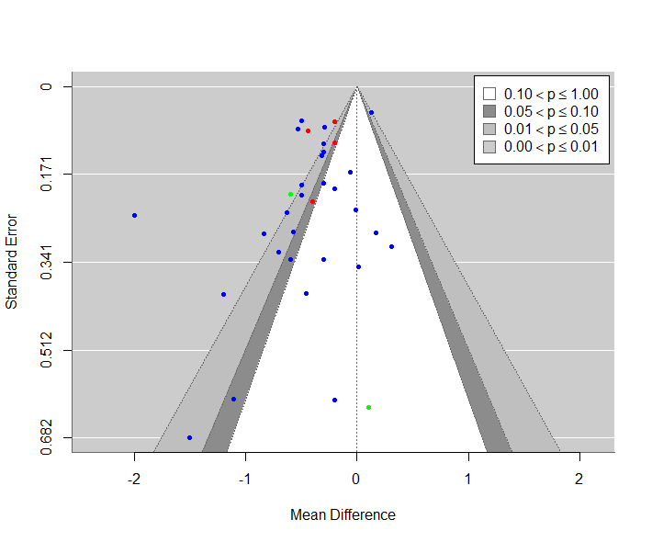
eFigure 4a Funnel plot visualising possible publication bias for the meta-analysis of primary studies comparing effectiveness of CGM against SMBG/UC between 2008 to 2022 by pooling for mean difference in prepost HbA1c change between CGM and SMBG/UC users across all studies, color-coded by study type [Blue = RCTs, Green =NRCTs , Red = Retrospective NRSIs]

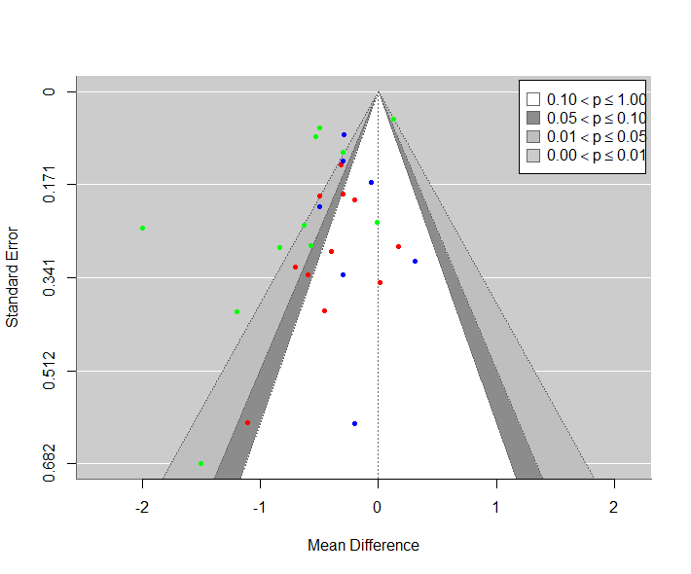
eFigure 4b Funnel plot visualizing possible publication bias for the meta-analysis of primary studies comparing effectiveness of CGM against SMBG/UC between 2008 to 2022 by pooling for mean difference in prepost HbA1c change between CGM and SMBG/UC users across RCT studies only, color-coding for CGM modality. [Blue =rCGM, Green = FGM, Red = rtCGM]

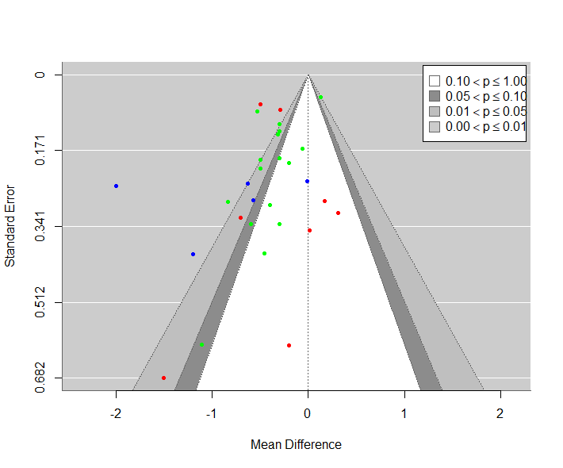
eFigure 4c Funnel plot visualising possible publication bias for the meta-analysis of primary studies comparing effectiveness of CGM against SMBG/UC between 2008 to 2022 by pooling for mean difference in prepost HbA1c change between CGM and SMBG/UC users across RCT studies only, color-coding for funding status. [Blue = Not reported, Green = Commercially funded, Red = Not funded]

(d) Time-in-range
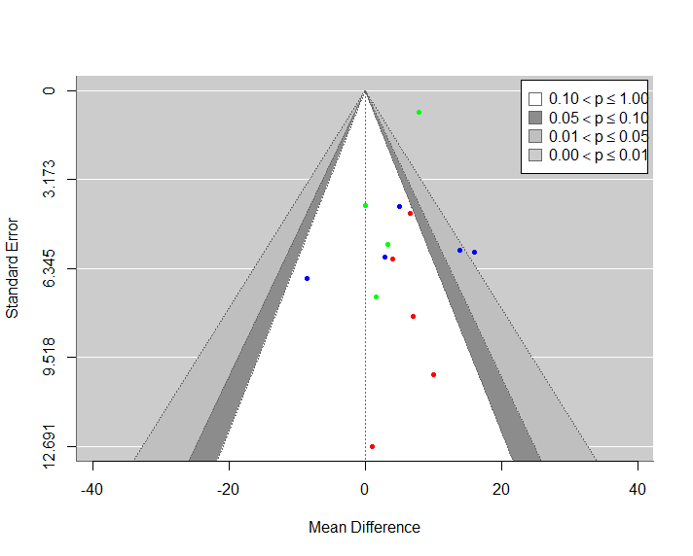
(e) Time-above-range
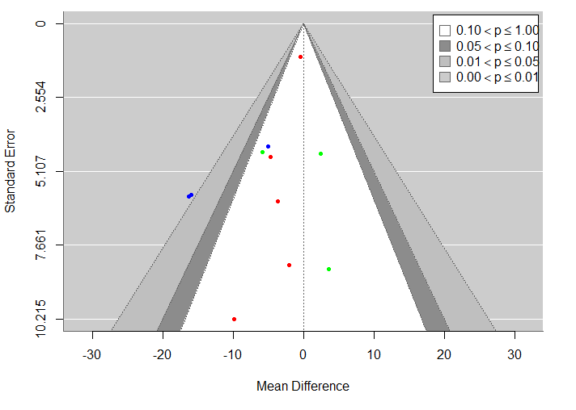

(f) Time-below-range
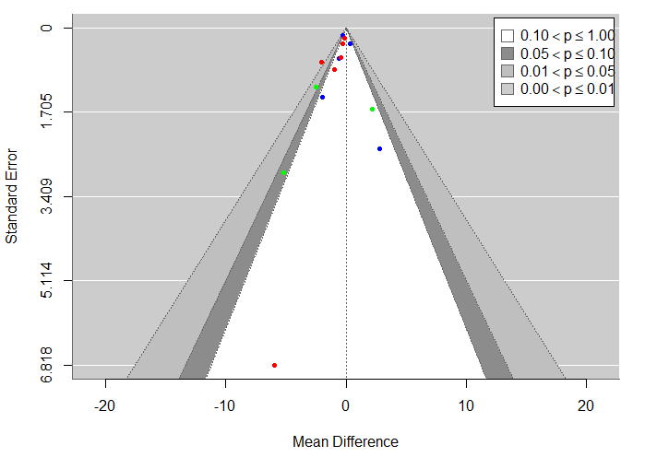

eFigure 4d-f Funnel plot visualising possible publication bias for the meta-analysis of primary studies comparing effectiveness of CGM against SMBG/UC between 2009 to 2023 by pooling for mean difference in (d) prepost change in time-in-range, (e) prepost change in time-above-range, (f) prepost change in time-below-range. eFigure 4d-f were color coded by CGM modality. [Blue =rCGM, Green = FGM, Red = rtCGM]

5. Prepost HbA1c Forest Plots
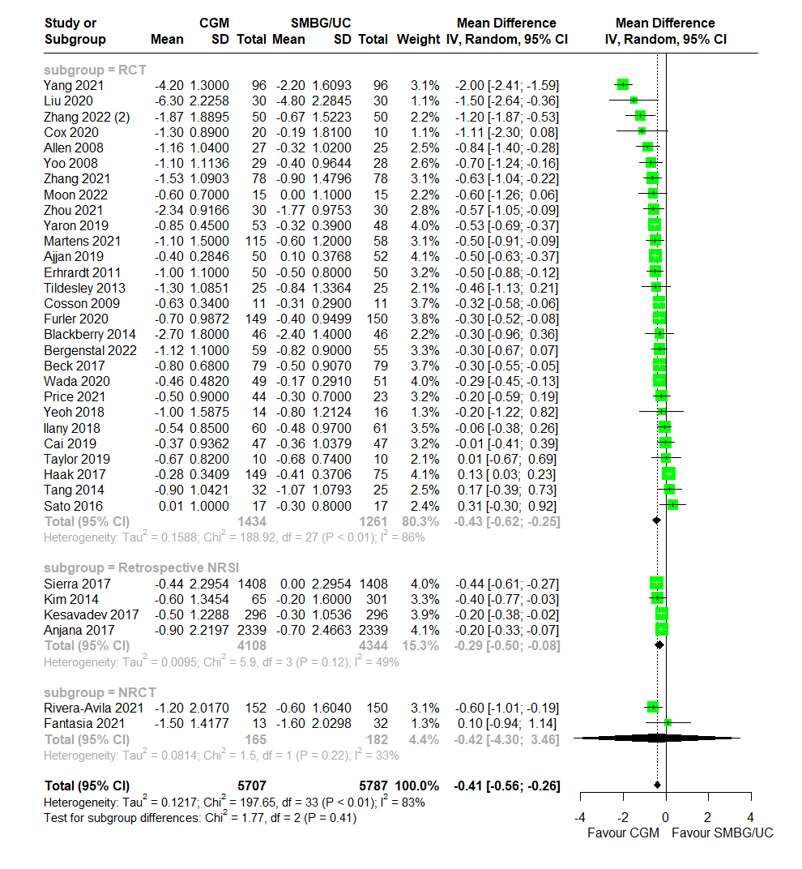
eFigure 5a Forest plot for meta-analysis of primary studies comparing effectiveness of CGM against SMBG/UC between 2008 to 2022 by pooling the mean difference in prepost HbA1c (%) change between CGM and SMBG/UC users across all studies, subgrouped by study type. Correlation coefficient for imputation set at 0.5. CGM significantly associated with greater HbA1c decrease over SMBG/UC (MD = -0.41 , 95% CI: -0.56 to -0.26)

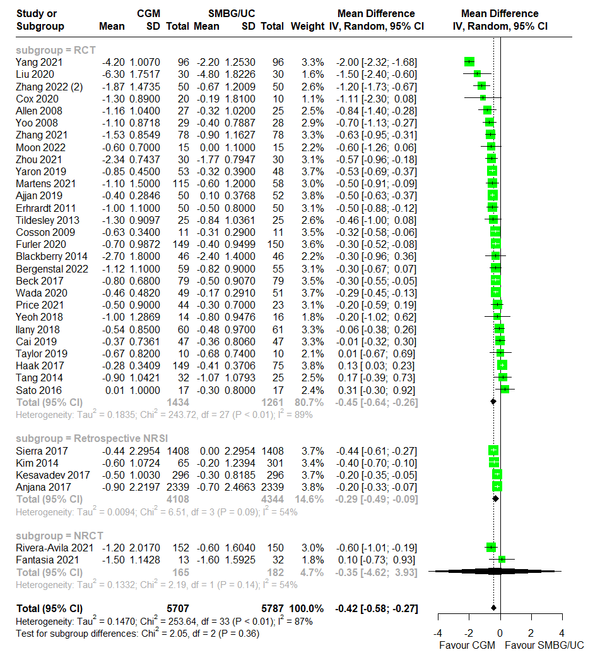
eFigure 5b Forest plot for meta-analysis of primary studies comparing effectiveness of CGM against SMBG/UC between 2008 to 2022 by pooling the mean difference in prepost HbA1c (%) change between CGM and SMBG/UC users across all studies, subgrouped by study type. Correlation coefficient for imputation set at 0.7. CGM significantly associated with greater HbA1c decrease over SMBG/UC (MD = -0.42, 95% CI: -0.58 to -0.27)

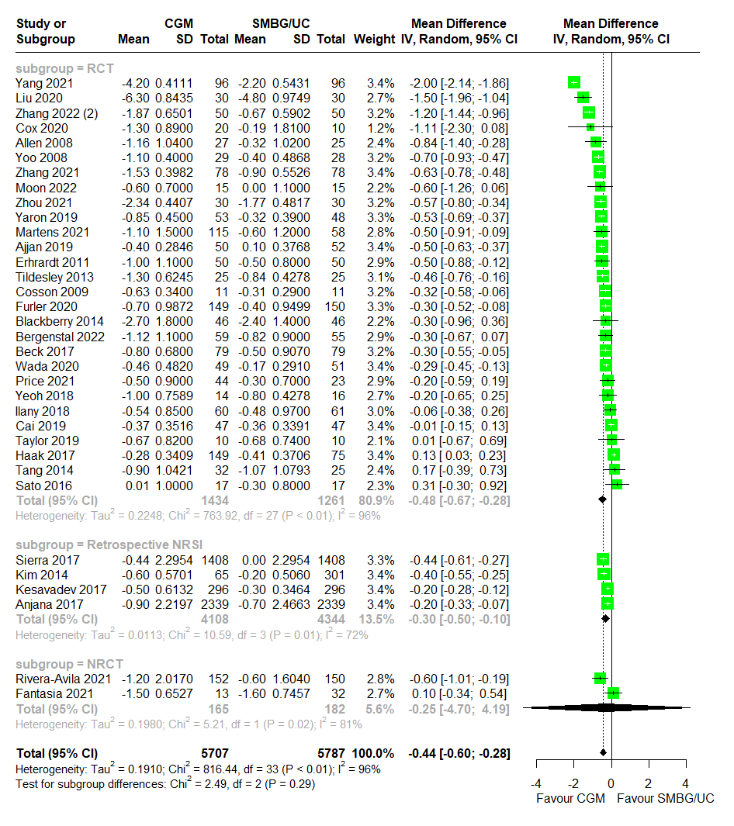
eFigure 5c Forest plot for meta-analysis of primary studies comparing effectiveness of CGM against SMBG/UC between 2008 to 2022 by pooling the mean difference in prepost HbA1c (%) change between CGM and SMBG/UC users across all studies, subgrouped by study type. Correlation coefficient for imputation set at 0.95. CGM significantly associated with greater HbA1c decrease over SMBG/UC (MD = -0.44 , 95% CI: -0.60 to -0.28)

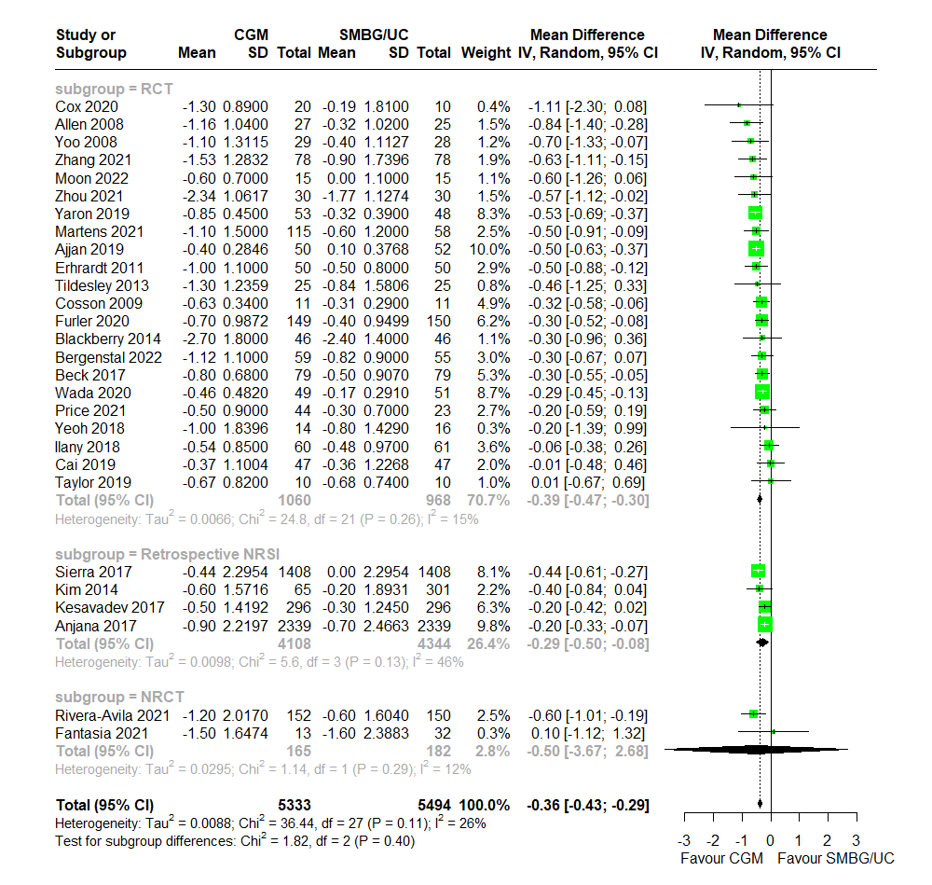
eFigure 5d Forest plot for meta-analysis of primary studies comparing effectiveness of CGM against SMBG/UC between 2008 to 2022 by pooling the mean difference in prepost HbA1c (%) change between CGM and SMBG/UC users across all studies with outliers identified by Baujat plot removed, subgrouped by study type. Correlation coefficient for imputation set at 0.3. CGM significantly associated with greater HbA1c decrease over SMBG/UC (MD = -0.36 , 95% CI: -0.43 to -0.29)

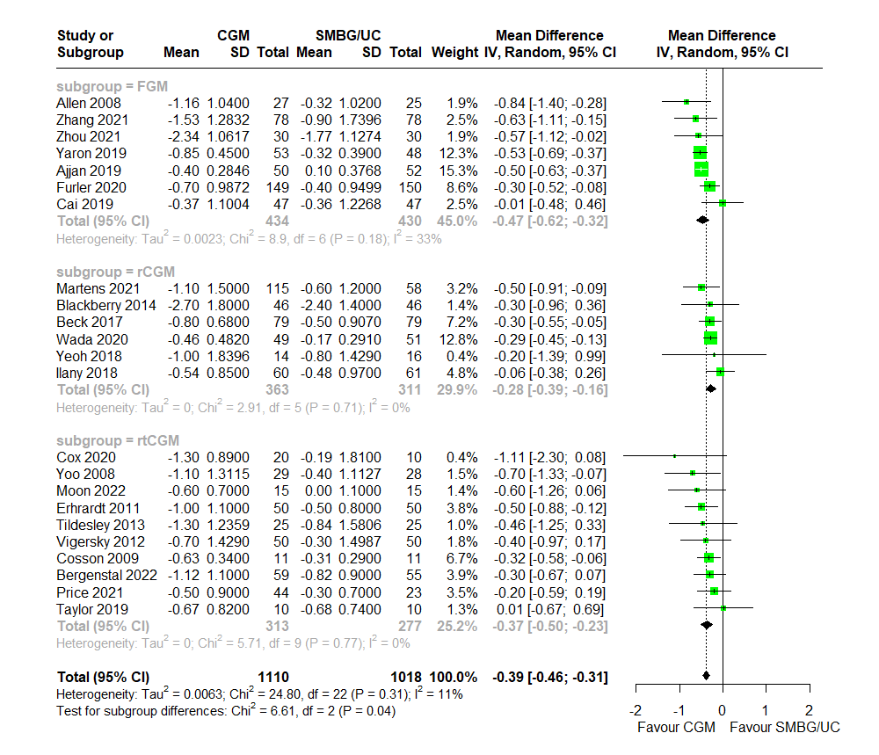
eFigure 5e Forest plot for meta-analysis of primary studies comparing effectiveness of CGM against SMBG/UC between 2008 to 2022 by pooling the mean difference in prepost HbA1c (%) change between CGM and SMBG/UC users across RCTs with outliers identified by Baujat plot removed, subgrouped by CGM modality. Correlation coefficient for imputation set at 0.3. CGM significantly associated with greater HbA1c decrease over SMBG/UC (MD = -0.39 , 95% CI: -0.46 to -0.31)

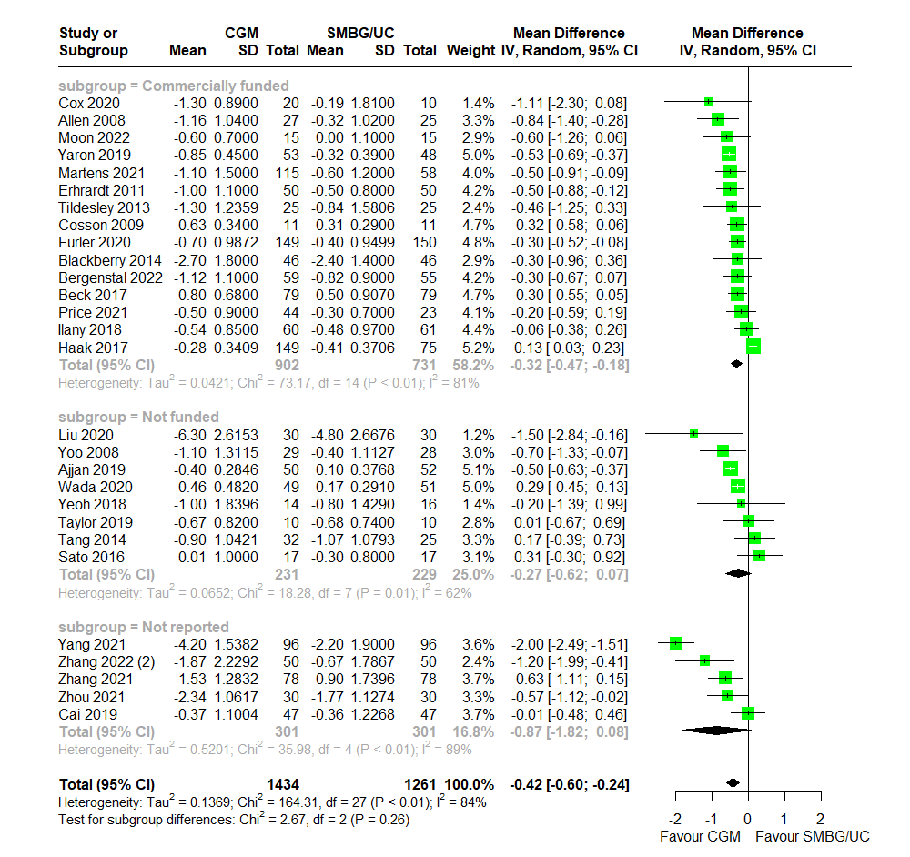
eFigure 5f Forest plot for meta-analysis of primary studies comparing effectiveness of CGM against SMBG/UC between 2008 to 2022 by pooling the mean difference in prepost HbA1c (%) change between CGM and SMBG/UC users across RCTs, subgrouped by funding status. Correlation coefficient for imputation set at 0.3. CGM significantly associated with greater HbA1c decrease over SMBG/UC (MD = -0.42 , 95% CI: -0.60 to -0.24). No significant differences between subgroups (p = 0.26).

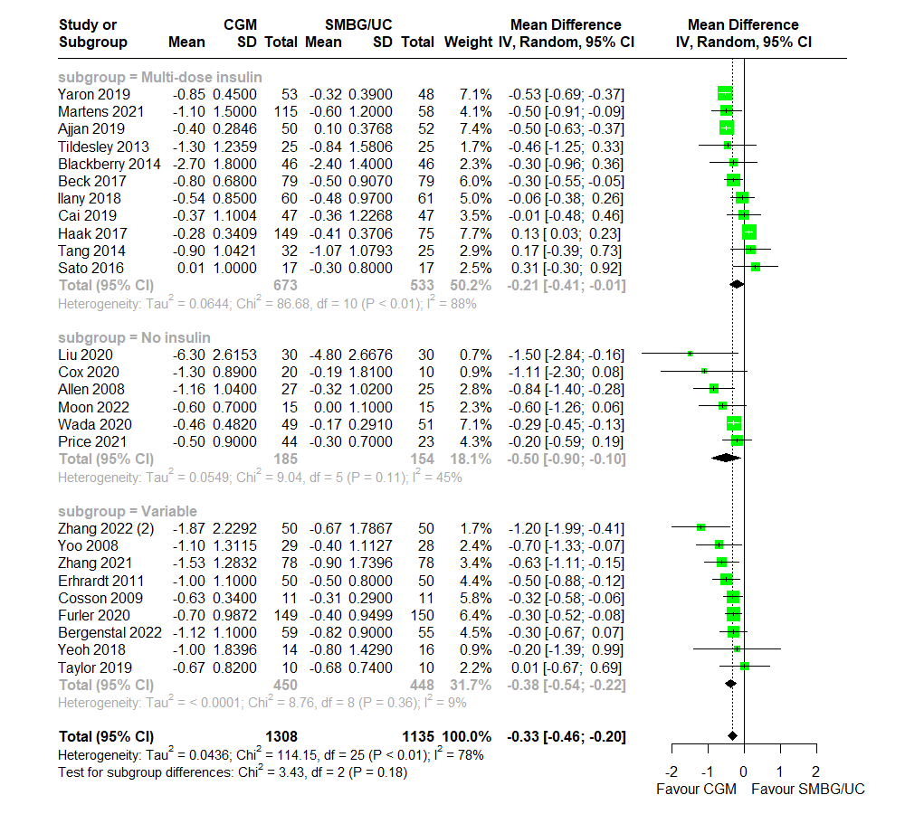
eFigure 5g Forest plot for meta-analysis of primary studies comparing effectiveness of CGM against SMBG/UC between 2008 to 2022 by pooling the mean difference in prepost HbA1c (%) change between CGM and SMBG/UC users across RCTs, subgrouped by insulin therapy. Correlation coefficient for imputation set at 0.3. CGM significantly associated with greater HbA1c decrease over SMBG/UC (MD = -0.33 , 95% CI: -0.46 to -0.20) No significant differences between subgroups (p = 0.17).

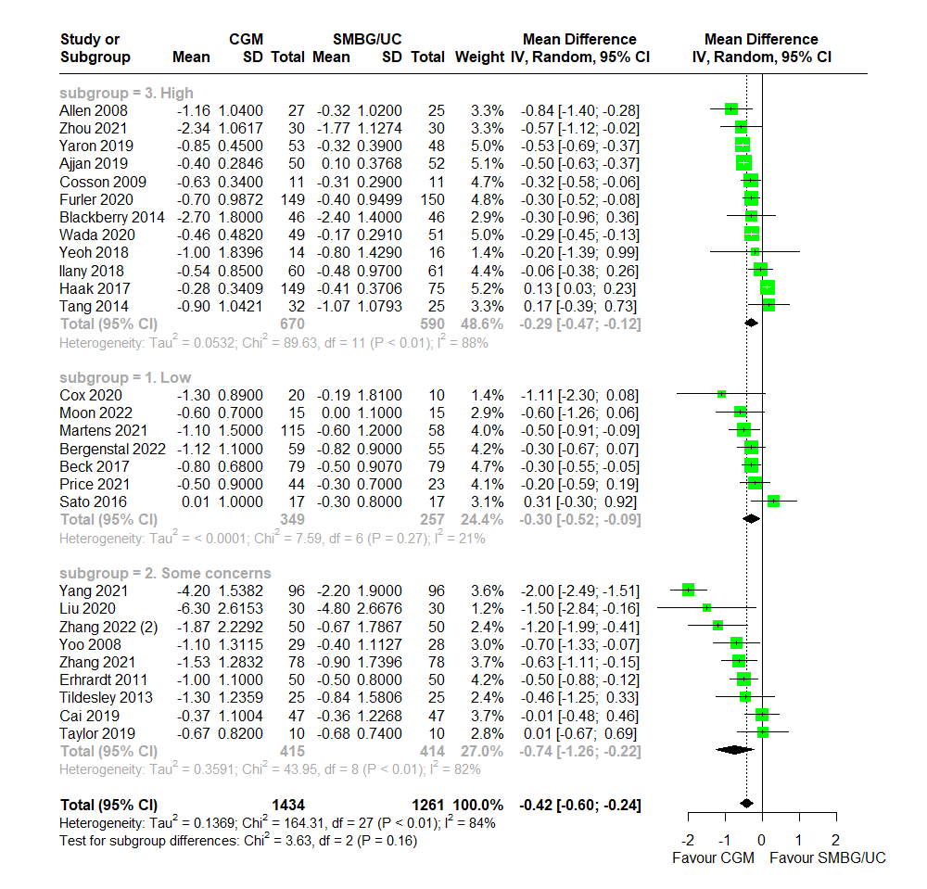
eFigure 5h Forest plot for meta-analysis of primary studies comparing effectiveness of CGM against SMBG/UC between 2008 to 2022 by pooling the mean difference in prepost HbA1c (%) change between CGM and SMBG/UC users across RCTs, subgrouped by risk-of-bias. Correlation coefficient for imputation set at 0.3. CGM significantly associated with greater HbA1c decrease over SMBG/UC (MD = -0.42 , 95% CI: -0.60 to -0.24). No significant differences between subgroups (p = 0.17).

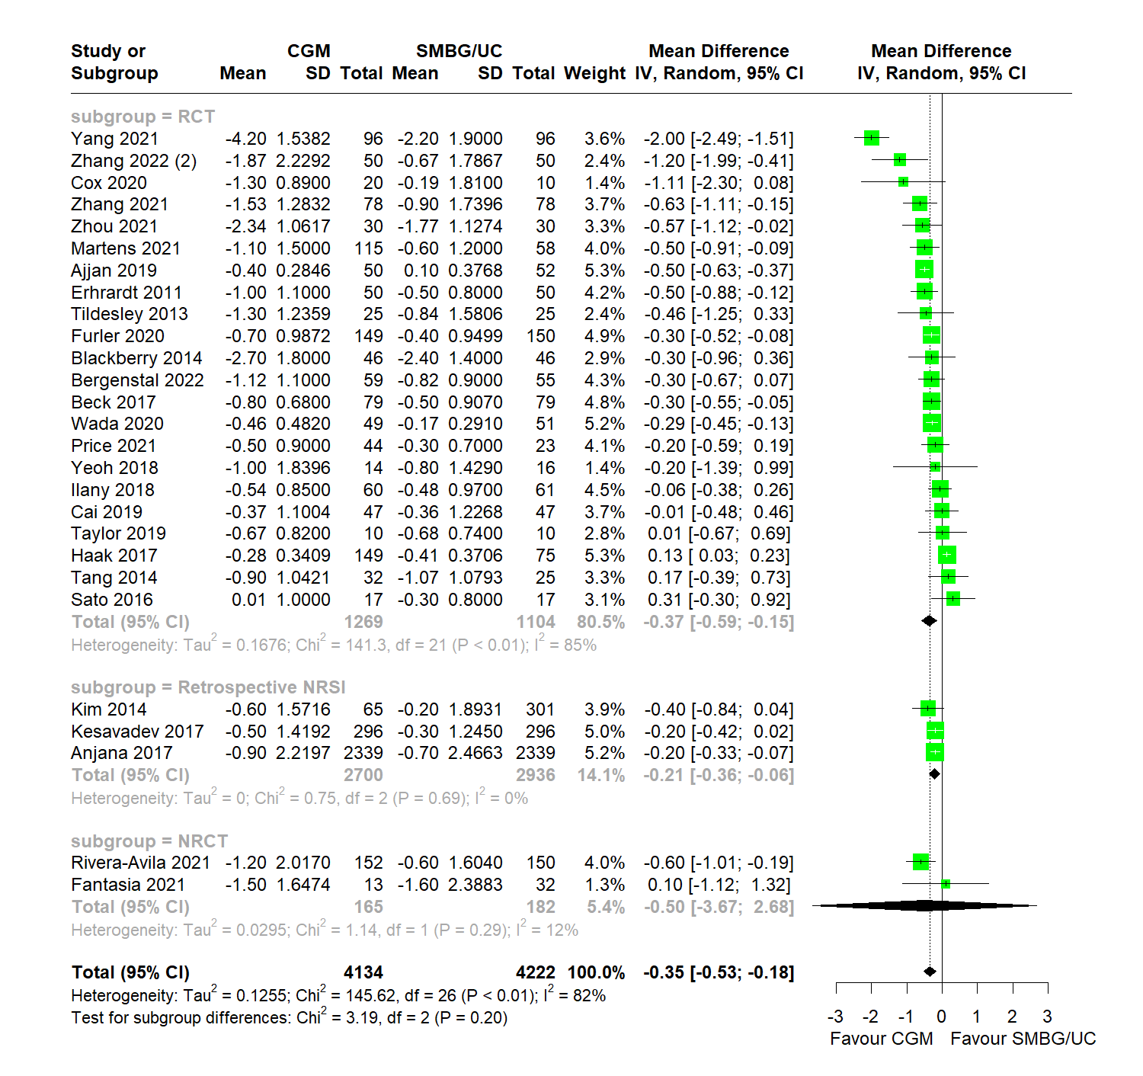
eFigure 5i Forest plot for meta-analysis of primary studies comparing effectiveness of CGM against SMBG/UC between 2011 to 2022 by pooling the mean difference in prepost HbA1c (%) change between CGM and SMBG/UC users across all studies with a follow-up duration of three months or more, subgrouped by study type. Correlation coefficient for imputation set at 0.3. CGM significantly associated with greater HbA1c decrease over SMBG/UC (MD = -0.35 , 95% CI: -0.53 to -0.18)

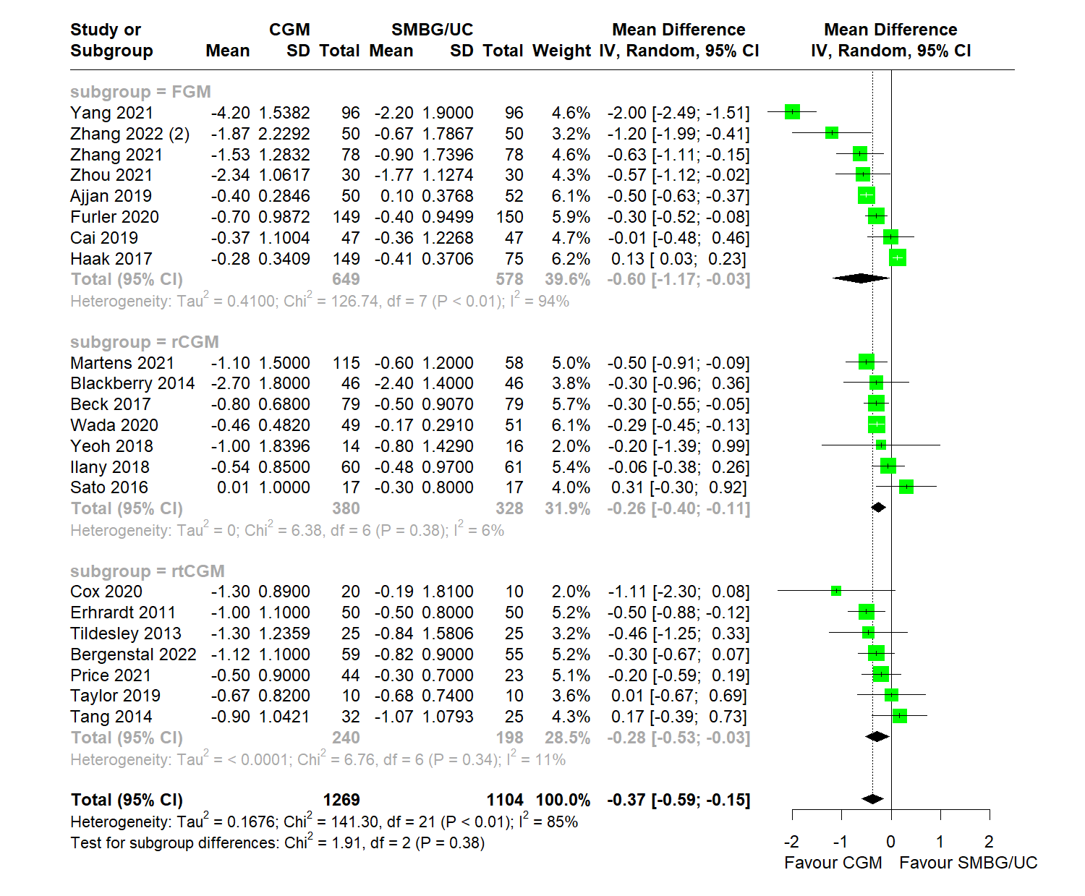
eFigure 5i Forest plot for meta-analysis of primary studies comparing effectiveness of CGM against SMBG/UC between 2011 to 2022 by pooling the mean difference in prepost HbA1c (%) change between CGM and SMBG/UC users across all RCTs with a follow-up duration of three months or more, subgrouped by type of CGM. Correlation coefficient for imputation set at 0.3. CGM significantly associated with greater HbA1c decrease over SMBG/UC (MD = -0.37 , 95% CI: -0.59 to -0.15)

6. Follow-up HbA1c Forest Plots
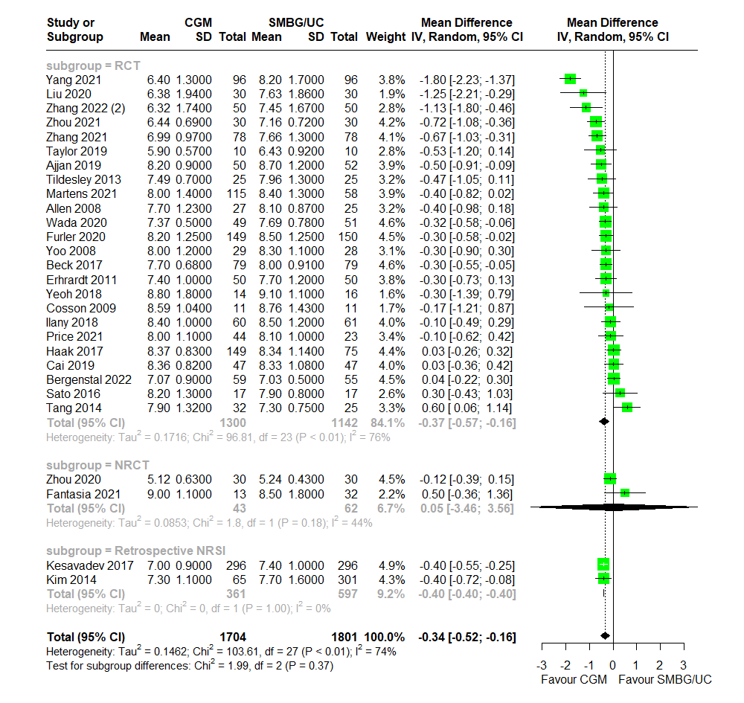
eFigure 6a Forest plot for meta-analysis of primary studies comparing effectiveness of CGM against SMBG/UC between 2008 to 2022 by pooling the mean difference in follow-up HbA1c (%) between CGM and SMBG/UC users across all studies, subgrouped by study type. CGM significantly associated with lower endpoint HbA1c (%) than SMBG/UC (MD = -0.34 , 95% CI: -0.52 to -0.16). No significant differences between subgroups (p = 0.38).

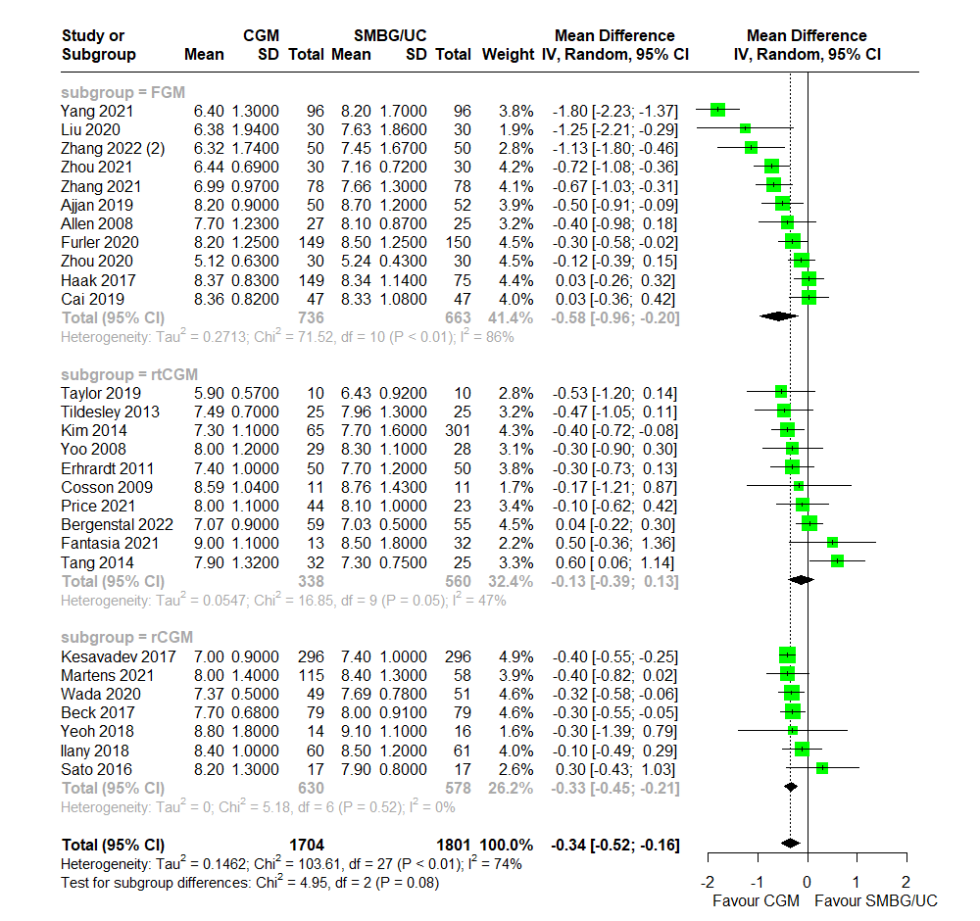
eFigure 6b Forest plot for meta-analysis of primary studies comparing effectiveness of CGM against SMBG/UC between 2008 to 2022 by pooling the mean difference in follow-up HbA1c (%) between CGM and SMBG/UC users across all studies, subgrouped by CGM modality. CGM significantly associated with lower endpoint HbA1c (%) than SMBG/UC (MD = -0.34 , 95% CI: -0.52 to -0.16). No significant differences between subgroups (p = 0.07).

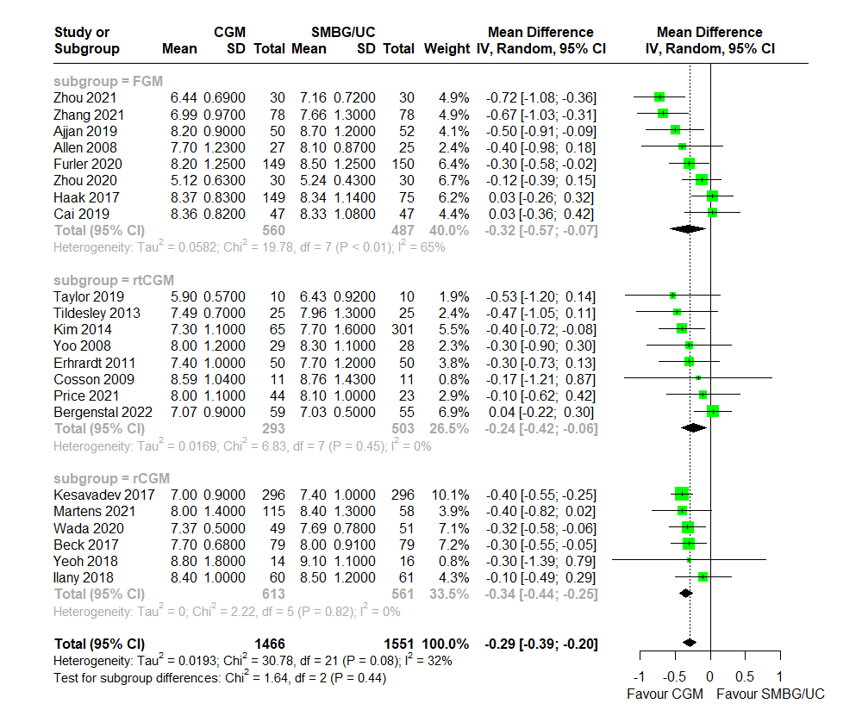
eFigure 6c Forest plot for meta-analysis of primary studies comparing effectiveness of CGM against SMBG/UC between 2008 to 2022 by pooling the mean difference in follow-up HbA1c (%) between CGM and SMBG/UC users across all studies with outliers identified by Baujat plot removed, subgrouped by CGM modality. CGM significantly associated with lower endpoint HbA1c (%) than SMBG/UC (MD = -0.29 , 95% CI: -0.39 to -0.20). No significant differences between subgroups (p = 0.79).

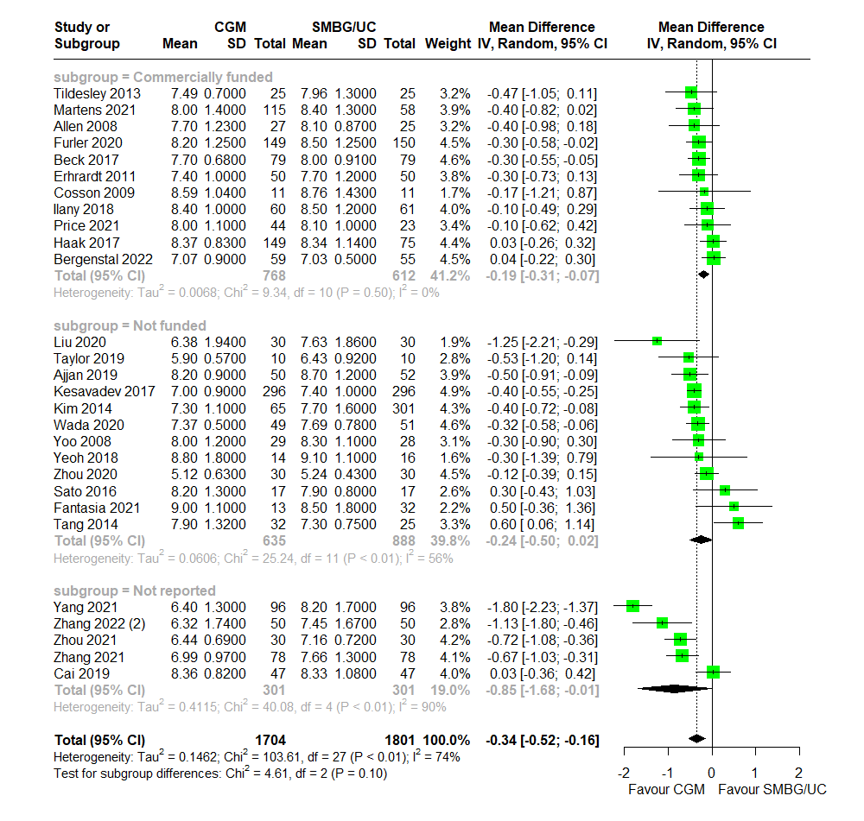
eFigure 6d Forest plot for meta-analysis of primary studies comparing effectiveness of CGM against SMBG/UC between 2008 to 2022 by pooling the mean difference in follow-up HbA1c (%) between CGM and SMBG/UC users across all studies, subgrouped by funding status. CGM significantly associated with lower endpoint HbA1c (%) than SMBG/UC (MD = -0.34 , 95% CI: -0.52 to -0.16). No significant differences between subgroups (p = 0.10).

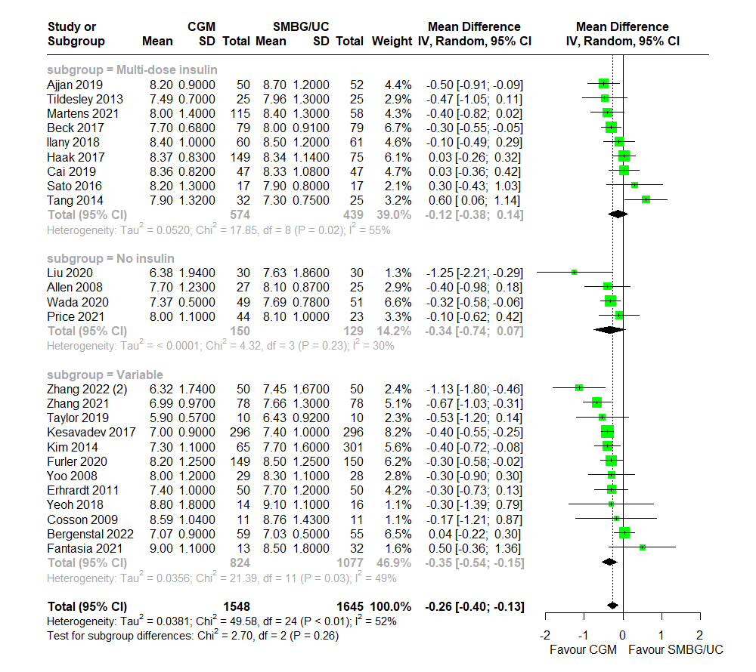
eFigure 6e Forest plot for meta-analysis of primary studies comparing effectiveness of CGM against SMBG/UC between 2008 to 2022 by pooling the mean difference in follow-up HbA1c (%) between CGM and SMBG/UC users across all studies, subgrouped by insulin treatment. CGM significantly associated with lower endpoint HbA1c (%) than SMBG/UC (MD = -0.26 , 95% CI: -0.40 to -0.13). No significant differences between subgroups (p = 0.26).

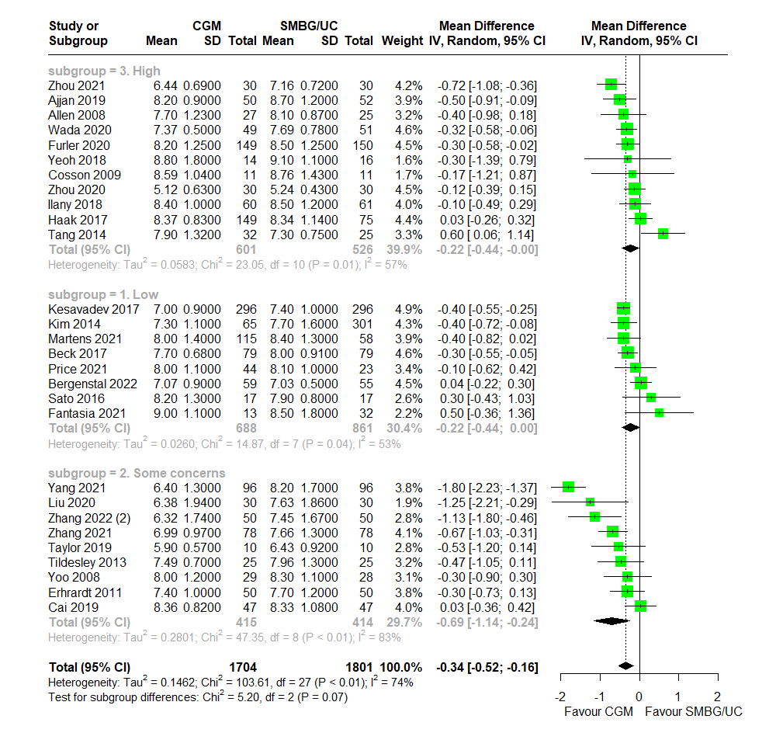
eFigure 6f Forest plot for meta-analysis of primary studies comparing effectiveness of CGM against SMBG/UC between 2008 to 2022 by pooling the mean difference in follow-up HbA1c (%) between CGM and SMBG/UC users across all studies, subgrouped by risk-of-bias. CGM significantly associated with lower endpoint HbA1c (%) than SMBG/UC (MD = -0.34 , 95% CI: -0.52 to -0.16). No significant differences between subgroups (p = 0.07).

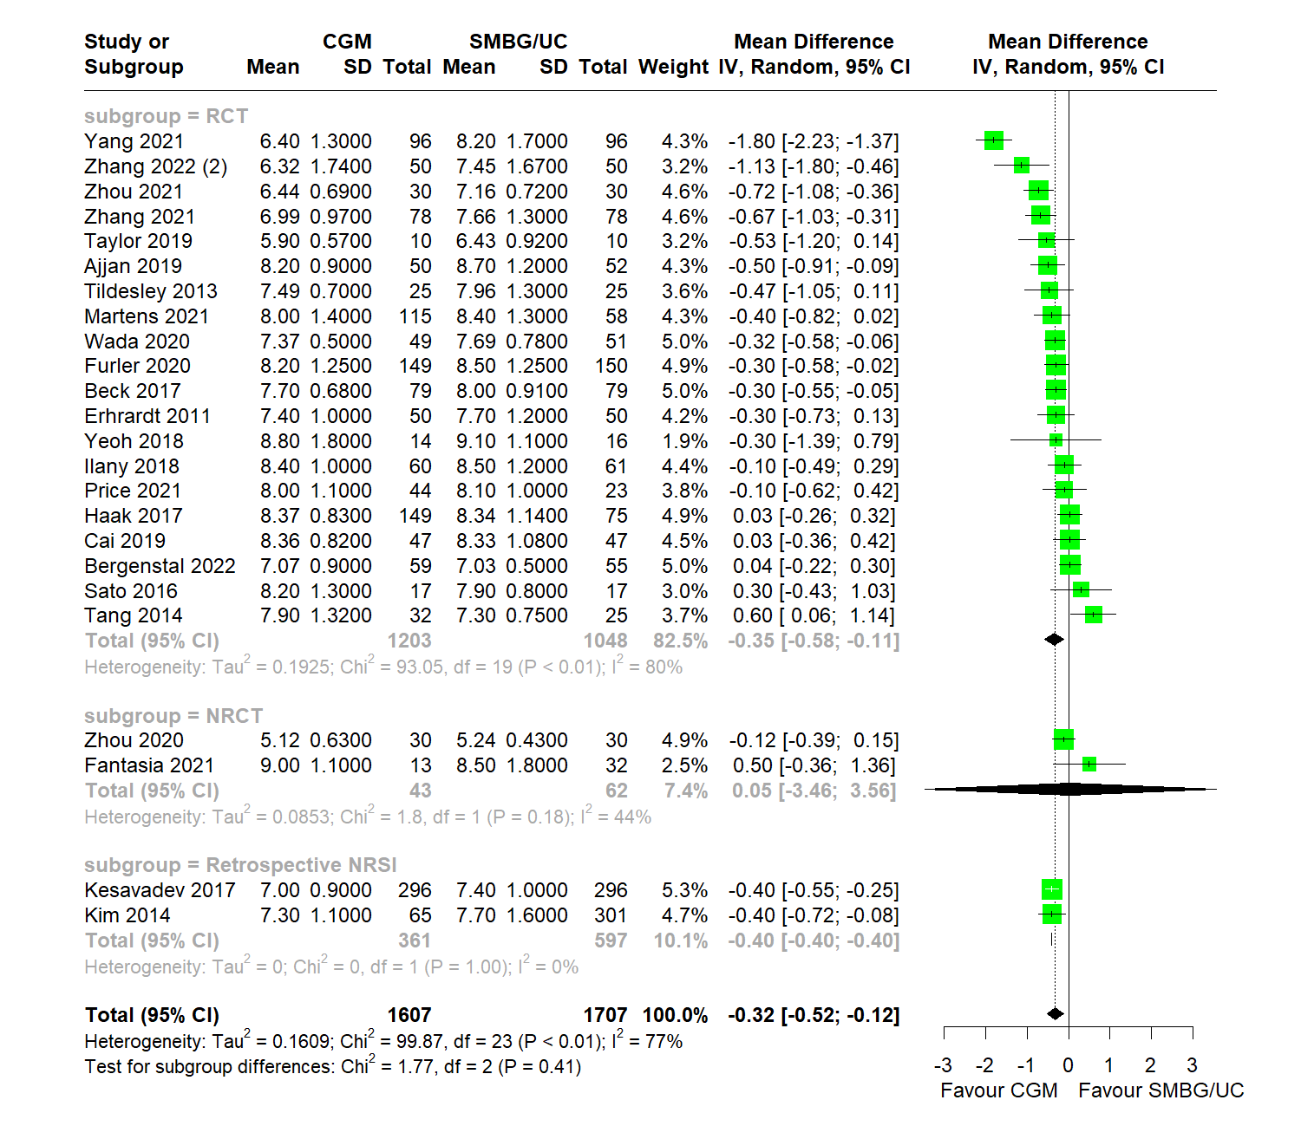
eFigure 6g Forest plot for meta-analysis of primary studies comparing effectiveness of CGM against SMBG/UC between 2013 to 2022 by pooling the mean difference in follow-up HbA1c (%) between CGM and SMBG/UC users across all studies with a follow-up duration of three months or more, subgrouped by study type. CGM significantly associated with lower endpoint HbA1c (%) than SMBG/UC (MD = -0.32 , 95% CI: -0.52 to -0.12). No significant differences between subgroups (p = 0.38).

7. Time-In-Range Forest Plots

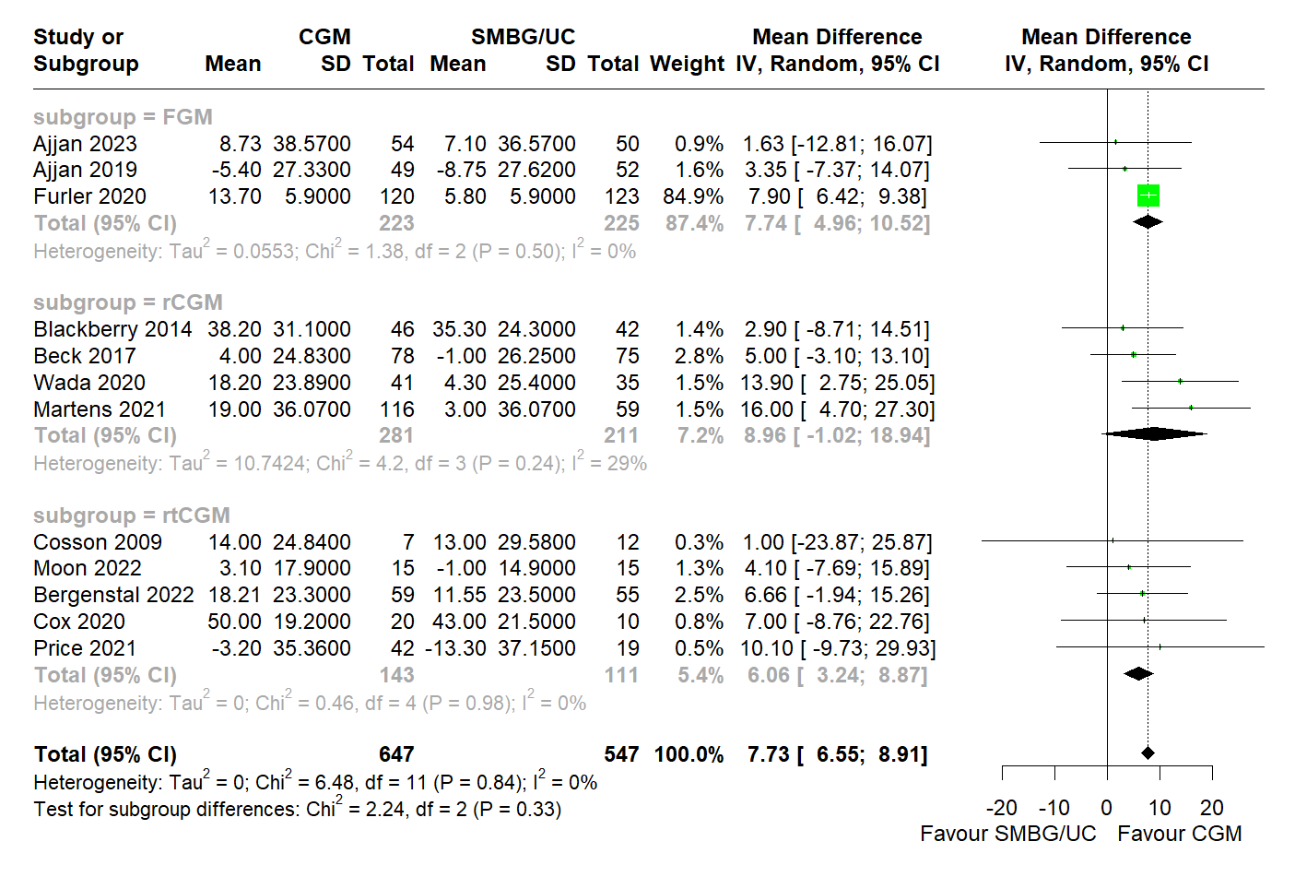
eFigure 7a: Forest plot for meta-analysis of primary studies comparing effectiveness of CGM against SMBG/UC between 2009 to 2023 by pooling the mean difference in prepost TIR change (% day) between CGM and SMBG/UC, with Baujat-informed outlier removal, subgrouped by CGM modality. CGM was significantly associated with greater TIR increase than SMBG/UC (MD = 7.73% , 95% CI: 6.55 to 8.91). No significant differences between subgroups (p = 0.33).

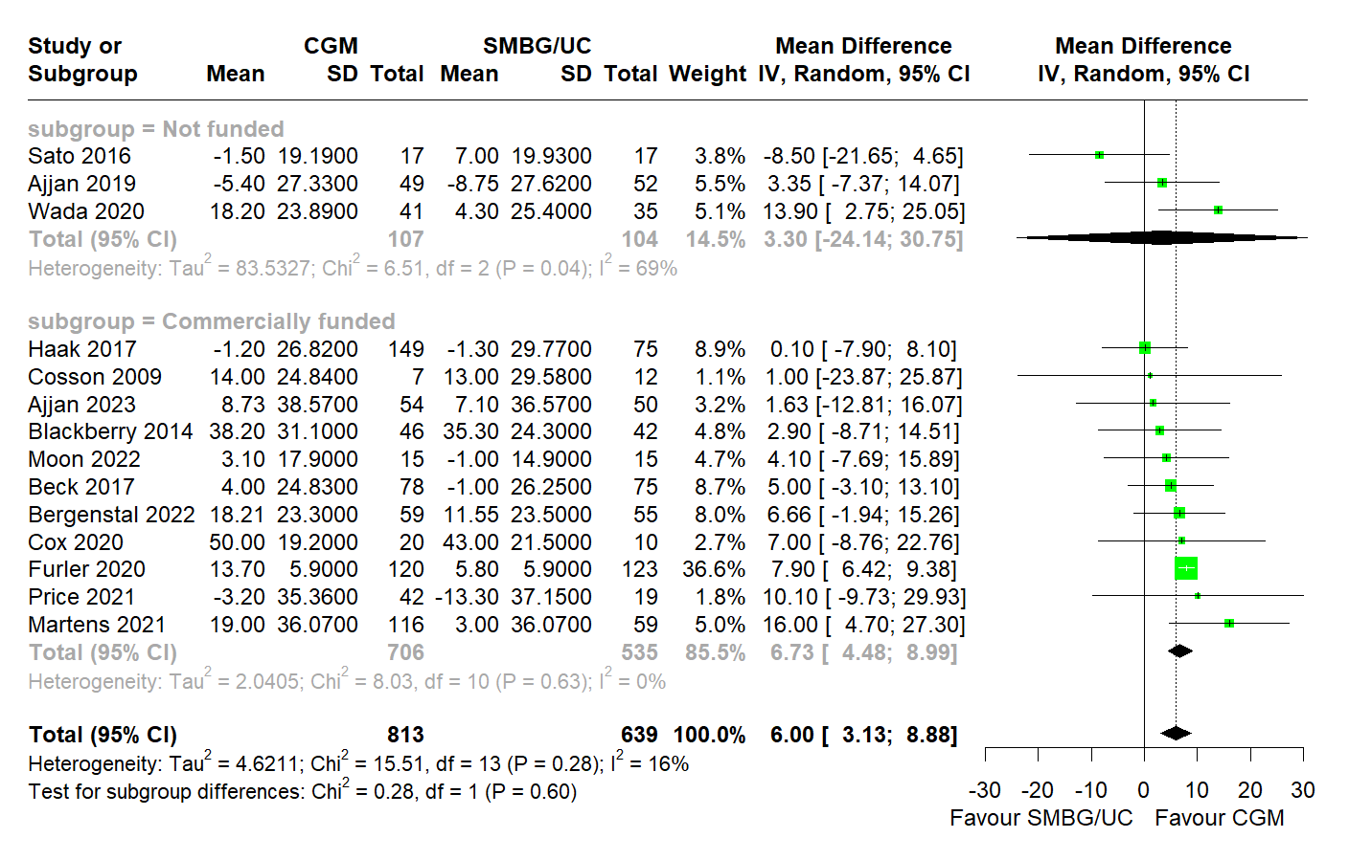
eFigure 7b: Forest plot for meta-analysis of primary studies comparing effectiveness of CGM against SMBG/UC between 2009 to 2023 by pooling the mean difference in prepost TIR change (% day) between CGM and SMBG/UC, subgrouped by funding. CGM was significantly associated with greater TIR increase than SMBG/UC (MD = 6.00% , 95% CI: 3.13 to 8.88). No significant differences between subgroups (p = 0.60).

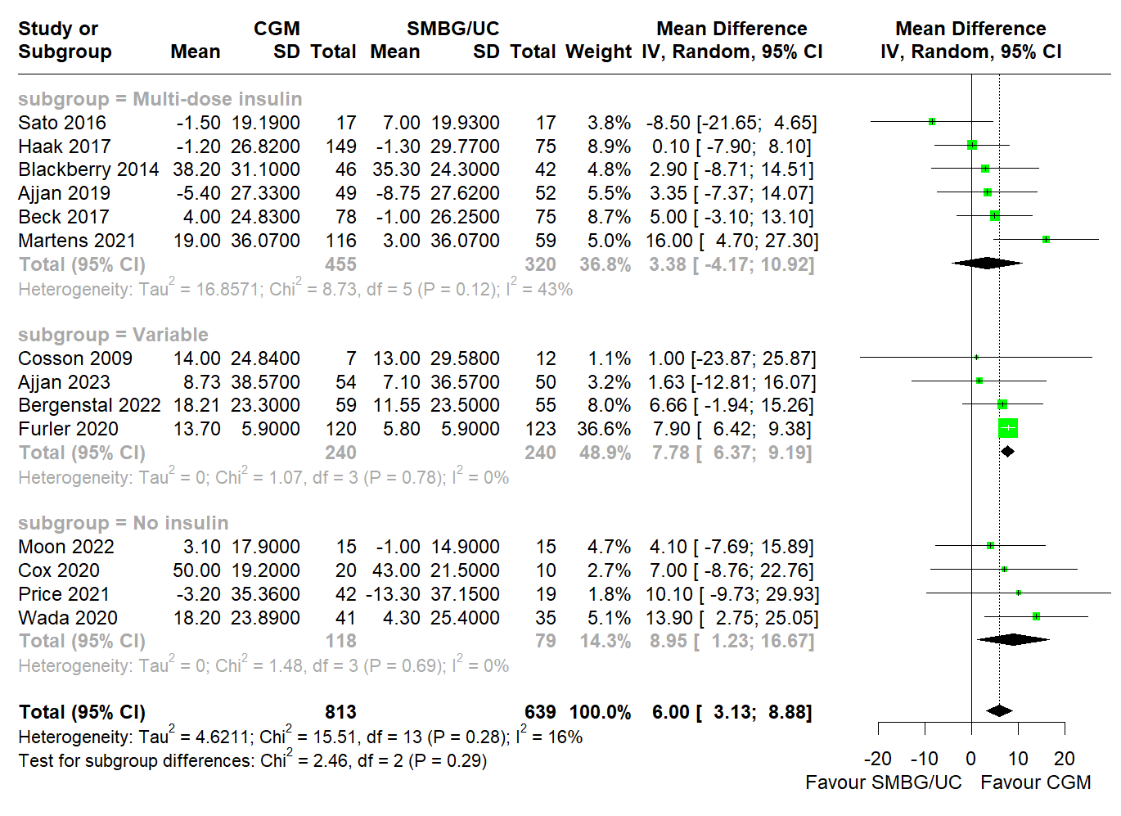
eFigure 7c: Forest plot for meta-analysis of primary studies comparing effectiveness of CGM against SMBG/UC between 2009 to 2023 by pooling the mean difference in prepost TIR change (% day) between CGM and SMBG/UC, subgrouped by insulin treatment. CGM was significantly associated with greater TIR increase than SMBG/UC (MD = 6.00% , 95% CI: 3.13 to 8.88). No significant differences between subgroups (p = 0.29).

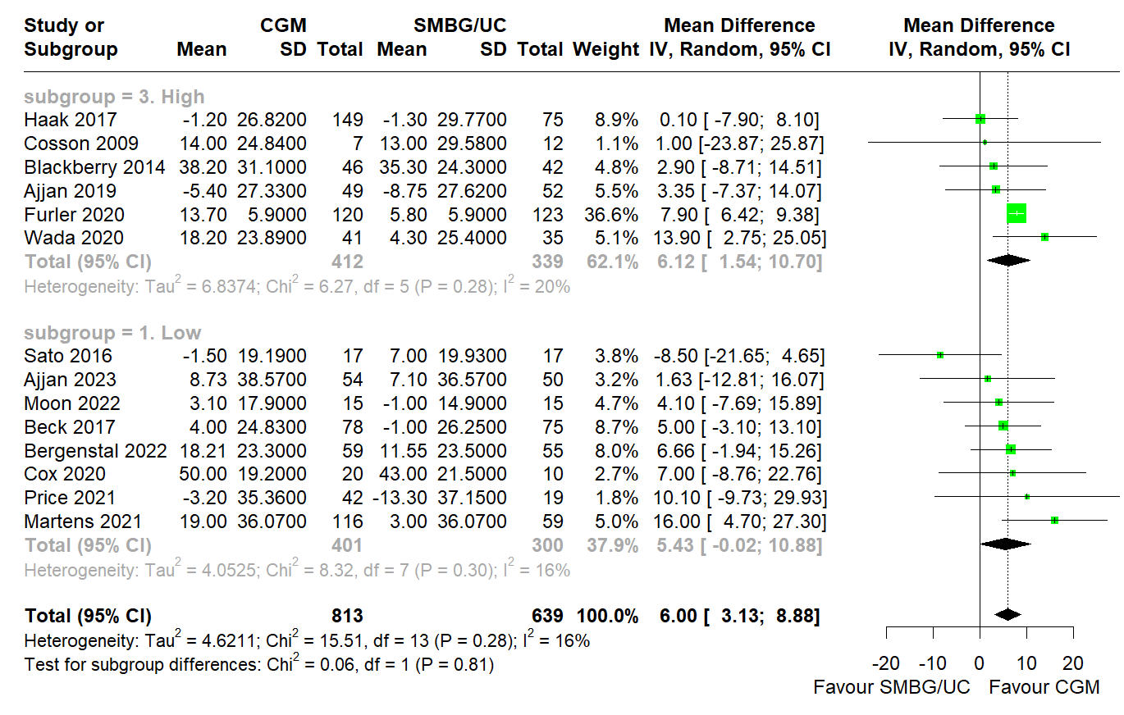
eFigure 7d: Forest plot for meta-analysis of primary studies comparing effectiveness of CGM against SMBG/UC between 2009 to 2023 by pooling the mean difference in prepost TIR change (% day) between CGM and SMBG/UC, subgrouped by risk-of-bias. CGM was significantly associated with greater TIR increase than SMBG/UC (MD = 6.00% , 95% CI: 3.13 to 8.88). No significant differences between subgroups (p = 0.81).

8. Time-Above-Range Forest Plots

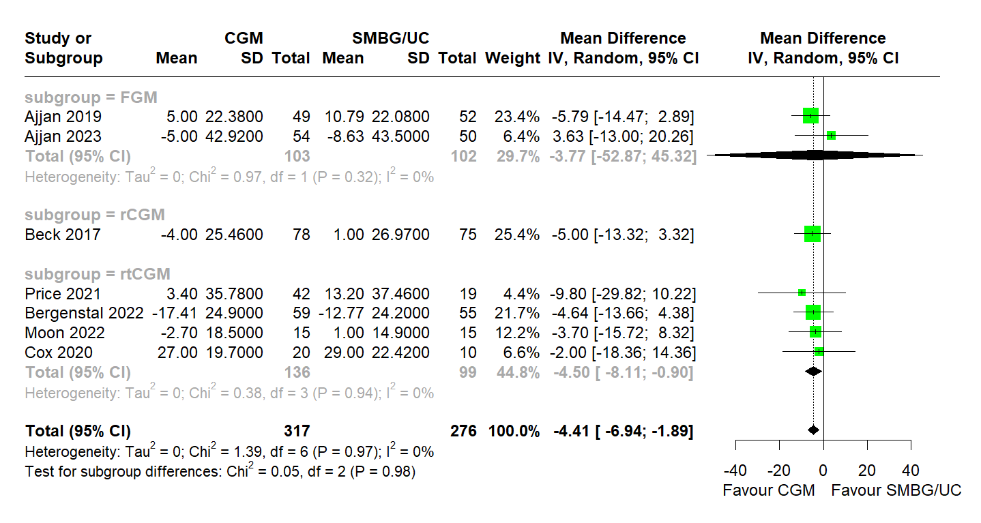
eFigure 8a: Forest plot for meta-analysis of primary studies comparing effectiveness of CGM against SMBG/UC between 2017 to 2023 by pooling the mean difference in prepost TAR change (% day) between CGM and SMBG/UC, with Baujat-informed outlier removal, subgrouped by CGM modality. CGM was significantly associated with greater TAR decrease than SMBG/UC (MD = -4.41% , 95% CI: -6.94 to -1.89). No significant differences between subgroups (p = 0.98).

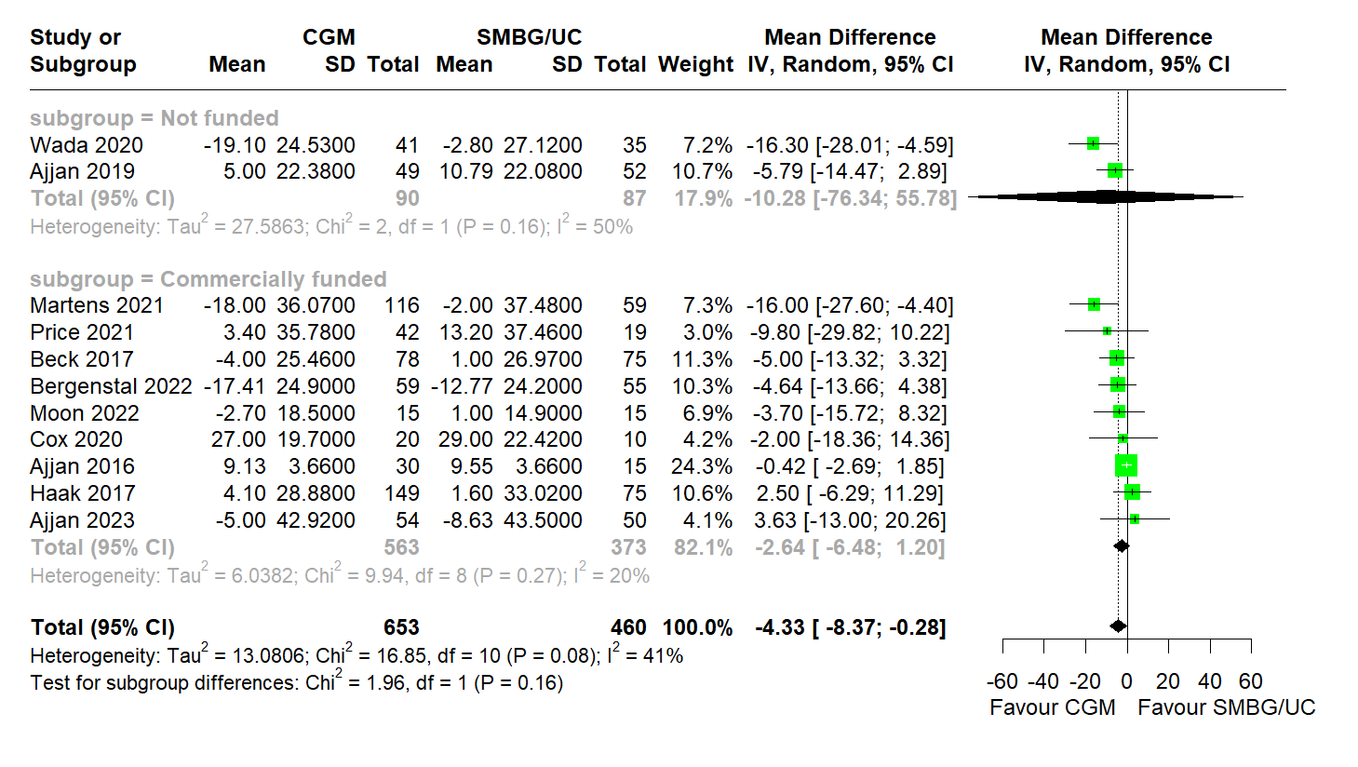
eFigure 8b: Forest plot for meta-analysis of primary studies comparing effectiveness of CGM against SMBG/UC between 2017 to 2023 by pooling the mean difference in prepost TAR change (% day) between CGM and SMBG/UC, subgrouped by funding. CGM was significantly associated with greater TAR decrease than SMBG/UC (MD= -4.33% [95%CI: -8.37 to -0.28]). No significant differences between subgroups (p = 0.16).

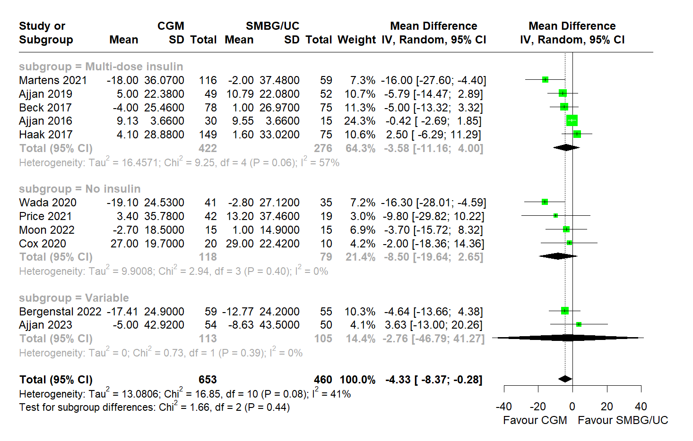
eFigure 8c: Forest plot for meta-analysis of primary studies comparing effectiveness of CGM against SMBG/UC between 2017 to 2023 by pooling the mean difference in prepost TAR change (% day) between CGM and SMBG/UC, subgrouped by insulin treatment. CGM was significantly associated with greater TAR decrease than SMBG/UC (MD= -4.33% [95%CI: -8.37 to -0.28]). No significant differences between subgroups (p = 0.44).

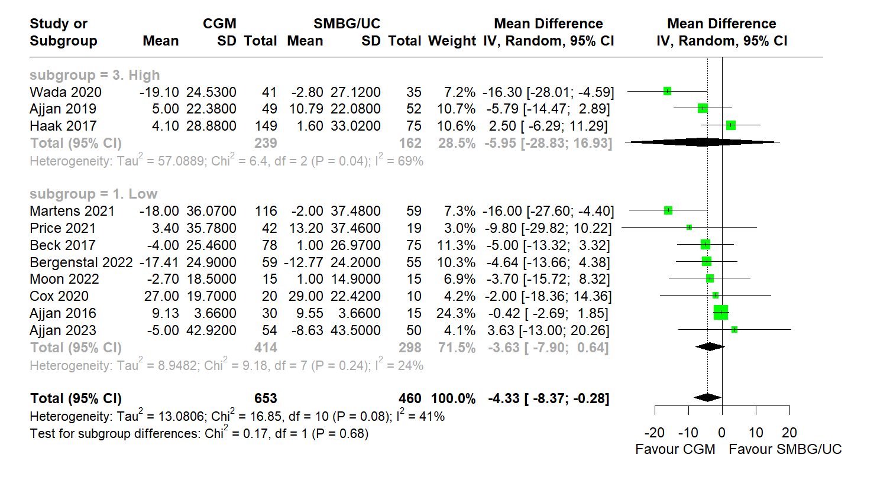
eFigure 8d: Forest plot for meta-analysis of primary studies comparing effectiveness of CGM against SMBG/UC between 2017 to 2023 by pooling the mean difference in prepost TAR change (% day) between CGM and SMBG/UC, subgrouped by risk-of-bias. CGM was significantly associated with greater TAR decrease than SMBG/UC (MD= -4.33% [95%CI: -8.37 to -0.28]) . No significant differences between subgroups (p = 0.68).

9. Time-Below-Range Forest Plots

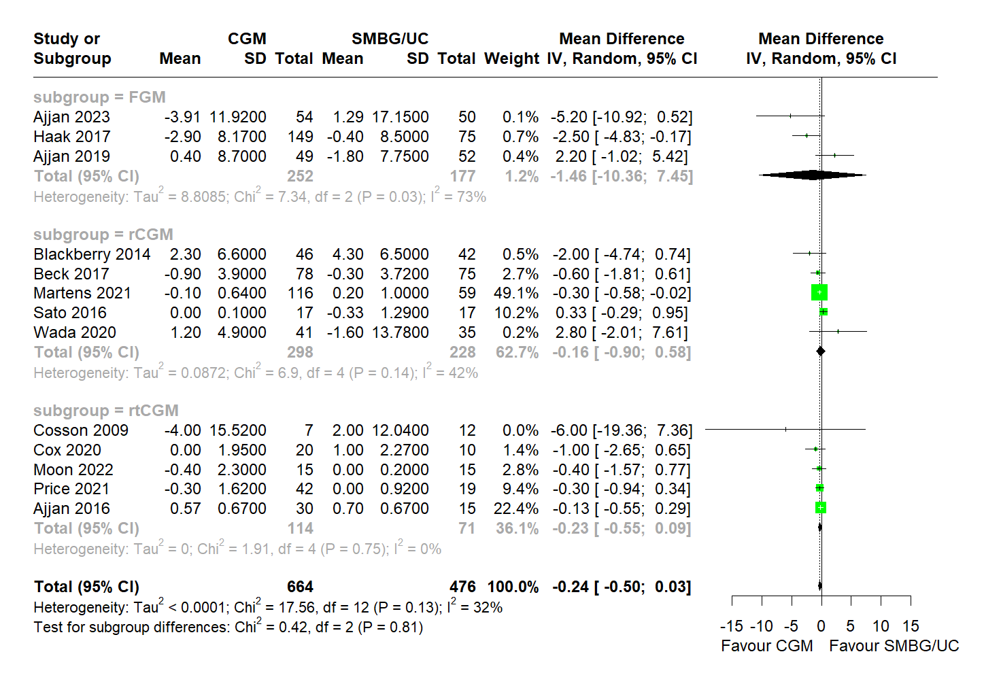
eFigure 9a: Forest plot for meta-analysis of primary studies comparing effectiveness of CGM against SMBG/UC between 2009 to 2023 by pooling the mean difference in prepost TBR change (% day) between CGM and SMBG/UC, with Baujat-informed outlier removal, subgrouped by CGM modality. There was no significant difference in prepost TBR change between CGM and SMBG/UC (MD = -0.24% , 95% CI: -0.50 to 0.03). No significant differences between subgroups (p = 0.81).

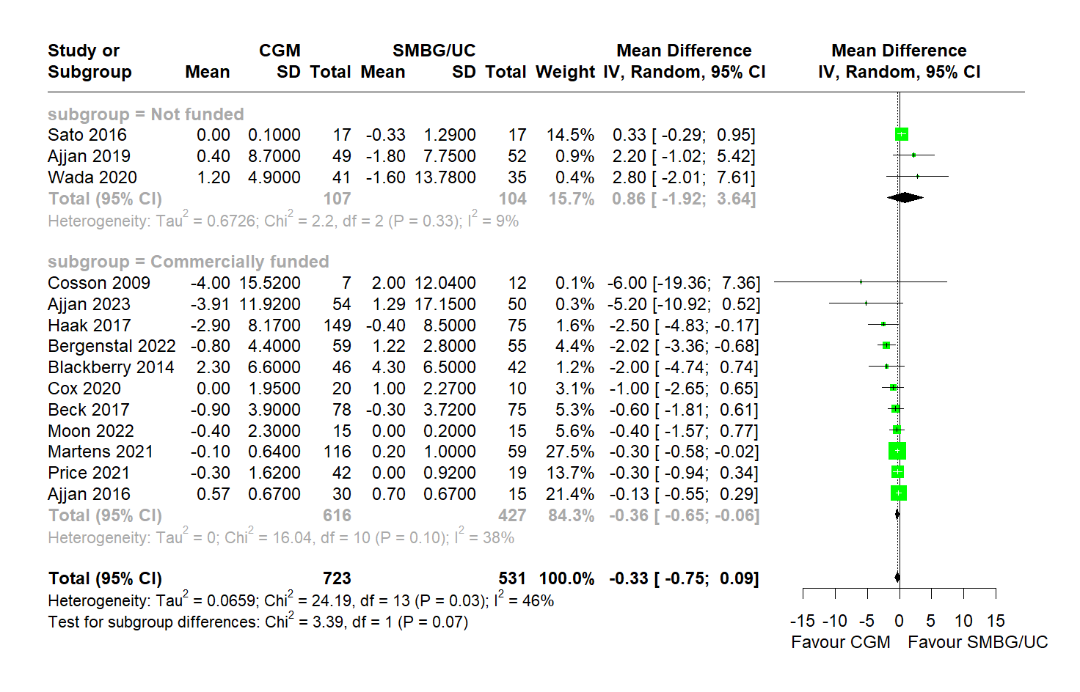
eFigure 9b: Forest plot for meta-analysis of primary studies comparing effectiveness of CGM against SMBG/UC between 2009 to 2023 by pooling the mean difference in prepost TBR change (% day) between CGM and SMBG/UC, subgrouped by funding. There was no significant difference in prepost TBR change between CGM and SMBG/UC (MD = -0.33% , 95% CI: -0.75 to 0.09). No significant differences between subgroups (p = 0.07).

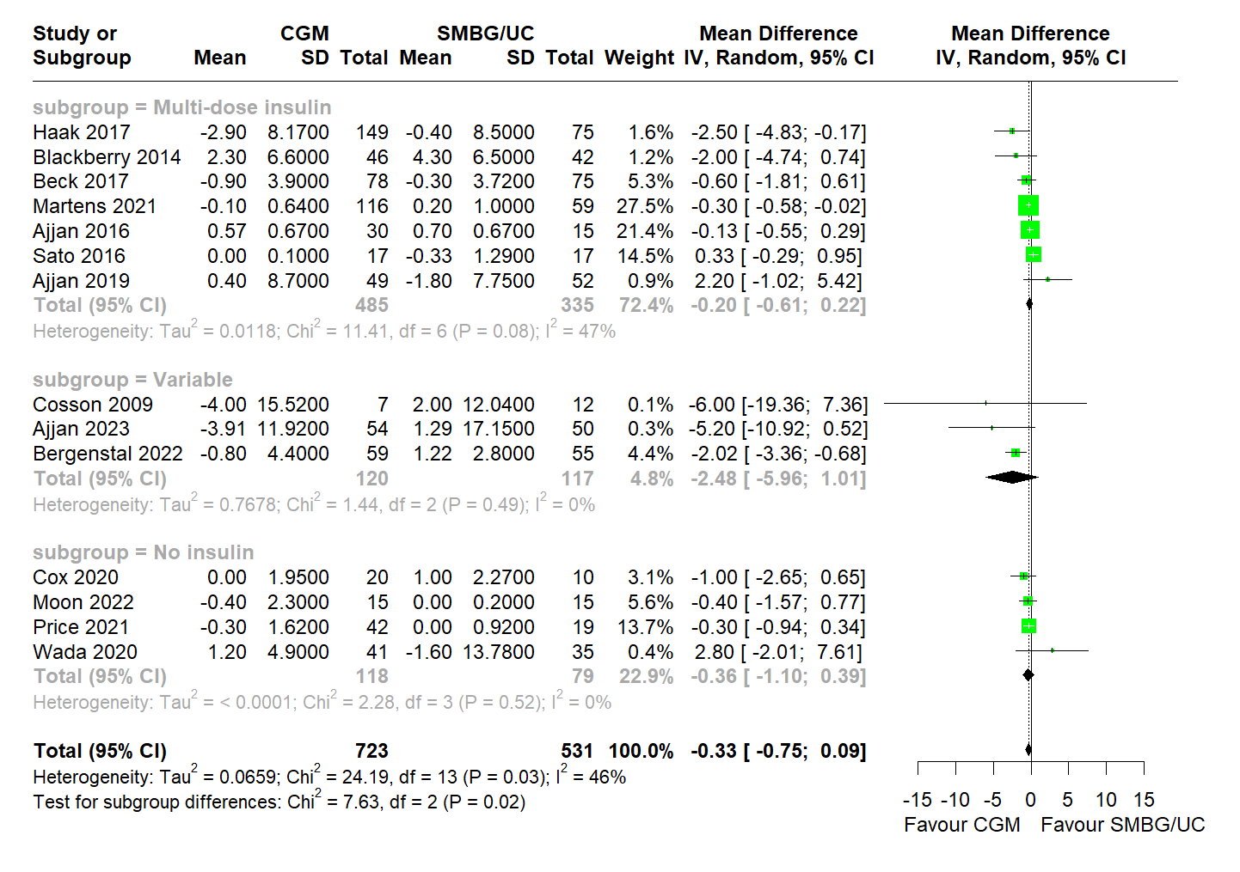
eFigure 9c: Forest plot for meta-analysis of primary studies comparing effectiveness of CGM against SMBG/UC between 2009 to 2023 by pooling the mean difference in prepost TBR change (% day) between CGM and SMBG/UC, subgrouped by insulin treatment. There was no significant difference in prepost TBR change between CGM and SMBG/UC (MD = -0.33% , 95% CI: -0.75 to 0.09). There was a significant difference between subgroups (p = 0.02).

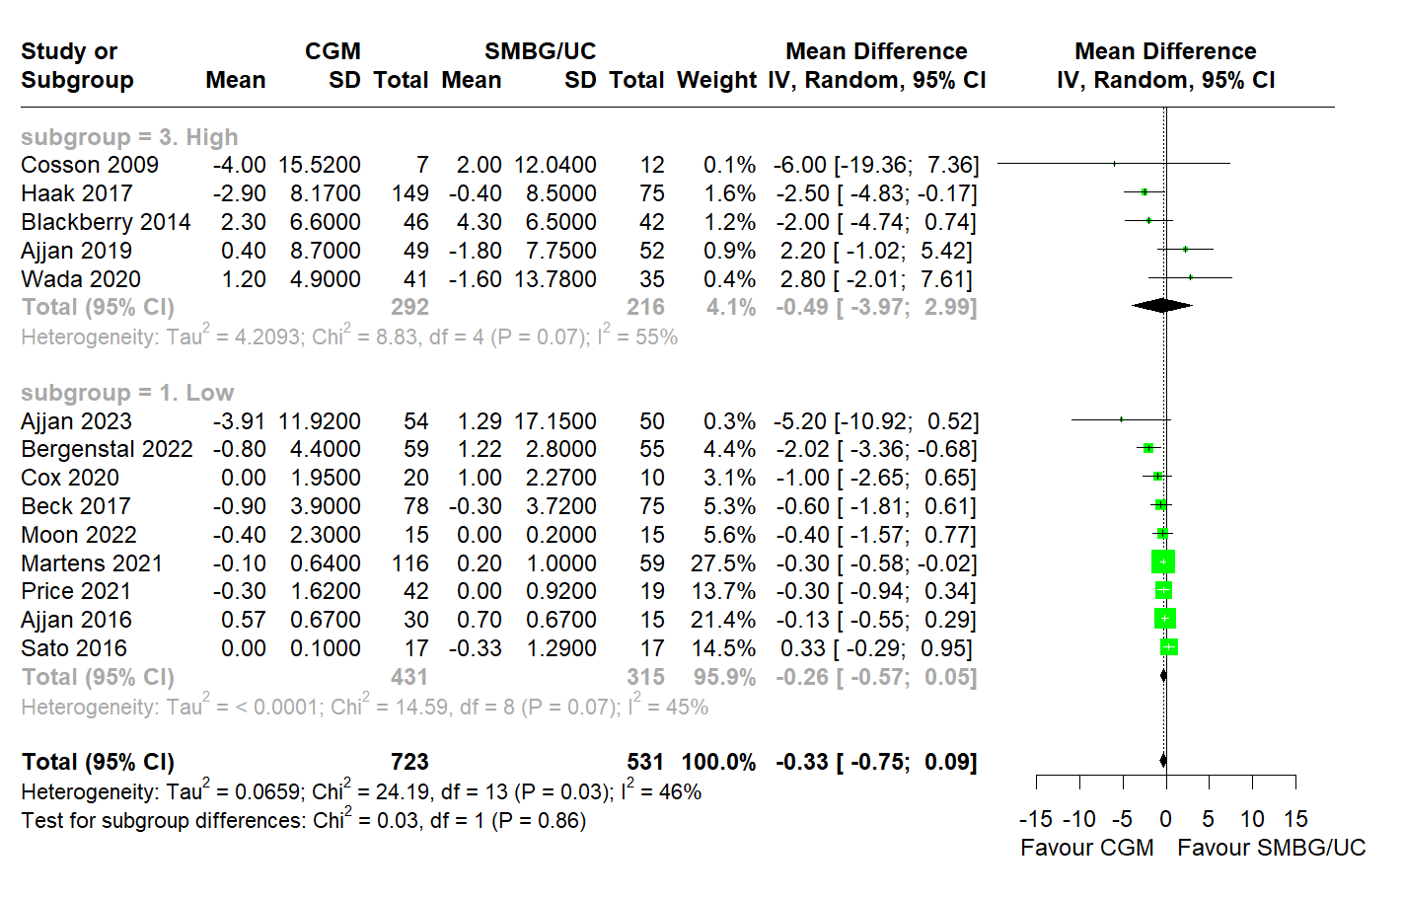
eFigure 9d: Forest plot for meta-analysis of primary studies comparing effectiveness of CGM against SMBG/UC between 2009 to 2023 by pooling the mean difference in prepost TBR change (% day) between CGM and SMBG/UC, subgrouped by risk-of-bias. There was no significant difference in prepost TBR change between CGM and SMBG/UC (MD = -0.33% , 95% CI: -0.75 to 0.09). No significant differences between subgroups (p = 0.68).

10. Patient Reported Outcome Measures (PROM)
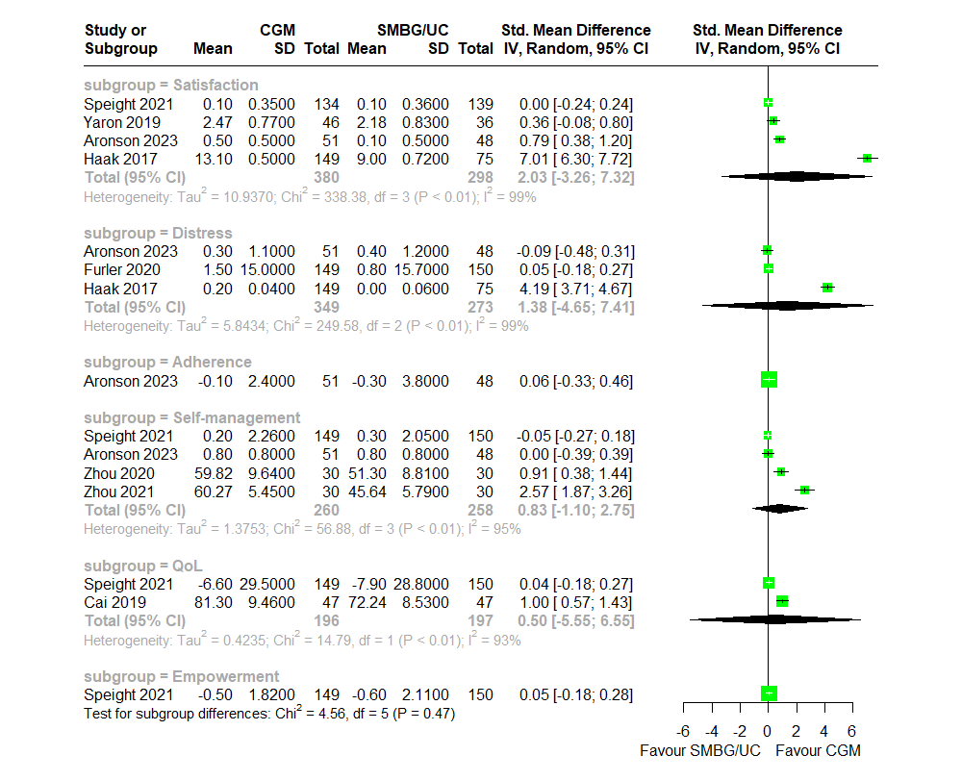
eFigure 10a: Meta-analysis of primary studies comparing effectiveness of CGM against SMBG/UC between 2017 to 2023 by pooling the standardized mean difference of prepost change in PROMs by domain amongst studies utilising FGM only. No significant effect size was observed across all domains.

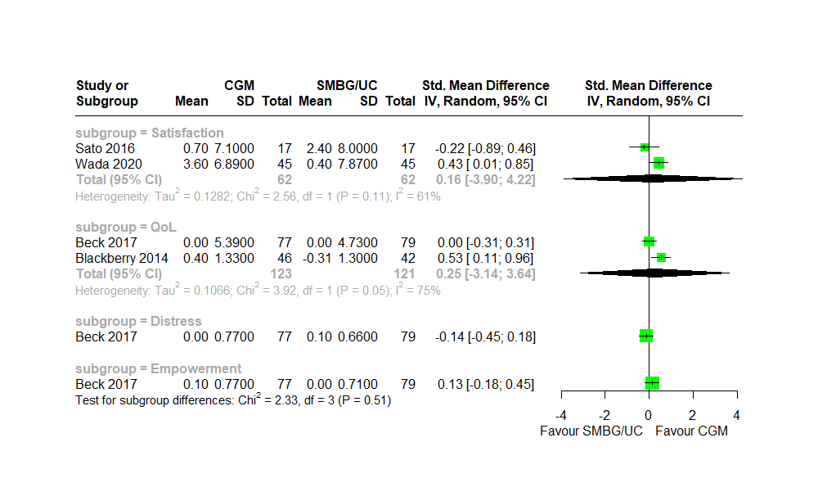
eFigure 10b: Meta-analysis of primary studies comparing effectiveness of CGM against SMBG/UC between 2017 to 2020 by pooling the standardized mean difference of prepost change in PROMs by domain amongst studies utilising rCGM. No significant effect size was observed across all domains.

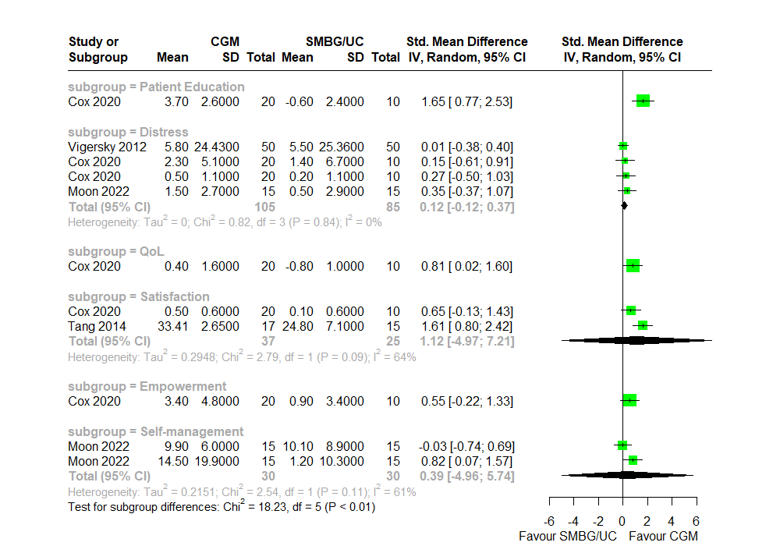
eFigure 10c: Meta-analysis of primary studies comparing effectiveness of CGM against SMBG/UC between 2012 to 2022 by pooling the standardized mean difference of prepost change in PROMs by domain amongst studies utilising rtGM. No significant effect size was observed across all domains.

11. Baujat Plots
(a) Prepost HbA1c change across all studies
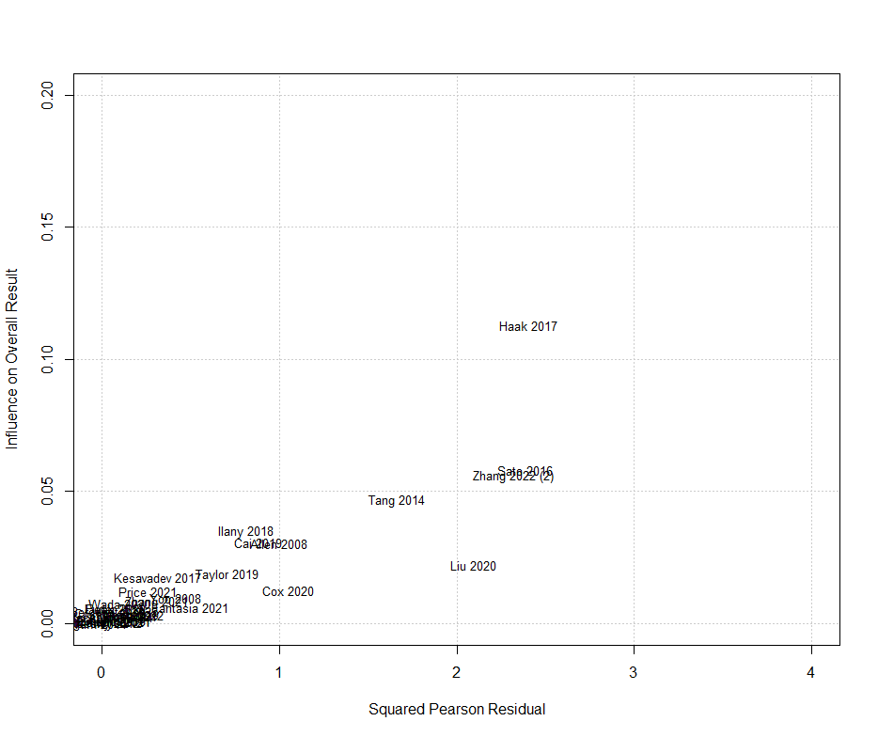
(b) Prepost HbA1c change across RCTs only
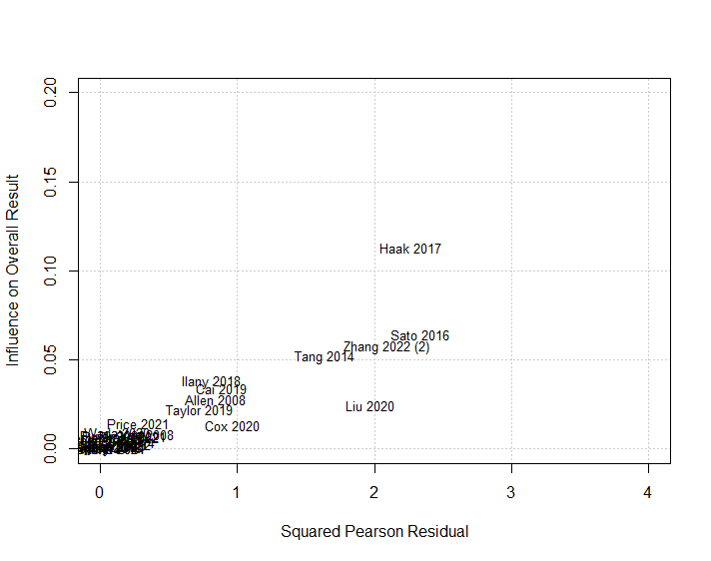
(c) Follow-up HbA1c value
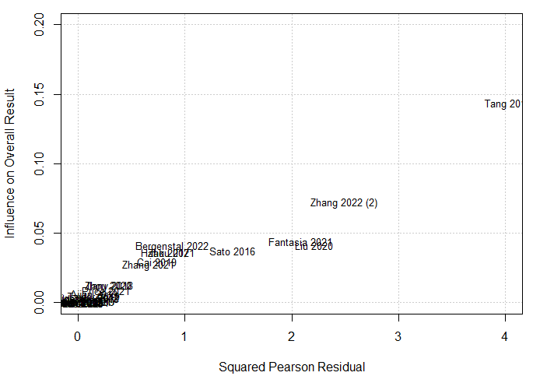
(d) Prepost time-in-range change
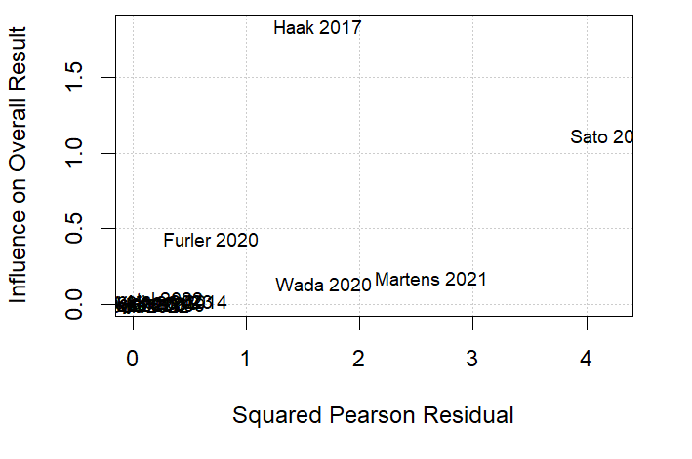

(e) Prepost time-above-range change
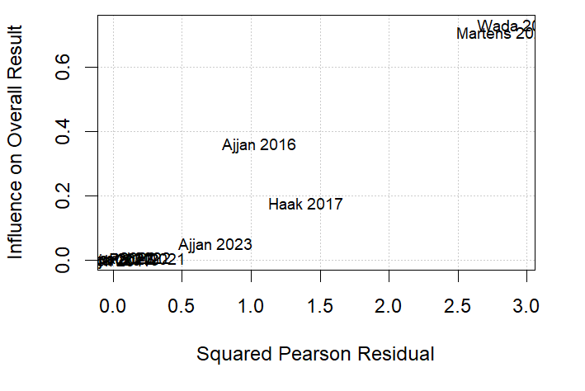
(f) Prepost time-below-range change
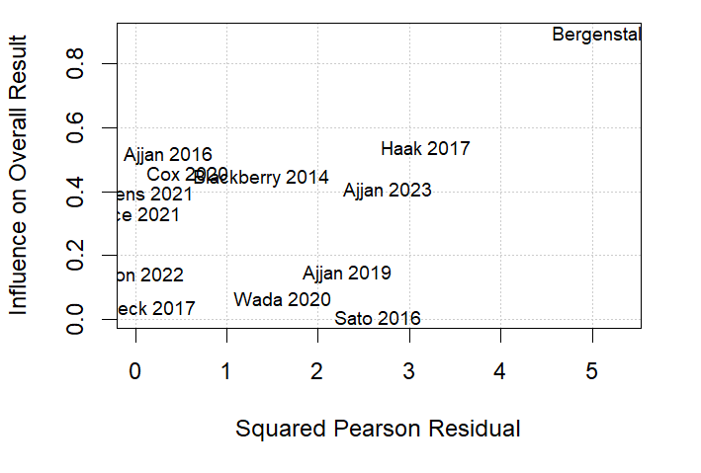

eFigure 11a Baujat plot plotting for outlier studies in the meta-analysis of primary studies comparing effectiveness of CGM against SMBG/UC between 2008 to 2023 by pooling the mean difference in (a) prepost HbA1c change across all studies, (b) prepost HbA1c change across RCTs only, (c) follow-up HbA1c value, (d) prepost time-in-range change, (e) prepost time-above-range and (f) prepost time-below-range between CGM and SMBG/UC groups. Yang 2021 not seen on eFigures 11a - c as it has disproportionately greater influence on the overall result and heterogeneity than the remaining studies.

