Supplementary material
Table S1 IV model for individual wealth and specific health indicators: robustness check with alternative health measurements
Dependent Variable | Self-Rated Health Status | CESD-10 | ADL-6 | IADL-5 | Functional Limitations | Cancer | Chronic Lung Diseases | Heart Diseases | Kidney Diseases | Digestive System Diseases | Memory-Related Diseases | Arthritis | Asthma
Variable | IV-OProbit | IV-OLS |  |  |  | IV-Probit
Present Wealth (log-) | -0.063*** | -0.602*** | -0.054*** | -0.058*** | -0.151*** | -0.062* | -0.059*** | -0.052*** | -0.048** | -0.046*** | -0.072** | -0.064*** | -0.075***
Present Wealth (log-) | (0.006) | (0.061) | (0.009) | (0.010) | (0.017) | (0.037) | (0.017) | (0.017) | (0.020) | (0.014) | (0.033) | (0.014) | (0.023)
Age | 0.010*** | 0.005 | 0.015*** | 0.018*** | 0.039*** | 0.002 | 0.016*** | 0.017*** | 0.002 | -0.003** | 0.029*** | 0.007*** | 0.019***
Age | (0.001) | (0.006) | (0.001) | (0.001) | (0.002) | (0.004) | (0.002) | (0.002) | (0.002) | (0.001) | (0.003) | (0.001) | (0.002)
Gender | -0.146*** | -1.386*** | -0.053*** | -0.094*** | -0.568*** | -0.242*** | 0.241*** | -0.320*** | 0.048 | -0.167*** | 0.085 | -0.231*** | 0.169***
Gender | (0.018) | (0.110) | (0.017) | (0.017) | (0.031) | (0.073) | (0.032) | (0.031) | (0.037) | (0.026) | (0.061) | (0.025) | (0.043)
Marital Status | 0.007 | -1.159*** | -0.083*** | -0.038 | -0.198*** | 0.168 | -0.039 | -0.025 | 0.003 | 0.093** | 0.054 | -0.004 | -0.047
Marital Status | (0.027) | (0.165) | (0.024) | (0.025) | (0.046) | (0.114) | (0.044) | (0.042) | (0.054) | (0.038) | (0.081) | (0.036) | (0.058)
Annual Income（log-） | -0.032*** | -0.073*** | -0.003 | 0.001 | -0.025*** | -0.022 | -0.001 | 0.014** | -0.001 | 0.003 | 0.003 | 0.001 | 0.004
Annual Income（log-） | (0.004) | (0.024) | (0.004) | (0.004) | (0.007) | (0.015) | (0.007) | (0.007) | (0.008) | (0.006) | (0.015) | (0.006) | (0.010)
Educational Attainment | -0.008*** | -0.080*** | -0.008*** | -0.017*** | -0.030*** | 0.011 | -0.007 | 0.015*** | 0.014*** | -0.006 | 0.009 | -0.010*** | 0.002
Educational Attainment | (0.003) | (0.015) | (0.002) | (0.002) | (0.004) | (0.010) | (0.004) | (0.004) | (0.005) | (0.004) | (0.009) | (0.003) | (0.006)
Living Region
Central Region | -0.124*** | -1.023*** | 0.001 | -0.027 | 0.078** | 0.071 | -0.176*** | 0.375*** | 0.014 | -0.019 | 0.035 | -0.380*** | -0.054
Central Region | (0.022) | (0.133) | (0.020) | (0.020) | (0.037) | (0.094) | (0.036) | (0.037) | (0.042) | (0.030) | (0.070) | (0.029) | (0.049)
Eastern Region | -0.253*** | -1.589*** | -0.117*** | -0.151*** | -0.188*** | 0.286*** | -0.389*** | 0.108*** | -0.223*** | -0.183*** | -0.099 | -0.609*** | -0.152***
Eastern Region | (0.022) | (0.139) | (0.021) | (0.021) | (0.039) | (0.093) | (0.040) | (0.040) | (0.047) | (0.032) | (0.078) | (0.031) | (0.054)
Household Registration Status | 0.017 | 0.544*** | 0.020 | 0.007 | -0.044 | -0.267*** | -0.113*** | -0.303*** | -0.103** | 0.054 | -0.219*** | 0.066* | -0.093
Household Registration Status | (0.024) | (0.149) | (0.023) | (0.023) | (0.042) | (0.091) | (0.043) | (0.040) | (0.049) | (0.036) | (0.080) | (0.034) | (0.058)
Childhood Health Status
Very Good | 0.101*** | 0.444** | 0.027 | 0.020 | 0.051 | -0.002 | -0.000 | 0.085* | 0.016 | -0.033 | 0.078 | -0.025 | -0.054
Very Good | (0.029) | (0.181) | (0.027) | (0.028) | (0.051) | (0.121) | (0.054) | (0.051) | (0.062) | (0.043) | (0.108) | (0.041) | (0.071)
Good | 0.166*** | 0.510*** | 0.010 | 0.009 | -0.021 | 0.079 | 0.034 | -0.026 | -0.004 | -0.007 | 0.143 | 0.024 | -0.034
Good | (0.031) | (0.189) | (0.028) | (0.029) | (0.053) | (0.123) | (0.056) | (0.053) | (0.064) | (0.045) | (0.110) | (0.043) | (0.073)
Fair | 0.208*** | 0.577*** | -0.032 | -0.015 | -0.005 | 0.024 | 0.069 | 0.030 | 0.037 | 0.099** | 0.038 | 0.121*** | -0.053
Fair | (0.033) | (0.203) | (0.030) | (0.032) | (0.058) | (0.135) | (0.059) | (0.057) | (0.068) | (0.048) | (0.120) | (0.046) | (0.079)
Poor | 0.308*** | 1.271*** | 0.068* | 0.022 | 0.116 | 0.075 | 0.146** | 0.194*** | 0.119 | 0.212*** | 0.192 | 0.170*** | 0.129
Poor | (0.041) | (0.252) | (0.038) | (0.039) | (0.071) | (0.160) | (0.071) | (0.068) | (0.082) | (0.058) | (0.137) | (0.056) | (0.092)
Constants | Yes | 16.087*** | 0.081 | 0.032 | 1.399*** | -1.784*** | -1.379*** | -1.694*** | -1.142*** | 0.024 | -3.394*** | 0.320* | -2.092***
Constants | Yes | (0.779) | (0.117) | (0.121) | (0.219) | (0.481) | (0.225) | (0.216) | (0.258) | (0.183) | (0.441) | (0.175) | (0.306)
Observations | 16584 | 12267 | 13205 | 13084 | 12869 | 13163 | 13164 | 13141 | 13109 | 13187 | 13175 | 13192 | 13174

Notes: Standard errors in parentheses, * p<0.1, ** p<0.05, *** p<0.01.

Figure S1 Flowchart of Research Design and Models

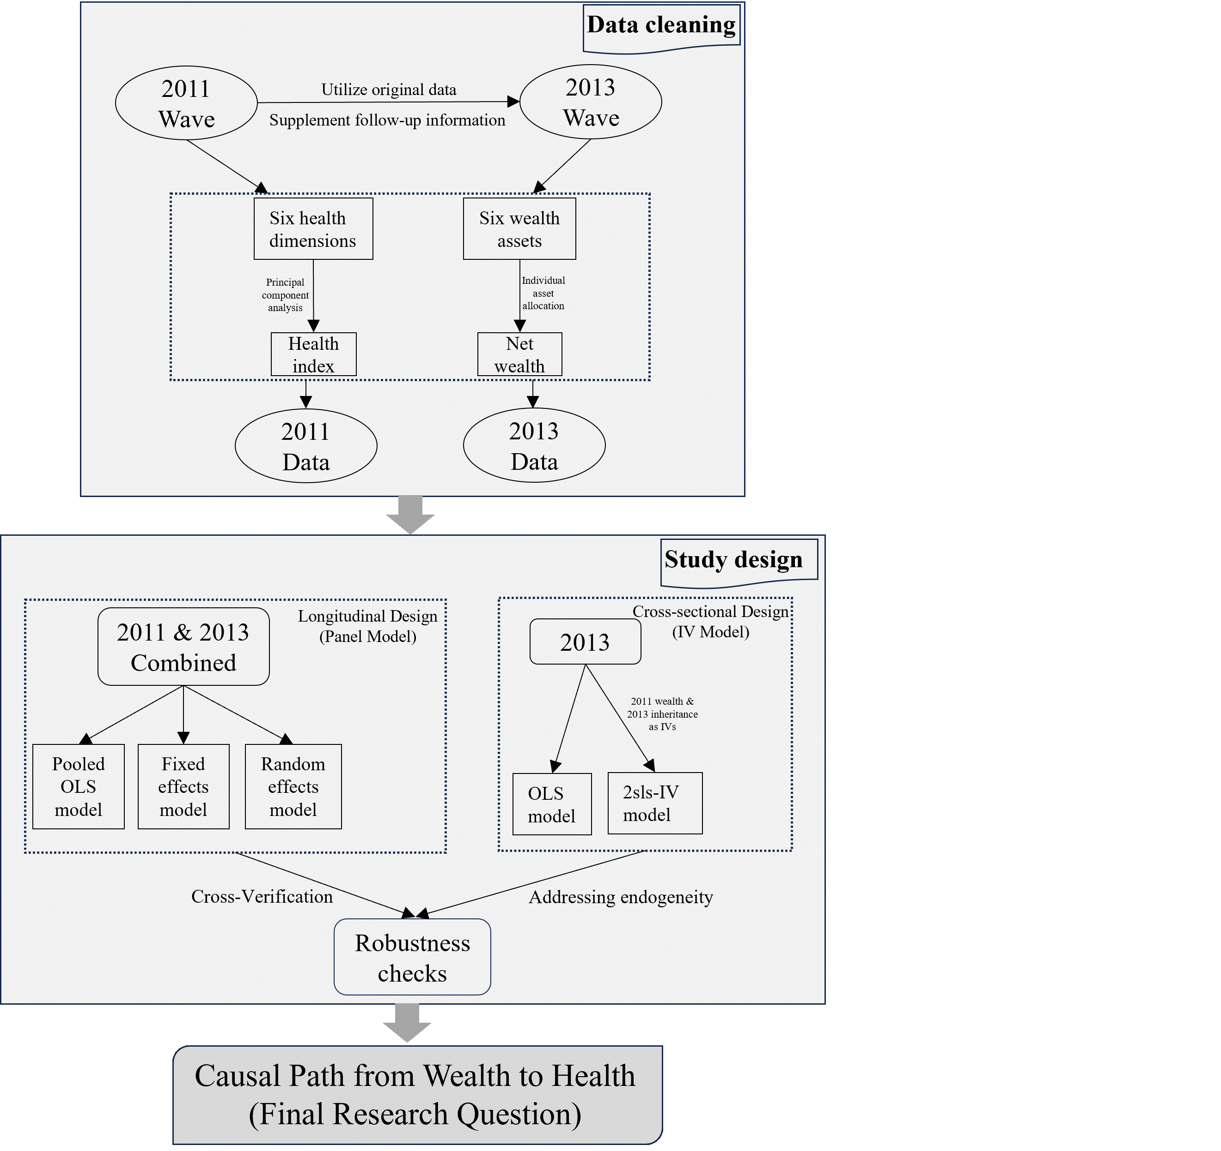

Figure S2 Directed acyclic graph for instrumental variables

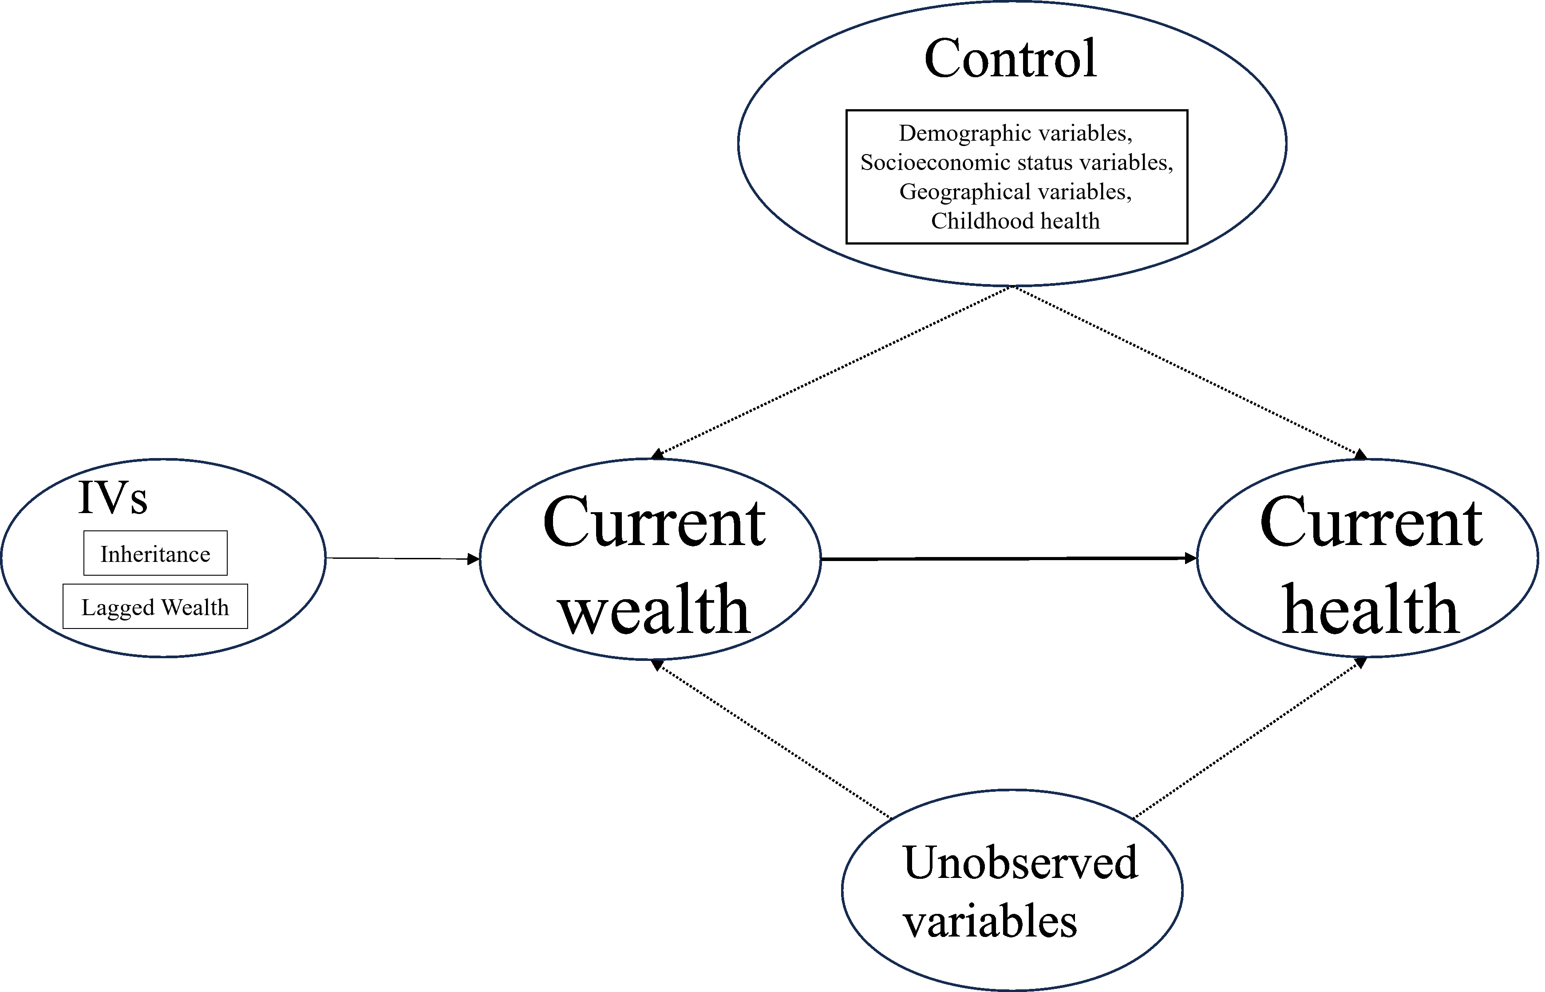

Table S2 Static panel model and IV model: robustness check with health index in quintiles
Variable | Order Logit pooled | Order Logit FE | Order Logit RE | Order Logit | Order Logit_2sls IV
Present Wealth(log) | -0.089*** | -0.053*** | -0.115*** | -0.090*** | -0.184***
 | (0.005) | (0.011) | (0.007) | (0.007) | (0.022)
Age | 0.048*** | 0.143*** | 0.085*** | 0.044*** | 0.044***
 | (0.001) | (0.015) | (0.003) | (0.002) | (0.002)
Marital Status | -0.147*** | -0.126 | -0.257*** | -0.108* | -0.097
(living alone as reference) | (0.036) | (0.190) | (0.067) | (0.058) | (0.062)
Gender | -0.516*** | —— | -0.863*** | -0.593*** | -0.605***
(female as reference) | (0.024) | —— | (0.047) | (0.038) | (0.038)
Annual Income(log-) | -0.050*** | -0.010 | -0.056*** | -0.043*** | -0.028***
 | (0.005) | (0.010) | (0.007) | (0.008) | (0.008)
Educational Attainment | -0.047*** | —— | -0.088*** | -0.041*** | -0.034***
 | (0.003) | —— | (0.006) | (0.005) | (0.006)
Household Registration Status | 0.024 | -0.216 | 0.118** | -0.010 | -0.091*
(urban as reference) | (0.030) | (0.183) | (0.056) | (0.047) | (0.050)
Living Region (western region as reference)
Central Region | -0.021 | —— | -0.032 | -0.032 | -0.030
 | (0.029) | —— | (0.057) | (0.045) | (0.045)
Eastern Region | -0.428*** | —— | -0.772*** | -0.471*** | -0.415***
 | (0.029) | —— | (0.058) | (0.046) | (0.046)
Childhood Health Status (excellent as reference)
Very Good | 0.098** | —— | 0.193** | 0.042 | 0.037
 | (0.038) | —— | (0.076) | (0.061) | (0.061)
Good | 0.101** | —— | 0.213*** | -0.001 | -0.003
 | (0.040) | —— | (0.079) | (0.064) | (0.063)
Fair | 0.238*** | —— | 0.449*** | 0.049 | 0.039
 | (0.043) | —— | (0.085) | (0.068) | (0.067)
Poor | 0.494*** | —— | 0.892*** | 0.264*** | 0.239***
 | (0.054) | —— | (0.107) | (0.086) | (0.088)
Constants | Yes | Yes | Yes | Yes | Yes
Observations | 27381 | 11662 | 27381 | 10954 | 10954

Notes: Standard errors in parentheses, * p<0.1, ** p<0.05, *** p<0.01.

