Table S1 Trajectory model statistics (male only)
Fit statistic | 1 | 2 | 3 | 4 | 5 | 6
BIC | 7146.52 | 6714.25 | 6648.79 | 6688.65 | 6690.07 | 6732.41
AIC | 7129.18 | 6662.22 | 6567.86 | 6578.81 | 6562.89 | 6564.77
Class proportion |  | Class 1, 58.30% | Class 1, 50.83% | Class 1, 27.38% | Class 1, 9.41% | Class 1, 8.02%
 |  | Class 2, 41.70% | Class 2, 13.28% | Class 2, 13.28% | Class 2, 13.28% | Class 2, 13.28%
 |  |  | Class 3, 35.88% | Class 3, 24.80% | Class 3, 33.69% | Class 3, 31.42%
 |  |  |  | Class 4, 34.53% | Class 4, 31.02% | Class 4, 22.97%
 |  |  |  |  | Class 5, 12.60% | Class 5, 13.95%
 |  |  |  |  |  | Class 6, 10.35%
APP |  | Class 1, 0.9785 | Class 1, 0.9215 | Class 1, 0.7371 | Class 1, 0.8020 | Class 1, 0.7329
 |  | Class 2, 0.9283 | Class 2,  1 | Class 2,  1 | Class 2,  1 | Class 2,  1
 |  |  | Class 3, 0.9225 | Class 3, 0.7239 | Class 3, 0.9146 | Class 3, 0.9020
 |  |  |  | Class 4, 0.9311 | Class 4, 0.8945 | Class 4, 0.7793
 |  |  |  |  | Class 5, 0.8262 | Class 5, 0.7938
 |  |  |  |  |  | Class 6, 0.8620

AIC Akaike’s information criterion, BIC Bayesian information criteria, APP average posterior probabilities

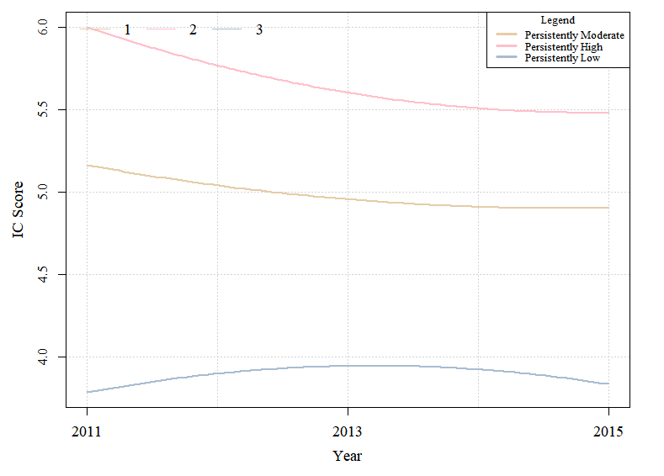
Figure S1 Mean trajectories of intrinsic capacity scores by time among male older adults

Table S2 Trajectory model statistics (female only)
Fit statistic | 1 | 2 | 3 | 4
BIC | 5197.55 | 4945.63 | 4974.53 | 4949.92
AIC | 5186.75 | 4897.02 | 4898.91 | 4852.70
Class proportion |  | Class 1, 54.27% | Class 1, 49.65% | Class 1, 21.39%
 |  | Class 2, 45.73% | Class 2, 40.44% | Class 2, 49.79%
 |  |  | Class 3, 9.91% | Class 3, 25.34%
 |  |  |  | Class 4, 3.48%
APP |  | Class 1, 0.9693 | Class 1, 0.9546 | Class 1, 0.8866
 |  | Class 2, 0.8935 | Class 2, 0.9230 | Class 2, 0.9233
 |  |  | Class 3, 0.7819 | Class 3, 0.8505
 |  |  |  | Class 4, 1
AIC Akaike’s information criterion, BIC Bayesian information criteria, APP average posterior probabilities

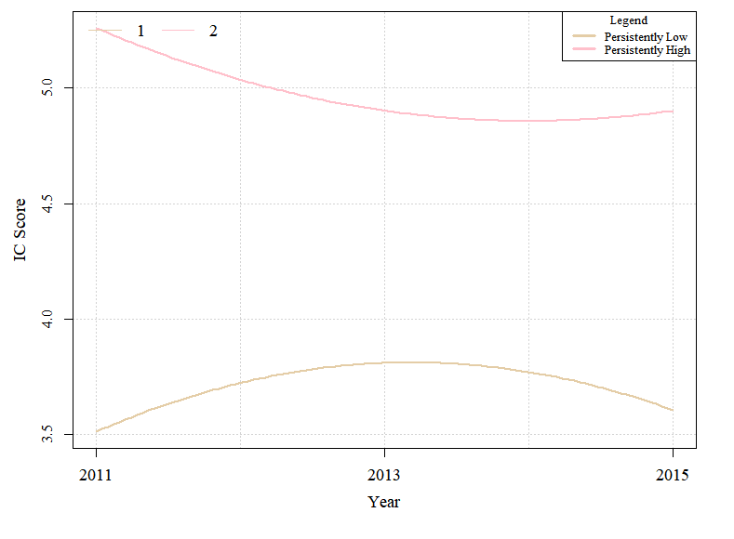
Figure S2 Mean trajectories of intrinsic capacity scores by time among female older adults

Table S3 Trajectory model statistics among participants with complete data across all three waves
Fit statistic | 1 | 2 | 3 | 4 | 5
BIC | 5726.712 | 5272.145 | 5162.223 | 5235.095 | 5270.35
AIC | 5710.337 | 5233.938 | 5102.183 | 5158.68 | 5155.728
Class proportion |  | Class 1, 52.08% | Class 1, 23.70% | Class 1, NaN | Class 1, 49.31%
 |  | Class 2, 47.92% | Class 2, 16.78% | Class 2, 6.57% | Class 2, 10.38%
 |  |  | Class 3, 59.51% | Class 3, 52.08% | Class 3, 23.01%
 |  |  |  | Class 4, 41.35% | Class 4, 17.30%
 |  |  |  |  | Class 5, NaN
APP |  | Class 1, 0.89808 | Class 1, 0.8462 | Class 1, NaN | Class 1, 0.8522
 |  | Class 2, 0.9477 | Class 2, 0.8793 | Class 2, 0.84358 | Class 2, 0.8183
 |  |  | Class 3, 0.8887 | Class 3, 0.8701 | Class 3, 0.7142
 |  |  |  | Class 4, 0.8976 | Class 4, 0.6495
 |  |  |  |  | Class 5, NaN
AIC Akaike’s information criterion, BIC Bayesian information criteria, APP average posterior probabilities

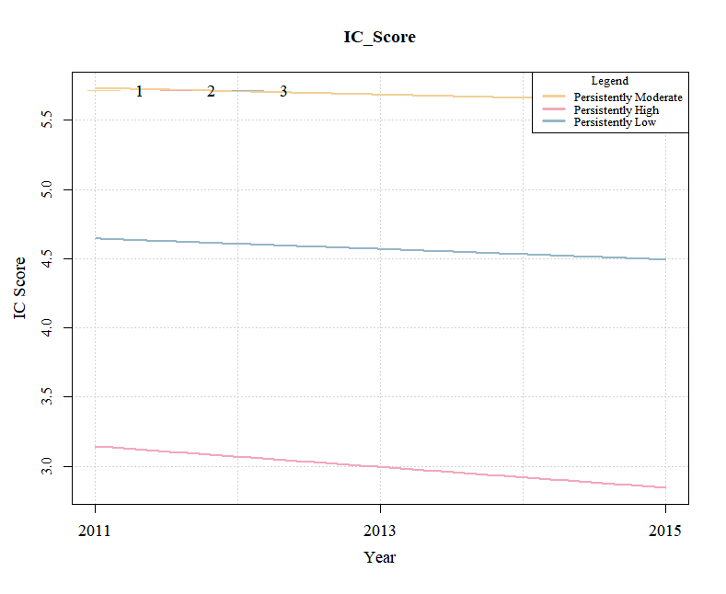
Figure S3 Mean trajectories of intrinsic capacity scores among participants with complete data across all three waves

