Supplementary Table 1. Marital and work status before the COVID-19 pandemic and the time of the survey response

MARITAL STATUS | TOTAL | Argentina | Brazil | Chile | Colombia | Uruguay
Before COVID-19, n | 1867 | 472 | 389 | 268 | 329 | 409
Never married | 855 (45.8%) | 182 (38.6%) | 186 (47.8%) | 146 (54.5%) | 192 (58.4%) | 149 (36.4%)
Currently married | 608 (32.6%) | 161 (34.1%) | 134 (34.4%) | 73 (27.2%) | 85 (25.8%) | 155 (37.9%)
Cohabitating | 230 (12.3%) | 64 (13.6%) | 44 (11.3%) | 33 (12.3%) | 31 (9.4%) | 58 (14.2%)
Separated | 32 (1.7%) | 15 (3.2%) | 1 (0.3%) | 5 (1.9%) | 7 (2.1%) | 4 (1.0%)
Divorced | 107 (5.7%) | 39 (8.3%) | 20 (5.1%) | 9 (3.4%) | 9 (2.7%) | 30 (7.3%)
Widowed | 28 (1.5%) | 7 (1.5%) | 4 (1.0%) | 1 (0.4%) | 4 (1.2%) | 12 (2.9%)
Not to say | 7 (0.4%) | 4 (0.8%) | 0 (0.0%) | 1 (0.4%) | 1 (0.3%) | 1 (0.2%)
At survey time
Never married | 802 (43.0%) | 178 (37.7%) | 170 (43.7%) | 130 (48.5%) | 180 (54.7%) | 144 (35.2%)
Currently married | 617 (33.0%) | 156 (33.1%) | 134 (34.4%) | 79 (29.5%) | 93 (28.3%) | 155 (37.9%)
Cohabitating | 256 (13.7%) | 68 (14.4%) | 55 (14.1%) | 43 (16.0%) | 33 (10.0%) | 57 (13.9%)
Separated | 39 (2.1%) | 22 (4.7%) | 0 (0.0%) | 1 (0.4%) | 6 (1.8%) | 10 (2.4%)
Divorced | 112 (6.0%) | 35 (7.4%) | 26 (6.7%) | 11 (4.1%) | 11 (3.3%) | 29 (7.1%)
Widowed | 29 (1.6%) | 7 (1.5%) | 4 (1.0%) | 1 (0.4%) | 4 (1.2%) | 13 (3.2%)
Not to say | 12 (0.6%) | 6 (1.3%) | 0 (0.0%) | 3 (1.1%) | 2 (0.6%) | 1 (0.2%)
WORK STATUS | TOTAL | Argentina | Brazil | Chile | Colombia | Uruguay
Before COVID-19, n | 1557 | 407 | 289 | 232 | 283 | 346
Government employee | 382 (24.5%) | 80 (19.7%) | 65 (22.5%) | 68 (29.3%) | 38 (13.4%) | 131 (37.9%)
Non-Government employee | 500 (32.1%) | 116 (28.5%) | 86 (29.8%) | 71 (30.6%) | 122 (43.1%) | 105 (30.3%)
Self-employed | 224 (14.4%) | 78 (19.2%) | 52 (18.0%) | 24 (10.3%) | 41 (14.5%) | 29 (8.4%)
Non-paid employed | 6 (0.4%) | 3 (0.7%) | 0 (0.0%) | 1 (0.4%) | 1 (0.4%) | 1 (0.3%)
Student | 278 (17.9%) | 79 (19.4%) | 46 (15.9%) | 56 (24.1%) | 61 (21.6%) | 36 (10.4%)
Homemaker | 30 (1.9%) | 12 (2.9%) | 8 (2.8%) | 2 (0.9%) | 4 (1.4%) | 4 (1.2%)
Retired | 63 (4.0%) | 21 (5.2%) | 9 (3.1%) | 2 (0.9%) | 9 (3.2%) | 22 (6.4%)
Unemployed¹ | 50 (3.2%) | 9 (2.2%) | 19 (6.6%) | 6 (2.6%) | 7 (2.5%) | 9 (2.6%)
Unemployed² | 20 (1.3%) | 9 (2.2%) | 1 (0.3%) | 2 (0.9%) | 0 (0.0%) | 8 (2.3%)
Prefer not say | 4 (0.3%) | 0 (0.0%) | 3 (1.0%) | 0 (0.0%) | 0 (0.0%) | 1 (0.3%)
At survey time
Government employee | 378 (24.3%) | 79 (19.4%) | 66 (22.8%) | 71 (30.6%) | 39 (13.8%) | 123 (35.5%)
Non-Government employee | 498 (32.0%) | 113 (27.8%) | 83 (28.7%) | 75 (32.3%) | 118 (41.7%) | 109 (31.5%)
Self-employed | 252 (16.2%)⤉ | 87 (21.4%) | 58 (20.1%) | 24 (10.3%) | 49 (17.3%) | 34 (9.8%)
Non-paid employed | 4 (0.3%) | 3 (0.7%) | 0 (0.0%) | 1 (0.4%) | 0 (0.0%) | 0 (0.0%)
Student | 230 (14.8%) | 72 (17.7%) | 41 (14.2%) | 43 (18.5%) | 48 (17.0%) | 26 (7.5%)
Homemaker | 29 (1.9%) | 8 (2.0%) | 9 (3.1%) | 3 (1.3%) | 3 (1.1%) | 6 (1.7%)
Retired | 85 (5.5%)⤉ | 26 (6.4%) | 11 (3.8%) | 4 (1.7%) | 11 (3.9%) | 33 (9.5%)
Unemployed¹ | 57 (3.7%) | 14 (3.4%) | 17 (5.9%) | 8 (3.4%) | 9 (3.2%) | 9 (2.6%)
Unemployed² | 20 (1.3%) | 5 (1.2%) | 0 (0.0%) | 3 (1.3%) | 6 (2.1%) | 6 (1.7%)
Prefer not say | 4 (0.3%) | 0 (0.0%) | 4 (1.4%) | 0 (0.0%) | 0 (0.0%) | 0 (0.0%)
1. Able to work; 2. Unable to work.

Supplementary Figure 1: Self-reported prevalence of cardiovascular risk factors and depression symptoms before the pandemic and at the time of the survey by country

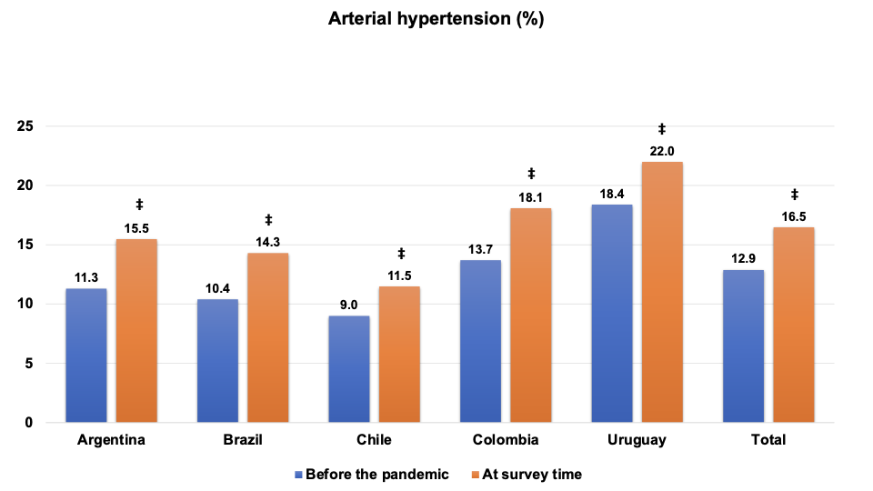

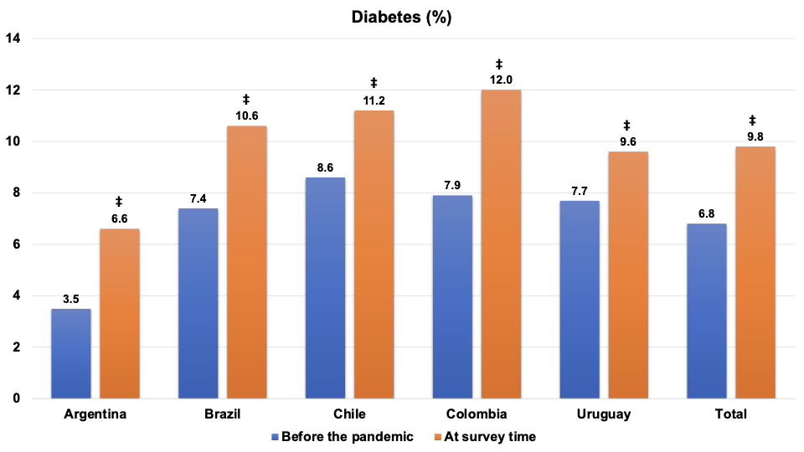

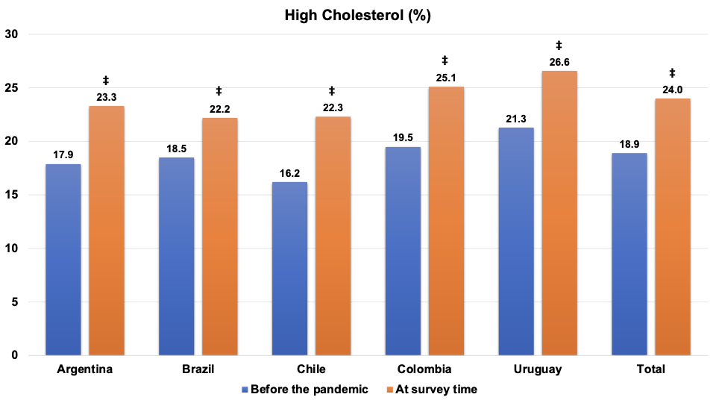

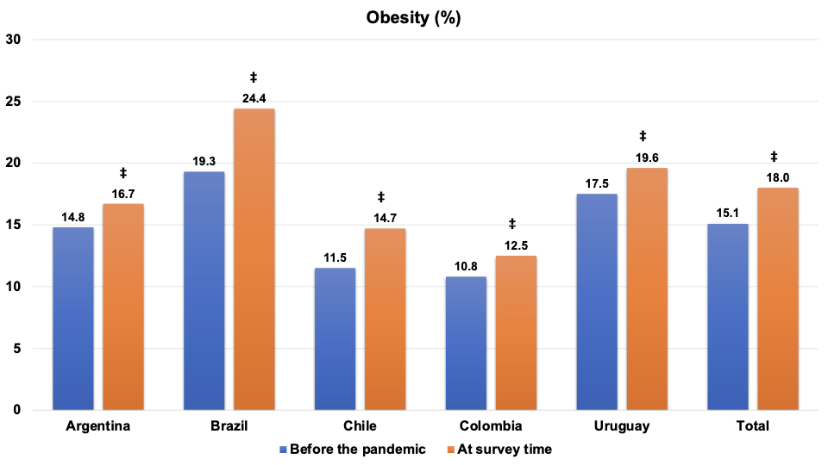

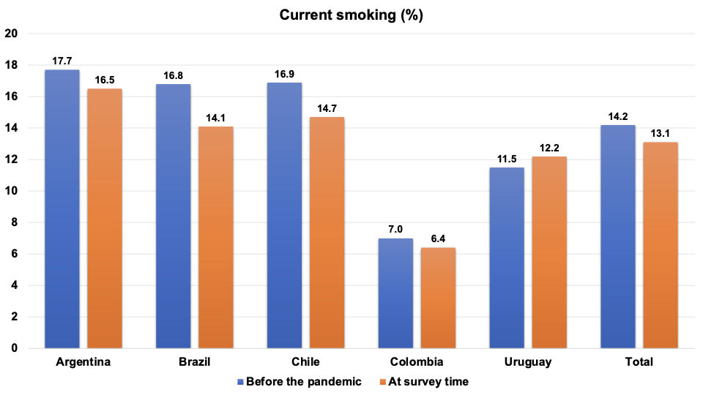

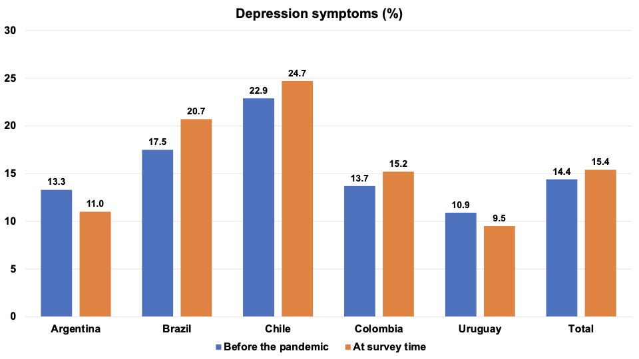
‡p < 0.05: before the pandemic vs. at survey time

