Additional file 4: Sensitivity analysis (forest plot) and publication bias (funnel plot) in sub-Saharan Africa, 2010 - 2025.
Additional file 4a. Sensitivity analysis of neonatal mortality rate in sub-Saharan Africa, 2010 - 2025.

Additional file 4b. Funnel plot for neonatal mortality rate in sub-Saharan Africa, 2010 - 2025.

Additional file 4c. Sensitivity analysis of prevalence of neonatal mortality in sub-Saharan Africa, 2010 - 2025.

Additional file 4d. Funnel plot for prevalence of neonatal mortality in sub-Saharan Africa, 2010 - 2025.

Additional file 4e. Sensitivity analysis for antenatal care visit vs neonatal mortality in sub-Saharan Africa, 2010 - 2025.

Additional file 4f. Funnel plot for antenatal care vs neonatal mortality in sub-Saharan Africa, 2010 - 2025.

Additional file 4g. Sensitivity analysis for place of delivery vs neonatal mortality in sub-Saharan Africa, 2010 - 2025.

Additional file 4h. Funnel plot for place of delivery vs neonatal mortality in sub-Saharan Africa, 2010 - 2025.
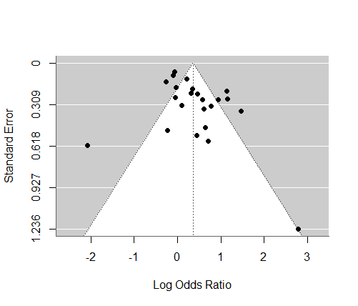

Additional file 4i. Funnel plot with trim and fill analysis for place of delivery vs neonatal mortality in sub-Saharan Africa, 2010 - 2025.
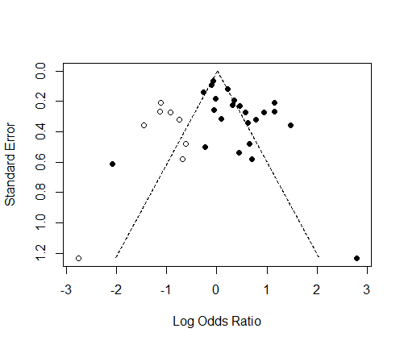

Additional file 4j. Sensitivity analysis for time at initiation of breastfeeding vs neonatal mortality in sub-Saharan Africa, 2010 - 2025.

Additional file 4k. Funnel plot for time at initiation of breastfeeding vs neonatal mortality in sub-Saharan Africa, 2010 - 2025.
