Supplementary information
Table S1. The 5 criteria for the frailty phenotype in the UK Biobank
Table S2. Frailty transition patterns across three waves
Table S3. Baseline characteristics of included vs excluded participants
Table S4. Association of frailty transition patterns with risks of incident CVD when using the competing risk model.
Table S5. Association of frailty transition patterns with risks of incident CVD after being imputed.
Table S6. Association of frailty transition patterns with risks of incident CVD adjusted using continuous clinical covariates (HbA1c, SBP, and DBP)
Table S7. Association of five frailty transition patterns with risks of incident CVD
Table S8 Association of frailty transition patterns with incident CVD stratified by BMI and physical activity
Figure S1 Kaplan–Meier survival curves of CVD risk by frailty transition patterns

Table S1. The 5 criteria for the frailty phenotype in the UK Biobank
Indicators | Criteria | Field ID
Weight loss | Question: Compared with one year ago, has your weight changed?  - Yes, lost weight=1;  - Others=0; Do not know=0;  - Prefer not to answer=excluded | 2306
Exhaustion | Question: Over the past 2 weeks, how often have you felt tired or had little energy?  - More than half the days or nearly every day =1;  - Others=0; Do not know=0  - Prefer not to answer=excluded | 2080
Weakness | Measured grip strength expressed in kg by sex- and BMI- adjusted cut-off points:  - Males:  BMI≤24 & grip strength≤29;  24.1≤BMI≤28 & grip strength≤30;  BMI>28 & grip strength≤32  - Females:  BMI≤23 & grip strength≤17;  23.1≤BMI≤26 & grip strength≤17.3;  26.1≤BMI≤29 & grip strength≤18;  BMI>29 & grip strength≤21 | 46  47
Walking speed | Question: How would you describe your usual walking pace?”  - Slow pace=1;  - Others=0;  - None of the above/Prefer not to answer=excluded | 924
Physical activity | Question: In the last 4 weeks did you spend any time doing the following?  - Walking for pleasure =0;  - Strenuous sports=0;  - Light DIY (eg: pruning, watering the lawn):  Frequency of once per week or less=1;  Frequency of more than once per week=0;  - Heavy DIY (eg: weeding, lawn mowing, carpentry, digging) =0;  - Other exercises (eg: swimming, cycling, keep fit, bowling) =0;  - None of the above=1;  - Prefer not to answer=excluded | 61641011

Table S2. Frailty transition patterns across three waves
Frailty transition patterns in main analysis | Instance 0 |  | Instance 1 | Instance 2 |  | n
Sustained frailty remission | Frail |  | Pre-frail | Pre-frail |  | 14
Sustained frailty remission | Frail |  | Pre-frail | Robust |  | 5
Sustained frailty remission | Frail |  | Robust | Robust |  | 0
Sustained frailty remission | Pre-frail |  | Robust | Robust |  | 332
Remain robust | Robust |  | Robust | Robust |  | 1,513
Remain pre-frail or frail | Frail |  | Frail | Frail |  | 11
Remain pre-frail or frail | Pre-frail |  | Pre-frail | Pre-frail |  | 516
Additional patterns in sensitivity analysis |  | Instance 0 | Instance 1 |  | Instance 2 |  | n
Frailty remission from instance 0 to instance 1, but deterioration from instance 1 to instance 2 | Frail |  | Robust | Frail |  | 0
 | Frail |  | Robust | Pre-frail |  | 1
 | Frail |  | Pre-frail | Frail |  | 4
 | Pre-frail |  | Robust | Frail |  | 1
 | Pre-frail |  | Robust | Pre-frail |  | 208
Sustained frailty deterioration | Robust |  | Pre-frail | Pre-frail |  | 576
Sustained frailty deterioration | Robust |  | Pre-frail | Frail |  | 11
Sustained frailty deterioration | Robust |  | Frail | Frail |  | 3
Sustained frailty deterioration | Pre-frail |  | Frail | Frail |  | 19

Table S3. Baseline characteristics of included vs excluded participants.
Characteristics | Included (n = 2,391) | Excluded due to missing frailty data  (n = 494,470) | p-value
Age, mean (SD), years | 54.97 (7.43) | 56.54 (8.1) | <0.001
Sex, n (%) |  |  | <0.001
Male | 1,183 (49.50) | 225,066 (45.50)
Female | 1,208 (50.50) | 269,404 (54.50)
White ethnicity, n (%) | 2,345 (98.10) | 466,484 (94.34) | <0.001
College/University degree, n (%) | 1,220 (52.10) | 157,266 (31.8%) | <0.001
Household income, n (%) |  |  | <0.001
Low (<£51,999) | 1,456 (60.90) | 311,067 (62.91%)
Middle (£52,000–£100,000) | 601 (25.10) | 84,406 (17.07%)
High (>£100,000) | 161 (6.73) | 22,498 (4.55%)
Occupational status, n (%) |  |  | <0.001
Working | 1,695 (70.90) | 284,307 (57.5%)
Retired | 592 (24.80) | 164,513 (33.27%)
Other | 99 (4.14) | 42,712 (8.64%)
TDI, median (IQR) | -2.86 (3.06) | -2.12 (4.20) | <0.001
Sleep duration, h, n (%) |  |  | <0.001
Short: 0~6 | 80 (3.35) | 27,312 (5.52%)
Normal: 6~9 | 2,168 (90.70) | 425,139 (85.98%)
Long: ≥9 | 141 (5.90) | 37,822 (7.65%)
Smoking status, n (%) |  |  | <0.001
Never | 1,532 (64.10) | 268.652 (54.33%)
Former | 723 (30.20) | 170,352 (34.45%)
Current | 134 (5.60) | 52,533 (10.62%)
Drinking status, n (%) |  |  | <0.001
Never | 69 (2.89) | 22,159 (4.48%)
Former | 41 (1.72) | 17,934 (3.63%)
Current | 2,281 (95.40) | 452,726 (91.56%)
Physical activities, n (%) |  |  | 0.36
Low | 365 (15.30) | 74,884 (15.14%)
Medium | 846 (35.40) | 161,139 (32.59%)
High | 849 (35.50) | 159,460 (32.25%)
BMI ≥ 30kg/m², n (%) | 275 (11.50) | 120,832 (24.44%) | <0.001
Diabetes, n (%) | 55 (2.30) | 26,149 (5.29%) | <0.001
High blood pressure, n (%) | 919 (38.40) | 217,706 (44.03%) | <0.001
Depression, n (%) | 79 (3.30) | 27,653 (5.59%) | <0.001
Cancer, n (%) | 130 (5.44) | 38,154 (7.72%) | <0.001
HDL-C, median (IQR), mmol/L | 1.44 (0.53) | 1.40 (0.50) | <0.001
LDL-d, median (IQR), mmol/L | 3.46 (1.05) | 3.52 (1.18) | 0.002
Cholesterol, median (IQR), mmol/L | 5.60 (1.28) | 5.65 (1.52) | 0.007
Triglycerides, median (IQR), mmol/L | 1.31 (0.96) | 1.48 (1.10) | <0.001
TDI, Townsend deprivation index; BMI, body mass index; SBP, systolic blood pressure; HDL-C, high-density lipoprotein cholesterol; LDL-d, low-density lipoprotein direct; Medication, medication for cholesterol, blood pressure or diabetes.

Table S4. Association of frailty transition patterns with risks of incident CVD when using the competing risk model.
Frailty transition patterns | n | Model 1 | Model 2 | Model 3
Frailty transition patterns | n | HR (95%CI) | HR (95%CI) | HR (95%CI)
Remain pre-frail or frail | 527 | 1 (reference) | 1 (reference) | 1 (reference)
Remain robust | 1,513 | 0.65 (0.52-0.80)*** | 0.77 (0.61-0.98)*** | 0.79 (0.62-0.99)***
Sustained remission | 351 | 0.24 (0.46-0.85)*** | 0.71 (0.52-0.98)*** | 0.72 (0.52-0.99)***
Model 1 unadjusted; Model 2 adjusted for age, sex, occupational status, TDI, drinking status, smoking status, BMI, HDL-C, LDL-d, cholesterol, triglycerides; Model 3 adjusted for Model 2, high blood pressure, diabetes, cancer and depression. *** means P ＜0.001; * means P ＜0.05.
Table S5. Association of frailty transition patterns with risks of incident CVD after being imputed.
Frailty transition patterns | n | Model 1 | Model 2 | Model 3
Frailty transition patterns | n | HR (95%CI) | HR (95%CI) | HR (95%CI)
Remain pre-frail or frail | 527 | 1 (reference) | 1 (reference) | 1 (reference)
Remain robust | 1,513 | 0.69 (0.57-0.84)*** | 0.76 (0.61-0.95)* | 0.75 (0.59-0.95)*
Sustained remission | 351 | 0.71 (0.53-0.93)* | 0.72 (0.53-0.98)* | 0.72 (0.53-0.99)*
Model 1 unadjusted; Model 2 adjusted for age, sex, occupational status, TDI, drinking status, smoking status, BMI, HDL-C, LDL-d, cholesterol, triglycerides; Model 3 adjusted for Model 2, high blood pressure, diabetes, cancer and depression. *** means P ＜0.001; * means P ＜0.05.
Table S6. Association of frailty transition patterns with risks of incident CVD adjusted using continuous clinical covariates (HbA1c, SBP, and DBP)
Frailty transition patterns | n | Model 1 | Model 2 | Model 3
Frailty transition patterns | n | HR (95%CI) | HR (95%CI) | HR (95%CI)
Remain pre-frail or frail | 527 | 1 (reference) | 1 (reference) | 1 (reference)
Remain robust | 1,513 | 0.69 (0.57-0.84)*** | 0.76 (0.61-0.95)* | 0.78 (0.61-0.99)*
Sustained remission | 351 | 0.71 (0.53-0.93)* | 0.72 (0.53-0.98)* | 0.71 (0.51-0.99)*
Model 1 unadjusted; Model 2 adjusted for age, sex, occupational status, TDI, drinking status, smoking status, BMI, HDL-C, LDL-d, cholesterol, triglycerides; Model 3 adjusted for Model 2, HbA1c, SBP, DBP, cancer and depression. *** means P ＜0.001; * means P ＜0.05.

Table S7. Association of five frailty transition patterns with risks of incident CVD
Frailty transition patterns | n | Model 1 | Model 2 | Model 3
Frailty transition patterns | n | HR (95%CI) | HR (95%CI) | HR (95%CI)
Remain pre-frail or frail | 527 | 1 (reference) | 1 (reference) | 1 (reference)
Remain robust | 1,513 | 0.69 (0.57-0.84)*** | 0.74 (0.60-0.93)*** | 0.73 (0.58-0.92)**
Sustained remission | 351 | 0.70 (0.53-0.93)* | 0.72 (0.53-0.97)* | 0.72 (0.53-0.99)*
Frailty remission from instance 0 to instance 1 but deteriorate from instance 1 to instance 2 | 214 | 0.80 (0.58-1.10) | 0.89 (0.61-1.21) | 0.85 (0.60-1.20)
Sustained deterioration | 609 | 1.07 (0.86-1.33) | 0.99 (0.78-1.25) | 1.00 (0.78-1.26)
Model 1 unadjusted; Model 2 adjusted for age, sex, occupational status, TDI, drinking status, smoking status, BMI, HDL-C, LDL-d, cholesterol, triglycerides; Model 3 adjusted for Model 2, high blood pressure, diabetes, cancer and depression.
*** means P ＜0.001; ** means P ＜0.01; * means P ＜0.05.

Table S8. Association of frailty transition patterns with incident CVD stratified by BMI and physical activity.
 | Frailty transition patterns | Model 1 | Model 2 | Model 3
 | Frailty transition patterns | HR (95%CI) | HR (95%CI) | HR (95%CI)
BMI<30 kg/m² | Remain pre-frail or frail | 1 (reference) | 1 (reference) | 1 (reference)
BMI<30 kg/m² | Remain robust | 0.87 (0.68-1.11) | 0.88 (0.67-1.14) | 0.87 (0.66-1.14)
BMI<30 kg/m² | Sustained remission | 0.86 (0.62-1.19) | 0.78 (0.55-1.11) | 0.78 (0.54-1.11)
BMI≥30 kg/m² | Remain pre-frail or frail | 1 (reference) | 1 (reference) | 1 (reference)
BMI≥30 kg/m² | Remain robust | 0.69 (0.45-1.05) | 0.61 (0.37-0.99) * | 0.59 (0.35-0.98) *
BMI≥30 kg/m² | Sustained remission | 0.73 (0.39-1.35) | 0.82 (0.41-1.64) | 0.78 (0.38-1.59)
Low physical activity | Remain pre-frail or frail | 1 (reference) | 1 (reference) | 1 (reference)
Low physical activity | Remain robust | 0.74 (0.45-1.21) | 0.79 (0.45-1.39) | 0.78 (0.44-1.39)
Low physical activity | Sustained remission | 0.75 (0.38-1.47) | 0.62 (0.28-1.40) | 0.55 (0.24-1.28)
Medium and high physical activity | Remain pre-frail or frail | 1 (reference) | 1 (reference) | 1 (reference)
Medium and high physical activity | Remain robust | 0.67 (0.53-0.86) *** | 0.81 (0.62-1.07) | 0.81 (0.61-1.07)
Medium and high physical activity | Sustained remission | 0.73 (0.52-1.01) | 0.79 (0.55-1.43) | 0.80 (0.55-1.16)
Model 1 unadjusted; Model 2 adjusted for age, sex, occupational status, TDI, drinking status, smoking status, BMI, HDL-C, LDL-d, cholesterol, triglycerides; Model 3 adjusted for Model 2, high blood pressure, diabetes, cancer and depression. *** means P ＜0.001. * means P ＜0.05.

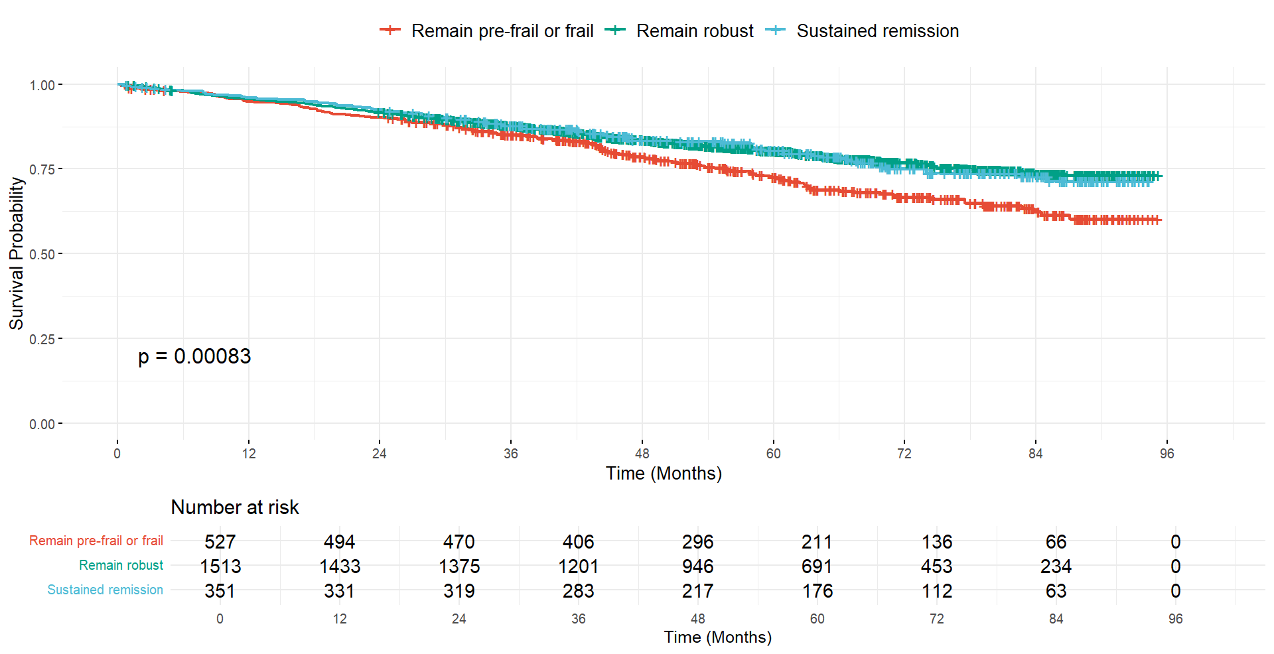
Figure S1 Kaplan–Meier survival curves of CVD risk by frailty transition patterns

