Supplementary Material – Figures
Unequal Budgeting and Limited WHO AWaRe Access Antibiotics in Punjab: Procurement Policy Gaps in Pakistan’s National Action Plan Against Antimicrobial Resistance
Shairyar Afzal ª, Mishal Bajwa ^{b}, Mian Shahzeb Haroon ^{c,d}, Huda Arooj ^{e}, Rana Muhammad Zahid Mushtaq ^{f}, Zikria Saleem ^{g}
ª Department of Pharmacy, DHQ Hospital Jhelum, Jhelum, Pakistan.
^{b} Department of Pharmacy, Quaid-i-Azam University, Islamabad, Islamabad, Pakistan.
^{c} Department of Pharmacology and Toxicology, University of Veterinary and Animal Sciences, Lahore, Lahore, Pakistan.
^{d} Department of Pharmacy, The University of Chenab, Gujrat, Gujrat, Pakistan.
^{e} Department of Pharmacy Practice, Faculty of Pharmacy, Bahauddin Zakariya University, Multan, Punjab, Pakistan.
^{f} Institute for Regeneration and Repair (IRR), Edinburgh Medical School, The University of Edinburgh, United Kingdom.
^{g} Department of Pharmacy Practice, College of Pharmacy, Qassim University, Saudi Arabia.
Correspondence
Shairyar Afzal
Department of Pharmacy, DHQ Hospital Jhelum, Jhelum, Pakistan, 49600.
mirzashairyar@gmail.com
+92-300-5466277
Zikria Saleem
Department of Pharmacy Practice, College of Pharmacy, Qassim University, Saudi Arabia.
s.zaikria@qu.edu.sa and xikria@gmail.com
+966-050-4824-750

Figure S1
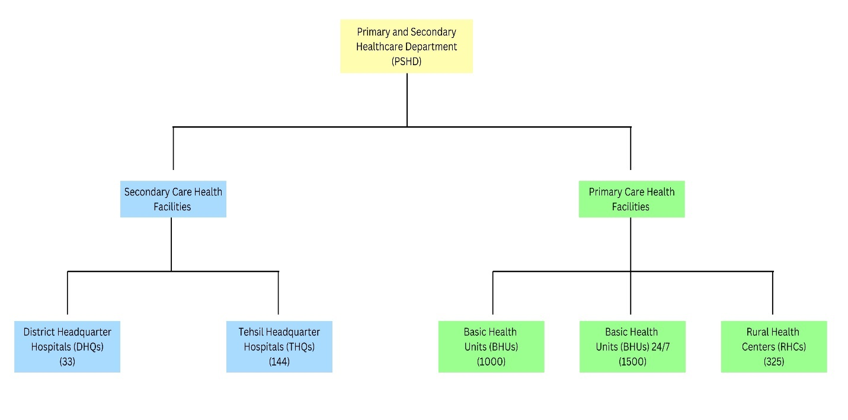
Figure S1: Organogram of the primary and secondary healthcare department of the province of Punjab, Antibiotic Procurement Policy in Punjab Fiscal Year 2023 – 2024.
Figure S2

Figure S2: Percentage cost of Standard Medicine List (SML)-advised antibiotics as per formulation and AWaRe classification in Punjab, Antibiotic Procurement Policy in Punjab Fiscal Year 2023 – 2024. [Intravenous (IV)]
Figure S3
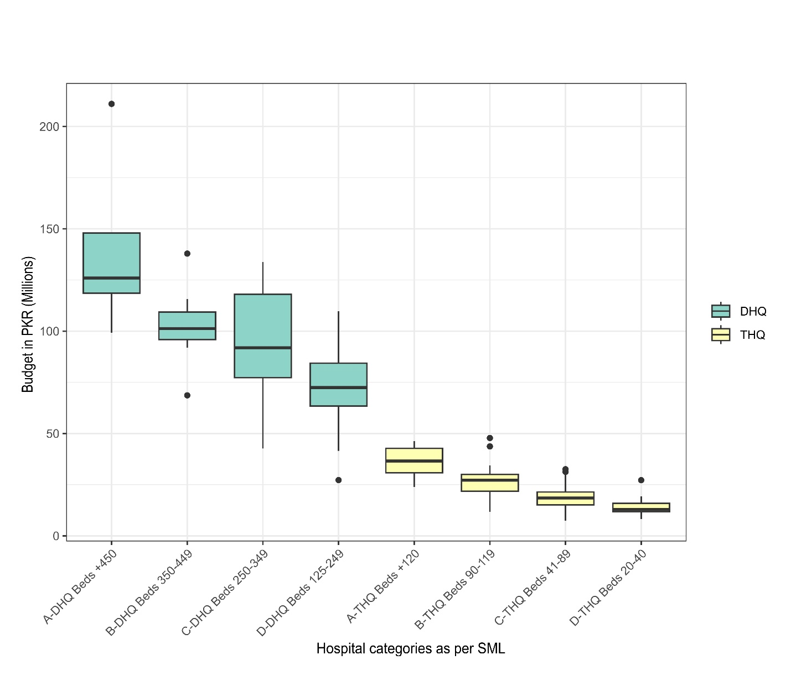

Figure S3: Relationship of medicine budget allocated versus secondary level hospital category as per the Standard Medicine List (SML) bed strength in Punjab, Antibiotic Procurement Policy in Punjab Fiscal Year 2023 – 2024. [Standard Medicine List (SML), District Headquarter Hospital (DHQ), Tehsil Headquarter Hospital (THQ)]

Figure S4
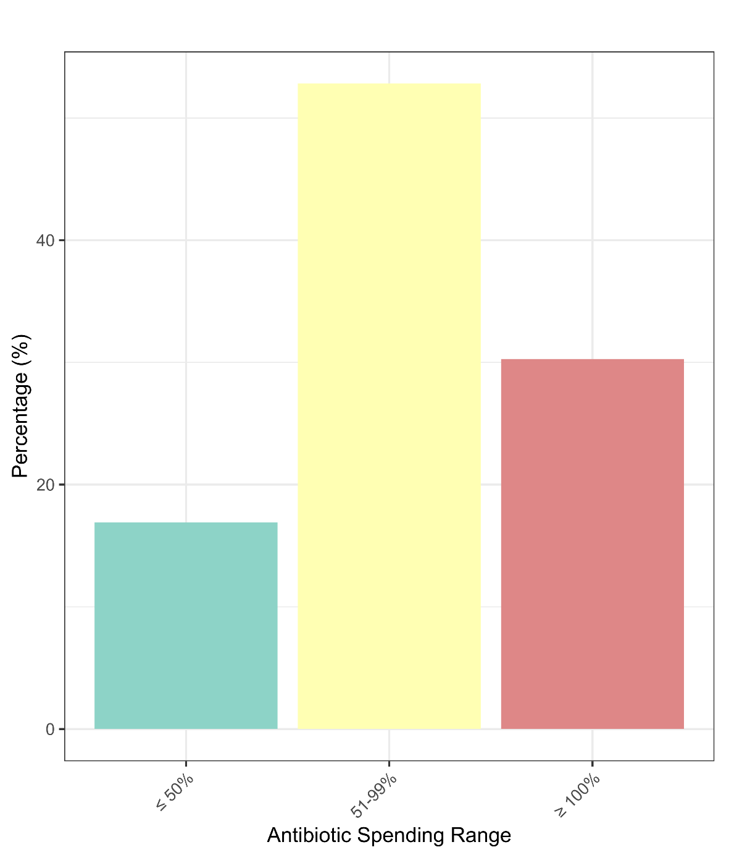
Figure S4: Bar chart illustrating the percentage of secondary level hospitals categorized as per the percentage medicine budget spending on Standard Medicine List (SML)-indicated antibiotics in Punjab, Antibiotic Procurement Policy in Punjab Fiscal Year 2023 – 2024.

Figure S5
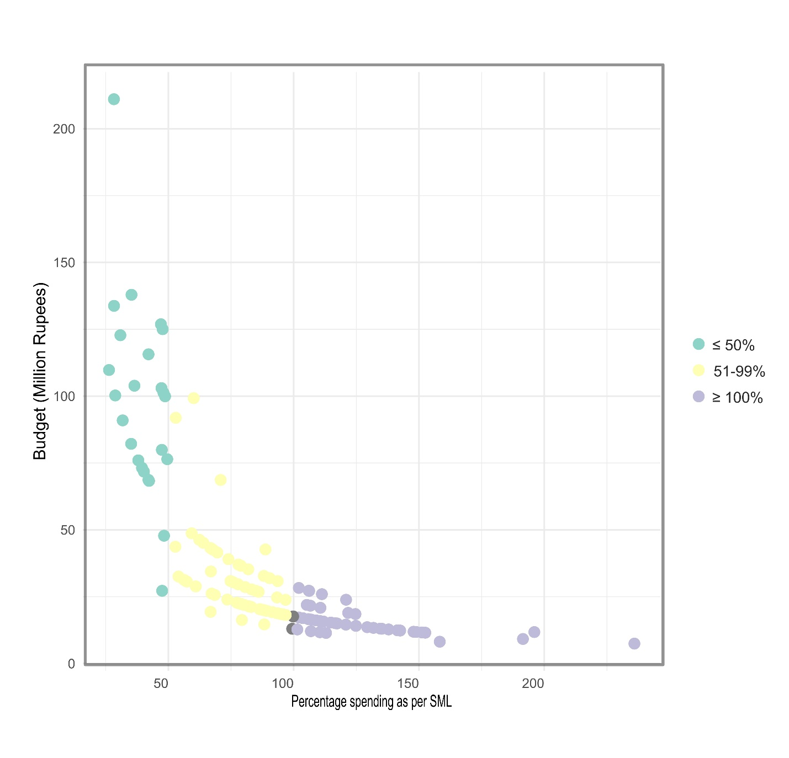
Figure S5: Scatter plot depicting medicine budget allocation against percentage antibiotic spending in secondary level hospitals of Punjab, Antibiotic Procurement Policy in Punjab Fiscal Year 2023 – 2024. [Standard Medicine List (SML)]

