Supplementary table 1. Trajectory Definitions of Depressive Symptoms.

 | wave4 | wave5 | wave6 | wave7
Persistently Low | - | - | - | -
Persistently High | + | + | + | +
Decreasing | + | - | - | -
 | + | + | - | -
Increasing | - | + | + | +
 | - | - | + | +
Fluctuating | All other cases where the above conditions are not met

This table defines the depressive symptom trajectories during the exposure period, including Persistently Low, Persistently High, Decreasing, Increasing, and Fluctuating patterns. Data were derived from participants in two population-based cohorts: the Health and Retirement Study (HRS, USA) and the English Longitudinal Study of Ageing (ELSA, UK). The exposure period covered HRS Rounds 4–7 (1998–2004) and ELSA Rounds 1–4 (2002–2008), during which depressive symptoms were repeatedly assessed to construct these trajectories.

Supplementary table 2. Cancer Case Counts Across Depressive Symptom Trajectories by Datasets (HRS, ELSA, and Combined)

Cancer | Consistently.low | Decreasing | Fluctuating | Increasing | Consistently.high
ELSA | 370 | 11 | 1300 | 20 | 53
HRS | 731 | 21 | 2550 | 30 | 104
All | 1101 | 32 | 3850 | 51 | 157
This table reports the number of incident cancer cases accrued during follow-up among participants in five depressive symptom trajectories. Data were derived from the Health and Retirement Study (HRS, USA) and the English Longitudinal Study of Ageing (ELSA, UK). The follow-up period covered HRS Rounds 8–12 (2004–2014) and ELSA Rounds 5–9 (2008–2018), during which incident cancer cases were counted within each depressive-symptom trajectory group.

Supplementary Figure. 1 Forest plot visualization of Model 1.

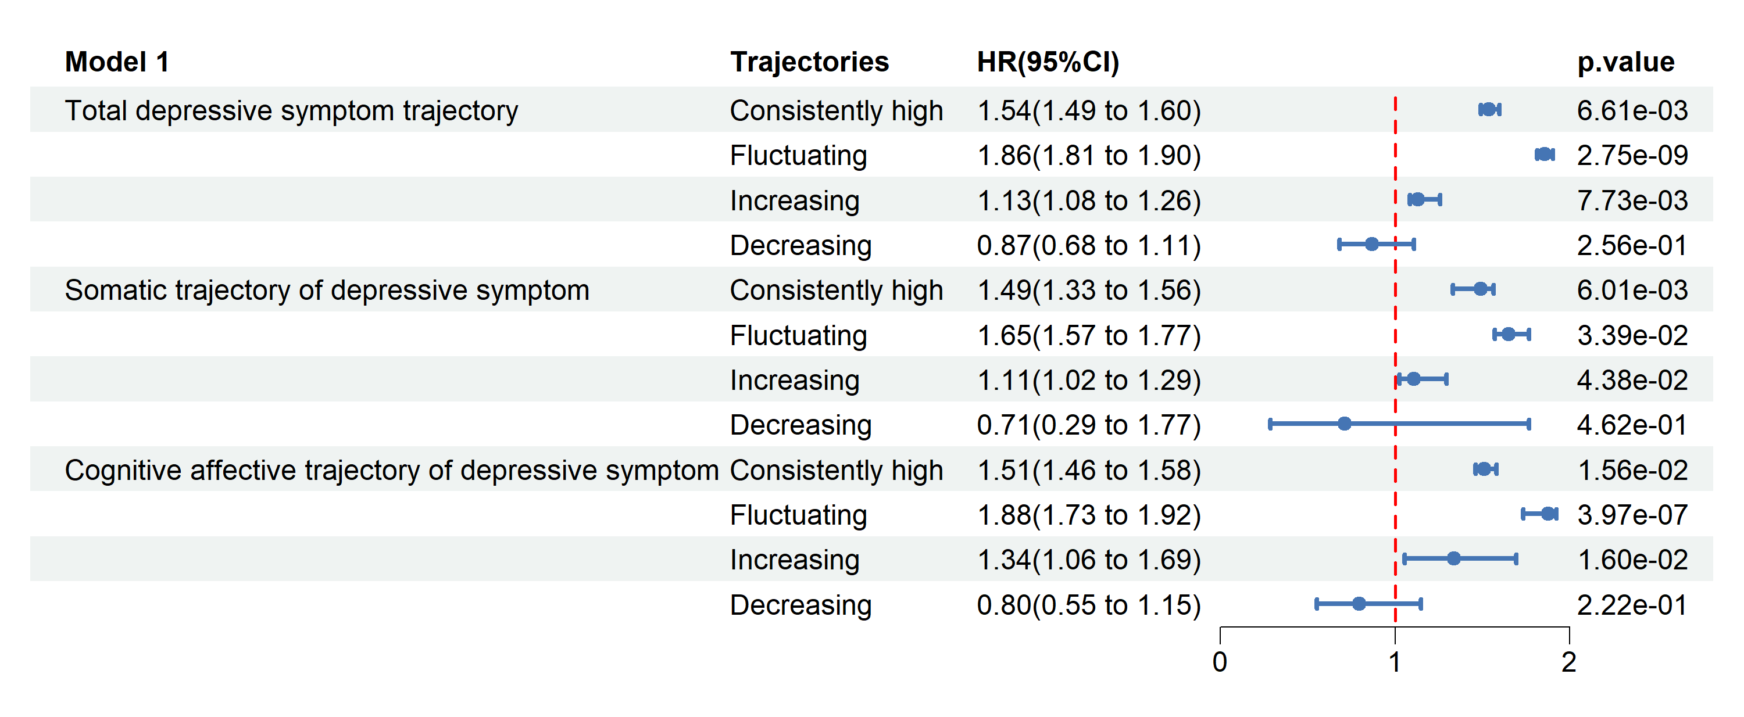
Supplementary Figure. 1 Forest plot visualization of Model 1. This forest plot displays the hazard ratios (HR) and 95% confidence intervals (CI) for each variable in Model 1 of Table 2. Each horizontal line represents a variable, with the square indicating the point estimate of the HR, and the horizontal line representing the 95% CI. The vertical dashed line (HR = 1) denotes no effect, with values to the right (HR > 1) indicating an increased risk. The analysis was based on participants from two population-based cohorts, the Health and Retirement Study (HRS, USA) and the English Longitudinal Study of Ageing (ELSA, UK). Data covered HRS Rounds 4–12 (1998–2014) and ELSA Rounds 1–9 (2002–2018), providing up to 10 years of follow-up. This figure illustrates the association between depressive symptom trajectories and subsequent cancer incidence.

Supplementary Figure. 2 Forest plot visualization of Model 2.

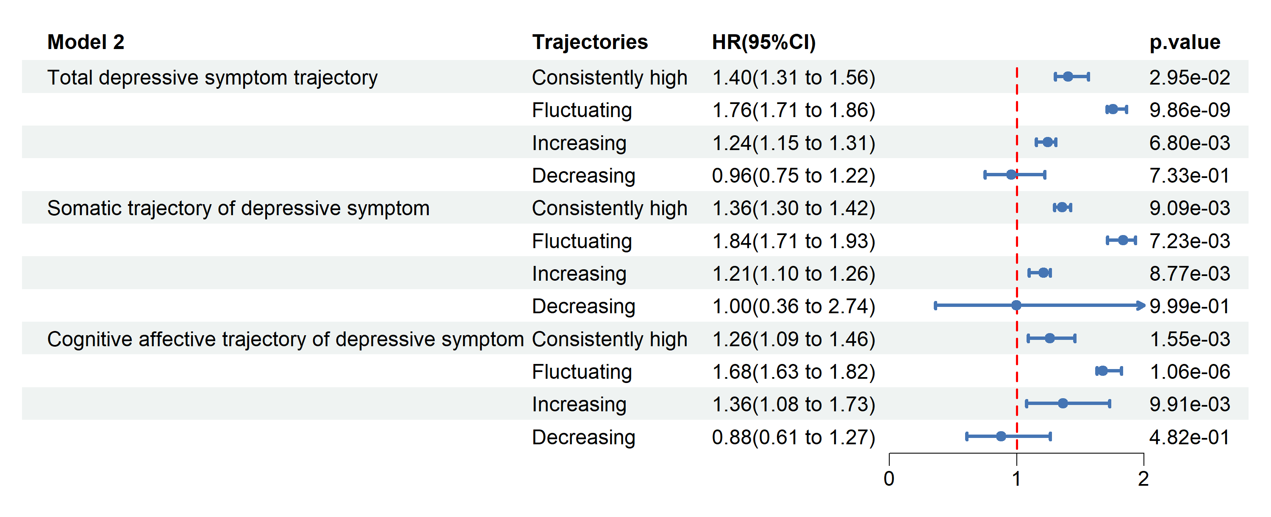
Supplementary Figure. 2 Forest plot visualization of Model 2. This forest plot displays the hazard ratios (HR) and 95% confidence intervals (CI) for each variable in Model 2 of Table 2. Each horizontal line represents a variable, with the square indicating the point estimate of the HR, and the horizontal line representing the 95% CI. The vertical dashed line (HR = 1) denotes no effect, with values to the right (HR > 1) indicating an increased risk. The analysis was based on participants from two population-based cohorts, the Health and Retirement Study (HRS, USA) and the English Longitudinal Study of Ageing (ELSA, UK). Data covered HRS Rounds 4–12 (1998–2014) and ELSA Rounds 1–9 (2002–2018), providing up to 10 years of follow-up. This figure illustrates the association between depressive symptom trajectories and subsequent cancer incidence.

Supplementary Figure. 3 Forest plot visualization of Model 3.

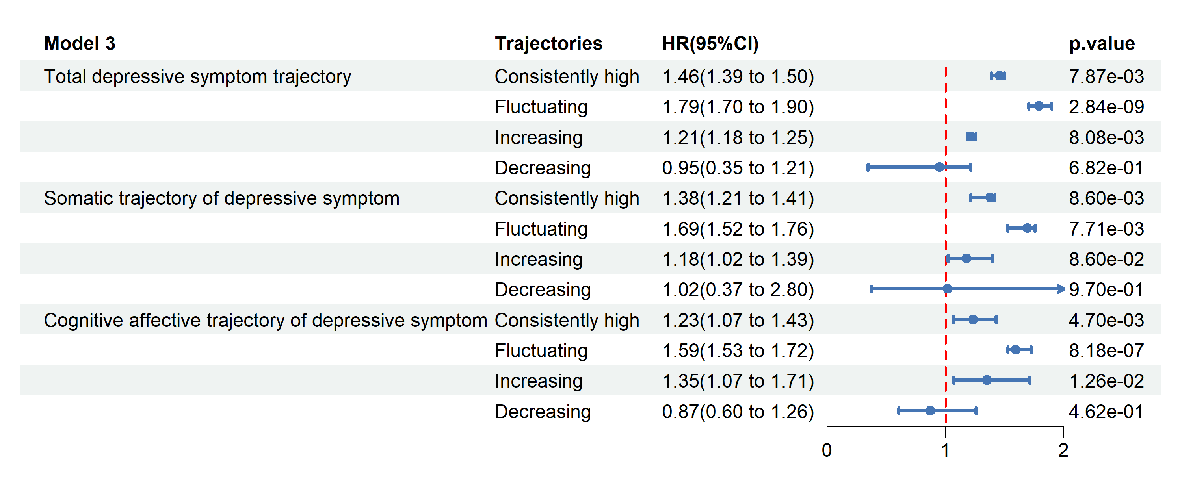
Supplementary Figure. 3 Forest plot visualization of Model 3. This forest plot displays the hazard ratios (HR) and 95% confidence intervals (CI) for each variable in Model 3 of Table 2. Each horizontal line represents a variable, with the square indicating the point estimate of the HR, and the horizontal line representing the 95% CI. The vertical dashed line (HR = 1) denotes no effect, with values to the right (HR > 1) indicating an increased risk. The analysis was based on participants from two population-based cohorts, the Health and Retirement Study (HRS, USA) and the English Longitudinal Study of Ageing (ELSA, UK). Data covered HRS Rounds 4–12 (1998–2014) and ELSA Rounds 1–9 (2002–2018), providing up to 10 years of follow-up. This figure illustrates the association between depressive symptom trajectories and subsequent cancer incidence.

Supplementary table 3. Cox Proportional Hazards Ratios for the Association Between Depressive Symptom Trajectories and Cancer During 10-year and 16-year Follow-up

 | Total Depressive Symptom Trajectory |  | Somatic Trajectory |  | Cognitive-affective
 | 10-year HR (95% CI) | 16-year HR (95% CI) | 10-year HR (95% CI) | 16-year HR (95% CI) | 10-year HR (95% CI) | 16-year HR (95% CI)
Consistently low | reference | reference | reference | reference | reference | reference
Consistently high | 1.46 (1.39-1.50) | 1.54 (1.37-1.68) | 1.38 (1.21-1.41) | 1.56 (1.44-1.68) | 1.23 (1.07-1.43) | 1.49 (1.37-1.62)
Fluctuating | 1.79 (1.70-1.90) | 1.81 (1.69-1.93) | 1.69 (1.52-1.76) | 1.69 (1.58-1.76) | 1.59 (1.53-1.72) | 1.77 (1.62-1.88)
Increasing | 1.21 (1.18-1.25) | 1.15 (1.09-1.24) | 1.18 (1.02-1.39) | 1.18 (1.09-1.26) | 1.35 (1.07-1.71) | 1.23 (1.12-1.41)
Decreasing | 0.95 (0.35-1.21) | 0.83 (0.76-1.48) | 1.02 (0.37-2.80) | 0.89 (0.64-1.25) | 0.87 (0.60-1.26) | 0.96 (0.73-1.53)

Consistently low depressive symptoms are used as the reference category. Adjusts for sociodemographic factors (age, sex, education, and marital status), health behaviors (smoking and alcohol consumption), and health conditions (hypertension and diabetes). Participants were drawn from two population-based cohorts, the Health and Retirement Study (HRS, USA) and the English Longitudinal Study of Ageing (ELSA, UK). The study period covered HRS Rounds 4–12 (1998–2014) and ELSA Rounds 1–9 (2002–2018). This table presents hazard ratios (HR) and 95% confidence intervals (CI) for both follow-up periods, providing a direct comparison between 10-year and 16-year outcomes.

