Appendix 1
Supplementary Table 1. Correlations of intrinsic capacity, multimorbidity, and health-related quality of life in Lianyungang, China (April-July 2024)
Variables | Multimorbidity | IC | EQ-5D-3L level
Multimorbidity | 1
IC | -0.222*** | 1
EQ-5D-3L level | 0.225*** | -0.246*** | 1
IC, intrinsic capacity; EQ-5D-3L, EuroQoL 5-Dimension 3-Level; ***p < 0.001.

Appendix 2
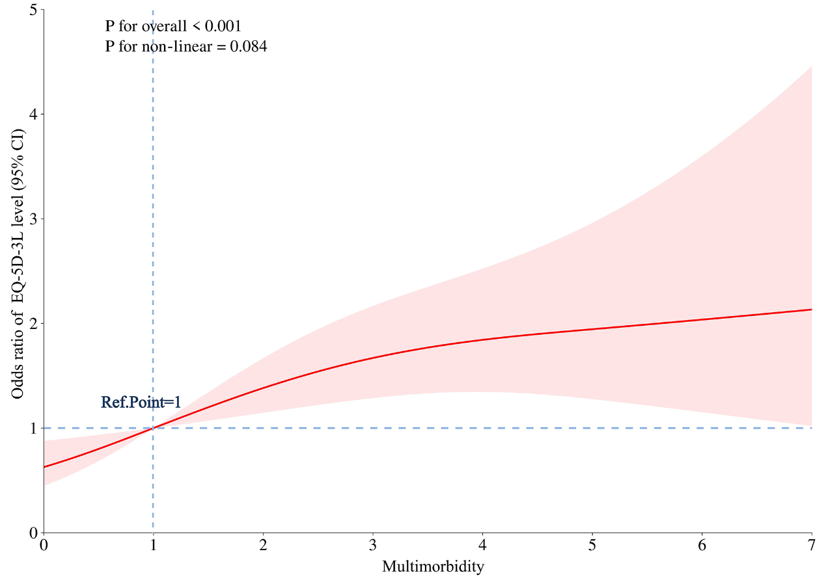
Supplementary Figure 1. Weighted restricted cubic spline curve describing the relationship between multimorbidity and health-related quality of life in Lianyungang, China (April-July 2024).
Adjusted for all covariates gender, age, marital status, education, nursing home resident status, intrinsic capacity.
Ref. Point, Reference. Point; CI, confidence interval; EQ-5D-3L, EuroQoL 5-Dimension 3-Level.

Appendix 3
Supplementary Table 2. Disease names incorporated into multimorbidity measurement in Lianyungang, China (April–July 2024)
No. | Disease Names
1 | Diabetes Mellitus
2 | Hyperlipidemia
3 | Coronary Heart Disease
4 | Heart Failure
5 | Atrial Fibrillation
6 | Stroke/Transient Ischemic Attack (TIA)
7 | Chronic Obstructive Pulmonary Disease (COPD)
8 | Chronic Gastroenteritis
9 | Chronic Liver Disease
10 | Chronic Kidney Disease
11 | Parkinson's Disease
12 | Malignant Tumor
13 | Dementia
14 | Depression
15 | Anxiety
16 | Delirium
17 | Neurasthenia
18 | Mental Disorder
19 | Other chronic conditions

Appendix 4
