Supplementary Table S1. English Version of the Chinese-Adapted Family Health Scale–Short Form (FHS-SF) Used in the 2023 Psychology and Behavior Investigation of Chinese Residents (PBICR) Survey, China.
Dimension | Item | Scoring options
Dimension | Item | Strongly disagree | Disagree | Neutral | Agree | Strongly agree
Family social/emotional health | In my family, we support each other. | 1 | 2 | 3 | 4 | 5
 | In my family, I feel safe in our family relationships. | 1 | 2 | 3 | 4 | 5
 | In my family, even during difficult times, we remain hopeful. | 1 | 2 | 3 | 4 | 5
Family healthy lifestyle | In my family, when needed, we help each other seek medical services (e.g., registration at hospitals). | 1 | 2 | 3 | 4 | 5
 | In my family, we help each other make changes to improve our health. | 1 | 2 | 3 | 4 | 5
Family health resources | In my family, we do not trust healthcare providers. | 5 | 4 | 3 | 2 | 1
 | During the past 12 months, after paying for basic living expenses, we had no money left. | 5 | 4 | 3 | 2 | 1
 | During the past 12 months, our housing did not meet the needs of the family. | 5 | 4 | 3 | 2 | 1
External family social support | When we encounter problems at school or work, our family can seek help from people outside the family. | 1 | 2 | 3 | 4 | 5
 | If we need financial assistance, our family can borrow money from people outside the family (e.g., 1,000 yuan). | 1 | 2 | 3 | 4 | 5
Note: Each item is scored from 1 (strongly disagree) to 5 (strongly agree); total score ranges from 10 to 50. Higher scores indicate better family health. Items in the Family Health Resources dimension are reverse-coded.

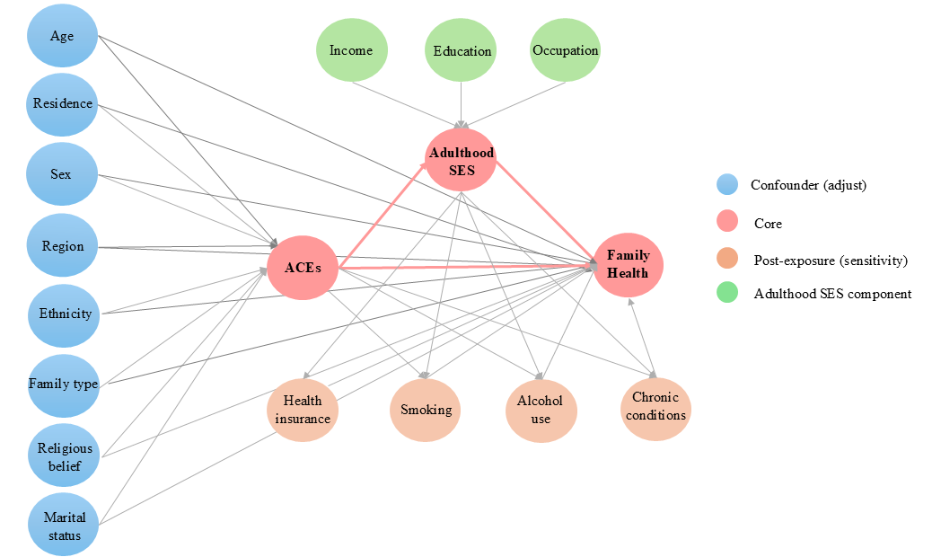

Supplementary Figure S1. Directed Acyclic Graph (DAG) of Hypothesized Relationships Among Adverse Childhood Experiences (ACEs), Adulthood Socioeconomic Status (SES), and Family Health: 2023 PBICR Survey, China.
Note: The primary adjustment set (age, sex, ethnicity, marital status, family type, residence, region, and religious belief) was selected to close backdoor paths.
Post-exposure factors (smoking, alcohol drinking, chronic conditions, and health insurance) are downstream of ACEs and SES; they were excluded from the primary model and included only in sensitivity analyses.
Adulthood SES comprises income, education, and occupation.
Node colors indicate variable roles: core variables (red), confounders (blue), post-exposure factors (orange), and SES components (green).
Abbreviations: ACEs, adverse childhood experiences; SES, socioeconomic status.

Supplementary Table S2 Classification of Adulthood Socioeconomic Status (SES) in the 2023 PBICR Survey, China.
Socioeconomic components | Classification | Score
Educational level
 | Postgraduate | 6
 | Bachelor's degree | 5
 | High school | 4
 | Middle school | 3
 | Elementary school | 2
 | Illiterate | 1
Occupation
 | Administration staff | 6
 | Professionals | 5
 | Clerk | 4
 | Service Personnel | 3
 | Manual worker | 2
 | Unemployed | 1
Monthly household income (¥)
 | ≥ 15,001 | 8
 | 12,001~15,000 | 7
 | 9,001~12,000 | 6
 | 5,001~9,000 | 5
 | 3,001~5,000 | 4
 | 2,001~3,000 | 3
 | 1001~2,000 | 2
 | ≤ 1000 | 1

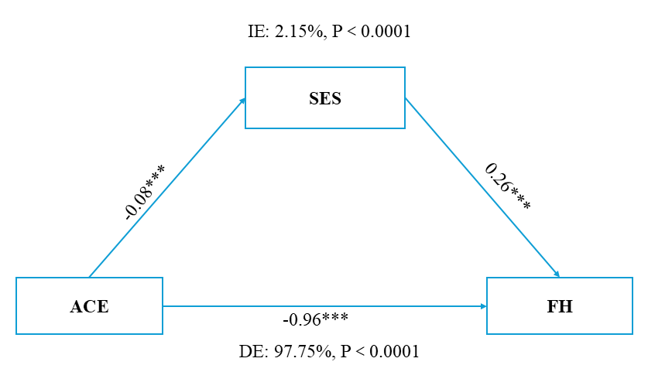
Supplementary Figure S2. Mediation Effect of Adulthood Socioeconomic Status (SES) on the Association Between Adverse Childhood Experiences (ACEs) and Family Health: Results from the 2023 PBICR Survey, China.
Note: Models were adjusted for age, sex, marital status, family type, religion, residence, region, and ethnicity. Coefficients were standardized. Indirect effects were estimated with bias-corrected bootstrap using 5 000 resamples. The proportion mediated was calculated as the indirect effect (product of the ACEs-to-SES and SES-to–family health paths) divided by the total effect.
Abbreviations: ACEs, adverse childhood experiences; SES, socioeconomic status; FH, family health; IE, indirect-effect proportion; DE, direct-effect proportion.

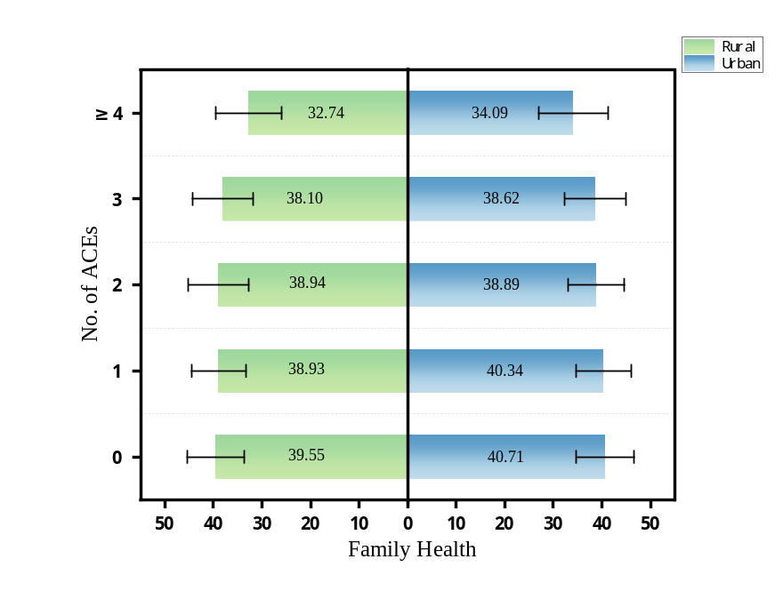
Supplementary Figure S3a Family Health Levels by Number of Adverse Childhood Experiences Among Urban and Rural Residents in China: Results from the 2023 PBICR Survey.
Note: Continuous variables were presented as mean±SD.
Abbreviations: ACEs, adverse childhood experiences.

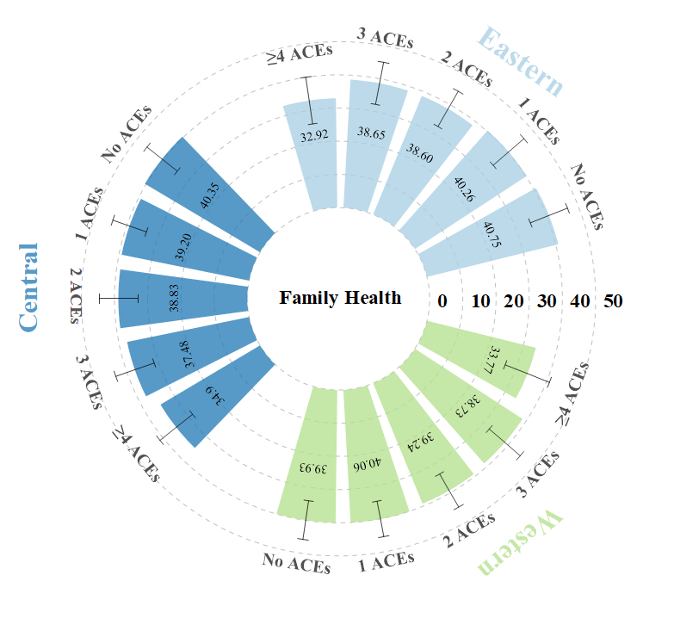

Supplementary Figure S3b. Family Health Levels by Number of Adverse Childhood Experiences Among Residents in Different Regions of China: Results from the 2023 PBICR Survey.
Note: Continuous variables were presented as mean±SD.
Abbreviations: ACEs, adverse childhood experiences.

 | β (95% CI) by No. of ACEs
 | 0ª | 1 | 2 | 3 | ≥4
Region
Eastern | 1 | -0.42(-0.78, -0.07) * | -1.88(-2.34, -1.43) *** | -1.81(-2.38, -1.24) *** | -6.51(-7.09, -5.93) ****
Central | 1 | -1.14(-1.59, -0.70) *** | -1.44(-2.02, -0.86) *** | -2.68(-3.41, -1.95) **** | -5.05(-5.90, -4.19) ****
Western | 1 | 0.20(-0.15,0.54) | -0.57(-1.00, -0.15) ** | -0.95(-1.47, -0.44) **** | -5.30(-5.83, -4.76) ****
Residency
Rural | 1 | -0.41(-0.81, -0.01) * | -0.46(-0.94,0.02) | -1.16(-1.75, -0.57) *** | -5.69(-6.28, -5.09) ****
Urban | 1 | -0.32(-0.58, -0.07) * | -1.64(-1.97, -1.31) **** | -1.86(-2.28, -1.44) **** | -5.80(-6.24, -5.35) ****
Supplementary Table S3. Association of Number of Adverse Childhood Experiences with Family Health Among Residents in Different Regions of China: Results from the 2023 PBICR Survey.

Note: *p < 0.05, **p < 0.01, ***p < 0.001, ****p < 0.0001, statistically significant in bold.
Model was adjusted for age, sex, ethnicity, marital status, family type, religious beliefs, residence, region.
ª Reference: No ACEs exposure.
Abbreviations: ACEs, adverse childhood experiences, β: standardized coefficient, CI: confidence interval.

a Balance across No ACEs vs ACEs b Balance across No ACEs vs ACEs with adulthood SES
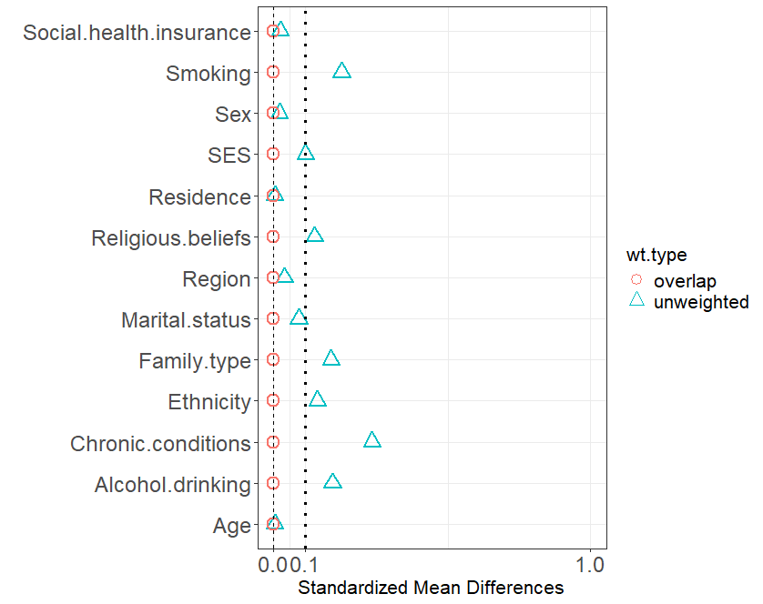
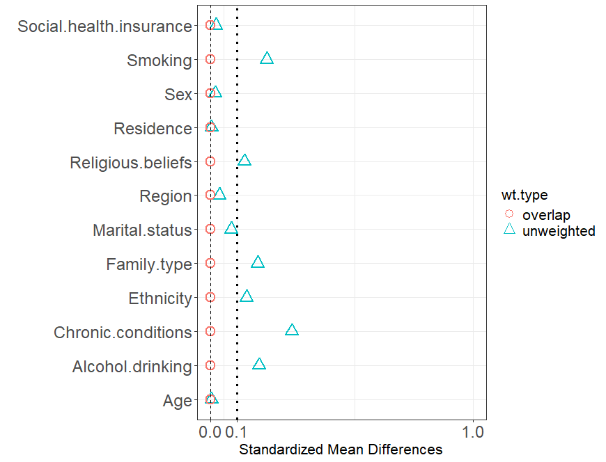
Supplementary Figure S4. Distribution of Overlap Weights from Propensity Score Overlap Weighting (PSOW): 2023 PBICR Survey, China.
Note: The absolute standardized mean difference (ASMD) is defined as the absolute difference in means between ACEs groups divided by the pooled standard deviation (SD). An ASMD less than or equal to 0.10 indicates good balance.
Abbreviations: ACEs, adverse childhood experiences; SES, socioeconomic status.

Supplementary Table S4. Association between Adverse Childhood Experiences and Family Health Based on Overlap Weighting Propensity Scores (Generalized Linear Regression): Results from the 2023 PBICR Survey, China
Variable | Estimate (St. Error) | 95%CI | P Value | Estimate (St. Error) | 95%CI | P Value
Family health | -1.44(0.08) | -1.60, -1.28 | ＜0.001 | -1.38(0.08) | -1.54, -1.22 | ＜0.001
Family social and emotional health processes | -0.82(0.03) | -0.88, -0.76 | ＜0.001 | -0.80(0.03) | -0.87, -0.74 | ＜0.001
Family healthy lifestyle | -0.42(0.02) | -0.46, -0.37 | ＜0.001 | -0.41(0.02) | -0.45, -0.36 | ＜0.001
Family health resources | 0.04(0.04) | -0.04,0.12 | 0.347 | 0.07(0.04) | -0.01, -0.04 | 0.090
Family external social supports | -0.25(0.02) | -0.29, -0.21 | ＜0.001 | -0.24(0.02) | -0.28, -0.20 | ＜0.001
Control adulthood SES | No |  |  | Yes
N (overlap) | 27 396 |  |  | 27 396
Note: Statistically significant in bold.
Abbreviations: β: standardized coefficient, CI: confidence interval, ACEs, adverse childhood experiences; SES, socioeconomic status.

Supplementary Table S5. Association between Adverse Childhood Experiences and Family Health (Generalized Ordered Logistic Regression): Results from the 2023 PBICR Survey, China.
Variable | OR (95% CI) by No. of ACEs
 | Male |  |  |  |  |  | Female
 | 0^{c} | 1 | 2 | 3 | ≥4 |  | 0^{c} | 1 | 2 | 3 | ≥4
Model 1ª
Family health | 1 | 0.92 (0.83, 1.02) | 0.69 (0.61, 0.79)**** | 0.71 (0.61, 0.83) **** | 0.21 (0.17, 0.26) **** |  | 1 | 0.85 (0.77, 0.93)*** | 0.62 (0.54, 0.71)*** | 0.54 (0.46, 0.63) **** | 0.23 (0.19, 0.29)****
Family social and emotional health processes | 1 | 0.84 (0.76, 0.90)*** | 0.62 (0.55, 0.70) **** | 0.58 (0.50, 0.68)**** | 0.23 (0.19, 0.27) **** |  | 1 | 0.68 (0.62, 0.75) **** | 0.52 (0.45, 0.59) **** | 0.50 (0.43, 0.59)**** | 0.20 (0.16, 0.24) ****
Family healthy lifestyle | 1 | 0.85 (0.77, 0.94) *** | 0.73 (0.64, 0.87) **** | 0.62 (0.53, 0.73)**** | 0.24 (0.20, 0.29) **** |  | 1 | 0.73 (0.67, 0.81)*** | 0.61 (0.53, 0.69) *** | 0.55 (0.47, 0.64) **** | 0.26 (0.21, 0.31) ****
Family health resources | 1 | 1.10 (0.94, 1.15) | 0.87 (0.77, 0.97)* | 0.96 (0.83, 1.12) | 0.73 (0.63, 0.84) **** |  | 1 | 1.12 (1.02, 1.23) | 1.00 (0.89, 1.14) | 0.82 (0.71, 0.96) ** | 0.74 (0.63, 0.87) ***
Family external social supports | 1 | 0.87 (0.79, 0.96) ** | 0.87 (0.78, 0.98) ** | 0.78 (0.67, 0.91) *** | 0.28 (0.24, 0.33) **** |  | 1 | 0.95 (0.87, 1.04) | 0.77 (0.68, 0.89)*** | 0.80 (0.69, 0.93) *** | 0.36 (0.31, 0.42) ****
Model 2^{b}
Family health | 1 | 0.92 (0.83, 1.02) | 0.69 (0.61, 0.78)**** | 0.71 (0.60, 0.83)**** | 0.21 (0.17, 0.26) **** |  | 1 | 0.84 (0.77, 0.93)*** | 0.62 (0.54, 0.73)*** | 0.54 (0.46, 0.63) *** | 0.23 (0.19, 0.28) ****
Family social and emotional health processes | 1 | 0.84 (0.76, 0.91) *** | 0.62 (0.55, 0.70) **** | 0.58 (0.50, 0.69)**** | 0.23 (0.20, 0.28) **** |  | 1 | 0.67 (0.61, 0.74) **** | 0.52 (0.43, 0.59)**** | 0.50 (0.42, 0.58) **** | 0.20 (0.16, 0.24) ****
Family healthy lifestyle | 1 | 0.86 (0.77, 0.94)** | 0.73 (0.64, 0.82)**** | 0.62 (0.53, 0.73)**** | 0.24 (0.20, 0.29)**** |  | 1 | 0.73 (0.67, 0.81) *** | 0.61 (0.52, 0.69) *** | 0.55 (0.47, 0.64) *** | 0.26 (0.21, 0.31) ****
Family health resources | 1 | 1.05 (0.94, 1.15) | 0.87 (0.77, 0.97)* | 0.96 (0.82, 1.11) | 0.73 (0.63, 0.85) **** |  | 1 | 1.11 (1.01, 1.22) | 1.00 (0.88, 1.14) | 0.82 (0.70, 0.95)** | 0.73 (0.63, 0.86)***
Family external social supports | 1 | 0.87 (0.79, 0.96)** | 0.86 (0.78, 0.97)** | 0.79 (0.68, 0.91) *** | 0.28 (0.24, 0.33)**** |  | 1 | 0.95 (0.86, 1.04) | 0.77 (0.68, 0.88)**** | 0.80 (0.69, 0.93)*** | 0.36 (0.31, 0.42)****
Note:*p < 0.05, **p < 0.01, ***p < 0.001, ****p < 0.0001, statistically significant in bold.
ª Model 1 was the crude model.
^{b} Model 2 was adjusted for age, ethnicity, marital status, family type, religious beliefs, residence, region.
^{c} Reference: No ACEs exposure.
Abbreviations: ACEs: adverse childhood experiences, OR, odds ratio, CI: confidence interval.

