S-Table 1 - Characteristics of the randomly selected general practitioners (GPs) according to gender
 | Male GP (N = 3,339) |  |  |  |  | Female GP (N = 1,661)
 | <40 yrs | 40-49 yrs | 50-59 yrs | ≥60 yrs |  | <40 yrs | 40-49 yrs | 50-59 yrs | ≥60 yrs
Number (% among gender) | 215 (6.4) | 453 (13.6) | 1,242 (37.2) | 1,428 (42.8) |  | 316 (19.0) | 479 (28.8) | 618 (37.2) | 249 (15.0)
Extra billing sector (N (%)) | 1 (0.5) | 6 (1.3) | 36 (2.9) | 146 (10.2) |  | 2 (0.6) | 1 (0.2) | 10 (1.6) | 21 (8.4)
Volume of activity (mean ± SD)
Number of daily acts | 22.8 ± 6.2 | 24.1 ± 7.4 | 23.6 ± 8.2 | 21.1 ± 7.7 |  | 20.3 ± 4.4 | 20.9 ± 6.1 | 19.9 ± 6.3 | 18.7 ± 6.6
Number of annual visits | 5,592 ± 1,830 | 5,931 ± 2032 | 5,891 ± 2,273 | 5,239 ± 2,163 |  | 4,592 ± 1,286 | 4,803 ± 1,667 | 4,714 ± 1,699 | 4,461 ± 1,950
Characteristics of caseload (mean ± SD)
Caseload either as MT or not | 1,782 ± 525 | 1,793 ± 598 | 1,705 ± 667 | 1,487 ± 632 |  | 1,573 ± 440 | 1,574 ± 535 | 1,488 ± 546 | 1,415 ± 568
Caseload as MT | 884 ± 339 | 1,003 ± 378 | 1,007 ± 411 | 884 ± 398 |  | 736 ± 258 | 836 ± 305 | 858 ± 341 | 808 ± 359
Caseload eligible for CRC screening as MT | 228 ± 107 | 260 ± 108 | 284 ± 116 | 274 ± 118 |  | 185 ± 84 | 201 ± 77 | 237 ± 95 | 240 ± 105
Proportion of CRC screening eligible population in the caseload as MT | 25.7 ± 6.1 | 26.2 ± 6.2 | 28.7 ± 5.3 | 31.9 ± 5.6 |  | 25.0 ± 6.7 | 24.7 ± 6.3 | 28.3 ± 5.8 | 30.1 ± 5.0
Pay-For-Performance (P4P) indicators (mean ± SD)
P4P indicator HbA1c | 0.87 ± 0.10 | 0.81 ± 0.13 | 0.79 ± 0.13 | 0.74 ± 0.15 |  | 0.88 ± 0.09 | 0.83 ± 0.11 | 0.82 ± 0.12 | 0.79 ± 0.12
P4P indicator Flue vaccination | 0.56 ± 0.09 | 0.54 ± 0.09 | 0.55 ± 0.09 | 0.52 ± 0.10 |  | 0.56 ± 0.09 | 0.54 ± 0.10 | 0.53 ± 0.09 | 0.51 ± 0.11
P4P indicator Breast cancer screening | 0.69 ± 0.08 | 0.67 ± 0.09 | 0.66 ± 0.08 | 0.65 ± 0.09 |  | 0.73 ± 0.08 | 0.70 ± 0.08 | 0.68 ± 0.08 | 0.68 ± 0.08
P4P indicator Cervical cancer screening | 0.59 ± 0.08 | 0.58 ± 0.09 | 0.55 ± 0.08 | 0.54 ± 0.09 |  | 0.62 ± 0.08 | 0.61 ± 0.08 | 0.58 ± 0.08 | 0.57 ± 0.08

S-Table 2 - Correlation between characteristics of physicians
 |  | Age of physician (continuous variable) | Number of daily acts | Caseload as preferred doctor (MT) | % of CRC screening eligible population in the caseload as MT | Pay-for-performance (P4P) prevention indicator
 |  |  |  |  |  | HBA1c | Flue vaccination | Breast cancer screening | Cervical cancer screening
Age of physician |  | 1 | -0.054*** | 0.021 | 0.399*** | -0.305*** | -0.116*** | -0.231*** | -0.278***
Number of daily acts |  |  | 1 | 0.779*** | -0.241*** | -0.020 | -0.027 | -0.109*** | -0.151***
Caseload as MT |  |  |  | 1 | -0.206*** | 0.045** | -0.002 | 0.082*** | 0.025
% of CRC screening eligible population in the caseload as MT |  |  |  |  | 1 | -0.110*** | -0.098*** | -0.052*** | -0.217***
P4P indicator | HBA1c |  |  |  |  | 1 | 0.277*** | 0.345*** | 0.263***
P4P indicator | Flue vaccination |  |  |  |  |  | 1 | 0.259*** | 0.121***
P4P indicator | Breast cancer screening |  |  |  |  |  |  | 1 | 0.591***
P4P indicator | Cervical cancer screening |  |  |  |  |  |  |  | 1
*p<0.05 ; ** p<10⁻² ; ***p<10⁻

S-Table 3 - Beneficiaries’ and general practitioners’ (GP) factors associated with participation to colorectal cancer (CRC) screening – Stratified analysis on gender of GP
 |  |  | Male GP  (N = 3,339 GPs and 1,052,742 beneficiaries) |  |  | Female GP  (N = 1,661 GPs and  414,711 beneficiaries)
 |  |  | ORa | CI95%ª |  | ORa | CI95%
Beneficiaries
Men gender |  | Male | 0.99 | [0.98-1.00] |  | 0.94 | [0.92-0.96]
Age |  | 55-59 | 1.01 | [0.99-1.02] |  | 1.04 | [1.02-1.06]
 |  | 60-64 | 1.18 | [1.17-1.20] |  | 1.22 | [1.19-1.23]
 |  | 65-69 | 1.28 | [1.26-1.29] |  | 1.29 | [1.26-1.31]
 |  | 70-74 | 1.14 | [1.13-1.16] |  | 1.14 | [1.11-1.16]
Health Insurance System^{b} |  | MSA | 0.80 | [0.80-0.84] |  | 0.84 | [0.81-0.87]
 |  | RSI | 0.78 | [0.77-0.80] |  | 0.81 | [0.79-0.84]
 |  | Other | 1.15 | [1.11-1.19] |  | 1.20 | [1.13-1.27]
CMU-C^{c} |  | Yes | 0.56 | [0.55-0.58] |  | 0.59 | [0.57-0.61]
Heathcare reimbursement in 2015 |  | Without any GP consultation | 0.34 | [0.32-0.35] |  | 0.35 | [0.33-0.36]
 |  | With ≥1 GP consultation | 0.63 | [0.62-0.64] |  | 0.64 | [0.62-0.65]
Comorbidity group in 2015 according to value of MRMIp |  | 1 | 0.72 | [0.71-0.73] |  | 0.73 | [0.71-0.74]
 |  | 2 | 0.57 | [0.56-0.58] |  | 0.60 | [0.58-0.62]
 |  | ≥3 | 0.58 | [0.57-0.60] |  | 0.61 | [0.59-0.63]
Deprivation  (FDEP)^{d} |  | Q2 | 1.00 | [0.98-1.02] |  | 1.01 | [0.99-1.04]
 |  | Q3 | 0.96 | [0.94-0.98] |  | 0.94 | [0.92-0.97]
 |  | Q4 | 0.92 | [0.91-0.94] |  | 0.92 | [0.89-0.95]
 |  | Q5 (Most deprived) | 0.90 | [0.88-0.92] |  | 0.88 | [0.86-0.91]
Residing in a medical desert^{e} |  |  | 0.98 | [0.96-1.00] |  | 0.98 | [0.95-1.00]
GP
Age (years) |  | 40-49 | 0.94 | [0.88-0.99] |  | 0.96 | [0.91-1.01]
 |  | 50-59 | 0.89 | [0.84-0.94] |  | 0.92 | [0.87-0.97]
 |  | > 60 | 0.88 | [0.83-0.93] |  | 0.89 | [0.84-0.95]
Extra billing sector |  |  | 0.85 | [0.80-0.89] |  | 0.77 | [0.69-0.87]
Number of daily acts (per 5 act) |  |  | 0.97 | [0.96-0.99] |  | 0.96 | [0.93-0.98]
Caseload as referent GP (per 50 patients) |  |  | 1.01 | [1.01-1.01] |  | 1.01 | [1.01-1.01]
% CRC screening eligible population (per 5%) |  |  | 1.04 | [1.02-1.05] |  | 1.02 | [1.01-1.04]
P4P^{f} indicators  (per 0.05 point) |  | HbA1c | 1.03 | [1.03-1.04] |  | 1.03 | [1.02-1.04]
 |  | Flue vaccination | 1.03 | [1.02-1.04] |  | 1.01 | [1.00-1.02]
 |  | Breast cancer screening | 1.09 | [1.08-1.10] |  | 1.09 | [1.08-1.10]
 |  | Cervical cancer screening | 1.01 | [1.00-1.02] |  | 1.02 | [1.01-1.03]
Intraclass Correlation Coefficient (ICC)^{g} | Adjusted on patients char. |  |  | 0.050 |  |  | 0.041
Intraclass Correlation Coefficient (ICC)^{g} | Final model |  |  | 0.030 |  |  | 0.027
ª ORa: adjusted odds ratio ; CI95%: confidence interval 95%
^{b} HIS scheme: General scheme and local mutualist section (RG-SLM); agricultural workers scheme (MSA); Self-employed workers scheme (RSI)
^{c} CMUc: Complementary universal health insurance (Free complementary universal health insurance under resource condition)
^{d} FDEP: French Deprivation Index of the city of residence
^{e} LPA of the city of residence
^{f} P4P: pay-for-performance indicators
^{g} ICC associated with level 2 variable (GP) calculated as follows: ICC = [variance (u0j)] / [variance (u0j) + π² /3], with variance (u0j) = Random intercept variance
S-Table 4 - Beneficiaries’ and general practitioners’ (GP) factors associated with participation to colorectal cancer (CRC) screening – Stratified analysis on age of GP
 |  | GP < 40 years  (N = 571 GPs and N=117,413 beneficiaries) |  |  | GP [40-49] years  (N = 932 GPs and N=243,653 beneficiaries) |  |  | GP [50-59] years  (N = 1,860 GPs and N=577,542 beneficiaries) |  |  | GP ≥60 years  (N = 1,677 GPs and N=528,845 beneficiaries)
 |  | ORa | CI95%ª |  | ORa | CI95%ª |  | ORa | CI95%ª |  | ORa | CI95%ª
Beneficiaries
Male |  | 0.96 | [0.94-0.98] |  | 0.96 | [0.94-0.97] |  | 0.98 | [0.97-0.99] |  | 0.98 | [0.96-0.99]
 | 55-59 | 1.05 | [1.01-1.09] |  | 1.04 | [1.01-1.06] |  | 1.01 | [0.99-1.03] |  | 1.00 | [0.98-1.02]
 | 60-64 | 1.24 | [1.19-1.29] |  | 1.23 | [1.20-1.27] |  | 1.17 | [1.15-1.19] |  | 1.18 | [1.16-1.20]
 | 65-69 | 1.30 | [1.25-1.35] |  | 1.31 | [1.28-1.35] |  | 1.27 | [1.25-1.30] |  | 1.27 | [1.24-1.29]
 | 70-74 | 1.16 | [1.11-1.21] |  | 1.18 | [1.14-1.21] |  | 1.14 | [1.12-1.17] |  | 1.12 | [1.09-1.14]
 | MSA | 0.85 | [0.80-0.89] |  | 0.83 | [0.80-0.87] |  | 0.84 | [0.81-0.86] |  | 0.81 | [0.79-0.83]
 | RSI | 0.82 | [0.78-0.87] |  | 0.81 | [0.78-0.84] |  | 0.79 | [0.77-0.81] |  | 0.79 | [0.77-0.81]
 | Other | 1.15 | [1.03-1.29] |  | 1.20 | [1.11-1.29] |  | 1.16 | [1.11-1.22] |  | 1.15 | [1.09-1.21]
CMU-C^{c} |  | 0.54 | [0.50-0.58] |  | 0.56 | [0.54-0.59] |  | 0.57 | [0.56-0.59] |  | 0.58 | [0.56-0.60]
Heathcare reimbursement in 2015 | None | 0.34 | [0.31-0.38] |  | 0.36 | [0.33-0.38] |  | 0.35 | [0.33-0.36] |  | 0.32 | [0.30-0.34]
Heathcare reimbursement in 2015 | Without any GP consultation | 0.70 | [0.66-0.74] |  | 0.63 | [0.60-0.65] |  | 0.63 | [0.62-0.65] |  | 0.62 | [0.60-0.63]
Comorbidity group in 2015 according to value of MRMIp | 1 | 0.71 | [0.68-0.73] |  | 0.71 | [0.70-0.73] |  | 0.72 | [0.71-0.73] |  | 0.72 | [0.71-0.74]
Comorbidity group in 2015 according to value of MRMIp | 2 | 0.54 | [0.51-0.58] |  | 0.56 | [0.54-0.59] |  | 0.58 | [0.57-0.60] |  | 0.59 | [0.57-0.61]
Comorbidity group in 2015 according to value of MRMIp | ≥3 | 0.54 | [0.51-0.57] |  | 0.59 | [0.56-0.62] |  | 0.60 | [0.58-0.62] |  | 0.60 | [0.58-0.62]
Deprivation  (FDEP)^{d} | Q2 | 0.97 | [0.92-1.02] |  | 1.01 | [0.97-1.04] |  | 1.02 | [1.00-1.05] |  | 1.00 | [0.97-1.03]
Deprivation  (FDEP)^{d} | Q3 | 0.92 | [0.87-0.97] |  | 0.94 | [0.91-0.98] |  | 0.95 | [0.93-0.98] |  | 0.98 | [0.95-1.01]
Deprivation  (FDEP)^{d} | Q4 | 0.90 | [0.85-0.95] |  | 0.90 | [0.86-0.93] |  | 0.94 | [0.92-0.97] |  | 0.94 | [0.91-0.96]
Deprivation  (FDEP)^{d} | Q5 (Most deprived) | 0.88 | [0.83-0.94] |  | 0.92 | [0.88-0.96] |  | 0.91 | [0.88-0.93] |  | 0.90 | [0.87-0.92]
Residing in a medical desert* |  | 0.98 | [0.93-1.032] |  | 0.99 | [0.95-1.03] |  | 0.97 | [0.94-0.99] |  | 0.99 | [0.97-1.02]
GP
Male |  | 0.99 | [0.93-1.05] |  | 0.96 | [0.92-1.00] |  | 0.94 | [0.91-0.97] |  | 0.94 | [0.89-0.99]
Extra billing sector |  | 0.66 | [0.44-0.98] |  | 0.74 | [0.58-0.95] |  | 0.80 | [0.72-0.89] |  | 0.87 | [0.82-0.93]
Number of daily acts (per 5 act) |  | 0.96 | [0.92-0.99] |  | 0.95 | [0.92-0.97] |  | 0.97 | [0.95-0.98] |  | 0.99 | [0.97-1.01]
Caseload as referent GP (per 50 patients) |  | 1.01 | [1.00-1.01] |  | 1.01 | [1.01-1.02] |  | 1.01 | [1.01-1.01] |  | 1.01 | [1.00-1.01]
% CRC screening eligible population (per 5%) |  | 1.00 | [0.98-1.03] |  | 1.01 | [0.99-1.03] |  | 1.04 | [1.02-1.05] |  | 1.05 | [1.03-1.07]
P4P | HbA1c | 1.04 | [1.02-1.05] |  | 1.03 | [1.02-1.04] |  | 1.03 | [1.03-1.04] |  | 1.03 | [1.03-1.04]
 | Flue vaccination | 1.00 | [0.98-1.02] |  | 1.02 | [1.00-1.03] |  | 1.02 | [1.01-1.03] |  | 1.04 | [1.03-1.05]
 | Breast cancer screening | 1.09 | [1.06-1.11] |  | 1.09 | [1.07-1.11] |  | 1.09 | [1.08-1.11] |  | 1.09 | [1.07-1.10]
 | Cervical cancer screening | 1.01 | [0.99-1.03] |  | 1.01 | [1.00-1.03] |  | 1.02 | [1.01-1.03] |  | 1.01 | [1.00-1.02]
Intraclass Correlation Coefficient (ICC) |  | 0.026 |  |  | 0.026 |  |  | 0.027 |  |  | 0.033

S-Figure 1 - Beneficiaries’ and general practitioners’ (GP) factors associated with participation to colorectal cancer (CRC) screening – Stratified analysis on characteristics of beneficiaries (age, comorbidity, Free complementary universal health insurance under resource condition (CMU-C) and deprivation of city of residence (FDEP))
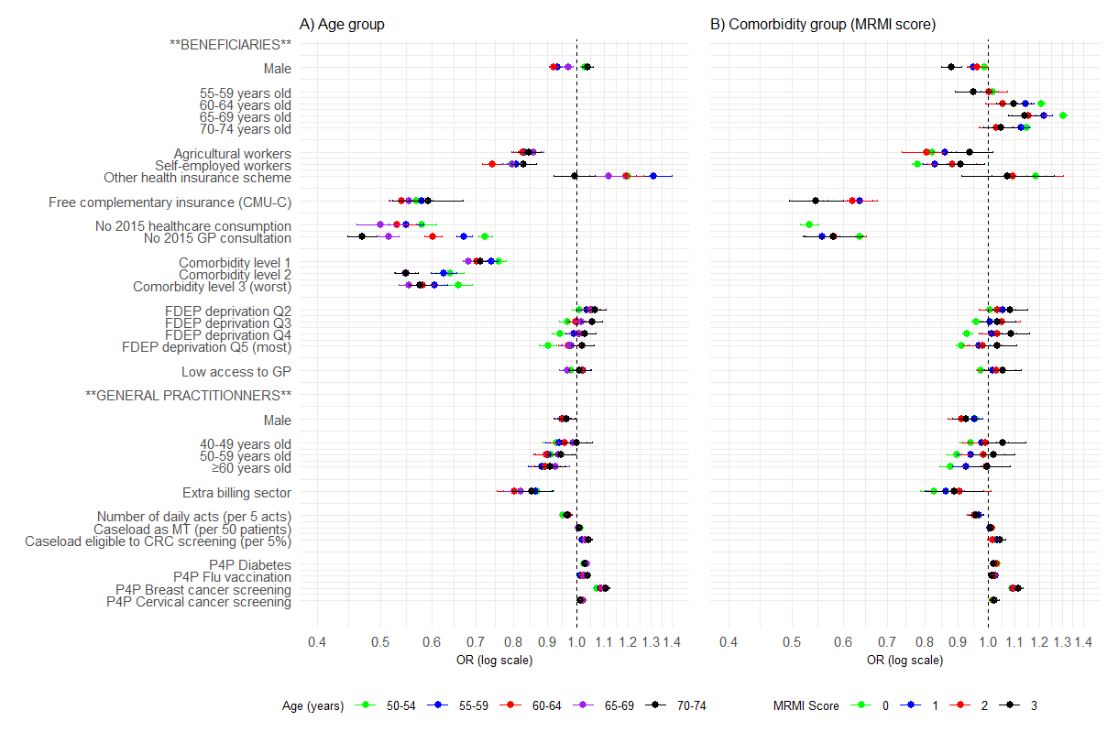
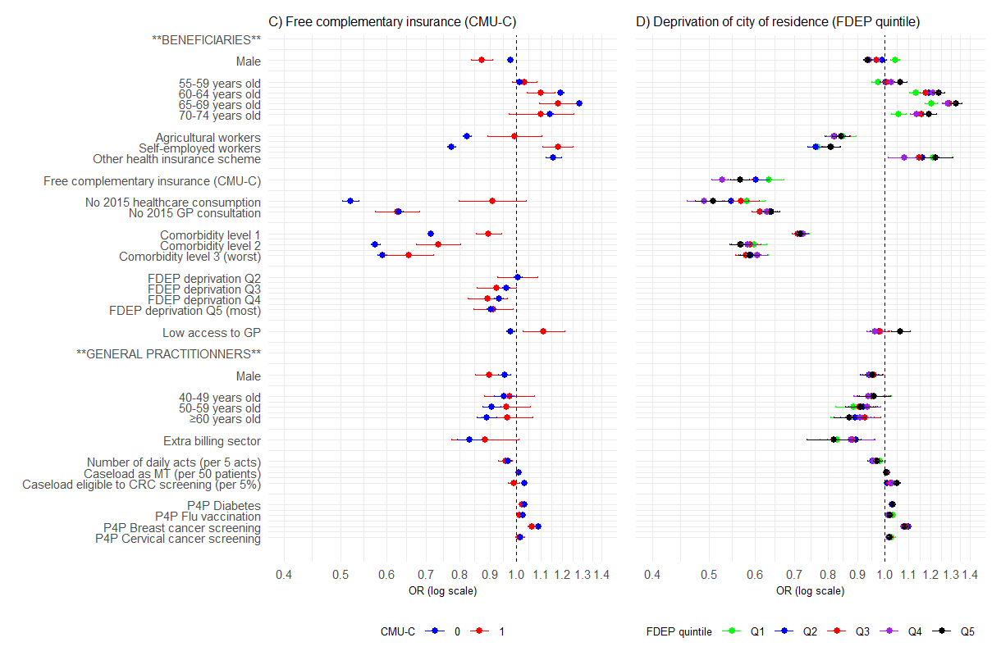

Appendix - Characteristics of GPs extracted from SNDS

1°) Definition of caseload as registered physician (MT for “médecin traitant” in French)
Population | Indicator
Patients ≥16 years old | From the age of 16, the Health Insurance System applies a discount to the reimbursement of healthcare costs for patients who have not registered with a general practitioner. The identifier of the GP is reported in each line of reimbursement of care in the SNDS database. A beneficiary can change his registration at any time. GP registration for the year 2015 was defined according to the latest reimbursement during the year 2015.
Patients <16 years old | For subjects aged less than 16, registration was attributed to the GP with the maximum number of consultations during the year 2015. In the event of a tie, no registration with any GP was recorded.

2°) Pay-for-performance P4P indicators
Disease | Indicator | Minimal number of targeted patients
HBA1c (Diabetes) | Proportion of registered patients treated with antidiabetics who had at least 2 HbA1c tests during the year | 10 patients
Flue vaccination | Proportion of registered patients aged 65 or over vaccinated against seasonal influenza | 10 patients
Breast cancer screening | Proportion of registered patients aged 50 to 74 taking part in breast cancer screening (organised or individual) | 20 patients
Cervical cancer screening | Percentage of female registered patients aged 25 to 65 having had a cervical cancer screening test in the last 3 years | 20 patients

