Supplementary Table S1: Blocking strategies employed to create a master dataset submitted for scoring the edges
Blocking pass | 1 | 2 | 3 | 4 | 5 | 6 | 7 | 8 | 9 | 10 | 11 | 12 | Total
Attribute(s)
First 4 letters of the first name | X | X
First 4 letters of surname | X |  | X
Last 4 letters of first name |  |  |  |  |  | X | X | X
Last 4 letters of surname |  |  |  |  |  | X | X |  | X
Last 1 letter of first name |  |  |  | X
Last 1 letter of surname |  |  |  |  | X
First name and second name inversion |  |  |  |  |  |  |  |  |  |  | X
First name and surname inversion |  |  |  |  |  |  |  |  |  | X
National ID number |  |  |  |  |  |  |  |  |  |  |  | X
Gender |  | X | X |  |  |  | X
Year of birth |  | X | X |  |  | X
Date of birth |  |  |  | X | X |  |  | X | X
Number of edges | 57,229,396 | 64,040,590 | 76,674,754 | 3,818,451 | 7,570,767 | 637,126 | 55,861,142 | 219,199 | 65,661 | 30,517 | 2,196,504 | 4,078 | 268,348,185

Supplementary Figure S1: Venn diagram of the linkage results for different data sources.
The figure shows the distribution (N, %) of 414,007 unique individuals across the databases. The interior percentages add up to 100%.

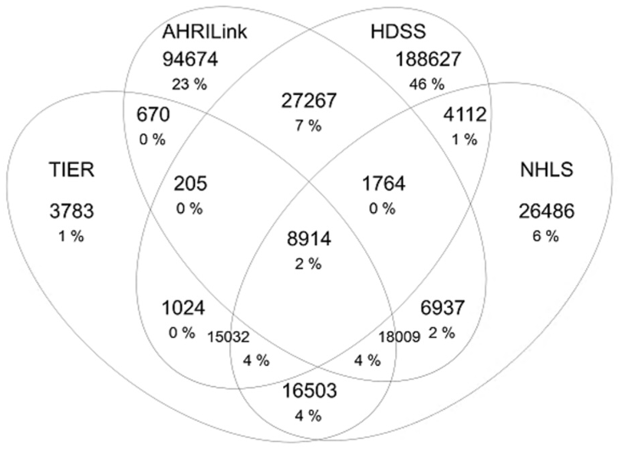

Supplementary Table S2: HIV care cascade definitions used in the study
HIV Care Cascade step | Definition | Numerator- denominator
People living with HIV(PLHIV) | Proportion of people testing positive for HIV through the dried blood spots collected from Africa Health Research Institute’s Health and Demographic Surveillance System | Numerator: All positive dried blood spots  Denominator: Adult residents tested for HIV
Diagnosed and aware of their HIV status | The proportion of people living with HIV who are aware of their HIV status  Dried blood spots results are not issued to research participants | Not applicable
Linked to care | The proportion of people living with HIV linked to care defined as having ART record in TIER.Net (recorded ART registration or initiation), CD4 count and viral load measurement from NHLS, reported ART initiation or follow clinic visit from AHRILink | Numerator: All individuals linked to care  Denominator: All adult residents tested HIV positive
Initiated ART | The proportion of people living with HIV who initiated ART defined as having recorded ART registration or initiation from TIER.Net, viral load measurement from NHLS, reported ART initiation or follow clinic visit from AHRILink (Hospital and clinics) | Numerator: All individuals with evidence of ART initiation  Denominator: All positive dried blood spots
Retained on ART | Proportion of people on sustained ART who initiated ART treatment defined as having a record in TIER.Net (ART clinic visit, ART medication), viral load measurement in NHLS and clinic visits from AHRILink (Hospital and clinics) | Numerator: All individuals with evidence of sustained ART treatment  Denominator: All positive dried blood spots
Virally suppressed | The proportion of people on ART treatment who have suppression of HIV defined as viral load of equal to or less than 200 copies/ml | Numerator: All individuals with evidence of sustained viral suppression  Denominator: All positive dried blood spots

Supplementary Table S3: HIV care cascade definitions used in the study
HIV Care Cascade step | Definition | Numerator- denominator
People living with HIV(PLHIV) | Proportion of people testing positive for HIV through the dried blood spots collected from Africa Health Research Institute’s Health and Demographic Surveillance System | Numerator: All positive dried blood spots  Denominator: Adult residents tested for HIV
Diagnosed and aware of their HIV status | The proportion of people living with HIV who are aware of their HIV status  Dried blood spots results are not issued to research participants | Not applicable
Linked to care | The proportion of people living with HIV linked to care defined as having ART record in TIER.Net (recorded ART registration or initiation), CD4 count and viral load measurement from NHLS, reported ART initiation or follow clinic visit from AHRILink | Numerator: All individuals linked to care  Denominator: All adult residents tested HIV positive
Initiated ART | The proportion of people living with HIV who initiated ART defined as having recorded ART registration or initiation from TIER.Net, viral load measurement from NHLS, reported ART initiation or follow clinic visit from AHRILink (Hospital and clinics) | Numerator: All individuals with evidence of ART initiation  Denominator: All adult residents linked to HIV care
Retained on ART | Proportion of people on sustained ART who initiated ART treatment defined as having a record in TIER.Net (ART clinic visit, ART medication), viral load measurement in NHLS and clinic visits from AHRILink (Hospital and clinics) | Numerator: All individuals with evidence of sustained ART treatment  Denominator: All adult residents linked to HIV care
Virally suppressed | The proportion of people on ART treatment who have suppression of HIV defined as viral load of equal to or less than 200 copies/ml | Numerator: All individuals with evidence of sustained viral suppression  Denominator: All adult residents who started ART treatment

Supplementary Figure S2: HIV care cascade¹ by age and sex among resident individuals under surveillance in the Africa Health Research Institute Health and Demographic Surveillance System between 2022 and 2024
