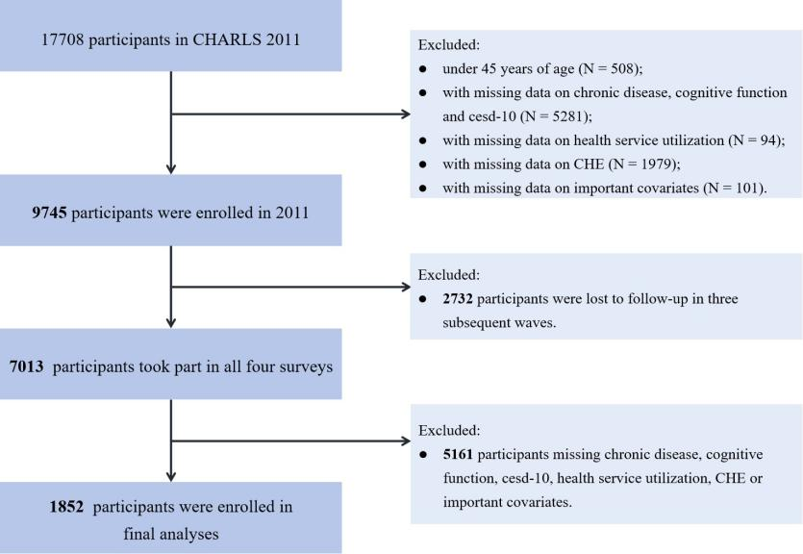

Figure_S1. Flowchart of participant selection without multiple imputation by chained equations of data in the sensitivity analysis

Table S1 Baseline demographic differences between included and excluded participants
Characteristic | All respondents at baseline |  | P-Value
Characteristic | Excluded  (N=5,435) | Included  (N=11,625) | P-Value
Age groups, y |  |  | <0.001
45~ | 51.97±4.38 | 52.37±4.37
≥60 | 70.81±7.85 | 67.04±6.01
Female | 2,595(47.75%) | 6,143(52.84%) | <0.001
Married and living with spouse | 4,470(82.24%) | 10,373(89.23%) | <0.001
Household total expenditure |  |  | <0.001
Higest | 1,358(24.99%) | 2,910(25.03%)
Higher | 1,360(25.02%) | 2,906(25.00%)
Lower | 1,358(24.99%) | 2,903(24.97%)
Lowest | 1,359(25.00%) | 2,906(25.00%)
Primary school or below | 3,435(63.20%) | 7,903(67.98%) | <0.001
Urban residence | 2,867(52.75%) | 4,040(34.75%) | <0.001
Region |  |  | =0.468
Eastern | 1,929(35.49%) | 4,015(34.54%)
Central | 1,769(32.55%) | 3,826(32.92%)
Western | 1,737(31.96%) | 3,784(32.54%)
Drinking | 2,304(42.39%) | 4,819(41.45%) | =0.250
Smoking | 2,314(42.58%) | 4,560(39.23%) | <0.001
Difficulty with ADL | 1,058(19.47%) | 1,794(15.43%) | <0.001
Health insurance | 4,937(90.84%) | 10,990(94.54%) | <0.001

Table S2 Association of disease type with catastrophic health expenditures under the 10% threshold by age and gender
 | total | age |  |  | gender
 |  | <60 | ≥60 |  | female | male
 |  | OR (95% CI) | OR (95% CI) |  | OR (95% CI) | OR (95% CI)
(1) | 1(ref) | 1(ref) | 1(ref) |  | 1(ref) | 1(ref)
(2) | 1.31(1.20-1.43)*** | 1.32(1.17-1.50)*** | 1.28(1.12-1.45)*** |  | 1.27(1.11-1.46)*** | 1.34(1.19-1.50)***
(3) | 1.30(1.14-1.49)*** | 1.30(1.08-1.56)*** | 1.29(1.05-1.58)** |  | 1.30(1.07-1.57)*** | 1.31(1.08-1.59)***
(4) | 1.01(0.84-1.21) | 1.01(0.75-1.36) | 0.99(0.79-1.24) |  | 0.97(0.77-1.24) | 1.07(0.81-1.41)
(5) | 2.09(1.93-2.26)*** | 2.05(1.83-2.29)*** | 2.06(1.84-2.30)*** |  | 2.15(1.90-2.43)*** | 2.04(1.83-2.26)***
(6) | 2.53(2.33-2.74)*** | 2.50(2.23-2.80)*** | 2.48(2.21-2.78)*** |  | 2.51(2.23-2.82)*** | 2.55(2.28-2.85)***
(7) | 1.65(1.48-1.85)*** | 1.68(1.37-2.06)*** | 1.62(1.41-1.87)*** |  | 1.58(1.35-1.85)*** | 1.80(1.52-2.14)***
(8) | 1.39(1.13-1.72)*** | 1.55(1.10-2.17)** | 1.29(0.99-1.69)* |  | 1.28(0.98-1.68)* | 1.65(1.16-2.34)***
(9) | 2.73(2.46-3.02)*** | 2.86(2.41-3.39)*** | 2.65(2.31-3.03)*** |  | 2.73(2.38-3.13)*** | 2.69(2.26-3.20)***
Note: (1) completely healthy group; (2) physical disease; (3) psychological disease; (4) cognitive disease; (5) multimorbidities of physical chronic diseases; (6) physical-psychological multimorbidity; (7) physical-cognitive multimorbidity; (8) psychological-cognitive multimorbidity; (9) physical-psychological-cognitive multimorbidity; **: P < 0.05, ***: P < 0.01; all P-values were corrected by Bonferroni

Table S3 Zero-inflated Poisson regression of the association between disease type and health care utilization
 | Number of outpatient visits |  |  | Days of hospitalization
 | OR(95%CI) | IRR(95%CI) |  | OR(95%CI) | IRR(95%CI)
(1) | 1(ref) | 1(ref) |  | 1(ref) | 1(ref)
(2) | 0.69(0.62-0.78)*** | 1.04(0.95-1.15) |  | 0.67(0.59-0.77)*** | 0.81(0.78-0.84)***
(3) | 0.66(0.56-0.79)*** | 1.07(0.94-1.22) |  | 0.65(0.53-0.79)*** | 0.97(0.92-1.02)
(4) | 1.14(0.89-1.46) | 1.11(0.92-1.35) |  | 0.82(0.62-1.07) | 1.17(1.10-1.25)***
(5) | 0.42(0.38-0.47)*** | 1.20(1.11-1.31)*** |  | 0.32(0.28-0.36)*** | 0.82(0.79-0.84)***
(6) | 0.35(0.32-0.39)*** | 1.41(1.30-1.53)*** |  | 0.28(0.25-0.32)*** | 0.87(0.84-0.89)***
(7) | 0.54(0.47-0.62)*** | 1.27(1.14-1.40)*** |  | 0.45(0.39-0.53)*** | 0.78(0.75-0.82)***
(8) | 0.60(0.46-0.78)*** | 0.99(0.81-1.21) |  | 0.55(0.41-0.74)*** | 0.79(0.73-0.85)***
(9) | 0.35(0.31-0.40)*** | 1.53(1.40-1.68)*** |  | 0.26(0.22-0.30)*** | 0.91(0.88-0.94)***
Note: (1) completely healthy group; (2) physical disease; (3) psychological disease; (4) cognitive disease; (5) multimorbidities of physical chronic diseases; (6) physical-psychological multimorbidity; (7) physical-cognitive multimorbidity; (8) psychological-cognitive multimorbidity; (9) physical-psychological-cognitive multimorbidity; **: P < 0.05, ***: P < 0.01；OR：OR in zero-inflated Poisson regression represents the association between predictors and the structural zero (unutilized health care) probability; all P-values were corrected by Bonferroni

Table S4 Analysis of the association between baseline disease state and disease state development before interpolation
Baseline | (2) |  | (3) |  | (4) |  | (5) |  | (6) |  | (7) |  | (8) |  | (9)
Baseline | N | OR  (95% CI) | N | OR  (95% CI) | N | OR  (95% CI) | N | OR  (95% CI) | N | OR  (95% CI) | N | OR  (95% CI) | N | OR  (95% CI) | N | OR  (95% CI)
(1) | 102 | 1.00 (ref) | 20 | 1.00 (ref) | 17 | 1.00 (ref) | 63 | 1.00 (ref) | 39 | 1.00 (ref) | 20 | 1.00 (ref) | 5 | 1.00 (ref) | 12 | 1.00 (ref)
(2) | 99 | 1.31 | 1 | 0.07 | 1 | 0.08 | 132 | 3.91 | 70 | 2.59 | 20 | 1.31 | 1 | 0.23 | 7 | 0.71
 |  | (0.95-1.82) |  | (0.01-0.50)*** |  | (0.01-0.58)** |  | (2.75-5.56)*** |  | (1.69-3.97)*** |  | (0.69-2.51) |  | (0.03-2.04) |  | (0.27-1.86)
(3) | 11 | 0.56 | 16 | 7.18 | 1 | 0.27 | 9 | 0.81 | 12 | 1.88 | 5 | 1.24 | 1 | 0.94 | 5 | 1.67
 |  | (0.28-1.10)* |  | (3.25-15.87)*** |  | (0.04-2.12) |  | (0.38-1.72) |  | (0.93-3.81)* |  | (0.44-3.48) |  | (0.11-8.39) |  | (0.55-5.08)
(4) | 7 | 0.35 | 4 | 1.29 | 13 | 3.71 | 6 | 0.60 | 4 | 0.52 | 19 | 4.92 | 6 | 5.18 | 6 | 1.85
 |  | (0.15-0.78)** |  | (0.41-4.11) |  | (1.65-8.35)*** |  | (0.25-1.44) |  | (0.18-1.20) |  | (2.42-9.99)*** |  | (1.45-18.43)** |  | (0.65-5.24)
(5) | 15 | 0.15 | 0 | --------- | 0 | --------- | 222 | 11.99 | 81 | 3.01 | 19 | 1.13 | 0 | --------- | 13 | 1.21
 |  | (0.08-0.26)*** |  | --------- |  | --------- |  | (8.35-17.22)*** |  | (1.97-4.59)*** |  | (0.58-2.19) |  | --------- |  | (0.53-2.75)
(6) | 23 | 0.30 | 1 | 0.08 | 0 | --------- | 92 | 3.29 | 131 | 7.66 | 12 | 0.73 | 2 | 0.44 | 34 | 2.95
 |  | (0.19-0.50)*** |  | (0.01-0.65)** |  | ---- ----- |  | (2.25-4.81)*** |  | (5.06-11.58)*** |  | (0.34-1.55) |  | (0.08-2.38) |  | (1.44-6.06)***
(7) | 7 | 0.24 | 0 | --------- | 0 | --------- | 38 | 4.25 | 22 | 2.37 | 27 | 4.56 | 0 | --------- | 16 | 3.05
 |  | (0.11-0.54)*** |  | --------- |  | --------- |  | (2.59-6.99)*** |  | (1.32-4.25)*** |  | (2.39-8.73)*** |  | --------- |  | (1.35-6.91)***
(8) | 1 | 0.12 | 2 | 1.23 | 4 | 3.50 | 4 | 1.19 | 6 | 2.10 | 4 | 2.59 | 3 | 11.20 | 4 | 2.37
 |  | (0.02-0.87)** |  | (0.22-6.77) |  | (0.94-13.05)* |  | (0.39-3.60) |  | (0.80-5.53) |  | (0.79-8.52) |  | (2.07-60.71)*** |  | (0.66-8.49)
(9) | 5 | 0.19 | 0 | --------- | 0 | --------- | 19 | 2.16 | 36 | 4.50 | 16 | 2.83 | 2 | 1.05 | 28 | 4.87
 |  | (0.07-0.49)*** |  | --------- |  | --------- |  | (1.20-3.92)** |  | (2.61-7.78)*** |  | (1.35-5.94)*** |  | (0.17-6.44) |  | (2.26-10.49)***
Note: (1) completely healthy group; (2) physical disease; (3) psychological disease; (4) cognitive disease; (5) multimorbidities of physical chronic diseases; (6) physical-psychological multimorbidity; (7) physical-cognitive multimorbidity; (8) psychological-cognitive multimorbidity; (9) physical-psychological-cognitive multimorbidity; **: P < 0.05, ***: P < 0.01; all P-values were corrected by Bonferroni
Table S5 Association between disease type and health care utilization patterns and CHE before interpolation
 | Outpatient service utilization | inpatient service utilization | Number of outpatient visits | Days of hospitalization | CHE
 | OR (95% CI) | OR (95% CI) | IRR (95% CI) | IRR (95% CI) | OR (95% CI)
(1) | 1(ref) | 1(ref) | 1(ref) | 1(ref) | 1(ref)
(2) | 1.70(1.30-2.22)*** | 1.50(1.04-2.16)** | 0.84(0.54-1.30) | 0.70(0.56-0.88)*** | 1.12(0.87-1.45)
(3) | 2.49(1.67-3.71)*** | 2.91(1.75-4.84)*** | 0.63(0.33-1.20) | 0.95(0.70-1.29) | 1.60(1.05-2.42)**
(4) | 1.84(1.17-2.88) | 1.61(0.87-2.99) | 0.86(0.40-1.84) | 0.74(0.51-1.09) | 1.23(0.78-1.94)
(5) | 3.04(2.41-3.87)*** | 3.63(2.66-4.96)*** | 0.92(0.62-1.35) | 0.68(0.56-0.82)*** | 2.16(1.73-2.68)***
(6) | 4.11(3.21-5.26)*** | 4.77(3.45-6.58)*** | 1.20(0.81-1.78) | 0.69(0.57-0.84)*** | 3.16(2.51-3.97)***
(7) | 2.73(1.99-3.76)*** | 1.91(1.23-2.95)*** | 1.11(0.67-1.85) | 0.77(0.58-1.00)* | 1.71(1.25-2.33)***
(8) | 1.92(0.98-3.77)* | 1.16(0.40-3.33) | 1.31(0.43-3.94) | 0.82(0.43-1.55) | 2.01(1.12-3.62)**
(9) | 3.84(2.79-5.27)*** | 3.38(2.25-5.10)*** | 1.32(0.79-2.19) | 0.68(0.53-0.87)*** | 3.07(2.27-4.16)***
Note: (1) completely healthy group; (2) physical disease; (3) psychological disease; (4) cognitive disease; (5) multimorbidities of physical chronic diseases; (6) physical-psychological multimorbidity; (7) physical-cognitive multimorbidity; (8) psychological-cognitive multimorbidity; (9) physical-psychological-cognitive multimorbidity; **: P < 0.05, ***: P < 0.01; all P-values were corrected by Bonferroni

