Additional File 1. Sensitivity Analysis using a Washout Period of Six Months after Risk Minimization Measures were Introduced

Figure 1: Forest plot of province-specific and pooled fluoroquinolone prescription relative rates by RMM segment with a six-month washout period following RMM implementation
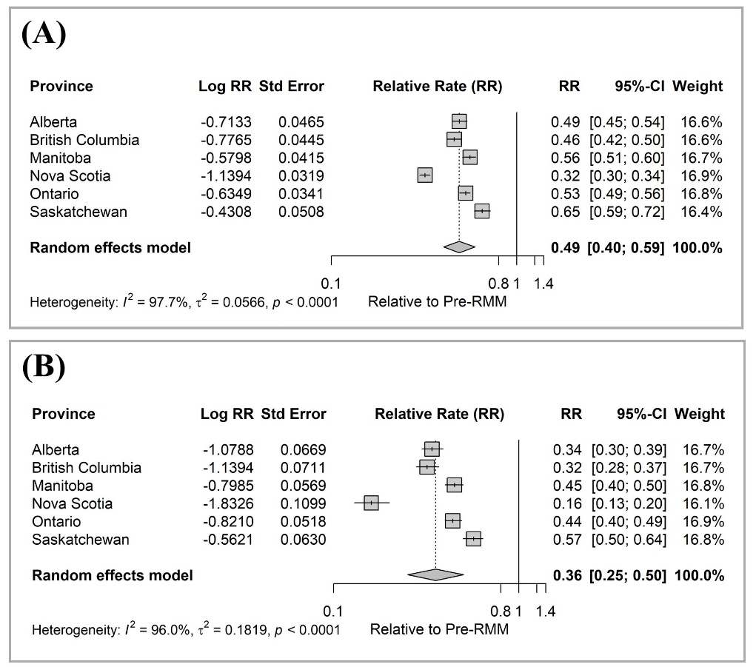
Note: Panel (A) corresponds to post-RMM pre-COVID segment (January 1, 2017 to February 29, 2020). Panel (B) corresponds to post-RMM within-COVID segment (March 1, 2020 to December 31, 2022). The reference is the pre-RMM segment (January 1, 2008 to December 31, 2016). CI = confidence interval; RMM = risk mitigation measure. Data available in Nova Scotia and Ontario for ≥ 66 years, and for ≥ 18 years for all other provinces. Rates are for four fluoroquinolones: ciprofloxacin, levofloxacin, moxifloxacin, norfloxacin.

