Additional File 2. Flow Charts of Cohort Construction for ABS, AECOPD, and UTI Antibiotic Indications

Figure 1: Flow chart of cohort construction for ABS indication
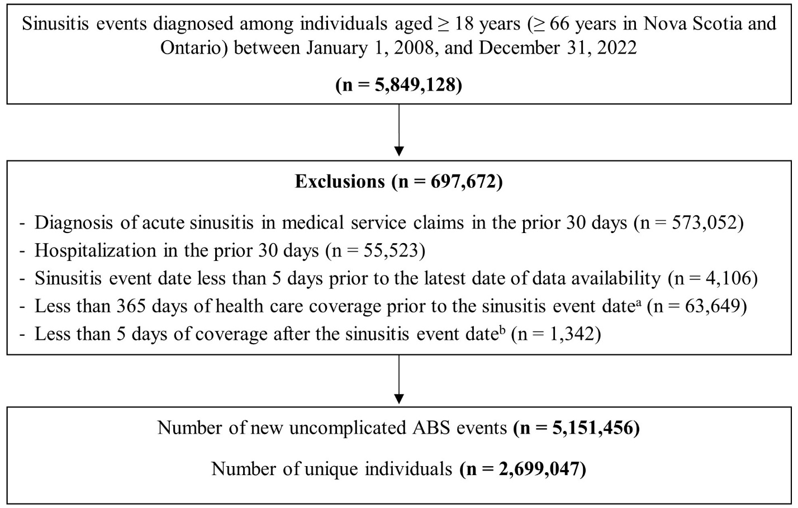
Note: ABS = acute bacterial sinusitis. Data are aggregated for all six provinces. Patients were allowed to enter the cohort multiple times with a new event.
ªPatients with less than 365 days of health care coverage prior to the event date could not be identified in Alberta due to the unavailability of start of coverage date.
^{b}Death or out-migration date was used a proxy for the end of coverage date in Alberta.

Figure 2: Flow chart of cohort construction for acute exacerbations of COPD indication
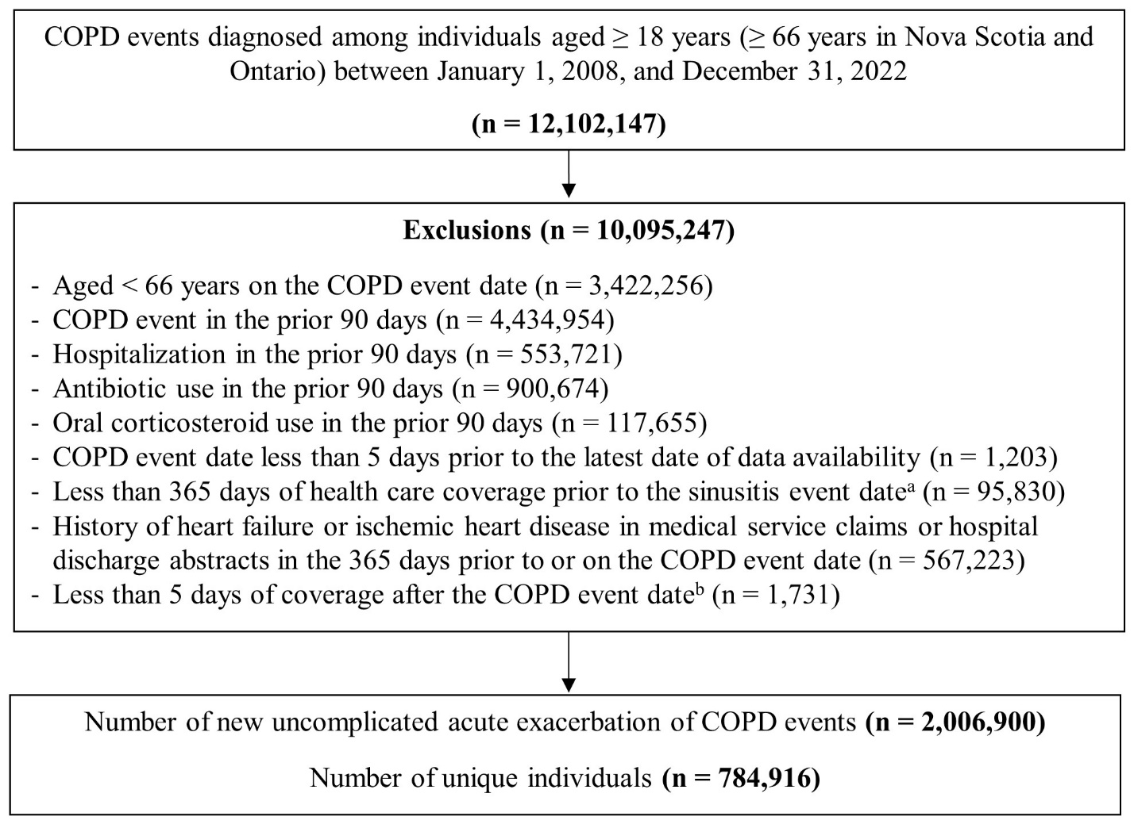
Note: COPD = chronic obstructive pulmonary disease. Data aggregated for all six provinces. Patients were allowed to enter the cohort multiple times with a new event.
ª Patients with less than 365 days of health care coverage prior to the event date could not be identified in Alberta due to the unavailability of start of coverage date.
^{b} Death or out-migration date was used a proxy for the end of coverage date in Alberta.
Figure 3: Flow chart of cohort construction for uncomplicated UTI indication
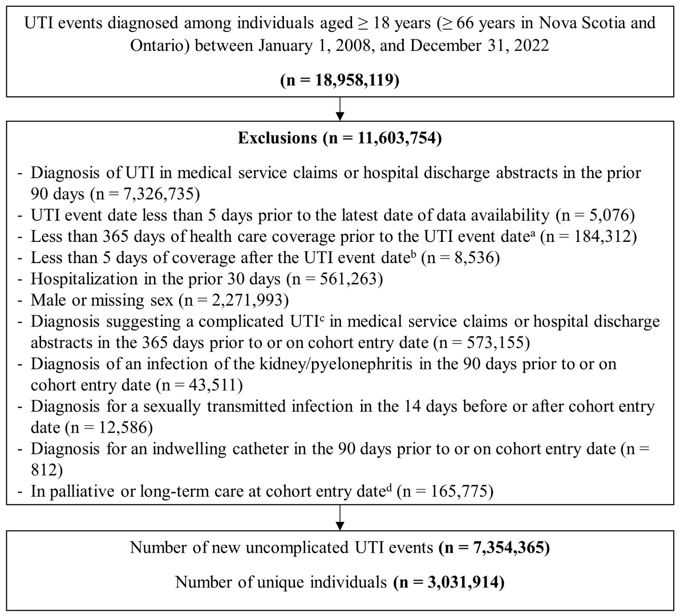
Note: UTI = urinary tract infection. Data aggregated for all six provinces. Patients were allowed to enter the cohort multiple times with a new event. Males were excluded because their UTIs are often complicated.
ª Patients with less than 365 days of health care coverage prior to the event date could not be identified in Alberta due to the unavailability of start of coverage date.
^{b} Death or out-migration date was used a proxy for the end of coverage date in Alberta.
^{c} Diagnosis for complicated female UTI includes structural abnormality of urinary tract (including stones), ureteral abnormality/vesicoureteral reflux, neurogenic bladder, neurologic conditions, pregnancy (in the 270 days prior), or severe diabetes.
^{d} In provinces where data are available. Palliative care data not available in Alberta.

