Additional File 3. Monthly age- and sex-standardized percentages of all antibiotic dispensations that are a fluoroquinolone

Figure 1: Overall smoothed trends in age- and sex-adjusted fluoroquinolone dispensation percentages by principal indication
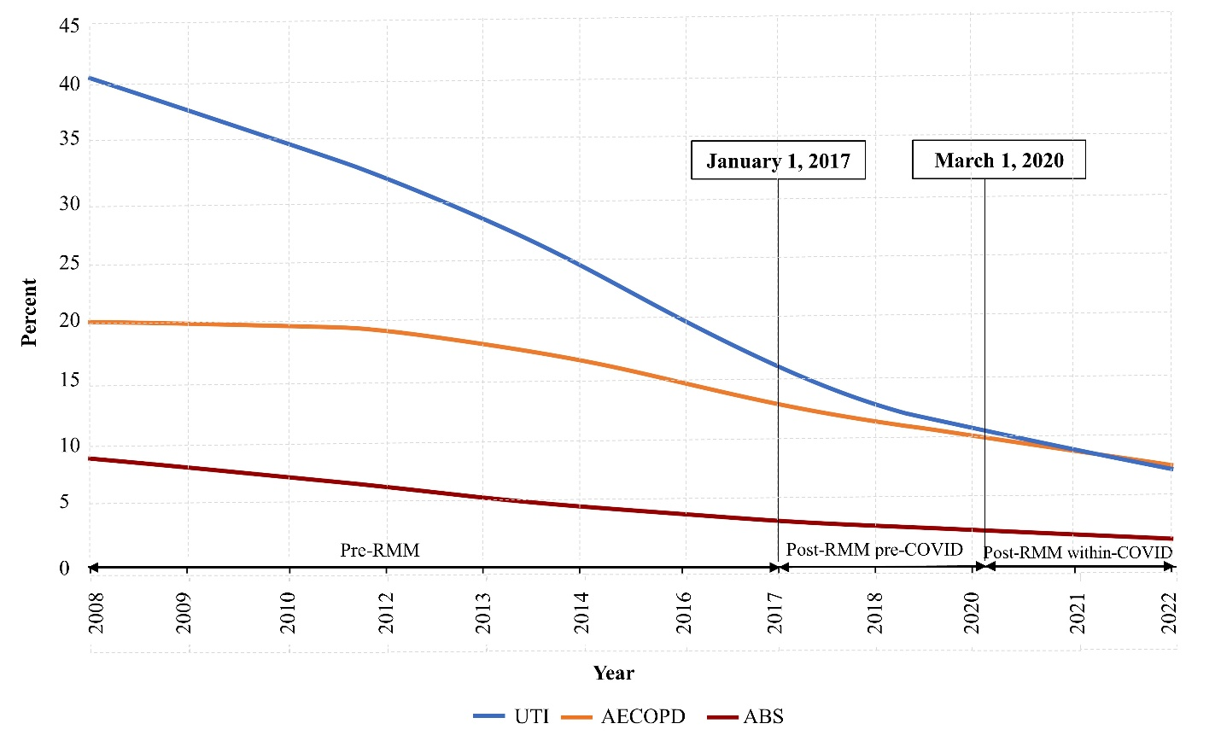
Note: Monthly values were averaged across provinces; smoothed trend lines were produced using Locally Estimated Scatterplot Smoothing (LOESS). AECOPD = acute exacerbation of chronic obstructive pulmonary disease; UTI = urinary tract infection; ABS = acute bacterial sinusitis;; RMM = risk mitigation measure.

Figure 2: Monthly percentages for the ABS indication by province and RMM segment

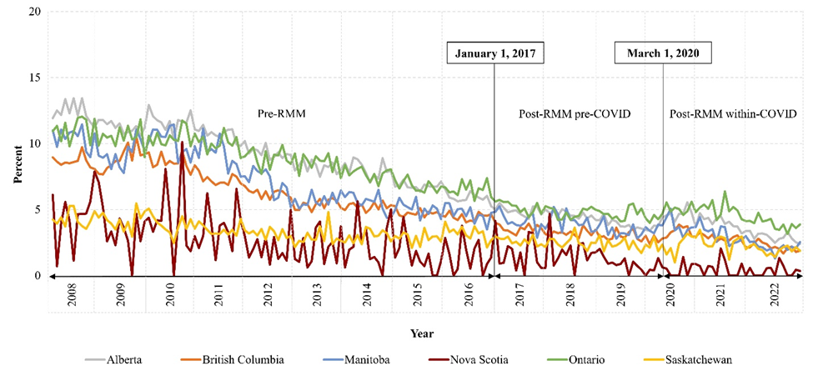
Note: Data available in Nova Scotia and Ontario for ≥ 66 years, and in other provinces for ≥ 18 years. Percentages are for four fluoroquinolones: ciprofloxacin, levofloxacin, moxifloxacin, norfloxacin. ABS = acute bacterial sinusitis; RMM = risk mitigation measure.
Figure 3: Monthly percentages for the AECOPD indication by province and RMM segment
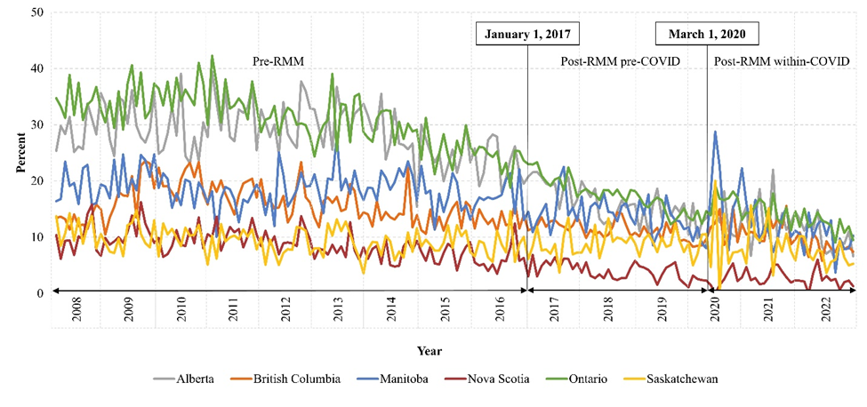
Note: Data available for ≥ 66 years. Percentages are for four fluoroquinolones: ciprofloxacin, levofloxacin, moxifloxacin, norfloxacin. AECOPD = acute exacerbation of chronic obstructive pulmonary disease; RMM = risk mitigation measure.

Figure 4: Monthly percentages for the UTI indication by province and RMM segment
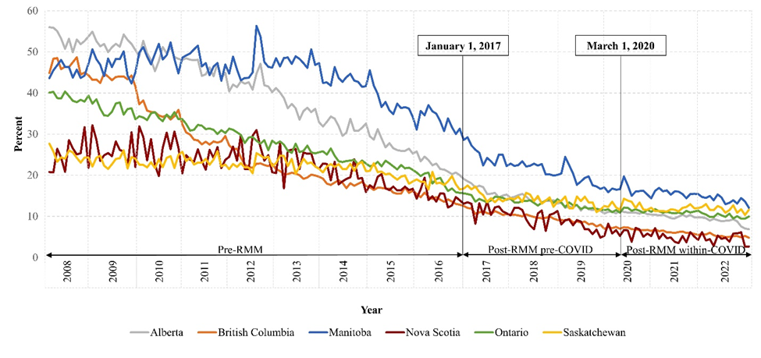
Note: Data available in Nova Scotia and Ontario for ≥ 66 years, and in other provinces for ≥ 18 years. Percentages are for four fluoroquinolones: ciprofloxacin, levofloxacin, moxifloxacin, norfloxacin. RMM = risk mitigation measure; UTI = urinary tract infection.

