Supplementary Table 1. Category ‘Other reasons’ for HIV testing among women diagnosed at Hospital Clínic Barcelona, 2000–2023

Reason | n (%)
Vertical transmission | 5 (21%)
Opioid use disorder | 3 (12%)
Diagnosis in child | 3 (12%)
Chronic anemia / fatigue | 2 (8%)
Accidental occupational exposure | 1 (4%)
Blood donation | 1 (4%)
Transfusion in country of origin | 1 (4%)
Sexual assault | 1 (4%)
Tricuspid endocarditis | 1 (4%)
Epilepsy | 1 (4%)
Primary pulmonary hypertension | 1 (4%)
Other genitourinary conditions | 1 (4%)
Other dermatologic conditions | 1 (4%)
Pruritus | 1 (4%)
Sepsis due to Gram-negative bacilli | 1 (4%)
Total | 24 (100%)

Supplementary Table 2. Unadjusted multinomial regression models for late and advanced HIV diagnosis by reason for testing among women at Hospital Clínic Barcelona, 2000–2023
Late diagnosis  (CD4 <350 cells/mm³) | RRR | [95% CI]
Pregnancy and preconception care | 1
Partner diagnosis | 1.20 | [0.68, 2.11]
Indicator condition | 2.55 | [1.46, 4.45]
Patient’s initiative | 0.20 | [0.04, 0.94]
Physician’s initiative | 1.38 | [0.78, 2.44]
Other | 2.89 | [0.94, 8.87]
Advanced diagnosis  (CD4 <200 cells/mm³) | RRR | [95% CI]
Pregnancy and preconception care | 1
Partner diagnosis | 0.62 | [0.29, 1.33]
Indicator condition | 3.01 | [1.64, 5.51]
Patient’s initiative | 0.27 | [0.03, 2.19]
Physician’s initiative | 1.00 | [0.49, 2.02]
Other | 2.30 | [0.76, 6.98]

Abbreviations: RRR: relative risk ratio; CI: confidence interval

Supplementary Figure 1. Age distribution of women with and without late HIV diagnosis by reason for testing at Hospital Clínic Barcelona, 2000–2023
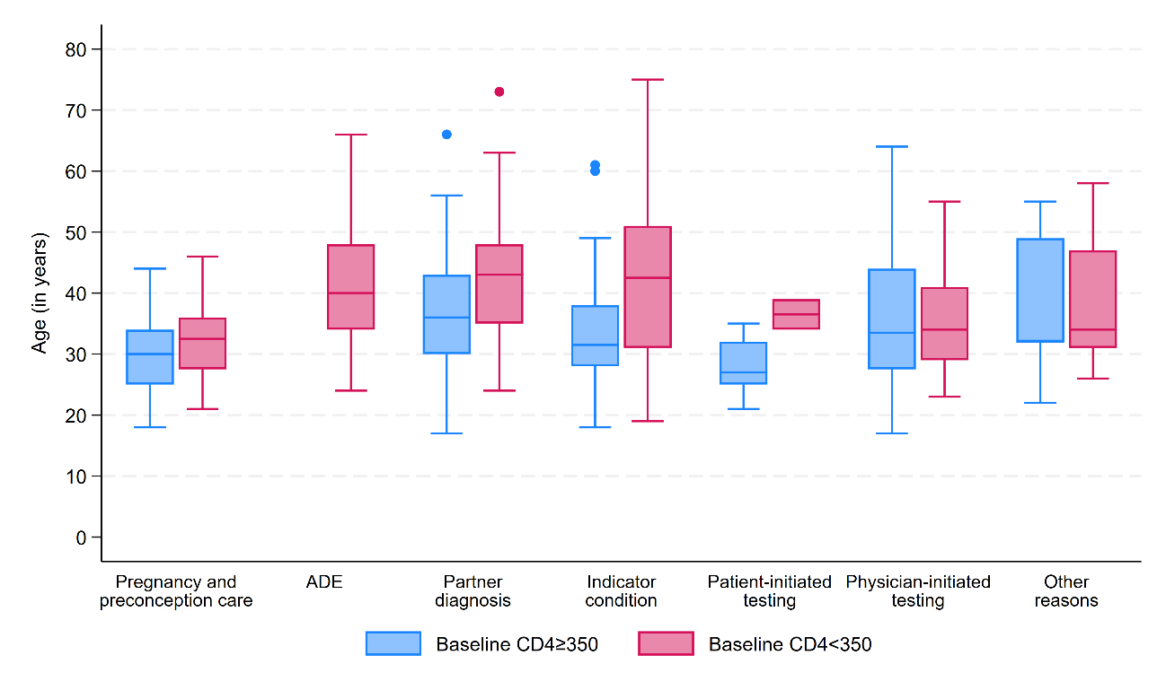
Abbreviations: ADE: AIDS-defining event

Supplementary Figure 2. Age distribution of women with and without advanced HIV diagnosis by reason for testing at Hospital Clínic Barcelona, 2000–2023
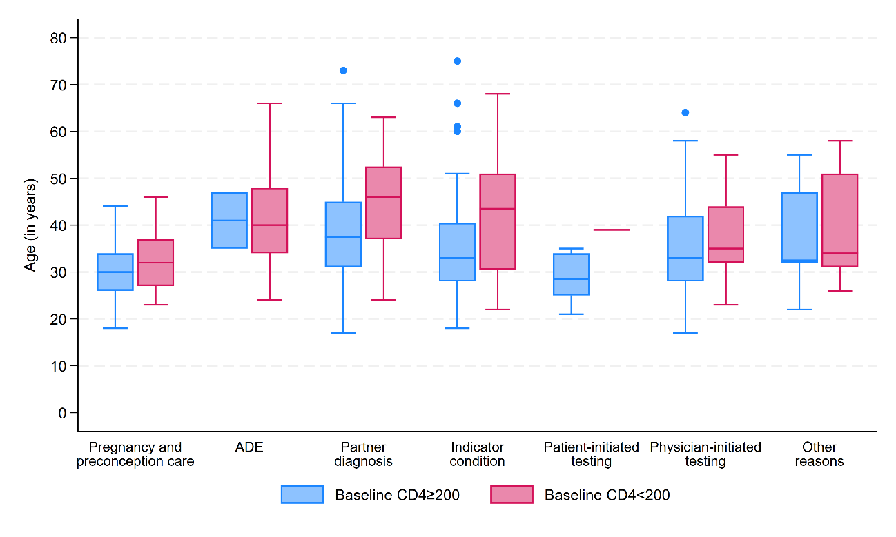
Abbreviations: ADE: AIDS-defining event

