Supplementary file: Z-score distributions
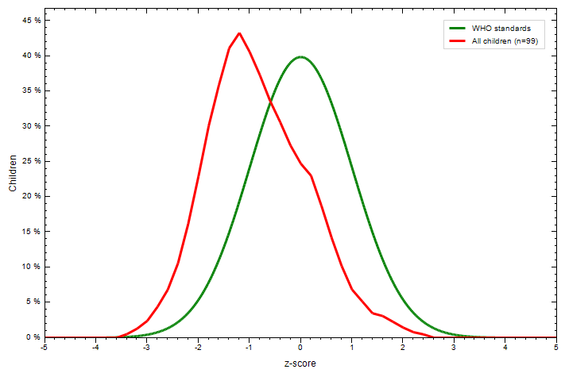

Figure 1. Z-score distribution for the weight-for-age of children compared with the WHO reference

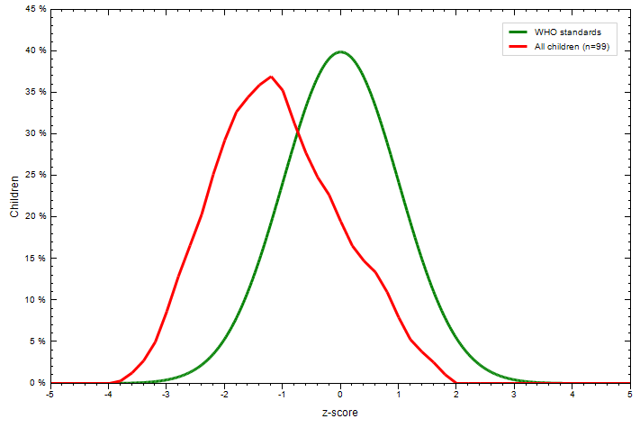

Figure 2. Z-score distribution for height-for-age of children compared with the WHO reference

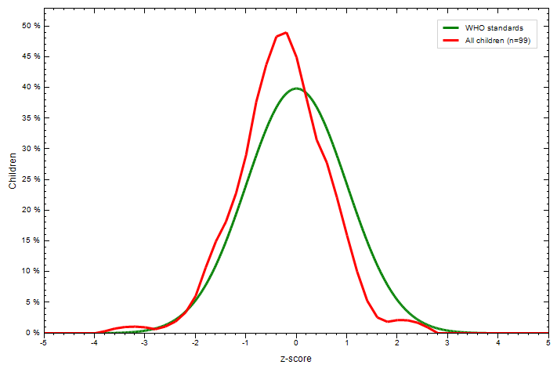

Figure 3. Z-score distribution for weight-for-height of children compared with the WHO reference

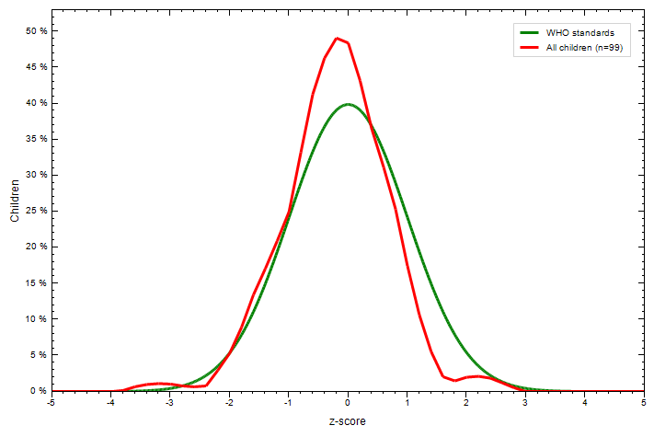
Figure 4. Z-Score distribution for BMI-for-age of children compared with the WHO reference

