Supplementary appendix

Associations of sociodemographic and behavioral factors with frailty transition patterns: a multi-state Markov analysis of the China Health and Retirement Longitudinal Study (CHARLS)

Page 1: Text 1 Supplementary materials
Page 2-3: Table S1 Construction of the 35-item frailty index in the China Health and Retirement Longitudinal Study (CHARLS), 2011-2020
Page 3: Table S2 Number of transitions between frailty states and death among middle-aged and older adults in the China Health and Retirement Longitudinal Study (CHARLS), 2011-2020
Page 4: Table S3 Transition probabilities between frailty states within 1-, 3-, 5-, and 10-year observation intervals by age group (45-60 vs. ≥ 60 years) among middle-aged and older adults in the China Health and Retirement Longitudinal Study (CHARLS), 2011-2020
Page 4: Table S4 Transition probabilities of frailty states within 1, 3, 5, and 10-year observation intervals in different age groups
Page 5: Table S5 Transition probabilities between frailty states within 1-, 3-, 5-, and 10-year observation intervals by gender (male vs. female) among middle-aged and older adults in the China Health and Retirement Longitudinal Study (CHARLS), 2011-2020
Page 6: Table S6 Hazard ratios and 95% confidence intervals of sociodemographic and behavioral factors for transitions between frailty states and death among participants aged 45-60 years in the China Health and Retirement Longitudinal Study (CHARLS), 2011-2020
Page 7: Table S7 Hazard ratios and 95% confidence intervals of sociodemographic and behavioral factors for transitions between frailty states and death among participants aged ≥ 60 years in the China Health and Retirement Longitudinal Study (CHARLS), 2011-2020
Page 8: Table S8 Hazard ratios and 95% confidence intervals of sociodemographic and behavioral factors for transitions between frailty states and death among male participants in the China Health and Retirement Longitudinal Study (CHARLS), 2011-2020
Page 9: Table S9 Hazard ratios and 95% confidence intervals of sociodemographic and behavioral factors for transitions between frailty states and death among female participants in the China Health and Retirement Longitudinal Study (CHARLS), 2011-2020
Page 10: Figure S1 Distribution of the frailty index at baseline among participants in the China Health and Retirement Longitudinal Study (CHARLS)
Page 10: Figure S2 Frailty index increases with age at baseline among participants in the China Health and Retirement Longitudinal Study (CHARLS)
Page 11: Figure S3 Multi-state Markov model evaluation diagrams for frailty state transitions among middle-aged and older adults in the China Health and Retirement Longitudinal Study (CHARLS), 2011-2020

Text 1 Supplementary materials
In the 'others' category of marital status, it includes married but not living with spouse temporarily for reasons such as work, separated, divorced, widowed, and never married.

Some common parameters of MSM models are as follows ^{[1]}. Briefly, transition intensity represents the instantaneous risk of transitioning from one state to another; whereas transition probability is the probability of moving from one state to another over a finite time period. The mean sojourn time represents the average time a person remained in a given state. Transient states allow individuals to transfer bi-directionally between adjacent states, whereas once in an absorbing state, individuals will no longer be able to undergo state transfer.

[1] Shi S Y, Zhao H Y, Liu Z K, et al. Development of diabetic complications and influencing factors among 32653 type 2 diabetes patients: retrospective cohort study using a multi-state Markov model[J].

Table S1 Construction of the 35-item frailty index in the China Health and Retirement Longitudinal Study (CHARLS), 2011-2020
Item number | Item definition | Cut point
1 | Self-reported physician diagnosed hypertension | Yes = 1, No = 0
2 | Self-reported physician diagnosed dyslipidemia | Yes = 1, No = 0
3 | Self-reported physician diagnosed heart disease | Yes = 1, No = 0
4 | Self-reported physician diagnosed stroke | Yes = 1, No = 0
5 | Self-reported physician diagnosed cancer | Yes = 1, No = 0
6 | Self-reported physician diagnosed arthritis | Yes = 1, No = 0
7 | Self-reported physician diagnosed chronic lung disease | Yes = 1, No = 0
8 | Self-reported physician diagnosed asthma | Yes = 1, No = 0
9 | Self-reported physician diagnosed any emotional, nervous, or psychiatric problems | Yes = 1, No = 0
10 | Self-reported physician diagnosed memory-related disease | Yes = 1, No = 0
11 | Self-reported physician diagnosed liver disease | Yes = 1, No = 0
12 | Self-reported physician diagnosed kidney disease | Yes = 1, No = 0
13 | Self-reported physician diagnosed diabetes or high blood sugar | Yes = 1, No = 0
14 | Self-reported physician diagnosed stomach or other digestive disease | Yes = 1, No = 0
15 | Self-reported general health status | Fair, poor, very poor=1, very good, good=0
16 | Difficulty with dressing | Yes = 1, No = 0
17 | Difficulty with bathing or showering | Yes = 1, No = 0
18 | Difficulty with eating | Yes = 1, No = 0
19 | Difficulty with getting in and out of bed | Yes = 1, No = 0
20 | Difficulty with using the toilet | Yes = 1, No = 0
21 | Difficulty with managing money | Yes = 1, No = 0
22 | Difficulty with taking medications | Yes = 1, No = 0
23 | Difficulty with shopping for groceries | Yes = 1, No = 0
24 | Difficulty with preparing meals | Yes = 1, No = 0
25 | Difficulty with doing housework | Yes = 1, No = 0
26 | Difficulty with controlling urination and defecation | Yes = 1, No = 0
27 | Bothered by things | Occasionally or a moderate, 5-7 days per week=1, < 1 day, 1-2 days per week=0
28 | Had trouble keeping mind | Occasionally or a moderate, 5-7 days per week=1, < 1 day, 1-2 days per week=0

Continuation of Table S1
29 | Felt depressed | Occasionally or a moderate, 5-7 days per week=1, < 1 day, 1-2 days per week=0
30 | I felt everything I did was an effort | Occasionally or a moderate, 5-7 days per week=1, < 1 day, 1-2 days per week=0
31 | I felt hopeful about the future | Occasionally or a moderate, 5-7 days per week=1, < 1 day, 1-2 days per week=0
32 | I felt fearful | Occasionally or a moderate, 5-7 days per week=1, < 1 day, 1-2 days per week=0
33 | I was happy | Occasionally or a moderate, 5-7 days per week=1, < 1 day, 1-2 days per week=0
34 | I felt lonely | Occasionally or a moderate, 5-7 days per week=1, < 1 day, 1-2 days per week=0
35 | I could not get on | Occasionally or a moderate, 5-7 days per week=1, < 1 day, 1-2 days per week=0
Note: CHARLS, China Health and Retirement Longitudinal Study; FI, Frailty Index.

Table S2 Number of transitions between frailty states and death among middle-aged and older adults in the China Health and Retirement Longitudinal Study (CHARLS), 2011-2020
From | To, n (%)
From | Robust | Prefrailty | Frailty | Death
Robust | 9023 (55.2) | 6268 (38.4) | 688 (4.2) | 364 (2.2)
Prefrailty | 5404 (18.3) | 17789 (60.1) | 5423 (18.3) | 969 (3.3)
Frailty | 375 (3.1) | 3691 (30.3) | 7166 (58.8) | 960 (7.9)
Note: CHARLS, China Health and Retirement Longitudinal Study.

Table S3 Transition intensity and mean sojourn time of frailty states among middle-aged and older adults in the China Health and Retirement Longitudinal Study (CHARLS), 2011-2020
From | To, transition intensity (95%CI) |  |  |  |  | Mean sojourn time (year)  (95%CI)
From | Robust | Prefrailty | Frailty | Death |  | Mean sojourn time (year)  (95%CI)
Robust | −0.308 (−0.316, −0.300) | 0.301 (0.293, 0.309) | 0 | 0.007 (0.006, 0.009) |  | 3.247 (3.162, 3.335)
Prefrailty | 0.146 (0.142, 0.151) | −0.292 (−0.298, −0.286) | 0.136 (0.132, 0.139) | 0.010 (0.009, 0.012) |  | 3.425 (3.355, 3.496)
Frailty | 0 | 0.217 (0.210, 0.224) | −0.258 (−0.265, −0.250) | 0.041 (0.038, 0.044) |  | 3.880 (3.763, 3.999)
Note: CHARLS, China Health and Retirement Longitudinal Study; HR, hazard ratio; CI, confidence interval.

Table S4 Transition probabilities between frailty states within 1-, 3-, 5-, and 10-year observation intervals by age group (45-60 vs. ≥ 60 years) among middle-aged and older adults in the China Health and Retirement Longitudinal Study (CHARLS), 2011-2020
 | 1-year |  |  |  |  | 3-year |  |  |  |  | 5-year |  |  |  |  |  |  | 10-year
 | Robust | Prefrailty | Frailty | Death |  | Robust | Prefrailty | Frailty | Death |  | Robust | Prefrailty | Frailty | Death |  |  | Robust |  | Prefrailty | Frailty | Death
45-60
Robust | 0.767 | 0.217 | 0.013 | 0.003 |  | 0.511 | 0.407 | 0.071 | 0.011 |  | 0.391 | 0.462 | 0.125 | 0.021 |  |  | 0.286 |  | 0.471 | 0.193 | 0.050
Prefrailty | 0.117 | 0.785 | 0.093 | 0.005 |  | 0.220 | 0.585 | 0.179 | 0.017 |  | 0.250 | 0.513 | 0.208 | 0.029 |  |  | 0.255 |  | 0.467 | 0.218 | 0.061
Frailty | 0.014 | 0.189 | 0.782 | 0.014 |  | 0.078 | 0.364 | 0.521 | 0.037 |  | 0.138 | 0.422 | 0.385 | 0.055 |  |  | 0.212 |  | 0.443 | 0.253 | 0.091
≥60
Robust | 0.712 | 0.248 | 0.021 | 0.019 |  | 0.415 | 0.417 | 0.104 | 0.063 |  | 0.285 | 0.432 | 0.172 | 0.112 |  |  | 0.169 |  | 0.363 | 0.227 | 0.241
Prefrailty | 0.098 | 0.755 | 0.124 | 0.023 |  | 0.165 | 0.526 | 0.230 | 0.079 |  | 0.171 | 0.435 | 0.257 | 0.137 |  |  | 0.144 |  | 0.342 | 0.241 | 0.273
Frailty | 0.010 | 0.147 | 0.785 | 0.058 |  | 0.049 | 0.273 | 0.527 | 0.151 |  | 0.081 | 0.306 | 0.390 | 0.223 |  |  | 0.107 |  | 0.287 | 0.244 | 0.361
Note: CHARLS, China Health and Retirement Longitudinal Study. Transition probabilities were estimated using a multi-state Markov model.

Table S5 Transition probabilities between frailty states within 1-, 3-, 5-, and 10-year observation intervals by gender (male vs. female) among middle-aged and older adults in the China Health and Retirement Longitudinal Study (CHARLS), 2011-2020
 | 1-year |  |  |  |  | 3-year |  |  |  |  | 5-year |  |  |  |  |  |  | 10-year
 | Robust | Prefrailty | Frailty | Death |  | Robust | Prefrailty | Frailty | Death |  | Robust | Prefrailty | Frailty | Death |  |  | Robust |  | Prefrailty | Frailty | Death
Male
Robust | 0.768 | 0.211 | 0.012 | 0.009 |  | 0.511 | 0.392 | 0.063 | 0.033 |  | 0.389 | 0.440 | 0.108 | 0.063 |  |  | 0.273 |  | 0.423 | 0.154 | 0.149
Prefrailty | 0.118 | 0.779 | 0.087 | 0.016 |  | 0.220 | 0.567 | 0.159 | 0.054 |  | 0.247 | 0.483 | 0.177 | 0.093 |  |  | 0.237 |  | 0.407 | 0.168 | 0.188
Frailty | 0.014 | 0.180 | 0.753 | 0.054 |  | 0.074 | 0.330 | 0.463 | 0.133 |  | 0.126 | 0.366 | 0.316 | 0.191 |  |  | 0.179 |  | 0.348 | 0.178 | 0.294
Female
Robust | 0.728 | 0.247 | 0.020 | 0.006 |  | 0.442 | 0.433 | 0.105 | 0.020 |  | 0.316 | 0.467 | 0.180 | 0.038 |  |  | 0.207 |  | 0.437 | 0.263 | 0.093
Prefrailty | 0.102 | 0.769 | 0.122 | 0.007 |  | 0.179 | 0.558 | 0.235 | 0.028 |  | 0.193 | 0.481 | 0.274 | 0.052 |  |  | 0.180 |  | 0.421 | 0.285 | 0.114
Frailty | 0.011 | 0.161 | 0.800 | 0.028 |  | 0.057 | 0.311 | 0.560 | 0.072 |  | 0.098 | 0.362 | 0.433 | 0.107 |  |  | 0.143 |  | 0.376 | 0.304 | 0.176
Note: CHARLS, China Health and Retirement Longitudinal Study. Transition probabilities were estimated using a multi-state Markov model.

Table S6 Hazard ratios and 95% confidence intervals of sociodemographic and behavioral factors for transitions between frailty states and death among participants aged 45-60 years in the China Health and Retirement Longitudinal Study (CHARLS), 2011-2020
Covariates | Recovery transition |  |  | Deteriorate transition |  |  | Death transition
Covariates | Prefrailty→Robust | Frailty→Prefrailty |  | Robust→Prefrailty | Prefrailty→Frailty |  | Robust→Death | Prefrailty→Death | Frailty→Death
Age, continuous | 0.98 (0.97,0.98) | 0.98 (0.97,0.99) |  | 1.01 (0.99,1.01) | 1.02 (1.01,1.03) |  | 0.99 (0.92,1.07) | 1.08 (1.03,1.13) | 1.05 (1.01,1.09)
Gender (ref = Male)
Female | 0.80 (0.71,0.90) | 0.84 (0.72,0.97) |  | 1.36 (1.22,1.53) | 1.41 (1.23,1.61) |  | 0.33 (0.08,1.35) | 0.28 (0.12,0.66) | 0.44 (0.26,0.73)
Residence areas (ref = Urban)
Rural | 1.18 (1.09,1.27) | 1.02 (0.92,1.12) |  | 1.16 (1.08,1.24) | 1.35 (1.24,1.47) |  | 1.75 (0.65,4.69) | 0.90 (0.53,1.53) | 0.90 (0.62,1.32)
Marital status (ref = Married)
Others* | 0.91 (0.81,1.02) | 0.84 (0.74,0.95) |  | 0.99 (0.90,1.11) | 1.05 (0.94,1.16) |  | 1.45 (0.50,4.18) | 1.48 (0.78,2.83) | 0.92 (0.59,1.42)
Highest educational levels (ref = Literate)
Illiterate | 1.26 (1.14,1.40) | 0.94 (0.84,1.05) |  | 1.01 (0.92,1.12) | 1.27 (1.15,1.40) |  | 1.69 (0.59,4.82) | 1.07 (0.48,2.37) | 0.88 (0.58,1.33)
Smoking status (ref = Not current smokers)
Current smokers | 0.90 (0.80,1.01) | 0.88 (0.76,1.01) |  | 1.13 (1.02,1.26) | 1.10 (0.96,1.24) |  | 1.30 (0.51,3.28) | 1.06 (0.59,1.91) | 1.23 (0.76,2.00)
Drinking status (ref = Not current drinkers)
Current drinkers | 1.06 (0.97,1.16) | 1.17 (1.05,1.30) |  | 0.99 (0.91,1.07) | 0.95 (0.86,1.05) |  | 0.86 (0.39,1.93) | 0.78 (0.47,1.28) | 0.49 (0.31,0.77)
Sleep times (ref = 6-8h)
<6h,>8h | 0.94 (0.87,1.02) | 0.83 (0.76,0.91) |  | 1.20 (1.11,1.29) | 1.22 (1.12,1.32) |  | 2.32 (1.14,4.75) | 0.94 (0.57,1.55) | 1.30 (0.92,1.83)
Note: CHARLS, China Health and Retirement Longitudinal Study; HR, hazard ratio; CI, confidence interval; Ref., reference group.
In marital status: *Others include married but not living with spouse temporarily for reasons such as work, separated, divorced, widowed, and never married.

Table S7 Hazard ratios and 95% confidence intervals of sociodemographic and behavioral factors for transitions between frailty states and death among participants aged ≥ 60 years in the China Health and Retirement Longitudinal Study (CHARLS), 2011-2020
Covariates | Recovery transition |  |  | Deteriorate transition |  |  | Death transition
Covariates | Prefrailty→Robust | Frailty→Prefrailty |  | Robust→Prefrailty | Prefrailty→Frailty |  | Robust→Death | Prefrailty→Death | Frailty→Death
Age, continuous | 1.00 (0.99,1.01) | 0.99 (0.98,1.00) |  | 1.01 (1.00,1.02) | 1.02 (1.01,1.03) |  | 1.11 (1.08,1.14) | 1.09 (1.07,1.12) | 1.11 (1.09,1.12)
Gender (ref = Male)
Female | 0.74 (0.63,0.87) | 0.81 (0.70,0.95) |  | 1.09 (0.95,1.26) | 1.38 (1.20,1.58) |  | 0.57 (0.30,1.09) | 0.75 (0.48,1.16) | 0.46 (0.37,0.58)
Residence areas (ref = Urban)
Rural | 1.35 (1.21,1.52) | 1.16 (1.04,1.30) |  | 1.21 (1.09,1.34) | 1.33 (1.21,1.46) |  | 0.85 (0.51,1.42) | 1.11 (0.82,1.50) | 1.00 (0.84,1.20)
Marital status (ref = Married)
Others* | 1.14 (0.99,1.30) | 0.97 (0.85,1.09) |  | 1.09 (0.97,1.24) | 0.95 (0.85,1.06) |  | 1.03 (0.57,1.85) | 1.41 (1.03,1.93) | 1.30 (1.09,1.55)
Highest educational levels (ref = Literate)
Illiterate | 1.65 (1.45,1.88) | 1.13 (1.00,1.27) |  | 1.16 (1.04,1.31) | 1.14 (1.03,1.26) |  | 1.47 (0.85,2.52) | 1.18 (0.83,1.67) | 1.48 (1.23,1.78)
Smoking status (ref = Not current smokers)
Current smokers | 0.93 (0.81,1.08) | 0.85 (0.71,0.98) |  | 1.00 (0.88,1.14) | 1.12 (0.98,1.27) |  | 0.77 (0.44,1.37) | 2.75 (1.78,4.26) | 1.07 (0.87,1.32)
Drinking status (ref = Not current drinkers)
Current drinkers | 1.09 (0.96,1.23) | 1.22 (1.08,1.38) |  | 0.96 (0.86,1.07) | 0.89 (0.80,0.99) |  | 0.97 (0.55,1.73) | 0.68 (0.48,0.94) | 0.71 (0.57,0.88)
Sleep times (ref = 6-8h)
<6h,>8h | 0.90 (0.81,1.01) | 0.89 (0.80,0.99) |  | 1.12 (1.01,1.24) | 1.25 (1.15,1.37) |  | 1.24 (0.72,2.15) | 1.08 (0.79,1.46) | 0.86 (0.72,1.01)
Note: CHARLS, China Health and Retirement Longitudinal Study; HR, hazard ratio; CI, confidence interval; Ref., reference group.
In marital status: *Others include married but not living with spouse temporarily for reasons such as work, separated, divorced, widowed, and never married.

Table S8 Hazard ratios and 95% confidence intervals of sociodemographic and behavioral factors for transitions between frailty states and death among male participants in the China Health and Retirement Longitudinal Study (CHARLS), 2011-2020
Covariates | Recovery transition |  |  | Deteriorate transition |  |  | Death transition
Covariates | Prefrailty→Robust | Frailty→Prefrailty |  | Robust→Prefrailty | Prefrailty→Frailty |  | Robust→Death | Prefrailty→Death | Frailty→Death
Age (≥45), continuous | 0.99 (0.98,0.99) | 0.98 (0.97,0.99) |  | 1.01 (1.01,1.02) | 1.02 (1.01,1.02) |  | 1.09 (1.06,1.12) | 1.08 (1.06,1.10) | 1.09 (1.08,1.11)
Residence areas (ref = Urban)
Rural | 1.24 (1.14,1.36) | 1.18 (1.04,1.32) |  | 1.16 (1.07,1.26) | 1.33 (1.20,1.46) |  | 0.99 (0.60,1.63) | 1.04 (0.77,1.41) | 0.99 (0.79,1.23)
Marital status (ref = Married)
Others* | 1.15 (1.01,1.30) | 0.91 (0.78,1.05) |  | 0.99 (0.88,1.12) | 1.10 (0.96,1.25) |  | 1.56 (0.89,2.75) | 1.30 (0.92,1.85) | 1.31 (1.04,1.65)
Highest educational levels (ref = Literate)
Illiterate | 1.50 (1.30,1.73) | 0.94 (0.80,1.11) |  | 1.20 (1.05,1.37) | 1.20 (1.04,1.39) |  | 0.61 (0.22,1.74) | 1.46 (0.98,2.18) | 1.29 (1.02,1.64)
Smoking status (ref = Not current smokers)
Current smokers | 0.94 (0.85,1.04) | 0.91 (0.79,1.04) |  | 1.10 (1.00,1.21) | 1.17 (1.04,1.32) |  | 0.92 (0.53,1.61) | 1.99 (1.24,3.21) | 1.16 (0.89,1.51)
Drinking status (ref = Not current drinkers)
Current drinkers | 1.06 (0.97,1.15) | 1.12 (0.99,1.25) |  | 0.96 (0.88,1.04) | 0.83 (0.75,0.91) |  | 0.84 (0.52,1.38) | 0.68 (0.51,0.91) | 0.66 (0.53,0.83)
Sleep times (ref = 6-8h)
<6h,>8h | 0.99 (0.91,1.01) | 0.87 (0.78,0.97) |  | 1.15 (1.06,1.25) | 1.21 (1.10,1.33) |  | 1.88 (1.09,3.24) | 1.04 (0.76,1.43) | 0.97 (0.78,1.19)
Note: CHARLS, China Health and Retirement Longitudinal Study; HR, hazard ratio; CI, confidence interval; Ref., reference group.
In marital status: *Others include married but not living with spouse temporarily for reasons such as work, separated, divorced, widowed, and never married.

Table S9 Hazard ratios and 95% confidence intervals of sociodemographic and behavioral factors for transitions between frailty states and death among female participants in the China Health and Retirement Longitudinal Study (CHARLS), 2011-2020
Covariates | Recovery transition |  |  | Deteriorate transition |  |  | Death transition
Covariates | Prefrailty→Robust | Frailty→Prefrailty |  | Robust→Prefrailty | Prefrailty→Frailty |  | Robust→Death | Prefrailty→Death | Frailty→Death
Age (≥45), continuous | 0.99 (0.98,0.99) | 0.99 (0.98,0.99) |  | 1.01 (1.00,1.01) | 1.02 (1.02,1.03) |  | 1.10 (1.05,1.16) | 1.11 (1.07,1.15) | 1.10 (1.09,1.12)
Residence areas (ref = Urban)
Rural | 1.20 (1.09,1.32) | 1.01 (0.92,1.11) |  | 1.18 (1.09,1.29) | 1.33 (1.23,1.45) |  | 0.92 (0.39,2.16) | 1.10 (0.68,1.77) | 0.96 (0.77,1.20)
Marital status (ref = Married)
Others* | 0.94 (0.83,1.05) | 0.90 (0.81,1.00) |  | 1.08 (0.96,1.20) | 0.94 (0.85,1.03) |  | 0.88 (0.24,3.26) | 1.24 (0.72,2.13) | 1.29 (1.03,1.61)
Highest educational levels (ref = Literate)
Illiterate | 1.38 (1.25,1.52) | 1.04 (0.95,1.15) |  | 1.03 (0.94,1.14) | 1.21 (1.11,1.31) |  | 2.64 (0.75,9.27) | 0.89 (0.50,1.60) | 1.47 (1.16,1.87)
Smoking status (ref = Not current smokers)
Current smokers | 0.80 (0.67,0.96) | 0.81 (0.69,0.94) |  | 0.99 (0.84,1.18) | 1.05 (0.92,1.20) |  | 0.83 (0.12,5.70) | 2.00 (1.09,3.67) | 1.07 (0.80,1.44)
Drinking status (ref = Not current drinkers)
Current drinkers | 1.10 (0.97,1.25) | 1.30 (1.14,1.48) |  | 1.04 (0.93,1.17) | 1.09 (0.97,1.22) |  | 0.67 (0.08,5.51) | 1.12 (0.56,2.26) | 0.58 (0.37,0.89)
Sleep times (ref = 6-8h)
<6h,>8h | 0.86 (0.78,0.94) | 0.84 (0.77,0.92) |  | 1.17 (1.07,1.27) | 1.24 (1.15,1.34) |  | 1.72 (0.55,5.37) | 0.87 (0.51,1.48) | 0.91 (0.73,1.14)
Note: CHARLS, China Health and Retirement Longitudinal Study; HR, hazard ratio; CI, confidence interval; Ref., reference group.
In marital status: *Others include married but not living with spouse temporarily for reasons such as work, separated, divorced, widowed, and never married.

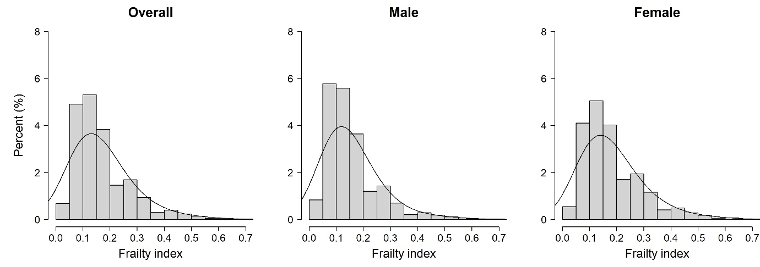
Figure S1 Distribution of the frailty index at baseline among participants in the China Health and Retirement Longitudinal Study (CHARLS)
Note: CHARLS, China Health and Retirement Longitudinal Study.
The solid line represents the fitted density plot of the frailty index.
The average frailty index for males and females was 0.15 ± 0.10 and 0.18 ± 0.11, respectively.
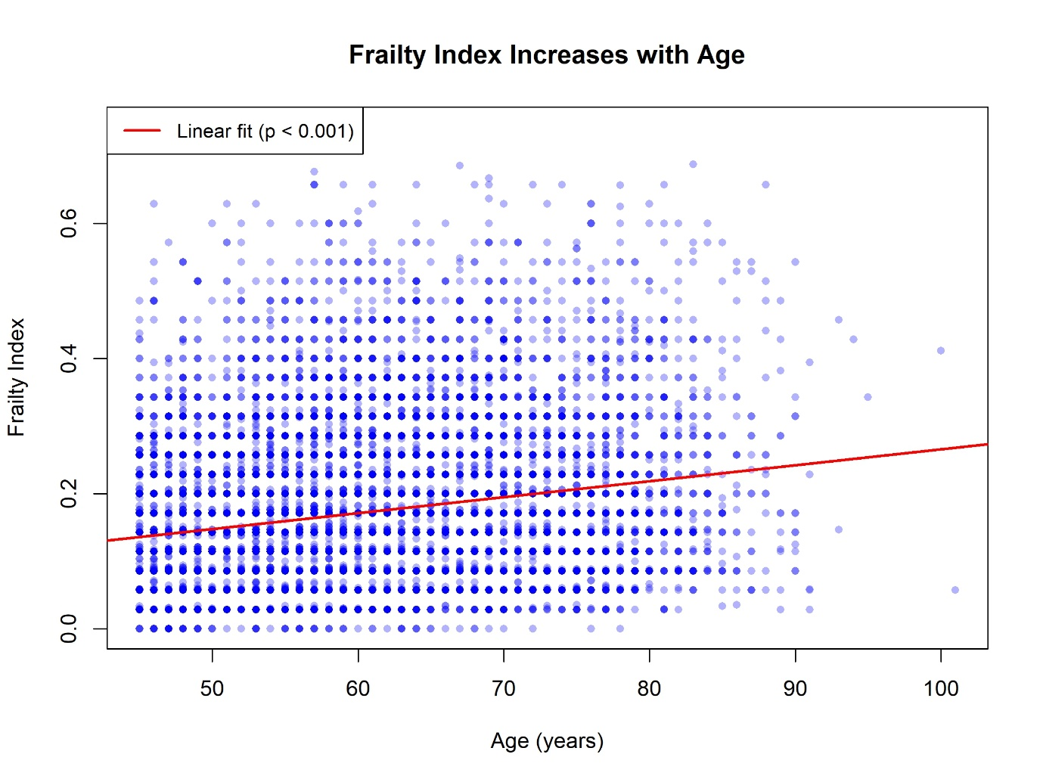
Figure S2 Frailty index increases with age at baseline among participants in the China Health and Retirement Longitudinal Study (CHARLS)
Note: CHARLS, China Health and Retirement Longitudinal Study.
The diagonal line represents the linear fit (p < 0.001).
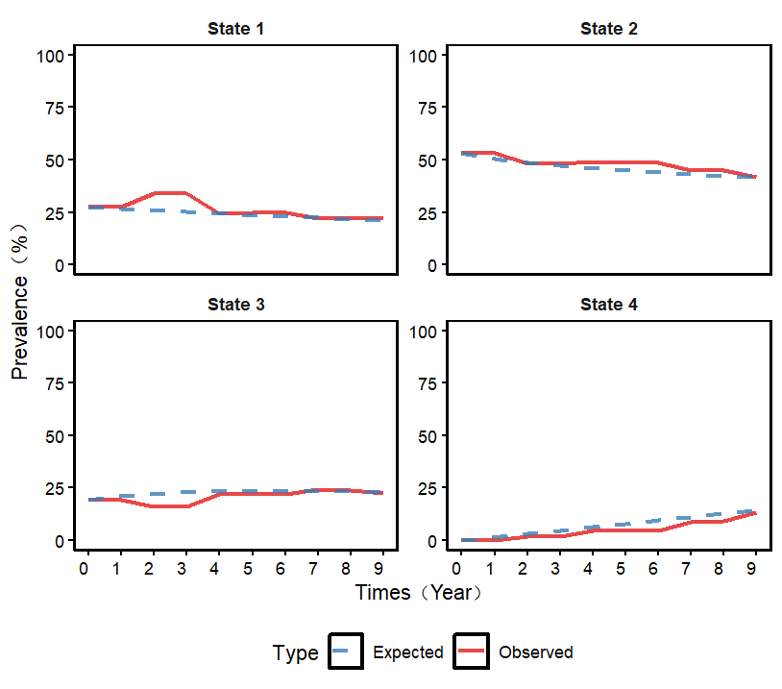
Figure S3 Multi-state Markov model evaluation diagrams for frailty state transitions among middle-aged and older adults in the China Health and Retirement Longitudinal Study (CHARLS), 2011-2020
Note: CHARLS, China Health and Retirement Longitudinal Study.
Comparison of observed and expected prevalence.
State 1: robust. State 2: prefrailty. State 3: frailty. State 4: death.
The horizontal axis is time, the vertical axis is the expected frequency percentage and observed frequency percentage, and the dashed and solid lines were the curves of the expected frequency percentage and observed frequency percentage for the four states of robust, prefrailty, frailty and death.

